

Strategic Management (LCMB7003)

Strategic Analysis of British American Tobacco
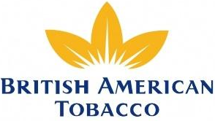

Student name: Rupal Patel
Student Number: 2133400
Lecturer:Hossein Shokri
Word count: 6197
Submission Date: 08/05/2023

Table of Contents
Introduction 2
BAT Background 2
BAT’s Mission and Objectives 2
Macro-Environment 3
PESTLE Analysis 3
Micro-Environment 5
Industry Life Cycle (ILC) 5
Porter’s Industry Five Forces Analysis 6
Internal Analysis 9
BAT’s Strategic Resources and Capabilities 9
Value Chain Analysis 11
Primary Activities 12
Secondary Activities 13
VRIO Analysis of Distinctive Resources and Capabilities 14
SWOT Analysis 16
Strategies to Sustain Competitive Advantage 18
Growth Strategies 20
Green Strategy and CSR 22
Green Strategy Value Chain 22
Corporate Social Responsibilities (CSR) of BAT 23
Conclusion 24
Recommendation 24
References 25

Introduction
Whittington, et al. (2020, p.5) defined strategy as ‘long-term direction’ of a firm to achieve specific aim and success in future. On the other hand, Chandler (1963, p.13) stated that strategy in an organisation setting are the actions adopted by the organisation and the resources allocated by it to meet long-term goals and objectives. When organisations covert their strategic aims into actions, it leads to strategic management (Bailey, et al., 2018, p.351). Strategic management is thus defined by Barney and Hesterly (2018, p.27) as the process of analysing and choosing good strategy that will help to generate competitive advantage.
The purpose of this report is to conduct a strategic analysis of British American Tobacco (BAT), using various theories and models, and to examine the competitive, growth and green strategies used by the company to achieve success in the industry.

BAT Background
BAT is a British multinational and a leading tobacco product manufacturing company that was founded in 1902 in the United States (BAT, 2023). Its main business activity includes manufacturing, distributing and selling cigarettes, tobacco and products for heating it, vape, and nicotine goods (GlobalData, 2023). These products are sold by a large number of retail businesses, and wholesalers and distributors across the world. BAT has more than 52,000 employees across the globe that contributes to the overall success of the company (BAT, 2023). The company had generated a revenue of £27,655m in the year ended 31 December 2022 and its current share price in the United Kingdom is 2823.50p (BAT, 2023).

BAT’s Mission and Objectives
The mission of BAT is to identify and meet the needs and preferences of global adult consumers and offer them a wide variety of tobacco products, stimulate their senses, and give pleasurable and low health-risk experience (BAT, 2023).
The main objective and purpose of BAT is to develop ‘A Better Tomorrow’ for employees, stakeholders and the community as a whole by lowering the health-related impact of their business (BAT, 2023).

Macro-Environment
Figure 1: Macro-environment and 6 Principle Factors of the PESTLE Analysis
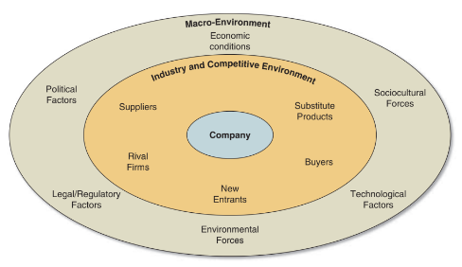
BAT
Source: Gamble, et al. (2014, p.39)
Macro-environment consists of the wider environment in which a firm operates and it covers 6 principle factors (See Fig. 1): political, economic, sociocultural, technological, legal and environmental factors, which helps management take strategic decisions and plan long-term business goals, objectives and strategies (Johnson, et al., 2017, p.33). PESTLE is an acronym for 6 principle factors that helps to evaluate the relevance of macro-environmental factors and their impact on the current and future business of the organisation (Gamble, et al., 2014, p.38).

PESTLE Analysis
The influence of macro-environmental factors on an organisation can be assessed using the PESTLE Analysis framework that helps to identify a firm’s potential threats and opportunities in the external environment (CIPD, 2021). The impact of PESTLE factors on Tobacco industry can be assessed as follows:
Political: Government and health organisations are well aware of the negative impact of tobacco products, like cigarettes, vapes and cigars, on the health of the people (Department of Health and Social Care, 2021). However, instead of completely banning these products, the government places high taxes on their purchase to decrease consumption and to make additional revenue (Gartner, et al., 2007). Although, government policy on not banning tobacco products can be beneficial for the industry, the heavy tax policy may decrease tobacco sales which can hamper overall growth of the industry.
Economic: UK Parliament (2023) reported that the cost-of-living and inflation (11.1% as of October 2022) had significantly risen across the United Kingdom (UK) in 2021 and 2022. As a result, the buying and spending habits of the UK public have changed and people are spending less on non-essential and leisure products, like tobacco (PWC, n.d.). This can be a major threat to future growth and profitability of the Tobacco industry.
Socio-cultural: Tobacco contains nicotine which is a highly addictive component. Due to this smoking cessation can be a major issue for people who are highly addictive to it (Benowitz, 2008). In addition, a network of chain smokers and those who regard smoking as normal behaviour and status of pride can influence non-smokers in the community (Gollust, Schroeder and Warner, 2009). Thus, the more people smoking tobacco, the higher would be the sales and turnover rate of the industry.
Technological: With the advancement in technology, innovative e-cigarettes and vaping devices, like vape pens, Bluetooth-operated vape devices, tobacco heating system, etc., are introduced in the market as an alternative to smoking (SciTech Patent Art Services Ltd., n.d.). Such devices generate an aerosol which resembles water vapours containing flavours and small amounts of nicotine that has fewer negative health impacts (National Institute on Drug Abuse, n.d.). Rising popularity and growing interest among the consumers for vaping devices can be an opportunity for industry to increase the manufacturing of such products (Ash, 2022).
Legal: Tobacco industry is highly affected by different legislations pertaining to tobacco consumption and exhibition. For instance, ‘Tobacco Display Regulation’ prohibits retailers from displaying and advertising tobacco products in their shops (UK Parliament, 2023). ‘Tobacco Advertising and Promotion Bill’ restricts promotion of these products on online platforms, billboard, newspaper, television and magazines (House of Commons, 2020). Further, it is illegal for adults under 18 years to buy and consume tobacco products as well as for retailers to sell to them. Although tobacco selling companies in the industry are aware of and abide by these regulations, they may limit the companies’ ability to extend their customer base.
Environmental: The smoke from the burning of tobacco products and the inappropriately discarded cigarette butts, containing chemical filters, can highly pollute the environment and ecosystem (Ash, 2021). Irrespective of the efficiency and regulation within the industry, tobacco products impose major threats to the health and the ecosystem which may further affect the long-term sustainability of the industry (Ash, 2021).

Micro-Environment
Micro-environment, also called market (industry) or competitive environment, consists of factors that have direct and immediate impact on the organisation (Hooley, et al., 2009, p.57, 58). The key components in this environment include, the emerging companies, substitutions, competitors, customers and suppliers (See Industry and Competitive Environment layer in Fig. 1). Contrasting to the macro-environment, factors in the micro-environment, to a certain level, can be controlled by the organisations (Xu, 2005, p.23, 24). In order to analyse the influence of micro-environment on BAT, industry life cycle and Porter’s five forces analysis framework will be taken into consideration.

Industry Life Cycle (ILC)
Maylin-Aguilar and Montoro-Sanchez (2021) explained that ILC is a model which showcases the evolution of an industry or a business from the start until it ends. It consists of various stages (See Fig. 2), like introduction of the industry, rapid growth stage, slow growth or maturity, and finally decline or divestment stage. Based on the characteristics, mentioned in Fig. 2, for each stage, the tobacco industry is claimed to be at a decline stage. The main feature of this stage is extreme competition which results in sales reduction and sustainability issues (Whittington, et al., 2020, p. 78).
According to the IBIS World report (2021), the tobacco industry has faced several challenges from 2016-2021. These include increased public awareness about the negative health impact of consuming tobacco, stricter UK Government legislations and heavy taxes (Office for National Statistics [ONS], 2022; Office for Health Improvement and Disparities, 2021; HM Revenue and Customs, 2023). In addition, adult smoking habits in the UK have significantly declined in recent times (ONS, 2022). All these barriers have resulted in the declining state of the tobacco industry life cycle. However, this decline can be resisted by the industry through increasing focus on vape and e-cigarette business that is gaining popularity among the UK consumers (Ash, 2022).
Figure 2: Stages of Tobacco Industry Life Cycle
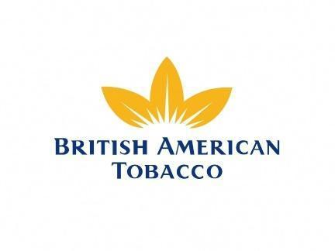
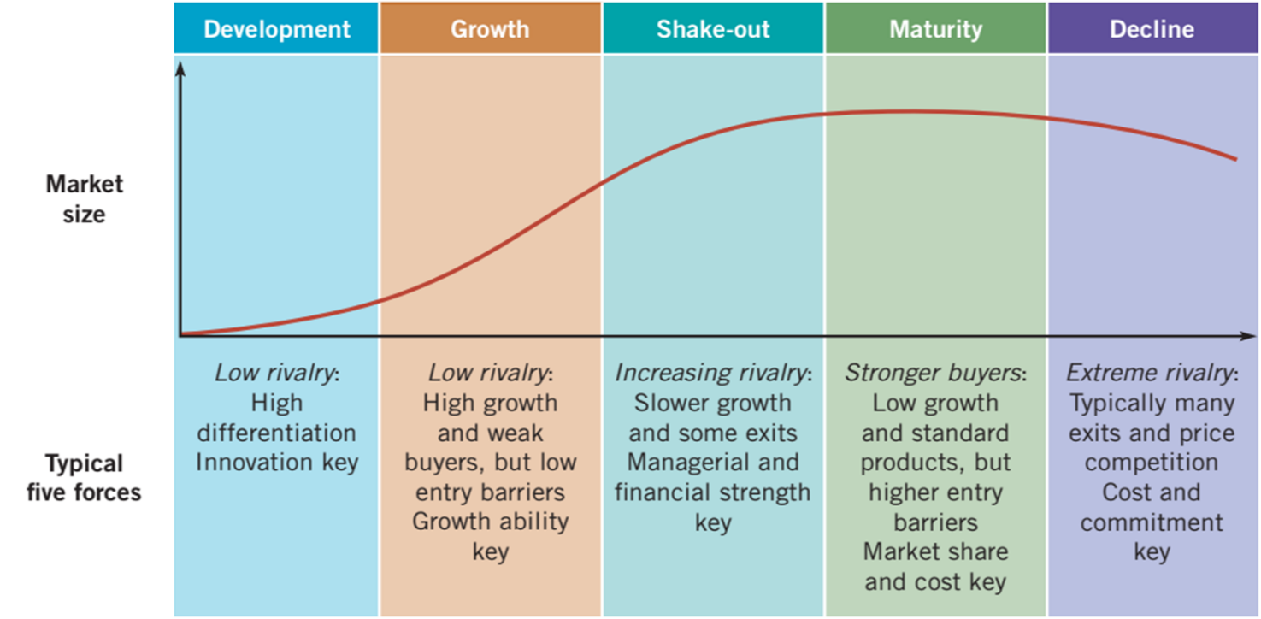
Source: Whittington, et al. (2020, p. 77)

Porter’s Industry Five Forces Analysis
Michael E. Porter had designed a 5 forces framework (See Fig. 3) for analysing current competitive ability and position of a company and for identifying the attractiveness of a market where the company wants to enter. Additionally, these forces are also used to examine the profitability of a potential product or service (Chartered Global Management Accountant, 2013).
Figure 3: Porter’s Five Forces Framework
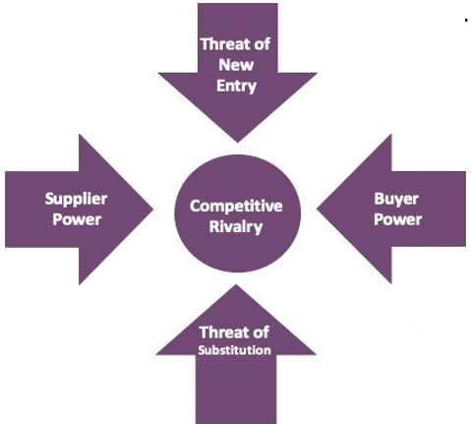
Source: Adapted from Lynch (2018, p. 91)
Threat of New Entry (medium): According to Lynch (2018), these force helps to assess the competition level in the industry as more number of entrants in the industry can lead to increasing loss of shares for the incumbents in the tobacco industry. Also, low switching cost of the entrants can further add pressure on incumbents to maintain their profitability (Porter, 2008). However, it could be difficult for new players to compete against the giant corporations, like BAT, which operate at a multinational level and which makes considerable investment in manufacturing, promoting, branding and distributing their products (Porter, 2008). Additionally, the restriction on tobacco advertising makes it tougher for the new players to increase their brand recognition and to attract more customers to their business (Bilgin, 2018).

Threat of Substitute (high): The substitute products of tobacco include e-cigarettes, skin patches, inhalators, chewing gums, oral strips, and nasal spray (NHS, n.d.). Also, the UK government is imposing high charges on tobacco and is constantly promoting the negative health effect of smoking which has compelled the consumers to switch to substitutes (Gartner, et al., 2007; Department of Health and Social Care, 2021). Additionally, there are low cost associated with switching to substitutes, for example, on a weekly basis in the UK, a smoker spent roughly £23.40/week, whereas a nicotine products’ consumer spent around £7.88/week, e-cigarette consumer spent £7.60/week and NRT consumers spent £8.15/week (Jackson, et al., 2019). Such a considerable difference in price can motivate smokers to either quit smoking or switch to the substitutes.

Supplier Power (low): In tobacco industry, the level of suppliers’ bargaining power is based on the number of suppliers in the industry, the availability or shortage of resources, and the value and power of the company associated with the supplier (Porter, 2008). Conglomerate, like BAT, has a large chain of suppliers (over 1500) present at local, national and global level (BAT, n.d.). This decreases the power of a supplier as there is an increasing possibility of incumbents switching to affordable suppliers (Porter, 2008). Furthermore, the number of tobacco smokers in the UK is decreasing (from 13.8% in 2020 to 13.0% in 2021) which may reduce the bargaining power of the suppliers as decreasing demand may lead to drop in tobacco manufacturing (ONS, 2022; Ghosh, D. and Shah, 2015).

Buyer Power (high): Like for suppliers, the bargaining power of buyers also depends on how many buyers are there in the industry, number of competitors in the market, and number and availability of substitute products (Porters, 2008). In the tobacco industry, the buyers have the power to choose the product they want to consume and to decide whether or not to continue smoking. Also, they can switch the brand based on their need and budget.

Competitive Rivalry (high): There is intense competition in the tobacco industry among the brands like BAT, Imperial Brands Plc., Unilever, Tesco, Britvic, etc. to surge their market share (Market Beat, n.d.). Additionally, brands like Elf, Geek, Edge, etc. are further increasing the competition in the market through their e-cigarette sales (Gelder, 2022). Further, low pricing strategy of one incumbent may hamper other incumbents as they may also have to reduce their price to attract more customers and to increase market shares.

Internal Analysis
Internal analysis helps to understand the essential aspects of the business, such as its strengths and weaknesses with regards to its resources, capabilities and competitive advantages that it gain due to potential opportunities and threats in the external environment (Aaker and Moorman, 2017, p.12)

BAT’s Strategic Resources and Capabilities
According to Whittington, et al. (2020, p.96), it is essential for a company to have adequate resources and capabilities so that it can survive and possibly be competitive in the long-run. Resources refer to the assets that a company has and can leverage, whereas capabilities refer to the manner in which those assets are used so that it can create value for the company (Whittington, et al., 2020, p.96). The internal resources and capabilities of BAT can be analysed using a resource-based view (RBV). RBV is a framework (See Fig. 4) that helps to analyse threshold resources and capabilities (physical and identifiable) and distinctive resources and capabilities (needed to gain competitive edge and superior long-term performance) of an organisation (Whittington, et al., 2020, p.95). This section will emphasise on the threshold resources of BAT.
Figure 4: RBV
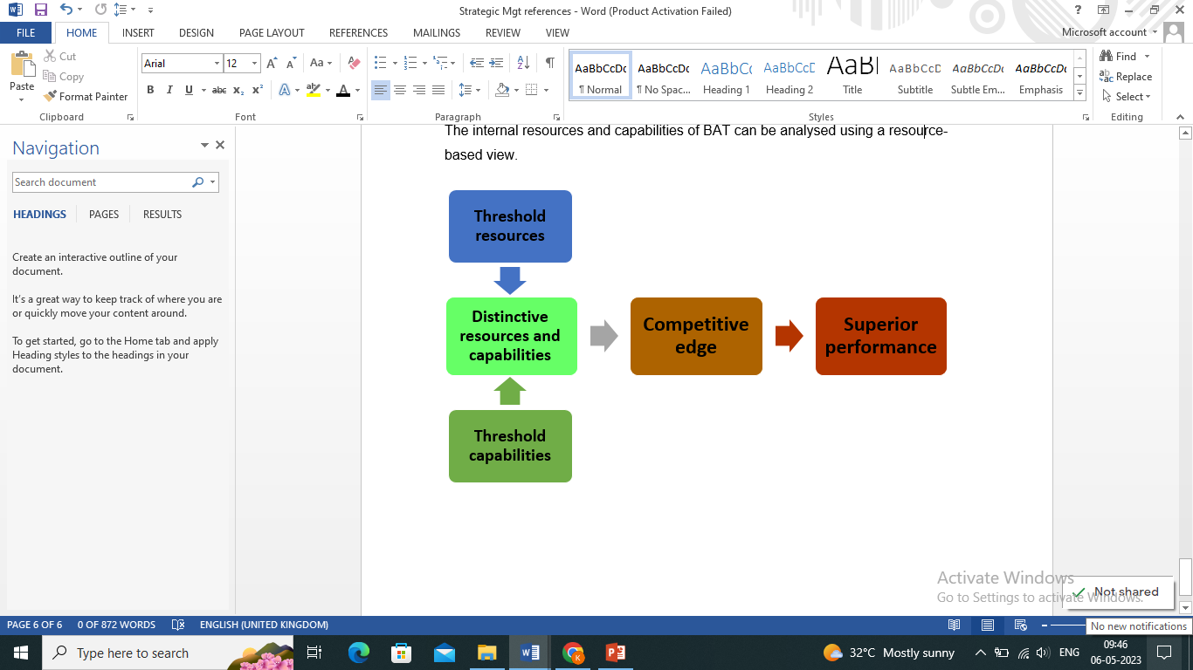
Source: Adapted from Whittington, et al. (2020)
The threshold resources and capabilities are essential for the organisation to be on par with the competitors as well as to compete with them. These are the physical, financial and human resources and capabilities of an organisation (See Fig. 5) needed to survive in the market (Whittington, et al., 2020, p.96, 98).
Figure 5: Threshold resources and capabilities
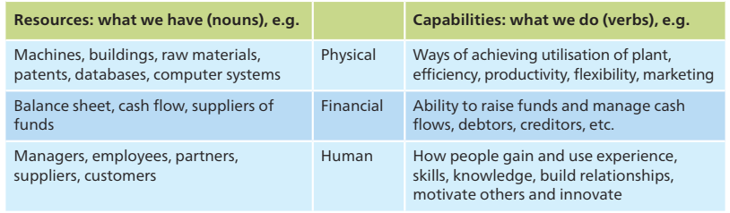
Source: Whittington, et al. (2020, p.96)
With regards to BAT, the physical resources include its global operational infrastructure, IT systems, production units, warehouses and offices; tobacco products, such as vape, cigarettes, tobacco heating product, and oral nicotine pouches; raw materials, like tobacco rod, tipping and cigarette papers and filter; machinery to make various types of tobacco products; labelling and packaging materials (BAT, n.d.). On the other hand the physical capabilities include the way it uses its properties and manufacturing units to make the tobacco products that gives it a competitive advantage. They also include BAT’s marketing activities and promotional tools, both offline and online, that are used to attract maximum customers’ attention.
The financial resources of BAT comprises revenue and profit that it generates through the sale of its products and services. In the year ending 31st December 2022, BAT was able to generate £27,655 million of revenue with a profit of £6,846 million. It also includes the earning that BAT generates from its shares which was £293.3 million (basic) £291.9 million (diluted) in the same year (BAT p.l.c, 2022). In terms of financial capabilities, BAT runs a Quantum Project to increase the efficiency and agility of their business and this project has helped BAT to save £1.9 billion from 2020 to 2022. Besides, BAT had made various investments in the year 2022, for example it invested in Sanity Group (a cannabis company in Germany), offered loan to Charlotte’s Web (products hemp extract wellness products), bough further shares, and used finances to support other business activities, like paying bills, salaries, suppliers, in risk assessments, etc. (BAT p.l.c, 2022).
According to the 2022 statistics and with regards to human resources, BAT has more than 50,000 people working across the globe. It has over 80,000 farmers that directly supply most of the raw materials. However, the company also deals with the 3rd-party suppliers which are roughly over 250,000 farmers. Additionally, the company has 22.5 million consumers that consume non-combustible products of BAT (BAT, n.d.). Nevertheless, to enhance the human capabilities, BAT attracts, recruits, trains and retains suitable employees across the business as they are the most important resources of the company that can help to bring in another important human resource, that is, customers (BAT, 2011). The customers are attracted through responsible marketing practices that are targeted towards adults and no young children. Also, the company ensures strong bonds with its suppliers and pays them in compliance with the UK regulations (BAT, 2022).

Value Chain Analysis
According to Stobierski (2020), it is a tool used to evaluate different activities embedded in the value chain framework of the company which helps to create goods and services. Value chain (VC) (See Fig. 6) helps to identify the strategic position of the company as well as of its resources and capabilities within the framework (Whittington, et al., 2020, p.105).
Figure 6: A Company’s Value Chain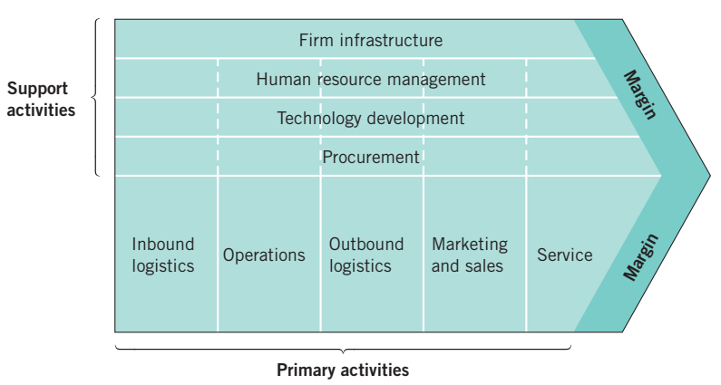
Source: Whittington, et al. (2020, p.105).
The VC is primarily divided into primary and support activities. The former activities are concerned with the development or delivery of goods and services, whereas the latter activities, also called secondary activities, are linked with the primary activities and aid in enhancing the effectiveness and efficiency of the latter (Whittington, et al., 2020, p.105, 106).

The primary activities of BAT includes –

Primary Activities
Inbound logistics are related to the inward supply of the products and services to the company. To produce the tobacco products, BAT relies on tobacco leaf which is directly supplied by the farmers (BAT, n.d.). BAT ensures that strong relationships are maintained with the farmers so that activities like, receiving, storing and distribution of the raw materials to begin the manufacturing process, are smoothly conducted.
Operations begin when tobacco leaf arrives at the manufacturing units of BAT where it is blended with other ingredients and flavouring after the quality check. This process is handled by the automated machines and careful tests are conducted at each stage of the manufacturing process. Even the packing process is handled by the machines until the final case is dispensed. (BAT, n.d.)
Outbound logistics of BAT includes storage of the dispensed cigarette cases until they are distributed to retailers (mini-super market and stores), convenience (Kiosks) and hotels, restaurants and cafes (BAT, n.d.). During the outbound logistics, BAT should ensure timely distribution of the products so that the end-users get the quality product which can further lead to customer satisfaction and profitability (Ensign, 2001).
BAT ensures responsible marketing and sales of its products. It promotes accurate content and ensures that its marketing is not misleading people about the smoking risks or about encouraging their decision to smoke. Additionally, they adhere to the government regulations of not publically advertising the products or targeting them to the young adults.
Generally services include post-sale activities, like repairing or installing, which sustains and increases the value of the product or services. However, with regards to BAT, it conducts a survey, called ‘Customer Voice Survey’, of the retailers to measure the attitude, perception and experience of the end-customers about using BAT products.

Secondary Activities
Procurement includes the raw material (tobacco leaf, filters, papers, and flavouring), the manufacturing team, the automated machines required to produce the cigarettes and cases, the farmers, the packaging materials, ‘trade marketing and distribution’ team of BAT that handles the responsible marketing and distribution of finished products to retailers, conveniences, etc. All these are linked with the primary activities and are necessary to produce the final products of BAT. (BAT, n.d.)
All primary activities of BAT incorporates technology development within its process, for example, at BAT, IT system is used to manage the inventory and supply-chain, automated machines are required for producing the finished products (cigarettes and its cases), even the marketing, distribution and surveys post the service is all managed by technological systems. In addition, the company invests in research and development (R&D) to bring new products to the market that can build a better tomorrow.
Human resource management at Bat is concerned with the training and development of all workforce, for example, the Made@BAT learning programme is offered to the marketing managers to enhance their skills. Besides, it conducts leadership programmes (3,200 managers attended it in 2022), digital learning programme (The Grid) and different development programmes for the employees. (BAT, n.d.)
Firm infrastructure include the warehouses, 75 manufacturing facilities across the world, R&D department, the cash flow, IT structure, and training and development centre.

VRIO Analysis of Distinctive Resources and Capabilities
Distinctive resources and capabilities refer to those needed to gain competitive edge and to achieve high level performance. There are the unique elements of an organisation which are valued by the customers and that are difficult for the rivals to copy or acquire (Barney & Hesterly, 2015). In order to examine these resources and capabilities, in terms of their competitive advantage, there are 4 benchmarks explained through the VRIO framework (See Fig. 7). These benchmarks are, the value of resources and capabilities, their rarity and uniqueness, their inimitability potential, and the organisational support in terms of its processes and systems (Lynch, 2018).
Figure 7: VRIO Framework
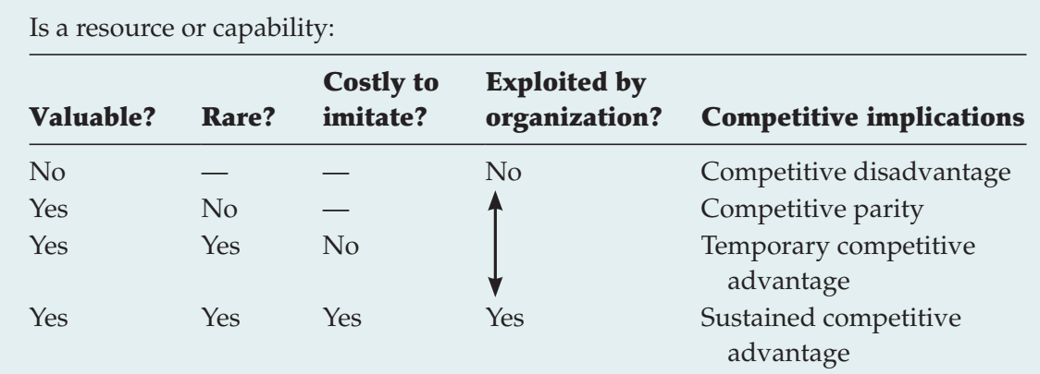
Source: Barney and Hesterly (2015)
Valuable: Firstly, the resources need to be valuable so that they can aid an organisation to implement strategies which will further enhance the organisations efficiency and effectiveness by taking advantage of the external opportunities or by mitigating external threats (Lynch, 2018). For example, the most valuable resource of BAT is its automated machine which improves the efficiency of the production process, has low maintenance cost and produces minimal waste. This valuable resource helps BAT to produce superior quality cigarette products that are highly valued by the customers (BAT, n.d.). Besides, BAT’s financial resources have increasing value as they help the company to make acquisitions and investments in the market which further aids in boosting its market shares thus giving it a competitive edge (Ariyani and Daryanto, 2018).
Rare: An organisation’s resources are considered rare only if they are possessed by fewer firms in the market. Such rare resources give competitive edge to the organisation (Business School 101, 2022). BAT’s packaging is distinctive and attractive as compared to the competitors’ packaging. However, the most salient feature about its packaging is that 92% of its packaging (case, plastic coating and tear-off strip) can be reused and recycled (BAT, 2022). This gives BAT a competitive disparity. Secondly, its R&D capabilities offer rarity as the efficient team constantly develops needed and safe products, for example, BAT was the first company in the UK to introduce the e-cigarette in 2013 (University of BATH, 2023).
Inimitability: Resources of an organisation which are costly for others to imitate or purchase are considered as inimitable resources that provide internal strength and competency to the organisation as well as competitive advantage (Barney and Hesterly, 2015). Such resources attract maximum competitors’ attention who would either directly imitate the organisation’s resources or produce a substitute (Business School 101, 2022). For example, the inimitable resource of BAT was its first e-cigarette, also called ‘electronic nicotine delivery systems or ENDS’, which entered the UK market in 2013. After a year of BAT’s e-cigarette success, competitors like Imperial Brands, Philip Morris, and Japan Tobacco International introduced their own e-cigarette brand in 2014 (University of BATH, 2023).
Organisational support: Resources competitive advantage are also based on the internal structure of the organisation. It is essential that the structure and the system of a company is well-organised in order to capture maximum value and to take complete advantage of its resources and capabilities (Business School 101, 2022). BAT has considerable financial resources and good brand reputation and recognition (BAT, 2022). As a result, it is able to enter new markets and begin new product development, identify mergers and acquisition opportunities and gain competitive advantage. In addition, its production and logistic processes are well-organised which further increases the profitability and competitiveness of BAT (BAT, 2022).
In relation to VRIO analysis, BAT’s resources and capabilities are valuable, inimitable, rare and well-organised which gives it a competitive edge and high probability of long-term superior performance.

SWOT Analysis
According to Hooley, et al. (2012), SWOT analysis refers to strengths and weaknesses of an organisation in its internal environment and possible opportunities and threats in its external environment that may impact the business and its operations. Table 1 below describes the SWOT analysis of BAT:
Strengths | Weaknesses
- Achieved well-known position and brand image in the national as well as international market  - Strong financial position which is evident from its investment in Sanity Group and Charlotte’s Web in 2022  - Increase in revenue (from £ 25,684m in 2021 to £ 27,655m in 2022)  - Long-chain of suppliers/farmers (80,000+ direct and 250,000+ 3rd-party)  - Responsible marketing practice and compliance with the government regulation in terms of conducting tobacco business  - Wide range of products to satisfy the needs and preferences of ever-changing consumers  - First company to launch e-cigarette in the UK and invests considerably in its R&D  - Increasing customer satisfaction as the brand adheres to their needs and preferences | - Constantly faces intense competition from competitors, like Imperial Brands Plc., Unilever, Tesco, Britvic, etc.  - Cannot use marketing tools to its full potential, for example cannot openly advertise brand on any audio, video or print media or digital media  - Competitors imitating the brand, for example, the company’s first e-cigarette was copied by Imperial Brands, Philip Morris, and Japan Tobacco International in 2014  - Although the company invests in R&D, there are no new innovative products introduced by the company after the e-cigarettes as it follows a mature organisation practice that introduces products on the basis of the tested products in the market
Opportunities | Threats
- BAT can expand in high smoking prevalence countries like Nauru, Kiribati, Tuvalu, West Virginia and many more  - Changing customers’ needs and trends can provide new product development or market development opportunities to BAT  - Post-Covid, increase in consumer spending (13% higher in 2022 than in February 2020) can help company to increase its revenue (ONS, 2021)  - Recent free trade agreement made possible by the UK government (Department for Business and Trade and Department for International Trade, 2022) | - Any change in the government regulations with regards to operating tobacco business  - Increasing health concern and negative health impact of tobacco  - Threat from new entrants who may emerge with new innovative products or new ways of working  - Imitation of BAT products by the competitors or new entrants  - Constant market disruption can lead to new innovative products introduced by key players or competitors in the industry  - If BAT fails to comply with any law during the course of its business, it may have to face lawsuit

Source: Created by the Author

Strategies to Sustain Competitive Advantage
Competitive advantage strategies focus on enhancing the competitive position and sustainability of an organisation in the market which it operates (Wheelen et al., 2018). An organisation can achieve a competitive edge if it is able to generate high economic value, either by reducing the price or by differentiating or innovating new products and services, in comparison to its competitors (Gamble, 2015). To aid companies in outperforming their competitors in the market, Michael Porter had suggested 3 generic strategies of competitive advantage (See Fig. 8). The term generic implies that these strategies can be adopted by any company, regardless of the size, type or form.
Figure 8: Porter’s Generic Strategy
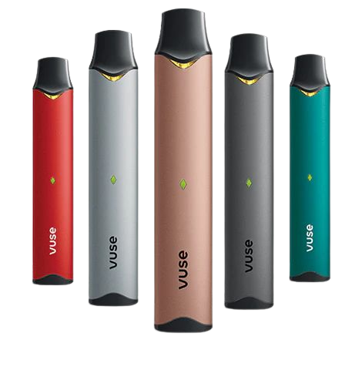
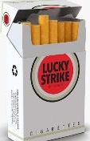

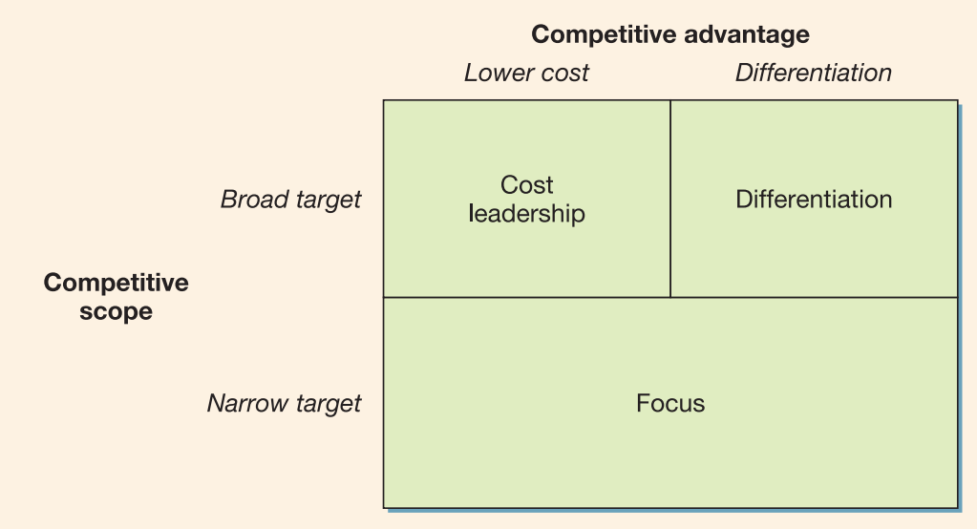
Source: Adapted from Drummond, et al., (2007)
To gain competitive advantage, BAT adopts cost leadership and differentiation strategies in the market along with keeping the focus on its adult segments. According to Drummond, et al. (2007), the strategy of an organisation to consistently offer its specific product or service at a lower cost than its competitors is termed as cost-leadership strategy. Using this strategy, BAT lowers the price of its existing cigarette brands, for example, Lucky Strike Red which is currently available at around £12.45 in the UK market (Tesco, n.d.) and this strategy of BAT helps it to give tough competition to its rival, such as Imperial Brands that currently offers its Lambert and Butler cigarettes at around £12.65 (Morrison, n.d.). However, when reducing the price, BAT needs to ensure not to compromise in terms of quality as this may further deviate the customers to the rivals (Lamb, et al., 2012). By meeting the quality standards along with low cost, BAT can increase the value of its cigarette products among its customers, which will give the company a competitive edge (Drummond, et al., 2007).
Further, BAT uses differentiation strategy for its most demanded vape products, called Vuse, that helped the company to earn 35.9% share in 2022 (BAT, n.d.). Since the introduction of the first e-cigarette by BAT in 2013 (University of BATH, 2023), until the present day, BAT’s product has been updated to meet the changing demands of the consumers. For example, BAT has incorporated advanced technology in its Vuse brand which includes Bluetooth-supported iSwitch and iSwitch Maxx technology that substitutes the old heating system consisting of coil and wick. Another technology used by the brand include Vype puretech that reduced the toxicants content by around 99%. This is the most salient feature of its device (BAT, n.d.). However, to further increase its competitiveness, BAT can use more advanced technology in its Vuse that facilitates customisation. For example, BAT can design its device in a way that allows customers to control the wattage, temperature and flavour of their vape based on their requirement. This can help to give personalised experience to the customers. Also, the device can be supported with a technology-enabled filter that offers the same mouthfeel experience of a traditional cigarette (Koperska, 2020). Such innovative features can not only help BAT to differentiate its products from its competitor and to add value to its customers.
Although the niche market of BAT is adults, using the cost leadership and differentiation strategies, the company can focus on both cost-sensitive customers as well as premium customers who can pay premium price for the company's high-tech vapes.

Growth Strategies
Growth strategies indicate the strategic choices that an organisation makes in order to boost its growth and profitability in the market (Johnson, et al., 2017). Irrespective of the size, i.e. large or small, every organisation should create their own growth strategy, depending on its products, services and goals, in order to expand its business and to increase its sustainability (West, et al., 2015). According to Whittington, et al. (2020), an organisation can either grow internally by updating its products and services or externally by increasing its presence in the other (international) markets. In accordance with this, the growth strategy of BAT with regards to its product portfolio can be best explained through Ansoff’s matrix (See Fig.9).
Figure 9: Ansoff’s Matrix
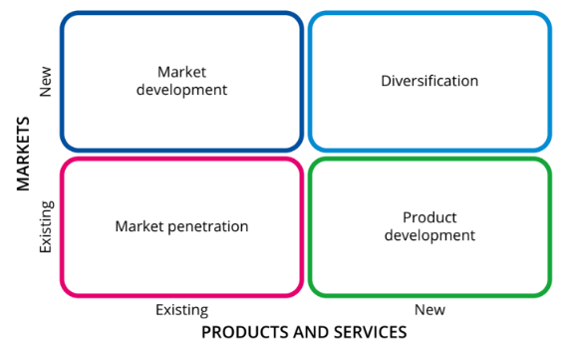
Source: MacKay (2023)
Market development: This indicates development of the existing products and services in a completely new market (Johnson, et al., 2012). MacKay (2023) explained that a new market for an organisation indicates a new geographical region or new customer group in the existing market after analysing that needs of the customers were not met. BAT can use market development strategy to enter potentially new markets with its existing product-line. Currently, BAT is operating in 180 countries across the globe (BAT, n.d.), however, the company should target highest smoking prevalence countries, such as Nauru (52.1% prevalence), Kiribati (52.0%) and Tuvalu (48.7%) in Asia and in West Virginia (23.8%) in United States (World Population Review, 2023).
Market penetration: This refers to enhancing the range of goods and services in the existing market (Johnson, et al., 2012). In other words, this strategy suggests that an organisation needs to raise either the number or the value (or both) of its products and services in order to achieve desired growth (MacKay, 2023). BAT has strong capabilities to penetrate its existing UK market with its innovative Vuse products (vape). By adding innovative and high-end technological features in the Vuse, like customisation features, Bat can enhance the vaping experience of its customers (Koperska, 2020). This strategy will BAT to attract more customers to its business thus increasing the growth of its sales, revenue and customer-base (MacKay, 2023).
Product development: This means that an organisation either modifies the existing product or develops completely new product in the current market of its operation (Johnson, et al., 2012). MacKay (2023) stated that product development offers a strategic route to the organisation for expanding its business and satisfying the customers with new product-line. Although, BAT offers a wide range of products, such as cigarettes, vapour, tobacco heating and modern oral products, it can also add other substitute products like nicotine chewing gums, nasal spray, and inhalators which are the nicotine replacement products (BAT, n.d.; NHS, n.d.). These products are highly used by the consumers to help them minimise the urge to smoke or to quit smoking (NHS, n.d.). Introducing such products in the market can help BAT to expand its product-line and overcome the threat of substitutes.
Unrelated diversification: When an organisation enters a new market with a new product or service, it is termed as product diversification. MacKay (2023) stated that diversification offers a new opportunity to the business in terms of launching a new product-line and developing a new mission. With regards to BAT, it cannot fully explore its marketing strategies, in terms of advertising and promoting its products as open advertisement of tobacco products if banned by the government (House of Commons, 2020). However, BAT can try expanding its business into a market which it can promote to the fullest, for example merchandising. The company can start its own merchandising products which will help in increasing the brand recognition. Thus by diversifying the business in a new segment, BAT can grab more customers’ attention and can further expand its growth.

Green Strategy and CSR
According to Lynch (2018), green strategies helps an organisation to contribute to the natural environment along with enhancing their business opportunities that may result due to its sustainable business practices. For a conglomerate, like BAT, green strategy helps to gain successful outcomes, for example, it helps to improve the brand image of the company in the eyes of government and consumers (Information Resources Management Association, 2019).

Green Strategy Value Chain
Green strategy value chain (See Fig. 10) is defined by Lynch (2018) as the way in which an organization reduces its carbon footprint, energy usage, water usage and adopts various recycling and reusing policies across its business operation, including the supply-chain.
Figure 10: Green Strategy Value Chain
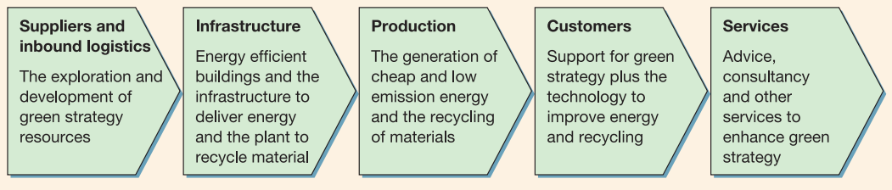
Source: Lynch (2018, p.479)
With regards to BAT, at suppliers and inbound logistics level, the company ensures that Sustainable Tobacco Programme initiatives are in place which helps to maintain standardisation in agriculture practices, aims for net zero deforestation, reduces waste during the leaf cultivation process, trains the farmers for agrochemical handling, and ensures farm monitoring (BAT, 2022).
At infrastructural and production level, the company targets to achieve net zero through its value chain by 2050 and carbon neutral across all its business activities by 2030. It also aims to speed its current environment target to 2025. Further the company produces cigarette packaging that can easily be reused and recycled. During the production process, BAT ensures that there is less energy and waste usage and wastage (BAT, n.d.).
At the customer level, the green strategy of BAT ensures to understand and satisfy the emerging needs of the customers, offer them pleasure through their products, minimise any kind of health risk and provide a wide range of product options.
It is essential for BAT to set realistic green policies as it can bring cost benefits as well as stakeholders’ benefit (Lynch, 2018).

Corporate Social Responsibilities (CSR) of BAT
CSR of an organisation illustrates its ethical commitment as well as commitment towards the development of the business while enhancing the life of staff, local community, society and whole as a whole (Goedeke and Fogliasso, 2020).
The CSR of BAT includes
- Conduct business lawfully and adhere to all government regulation concerning no public advertisement of tobacco and no targeting youth and teenagers
- Focusing on understanding the needs and preferences of its consumers present in the market of their operation
- Offering a range of products to the customers as per their preferences
- Ensure that the rights and freedom of consumers, with regards to smoking choice, are respected
- Work with the government to inform adult consumers about the products of the brand
- Minimise the negative impact of BAT’s business on consumers’ health by conducting the business responsibly
- Conduct responsible marketing practice and maintain transparency in all communication with the consumers
Source: BAT (n.d.)

Conclusion
Overall, BAT is a leading and well-recognised company in the tobacco industry. However, the company faces many challenges, with regards to strict government regulations and changing customers’ preferences, and declining tobacco market. Nevertheless, BAT is able to sustain and survive in the challenging market situation due to its strong internal resources and capabilities. Its physical, financial and human resources and capabilities provide sustainability whereas its valuable, rare, inimitable and organised distinctive resources offer it a competitive advantage. Further, the company can gain competitive edge using cost leadership strategy with its cigarette product-line and differentiation strategy with its vape products. Moreover, market development in new unidentified markets, enhancing market penetration by updating its vape products, developing new substitute products, and diversifying business through merchandising can offer increasing growth opportunities to BAT. However, along with growth and competitive strategies, BAT also needs to practice and realise green strategies and fulfil its CSR to contribute to the development of business, workforce, society and environment.

Recommendation
- BAT needs to ensure that it always compliance with the government regulations and conducts its business responsibly
- It can use cost leadership strategy with one of its cigarette brands, like Lucky Strike Red to attract more customers and to offer competition to others in the market
- The company can use differentiation strategy and enhance its vape product by using latest technology in the devices
- BAT should try to innovate and launch new product-line according to the needs and preferences of the consumers
- It can start its own merchandising business to attract more customers to the business and to increase brand visibility and recognition

References
Aaker, D.A. and Moorman, C. (2017) Strategic market management. 11th edition. New Jersey: John Wiley & Sons.
Ariyani, W. and Daryanto, A. (2018) ‘Operationalization of Internal Analysis Using the VRIO Framework: Development of Scale for Resource and Capabilities Organization (Case Study: XYZ Company Animal Feed Business Unit)’, Asian Business Research Journal, 3, pp.9-14.
Ash (2021) Tobacco and the Environment. Available at: https://ash.org.uk/uploads/Tobacco-Environment.pdf?v=1650647225 [Accessed: 26 March 2023].
Ash (2022) Use of e-cigarettes (vapes) among young people in Great Britain. Available at: https://ash.org.uk/uploads/Use-of-e-cigarettes-among-young-people-in-Great-Britain-2022.pdf [Accessed: 27 March 2023].
Bailey, C., Mankin, D., Kelliher, C. & Garavan, T. (2018) Strategic Human Resource Management. 2 ed. Oxford: Oxford University Press, pp.351.
Barney, J. B. & Hesterly, W. S. (2015) Strategic Management and Competitive Advantage: Concepts and Cases. 5th edition. Essex: Pearson Education Limited.
Barney, J.B. and Hesterly, W.S. (2018) Strategic management and competitive advantage: Concepts and Cases. 6 ed. New Jersey: Prentice hall, pp.27.
BAT (2011) Employment Principles. Available at: https://www.bat.com/group/sites/uk__9d9kcy.nsf/vwPagesWebLive/DO9EAMHQ/$FILE/medMD9G7LVW.pdf?openelement [Accessed: 31 March 2023].
BAT (2022) Sustainability. Available at: https://www.bat.com/group/sites/uk__9d9kcy.nsf/vwPagesWebLive/DOC88FUS/$FILE/medMDCFMPND.pdf?openelement [Accessed: 7 April 2023].
BAT (2022) The pivotal role of suppliers in our transformation. Available at: https://www.bat.com/group/sites/UK__9D9KCY.nsf/vwPagesWebLive/DOCH4G8E [Accessed: 31 March 2023].
BAT (2023) Building A Better Tomorrow™. Available at: https://www.bat.com/group/sites/UK__9D9KCY.nsf/vwPagesWebLive/DOC56HHG#:~:text=Our%20mission%20is%20to%20anticipate,senses%20of%20adult%20consumers%20worldwide. [Accessed: 21 March 2023].
BAT (2023) Life at BAT. Available at: https://www.bat.com/group/sites/UK__9D9KCY.nsf/vwPagesWebLive/DOBDRS72 [Accessed: 21 March 2023].
BAT (2023) Our history – a timeline. Available at: https://www.bat.com/history [Accessed: 21 March 2023].
BAT (2023) Our purpose and strategy. Available at: https://www.bat.com/group/sites/UK__9D9KCY.nsf/vwPagesWebLive/DO9DEM4L [Accessed: 21 March 2023].
BAT (2023) Working with retailers. Available at: https://www.bat.com/distribution [Accessed: 21 March 2023].
BAT (n.d.) A Better Tomorrow™ For Our People. Available at: https://www.bat.com/ar/2022/employees.html#:~:text=We%20employ%2050%2C000%2B%20people%20worldwide,and%20purposeful%20place%20to%20work. [Accessed: 31 March 2023].
BAT (n.d.) A sustainable approach. Available at: https://www.bat.com/group/sites/UK__9D9KCY.nsf/vwPagesWebLive/DO9DCFJG [Accessed: 7 April 2023].
BAT (n.d.) BAT launches first CBD vaping product. Available at: https://www.bat.com/group/sites/UK__9D9KCY.nsf/vwPagesWebLive/DOBX3MN [Accessed: 12 April 2023].
BAT (n.d.) Business Principles and Framework for CSR. Available at: https://www.bat.com/oneweb/framework.nsf/F/MB1?opendocument [Accessed: 5 April 2023].
BAT (n.d.) Career development. Available at: https://www.bat.com/group/sites/UK__9D9KCY.nsf/vwPagesWebLive/DO9DKH5M#:~:text=Our%20flagship%20learning%20programme%2C%20Made,brands%20in%20the%20digital%20era. [Accessed: 5 April 2023].
BAT (n.d.) Environment and climate. Available at: https://www.bat.com/environment [Accessed: 27 March 2023].
BAT (n.d.) Global directory. Available at: https://www.bat.com/group/sites/uk__9d9kcy.nsf/vwPagesWebLive/DO9FEJ8K [Accessed: 5 April 2023].
BAT (n.d.) Manufacturing. Available at: https://www.bat.com/production [Accessed: 31 March 2023].
BAT (n.d.) Marketing our products responsibly. Available at: https://www.bat.com/imp [Accessed: 31 March 2023].
BAT (n.d.) Modern oral products. Available at: https://www.bat.com/snus [Accessed: 10 April 2023].
BAT (n.d.) News Release. Available at: https://www.bat.com/group/sites/UK__9D9KCY.nsf/vwPagesWebLive/DOB7CJSR [Accessed: 25 April 2023].
BAT (n.d.) Our portfolio. Available at: https://www.bat.com/brands [Accessed: 4 April 2023].
BAT (n.d.) Our products. Available at: https://www.bat.com/products [Accessed: 31 March 2023].
BAT (n.d.) Our transformation journey. Available at: https://www.bat.com/group/sites/UK__9D9KCY.nsf/vwPagesWebLive/DOC56HHG#:~:text=Strong%20foundations%20for%20our%20evolved%20strategy&text=As%20part%20of%20our%20growth,products%20(up%204.2%20million). [Accessed: 31 March 2023].
BAT (n.d.) Responsible marketing. Available at: https://www.batcaribbean.com/group/sites/BAT_AYVB8L.nsf/vwPagesWebLive/DOA5UMKX [Accessed: 5 April 2023].
BAT (n.d.) Supply chain management. Available at: https://www.bat.com/group/sites/UK__9D9KCY.nsf/vwPagesWebLive/DOC88FUS#:~:text=Beyond%20the%20tobacco%20supply%20chain&text=In%202022%2C%20we%20had%201%2C500,regional%20and%20local%20Procurement%20teams. [Accessed: 29 March 2023].
BAT (n.d.) Tobacco. Available at: https://www.bat.com/group/sites/UK__9D9KCY.nsf/vwPagesWebLive/DO6HHJ9F# [Accessed: 31 March 2023].
BAT (n.d.) Vapour products. Available at: https://www.bat.com/ecigarettes [Accessed: 5 April 2023].
BAT (n.d.) Waste and circular economy. Available at: https://www.bat.com/group/sites/UK__9D9KCY.nsf/vwPagesWebLive/DOC88F9E [Accessed: 3 April 2023].
BAT (n.d.) Waste and circular economy. Available at: https://www.bat.com/distribution [Accessed: 5 April 2023].
BAT (n.d.) We are BAT. Available at: https://www.bat.com/wearebat/ [Accessed: 5 April 2023].
BAT p.l.c. (2022) Annual Report on Form 20-F 2022. Available at: https://www.bat.com/group/sites/UK__9D9KCY.nsf/vwPagesWebLive/DOAWWGJT/$file/BAT_Annual_Report_on_Form_20-F_2022.pdf [Accessed: 31 March 2023].
Benowitz, N.L. (2008) ‘Neurobiology of nicotine addiction: implications for smoking cessation treatment’, The American Journal of Medicine, 121(4), pp.S3-S10.
Bilgin, Y. (2018) ‘The effect of social media marketing activities on brand awareness, brand image and brand loyalty’, Business & Management Studies: An International Journal, 6(1), pp.128-148.
Business School 101 (2022) Internal Analysis: The VRIO Framework | Strategic Management | From A Business Professor. Available at: https://www.youtube.com/watch?v=afrPC91zCkQ [Accessed: 4 April 2023].
Chandler Jr, A.D. (1963) Strategy and structure: Chapters in the history of the American industrial enterprise. 1 ed. Massachusetts: MIT Press, pp.13.
Chartered Global Management Accountant (2013) Porter’s Five Forces. Available at: https://www.cgma.org/resources/tools/essential-tools/porters-five-forces.html [Accessed: 29 March 2023].
Chartered Global Management Accountant (2013) Porter’s Five Forces of Competitive Position Analysis. Available at: https://www.aicpa-cima.com/resources/article/porters-five-forces-of-competitive-position-analysis [Accessed: 29 March 2023].
CIPD (2021) PESTLE analysis. Available at: https://www.cipd.co.uk/knowledge/strategy/organisational-development/pestle-analysis-factsheet#gref [Accessed: 26 March 2023].
Department for Business and Trade and Department for International Trade (2022) The UK’s trade agreements. Available at: https://www.gov.uk/government/collections/the-uks-trade-agreements [Accessed: 10 April 2023].
Department of Health and Social Care (2021) Rules about tobacco, e-cigarettes and smoking. Available at: https://www.gov.uk/government/publications/new-rules-about-tobacco-e-cigarettes-and-smoking-1-october-2015/new-rules-about-tobacco-e-cigarettes-and-smoking-1-october-2015 [Accessed: 26 March 2023].
Department of Health and Social Care (2021) Smoking and tobacco use. Available at: https://www.gov.uk/government/publications/delivering-better-oral-health-an-evidence-based-toolkit-for-prevention/chapter-11-smoking-and-tobacco-use [Accessed: 26 March 2023].
Ensign, 2001) Available at: [Accessed: 5 April 2023].
Ensign, P.C. (2001) ‘Value chain analysis and competitive advantage’, Journal of General Management, 27(1), pp.18-42.
Gamble, J., Thompson, A. and Peteraf, M. (2014) Essentials of Strategic Management. 4 ed. New York: McGraw Hill Education.
Gartner, C.E., Hall, W.D., Chapman, S. and Freeman, B. (2007) ‘Should the health community promote smokeless tobacco (snus) as a harm reduction measure?’ PLoS Medicine, 4(7), pp.e185.
Gelder, K. V. (2022) ‘Sales of the leading e-cigarette brands in convenience and independent grocery stores in the UK in 2022’, Statista. Available at: https://www.statista.com/statistics/1190770/leading-e-cigarette-brands-in-c-store-and-independent-grocers-uk/ [Accessed: 29 March 2023].
Ghosh, D. and Shah, J. (2015) ‘Supply chain analysis under green sensitive consumer demand and cost sharing contract’, International Journal of Production Economics, 164, pp.319-329.
GlobalData (2023) British American Tobacco Plc Strategy Report. Available at: https://www.globaldata.com/company-profile/british-american-tobacco-plc/#:~:text=British%20American%20Tobacco%20plc%20(BAT,%2C%20moist%20snuff%2C%20and%20vapor. [Accessed: 21 March 2023].
Goedeke, M. and Fogliasso, C. (2020) ‘Is CSR Becoming a Corporate Requirement?’, Journal of Managerial Issues, 32(2), pp.162-175.
Gollust, S., Schroeder, S. and Warner, K. (2009) ‘Helping smokers quit: Understanding the barriers to utilisation of smoking cessation services’, The Milbank Quarterly, 86(4), pp. 601-627.
HM Revenue and Customs (2023) Changes to tobacco duty rates from 15 March 2023. Available at: https://www.gov.uk/government/publications/tobacco-duty-changes-to-rates/changes-to-tobacco-duty-rates-from-15-march-2023 [Accessed: 28 March 2023].
Hooley, G.J., Piercy, N. and Nicoulaud, B. (2008) Marketing strategy and competitive positioning. 4th edition. Essex: Pearson Education.
House of Commons (2020) The Tobacco Advertising and Promotion Bill. Available at: https://researchbriefings.files.parliament.uk/documents/RP02-20/RP02-20.pdf [Accessed: 26 March 2023].
IBIS World report (2021) Global Cigarette & Tobacco Manufacturing Industry - Market Research Report. Available at: https://www.ibisworld.com/global/market-research-reports/global-cigarette-tobacco-manufacturing-industry/ [Accessed: 28 March 2023].
Imperial Brands (n.d.) Brands of choice. Available at: https://www.imperialbrandsplc.com/brands-of-choice/ngp [Accessed: 15 April 2023].
Imperial Brands (n.d.) Cigarettes. Available at: https://www.imperialbrandsplc.com/brands-of-choice [Accessed: 15 April 2023].
Information Resource Management Association (2019) Green Business Concepts, Methodologies, Tools, and Applications. Hershey: IGI Global.
Jackson, S.E., Shahab, L., Kock, L., West, R. and Brown, J. (2019) ‘Expenditure on smoking and alternative nicotine delivery products: a population survey in England’, Addiction, 114(11), pp.2026-2036.
Johnson, G., Whittington, R. and Scholes, K. (2011) Exploring strategy, text and cases. 2 ed. Harlow: Pearson Education Limited.
Johnson, G., Whittington, R., Regnér, P., Angwin, D. and Scholes, K. (2017) Exploring strategy, text and cases. 11 ed. Harlow: Pearson Education Limited, pp.5.
Koperska, A. (2020) ‘How has innovation evolved vaping technology? What does the future look like?’, Vape.Co.UK. Available at: https://vape.co.uk/2020/12/07/how-has-innovation-evolved-vaping-technology-what-does-the-future-look-like [Accessed: 18 April 2023].
Lamb, C. W., Hair, J. F. and McDaniel, C. (2013) Marketing. 12 ed. Mason: Cengage Learning.
Lynch, R. (2018) Strategic Management. 8th edition. Harlow: Pearson Education Limited.
MacKay, B. (2023) Strategy Theory, Practice, Implementation. 2 ed. Oxford: Oxford University Press.
Market Beat (n.d.) British American Tobacco (BATS) Competitors. Available at: https://www.marketbeat.com/stocks/LON/BATS/competitors-and-alternatives/#:~:text=The%20main%20competitors%20of%20British,Dairy%20Crest%20Group%20(DCG). [Accessed: 29 March 2023].
Maylin -Aguilar, C. and Montoro- Sanchez, A. (2021) ‘The Industry Life Cycle in an Economic Downturn: Lessons from Firm’s Behavior in Spain, 2007–2012’, Journal of Business Cycle Research, 17, pp.185-214.
Morrisons (n.d.) Lambert and Butler original silver cigarette. Available at: https://groceries.morrisons.com/products/lambert-butler-original-silver-cigarettes-364039011#:~:text=%C2%A312.65&text=You'll%20be%20asked%20to,are%20over%2018%20on%20delivery. [Accessed: 20 April 2023].
National Institute on Drug Abuse (n.d.) What are vaping devices? Available at: https://nida.nih.gov/publications/drugfacts/vaping-devices-electronic-cigarettes [Accessed: 27 March 2023].
NHS (n.d.) Stop smoking treatments. Available at: https://www.nhs.uk/conditions/stop-smoking-treatments/ [Accessed: 29 March 2023].
Office for Health Improvement and Disparities (2021) Tobacco and smoking: policy, regulation and guidance. Available at: https://www.gov.uk/government/collections/tobacco-and-smoking-policy-regulation-and-guidance [Accessed: 28 March 2023].
ONS (2021) How our spending has changed since the end of coronavirus (COVID-19) restrictions. Available at: https://www.ons.gov.uk/businessindustryandtrade/retailindustry/articles/howourspendinghaschangedsincetheendofcoronaviruscovid19restrictions/2022-07-11#:~:text=This%20means%20that%2C%20while%20overall,were%20only%20up%20by%202.6%25. [Accessed: 10 April 2023].
ONS (2022) Adult smoking habits in the UK. Available at: https://www.ons.gov.uk/peoplepopulationandcommunity/healthandsocialcare/healthandlifeexpectancies/bulletins/adultsmokinghabitsingreatbritain/2021 [Accessed: 28 March 2023].
Porter, M.E. (2008) ‘The five competitive forces that shape strategy’, Harvard Business Review, 86(1), pp.1-143.
PWC (n.d.) Why resilience matters to the UK public? Available at: https://www.pwc.co.uk/services/risk/rethink-risk/insights/how-the-cost-of-living-crisis-is-changing-people-s-behaviours-an.html [Accessed: 26 March 2023].
SciTech Patent Art Services Ltd. (n.d.) Advancements in Vaping. Available at: https://www.patent-art.com/knowledge-center/advancements-in-vaping/ [Accessed: 27 March 2023].
Stobierski, T. (2020) What is Value Chain Analysis? Available at: https://online.hbs.edu/blog/post/what-is-value-chain-analysis#:~:text=Value%20chain%20analysis%20is%20a,your%20final%20product%20or%20service. [Accessed: 5 April 2023].
Tesco (n.d.) Lucky Strike Red King Size 20 Pack. Available at: https://www.tesco.com/groceries/en-GB/products/250710969 [Accessed: 20 April 2023].
UK Parliament (2023) Prohibition of tobacco displays in shops. Available at: https://commonslibrary.parliament.uk/research-briefings/sn05537/ [Accessed: 26 March 2023].
UK Parliament (2023) Rising cost of living in the UK. Available at: https://commonslibrary.parliament.uk/research-briefings/cbp-9428/#:~:text=The%20cost%20of%20living%20increased,2023%20to%2010.4%25%20in%20February. [Accessed: 27 March 2023].
University of BATH (2023) E-cigarettes. Available at: https://tobaccotactics.org/article/e-cigarettes/ [Accessed: 5 April 2023].
University of BATH (2023) E-cigarettes: British American Tobacco. Available at: https://tobaccotactics.org/article/e-cigarettes-british-american-tobacco/ [Accessed: 5 April 2023].
Whittington, R., Regner, P., Angwin, D., Johnson, G. and Scholes, K. (2020) Exploring strategy. 12 ed. Harlow: Pearson Education Limited.
World Population Review (2023) Smoking Rates by Country 2023. Available at: https://worldpopulationreview.com/country-rankings/smoking-rates-by-country [Accessed: 15 April 2023].
Xu, J. (2005) Market research handbook: Measurement, approach and practice. Nebraska: iUniverse.

