Impact of Virtual Learning Environment (VLE) on Student’s learning experience
Student’s Id-1920393
Student’s Name-Ana Caltea
Teacher Name-Olusoyi Ashaye
University Name: University of Wales Trinity Saint David

Table of Contents
Introduction 3
Impact of Virtual Learning Environment (VLE) on student’s learning experience 3
Methodology 6
Discussion 6
Conclusion 6
Reference 7

Introduction
The purpose of the research report is to discuss about the impact of Virtual learning Environment (VLE) on the learning experience of the students in University of Wales Trinity Saint David, London campus. VLE is referred as a web based educational technology that provides resources as well as interacts with the students through online platform. It involves content management where creation, storage and use of learning resources are done, online tutors plans the curriculum and give personalized learning experience to the students. Likewise, the research report shall report shall also gather certain primary data with the help of questionnaire and survey the students of the mentioned educational institute to trace their learning experience involving VLE. Furthermore, the report shall gather relevant secondary literature from secondary data from appropriate sources as well as from the websites of the educational institutes to trace the impact of VLE on the performance of the students and how the platform is influencing final grades of the students. It shall discuss in-depth regarding different approaches of VLC and its effective in the teaching learning process.

Impact of Virtual Learning Environment (VLE) on student’s learning experience
In the current era, people have started to depend more on the social sites and online platforms and the dependency of students of young generation on the social sites has been witnessed more as compared to the elder generation. With the advancement in the technology, researcher has blended the online platform to provide education to the students in the form of Virtual Learning Environment (VLE). The platform is quite flexible as students can learn from anywhere that is from outside the campus (Chen, 2020). During the pandemic situation that occurred due to the spread of corona virus, the VLE has helped thousands of students to continue their learning processes. Within the framework of online learning environment, students gets to review their desired lecture notes, assignments, exercise notes, questionnaires, quizzes and various other learning materials as well as are able to prepare themselves for appearing in the tests or examination.
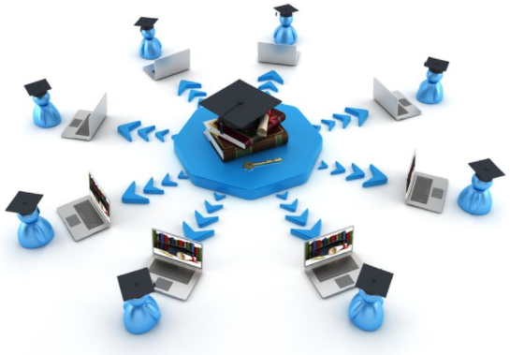
Figure: A design to show the setup of Virtual Learning Environment
Since the last few eras, several educators have been found to utilize a blended approach including both conventional classroom approaches along with Virtual Learning Environment (VLE). However researchers has found out that in online discussions, teachers divide the students in groups and develop an opinion forum where students are allow to reflect constructive and positive feedbacks wherein, tutors enhances the knowledge of the students through lectures (Melissa, 2020). Thus, it becomes possible to deal with small group of students in the online platform; more attention could be given to individual students. Likewise, in a recent study it has been revealed that around 54% of the educators in the UK prefer VLE (Pererva et al., 2020)
In the virtual learning environment it also becomes possible to determine the skills of communication in the online platform that is how the students are expressing themselves, their fluency, and their capability of understanding the given commands and messages, power of concentration, their level of making enquiries. As in the present era, various official works occurs through online platforms, from meetings with the clients to communication a particular message with the groups, from online marketing to online selling, employees need to develop the technical communicative skills and t become familiar in the online commands wherein, the skills of online communication sharpens the students for their future professional life (Hallberg et al., 2020).
VLE is utilized by the teachers where they upload the notes or learning materials and they are stored online. The platform also allows the teachers to organize online test where the students shall participate and teachers gets the chance to monitor them thoroughly. Every step occurs in a transparent way. Often students gets involved in part time works or might get ill, in those cases the stored materials become extremely effective for the learners. The flexible learning systems are quite appreciable by the students. It allows the teacher to monitor every aspect of student’s activities which are often not possible in the conventional class based approaches. Teachers track the activities, interrupts them whenever needed that results in better cooperation and better understanding skills in the students (Moiz, 2020).
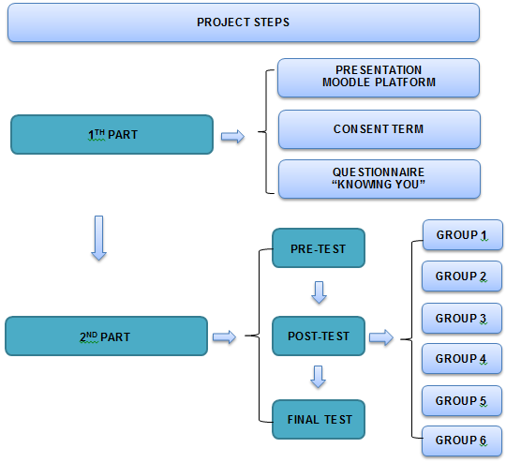
Figure: Showing the process of examination in VLE
The teacher gets to review the task after logging into the VLE and performs assignment reviews, course reviews, forum review, assignment review, discussion review and also could review the date and time of such uploads (Ouherrou et al., 2019). In VLE, the teachers activity influence the activity of the students, when teachers engage themselves complete in the online environment, interact, motivate and engage the students completely then the students learning experience gets influenced as well as improved. In a study conducted including 15 educational institutes in the UK, 70% of the teachers had revealed that VLE offer them with better understand of the student’s activities and it helps them to understand what the learners prefer (Boroni, 2019). According to the preference, tutors are able to design more appropriate activities and teaching learning materials. The system is transforming education and making it exciting for the learners.
There are various approaches that are utilized to measure the quality and effectiveness of VLE. Several individual tries to analyze the quality of learning material and some tries to analyze the communication skills that occur in the e-learning process. Critical analysis of a relevant article has revealed that learners have their own perspectives over VLE, in that study majority of the students (74%) revealed that VLE assist to improve their learning process (Bdiwi et al., 2019).
VLE requires adaptability, accessibility and clarity in different categories such as in cognitive information and effective management. The affective category includes an environment where the students are supported by social strategies along with a teaching aspect. The cognitive management involves accessibility dimension that increase the access to online instructions and courses and features in online instruction. Information management is related with updating the students and is generally flexible and student friendly (Hassan et al., 2019).
Educational institutes have revealed that they engage VLE and it impacts the students’ performance positively, Students those who have low online engagement get lower grades. In a recent study, the relation between the student’s studying habits, access behavior and overall performance were analyzes wherein, it was found that students had to view the lecture along with additional notes, solve sample quiz, perform practice sets and so on in VLE platform (Waheed, 2002). It prepares them instantly for the tests and also to develop the project works.
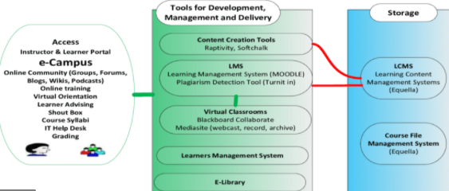
Figure: Showing the process of teaching-learning in VLE
In VLE the success factors have been identified as the motivation and opportunities to collaborate, including several methods of delivery and user oriented technology. Students get to acquire all such skills that shall help them in their professional life too. Another important feature of VLE is the incorporation of the time dependent media, availability of self-check test and maximizing the syllabus within 14-15 pages, that results in efficient learning and improved productivity. Elements of VLE offer several opportunities for student-centered learning approaches that influence the final grades (Chen, 2020). Critical analysis has revealed that VLE if designed accurately then might include several active styles of teaching and studying. Students who learn in offline platforms have been found to become more dependent wherein, in the online platform learning process becomes more and more independent. They get the scope to explore various learning styles.
VLE manages the educational record and have software that distributes the courses through internet. Stored data offers the students for data mining and to examine them. In the field of e-learning, data mining helps to visualize, explore and analyze the data whenever required and useful patterns could be identified. There is a system called “Bayesian network” that models different perspectives of a user’s behavior, and it becomes possible to identify the learning style or behavior of the student. It is a probabilistic graphical model that represents several students’ behavior and determines their learning styles. On understanding the learning style, it becomes easier for the tutor to design the teaching-learning material accurately. There are hardly few universities across the world that does not use VLE to support their students in the teaching learning procedures. Interestingly, research has traced that students engaged in VLE platforms are more likely to achieve better grades. In a articles, including 25 educational institutes that tried to trace the influence of VLE on the grades. They identified that the institutes attached with VLE have reflected 16% better grades as compared to those institutes those who does not involve VLE (Baroni et al., 2019).

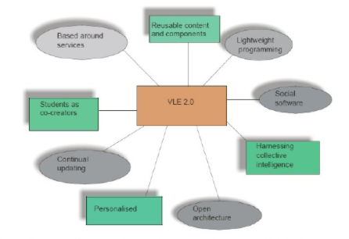
Figure: Showing the features of VLE

Methodology
The research report has been conducted depending on mixed method where both secondary and primary methods have been involved. Secondary data including relevant academic publications, websites of educational institutes has been searched to trace the engagement of VLE with the institutes. Perspectives of various authors and researches have been traced to understand the impact of VLE on student’s learning experience as well as to acquire more reliable outcomes. To gather primary information, questionnaire has been utilized to survey the experience of the students of the university and to reach a reliable outcome.
Questionnaire
- Are you more comfortable in the traditional classroom-based learning process or in VLE system?
- Do you use VLE in campus or outside the campus?
- Online or offline mode is more familiar to your peer groups?
- Does VLE effete your grades; If yes them positively or negatively?
- Do you see more dominance of VLE in the future of education?

Discussion
The research report has traced from the survey that majority of the students gets are comfortable in VLE due to its flexible style. Moreover, they use VLE from the campus also expressing their attachment with the platform as compared to the traditional method. The students have revealed that more than half of their peer groups prefers VLE. It has proven to affect their grades too positively and they think that the platform shall become more dominant in the future due to its student-centric approach.
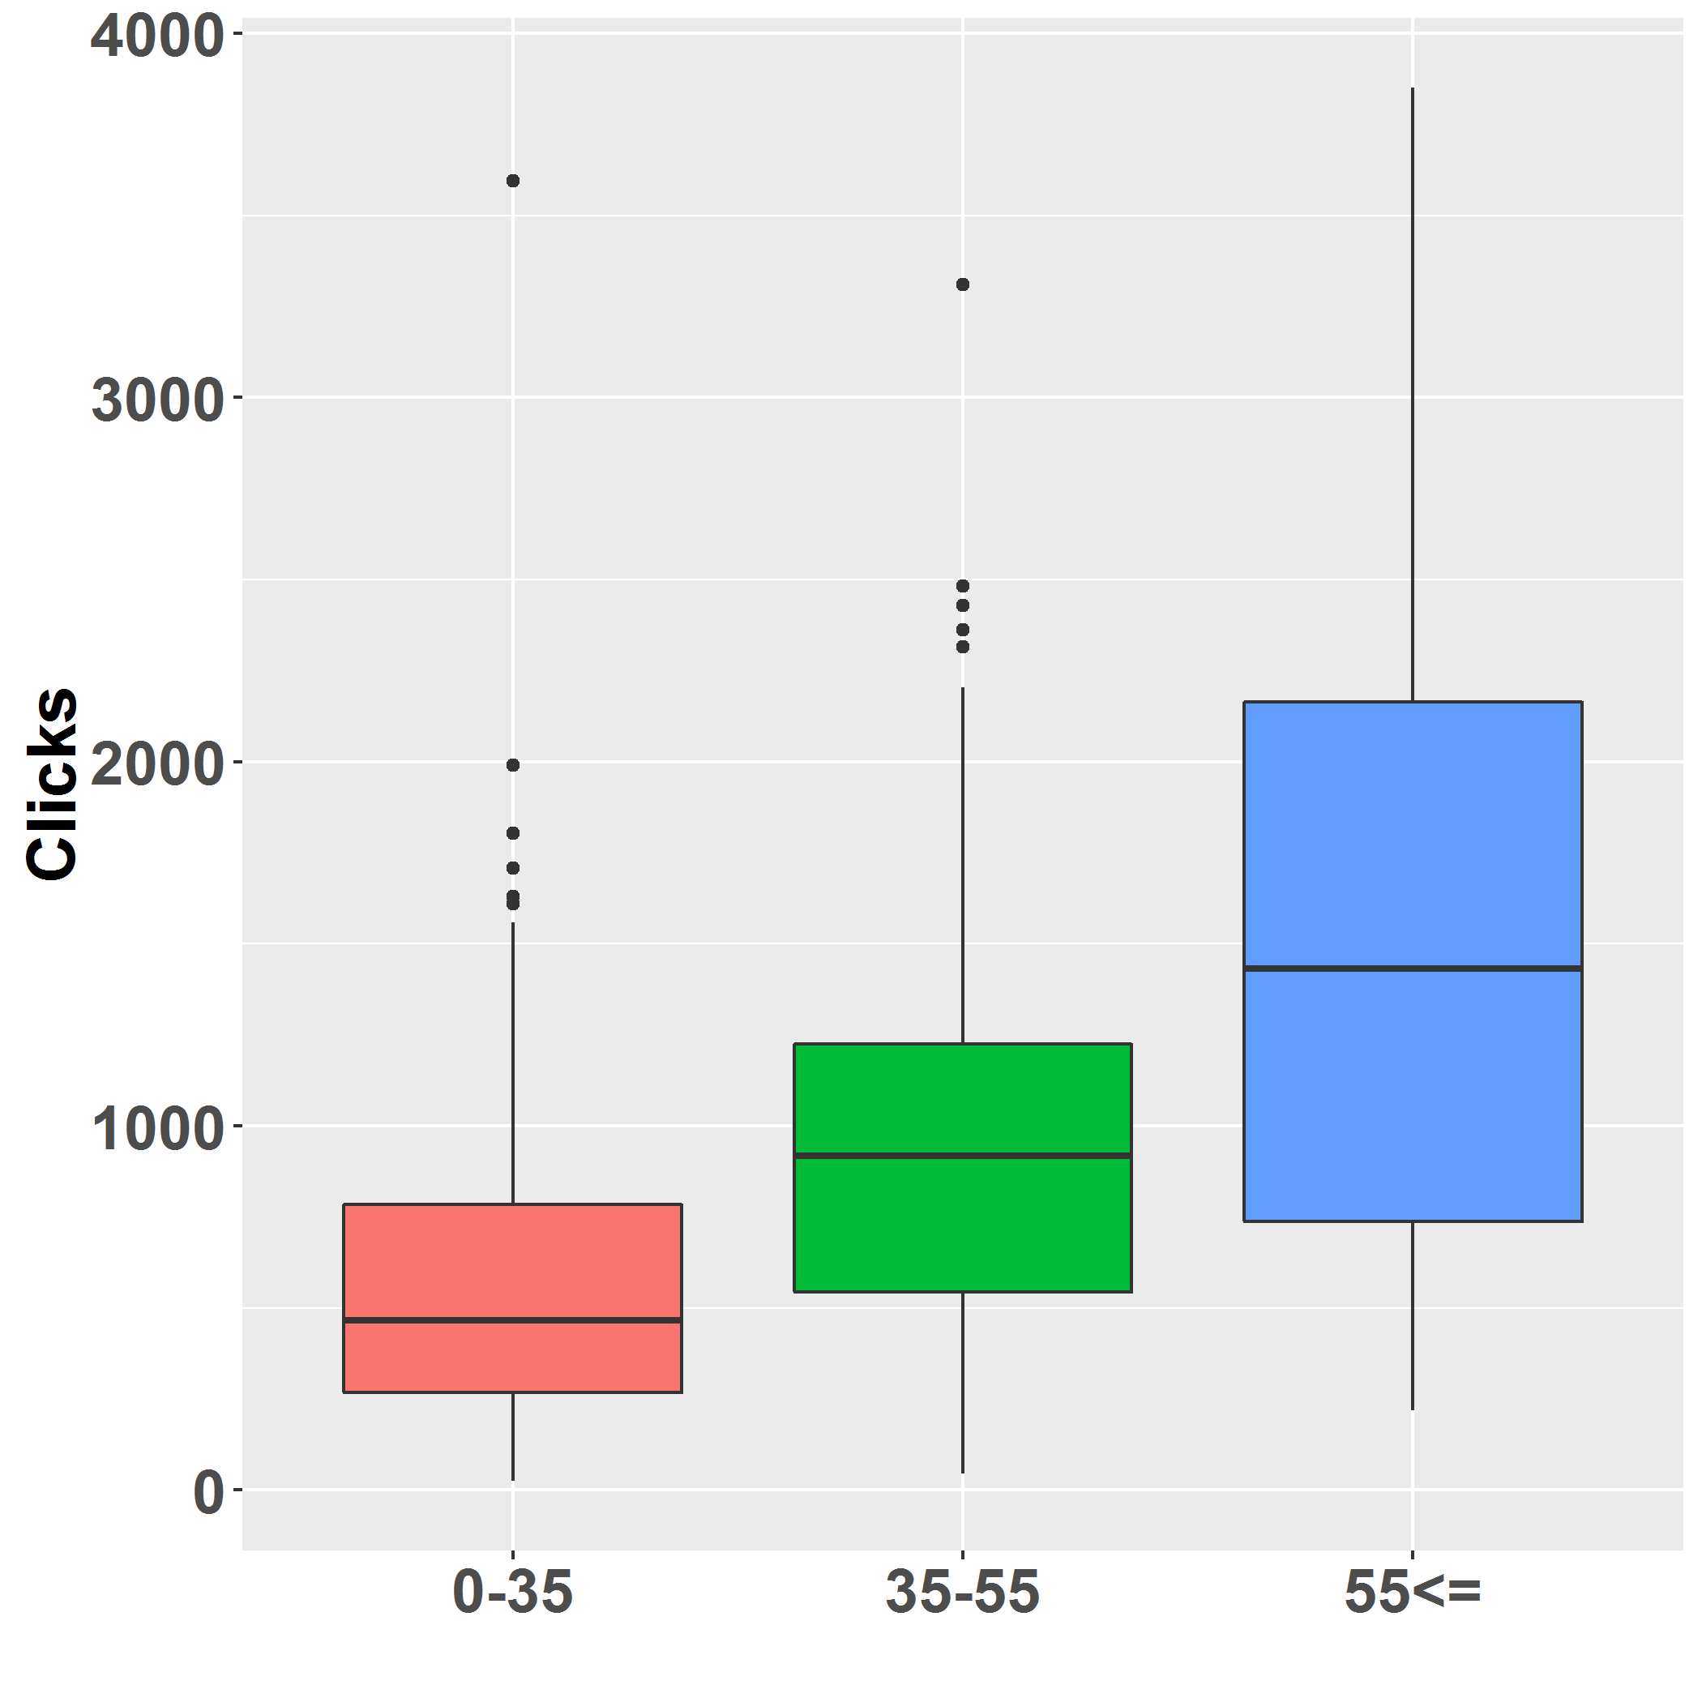

Figure: Showing the increase in grades with increase in clicks in the online platform

Secondary data has helped to understand that as VLE helps the tutors to interact more closely with the students and they get to know the learning behavior of the students and get the opportunity to design the learning material and activities according to the student’s preference, it increases student’s motivation and zeal to learn (Moiz, 2020). Accurate review of the assignments that are done by students and giving feedbacks and discussion sessions has been proved to help the students and it increases students experience and influence their grades positively.

Conclusion
Thus in a nutshell it shall be revealed that virtual learning environment is a technical web based online education platform that has gained sufficient popularity in the last few years. Due to increased engagement of the present day’s students with the online platform, VLE has become more familiar to the students. The flexible of the system and various teaching styles attracts the students. From the survey as well as from the secondary data it has become confirmed that majority of the students prefers VLE due to its student-friendly approach. The stored resources, personalized attention of the tutors according the learning behavior of the students has helped the learners to increase their grades and to gain knowledge outside the campus. The online interactive platform has also helped the students to expand their technical communication skills. Likewise, this system of teaching-learning process has proved to help the students in gaining better grades as it helps the students and to experience better learning experience as compared to traditional classroom based approach. Moreover, researchers shall find our various other teaching styles and student-friendly software in the future to further improve the teaching –learning experience.

Reference
Al-Azawei, A. and Al-Masoudy, M., 2020. Predicting Learners' Performance in Virtual Learning Environment (VLE) based on Demographic, Behavioral and Engagement Antecedents. International Journal of Emerging Technologies in Learning (iJET), 15(9), pp.60-75.
Baroni, A., Dooly, M., García, P.G., Guth, S., Hauck, M., Helm, F., Lewis, T., Mueller-Hartmann, A., O’Dowd, R., Rienties, B. and Rogaten, J., 2019. Evaluating the impact of virtual exchange on initial teacher education: a European policy experiment. Research-publishing. net.
Bdiwi, R., de Runz, C., Faiz, S. and Cherif, A.A., 2019. Smart Learning Environment: Teacher's Role in Assessing Classroom Attention. Research in Learning Technology, 27.
Bogusevschi, D., Muntean, C. and Muntean, G.M., 2020. Teaching and Learning Physics using 3D Virtual Learning Environment: A Case Study of Combined Virtual Reality and Virtual Laboratory in Secondary School. Journal of Computers in Mathematics and Science Teaching, 39(1), pp.5-18.
Bogusevschi, D., Muntean, C. and Muntean, G.M., 2020. Teaching and Learning Physics using 3D Virtual Learning Environment: A Case Study of Combined Virtual Reality and Virtual Laboratory in Secondary School. Journal of Computers in Mathematics and Science Teaching, 39(1), pp.5-18.
Chen, J.C.W., 2020. AI in Music Education: The Impact of Using Artificial Intelligence (AI) Application to Practise Scales and Arpeggios in a Virtual Learning Environment. In Learning Environment and Design (pp. 307-322). Springer, Singapore.
Hallberg, S., Hirsto, L. and Kaasinen, J., 2020. Experiences and outcomes of craft skill learning with a 360° virtual learning environment and a head-mounted display. Heliyon, 6(8), p.e04705.
Hassan, S.U., Waheed, H., Aljohani, N.R., Ali, M., Ventura, S. and Herrera, F., 2019. Virtual learning environment to predict withdrawal by leveraging deep learning. International Journal of Intelligent Systems, 34(8), pp.1935-1952.
Henritius, E., Löfström, E. and Hannula, M.S., 2019. University students’ emotions in virtual learning: A review of empirical research in the 21st century. British Journal of Educational Technology, 50(1), pp.80-100.
Melissa Ng Lee Yen, A., 2020. The influence of self-regulation processes on metacognition in a virtual learning environment. Educational Studies, 46(1), pp.1-17.
Moiz, S.A., 2020. Impact of Human Interaction in Agile-Oriented Content Delivery in Learning Environments. In Handbook of Research on the Role of Human Factors in IT Project Management (pp. 243-259). IGI Global.
Ouherrou, N., Elhammoumi, O., Benmarrakchi, F. and El Kafi, J., 2019. Comparative study on emotions analysis from facial expressions in children with and without learning disabilities in virtual learning environment. Education and Information Technologies, 24(2), pp.1777-1792.
Pererva, V., Lavrentieva, O., Lakomova, O., Zavalniuk, O. and Tolmachev, S., 2020. The technique of the use of Virtual Learning Environment in the process of organizing the future teachers' terminological work by specialty.
Waheed, H., Hassan, S.U., Aljohani, N.R., Hardman, J., Alelyani, S. and Nawaz, R., 2020. Predicting academic performance of students from VLE big data using deep learning models. Computers in Human Behavior, 104, p.106189.

