Project Planning

Engineering Management (ACHA5012)
Daniel Gooch
2404008
University of Wales Trinity Saint David
Motorsport Engineering
Submission Deadline: 23/11/25

Contents:

Introduction 3
Group Roles 4
My Role 4
Group Tasks 6
Personal Tasks 7
Personal Material List 10
Significant Milestones and Gateways 11
Group Milestones 11
Personal Gateway 12
Risk Management 13
Area of Concern 1 13
Area of Concern 2 13
Group GANT Chart 14
Personal GANT Chart 15
References 16

Introduction

Our group project involves adapting an F750 car into an electric vehicle using hybrid batteries. The goal is the make the car have 2 battery power supplies optimal power to the motor to keep a competitive pace while also making the race distance. We are also aiming to keep the car within nay regulations for electric vehicles and any regulations relevant to our car for the F750 series.
Success will be measured on the car’s legality, competitiveness and adherence to any driver safety regulations.
The role assigned to me is controlling the mass distribution and suspension. This means controlling, understanding and optimising the centre of mass, making any necessary adjustments to the suspension. Success for me will be measured by the stability of the car and how well it is able to handle corners, hills and bumps on the circuit.

Group Roles

Name of Member | Role | Responsibilities
George | Leader | Must keep all group members on task by creating deadlines and in what order we need them. They must also make sure the whole project is coming together within the overall goal and makes any changes necessary to the plan.
Tasha | Battery Research | To gather data and any information on the batteries being for the project so we know exactly how many batteries are needed, where they must go and how they should be safely stored and contained.
Jack | CAD | Must make sure that all changes, parts and necessary models are made on CAD so that there is a reference to design around.
Lily | Control Unit | To research how to use the control unit and code direct instructions for any necessary electronic systems.
Alex | Motor and Drive Train | Setting up the motor for testing and deciding how the drivetrain will be set up (Axels, Differential, Chain, Flywheel and Motor)
Ellis | Driver Cell | Ensuring the drivers safety and comfort in the car while providing necessary information for the driver on a dash.
Tristain | Packaging and Wiring | Creating suitable and safe casing and panelling around any parts which need it.
Daniel | Mass Distribution + suspension | Deciding where parts and components are best to go for mass distribution and optimising the suspension around it.

My Role
My assigned role within the team is mass distribution. This involves the determining of the ideal centre of mass for the vehicle and ensuring the final car comes as close to this position as possible
This role requires strong teamworking skills as it needs communication with the other roles to figure out how much space they need and the mass of the part. It also requires good maths and problem-solving skills to calculate position and any suspension changes.

Belbin’s Category | Implementer | Coordinator | Shaper | Plant | Resource Investigator | Monitor Evaluator | Team Worker | Complete Finisher
My Score | 14 | 7 | 5 | 7 | 9 | 6 | 13 | 9
Best Fit for Role | 12 | 4 | 9 | 9 | 7 | 6 | 13 | 10
Variation | 2 | 3 | -4 | -2 | 2 | 0 | 0 | -1
(Belbin, 2025)
After evaluating Belbin’s model, to complete this project to the best ability I must improve my creativity and shaping abilities as both are major weak points.

Group Tasks

Task | Description | Date of Completion | Hours
Research Regulations | Researching the regulations specific to their segment. | 19/10/25 | 4
Designing Battery Box | The batteries for this project require aluminium casing with a kill switch and cooling, which will be custom designed. | 30/10/25 | 8
Manufactured Battery Box | This may be outsourced so will take time, but it will need to be cnc machined. | 25/01/26 | -
Purchasing Parts | It is the groups responsibility to make sure all parts needed are researched and purchased in time. | 31/01/26 | 2
Fitting the floor | The floor for the car must be made before components are inserted. The group will need to work together to make sure this is assembled properly. | 28/11/25 | 3
Installing radiators | Making mounts for radiators and installing them with cooling lines. | 30/01/26 | 5
Assemble drivetrain | The rear axles will be custom made for the car to connect from an MX5 differential onto the wheels. This means we also must modify the differentials casing. | 6/02/26 | 3
Installing coolants pumps and lines | Linking all the components to the pumps and radiators and ensuring that the correct fluid flow rate is achieved. | 30/01/26 | 4
Adjustments and modifications to body | With all the changes to the car, the body kit will need adjustments. | 20/02/26 | 10
Testing Car | Taking data on car performance compared to the championship. | 13/03/26 | -
Presentation work | Ahead of the viva, the slides for the presentation must be made. | 22/03/26 | 5

Personal Tasks

Task | Time (hours) | Description | Date Start and End | Equipment
Group Meetings | 42 | Per week of the project there are two meetings that are an hour long. Excluding Christmas, 21 weeks of meetings. | 6/10/25 to 22/03/26 | -
Moving car from garage to workshop | 2 | The car is kept outside the workshop so will need to be transported into the main workshop. | 10/10/25  (Done in one day) | -
Modelling boxes for sizing | 5 | Ahead of CAD being done, cardboard models can be made to get an idea of space within the car. | 13/10/25 to 15/10/25 | -
Research into rules and Regs | 2 | This is to know what can be changed to do with the car and where we are allowed to put and contain certain elements, particularly the batteries. | 16/10/25 to 19/10/25 | -
Weigh Chassis, Motor and Controller | 2 | Taking the total weight of the chassis with the wheels and suspension connected, then measuring the un-sprung mass. | 20/10/25 to 21/10/25 | Corner Scales
Research ideal mass distribution | 4 | Researching the F750 racing series and its cars to determine standard centre of mass. Then additional research on where the most ideal place would be. | 21/10/25 to 24/10/25 | -
Research estimated mass | 2 | Researching the weight of the components not bought yet for the car and recording it for use in the mass distribution. | 25/10/25 to 27/10/25 | -
Estimation of mass distribution | 4 | Using Jack’s CAD model and adding the components with mass to run a simulation on the centre of mass of the car. Then adapting the position of each component to optimise the centre of mass. | 3/11/25 to 8/11/25 | -
Research and buy new tyres | 4 | The F750 has specific tyres that the series is required to run. This means researching the specific tyres and finding the size, spring constant and contact patch of the new tyres. | 9/11/25 to 12/11/25 | -
Removal of the rear mount points | 3 | The rear mount points are in the way things in the rear so it will be necessary to remove the points and file them down to remove sharp edges. | 13/11/25 to 17/11/25 | -
Design for new body work mounts | 3 | The changes in the rear mean a new rear mount which will need to be designed around the components in the rear. The side pods also need more support as there is a large amount of droop. | 18/11/25 to 20/11/25 | -
Calculate the suspension changes | 5 | The centre of mass of the car will determine how stiff the suspension should be for the car so I will need to calculate the necessary changes to the setup, dampening and stiffness for the suspension. | 21/11/25 to 23/11/25 | -
Testing springs and dampeners | 2 | This will require the use of the dynamometer to test the suspension on the car and make sure they’re suitable. | 24/11/12 | Damper and Spring Dyno
Researching +purchasing new suspension | 2 | This may only be required if the current springs and dampeners are not suitable for the new weight and distribution for the car. Requires research into the necessary springs for the job then ordering them. | 25/11/25 to 30/11/25 | -
Viva presentation work | 10 | There will need to be a lot of time devoted to making an appropriate viva presentation for the group work. | 1/12/25 to 7/12/25 | -
Adjusting the framework to the left of the driver | 18 | This is a large step in the process as the area will need to accommodate the large battery unit next to the driver and we must be able to place and remove the unit when necessary. This means the removal of the top bar along with the design and manufacturing of an alternative support. | 10/12/25 to 23/01/26 (Research over Christmas) | -
Manufacture and instal new read deck mount | 8 | This is to replace the previously removed mount point. It will have to accommodate the components in the rear and still be sufficiently strong. | 24/01/26 to 28/01/26
Re-assess centre of mass | 5 | After all the modifications and changes to the car, the centre of mass will need to be re-measured before adjusting the suspension. | 29/01/26 to 1/02/26
Adjusting and re-installing suspension | 5 | This may necessitate changing the lengths of some of the suspension arms depending on the lengths of the new coil-overs. | 2/02/26 to 11/02/26 | -
Calculating camber and toe | 5 | The optimal camber and toe must be decided and adjusted throughout testing the car. | 23/02/26 to 27/02/26 (depending on testing) | -
Preparing for final viva | 15 | This makes up the grade so it vital that a lot of time and effort is put into this presentation. |  | -
Hours on group tasks | 48 | - | (Spread through project) | -
Total Hrs | 196

The total hour estimate is based on an average expected time. An optimistic estimate would be 150 hours while a pessimistic estimate is around 250 hours. To determine leeway time at the end of the project, a pessimistic estimate can be calculated from a PERT estimate:
Expected Time = (optimistic + 4*middle + pessimistic)/6 (Simpliaxis, 2023)
Adjusted Formula = (optimistic + 3*middle + 2*pessimistic)/6
(T(opt) + 3T(avr) + 2T(pes))/6 = (150+3*196 + 2*250)/6 = 206 hours
The safe estimate for leeway time within the project is roughly then 10 hours of time.
Due to being a primarily research and mathematical based section, there is not a lot of specialist equipment needed. However, the dampers will need to be tested on the dyno to see whether they are suitable and the vehicle must be weighed using corner scales.

Personal Material List
Material | Cost | Needed By | Lead Time
Damper | £113.56 Each  (Demon Tweeks, 2025) | 26/01/26 | 2-3 working days
New Tyres (750 Reg) | £159.24 Each, New (Demon Tweeks, 2025) | 01/03/26 | 2-3 working days

Significant Milestones and Gateways

Group Milestones

Throughout the project, several major milestones must be achieved and reviewed. Two key checkpoints are presentation Vivas, which mark the midpoint and final completion of the group project. The other milestones are:
The first milestone for the group project is the completion of CAD designs for all components, including accurate mass distribution. Completing this early is essential, as it defines the available space within the chassis and highlights any components which may need adjustment or removal.
The next milestone would be the successful testing of the motor and control unit. This would have a large impact on the project as. A successful test confirms that the motor and control unit can deliver the required performance. This goes hand in hand with the milestone of the battery casing being complete and tested successfully.
Following this successful testing, the cars floor can be manufactured and installed. This enables us to continue to assemble the car and get components in, setting up the next milestone for completing powertrain construction. This involves connecting all the components like the motor, differential and axels.
After the successful connection and inclusion of the powertrain, the cooling systems must be installed and tested to ensure correct operating temperatures and flow rate. After this, the next milestone of linking all the break lines and accelerator can be completed.
Before fully testing the car, all the electronics must be re-tested successfully, including the safety lights and the accelerator functioning and adjusted. Once this has done, the final major milestone within the project is a successful testing of the car, making sure all systems are working and the performance is as expected.

Personal Gateway

The objective gateway for my area of the project is to have all four springs and dampers adjusted and functional for the car. This begins with calculating the required coil-over stiffness values.
Each spring and damper must then be tested against these targets, with both front coil-overs matching each other and both rears matching. This provides a reliable baseline and makes any adjustments easy to track. Technical success is achieved when the dynamometer results fall within an acceptable percentage difference from the calculated stiffness values. This tolerance will be defined once the calculations are complete. The segment cannot progress until these performance requirements are met.
The dampers must also be proven to support the added forces of the car due to the increased weight. If the dampers show indication of structural failure, then they’re unsuitable for the role and the gateway cannot be passed till they are removed and replaced.
Cost performance is acceptable so long as spending doesn’t exceed the cost of the new damper for the car. If, for example, the car needs new springs and dampers all round, then the gateway can still be moved on from despite the financial set back.

Risk Management

Risk management is the systematic process of identifying, assessing and mitigating risks (Gibson, 2023)
This means that when the area of concerns area covered, they should be easily identified and had processes in place to reduce the effects of the hazard.

Area of Concern 1
A key concern within my segment of the project is that the car’s centre of mass is too far rearward once fully assembled. This is due to a large amount of the mass (the batteries, motor and controller) is to be located towards the rear of the car.
To mitigate the this, I will need to attempt to get as many other parts as possible towards the front of the car and centrally. This may require modification to the chassis of the car or compromising the desired layout to rescue the mass distribution as much as possible.
To make sure to keep to the timings, this should be done when assessing the centre of mass on CAD as it is quicker and more efficient to do online before in person.

Area of Concern 2
Another major concern is the impact on the structural integrity of the chassis if the framework is modified to accommodate the batteries alongside the driver.
To minimise this risk, it may be necessary to do a stress analysis on the framework to understand the existing load. From this we can design any new framework necessary to take the previous load while still making necessary space for the batteries.
To stay on schedule, this can be done simultaneously with other tasks such as suspension testing. A safe estimate has also been given for this section of the project to be complete.

Group GANT Chart
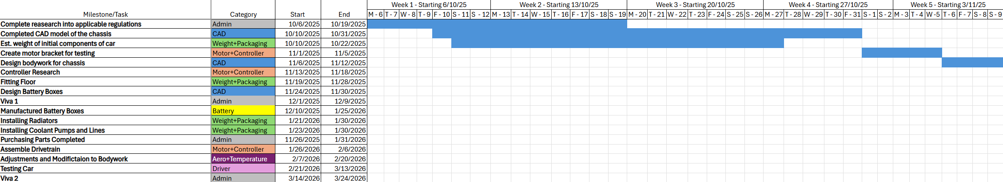
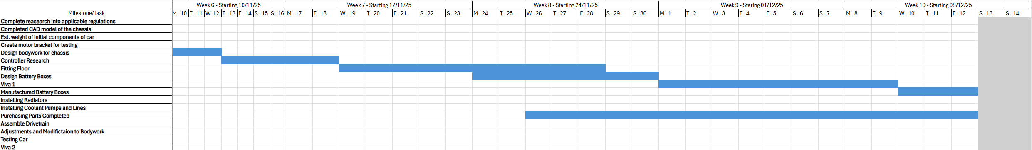
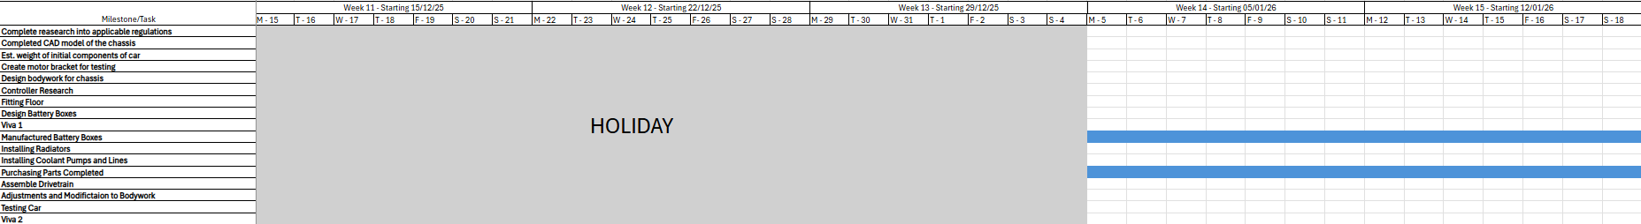
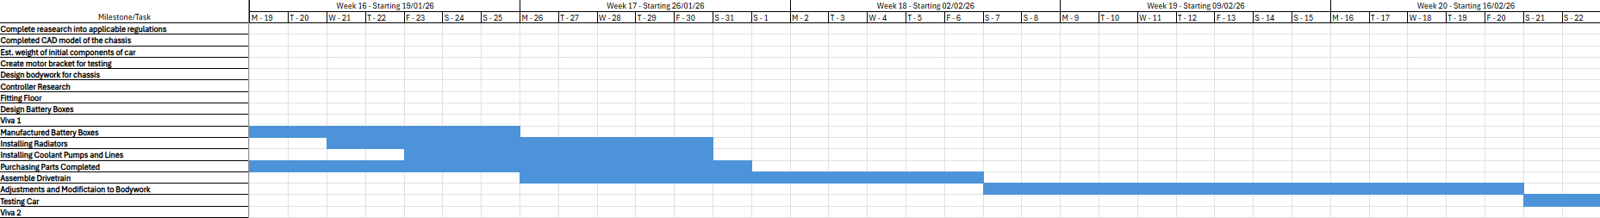
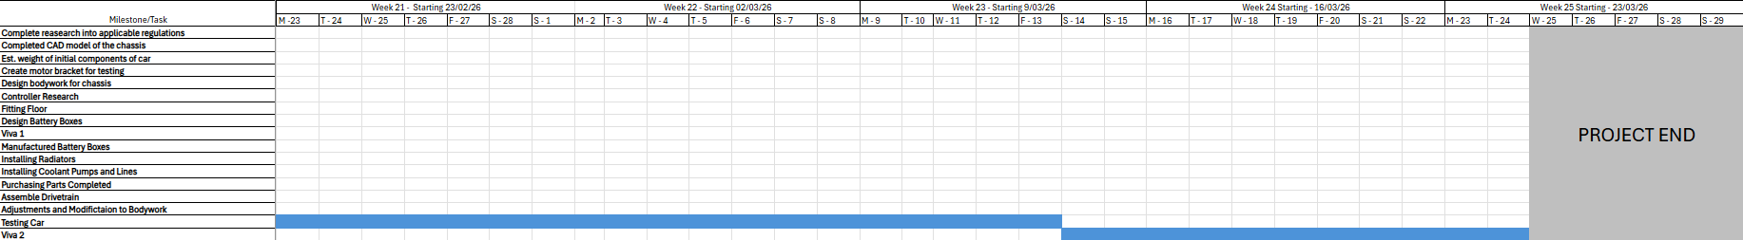
Each of the tasks laid out represent a milestone within the project. All of which have a category responding to the role they align with.

Personal GANT Chart
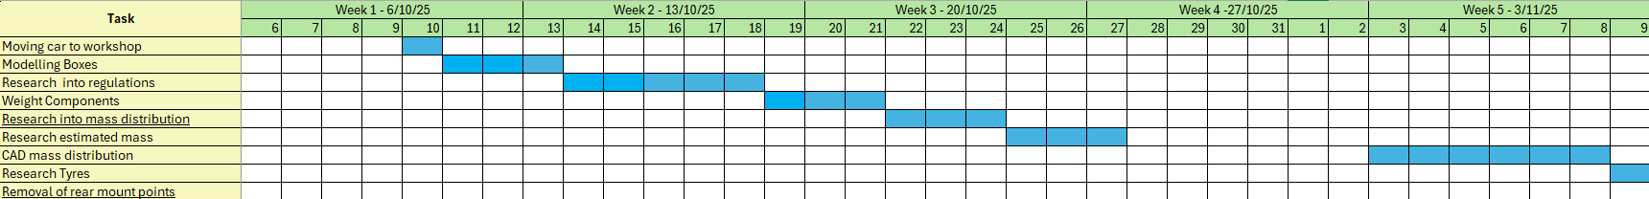
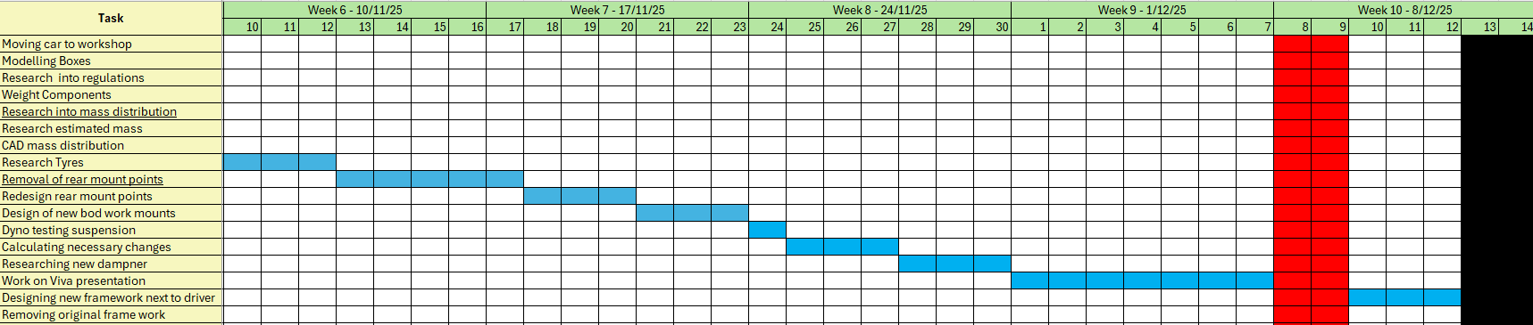
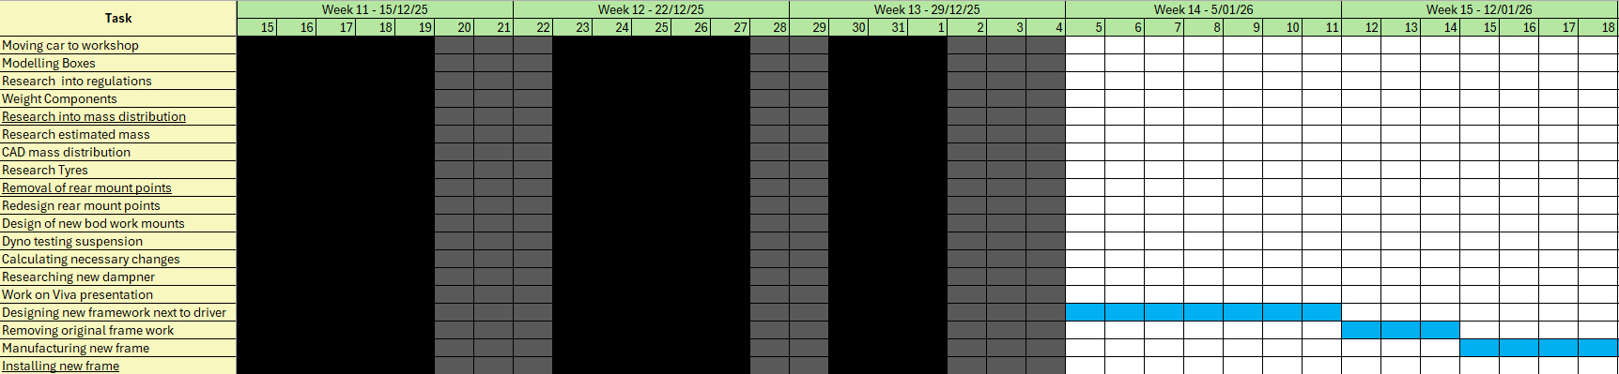
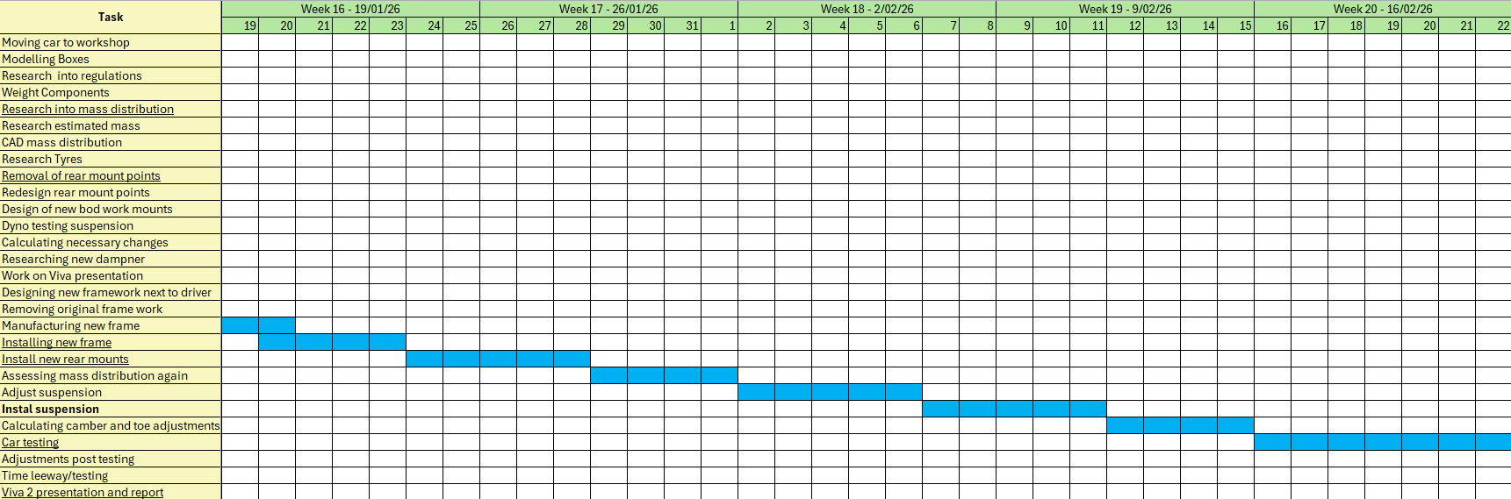
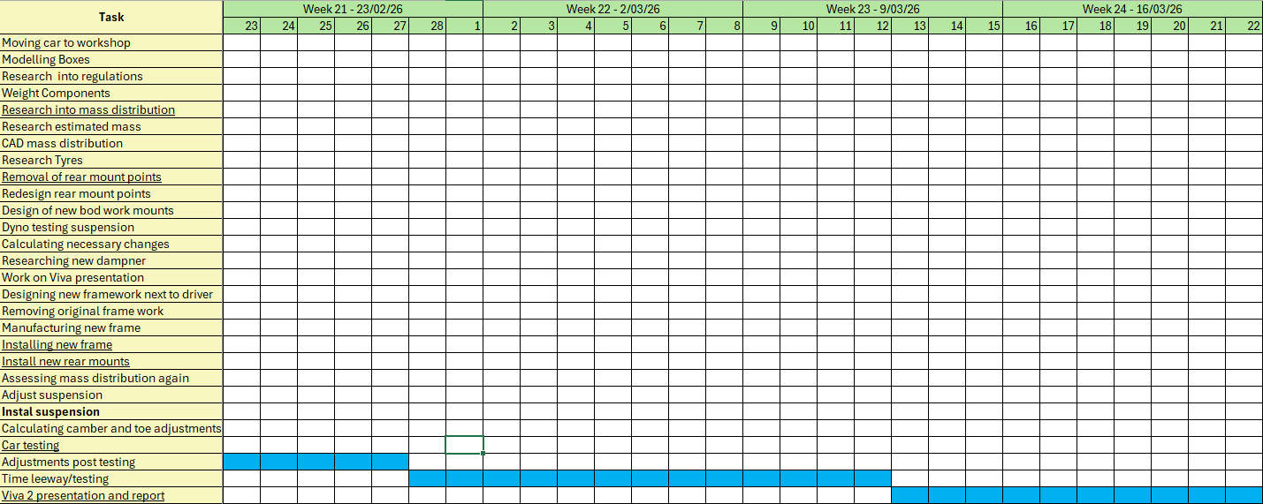
The parts of the GANT chart empty are when tasks couldn’t be completed until others were done. Red = Presentation Days, Black = Away on Holiday, Grey = Away from uni.

References

Belbin, M (2025) The Nine Belbin Team Roles. Available at: https://www.belbin.com/about/belbin-team-roles (Accessed: 16 November 2025)

Simpliaxis (2023) PERT: A Three-Point Estimating Technique. Available at: https://www.simpliaxis.com/resources/pert-a-three-point-estimating-technique (Accessed: 20 November 2025)

Demon Tweeks (2025) Avo Universal Twin Tube Coil over Damper. Available at: https://www.demon-tweeks.com/uk/avo-universal-twin-tube-coilover-damper-240886/ (Accessed: 20 November 2025)

Demon Tweeks (2025) Hankook Ventus F200 Slick Racing Tyre. Available at: Buy Hankook Ventus F200 Slick Racing Tyre | Demon Twehttps://www.demon-tweeks.com/hankook-ventus-f200-slick-racing-tyre-802020/?sku=HAN17051513F200C92&gclsrc=aw.ds&gad_source=1&gad_campaignid=23082927486&gclid=CjwKCAiA_dDIBhB6EiwAvzc1cHWtILFQghpLPx5BMbsBfKoUl4Re0LbVPTfdaZJYDuzFT0-WkX_v9BoChnoQAvD_BwEeks (Accessed 16 November 2025)

Gibson, K (2023) What Is Risk Management & Why Is It Important? Available at: https://online.hbs.edu/blog/post/risk-management (Accessed: 16 November 2025)

