 | Student No: | 1807295
 | Module Title: | Business Skills for the International Hotel Industry
 | Module Code: | BMIH4007
 | Lecturer: | Daniel Payne

Component One: Reflective Journal 1000 words

Week 2: High Expectations, Worry, and Imposter Syndrome
Experience:
At the start of the business skills course, I felt excited but also nervous. I had high expectations, but I doubted I could succeed. I felt like I didn’t belong in the university, even though others told me I deserved to be there. This feeling is called imposter syndrome (Cambridge University Press & Assessment, 2024).
Reflection:
I learned that many people feel this way in a new and difficult environment. My worries were not because I couldn’t do the work, but because I was being hard on myself. I understood that success is about learning and trying, not about being perfect.
Action:
To feel more confident, I started celebrating my small successes and reminding myself why I chose this course. I also shared my feelings with classmates, which helped me feel less alone. I decided to focus on improving step by step and to accept that making mistakes is part of learning.

Week 3: Struggling with University Writing and Language Barriers
Experience:
This week was hard because I struggled with writing in English, which is not my first language. I am a French speaker, and writing essays in English was very difficult. I also had to learn Harvard referencing (Pears and Shields, 2022), which was confusing at first.
Reflection:
I realized that learning to write well in English would take time and that it was normal to feel challenged. This was not just a problem for me; other students also found it difficult. I saw that this was a chance to improve my writing and communication skills, which are important for my future.
Action:
I asked for help from the university’s writing support and joined workshops to learn better writing skills. I also practised English every day by reading and writing small paragraphs. To make referencing easier, I created a simple guide for myself, which helped me follow the rules step by step.

Week 4: Digital Skills and Information Overload
Experience:
This week, we learned about digital tools, which I thought I already knew. However, the amount of information was overwhelming. I felt confused and unsure about how to use everything we were taught.
Reflection:
I learned that trying to learn everything at once was too much. I needed to slow down and focus on one thing at a time. This experience showed me that organizing information is very important in today’s digital world.
Action:
I started to divide my learning into smaller parts. I set clear goals for what I wanted to learn each day. I also used apps to keep my notes and ideas in one place. This helped me feel more in control and less stressed about the information.

Week 5: Time Management and Balancing Multiple Demands
Experience:
This week, I struggled with managing my time because I had so many assignments to complete for different courses. I often worked late and felt very tired. I didn’t have enough time to prepare well for everything.
Reflection:
I realized that my problem was not the amount of work but the way I was organizing my time. Working without a plan made me rush and feel stressed. I saw that I needed to plan my time better to balance my studies and other activities.
Action:
I started using a calendar to plan my week. I wrote down all my tasks and gave each one a deadline. I also started using the Pomodoro technique (Corillo, 2018), where I worked for 25 minutes and then took a 5-minute break. This expanded from dividing tasks last week and helped me stay focused and not feel too tired.

Week 6: Mastering New Digital Skills and Practical Applications
Experience:
This week, I learned about Canva and practised table setting and plate delivery. I thought I already knew how to do these tasks, but I realized there was a lot I didn’t know. It was frustrating but also a good learning moment.
Reflection:
I learned that it is important to stay open to new ideas, even for things I think I already know. This experience taught me that practical skills are just as important as academic knowledge in hospitality.
Action:
I practised using Canva by watching tutorials and trying out different designs. For table setting and plate delivery, I asked for feedback from my classmates to improve. I also made a checklist for myself to make sure I followed the correct steps each time.

Week 7: Food Safety and Cultural Differences
Experience:
This week, we studied food safety and the history of regulations (HSE, 2024). I learned about how food safety is strictly enforced in the UK compared to the Democratic Republic of Congo (DRC). The differences in rules and enforcement between the two countries were very interesting.
Reflection:
I understood that cultural and economic factors shape how food safety rules are enforced in different places. This made me realize how important it is to understand local rules when working in the hospitality industry.
Action:
I decided to learn more about food safety regulations in both the UK and the DRC. I also read about international standards to prepare for working in different countries. This knowledge will help me adapt to different environments in my career.
Week 8: Fear of Deadlines and Work Quality
Experience:
As deadlines came closer, I felt very stressed and worried that my work was not good enough. I doubted if I had done everything correctly and felt overwhelmed by all the assignments.
Reflection:
I realized that my fear came from wanting to do well, but it was stopping me from focusing. Looking back at my progress in the course, I saw that I had improved a lot. This gave me some confidence that I could finish my tasks successfully.
Action:
I looked at my journal, broke my assignments into even smaller tasks and worked on them step by step. I also asked for feedback early to make sure I was on the right track. To manage my stress, I reminded myself of how much I had learned and how far I had come.

Component Two: Action Plan

These six weeks have been full of challenges, but they have helped me grow. I learned to face imposter syndrome (Bravata et al., 2019), improve my writing and digital skills, and manage my time better. I also gained a deeper understanding of food safety and cultural differences. By using the ERA model, I turned my struggles into lessons that will help me in my studies and future career. Taking the actions I have put into place during the course, this is what I plan to do in the future.
- Academic Writing and Language Skills
Writing essays in English is still difficult for me because English is not my first language. Harvard referencing (Pears and Shields, 2022) is better now, but I need more practice. By the end of the semester, I want to write assignments with fewer grammar and referencing mistakes.
To do this I will:
  - Spend 30 minutes every day reading academic texts to learn new words and understand academic writing better.
  - Attend more university workshops on writing and referencing.
  - Use tools like Grammarly to check grammar and make my writing clearer.
- Time Management
Managing many assignments and deadlines at the same time is stressful for me. Sometimes, I wait too long to start tasks but I want to complete all assignments on time without feeling rushed or stressed.
To do this I will:
  - Use the Pomodoro technique to stay focused and break tasks into smaller parts (Corillo, 2018).
  - Plan my week every Sunday and write down the most important tasks.
  - Allow extra time for unexpected problems, so I do not miss deadlines.

- Digital Skills
I have learned tools like Canva, but I feel overwhelmed when I have to learn many tools at once. By the end of the course, I want to use Canva and other tools confidently for professional work.
To do this I will:
  - Focus on learning one tool at a time and practice with small projects.
  - Join workshops about digital tools that are important in hospitality.
- Practical Skills in Hospitality
I enjoy practical tasks like table setting and food delivery. These skills are very important for creating a good guest experience.
To do this I will:
  - Practice these skills often to improve speed and accuracy.
  - Ask for feedback from classmates and teachers to get better.
  - Help classmates who may need support with these tasks to share my knowledge.
- Adaptability and Resilience
Over the last six weeks, I have worked hard to overcome challenges, such as feeling like I do not belong and managing a lot of work.
To do this I will:
  - Write down my successes every week to remind myself of my progress.
  - Accept feedback and use it to grow and improve.
By focusing on my weaknesses and improving my strengths, I will build the skills I need to succeed in my studies and future career. Improving my writing, digital, and practical skills will prepare me for internships and jobs in hospitality. Being strong in catering skills, food safety, and marketing tools like Canva will help me stand out. Learning better time management and staying adaptable will make it easier to handle the fast-paced work environment in hospitality.

References
Bravata, D.M., Watts, S.A., Keefer, A.L., Madhusudhan, D.K., Taylor, K.T., Clark, D.M., Nelson, R.S., Cokley, K.O. and Hagg, H.K. (2019). Prevalence, Predictors, and Treatment of Impostor Syndrome: a Systematic Review. Journal of General Internal Medicine, 35(4), pp.1252–1275. doi:https://doi.org/10.1007/s11606-019-05364-1.
Cambridge University Press & Assessment (2024). Impostor Syndrome. dictionary.cambridge.org. Available at: https://dictionary.cambridge.org/dictionary/english/impostor-syndrome.
Corillo, F. (2018). The Pomodoro Technique: The Acclaimed Time-management System That Has Transformed How We Work. Currency.
HSE (2024). Health and Safety in Catering and Hospitality. www.hse.gov.uk. Available at: https://www.hse.gov.uk/catering/.
Pears, R. and Shields, G.J. (2022). Cite them right : the essential referencing guide. Basingstoke: Palgrave Macmillan.

Component Three: Professional development: build a personal brand and promote a professional identity. (700 words)

Canva Document

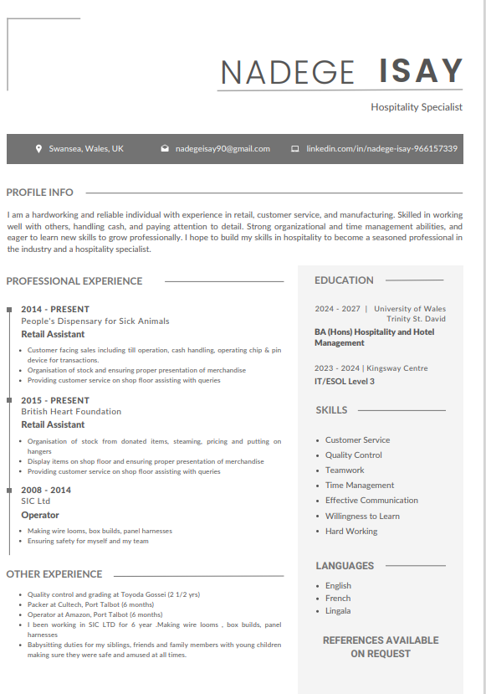

Linkedin Screenshot

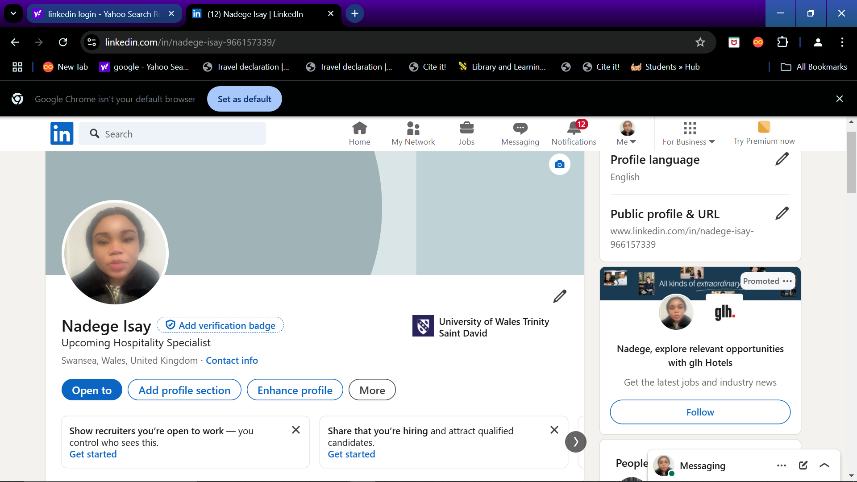
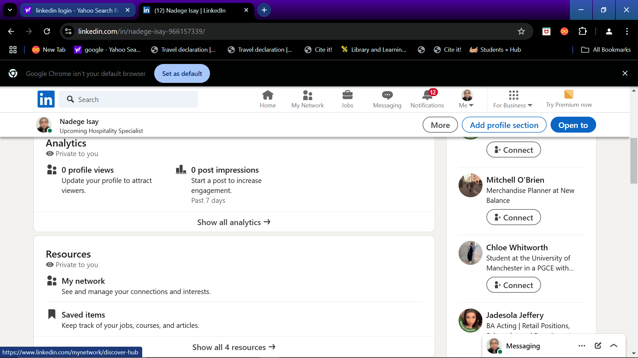

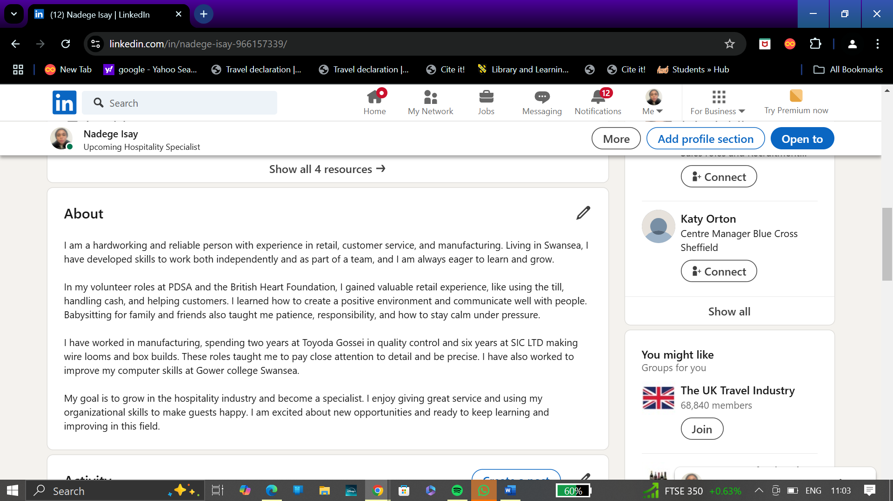

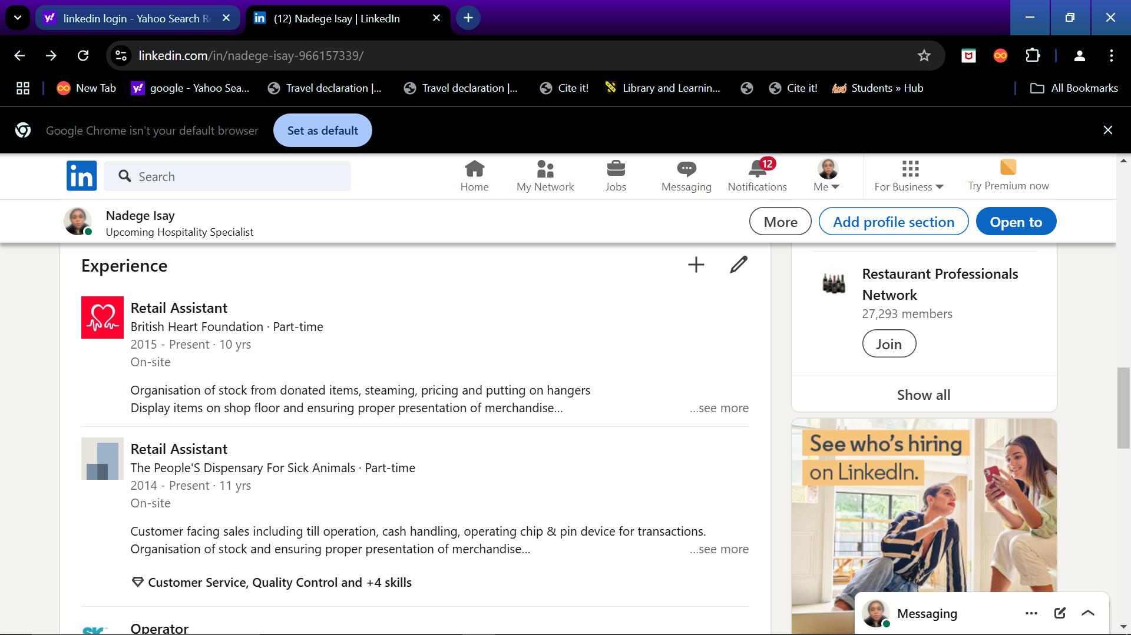

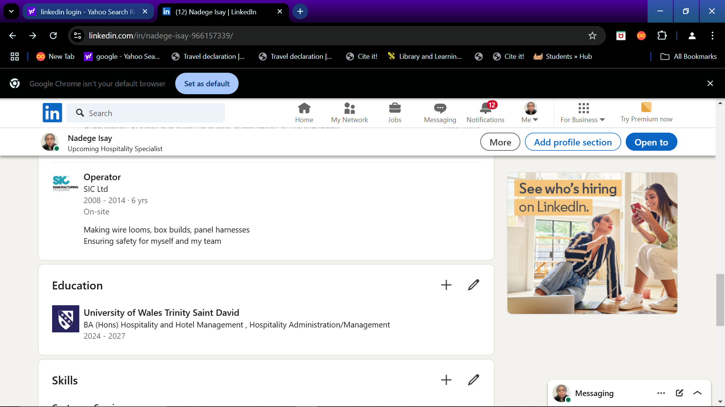

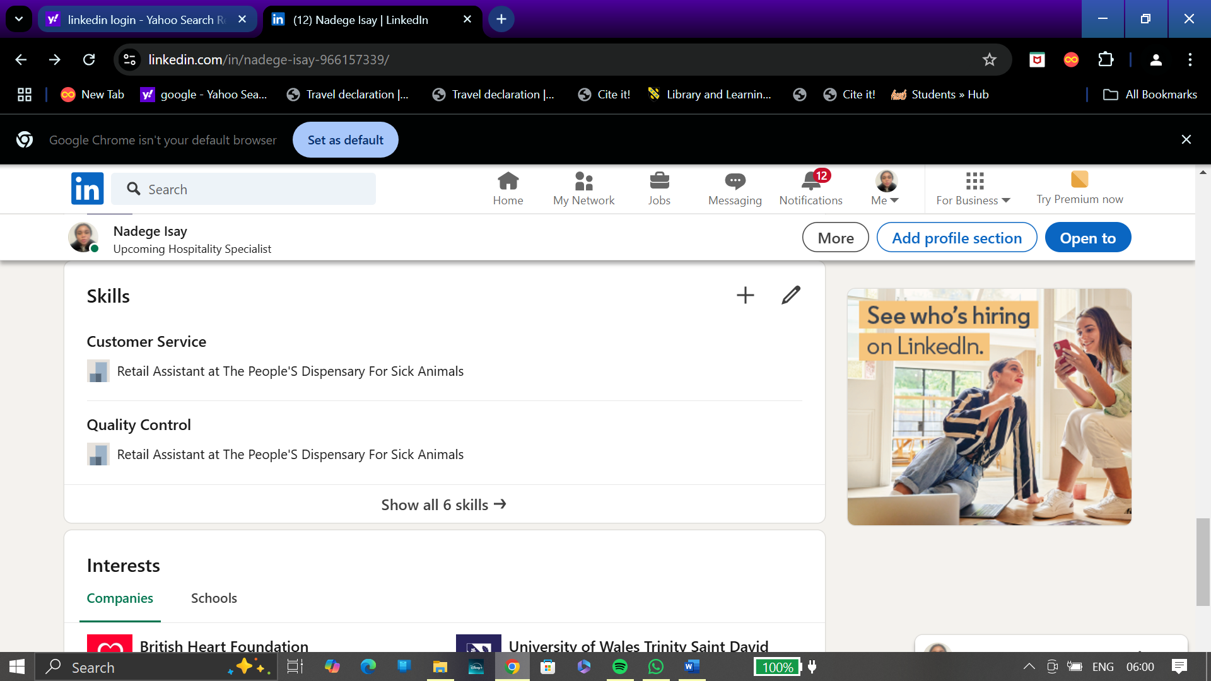
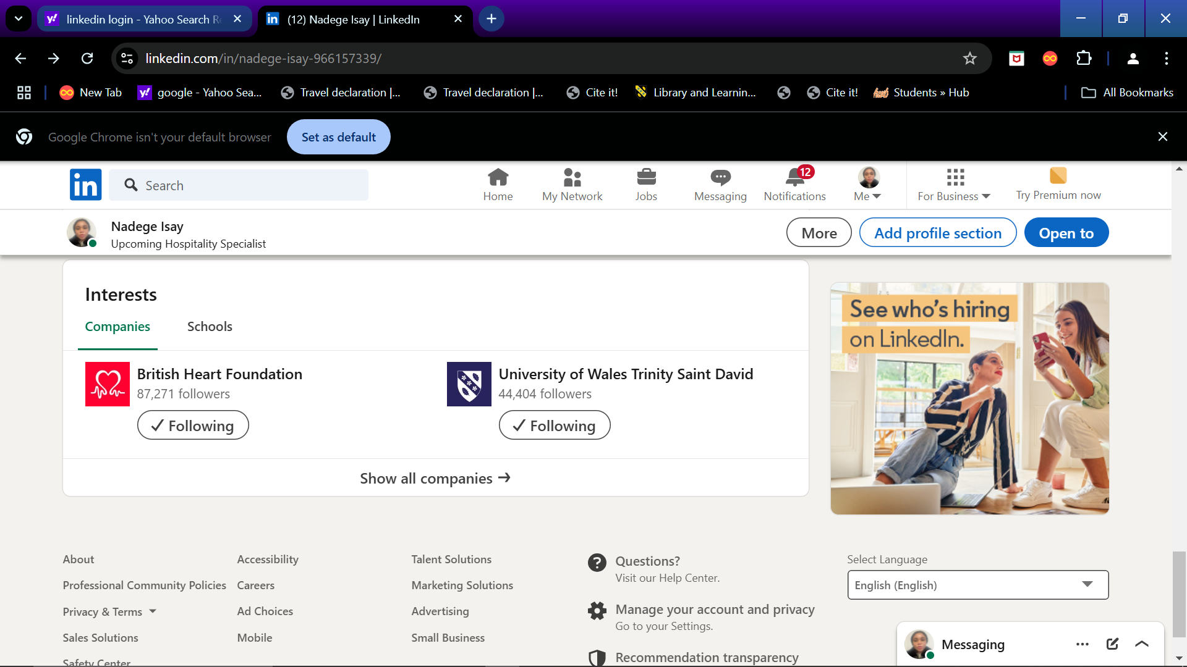

https://www.linkedin.com/in/nadege-isay-966157339/

Component Four: Using the information prepared for your CV, present a 5 minute presentation on the key attributes that a person working within the hospitality industry should possess.

This Presentation will be completed in person on site.

Place your presentation time below.

Timeslot:9:02

