level 4: 3D Production design and animation
Assignment: Art…..is real sorcery
Thomas Cahill
2004206
Ba computer animation

Table of Contents
Introduction 3
Location/Setting 3
Artifact Research 3
Production Log 6
Pre-production 6
Production 8
References 10

Introduction
This research project will document my visual research and design processes for my practical work on a scene within The Fire Within by Chris d’Lacey (2001). The book is the first in a light fantasy novel series aimed at a general audience. The scene I am interpreting is the protagonist David’s first time entering the Dragons Den, a pottery studio within the suburban house where he is a lodger in the English early 2000’s. David, having been outside in the afternoon and believing he’d seen a fire in the Den, raises the alarm to his landlady Liz Pennykettle, who calmly shows him up to the room. He is only just beginning to get used to the quirks of Liz, her daughter Lucy and their many clay dragons that are found around the house. He is initially astonished at how many more dragons line the shelves in the studio, before approaching the workbench to admire the 2 more unique dragons on it, including his own newly made one, which he names Gadzooks.

Location/Setting
During the multiple times I have read this book over the years, I have always had a clear mental image of the rooms inside the house, but my focus will be on The Dragons Den, due to that being the setting of my chosen scene. The descriptions of the house in other passages always reminded me of the house of my neighbour, which is a suburban detached house which was built with brick around the late 1980s or early 1990s, with numerous square rooms and a sizable front and back garden. I have visited this house countless times over the years. I even read this book there a few times, which probably helped form my current mental image of the Pennykettle household; the outside similar in appearance to my neighbour’s house, a smaller front and back garden, with a different arrangement of rooms inside, being very average for the time period in terms of décor, except for the clay dragons that mysteriously change places around the house.
The part of the Pennykettle household that will be the point of my focus is The Dragons Den and the door leading to it. The door has a brass doorknob and a sign labelled “Dragon’s Den” which is “hand-painted, gold and green, with bright orange flames leaping up around the lettering” [1]. The door opens into a studio room overlooking the back garden, where “All around the studio, arranged on tiers of wooden shelves, were dozens and dozens of handcrafted dragons.”, “Only the window wall didn't have a rack. Over there, instead, stood a large old bench” [3]. Both Gadzooks and Liz’s personal dragon Guinevere are on this bench, with Gadzooks freshly kilned on a potter’s wheel and Guinevere on a stand of her own behind him [3] [4]. When the room is described, it is directly mentioned twice that it’s missing a potter’s oven or kiln of any kind [5] [7], which is one of the earlier signs in the narrative that not everything in this house was as it seemed, beginning some of the plot’s mystery.

Artifact Research
The Dragon’s Den has multiple features aside from its titular dragons:
Brushes and scraping tools: these tools are placed in jars around the workbench. The scraping tools are never directly mentioned but based off my own experience with clay sculpting, these tools are very common.

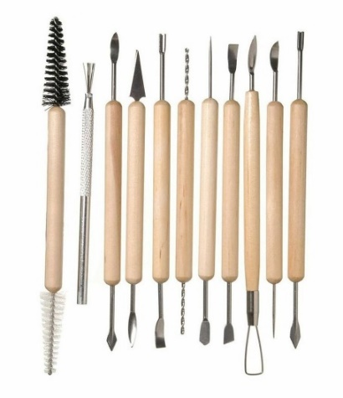
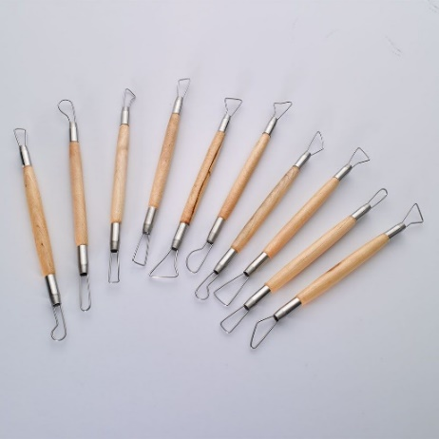
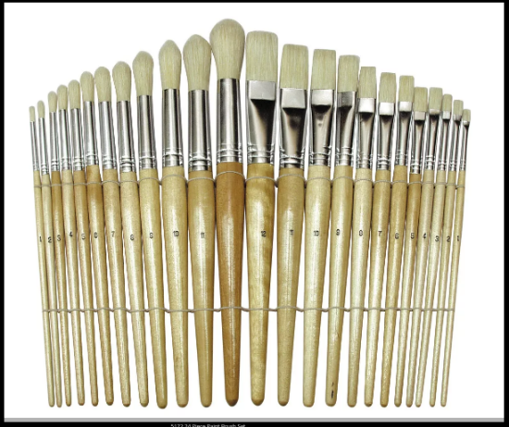
[11]
[10]
[9]
Glass Ornament
When David enters the Den, Liz tells him that he mistook the reflections of her glass ornament for a fire, so while this isn’t true, I would want to make an ornament design which has colours that would align with Liz’s cover story, so reds and oranges would be good colours to work with.
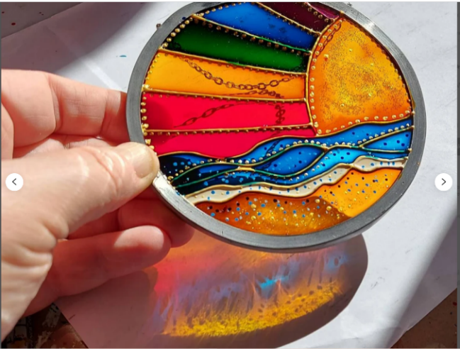
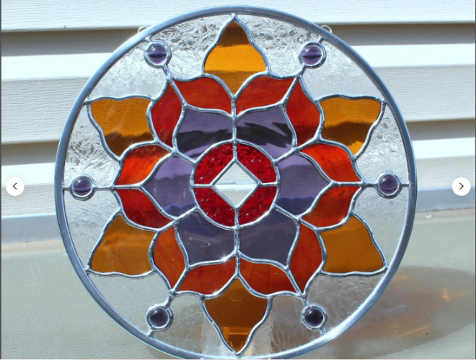
[13]
[12]

Potter’s Wheel
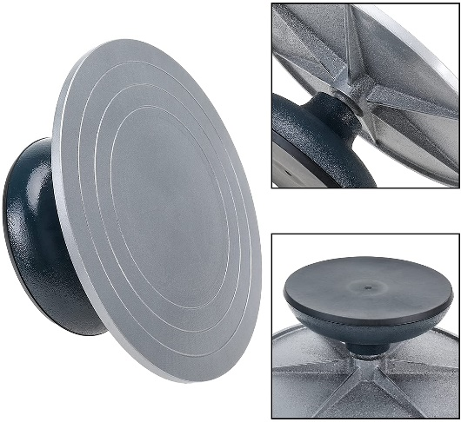
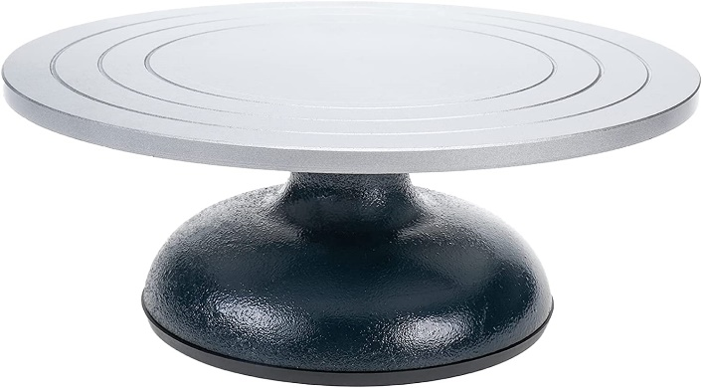
The type of this wheel is never stated to be mechanised or not, but based off some assumptions about the Pennykettle’s sculpting methods and the fact that they only make dragons, along with this stand being on an already crowded bench, I can easily imagine this to be a simple stand which only rotates by hand.
[14]
Shelves
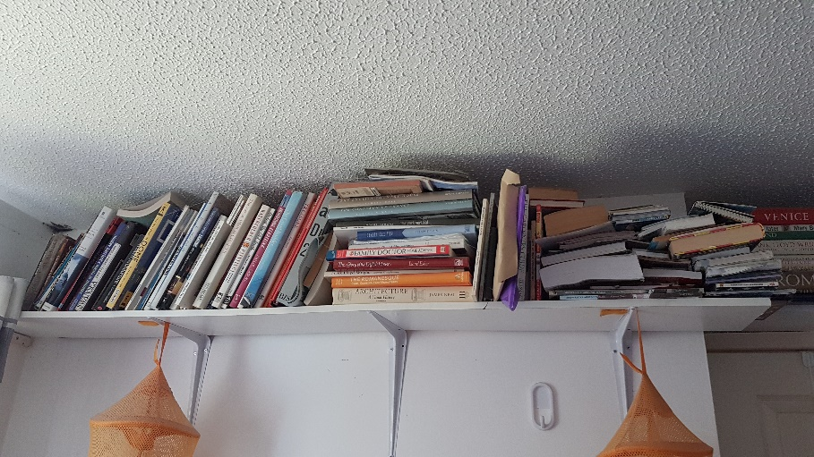
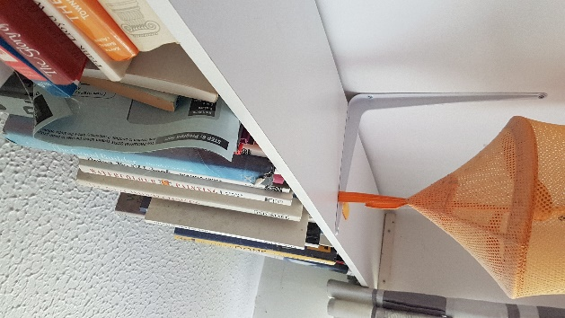
Three of the walls in the Den are lined with shelving full of clay dragons. I’ve always had a clear image of what these shelves would look like, simple wooden panels attached to the wall with metal braces. The reason I’ve seen this mentally is due to having identical shelving in my own room, which was installed around the same time the book takes place. This is very convenient for referencing, due to the subject being directly above me in the time of writing.

The Studio
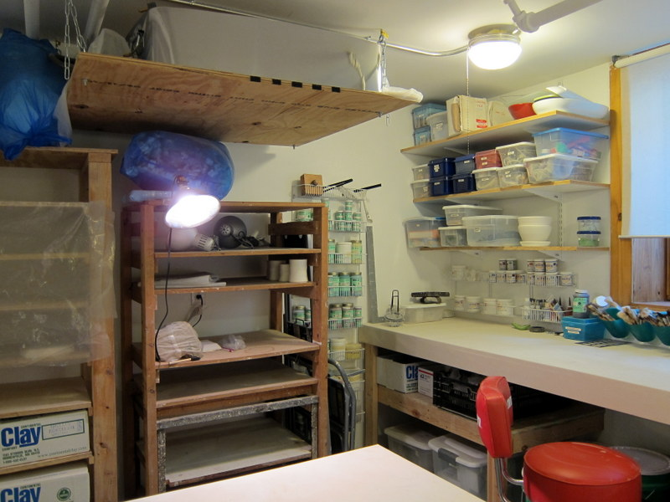
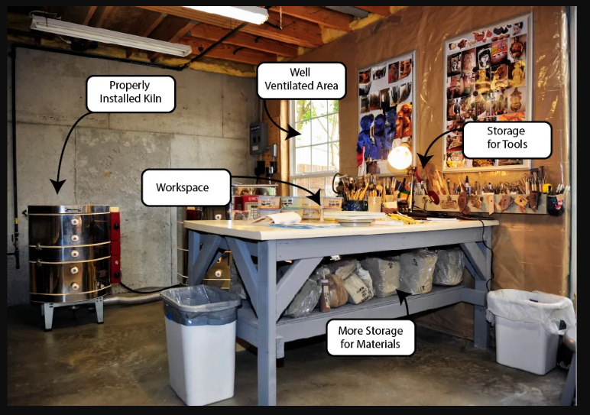
The Dragon’s Den is a pottery studio from the early 2000’s, so it would be good to look at different studios from the same period to get an idea of how it may be laid out. This is a rather difficult endeavour, as I already have had the layout in my head for a few years, so I may subconsciously search for studios that fit the idea in my head, which would rule out many different options I may have. I will do my best to keep an open mind in my search.
[16]
[15]

The Afternoon Sky

Since this scene takes place soon after Liz’s daughter Lucy has returned from school, it’d be around 4 or 5PM in the evening, so the sky should reflect that.
[17]

Production Log

Pre-production
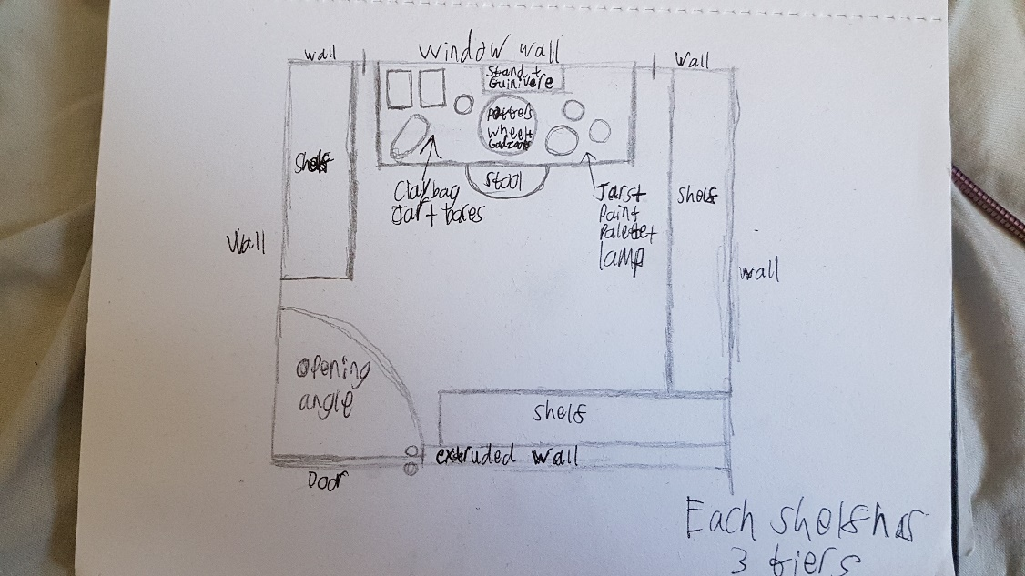
I began by making a floor plan of the Den, which made use of some very basic skills taught to me by my Father who is an architect.

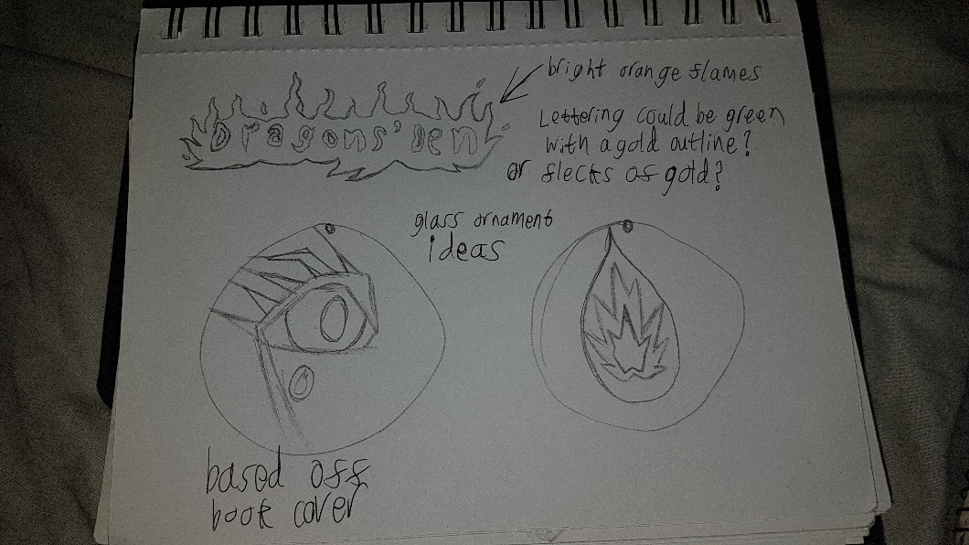
After that, I began sketching concepts for door sign and glass ornament. The door sign was based purely off the description rom its passage, whereas the glass ornaments were my own ideas. The first of the two was of a dragon shedding its fire tear, the second being a fire tear by itself. Both are meant to be a direct reference to the book cover

Next was the thumbnails, where I worked out what shots I should use for my storyboard and what actions and camera movements would occur in the scene.

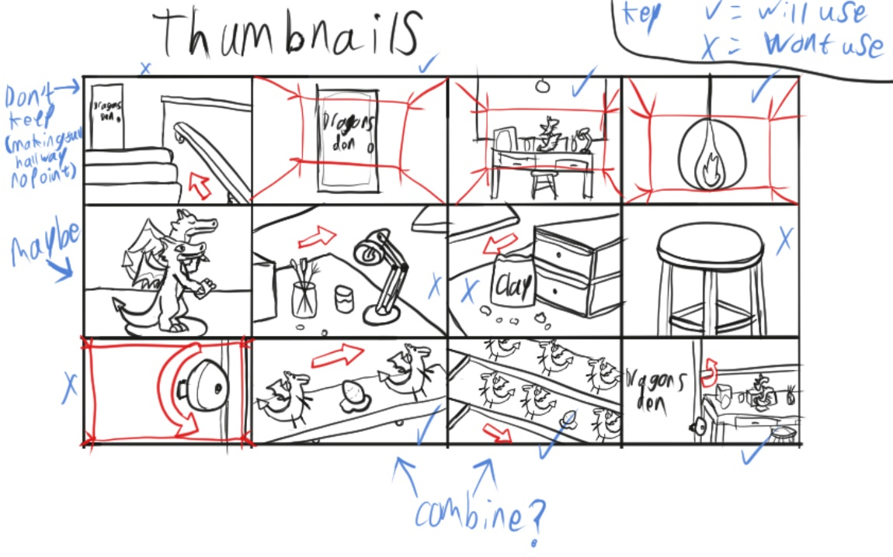
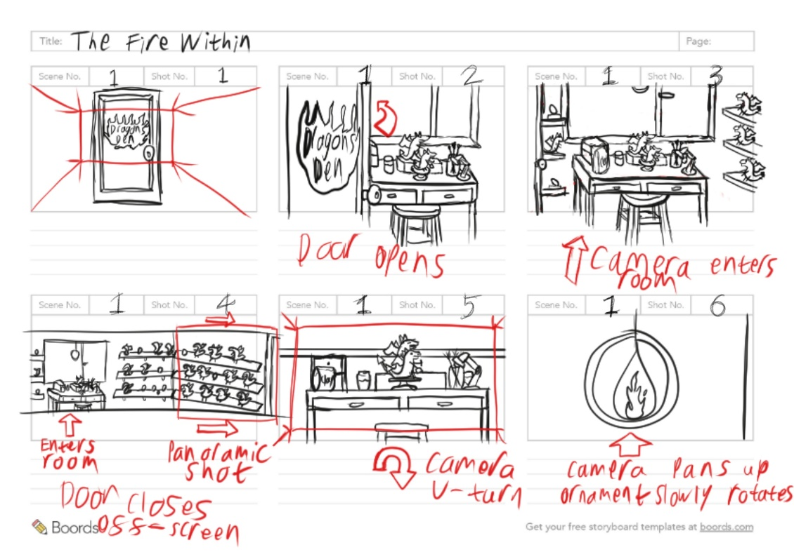
Continuing off the ideas posed by my thumbnails, I plotted out my storyboard. I forsook some of the close-up shots on the shelves from my thumbnails since they would make the sequence too long. I replaced these shots with more appropriate ones, such as the first travelling shot of the camera moving up the stairs towards the door, was changed to an establishing shot of the door by itself. Throughout I included cinematic annotations and arrows to represent and describe movement in the scene. As this is an establishing scene of the location, I elected to use a long shot to start the sequence, followed by several medium-long shots as the camera pans around the room, before zooming in to an extreme close-up in the last shot.

From the storyboard began the animatic, which was to help translate the movement of the camera through the space. Admittedly it was a lot more work than I expected, but it was useful to help work out the speed of which the camera moves.
The link is included here: https://youtu.be/AGCu57d4_oU

Production
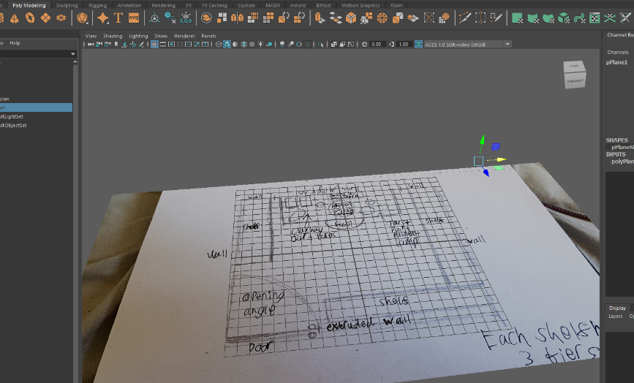
First, I placed my floorplan in Maya using an image plane and aligned it correctly. This was to help me ‘build up’ the scene to scale with the rest of the room
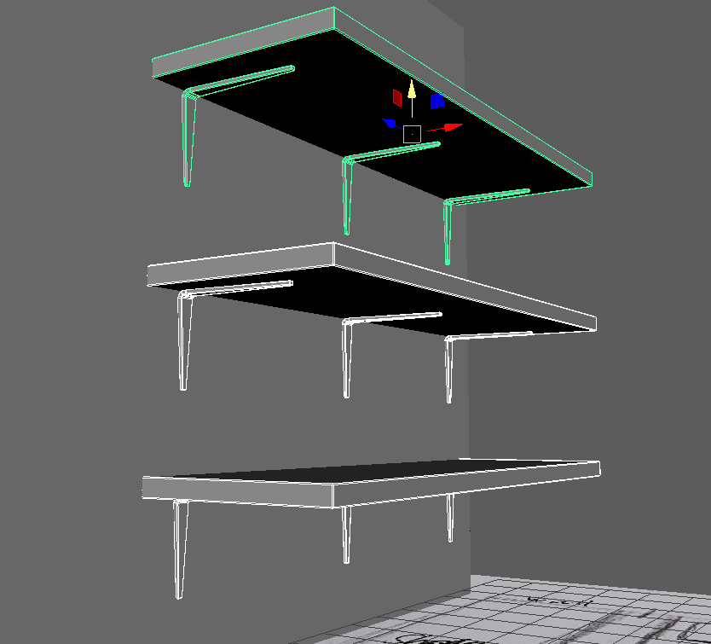
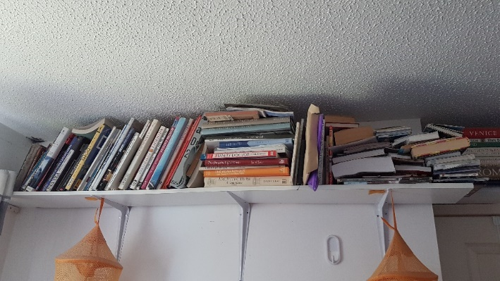
Compared to my research on shelving, my results were fairly true to form. The main difference being the lack of a protrusion along the middle of the wall brackets

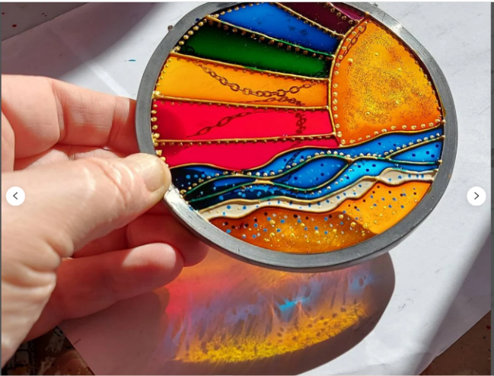

For my ornament design, I went with the idea of fiery colours and the fire tear design from my sketches, whilst sticking with its broad description [2]. Whist the colouration of fire tears are directly from the book, colour theory still relates to them. Although the design has a light blue, which is a more cheerful colour, I had originally intended for it to be a deeper shade of blue to emulate a more melancholic feeling (in the books, a dragon dies when they shed a fire tear), but it didn’t look right with the purple and orange which led to me using the lighter blue.

If this space were to be used in a film or sequence with a longer duration, it’d be larger to have the space to accommodate multiple characters and for the camera to have more freedom. This would allow for some of the more varied scenes to take place in the environment

References
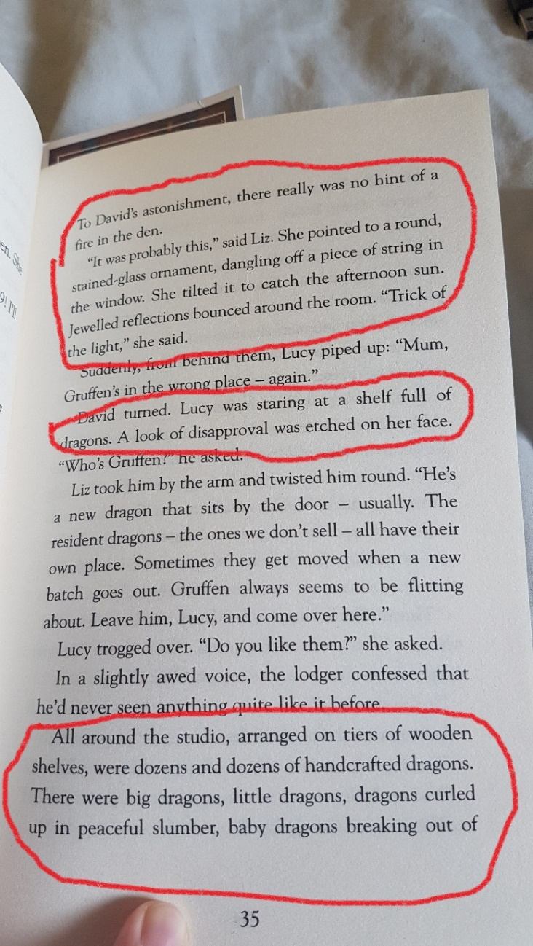
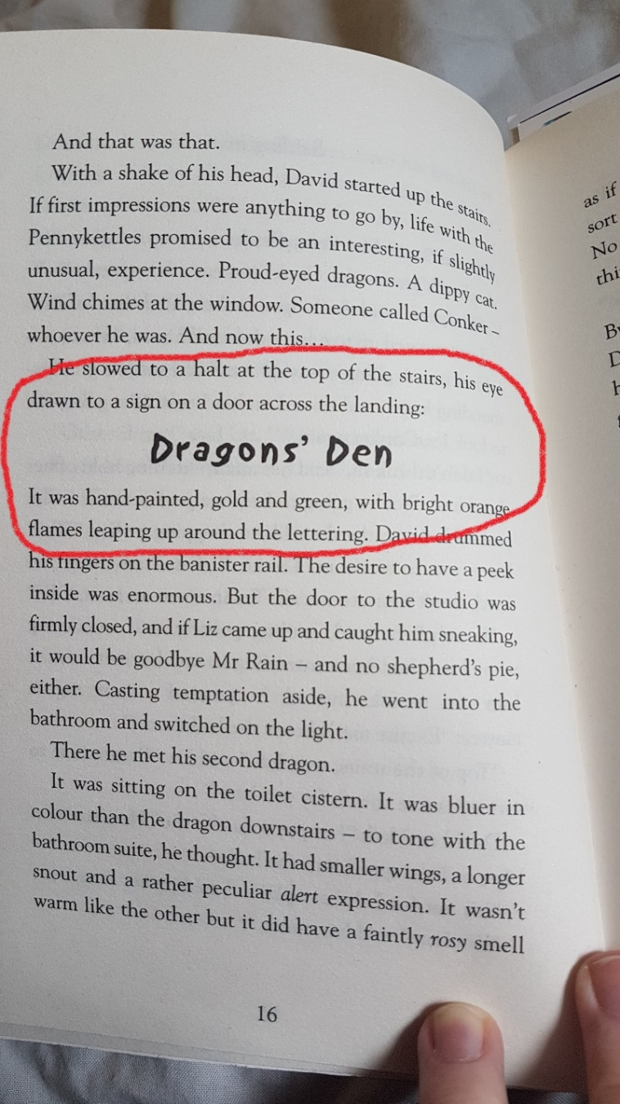
Key Texts (relevant passages are circled or underlined in red)
[2]
[1]

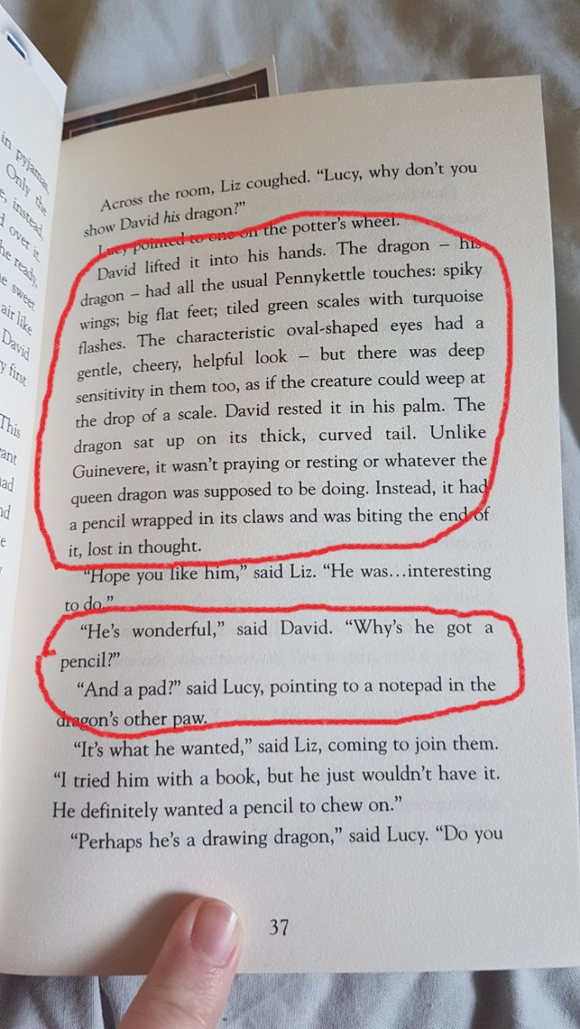
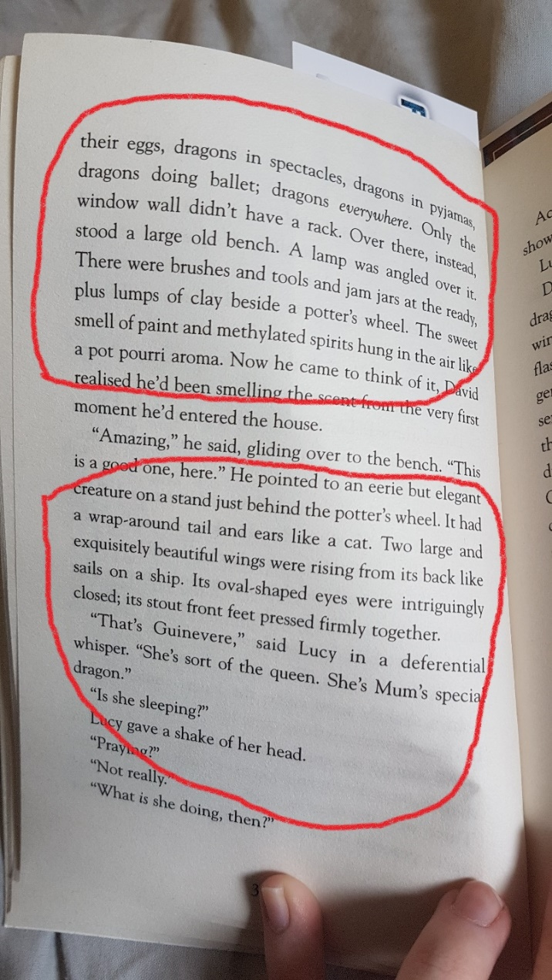
[4]
[3]
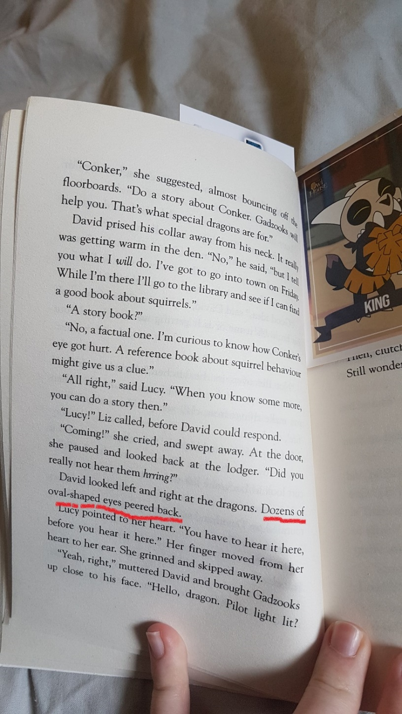
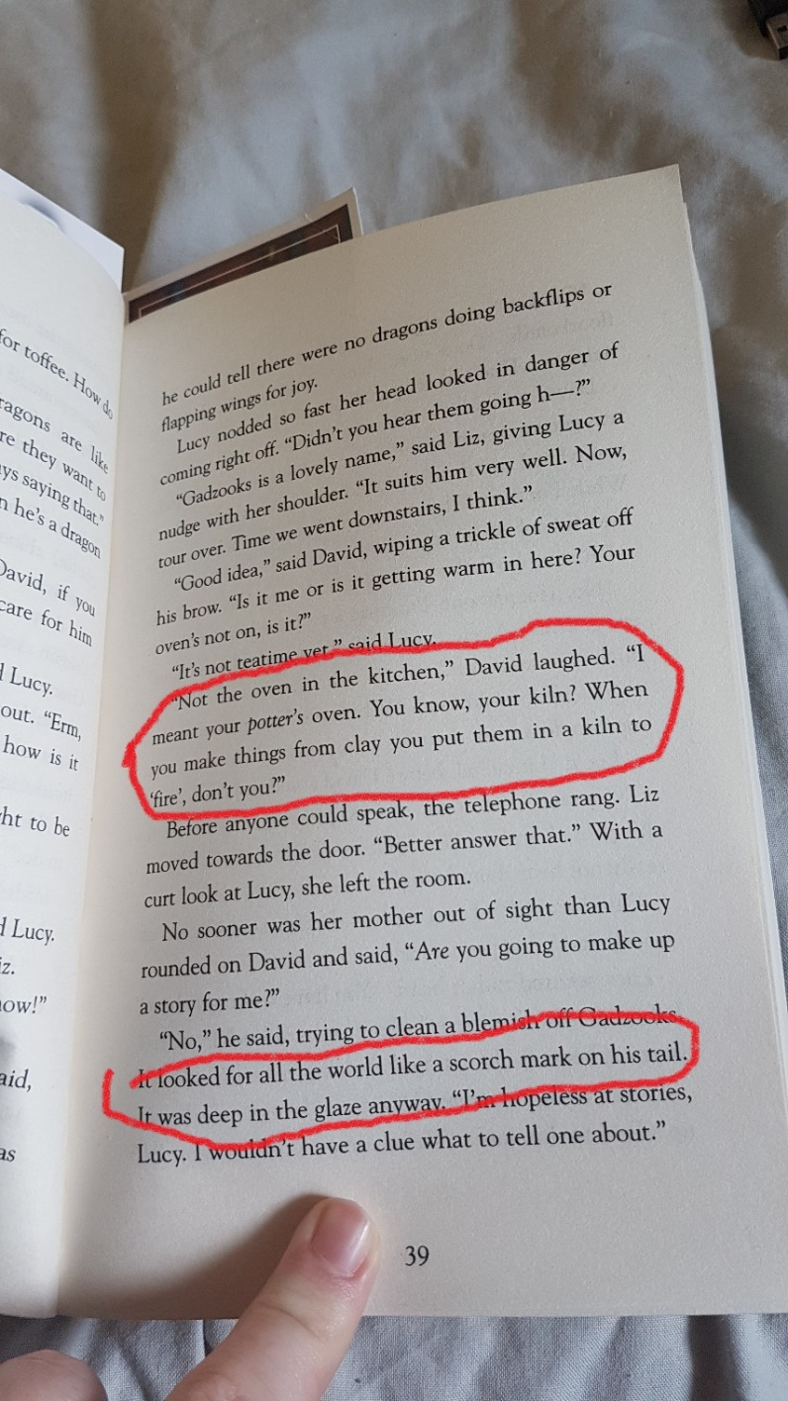
[6]
[5]
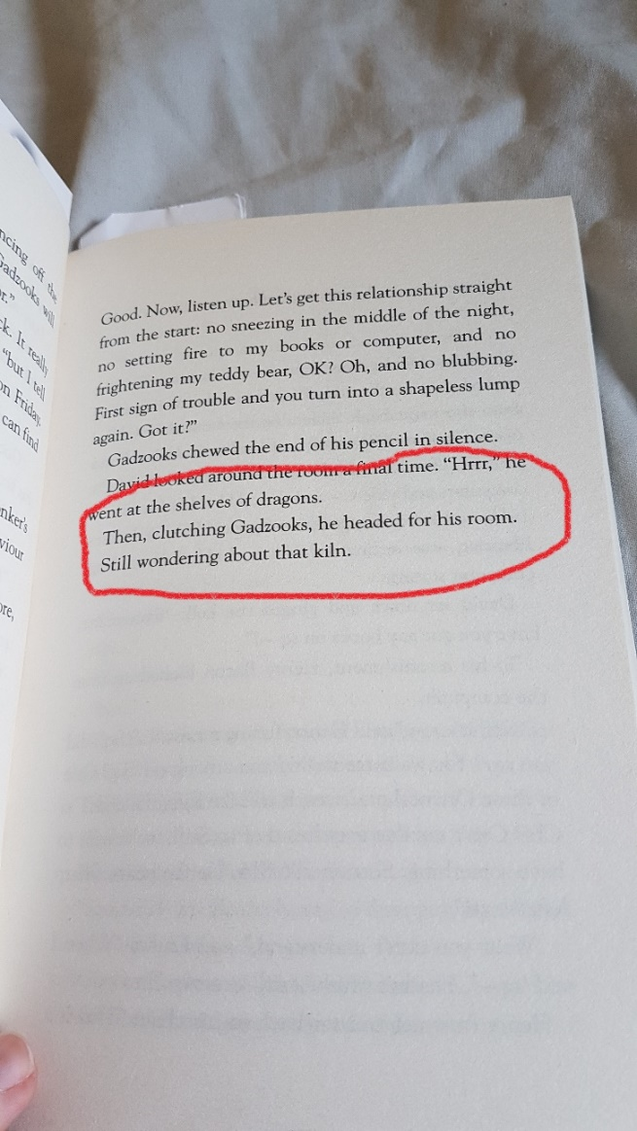
[7]
[8] C. d’Lacey, The Fire Within, London: Orchard Books, 2001. pp.16-41.
[9] WL Coller. (). Paintbrushes - Classroom Set. Available: https://wlcoller.co.uk/product/classroom-paint-brush-set/ [Accessed Apr 26, 2022].
[10] Dryad. (). Specialist Crafts Economy Double-Ended Loop Tool Set. Available: https://www.dryadeducation.co.uk/specialist-crafts-economy-double-ended-loop-tool-set [Accessed Apr 26, 2022].
[11] Artway. (Jun 6,). 11 Piece Carving/Sculpture/Modelling Tools. Available: https://artway.co.uk/artway-11-piece-modelling-tool-set/ [Accessed Apr 26, 2022].
[12] S. Lewis. (). Leaded Glass Rainbow Beach Suncatcher | Etsy UK. Available: https://www.etsy.com/uk/listing/1020119455/leaded-glass-rainbow-beach-suncatcher?utm_source=OpenGraph&utm_medium=PageTools&utm_campaign=Share [Accessed Apr 26, 2022].
[13] Anonymous (Aug 13,). Round Stained Glass Panel in Red Purple and Amber | Etsy UK. Available: https://www.etsy.com/uk/listing/590502126/round-stained-glass-panel-in-red-purple?utm_source=OpenGraph&utm_medium=PageTools&utm_campaign=Share [Accessed Apr 26, 2022].
[14] Anonymous (). Ubuy. Available: https://www.u-buy.co.uk/product/1J0LE2VSW-yaegarden-heavy-duty-12-diameter-sculpting-wheel-all-metal-construction-sculptor-turntable-with-ball-bearings [Accessed Apr 21, 2022]
[15] S. Casey, "Pottery Studio Setup at Home – The Bare Bones Basics!" 2019. Available: https://www.sumiceramics.com/basic-home-studio-setup/ [Accessed Apr 26, 2022].
[16] E. Murphy, "a pottery studio tour: my sunny basement studio | pottery blog: emily murphy," 2012. Available: https://potteryblog.com/2012/09/a-tour-of-my-pottery-studio-basement-studio/ [Accessed Apr 26, 2022].
[17] Anonymous (). late afternoon sky - Picture of Perdido Sun 1106, Perdido Key - Tripadvisor. Available: https://en.tripadvisor.com.hk/LocationPhotoDirectLink-g34551-d116004-i85494587-Perdido_Sun_1106-Perdido_Key_Florida.html [Accessed May 17, 2022].

