Programme: BA (Hons) Leadership and Management Skills in the Workplace

Module: Organisational Culture

Module Code: LCLM5005

Student Name: Luis Chisaguano

Student ID: 2332661

Lecture: Toyin Adisa

Executive Summary
The report is based on the utilisation of the cultural attributes in business strategy planning and structural retention by a popular UK-based airline service provider, British Airways. The cultural elements affecting the operations of the company have been elaborated on, where a number of company-driven initiatives have been mentioned as examples. A section has been dedicated to using Hofstede’s cultural dimensions and Handy’s cultural types to detect the actual cultural attributes of the company in its recent dealings. A critical assessment of the cultural implementations in the company has been provided along with a number of mitigation paths to curb the detected issues and barriers.

Table of Contents
Introduction 4
Evaluation of the Influences of The Organisational Culture in BA’s Structure and Decision-making Processes 4
The Type of Organisational Culture in BA 6
The Application of Handy’s Cultural Types and the Detection of the Culture 6
The Application of Hofstede’s Cultural Dimensions and the Detection of the Culture 7
Analysis of how BA Leverages Its Organisational Culture in Adapting to External Environmental Influences 8
Assessment of the Culture 9
Assessment 10
Impacts of the Organisational Culture 11
Recommendations 12
Conclusion 12
References 13

Introduction
Organisational culture is often termed as the backbone of a business entity’s operational ethics and fundamental business strategy policies. The key concept behind this culture projects a combination of beliefs, shared values and a behavioural pattern followed by a company and its employees, shaping the organisational personality of the organisation, aligning with company objectives (Mullins and Christy, 2016). This report aims to delineate the organisational cultures’ influence on the business operations and the overall performance of one of the most popular UK-based airline service providers, British Airways (BA). Suitable options to enhance the business performance of the organisation and its management will also be recommended and elaborated on.

Evaluation of the Influences of The Organisational Culture in BA’s Structure and Decision-making Processes
Structured and Hierarchical: BA projects a clear and justified hierarchical design in its top decision-making body, while the retention of a democratic work structure is present in the baseline employee groups, such as cabin crew and ground crew, is profound. The apex management body is presided over by the current Chief Executive Officer (CEO) or BA, Mr Sean Doyle (britishairways.com, 2026). The key influence of the company’s organisational hierarchical culture can be seen in the flexible management board development, which consists of Managing Directors (MD), with a majority of personnel having expertise in airline services’ functions and controls.
Dual Cultures: The presence of dual cultures is profound in BA’s operations, as the hierarchical culture is seen in the decision-making endeavours of the management board, while the use of a clan culture is present in its bottom-line service management, including port-based hospitality services to passengers. As a result of this influential cultural combination, BA gets immense benefits in handling its passengers and retaining its loyal customer base. Moreover, the cultural attributes also influence the structure of the company, which supports the democratic environment, subject to the employee base.
Flat Structure: The selected airline service provider can be seen as maintaining a flat structure in its employee base, which drives the key operations of the company. In this context, the influence of the collaborative culture (clan culture) can be seen in the employee engagement made successful by B, through handling its massive 30,000 employees (britishairways.com, 2026). A flat structure is always a good platform to promote open communication channels, which actually benefits the detection of issues concerning employee welfare and satisfaction. Thus, its importance is massive in driving problem-solving plans during times of need.
Specialisation-based Roles: It has been mentioned earlier in this section that the selected company promotes a prioritisation of specialisation in decision-making job roles, such as the duties of its MDs. Taking the piece of evidence from the mentioned fact, it has been seen that the business organisation has a positive endeavour in appointing specialists to handle departmental tasks and supervision-centric duties also. Its benefits generally promote an increase in the accuracy level in task operations, such as security checks of baggage.
Top-down Decision-making: The presence of a centralised decision-making system is a result of the company’s culture projecting the prioritisation of a top-down decision-making chain. Its key focus can be seen in the inclusion of issue detection endeavours, which start from the end of departmental supervisors and managers, who seek feedback on job roles and provide resources, from employees. After the collection of the data, the managerial personnel appointed by BA share the same with the management board, where the probable impacts of issues are evaluated and predicted to help make mitigation strategies.
"To Fly. To Serve." Focus: The global financial crisis of 2008 was a lesson for BA, which survived the malediction through its robust inventory management. Since then, the company has been focusing on the practical implementation of its motto, "To Fly. To Serve." (londonairtravel.com, 2026). This is the result of the cultural influence of the company prioritising sustainable business growth. This motto defines the service endeavour of BA to touch excellence in customer service and hospitality offerings. Undoubtedly, this fact has helped the organisation to position itself as one of the top airline service providers in the world.
Performance-Based Promotion: The three values that are maintained by BA in its employability also reflect the influence of a collaborative culture. The three values include excellence, care and open-mindedness, which govern the recognition of talents by the hierarchy (careers.ba.com, 2026). The first value projects the company’s emphasis on service-based creativity and excellence as a measure to evaluate one’s contribution to the company’s performance and to project the viability to get promoted to higher roles and responsibilities.
Empowerment Endeavours: Due to the presence of the same culture, BA has been noted as prioritising its employee well-being with flexible working offers for specific roles. Each employee is provided with provisional training sessions by the company to develop professional skills, helping him/her to promote his/her career growth. In addition to that, BA also provides £1,500 to buy tech products and white goods for service (careers.ba.com, 2026).

The Type of Organisational Culture in BA

The Application of Handy’s Cultural Types and the Detection of the Culture
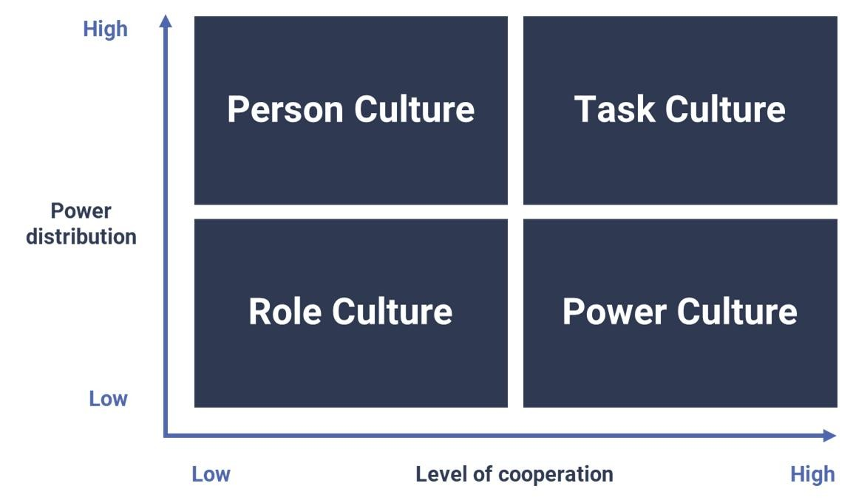
Figure 1: Handy’s Cultural Types
(Source: Peters et al., 2022)
Handy’s Cultural Types (Fig. 1) projects four different kinds of cultural forces in organisational structure and decision-making procedures. These four cultural forces are Person Culture (Zeus), Role Culture (Apollo), Task Culture (Athena) and Person Culture (Dionysus) (Peters et al., 2022). These cultural aspects project the crude power distribution and cooperative levels in a workplace. The increased influence of person and role cultures promotes the presence of a strong autocratic and hierarchical cultural effort in the working policy of a business organisation, such as the selected airline service provider. The detected type and its attributes in the company have been discussed below.
The hierarchical structure (autocratic culture) in any business entity promotes the retention of stable values and norms in driving a decision-making process, especially borne by the management body of a company. In this context, the application of a company’s chain of commands can be seen as being headed by a single supreme leader. In the case of BA, the CEO of the company, Mr Sean Doyle, has been noted as entertaining this power. At the same time, the culture also projects a vertical communication, which usually means that the top decision-making body gets the information about departmental performance issues from the department heads, not from the baseline employees. Additionally, its pyramid representation projects a small number of people, in the apex board, to promote a less conflicting scenario in strategy-making efforts. However, this culture is limited only to BA’s hierarchical positions, as the bottom-line employee base is subject to a totally different culture.

The Application of Hofstede’s Cultural Dimensions and the Detection of the Culture
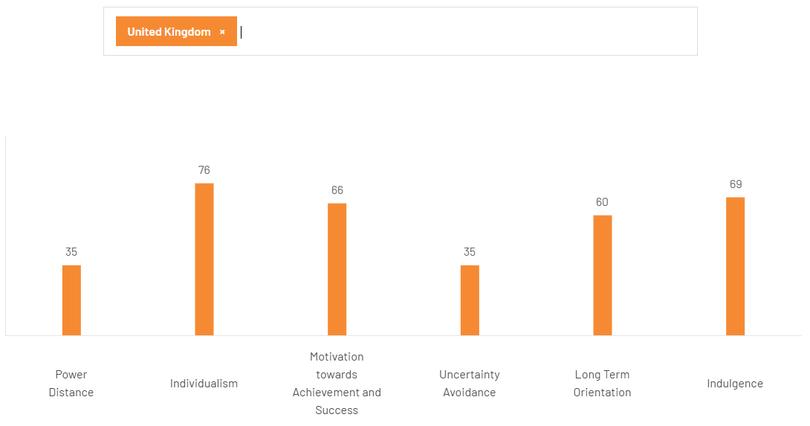
Figure 2: Hofstede’s Cultural Dimensions
(Source: theculturefactor.com, 2026)
Hofstede’s cultural dimensions (Fig. 2) are generally involved in the analysis of the cultural attributes for six distinct areas of consideration in workplace management. This model is basically connected to the external environment analysis of a business organisation, as it depicts the influence of a nation’s cultural sides influencing the cultural stature of a business organisation operating its business there. According to Fig. 2, the power distance in the US, the homeland of BA, has been projected as having a score of 35, which represents a lower level of power difference among employees. 66 has been scored for motivations for achievements and success among employees, irrespective of gender. Such results signify the presence of a clan culture or a collaborative culture in BA, especially in its baseline employee groups, such as cabin crew and ground crew. The detected culture’s attributes have been discussed below.
As the name suggests, the detected culture promotes collaborative work endeavours in a democratic work environment. This can be seen as having immense power to provide an open communication network among employees, encouraging them to state any problems or issues to department heads (Monteiro and Joseph, 2023). Due to these characteristics of the detected culture, the culture is generally established on a flat structure. In BA, the example is clear in the career growth scope, where each employee is provided with group-based training sessions.

Analysis of how BA Leverages Its Organisational Culture in Adapting to External Environmental Influences
Premium-Service Offerings: The external environment of BA projects the presence of a highly competitive market in its homeland’s aviation sector. This factor is a clear depiction of the competitive rivalry among key players of airline services in the air, where some smaller airline service providers, such as RyanAir and EasyJet, can also be traced as popular brands. Such a rivalry is generally controlled by BA using its premium service offerings. For example, it has personalised dining options for business-class passengers, which is unique in the sector (britishairways.com, 2026). In the long run, this pricing policy for premium flight packages can be effective enough to make the company retain its current position in the market.
"Pack for Change" Program: The programs under “Pack for Change” met practical implementations two times by BA, once in 2017 and another, in 2022. In the first implementation, the airline service provider focused on the representation of the financial crisis in the UK, where the company lost a significant amount of its invested money in its Terminal 5 construction at Heathrow Airport. In this situation, the hierarchical culture of the company proposed to use discounted flight tickets to attract more passengers to revitalise the cash flow. The second implementation of the program was noted in 2022, just after the global lockdown, which was an aftermath of the COVID-19 pandemic (britishairways.com, 2026). During this time, the company focused on online service expansion using third-party airline ticket vendors.
Strategic Flexibility: The collaborative culture of the airline service provider has included strategic flexibility in the recent efforts being executed by BA in the UK and outside it. The reason for the flexibility is aimed at the beneficial factors for satisfying the local employee bases of its international destinations. One of the examples of this endeavour of BA can be seen in its code-sharing policy with partners outside the UK. Its rationale can be noted in the ease of control in fuel acquisition for combating the volatile fuel prices in the world.
"One Destination" Approach: The rise of awareness on environmental well-being is not a solitary development in the airline customer base of the UK, but also a driving factor for environmental sustainability in other parts of the world. Being a follower of the UN SDGs 7 and 11, BA also promotes sustainability initiatives. One such initiative can be seen in its “One Destination” approach, stemming from the hierarchy culture. Under this initiative, BA is offering green flights, using sustainable options in fuel choices to reduce emissions levels since 2022 (greenaironline.com, 2022). However, this operation is currently facing some hindrances due to the scrapping of many Boeing planes.
Safety Compliance: Since the COVID-19 pandemic, the airline service provider has been promoting a higher level of passenger and service safety policy. Its new Heathrow terminal operation includes an improved safety check for baggage to identify illegal narcotics presence, which is a safety protocol under the reduction of criminal activities in the land (britishairways.com, 2026). In this context, the application of safety compliance is generally pre-planned and installed by the company using some local IT firms. Apart from this, the three-layer passport check in the online ticketing portal is also one of the parts of the initiative.
Service Offerings: The clan culture practised by the company is projecting its use of hospitality service offerings for passengers, especially in port lounges. The key driver of this consideration is the preferences of a high bargain power of the loyal customers of the company and the ease of controlling the service offerings to reduce threats from its rivals. As a part of this service, the airline service providers also promote a personalised dining option for passengers opting for business-class or premium packages.

Assessment of the Culture
Inconsistency of Services: The hierarchical culture of the company is somehow not completely able to mitigate its issue concerning the inconsistent service of flights. Its application can be seen as largely applied in the context of the unnecessary flight delays, due to the failures being reported, describing the malfunctioning of age-old Rolls-Royce Trent engines in aircraft. According to a popular and well-circulated news vendor, the company is currently finding it difficult to get the desired profit against its investment of £7 billion in service enhancement. The problem is affecting customer loyalty a bit, making the company get some competitive backlash in the home market. Its rooted context may be found in the implementation of the hierarchical decision-making endeavour to combat the technical faults of the service, without getting suggestions from the end of baseline employees.
Tech-based Troubles: According to the company’s press release, the CEO of the airline service provider has apologised to customers for a whopping increase of 90% in flight delays, only in 2024 (fortune.com, 2025). The barrier affecting the collaborative or clan culture of the business entity can be seen as rooted in the context of its new AI-based online ticketing and passenger profile recognition. The system has been installed in a semi-compatible technological and digital ecosystem of the airline service, which is affecting the customer service and the auto-updating features to run its airline services. Thus, the technical inadequacy of systems can also be held responsible for fighting against the mentioned problem or barrier to the performance of the company. In most cases, this type of activity needs a higher level of cloud computing.
Inadequate Staff: Despite having a well-established organisational culture, the company has been facing difficulties in fulfilling the gap in its employee base since 2022. During the pandemic period, the subsequent global lockdowns hit the company massively with the mass recession, due to which the company lost more than 12,000 employees (globaldata.com, 2026). In this context, the utilisation of the utilisation-based attributes in employee management policies of the company has made little modifications, which are not at all effective in promoting a rapid workforce strength regaining procedure. Such a problem can be considered as a barrier to BA, especially in its HRM process, which needs some serious concern for enhancement from the end of the management board. However, the company is currently moving towards a positive result due to its inclusion of some third-party HR agencies in the broadening aspect of employee numbers.

Assessment
The company has been projected as having three critical barriers for the apex result and benefit-gaining context, as the company has already been subjected to a number of customer issues. However, the positive impacts of the company, from the two detected cultures, have already surpassed the projected barriers. First of all, the inclusion of the premium service has already created a separate customer base, which is helping the company outperform some native players, such as RyanAir and EasyJet. Secondly, the company is getting the benefits of its hospitality service overhaul at Heathrow airport, which is benefiting the company in modulating its services. Considering these factors, the cultures are actually helping the company in retaining its performance, while there is a need for specific improvements, which will be discussed in the recommendations.

Impacts of the Organisational Culture
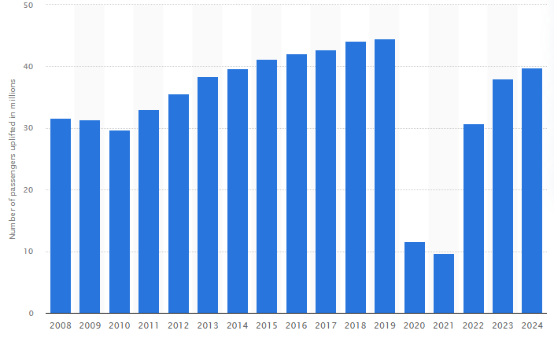
Figure 3: Online Traffic of BA
(Source: statista.com, 2024)
The impact of the cultural attributes in the planning of the company’s online ticketing integration may have faced some initial glitches and delays; however, the interconnected set of activities in the developed digital configuration of the ticketing portal has projected a significant inclusion of the company’s inclusion in the service category. As a result of this, a rise of 39.8 million in the number of online bookers has been noted in 2024, in BA’s online portal (statista.com, 2024). This fact is contributing to the inclusion of effective aspects connected to the company’s use of sufficiency in customer engagement.
Another positive result of the company’s clan culture has been seen in the robust revenue generation despite facing a dent in overall sales in the current year. According to the declaration made by the company’s CEO, BA has acquired approximately £14.6 billion in revenue (mediacentre.britishairways.com, 2026). This fact shows the accessible aspects connected to the company’s effective flight management. However, the problems connected to age-old machinery are still looming in the service offerings of BA. In the recent policy overhaul, the management board has mentioned this fact with an emphasis on promoting further partnership efforts with some international suppliers.

Recommendations
Laissez-faire is generally considered a leadership approach or style that promotes freedom to employees to use their innovative ideas to plan a service offering or product design (Kamal and Kesuma, 2024). Its initiation is generally driven by the distribution of accountability to handle the innovation of a company’s product or service offerings. This can be an effective solution for BA to enrich its airline service, especially in the improvement of its online ticketing activities and real-time flight updates to be visualised in IoT devices. This can be seen as a feasible way to use managerial personnel to plan service distribution and improved plans for customer engagement.
Apart from this, the company’s inclusion of green HRM can also be effective in managing the subjective aspects connected to the company’s employee base enhancement endeavour. Moreover, it has the capability to reduce the operational cost of recruitment drives. In most cases, it can be executed by third-party HR agencies.

Conclusion
It can be concluded from this report that BA needs to prioritise green employability efforts, as it can be an effective measure projecting the company’s benefits in meeting the skills needs in the workforce. At the same time, the inclusion of the company’s workforce management with a laissez-faire approach in leadership is also a good inclusion in the company’s efficiency in handling innovations in service offerings. Hofstede’s cultural dimensions and Handy’s cultural types have been used in this report as tools to detect the company’s cultural attributes in handling its operations. A set of recommendations has been conveyed in the concluding section to help the company improve its performance.

References
britishairways.com., (2026). “ba-better-world” Available at: https://www.britishairways.com/content/information/about-ba/ba-better-world [accessed on: 18 Apr 2026]
britishairways.com., (2026). “Benefits” Available at: https://www.britishairways.com/content/en/in/information/about-ba?source=bot_about_ba [accessed on: 18 Apr 2026]
britishairways.com., (2026). “the-ba-experience” Available at: https://www.britishairways.com/content/information/the-ba-experience [accessed on: 18 Apr 2026]
careers.ba.com., (2026). “Benefits” Available at: https://careers.ba.com/benefits [accessed on: 18 Apr 2026]
careers.ba.com., (2026). “Our Culture” Available at: https://careers.ba.com/our-culture [accessed on: 18 Apr 2026]
fortune.com., (2025). “british-airways-ai-cut-flight-delays-disruption” Available at: https://fortune.com/europe/2025/05/13/british-airways-ai-cut-flight-delays-disruption/ [accessed on: 18 Apr 2026]
globaldata.com., (2026). “british-airways-plc” Available at: https://www.globaldata.com/company-profile/british-airways-plc/ [accessed on: 18 Apr 2026]
greenaironline.com., (2022). “British Airways, BAA and NATS produce the 'perfect' environmental flight from London to Edinburgh” Available at: https://archives.greenairnews.com/www.greenaironline.com/news26ac.html?viewStory=876 [accessed on: 18 Apr 2026]
Kamal, F. and Kesuma, T.A.R.P., (2024). Laissez-Faire Leadership: A Comprehensive Systematic Review for Effective Education Practices. Journal of Education and Learning (EduLearn), 18(4), pp.1460-1467.
londonairtravel.com., (2026). “british-airways-advertising” Available at: https://londonairtravel.com/aviation-history-nostalgia/british-airways-advertising/ [accessed on: 18 Apr 2026]
mediacentre.britishairways.com., (2026). “pressrelease” Available at: https://mediacentre.britishairways.com/pressrelease/details/24855 [accessed on: 18 Apr 2026]
Monteiro, E. and Joseph, J., (2023). A review on the impact of workplace culture on employee mental health and well-being. International Journal of Case Studies in Business, IT and Education (IJCSBE), 7(2), pp.291-317.
Mullins, L. and Christy, G. (2016). Management and Organisational Behaviour (11th ed.). Pearson Education Limited.
Peters, T., Waterman, R., Schein, E., Handy, C., Smircich, L. and Willmott, H., (2022). Organizational culture. Organ Behav.
statista.com., (2024). “british-airways-uk-passenger-numbers” Available at: https://www.statista.com/statistics/309349/british-airways-uk-passenger-numbers/?srsltid=AfmBOoqFhHP_REvFA6_WEPOFkJOyCsh8PMA5D_QyXLvRcuDOWi8riP_K [accessed on: 18 Apr 2026]
Tadesse Bogale, A. and Debela, K.L., (2024). Organizational culture: a systematic review. Cogent Business & Management, 11(1), p.2340129.
theculturefactor.com., (2026). “/country-comparison-tool” Available at: https://www.theculturefactor.com/country-comparison-tool?countries=united+kingdom [accessed on: 18 Apr 2026]
theguardian.com., (2025). “is-british-airways-getting-better-complaints-7bn-turnaround-plan” Available at: https://www.theguardian.com/business/2024/dec/28/is-british-airways-getting-better-complaints-7bn-turnaround-plan [accessed on: 18 Apr 2026]

