

Module Name: Learning In The Digital Era
Module Code: (BMBM4008)
Assignment Topic: Video And supporting Materials
Student Name: Salma Shnnib
Student Number:(2332494)
Lecturer: Ffion Cumberpatch
Deadline: Monday 8th December 23.59 23.59

Supporting Notes:
During this module, my understanding of digital and academic skills has significantly developed. At the beginning, I had only a basic knowledge of how to search for information and use simple digital tools. As the module progressed, I learned to use technology more effectively to organize my studies, manage deadlines, and plan tasks. I also developed the ability to evaluate information critically, which has helped me distinguish between reliable and unreliable sources, improving the accuracy and quality of my research.
One of the most important new skills I acquired was evaluating sources using the CRAAP Test. Before this module, I had never heard of this method. Learning about Currency, Relevance, Authority, Accuracy, and Purpose helped me to critically assess websites and academic articles, ensuring that I rely on credible sources in my assignments. Additionally, I built on skills I already had, such as using Google to search for information, by applying more advanced research techniques. For example, in Task 1 of the module, I evaluated sources related to celebrity endorsements using the CRAAP Test, considering both recent and older studies to synthesize information accurately. This helped me create a complete picture of the topic, integrating theoretical knowledge and practical marketing insights.
There were also skills I had to develop from scratch. Referencing using Harvard Style was initially confusing, but I learned to cite books, websites, and academic articles correctly. I also improved my time-management skills by using digital tools such as planners and calendars to track my tasks and meet deadlines. Through completing Task 2, an essay on celebrity endorsements in business marketing, I applied these skills to structure my arguments, analyse sources, and present my findings coherently. This task also reinforced my understanding of the importance of integrating multiple perspectives and presenting evidence accurately.
Although AI did not play a major role in my studies, digital tools like Google and online academic resources supported my learning. They helped me clarify concepts, access additional explanations, and organize my ideas. I ensured that these tools were supportive rather than relied upon entirely, maintaining independence in my research and writing.
One of the biggest challenges I faced was balancing my studies with personal responsibilities. Being a mother of three children, pregnant, and managing health issues made it difficult to complete assignments on time and fully understand complex topics. I overcame these challenges by organizing my schedule, prioritizing tasks, and seeking help when needed. These strategies allowed me to maintain progress and achieve a sense of control over my learning journey.

I am proud of continuing my studies despite these challenges. Completing assignments on time, improving my research and writing skills, and staying committed to my education while managing family responsibilities and health issues is a significant achievement. This demonstrates perseverance, dedication, and the ability to adapt to difficult circumstances.
My personal goal for the future is to finish university, secure a good job, start my own business, and become a successful and independent woman. This module has helped me work toward these goals by equipping me with essential academic and digital skills, including research, referencing, evaluating information, and using technology effectively. It has also encouraged me to be an independent learner, reflect on my progress, and continuously improve my skills.
Overall, the module has strengthened my ability to research, analyse, and synthesize information, manage my time efficiently, and use digital tools to enhance my learning. It has also increased my confidence and prepared me for future academic and professional challenges. I now feel more capable of navigating the digital era as a self-directed learner, applying my knowledge to achieve both my educational and personal goals.

Appendices:
Appendix A – CRAAP Test Summary
Source 1 (Jun et al., 2023):
Recent and relevant to celebrity endorsements.
Peer-reviewed and accurate based on three studies.
Purpose: academic research on consumer psychology.
Source 2 (Foong & Yazdanifard, 2014):
Still relevant for background on marketing.
Supported by credible data (e.g., Forbes, Nielsen).
Purpose: explaining how endorsements influence consumer behaviour.
Appendix B – Reflection Notes
Learned CRAAP Test, Harvard referencing, and digital planning tools.
Developed skills from scratch: evaluating sources, referencing, time management. Used AI minimally—mainly Google for explanations.
Appendix C – Evidence of Learning
Task 1:
Evaluated two sources and compared psychological vs. marketing perspectives.
Task 2:
Used the 4As model to analyse benefits and risks of celebrity endorsement.
Appendix D – Presentation Notes
Topics covered: Introduction to celebrity endorsements,key findings from research, Real-World example, evaluation and conclusion.


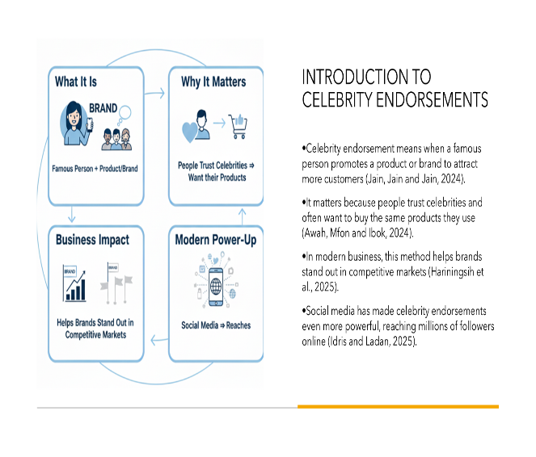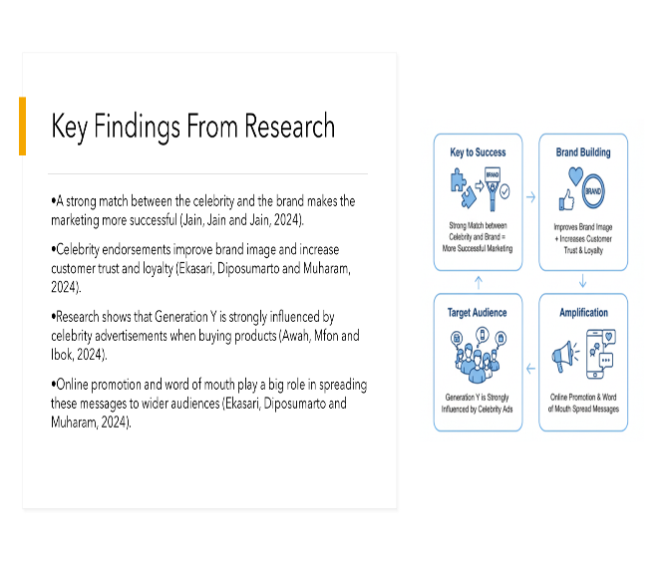

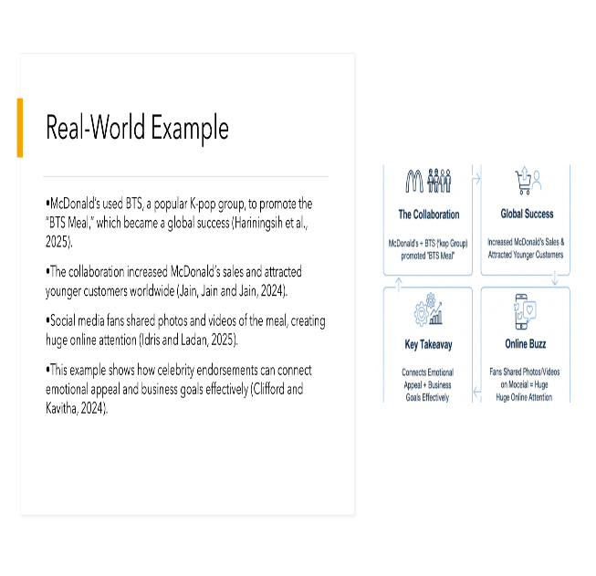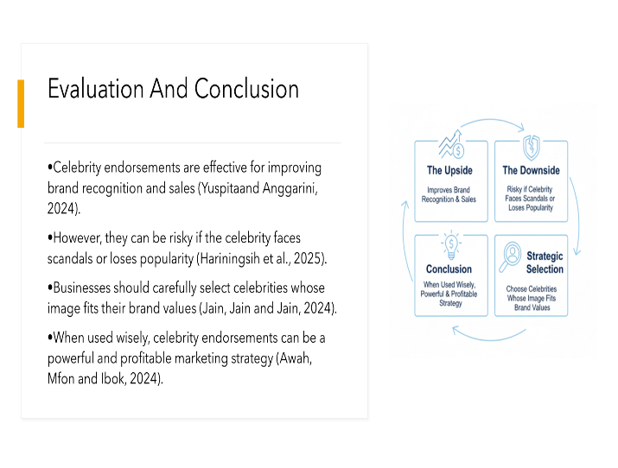

Appendix E – VLOG Planning Notes
How digital/academic skills improved.
New skills gained.
Challenge: studying while managing family and pregnancy.
Achievement: completing tasks on time.
Goal: finish university and start a business.

VLOG: Recording-20251208_165822.webm

