

Module name: Introduction to Public Health
Module code:(LCHS4008_LON)
Student name: Darianny Santana Valdez
Student ID: 2440015

Lecturer’s name: Odette Jack

Table of contents
- Introduction & stroke.
- Main body.
- How is stroke controlled?
- Consequences of stroke?
- Health and social care support services are required to meet the needs of individuals affected by stroke within the community

Introduction
Stroke is one of the most common conditions worldwide, and it can happen suddenly without you knowing. The main symptoms are sudden numbness or weakness in the face, arm, or leg, especially on one side of the body, Sudden confusion, trouble speaking, or difficulty understanding speech, sudden trouble seeing in one or both eyes, Sudden trouble walking, dizziness, loss of balance, or lack of coordination, according to NHS Stroke (2024). Over the past few decades have been studied, and in this time, there is more knowledge about this condition or disease. This disease doesn’t have an exact age at which a person dies, but it is more likely to happen to older people.
Stroke risk increases when medical conditions, lifestyle choices, and genetic or demographic factors damage blood vessels, promote clot formation, leading to interrupted blood flow to the brain. However, stroke is a major global health issue with high mortality rates globally. According to the World Health Organisation (WHO), 12.2 million people experience a stroke each year worldwide, and around 6.5 million deaths are attributed to stroke annually. In the UK, this issue also represents a major public health concern. Data from the Office for National Statistics (ONS) and Office for Health Improvement and Disparities (OHID) shows me that there are approximately 100,000 new strokes each year, causing around 38,000 deaths annually. The good news is that
over 1.2 million survivors are living in the UK. This report will provide an overview of stroke, including a clear definition of the condition based on recognised sources such as the World Health Organization or the National Health Service. It will then outline the key signs and symptoms of stroke, followed by the main risk factors that increase the likelihood of developing the condition. The report will also examine the incidence of stroke, using both global statistics from organisations such as the WHO and UK data from sources like the Office for National Statistics, to highlight the severity of the issue. Overall, the aim is to provide a clear understanding of stroke, its causes, impact, and importance as a major public health concern.

Main Body
Approaches used to measure and monitor stroke
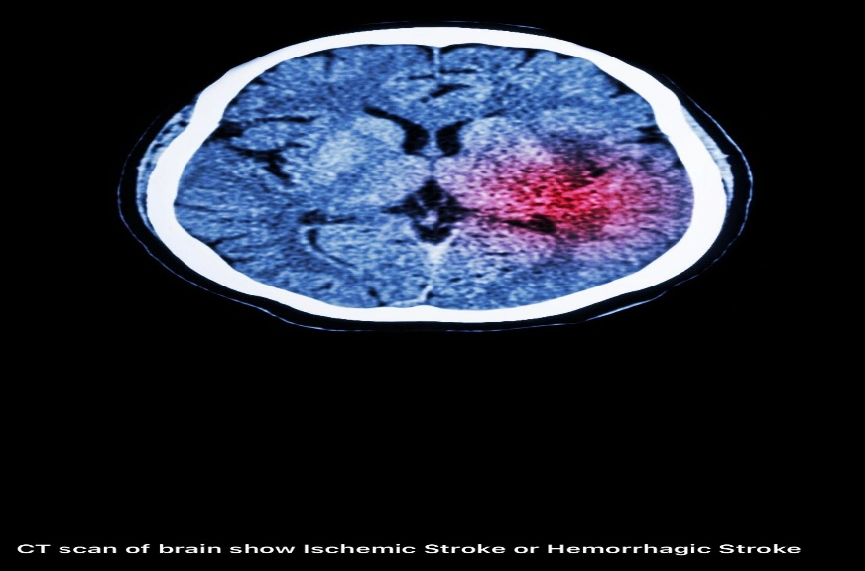
In the UK, stroke is measured through fast clinical assessment and diagnostic testing. The FAST (Face, Arm, Speech, Time) test is widely used to identify symptoms quickly. In hospitals, CT and MRI scans confirm the diagnosis and determine the type of stroke. Healthcare professionals also carry out neurological examinations to assess the severity of brain impairment. Data on stroke incidence and outcomes are collected nationally through systems such as the Sentinel Stroke National Audit Programme (SSNAP) and the Office for National Statistics, which helps track patterns and improve stroke care across the country.
Approaches used in the UK to monitor stroke. Monitoring stroke in the UK involves ongoing assessment after diagnosis to support recovery and prevent this to happening again. Patients attend regular follow-up appointments where healthcare professionals monitor blood pressure, cholesterol levels, and overall health. Rehabilitation progress is tracked by physiotherapists, occupational therapists, and speech and language therapists. Community services and GPs provide long-term support and review risk factors such as smoking and diet. National audits like SSNAP also monitor the quality of stroke care and patient outcomes, ensuring continuous improvement in services and helping to reduce future stroke risk.

How is stroke controlled?
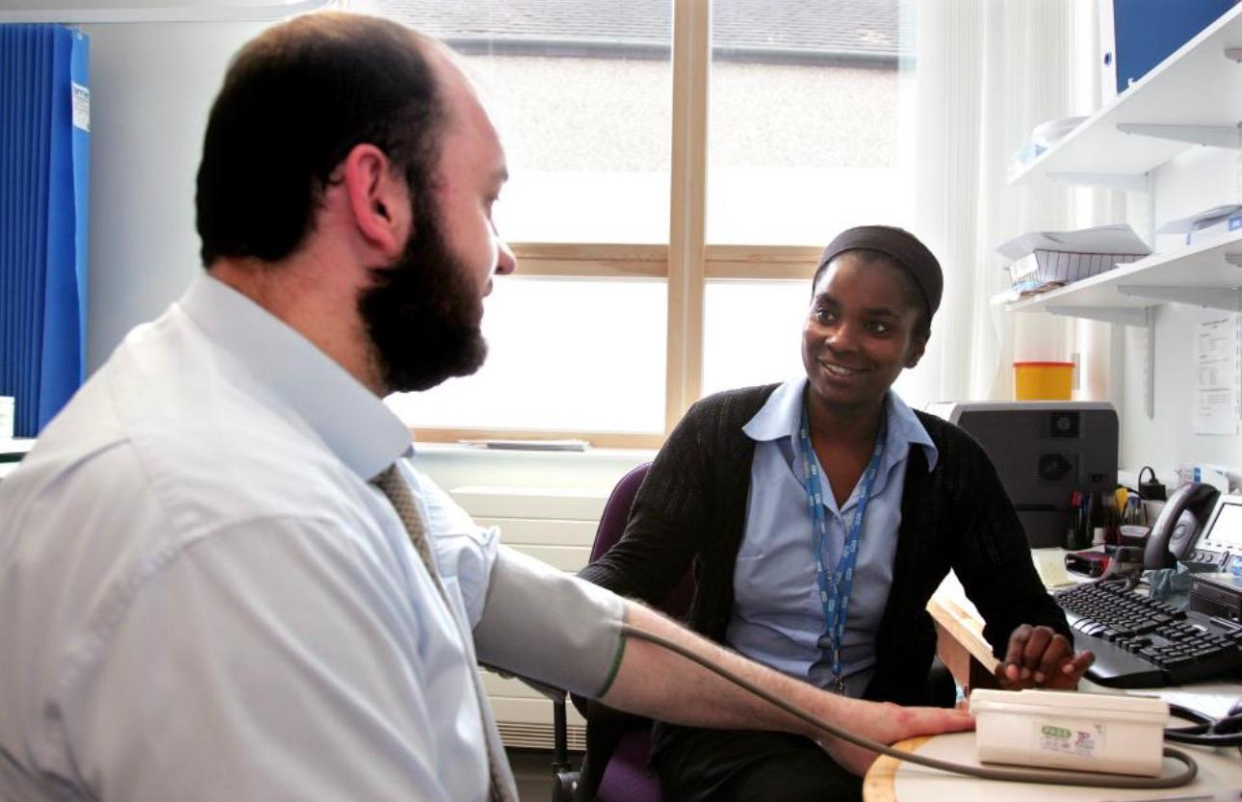
Stroke is controlled in the UK through prevention programmes, rapid emergency treatment, and long-term management strategies led by the National Health Service (NHS). A key prevention programme is the NHS Health Check, which targets adults aged 40–74 to identify those at risk of cardiovascular diseases, including stroke. It aims to detect conditions such as high blood pressure, high cholesterol, diabetes, and obesity early. Interventions include lifestyle advice, such as improving diet, increasing physical activity, reducing alcohol intake, and stopping smoking. Medication may also be prescribed to control risk factors. Public health campaigns, such as the FAST campaign, are used to raise awareness of stroke symptoms and encourage people to seek immediate medical help. Early recognition is vital, as timely treatment can significantly reduce brain damage and improve survival rates. Emergency care is another crucial aspect of stroke control. The NHS provides specialist stroke units where patients receive rapid assessment and treatment. Interventions such as thrombolysis (clot-busting drugs) and mechanical thrombectomy are used to restore blood flow to the brain in suitable patients. Long-term management focuses on preventing recurrence. Patients are often prescribed medications such as antihypertensives, anticoagulants, and statins. Regular monitoring by GPs and community health services ensures that risk factors are controlled. Overall, stroke control in the UK is achieved through a comprehensive approach combining prevention, rapid treatment, and ongoing care.

Consequences of stroke
Stroke has wide-ranging consequences that affect individuals, families, and communities, often described using a biopsychosocial approach. Physically, a stroke can cause weakness or paralysis, usually on one side of the body, as well as problems with coordination, balance, and mobility. Some individuals experience difficulties with speech (aphasia), swallowing, or vision. 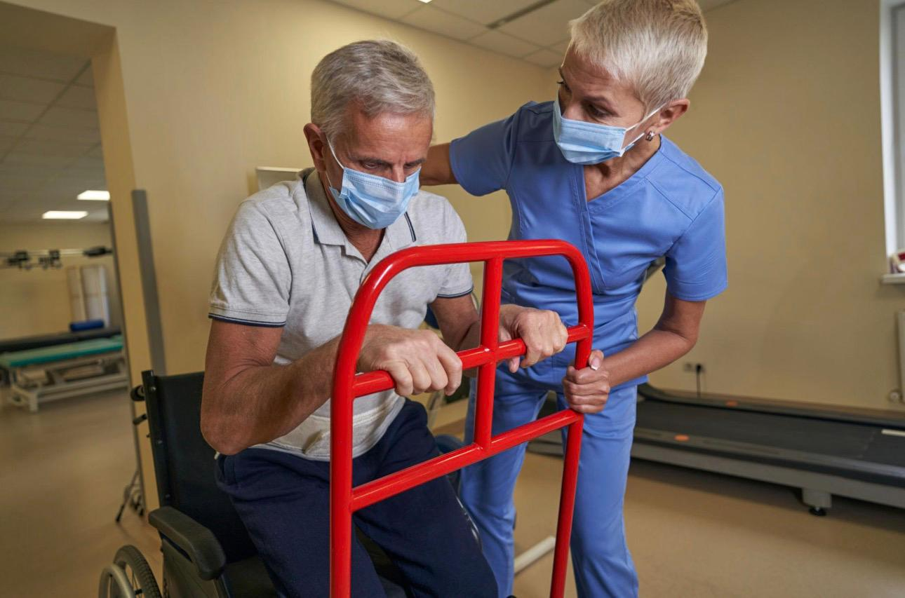
These physical impairments can significantly reduce independence and require long-term rehabilitation. Psychological consequences are also common. Many stroke survivors experience depression, anxiety, or reduced self-esteem due to the sudden loss of function and lifestyle changes. Cognitive impairments, such as memory loss or difficulty concentrating, may also occur, affecting daily activities and decision-making. Socially, stroke can have a major impact on relationships and quality of life. Individuals may be unable to return to work, leading to financial difficulties and social isolation. They may also rely heavily on family members or carers for support with everyday tasks. This can place emotional and physical strain on caregivers, affecting their well-being as well. At a community level, stroke increases demand on health and social care services, including rehabilitation, long-term care, and support services. Organisations such as the Stroke Association provide support groups and resources to help individuals adjust and maintain social connections. Overall, the consequences of stroke are complex and long-lasting, affecting physical health, mental well-being, and social participation. Effective support and rehabilitation are essential to improve outcomes and help individuals regain as much independence as possible.

Health and social care support services required to meet the needs of individuals affected by stroke within the community.
Individuals affected by stroke often experience a wide range of physical, psychological, and social challenges, requiring coordinated health and social care support within the community. Physically, stroke survivors may have mobility issues, paralysis, speech and language difficulties, and problems with daily functioning. Community-based services such as physiotherapy, occupational therapy, and speech and language therapy are essential to support rehabilitation and promote independence. Access to community nurses and general practitioners ensures ongoing monitoring of health conditions and prevention of complications such as recurrent strokes. Psychological support is equally important, as many individuals experience depression, anxiety, or reduced self-esteem following a stroke. Counselling services, clinical psychologists, and peer support groups can help individuals cope with emotional changes and adjust to life after stroke. Social support plays a vital role in reducing isolation. Community stroke clubs, day centres, and voluntary organisations provide opportunities for social interaction, improving overall wellbeing and quality of life.
In addition, individuals may require economic and daily living support. This includes assistance with personal care, home adaptations (such as grab rails or ramps), and financial support through disability benefits or social services. Home care workers and support services can help with daily tasks such as cooking, cleaning, and personal hygiene, enabling individuals to live safely at home. Support for family members and caregivers is also crucial, as they often experience physical, emotional, and financial strain. Respite care services provide temporary relief, while caregiver support groups and education programs help families understand stroke recovery and manage caregiving responsibilities effectively.
Overall, a holistic, community-based approach that integrates health, psychological, social, and economic support is essential to meet the diverse needs of stroke survivors and their caregivers.

conclusion
In conclusion, stroke is a serious health condition that requires effective prevention, control, and long-term management within the community. Understanding stroke and its causes helps individuals adopt healthier lifestyles and reduce risk. Effective control includes medical treatment, rehabilitation, and monitoring to prevent recurrence. However, stroke often leads to significant physical, psychological, and social consequences, affecting independence and quality of life. Therefore, comprehensive health and social care support services are essential. These include physiotherapy, psychological support, community programs, and assistance with daily living. Support for families and caregivers is also crucial to reduce burden and improve care outcomes. Overall, a coordinated, community-based approach ensures better recovery, promotes independence, and enhances the well-being of individuals affected by stroke. This approach supports inclusion, dignity, and long-term sustainability in care.

References
Office for Health Improvement and Disparities (OHID) (2024) Stroke statistics in England. Available at: https://www.gov.uk (Accessed:14/04/2026).

Office for National Statistics (ONS) (2024) Stroke incidence and mortality statistics in the UK. Available at: https://www.ons.gov.uk (Accessed14/04/2026).

Royal College of Physicians (2024) Sentinel Stroke National Audit Programme (SSNAP) report. Available at: https://www.strokeaudit.org (Accessed:15/04/2026).
Stroke Association (2024). State of the Nation: Stroke statistics. Available at: https://www.stroke.org.uk (Accessed: 15/04/2026).

National Health Service (NHS) (2024) Stroke. Available at: https://www.nhs.uk/conditions/stroke/ (Accessed: 16/04/2026).

World Health Organization (WHO) (2024) Stroke, cerebrovascular accident. Available at: https://www.who.int (Accessed: 16/04/2026).

