Diversity in hospitality industry

Student name: Cornelia Stoian
Student number: 2013911
Module Title: Contemporary themes in the hotel and hospitality industry BMIH6001
Lecturer: Laurence Blake

Content Pages

- Introduction……………………………………………………………...3
- Types of Diversity ………………………………………………………3
- Cultural Diversity…………………………………………………4
- Race Diversity……………………………………………………4
- Religious Diversity……………………………………………….4
- Age Diversity……………………………………………………..4
- Gender/Sexual Orientation Diversity…………………………..4
- Disability………………………………………………………….4
- Benefits of Diversity in the Workplace………………………………...5
- Increased Productivity…………………………………………..5
- Increased Creativity……………………………………………..5
- Improved cultural awareness…………………………………...5
- A positive reputation……………………………………………..5
- Increase in marketing opportunities…………………………....6
- Research Findings……………………………………………………...6
- Application to the hotel management and hospitality sector………..7
- Housekeeping Department……………………………………..7
- Food and beverage department………………………………..8
- Recruit for Diversity……………………………………………...8
- Recommendations……………………………………………………..9
- References…………………………………………………………….11

- Introduction
Diversity in hospitality sector works along with multiculturalism and are very important to hotels because it refers to both employees and customers. Developing good diversity for a team in hotel industry also brings better customers service and better creativity and performance. At the foundation of diversity is an understanding of varied and unique experiences, cultural histories, and perspectives. Diversity in hospitality is defined as recognising, valuing, and leveraging these differences in both employees and customers to improve the overall experience for everyone. Diversity is important in hotel industry because it helps improving the service for guests of different cultures, brings different ideas, views, and perspectives to innovate and offer new different services, and help the marketing management team to create better marketing strategies because it helps understand the audience and can adapt the service to guest’s needs. (Roches, 2022)
Once diversity has been implemented in the hotel, the management team have to be proactive about managing the diversity workforce by educating the leaderships in what diversity is and why it is important, find ways to celebrate and recognise diversity, be open to recognise employees feedback because that can be a massive help with cultural knowledge, host meetings about how to bring into the hotel more diversity, and establish clear diversity goals and measure progress to make sure it worth your hard work. (Overproof, 2020)
In few words, diversity is the perfect way to bring fresh perspective in the company and improve service, communication, and innovation, to increase productivity and sales.

- Types of Diversity
Based on the standard diversity definition, the types of diversity in a social context are theoretically infinite: they encompass every characteristic that appears with variations among a group of people such as hair or eye colour, but when it comes to workplaces, there are seven types of diversity to consider: cultural diversity, racial diversity, religious diversity, age diversity, gender/sexual orientation, and disability. (employers, 2023)

- Cultural Diversity
Cultural diversity is related to everyone’s ethnicity and is the set of the family’s values that we grow up with and we bring in the society. This type of diversity is found more in multinational companies.
- Race Diversity
Race diversity has to do with an individual’s physical traits, as example African, Asian, Latino.
- Religious Diversity
Religious diversity refers to multiple religions and believes in the workplace, for example Atheism, Christianity, Buddhism, Islam, and so on.
- Age Diversity
Age diversity means having in the company employees of different ages and generations.
- Gender/Sexual Orientation
Gender can be referring as traditional sense of male and female employees. Some companies might use the term gender balance trying to achieve a 50-50 percent between male and female employees. But because the gender is increasingly redefined these days, the term gender diversity is more appropriate because of the multiple variations in sexual orientation and gender.
- Disability
Here a various list of disabilities can be included, from physical disabilities to chronic conditions. Companies are making accommodations like ramps, facilities, or even providing mental health support so people with disabilities can adapt and integrate into the company.

- Benefits of Diversity in the Workplace
Diversity in the workplace brinks in the environment equal rights and opportunities for all employees, regardless the gender, colour, age, ethnicity, physical ability, sexual orientation, religious beliefs, types of diversity mentioned above. When recognising these types of diversity, as an employer it is important to implement ways to provide ways that contribute to a more diverse and inclusive workplace.
Having diversity in the workplace bring several benefits because these days, world is more and more globalised and interconnected. It is vital for a company’s wellbeing and increased productivity to take advantages for the diverse range of skills that individuals from different backgrounds and languages can bring. There are 5 main benefits that diversity can bring in a company: increased productivity, increased creativity, improved cultural awareness, a positive reputation, increased marketing opportunities. (Options, 2022) Diversity in the workplace will help the company reaching out the very best of their employees and give them the opportunity to achieve their best potential.
- Increased productivity
Bringing diversity into workplace allows more ideas and productivity by bringing in the company a broader range of skills and talent among the employees, along with a broader experience and potential of meeting guests cultural needs.
- Increased creativity
Increased creativity works along with various cultures and backgrounds. If there are many people with different perspectives and solutions to problems, there is a greater chance in the company for problems to be solved.
- Improved cultural awareness.
A diverse range of cultures in a company helps with the global business. For example, if there are guests in the hotel from Asia, having an employee who can speak Filipino will help the language barriers.
- A positive reputation
Companies that support diversity in the workplaces are always known as better and supportive employers because potential employees want an employer who can treat them fairly and accept their background.
- Increase in marketing opportunities.
A company who promotes diversity in the workplace show employees and customers more trust because this makes them feel like they can rely on the company more. Using diversity marketing strategies when advertising, will promote the potential employee a positive reputation of the company.

- Research findings
Research analysis shown that businesses who supported both gender diversity and cultural and ethnic diversity are stronger and brings more profit. The most diverse companies are these days, the more likely they are to increase their profitability.
A case study shown that in 2019 companies in the top quartile for gender diversity on executive teams were 25 percent more likely to have above-average profitability then companies in the fourth quartile.
In the case of ethnic and cultural diversity, the business-case findings are equal: in 2019 top quartile companies outperforming those in the fourth one by 36 percent in profitability. The likelihood of performance continues to be higher for diversity in ethnicity rather than gender.
The business case for diversity in executive teams remains strong.
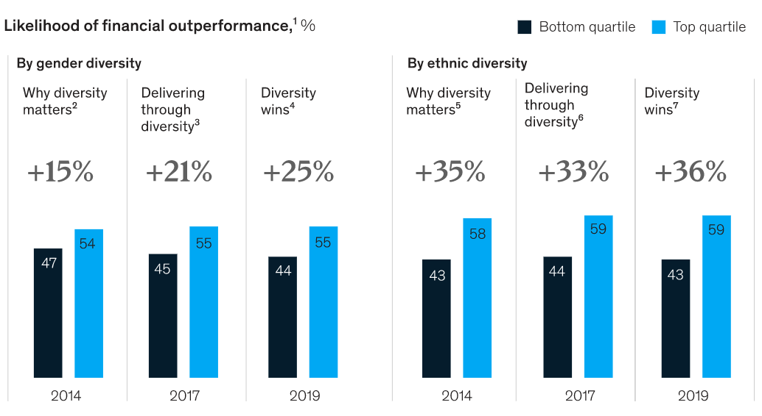
(McKinsey&Company, 2020)
The general business diversity management research suggests that workgroup composition can influence individual and group performance along with the quality work performance and co-workers’ relationship. Given the team orientated, independent nature of work in the hospitality and tourism industry, researched conducted studies that help practitioners understand which are the most effective perspectives and approaches to diversity management. Also, there are a lot of research on diversity management focusing on employees with disabilities. It is important to put more light on diversity management practices, workplace etiquette of this smaller group of employees and their interaction with their other colleagues. ( Kalargyrou & Costen, 2017)

- Application to the hotel management and hospitality sector
Having a diverse workforce goes behind just Human Resource management. If it is applied in a proper way, there are many benefits of diversity in a hotel department because a more diverse workforce is more creative, solve problems more effectively, are more innovative, and are better decision making. Cultivating employee engagement and internal communication strategies places diversity at the core of everything you do in the workplace and demonstrate sustained commitment to employee connection for all. (Grossmann, 2022)
- Housekeeping department
Educate housekeeping manager in what are benefits of diversity in the workplace. Housekeeping is the department with the most women because this is the nature of the job. However, employing male porters and laundry staff will help making a balance in gender diversity. When it comes to cultural diversity, the location of the hotel is very important. For example, if a hotel is situated in London cultural diversity is more varied because there are more nationalities living in London rather than a smaller location, for example Blackpool. But a balance should still be considered when hiring new staff so a varied nationality should be brough in the hotel, especially of the hotel usually has a range of other nationalities as guests. Age is another factor that should be considered in housekeeping diversity. Although older housekeepers are more effective and efficient when doing their job because they are more experienced, younger housekeepers can bring an increased morale in the team and they are more open to friendships and teamwork.
- Food and beverage department
According to a research, food and beverage companies often fail their diversity, inclusion, and equality strategies because they hire more women for example, rather than looking at the company’s structures that favour certain groups. Before looking at gender diversity, is important to state that changes need to start with company’s leaders because they are in the position to stimulate changes, set targets, and measure progresses in how effective diversity is. (Macdonald, 2022) Extending food careers in food and beverage department is another way to improve diversity. To do this, develop diverse talent through training and mentorship programmes, promote diverse leaders and increase their visibility, create cultures of belongings. (Connell, 2022)
- Recruit for diversity
As mentioned at the beginning of the report, it is proven that companies who improve and work with diversity are more innovative, profitable, and work generally better because diverse people naturally bring new ideas and perspectives on board with them, and they are especially good at problem solving. Hiring for diversity helps the company by having a variety of cultural insights and background in the team. The benefits of hiring for diversity is that when you work with people of different background and working styles this will encourage your old staff in the team to have a more creative thinking which leads to better decision making.
When hiring a diverse range of staff, you show your employees and customers that you appreciate everyone’s work despite their race, age, ethnicity, sexual orientation and so on. By showing this to your customers, they will appreciate your business and your way that you treat your employees, and they will become more loyal to your service.
Another point of hiring for diversity is that is increases the likelihood of having a staff member that understand the needs of a specific client, for example cultural or ethnical needs.
According to research, when it comes to hiring for diversity food and beverage companies focus the most on gender diversity (71%) because now in this industry there are more female employees rather than male employees. Next it comes racial and ethnic diversity (49%) because this helps with customer service and understanding customer’s ethnic and cultural needs. The third aspect when hiring for diversity in food and beverage sector is age diversity (48%). It must be a balance between age employees because of experience, performance, knowledge, but also morale and teamwork. It is shown that younger employees are more opened to work as a team and develop better work relationships rather than older generations.
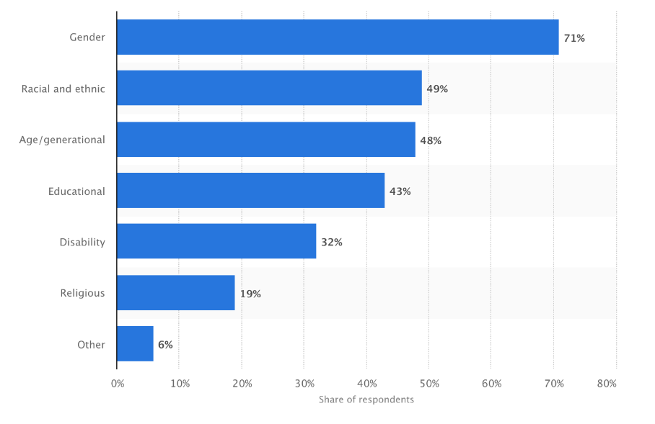
(Rosie, 2021)
- Recommendations
One of the biggest recommendations when it comes to diversity is to stop thinking about it as a buzzword. Is a good practice for a company to remember that building diversity is something that as a manager you should focus and work on it every day, just as all other employees work for the company’s wellbeing and sales every day because diversity is not just about hiring new workforce and that is the end of it, or about putting new policies in place and looking at the diversity levels. As a manager of a company who wants to promote diversity, this should be on a daily tasks list, and it should be observed every day.
Make diversity a part of your company’s hire process and consider your diversity levels when deciding about your next employee.
Make sure leadership is aligned with the company’s goals because managing a diverse culture is not easy just for one person and it can be challenging at times. Without the help of your managing team, it might be a lost cause. As a recommendation, a leader should be on board with the general manager’s plans about diversity. Additionally, to your support, a leader’s behaviour and actions will serve as an example to all other employees and will make clear what are the expectations from them. (Team, 2019)
Looking at the companies’ policies is also important when implementing diversity, because the company’s policies must follow what is currently going on in the company and how things work. A diverse company should have policies in place that fight systematic inequality, that support employees of other sex orientation as well as traditional couples, should have policies for employees with disabilities, and so on.
And the finally, creating a culture with empathy and forgiveness will help maintain diversity and inclusion. To promote this, department leaders must admit their mistakes so in this way they will be an example and they will encourage other employees to do the same with their colleagues.

- References

References
Kalargyrou, V. & Costen, W., 2017. Research gate. [Online]
Available at: https://www.researchgate.net/publication/312667981_Diversity_management_research_in_hospitality_and_tourism_past_present_and_future
[Accessed 24 5 2023].
Connell, S. F., 2022. Forbes. [Online]
Available at: https://www.forbes.com/sites/forbescoachescouncil/2022/02/14/the-opportunity-for-diversity-in-food-service-is-at-the-top/
[Accessed 24 5 2023].
employers, R. f., 2023. Resources for employers. [Online]
Available at: https://resources.workable.com/hr-terms/the-types-of-diversity
[Accessed 19 5 2023].
Grossmann, C., 2022. Beekeeper. [Online]
Available at: https://www.beekeeper.io/blog/5-ways-promote-workplace-diversity/
[Accessed 24 5 2023].
Macdonald, C., 2022. Global Insights. [Online]
Available at: https://insights.figlobal.com/diversity-inclusion/how-food-and-drink-companies-can-work-toward-diversity-and-inclusion
[Accessed 24 5 2023].
McKinsey&Company, 2020. McKinsey&Company. [Online]
Available at: https://www.mckinsey.com/featured-insights/diversity-and-inclusion/diversity-wins-how-inclusion-matters
[Accessed 24 5 2023].
Options, A., 2022. Ability Options. [Online]
Available at: https://abilityoptions.org.au/5-benefits-of-diversity-in-the-workplace/#:~:text=A%20diverse%20workplace%20is%20an%20inclusive%20environment%20that%20provides%20equal,religious%20beliefs%2C%20and%20so%20on.
[Accessed 19 5 2023].
Overproof, 2020. Overproof. [Online]
Available at: https://overproof.com/2020/06/15/the-importance-of-diversity-in-the-hospitality-industry/
[Accessed 19 5 2023].
Roches, L., 2022. Les Roches. [Online]
Available at: https://lesroches.edu/blog/diversity-hospitality-industry/#:~:text=Diversity%20in%20hospitality%20means%20recognizing,the%20overall%20experience%20for%20everyone.
[Accessed 19 5 2023].
Rosie, 2021. Harver. [Online]
Available at: https://harver.com/blog/diversity-in-hospitality/
[Accessed 24 5 2023].
Team, T., 2019. Talent Culture. [Online]
Available at: https://talentculture.com/7-tips-to-manage-a-diverse-workforce/
[Accessed 24 5 2023].

