Mohammed Muddasar

Operating Hotel Facilities

Student id: 2121682

Ffion Cumberpatch

Development Plan

BMIH4006


HOUSKEEPING
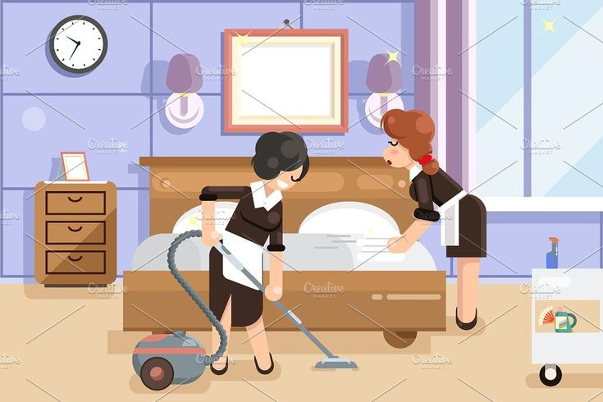
INDUCTION SHIFT GUIDE
# (Pinterest, n.d.), (hotelstrinity.com, n.d.)
WEEK  ONE | WEEK TWO | WEEK THREE | WEEK FOUR | WEEK FIVE | WEEK SIX | WEEK SEVEN | WEEK EIGHT
TOUR  OF  BUILDING | SHADOW  AN  EMPLOYEE | SHADOW  AN  EMPLOYEE | SHADOW  AN  EMPLOYEE | DIFFERENT ROOM SETUP  DEMO | DIFFERENT ROOM SETUP CHECK | PUBLIC AREA  CLEANING | PUBLIC AREA CLEANING  CHECK
INTRO  TO  TEAM | UNIFORM  STANDARD  TRY ON | HOW  TO  USE EQUIPMENT | ROOM TIMINGS | ROOM TIMINGS CHECK | SHADOW  HOUSE  KEEPING  MANAGER | MORNING TROLLEY SETUPS  DEMO | MORNING TROLLEY SETUP  CHECK
BENEFITS  &  REWARDS  SETUP | CLEANING  ROUTINE  DEMO | CLEANING  ROUTINE  DEMO  CHECK | FIRST  AID TRAINING | FIRST  AID TRAINING | FIRST  AID TRAINING | LIFTING AND MOVING HEAVY LOADS DEMO | LIFTING AND MOVING HEAVY LOADS  CHECK
UNIFORM  &  KEYS  CLOCK  MACHINE | COSHH  TRAINING | COSHH  TRAINING | HOW  TO  SETUP COT | BODY FLUID AND SHARPS KIT  DEMO | BODY FLUID AND SHARPS KIT  CHECK | ACCEPTING DELIVERIES DEMO | ACCEPTING DELIVERIES  CHECK
ACADEMY  ONLINE  TRAINING | ACADEMY  ONLINE  TRAINING | ACADEMY  ONLINE  TRAINING | ACADEMY  ONLINE  TRAINING | ACADEMY  ONLINE  TRAINING | ACADEMY  ONLINE  TRAINING | ACADEMY  ONLINE  TRAINING | ACADEMY  ONLINE  TRAINING
HEALTH AND  SAFETY  INDUCTION | HOUSEKEEPING  GENIE  SYSTEM  DEMO | HOUSEKEEPING  GENIE  SYSTEM  CHECK | LEARNING  WATER SHUT OFF | LINEN STORE  DEMO | LINEN STORE  CHECK | LEARNING SKILLS MATRIX | LEARNING  SKILLS MATRIX
FIRE SAFETY  AND  ASSEMBLY  POINT | BRAND  STANDARD  SETUP  DEMO | BRAND  STANDARD  SETUP  CHECK | WASHING  MACHINE AND DRYER USE | ORDER SYSTEM TRAINING | ORDER SYSTEM TRAINING  CHECK | STOCK CHECK TRAINING  DEMO | STOCK CHECK TRAINING  CHECK
REPORT  TO  MANAGER  MAX | REPORT  TO  MANAGER  OLIVIA | REPORT  TO  MANAGER  STEVE | REPORT  TO  MANAGER  GRACE | REPORT  TO  MANAGER  MAX | REPORT  TO  MANAGER  OLIVIA | REPORT  TO  MANAGER  STEVE | REPORT  TO  MANAGER  GRACE
WEEK ONE
You will report to Max the manager on shift for week one. Week one will consist of the following tasks and things to do. Firstly, you will have an extensive tour of the building, also an introduction to the team through the week. How to use the clock in machine and uniform expectations. Benefits and rewards program setup, you will have to spend time on academy online, (academy.whitbread.co.uk, n.d.) throughout the week to complete your training (around 30 modules). You will have a health and safety induction and to complete online course with designated company, (High Speed Training, n.d.). Also, to be told the fire evacuation procedure and fire safety assembly point.

WEEK TWO
You will report to Olivia the manager on shift for week two. You will shadow an employee for the next three weeks; you will need to try your uniform and to report any adjustments that are needed. You will be shown a cleaning routine demonstration, Carry on with your online academy training. You will have to do COSHH training with Diversey (Diversey Global, n.d.) and learn the genie system for housekeeping. A demonstration will be shown to you of how the brand standards on room setup are required by the company.

WEEK THREE
You will report to Steve the manager on shift for week three. Still shadowing an employee, you will be shown how to use relevant equipment related to your department. The cleaning routine shown to you on previous week the manager will have to do a visual check and sign it off, the second leg of your COSHH training will need to be completed. Carry on with your online academy training, also a visual check will have to be done and signed off by manager regarding your training on the genie system which you had on the previous week. A brand standard visual check also will have to be done by the manager as you had training on this on previous week.
WEEK FOUR
You will report to Grace the manager on shift for week four. This will be your last week shadowing an employee after this you will be on your own cleaning rooms; all room timings will be explained to you as well as how to setup a baby cot and extra bed, you will have to start first aid training. Also carry on with online academy training, the manager will show you physically were the water main shut off is in case of any emergency the main one and the individual ones in the bedrooms. The use of the many washing machines and dryers will be shown to you and what products are needed for them.

WEEK FIVE
You will report to Max the manager on shift for week five. You will be shown a demonstration of the different types of room setups, also average times will be taken on how long you’re cleaning each room. Carry on with your first aid training, a demonstration will be shown to you regarding body fluids and sharps kit. Continue with your online academy training, a linen store setup demonstration will be given to you. Training will be given on how to order products in your department.

WEEK SIX
You will report to Olivia the manager on shift for week six. A check list will be ticked off regarding the different room setups you were shown the previous week, you will also be shadowing the housekeeping manager throughout this week. You will need to complete the last module of your first aid training; a checklist will be ticked off by manager regarding the visual demonstration you was given on body fluids and sharps kit in the previous week. Continue with your online academy training, a check list will be ticked off regarding the linen store setup demonstration you were given in previous week. You will be placing an order on the system as you were shown in the previous week.
WEEK SEVEN
You will report to Steve the manager on shift for week seven. How to clean public areas and how to setup the morning trolley will be shown to you by manager. You will be doing online course and visually be shown on how to lift heavy items and general lifting, Carry on with your online academy training. Training will be given to you on how you go about doing the stock check for your relevant department, also you will have to complete the skills matrix.

WEEK EIGHT
You will report to Grace the manager on shift for week eight. A checklist will be signed and ticked off regarding the training you had with cleaning public areas and setting up the morning trolley, you will have to give a demonstration about heavy lifting and the procedure on how to lift goods correctly. Finish whatever you have left on your online academy training. Complete the rest of your skills matrix and you will have to demonstrate on how to do stock check which you learnt on the previous week.

REFERENCES

Pinterest. (n.d.). Housemaid cleaners clean hotel room | Hotels room, Illustration, Hotel floor. [online] Available at: https://www.pinterest.co.uk/pin/838021443145540897/ [Accessed 12 Nov. 2022].
‌hotelstrinity.com. (n.d.). Best Hotels in Coimbatore. [online] Available at: http://hotelstrinity.com/ [Accessed 12 Nov. 2022].

academy.whitbread.co.uk. (n.d.). Academy Online: Log in to the site. [online] Available at: https://academy.whitbread.co.uk/login/ [Accessed 12 Nov. 2022].

High Speed Training | Over 160 Online Training Courses. [online] High Speed Training Limited. Available at: https://www.highspeedtraining.co.uk/.

Diversey Global. (n.d.). Caring. Protecting. Always. | Diversey. [online] Available at: https://diversey.com/en.
‌

‌

‌

