Ethics, Intention and Controversy through the Context of Political Art and Activism

Why Must Art Require Context?

Word Count:4915

Table of Contents

Figures 3

Summary of Topic 6

Introduction 7

Chapter Two - What defines good art? 18

Chapter Three – Intention vs Narrative 24

Chapter Four – Ethics and Hyper-Objectivity 30

Bibliography 36

Figures

Figure 1 - Ron Athey and Darryl Carlton, (1994), Performing Four Scenes in a Harsh Life 9

Figure 2 - Derek Jarman, (1987), Sowers and Reapers 12

Figure 3 - Derek Jarman (1987), Dead Man's Eyes 13

Figure 4 - Andrés Serrano (1990), Semen and Blood VI 14

Figure 5 - Andrés Serrano, (1990), Dante’s Inferno. 15

Figure 6 - Andres Serrano (1990), Semen and Blood III 15

Figure 7 - Gustav Klimt (1907), Danae 19

Figure 8 - Joseph Beuys (1982), 7000 Oak Trees 22

Figure 9 - C, Büchel (2019) Barca Nostra 25

Figure 10 - Forensic Architects, (2022), Drift-backs in the Aegean Sea 27

Figure 11 - Jez Riley French, (2019), island | fjórar 31

Figure 12 - Derek Jarman (1992), Oh Zone 33

Figure 13 - Derek Jarman (1992), Acid Rain 33

- Walkerart.org. (2014). Ron Athey’s 1994 Minneapolis Performance and the Anatomy of a Media Scandal. [online] Available at: https://walkerart.org/magazine/ron-atheys-1994-minneapolis-performance-and-the-anatomy-of-a-media-scandal#_edn1 [Accessed 6 Dec. 2022].
- Artuk.org. (2021). Derek Jarman: painting, protest and the AIDS pandemic | Art UK. [online] Available at: https://artuk.org/discover/stories/derek-jarman-painting-protest-and-the-aids-pandemic [Accessed 14 Dec. 2022].
- Artuk.org. (2021). Derek Jarman: painting, protest and the AIDS pandemic | Art UK. [online] Available at: https://artuk.org/discover/stories/derek-jarman-painting-protest-and-the-aids-pandemic [Accessed 14 Dec. 2022].
- Serrano, A. (2009). Blood + Semen V, 1990. [online] Mutualart.com. Available at: https://www.mutualart.com/Artwork/Blood---Semen-V--1990/E54C381857DD078C [Accessed 7 Dec. 2022].
- Serrano, A. (2022). Dante’s Inferno. [online] Artnet.com. Available at: https://www.artnet.com/artists/andres-serrano/dantes-inferno-MO1z7R-VOa2XwSRwInwlVQ2 [Accessed 14 Dec. 2022].
- Serrano, A. (2000). Semen and Blood III. [online] Mutualart.com. Available at: https://www.mutualart.com/Artwork/Semen-and-Blood-III/C4B5097E13711EAC [Accessed 7 Dec. 2022].
- Gustav-klimt.com. (2022). Danae, 1907 by Gustav Klimt. [online] Available at: https://www.gustav-klimt.com/Danae.jsp [Accessed 14 Dec. 2022].
- Tate (2021). ‘7000 Oak Trees‘, Joseph Beuys, 1982 | Tate. [online] Tate. Available at: https://www.tate.org.uk/art/artworks/beuys-7000-oak-trees-ar00745 [Accessed 14 Dec. 2022].
- Dafoe, T. (2021). The Migrant Ship That Christoph Büchel Controversially Displayed at the Venice Biennale Has Returned to Sicily, Where It Will Become a Memorial. [online] Artnet News. Available at: https://news.artnet.com/art-world/fishing-ship-behind- controversial-artwork-venice-biennale-returned-sicily-will-become-memorial-garden- 1961025 [Accessed 10 Dec 2022].
- Forensic-architecture.org. (2022). Forensic Architecture. [online] Available at: https://forensic-architecture.org/investigation/drift-backs-in-the-aegean-sea [Accessed 13 Dec. 2022].
- Jezrileyfrench.co.uk. (2021). island fjórar. [online] Available at: https://jezrileyfrench.co.uk/island----fj%C3%B3rar---2013-on-going.php [Accessed 14 Dec. 2022].
- Amanda Wilkinson. (2020). Derek Jarman, Acid Rain, 1992. [online] Available at: https://amandawilkinsongallery.com/artists/31-derek-jarman/works/5944-derek-jarman-acid-rain-1992/ [Accessed 14 Dec. 2022].
- Amanda Wilkinson. (2020). Derek Jarman, Oh Zone, 1992. [online] Available at: https://amandawilkinsongallery.com/artists/31-derek-jarman/works/5945-derek-jarman-oh-zone-1992/ [Accessed 14 Dec. 2022].
‌
.

Summary of Topic

.
This research paper is an enquiry into ‘Why must Art require context?’. Its purpose is comprised by the exploration and consideration of context through Fine Art. This research investigates what we consider to be art and why, as well as, how far we may go to create ‘good’ art. Through the lens of ethics, we discover themes of controversy and narrative, allowing ourselves to question the intentions of an artist. Here, the idea arises that there may be inherent value in art, depending on it’s artistic and aesthetic autonomy, independent of it’s subject matter. Can the artist be separated from the art? An investigation into the obscurity between an artist’s purpose and morality, the occurrence of sacrificing personal ethics in the attempts to redeem success (an act of the ego, rather than of altruism). This query will also endeavour into, how art can become an anchor point for influencing conscious efforts in making, long term sustainable choices that impact communities and climate.

Introduction

In order to establish a well informed and comprehensive understanding of the ‘on going’ debate that divides art from aesthetic, we must discuss the reasoning why art requires meaning in the first place.... and what defines art.
This paper will be, making criticisms and comments on the shifts in contemporary art and the significance it plays. It will also consider, the cultural significances that influence modern art. I will be scrutinizing the theories behind those that have created exceptionally significant works of art throughout the 21st century. In particular, I will be querying the works that sparked speculation and directly spurred controversy in the art world. Alternatively, the controversy of the materiality and the morality of artists, respective to their work.
Danto argued instead that the art world provides a background theory that an artist invokes when exhibiting something as art. This relevant ‘theory’ is not a thought in the artist’s head, but something the social and cultural context enables both artist and audience to grasp.
C, Freeland, p.55

Chapter One – Controversy

The idea of ‘controversy’ is widely discussed in art literature and encapsulated by much of the modern day art scene, as many of which become consumed by large scale public disagreements and frequently generates heated discussions (Cambridge Dictionary, 2022).

One of the most pressing questions of the past decade asked, ‘was Michael Jackson truly a paedophile?’ ….. and with his untimely death headlining the globe, do people still acknowledge this part of Jackson’s reality? Is he too big to cancel?
To ‘cancel’ a worldwide icon, or rather, public figure, has become a recurrent event in modern culture. This form of, ‘cancel culture’ per say, refers to a common practice of encouraging the discontinuation of any form of backing or support. This is often due to discovering negative recollections from their, (quite frequently) distant past, which is commonly, a statement made that is now considered offensive or inappropriate (Lemoine, 2020).

It seems to be a relative theme that accountability faults, especially when allegations are pasted worldwide of sexual assault, particularly when the persecuted was once seen as a universal idol. Audiences almost refuse to countenance moral or legal absolutes.
Can we still listen to his music? It is worth noting the first allegations headlined during the nineties, he slept in the same bed as a 13-year-old boy for 30 nights (Orth, 2019).

It's tough to separate man and music when his output amounts to a cultural phenomenon and his impact extends far beyond music. Should the same critique apply to all artists?
Art can no longer be art today if it does not reach into the heart of our present culture and work transformatively [sic] within it that is, an art which cannot mould society — and through this naturally operate upon the core questions of our society — is not art.
Joseph Beuys, (anull)
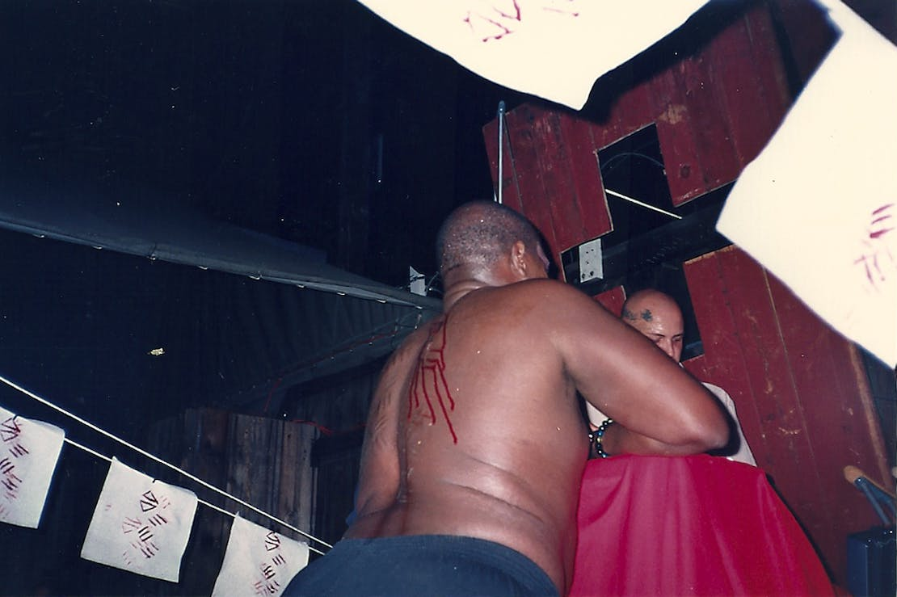
Figure 1 - Ron Athey and Darryl Carlton, (1994), Performing Four Scenes in a Harsh Life

Is it important/ necessary to censor particular artistic content and imagery that lacks redeeming social values????
Some works of art, or rather the actions of a creative endeavour, many left to be more contestable than others, are too shocking to disregard repercussion. Ron Athey, a performance based artist, who’s work thrived in the 90s, was often overlooked due to his intimate exhibitions of ‘physical intensity’ (Athey, 2014). During one spectacle in particular, set in Minneapolis, Athey took the risk of sacrificing any reputability, via creating mass panic and hysteria. His actions were in the form of bloody soaked rags displayed over the audience. Ron Athey is openly HIV positive, potentially putting spectators at risk of transmission (C, Freeland. p. 4). Thus, the meaning of the work was disregarded. Thereafter, a large quantity of negative publicity following the performance, highlighted only the scare that it had produced (p.4). Subsequently, articles frequently referring to Athey as the ‘AIDS Artist’ (L.A. Times, 1994), virtually reducing the performer’s medium to the virus itself. In reality, the blood used was never his own, and thus his work became grossly accused of ‘endangerment’ and for a long period of time was left with a limited audience (Vice.com, 2014). The dominating principle underlying this issue, is the relevance of context. The crucial aspects of the message portrayed by the performance were rescinded by the moral principles of the witnesses. Unfortunately, the actions only magnified the issues that Athey was attempting to represent in the first place. The response highlighted the intolerance and fear mongering that was ever prevalent during 1980s period (HIV.gov, 2022). Furthermore, questions of materiality are raised. Was the use of blood crucial to the context of the artwork?
David Hume theorised that a work of art is only wonderful if it elicits a specific emotion. Beauty appeals to "shared sentiment," therefore the response should be universal to objective observers. He believed in a standard of taste, a universal consensus, allowing experts to filtrate what fell into this categorisation (c. Freeland, p 9). This was arguably, a form of censorship. However, if this is the case, did Athey not achieve exactly that, he evoked and received an overwhelming shared response from the spectators.
Nonetheless, it is probable that Hume would have disregarded artworks that displayed any relevance of profanity, corruption and dishonourable means. Imagery of sex or the use of any bodily fluids would not have been deemed appropriate, with no place in art. Alternatively, Hume felt that artists should follow the path of supporting visions of progress, informed and cultured values, as well as encouraging ethical and virtuous refinements or of personal developments (C, Freeland, p 8). All positively positive….

Is the topic/subject matter the controversial part? Or is it the material?

During the 1980-90s, HIV became a feared diagnosis, as it was in many ways a ‘death sentence’.
The narrative for this hyper-object was extensively misunderstood, with many of the first publications headlining, what was, back then, a nameless disease, referred to as ‘Gay Men’s Pneumonia’ (HIV.gov, 2022).

Derek Jarman was an English Painter and film maker, whose work commonly followed the route of an autobiographical nature (Derek Jarman, 2018). Jarman’s work being a vibrant representation for unity, visibility, equality and was a way of registering and comprehending his declining health. Jarman was faced with his HIV diagnosis in 1986 (Tate, 2022)
and rapidly became an, unapologetically, outspoken critic on homophobia during this time, ‘I thought: this is not true, then I realised the enormity. I had been pushed into yet another corner, this time for keeps’. (Artuk.org, 2021).

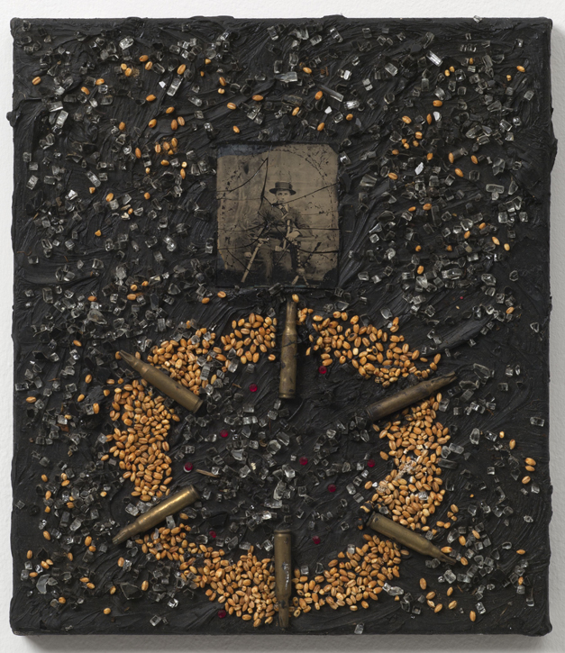
Figure 2 - Derek Jarman, (1987), Sowers and Reapers

Sowers and Reapers (1987) was one of a series of ‘Black Paintings’, a wordplay on the string of works by Francisco Goya, whose subject correspondingly portrayed his bleak perspective of society (Phelan, 2019). Jarman’s series of ‘black paintings’, was the formulation of a ‘rebellion’ against section 28, which prohibited the ‘promotion of homosexuality’ (Education and the Law, 2014).

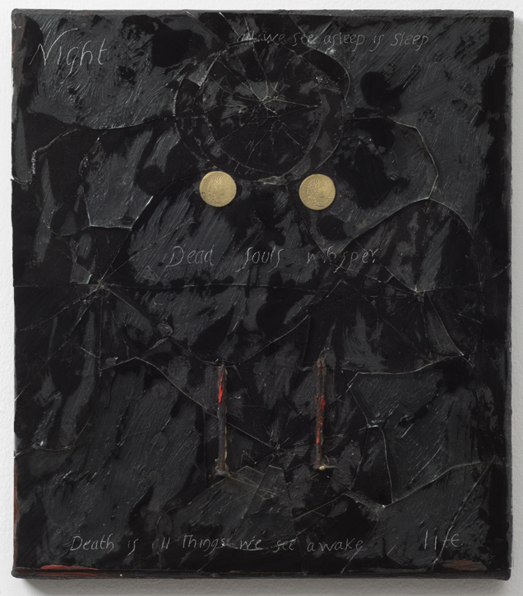
Figure 3 - Derek Jarman (1987), Dead Man's Eyes

The way in which the queer community struggled in the 1980s, has been instrumental in our understanding of these works Jarman produced. In particular, Dead Man’s Eyes (1987), in which Jarman composed a far more significant piece of work in response to the hostility. He ‘gestured’ and impressed two gold coins into the painting. This was in reference and preceded to his sight atrophy (Artuk.org, 2021). In addition, alluding to and possibly coming to terms with, the eventual realities of his diagnoses and progression to Aids, Jarman engraves into the impasto, ‘death is on things we see awake’, perhaps in reference to the atrocities he had witnessed throughout his lifetime. This may not be limited to the HIV crisis, but also his interaction with environmental concerns.

Jarman curated his work without the means of using ‘offensive’ materiality. The contents of his practice follows that of Rom Athey’s, a continuation of the similarity in struggle and oppression. Nonetheless, Jarman’s practice, in comparison, suffered fewer forms of censorship, when exhibiting.

The book, ‘Is it Art’ by Cynthia Freeland offers the opinion that by today’s standard there is little merit in what constitutes art, ‘anything can be a work of art, given the right situation and theory’ (C, Freeland p.57).
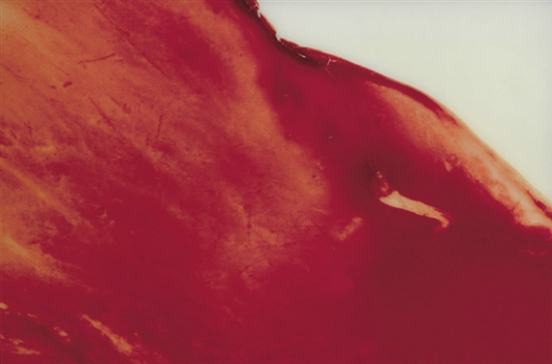

Figure 4 - Andrés Serrano (1990), Semen and Blood VI

Analogously, at the height of the AIDS crisis, Blood and Semen V (1990), produced by Andres Serrano, reduced the life and death cycle to a mixture of two biological fluids as seen through a microscope (C, Freeland, 2001).
Serrano created a ‘self-referential aesthetic’ by repurposing the body and its fluids as material in this abstract work. A work carrying the properties of both construction and destruction, portrayed in an elegant picture. Serrano was not looking to cause contention, but rather to investigate the aesthetic effects that human fluids might have when shot in photographic portraits. The result of this novel technique is a melancholy rendition of sacred iconography. Which appears, relevant in this series of work, incorporating the use of religious figurines captured submerged in an array of bodily fluids, including that of blood and semen.

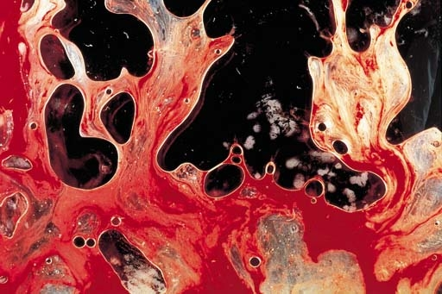
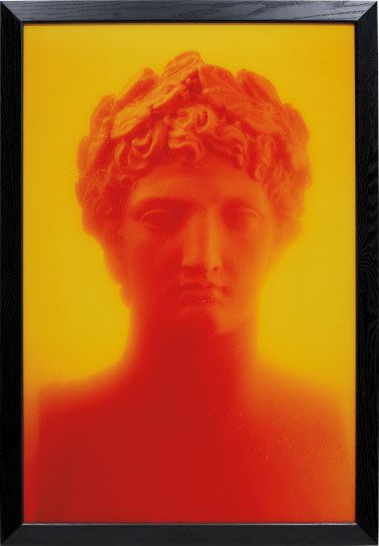
Figure 5 - Andres Serrano (1990), Dante’s Inferno.
Figure 6 - Andrés Serrano, (1990), Semen and Blood III

Fabricating artworks that constitute the use of using materiality that is unconventionally sourced may be a vivid attempt to create reaction. Are Athey and Serrano victims of the pressures of eccentricity? Or are they just alternatively defining/expressing their own truths?
Industry has been mechanized and an artists’ cannot work mechanically for mass production…. Artists find it incumbent…. To betake themselves to their work as an isolated means of ‘self-expression’. In order not to cater to the trend of economic forces, they often feel obliged to exaggerate their separateness to the point of eccentricity.
(C. Freeland, 2001, p. 6)

In an interview, Athey discussed how, despite the nature of his practice, he did not make create performances for his audiences. Confidently expressing that he certainly did not fabricate these perilous and scathing productions for the attention of the media, “He's working through his own experience-the experience of outliving your friends in an epidemic, and not quite understanding why you're alive” (Vice.com, 2014). His work rather is exclaiming the profanity, devastation and obscenity that occurred in an era that many could not even comprehend.
Every man is an artist: Only art is capable of dismantling the repressive effects of a senile social system that continues to totter along the deathline [sic]: to dismantle in order to build A SOCIAL ORGANISM AS A WORK OF ART. This most modern art discipline – Social Sculpture/Social Architecture – will only reach fruition when every living person becomes a creator, a sculptor, or architect of the social organism.
(Tate, 2021)

Joseph Beuys was well known for his contributions to the ‘extended definitions of art’ (Tate, 2022), in which he progressed ideas of sculpture as a social construct, formulations and discussions for a variety of socio-economic and environmental issues. Beuys’ approach to art and materiality progressed into a means to generate change, his theory of sculpture characterized as, ‘the passage of all things in the world from a state of chaos into a state of order’, (Wackenhut, 2015).
By questioning the functionality and possibilities of art, Beuys lays out the ways in which transgressive artwork challenges conventional ways of considering art.

Chapter Two - What defines good art?

“The art world is a competitive place, and artists need any edge they can get, including shock value.” (C, Freeland, 2002, p.6)
Art can play an important role in addressing global issues such as the climate crisis, war and politics. Despite the positive position art can play and thus contribute to these subjects, is it imperative that art must always have ulterior motives, or rather, something to testify to?
Is the intention of the artwork just as, if not more, important than the aesthetic execution?
The argument against art for arts sake, or rather, the relation to exhibiting works for the premise of ‘aesthetic value’, seemingly becomes less prominent. ‘Aesthetic’, meaning the enjoyment of, or relation to something an individual finds pleasing to the eye, or holds a quality of beauty (Cambridge Dictionary, 2022), comes from the Greek word, ‘aisthesis’. However, ‘aisthesis’, holds more value, meaning ‘sensation or perception’ (C.Freeland, 2002, p.8).

Aisthesis was used to theorise not just concerns of beauty and art, but also perception, the theory of knowledge, and the relations between them. It was only later subsumed by the German philosopher, Alexander Baumgarten, who superseded the word, with Aesthetic, narrowing the meaning to the enquiry of beauty (Vichnar and Armand, 2017).
Ergo, what can be defined as beautiful and is there a criterion or measure for what beauty is? Is it not as subjective, as it is commonly, understood to be?

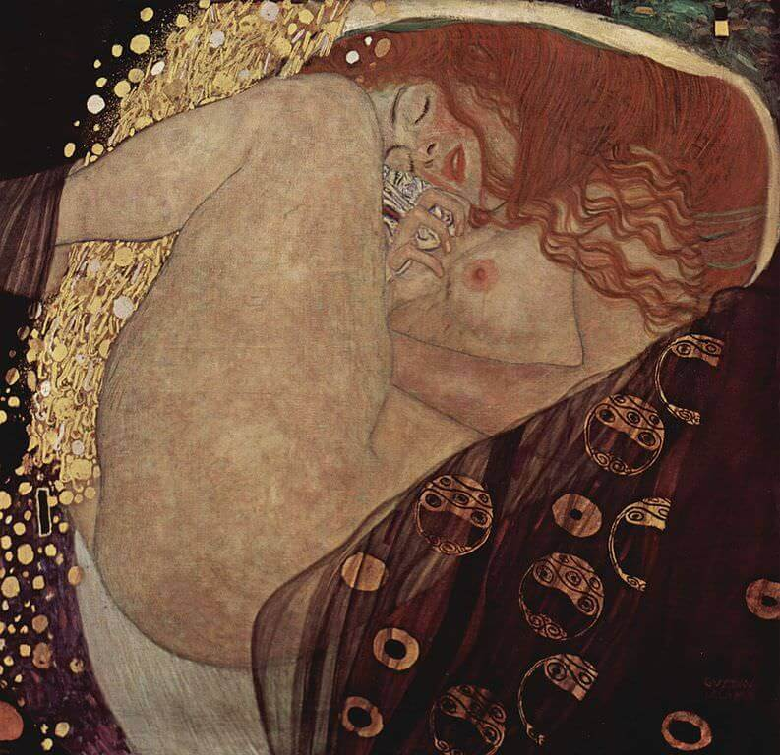
Figure 7 - Gustav Klimt (1907), Danae

For example, through observations of Gustav Klimt’s, Danae, we can denote the depiction of a redheaded woman in ‘peaceful slumber’. When examined more closely, we notice the carefully selected palette and the positioning of the figure; to the innate arrangement of the sheer veil, the subtly parted lips and legs. These are nuances to a sensual experience. Within ‘ReavealingArt’, by Matthew Kieran, Figure 7 was used as a descriptive image connoting beauty.

Klimt’s painting is a portrayal of Danaë, the daughter of King Acrisius of Argos and Queen Eurydice, who, according to Greek mythology, was locked away in a bronze tower, following a clairvoyant’s prophecy stating that Danaë’s son would kill the king. Zeus, the Greek god of sky and thunder, had become fond of Danaë, thus appeared to Danaë in the form of golden rain, impregnating the princess. (GreekMythology.com, 2015).
The poise, delineation and simplicity of the figure and composition, results in a painting that is not only ‘beautiful’, but also highlights the physical features of sensuality. In essence, the openness of the legs, as well as, the genitalia and chest, of which structures the primary symbolism of the figure; representation of a calm disposition of sexuality.

Danaë, like a great deal of Klimt’s images, are of fantastical nature, ‘portraying rather idealised’ versions of the human figure, often directed towards an erotic essence (M, Kieran. 2005, pp.156-158). The sole concern is often being the simplistic outlines of the female figure composed in a state of arousal, offering little background nor context. The separation between, the idealisation of the figure and the tale the composition depicts, is obscured.

Arguably, this variety of imagery could be defined by a pornographic nature, more so than that which is, ‘true to life’. Klimt attempts to create a distinction between erotic art and pornography, were often deemed too provocative by his successors and counterparts. They raised controversy over the proposition that Klimt’s practice presented exceeding amounts of objectified nakedness, dismissing the works as ‘fantastical’ removing their entitlement to ‘good art’, despite it’s aesthetic appeal (M, Kieran, 2005, p.157).
Matthew Kieran discusses Klimt’s work in accordance with the theory of Roger Scruton, who theorised that an appreciation of beauty is fundamentally separate from the inclination to fuel one’s fantasies and impulses (M, Kieran, 2005, p.156).

That between representation, which is addressed to the creative imagination and bound by principle truth, and substitution, which is addressed to the sexual fantasy and bound only by the requirement of gratificatory [sic] power. The latter must always offend against the properties of art, while the former may remain obedient to them.
(M, Kieran, 2005, p.156)

Alternatively, the autonomy of art dictates that we can appreciate any form of artwork, absent from it’s necessary function or instrumental value. For this to be true, we would rely purely on the sensory influences and effects, therefore disregarding any meaning behind a piece… but then does that not mean, art no longer has purpose?

If you look at expression and the cognitive theory it is understood that art has the capability to play an essential role in the communication of humans.
The concepts of these theories in art are central to understanding why artworks are expressive. They stand in relation to articulate an artists' current emotions (C, Freeland p.173). Therefore, we could assume aesthetic, on the contrary, means very little.
Art alone makes life possible - this is how radically I should like to formulate it. I would say that without art man is inconceivable in physiological terms...
Even the act of peeling a potato can be an artistic act if it is consciously done.

(L, Lippard, 1973, p.121)

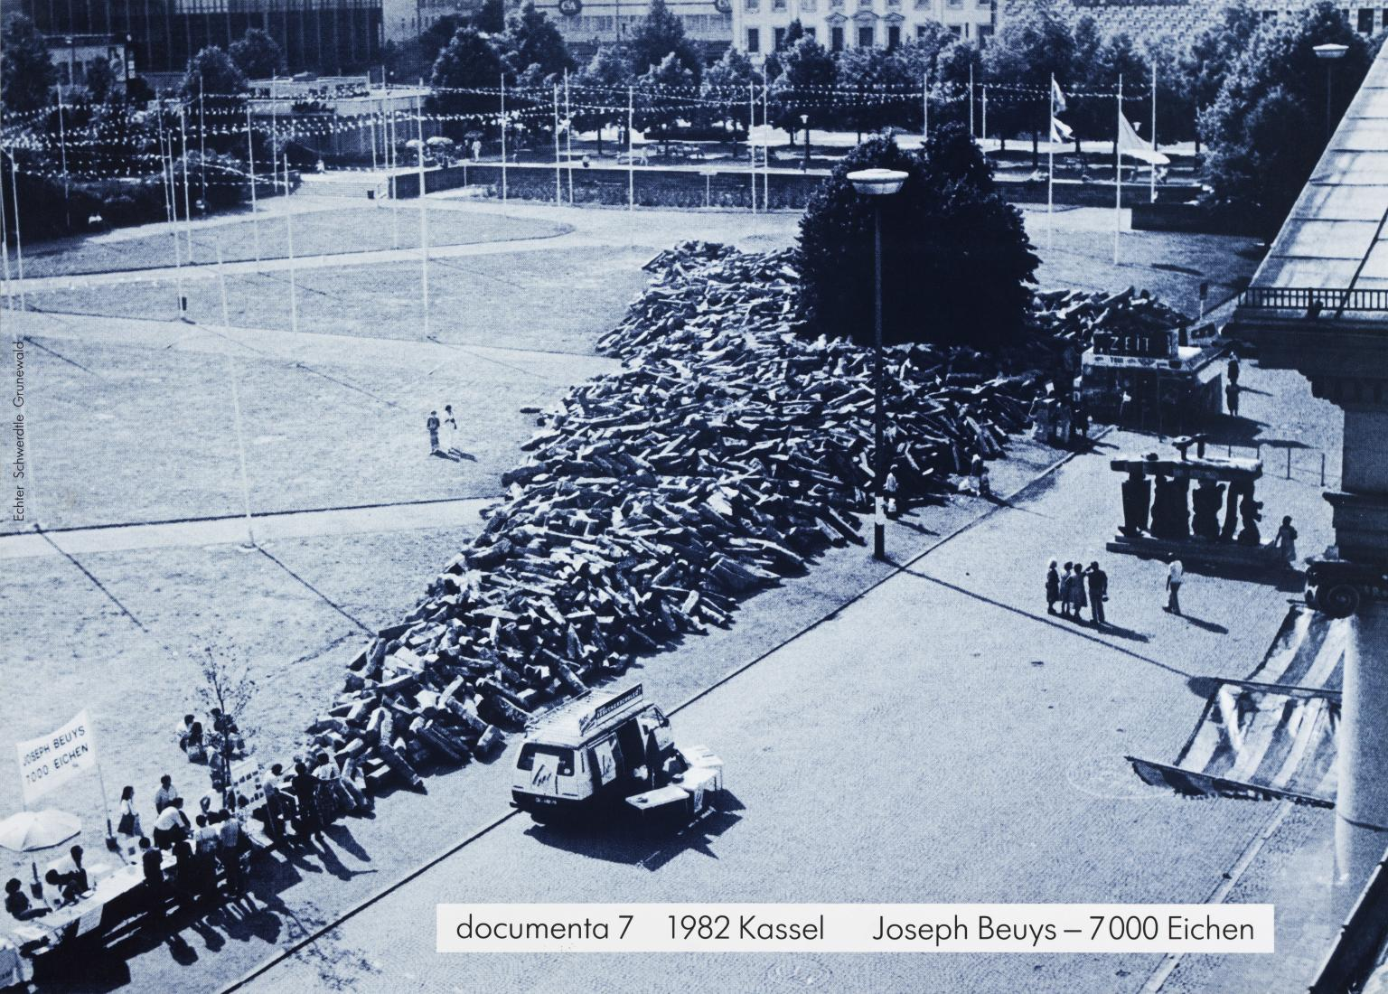
Figure 8 - Joseph Beuys (1982), 7000 Oak Trees

As portrayed in Figure 8, Beuys schemed for 7000 oak trees to be planted in Kassel, a city in central Germany. This form of urban renewal was seen as display and motion of progression (Tate, 2021), a step towards conscious rural architecture.

Beuys’ continuation of developments into social sculpture, only reinforced his desire to attain an understanding of the energy of materiality and thus the experience of life, a sense of relational aesthetics (Wackenhut, 2015). It was an ‘aesthetic modernity’ that could be characterised by attitudes which find a common focus in a changed consciousness of time (H, Foster et al. 1998, p3), an intentional act of art.

The term, ‘relational aesthetics’ was introduced to us in the 1990s by curator Nicolas Bourriaud, who coined the phrase to describe the inclination of some artist’s. This disposition being, to produce works of art elicited from the social circumstances of people, and the interpersonal relations between them (Tate, 2017). Bourriaud discusses how ‘a work of art has a quality that sets it apart from other things produced from human activities’(N, Bourriaud, 2002, p 41). This concept is central to the discussion of what defines art. It defies the popular opinion that given the correct situation and theory, anything can classify as art (C, Freeman, 2001 p).

Beuys’ environmental actions, approximately forty years later, are still growing throughout the city of Kassel; undoubtedly beautiful by nature, and perhaps beautiful by intention.

Chapter Three – Intention vs Narrative

Intention; can be outlined as simply an ‘objective’ or ‘purpose’ (Cambridge Dictionary, 2022). Whereas, the word ‘Narrative’, can be described as a way of presenting or understanding a situation or series of events (Cambridge Dictionary, 2022). These both often reflect a particular point of view or set of values. An artist’s motive could be defined as, ‘cognizance of order, coherence and purpose is one’s existence, the pursuit and attainment of worthwhile goals, and an accompanying sense of fulfilment.’ (Reker and Wong, 1988, p.221).

Artists' intentions can be frequently captured through the use of their materiality and appearance of artwork. Artistic intentions can also be deciphered by the means in which they choose to communicate through a medium or through symbolism and how they wish for their work to be perceived.

In spite of this, the personal narratives of an artist have the ability to disrupt the spectator’s perception of their practice. Namely, referring to the debate that encompases whether the art can be separated from the artist. On the contrary, the intentions can be altered by a misleading narrative. Ultimately, this can lead to doubting the principles and morality of the original intentions, and the ethics of the artist themselves.

Christoph Büchel is a conceptual artist, well known for his large scale installations. Büchel’s work is often provocative and challenging, following that of a political nature, or of one that confronts society.
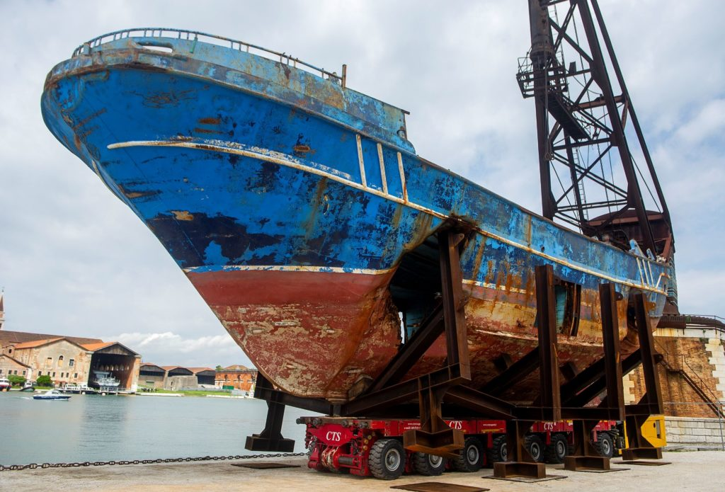
Figure 9 - C, Büchel (2019) Barca Nostra

Büchel was invited to present his work in the 2019 Venice Biennale, at which he unveiled his latest artistic endeavour. In the form of a public sculpture, Büchel contributed a shipwreck, which was at first impressions, quite unassuming. The loose translation of Barca Nostra meaning ‘Our Ship’ (Keener and Keener, 2020), was named with the intention of commemorating the Mediterranean migrant crisis.

This vessel, Barca Nostra, in April of 2015 was responsible for transporting over one thousand refugees from Africa. It collided and sunk off of the coast of Libya. Hundreds of people on board drowned, leaving only twenty-seven survivors. They now believe that there are approximately between seven hundred and a thousand people missing, presumed dead.
Subsequently, the shipwreck was retrieved by the Italian government, in hopes to identify remains and provide information and closure for relatives. It was later proposed that the Ship be relocated to Brussels - a suggestion made by Italy’s Prime Minister, Matteo Renzi. The intention being to attract the attention of Europe, in the expectation that responsibility would be upheld, and instate the prevention of a catastrophe akin to Barca Nostra (La Biennale di Venezia, 2019).

However, the display was heavily condemned by critics for lacking context, ‘migration studies, critical or otherwise have long been challenged not to become ensnared in this spectacle, and the fet-ishised reification of migrant “illegality”’ (E,Byrne, 2021, pp. 46-62) and thus deplored for its insensitivity (Pes and Rea, 2019). Furthermore, the legitimacy of it’s title as ‘Art’ was challenged, formulating questions of scepticism. Alternatively, this was a deliberate action of provocation. The controversial ‘sculpture’ was, perhaps, intended to cause disruption and urge the public to question the ethics of his actions.
The Venice Biennale, set in a cosmopolitan city, is a universally distinguished exhibition for art and cultural, renowned for traditionally captivating the audience of aristocracy (La Biennale di Venezia, 2017). Furthermore, it is associated with displays of wealth and, stereotypically, ignorance to such controversial matters.

One of the broad assumptions about works of art in this exhibition is that works of art are never reducible to being ‘about’ a particular issue or subject. Art is not a message that we can simply decipher and comprehend; Indeed, interesting artworks do not offer us conclusions so much as deeply engaging points of departure.
Rugoff, R (2019)

It is viable that Büchel’s ‘intention’ to highlight these neglectful perspectives, was deliberate, as for the first time, this was a large scale international audience. A spectatorship which created a response of empathy on an unprecedented scale. An improbable occasion where an audience possibly took genuine consideration of this human rights crisis.

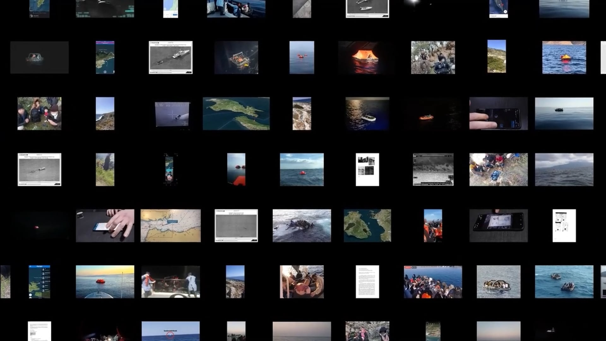
In spite of this, the exhibiting of the Barca Nostra raised a magnitude of questions about the ethics in making the decision to resurrect this ‘artefact’. Notwithstanding this, the exhibition prompted an irrefutable European response, of collective guilt and commiseration. The work is communal use of monument, memorialising the horrific operations portrayed in the acts of contemporary migration. Undoubtedly, this public sculpture is a delineation to the climate of politics that engage in such preventable events, but also a dedication to the lives lost in it’s path, fundamentally illustrating that their ‘narrative’ is not forgotten.

Figure 10 – Forensic Architects, (2022), Drift-backs in the Aegean Sea

Correspondingly, the ‘Forensic Architects’, a human rights research organisation, which investigates violations via governing bodies and large scale corporations (Forensic-architecture.org, 2022). The ambition of this agency is to inspect the misconducts that are directly affecting communities, in essence, unravelling the malpractice’s formulating the rise in conflict, migration jurisdictions, as well as ecological warfare.
Through approaching these, major and impacting, humanitarian and environmental topics, their methodology to comprehending such hyper-objects is through creative mediums. They frequently employ, ‘cutting-edge techniques in spatial and architectural analysis, open source investigation, digital modelling, and immersive technologies, as well as documentary research, situated interviews, and academic collaboration’ (Forensic-architecture.org, 2022), in attempts to translate these affairs in a complete and unembellished format.

In particular, in accordance with Figure 9, this short film entitled, ‘Drift-backs in the Aegean Sea’, highlights the distance people hold from the realities of immigration. The title, is in relation to a practice named ‘Drift-backs’, which has become a frequent occurrence in the movement of refugees. This procedure is increasingly being performed off of the coast of Greece, where the asylum seekers are abandoned with nothing but life rafts, and sent back to drift and ultimately drown in the Turkish coast (Forensic-architecture.org, 2022).

Forensic Architecture, features their findings in exhibitions all around the globe (Forensic-architecture.org, 2022) However, it is in question, whether the substance and commodity of their investigative outcomes, classify or present themselves as art.

.this quality is its (relative) social transparency. If a work of art is successful it will invariably set its lights beyond its mere presence in space; it will open to dialogue, discussion and that form of inter- human negotiation that Marcel Duchamp called “the coefficient of art”, which is a temporal process being played out here and now.
(N, Bourriaud, 2002, p.41)

Like Büchel’s Barca Nostra, the importance and consequently the ‘intention’ of the work is as conceptual as it is to stimulate important conversation. Arguably, it is engaging in dialogue that previously may not have previously received the platform it deserved.

Chapter Four – Ethics and Hyper-Objectivity

Fundamentally, the focus on environmental sustainability and materiality is a quintessential ‘intention’ of my own personal ethics and creative practice. The unsurpassed goal is to generate as little negative interference with ecology and environment. Logically, it is acknowledged, that ‘sustainability’ and, therefore, ‘morality’ is not restricted to impacts on the globe.
Ethics are the actions by which we present ourselves, highlighted in how we treat ourselves, our surroundings, and those that inhabit them. Subsequently, these ‘actions’, are the foundations of what become our morals (Lumenlearning.com, 2013). This is not limited to the progressions made in societal routine, but in every aspect of existence, including the context of Art. Is accountability, for the poor ethical decisions of an artist, their responsibility to carry burden? Alternatively, is the industry to blame? For instance, paint is undoubtedly a popular medium amongst artists, specifically acrylics. Regardless, acrylic paints are ‘plastic-based’ products, which evidently develop into micro plastics, entering the earths ecosystem (Our Endangered World, 2021). Sequentially, actions like these, build up, impacting the over-all equilibrium of nature, ultimately contribute to the ever-developing climate crisis. The matter of Climate Change is arguably far beyond our comprehension.

Hyper-objectivity, is a state that efficiently describes an issue that defies not only our control but also our conception. Conceivably, the Climate emergency, or rather, Global Warming is an extreme template, for what could be describe as a, ‘Hyper-object’. A system that is, ‘of such vast temporal and spatial dimensions that they defeat traditional ideas about what a thing is in the first place’ (T, Morton, 2013 anon).

Wishing instead for strangeness, beauty, and hesitation, Morton revisits their well-known notion of the “hyperobject” (Morton, 2013), arguing that art can open humans to a sense of ambiguity and wonder, to help us face a climate crisis that can seem too huge to comprehend.
(Hart, H, 2022, p.1)

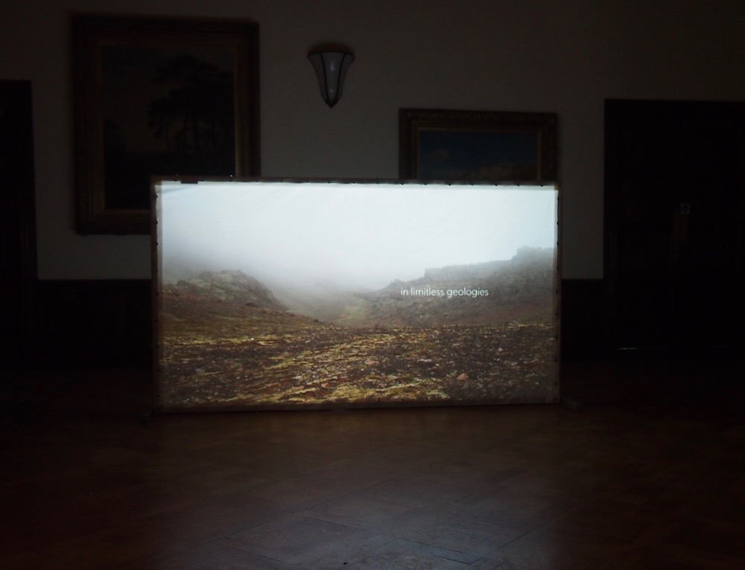

Figure 11 - Jez Riley French, (2019), island | fjórar

A concise example of exploring the realms of Climate Change as a ‘hyper-object’, is the four channelled audio piece created by Jez Riley French, who’s work frequently focuses on the nature of sounds, producing ‘intuitive compositions’ of installation and photography (Jezrileyfrench.co.uk, 2021).

In French’s Island installation, he discloses sounds that are not instantly discernable to the human frequency. These are noises produced by the earths geothermic activity. It elicits the, ‘sound of the world turning; ancient air escaping from glaciers; sound of minerals, ceramics and civil structures dissolved through the actions of acid rain, neglect and performance techniques’ (Arts, 2014). This, in turn, acts out the human perception of environmental surfaces and the rigidity between them, offering an outlook outside of human consciousness. Island, through the medium of sound and geological technology, has accomplished and encapsulated the ‘inter-objects’ produced by ‘Climate Change’ (Jezrileyfrench.co.uk, 2021).

This investigation into the ‘inter-objects’ of Climate Change is a formulation heavily presented in Timothy Morton’s discussion throughout ‘All Art is Ecological’, in which he reiterates that through persevering with representation of art-forms that inspire the conversation about climate change, during a ‘mass extinction’. This quintessentially, has the potential to create an, ‘ambiguity and wonder, to help us face a climate crisis that can seem too huge to comprehend’ (Hart, H, 2022. p.1)

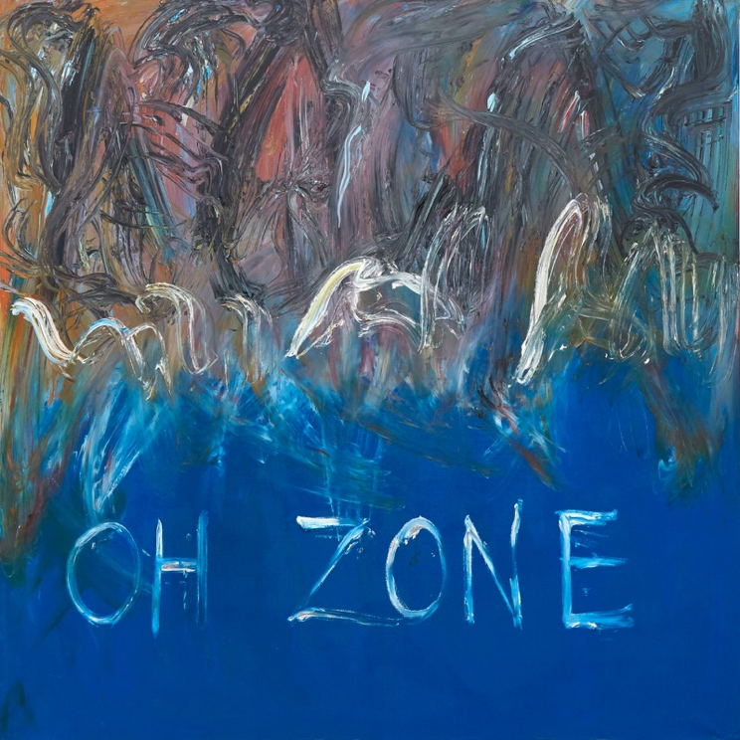
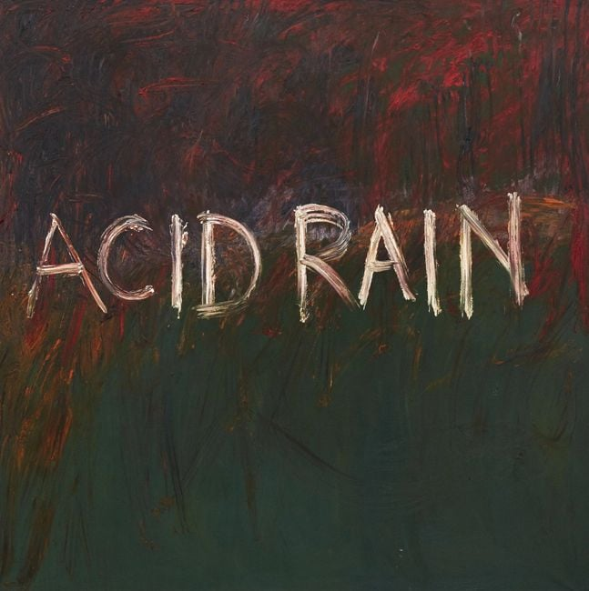

Figure 13 - Derek Jarman (1992), Acid Rain

Figure 12 - Derek Jarman (1992), Oh Zone

An extension of the themes of environmental art, is the collections of paintings (as shown in Figures 12 and 13), by Derek Jarman, whose work is heavily based on the ‘narrative’ of challenging the nature of landscape, and how we as a society and race contribute to it’s physical conditioning.

These landscape paintings are both brash displays of anger and frustration, as seen by the impetuous finger brushes through the thick layers of impasto, almost articulating that of screams. Both, ‘Acid Rain’ and ‘Oh Zone’, remain as paralleled pieces to accompany Jarman’s cottage, who’s vista from a coastal heaven, was disrupted by the eyesore of a nuclear power station (T, Glover, 2020). His artwork could be classified as a foreshadowing for how one, or rather collectively, we cannot escape a ‘climate crisis’. Consequently, the imagery presented in this chapter are representatives of artworks that are ‘true to life’, and categorically, “there is something rough and ready about truth” (T, Morton p.3), “it should be transparent. It should be obvious. We should deliver this obviousness in an obvious way, like a slap upside the head” (T, Morton p.2). It is conceivable that this is exactly the directive of such artists and organisations.

Conclusion

This independent research has culminated to vast development of adjacent topics and subjects that underpin the weight of contextual importance in art. The temporal nature of art, requires a level of understanding, and therefore displays itself in a diversity of mechanisms and methodologies. A myriad of artworks is are self explanatory and provide sufficient means of appreciation absent from their functionalities. Nonetheless, conversation and movement for progression are palpable through more conceptual realms of artistic endeavours, and often have a tumultuous effect on spectators. Hence, why many controversial artworks are still discussed decades after their conception, they arguably fossilise in society and have the ability to mould the actions of the artists that follow. To censor or ‘standardise’ the art world, to create regulations, goes against the very grain and materiality of Fine Art.
Furthermore, it has transpired that to determine what is categorised as art, is non-viable and illogical. For art has its own definition to an individual, it is of a subjective nature and consequently cannot be defined.

Bibliography

Books

ALL WE CAN SAVE: Truth, Courage, and Solutions for the Climate Crisis. 2020. Austin: Kirkus Media LLC.

ARTBISCUIT, E. and MARSHALL, N., 2010. Do my bidding Europe! : a venture into relational aesthetics. Swansea Metropolitan University.

BEARDSLEY, M.C., 1958. Aesthetics problems in the philosophy of criticism. Harcourt Brace & World.

BERGER, J., 2002. The shape of a pocket. London: Bloomsbury.

BERGER, J., 2009. About looking. London: Bloomsbury.

BOULTON, E., 2016. Climate change as a 'hyperobject': a critical review of Timothy Morton's reframing narrative. Wiley interdisciplinary reviews.Climate change; WIREs Clim Change, 7(5), pp. 772-785.

BOURRIAUD, N., PLEASANCE, S., WOODS, F. and COPELAND, M., 2002. Relational aesthetics. Dijon?: Presses du Réel.

CASHELL, K., 2009. Aftershock : the ethics of contemporary transgressive art. London: I. B. Tauris.

FOSTER, H., 2002. The anti-aesthetic : essays on postmodern culture. New York: New Press.

FRASCINA, F. and HARRIS, J.(.P.)., 1992. Art in modern culture : an anthology of critical texts. London: Phaidon Press, in association with the Open University.
FREELAND, C.A., 2001. But is it art? : an introduction to art theory. Oxford ;: Oxford University Press.

KIERAN, M., 2005. Revealing art. London: Routledge.

MORTON, T., 2021. All Art Is Ecological. Penguin.

MORTON, T., 2013. Hyperobjects : philosophy and ecology after the end of the world. Minneapolis: University of Minnesota Press.

STANISZEWSKI, M.A., 1995. Believing is seeing : creating the culture of art. Harmondsworth: Penguin.

Academic Papers
Adajian, T. (2018). The Definition of Art (Stanford Encyclopedia of Philosophy). [online] Stanford.edu. Available at: https://plato.stanford.edu/entries/art-definition/#TraDef [Accessed 12 Dec. 2022].

BYRNE, E., 2021. Migration, Disaster and The Globalised Mediterranean: Between Barca Nostra and Vertigo Sea. Parallax, 27(1), pp. 46-62.

MACNAIR, M.R.T., 1989. Homosexuality in schools — Section 28 Local Government Act 1988. Education and the Law, 1(1), pp. 35-39.

MORTENSEN, M., 2017. No title. Media, Culture and Society, 38(8), pp. 1142.

PHILLIPS-AMOS, G., 2021. What Comes After Farce?: Art and Criticism at a Time of Debacle. By Hal Foster. London: Verso Books, 2020; 205 pp.; black-and-white illustrations. $24.95 cloth, e-book available. TDR : Drama review, 65(2), pp. 191-194.

SMYTHE, S.A., 2018. No title. Middle East Report, 286, pp. 3.

Keener, K. and Keener, K. (2020). Concerns grow as ‘Barca Nostra’, made of the wreckage that killed hundreds, overstays its welcome in Venice. [online] Art Critique. Available at: https://www.art-critique.com/en/2020/12/barca-nostra-at-the-heart-of-another-potential-tragedy/ [Accessed 12 Dec. 2022].

Websites/ Online Articles
A-Z Quotes. (2014). TOP 25 QUOTES BY JOSEPH BEUYS | A-Z Quotes. [online] Available at: https://www.azquotes.com/author/1360-Joseph_Beuys [Accessed 10 Dec. 2022].
- Adajian, T. (2018). The Definition of Art (Stanford Encyclopedia of Philosophy). [online] Stanford.edu. Available at: https://plato.stanford.edu/entries/art-definition/#TraDef [Accessed 12 Dec. 2022].
- Aesthetics-conversations.com. (2017). Roger Scruton – Conversations on Art and Aesthetics. [online] Available at: http://aesthetics-conversations.com/roger-scruton/ [Accessed 12 Dec. 2022].
- Amanda Wilkinson. (2020a). Derek Jarman, Acid Rain, 1992. [online] Available at: https://amandawilkinsongallery.com/artists/31-derek-jarman/works/5944-derek-jarman-acid-rain-1992/ [Accessed 14 Dec. 2022].
- Amanda Wilkinson. (2020b). Derek Jarman, Oh Zone, 1992. [online] Available at: https://amandawilkinsongallery.com/artists/31-derek-jarman/works/5945-derek-jarman-oh-zone-1992/ [Accessed 14 Dec. 2022].
- Andres Serrano | Biography, Art, Photography, & Facts | Britannica. (2022). In: Encyclopædia Britannica. [online] Available at: https://www.britannica.com/biography/Andres-Serrano#ref996245 [Accessed 12 Dec. 2022].
- Anonymous (2018). Blood and Semen V. [online] Cleveland Museum of Art. Available at: https://www.clevelandart.org/art/1995.204.7 [Accessed 7 Dec. 2022].
- Arts, C. (2014). Catalyst Arts. [online] Catalyst Arts. Available at: https://www.catalystarts.org.uk/hyperobjects [Accessed 14 Dec. 2022].
- Artuk.org. (2021a). Derek Jarman: painting, protest and the AIDS pandemic | Art UK. [online] Available at: https://artuk.org/discover/stories/derek-jarman-painting-protest-and-the-aids-pandemic#:~:text=In%20September%201989%2C%20Derek%20Jarman,’ [Accessed 10 Dec. 2022].
- Artuk.org. (2021b). Derek Jarman: painting, protest and the AIDS pandemic | Art UK. [online] Available at: https://artuk.org/discover/stories/derek-jarman-painting-protest-and-the-aids-pandemic [Accessed 14 Dec. 2022].
- Athey, R. (2014). Ron Athey. [online] Ron Athey. Available at: https://www.ronathey.org/about [Accessed 1 Dec. 2022].
- Athey, R. (2019). Ron Athey. [online] Ron Athey. Available at: https://www.ronathey.org/ [Accessed 6 Dec. 2022].
- Berger, K. (1999). Aesthetics II. The Uses of Art. A Theory of Art, [online] pp.65–107. doi:10.1093/0195128605.003.0002.
- Byrne, E. (2021). Migration, Disaster and The Globalised Mediterranean: Between Barca Nostra and Vertigo Sea. Parallax, [online] 27(1), pp.46–62. doi:10.1080/13534645.2021.1976459.
- Cambridge Dictionary (2022a). aesthetic. [online] @CambridgeWords. Available at: https://dictionary.cambridge.org/dictionary/english/aesthetic [Accessed 2 Dec. 2022].
- Cambridge Dictionary (2022b). controversy. [online] @CambridgeWords. Available at: https://dictionary.cambridge.org/dictionary/english/controversy [Accessed 7 Dec. 2022].
- Cambridge Dictionary (2022c). intention. [online] @CambridgeWords. Available at: https://dictionary.cambridge.org/dictionary/english/intention [Accessed 13 Dec. 2022].
- Cambridge Dictionary (2022d). narrative. [online] @CambridgeWords. Available at: https://dictionary.cambridge.org/dictionary/english/narrative [Accessed 12 Dec. 2022].
- circulation (2021a). Bleeding Out: On the Use of Blood in Contemporary Art | ART PAPERS. [online] Art Papers. Available at: https://www.artpapers.org/bleeding-out-on-the-use-of-blood-in-contemporary-art/ [Accessed 1 Dec. 2022].
- circulation (2021b). Bleeding Out: On the Use of Blood in Contemporary Art | ART PAPERS. [online] Art Papers. Available at: https://www.artpapers.org/bleeding-out-on-the-use-of-blood-in-contemporary-art/ [Accessed 5 Dec. 2022].
Derek Jarman. (2018). Martin Frey: Derek Jarman – Moving Pictures of a Painter. [online] Available at: https://www.jarman-film-book.com/ [Accessed 10 Dec. 2022].
- Derek Jarman. (2018). Martin Frey: Derek Jarman – Moving Pictures of a Painter. [online] Available at: https://www.jarman-film-book.com/ [Accessed 12 Dec. 2022].
- Dia Art Foundation (2020a). Joseph Beuys, 7000 Oaks | Visit Our Locations & Sites | Visit | Dia. [online] Diaart.org. Available at: https://www.diaart.org/visit/visit-our-locations-sites/joseph-beuys-7000-oaks [Accessed 14 Dec. 2022].
- Dia Art Foundation (2020b). Joseph Beuys, 7000 Oaks | Visit Our Locations & Sites | Visit | Dia. [online] Diaart.org. Available at: https://www.diaart.org/visit/visit-our-locations-sites/joseph-beuys-7000-oaks [Accessed 14 Dec. 2022].
Dickie, George (1974), Art and the Aesthetic: An Institutional Analysis, Ithaca, NY: Cornell University Press.
- Eden Gallery. (2021). What is Good Art & What Makes it Good? -Eden Gallery. [online] Available at: https://www.eden-gallery.com/news/what-makes-good-art [Accessed 12 Dec. 2022].
- Education and the Law. (2014). Homosexuality in schools — Section 28 Local Government Act 1988. [online] Available at: https://www.tandfonline.com/doi/abs/10.1080/0953996890010106 [Accessed 12 Dec. 2022].
- Ethicalunicorn.com. (2021). How To Be A Sustainable & Eco-Friendly Artist – ETHICAL UNICORN. [online] Available at: https://ethicalunicorn.com/2021/06/23/how-to-be-a-sustainable-eco-friendly-artist/#:~:text=Acrylic%20paint%20isn’t%20water,end%20up%20in%20the%20environment. [Accessed 14 Dec. 2022].
- Forensic-architecture.org. (2022a). Forensic Architecture. [online] Available at: https://forensic-architecture.org/about/agency [Accessed 13 Dec. 2022].
- Forensic-architecture.org. (2022b). Forensic Architecture. [online] Available at: https://forensic-architecture.org/investigation/drift-backs-in-the-aegean-sea [Accessed 13 Dec. 2022].
- Forensic-architecture.org. (2022c). Forensic Architecture. [online] Available at: https://forensic-architecture.org/programme/exhibitions [Accessed 13 Dec. 2022].
- Forensic-architecture.org. (2022d). Forensic Architecture. [online] Available at: https://forensic-architecture.org/investigation/drift-backs-in-the-aegean-sea [Accessed 13 Dec. 2022].
- Forensic-architecture.org. (2022e). Forensic Architecture. [online] Available at: https://forensic-architecture.org/about/agency [Accessed 13 Dec. 2022].
- From (1994). HIV-Infected Artist’s Show Draws Anger of 2 Senators : Arts: The performance includes passing a bloodied towe. [online] Los Angeles Times. Available at: https://www.latimes.com/archives/la-xpm-1994-06-21-mn-6768-story.html [Accessed 1 Dec. 2022].
- Gallery Climate Coalition. (2022a). Gallery Climate Coalition. [online] Available at: https://galleryclimatecoalition.org/ [Accessed 13 Dec. 2022].
- Gallery Climate Coalition. (2022b). Gallery Climate Coalition. [online] Available at: https://galleryclimatecoalition.org/ [Accessed 13 Dec. 2022].
- Goodreads.com. (2021). A quote by Joseph Beuys. [online] Available at: https://www.goodreads.com/quotes/8643727-every-human-being-is-an-artist-a-freedom-being-called [Accessed 10 Dec. 2022].
- Google.com. (2013). Arthur Coleman Danto - Google Search. [online] Available at: https://www.google.com/search?q=Arthur+Coleman+Danto&oq=Arthur+Coleman+Danto&aqs=chrome..69i57.607j0j9&sourceid=chrome&ie=UTF-8 [Accessed 5 Dec. 2022].
- Google.com. (2015). Alexander Baumgarten - Google Search. [online] Available at: https://www.google.com/search?q=Alexander+Baumgarten&oq=Alexander+Baumgarten&aqs=chrome..69i57.365j0j9&sourceid=chrome&ie=UTF-8 [Accessed 6 Dec. 2022].
- Google.com. (2022). Alexander Baumgarten - Google Search. [online] Available at: https://www.google.com/search?q=Alexander+Baumgarten&oq=Alexander+Baumgarten&aqs=chrome..69i57.365j0j9&sourceid=chrome&ie=UTF-8 [Accessed 5 Dec. 2022].
- GreekMythology.com (2015). Danae - Greek Mythology. [online] Greekmythology.com. Available at: https://www.greekmythology.com/Myths/Mortals/Danae/danae.html [Accessed 12 Dec. 2022].
- Greenwood, R. (2019a). #114. Tim Scott quotes from and comments on ‘But is it Art?’ (OUP 2001), by Cynthia Freeland. [online] Abcrit. Available at: https://abcrit.org/2019/06/05/114-tim-scott-quotes-from-and-comments-on-but-is-it-art-oup-2001-by-cynthia-freeland/ [Accessed 5 Dec. 2022].
- Greenwood, R. (2019b). #114. Tim Scott quotes from and comments on ‘But is it Art?’ (OUP 2001), by Cynthia Freeland. [online] Abcrit. Available at: https://abcrit.org/2019/06/05/114-tim-scott-quotes-from-and-comments-on-but-is-it-art-oup-2001-by-cynthia-freeland/ [Accessed 12 Dec. 2022].
- Greenwood, R. (2019c). #114. Tim Scott quotes from and comments on ‘But is it Art?’ (OUP 2001), by Cynthia Freeland. [online] Abcrit. Available at: https://abcrit.org/2019/06/05/114-tim-scott-quotes-from-and-comments-on-but-is-it-art-oup-2001-by-cynthia-freeland/ [Accessed 12 Dec. 2022].
- Günseli Yalcinkaya (2016). Is there such a thing as Bad Art? [online] Dazed. Available at: https://www.dazeddigital.com/artsandculture/article/31086/1/is-there-such-a-thing-as-bad-art#:~:text=Bad%20Art%20is%20unchallenging%2C%20safe,be%20disliked%20by%20the%20viewer. [Accessed 12 Dec. 2022].
- Hart, H. (2022a). Timothy Morton (2021). All Art Is Ecological. Journal of Ecohumanism, [online] 1(1), pp.77–80. doi:10.33182/joe.v1i1.2061.
- HIV.gov. (2022). A Timeline of HIV and AIDS. [online] Available at: https://www.hiv.gov/hiv-basics/overview/history/hiv-and-aids-timeline#year-1981 [Accessed 12 Dec. 2022].
Interview in "Artforum" Magazine, November 1969; as quoted in "Six Years: The Dematerialization of the Art Object from 1966 to 1972" by Lucy R. Lippard, University of California Press, (p. 121), 1973.
- Jezrileyfrench.co.uk. (2021a). island fjórar. [online] Available at: https://jezrileyfrench.co.uk/island----fj%C3%B3rar---2013-on-going.php [Accessed 14 Dec. 2022].
- Jezrileyfrench.co.uk. (2021b). jez riley french. [online] Available at: https://jezrileyfrench.co.uk/about.php [Accessed 14 Dec. 2022].
- Jones, C.P. (2019). Does Art Need Explaining? - Thinksheet - Medium. [online] Medium. Available at: https://medium.com/thinksheet/does-art-need-explaining-d66447c41e2f [Accessed 12 Dec. 2022].
Joseph Beuys (1973) Interview in "Artforum" Magazine, November 1969; as quoted in "Six Years: The Dematerialization of the Art Object from 1966 to 1972" by Lucy R. Lippard, University of California Press, (p. 121),
- La Biennale di Venezia. (2019a). Biennale Arte 2019 | Christoph Büchel. [online] Available at: https://www.labiennale.org/en/art/2019/partecipants/christoph-b%C3%BCchel [Accessed 13 Dec. 2022].
- La Biennale di Venezia. (2019b). Biennale Arte 2019 | Christoph Büchel. [online] Available at: https://www.labiennale.org/en/art/2019/partecipants/christoph-b%C3%BCchel [Accessed 14 Dec. 2022].
Lemoine, A. (2020). cancel culture. [online] Dictionary.com. Available at: https://www.dictionary.com/e/pop-culture/cancel-culture/ [Accessed 8 Dec. 2022].
- Linsenmayer, M. (2022). Ep. 288: Scruton on Ethical Art (Part One) | The Partially Examined Life Philosophy Podcast | A Philosophy Podcast and Blog. [online] The Partially Examined Life Philosophy Podcast | A Philosophy Podcast and Philosophy Blog. Available at: https://partiallyexaminedlife.com/2022/02/28/ep288-1-scruton-art-ethics/ [Accessed 12 Dec. 2022].
Livingston, P. (2005). Art and Intention. [online] Oxford University PressOxford. doi:10.1093/0199278067.001.0001. [Accessed 8 Dec 2022]
- Livingston, P. (2005). Art and Intention. [online] Oxford University PressOxford. doi:10.1093/0199278067.001.0001.
- Loiseau, B. (2019a). Olivia Laing, Jon Savage, Peter Tatchell and Charlie Porter look back on Derek Jarman’s radical legacy at PROTEST, the largest retrospective of his work. [online] Vice.com. Available at: https://i-d.vice.com/en/article/43k94m/looking-back-on-derek-jarmans-radical-legacy [Accessed 12 Dec. 2022].
- Maira, S. (2017). The artist’s dilemma: If my art is beautiful, will it still be considered great? [online] Scroll.in. Available at: https://scroll.in/article/829696/the-artists-dilemma-if-my-art-is-beautiful-will-it-still-be-considered-great [Accessed 12 Dec. 2022].
- Nishiyama, C. (2020). What Makes Good Art?: 4 Theories for Judging Your Art. [online] Might-could.com. Available at: https://might-could.com/essays/what-makes-good-art/#:~:text=Art%20is%20good%20when%20it%20masters%20the%20artistic%20elements%20and,other%20artistic%20elements%20and%20principles. [Accessed 5 Dec. 2022].
- Ocula.com. (2022). Acid Rain, 1992 by Derek Jarman. [online] Available at: https://ocula.com/art-galleries/amanda-wilkinson-gallery/artworks/derek-jarman/acid-rain/ [Accessed 14 Dec. 2022].
- Ogasawara, L. (2021a). Your Brain on Art: Timothy Morton’s All Art is Ecological. [online] 3 Quarks Daily. Available at: https://3quarksdaily.com/3quarksdaily/2021/09/your-brain-on-art-timothy-mortons-all-art-is-ecological.html [Accessed 6 Dec. 2022].
- Orth, M. (2019). 10 Undeniable Facts About the Michael Jackson Sexual-Abuse Allegations. [online] Vanity Fair. Available at: https://www.vanityfair.com/hollywood/2019/03/10-undeniable-facts-about-the-michael-jackson-sexual-abuse-allegations [Accessed 5 Dec. 2022].
- Our Endangered World. (2021). Is Acrylic Paint Bad for the Environment? [online] Available at: https://www.ourendangeredworld.com/eco/is-acrylic-paint-bad-for-the-environment/ [Accessed 14 Dec. 2022].
- Pes, J. and Rea, N. (2019). ‘Absolutely Vile’ or ‘Powerful’? Christoph Buchel’s Migrant Boat Is the Most Divisive Work at the Venice Biennale. [online] Artnet News. Available at: https://news.artnet.com/art-world/barca-nostra-1548946 [Accessed 13 Dec. 2022].
- Petridis, A., Winship, L., Elan, P., Snapes, L. and Hans, S. (2019). ‘Too big to cancel’: can we still listen to Michael Jackson? [online] the Guardian. Available at: https://www.theguardian.com/music/2019/mar/01/leaving-neverland-is-it-still-ok-to-listen-to-michael-jackson [Accessed 5 Dec. 2022].
- Royalacademy.org.uk. (2014). ‘Sensation’ works on view at Christie’s | Blog | Royal Academy of Arts. [online] Available at: https://www.royalacademy.org.uk/article/sensation-works-on-view-at [Accessed 5 Dec. 2022].
Rugoff, R. (n.d.). Curator of the 58 th International Art Exhibition. [online] Available at: https://bagrifoundation.org/wp-content/uploads/2019/07/3.-Statement-by-Ralph-Rugoff.pdf.
- Swapnil Dhruv Bose (2021a). How Derek Jarman film ‘Blue’ captures the HIV experience like no other. [online] Far Out Magazine. Available at: https://faroutmagazine.co.uk/how-derek-jarman-film-blue-hiv-experience/ [Accessed 10 Dec. 2022].
Tate (2017). Relational aesthetics | Tate. [online] Tate. Available at: https://www.tate.org.uk/art/art-terms/r/relational-aesthetics [Accessed 11 Dec. 2022].
- Tate (2021a). ‘7000 Oak Trees‘, Joseph Beuys, 1982 | Tate. [online] Tate. Available at: https://www.tate.org.uk/art/artworks/beuys-7000-oak-trees-ar00745 [Accessed 14 Dec. 2022].
- Tate (2021b). ‘Jim, Sausalito‘, Robert Mapplethorpe, 1977 | Tate. [online] Tate. Available at: https://www.tate.org.uk/art/artworks/mapplethorpe-jim-sausalito-ar00198 [Accessed 12 Dec. 2022].
- Tate (2021c). ‘Joseph Beuys. Every Man is An Artist‘, Joseph Beuys, 1978 | Tate. [online] Tate. Available at: https://www.tate.org.uk/art/artworks/beuys-joseph-beuys-every-man-is-an-artist-ar00704 [Accessed 10 Dec. 2022].
- Tate (2021d). ‘Joseph Beuys. Every Man is An Artist‘, Joseph Beuys, 1978 | Tate. [online] Tate. Available at: https://www.tate.org.uk/art/artworks/beuys-joseph-beuys-every-man-is-an-artist ar00704#:~:text=Display%20caption,AS%20A%20WORK%20OF%20ART. [Accessed 14 Dec. 2022].
- Tate (2021e). ‘Rhythm 0‘, Marina Abramovic, 1974 | Tate. [online] Tate. Available at: https://www.tate.org.uk/art/artworks/abramovic-rhythm-0-t14875 [Accessed 6 Dec. 2022].
- Tate (2022a). ‘Ataxia - Aids is Fun‘, Derek Jarman, 1993 | Tate. [online] Tate. Available at: https://www.tate.org.uk/art/artworks/jarman-ataxia-aids-is-fun-t06768 [Accessed 10 Dec. 2022].
- Tate (2022c). ‘Derek Jarman‘, Richard Hamilton, 1996–7 | Tate. [online] Tate. Available at: https://www.tate.org.uk/art/artworks/hamilton-derek-jarman-p78013 [Accessed 12 Dec. 2022].
- Tate (2022d). Joseph Beuys 1921–1986 | Tate. [online] Tate. Available at: https://www.tate.org.uk/art/artists/joseph-beuys-747 [Accessed 10 Dec. 2022].
- The Museum of Modern Art. (2019). Chris Ofili. The Holy Virgin Mary. 1996. [online] Available at: https://www.moma.org/collection/works/283373 [Accessed 12 Dec. 2022].
- Thehistoryofart.org. (2020). [online] Available at: https://www.thehistoryofart.org/francisco-de-goya/saturn-devouring-his-son/ [Accessed 12 Dec. 2022].
- Tiplady, J. (2022a). We Need To Keep Derek Jarman’s Protest Alive. [online] Plinth. Available at: https://plinth.uk.com/blogs/in-the-studio-with/derek-jarman-protest-manchester-art-gallery-essay [Accessed 12 Dec. 2022].
- Tiplady, J. (2022b). We Need To Keep Derek Jarman’s Protest Alive. [online] Plinth. Available at: https://plinth.uk.com/blogs/in-the-studio-with/derek-jarman-protest-manchester-art-gallery-essay [Accessed 12 Dec. 2022].
- Trichal, K. (2021). The Madness within Goya: Making Sense of Saturn Devouring his Son. [online] Medium. Available at: https://karantrichal.medium.com/goyas-painting-saturn-devouring-his-son-is-one-of-the-most-fascinating-works-of-visual-art-of-aa3cf671e32f [Accessed 12 Dec. 2022].
- Uwtsd.ac.uk. (2022a). [online] Available at: https://wires-onlinelibrary-wiley-com.ezproxy.uwtsd.ac.uk/doi/pdf/10.1002/wcc.410 [Accessed 6 Dec. 2022].
- Uwtsd.ac.uk. (2022b). [online] Available at: https://web-p-ebscohost-com.ezproxy.uwtsd.ac.uk/ehost/ebookviewer/ebook/bmxlYmtfXzY1MTYxMl9fQU41?sid=8079620d-43eb-47d5-a660-679554c8362b@redis&vid=3&format=EB&rid=1 [Accessed 6 Dec. 2022].
- Uwtsd.ac.uk. (2022c). [online] Available at: https://librarysearch.uwtsd.ac.uk/discovery/fulldisplay?docid=cdi_crossref_primary_10_1017_S1054204321000228&context=PC&vid=44WHELF_UWTSD:44WHELF_UWTSD_VU1&lang=en&search_scope=Search_ELEC&adaptor=Primo%20Central&tab=Everything&query=any,contains,%27what%20comes%20after%20farce%27&offset=0 [Accessed 6 Dec. 2022].
- Uwtsd.ac.uk. (2022d). [online] Available at: https://librarysearch.uwtsd.ac.uk/discovery/fulldisplay?docid=cdi_crossref_primary_10_1017_S1054204321000228&context=PC&vid=44WHELF_UWTSD:44WHELF_UWTSD_VU1&lang=en&search_scope=Search_ELEC&adaptor=Primo%20Central&tab=Everything&query=any,contains,%27what%20comes%20after%20farce%27&offset=0 [Accessed 12 Dec. 2022].
- Vice.com. (2014). Ron Athey Literally Bleeds for His Art. [online] Available at: https://www.vice.com/en/article/vdpx8y/ron-athey-performance-art-amelia-abraham-121 [Accessed 1 Dec. 2022].
Vichnar, D. and Armand, L. (2017). Aisthēsis. Oxford Research Encyclopedia of Literature. [online] doi:10.1093/acrefore/9780190201098.013.104. [Accessed 6 Dec. 2022]
- Wackenhut, C. (2015). FRENCH & MICHIGAN. [online] FRENCH & MICHIGAN. Available at: http://www.frenchandmichigan.com/reading/tag/relational+aesthetics [Accessed 14 Dec. 2022].
- Walkerart.org. (2014). Ron Athey’s 1994 Minneapolis Performance and the Anatomy of a Media Scandal. [online] Available at: https://walkerart.org/magazine/ron-atheys-1994-minneapolis-performance-and-the-anatomy-of-a-media-scandal [Accessed 1 Dec. 2022].
- whynow. (2021). ‘My garden’s boundaries are the horizon’ – Derek Jarman at the Garden Museum. [online] Available at: https://whynow.co.uk/read/my-gardens-boundaries-are-the-horizon-derek-jarman-at-the-garden-museum [Accessed 13 Dec. 2022].
- Widewalls. (2020). The Controversy of the Sensation Art Exhibition | Widewalls. [online] Available at: https://www.widewalls.ch/magazine/sensation-art-exhibition [Accessed 6 Dec. 2022].
- Wolfe, S. (2021). The Shows That Made Contemporary Art History: Sensation - Artland Magazine. [online] Artland Magazine. Available at: https://magazine.artland.com/shows-that-made-contemporary-art-history-sensation/ [Accessed 6 Dec. 2022].
- www.wikiart.org. (2022). Saturn Devouring One of His Sons, 1819 - 1823 - Francisco Goya - WikiArt.org. [online] Available at: https://www.wikiart.org/en/francisco-goya/saturn-devouring-his-son-1823-1#:~:text=Saturn%20Devouring%20His%20Son%20is,each%20one%20upon%20their%20birth. [Accessed 12 Dec. 2022].

