

Analysis of social media marketing in the telecommunication industry: Xiaomi Corporation case study

Name: ZHOU ZIXUAN
Student Number: 2004118

Dissertation submitted as part of the requirements for the award BA (Hons) International Finance.

DECLARATION

This work has not previously been accepted in substance for any degree and is not being concurrently submitted in candidature for any degree
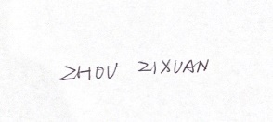

Signed……………………………………………
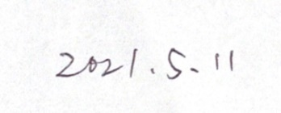

Date………………………………………………

STATEMENT 1

This dissertation is being submitted in partial fulfilment of the requirements for the degree of BA.

Signed…………………………………………….

Date………………………………………………

STATEMENT 2

This dissertation is the result of my own independent work/investigation, except where otherwise stated.

Other sources are acknowledged by footnotes giving explicit references. A bibliography is appended.

Signed……………………………………………

Date………………………………………………

STATEMENT 3

I hereby give consent for my dissertation, if accepted, to be available for photocopying and for interlibrary loan, and for the title and summary to be made available to outside organizations.

Signed………………………………………………

Date…………………………………………………

STATEMENT 4

I hereby give consent for my dissertation, if accepted, to be available on the university’s IT system to those who have consent to use the system.

Signed………………………………………………

Date…………………………………………………
COVID-19

Covid-19 is the biggest problem the world has faced in the last few years, not only in terms of the disturbance it causes to people's normal lives, but also in terms of the impact of this research. First of all Xiaomi has had large fluctuations in its financial figures due to the effects of covid-19, which means that it is difficult to measure what is causing this fluctuation, whether it is a virus or a company strategy. So, it is difficult to see from the financial data of this period whether the company's social media marketing strategy is sound or not. The second is the collection of data, the inability to conduct offline distribution of questionnaires and interviews, which somewhat influenced the results of the data collected by the researcher. Finally, the researcher was studying online throughout the course, which deprived the researcher of the opportunity to meet face-to-face with the tutors, Dr Gareth and Dr Caroline, which also had an impact on the research. However, I would like to thank both supervisors for being very quick to respond to emails during this difficult time, which was very helpful.

Acknowledgments

I would like to thank my supervisors Dr Gareth and Dr Caroline, they helped us a lot in such a difficult time by communicating online, answering my emails very promptly and even communicating with me on Teams to give me help. From choosing the topic to determining the content of each part of the article to finalising the draft, the teachers' patience and high academic standards helped me a lot and benefited me a lot at the same time.

I would also like to thank the UWTSD teachers in China for their help in communicating with us at this particular time.

I would also like to thank my family for taking care of me during the completion of my studies, providing financial support and giving me encouragement when I was depressed.

Abstract

This dissertation focuses on Xiaomi's use of social media marketing, including how Xiaomi uses social media marketing, the impact of social media marketing on Xiaomi's performance. It also examines the future prospects, opportunities and challenges of social media marketing. The overall approach is a combination of primary and secondary data, where questionnaires were used to collect data and analyse customer perceptions of Xiaomi's social media marketing in order to summarise and make recommendations. The researcher's main conclusion from analysing the data is that Xiaomi has invested heavily in social media marketing, but overall utilisation is low and how to improve utilisation is a question for Xiaomi or companies in the communications industry to consider in the future. Among them is choosing the right social media spokesperson, the right social media for marketing and how to identify precisely who to market to, the potential customers of the business. Choosing the right type of advertising, such as short videos. Reducing the amount of time users spend reading text. These are the results of this study.

Table of Contents

Chapter 1: Introduction 1
1.1 Introduction 1
1.2 Background 2
1.3 Aim and Objectives 4
1.3.1 Aim and Objectives. 4
1.4 Research structure 5
1.5 Conclusion 6
Chapter 2: literature review 7
2.1 Introduction 7
2.2 Social media marketing 8
2.3 Different ways of social media marketing 11
2.3.1 Advertising 12
2.3.2 QR code marketing model 13
2.3.3 Word of mouth marketing model 14
2.4 Pros and cons of social media marketing 15
2.4.1 Lack of awareness of target customers and media 15
2.4.2 An inauthentic consumer experience 16
2.4.3 Advantage of social media marketing 18
2.5 Social media marketing in telecommunication 19
2.6 Social media marketing of Xiaomi 20
2.7 Gap in the literature 22
Chapter 3: Research Methodology 24
3.1 Introduction 24
3.2 What is research 26
3.3 Research onion 26
3.3.1 Philosophy 27
3.3.2 Approach & strategy 28
3.3.3 Choices of Methods 29
3.4 Data collection 30
3.4.1 Qualitative and quantitative 30
3.4.2 Method of collect information 31
3.5 Pilot Study 32
3.6 Interview design 33
3.7 Analysis 33
3.8 Reliability and validity 34
3.9 Limitation 34
3.10 Ethical Considerations 35
3.11 Conclusion 36
Chapter 4: Analysis Of Results 37
4.1 Introduction 37
4.2 Data analysis 37
4.3 Overview data from questionnaire 38
4.3.1 Demographics 38
4.3.2 Social media use 40
4.3.3 Reviews of Xiaomi's products 43
4.3.4 Purchase behaviour 45
4.3.5 Advantages and disadvantages of social media marketing 51
4.3.6 The face of social media 53
4.4 Information presented from interviews 59
4.5 Second-hand information 59
4.6 Data analysis based on three objectives 62
4.6.1 How Xiaomi uses social media for marketing 62
4.6.2 The impact of social media marketing on Xiaomi's performance 65
4.6.3 The future challenges of social media marketing 66
4.7 Conclusion 67
Chapter 5: Conclusions And Recommendations 69
5.1 Introduction 69
5.2 Main finding 69
5.3 Implications 71
5.4 Limitation 71
5.5 Recommendations 72
5.6 Further Research 74
5.7 Achievement of objectives 75
5.7 Self Reflection 77
5.8 Conclusions 78
6.0 References 81
7.0 Appendix 101

Appendices

Appendix 1 Declaration

Appendix 2：Questionnaire

Appendix 3: Question and literature review matrix

Appendix 4: Ethical guidelines for data collection

Appendix 5: Interview

Chapter 1: Introduction

Introduction

In the rapidly developing 21st century, social media platforms have become known as the mainstream communication tool for people, and how to use social media platforms for marketing is a question that companies should think about today.

The purpose of this chapter is to discuss the background, rationale and purpose of this study. The main structure of this study is also included.

The main aim of this research is to discuss the application of social media marketing in the electronic communications industry and to conduct a case study with Xiaomi.

Previous studies have shown that the use of social media marketing in the electronic communication industry is there, but it is not enough. Many companies are not yet making good use of social media marketing to improve their business performance. (Della Corte, Iavazzi and D'Andrea, 2015)

Many businesses do not even know how to use social media marketing to improve their performance and help them to have better growth. (Felix, Rauschnabel and Hinsch, 2017) However, among them Xiaomi is still relatively successful in its social media marketing. (Shih, Lin and Luarn, 2014)

Many businesses don't even know how to use social media marketing to improve their performance and help them to have better growth. (Shih, Lin and Luarn, 2014) However, among them Xiaomi is still relatively successful in its social media marketing.

Therefore, this study is to find out the gaps that can be studied in the field of social media marketing by summarising the acting skills of the predecessors, to find out what kind of social media marketing is suitable for the telecommunication industry, and to find out the opportunities and challenges for the future development of social media marketing.

Background

Every age has a method of communicating in every age. In 21 centuries, actuality this method of communication has just turned into a social media platform. This way of delivering information has also had a huge impact on businesses.

Social media marketing refers to the use of a number of social media platforms that allow businesses to connect with their audience base, sustain their brand and therefore increase sales.

Social media marketing has been around since its emergence and has always been something that businesses have wanted to actively utilise. Various content is shared on social media to generate traffic to visit a website or app, and hopefully use this traffic to generate purchases. (Buffer, 2019) But today social media has gone far beyond the initial dissemination of content.

Social media can be used extensively for data collection, brand evaluation and even to guide consumer behaviour. (Barnhart, 2019)

Xiaomi was officially founded in April 2010 as an innovative technology company focused on developing and selling advanced smartphones, Internet TVs and building a smart home eco-chain. (Xiaomi, 2021)

Xiaomi's vision is to "make technology accessible to everyone". Xiaomi pioneered the development of physical products using the Internet development model and is committed to making quality technology products available to every customer around the world. (Xiaomi, 2021)

Since its inception, Xiaomi has grown at an astonishing rate. Xiaomi sold 7.19 million mobile phones in 2012, 18.7 million in 2013 and 61.12 million in 2014. (Xiaomi, 2021)

Xiaomi has also had amazing success in areas such as Internet TV set top boxes and Internet smart TVs, as well as home smart routers and smart home products. By the end of 2016, Xiaomi's eco-chain of companies had reached 77. (Xiaomi, 2021)

On 29 March 2016, Xiaomi strategically upgraded the Xiaomi eco-chain and launched a new brand - MIJIA, known as "Mijia" in Chinese.(Xiaomi, 2021)

In 2020, Xiaomi Market Value crosses the $100 Billion mark, achieving its 2018 IPO Goal. (Sean, 2020)

Aim and Objectives

Aim and Objectives.

The main objective of this study is to examine the link between Xiaomi and social media marketing. The main purpose is these three questions.

How does Xiaomi use social media marketing?

How has social media marketing contributed to Xiaomi's performance?

What are the opportunities and challenges for social media marketing in the future?

Research structure

In order to achieve the objectives of the study, the study will consist of five chapters. Chapter 1 is an introduction, Chapter 2 is a literature review, Chapter 3 is methodology and methods, Chapter 4 is data collection and analysis, and Chapter 5 is conclusions and recommendations.

Chapter one focuses on the purpose of the study and states the aims and significance of the study.

Chapter 2 is the literature review, Social Media Marketing. The literature review will help the researcher to understand the results of previous studies in this field so that gaps in the research can be identified and provide guidance to the researcher on the direction of the study.

The third chapter is the methodological section that will identify the main approaches and strategies of this research.

Chapter four will analyse the data and draw conclusions naturally from the analysis of the data collected.

Chapter five will discuss and review the aims and objectives of this study. Limitations will be discussed and the findings will be summarised and recommendations made.

Conclusion

The first chapter provides an introduction to this research, setting out the objectives and direction of the study. The next chapter presents a literature review that brings more depth to the issues discussed in Chapter 1.

Chapter 2: literature review

2.1 Introduction

The purpose of this section in the dissertation is to review the existing literature describing social media marketing for Xiaomi.

In this chapter, the researcher explores the use of social media marketing in telecommunication, with Xiaomi company as case study, to explore the effecting impact of social media marketing on company performance.

Xiaomi is a large emerging technology company in the world and also social media marketing is a new and popular field in recent years. Therefore, not much relevant literature has been collected. In this section the researcher will critically analyse the existing literature in the field and what impact Xiaomi's social media marketing has actually had on the company's performance.
use
Xiaomi is a Chinese company. So, this dissertation may use more Chinese literature, books on social media marketing, and information on this field on the internet will be consulted. Also, by summarising the relevant information, it will help to specify the direction of information gathering in the third part.

Finally, the literature review section will attempt to identify existing gaps in the research on this purpose and will be followed up by a dissertation that will add to the research in this area.

2.2 Social media marketing

In recent years, with the gradual development of Internet technology, the technological level of each country is constantly improving. With the increasing popularity of smartphones, more and more social media software such as Facebook, Instagram, Twitter, TikTok, Weibo ,Wechat, Douyin.(Li, 2017)

The number of social media users worldwide has reached 378 million in 2021.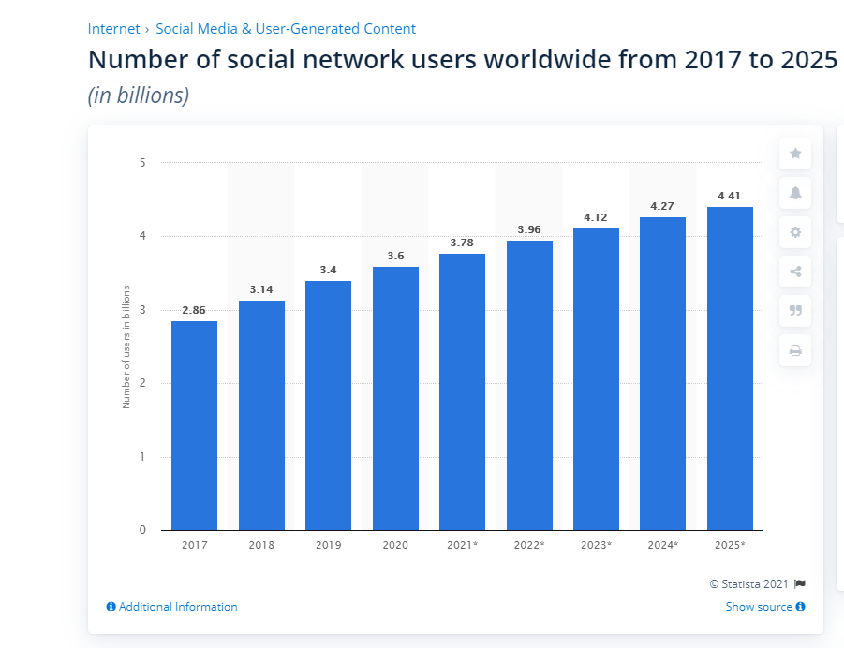

Figure 1: Number of social network users worldwide from 2107 to 2025 (Tankovska, 2021)

Based on the huge number of views caused by the large number of active Internet users, a set of data shows that the daily views of Chinese Internet users based on the software Weibo reached 420018 for just one topic. This figure is for the 420018 people who searched and viewed this one topic every minute on Weibo, which could be a news story or a celebrity gossip. Such a huge amount of data is one of the most powerful pillars supporting the birth of the new field of social media marketing. (Buffer, 2019)

Kesharwani, Sarkar & Oberoi, (2019) argue that in every era, people have their own unique ways of communicating. In today's volume based on 2 billion internet users, social media marketing has become an emerging way for internet users to express themselves and communicate with people. People are no longer writing letters to each other or calling and texting as often.

At the same time, this way of communicating with each other has had a huge impact on the marketing activities of businesses. Many companies are realising that if they do not use social media marketing well in today's digital world, it will be difficult for them to stand on the wave of the times. It is even more difficult to make greater gains today. Social media has even more amazing influence in the world, for example, if Facebook were a country with a huge user base and usage of 2.7 billion active users, this would be the world's most populous country. (Tankovska, 2021a) It world is connected by social media into a circle where people all over the world can communicate with each other. (Lokumannage, 2020)

While it is important to use social media for marketing, this cannot be the entirety of a company's marketing interactions. A combination of traditional TV commercials, posters, which are advertising in nature, and social media marketing is the more appropriate direction for businesses today. (Cao et al., 2020)

2.3 Different ways of social media marketing

WeChat is a social media and multi-functional program in China that allows users to not only chat with each other and browse news on WeChat, but even browse articles through 'Public'. So, for WeChat is not only a social media software but also a multifunctional application. With over one billion monthly active users in 2018, WeChat has become one of the most popular social media platforms in the world. Although WeChat has a large number of users, it is rarely known in the West. (Montag, Becker and Gan, 2018)

For the basic approach and content of social media marketing, based on a review of the Zheng, (2016) literature. This literature uses WeChat as the main subject of study, as it is the most widely used social media in China, with 1.17 billion users in the country. In terms of social media marketing implemented in WeChat, he believes that there is a total of several avenues and modes. These are through advertising, QR code marketing and word-of-mouth marketing respectively, through which effective social media marketing can be carried out to customers from WeChat.

2.3.1 Advertising

Social media is a mixed bag of users, with companies or individuals posting messages or comments to their friends to carry out the most basic and cheapest form of social media marketing. This can include relevant advertising messages. This is particularly effective when the main purpose of such advertising is to share life rather than to advertise. In particular, a lot of social media marketing uses not only the sharing of news, but also stories, hot topics, and so on. For example, if a company marketer simply shares an item that he or she finds useful, a friend or customer will ask where to buy it. (Sakshi, 2017)

Users are more likely to trust an inadvertent share on social media, as they tend not to perceive it as an advertisement. Whereas when an ad is pushed by a customer who is aware of it from the outset, often users will doubt the authenticity of the effect of the product in the ad. (Anspach, 2017)

So, this is called media marketing, is to make the ad look like it is not an ad, and thus gain the trust of the consumer. (Alalwan et al., 2017)

2.3.2 QR code marketing model

QR code marketing is at the same time a very customary form of social media marketing on WeChat, and how to use QR code marketing is also a part of the business focus.
Another feature on WeChat in China is the 'swipe' function for QR codes, which are a graphic similar to the one in figure 2. The QR code is placed in the viewfinder and the QR code is scanned in front of you to obtain information. When using QR codes for marketing purposes, they will generally be coupons for the merchant, membership information for the merchant, news from the merchant and even the ability to receive payments.

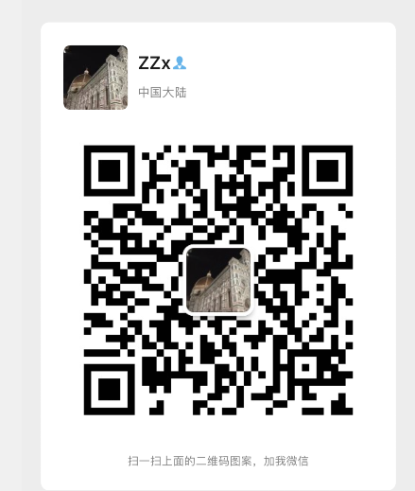

Figure 2: Researcher’s WeChat QR code.

2.3.3 Word of mouth marketing model

It is a way of using user feedback to attract more potential consumers by placing positive user reviews on the appropriate social media platforms. (De Bruyn and Lilien, 2008) It is a way of using social media platforms to create a strong relationship between a business and its customers. Customers and customers spread the word to each other, and customers have a better perception and attitude towards the company through positive reviews on social media. (Blazevic et al., 2013) And by using the retweeting function of social media platforms, more and more potential consumers can be converted into business performance. The effect of word-of-mouth marketing is achieved.

In this case, the backend of the social media platform records the feelings of individual users about different products, which results in big data. Once the data has been analysed, each user is then recommended the right product for them.
Researchers believe that traditional marketing concepts refer to a similar approach as viral marketing, using word-of-mouth from users' reviews of products. to achieve a promotional effect for a product. (Baccarella et al., 2018)However, on social media platforms, social media amplifies the effect of this model, spreading faster, wider and more effectively.

2.4 Pros and cons of social media marketing

The process of moving from awareness of the importance of social media to actually using social media marketing to achieve improved performance still reveals the problems that some companies currently have when conducting marketing.

2.4.1 Lack of awareness of target customers and media

Liang & Yao, (2017) believes that there is a lack of clarity in the choice of target customers and social media. Many companies, in pursuit of their own economic benefits, do not target their social media marketing extensively and spend high costs on overwhelming advertising and sharing. But they do not receive the results they should. At the same time, this is a kind of random marketing without design and targeting. Companies do not research the nature of their products and brand positioning, nor do they have good market research to segment their customers, but simply follow the trend of social media marketing. The right target market and the right target customers are not chosen.

When a company does not select the exact target audience for social media marketing, for example when the customer is a low income person and the expensive car company does a lot of social media marketing to him. In the short term this appears to be a waste of business resources and the customer is not capable of closing a deal with that business. In the long run the customer may even become bored with the business because he will be looking at ads that have nothing to do with him every day. Social media marketing in this context is obviously not conducive to the development of the company and can even have a side effect on the image of the company.

2.4.2 An inauthentic consumer experience

Ultimately, social media marketing is used by companies to promote their own products, to stand out from the competition, to increase their share of the market and thus to improve their performance and economic efficiency. However, with the rise of social media platforms, some customers have a way of directly evaluating and recommending companies. For example, after experiencing a company's services, they share their thoughts directly on social media about their feelings. (Liu, Perry and Gadzinski, 2018) Good reviews can bring more customers to a business, allowing the business to develop a good reputation and convert potential customers into real ones. This can lead to more benefits for the business. (Chen, Liang and Cai, 2018)

But social media is often a double-edged sword in this, with many businesses' would-be rivals maliciously badmouthing a business on social media. The rise of this 'online army' has to some extent used social media marketing as a weapon to attack competitors, deliberately interfering with consumer orientation. (Hearn, 2020) Here, social media influencing consumers' consumer orientation is considered. Consumers buy things that they clearly have no need for and they buy them simply because of the advertising on social media marketing. (Jin, Muqaddam and Ryu, 2019)

There are even 'water armies' who maliciously attack companies and engage in blackmail, thereby seeking to make high profits. There are negative untrue consumer experiences and there are exaggerated untrue consumer experiences. Companies over-exaggerate their products and services to attract customers. And when customers actually experience them, the publicity and the real experience are often very different. So, all kinds of untrue consumer experiences interfere with consumers' judgement to a certain extent, making it difficult for them to make a real and correct judgement. (Vashistha et al., 2019)

2.4.3 Advantage of social media marketing

But in many cases, there are also very many benefits to social media marketing
Social media marketing is a way to help companies better understand their customers' needs and thus help them build customer relationships more effectively. (Amoako, Okpattah and Arthur, 2019)

Through social media, there has been a shift in the way companies use advertising and marketing campaigns, from the traditional newspaper, telephone, radio and television to a new form of online marketing based on social media. (Chi, 2011) The most helpful aspect of social media is that it creates a connection between the company's stakeholders and allows the company to get direct feedback from customers. (Vinerean et al., 2013)

At the same time social media can help companies to build a strategy around their product and service communities. (Mcdonald, 2018)It builds brand loyalty, increases the barriers of one's brand and helps companies to promote viral marketing through customer reviews.

Helping companies to better listen to consumer suggestions and opinions. Market research companies that help companies gather brand intelligence on social media platforms. Although in many cases, it is unethical in business ethics to collect information about customers and use it. However, there is no denying that this can be beneficial to a certain extent for the client's development. (Zhang and Gupta, 2018)

2.5 Social media marketing in telecommunication

In the telecommunication industry, the impact of social media influence is particularly significant. The essence of social media is the emerging communication tools. Companies in the telecommunication industry are mostly focused on the production of mobile phones in China. For example, HUA WEI OPPO ONE PLUS. (Tan et al., 2020) They themselves produce mobile phones with their own community-like apps, which facilitate small sets of their user groups. It is also a kind of social media marketing, where companies can easily make an effective social media marketing to the customers of their own products in a segmented customer market. (Khajuria and Rachna, 2019)

In for marketers, social media has the ability to achieve great results in a much shorter period of time at a very low cost. However, in the communications industry this can bring incalculable risks.

In this study, the results of an online survey of 287 users followed by Egyptian telecoms companies on social media showed that social media marketing campaigns consist of three dimensions; fashion, personalisation and word of mouth. These attributes of social media marketing directly affect brand loyalty and indirectly affect brand equity mediated by brand trust. (Ebrahim, 2019)

2.6 Social media marketing of Xiaomi

On how Xiaomi conducts social media marketing, xxx argues in his article. Xiaomi's chosen channels for social media marketing include Weibo and WeChat. Each channel has different characteristics and forms a matrix of communication channels.

Xiaomi has its unique Xiaomi community, which is the equivalent of a portal for the Xiaomi brand as a whole. In this, all kinds of information about Xiaomi's products are presented in a comprehensive manner. Xiaomi's fans are generally known as 'Mi fans' and this community also provides a platform for them to communicate with each other. The Xiaomi community has a unique daily signature slot, which gives 'Mi fans' the opportunity and power to express themselves on a daily basis. Similarly, Xiaomi's Weibo account pushes Xiaomi to a much wider audience. Including on the WeChat platform Xiaomi will also have its own unique WeChat public number. All methods are designed so that Xiaomi can maintain a stable and good customer relationship. Making 'Mi fans' feel connected to the company. (Zheng and Huang, 2019)

At the same time, the community has established a good user experience feedback system, where 'Mi fans' share the physical products, they have received and their experience of using them with the community after they have purchased them. This way customers who are already 'rice fans' in the community can buy with more confidence. 'Rica fans' are loyal users of Xiaomi and can also be described as fans of the company. They use a large number of Xiaomi products and keep an eye on what's going on in the company. The majority of companies make most of their profits from a small number of loyal customers. In this regard, Xiaomi's use of social media marketing is certainly outstanding. (Tian, 2019)

Xiaomi has also set up, an online hometown system. This helps 'Mi fans' in a city to meet and get to know each other. From time to time, they hold lucky draws and other activities to promote the relationship of 'Mi fans' in the same city.

Xiaomi's marketing efforts are all aimed at creating a complete Xiaomi eco-system, so that its loyal customers can't live without Xiaomi. Imagine a customer who uses Xiaomi for their mobile phone, Xiaomi smart furniture for their furniture, and a partner they met through an online party. Such a customer who is fully part of the Xiaomi ecosystem will create so much value for Xiaomi. (Wang, 2021)

2.7 Gap in the literature

Social media marketing is more environmentally friendly than many traditional marketing models, reducing the waste of paper for example in brochures, leaflets etc. It is also an important way to save on advertising costs for companies in China, compared to the tens of thousands of dollars a second spent on TV commercials. Social media marketing requires little more than manpower and creativity. For example, many of the social media mentioned in today's papers have long since been eliminated, with the old 'qq space, Renren' having been replaced by today's Jitterbug, Sina Weibo and WeChat.

In the reviewed literature, researchers also suggest that it is narrow-minded to arbitrarily assume that social media marketing is necessarily superior to traditional marketing, and that this view is not made of data. The researcher will subsequently investigate the data to determine which is better and which is worse for Xiaomi.

In the case of Xiaomi, Lei Jun, the chairman of Xiaomi, is a very personal and influential entrepreneur. This is something that is not mentioned in many articles.

In this article the researcher will focus on how Xiaomi is marketing itself in the emerging social media. Even how the founder Lei Jun's personal marketing interests have been used to market the company, and how social media marketing has been used to save on advertising costs and thus what benefits have been gained.

Chapter 3: Research Methodology

3.1 Introduction

A summary of the literature in this field of study was completed in the previous phase. The reader was made aware of what social media marketing is and the importance of social media marketing to businesses today, but there are still some gaps in the field regarding Xiaomi's social media marketing strategy and consumer perceptions of Xiaomi's social media marketing.

There is even a lack of understanding of how social media marketing can be implemented appropriately and what impact it has on the performance of a company.

Researcher will be focus on the three objectives, in an example Xiaomi company.

- First is how to use social media to marketing, how social media marketing is being used in the existing communications industry as a whole, with a focus on Xiaomi's current approach to social media marketing.

In this section the researcher will mainly use secondary data to support the analysis, using examples of marketing by various companies collected on various social media networks.

- Then is effect of company's performance by social media marketing. Take Xiaomi as an example. Whether the social media marketing conducted by Xiaomi can influence customers to bring revenue to Xiaomi.

This section will use some of the questionnaire and interview data and Xiaomi's publicly disclosed financial data to support the analysis.

- last one is challenge about social media in future. What kind of social media marketing is good and can help companies achieve their strategic goals. What do companies have to do to make complete use of social media marketing.

This section will make extensive use of first-hand data, collected from various sources, to evaluate Xiaomi's current social media marketing and make predictions for the future.

3.2 What is research

Research is often defined as the creation of new knowledge in new and creative ways. Alternatively, it is the use of summarising existing knowledge in order to generate a new understanding of the field. (Wright, 1966) This can include analysing and adding to previous research in order to produce new findings. (Westernsydney.edu.au, 2019)

Due to the nature of the research in this paper, a mixed methods study is used, which is a complement to the traditional qualitative and quantitative research. (Johnson and Onwuegbuzie, 2004)

3.3 Research onion

The Research Onion Model presented by Saunders, Lewis and Thornhill (2016) in 'Research Methods for Business Students'. It is good research class model in this dissertation that can be effective in helping this part of the research to gather information and more comprehensive research.


Figure 3 Research onion (Saunders, Lewis and Thornhill, 2016)

In this dissertation research onion will consists of a philosophy, an approach, a strategy, a selection of methods and a time frame.

3.3.1 Philosophy

This study is part of positivism, which is defined by the fact that knowledge of facts is based on the proof of cumulative data. (Feigl, 2018)

In this study, questionnaires, interviews were used as the basis for a large amount of data. The conclusions drawn from processing this data are clearly in line with positivism.

3.3.2 Approach & strategy

A study of the usual inductive and deductive methods. Even a combination of the two methods in some cases. The inductive approach is suitable for cases where there is little literature and theoretical support, and the limitations of this approach are that it is difficult to really prove and verify.

The deductive approach implies the study and validation of theories based on previous work and is limited to the fact that the deductive approach is difficult to carry out if there is no literature base. (Streefkerk, 2019)

Social media marketing is an emerging marketing model, and Xiaomi is also an emerging mobile phone technology company, and there is no good reference in the overall literature to analyse this company's social media marketing. Therefore, the researcher chose to use an inductive approach, combining data and theories from different companies in the same industry, in order to finally evaluate the social media marketing methods and results of Xiaomi.

In this dissertation, all the research and data are based on the foundation Xiaomi Corporation. So, this is a case study, for which data was collected and thus analysed.

3.3.3 Choices of Methods

One of the recommendations of the Onion study is to use a single research method mixed methods and multiple methods as the main research guide. The method chosen for this study was a mixed research approach to data collection. Both qualitative and quantitative methods were used in this study. Although the presence of COVID-19 did not prevent the researcher from studying it to some extent. Social media platforms were used to share questionnaires to collect data. The interviews were also conducted through social media, which to some extent also highlights the superiority of social media.

Secondly, there are many ways in which researchers collect and analyse data. Not only from specific websites or direct observation, but in many cases, researchers collect more data from public comments. In order to gain a comprehensive understanding of Xiaomi's social media marketing. (Verschuren, 2003).

And, the study needed to first explore Xiaomi's specific social media marketing strategies from its annual report and website, and then from its revenue and customer questionnaires to understand whether its social media marketing was effective and how it was rated by its customers. A mixed research approach was chosen for this study, combining qualitative and quantitative data, first-hand data and secondary hand data, questionnaires and interviews. (Wang, 2018)

The company chosen by the researcher is from China and will use more Chinese "Questionnaire Star" software to create the questionnaire when distributing it, which generates its own graphs and summaries of the data, without collecting personal information, including names. (www.wjx.cn, n.d.)

3.4 Data collection

3.4.1 Qualitative and quantitative

A quantitative study is a study that is conducted with a large amount of data and information. A large amount of data is analysed to obtain the nature of the object of study. (Ercikan and Roth, 2006)

Qualitative research is usually based on descriptive data and analysis. It is usually based on language, text. (Dixon-Woods et al., 2005)

3.4.2 Method of collect information

The researcher will design a questionnaire to first-hand data regarding social media marketing, the practical application of social media marketing in Xiaomi. The target audience for distribution is the general social media users.

Using questionnaires gives a clear picture of the information and information and opinions of the people being collected, as it is a direct survey and a way to reach out to the audience directly. However, there are still considered to be some problems in the tradition, firstly the use of large amounts of paper can cause a degree of waste of resources, secondly the large amount of data that needs to be would be aggregated and analysed, there is a huge amount of work involved in this method and finally the time to distribute and collect is a time consuming and labour-intensive process. (Parajuli, 2008)

Today researchers use a function in WeChat to conduct questionnaires, which is good for avoiding the above problems, whether it is the initial questionnaire or the analysis and summary of the data or even the graphing that is done by the app.

Based on the data obtained from the questionnaire, the researcher will then conduct in-depth interviews with key users of Xiaomi's products to collect data. An in-depth interview, also known as an unstructured interview, is a type of interview used by the researcher to obtain information in order to gain an overall understanding of the respondent's views or situation. (Rita, 1999)

This method has a significant open-ended character, but at the same time is limited by the personal sensitivities of the interviewees, with the same questions being asked to the same interviewees and even different data being returned depending on the mood of the day. The data collected in this method is often highly unstable. (Lederman, 1990)

3.5 Pilot Study

In order to obtain high quality results, a pilot study with relevant experiments and accuracy performance needed to be designed. For this reason, it is useful to effectively analyse the feasibility of the main study before it is carried out. (In, 2017) The pilot study is the first step in the overall research protocol and the pilot study is usually carried out before the main experiment to analyse its validity. (Lancaster, 2015)

3.6 Interview design

The researcher conducted three interviews with the researcher's peers, the researcher's elders, and a marketing practitioner. A total of four questions were designed, and because of the covid-19 relationship all interviews were conducted via video call.

3.7 Analysis

The researchers will use a Chinese software called Questionnaire Star to collect and analyse the data from the questionnaire and use graphs to present the data. The open-ended interviews will be analysed using a thematic approach to look for any common themes, trends or patterns.

3.8 Reliability and validity

Reliability and validity are concepts used to assess the quality of research.

Reliability indicates the extent to which results can be reproduced when a study is repeated under the same conditions. The consistency of results is checked by different time spans and different observers.

Validity is to a large extent a true measure of the extent to which they should be measured. (Middleton, 2019)

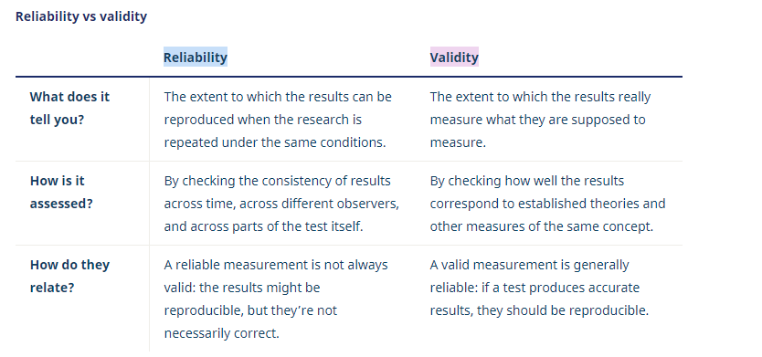
Figure 4: Reliability vs validity: what’s the difference? (Middleton, 2019)

3.9 Limitation

As the aim of the study was to find out the opinions of the general public, it was reasonable to use a sampling method. However, in this, it is difficult to ensure that every survey is valid because the covid-19 researcher was unable to distribute the questionnaire offline, which made it difficult for the online questionnaire researcher to know if the respondents were scribbling. (Leung, 2001)

People's perceptions of things are very subjective, and often the same advertisement can be viewed differently or even contradictorily depending on gender and age. So, there are some errors in this, although the survey is designed to ensure objectivity, it is difficult to avoid such mistakes because each respondent is subjective. (Stone, 1993)

3.10 Ethical Considerations

Ethics usually considers whether research is appropriate in terms of social issues. Ethics are needed to govern the design, use and storage of data. Ethics in research includes whether it is supported by the public, social responsibility, etc. (Kjellstrom, Ross and Fridlund, 2010)

The specific ethics in Appendix 3: Ethical guidelines for data collection

3.11 Conclusion

This chapter identifies the direction and methodology of the study, the direction of secondary data collection, and the methods of primary data collection (questionnaires and interviews). Also, the mixed research approach and the case study strategy used in this study are explained. The analysis of the collected data is explicitly presented in Chapter 4.

Chapter 4: Analysis Of Results

4.1 Introduction

The previous chapter consisted of some research methods and guidelines, in this section aimed at achieving the research objectives of this dissertation doing the basis of the data. The survey collected 356 respondents, each with a 100 per cent question completeness rate, along with three interviewed volunteers.

Their perceptions of social media marketing and the evaluation of Xiaomi's existing social media marketing were investigated. This data will be used in this section to respond to the three research objectives covered in the previous chapter. A critical and dialectical analysis is also conducted. (Wodak and Meyer, 2016)

4.2 Data analysis

Data analysis is the process of counting and classifying the data that has been collected so that it can be more easily applied and finally some conclusions can be naturally drawn from it. (Ram Gnanadesikan, 1983)

The main purpose of analysing and managing the data in this dissertation is to respond to three objectives, so the data will be developed based on these three scopes.

4.3 Overview data from questionnaire

4.3.1 Demographics

Basic information about the respondents is an important part of the survey, but also in conducting social media marketing. (Ott and Longnecker, 2020) Because of the covid-19. questionnaire was shared via social media; the respondents were mainly of a similar age to the researcher. Of the respondents, 85.95% were between the ages of 18-22 and 86.8% were professional secondary school students. 79.21% of the respondents were female and only 20.79% were male. A very interesting data collection with a very different gender of the subjects. (Schnell, 2009)

Here the researcher believes that to some extent it shows that women have a stronger interest in social media related questionnaires. It may even be that women are more willing to help others and help with data collection for research. It may even be that the researcher's own social circle, where she knows more women friends, also indicates to some extent that the study is somewhat limited. But of course, this is only speculation on the part of the researcher.

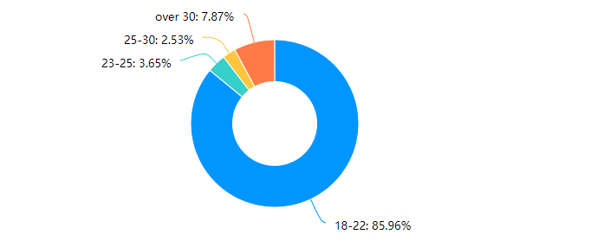

Figure 5: Q1 Age of Respondents

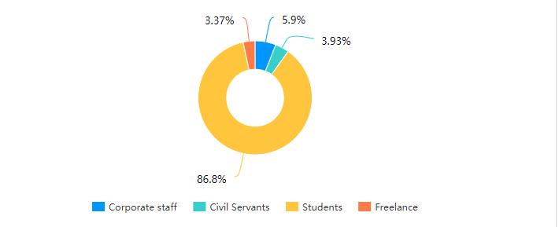

Figure 6: Q2 Job of Respondents

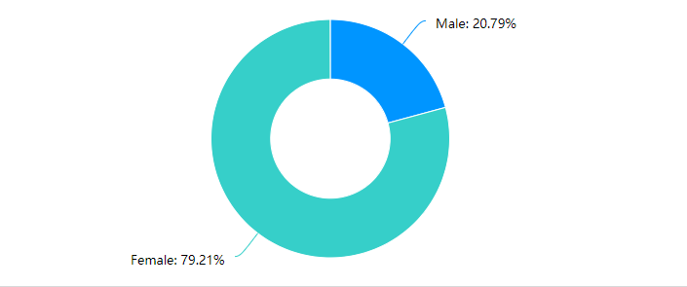
Figure 7: Q3 Gender of Respondents

4.3.2 Social media use

Respondents' use of social media, both in terms of time and specific content of use. The data from several of these questions shows that 67% of people use social media software on a daily basis. At the same time, only 1.97 per cent of the population, based on a sample of 356, or seven people, do not use social media at all. (Weinberg and Pehlivan, 2011)

The vast majority of people use it for almost three hours. Among the most popular uses of social media are making friends, watching videos and shopping. It can also be seen that only ten people are dissatisfied with the information they take in on social media and the vast majority are more than satisfied.

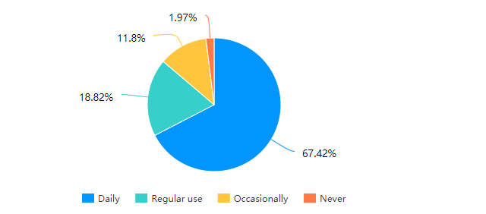

Figure 8: Q4 How often do you use social media apps

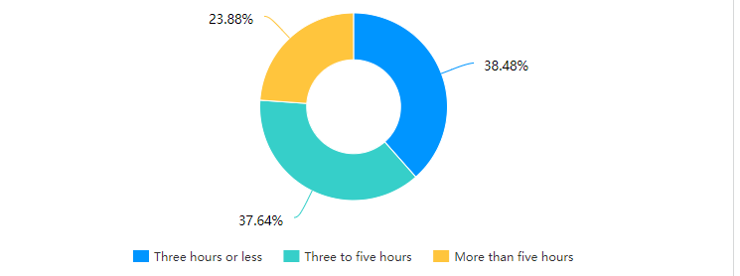

Figure 9: Q5 The amount of time you spend on social media platforms each day

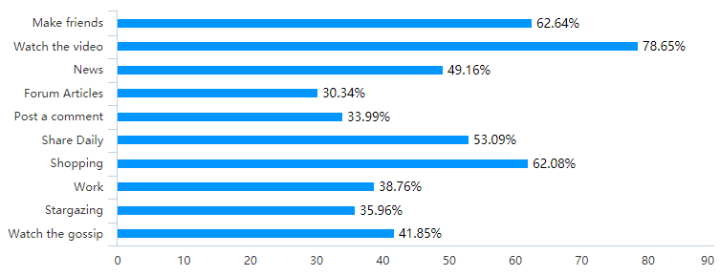
Figure 10: Q6 Which of the following activities have you used social media for

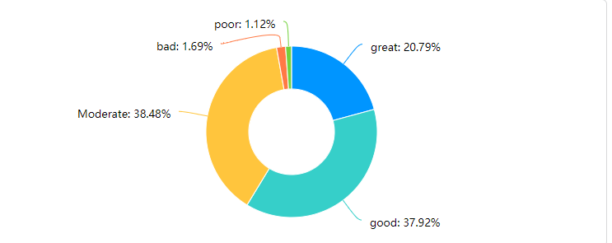

Figure 11: Q7 Overall, how to rate the quality of information you get from social media platforms

It is easy to see from figure12 and 13 that existing advertising on social media is ineffective and only eleven percent of people will make a purchase. Even 44 percent think that it interferes with normal use. Only 69 per cent of people will pay attention to social media marketing messages at their leisure.

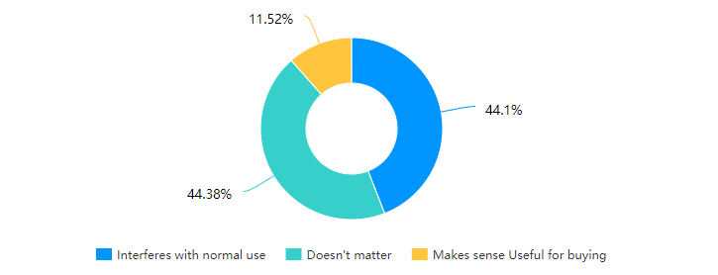
Figure 12: Q8 How to think about advertising for companies on social media platforms

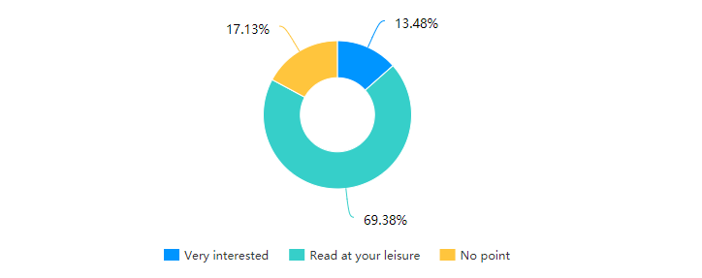

Figure 13: Q9 Your views on the additional features of social media platforms (e.g., WeChat applets, public numbers, Jitterbug live streaming

4.3.3 Reviews of Xiaomi's products

This part of the figures shows that Xiaomi's mobile phones are still the main consumer target, while Xiaomi's non-mobile business has also had a good sales volume. Overall Xiaomi's products are good and the vast majority of users think they are good. Home products and other electronic products such as rechargeable batteries and headphones are well received. (Tan and Zhan, 2016)

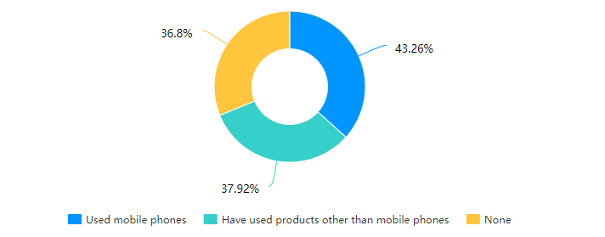
Figure 14: Q10 Have you used Xiaomi products

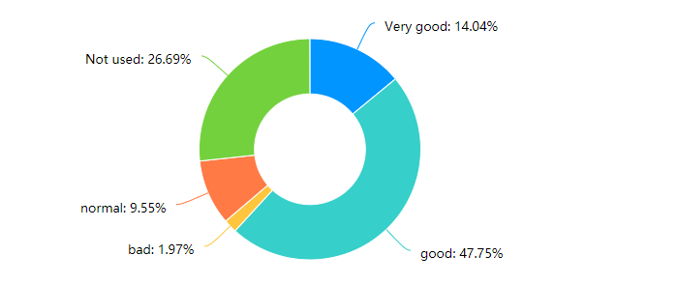

Figure 15: Q11 How do you rate the Xiaomi products you have used

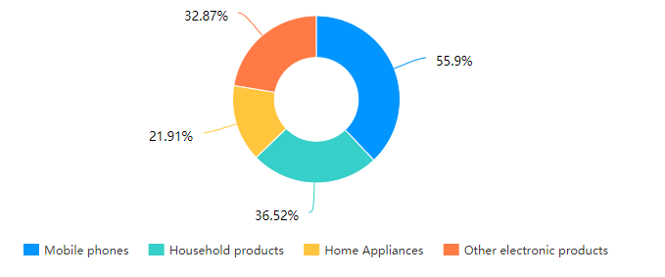
Figure 16: Q12 When comparing it to Xiaomi's other products, which one do you think appeals to you more

4.3.4 Purchase behaviour

With this part of the data, the influence on social media only makes less than half of the people want to buy. Also, the most crucial factor for Xiaomi as a brand is the excellent value for money. The three main social media platforms in China are Douyin, Wechat and Weibo, which are similar to Tiktok in that they provide a platform for users to share short videos of their daily lives, Wechat is similar to Fackbook in that it provides a platform for daily chats and sharing of life among friends, and Weibo is similar to twitter in that it is a platform for socialites or celebrities to share their lives. Weibo is a platform for socialites and celebrities to share information. The data shows that Xiaomi's main social media marketing is not on any of the major social media platforms. (Delisle, Goldstein and Yang, 2016)

It is also clear that Xiaomi's marketing is currently low, and that the advertising is inefficient and hardly stimulates the desire to buy. There are even some that have a negative impact on the company, but it is good to see that Xiaomi's social network accounts are still highly visible. (Erkan and Evans, 2016)

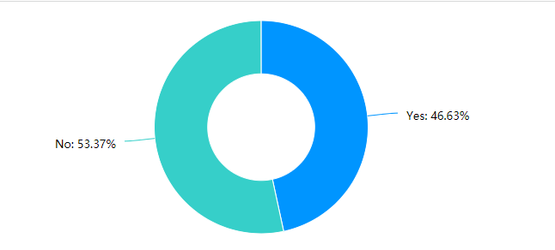
Figure 17: Q13 Has social media marketing motivated you to buy Xiaomi products?

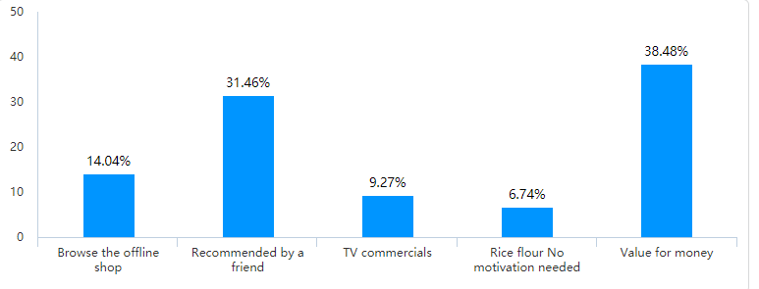

Figure 18: Q14 What is your motivation for buying Xiaomi products

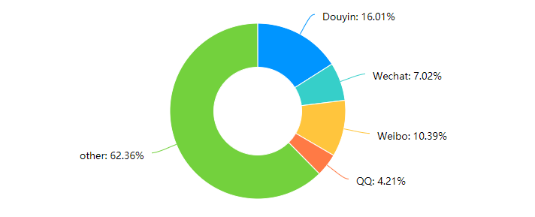

Figure 19：Q15 On which social media did you discover Xiaomi products
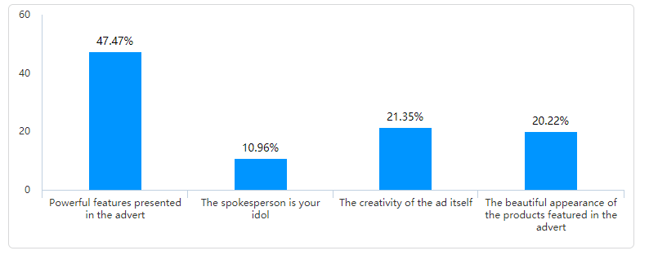
Figure 20：Q16 What specifically appeals to you about Xiaomi's social media marketing

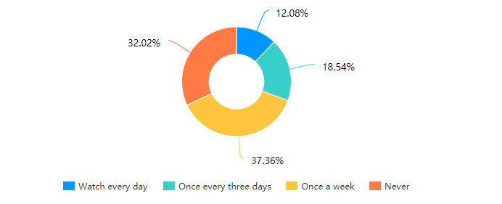
Figure 21：Q17 How often do you see Xiaomi's ads on social media platforms

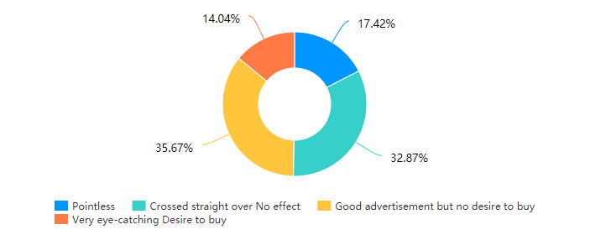

Figure 22：Q18 How do you rate Xiaomi's advertising on social media platforms

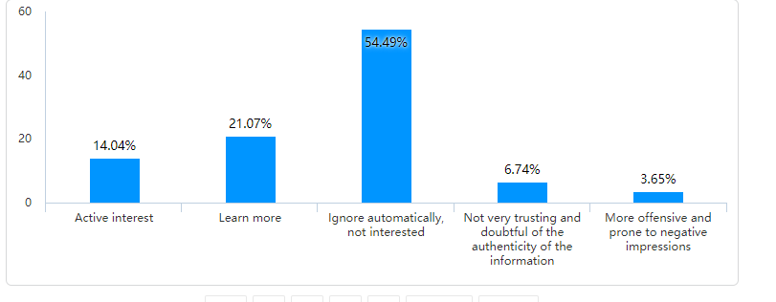
Figure 23：Q19 Your attitude towards the marketing activities conducted by Xiaomi on social media? (e.g., @friends, coupons, etc.)

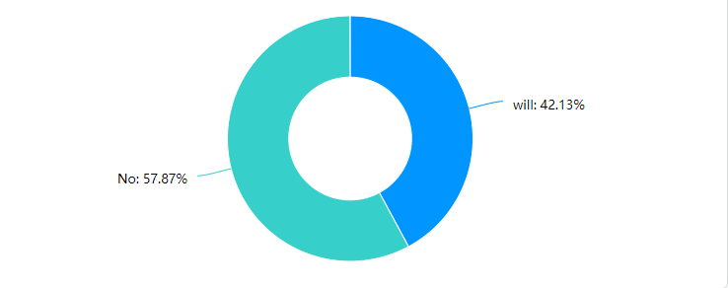

Figure 24：Q20 Do you actively search for information about Xiaomi Corporation or Xiaomi phones on social media platforms

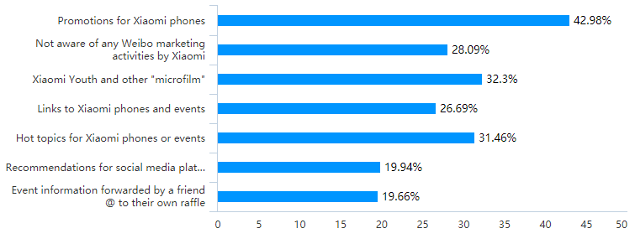
Figure25：Q21 Which Xiaomi companies are you impressed with in terms of social media marketing

Question 22 is a fill-in-the-blank question that what kind of advice do you have for Xiaomi's current marketing strategy. The researcher listed some of the valid answers.

Respondent Serial Number | Suggestions
1 | Improving quality
2 | More accurate placement on platforms
8 | Better use of social media traffic
20 | More display of Lehman's message
198 | More diversity
209 | More stars
290 | Youthfulness
301 | No advertising

Table: Q22 Your suggestions for Xiaomi's social media marketing

4.3.5 Advantages and disadvantages of social media marketing

The main advantages of social media marketing as perceived by respondents are its wide audience reach, low cost and speed of distribution.
At the same time, the main disadvantage is that it is easy to create a negative impact on customers, and the wrong spokesperson is likely to bring the company down.

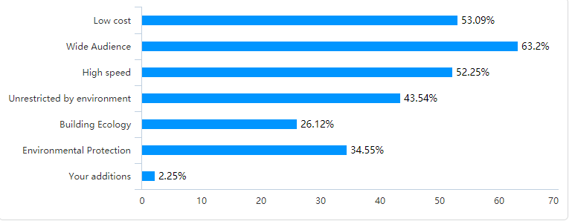

Figure 26: Q23 What do you think are the advantages of marketing on social media platforms for businesses (including but not limited to advertising, live streaming)

*(Your addition is the researcher's opinion on the issue and is not included in the options.)
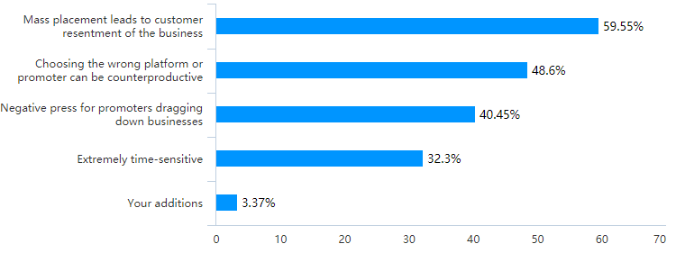
Figure 27：Q24 What do you think are the shortcomings of marketing on social media platforms

4.3.6 The face of social media

While 77 percent of people do not follow Lei Jun's personal account, there are still some who say they will in the future but mainly because of curiosity rather than a liking and desire to know more about the brand. 94 percent of respondents said they would buy Xiaomi products because of Lei Jun, while 68 percent of respondents thought it was good for the entrepreneur to be the face of the company.

The main reason is better promotion of corporate culture and better corporate image. But the main downside comes from the fact that it is easy to brand a company with a particular person. (Rokka, Karlsson and Tienari, 2013)

Meanwhile short videos remain the most popular means of social media distribution for users, while forty-three percent of people don't follow any of Xiaomi's marketing activities on social media at all. (Killian and McManus, 2015)

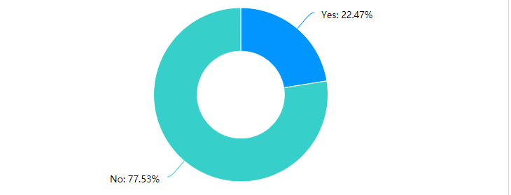

Figure 28：Q25 Do you follow Lei Jun's personal account on Shake or Weibo

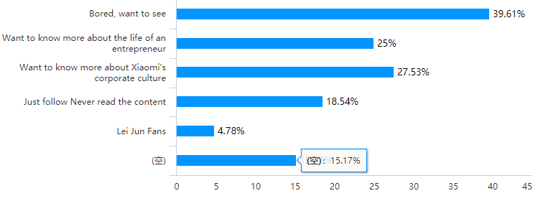
Figure 29：Q26 Why do you follow Lei Jun's social media accounts

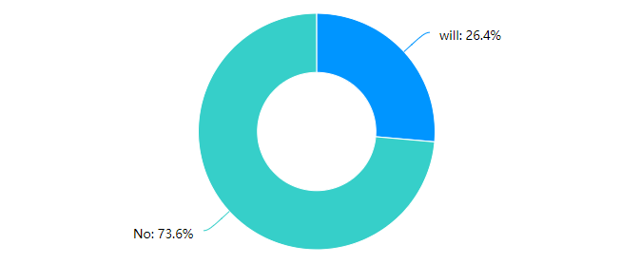

Figure 30：Q27 Would you buy a Xiaomi product because of Lei Jun
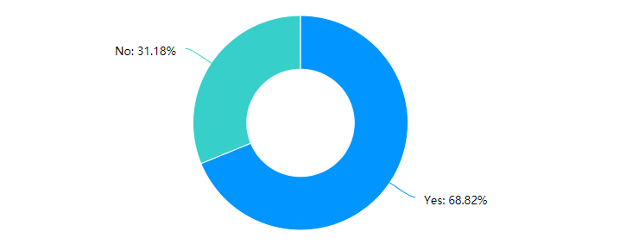

Figure 31：Q28 Do you think it is good for entrepreneurs to do social media marketing themselves
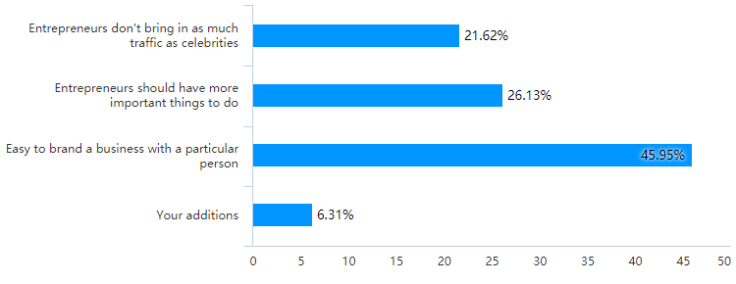

Figure 32：Q29 Your reasons
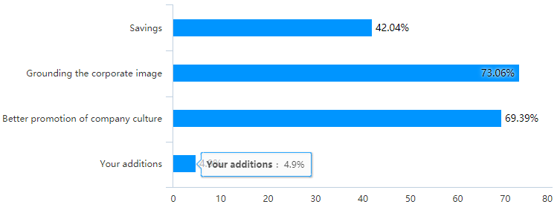
Figure 33：Q30 Your reasons
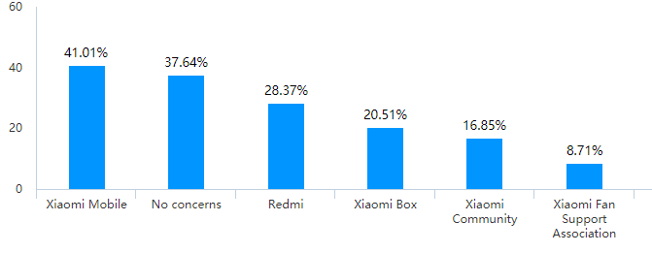

Figure 34：Q31 Which Xiaomi-related social media platform accounts do you already follow

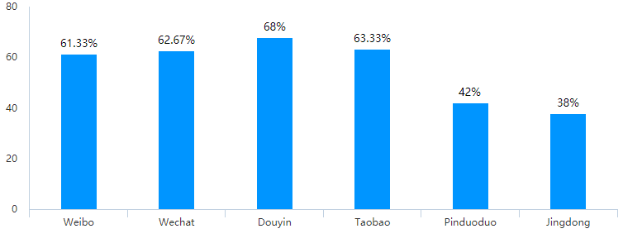
Figure 35：Q32 Which social media

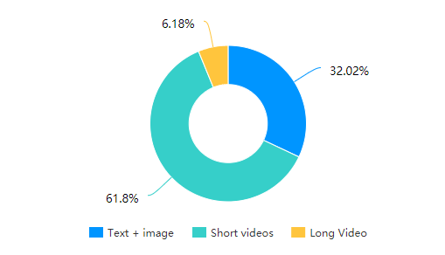
Figure 36：Q33 What forms of social media advertising are you more interested in
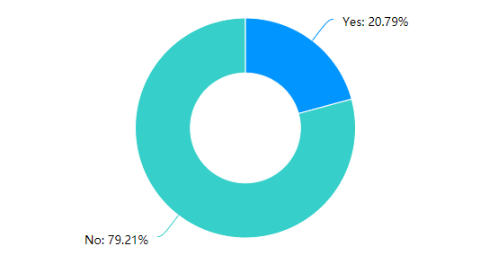

Figure 37：Q34 Have you reported or complained about Xiaomi's marketing activities on social media

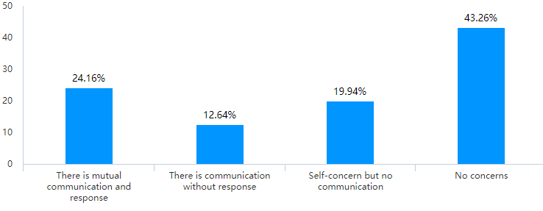
Figure 38：Q35 Have you ever recommended, @ or retweeted information about Xiaomi's social media marketing campaigns to a friend

4.4 Information presented from interviews

Appendix 4: Interview

4.5 Second-hand information

There is very little information in this section, as much of the data is difficult to quantify whether it is used for social media marketing or not. In total, there are two paragraphs from the data disclosed in Xiaomi's 2020 annual report.

Xiaomi's sales and promotion expenditure increased by forty percent from RMB2.3 billion in 2019 to RMB3.2 billion in 2020. This is mainly for marketing and promotion. (XIAOMI, 2020)

Of which promotional advertising was noted to increase from six hundred and eighty-one million yuan in the second quarter of 2019 to 1,068 million yuan in the second quarter of 2020. The increase amounted to fifty-six percent. This was mainly due to increased promotion of 5G phones and high-end phones.

R&D spending increased by twenty-five percent from RMB1.6 billion in 2019 to RMB2.0 billion in 2020. (XIAOMI, 2020)

The new social media marketing strategy will also see the launch of a new social app "Xiaomi Youpin". This is Xiaomi's new strategy to focus on a socially accessible e-commerce platform. In it, consumers engage in 'viral marketing' with each other to generate purchases. (XIAOMI, 2020)

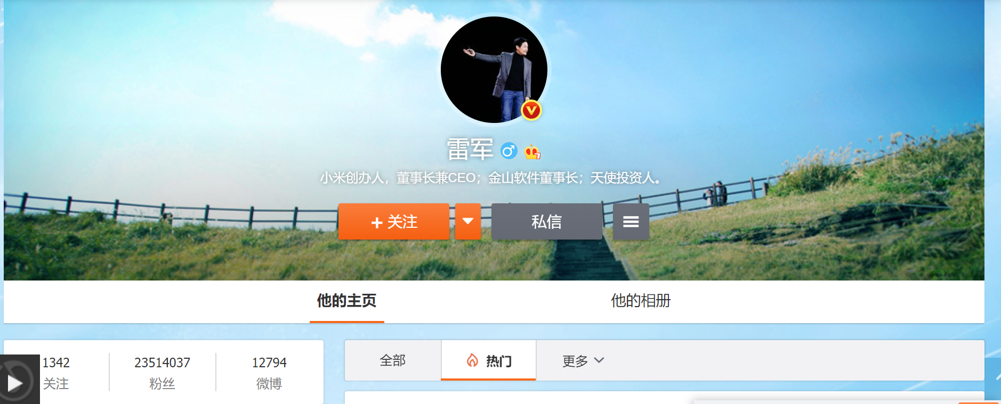
Figure 39 Lei Jun's personal Weibo

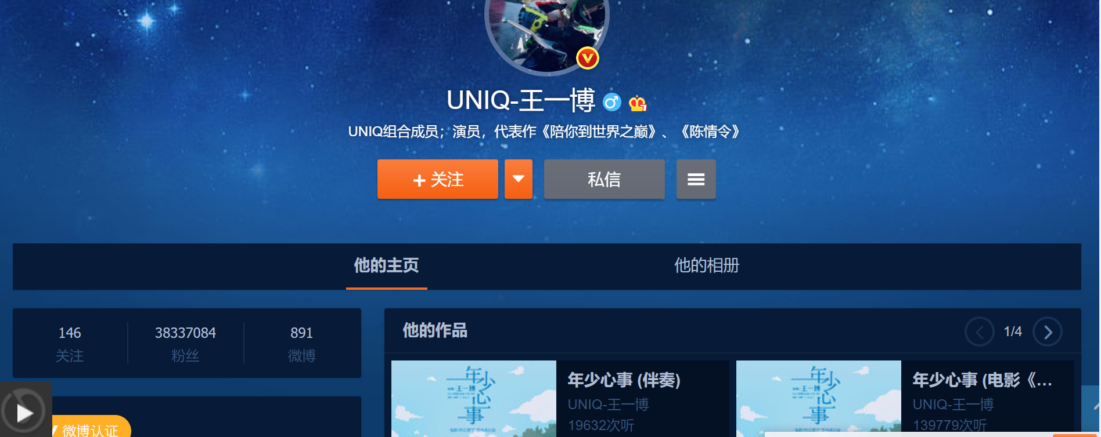
Figure 40 Wangyibo‘s personal Weibo

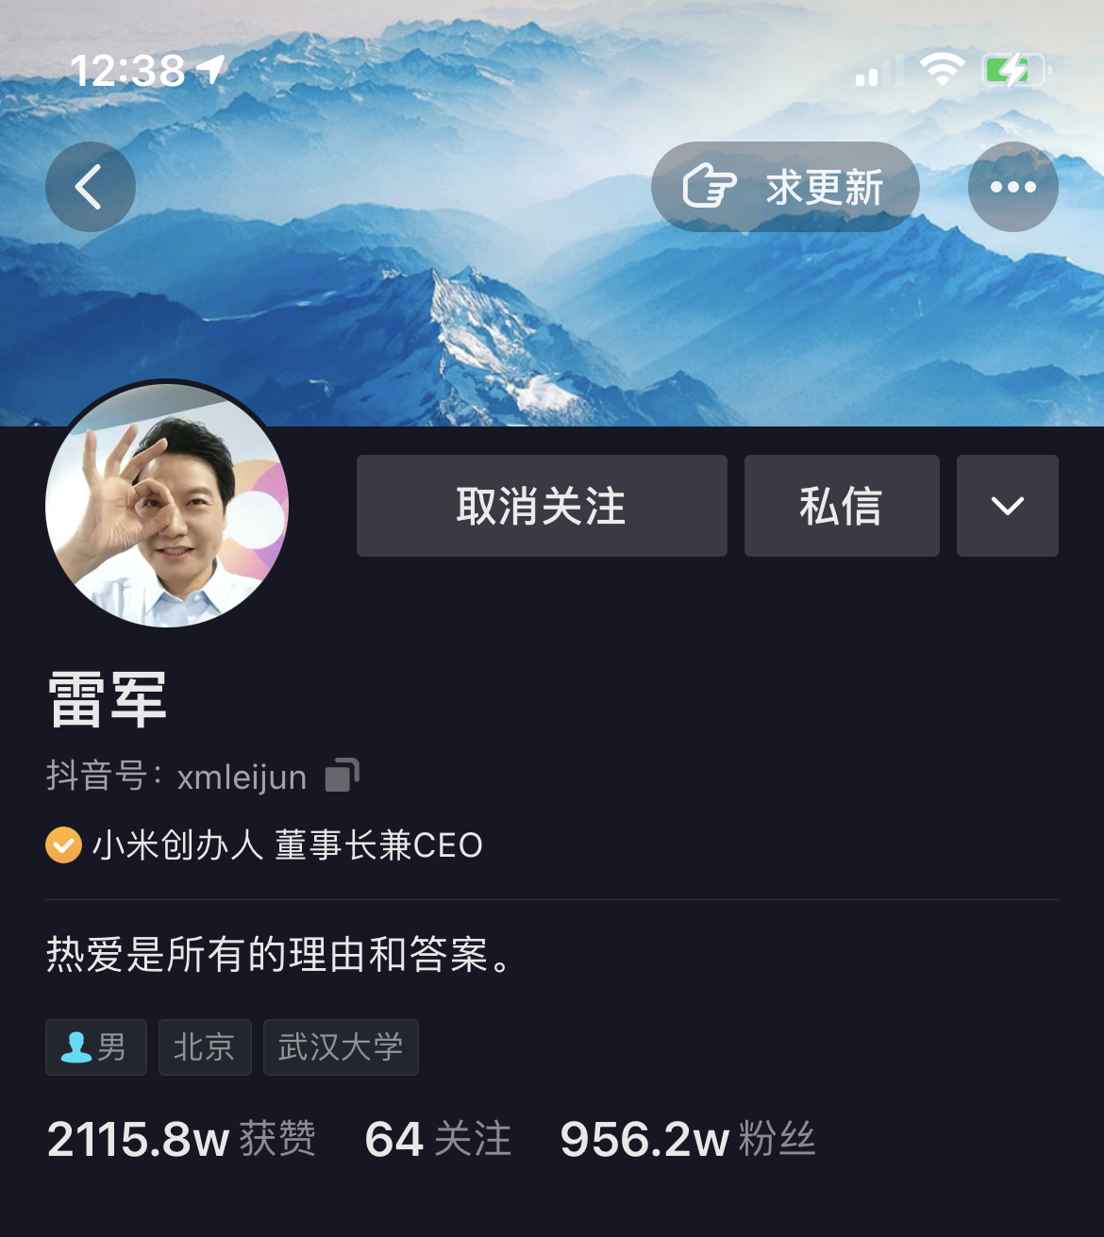

Figure 41：Lijun’s Douyin

4.6 Data analysis based on three objectives

All three areas of data collected by the researcher have been listed and in this section the researcher will summarise and analyse the data based on three research objectives

4.6.1 How Xiaomi uses social media for marketing

Xiaomi's social media strategy is as follows. Xiaomi currently has two spokespeople on social media, one is Chinese star Wang Yibo and thought is Lei Jun, Chairman of Xiaomi. Both spokespersons are by Weibo and Douyin accounts respectively and are sharing updates almost daily. The two spokespersons directly reach two of the largest customer audiences, the young and trendy celebrity followers and the loyal Xiaomi users who are focused on product performance and quality. (Cheung et al., 2020)

From figure39-41 you can see that Lei Jun's personal Weibo followers are up to 23 million, while Wang Yibo's is up to 38 million followers. Lei Jun's Douyin account has 9.5 million followers.

Both of them have a huge influence on social media, with millions of buzzes from random developments. The economic value that can be created is also unimaginable.

These two types of customers contribute the vast majority of Xiaomi's revenue. Xiaomi's unique social media e-commerce platform gives Xiaomi's loyal users, also known as Mi fans, a place to interact with each other, in which loyal users spread the word and influence each other, bringing huge marketing value to the company. (Carlson et al., 2019)

Xiaomi also has a variety of advertisements on different social media platforms, and even a weekly live stream of Xiaomi's products on its Douyin account. (Kuo, Luarn and Chen, 2017) Live streaming is an emerging marketing method in China, where an anchor shows products to customers online in a live stream.

At the same time various retweets of discounted promotions are made on various social media platforms. (Kuo, Luarn and Chen, 2017) Strategically Xiaomi's social media marketing strategy is still very much intact.

Based on the information gathered, the researcher concluded that there is still much room for improvement in Xiaomi's social media marketing.

Users still spend a lot of time using social media in general, which means the future of the industry is huge. However, Xiaomi's social media marketing has not actually been very effective in motivating customers to buy. At the same time customers pay very little attention to Xiaomi's marketing activities.

It is worth acknowledging that the majority of respondents are pushing for the chairman as the spokesperson of the company, which is a social media marketing strategy that Xiaomi deserves recognition.

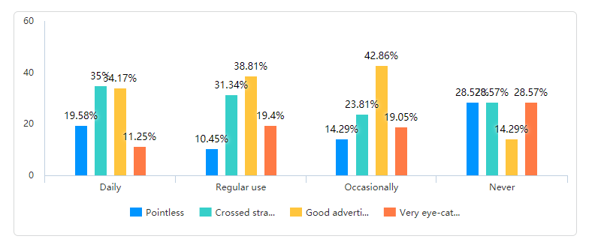
Figure 42：Cross-tabulation, frequency of use of social media and whether purchase desire is generated

4.6.2 The impact of social media marketing on Xiaomi's performance

This part of the data is actually very difficult to collect, as it is difficult to say how much revenue social media marketing actually generates for a business, but it is possible to find out through some details that. This also goes some way to saying that online shipments are greater than offline. (Erdoğmuş and Çiçek, 2012) Much of the credit for driving customer purchases is also due to social media marketing. The figures in the annual report also show that Xiaomi spends more on promotion than on marketing, and that it is the quality of a product and its marketing that directly affects its sales. (Keegan and Rowley, 2017) These figures show that Xiaomi's sales are still largely dependent on good marketing.

4.6.3 The future challenges of social media marketing

Social media marketing in general is a promising business, but Xiaomi is actually underutilised, spending huge amounts of money and time but the results actually leave a lot of room for growth. The fact that consumption is the main function of social media for customers is a good indicator of the industry's future, and the fact that Xiaomi's products are recognised by users as being of high-quality means that they are, to a certain extent, qualified to be marketed. However, Xiaomi still needs to improve on how to make effective and engaging social media advertising. But this question happened to be answered during the interview. The real social media marketing that customers need is passive and unintentional. (Dwivedi et al., 2020) Truly brilliant social media marketing does not let the customer see that it's an ad, and that's what customers tend to like. Because the person makes the customer have an initiative, the customer actively asks what the product is that is shared on the social media platform and what brand it is. Then the customer takes the initiative to buy. (Hofacker and Belanche, 2016) What a good business should do is to reduce some of the advertising, because it is to some extent reducing the goodwill of the customer. Businesses make good products and then show them off unobtrusively and let customers choose for themselves.

Meanwhile Xiaomi's home products have a lot to offer in terms of social media influence and can be a good showcase for the products, and research has shown that many people are more interested in home products than electronics.

In the future Xiaomi should amplify the personal influence of its chairman even more, the company has inevitably become tied to Lei Jun, much like Musk and Tesla. So, a more personal approach to marketing with Lei Jun's influence could be a better way to save costs and make social media marketing more efficient. (Constantinides, 2013)

At the same time carry out more youthful marketing activities, for example, do promotion in college freshmen exchange groups, this promotion should also be unconscious sharing, rather than a brain to invest in advertising in the marketing campaign.

4.7 Conclusion

Overall, the study was successful, with the appropriate data collected for each of the three objectives set by the researcher, and the method of analysis followed the mixed approach described in the previous section.

Chapter 5: Conclusions And Recommendations

5.1 Introduction

The previous chapter analysed all the data collected for this study, and the three research aims presented this time are supported by the data and certain conclusions are drawn.

In this section the practical implications of the study are discussed and the limitations of the study after the analysis of the data are explained and more possible methods for future investigations are looked at.

It also makes recommendations for the future social media marketing of Xiaomi.

At the same time, the researcher will present what has not been done well in this study and reflect on it in order to improve it for the future.

5.2 Main finding

The main objectives of this study are firstly how Xiaomi currently conducts social media marketing, secondly the impact of Xiaomi's social media marketing on the company's performance, and thirdly the challenges facing social media marketing in the future. The three findings after analysis are that

Xiaomi's existing social media marketing strategy is generally comprehensive, both in terms of the operation of its marketing campaigns and the choice of spokespeople on social media is undoubtedly good, but at the same time it faces the problem of being inefficient and not choosing the right approach. (Barker et al., 2017) Users want more or indirect and fast marketing. To be able to stimulate the customer in a lot of time and thus hit into a purchase.

Again, the impact of Xiaomi's social media marketing on performance is significant, both in terms of the findings in the financial data and the number of shipments Xiaomi makes on its online platform, which shows that a large part of Xiaomi's revenue still comes from social media marketing.

At the end of the day social media marketing is undoubtedly used over a vast prospect, especially in China where there are a large number of social media users who spend a lot of time on social media every day. (Barker et al., 2017) What more users need is advertising that stimulates the desire to consume, short video type. The campaign should also be youthful, as the interviews revealed that even middle-aged people would like to participate in youthful interactions.

5.3 Implications

Shih, Lin and Luarn (2014) note that the majority of Xiaomi's existing marketing activities are still based on Xiaomi's loyal customers, and maintaining loyal customers has always been a strength of Xiaomi's marketing, but at the same time, the data seen in this study shows that there are still many people who have not used Xiaomi's products but are interested in learning more about the company. (Cheung, Pires and Rosenberger, 2020)

The first thing that this study highlights is the public's attitude towards social media, which is readily accepted and enjoyed by the public, so marketing on social media is a natural advantage. (Kumar and Mirchandani, 2013)

At the same time, the dynamics carried out by companies on social media are not only a form of publicity for the company, but also a reflection of corporate social responsibility, with companies and users working together to maintain a good social media environment.

5.4 Limitation

At the same time there are too many limitations and things that the researcher did not do well in this study, and also the impact of covid-19 on the researcher was huge. The questionnaire data collection process was exceptionally difficult because of covid-19, and the interviews did not go face to face. Also, the data collection was very narrow in terms of who could be selected, which made the whole dissertation very slow.

The researcher also saw on the backend of the questionnaire platform that many respondents took less than a minute to complete the thirty-five-question questionnaire, which made it difficult to ensure that the data was authentic. This even contaminated the entire data pool.

5.5 Recommendations

At this point in the study, the researcher believes that some recommendations can be made based on the findings currently available.

The first is based on Xiaomi's marketing strategy, the use of popular celebrity so-called endorsements is a method that the company has always used well, but based on the structure of Xiaomi's users, and the users' perception of the company. Xiaomi. (Kumar and Mirchandani, 2013) The company can gradually use Lei Jun as an endorsement instead of a star. Lei Jun's personal influence is huge on social media platforms, which would not only help the company save costs and use more ex to develop the phone, but also bring users closer to Xiaomi's corporate culture, as the chairman of a company is often the one who understands it best, after all, he is the one who sets it. (Kim, 2018)

At the same time Xiaomi's marketing is to a certain extent helping the performance of the company, but the problem Xiaomi faces is still the lack of R&D costs, marketing is to a certain extent marketing the revenue of the company, but the key to the company is still a good product. (Yadav and Rahman, 2017) The company has to cut back on excessive marketing that reduces the goodwill of users to a certain extent, and use the limited funds more efficiently. The company should invest more in research and development when doing so. Social media marketing is not a category where the more money you spend, the more effective it is. Learning to do it unobtrusively, and getting users to social media market to each other, is what is most effective and most helpful to performance.

Social media marketing is still promising in the future, but at the same time there are huge risks, if the placement is not accurate it is easy to reduce the user's goodwill towards Xiaomi. This is why it is important for Xiaomi to consider how it can be combined with big data to deliver accurate campaigns. (Chhabra and Metkar, 2020) At the same time it is also necessary to take into account the issue of information security, once the company has information leakage problems, the blow to the company is fatal, it is easy for users to never trust again.

5.6 Further Research

In future studies, a combination of primary and secondary data is still necessary, especially for case studies based on one company. Also, a combination of questionnaires and interviews with qualitative and quantitative interactions is necessary. It can provide the researcher with richer, more insightful data to support the research.

If the research based on this case study could be continued, to go further and explore the link between Xiaomi's performance and social media, the complete study would require extensive collection and screening of secondary data and even interviews with Xiaomi's practitioners.

The data collected for this study was mainly based on people under the age of 30 for a number of reasons, and future research would need to widen the age range if possible.

It is also important to explore the link between social media marketing and corporate social responsibility.

5.7 Achievement of objectives

In addition to the three research objectives set by the researcher in Part 3. The researcher also achieved a number of other objectives.

1. A review of selected literature on the communication technology industry for social media marketing has been reviewed and critically analysed.

Reviewed the literature on social media marketing and how companies conduct social media marketing, along with the impact of social media marketing on business performance.

2. A research strategy using the Research Onion to select an appropriate research methodology.

Due to the limitations of Covid-19, there may be some errors in the data. However, overall, it is a scientific research method that meets the research needs.

3. Analysed and organised the huge amount of data collected and learnt to use the analysis software to some extent, but left much to be desired. This was done through a Chinese questionnaire software, while the researcher translated all the questions into English before making the graphs.

4. Deriving the results of the study and making recommendations based on the findings of the study

The conclusions and recommendations are made by considering the actual results of the study and by combining them with previous similar studies.
Based on a survey of respondents conducting social media marketing use and an assessment of the current social media marketing strategies employed by Xiaomi.

5. Summarising the limitations of the sample
Through this research the researcher is aware of the limitations at the time of the study. In addition to the limitations posed by Covid-19. There are also some limitations when collecting data and there is a need for better ways and means to collect and analyse data. The collection of the sample should go beyond the social circle of the researcher himself, to a wider age range and a wider range of occupations.

6. Self-reflection of the researcher

Researchers should strengthen their own time management. Reasonable planning of the time that should be spent on each part strictly follows the time schedule of the Gantt chart in the template. This is one of the objectives of this research completion

5.7 Self Reflection

At the same time 2019-2020 is the worst time for covid-19 in China Xiaomi's operations are also affected to a certain extent and all the financial data in this section is also difficult to ensure is complete.

The researcher should have been able to collect the data by distributing questionnaires at the beginning and discussing the details of the study with the supervisor earlier and more often, but this was delayed to some extent because the researcher was not able to travel to the UK.

In the data analysis section, the researcher still lacked some data analysis and its skills and did not have good models and specific icons to support them. (Lew and Schmidt, 2011)

5.8 Conclusions

Overall, the objectives of this study are fairly complete and all three research aims are accomplished.

The aim of this study was to explore more about users' perceptions of social media marketing, particularly in relation to Xiaomi's social media marketing. (Chhabra and Metkar, 2020) Overall the data collection was relevant and the conclusions obtained from the analysis were meaningful. The comments made are also constructive. It could be helpful for Xiaomi to better conduct its social media marketing.

The study also fulfils the objectives set. Chapter one focuses on the rationale for the study and the need for the study.

Chapter two provides an in-depth review of the literature to identify the gaps in the research field, and the direction of the research.

Chapter three specifically identifies the three aims of the study and also identifies appropriate research methods and instruments based on the research onion, in the form of questionnaires, and interviews. This is combined with secondary data.

The data in chapter four completes the data support for the three objectives, and successfully analyses the data collected to explore users' perceptions of social media marketing and their favourability towards Xiaomi's existing social media marketing. (Kim, 2018)

The final chapter is achieved, summarising the findings and limitations of the study, as well as elaborating on the other objectives reached, and concludes with a reflection by the researcher.

6.0 References

Alalwan, A.A., Rana, N.P., Dwivedi, Y.K. and Algharabat, R. (2017). Social media in marketing: A review and analysis of the existing literature. Telematics and Informatics, [online] 34(7), pp.1177–1190. Available at: https://www.sciencedirect.com/science/article/pii/S0736585317301077.
Amoako, G.K., Okpattah, B.K. and Arthur, E. (2019). The impact of social media marketing on brand equity - A perspective of the telecommunication industry in Ghana. Journal of Business & Retail Management Research, 13(03).
Anspach, N.M. (2017). The New Personal Influence: How Our Facebook Friends Influence the News We Read. Political Communication, 34(4), pp.590–606.
Aydin, G. (2019). Social media engagement and organic post effectiveness: A roadmap for increasing the effectiveness of social media use in hospitality industry. Journal of Hospitality Marketing & Management, 29(1), pp.1–21.
Baccarella, C.V., Wagner, T.F., Kietzmann, J.H. and McCarthy, I.P. (2018). Social media? It’s serious! Understanding the dark side of social media. European Management Journal, 36(4), pp.431–438.
Barker, M.S., Mary Lou Roberts, Zahay, D.L., Bormann, N.F. and Barker, D.I. (2017). Social media marketing : a strategic approach. Boston, Ma, Usa Cengage Learning.
Barnhart, B. (2019). How to build your social media marketing strategy for 2019. [online] Sprout Social. Available at: https://sproutsocial.com/insights/social-media-marketing-strategy/.
Blazevic, V., Hammedi, W., Garnefeld, I., Rust, R.T., Keiningham, T., Andreassen, T.W., Donthu, N. and Carl, W. (2013). Beyond traditional word‐of‐mouth. Journal of Service Management, 24(3), pp.294–313.
Buffer (2019). What Is Social Media Marketing? [online] Buffer.com. Available at: https://buffer.com/social-media-marketing.
Cao, X., Gong, M., Yu, L. and Dai, B. (2020a). Exploring the mechanism of social media addiction: an empirical study from WeChat users. Internet Research, 30(4), pp.1305–1328.
Cao, X., Ouyang, T., Balozian, P. and Zhang, S. (2020b). The Role of Managerial Cognitive Capability in Developing a Sustainable Innovation Ecosystem: A Case Study of Xiaomi. Sustainability, 12(17), p.7176.
Carlson, J., Gudergan, S.P., Gelhard, C. and Rahman, M.M. (2019). Customer engagement with brands in social media platforms. European Journal of Marketing.
Chen, H. (Allan), Choi, W., Liu, Y. (Lucy), Sun, H. and Liu, F. (2021). More or Less? Consumer Goal Orientation and Product Choice. Customer Needs and Solutions.
Chen, Y., Liang, C. and Cai, D. (2018). Understanding WeChat Users’ Behavior of Sharing Social Crisis Information. International Journal of Human–Computer Interaction, 34(4), pp.356–366.
Cheung, M.L., Pires, G. and Rosenberger, P.J. (2020). The influence of perceived social media marketing elements on consumer–brand engagement and brand knowledge. Asia Pacific Journal of Marketing and Logistics, 32(3), pp.695–720.
Cheung, M.L., Pires, G.D., Rosenberger III, P.J. and De Oliveira, M.J. (2020). Driving COBRAs: the power of social media marketing. Marketing Intelligence & Planning, ahead-of-print(ahead-of-print).
Chhabra, H.A. and Metkar, A.B. (2020). Marketing without Advertising – A Case Study of Xiaomi Mobile in India. SSRN Electronic Journal.
Chi, H.-H. (2011). Interactive Digital Advertising vs. Virtual Brand Community. Journal of Interactive Advertising, 12(1), pp.44–61.
Chung, W. (2016). Social media analytics: Security and privacy issues. Journal of Information Privacy and Security, 12(3), pp.105–106.
Clarke, C. (2009). Paths between Positivism and Interpretivism: An Appraisal of Hay’s Via Media. Politics, 29(1), pp.28–36.
Constantinides, E. (2013). Social Media Marketing: Challenges and Opportunities in the Web 2.0 Marketplace. [online] Consumer Information Systems and Relationship Management: Design, Implementation, and Use. Available at: https://www.igi-global.com/chapter/social-media-marketing/77463 [Accessed 12 Oct. 2020].
Dawson, J., Johnston, M.J., Stewart, E.J., Lemieux, C.J., Lemelin, R.H., Maher, P.T. and Grimwood, B.S.R. (2011). Ethical considerations of last chance tourism. Journal of Ecotourism, 10(3), pp.250–265.
De Bruyn, A. and Lilien, G.L. (2008). A multi-stage model of word-of-mouth influence through viral marketing. International Journal of Research in Marketing, 25(3), pp.151–163.
Deibert, R.J. (2019). Three Painful Truths About Social Media. Journal of Democracy, 30(1), pp.25–39.
Delisle, J., Goldstein, A. and Yang, G. (2016). Front Matter. In: The Internet, Social Media, and a Changing China. [online] University of Pennsylvania Press, pp.i–iv. Available at: https://www.jstor.org/stable/j.ctt1b3t8nr.
Della Corte, V., Iavazzi, A. and D’Andrea, C. (2015). Customer involvement through social media: the cases of some telecommunication firms. Journal of Open Innovation: Technology, Market, and Complexity, 1(1).
Dwivedi, Y.K., Ismagilova, E., Hughes, D.L., Carlson, J., Filieri, R., Jacobson, J., Jain, V., Karjaluoto, H., Kefi, H., Krishen, A.S., Kumar, V., Rahman, M.M., Raman, R., Rauschnabel, P.A., Rowley, J., Salo, J., Tran, G.A. and Wang, Y. (2020). Setting the future of digital and social media marketing research: Perspectives and research propositions. International Journal of Information Management, [online] p.102168.
Ebrahim, R.S. (2019). The Role of Trust in Understanding the Impact of Social Media Marketing on Brand Equity and Brand Loyalty. Journal of Relationship Marketing, 19(4), pp.1–22.
EEMEREN, F.H. (1986). Dialectical analysis as a normative reconstruction of argumentative discourse. Text - Interdisciplinary Journal for the Study of Discourse, 6(1), pp.1–16.
Emami, A., Momeni, P., Hossein, M.A.A. and Maddah, S.S. (2010). Developing a questionnaire for conducting cross-national studies -“Self-reported health and needs among elderly Iranians and Swedes.” Scandinavian Journal of Caring Sciences, 24(2), pp.372–379.
Ercikan, K. and Roth, W.-M. (2006). What Good Is Polarizing Research Into Qualitative and Quantitative? Educational Researcher, 35(5), pp.14–23.
Erdoğmuş, İ.E. and Çiçek, M. (2012). The Impact of Social Media Marketing on Brand Loyalty. Procedia - Social and Behavioral Sciences, [online] 58, pp.1353–1360. Available at: https://www.sciencedirect.com/science/article/pii/S1877042812045818.
Erkan, I. and Evans, C. (2016). The influence of eWOM in social media on consumers’ purchase intentions: An extended approach to information adoption. Computers in Human Behavior, [online] 61, pp.47–55. Available at: https://www.sciencedirect.com/science/article/pii/S0747563216301650.
Felix, R., Rauschnabel, P.A. and Hinsch, C. (2017). Elements of strategic social media marketing: A holistic framework. Journal of Business Research, 70(), pp.118–126.
Fuchs, C. (2017). Critical Social Theory and Sustainable Development: The Role of Class, Capitalism and Domination in a Dialectical Analysis of Un/Sustainability. Sustainable Development, 25(5), pp.443–458.
Hasan, M.N. (2014). Positivism: to what extent does it aid our understanding of the contemporary social world? Quality & Quantity, 50(1), pp.317–325.
He, S. (2018). Research on Platform Strategy of Enterprises from the Perspective of Value Co-Creation -Taking Xiaomi’s Ecological Chain as an Example. [online] www.atlantis-press.com. Available at: https://www.atlantis-press.com/proceedings/icmess-18/25897285 [Accessed 5 May 2021].
Hearn, E. (2020). Buying Globalization: Consumer Orientation and Perceptions about Trade. Politics & Policy.
Heckadon, D. (2010). Critical Success Factors for Creating and Implementing Effective Social Media Marketing Campaigns. SSRN Electronic Journal.
Herrington, J., McKenney, S., Reeves, T. and Oliver, R. (2007). Design-based research and doctoral students: Guidelines for preparing a dissertation proposal. [online] www.learntechlib.org. Available at: https://www.learntechlib.org/p/25967/ [Accessed 5 May 2021].
Hofacker, C.F. and Belanche, D. (2016). Eight social media challenges for marketing managers. Spanish Journal of Marketing - ESIC, [online] 20(2), pp.73–80. Available at: https://www.sciencedirect.com/science/article/pii/S2444969516300257.
Hutter, K., Hautz, J., Dennhardt, S. and Füller, J. (2013). The impact of user interactions in social media on brand awareness and purchase intention: the case of MINI on Facebook. Journal of Product & Brand Management, 22(5/6), pp.342–351.
In, J. (2017). Introduction of a pilot study. Korean Journal of Anesthesiology, [online] 70(6), p.601. Available at: https://www.ncbi.nlm.nih.gov/pmc/articles/PMC5716817/.
Irshaidat, R. (2019). Interpretivism vs. Positivism in Political Marketing Research. Journal of Political Marketing, pp.1–35.
Jacobson, J., Gruzd, A. and Hernández-García, Á. (2019). Social media marketing: Who is watching the watchers? Journal of Retailing and Consumer Services, 53.
Jin, S.V., Muqaddam, A. and Ryu, E. (2019). Instafamous and social media influencer marketing. Marketing Intelligence & Planning, [online] 37(5). Available at: https://www.emerald.com/insight/content/doi/10.1108/MIP-09-2018-0375/full/html#loginreload.
Johnson, R.B. and Onwuegbuzie, A.J. (2004). Mixed Methods Research: A Research Paradigm Whose Time Has Come. Educational Researcher, 33(7), pp.14–26.
Keegan, B.J. and Rowley, J. (2017). Evaluation and decision making in social media marketing. Management Decision, 55(1), pp.15–31.
Khajuria, I. and Rachna (2019). Social Media Marketing in Creating Brand Awareness and Brand Trust. MANTHAN: Journal of Commerce and Management, (1).
KILBOURN, B. (2006). The Qualitative Doctoral Dissertation Proposal. Teachers College Record, 108(4), pp.529–576.
Killian, G. and McManus, K. (2015). A marketing communications approach for the digital era: Managerial guidelines for social media integration. Business Horizons, 58(5), pp.539–549.
Kim, S.H. (2018). Emergence and Success of Xiaomi in the Transitional Situation of Chinese Smartphone Industry. The East Asian Journal of Business Management, 6(3), pp.16–23.
Kjellstrom, S., Ross, S.N. and Fridlund, B. (2010). Research ethics in dissertations: ethical issues and complexity of reasoning. Journal of Medical Ethics, 36(7), pp.425–430.
Kumar, V. and Mirchandani, R. (2013). Increasing the ROI of social media marketing. IEEE Engineering Management Review, 41(3), pp.17–23.
Kuo, H.-C., Luarn, P. and Chen, I.-J. (2017). Value Co-Creation of Xiaomi in China. [online] papers.ssrn.com. Available at: https://papers.ssrn.com/sol3/papers.cfm?abstract_id=3155117.
Kusumasondjaja, S. (2018). The roles of message appeals and orientation on social media brand communication effectiveness. Asia Pacific Journal of Marketing and Logistics, 30(4), pp.1135–1158.
L, T. (2017). Social Media Marketing. S.L.: Sage Publications.
Lancaster, G.A. (2015). Pilot and feasibility studies come of age! Pilot and Feasibility Studies, 1(1).
Lederman, L.C. (1990). Assessing educational effectiveness: The focus group interview as a technique for data collection1. Communication Education, 39(2), pp.117–127.
Leung, W.-C. (2001). How to design a questionnaire. BMJ, 322(Suppl S6), p.0106187.
Lew, M.D.N. and Schmidt, H.G. (2011). Self-reflection and academic performance: is there a relationship? Advances in Health Sciences Education, 16(4), pp.529–545.
Liao, Z. (2015). Implications of China’s latest statute on internet and the forthcoming real-name registration scheme. International Journal of Technology Policy and Law, 2(1), p.55.
Liu, S., Perry, P. and Gadzinski, G. (2018). The implications of digital marketing on WeChat for luxury fashion brands in China. Journal of Brand Management.
Lokumannage, A. (2020). Social Media Content Regulation in China: Analysis of English Language Wechat Accounts. SSRN Electronic Journal.
Margaret Hodgon, V. and Ehsanul Hoque, M. (2017). The growth strategies of a global pharmaceutical company: a case study of Aspen Pharmacare Holdings Limited. Problems and Perspectives in Management, 15(1), pp.248–259.
Marton, F. (1986). Phenomenography—A Research Approach to Investigating Different Understandings of Reality. Journal of Thought, [online] 21(3), pp.28–49. Available at: https://www.jstor.org/stable/42589189?seq=1#metadata_info_tab_contents [Accessed 6 Feb. 2021].
Mason, R.O. (1969). A Dialectical Approach to Strategic Planning. Management Science, 15(8), p.B-403-B-414.
Mcdonald, J. (2018). SOCIAL MEDIA MARKETING WORKBOOK : how to use social media for business. S.L.: Createspace Indep Pub.
Middleton, F. (2019). Reliability vs Validity in Research | Differences, Types and Examples. [online] Scribbr. Available at: https://www.scribbr.com/methodology/reliability-vs-validity/#:~:text=Reliability%20and%20validity%20are%20concepts.
Miklian, J. and Hoelscher, K. (2017). A new research approach for Peace Innovation. Innovation and Development, [online] 8(2), pp.189–207. Available at: https://rsa.tandfonline.com/doi/pdf/10.1080/2157930X.2017.1349580.
Montag, C., Becker, B. and Gan, C. (2018). The Multipurpose Application WeChat: A Review on Recent Research. Frontiers in Psychology, 9.
Orth, C. de O. and Maçada, A.C.G. (2020). Corporate fraud and relationships: a systematic literature review in the light of research onion. Journal of Financial Crime, ahead-of-print(ahead-of-print).
Ott, L. and Longnecker, M. (2020). An introduction to statistical methods & data analysis. Pacific Grove: Brooks/Cole.
Overbey, K.N., Jaykus, L.-A. and Chapman, B.J. (2017). A Systematic Review of the Use of Social Media for Food Safety Risk Communication. Journal of Food Protection, 80(9), pp.1537–1549.
Parajuli, B.K. (2008). Questionnaire: A Tool of Primary Data Collection. Himalayan Journal of Sociology and Anthropology, 1, pp.51–63.
Pee, L.G., Pan, S.L., Li, M. and Jia, S. (2019). Social informatics of information value cocreation: A case study of Xiaomi’s online user community. Journal of the Association for Information Science and Technology, 71(4), pp.409–422.
Qalati, S.A., Yuan, L.W., Khan, M.A.S. and Anwar, F. (2021). A mediated model on the adoption of social media and SMEs’ performance in developing countries. Technology in Society, 64, p.101513.
Rahman, S. ur, Khan, M.A. and Iqbal, N. (2018). Motivations and barriers to purchasing online: understanding consumer responses. South Asian Journal of Business Studies, 7(1), pp.111–128.
Ram Gnanadesikan (1983). Statistical data analysis. Providence, R.I.: American Mathematical Society.
Riehm, K.E., Feder, K.A., Tormohlen, K.N., Crum, R.M., Young, A.S., Green, K.M., Pacek, L.R., La Flair, L.N. and Mojtabai, R. (2019). Associations Between Time Spent Using Social Media and Internalizing and Externalizing Problems Among US Youth. JAMA Psychiatry, [online] 76(12), p.1. Available at: https://jamanetwork.com/journals/jamapsychiatry/fullarticle/2749480.
Rita, B. (1999). “Collecting data by in-depth interviewing.” Leeds.ac.uk. [online] Available at: http://www.leeds.ac.uk/educol/documents/000001172.htm [Accessed 24 Oct. 2019].
Rokka, J., Karlsson, K. and Tienari, J. (2013). Balancing acts: Managing employees and reputation in social media. Journal of Marketing Management, 30(7-8), pp.802–827.
Sakshi (2017). Social Media: The Future of Marketing. International Journal of Contemporary Research and Review.
Saunders, M., Lewis, P. and Thornhill, A. (2016). Research Methods for Business Students. 7th ed. Pearson.
Schnell, T. (2009). The Sources of Meaning and Meaning in Life Questionnaire (SoMe): Relations to demographics and well-being. The Journal of Positive Psychology, 4(6), pp.483–499.
Scott, C.F., Bay-Cheng, L.Y., Prince, M.A., Nochajski, T.H. and Collins, R.L. (2017). Time spent online: Latent profile analyses of emerging adults’ social media use. Computers in Human Behavior, 75, pp.311–319.
Sean (2020). Xiaomi Market Value crosses the $100 Billion mark, achieving its 2018 IPO Goal. [online] Gizmochina. Available at: https://www.gizmochina.com/2020/12/24/Xiaomi-market-value-crosses-100-billion-2018-goal/ [Accessed 11 May 2021].
Shih, C.-C., Lin, T.M.Y. and Luarn, P. (2014). Fan-centric social media: The Xiaomi phenomenon in China. Business Horizons, [online] 57(3), pp.349–358. Available at: https://www.sciencedirect.com/science/article/pii/S0007681313002140.
Shou, Y., Li, Y., Park, Y.W. and Kang, M. (2017). The impact of product complexity and variety on supply chain integration. International Journal of Physical Distribution & Logistics Management, 47(4), pp.297–317.
Singer, P.W. (2019). LIKEWAR : the weaponization of social media. S.L.: Mariner Books.
Smith, R., Morgan, J. and Monks, C. (2017). Students’ perceptions of the effect of social media ostracism on wellbeing. Computers in Human Behavior, 68, pp.276–285.
Soleymani, S. (2021). Positivism vs. Interpretivism in research. [online] Medium. Available at: https://saber.medium.com/positivism-vs-interpretivism-in-research-1299e4a6877a.
Stone, D.H. (1993). Design a questionnaire. BMJ, 307(6914), pp.1264–1266.
Streefkerk, R. (2019). Inductive vs. Deductive Research Approach | Examples and Limitations. [online] Scribbr. Available at: https://www.scribbr.com/methodology/inductive-deductive-reasoning/.
Tan, J., Wang, L., Zhang, H. and Li, W. (2020a). Disruptive innovation and technology ecosystem: The evolution of the intercohesive public–private collaboration network in Chinese telecommunication industry. Journal of Engineering and Technology Management, 57, p.101573.
Tan, J., Wang, L., Zhang, H. and Li, W. (2020b). Disruptive innovation and technology ecosystem: The evolution of the intercohesive public–private collaboration network in Chinese telecommunication industry. Journal of Engineering and Technology Management, 57, p.101573.
Tan, K.H. and Zhan, Y. (2016). Improving new product development using big data: a case study of an electronics company. R&D Management, 47(4), pp.570–582.
Tankovska, H. (2021a). Facebook users worldwide 2020 | Statista. [online] Statista. Available at: https://www.statista.com/statistics/264810/number-of-monthly-active-facebook-users-worldwide/.
Tankovska, H. (2021b). Number of social media users worldwide 2010-2021 | Statista. [online] Statista. Available at: https://www.statista.com/statistics/278414/number-of-worldwide-social-network-users/.
TIAN, J. (2019). Customer Engagement in Value Co-creation of Xiaomi: A Case Study. DEStech Transactions on Social Science, Education and Human Science, (ermas).
Trusov, M., Bucklin, R.E. and Pauwels, K.H. (2008). Effects of Word-of-Mouth versus Traditional Marketing: Findings from an Internet Social Networking Site. SSRN Electronic Journal, 73(5).
Tuten, T.L. (2008). Advertising 2.0 : social media marketing in a Web 2.0 world. Westport, Conn.: Praeger.
Vaast, E. (2019). A Seat at the Table and a Room of Their Own: Interconnected processes of social media use at the intersection of gender and occupation. Organization Studies, 41(12), pp.1673–1695.
Vashistha, A., Garg, A., Anderson, R. and Raza, A.A. (2019). Threats, Abuses, Flirting, and Blackmail. Proceedings of the 2019 CHI Conference on Human Factors in Computing Systems.
Verschuren, P. (2003). Case study as a research strategy: Some ambiguities and opportunities. International Journal of Social Research Methodology, 6(2), pp.121–139.
Vinerean, S., Cetina, I., Dumitrescu, L. and Tichindelean, M. (2013). The Effects of Social Media Marketing on Online Consumer Behavior. International Journal of Business and Management, 8(14).
Vinuales, G. and Thomas, V.L. (2020). Not so social: When social media increases perceptions of exclusions and negatively affects attitudes toward content. Psychology & Marketing.
Walton, D.N. (1999). One-sided arguments : a dialectical analysis of bias. Albany, Ny: State University Of New York Press.
Wan, X. and Sanders, N.R. (2017). The negative impact of product variety: Forecast bias, inventory levels, and the role of vertical integration. International Journal of Production Economics, 186, pp.123–131.
Wang, K. (2021). Xiaomi in the internationalization process: failures and lessons. bibliotecadigital.fgv.br. [online] Available at: https://bibliotecadigital.fgv.br/dspace/handle/10438/30300 [Accessed 31 Mar. 2021].
Wang, S. (2018). Exploring a Research Method - Interview. Advances in Social Sciences Research Journal, 2(7).
Weber, R. (2004). Editor’s Comments: The Rhetoric of Positivism versus Interpretivism: A Personal View. MIS Quarterly, 28(1), p.iii.
Weinberg, B.D. and Pehlivan, E. (2011). Social spending: Managing the social media mix. Business Horizons, 54(3), pp.275–282.
Westernsydney.edu.au. (2019). Western Sydney University. [online] Available at: https://www.westernsydney.edu.au/research/researchers/preparing_a_grant_application/dest_definition_of_research.
Wodak, R. and Meyer, M. (2016). Methods of critical discourse studies. London ; Thousand Oaks, California: Sage.
WordStream (2019). Social Media Marketing for Businesses | WordStream. [online] Wordstream.com. Available at: https://www.wordstream.com/social-media-marketing.
Wright, M.R. (1966). RESEARCH AND RESEARCH. Nursing Research, 15(3), p.244???245.
www.wjx.cn. (n.d.). 问卷星_不止问卷调查/在线考试. [online] Available at: https://www.wjx.cn/ [Accessed 11 May 2021].
Xiao, L. (2018). Analyzing consumer online group buying motivations: An interpretive structural modeling approach. Telematics and Informatics, 35(4), pp.629–642.
XIAOMI (2020). 小米 - 投资者关系. [online] company.mi.com. Available at: https://company.mi.com/zh-cn/ir/financialInfo/ [Accessed 5 May 2021].
Xiaomi (2021). 公司簡介 - 關於小米 - 小米香港官網. [online] www.mi.com. Available at: https://www.mi.com/hk/about/ [Accessed 11 May 2021].
Yadav, M. and Rahman, Z. (2017a). Measuring consumer perception of social media marketing activities in e-commerce industry: Scale development & validation. Telematics and Informatics, 34(7), pp.1294–1307.
Yadav, M. and Rahman, Z. (2017b). Social media marketing: literature review and future research directions. International Journal of Business Information Systems, 25(2), p.213.
YAN, N. and SU, K. (2017). On Transformation of China’s TV Media in Omni-media Era. DEStech Transactions on Social Science, Education and Human Science, (icss).
Yang, S. and Wos, A. (2016). Case Study 3: Co-create a Smart Phone Brand with Consumers via Social Media: A Case Study of Xiaomi in China. Services Marketing Cases in Emerging Markets, [online] pp.27–34. Available at: https://link.springer.com/chapter/10.1007%2F978-3-319-32970-3_4 [Accessed 19 Nov. 2019].
Yuzhakova, O. (2019). How to Address Cultural Variety in Global Marketing Campaigns? [online] www.theseus.fi. Available at: https://www.theseus.fi/handle/10024/172800 [Accessed 5 May 2021].
Zhang, Z. and Gupta, B.B. (2018). Social media security and trustworthiness: Overview and new direction. Future Generation Computer Systems, 86, pp.914–925.
Zheng, X. and Huang, K. (2019). Xiaomi Marketing Strategies for Success. [online] eLibrary.ru. Available at: https://www.elibrary.ru/item.asp?id=42742686 [Accessed 31 Mar. 2021].

7.0 Appendix

Appendix 1 Declaration

DECLARATION

This work has not previously been accepted in substance for any degree and is not being concurrently submitted in candidature for any degree

Signed……………………………………………

Date………………………………………………

STATEMENT 1

This dissertation is being submitted in partial fulfilment of the requirements for the degree of BA.

Signed…………………………………………….

Date………………………………………………

STATEMENT 2

This dissertation is the result of my own independent work/investigation, except where otherwise stated.

Other sources are acknowledged by footnotes giving explicit references. A bibliography is appended.

Signed……………………………………………

Date………………………………………………

STATEMENT 3

I hereby give consent for my dissertation, if accepted, to be available for photocopying and for interlibrary loan, and for the title and summary to be made available to outside organisations.

Signed………………………………………………

Date…………………………………………………

STATEMENT 4

I hereby give consent for my dissertation, if accepted, to be available on the university’s IT system to those who have consent to use the system.

Signed………………………………………………

Date…………………………………………………

Appendix 2：Questionaire
Thank you for your support for this research. It will take about ten minutes of your time, but it will play a key role in my research. Your answers will be treated in strict confidence and will be completely anonymous unless you choose to provide an email address. If you have any questions about this questionnaire, please contact Zhou Zixuan.

1 Your age

18-22
23-25
25-30
Over 30

Q2What kind of work do you do

Corporate employee
Civil servant
Student
Freelance

Q3 What is your gender?

Male
Female

Q4 How often do you use social media apps?

Daily
Often
Occasionally
Never

Q5 How much time do you spend using social media? (a day)

Three hours or less
Three hours to five hours
Seven hours to nine hours
Nine hours or more

Q6 Which of the following activities have you used social media for?

Making friends
Watching videos
Watching news and gossip
Read forums and articles
Posting comments
Share your daily life
Shopping
Work

Q7 How would you evaluate the quality of the information you get from social media platforms?

Very good
Good
Moderate
poor
Very poor

Q8 Do you believe it is safe to share your life on social media?
Yes
No

Q9 Are you concerned that you spend too much time on social media apps each day?
Yes
Yes No

Q10 Your views on additional features of social media platforms (e.g. WeChat applets, public websites, Jitterbug live streaming with goods)

Very interesting
Leisure time
Not meaningful

Q11 Have you ever used any Xiaomi products

Used a mobile phone
Used a product other than a mobile phone
Used both of the above
No

Q12 How would you rate the Xiaomi phone you have used

Great
Good
Bad
Normal
Haven't used it No comment

Q13 How would you rate the non-phone products you have used from Xiaomi

Great
Good
Bad
Normal
Haven't used it No comment

Q14 Which do you think appeals to you more when comparing the phone to Xiaomi's other products?

Mobile phone
Home products
Home appliance
Other electronic products

Q15 Are you motivated to buy Xiaomi products by social media marketing?

Yes
No

Q16 What is your motivation for buying Xiaomi products?

Browsing offline shops
Recommendation from friends
TV commercials
Loyal Mi fans No motivation needed

*Mi Fans: Long-time loyal customers of Xiaomi

Q17 In which social media did you discover Xiaomi products?

Dou Yin
WeChat
Weibo
Other
Q18 What specifically attracted you to Xiaomi's social media marketing?

The powerful features introduced in the ads
The spokesperson being your idol
The creative of the ad itself
The beautiful look of the product presented in the ad

Q19 How often do you see Xiaomi's ads on social media platforms?

Every day
Once every three days
Once a week
Never

Q20 How would you evaluate Xiaomi's advertisements on social media platforms

Meaningless Not a big deal
Crossed right over No impact
The ads were good No desire to buy
Very eye-catching Desire to buy

Q21 Are you a fan of Lei Jun, Chairman of Xiaomi?

Yes
No

Q22 Do you follow Lei Jun's personal account on Douyin or Weibo?

Yes
No

Q23 Why do you follow Lei Jun's social media accounts? Multiple choice

Bored and want to see
Want to know more about the entrepreneur's life
Want to know more about Xiaomi's corporate culture
Just follow Never read the content

Q24 Would you buy Xiaomi products because of Lei Jun?

Yes
No

Appendix 3: Question and literature review matrix

Questions in survey | Answers | Relation to chapter two
Q1 How old are you ? | 18-22  23-25  25-30  Over 30 | Questions 1-3 were all demographic which will help to gather relevant information. to create charts and use age or occupation to break down further when analysing some key data.  Social media use is related to age and occupation and even gender to some extent. (Vaast, 2019)
Q2 What kind of work do you do? | Corporate employee  Civil servant  Student  Freelance
Q3 What is your gender? | Male  Female
Q4 4 How often do you use social media apps? | Daily  Often  Occasionally  Never | Q4-5, a survey of the amount of time users spending on social media on a daily basis, thus paving the way for subsequent conclusions on the frequency of exposure to social media marketing. (Scott et al., 2017)
Q5 How much time do you spend using social media? (a day) | Three hours or less  Three hours to five hours  Seven hours to nine hours  Nine hours or more
Q6 Which of the following activities have you used social media for? | Making friends  Watching videos  Watching news and gossip  Read forums and articles  Posting comments  Share your daily life  Shopping  Work | Q6-9, in order to gain a deeper understanding of what users are using social media for, and thus analyse the likelihood of them being exposed to social media marketing.  At the same time social media was initially used to provide a channel for people to communicate online and with the development and advancement of technology it has gradually become available for businesses to use for marketing.  So whether users believe in or reject some of the additional items from social media is an important determinant of the success of social media marketing. (Vinuales and Thomas, 2020)
Q7 How would you evaluate the quality of the information you get from social media platforms? | Very good  Good  Moderate  poor  Very poor
Q8 How do you see companies advertising on social media platforms? | Interferes with normal use  Doesn't matter  Makes sense Useful for purchase
Q9 Your views on the additional features of social media platforms (e.g. WeChat applets, public numbers, Jitterbug live streaming with goods) | Very interested  Watch in your spare time  No point
Q10 Have you ever used any Xiaomi products | Used a mobile phone  Used a product other than a mobile phone  Used both of the above  No | Q10-12, The best marketing is meaningless if the product itself is poor, so it is vital to know what customers think of Xiaomi's products. (Wan and Sanders, 2017)  Xiaomi has a wide range of products and different users focus on different products, so it is important to identify the type of products that customers want for marketing.  The company has a wide range of products and different users focus on different products.(Shou et al., 2017)
Q11 How would you rate the Xiaomi products you have used? | Great  Good  Bad  Normal  Haven't used it No comment
Q12 Which do you think appeals to you more when comparing the phone to Xiaomi's other products? | Mobile phone  Home products  Home appliance  Other electronic products
Q13 Are you motivated to buy Xiaomi products by social media marketing? | Yes  No | Q13-22, understanding the true motivation of customers to create a desire to buy is essential for good marketing. (Xiao, 2018) In addition to receiving social media marketing.  Also if the customer's motivation to buy is derived from social media, then which is the dominant social media in China, for which the Chinese social media will be explained in the analysis phase. (Rahman, Khan and Iqbal, 2018)  It also collects user reviews of Xiaomi's existing social media marketing to help Xiaomi improve its social media marketing.
Q14 What is your motivation for buying Xiaomi products? | Browsing offline shops  Recommendation from friends  TV commercials  Loyal Mi fans No motivation needed  *Mi Fans: Long-time loyal customers of Xiaomi
Q15 In which social media did you discover Xiaomi products? | Dou Yin  WeChat  Weibo  Other
Q16 What specifically attracted you to Xiaomi's social media marketing? | The powerful features introduced in the ads  The spokesperson being your idol  The creative of the ad itself  The beautiful look of the product presented in the ad
Q17 How often do you see Xiaomi's ads on social media platforms? | Every day  Once every three days  Once a week  Never
Q18 How would you evaluate Xiaomi's advertisements on social media platforms | Meaningless Not a big deal  Crossed right over No impact  The ads were good No desire to buy  Very eye-catching Desire to buy
Q19 Your attitude towards Xiaomi's marketing activities on social media? | Actively following  Detailed understanding  Automatically ignore, not interested  Don't trust much, doubt authenticity  Relatively disgusted, easily create negative impressions
Q20 Do you actively search for information about Xiaomi Corporation or Xiaomi phones on social media platforms? | Yes  No
Q21 Which Xiaomi companies are you impressed with in terms of social media marketing? | Promotions for Xiaomi phones  Not aware of any Weibo marketing activities by Xiaomi  Branding videos such as the Xiaomi Youth "microfilm"  Links to Xiaomi phones and events  Hot topics for Xiaomi phones or events  Recommendations from big social media platforms with a certain number of followers  Event information retweeted by a friend @ your own sweepstakes
Q22 Your suggestions for Xiaomi's social media marketing | Fill-in-the-blank questions
Q23 What do you think are the advantages of marketing on social media platforms for businesses (including but not limited to advertising, live streaming)? | High speed  Wide Audience  Low cost  not limited by environment  building ecology  environmentally friendly  Your complement | Q23-24, customer perceptions of social media marketing are important, and if some customers hate it, too much marketing will only be counterproductive. (Alalwan et al., 2017)
Q24 What do you think are the shortcomings of marketing on social media platforms? | Mass placement leads to customer resentment of the business  Choosing the wrong platform or promoter leads to counterproductive results  Negative press about the promoter can lead to negative publicity for the company  Extremely time-sensitive  Your complement
Q25 Do you follow Lei Jun's personal account on Douyin or Weibo? | Yes  No | Q25-30, Many companies in China are popular in having entrepreneurs as the face of the company, and Xiaomi is a pioneer of this model. Gathering customer perceptions of this emerging marketing model is useful to help use it better.
Q26 Why do you follow Lei Jun's social media accounts? Multiple choice | Bored and want to see  Want to know more about the entrepreneur's life  Want to know more about Xiaomi's corporate culture  Just follow Never read the content
Q27 Would you buy Xiaomi products because of Lei Jun? | Yes  No
Q28 Do you think it is good for entrepreneurs to do social media marketing themselves? | Yes  No
Q29 Your resaons  Based on the second option of question 28 | Entrepreneurs don't bring in as much traffic as celebrities  Entrepreneurs should have more important things to do  It's easy to brand a business with a particular person  Your addition
Q30 Your reason  Based on the first option of question 28 | Savings  Grounding the corporate image  Better promote the company culture  Your complement
Q31Which Xiaomi-related social media platform accounts do you already follow? | Xiaomi Mobile  Redmi  Xiaomi Box  Xiaomi Community  Xiaomi Fan Support Club  Do not follow | Q31-35, a survey based on the real followers of Xiaomi's existing social media accounts to see the potential of Xiaomi's current social media marketing. (Pee et al., 2019)The survey also looked at customer engagement with Xiaomi's social media marketing. (Shih, Lin and Luarn, 2014)
Q32Which social media? | Microblogging  WeChat  Shake  Taobao  Pindoduo  Jingdong
Q33What forms of social media advertising are you more interested in? | Text + image  Short video  Long video
Q34Have you reported or complained about Xiaomi's marketing activities on social media | Yes  No
Q35Have you ever recommended, @ or retweeted information about Xiaomi's social media marketing campaigns to a friend? | There is mutual communication and response  There is communication without response  Self-regarding but no communication  No attention

Appendix 4: Ethical guidelines for data collection

The primary information in this study is anonymous and the data is secure to meet the ethical considerations. All specific personal information, including names, will not be disclosed. The study is also voluntary and all participants are over the age of 18. The data is stored on the researcher's personal account, which is password protected to prevent misuse. This goes some way to avoiding ethical risks and makes the study healthy and ethical. (Dawson et al., 2011)

Appendix 5: Interview

The first interviewee
Graduate student in marketing Heavy social media user
One year of experience with Xiaomi products

Questions | Answer
Which social media platforms have you visited for marketing? | The Weibo login screen often features ads from KFC, XIAOMI, HUAWEI, and food recommendations from VW Dianping (a Chinese food review app).  I have also received ads from WeChat and have even seen food podcasts on Douyin
Views on this | Also on social media platforms, they like to see what their friends or online friends share inadvertently, thus creating a desire to buy.  Opinion on social media marketing is that it doesn't matter  It doesn't interfere with everyday use and browsing of information but at the same time it doesn't make you want to buy the product itself except for the food category.
What kind of social media marketing currently exists at Xiaomi, and what do you see as the benefits and shortcomings? | The current placement is not attractive enough for the participant  There are no celebrities that you like The current Xiaomi campaign is still focused on mobile phones but the interviewees want more home products The marketing should be more widespread  Even if there is a favourite celebrity in the live broadcast, it's just a clip of the celebrity  The format itself is limited to a certain range of people
Participatory offline marketing activities | Cosmetics shops will participate in the offline interactions promoted on social media platforms  Will not participate in the offline marketing activities of the company's clubs, but will be eager to participate at a later date, for example in the cosmetics category. Eager to widen their social circle because of a product.

The second respondent
Middle-aged people rarely use social media but are loyal users of Xiaomi

Questions | Answer
Which social media platforms have you visited for marketing? | The general use of social media is still dominated by WeChat and Douyin, mainly looking at some short video ads based on social media marketing.
Views on this | Very good channels allow him to receive a good variety of up-to-date information , such as new product launches. Also will see a variety of short videos sharing Xiaomi home products on short video platforms. Other people's personal experiences make him very eager to buy
What kind of social media marketing currently exists at Xiaomi, and what do you see as the benefits and shortcomings? | Need a channel to get a comprehensive and detailed understanding of the product you don't need to be interested in  It is more likely to be shared by users than direct advertising by companies  Even for celebrities, the impact on consumers is minimal  Purchase behaviour is mainly influenced by demand and price
Participatory offline marketing activities | Never been involved and don't want to be involved in the future

The third interviewee
Marketing practitioner and teacher of marketing

Questions | Answer
Which social media platforms have you visited for marketing? | Various include retweeting discounts, retweeting to collect friends' reviews, social media promotions on various social media platforms. There is also exposure to short and long-form video marketing. Even advertising in front of long videos.
Views on this | Social media marketing is still very new and meaningful, and this new approach can help companies save a lot of money, as well as helping customers to make a better choice of products. However, existing social media marketing is still ineffective, and it is difficult to do social media marketing well. Companies are still figuring it out and trying it out.
What kind of social media marketing currently exists at Xiaomi, and what do you see as the benefits and shortcomings? | For Lei Jun's behaviour, I appreciate that the connection between himself and the brand is greater, with a stronger affinity and persuasive power Celebrity endorsement does not deepen the goodwill of the company The spokesperson and the brand are separate The entrepreneur as founder is better able to convey the brand culture and maintain the brand image  There are many things that a celebrity can endorse, but a brand founder can only endorse his own brand, which is a more prominent image
Participatory offline marketing activities | Have attended some offline new product launches of companies, car clubs. To some extent it will lead to some purchases and widen the social circle, but in general it is a waste of time.

