

Student name: Erkan Paca
Student ID: 2010132

Module name: Principle of Health & Social Care
Module code: BMHP5002 Assessment 2
Lecturer name: Mentesnot Mengesha

Table of Contents
Introduction 1
Purpose………………………………………………………………………………………………. 2
Approach 3
Discussion 4
Recommendation 5
References 6

Introduction;
Person centre care is an approach that is broadly utilised in health and social care. The person is the centre of care where professionals now using the concept from hospital settings to home cares currently.
NHS has many obstacles, aging population experiencing so many problems in receiving proper care especially elderlies living with dementia and other mental health conditions try to manage their health conditions and ailments.
This cause an immense pressure on NHS dealing with their issues including financially to manage and provide a centralised care for patients somehow made us to realise that how important patients and health services relation is, how patients and health services should be close and act on by evaluating the best care services should be so that relevant quality of care can be given those who seek it deservedly.
Incorporated work is essential between the patients and health and social care professionals. Person Centre Care help people to understand and identify their conditions affecting their life style. How aware are they, empowering them to take control of their life efficiently to cope with a shared decision manner, meeting their needs, values, beliefs with an integrated care approach. The Health Foundation (2016).
Person-centred care is a broadly utilised approach focussing on a person’s overall positive health outcomes rather than concentrating solely on their conditions especially people with dementia. Cormack (2004).
Fundamentals of person centre care within health sector revolve around personal, families and their “communities” are benefited to take part by reliable health mechanism to provide a good and quality of care to answer their necessities in “humane” and “holistic” ways. Mc Cormack B, Mc Cance (2016).

Purpose;

The structured of person-centre care described to be made up of four fundamentals according to health foundation.
Providing individuals dignity, compassion and respect.
Proposing integrated care, help, and therapy.
Giving out individualised care, aid and therapy.
Enabling individuals to identify and progress their personal durability and capability to improve to have a self-sufficient care and life.
Department of Health & Social Care, in 2013, recognised the importance of those described fundamentals and advised that implementation of these concepts should be integrated in health and social care as person-centre care perspectives. It was announced that the structure should be in a way to be collective and engaging. “person-centre integrated care” CPD Online (2021)
Person centre care reduces the danger of maleficence therapy, abandoned service users receive care within health and social care context.
They get to decide on controlling what kind of therapy of care and aid to be provided.
Exploring the individuals need of care comparatively force upon a certain way of therapy or care method where person centre care approach places the care beneficiary in the centre of their own care or therapy plan. The intention is helping individuals in holistic way rather than just treatment solely.
Moreover, the concept of treating and caring a person in a continual medical way just not enough solely, their lived experiences need to be explored, identified and should also be integrated into care especially people suffer from dementia with all phases. Mc Cormack (2004). There is no pure definition scholarly with regards to person centre care. Some of the definitions were made as “skilled companionship” Mc Cormack (2004), “senses framework” Nolan et al (2006) summarised the person centre care.
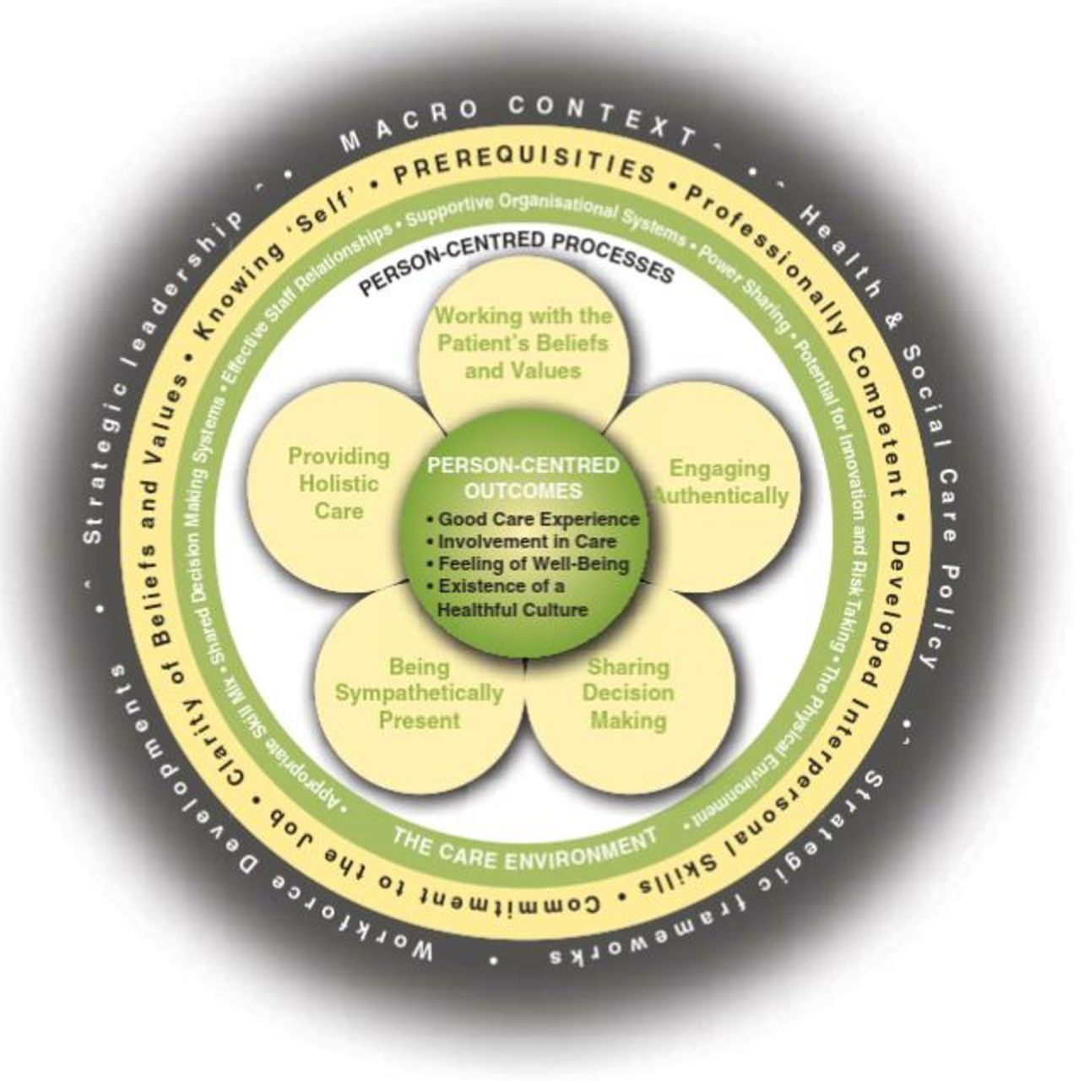
This Photo by Unknown Author is licensed under CC BY-NC Microsoft bing (2021)
One of the aspects reaching the individual in the right way in person centre care perspective is recognising their personal experiences in the past which will help professional not only concentrating person’s illness or complaints merely getting to know them in personhood historically will enable professionals to have a special relationship of trust. Clarke et al (2003)
Another approach of care for people suffer dementia or related mental health issues that, that person’s global view of his/her memoirs, pictures, music, notebooks will help those cognitively which encourages person centeredness.
“Validation therapy” is the different method which is now utilised in clinical environments. Accepting the person’s lived experiences, “personhood” which emerges from the idea amending and placing the person with Alzheimer or Dementia to realities where usually is a way of recognition from a healthcare points of view. It generates anxiousness and insecurity between the patient and professionals. Decisive approach with positiveness encourages good health and self-belief. Neal , Barton (1999).
Concurrently healthcare workers in clinical settings try to function in the person-centred way which the knowledge is there but in reality, they don’t know how to utilise it in the current system properly. Mc Carthy (2006)
Dowing (2004) nurses perspective elaborates the need of more inventive approach in the clinics.
Life story work consists of individuals and their family that individuals belong to, finding out what personal experiences they have been experiencing throughout their life. By taking in consideration their personal belongings, recordings, photos, anecdotes, letters, souvenirs could be used as an example for the person’s history of reflection. Pietrukowicz, Johnson (1991).
Case studies carried out to establish how person felt when they were involved in their own care by simply showing them items such as pictures, pens, notes as a part of their life in the past lived experiences created great recognition of value, respect and dignity mutually. Mc Keown et al (2010).
“One of the support workers stated that how important it was for the patient to open-up to her because she has really seen the actual person who shared their values and what sort of person once she was in an unprejudiced way.
Sometimes we forget the basic need of care by simply not remember how this person was before when they were healthy. Putting this into practice would enable patients to gain positive outcomes socially in a person-centred way. Sense of feeling heard, most of the times patients hide themselves behind their depression, taken pride when they were involved in their own care support people physically and cognitively.
According to nurses work in clinical settings confirm that, in many cases how valuable patients felt when they were helped holistically. Woods (1998).
It would also enable special bond between the patients and professionals emotionally. Sabat, Harre (1992).
Life story work encourage people with dementia going farther on, to find out the personhood and hearing the person when they were involved in their own care.
Approach;
“The patient and the four principles”, ethical responsibilities in healthcare network regarding patients.
Justice and accessibility to services, being able to access therapeutic devices for everyone equally, no financial restriction equally on treatment options too.
Daniels (2013).
Several facts that decided accessing to healthcare, “socio economics status and geography” Substantial studies were made to inform us high level of income means better and rapid access to healthcare services. In the USA, many disparities like “inequality” is associated by socioeconomic fluctuations.
Dickman et al (2017)
“Nonmaleficence and safety”
It is also called no harm causing to others principle. For example, transferring patient from one place to another can cause harm during the procedure because of the services covered by in wider areas. Also, their information shared by third parties can be harmful too. BMC (2018).
“Beneficence and continuity of care” (“doing good”)
Getting the benefit out of the healthcare. Whereby professional should behave for the patient’s best interest. Weighing up the use of the therapy comparing the danger and cost side of the therapy. PMC (2009)
“Patient Autonomy”
It means patients have a maximum right to choose about their therapy.
Professionals should respect the patients their own choices with pride when they made shared decision to be able to continue their life with their own “values, belief and choices”. PHCFM (2017).
It made up of four principles according to nurses work in the settings to reflect a holistic approach, knowing the person, “to know that you know” and “to dare”
Person-centred care; “statutory duties”
“Health and Social Care Act 2012” necessitates with “Clinical Commissioning Group to encourage people involving in their own care.
“Care Act 2014” necessitates local government bodies to compelling adults in their evaluation, care and help organising and reassessment.
“Integrated care licence condition” authorised by NHS funded scheme
“CQC” Health and Social Care Act 2008 Regulations 2014 ensuring people receive person-centred care and therapy.
Mental Capacity Act 2005 was been in power 2007 onwards.
Putting people in power in decision making process especially the ones who lack the ability to do so, placing them in the centre of decision-making process prospectively. It includes people who work to individuals in care providing therapy, assessment anybody who is 16 or above in England and Wales. It is map out to safeguard those who are at risk and giving back to control their life.
People work in the health and social care have a duty to follow code of practice including the non-formal carers. Five fundamentals of the act are assuming that person have the mental ability to decide. Help to decide by involving people in their own decision. Respect their values, beliefs, choices despite being incapacitated. It should be done via considering for their best interests. Any decision made up on behalf of them, it should not intervene their personal rights or freedom of choice. These are relevant bodies assisting the mental health act; “LPA’s, court of protection and deputies, public guardian, independent mental capacity adviser” regarding the mental health act. Liberty protection safeguards in 2018 (amended bill) which will take effect on 01/04/2022. SCIE (2009).

Discussion;
Person centre care is operating partially on ethical basis of independence and taking patient’s view in consideration, cultural background, personal choices, values, parental circumstances and their way of life. Journal of Healthcare Risk Management (2011)
Using the ethical principles of justice, nonmaleficence, autonomy and beneficence on everyday use will permit professional to give the best possible care. BMC Medical Ethics (2018)
Advantages of person-centre care;
Enhances your overall wellness and physical state, ethical concept of person centre care strengthens your capabilities for person’s maintaining their self-sufficiency in regard to morals, independence in deciding to choose and initiatives. These characteristics are essential for maximise confidence and your quality of life. Consequently, the individual will encounter better overall results in their health outcome, maximises self-reliant and being able to control (empowerment). Another constructive outcome people who live dementia specified as anxiety over self-confidence of making the right choice, self-reliant and meaningful life. Li & Porock (2014).
Past studies have shown to indicate that person centre care enhances overall “quality of life” and “life satisfaction” Wigham et al (2008).
It enhances the concept of collective understanding by simply respecting each other’s view that creates shared decision and shared co-operation.
Also enhances cost-efficiency (economics) overall view of healthcare places aim to release patients as quick as possible, this will cut the cost substantially as well as in timely manner. Wildevuur & Simonse (2015).
Report by Hansson et al (2016) stated that people assisted with person centre care are less costly than other alternative groups. When PCC fully applied, the result is significantly more beneficial as less time consumed of hospital admission lowering to 2.5 days. Ekman et al (2012).
Enhanced work place atmosphere, given proper care to patients reduces the work loads on professionals not causing stress related work environment.
Disadvantages of person-centred care;
There aren’t many articles about the disadvantages of PCC purely many research workers who obtain a view on PCC they have more constructive approach to person centred care. Edwardson et al (2017).
Maximised individual cost and monetary expenditure, practising PCC needs attention in details particularly people with cognitive issues, but sometimes the fall occur in the hospital settings which is costly to deal with. The cost of caused affliction (bodily), “fractures” and “pain” that maximise the expenditure for healthcare and recovery costs.
Omission of personnel “personhood”;
Generally, the attention on PC care for patients/person/staff relationship are been abandoned with regards to “personhood”. Unfortunately displaying lack of ethics and not showing conscientious by staff risking the patient’s safety and debilitate the PC care.
Overloaded work causing tiredness. Many healthcare workers, as a result of PC care loaded by heavy duties and constant detailed care, exhausting the professionals, causing depression, insomnia and anxiousness. Hansen et al (2018).
Being too empathic can be risky, it is not justly or fair or ethical too.
Recommendation;
Medical workers fundamentals should be in these concepts; have a responsibility of reaching out those need a best care service, fellow workers and the public entirely. Any person or their co-workers who fulfil these duties in a malicious way they contravene the ethics of respect and safeguarding patients. PMC (2009).
Comparing the two paradoxes (positive and negative outlook) for the benefit of person-centred care, can be weighed comparatively and implemented and incorporated into healthcare setting would be the advantage for anyone who involved working in the healthcare environment. Most people seem to believe that PC care have a constructive effect of care concept. This realisation can help healthcare workers to adopt PC care and reflect it with positive attitudes. Wiley Online Library (2020).
Moreover, the medicine itself derives from ethical values between the people and the providers of healthcare professionals. Therefore, patient centred-care demonstrates this core values and beliefs. One the main element in the practice itself is beneficence which is to do good for patients interests and should be balanced with patients’ choices integrated into practice. In order to benefit from person-centred care, we need to set up training initiatives to teach healthcare professional act according to PC care ethics.
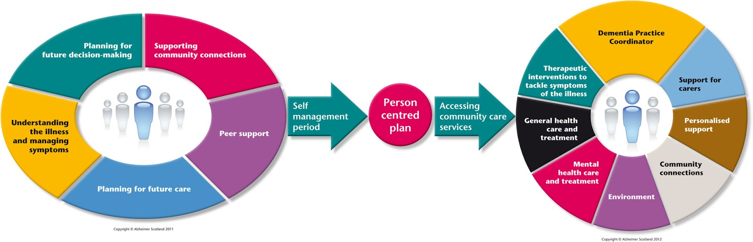
This Photo by Unknown Author is licensed under CC BY Microsoft bing (2021)

References;
BMC (2018) The patient perspective in healthcare networks: [Online] Available at: https://doi.org/10.1186/s12910-018-0298. Accessed (30/12/2021).
Clarke A., Hanson E. & Ross H. (2003) Seeing the person behind the patient: enhancing the care of older people using a biographical approach. Journal of Clinical Nursing 12, p 697–706 [Online]. Available at: https://doi.org/10.1046/j.1365-2702.2003.00784.x. Accessed (30/12/2021)
CPD Online (2021) Why is person-centre care important: [Online]. Available at: https://cpdonline.co.uk/knowledge-base-person-centred-care. Accessed (29/12/2021)
Daniels N (2013) Justice and access to healthcare: [Online] Available at: https://plato.stanford.edu/archives/spr2013/entries/justice-healthcareaccess. Accessed (30/12/2021)
Dickman SL, Himmelstein DU, Woolhandler S (2017) Inequality and health-care system in the USA: N Engl Journal Med. P1431-1441 [Online] Available at: https://www.inequality-and-the-healthcare-system-in-the-USA. Accessed 930/12/2021)
Edwardsson D, Watt, E & Pearce, F (2017) Patients experiences of caring and person-centredness are associated with perceived nursing care quality: Journal of Advance Nursing p.217-227. [Online]. Available at: https://doi.org/10.1111/lan.13105. Accessed (31/12/2021)
Ekman I, Wolf, A, Olsson, L, E., Taft, C., Dudas, K., Schaufelberger, M., & Swedberg, K. (2012) Effects of person-centred care in patients with chronic heart failure: European Heart Journal p. 1112-1119. [Online] Available at: https://doi.org/10.1093/eurheartj/ehr306. Accessed (31/12/2021)
Hansen, E. M., Eklund, J.H., Hallen, A., Bjurhager, C. S., Norrstorm, E., Viman, A., & Stocks, E.L. (2018) Does feeling Empathy lead compassion fatigue or compassion satisfaction: The Journal of Psychologyp.630-645. [Inline]. Available at: https://doi.org/10.1080/00223980.2018.1495170. Accessed (31/12/2021)
The Health Foundation (2016) Person-centre care made simple: What everyone should know about person-centre care. [Online] Available at: https://www.health.org.uk/publications/person-centre-care-made-simple. Accessed (27/12/2021)
Li, J., Porock D (2014) Resident outcomes of person-centred care in long term care: A narrative review of interventional research. International Journal of nursing studies 51(10) p.1395-1415. [Online]. Available at: https://doi.org/10.1016/j.ijnurstu.2014.04.003. Accessed (30/12/2021)
Microsoft Bing (2021) Person-centred perspectives: Image1-2-3: [Online]. Available at: https://www.microsoftbing/onlinepictures/imageofpersoncentredperspective. Accessed (31/12/2021).
Mc Carthy (2006) Translating person-centred care: a case study of preceptor nurses and their teaching practices in acute care areas: [Online] Journal of Clinical 15, p629-638. Available at: https://doi.org/1111.j.1748-3743-2010-0021.j Accessed (29/12/2021)
McCormack B (2004) Person-centredness in gerontological nursing: an overview of literature. [Online]. Available at: https://doi.org/10.1111/j.1365-2702.00924.x. Accessed (30/12/2021)
Mc Cormack B, Mc Cance T (2016) Person-Centred Practice in Nursing and Healthcare: Theory and Practice. [Online]: Available at: https://www.books.google.co.uk/perso-centred-practice-in-nursing-and-healthcare. Accessed (26/12/2021)
McKeown, J, Clarke, A, Ingleton, C, Ryan T, Repper, J. (2010) The use of life story book people with dementia to enhance person-centred care: International Journal of Older People Nursing. [Online]. Available at: https://doi.org/10.1111/j.1748-3743.201.00219.x. Accessed (31/12/2021)
Neal M, Barton P (1999) Validation therapy for dementia: Cochrane Library. [Online]. Available at: https://doi.org/10.1002/14651858.CD0011394. Accessed (30/12/2021)
Nolan M., Brown J., Davies S., Nolan J. & Keady J. (2006) The Senses Framework: Improving Care for Older People through a Relationship-Centred Care Approach: Getting research into practice series. University of Sheffield, Sheffield. [Online]. Available at: https://doi.org/10.1111/j.1748-3743.2010.00219.x. Accessed (30/12/2021)
PHCFM (2017) Patient-or person-centred practice in medicine: A review concept: [Online] Available at: https://doi.org/10.4102/phcfm.v9i.1455 Accessed (30/12/2021)
Pietrukowicz M, Johnson M. (1991) Using life histories to individualise nursing home staff attitudes towards residents: The Gerontologist,31,105-106. [Online] Available at: https://doi.org/10.1093/geront/31.1.102. Accessed (30/12/2021)
PMC (2009) Beneficence and the professional’s moral imperative: [Online] Available at: https://www.ncbi.nlm.nih.gov/pmc/articles/pmc3342811. Accessed (30/12/2021)
Sabat S, Harre R. (1992) The construction and deconstruction of self in Alzheimer’s disease: Ageing and Society12, p 443-461. [Online]. Available at: https://doi.org/10.1017/SOI44686X00005262. Accessed (31/12/2021)
SCIE (2009) Mental Capacity Act: Mental Capacity Act at a glance: [Online]. Available at: https://www.scie.org.uk/mca/lps/latest. Accessed (29/12/2021)
Wildevuur S, E., & Simmonse LW (2015) Information Technology-enabled person-centred care for the “Big Five” chronic conditions: Journal of Medical Internet Research. [Online]. Available at: doi.org/10.2196/jmir.3687. Accessed (31/12/2021)
Wiley Online Library (2020) Paradoxes of person-centred care: A discussion paper: [Online]. Available at: https://doi.org/10.1002/nop2.520. Accessed (30/12/2021)
Woods B (1998) Reminiscence communication: In Reminiscence in Dementia Care p.143-148. [Online]. Available at: https://books.google.com/books/about/The-Therapeutic-Purpose-of-Reminiscence.html?id=kohLITVMPXIC. Accessed (31/12/2021)

Appendix

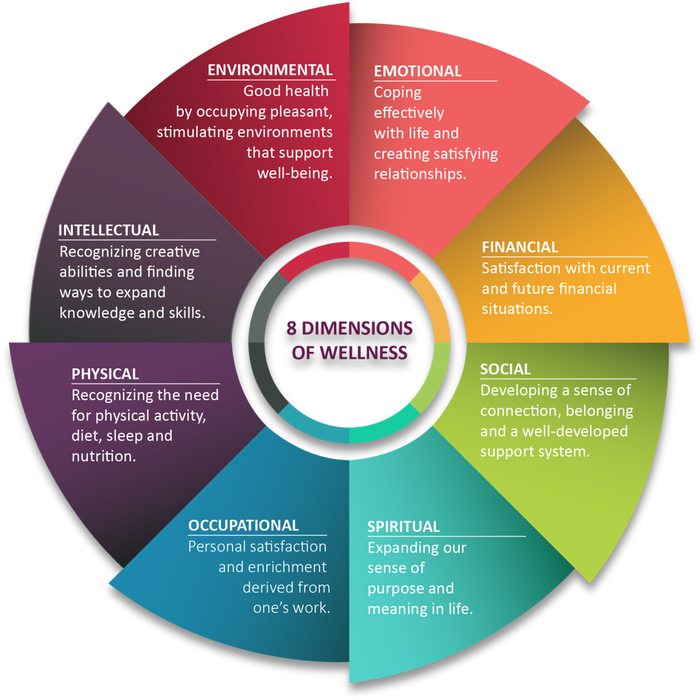
This Photo by Unknown Author is licensed under CC BY-SA Microsoftbing (2021)

