

Euan Kelly

Fault Tree Analysis

University of Wales Trinity Saint David
Systems Engineering

OME BEng

Supervisor: Dave Holley
April 2026

Contents
Abstract 2
What is a Fault Tree Analysis 3
AND Gates 3
OR Gates 4
Calculating Gate Probabilities 5
Fault Tree Analysis of a Hot Drink 6
Scenario Overview 7
Bill at the Highest Efficiency 7
Selecting Cup 7
Hot water 7
Ingredients In Cup 7
Hot Drink Milk and Sugar 8
Bill Awakening at Night 8
Conclusion of FTA 8
Human Factors 8
References 8

Figure 1 - Fault Tree Analysis [3] 3
Figure 2 - AND Gate 3
Figure 3 - AND Gate Example 4
Figure 4 - OR Gate 4
Figure 5 - OR Gate Example 4
Figure 6 - Process Chart to Produce a Hot Drink 6
Figure 7 - Probabilities of Each Event in The Process Chart 6

Abstract
This report demonstrates the purpose and benefits of Fault Tree Analysis (FTA). The report details the probability of producing a hot drink with milk and sugar, with given probabilities, and how the probability of this process varies when introducing human factors such as fatigue and lower awareness. Using the provided values for the probabilities, the probability that Bill's process succeeds drops from 0.682 to 0.345. This shows how valuable human factors are in a system that includes operators. The probability of falling can be prevented through both physical changes to the system and better support of the operator. This support can be provided through training, supporting staff wellbeing and implementing clear instructions of work.

What is a Fault Tree Analysis
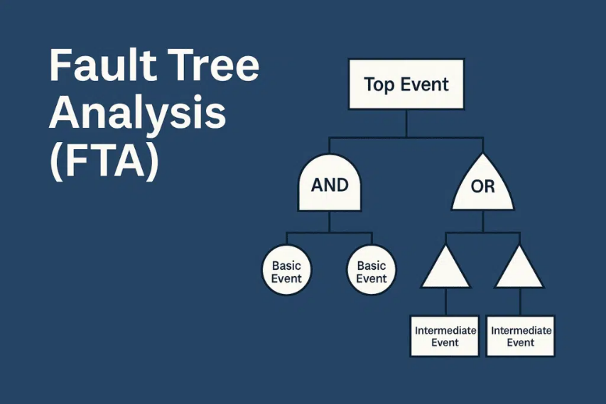
FTA was introduced in 1961 by H. Watson. Since its development, it has become a widely used method for assessing safety and reliability in various systems, both complex and basic. As shown in Figure 1, a fault tree is a structured logical diagram modelling all stages of a system. The diagram shows the relationship between individual component failures and the overall system failure. It is constructed using various shapes/symbols to demonstrate key events, most commonly ‘and’ as well as ‘or’ gates. By identifying and analysing the basic events that can lead to a system ultimately failing, an FTA provides a focused and efficient approach to reliability and safety evaluation [1].
Figure 1 - Fault Tree Analysis [3]

AND Gates
‘AND’ gates are used to indicate that the output can only occur if all other linked basic events occur simultaneously. An example of what an AND gate looks like can be seen in Figure 2. AND gates can only be used when there are at least 2 basic events linked together in the system [2].

Figure 2 - AND Gate

An example of an AND gate can be seen in Figure 3 where A, B and C represent basic events or components within a system. The system can only fail once all basic events or components have failed.

System Failure

A
C
B

Figure 3 - AND Gate Example

OR Gates
‘OR’ gates represent a stage in a system where the failure occurs if at least one of the basic events occurs. Similarly to an AND gate, it requires a minimum of 2 events [2]. Figure 4 illustrates an OR gate, whilst Figure 5 demonstrates the use of an OR gate. Where at least one basic event occurs, the system will fail.

Figure 4 - OR Gate

System Failure

A
C
B

Figure 5 - OR Gate Example

Calculating Gate Probabilities
To calculate the probability of a failure from 3 events with an AND gate, you must identify the probability of each event and multiply them together. For example, where P(A)=probability of component A failing and the probability of system failure = P(F). Using Figure 3, if component A has a probability of failure P(A)=0.2, component B has P(B)=0.6, and component C has P(C)=0.1, then the probability would be calculated as:
P(F) = P(A x B x C) = 0.2 x 0.6 x 0.1 = 0.012
This means there is a 1.2% chance of failure of all 3 inputs failing, leading to total system failure.
To calculate the probability of a failure from a single event when using an OR gate, you use a different method. In this case, you must subtract the probability of each event from 1 and then multiply the 3 answers together below. Using the same values as above, the OR gate in Figure 5 would show the following probabilities of failure:
P(F) = 1 – [(1-P(A))(1-P(B))(1-P(C))]
P(A) = 0.2 ~ 1-P(A) =0.8
P(B) = 0.6 ~ 1-P(B) =0.4
P(C) = 0.1 ~ 1-P(C) =0.9
0.8 x 0.4 x 0.9 = 0.288
P(F) = 1 – 0.288 = 0.712 = 71.2%

Fault Tree Analysis of a Hot Drink
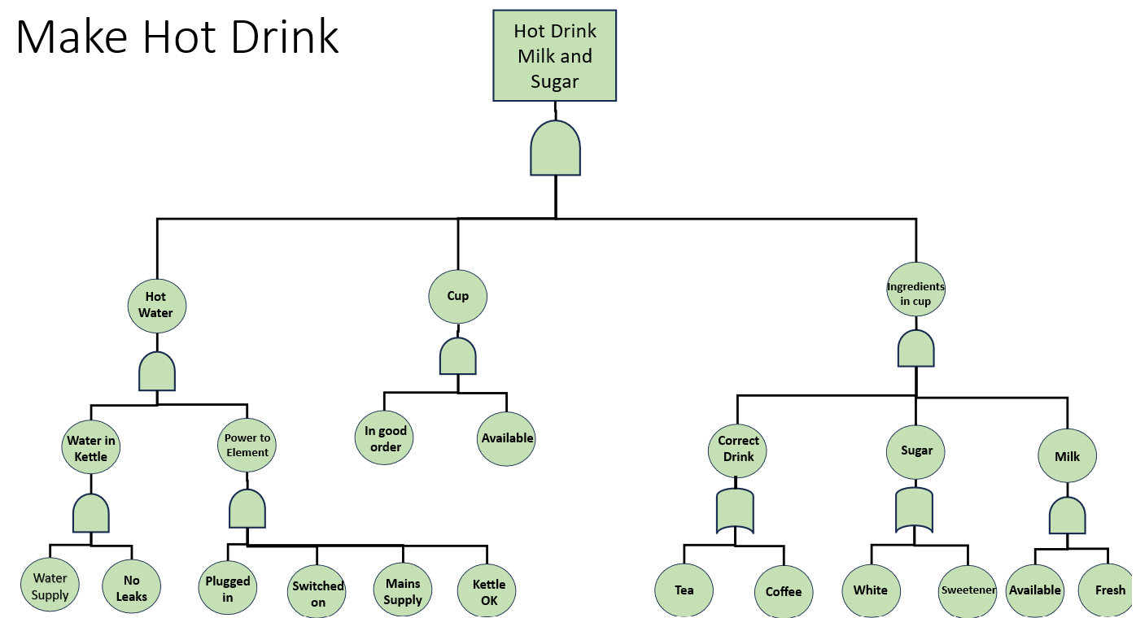
Figure 6 shows a process chart for producing a hot drink. This process chart, in conjunction with the table of probabilities in Figure 7, will be used to determine the probability of producing a successful hot drink.
Figure 6 - Process Chart to Produce a Hot Drink

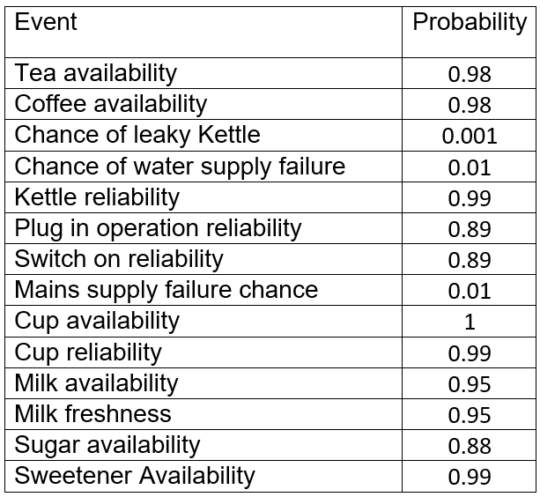
Figure 7 - Probabilities of Each Event in The Process Chart

Scenario Overview
FTA will be used in two environments of hot drink making. The first scenario is Bill in the most efficient environment. Scenario 2 introduces that Bill has woken in the middle of the night, and that his ability to plug in and switch on the kettle has dropped to 75%, as well as his ability to select a cup has dropped to 90%. All values for FTA will be obtained from Figure 7.

Bill at the Highest Efficiency

Selecting Cup
The process of obtaining a cup uses an AND gate, and therefore, both basic events must be achievable for this process to occur. Using Figure 7, where Cup availability is 1 and reliability is 0.99, the probability of failure in this case is: P(F) = (1x0.99) = 0.99

Hot water
To achieve hot water, 2 events are required to occur successfully, which have their own sub-events. Firstly, water in the kettle is achieved through a water supply P(A) and no leaks P(B). These are linked through an AND gate, so using the values in Figure 7, the probability of failure is P(F)(0.99x0.999) = 0.98901
The next stage of achieving hot water is the power to the element. To achieve this, 4 events must all successfully occur due to the use of an AND gate. Where plugged in = P(A) = 0.89, Switched on = P(B) = 0.89, Mains supply = P(C) = 0.99 and Kettle ok = P(D) = 0.99 then the P(F) of power to element = (0.89 x 0.89 x 0.99 x 0.99) = 0.77633721
Now that water in kettle and power to the element are calculated, the probabilities of both must be multiplied due to the and gate connecting them to hot water. Where water in kettle = P(A) and Power to element = P(B) then the P(F) for hot water = 0.7678052640621 or 0.768 to 3dp

Ingredients In Cup
As shown in Figure 6, all 3 events under ingredients in the cup must occur to produce the hot drink, due to the AND gate connecting them.
Firstly, milk is provided through the success of 2 basic events connected by an AND gate. These events are Available P(A) with a probability of 0.95 and Freshness P(B) with a probability of 0.95. Therefore, P(F) = (0.95 x 0.95) = 0.9025
Next up is sugar. This event connects 2 inputs by an OR gate, meaning the event will occur if either input is applied to the system. The probability of white sugar P(A) is 0.88 with sweetener P(B) = 0.95. Using the OR gate equation P(F) = 1 – [(1-P(A))(1-P(B))], the probability of sugar is 1-(0.12 x 0.05) = 1-(0.006) = 0.994
The third event is the correct drink. Like sugar, the 2 events are connected through an OR gate. Where the tea availability P(A) is 0.98, and the coffee availability P(B) = 0.98, the probability of selecting the correct drink is: 1-(0.02 x 0.02) = 1-(0.0004) = 0.9996
As all 3 stages are connected to ingredients via an AND gate, then the sum of all events occurring must be multiplied together. This gives the P(F) for ingredients in a cup as:
P(0.9025 x 0.994 x 0.9996) = 0.896726166 or 0.897 to 3dp.

Hot Drink Milk and Sugar
Now that the 3 key steps of the process have been calculated, they must all be multiplied together to find the overall probability due to them being connected through an AND gate. Where P(A) represents Hot Water P(0.768), P(B) represents Cup P(0.99), and P(C) represents Ingredients P(0.897), the overall probability of a successful hot drink including milk and sugar at optimal performance is:
P= (0.768 x 0.99 x 0.897) = 0.682 to 3dp or 68% likelihood.

Bill Awakening at Night
As previously stated, Bill has woken up during the night to make the same product. Due to Bill completing this task after abruptly awakening, he will not be at full operational capability and is likely to make mistakes due to tiredness, leading to fatigue and a decrease in awareness.
Bill's ability to plug in and switch the kettle on has subsequently dropped to 75% of normal, and his ability to select a cup has dropped to 90% of normal.
The probability of including the correct ingredients has not changed and remains 0.897.
As a result of Bill's ability to select a cup, becoming 90% of his normal ability, the probability of selecting a cup has fallen from 0.99 to 0.891.
The original probability for plugging in and switching on the kettle was 0.89, due to the human factors involved, his ability is now only 75% of this value, giving an updated probability of 0.6675. This provides a new probability of power to the element:
P(0.6675 x 0.6675 x 0.99 x 0.99) = 0.437 to 3dp.
This then provides a reduced probability for the hot water event to occur:
P(0.98901 x 0.437) = 0.432 to 3dp
Overall, Bill's ability to produce a hot drink with sugar and milk will drop to the following probability:
P(0.897 x 0.891 x 0.432) = 0.345 to 3dp.

Conclusion of FTA
Bills' probability of producing a hot drink with sugar and milk has drastically dropped from 0.682 to 0.345 when factoring in the human factors he is likely experiencing. This change in result shows that he is now more than unlikely to produce his hot drink than previously, where he was more likely to be successful.
In conclusion, the FTA are vitally important in engineering because they provide clear, structured ways to understand how and why systems can fail. They do this by breaking down systems into smaller events and how they combine to cause a failure. FTAs can be used on both basic systems, such as making a hot drink, all the way through the complex weapons in the defence industry, allowing engineers to identify where the risk of failure may occur and how to prevent this.
Bills' scenario demonstrates how FTA incorporates human factors as it looks at both technical inputs as well as the inclusion of human actions and decisions at key points. By factoring in human factors such as fatigue and awareness, engineers can understand the human influences on system reliability. The evidence provided from an FTA can be applied to a product throughout its whole life. For example, processes can be identified that are susceptible to failure can be identified in the design stage and altered to increase success. On the other hand, training for staff and ensuring staff wellbeing is supported can lead to fewer mistakes.

References

[1] | Z. Chen, Electrical Drives For Direct Renewable Energy Systems, 2013.
[2] | PTC, “AND Gate,” [Online]. Available: https://support.ptc.com/help/wrr/r12.0.0.0/en/index.html#page/wrr/ReferenceGuide/fta/and_gate.html. [Accessed 15 April 2026].
[3] | M. Lanjewar, “HSE Study Guide - Fault Tree Analysis (FTA,” HSE, 2025 August 2025. [Online]. Available: https://www.hsestudyguide.com/fault-tree-analysis-fta/. [Accessed 15 April 2026].

