

Author’s Declaration
I declare that the work in this dissertation was carried out in accordance with the regulations of the University of Wales, Trinity Saint David. The work is original except where indicated by special references in the text and no part of the dissertation has been submitted for any other degree.
Any views expressed in the dissertation are those of the author and in no way represent those of the University of Wales, Trinity Saint David.
The dissertation has not been presented to any other University for examination either in the United Kingdom or overseas.
I hereby give permission for my work, if accepted, to be available for photocopying and inter-library loan, and for the title and summary to be made available to outside organisations.

Signed Rhian Peto
Dated 29th May 2020

University of Wales Trinity David
Prifysgol Cymur Y Drindod Dewi Sant

Environmental Conservation and Management(MSc)


Can the use of Media support changing individual perceptions and behaviour in raising environmental awareness and conservation of Plastic Pollution in the Oceans?

Rhian Peto
St 1201527
Word Count 15,701

Sumitted in partial Fulfilment of the degree of Master In Science

Acknowledgements .
To begin, I would like to thank my dissertation supervisor Alan Nantel for all his advice and support during exceptional circumstances with advice and communication .In addition over the two years all of the lecturers from the MSC Program .
To my mother and father who have supported me during the university period, their support has been an ever present .In addition my work colleagues from Neath Port Talbot council for their words of support ,advice, friendship, and information during the gathering of data .
My friend Neil who supported me during year one and two with proof reading. In addition Casey whose friendship has supported me through two years of the course and whose friendship is inspiring and has carried on long after the course has finished .

Abstract
The oceans are an ever-present habitat for unique species of mammals and wildlife over the years the oceans have been under threat from many types of pollution, including oil, untreated sewage, and waste in this case Plastic .Yet the amount of plastic waste is increasing and is a growing concern, the effect of plastic pollution has affected many species in the oceans including Sea Birds ,Turtles, Whales, and other wildlife. Blue Planet two is said to have brought this topic to the forefront of the media. Media tools are present in today's global world with most homes accessing some types of media tools, most media are accessible twenty- four hours a day there is a constant stream of information at hand.
The researcher adopted a quantitative approach. In order to gather data the tool adopted by the researcher was questionnaires in total one hundred and eight questionnaires were sent via email, Social Media, and paper copy. Participants chosen included work colleagues from the local authority in this case (NPTC) Neath Port Talbot Council specifically the Trade Waste Department plus some library staff. Results indicated that the over fifty- five age group accessed all types of media tools it appeared any environmental documentary presented by Sir David Attenborough was favourable among some individuals plus Spring watch and the news channels.
Although this was a small scale project data has been varied and rich, the data in this dissertation could be used to support further studies whether this is in Media or environmental issues, limitations were encountered during the writing of the dissertation, the Corona Virus pandemic effected the writing of the dissertation .The researcher found that education is a tool used by some organisations and it appears this could be a way forward to instil recycling principle’s. Results illustrated which media tools have been preferable to some individuals example TV .In addition specific target audiences view specific programs, an example age groups, plus communication between individuals is important. Environmental groups could look at this data for use in studies being undertaken or to support long term data already acquired and ongoing.

Contents
Author’s Declaration 1
Acknowledgements . 3
Abstract 4
List of Tables 7
List Of Illustrations 8
List of Abbreviations 9
1. Introduction 10
1.0 Objectives of this dissertation: 13
2. Review of Literature 16
3 Methodology 29
3.0 Approaches to data gathering 29
3.1 Data Collection 30
3.2 Dissertation Objectives 30
3.3 Questionnaires 31
3.4 Social Media 32
3.5Pilot Study and issues presented 32
3.6 Participants Chosen -Pilot Study, Questionnaire and Social Media 33
3.7Other Methods Adopted 35
3.8 Other Literature 37
3.9Ethical Considerations 37
4. Results 39
Results and Discussions 39
4.1Pie Charts and Excel 40
4.2 Questionnaires 41
4.3 Participants 41
4.5 In response to Questions 1-4 43
4.6 Results 43
4.7 In response to question 5 to 7 45
4.8 Responses received how media has influenced perceptions: 46
4.9 The table below illustrates how some individuals felt media tools portray any coverage of issues: 46
4.10 Most popular programmes watched via Documentaries and others with environmental references: 47
4.11 In response to questions 7-10 49
To recommend and draw conclusion from analysis which can be added to future research: Error! Bookmark not defined.
5. Conclusion and Recommendations. 50
5.1 Objective One -Recommendations 50
5.2 Objective two 51
5.3 Objective three Recommendations 52
To recommend and draw conclusion from analysis which can be added to future research 52
5.4 Recommendations 56
6. Reference lists 58

List of Tables

Table One - Neath Port Talbot Figures
Table two- and two a-Objectives for the Dissertation
Table three -Participants chosen
Table Four -Other Methods used in the Dissertation
Table five - Pie Chart how data was analyzed
Table six-Questionnaire Advantages
Table seven - Male and Female participant data
Table Eight- Age Group of Participant Data
Table nine- Data-Popular Media Tools Chosen
Table ten- Data Media Influences data
Table eleven-Data -Popular TV programmes/ views
Table twelve -Data Other Information on TV program

List Of Illustrations
Image One- Blue Planet 2
Image Two-Dynasties
Image Three- Doctor Lucy Quinn
Image- Four Sea Turtle
Image Five-Sir David Attenborough
Image Six- Blue Planet
Image Seven-Seven Worlds One Planet
Image Eight -BBC World News
Image Nine-Springwatch
Image Ten- CountryFile

List of Abbreviations
MCS- Marine Conservation Society
MPA’S -Marine Protected Areas
UK -United Kingdom
EU -The European Union
NPTC-Neath Port Talbot Council
SD-Sustainable Development
SDG’S -Sustainable Development Goal
UN - The United Nations
WWF -World Wildlife

Latin Names
Pantheraleo -Lion
Proceiiiformes- Albatross
Pantrogdytes-Chimpanzee
Blue Whale-Balaenoptera
Blue Fin Tuna- Thynnus thynnus

1. Introduction

Can the use of media support changing individual perceptions and behaviour in raising environmental awareness and conservation of plastic pollution in the oceans?

Firstly It is important to define the term “media”, what does this refers to? .The Collins dictionary describes media as television, radio, and newspapers collectively. Collins (2008). These are all sources of communication, these tools portray information which are convenient ,and accessible, it will be important to remember not everyone will have access to some media tools dependent on location i.e. communities living in remote areas.
In comparison ,Boyle notes that over forty-six per cent of homes can now access other programs via Television using streaming services, examples, Netflix, Amazon and Now TV. Netflix is the most popular with over eleven million and forty -seven subscribers, during 2019 more than thirteen million people had at least one streaming subscription .It appears there is indeed a demand for media tools, however bearing in mind this survey was conducted in 2019 this may well have increased . Boyle, M (2020)
The oceans are rich in varied environments and are home to numerous species, the oceans cover seventy percent of the world's service, yet the oceans are facing a precarious future from man-made pollutants notably plastics.( Open university 2019). It could be argued that Blue Planet 2 brought the issues of plastic pollution to the surface even though plastic pollution has been evident for some time. yet there are many types of pollution affecting the oceans today including oil. The media has been used as a tool in portraying this topic to the population, an example, the amount of plastic in the environment .It appears this plastic waste has reached vast areas of the ocean and is circulated by the tides and including remote areas such as the Arctic .
It is important to highlight current measures being undertaken to reduce plastic waste from entering the oceans and how this supports the mitigation of waste. This starts at the manufacturing level, it appears some manufacturers have taken a stance by reducing packaging an example ,Coco- Cola, yet there is still much more to be done both at a local and global level plus all members of the public will be aware of the plastic bag levy scheme ,this has appeared to be successful in the United Kingdom .
In addition, the Marine Conservation Society notes that in parts of the ocean there are six times more micro-plastics than plankton yet it appears measures were taken and now micro- beads are banned in some cosmetics (Foster, L 2020).Yet plastic pollution is ongoing and looks likely to continue, according to this literature if no action is taken it is likely that by 2025 that the increase of plastic will be threefold in the ocean( Open University 2019). In some cases it could be argued that the media has supported changing perceptions of individuals in regards to environmental concerns, an example the alleged success of Blue Planet two, yet the question must be asked can it have a negative effect too, yet could it be the case out of sight out of mind?
The idea for this topic stemmed from working at local level in Trade Waste and having daily dealings with business customers i.e. disposing of trade waste, this supports the local council to meet recycling targets. According to the World Wildlife Fund, “one dump truck full of plastic waste enters our oceans every minute (WWF 2020). The researcher supports other departments such as waste enforcement officers i.e. fly -tipping. The decision to produce this work aims to support data- already since the issues of Plastic pollution is ongoing and may take several decades to resolve. This will be an insurmountable task as some global countries may not have a recognised waste service in place and sometimes could be non -existent .
The aim of this dissertation will be to explore this topic through devised research questions, questions were designed to further support the acquisition of information with the aim to add to future data studies in this field. The researcher was able to locate a number of articles on the use of social media and conservation, however some were focused on using social media alongside the effects of tourism in some natural environments an example Safari Trips , In addition one article discussed how social media could be used in the areas of Marine Conservation, yet there appears to be a number of articles available to read, however, the literature explored by the researcher did not look at using other media forms in conservation, an example Radio. This dissertation's findings could support both the use of social media and other media forms in conservation.
Social media is constantly available and appeals to many individuals. Internet sites such as Twitter, Instagram and Facebook portray relevant issues, with the exceptions of certain groups social media is available in public spaces, work areas, and households. Other media include television, radio, pod casts plus literature such as, newspapers and magazines, however considering not every household will have a radio, computer or television, yet venues such libraries and internet cafes can provide opportunities to access media sources.
.In addition, recognizing that some communities around the globe will possibly not have a residence or access to equipment, however some countries an example ,Africa, in particular Egypt ,Nigeria, and Botswana have introduced total bans on plastic bags, in Tanzania young people have turned plastic bags into mattresses, it appears that some countries are leading by example it will be important to understand that Africa is a large nation and some parts are wealthier and some areas reliant on tourism plastic could be a deterrent to tourists. Fisher, C(2019)

1.0 Objectives of this dissertation:

- To understand the role of media in highlighting issues of plastic pollution in the ocean ,ie which media tools are most popular in portraying these issues and why ?
- Evaluate and analyze via methodology and accessing tools to support data collection in order to explore individual perceptions and behaviour influences because of media exposure
- To recommend the data findings to professionals in the field of Conservation or media and draw a conclusion from analysis which can add to future research
The dissertation will follow the approach:
- Literature Review
- Methodology
- Data Collection and Analysis
- Results and Discussions
- Conclusion and Limitations
The literature review will focus on the evaluation of primary and secondary data sources. The methodology will adopt data gathering tools to further support the results and discussions chapter, finally, the dissertation will conclude and look at recommendations and limitations
Methods adopted include: Firstly, to undertake a small-scale pilot study with up to four members of university students. Secondly a devised questionnaire with participants these will include members of the local authority working in the field of refuse, recycling, and other departments finally social media individuals in terms of figures the questionnaires equate to a hundred- plus recipients. The advantage of the questionnaire it can be sent to large groups of individuals, plus media platforms can be used to create templates, more information will be given in the methodology of the methods and participants adopted. The time frame for data collection will begin from December 2019 to March 2020. overall, these methods aim to support the gathering of data and support the three objectives, the use of tables and graphs will be explored to portray data, finally, results, and conclusion will support the dissertation objectives.
Blue planet two has long finished yet new documentaries such as' Seven Worlds one planet 'are due to be aired and will reach a global audience. However, there are schemes already in place with the aim to eradicate plastic pollution these will be explored further in the literature review, it could be argued the manufacturing of plastic would cease to exist if other materials were produced or adopted, an example starch, however ,plastic is a widely used product and is convenient and possibly cheap to produce ,yet when it comes to disposal this appears is being undertaken irresponsibility, it could be landfill areas are considered to be less of a favourable option for waste disposal plus land space is limited ,In addition, the amount of Fly -Tipping observed in natural environments contributes to plastic pollution ,with all that is understood of the fight on plastic pollution the issue is ongoing and does not look likely to decrease
Yet, during December The United Nations Climate Change conference was held in Madrid, the conference reconfirmed the issues of climate change to member states, the conclusion of the conference illustrated there is still more to be done, members were asked to come up with more ambitious targets to cut greenhouse gasses this followed on from the Paris Accord of 2015. Media coverage of events could influence ongoing campaigns, for example the schoolgirl Greta Thunberg is an ongoing campaigner for environmental awareness, however, not everyone will appreciate her stance on conservation this could be down to various reasons. In addition, other quotes will be included in the dissertation primarily from Sir David Attenborough.
It will be important to realize that Sir David Attenborough quotes may be considered bias ,yet Sir David Attenborough was chosen for his knowledge base in both areas of media and conservation, others note that Sir David Attenborough is a respected naturalist with decades of hands -on experience, however, there are many naturalists and conservation workers including Chris Packham and Iolo Williams, the literature review will refer to other agreements an example, Sustainable Development Goals .The dissertation is an ideal position to illustrate current environmental issues and to add to future data collection.

2. Review of Literature
The review will explore literature pertaining to media and conservation, in particular plastics pollution and concentrating on plastics in the ocean whilst giving examples of plastics observed in other environments ,for the purpose of this dissertation ( NPTC) Neath Port Talbot council has been used to illustrate how at local level organisations aim to reduce plastic waste whilst remembering the local authority has to meet recycling targets by 2050.
To begin, by quoting Sir David Attenborough” In my lifetime there has been great changes in the ocean , species of fish that we once took for granted have disappeared and whole eco systems are on the verge of disaster” Attenborough (2017,p.304). The health of the world’s oceans has been highlighted through via the news and programmes such as Blue Planet 2. Pollution comes in many forms chemical (oil), materials (plastics) including ship ballast all these materials has had an effect both on land and water.
There are millions of plastic bottles and bags floating in the world’s ocean, this plastic breaks down in micro Pisces and is ingested by marine animals. The ocean covers seventy per cent of the earth’s surface with varying eco systems, it is the planets largest biosphere (United Nations 2020) . It could be argued that if the media did not highlight these issues many of the population would not be aware. Curran refers to many major cooperation’s and cultural and geographical reach are being extended worldwide. Curran (2005)
Attenborough notes that since 1956 great changes have been observed especially in underwater filing, the success of this filming has attracted awards and overwhelming responses from audiences ,secondly “no single series could hope to comprehensively cover the undersea world”Attenborough,D (2017 p.8), this does appear to suggests that technology has advanced and media audiences have entered a new world. Yet decades later the health of the world’s oceans has been highlighted through media via the news and especially Blue Planet two. In conjunction Boyle firstly notes that six in ten i.e. sixty three per cent of UK adults "thought it was important for society overall that broadcasters provide current affairs programming" secondly with fifty one per cent of adults noting it was more important to them personally ,yet sixty two per cent is a medium figure although as this data was taken in 2019 this may have well increased this does seem to be in conjunction with the advancement of media (Boyle 2020 ). Blewitt firstly refers to the fact that humans view or see things because we are social beings, images interact with word ,and secondly illustrates the media use visual imagery to portray day to day issues to the audience, the use of imagery supports interaction between the viewer and the object, thus the viewer can make sense of what is seen and heard, in addition the use of music and sound effects shape the viewers connotations ,moods or emotional states. Blewitt (2010) .Firstly Attenborough refers to the BBC Dynasties program in which followed the lives of five animal groups ,example .:Lions,Tiger,Chimpanzee,Penguin and African Dog .Secondly Attenborough quotes ”producers determined before the program went into production that once a community had been chosen the frame would be told exactly as it happened , you must now be the judge as to whether these varied and extraordinary histories are tragedies or triumphs “ Attenborough, D(2018,p.7)
Image two-Dynasties
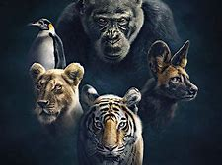
(BT.COM 2018)

Blue Planet 2 highlighted the issue of plastic pollution whilst the program was aired it appeared action was swift, The guardian reports that 14.1 million people watched Blue Planet during its first week on television (Guardian 2018) .Although there have been many other documentaries including Spring watch and Countryfile reporting on issues of plastic waste affecting natural habitat. Disney introduced its futuristic robot Wall -E who collect litter to help save the planet (Disney Life 2020)
Curran et al illustrate that the role of media is through engagement and to cover events and issues which cause debate, this is important to the success of the program. Curran (2005). Williams firstly illustrates that the majority of plastic waste comes from polymers with this classed as increasing drastically, secondly there are two types of plastic, example thermoplastics and thermosets these cannot be remoulded, thermoplastics plastics are commonly used in European areas and compromise of 80 per cent use of plastic types, these products can then be recycled. Following Blue Planet two it appeared some organisations attempted to switch from using plastic products an example: McDonalds switched to paper straws and Morrison's using paper bags for fruit and Vegetables .It is important to remember sustainable living contributes to increase of materials and Goal 14 of the SDGS speak of conserving and sustaining resources of life below water (UN 2020
Image One- Blue Planet
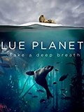
(Ref IDMB)
Since Blue Planet finished many organisations organised litter picks and public reaction was astounding although some local authorities carried on organising litter picks and arranged educational events focusing on recycling and plastic pollution for example, Keep Wales tidy .The Organisation focused on litter picks along local beaches i.e. Aberavon Beach, The Keep Wales tidy scheme then evolved to Caru Cymru (Keep Wales tidy 2019). Caru Cymru is a new initiative aiming to tackle the biggest environmental issues affecting Welsh communities, the project will concentrate on issues such as fly tipping fouling, graffiti and litter picks, as of yet data is not available to how successful this project will be yet it appears that work is being undertaken and plans of habitat management in place Caru Cymru will work alongside NPTC in the sharing of information mainly through social media and local group hubs.

Literature books
The researcher firstly purchased some literature privately, which were not available at the secondly the researcher is a member of the Marine Conservation Society and literature was sent via post each month i.e. monthly magazine. Finally, the researcher is also a member of the climate coalition group with the Women’s Institute and receives regular emails monthly this information is then presented to WI members hence information was consistent and up to date. During February, the Climate Coalitions ‘Show the love campaign’ take place, the researcher was able to access this pack and use resources for the dissertation (climate coalition 2020) (Appendix 5)
The researcher also explored other information packs such as World Oceans Day and Earth Hour 2020, these events take place annually during March and June, As the researcher works with the local authority some of these events will be celebrated by various departments, example bio diversity and recycling departments. In addition, the researcher works Saturdays at the local library this is also owned by the local council the researcher was able to access a number of books and take these homes, during the writing of this dissertation events were held at the library, an example, environmental events, including plastic awareness, some materials displayed were available able to print out to use in the dissertation, this literature was mainly sourced from the World Wildlife Fund.
The area of Neath and Port Talbot is home to hundred and thousand people the area is allegedly twice as dense as Wales as a while, although this data was recorded in 2006, it is likely this figure will have increased ,It is important to add that at this time local authorities are aiming to support recycling targets set out by the Welsh government, the scheme called One Planet One Wales aims to eradicate plastic waste to seventy per cent by 2025, if not authorities will incur fines (recycle wales 2019). From March 2018 to April 2019 NPTC illustrated that the amount of plastics via kerbside recycling equated to two thousand, two hundred and ninety-seven tonnes. NPT note that it met its 2018 target by fifty per cent and aim to reach sixty-four per cent by 2019, Education though social media and specific roles aim to meet recycling targets. (NPT 2018). (Appendix one)
In addition, NPT have specific roles such as side waste enforcement officers ,at this time three staff members undertake this role ,side waste officers are allocated certain areas of Neath and Port Talbot eligible households can apply for a scheme to be exempt to recycle .The use of social media works alongside this role and the use of literature to inform households of this scheme (NPT 2020).
Data from 2018-2019 illustrate that the side waste role saw a decrease in residual waste, refuse figures illustrate that in 2018,15001 tonnes of refuse was observed ,this figure decreased to 11734 in 2019 .It is clear that the role of side waste officers have been successful in this authority, plus information via media tools has appeared to come across ,although not everyone will stick to this criteria yet this may change in the future where recycling is counted in residual waste NPT(2020) (Appendix 2 ) .
In addition, trade waste staff deal with refuse and recycling waste commercial premises, the trade team use many forms of communication especially social media. ,This platform is used to inform individuals of events and update relevant information on waste management examples Facebook and twitter, it appears the trade wastes Facebook Page i.e. recycle4npt Is liked by 1,741 people and 1.801 follow this page, as stated recycle4npt aims to encourage "Neath Port Talbot residents to Reduce, Reuse and Recycle as much of their waste as possible together we can achieve zero waste 2“(Recycle4NPT 2020).
Tolvoned et al illustrate that the use of social media platforms in science and conservation is very limited ,however the data taken from social media has been useful to professionals in this field, crown sourcing, data collection and citizen science data has been used in many fields where resources have been limited , however since the introduction of GPS on smart phones citizen science appears to have decreased ,however this is also dependent on individual choice, one person may take part ,whilst one may feel it is irrelevant Tolvonen et al (2015)
In addition, plastics are also been disposed of via fly Tipp behaviour, fly tipping is a result of careless disposal, it is clear people are fly tipping waste including plastics, The NPT waste enforcement team deal with fly Tipp offenders on a daily basis ,as illustrated in BBC Ones X-ray documentary . In2019 enforcement officers investigated 13,000 fly tipping offences. (X-ray 2020). The NPT Crime Waste Facebook page illustrate the amount of waste disposed of in areas , plus through unregistered waste carriers ,the council use prepared video footage to deter people from fly tipping hence a form of education is used, dispute this fly tipping is ongoing and increasing as stated “NPTCBC Waste Enforcement Team are responsible for investigating Environmental Crimes throughout the County Borough, this includes fly tipping, dog fouling, abandoned vehicles, littering and presentation of commercial/household waste.” (NPT Waste Crime 2020),
The effect of this behaviour results in damage to habitat plus is a route for contamination and materials to enter water courses. Yet the above data illustrates work is being undertaken to reach recycling targets, householders are involved in this process and this relationship is reliant on working together to eradicate plastic transfer to the ocean and landfill ,not everyone will feel the same about meeting recycling targets, yet it certainly appears education is a tool adopted by the NPT council . (NPT Waste Crime 2020),
The United Nations (UN) state that the ocean is home to eighty per cent of life on earth and quotes "its health and ability to sustain life will only get worse as the population grows and human activities increase" (UN 2020)
.In addition the UN note:
1. It Nurtures biodiversity and produces food and jobs
2. Resources of minerals and nutrients
3. Captures ninety per cent of Carbon Dioxide
It is clear that the ocean is a special commodity not only for natural resources but for wellbeing and to support human life i.e. energy sources, The UN quote "we must act now to protect the state of our ocean " (UN 2020) .It is clear there will be some type of effect on the oceans from human activities despite their being Marine Protected areas and other legislation. The Marine Conservation Society (MCS) campaign to create Marine Protected Areas (MPA). The MCS state only four of three hundred and fifty-five MPA's are fully protected in the UK. A recent campaign illustrated five thousand people signed up to support the MCS work to create MPA's. Donovan et al (2019)
It is important to remember that Marine Protected areas are human inspired i.e. these areas are mapped out by humans it would require cooperation from other stakeholders for these areas to sustain wildlife. It appears the future for stakeholders both at a local and national level is ongoing with positive contribution, however issues with fishery stocks remain a concern, Markham refers to the pressure on the sea causing devastation to fish stocks, plus the added mismanagement and development of coastal zones Markham (1995).
Yet issues connected to the ocean are ongoing there have been campaigns and groups involved in these issues there are a number of activist groups such as Greenpeace ,it could be argued that without groups adding extra pressure to stakeholders the issue of plastic pollution may not be as well publicised ,yet groups such as Green peace attract media coverage through certain behaviour an example protesting and marches ,whether these actions are successful is dependent on many factors, i.e. any type of action is requires cooperation from other sources such as Government .
Budd illustrates that campaigners i.e. eco warriors are of all ages and from all walks of life, these groups of people campaign to save the natural environment for its wildlife and quality of life of individuals. Budd (2000) Kumar believes that climate change, poverty, economic damage and food shortages are contributing problems to the wellbeing of future generations and needs to be managed and quotes " You cannot manage what you do not measure "Kumar P,(2010,p.xxv). Yet society can play a part in data sharing .This would occur with the UN' SDG Goal number 14 Life Below Water ,to conserve and sustainably use the oceans, seas and marine resources for Sustainable development without conserving natural resources there will be a decrease of materials to use as mentioned the population is likely to increase.(UN 2020)
.
Tolvnen et al refer to a survey carried out using social media platforms ,the data from social media platforms illustrate the natural hotspots where individuals have visited i.e. profile feeds an example Facebook ,this data has been useful to professionals in order to ascertain locations, experiences and areas of biodiversity ,conservationists are increasingly extracting data from these feeds, in addition by individual posting pictures of natural hotspots scientists are able to work out latitudes and longitudes of destinations. Although the authors refer to this task as time consuming and required a human analyst to undertake this yet it appears the data gathered was constructive, however the author acknowledged ethical issues ,bias and content had to be taken into consideration whilst this survey was carried out .Tolvnen et al (2015)
There are other initiatives in place which aim to reduce plastic waste such as bottle pack schemes ,one such schemes known as ‘Pants’ recycled a total of 17,00 tonnes of cans and 20,000 of Pet bottles, this scheme has been highly successful, these items are then reused into bottles and cans. It is important to add this data was recorded in2018, this figure may have increased, this type of scheme is not only evident in Sweden, some parts of Germany and Norway have also installed bottle back machinery ,this scheme would certainly support plastic being disposed of appropriately and form entering water courses. (The local 2018) (Appendix 2).
In addition, Prior illustrates The Marine Conservation Societies beach clean campaign SAW 437 beaches Cleaned , a staggering 10.833 kg of litter was removed from the beaches equating to 11 tonnes in one weekend observation illustrated an increase of plastic bottles and drinks containers leading to the call for deposit return schemes. Prior. L (2019). The MCS notes that the UK could see the introduction of Deposit schemes by 2023 yet this will be three years behind Scotland’s pledge (Donovan et al 2019). Recently NPTC introduced specific recycling containers in the town Centres, the aim to reach recycling targets and support eradication of plastic waste. Social Media is used to inform the public of how the council works towards meeting recycling targets.( NPT 2020 )
It appears the figures represented two thousand , two hundred and ninety seven tonnes is from one local authority will be part of an overall figure of tonnage it seems, obviously this is 2019 figures the figures for 2020 may be slightly different with the current Corona Pandemic affecting the United kingdom, with household possibly recycling more form purchasing food, this figure may well have increased although with less habitat to visit the observation of plastic waste on beaches may well have decreased along with some type of recovery for habitat and wildlife
.
However, no areas are untouched by plastic waste, plastics have been observed in arctic regions plus on the ocean floor, Attenborough refers to how easily the North and South poles can be accessed via plane and helicopter, whereas centuries ago these regions were undiscovered, the realisation that such areas could be discovered were led by ambitious people. Berlowitx,V(2010) .The effect to such regions from plastics waste has led to aquatic wildlife such as Fish, Large Mammals (Whales/sharks ) plus sea birds mistaking plastic for food and ingesting products .As far away as South Georgia at Bird Island, scientists in this case from the British Antarctic Survey have been recoding data, plastic materials found in Albatross birds (Procellarifomes) this data could be used to address manufacturing of materials BBC Earth(2020)

Data illustrated that deceased birds were found with plastic materials in stomach contents , the birds subsequently died, however this was not due to the plastic material, the cause of deaths were due to the birds unable to digest food, ninety per cent of sea birds have consumed plastics mistaking it for food , Evidence illustrates that plastics have been discovered in these regions and that tidal patterns have carried this plastic hence seabirds have taken this back to nesting grounds. (Brownlow and Honeyborne 2017) . It is estimated that eighty per cent of all pollution in the ocean originates from land based activity yet cases such as the Albatross birds and plastic is directly linked if the birds had not swallowed the plastic their stomachs would not have been clogged and it is clear that humans are not disposing of their plastic waste appropriately (Open university 2019 )

Image of British Antarctica Scientist Doctor Lucy Quinn undertaking Surveys in South Georgia (BBC ONE 2020)
Image Three
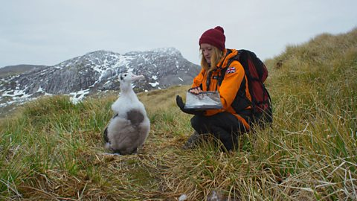
Brownlow and Honeyborne (2017) refer to the fact that climate change, bleaching and pollution amongst others are effecting the Coral Reefs. The ocean is an environment and is habitat to be managed . Habitat Loss through loss of land is being used for commercial housing or industrial this has an effect on population numbers and hence waste disposal ,plus habitat loss has a direct impact on wildlife numbers. Attenborough firstly refers to the decrease in lion populations Panthera Leo).Secondly in the Masai Mara ,numbers remained high until the 20th century where habitat loss and hunting resulted in this decrease, this not only refers to lions but other wildlife such as Chimpanzees (Pantroglodytes)
The rise of the Gold mining industry has created problems for the chimpanzees habitat this species is officially classed as Endangered .Moss,S(2018). This issue was recently portrayed in David Attenborough Seven World One planet Orangutans habitat was being destroyed by deforestation , Tolvonen et al illustrate that the use of social media could be useful in science and practice this would be linked to support the conservation of species this would appear to be in conjunction with Tolvonen's statement, as noted data is being recorded by scientists as illustrated in Blue Planet two.
Morris firstly indicates that such species are at risk of extinction and states each day more than 100 species go extent secondly some sea birds represent millions of year of evolutionary change Morris (1995). It appears global wildlife are facing threats from plastic pollution, climate change and habitat loss with many species facing extinction, the endangered species lists note the: Blue Whale (Balaenophera Musculuc) and Blue Fin Tuna (Thynnus thynnus) conservation status as Endangered. It is important to add that the number of sea birds may have increased as part of natural evolution i.e. through breeding yet habitat for this species may have decreased in size. although as noted any data stored can be used to support increase in wildlife numbers. (Appendix 3.
The below image notes the relationship between turtles mistaking plastic for food. Image Four :Turtles
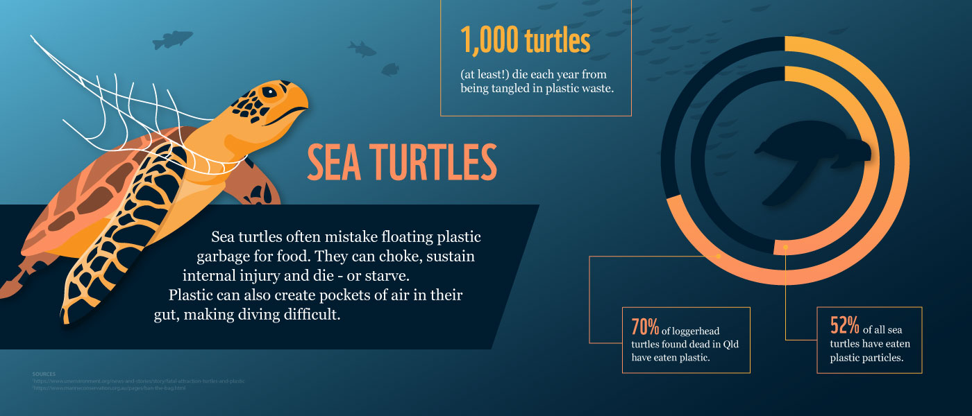
(WWF 2020)
It appears that plastic pollution is an increasing issue and has been evident for some time possibly a decade. In comparison, BBC news refer to the fact sixteen tonnes of rubbish has been removed from Everest such as Oxygen tanks, tents and plastic waste, the majority of rubbish has been observed at camp two, the majority of this clean-up is undertaken by volunteer tourists and Sherpa's can be paid up to 2 dollars for each kilo of waste they pick up. (BBC Newsbeat 2017.) This illustrates that other habitat has been affected by waste such as plastics, however mountainous regions, in this case Everest are chosen to be explored by humans, if these areas were left unexplored there would not be the amount of waste evident, the area would be left in a natural state. (Appendix 4)
What does the future hold for environmental issues for the United Kingdom? the issue of Brexit could be and underlying factor in how organisations move forward with the disposal of waste and plastics. However, Brexit could also have a positive effect on environmental issues. The European union devised the Sustainable Development goals (SDG) an example SD goal 12, Responsible Consumption and production, which refers to recycle paper, plastic, glass and aluminium, Hawksworth believes that parliamentary action is not lacking and refers to a time where MPS’S asked questions and raised awareness to nature conservation a house of commons select committee was set up and the first of many was held in 1975 Hawksworth( 2001) .
There has been a number of legislations since this time an example ,Williams refers to the EC Waste Landfill directive of 1999 this notes that landfill use is the least favourable option, the directive ensures recycling , reuse and recovery is considered as an option before landfill , landfill does not support the use of the product once it is discarded .Williams (2005) .The ban on whaling is an example of cooperation and law between nations, the ban took place in 1985/1986 enforced by the International Whaling Committee and is still in place today, although there is some countries the ban is not in place (International Whaling Committee 2020)
SD GOAL 12 is a platform which aims to address use of materials and ensure the current use of materials is not over exceeded , in 2017 worldwide material consumption reached 92.1 billion tonnes this illustrates the population is using a vast amount of materials in everyday life, materials are then are discarded at some point , this has a direct impact on natural resources in that the population then looks to use natural resources environmental , the SD goal 12 may possibly may cease to exist in the future jeopardising current relationships and agreements. (united Nations 2020). Yet the UK’S ‘A green future’ 25-year plan to would continue to address concerns for the environment with the Waste strategy plan in force setting out targets for local authorities.
It is likely that Britain will leave the European Union it could be that any data gathered may have an impact on the dissertations results 2019, however there would be some type of transition and the UK government would still have to honour some agreements upon leaving the EU, since starting this literature review Britain has left the EU, it could take years to gather data to how the environment will move forward, with all that Britain will face the environment may take a back foot, At local level .there appears to many small scale schemes in a position to address plastic pollution, an example bottle pack machines,
It could be argued that each person has a duty to care for the planet, however not everyone will look to recycle or look at reducing carbon footprint , this may not be enough to contribute to the eradication of plastic waste, it will require cooperation from all at global level, yet at local level, local authority’s waste services appear to be moving forward yet this may not be an easy task to end , Attenborough quotes “Surely we have a responsibility to care for our blue planet ,the future of humanity and indeed of all of life on Earth now depends on us “Attenborough, D(2017.p.304)

Image Five -Sir David Attenborough (Irish times 2020
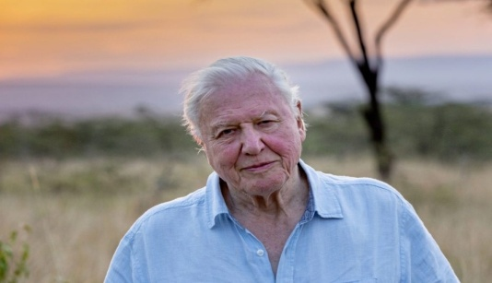

3 Methodology
The dissertation aims to explore whether media tools influence individual behaviour changes in regards to conservation. To undertake research of any nature a range of methods are applied to data collection. This section will explore the methods adopted for this dissertation to answer the objectives devised
Farrell, illustrates A methodology is devised to describe the way you have conducted your study; the methodology should justify the way you have done this, and finally the methodology should answer the questions why, how and what. Farrell (2011) Thomas goes onto say that the methodology is simply not chapter on the presentation of your method it is a discussion of methods used in your research Basically a method is a technique or a way of undertaking a task (Collins 2008)

3.0 Approaches to data gathering
There are a number of methods which can be applied to data collection, examples Qualitative and Quantitative
Sapsford and Japp (1996,p.284)quote "Qualitative research is largely descriptive in nature". Farrell firstly goes onto say qualitative data refers to hypothesis and throwing up hunches, the use of theory is less clear than a quantitative approach. Secondly Farrell points out that both approaches are not closed boxes, data may fit into either category, however the researcher should be a realist in which approach is used, plus the researcher should be innovative and proactive Farrell (2011). Thomas firstly notes Quantitative data research is referred to as "research using number" secondly goes onto say that both Qualitative and Quantitative research work together and are "not in opposition to one another". Thomas, G(2008) .The method chosen for this dissertation encompassed a quantitative approach i.e. numerical method, the researcher had not used a quantitative approach before and was apprehensive at the start, the researcher did struggle with the decoding of numerical data

3.1 Data Collection
Data collection can be gathered via many methods an example ,Questionnaires, Interviews, focus groups, pilot studies and case studies. For the purpose of this dissertation the chosen method was Questionnaires. Sapsford and Japp refer to the fact "questionnaire are just as much highly structured" .the main positives of questionnaires are : they are inexpensive you can use both open and closed questions. Although questionnaires can have negative aspects :response rate can be low, : "different sorts of bias may arise" Sapsford and Japp( 1996.p102). Collins describes bias ,cause someone to be prejudice and someone to have a bias Collins (2008). Sapsford and Japp state "proceeding data collection itself what cases to select and how the study should be designed this supports validity of evidence." Sapsford and Japp(1996,p.1)

3.2 Dissertation Objectives
The table below outlines the dissertations Objectives:
Objective one -To Understand the role of media with ref to plastics | Objective two-Evaluate analyse via methodology Individuals perceptions /behaviour as a result of media influences | Objective three-To recommend /draw conclusion from analysis

The table below notes how the questionnaire aims to address the objectives
Objective one | Objective two | Objective Three
How participates viewed Media or any other feedback. Age groups of individual accessing media and what types | What behaviour /influences participants undertook if any ?  Any groups which people may belong to | Any recommendations participants indicated for the future of media and conservation

3.3 Questionnaires
The researcher felt that online platforms and email was best fitted for this purpose to deliver questionnaire links, the questionnaires were devised using an online website ,the site illustrated templates for researchers to download, some of these templates were free and other designs incurred a charge , it was important that any method of data collection created would aim to explore and expand on the objectives devised (table provided). The researcher did have to decide on what questions would be included in the questionnaire and these were related back to the dissertations objectives .In this case the use of questionnaires was deemed appropriate for data collection in the following ways:
A. Would reach a wide range of individuals
B. Could be sent electronically and posted on social media
C. The questionnaire would be easy to follow
D. Would support multiple choice answers
E. Allow the participant to give an onion plus expand on some questions.
The Questionnaire would need to receive a number of responses back in order for data to be varied and valid, in this case the researcher felt over hundred questionnaires should be devised, although the researcher was aware this was a small number . The majority of questionnaires were sent January 23rd 2020, the questionnaires would not be sent out to the public until approval had been given by pilot study participants .
Some emails via were sent via email the rest were given as hard copies , altogether one hundred and eight were devised with one hundred and eight received back ,further information will be in the results chapter ,the use of email did present some challenges for the researcher due to work commitments, the researcher works within two departments at the local council: one as trade waste assistant and one library assistant , the majority of emails were sent through lunch breaks and had to be sent form the researcher student email and not work email ,the researcher had to keep rechecking email addresses to copy into student email, hence this took up some time and thirty minutes was not long enough for this task , although due to evening restraints this was the easiest way to attend to this task ,

3.4 Social Media
Secondly the questionnaire link was uploaded to social media platform in this case Facebook , the researcher chose this platform in order to facilitate fast response times plus Facebook profiles are made up of friends list an example ,the number of individuals on the researchers profile i.e. over five hundred people, by uploading the link participants could then click the link to the questionnaire website. Advantages of using social media would be: responses time ,data would come from varying groups, plus the advantage was the researcher was able to how many had accessed the questionnaire via Facebook. It did appear that social media platforms delivered the majority of data in a quick time, questionnaire links via email were intermittent this could have been down to participants work load and outside commitments , although some colleague in the office environment may not have completed the questionnaires . .

3.5Pilot Study and issues presented
This pilot study was arranged via university lecturers and an email sent by the researcher to ask permission for the pilot study to take place, plus the researcher is part of the Masters programme /environmental cohort ,the group was chosen for their knowledge base of environmental issues and the group is currently undertaking the masters programme ,it will be important to remember that bias could be mistook, however the researcher did not know the group in question. Due to the nature of the dissertation sustainable methods were thought of in order to conduct data gathering i.e. the medium in which to collect data, an example using a vehicle to distribute hard copies, it was regarded car travel was deemed to be acceptable. The evening of the pilot study the researcher travelled from work to the university this is a considerable distance however it was important the pilot study took place was due to the fact the questionnaire was waiting approval to be sent out to the public.

The pilot study took place on January 22nd 2020 a Wednesday evening at six pm, The researcher was introduced to the group upon entering the room, the group were handed paper copies of the questionnaire altogether ten was printed. Limitations were encountered firstly due the number of participates this consisted of five members hence data would come from a small source, additional feedback i.e. question choice and other details could be limited, however this could have been down to the nature of the setting , the researcher had to consider this group was in a lesson, it may be with time restraints answers were not given the full attention required .

The group indicated that the use of paper copy was in contrast to sustainable tools i.e. the use and number of sheets to print the questionnaires. The researcher felt the paper copies were of a lengthy nature i.e. paper used , the researcher did point out the group that online these questions may not appear long, some hand writing was difficult to read ,however was acceptable , yet the group did appear happy to support the researchers study

3.6 Participants Chosen -Pilot Study, Questionnaire and Social Media
The table below displays the participants that were chosen by the researcher and reasons why.
Tool Questionnaire Colleagues - NPTC | Tool Social media Participants Researchers Profile | Pilot Study -students/researchers cohort | Tool Questionnaires Library Colleagues -Neath Council
Convenience  Access to Data | Convenience | Convenient | Convenience-Access to literature
Knowledgeable | Varying age groups | Knowledgeable | Knowledgeable
Willing to assist | Varying participants | Willing to assist | Willing to assist
Professional Capacity | Wider interests | Professional | Professional capacity

Firstly participants were chosen from the researchers work settings i.e. library and Trade Waste ,secondly social media platforms. The researcher works with a large number of colleagues at the local authority i.e. Neath and Port Talbot Council, it was deemed acceptable to approach some staff members, colleagues chosen were deemed to be knowledgeable, professional , had access to data and work in a related field.
In addition ,colleagues wishes to assist in the research process, the researcher did ask permission from line managers to undertake this task. After permission was granted the researcher approached thirty colleagues at trade waste this included :side waste officers, trade waste officers and waste enforcement officers, the researcher felt the data received from these colleagues would be relevant and up to date .Secondly up to ten colleagues in the library was chosen, these colleagues had access to resources and practised recycling in the library building .
In comparison an email was sent to the city and county of Swansea recycling team ,an email was received back with website links to be explored further , Results illustrated the questionnaire links sent via email were intermittent this could have been down to participants work load and outside commitments , although some colleague in the office environment did comment on how interesting the topic choice was and was relevant to today's society , others wished to complete it to support the researchers desertion work
On reflection the researcher could have sent out questionnaire links to outside agencies such as consumers i.e. retailers and other professionals in the field of refuse. yet this would not have guaranteed responses ,however would have varied individual contacted . In addition the researcher could have included other staff members such as the Bio diversity team and Regeneration. In the next instance participants would be chosen from the researcher’s social media platform, It did appear that social media platforms delivered the majority of data in a quick time. The questionnaires would not be sent out to the public until approval had been given by pilot study participates ..

3.7Other Methods Adopted
The table below highlights Other methods adopted to gather data.
DVD's: Explored:  Blue Planet 2  Seven Worlds, One Planet  Dynasties | Personal Dictaphone/Mobile: | Public library Venues  Plus University Library: | First Hand primary data:
Visual Information  Presenters Insights  Highlighted current issues  Other professionals involved | Recording of notes  Convenient  Can be accessed 24 hours  Can take photos for research | Access to other literature and other sources  Staff could enquire further  Printing facilities | Researcher had completed an undergraduate Dissertation on Early Childhood play in Natural habitat

The researchers adopted other methods to support data collection , other methods were deemed to be acceptable to data collection and easy to access , other tools included: Dictaphone to record notes, the Dictaphone was useful for the researchers recording of ideas and time keeping .A mobile phone device added support via written notes or to take any pictures to add to appendices example if the researcher was visiting the beach and observed litter a photo could be taken. .
In addition the researcher accessed a portable DVD player to view environmental films, the researcher chose DVDS such as Blue planet two ,Dynasties ,Human Planet and Seven Worlds One Planet , these complemented the bibliography chosen for the literature review and proved to be invaluable to research methods , the majority of DVDs explored by the researcher were presented by Sir David Attenborough, the DVDs supported visual learning and give an insight into the experiences of wildlife in habitat , plastic pollution , habitat management and climate change, plus the DVDs included presenters insights , Documentaries also illustrated work being undertaken by others in the field of conservation :these included Marine Biologists, scientists, fisheries and conservationists , it will be important to realise that these individuals are experts in their field and could be considered bias, although presenters such as David Attenbourgh is regarded as a trusted naturalist with decades of experience
The research also explored personal literature undertaken in a previous undergraduate dissertation, this explored Early Years Education and outdoor environments i.e. forest school or coastal school settings, these types of environments supported children’s learning and understanding of conservation efforts ,with the aim to further support the accumulation of knowledge into adult hood. Peto, R( 2015) . In conjunction with the BA Dissertation the researcher also run an outdoor small Beach School setting , this business supported early years interaction I.e. natural environment in this case the beach visited was located in Aberavon near Port Talbot, firstly the aim of the beach school was to enhance children's learning in natural environments and secondly support conservation efforts all be it locally .
The beach school conducted these through hour long sessions i.e. children learning in nature i.e. . nature walks , arts and crafts , storytelling , and wildlife ID , the beach school also raised awareness of events such as World Ocean Days and Earth Hour these were done via lessons and social media platform , sessions also supported children’s sensory development , the researcher was able to access notes and literature and reflect from devised lesson plans . In addition the researcher observed firsthand the amount of plastic waste on the beach ,this was collected and disposed of before and after sessions , this information was useful for the dissertation it was considered a primary data source, although this could be considered bias ,yet this data was current and worthwhile to be explored.
The researcher also looked at other Masters dissertations written by previous students on environmental courses, however this proved to be less of a favourable option, the researcher found only one at the library in university, the majority of dissertations found were of an educational nature, yet the researcher could have looked on the online library, on reflection this could be a consideration for others undertaking future studies . The researcher accessed a number of venues to write chapters ,such as the work place canteen after hours and during lunch hours ,plus some local libraries were visited during lunch hours to view literature, although the university library was better placed to provide support, as literature was in date and a wide range of choice after consideration some venues were not ideal, however these venues did support the writing of some chapters, the researcher works full time hence lunch hours was considered to be an ideal time to continue researching.

3.8 Other Literature
As discussed in the literature review a number of literature books were explored, the researcher is a member of the Marine Conservation Society and literature was sent via post each month i.e. monthly magazine. Finally, the researcher is also a member of the climate coalition group with the Women’s Institute and receives regular emails on a monthly basis this information is then presented to WI members hence information is consistent and up to date.

3.9Ethical Considerations
Before research in conducted Ethical consideration must be thought of and applied to data collection Firstly, it is important to define the word ethics, simply Ethics is the system of moral principles. BBC (2020).
Thomas goes onto say that Ethics underpins university research due to the fact university is a place of inquiry and ideas ,ethics is about the “conduct of your work and are a principle of conduct of what is right and wrong, ethical principles encompass some decisions and dilemmas i.e. what is right for the researcher may not be right for the participants, “ it is important for the researcher to gain consent from participants ,potential participants must be informed of what they are taking part in an informed consent is needed Thomas (2009,p.147). Hek goes onto say that ethical principles support human rights and should be followed throughout a research study. Hek et al.(200
Ethical consideration was at the forefront of the researchers progress, firstly ethical consent was received from the university to undertake research plus the researchers ethical behaviour was considered throughout the work .The researcher considered what questions should be included in the questionnaire these were designed to be impartial and should not contain emotive content, however some questions did ask for age and location, yet participants could choose not to answer these ,the questionnaire was designed to be anonymous .The researcher had completed a dissertation previously and was aware of ethical procedures . It is important to
remember ethical consideration stand as a form of protection for recipients and the researcher, content such as environmental issues is emotive although not everyone will consider this topic important, yet the issue is prominent and should be awarded a degree of importance in order to support a sustainable future .The researcher did not include focus group or interviews in this dissertation and were deemed unnecessary however were considered, although the researcher did wish to use interview methods to undertake research with time restraints this was not feasible.

4. Results
Can the use of media support in changing individual perceptions and behaviour in raising environmental awareness and conservation?

Results and Discussions
This chapter aims to explore the results gathered from the researcher’s questionnaire and discuss any outcomes, the final chapter will discuss any limitations and offer a conclusion. The design of the dissertation was important to the analysis of data an example, the use of pictures and photographs ,these will be included in the appendices .The researcher explored what methods to use to display data, an example graphs , tables or charts. The researcher decided to use tables and pie charts, as it was deemed the data would be easier to understand.
Table Data -These types of charts can be easily read, data is visualised and held in rows and columns and comparisons can be made easily , the researcher felt this was the easiest method to adopt as it was useful to data collection (Skillwise 2020) results these were then cross references to information in the literature review this revealed themes to responses received i.e. popular responses The researcher then adopted a basic cycle design to illustrate how data was analysed this was done via word document, this cycle design would visually display this process .

The chart below illustrates how data was analyzed using a basic cycle stage design.

4.1Pie Charts and Excel

The researcher adopted Excel and Pie Charts to display data and felt this was appropriate , the visual aspect would be to the point Thomas notes that descriptive statistics are about simplification , organisation and summary these types of are a way of plotting numerical data .Thomas (2009) The researcher decoded data manually and then split into headings to make it easier to understand, Data was displayed via table and Pie Charts with first imputing the data into Excel , Excels is a tool that allows for Eyeballing of information Thomas describes " Eyeballing is having a look at a range of number to see what the look tells you " Thomas ( 2009,p.212)

4.2 Questionnaires

The below Table represents questions devised for the questionnaires , A copy of the questionnaire can be seen in Appendices
Question 1- What age bracket are you in? Under 18/ 18-24/25-34/ 35-54 / 55 plus

Question 2 What is your gender? M/F

Question 3 in what area do you live? Neath, Swansea Bridgend, Cardiff, Other......

Question 4 What types of media do you prefer to utilise? Newspaper, Podcast, TV, Radio, Cinema, DVD, and literature

Question 5 Have you viewed any environmental programmes in the last six months, and can you name them?

Question 6 How do you feel general media portrays plastic pollution?

Question 7 Has any of the media mentioned here changed your perceptions of plastic pollution if yes in what way ? please make any comments : Yes / No /undecided
Question 8 Do you belong to any of the following environmental groups, if yes please tick which one : World Wildlife Fund, Greenpeace, local Nature groups , Marine Conservation Society or other

Question9 Would you like to give any other information on what prompted you to join these groups

Question 10 Is there anything else you would like to add in relation to plastic pollution

4.3 Participants
To begin, it is important to give a figure of how many individuals answered the questionnaires sent out : To recap these included male and female and included the researchers trade waste and library colleagues , plus social media feed/ friends on Facebook .In total Over 108 questionnaires were sent out these were sent via email and social media platform ,plus hard copies were used for the pilot study , In total 108 people answered the online questionnaires ,although results illustrated some questions were not answered some individuals omitted answering some questions ,
This figures illustrated many people looked at the questionnaire :
Male/100 | Females/100
38 | 61

Age Groups answered
Ages /18-24 | Ages /25-34 | Ages/ 35-54 | Ages /55plus
7 | 17 | 44 | 33
Least | Middle Bracket | Highest Bracket | 2nd Highest

It appears that the questionnaires were answered by the majority of women ,this was not expected as the researcher believed more men would answer the questionnaires this was due to the fact the researchers work place is primarily male orientated ,however it appears the Face book link has attracted more women, with forty nine women answering online and twelve women via paper copy .The majority of age groups answered were aged 35 to 54 , yet ages 55 plus was second highest , it appears seven people aged eighteen to twenty four answered some questions, however this age group was far less.

4.5 In response to Questions 1-4

To understand the role of media with reference to plastic pollution exploring the use of media i.e. television plus social media pages, this section has been divided into themes of most popular responses received:
Most Popular Response out of 100 participants
Responses | Number of Participants /100
Television | 75
Social Media | 18
Newspaper | 25

Responses | Number of Participants /100
Radio | 42
Cinema | 19
DVD | 5
Results from Of Come 2018 per cent ages of individuals in the UK accessing media tools:
Television (Of com) | Radio(Of Com) | Internet (OfCom) | Newspaper (Of com)
79 per cent | 44 per cent | 64 per cent | 40 per cent

4.6 Results
Out of those 108 hundred people who filled in the questionnaire, it appears television and Newspaper was accessed frequently ,according to Of com television is the most accessible platform for news in the UK with 79 per cent of adults viewing ( Of com 2018 ). It appears social media access was low Of com refer to the fact sixty four percent of adults viewed the internet this would appear to be higher than participates had chosen (Of com 2018 ) The results seems to correspond with Tolvnen survey that social media platforms are a useful tool in obtaining data collection. Tolvnen et al (2015) ,in particular Facebook is a favourable option for users . Facebook was used as platform to launch the survey, however it is important to remember most people had chosen numerous options examples ,radio , podcast and you tube , hence one person may have accessed a number of media tools., Radio was most popular with Of com suggesting forty four per cent of people accessed a radio. yet the Of com survey was conducted in 2018 results may have well changed.

The table blow illustrates the positives and negatives of media tools with responses received via the questionnaire .

Social Media Positives | Social Media Limits | Television  Positive | Television  Limits | Newspaper  Positives | Newspaper  Limits
Accessible 24 hours a day | Not everyone will have access | Accessible 24 hours a day | Expensive to purchase | Can be bought daily | Newspapers can be expensive
Updated regularly | Not everyone Will want to use social media | Widely accessible | Not every household has a television set | Current news up to date information | Some countries may not distribute newspapers
Translated into other languages | Certain groups may find navigation difficult | Translated into other languages | Some programs onto late although taping is an option | Can be read online or via other tools i.e. tablet devices | Some people discard after use
Keeping in contact with others | Requires internet access | Wide range of programmes available i.e. streaming | Not everyone will want to watch television | Illustrates Other information | Can be lengthy

4.7 In response to question 5 to 7
Evaluate and analyse via methodology individual perceptions and behaviour influences as a result of media exposure, accessing tools to support data gathering:
Data gathered a number or responses to individual perceptions and behaviour influences, to make this easier to read the data has been put into headings of most popular findings plus a table was created illustrating other responses. it will be important to remember some people omitted some questions so data may not reflect true responses

When asked if media had influenced changing perceptions of environmental issues
Yes /100 | No /100 | Undecided /100
57 | 29 | 21
Highest Bracket | 2nd Highest | Middle

A Doughnut chart was used in this instance as the researcher felt it highlighted the data effectively, it appears that doughnut and pie charts are amongst those most favoured , this type of chart reflects the relational proportions between data (chartsjs 2020)
It appears 57 out of hundred people answered yes to this questions with twenty nine participants stating no and twenty one undecided ,results illustrate in this case media has affected behaviour influences ,although twenty one individuals were undecided, it is unclear if the Yes bracket would increase ,if the researcher had sent more questionnaires figures may have increased .The tables below illustrates responses received from individuals on how media has influenced their behaviours, although it is important to remember that these individuals may already have been members for some time of these organisations and not from media influences, the questionnaires were sent to a wide range of individuals some working in the field and some not

4.8 Responses received how media has influenced perceptions:
Behaviour- Responses
Joined local environmental groups to area
Recycles at home most items
Attend litter picks with community groups
Reuse of some products which cannot be recycled
Donates to some charities regarding climate change

4.9 The table below illustrates how some individuals felt media tools portray any coverage of issues:
Media Positives | Media Negatives | Other -Media
Raises Awareness | Not enough awareness | Adapts shock Tactics
Right amount of coverage | Lack of Information | Harrowing Stories
Highlights the Damages out there | Could do More | Grave Threats
Interesting stories/countries you may not be able to visit | Media Exaggerates problem | Sensationalises the issues

4.10 Most popular programmes watched via Documentaries and others with environmental references:
Popular Environmental Programmes | Individuals viewed/100 | Other Programs Watched with environmental elements
Blue Planet 2  Image six  (IMDB,2020) | 28 individuals | Our Planet
Seven Worlds One Planet    Image 7  (Technadu, 2020) | 18 individuals | War on Plastic
BBC NEWS /XRAY    Image eight  (BBC 2020) | 7 individuals | You Tube
Spring Watch  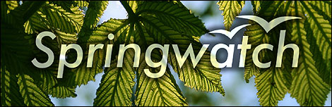  Image nine  (BBC, 2014) | 8 individuals | Doctor Who futuristic (1 person)
Country File  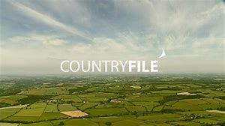  Image ten  (BBC ,Home 2014 ) | 5 individuals | Iceland Advert on Deforestation (1 person)

These are just some responses received from questions five and six i.e. questionnaire, It is important to remember that some people have omitted some questions ,as figures illustrate it does appear that documentaries with Sir David Attenborough are very popular , this would appear to confirm the Guardians article that Blue Planet two had attracted a large audience , an estimated figure 14.1 million people tuned in to watch( Guardian 2018) . It also appears the Spring Watch series was popular, this included Autumn Watch and Winter watch, plus Country file was also viewed . The news and X-ray program were amongst those popular viewed , during the recent floods and Bush fires the news aired these scenes daily.
However, the recent flooding in South Wales may have affected the way people view climate change i.e. the rise of temperatures, although this may not be conclusive. The recent bush fires in Australia noted that climate change would not be considered as being a contributing factor to this disaster .Reville reports that global warming alone did not exacerbate the bush fires other factors were considered (Reville,W 2020). The media aired scenes of both disasters, highlighting the effect the fires had on the loss of wildlife and loss of family's belongings , it appeared campaigns were launched via social media to support families affected by flooding and the wildlife lost in the Australian bush fires .
It does appears in this instance that media has affected the emotional states of individuals to assist in these disasters this would appear to relate to Blewits reference that the media uses visual imagery plus music and sound to support the viewers emotional attachment, Blewitt (2010 ),it is important to remember that these events were disasters ,this implies a threat was imminent to human life or a threat to habitat, it is reasonable then to say this kind of threat would draw attention .
It is interesting that Doctor Who and the Iceland advert were regarded as environmental program although only one participant referred to these programs The participant indicated these programs illustrated scenes of deforestation . In particular loss of Orang-utan habitat (Iceland) ,however it appears the Iceland advert caused controversy and was banned from appearing during the Christmas period of 2018, television officials deemed it as too political due to the portrayal and criticism of Palm Oil . At the time it appears Iceland were in the process of removing all products containing palm oil form there stores , in this case it appears media tools did not reach the audience intended, although it can still be viewed on other platforms. (Sweney,M 2018 )

4.11 In response to questions 7-10
.
The questionnaire included other comments box this was left blank to allow for any additional thoughts or ideas .The answers illustrate that plastic pollution is a subject the majority of people are aware off even if some have omitted to answer, it was noted 49 people omitted answering this question, this could have been down to a number of reasons. The majority of people will be aware of the plastic bag levy scheme in the UK even though other countries have adopted similar schemes, this is linked to the principles of recycling , reuse and reduce. It would be reasonable to say that people will be aware of recycling even if they do not practice if only at the supermarket and with household recycling. Education has been highlighted by participants as an option to inform the principles of recycling, it does appear this is being undertaken by local authorities .The researcher was aware that if more participants had been chosen data would have been expanded upon it appears the results gathered have been diverse and worthwhile

Below are some responses received from participants to the final question, number 10 Questionnaire.
Packaging | Education | Plastic Waste
Excess Packaging to be banned | Targeting Younger audiences | "Only confirmed what I thought plastic Waste is a growing concern"

5. Conclusion and Recommendations.

This chapter recaps the key findings of this dissertation, Key findings were from direct responses to the devised objectives. firstly, the dissertation illustrated that the media has had a powerful affect on the way participants perceived environmental topics. It appears television, social media and radio were favourable tools and accessed by the majority of participants, even though data shows certain age groups accessed media

5.1 Objective One -Recommendations
To understand the role of media with reference to plastic pollution exploring the use of media i.e. television plus social media pages, this section has been divided into themes of most popular responses received:
It appears the majority of people who answered the questionnaire all accessed some type of media as was illustrated in objective one television and, social media was most popular. These types of media tools look likely to continue into the future, although not very generation will access social media some older adults may find social media hard to negotiate, children and young people are being taught to use ICT in education i.e. school hence it is likely that this option will be popular amongst the younger generation .It does appear the majority of people who answered the questionnaire were in the age range of thirty- five to fifty plus. It appears everyone who answered the questionnaire viewed environmental programs of some description presented by Sir David Attenborough documentaries alongside Spring watch.
It appears Blue Planet two was most popular with’ Seven Worlds One Planet ‘in second place, the researcher was expecting this result due to the popularity of Sir David Attenborough and his long history with conservation. This certainly supported the suggestion by the Guardian newspaper that 14.1 million people tuned into see Blue Planet 2.(The Guardian 2018) It also appears the Spring Watch series was popular, this included Autumn Watch and Winter watch, plus Country file was also viewed. The news and X-ray program were amongst those popular viewed, during the recent floods and Bush fires the news aired these scenes daily.
The effect of Blue Planet pollution was acknowledged by the government plus other leaders including Prince Charles and the Duke of Cambridge. It looks likely Sir David Attenborough will continue to present these types of programmes, although it looks like his legacy will continue this would appear to be in conjunction with Blewitts suggestion that the use of imagery supports interaction with viewers with sound and music supporting the viewers emotional experience whilst watching a documentary, data indicated that participants were influenced or their emotions affected from what was seen on programmes, however this could also be down to other reasons Blewitt(2010)

5.2 Objective two
Evaluate and analyse via methodology individual perceptions and behaviour influences because of media exposure, accessing tools to support data gathering
The dissertation illustrated most of the participants viewed media relating to Sir David Attenborough with Blue Planet two being the most popular, in fact the majority of participants mentioned any documentary with Sir David Attenborough was favourable, although spring watch and the news was also popular. Most of the participants belonged to environmental groups with some belong to Greenpeace and Extinction Rebellion plus local nature groups although some participants did not belong to any groups yet supported recycling efforts in other ways such as home recycling. Local groups in Neath such as Caru Cymru work alongside NPT council to litter pick beach areas all these steps make a difference (Caru Cymru 2020)
Mainly all participants indicated that the media had influenced their behaviour change although some participants were already in this field, whilst others were aware of the need for plastic recycling due to media attention and information from the news. Some participants indicated the media needed to do more to highlight the issue of plastic pollution whilst others felt it was enough, the words some used the media was powerful. Indeed the media is a powerful tool, yet it can be also be intrusive and constant some news can be replayed over and over again which can be frustrating for some especially, although news channels could be relied upon to be a trusted source of information.
Yet it is important to remember that the majority of conservation groups have been in existence for years possibly decades, current sustainable lifestyles goals i.e. vegan and Farm to Fork products are becmoing popular ,most people are choosing to adopt sustainable goals i.e. recycling and reuse awareness seems to be increasing of conservation and sustainability in general. this would appear to be linked to the SDG,S Sustainable Development Goal of Responsible Consumption and production of products, plus Goal 14 Life below the sea ,if natural resources are not managed effectively as population increases resources will deplete (UN 2020)
It appears Doctor Who illustrated scenes of waste, in particular plastic pollution ,Doctor who is a fictional program yet its audiences include children and young people ,hence a program of this nature would be useful as a tool in educating the future generation . In addition, Disney/ Pixar’s Wall -E film illustrated a futuristic robot disposing of waste to save the planet being destroyed, these types of films are messages to audiences on the issues affecting the global world, plus Blewits suggestion that imagery and other sensory aspects plays a part in these programmes hence it will appeal to certain people.Blewitt (2010)

5.3 Objective three Recommendations

To recommend and draw conclusion from analysis which can be added to future research

The use of education could be a way forward the local authority of NPTC uses both social media and practical methods to educate households .The NPT use of social media is an advantage to the trade team any questions from the public are sent via the Face book message option this is answered by a member of the team and appears to be a way forward in order to relay future news or events in the communities. This appears to be in contrast with Tolvonen suggestion that social media is of limited use in the field of science ,yet data is useful to professionals in these areas.Tolvonen et al(2015)
Face to Face events i.e. questions and answers sessions are also a means of educating the public ,this can be done at local centres or libraries , the trade team in particular attend talks at women’s institutes, food festivals, educational settings, Brownies and Scouts groups this could be replicated by other authorities (NPT 2020).Although these are small steps it does support community interaction all be it on a small scale ,however face to face events could support the acquisition of knowledge i.e. which someone may not be aware of at the time and then passed on to others, a possible solution if local authorities could target young people in secondary school settings, Church or youth clubs to get this message across .

In addition, programmes such as Spring watch and Country file are in an ideal position to target a younger audience i.e. children and young people, however with timings this may not be accessible for some children, it would be ideal for documentaries to be shown in education settings such as libraries or community venues. The researchers role as Trade Waste assistant involves supporting trade waste pollution, from previous research it appears education is being used to inform young children of plastic pollution and damage to habitat, yet figures illustrated NPTC are working towards meeting the recycling target set out by the welsh Government it is important to remember that local householders are a big part of meeting this target and require constant interaction and cooperation.
Education is also used in an attempt to deter fly tipping which causes damage to wildlife and habitat and could be a route for plastics into water courses i.e. streams and rivers, which then flows into oceans and can reach vast areas, this appears to be the case as Brownlow and HoneyBorne noted that Albatross birds carrying plastic back to their nests)( Brownlow and HoneyBorne, 2017).This is linked to what the UN noted that human activities effects the ocean and is likely to continue unless action is taken, SDG'S Certainly assist to support the health of the ocean with SDG goal 12 , however this does require co operation from world leaders and individuals .(UN 2020)

The enforcement team at NPTC use prepared video messages ,howvere this is an ongoing concern for local authorities, even though fines and sentences are in place for such individuals, it appears this is not enough to eradicate the problem, it does not appear likely this behaviour will decrease. Not everyone will agree on whether the work local authorities do is positive or negative. It would be reasonable to suggest there is always disagreement on whether fines are not high enough and whether enough is being done to combat issues whilst remembering local councils have to meet recycling targets. (NPT 2020)
It could be argued whether the effects of these unprecedented times would have had any effect on waste pollution in the ocean ,although the researcher observed an increase in fly tipping in one local area, hence it would be reasonable to suggest that plastic waste may have been amongst fly- tips, yet it may be that natural environments could indeed be less populated and affects of any type of pollution decreased ,however there has been work and measure undertaken to deter fly tipping and this is ongoing yet may take years to address
The researcher observed that even in the present day some individuals are finding recycling hard to manage, this could be down to a number of reasons i.e. not having enough time to recycle, not knowing how to recycle .It does appear that the local authority explored in this project, NPTC are attempting to meet recycling targets, although this is positive, the eradication on waste will not cease overnight it requires cooperation from all ,although older adults i.e. elderly may struggle to understand recycling concepts.
It appears positive steps and actions have been initiated in countries and organisations, although it could be argued this is not enough to eradicate plastic pollution ,it appears at local level local litter groups work areas to manage plastic pollution, at international level Sweden has installed plastic back schemes, yet commercial organisations could look at eradicating all plastic bags, from observation stores are still selling these to customers ,although some stores have replaced plastic clear bags with paper bags in fruit and vegetable sections, this is a step forward, however this needs to be implemented across all supermarkets chains for this to be successful.

The invention of plastic has changed the world, ideally the production of alternative materials to replace plastic could be the way forward, ideally if plastic production would cease altogether ,it is likely no plastic waste would find their ways in watercourse. Local governments could invest in schemes which could focus on design and manufacturing, investment into these areas for future roles could appeal to future generations as each generation evolves new ideas are thought of. It appears from a young age children are more accessible to this type of outdoor learning where in an ideal world this knowledge would carry on for life. The survival of the world’s oceans is dependent on many scenarios working together
Due to the nature of Dissertation Carbon Footprint was considered the researcher did have to use a vehicle to travel to Swansea petrol was acquired ,there is reference to Plant based products supporting the reduction of Carbon Footprint, although this would be dependent on how you purchase the products i.e. if you travel to a supermarket. .The research did not include Carbon Footprint as such in this work yet Carbon Footprint works in conjunction with climate change this could be included in future research for others
At this time the future for Environmental issues are unclear, the effect of Brexit is yet to be seen and with current issues facing the UK in 2020 Brexit has now taken a back seat .Yet Some participants highlighted their concern to climate change, this was highlighted lately by recent flooding in the UK plus in Australia with bush fires affecting many regions ,although there is no conclusive evidence that climate change was connected to these disasters. It could be that to blame Climate Change is an easy option for disasters incurred ,although it would be reasonable to say as there is no one else to blame for such disasters .
Although as this was a small-scale project there may have been individuals who simply did not wish to comment ,however, Britian indeed the world is facing an unprecedented period February 2020 has seen the outbreak of the corona pandemic, this has affected some individuals all over the United Kingdom and world ,the outbreak has affected the completion of the researchers studies and opportunities to visit university to print or visit the library ,the researcher has relied upon Information Technology to discuss any matters concerning the dissertation with lecturers.
The researcher was constantly in a position to learn via the role, this supported the gathering of data and research, the role supported the researcher personal development and the acquisition of information plus as in good practice the researcher was able to share information with colleagues and discuss both an informal and professional level. The sharing of information is a way for communication to others. The researcher’s personal circumstances have been affected in a profound way and the added pressure of being an essential worker was challenging during this time. To Recap:

5.4 Recommendations
1 Education can be used as a tool to specific groups
2 Future Research could include Carbon Footprint
3 Sharing of Information is linked to Education
4. Design of Products investing in roles to inspire Ideas.
Data from Blue Planet two and others documentaries are relevant to the present time, this data can be explored in the future to reference any changes. The dissertation has given reference to age groups i.e. age groups of individuals and popular documentaries viewed even though the data is of small scale it is useful and could support documentary production through target audiences. Yet there has been work and measure undertaken to conserve the oceans, this is ongoing . small measures have been achieved with plastic bag schemes, with some individuals undertaken and local groups recycling plus larger companies use of alternative materials if each person has practiced some type of recycling this is a small step to bigger steps, this is all contributing to the eradication of plastic pollution before it ends up in the ocean environment ..

6. Reference lists
Introduction
Boyle .M. (2020) TV Streaming Statistics. Available at http://finder.com /uk/tv (Accessed: 23rd May 2020) check
Collins.(2008 )English Dictionary .Glasgow: Harper Collins Publications.
Fisher, C (2019) ‘Beating Plastic Pollution’ Marine conservation Society, pp44-47
Foster, L.(2018 )’living without single use plastic’ Marine Conservation Society.England:Ross On Wye
Open University(2019)Our Blue Planet Exploring human impacts on the ocean and what we can do to protect it .Miton Keynes:Open university.
World Wildlife Fund (2018)Plastic Pollution is killing sea turtles Available at :http://wwf.org.au/news( Accessed: 1st December 2019).
World Wildlife Fund (2020 )Ocean Overview .Available at: http://www.worldwildlife.org.uk( Accessed: 1st December 2019).

Literature review
Attenborough, D.(2018) .Foreword. In Moss,S.Dynasties The rise and Fall of animal families .London:BBC Books
Attenborough, D.(2017).Foreword. In Brownlow,M,.HoneyBorne,J. Blue Planet 11 A new world of Hidden Depth.london:BBC Books
Attenborough,D.(207).Foreword.In Brownlow,M,.HoneyBorne,J.Blue Planet 11 A new world of hidden Depth.London.BBC Books
BBC Newsbeat(2017) Tonnes of Rubbish is being cleared from Mount Everest .Available at :HTTP://www.bbc.co.uk/Accessed: 2Febraury 2020).
Berlowitz, V and Fothergill,A.(2011)Frozen Planet a world beyond imagination. London: BBC Books
Blewitt, J.(2010)Media, Ecology Conservation , using the media to protect the worlds wildlife and ecosystems , Cambridge :Green Books ltd.
Brownlow M. and Honeyborne,J.(2017) Blue Planet 2 A new world of hidden depths.London:BBC Books.
British Telecom( 2018)Sir David Attenborough Dynasties .Available at: http://tv.bt.com (Accessed 23rd May 2020)
Budd,J.(2000) Beyond The Bin, The livewire guide to reusing and recycling .London:Womens Press Ltd.
Climate Coalition(2029)Show the love campaign .Available at https://www.theclimatecoalition.org/resource (Accessed: 12th December 2019)
Curran,J. and Gureuitch,M.(2005)Mass media and Society.4th edition .London:Hodder and Arnold
Disney Life (2020) WALL .E. Available at http://disneylife.com(Accessed 23rd May)
Donovan, J., O, O, Neil’E. (2019) ‘The next step in the fight against Throwaway Plastic’ ,Marine Conservation Society (Spring),pp.8-9.
Dunn, G (2019) 'Sir David Attenborough examines Our Planet for Netflix '.Irish News Available at https://www.irishnews.com/lifestyle/2019/04/01/news/sir-david-attenborough-examines-our-planet-for-netflix-1584597/ .(Accessed: 23rd May 2020).
Gemmell,C(2019)’Plunging Headfirst into the plastic pollution problem’, Marine Conservation Society, (winter),pp.40-45.
Hawksworth, E (2001)The Changing wildlife of Great Britain and Ireland. London: Taylor and Francis
Imdb.com(2020)Blue Planet 11 Available at :https://ww.idmb.com.(Accessed :23 May 2020)
Keep Wales tidy(2019) keep Wales today. Available at: http://keepwalestidy(Accessed: 12 December 2019)
Kumar,P.(2010)The economics of Ecosystems and Biodiversity ,Ecological and Economic Foundations.London:Routledge Taylor &Francis group.
Makham,A.(1995) A brief history of pollution .London:Earthcon Publications .
Morris, D.B. (1995) Earth Warrior Overboard with Paul Watson and the Sea Shepherd Conservation Society. California:Fulcrum publishing.
Moss, S.(2018)Dynasties The rise and fall of animal families .London:BBC Books .
Neath Port Talbot Council (2020) Available at:http://www.npt.gov.uk/(Acessed: 21st January 2020).
Neath Port Talbot (2020) Waste Crime .Available at : https://www.facebook.com/NPTWasteCrime/ Accessed :(5th February 2020)
O’Neil, E.(2019)‘Plastic, Protection and Guilt’, Marine Conservation Society’, (winter(,pp.8-9
Open University(2019)Our Blue Planet Exploring human impacts on the ocean and what we can do to protect it .Miton Keynes:Open university.
Prior,L.(2019) ‘Results confirm desperate need for Deposit Return Schemes’ Marine Conservation Society,(winter),pp.46- 51.
Recycle For Wales (2020) One Wales , One Planet. Available at: http://www.recycleforwales.org.uk(Accessed :16th February 2020)
Recycle4NPT(2020) available at https://www.facebook.com/Recycle4NPT (Accessed: 9th March 2020)
Reville,W.(2020) ‘Australian bush Fires were not caused by climate change ,Available at :http://www.irishtimes (Accessed: 3rd February 2020
The Guardian Newspaper (2018) Blue Planet 11 is years most watched British tv show. available at: http://www.theguardian.com. Accessed: 24th March 2020)
The Local(2018)Sweden are recycling more than ever via their bottle deposit scheme. Available at: http://www.thelocalse (Accessed 16th February 2020)
Tolvonen,T,Tenkanen,H,Minin,D,E(2015)’Prospects and challenges for social media data in conservation science ‘ Frontiers in Environmental Science ,Available at: https://doi.org/10.3389/fenvs.2015.00063
United Nations Environment Program (2020 )Life Below Water. Available at:https://www.unenvironment.org/explore-topics/sustainable-development-goals/why-do-sustainable-development-goals-matter/goal-14
United Nations(2020)Sustainable Development Goals Available at https://sustainabledevelopment.un.org (accessed :2oth February 2020)
Unite Nations(2020) About the oceans 2020 Conference .Available at: https://www.un.org/en/conferences/ocean2020/about(Accessed 23rd May 2020)
Weather Forecast.com (2020) Map of Neath. Available at :http://weather-forecast.com Accessed: 14 march 2020
William,P.T.(2005) Waste Treatment and Disposal 2nd edition .West Susses: Wiley &sons
World Atlas(2020 Tragedy of the commons .Available at :https://www.worldatlas.com/articles/what-is-the-tragedy-of-the-commons ( Accessed: 26th February 2020)

Methodology

BBC (2020)Ethics Guide available at: http://www.bbc.co.uk/ethics(Accessed 10th February 2020)
BBC Skillwise Graphs and Charts. available at :http://ww.bbc.co.uk/teach/skillwise (Accessed 2nd March 2020)
Farrell, P.(2011)Writing a Built Environment Dissertation Practical Guides and examples. Oxfrod:Wiley-Blackwell
Hek,G and Moule, P.(2006)making sense of Research An introduction for health and social care practitioners.London:Sage publishers
Sapsford,R.,Jupp,V.(1996) Data Collection and Analysis .London:Sage Publications
Thomas, G.(2009)How to do your research Project .London:Sage Publications
Though co(2020)How to determine a reliable source internet ,available at :http://www.thoughtco.com (Accessed 11th March 2020)

Results
BBC skill wise( 2020 )Graphs, lists and Tables .Available at :htttp://www.bbc.co.uk/teach/skillswiseAccessed :1st May 2020)
BBC World News(2020)World News .Available at :https://www.bbc.co.uk(Accessed 23RD May 2020)
BBC Cambridge (2014) Out and About Available at: https:// www.bbc.co.uk/cambridgeshire/content/articles/2007/05/09/springwatch_festival_feature.shtml(Accessed: 23rd May 2020)
Chartsjs.org (2020 )Available at http://www.chartjs.org/docs/latest/charts/doughnut.html (Accessed 23rd may 2020)
Blewitt, J.(2010) Media, Ecology Conservation , using the media to protect the worlds wildlife and ecosystems , Cambridge :Green Books ltd.
Imdb.com(2020)Blue Planet 11 Available at :https://ww.idmb.com.(Accessed :23 May 2020)
Reville,W(2020) ‘Australian bush Fires were not caused by climate change .Available at: http (Accessed 3rd February 2020)
Of Com (2018) Key findings from the report .Available at http://ofcom.org.uk (Accessed: 23rd May 2020 )
Sweney,M(2018) Body that rejected Iceland Christmas Ad faced storm of Abuse Available at http: https://www.theguardian.com/media/2018/nov/19/banned-iceland-christmas-ad-clearcast-facvebook-palm-oil
The Guardian Newspaper (2018) Blue Planet 11 is year's most watched British tv show available at: http://www.theguardian.com( Accessed 24th March 2020)
Technadu.com( 2020 )How to Watch Seven Worlds One Planet Online available at: https://technadu.com (Accessed 23rd May 2020)
Thomas, Gary (2009) How to do your research Project ,a guide for students in education and applied social sciences London:Sage
Tolvonen,T,Tenkanen,H,Minin,D,E(2015)’Prospects and challenges for social media data in conservation science ‘Frontiers in Environmental Science https://doi.org/10.3389/fenvs.2015.00063

Conclusions
Blewitt, J.(2010)Media, Ecology Conservation , using the media to protect the worlds wildlife and ecosystems , Cambridge :Green Books ltd.
Brownlow M. and Honeyborne,J.(2017) Blue Planet 2 A new world of hidden depths.London:BBC Books.
Tolvonen,T,Tenkanen,H,Minin,D,E(2015)’Prospects and challenges for social media data in conservation science ‘ Frontiers in Environmental Science ,Available at: https://doi.org/10.3389/fenvs.2015.00063
The Guardian Newspaper (2018) Blue Planet 11 is year's most watched British TV show. available at: http://www.theguardian.com. Accessed: 24th March 2020)
United Nations(2020)Sustainable Development Goals Available at https://sustainabledevelopment.un.org (accessed :2oth February 2020)

Appendix one

Recycling Figures 2016-2916
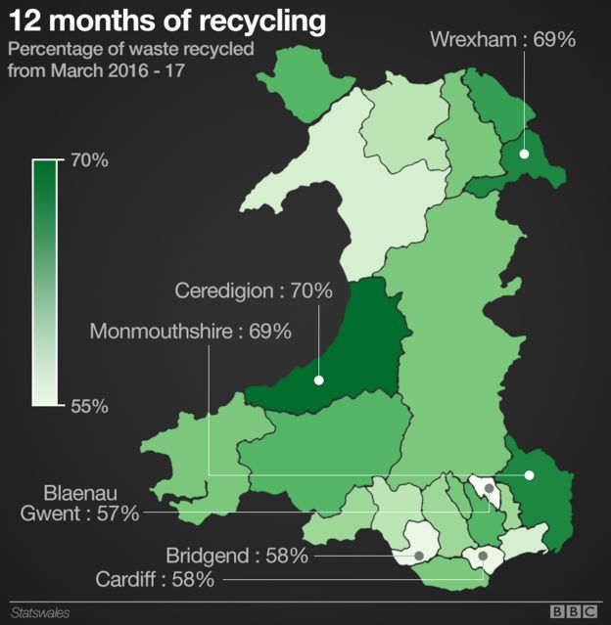
Map of Neath
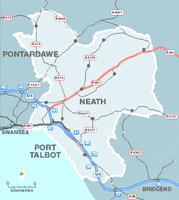

Plastics Tonnage Data
April to June -598 tonnes
July to Octber-418 tonnes
Oct to December -598 tonnes
Jan to March 692 tonnes
Total 2,297 tonnes
(Ref NPT 2019)

Appendix two
Bottle Back Scheme in Sweden
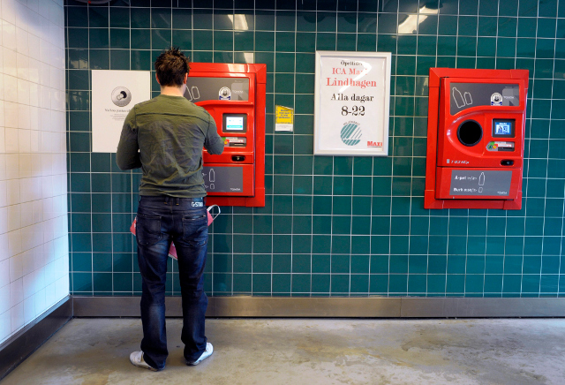

NPT Recycling Guide -Residents

Appendix three

Blue Whale and Blue Fin Tuna
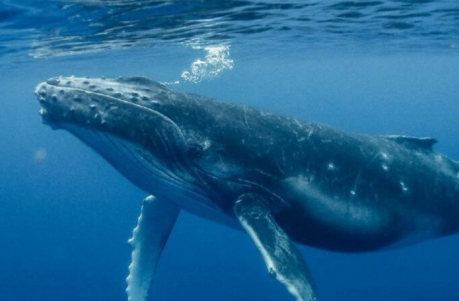

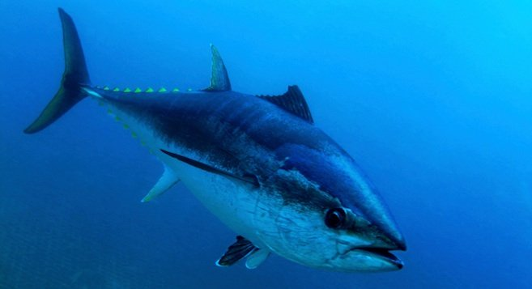

Appendix Four
Plastic Bottles on Everest
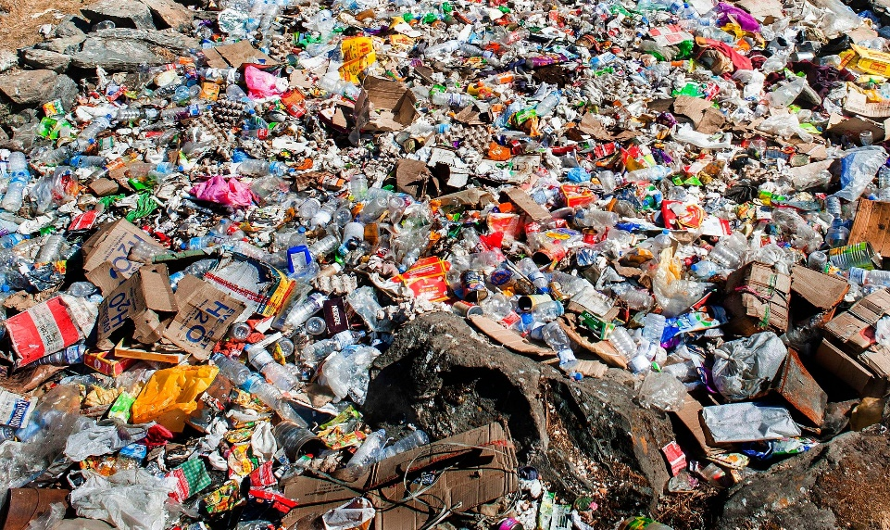

Discarded tents and waste Everest
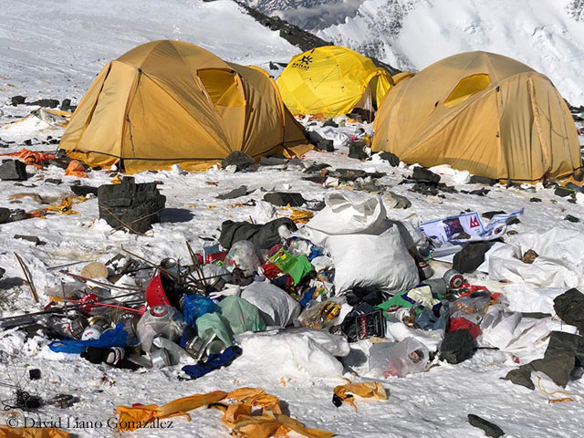

Appendix Five
Climate Coalition Green Heart Pack


