

LOCATION: Swansea | LLEOLIAD: abertawe
LEVEL 5 | LEFEL 5
EXAMINATION PERIOD | CYFNOD ARHOLIADAU
JAN 2026 | JAN 2026

MODULE CODE: ACDB5002
Electronics I

Marking Scheme

SENARIO
A smart energy-saving device is to be installed in rural homes where street lighting is minimal. The goal is to design a compact system that can automatically detect low light conditions and trigger an emergency light (LED), while also displaying status messages on an LCD.
The system will use a PIC16F877A microcontroller and should operate using standard electronic components. It must be developed and tested using Proteus simulation software and programmed using CCS C.
SYSTEM SPECIFACTIONS
- A 12V DC source must be stepped down and regulated to 5V using a voltage regulator.
- An LDR-based light sensor and an LM393 comparator must be used to detect ambient light:
  - Output LOW (0V) in darkness.
  - Output HIGH (5V) in brightness.
  - Output connected to RB0 of PIC16F877A.
- An LED connected to RD0 must:
  - Turn ON in dark conditions.
  - Turn OFF in bright conditions.
- A 16x2 LCD must display:
  - "DARK CONDITION" when it is dark.
  - "BRIGHT CONDITION" when it is bright.

Answer the Following
- Design the following circuits using correct component values and connectivity.
  - Power Supply Circuit. [10 Marks]
SOLUTION
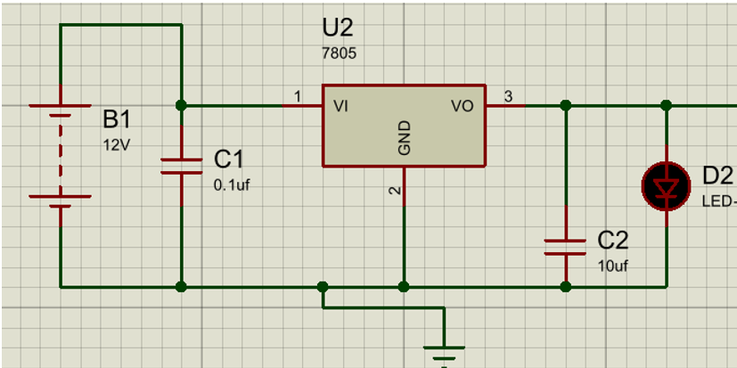
    - Correct use of 7805 voltage regulator (input, output, ground pins properly connected) [2 Marks]
    - Input capacitor (typically 0.1µF or 10µF) connected between input and ground [1 Mark]
    - Output capacitor (typically 0.1µF or 10µF) connected between output and ground [1 Mark]
    - Input voltage source correctly set to 12V DC [1 Mark]
    - Regulated 5V output successfully provided [2 Marks]
    - Correct grounding for all components [1 Mark]
    - Circuit layout clarity and completeness (no floating pins, labelled components)
[2 Marks]
  - LDR-based Light Detection Circuit using LM393 comparator [10 Marks]
SOLUTION
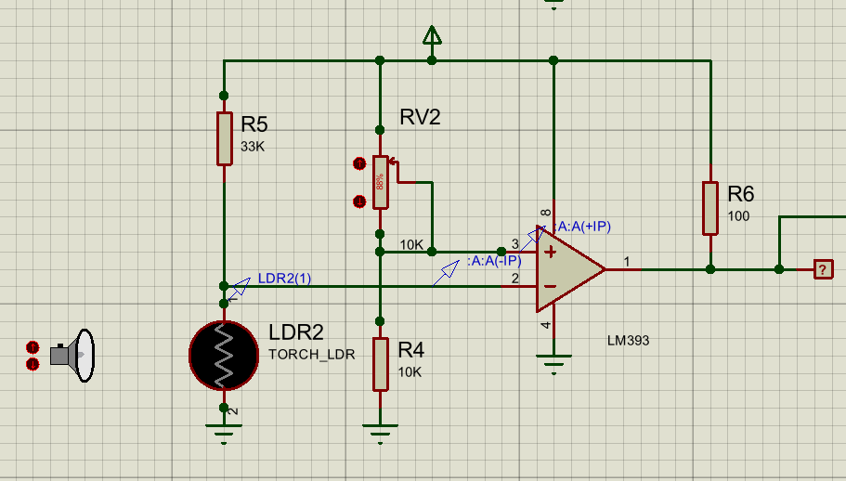
- LDR and fixed resistor correctly arranged as a voltage divider
[2 Marks]
- Pr Reference voltage (via potentiometer or fixed resistor) correctly connected.
[1 Mark]
- to IN−oper connection of voltage divider to comparator input (IN+)
[1 Mark]
- Comparator output connected with a pull-up resistor [1 Mark]
- Correct Vcc and GND connections to the LM393 [1 Mark]
- Output logic:
  - LOW when dark, [1 Mark]
  - HIGH when bright – correctly implemented [1 Mark]
- Clarity and completeness of circuit diagram (labelled, no open pins, clean layout) [2 Marks]
- Simulate and validate the above (i) said designed circuits:
  - Power Supply Circuit simulation. [5 Marks]
SOLUTION
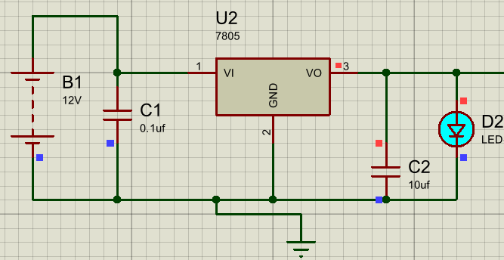
[5 Marks]
  - LDR-based Light Detection Circuit simulation. [5 Marks]
SOLUTION
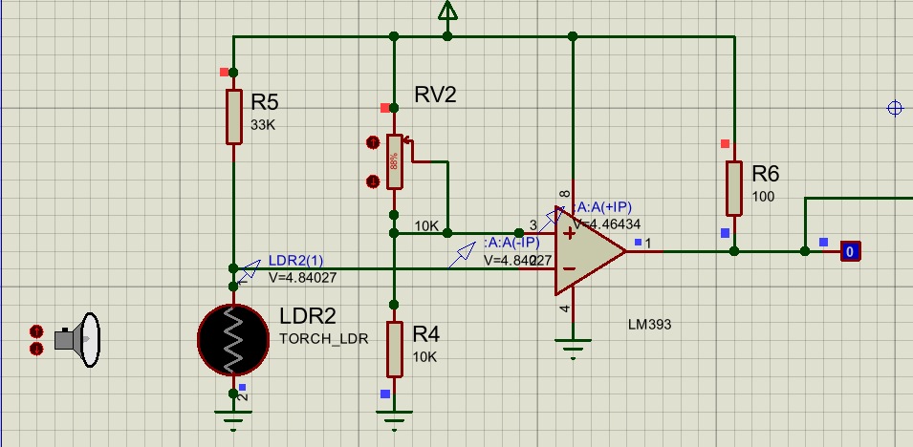
[2.5 Marks]
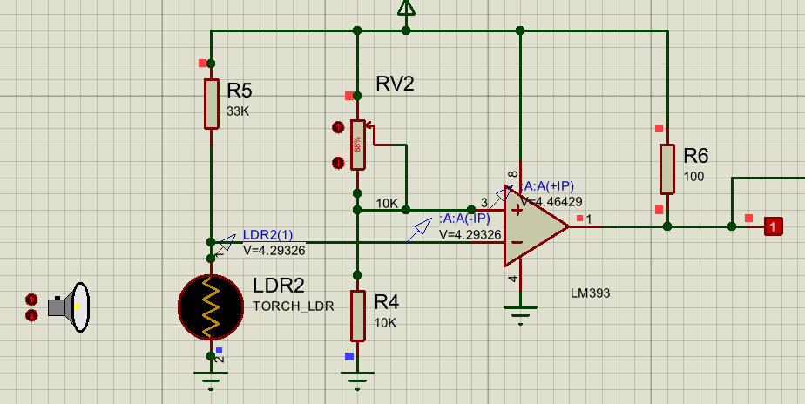
[2.5 Marks]
- Develop a single CCS C program to:
  - Read digital input from RB0.
  - Control LED output on RD0.
  - Display "DARK CONDITION" or "BRIGHT CONDITION" on the LCD based on input. [20 Marks]
SOLUTIONS
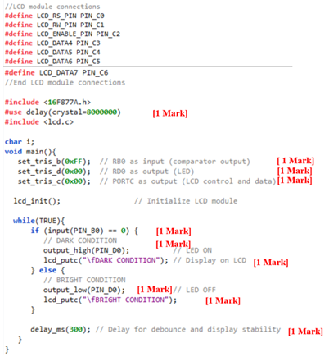
Including Adequate comments [2 Marks]
Variable Naming and Declaration: Considering the Ports from the question and declaring them. [ 2 Marks]

Code Optimization [2 Marks]
Code Structure and Readability: Marks for logical Flow and easy understandability
[2 Marks]
Correctness and Functionality. [2 Marks]
- Simulate the complete system and demonstrate functionality by submitting clear screen shots showing the correct outputs for the responses on LED and LCD under dark and bright conditions. [20 Marks]
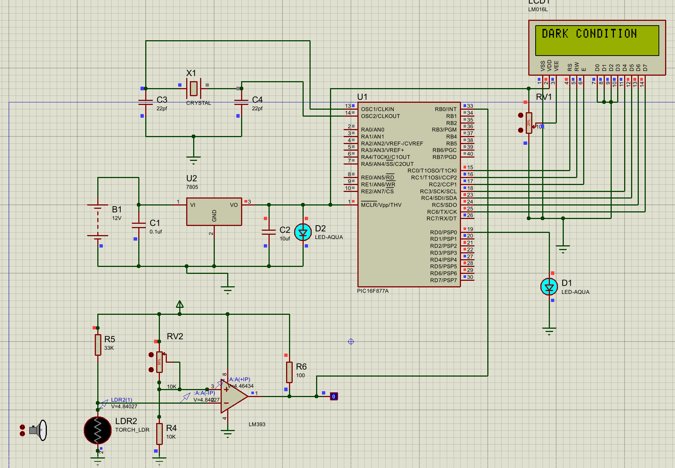
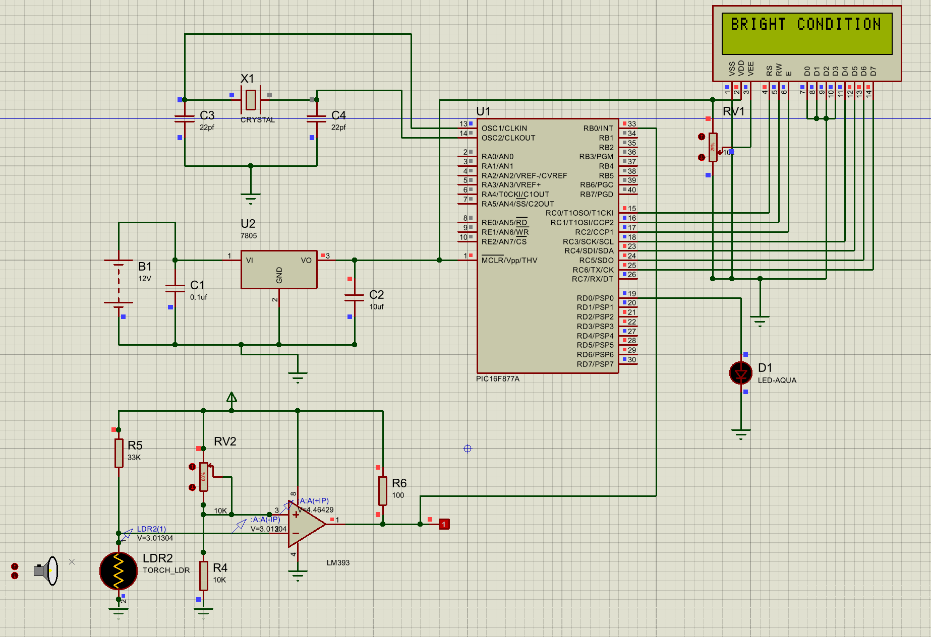
- Correct simulation setup in Proteus (includes power supply, PIC, LDR, comparator, LED, LCD) [4 Marks]
- Functional output for dark condition:
- LED turns ON [2 Marks]
- LCD displays "DARK CONDITION" [2 Marks]
- Functional output for bright condition:
- LED turns OFF [2 Marks]
- LCD displays "BRIGHT CONDITION" [2 Marks]
- Clear and labelled screenshots showing both states (dark & bright) [4 Marks]
- Accuracy and presentation of the overall system (clear layout, correct logic, no floating connections, realistic behaviour) [4 Marks]

- Answer the following theoretically
  - Explain the working of the Night Light Sensor circuit. [10 Marks]
SOLUTION
- The purpose of Night light sensor is to make the LED ON when there is no light/ during darkness.
- Light sensors can be used to measure illuminance, respond to changes in the amount of light received, or convert light to electricity. [2 Marks]
- The LM393 IC is a low-power, single-supply, low-offset voltage, double, differential comparators.
• It is used to calculate the voltages at two dissimilar terminals and contrasts the dissimilarity in voltage quantity.
• If the voltage of the first terminal has a high voltage than the second terminal, the switch will activate.
• If the first terminal has a low voltage than the second terminal, the switch will deactivate. [4 Marks]
• This circuit uses a photoresistor for controlling the circuit of a voltage divider. When this circuit absorbs to bright light, then the output device will be turned OFF.
• When the circuit absorbs the darkness then the output device will be turned ON.
• If the inverting terminal (𝑉1 ) of the IC voltage is higher than the non-inverting terminal V2 then the output device activates. 𝑉1>𝑉2→LED ON.
• Similarly, if the inverting terminal 𝑉1 of the IC voltage is lower than the non-inverting terminal 𝑉2 , then the output device deactivates. 𝑉1<𝑉2→LED OFF. [4 Marks]

  - Explain the working of the Voltage Regulator circuit with a neat diagram. [10 Marks]
SOLUITION
- The voltage regulator has an unregulated dc input voltage Vi applied to one input terminal, a regulated output dc voltage Vo from a second terminal, and the third terminal connected to ground. [2 Marks]
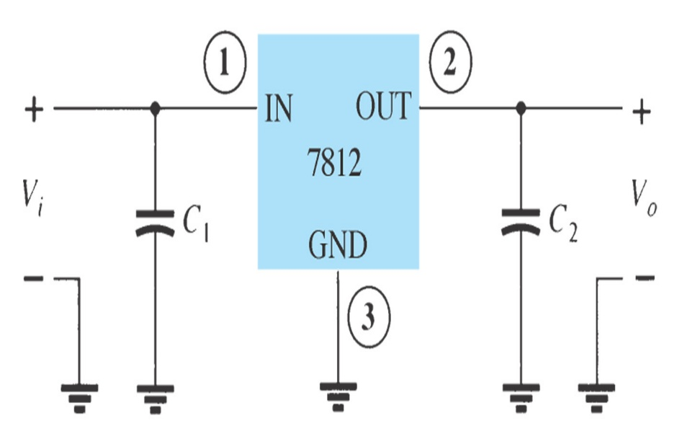 [3 Marks]
Fixed-Positive Voltage Regulator
- The series 78XX regulators are the three-terminal devices that provide a fixed positive output voltage.
- An unregulated input voltage Vi is filtered by a capacitor C1 and connected to the IC’s IN terminal.
- The IC’s OUT terminal provides a regulated +12 V, which is filtered by capacitor C2. The third IC terminal is connected to ground (GND) [3 Marks]

Fixed-Negative Voltage Regulator
- The series 79XX regulators are the three-terminal IC regulators that provide a fixed negative output voltage. [2 Marks]
- Explain the functions of RS, RW, E, D0–D7, VSS, VDD and VEE in a 16x2 LCD module. [10 Marks]
SOLUTION
- RS (Register Select):
  - Selects between instruction register (RS = 0) and data register (RS = 1).
  - Controls whether the input sent is a command or display data.
[2 Marks]
- RW (Read/Write):
  - Controls the direction of data.
  - RW = 0 for write operations (from MCU to LCD),
  - RW = 1 for read operations (from LCD to MCU).
[2 Marks]
- E (Enable):
  - Acts as a latch.
  - On a high-to-low pulse, the LCD reads data from the data lines.
  - Must be toggled each time data/command is sent.
[2 Marks]
  - D0–D7 data pins – State their role in sending data or instructions; mention 4-bit/8-bit modes. [2 Marks]
- VSS and VDD pins – Identify ground and positive supply terminals.
[1 Mark]
- VEE pin – Mention its use for adjusting display contrast.
[1 Mark]

Diwedd/End

