



BEng MAnufacturing Systems
Lecturer: Kelvin Lake Module Code: M6X00420

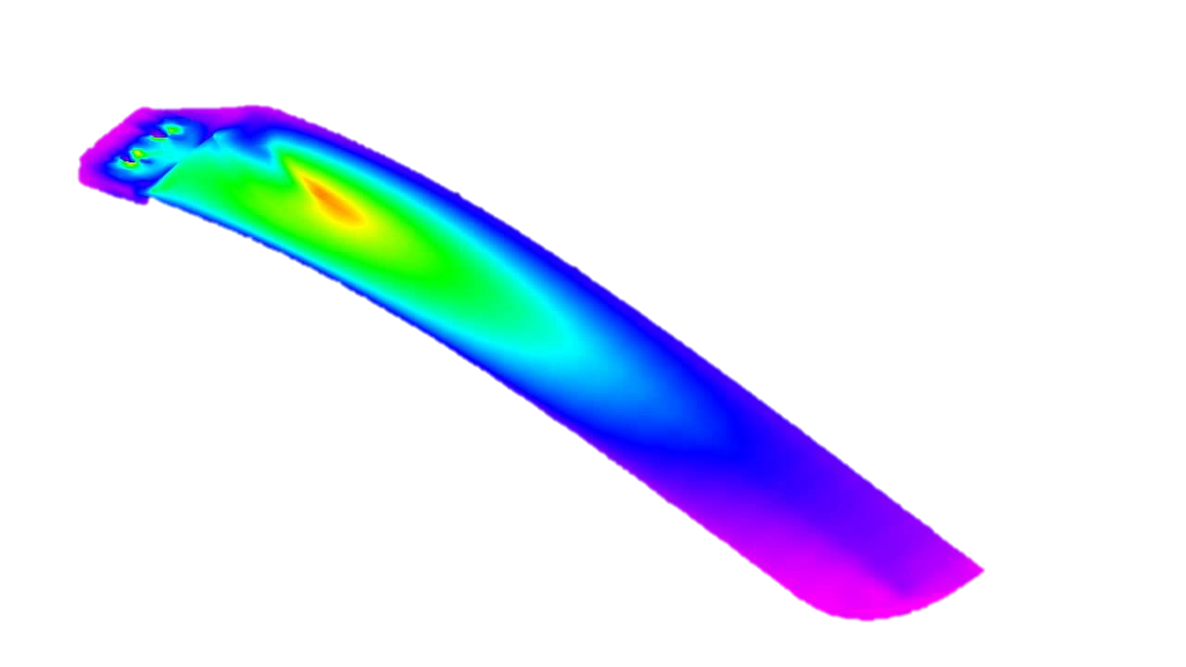
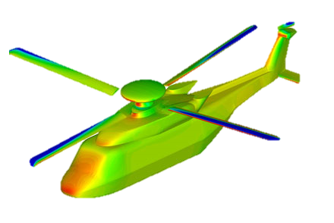

Aaron Pritchard P151481

Advanced Computational Methods:
Assessment of a Helicopter Tail Rotor

Aaron C. L. Pritchard Wh.Sch.
University of Wales Trinity St David

Executive Summary
Helicopter rotor blades are subject to many loads and stresses over their serviceable life and these moments are what dictates the safety, performability and life expectancy of the component. All components will eventually fail, however with rotor blades it is critical that the material used and tested is more than capable to perform reliably. Finite Element Analysis (FEA) enables this to become common practice when designing and testing a component without the demands of time, cost and physical destructive testing compromising a quality product being delivered safely and efficiently. The limitations of Solidworks resulted in the rotor blade being tested being of solid construction using the material weakest in a helicopter blade, AISI 316 Stainless Steel, and how it holds up under the calculated forces it will have to withstand. The FEA results are evaluated and the reliability of the rotor discussed further to identify its suitability for its designed purpose.

__________________________________________________________________________________
Table of Contents
List of Figures 3
List of Tables 4
1. Introduction 5
2. Construction and Analysis of Helicopter Tail Rotor Design 6
3. FE Model for Current Tail Rotor Design 13
3.1 Static Study 14
3.2 Frequency Study 17
3.2.1 Frequency Study in Natural State 17
3.2.2 Frequency Study with Acting Forces Present 17
4. FE Results Analysis 18
4.1 Static FEA Study Analysis with Acting Forces 18
4.2 Frequency Results in Natural State 19
5. Conclusion 21
6. Bibliography 24

List of Figures
__________________________________________________________________________________
Figure 1 - Helicopter and Blade Design, Assignment Brief 6
Figure 2 - AISI 316 Material Properties (SolidWorks, 2019) 7
Figure 3 - Component Mass Properties in AISI 316 (SolidWorks, 2019) 7
Figure 4 - Centrifugal Force Acting on the Rotor Blade (SolidWorks, 2019) 8
Figure 5 - Formation of Induced Parasite Drag with Downward Deflection of the Airstream Near Rotor Blade (SolidWorks, 2019) 9
Figure 6 - Coefficient of Drag on Different Shapes (NASA, 1998) 10
Figure 7 - Area of Blade Passing Through Fluid (SolidWorks, 2019) 10
Figure 8 - Area of Blade Passing Through Fluid (SolidWorks, 2019) 11
Figure 9 - Total Drag Added to Static Study (SolidWorks, 2019) 11
Figure 10 - Area of Rotor Blade Experiencing Lifting Force (SolidWorks, 2019) 12
Figure 11 - Rotor Blade with Lifting Force Applied (SolidWorks, 2019) 13
Figure 12 - 3mm Mesh Applied to the Blade (SolidWorks, 2019) 15
Figure 13 - von Mises Results (3mm Mesh) (SolidWorks, 2019) 16
Figure 14 - Static Study Stress Highlighted (SolidWorks, 2019) 16
Figure 15 - 10mm Mesh (SolidWorks, 2019) 17
Figure 16 - Deformation of the Blade Using 10mm Mesh (SolidWorks, 2019) 17
Figure 17 - Highlighted Stress in the Blade with 10mm Mesh (SolidWorks, 2019) 17
Figure 18 - Natural Frequency Study (SolidWorks, 2019) 18
Figure 19 - Frequency Study with Acting Forces Present (SolidWorks, 2019) 18
Figure 20 - Frequency Results with Forces Present (SolidWorks, 2019) 19
Figure 21 - Displacement of the Blade with Acting Forces During a Frequency Study (SolidWorks, 2019) 19
Figure 22 - S-N Curve for AISI 316 SS Rotor Blade (SolidWorks, 2019) 20
Figure 23 - Frequency Study Results (Natural State) (SolidWorks, 2019) 21
Figure 24 - von Mises Results for Ti-5Al-2.5Sn Rotor Blade (SolidWorks, 2019) 22
Figure 25 - Concentrated Stress Area on Ti-5Al-2.5Sn Rotor Blade (SolidWorks, 2019) 23
Figure 26 - von Mises Stress Analysis for Alternative Mounting Position Using AISI 316 SS (SolidWorks, 2019) 23
Figure 27 - Displacement Using Alternative Mounting Position for AISI 316 SS Rotor Blade (SolidWorks, 2019) 24
Figure 28 - Ti-5Al-2.5Sn S-N Curve Highlighting Higher Lifetime Cycle Count (SolidWorks, 2019) 24

List of Tables
__________________________________________________________________________________
Table 1 - Advantages and Disadvantages of FE Analysis 13
Table 2 - Static Test Run Time Relevant to Mesh Size 14

1. Introduction
With many complex geometries helicopter rotor blades are multi-layered. Modern day manufacturing use composite laminates in a sandwich panel formation utilising low density foam and honeycomb panels reinforced using lamina, this minimises weight but provides flexibility in the design while maintaining high strength-to-weight ratio.
Helicopter tail rotor blades have many forces and stresses acting upon them simultaneously when in motion. Therefore, it is vital that the material choice and structural composition of the rotors are able to cope. Such forces include centrifugal force and torsion, while tensile and torsional stresses as a resultant of the centrifugal forces occur too. Along with material choice, the mounting design is critical to supporting the stress and operation of the blade. This is analysed further in the report to examine whether the current design is adequate or requires improvement using FEA analysis.
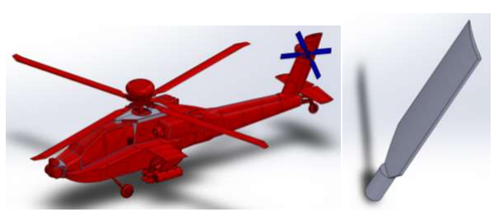
Figure 1 - Helicopter and Blade Design, Assignment Brief

2. Construction and Analysis of Helicopter Tail Rotor Design
According to an online site titled AH-64 Apache (2019), the four bladed tail rotor of an Apache helicopter has a diameter of 2.539m and rotates at maximum speeds of 1,411rpm.
An Apache blade construction is a layered structure. The skeleton of the blade is stainless steel arms, surrounded by a fibreglass skeleton paired with a graphite composite material trailing edge (Harris, 2019). Harris elaborates on the blade construction highlighting that each blade has a leading edge made of titanium in order to withstand any impact with such objects as trees when flying at low altitude.
Due to the limitations in a simulation study on Solidworks, the construction of the tail rotor blade has been treated as a solid body using the weakest material choice in the structure of the blade, stainless steel. After researching typical stainless steel (SS) used in aerospace, Marlin Steel (2019) highlights that a common SS for structural components was AISI 316 Stainless Steel. AISI 316 material properties are shown in Figure 2.
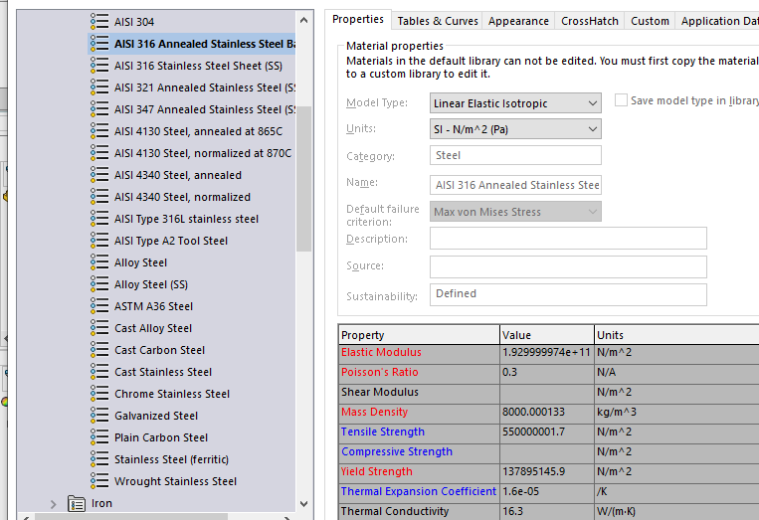
Figure 2 - AISI 316 Material Properties (SolidWorks, 2019)

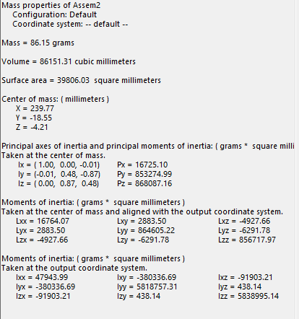
When constructed from AISI 316 as a solid body, the mass properties for the blade are shown in Figure 3. Using the known mass (86.15g), velocity of the blade when rotating at maximum velocity (1411rpm), and radius of rotation for the pair of blades (1.2695m), it is possible to calculate the maximum centrifugal force acting on the blade during operation to test whether the current design and weakest material used would be able to withstand the stresses acting on the body.
Figure 3 - Component Mass Properties in AISI 316 (SolidWorks, 2019)

The equation for calculating centrifugal force is given as;
$$F=m ×\frac{v^{2}}{r}$$
Where;
- F = Force (N)
- m = Mass (Kg)
- v = Velocity (m/s)
- r = Radius (m)
Therefore;
$$F=0.08615 ×\frac{{187.58}^{2}}{1.2695}$$
$$F=2387.79 N$$

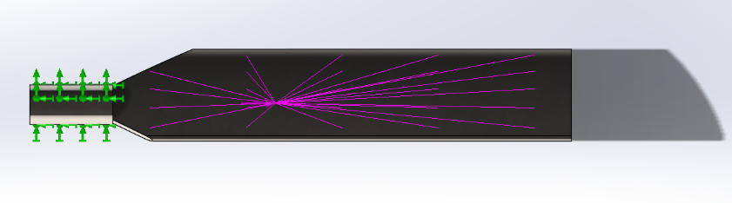
In order to analyse the stress exerted on the component in Solidworks study, the centrifugal force was positioned at the centre of mass and directed away from the base of rotation as shown in Figure 4.
Figure 4 - Centrifugal Force Acting on the Rotor Blade (SolidWorks, 2019)

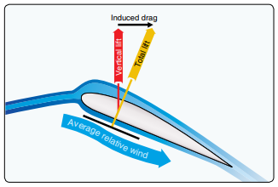
The blade will also experience parasite drag. Parasite drag is stated by The FAA (2019) as being present any time the helicopter is moving through the air, and increases with airspeed. Figure 5 demonstrates the induced parasite drag on the rotor blade as it operates.
Figure 5 - Formation of Induced Parasite Drag with Downward Deflection of the Airstream Near Rotor Blade (SolidWorks, 2019)

The force of drag is calculated using the equation;
$$D=\left(\frac{1}{2}\right)\left(C\right)\left(ρ\right)\left(v^{2}\right)\left(A\right)$$
Where;
- D = Drag Force (N)
- C = Coefficient of drag
- $ρ$ = Density of the fluid
- v = Objects velocity
- A = Area of object passing through fluid
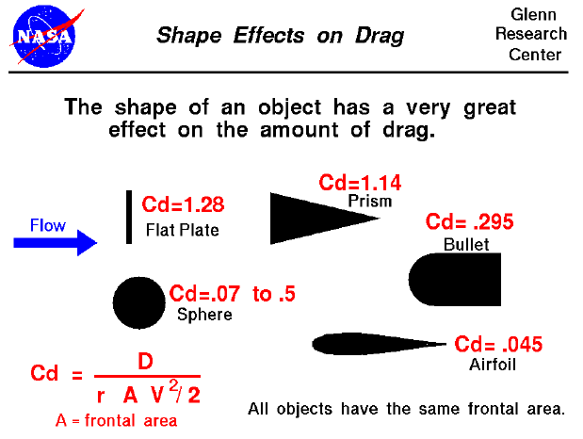
When calculating the drag exerted on a component, the drag coefficient of the body’s shape is essential. According to NASA (1998), the solid body of a helicopter blade (Airfoil) experiences a drag coefficient of 0.45 as shown in Figure 6.
Figure 6 - Coefficient of Drag on Different Shapes (NASA, 1998)

The value for density of air at sea level in standard temperature and pressure (STP) has an International Standard Atmosphere stated value of 1.225 kg/$m^{3}$ at sea level and 15 degrees Celsius. Thus, this is the value used for density in the calculation of drag acting on the body.
The maximum velocity of the object is stated as 1,411rpm, or 187.58 m/s.
The area of the object passing through the fluid can be calculated using Solidworks as shown in Figure 7 and Figure 8. There are two faces passing through the fluid therefore these areas are added together for a total area that is to be used in calculating the drag present.
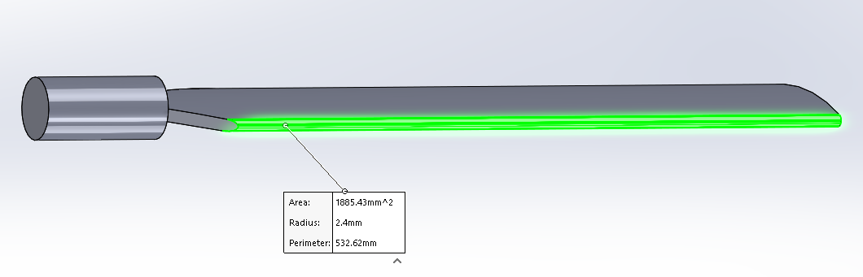
Figure 7 - Area of Blade Passing Through Fluid (SolidWorks, 2019)

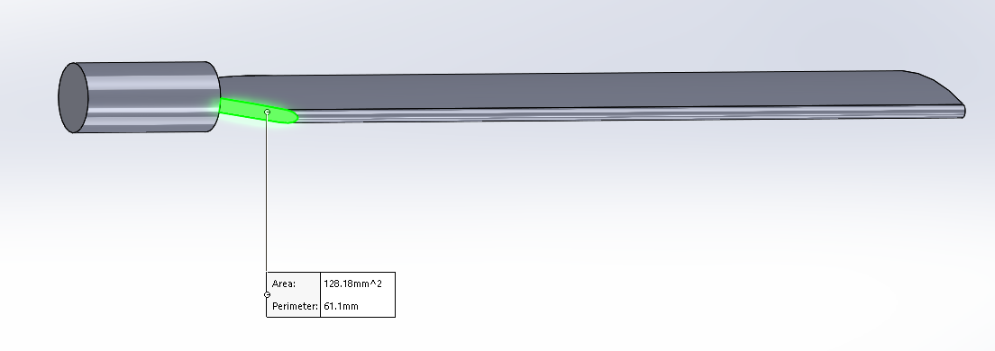
Figure 8 - Area of Blade Passing Through Fluid (SolidWorks, 2019)
The area shown in Figure 7 is 0.00188543$m^{2}$ and Figure 8 shows an area of 0.00012818$m^{2}$ giving a total area of 0.00201361$m^{2}$.
Therefore, the drag force acting on the blade can be calculated as;
$$D=\left(\frac{1}{2}\right)\left(0.45\right)\left(1.225\right)\left({187.58}^{2}\right)\left(0.00201361\right)$$
$$D=19.528 N$$

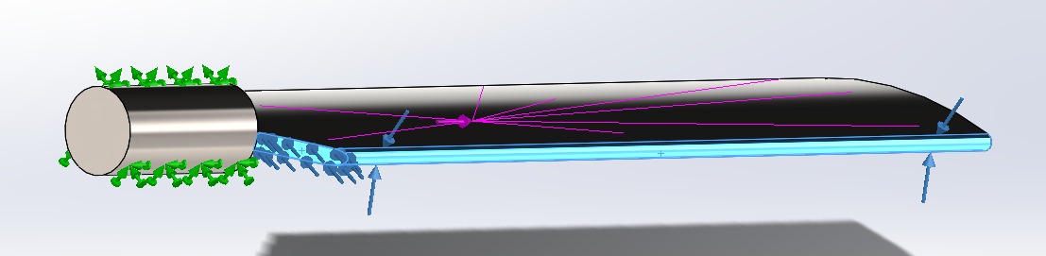
The drag present was then added to the faces experiencing the force on the Solidworks study as shown in Figure 9.
Figure 9 - Total Drag Added to Static Study (SolidWorks, 2019)

The rotor blade during operation will also experience the force of lift. The equation for calculating lift is;
$$L=\left(\frac{1}{2}\right)(ρ)(v^{2})(A)(C_{l})$$
Where;
- L = Lift force (N)
- $ρ$ = Density (kg/$m^{3})$
- $v^{2}$ = Velocity of object (m/s)
- A = Area of Object face experiencing lift ($m^{2}$)
- $C_{l}$ = Lift Coefficient

The area of the rotor blade in question is the underside. This is shown in Figure 10 and provides a value of 0.01624455$m^{2}$.
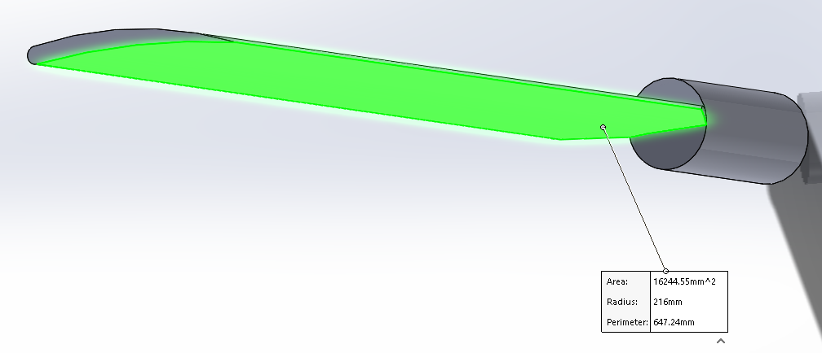
According to Marker (2018) who studied the lift force present on helicopter rotor blades, states that the lift coefficient for helicopter rotor blades is 0.4, which can only be determined experimentally once lift is calculated, which itself depends on the coefficient of lift value.
Figure 10 - Area of Rotor Blade Experiencing Lifting Force (SolidWorks, 2019)

Therefore, it is fair to assume that the lifting force experienced on the rotor blade in question can be calculated as;
$$L=\left(\frac{1}{2}\right)(1.225)({187.58}^{2})(0.01624455)(0.4)$$
$$L=140.039 N$$
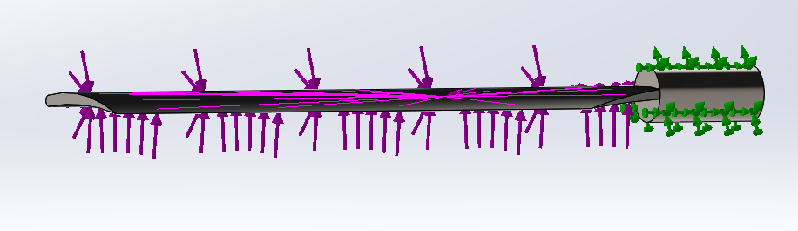
Using the lifting force value calculated, this was applied to the Solidworks static study as shown in Figure 11.
Figure 11 - Rotor Blade with Lifting Force Applied (SolidWorks, 2019)

3. FE Model for Current Tail Rotor Design
Nikishkov (2004) describes Finite Element as a method of using a numerical technique for solving nodal values of a physical field depending on the desired results required, a field that Roylance (2001) has highlighted as an annual multi-billion dollar industry. Although the FE has many benefits and possibilities, with precise values and properties within FE simulation software, the results cannot be guaranteed as completely accurate. The advantages and disadvantages of FE analysis are shown in Table 1.

Advantages | Disadvantages
Cheap and quick simulation saving time in the development stage | Results are estimated, any design or material errors and results could vary greatly
Easy to modify design to implement improvements or multiple design concepts | Initial training required in order for operator to provide relevant and accurate results
Material can be altered quickly providing multiple variations of the same concept quickly | Initial set up cost can be high for smaller companies
Results are calculated using precise material properties | Material list is large but there are also missing known values such as Carbon-based materials
No need for multiple physical models to be created until final few designs have been chosen | Is a linear solver, therefore only operates up to a materials yield strength. Suitable for ferrous metals but not for plastic-materials.
Safe to trial concepts without destructive testing and its implications until a safe design has been created
Table 1 - Advantages and Disadvantages of FE Analysis

3.1 Static Study
An FE static study was conducted on the AISI 316 SS rotor blade to assess the stress and displacement that would be present under the forces calculated. A static study enabled the component to undergo a linear solver to which any stress that exceeds the yield strength of the material will be identified.
Initially the study was completed using a 3mm mesh as shown in Figure 12.
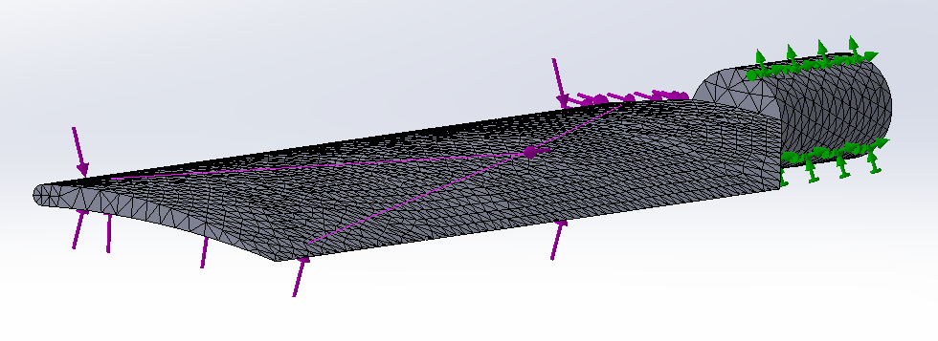
Figure 12 - 3mm Mesh Applied to the Blade (SolidWorks, 2019)

This study with a 3mm mesh took 14 seconds to finish. Mesh size is a common stumbling block in FEA as larger elements provide quicker but less accurate results, whereas smaller elements will be more accurate but take longer to run studies, a design issue if working with multiple variations and design modifications. In some instances Enterfea (2019) reports that studies have increased computing time over two times to result in improved accuracy by only 1%, resulting in a waste of time. Using the current static study, the mesh size was altered and the amount of nodes, elements and time taken to complete the study was recorded. Although the 3mm mesh provided more acurate results, a 10mm mesh proved reliable and completed a test in 28.57% of the time taken for the 3mm study as shown in Table 2.
Natural State Frequency Study
Mesh Size (mm) | 3 | 7 | 10 | 12
Nodes | 60382 | 14520 | 7057 | 5523
Elements | 35973 | 7924 | 3614 | 2797
Time (s) | 14 | 8 | 4 | 2

Table 2 - Static Test Run Time Relevant to Mesh Size

Therefore, future studies were completed using a 10mm mesh in order to improve time taken while maintaining reliable report data.
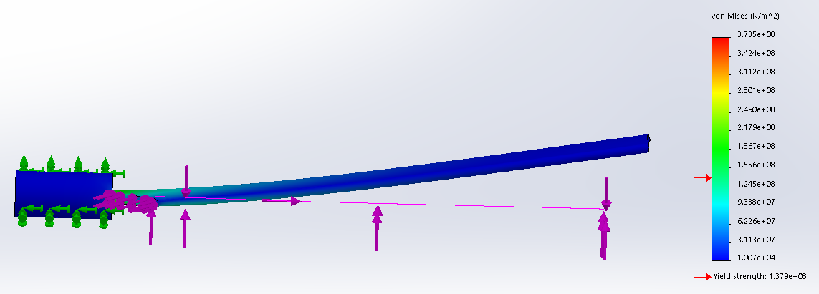
Figure 13 - von Mises Results (3mm Mesh) (SolidWorks, 2019)

Highlighted in Figure 13 are the stress results of the FE static study highlighting where the areas of greater stresses are. Identified weaknesses are within the join between the blade and the mounting shaft that sits inside the rotary hub of the tail rotor as shown in Figure 14.
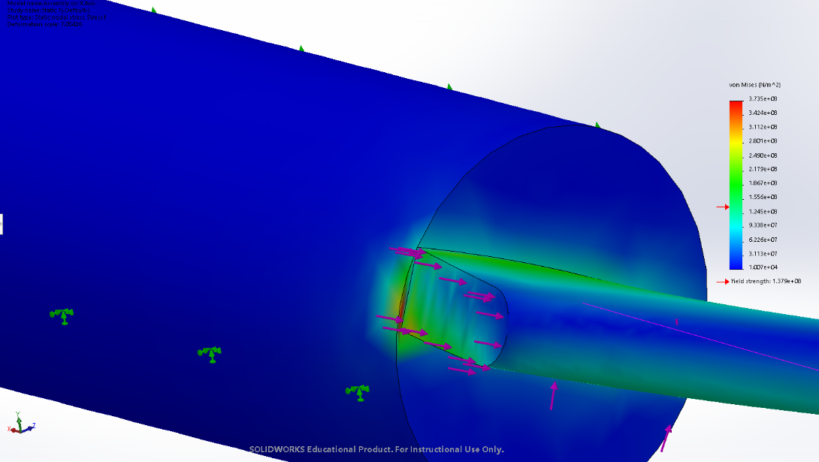
Figure 14 - Static Study Stress Highlighted (SolidWorks, 2019)

In order to reduce the running time for studies the mesh size was changed to 10mm (Figure 15) which resulted in a run time of only 7 seconds. This allowed an accurate stress analysis result while increasing the testing speeds for optimum performance. This provided similar results (Figure 16 and Figure 17) to the 3mm mesh shown in Figure 12 and Figure 13 which highlights the same area and intensity of stress on the object. Therefore, a mesh size of 10mm can be deemed as both accurate and quicker to operate with in this study.
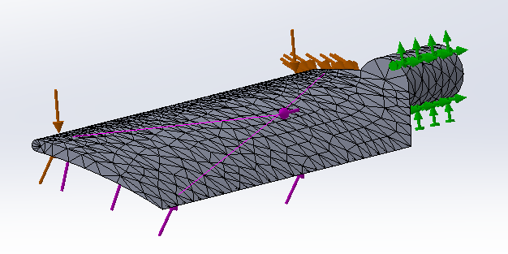
Figure 15 - 10mm Mesh (SolidWorks, 2019)
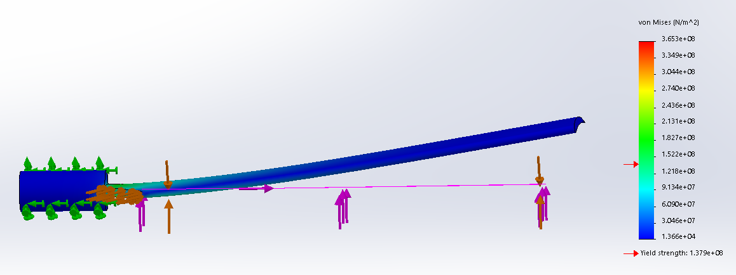
Figure 16 - Deformation of the Blade Using 10mm Mesh (SolidWorks, 2019)
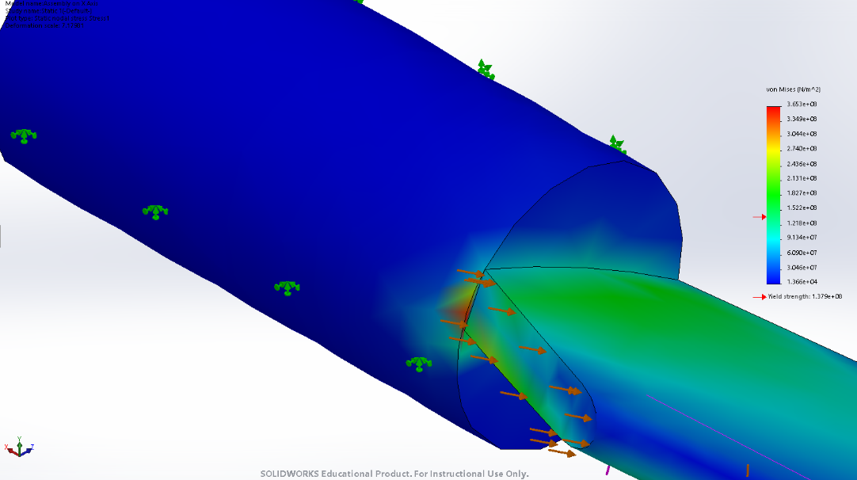
Figure 17 - Highlighted Stress in the Blade with 10mm Mesh (SolidWorks, 2019)

3.2 Frequency Study

3.2.1 Frequency Study in Natural State
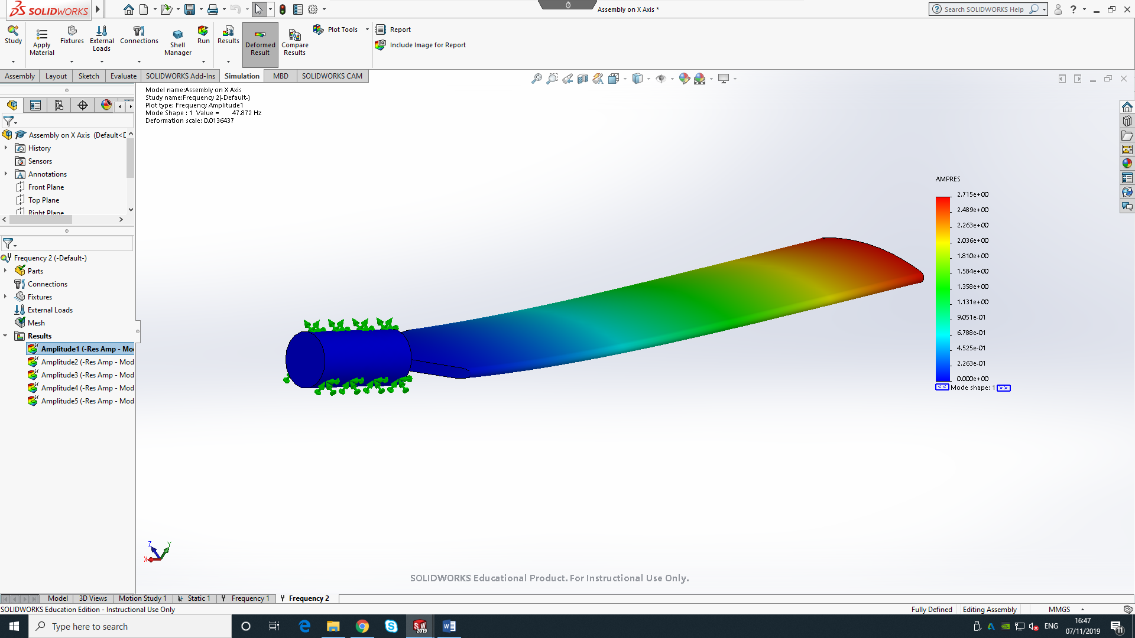
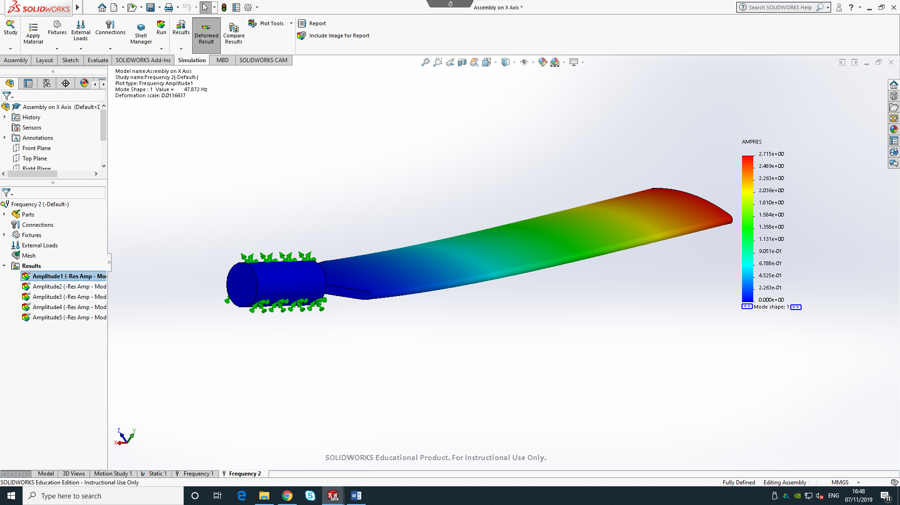
The importance of a frequency study at natural state is because every structure has a tendency to vibrate. Problems occur when a structure is excited by a loading which coincides with its natural frequency, resulting in larger displacements and stresses experienced on the component. Often common within engine powered machines, when the engine is running it is operating with its own frequency, if this coincides with for example the blade of the helicopter, larger stresses will be witnessed in the blade, thus one of them ideally being altered to combat this effect referred to commonly as resonance (Dassault Systemes, 2019).
Figure 18 - Natural Frequency Study (SolidWorks, 2019)

https://help.solidworks.com/2017/english/SolidWorks/cworks/c_Frequency_Analysis.htm

3.2.2 Frequency Study with Acting Forces Present
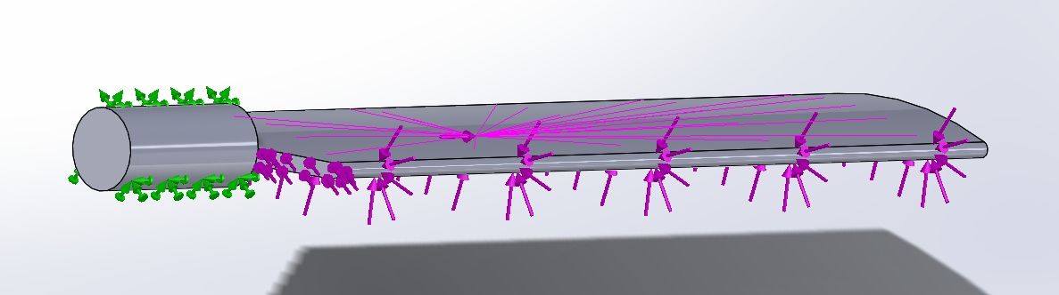
A frequency study was conducted while accounting for all the calcualted acting forces from the static study. The study used a 10mm mesh and took 34 minutes to complete. This study highlighted how to blade might behave during full speed operation and if the deformation or frequency of the blade would vary much from its natural state.
Figure 19 - Frequency Study with Acting Forces Present (SolidWorks, 2019)

Figure 20 portrays the results from the study. The blade showed a resultant frequency of 53.863Hz.
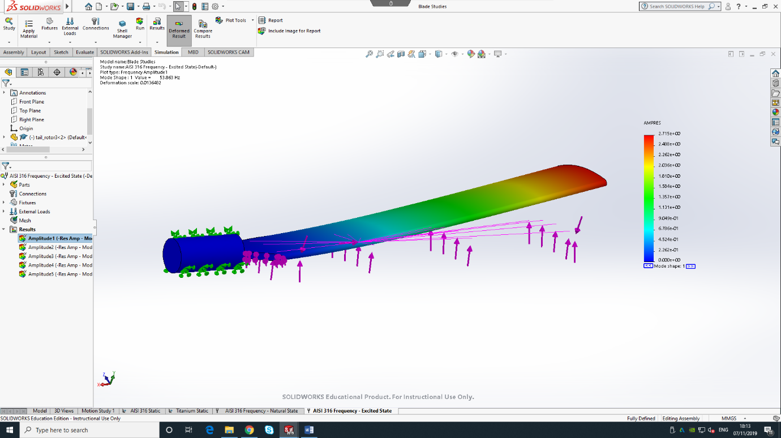
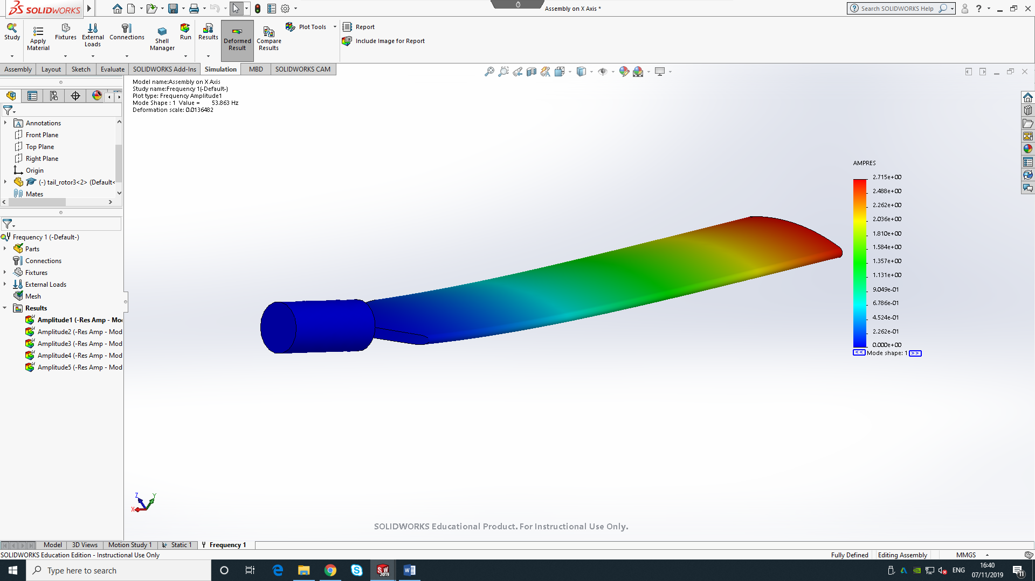
Figure 20 - Frequency Results with Forces Present (SolidWorks, 2019)

4. FE Results Analysis

4.1 Static FEA Study Analysis with Acting Forces
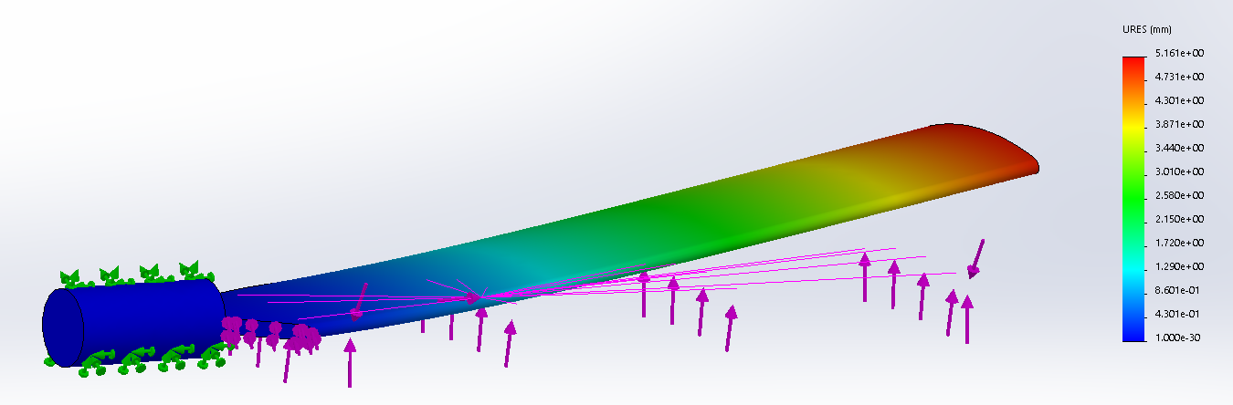
The FE study run in this report identifies that if the blade was a solid body and its material properties were that of AISI 316 SS with a yield strength of 1.379e+08 ${N/m}^{2}$ as shown in Figure 16, the part would fail. The highlighted areas of stress shown in Figure 17 indicates that the stress experienced in the join has a small section that is experiencing 3.653e+08 ${N/m}^{2}$ of stress which is almost three times higher than the yield strength. The displacement in the AISI 316 SS blade is anticipated to be 5.161mm at its highest value, witnessed at the furthest point of the blade from the central hub as shown in Figure 21.
Figure 21 - Displacement of the Blade with Acting Forces During a Frequency Study (SolidWorks, 2019)

These areas of stress indicate that due to the lower yield strength of the material, failure will begin to occur quickly in those weaker areas and these may require redesigning, subject to further investigation with use of alternative materials. Fatigue occurs when a member is subjected to repeated cyclic loadings (Dubina, 1993). Cracks can appear and eventually after a certain number of cycles, a component constructed of a ferrous metal will fail. An S-N Curve graph plots the values related to the amount of stress a component can handle for how many repeated cyclic loadings. In all materials, the lower the stress placed on a member during cycles will result in a higher cycle life. The S-N curve for AISI 316 SS for the rotor blade is shown in Figure 22.
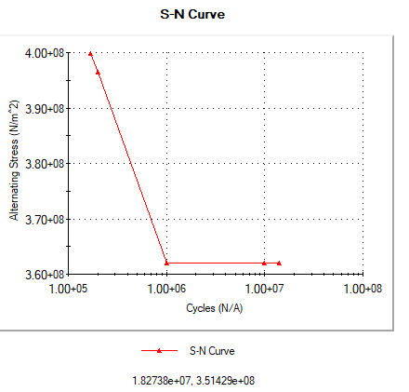
Figure 22 - S-N Curve for AISI 316 SS Rotor Blade (SolidWorks, 2019)

Investigating displacement values using FE is important as often the results are too small for the naked eye to see what is happening to the component (Value Design Consulting, 2019). The results shown in Figure 21 predict that the maximum amount of displacement in the blade is at the end with values of 5.161mm present. It is stated by NASA (2012) that blade displacement can be used to resolve blade shape and position to optimise the performance of the rotor. If an inefficient or unsafe amount of displacement is experienced in the FE study then alterations can be made accordingly. Without further testing, the displacement data in these studies cannot be used to gain a suitable conclusion on the behaviour of the blade.

4.2 Frequency Results in Natural State
A frequency study for the AISI 316 SS blade while in its natural state is shown in Figure 18 and Figure 23. It depicts that the blade is expected to vibrate at 47.872 Hz. If an analysis of the GE T700 engines that power an Apache for example were to excite at the same frequency, the vibration sent through the blades could exaggerate the results found in this study and therefore increase the stress and deformation in the blade reducing the amount of fatigue it can withstand.
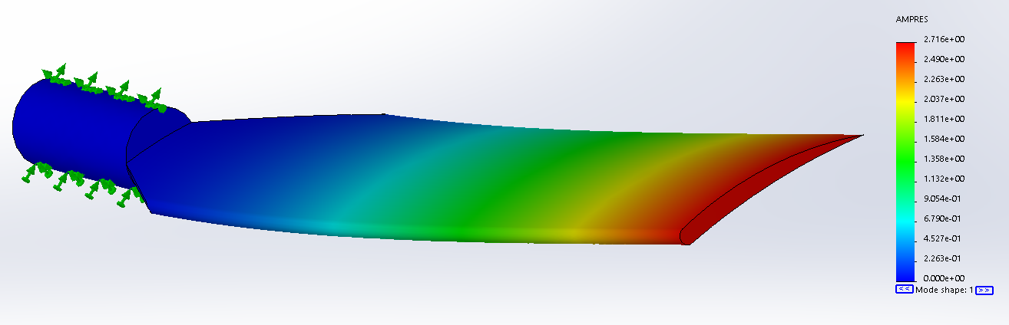
Figure 23 - Frequency Study Results (Natural State) (SolidWorks, 2019)

5. Conclusion
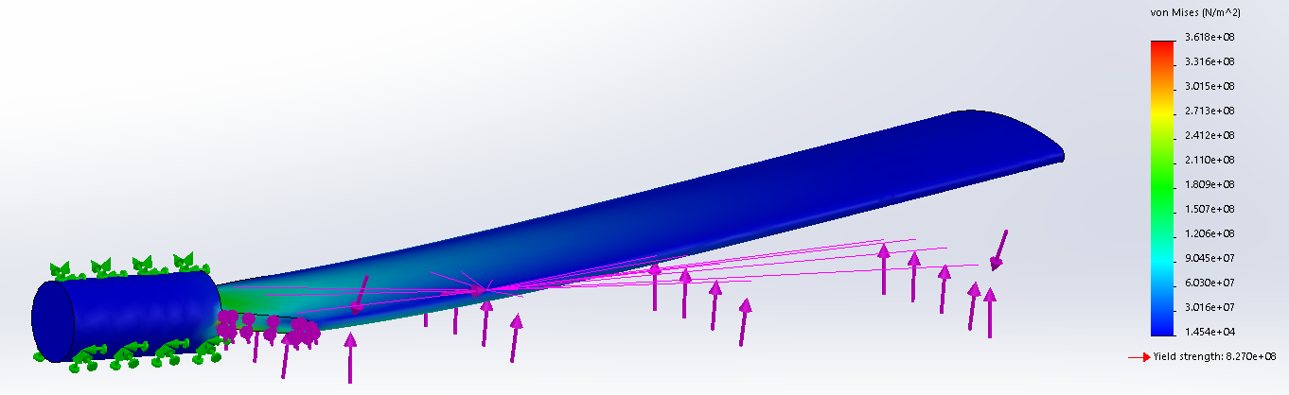
The current design is difficult to assess if fit for purpose. In this report certain assumptions are made such as the conditions of the blades operation being unaffected by the other blades turbulent air flow and the density of air, it is a system in isolation. Secondly, due to the complicated construction of the blade being layered with a mixture of metals and composite materials, analysing a solid body instead provides unreliable results. This acknowledged, using the weakest structural material such as AISI 316 steel enabled an estimate that if this was fit for purpose solely with no other structural support, of which it was not. Due to the limitations of carbon and composite materials in Solidworks inventory, AISI 316 was switched for Titanium Ti-5Al-2.5Sn as it is a stronger metal within the blade construction and run through a static study. This would establish if it is safe to assume a build up of layers using materials of higher tensile strength would be satisfactory and the results are shown below. The yield strength of the Titanium solid blade is twice as high of that of the highest areas of anticipated stress as shown in Figure 24 and Figure 25, deeming it fit for purpose on strength alone to handle the stresses estimated.
Figure 24 - von Mises Results for Ti-5Al-2.5Sn Rotor Blade (SolidWorks, 2019)

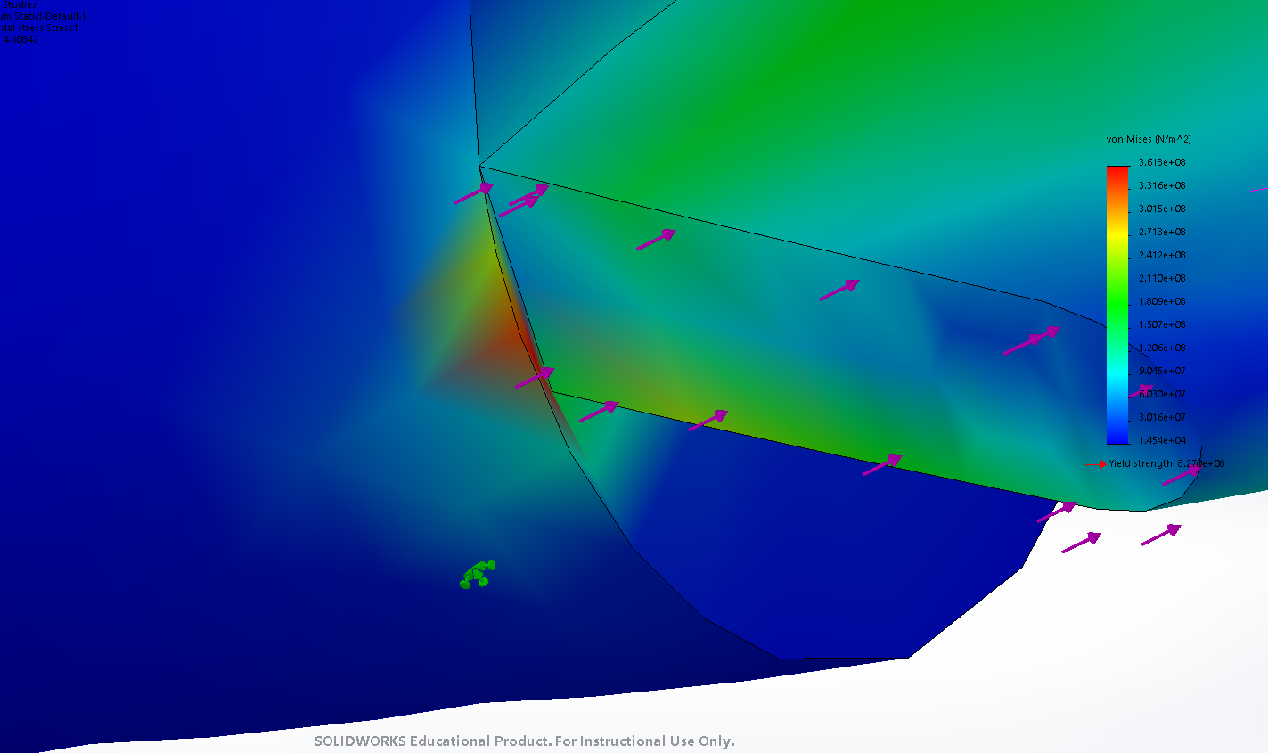
Figure 25 - Concentrated Stress Area on Ti-5Al-2.5Sn Rotor Blade (SolidWorks, 2019)
Alternatively, assessing where the blade is mounted has a positive result in the stress experienced. Mounting the blade from the furthest end as shown in Figure 26 highlights that the max stress experienced is now 2.350e+08$N/m^{2}$ compared to the previous 3.653e+08$N/m^{2}$ in Figure 16. Although the yield stress of the material is still exceeded, the mounting change highlights that when an appropriate material is selected, the stress can be reduced even more increasing the life expentency of the component.
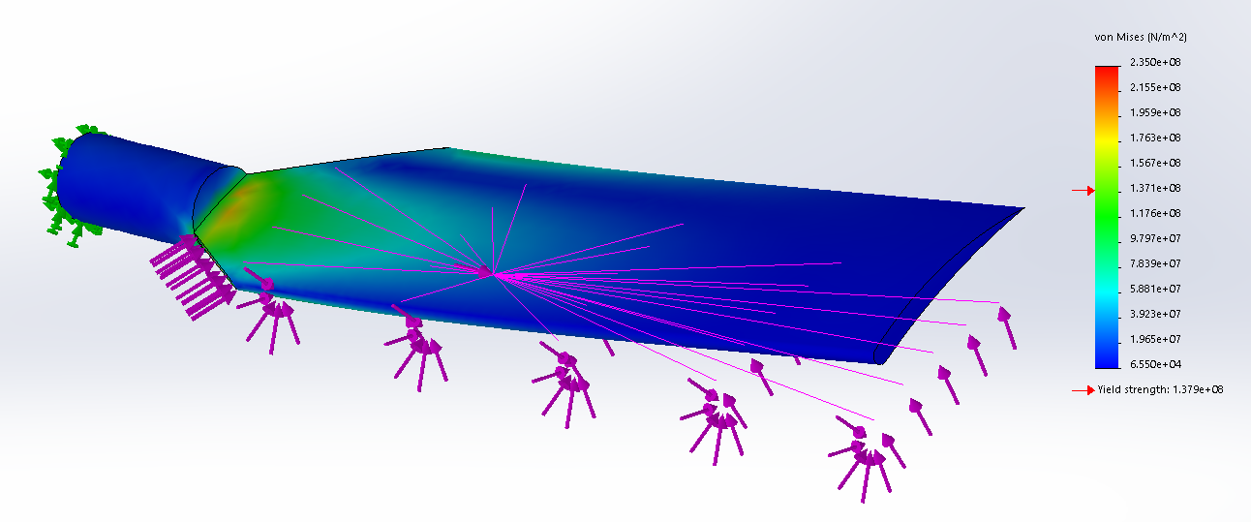
Figure 26 - von Mises Stress Analysis for Alternative Mounting Position Using AISI 316 SS (SolidWorks, 2019)

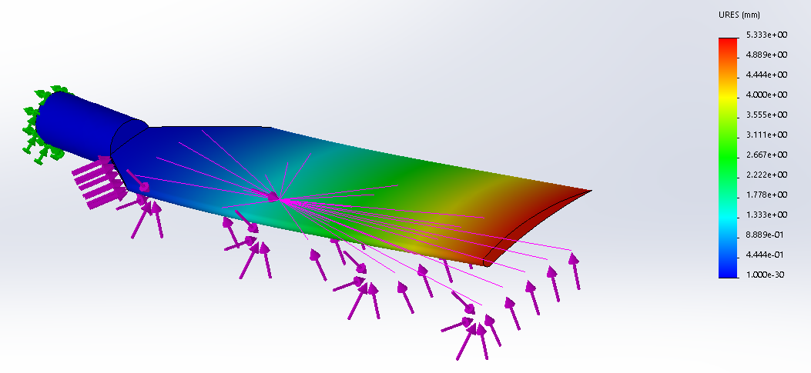
Although stress is reduced in the part and now spread evenly across the join instead of concentrated on a smaller section, the displacement witnessed varies by an increase of 0.172mm.
Figure 27 - Displacement Using Alternative Mounting Position for AISI 316 SS Rotor Blade (SolidWorks, 2019)

The Ti-5Al-2.5Sn rotor blade demonstrates a higher life cycle than the AISI 316 SS alternative. The amount of completed cycles as shown in Figure 28 is far larger before the material witness’s failure and therefore would prolong wear and reduce the frequency of required replacement parts. More importantly, the safety margin before failure is far larger resulting in a more reliable component.
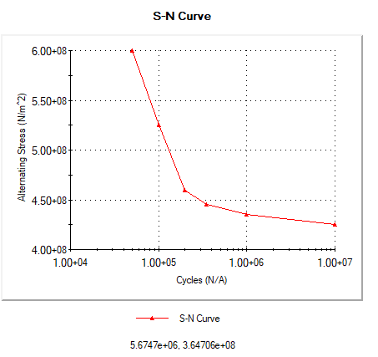
Figure 28 - Ti-5Al-2.5Sn S-N Curve Highlighting Higher Lifetime Cycle Count (SolidWorks, 2019)

6. Bibliography
Abrego, A. I. et al., 2012. Blade Displacement Measurement Technique Applied to a Full-Scale Rotor Test, California: NASA.
Dassault Systemes, 2019. Frequency Analysis. [Online]
Available at: https://help.solidworks.com/2017/english/SolidWorks/cworks/c_Frequency_Analysis.htm
[Accessed 07 November 2019].
Department for Business Innovation & Skills, 2010. Manufacturing in the UK: An economic analysis of the sector. [Online]
Available at: https://assets.publishing.service.gov.uk/government/uploads/system/uploads/attachment_data/file/31785/10-1333-manufacturing-in-the-UK-an-economic-analysis-of-the-sector.pdf
[Accessed 24 October 2019].
Dubina, P. D., 1993. Introduction to Fatigue. [Online]
Available at: https://www.ct.upt.ro/suscos/files/2013-2015/2C08/L6-Fatigue%20of%20structures.pdf
[Accessed 08 November 2019].
Enterfea, 2019. Correct mesh size. [Online]
Available at: https://enterfea.com/correct-mesh-size-quick-guide/
[Accessed 08 November 2019].
FAA, 2019. Aerodynamics of Flight. [Online]
Available at: https://www.faa.gov/regulations_policies/handbooks_manuals/aviation/helicopter_flying_handbook/media/hfh_ch02.pdf
[Accessed 07 November 2019].
Harris, T., 2019. Apache Rotors and Blades. [Online]
Available at: https://science.howstuffworks.com/apache-helicopter1.htm
[Accessed 07 November 2019].
Krishnamoorthy, K., 2009. Quality Assurance in NDT, Toronto: Atomic Energy of Canada Ltd.
Marker, J., 2018. How to Calculate Lift for Rotor Blades. [Online]
Available at: https://sciencing.com/calculate-lift-rotor-blades-7680704.html
[Accessed 13 November 2019].
NASA, 1998. Shape Effects on Drag. [Online]
Available at: https://wright.nasa.gov/airplane/shaped.html
[Accessed 07 November 2019].
Nikishkov, G. P., 2004. Introduction to the Finite Element Method, Aizu-Wakamatsu: University of Aizu.
Roylance, D., 2001. Finite Element Analysis, Cambridge, MA: Massachusetts Institute of Technology.
SolidWorks, 2019. SolidWorks 2019. London: Dassault Systèmes.
Steel, M., 2019. Why You Should Use Stainless Steel for Aerospace Applications. [Online]
Available at: https://www.marlinwire.com/blog/why-you-should-use-stainless-steel-for-aerospace-applications
[Accessed 07 November 2019].
The Manufacturer, 2019. Manufacturing Statistics. [Online]
Available at: https://www.themanufacturer.com/uk-manufacturing-statistics/
[Accessed 24 October 2019].
This Day in Aviation, 2019. AH-64 Apache. [Online]
Available at: https://www.thisdayinaviation.com/tag/ah-64-apache/
[Accessed 07 November 2019].
Value Design Consulting, 2019. Investigating FEA Results. [Online]
Available at: http://www.value-design-consulting.co.uk/investigating-fea-results.html
[Accessed 08 November 2019].

