Module: Hospitality and Guest Services

The role and importance of quality service, hospitality, and guest services within the hotel Industry

Student Name: Georgiana Pangonis
Student ID: 2245303
Module Code: BMIH4003

Table of Contents
Introduction 3
Overview of the JW Marriott 4
Target Customers of JW Marriott 5
The nature, role, and scope of guest services of JW Marriott 6
Role and Functions of Guest Services 8
Importance of the Hospitality Sector 9
Conclusion 10
References 11

Introduction
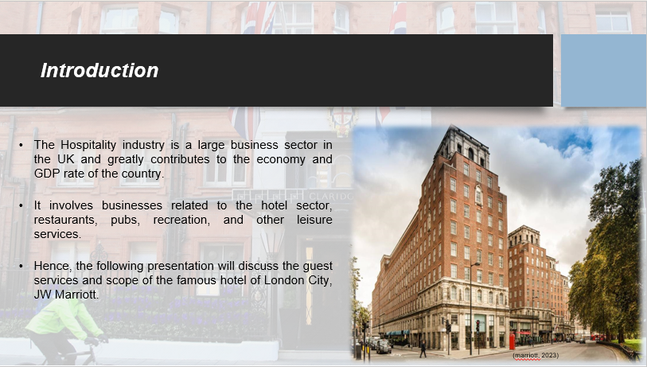
The Hospitality industry is a large business sector in the UK and greatly contributes to the economy and GDP rate of the country. It involves businesses related to the hotel sector, restaurants, pubs, recreation, and other leisure services. Hence, the following presentation will discuss the guest services and scope of the famous hotel of London City, JW Marriott. A brief overview of the hotel will be mentioned along with the potential target customers of the sector. Additionally, the nature, role and scope of the guest services offered by the hotel will be underlined. The role and function of guest services along with the importance of the hospitality sector to enhance the quality of services will be discussed in the following presentation.

Overview of the JW Marriott
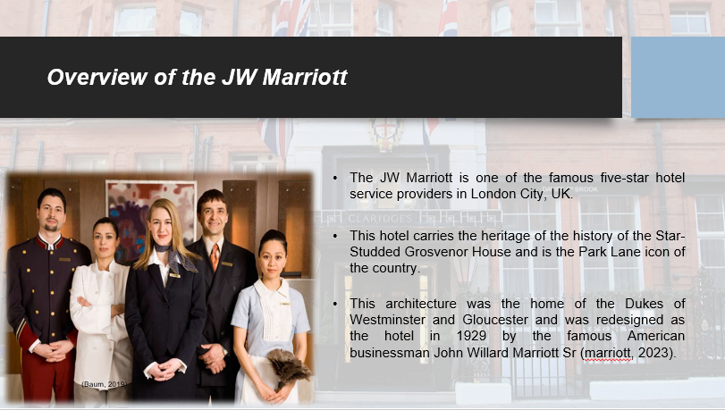
The JW Marriott is one of the famous five-star hotel service providers in London City, UK. This hotel carries the heritage of the history of the Star-Studded Grosvenor House and is the Park Lane icon of the country. This architecture was the home of the Dukes of Westminster and Gloucester and was redesigned as the hotel in 1929 by the famous American businessman John Willard Marriott Sr (marriott, 2023). Recent statistical data show that the hotel has a revenue of around £11.34 billion in 2023. Brand awareness of this hotel in the UK is around 80% and the market size has amounted to about £13.43 billion (Kunst, 2023). Moreover, the specific hotel sector in the United Kingdom inspired and adopted the principles of mindfulness and providing happiness to the minds of the visitors.

Target Customers of JW Marriott
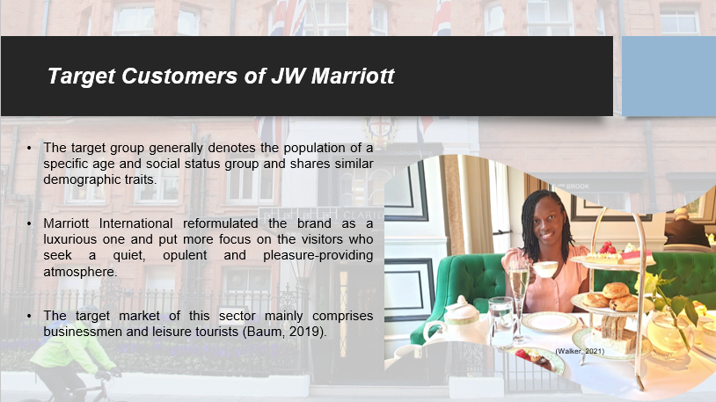
The target group generally denotes the population of a specific age and social status group and shares similar demographic traits. Marriott International reformulated the brand as a luxurious one and put more focus on the visitors who seek a quiet, opulent and pleasure-providing atmosphere. The target market of this sector mainly comprises businessmen and leisure tourists (Baum, 2019). They are attracted by the brand, familiarity, and amenities offered by the Marriott hotel. The population who strongly prefer the brand, favor accommodation in the business environment and find a convenient place near the airport and better transportation facilities are the target group of the hotel. The management of the hotel adopts necessary steps to meet the expectations of their guests and thus accelerate sustainable development in the global market.

The nature, role, and scope of guest services of JW Marriott
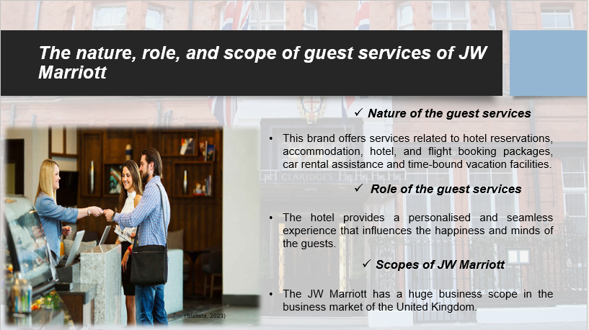
Nature of the guest services
The JW Marriott is one of the luxurious hotel brands of the Marriott group. This brand offers services related to hotel reservations, accommodation, hotel, and flight booking packages, car rental assistance and time-bound vacation facilities. The authority of the brand aims to provide modern as well as premium-level services that help in a better experience for the tourists (Walker, 2021). The environment and services not only influence the minds of the visitors but also have an impact on the minds and well-being of the guests and assure them about their safety and security.
Role of the guest services
The hotel provides a personalised and seamless experience that influences the happiness and minds of the guests. They provide effective accommodation, dining, leisure, and certain tour activities. The organisation takes effective strategies to meet the technological upliftment and aims to meet the requirements of their customers (Ford, 2020). They provide a welcoming and enjoyable atmosphere that provides comfort to the people away from their homes. Lastly, the management conducts some customer surveys to analyse the effectiveness of their services in the minds of the travelers.
Scopes of JW Marriott
The JW Marriott has a huge business scope in the business market of the United Kingdom. This sector comprises nearly 31 brands and more than 8500 properties across 138 countries in the world and provides an opportunity for the population to experience more and connect globally. The enterprise provides holistic chances to its employees and supports their career development (Statista, 2023). The data for 2022 show that the industry has a workforce of 377,000 associates. The sector appointed approximately 1,40,000 employees in the world in 2022.

Role and Functions of Guest Services
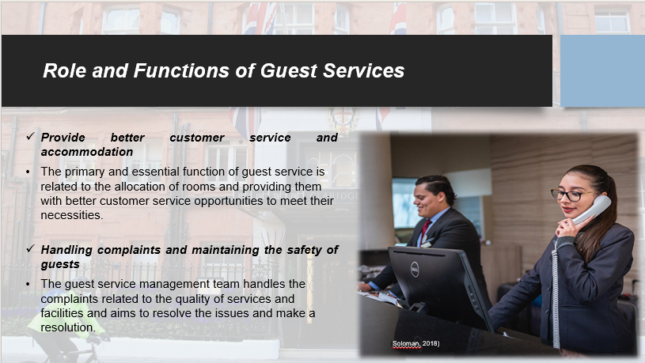
The aim of effective guest service is related to the delivery of enjoyable experiences to the customers. The role and functions of the guest services are discussed below.
Provide better customer service and accommodation
The primary and essential function of guest service is related to the allocation of rooms and providing them with better customer service opportunities to meet their necessities. The welcome process and checking of the requirements of the guests to make them comfortable is crucial (Soloman, 2018). The management also aids resolve the queries of the individuals and provides information regarding the hotel surroundings, offered services and amenities facilities of the sector.
Handling complaints and maintaining the safety of guests
The guest service management team handles the complaints related to the quality of services and facilities and aims to resolve the issues and make a resolution. Additionally, they also ensure the security of the guests and their belongings to maintain a healthy environment.

Importance of the Hospitality Sector
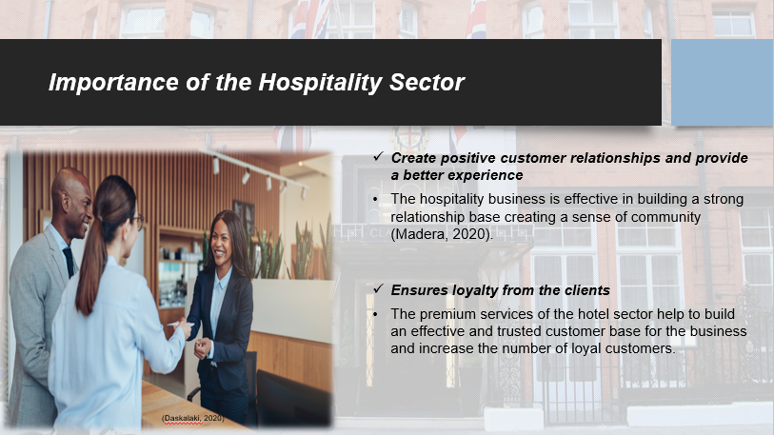
Hospitality denotes the friendly act that welcomes the guests and meets their accommodation, food, and leisure requirements. The UK hospitality sector contributes nearly 4% of the country’s GDP (Statista, 2023). Therefore, the respective sector poses various importance, and these are discussed below.
Create positive customer relationships and provide a better experience
The hospitality business is effective in building a strong relationship base creating a sense of community (Madera, 2020). They provide a better customer experience that reaches the expectations beyond the necessities of the guests. This in turn helps to raise the reputation and market competition of the business.
Ensures loyalty from the clients
The premium services of the hotel sector help to build an effective and trusted customer base for the business and increase the number of loyal customers. The famous hotel enterprises attract the interest of the customers (Daskalaki, 2020). The fulfillment of the requirements engages the clients and raises their loyalty level which will boost the urge to revisit the enterprise in the future.

Conclusion
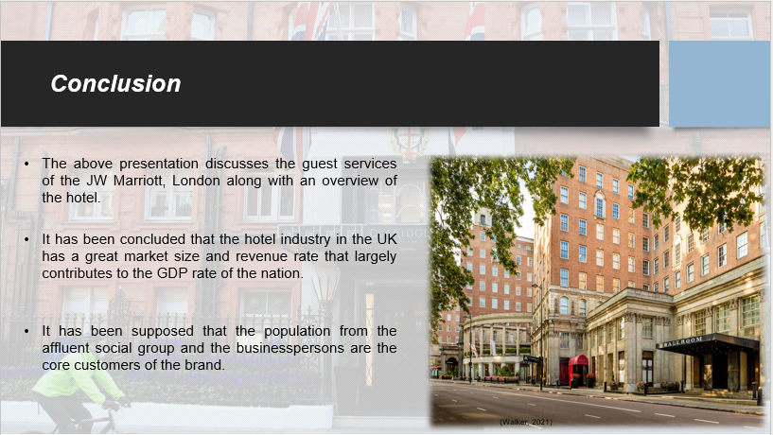
The above presentation discusses the guest services of the JW Marriott, London along with an overview of the hotel. It has been concluded that the hotel industry in the UK has a great market size and revenue rate that largely contributes to the GDP rate of the nation. The target customers of the JW Marriott, London have been analysed. It has been supposed that the population from the affluent social group and the businesspersons are the core customers of the brand. Besides this, the job opportunity of JW Marriott has deduced that highlight that this sector provides great job opportunities and conducts the roles of the hotel sector. Moreover, the functions of the guest services offered by the hospitality industry have been underlined to highlight the importance of positive customer relationships and the loyalty of clients. These services help to raise the brand image of the hotel.

References
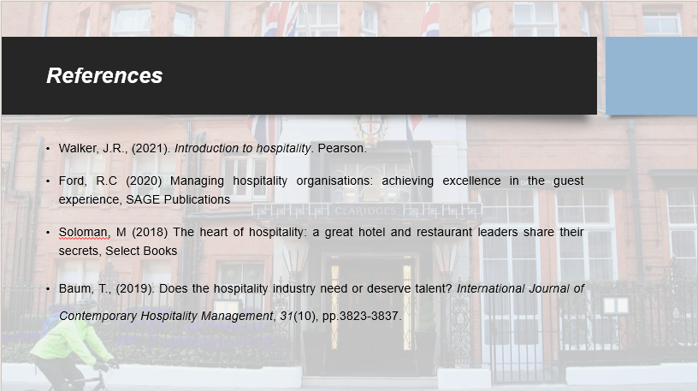
Baum, T., (2019). Does the hospitality industry need or deserve talent? International Journal of Contemporary Hospitality Management, 31(10), pp.3823-3837.
Daskalaki, E., (2020). Cultural Diversity and Indicated Intercultural Implications in the Hotel Working Environment in the United Kingdom: Underpinning the Employee’s Perspective. The Market: International Journal of Business, 1, pp.91-107.
Ford, R.C (2020) Managing hospitality organisations: achieving excellence in the guest experience, SAGE Publications
Kunst, A., (2023). Marriott brand awareness, usage, popularity, loyalty, and buzz among hotel customers in the UK in 2022. [Online] Available at: https://www.statista.com/forecasts/1335619/marriott-hotels-brand-profile-in-the-uk[Accessed 04 October 2023].
Madera, J.M., Taylor, D.C. and Barber, N.A., (2020). Customer service evaluations of employees with disabilities: The roles of perceived competence and service failure. Cornell Hospitality Quarterly, 61(1), pp.5-18.
marriott, (2023). JW MARRIOTT. [Online] Available at: https://www.marriott.com/en-us/hotels/longh-jw-marriott-grosvenor-house-london/overview/[Accessed 04 October 2023].
Soloman, M (2018) The heart of hospitality: a great hotel and restaurant leaders share their secrets, Select Books
Statista, (2023). Number of Marriott International employees worldwide from 2007 to 2022(in thousands). [Online]Available at:https://www.statista.com/statistics/297269/number-of-marriott-international-employees-worldwide/[Accessed 05 October 2023].
Walker, J.R., (2021). Introduction to hospitality. Pearson.

