Ethical Hacking
Acca7033
1808495

Contents
Acronyms 3
Abstract 4
Part One - Introduction 4
Types of cybersecurity controls relevant to each attack 5
British Library Cyberattack 6
British Library Countermeasures 7
NYU Cyberattack 7
NY Blood Centre Countermeasures 8
New York University (NYU) Countermeasures 9
Topology Diagram - Cureton Pharmaceutical Company (CPC) 11
Introduction and Methodology 12
Figure 2: Five Stages of Ethical Hacking [14] 12
Mitre ATT&CK Matrix 13
Figure 3: Attack groups' habits used to create Red Team methodology 14
Reconnaissance Workflow 17
Reconnaissance, scanning, and exploitation methodology Implementation 18
Targeted Vulnerabilities 18
Red Teaming Modelling outcome 19
Mitigation or Blue Teaming to counteract or resolve vulnerabilities 22
Figure 11: Vulnerabilities and Mitigations or controls to stop or limit exposure 24
Broken Authentication/Access Control – Countermeasures 24
Injection Attack Defences/Countermeasures 25
Security Misconfiguration - Countermeasures 26
Vulnerable and Outdated Components [45]. 26
Security Logging and Monitoring Failures 26
Insecure Design - XML External Entities – Countermeasures 27
Appendix 29
Appendix A – (Information Gathering or Reconnaissance): 29
Appendix B: Attack/Hack Methodology - Search for file upload Vulnerabilities 43
Appendix C: Attack/Hack Methodology (Discover SQL – POST) 51
Appendix D: Attack/Hack Methodology – Discover SQL Injections 57
Appendix E: Attack/Hack Methodology – SQL Injection Blind 65
Appendix F: Attack/Hack Methodology – XSS (Beef) 69
Appendix G: Attack/Hack Methodology – Cross Site Scripting 73
Appendix H: Attack/Hack Methodology - Cross Site Request Recovery 78
Appendix I: Attack/Hack Methodology – Brute Force 84
References 87

Acronyms
DVWA – Dam Vulnerable Website
DTD – Document type definition
SQL – Structure Query Language
OWASP – Open Web Application security Project
DevOps – Development and Operation
DevSecOps – Development Security and Operation
Blacker Hacker – Malicious Hackers

Abstract
Cyberattacks on critical institutions are increasing, posing serious risks across sectors. This assignment analyses incidents at the New York Blood Centre, New York University, and the British Library, all of which faced significant disruptions from ransomware and cyber extortion. Key vulnerabilities identified include inadequate access controls, misconfigured systems, and limited incident response capabilities. Addressing these weaknesses is essential for strengthening security and enhancing resilience against future threats.

Part One - Introduction
‘UK experiencing four 'nationally significant' cyber-attacks every week [1].’
According to Dr Richard Horne, Chief Executive of the NCSC ‘Cyber security is now a matter of business survival and national resilience.’
Cyber threats are rising rapidly, with many incidents deemed nationally significant. Organisations must act quickly to strengthen defences, hesitation is a vulnerability, and prompt decision-making is crucial [2].
Experts believe cyber security breaches are rising annually due to our reliance on technology, rapid technological advancements, and the financial gains for hackers, especially those with state support. A good example of this is how we're seeing so many IoT devices, AI (Artificial Intelligence), automation, and ML (Machine Learning) popping up everywhere in our lives. But as tech becomes an increasingly big part of our world, there are also ethical dilemmas that come with it.
The latest Annual Review from the UK’s cyber agency, part of GCHQ, indicates a rise in cyber threats. The NCSC managed 204 ‘nationally significant’ cyber-attacks in the 12 months to August 2025, up from 89 the previous year.
Throughout this study, three cybersecurity incidents/breaches will be discussed that exhibit a similar pattern across the globe for governments and companies worldwide. The aim is to critically analyse organisations across different industries that suffered varying degrees of adverse impact following a cyber-attack.

Types of cybersecurity controls relevant to each attack [3]
Cybersecurity Control | British Library | NY Blood Centre | NYU | Purpose
MFA & IAM [3] | Not Used | Not Used | Not Used | Prevents misuse of stolen credentials
Network Segmentation / Zero Trust [3] | Not Used | Not Used | Not Used | Limits lateral movement
EDR / XDR  (End point detection/ Extended detection and response) | Not Used | Not Used | Not Used | Detects ransomware early
Immutable / Offline Backups | Not Used | Not Used | Not Used | Enables recovery without ransom
Email Security & Phishing Training | Not Used | Not Used | Not Used | Reduces initial compromise
Patch & Vulnerability Management [4] | Not Used | Not Used | Not Used | Prevents exploitation of known flaws
SOC / SIEM Monitoring | Not Used | Not Used | Not Used | Improves detection & response time
DLP & Data Encryption | Not Used | Not Used | Not Used | Reduces data theft impact

Figure One: Types of Cybersecurity controls relevant to each attack.

British Library Cyberattack
The British Library was targeted by a ransomware attack from a group called Rhysidai in October 2023. The attackers encrypted or destroyed around 440 GB of sensitive data and demanded a ransom of 20 bitcoin, worth £600,000. Following UK government policy from the NCSC, the library chose not to pay, resulting in the files being leaked onto the Dark Web.
The library faced significant operational challenges, impacting services like the website and online catalogue, with some not expected to be restored until 2026 [5]. To support staff and authors during this time, the library is working to expedite payments and re-establish fellowship programs while managing recovery costs of nearly seven million pounds.
The exact timing of the attack remains uncertain due to the hacker's use of anti-forensic techniques. It is suspected that access was gained by compromising privileged account credentials through phishing, spear-phishing, or a brute force attack using a password database (Mitre Attack) [6].

British Library Countermeasures
Countermeasures | NIST CSF Function | Explanation
Implement DDoS Protection (e.g., Cloudflare, AWS Shield) | Protect (PR) | The British Library should consider DDoS protection services from cloud providers or CDNs like Cloudflare to absorb and mitigate large traffic volumes, ensuring their systems remain stable.
Regular Penetration Testing | Identify (ID) / Protect (PR) | Routine penetration testing and red teaming can improve the library's web application security against large-scale attacks.
Network Segmentation | Protect (PR) | Segmenting critical systems from the web infrastructure would prevent a complete shutdown from an attack.
Traffic Filtering & Rate Limiting | Protect (PR) / Detect (DE) | To enhance security, it is advisable to implement rate limiting and traffic filtering mechanisms to effectively identify and block suspicious traffic at the network perimeter.

NYU Cyberattack
Considering the incident, Reddit users and cybersecurity enthusiasts have proposed that it may have been a DNS hijacking attack, potentially resulting from a registrar account compromise or manipulation of DNS records. The attack allowed users attempting to access www.nyu.edu to be redirected to dsvdfvx64.github.io, a GitHub-hosted page where the stolen data was temporarily exposed. Alternatively, WHOIS records indicated that NYU's ownership remained secure, suggesting that the incident was likely due to DNS-level manipulation rather than a full breach of their infrastructure. This highlights the importance of robust security measures at both the registrar and DNS levels to prevent similar occurrences in the future.
The breach is attributed to a group called “Computer Niggy Exploitation,” which also claimed a similar data leak at the University of Minnesota in July 2023 [7].
Multiple lawsuits directly criticise the university for keeping applicants’ data for decades, contrary to industry guidelines recommending prompt encryption or disposal. NYU's policy mandates the destruction of application data after two years, except for enrolled students, whose data is destroyed five years post-graduation.
The university responded, stating they are "informing individuals whose Social Security numbers were included in the affected files [8]."

NY Blood Centre Countermeasures
Countermeasures | NIST CSF Function | Explanation
Strengthen Access controls | Protect (PR) | Implementing MFA (Multi- Factor Authentication across all admin and user accounts and enforcing password policies and password managers.
Secure DNS & Web Hosting Configuration | Protect (PR) | Tightens DNS and hosting controls to prevent homepage redirection and defacement, following the March 22 incident affecting 3+ million applicants
Timely Notification to Affected Parties & Regulators | Respond (RS) | Following a review of the impacted data, NYU began issuing breach notifications and providing credit monitoring to affected individuals
Continuous Intrusion Detection & Log Analysis | Detect (DE) | Enables early detection of suspicious activity or unauthorized changes on public servers, reducing the risk of malicious page hosting or data leakage

NY Blood bank Cyberattack
New York Blood Centre Enterprises (NYBCe), one of the largest nonprofit blood collection and distribution organisations in the U.S., experienced a ransomware attack on January 26, 2025 [9]. During the incident, an unauthorised party accessed its internal IT network between January 20 and January 26.
The attack resulted in unauthorised access to NYBCe's network, exposing sensitive information for about 194,000 individuals. In response, NYBCe took systems offline, enlisted external cybersecurity experts, notified law enforcement, and provided breach notifications and free credit monitoring to affected individuals.
Unlike the other cyber-attacks, the NY blood centre was able to continue its work of maintaining critical blood collection and distribution with support from partner centres.

New York University (NYU) Countermeasures
Countermeasure | NIST CSF Function | Explanation
Immediate Threat Identification & Third-Party Expertise | Detect (DE) | External expertise enhances investigation, containment, and remediation capabilities.
System Shutdown and Network Isolation | Respond (RS) | Compromised systems taken offline to stop further malware spread.
Notification of Law Enforcement and Regulators | Respond (RS) | Coordinated with law enforcement and submitted all required breach notifications to state authorities.
Credit Monitoring and Identity Theft Services | Recover (RC) | Impacted individuals received free credit monitoring and identity protection.

Further Countermeasures against cyberattacks include: -
- Staff Training- Educating employees to prevent credential compromise and insecure practices.
- Cyber Insurance & Legal Preparedness- Ensuring readiness for lawsuits and risk transfer following a breach.
- Data Encryption & Retention Policies- Minimising risks from retained applicant data and addressing issues related to unnecessary data retention.
- Incident Response Team & External Experts- Hiring outside cybersecurity consultants for investigation and system security after an incident.

To protect against sophisticated ransomware threats, such as those faced by the British Library, New York Blood Centre, and NYU, organisations should adopt a layered defence strategy. This strategy focuses on protecting identities, designing resilient systems, and monitoring proactively. Key preventive steps include using multi-factor authentication, limiting access only when needed, and applying software updates promptly to block initial attacks exploiting stolen credentials or known weaknesses. Strengthening systems with Zero Trust principles, segmenting networks, and creating backup plans that resist ransomware further limit the movement of attackers and decrease operational disruption during a [10] [11] [6].

Rapid detection is also crucial. Continuous monitoring with endpoint detection and response (EDR), centralised logging (SIEM), and alerts for unusual data access help security teams respond before attackers can encrypt data or demand ransom. Together, these practices shift cybersecurity from reactive incident response to proactive threat prevention and rapid problem containment [12].

Recent cyberattacks on New York University, the New York Blood Centre, and the British Library reveal that organisations across education, healthcare, and public services face common ransomware and extortion challenges, including weak access controls and outdated systems. The effects of these attacks stem from both technical vulnerabilities and management decisions. Ethical hacking, guided by frameworks such as the OWASP Top 10 and NIST, not only identifies technical issues but also helps organisations build stronger defences and understand the attacker mindset, reducing disruptions and protecting reputations. Proactive ethical hacking through penetration testing, vulnerability scanning, and red-team exercises could have pinpointed vulnerabilities sooner, minimising their impact. These examples underscore the importance of ethical hacking as a key element of a security strategy, enhancing resilience and enabling adaptation to new cyber threats.

Topology Diagram - Cureton Pharmaceutical Company (CPC)
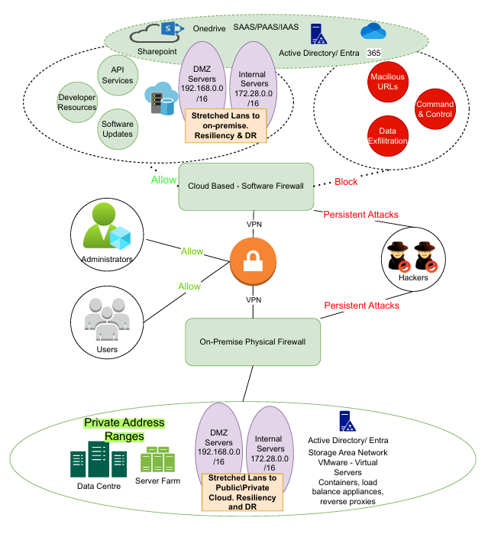

Introduction and Methodology
Red Teaming is an ethical hacking process, i.e., imitating or impersonating a black hacker. Playing the role of an adversary to try and compromise the confidentiality, integrity or availability of a system and provide feedback regarding any vulnerabilities [13].
The Red teaming methodology for Cureton Pharmaceutical Company (CPC) was developed by leveraging the MITRE ATT&CK Matrix alongside the OWASP Top 10 (2017 [14] and 2021 [3] versions, including the Testing Guide and Testing Checklist) to systematically analyse and compare cyberattack behaviours.
The idea was to follow the five stages of the ethical hacking life cycle, which are integrated into the MITRE ATT&ACK Matrix.
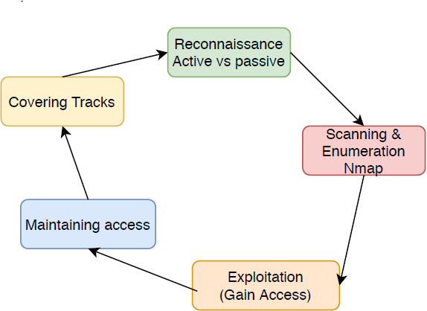

Figure 2: Five Stages of Ethical Hacking [15]

Red Teaming using the five stages was carried out on purpose-built servers running in a virtual Lab environment, using well-known labs and vulnerable applications, including DVWA (DAM Vulnerable Web Application), Metasploitable, and Portswigger (Burpsuite) labs, which are industry-leading websites with known vulnerabilities. Passive reconnaissance was conducted without affecting any websites to develop a methodology to pinpoint potential avenues of exploitation (see Appendix A).
The strategy involved evaluating multiple Advanced Persistent Threat (APT) groups by examining their Tactics, Techniques, and Procedures (TTPs), allowing for a structured approach to understanding attacker patterns [16].
The research was further developed using Google Cloud’s Threat Intelligence Units and their Threat Analysis Group [5], which provided up-to-date threat data to validate attack patterns. The MITRE ATT&CK framework, originally designed to aid Red Team exercises and simulated cyberattack modelling, enabled a granular comparison of the techniques used by different attackers. In particular, the ATT&CK Navigator was used to visually map and compare the techniques across multiple APT groups, highlighting overlaps and unique behaviours.
Multiple Hacking groups were compared [17]; however, only three were analysed in detail to develop the methodology. By mapping their respective TTPs (Tactics, Techniques and Procedures) in the MITRE ATT&CK [15]] and cross-referencing with vulnerabilities identified in the OWASP Top 10 [18] and the Cloud Security Alliance (CSA), a comprehensive methodology was created that clearly illustrated the attack tactics, targeted vulnerabilities, and progression patterns typically exploited by sophisticated attackers. This approach allows defenders (Blue Teamers) to prioritise security measures, anticipate attacker behaviour, and implement proactive threat detection and mitigation strategies.

Flow diagrams were created to apply red-team attack modelling techniques. One of the keyways adversaries infiltrate networks is by targeting employees in the organisation who have elevated privileges, such as administrators, or who have the authority to request elevated privileges or urgent password resets, such as senior managers. The different types of phishing, particularly Spearfishing, are Social Engineering attack techniques widely used in reconnaissance to gain initial access [19]. Social networking sites (SNSs) have increased the likelihood of social engineering victimisation (SEV), i.e. phishing websites, fake user accounts, fraudulent messages, impersonation of close friends, and malicious links shared through comments or posts on SNS platforms [20]

Mitre ATT&CK Matrix
The MITRE ATT&CK Navigator was used to compare the different attack groups known to target diverse organisations for varying purposes, funded by differing levels of influential or powerful bodies, such as state-sponsored and smaller, independent groups. The navigator diagrams below analyse two groups (green, blue), as vaccine breakthroughs are a billion-dollar business, and multiple organisations would see this as valuable information, including offshore government-sponsored hacking groups and loan hacking groups, purely for financial gain. The thought process was to use one diverse group in green and a second, financial-based group in blue to reduce the probability of missing potential threats.

Group Name | Tseype/Motivation | Primary Target | Typical Attack method | Notable Characteristics
FIN13 | Financially motivated cybercrime | Retail, hospitality, and financial services | Phishing, credential theft, point-of-sale (POS) malware | Focuses on stealing payment card data; often works quietly to avoid detection
Moonstone Sleet | Nation-state aligned (suspected North Korea) | Software, tech firms, cryptocurrency, research orgs | Supply-chain attacks, malware, and social engineering | Known for stealthy intrusions and links to crypto theft and espionage
APT41 | Dual-purpose: espionage and financial crime | Governments, healthcare, telecom, tech, gaming | Zero-day exploits, custom malware, supply-chain attacks | Unusual for mixing state spying and profit-driven attacks; very sophisticated
FIN4 | Financially motivated | Hospitality, restaurants, retail | Spear-phishing, credential harvesting, and email compromise. | Specialises in insider trading and stock manipulation via stolen info
FIN5 | Financially motivated | Hospitality, restaurants, retail | POS malware, lateral movement, password dumping | Known for long-term persistence inside networks and large-scale payment-card thefts
FIN6 | Financially motivated | Retail and e-commerce | POS malware, web skimming (Magecart-style attacks) | Fast-moving group; steals card data and quickly monetises it

Figure 3: Attack groups' habits used to create Red Team methodology [17] [15] [16]

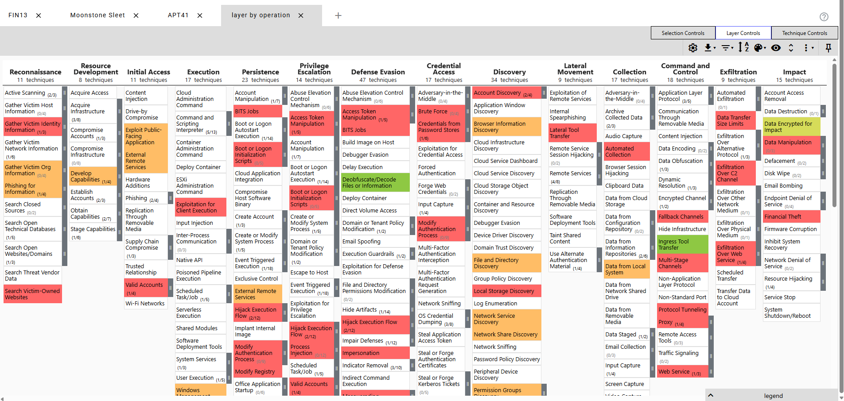

Figure 4: Screenshot 1A – Compare Three Attack Group Tactics and Techniques, i.e. FIN13, Moonstone and APT41. Yellow has the most matches, Green the second-highest, and Brown the third-highest [14].

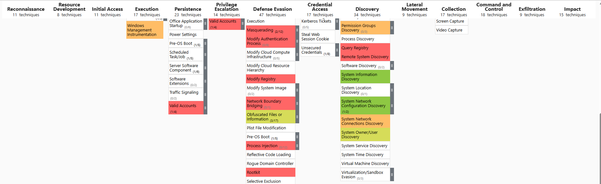

Figure5: Screenshot 1B Compare Three Attack Groups Tactics and Techniques, i.e. FIN13, Moonstone and APT41. Yellow has the most matches, Green the second, and Brown the third [15].

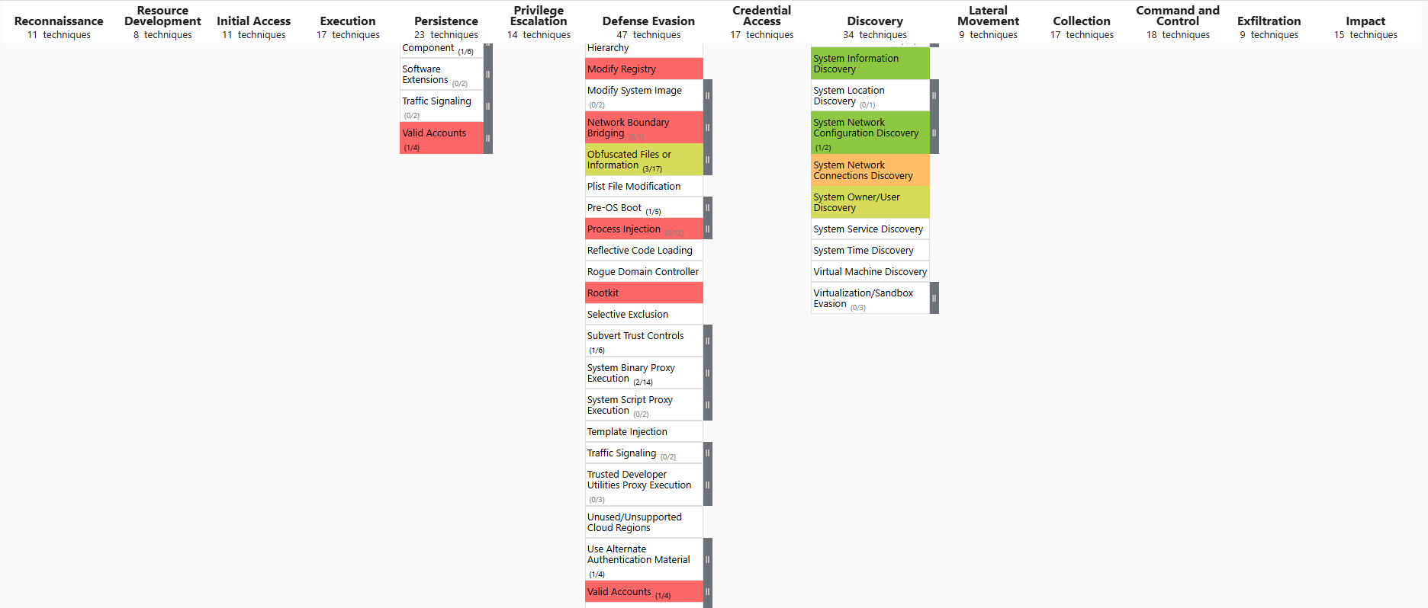

Figure6: Screenshot 1C – Compare Three Attack Groups Tactics and Techniques, i.e. FIN13, Moonstone and APT41 [15].

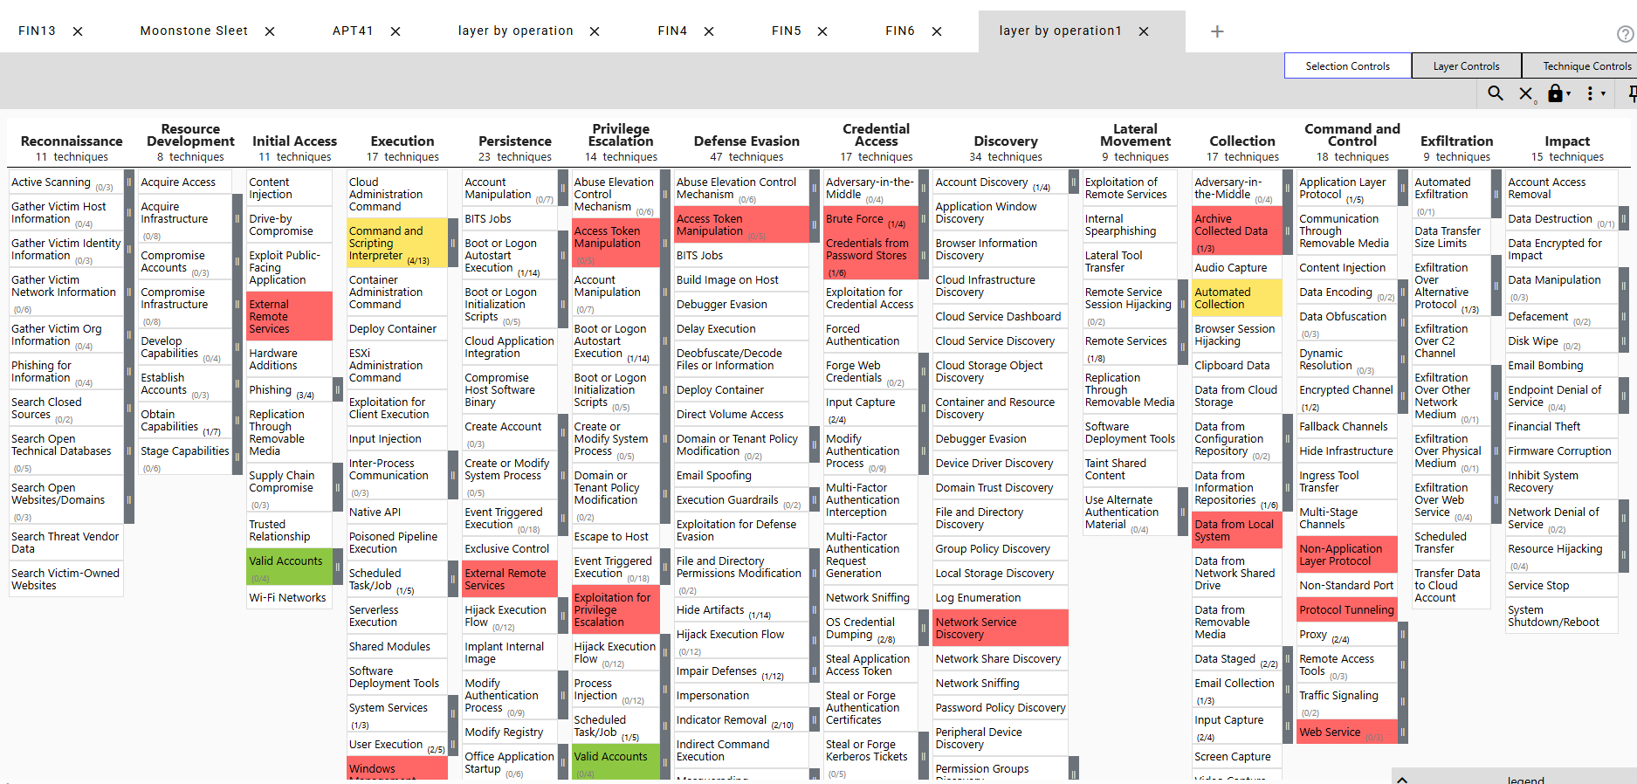
Figure7: Screenshot 2A – Compare Three Attack Groups Tactics and Techniques, i.e. FIN4, FIN5 and FIN6 [15].

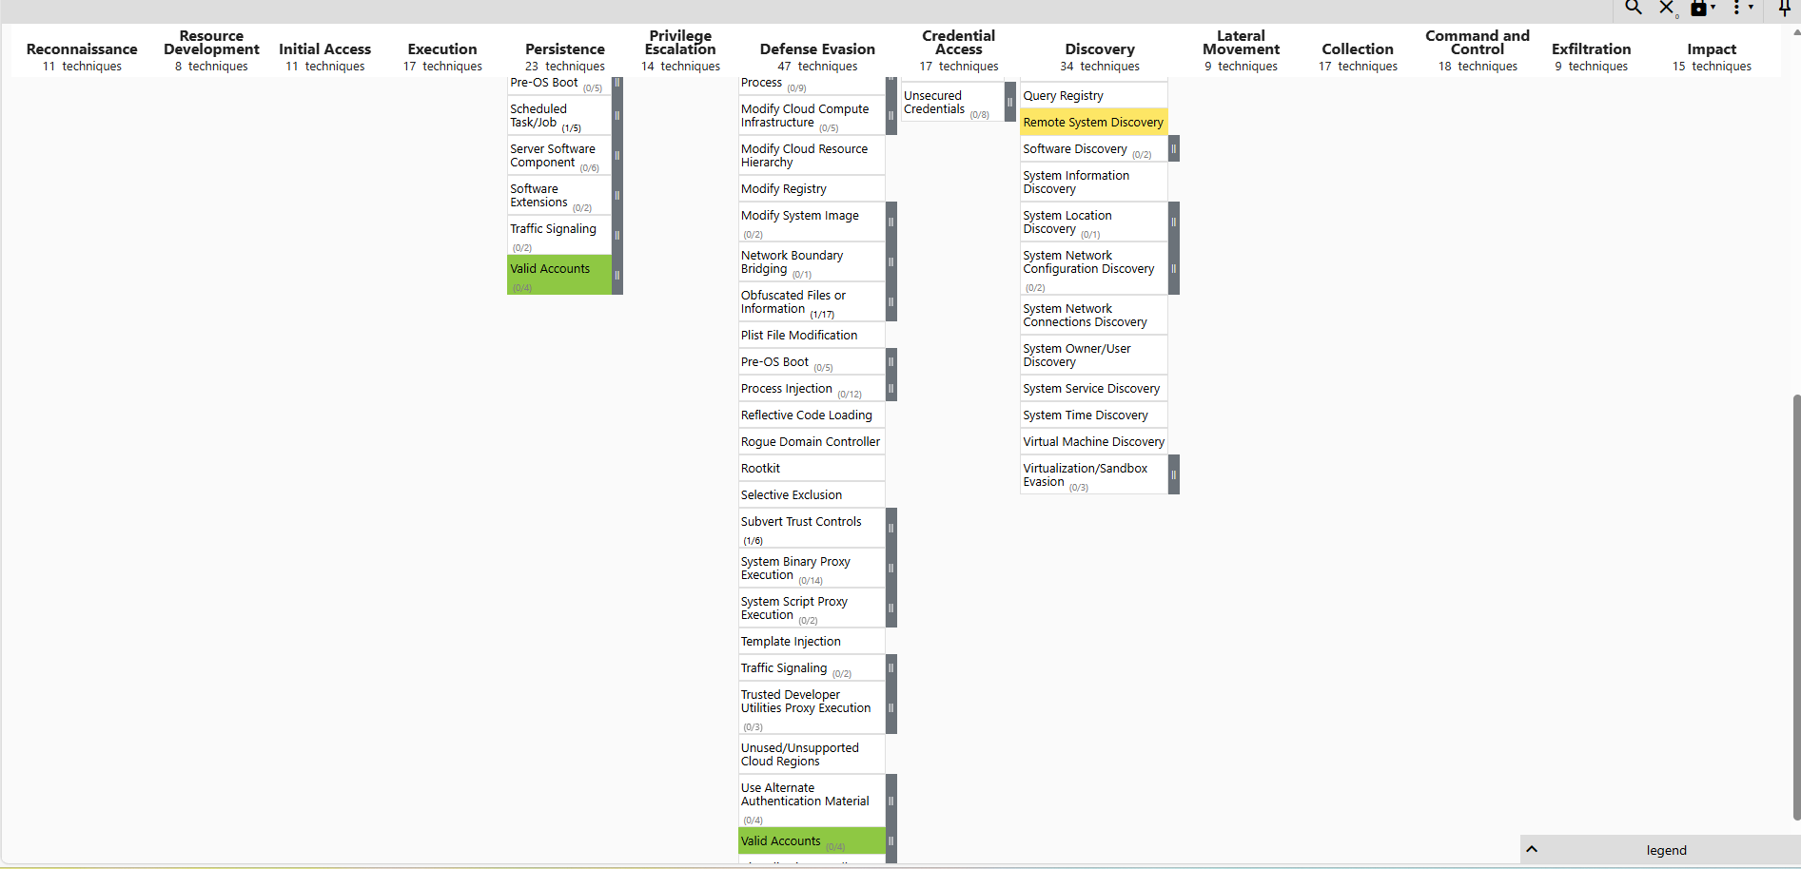

Screen2 – Compare Three Attack Groups Tactics and Techniques i.e. FIN4, FIN5 and FIN6 [15].

Reconnaissance Workflow
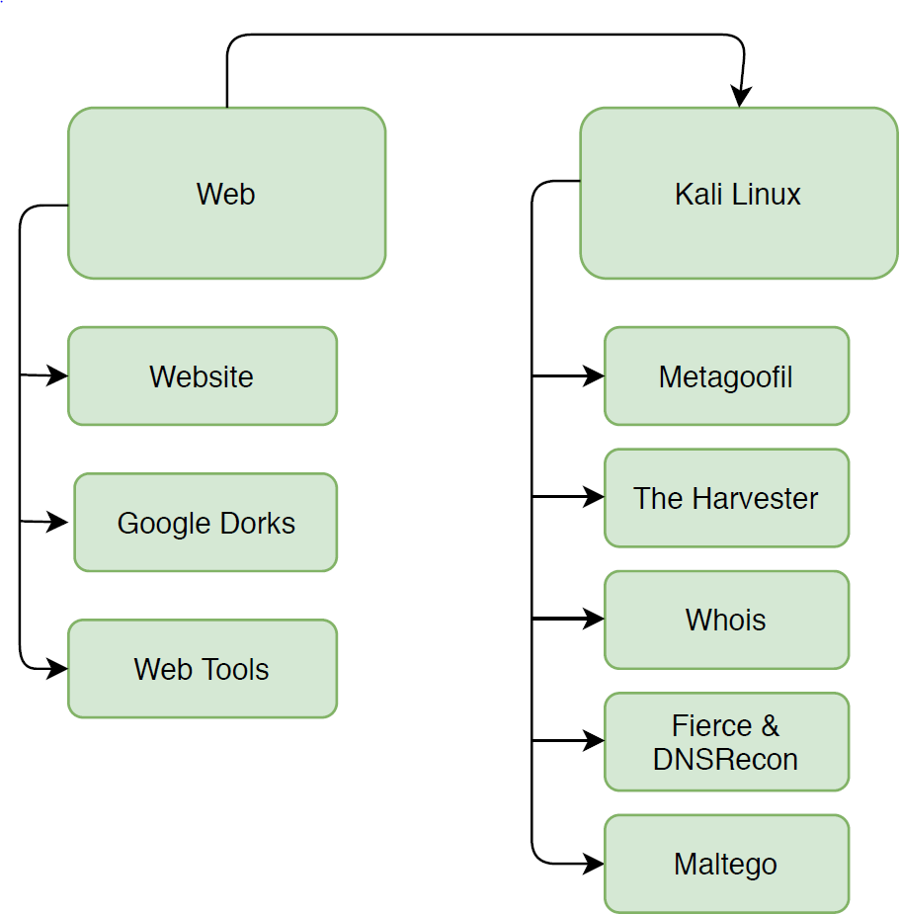

Figure 8: Reconnaissance Workflow

Reconnaissance, scanning, and exploitation methodology Implementation

Targeted Vulnerabilities
Appendix A – (Information Gathering)
Appendix B: Attack/Hack Methodology Search for file upload Vulnerabilities
Appendix C: Attack/Hack Methodology: Discover SQL Injection Vulnerabilities using the POST method

Appendix D: Attack/Hack Methodology – Discover SQL Injections: Discover SQL Injection Vulnerabilities using the GET method
Appendix E: Attack/Hack Methodology – SQL Injection Blind SQL Injection discover method without any database or system errors displayed (Blind)
Appendix F: Attack/Hack Methodology – XSS (Beef) Cross-Site Scripting (XSS) Injection and exploitation (Beef)
Appendix G: Attack/Hack Methodology – Cross-Site Scripting Exploit XSS using the Beef Framework
Appendix H: Attack/Hack Methodology - Cross-Site Request Recovery
Appendix I: Attack/Hack Methodology – Brute Force

Figure 9: Targeted Vulnerabilities Table and Appendix reference.

Red Team\Pentesting Tools, Commands and protocols
Google Dorks | Metagoofil | The Harvester | Whois | Fierce/DNS Recon | Maltego | Hydra
Nmap | Burpsuite | Netcat | PHP Passthru command | SQL Orderby | SQL Union | SQL
Crunch

Figure 10: Pentest Tools, Commands and Protocols

Red Teaming Modelling outcome
The reconnaissance stage was initially a passive process aimed at being as stealthy and undetectable as possible. It aims to research the website and conduct Google searches (Appendix A), e.g., using the website menu map and searching for PDFs and login pages. The WHOIS online utility was used, which returned a wealth of information about the hosting company, which at the time was HostGator (A5). WHOIS Information also includes DNS servers' IP addresses, location, DNSSEC state, etc. Metagoofil (A6) was used to try to automate the process of gathering public documents from Google and generating a report. The utility did not collect any relevant information. The Harvester (A7) utility was used to gather email addresses, addresses, subdomains, and IP addresses. The search parameters were between 100 and 200, initially because it was used alongside Maltego, another potent information-gathering tool. Maltego (A8) gathered all Websites hosted in the HostGator environment that share the same IP address. Any site on that IP address with a vulnerability could be used as a gateway to infiltrate the target's website.
Appendix A9[21] Reconnaissance and Scanning Checklist
The OWASP checklist and Test Guide were used to continuously gather information and pinpoint potential vulnerabilities. At this stage, Penetration testing began moving from a passive gathering exercise to an active one due to the limited available information. Recon-ng checked for zone DNS transfer vulnerabilities and failed. It then performed a non-disruptive brute-force DNS check for previously discovered subdomains. NMAP (A10) scanning revealed which ports are open, which are filtered by a perimeter firewall.

Appendix A11 [21] Reconnreconnaissance and Scanning OWASP Checklist

Burp Suite, one of the market-leading website scanning tools, was used to Spider, or map, the entire website structure. It was also used to scan the site for vulnerabilities and pinpoint potential issues for investigation. All testing was completed on DVWA (Dam Vulnerable Web Application) and Metasploitable.

Appendix B [21] Attack/Exploitation OWASP Checklist
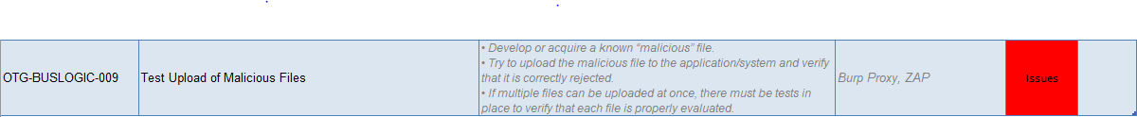
Carried out Remote and Local file attacks to infiltrate the DVWA website using the OWASP checklist. Weevly, a purpose-built stealthy PHP web shell, was used to attempt backdoor access. To fully implement this process, malicious code was uploaded to writable log files. Burpsuite was used to intercept requests and encode the data, so it passes website checks. Malicious PHP code was implanted in the agent field of the traffic, which will infect the Server/Website and allow the Netcat listening device to gain full access. The flowchart and screenshots show the attack methodology used (Appendix B).

Appendix C,D & E [22] – Attack/Exploitation OWASP Checklist (SQL Injection)
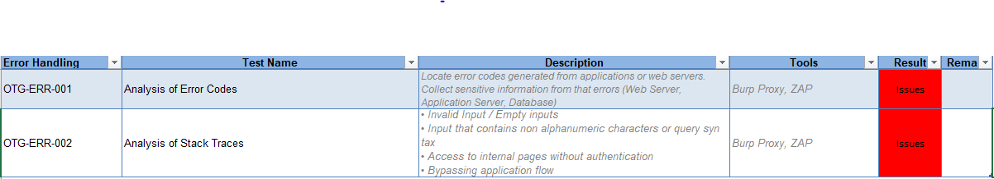

SQL injection process involved a discovery stage using POST to pinpoint vulnerabilities in the Multillidae website (Appendix C). Burp Suite was used to intercept traffic flow and determine if filtering was client-side or server-based. Injecting quotation marks caused an error, which was the first step in determining vulnerabilities. Using hash symbols allowed password bypassing. The discovery stage also included using the HTTP GET command alongside Burp Suite (Appendix D). The POST-stage investigation showed that we can bypass authentication. The GET method allowed manipulation of the Database using SQL commands like Order by and Union (Appendix D). Blind SQL discovery is the final stage, which uses a true-or-false statement to determine whether a vulnerability exists. No injection errors were displayed, and the attack was determined a success or failure based on whether the expected output was displayed on the screen or the URL broke (Appendix E).

Appendix F & G [22]– Attack/Exploitation OWASP Checklist (XSS)
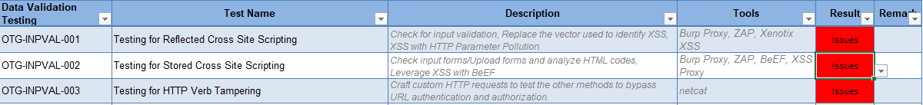
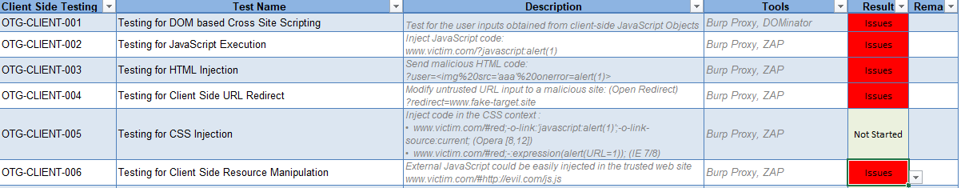
Cross-Site Scripting code injects multiple JavaScript patterns into DVWA (Appendix F) to force a full-control connection to the attacker device. Circumventing filtering required converting the redirection link to CharCode and tweaking the patterns until they successfully bypass security (Appendix F). The implanted code will redirect or hook any client that accesses the website to the Beef framework. See flowcharts in Appendix G for different attack procedures.
The cross-site request forgery process involved creating fake login pages to trick users into entering their credentials. Create an invisible, coded form that automatically resets the user's login and password set by the attacker and upload it to the DVWA website. Send a URL to a social-engineered target that runs the code (Appendix H).

Appendix I [21]– Attack/Exploitation OWASP Checklist (Brute Force)
Brute Force required generating a password list using the crunch. Hydra, a network login cracker tool, was used alongside Burpsuite. The Hydra syntax was used in Burp Suite to manipulate the crunch password list to capture the authentication request sent to Mutillidae or the target website, and to fine-tune the syntax of the hack so it would succeed. The flowchart and screenshots in Appendix I show the attack steps.

Mitigation or Blue Teaming to counteract or resolve vulnerabilities.[23].
Cureton Pharmaceutical's network topology would benefit from adding in-depth security in a zero-trust design to protect highly sensitive breakthrough vaccine data. Segmentation should also be a requirement, as they currently have two extremely large subnets (Topology Diagram) stretched across on-prem and cloud (Hybrid). This allows hackers to move laterally more easily and does not help defend against insider threats. The XDR and Siem implementation should be seriously considered based on the Red Team Modelling vulnerabilities identified. If the overall cost is a significant factor, at least implementing one would be highly recommended. At a minimum, all the top three vulnerability controls identified in table/figure eleven should be implemented as soon as possible, as they closely align with the Red Team Modelling used. CSA [24] for the cloud setup in the design and NIST[25], or possibly the equivalent ISO 27000 controls, should be prioritised as a critical project-managed requirement.
Security practices recommend a zero-trust design to defend against External and Insider [26], along with in-depth security implemented through appliances and software at multiple boundaries. Reporting all events to a central hub or Security Operations Centre (SOC), using Artificial Intelligence (AI) and machine learning to analyse, benchmark and identify the holistic legitimate everyday workflows throughout our network, on-premises and in the cloud. This allows SIEM (Security Information and Event Management) tools to identify anomalous events (Threat Intelligence) in real time and act quickly to block or limit potential threats, resulting in reducing the impact or blast radius of an attack.

Boundaries can be seen as multiple security layers. Securityindepth uses numerous layers of defence so that if one fails—like a phishing email getting through—MFA[27], endpoint protection, network segmentation, and XDR’s cross-layer detection and automated response still work together to block, contain, or limit the attack.

The mitigation techniques or controls listed below were used because the company's design/topology includes both cloud and on-premises technology (Hybrid). The Cloud Security Alliance can be used for cloud presence, and NIST for on-premises security improvements. However, they can be cross-referenced, and at the same time, they do have some differences, as shown in the CSA Top 10 deep dive 2025 security documentation and the CSA Matrix.

 | OWASP Top 10 | Cloud Security Alliance Matrix and Controls [24] [28] [15] | NIST Special Publication 800-53 [25] [29] | SAN: Common Weakness Enumeration | Appendix  Methodology  Implementation  Mapping
A  0  1 | Broken Access Control | IAM-02 User Access Authorization  IAM-03 Privileged Access Mgmt.  IAM-12 Least Privilege | Access Control  AC-2 Account Management  AC-3 Access Enforcement  AC-6 Least Privilege | CWE-284 Improper Access Control [30]  CWE-285 Improper Authorisation [31]  CWE-862 Missing Authorisation [32] | Appendix D, F, G,H and I
A 0  2 | Cryptographic Failures | EKM-03 Encryption at Rest  EKM-04 Encryption in Transit  EKM-05 Key Management | SC-12 Cryptographic Key Establishment  SC-13 Cryptographic Protection | CWE-319: Cleartext Transmission of Sensitive [33]  CWE-326 Inadequate Encryption Strength [34] | Didn’t prevent the breach but would have limited the blast radius/exposure of Broken Access Control, encrypt data at rest (TLS) and in transit i.e. Signed  tokens, JWT with strong algorithms. Reduce lateral movement Appendix
A  0  3 | Injection | AIS-02 App Security Design  AIS-03 Secure Coding | SI-10 Input Validation  SA-11 Developer Testing | CWE-77 Command Injection  CWE-89 SQL Injection  CWE-79 XSS | Appendix C, D, E
A  0  4 | Insecure Design | AIS-01 Secure SDLC  SEF-01 Threat Modelling | SA-8 Security Engineering  SA-15 Development Process | CWE-209 Info Exposure  CWE-256 Plaintext Credentials  CWE-311 Missing Encryption of Sensitive Data [35] [36]  CWE-522 Weak Credential Protection | Appendix D, F, G,H
A  0  7 | Identification & Authentication Failures | IAM-01 Identity Lifecycle  IAM-04 Strong Authentication | IA-2 Identification & Auth  IA-5 Authenticator Mgmt | CWE-287 Improper Authentication  CWE-384 Session Fixation | Appendix C, D, F

Figure 11: Vulnerabilities and Mitigations or controls to stop or limit exposure

Broken Authentication/Access Control – Countermeasures [37]
Only allow Trusted server-side code. Deny all access by default and only allow access for specific user requirements. Implement access control once and then reuse it to develop consistent standards. Log all failures and alert the security team if a precise boundary is surpassed, which could be an attack. Rate limit access to specific features; automated attacks will be significantly slowed down, which generally results in the attacker believing the system is secure and aborting the attack. Automated alerting will also have a higher probability of identifying the attack and notifying the security team while it is running. Multi-factor authentication and rotating session IDs eliminate session fixation [27]. Implement least-privilege techniques by only allowing users the minimum access and the minimum time required to do their job. This action lowers the probability of a successful attack because user access is time-based.
Web Application Firewalls (WAFs) can block this attack, but good design and accurate configuration are the best approaches.

Injection Attack Defences/Countermeasures [38]
The serialisation process involves separating the SQL statements from the parameters included in the database callback. All user input must be validated, so they conform to the expected characters; only characters that are not numbers or symbols are allowed. The user input must comply; otherwise, it is rejected. SQL best-practice configuration is to limit the size of data returned from a database call; only a specific maximum is allowed, like windowing in networking. WAF (Web Application Firewalls) [39] is an industry-standard solution because it performs deep packet inspection of network traffic flowing between the client and servers; it then identifies and blocks attacks [39]. The best form of defence is to follow best practices for designing and building applications, websites, and databases properly, and to consider security throughout the entire software development life cycle (SDLC) [21], i.e., a DevSecOps approach.

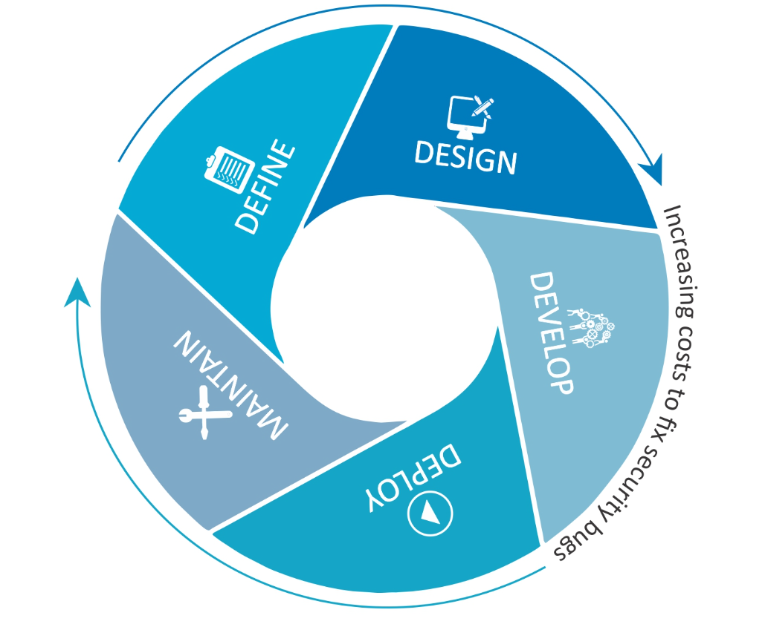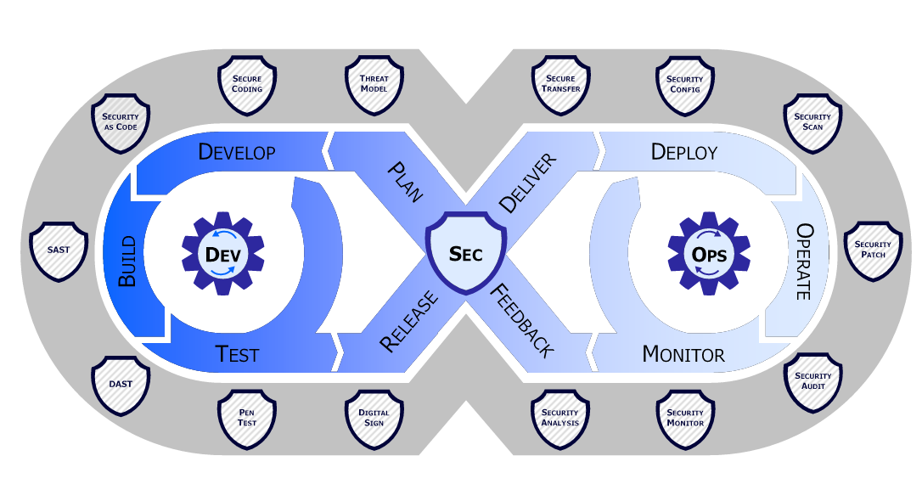
Software Development Life Cycle[21] DevSecOps – Security throughout SDLC[40]

Cryptographic or Sensitive Data Exposure - Remediation/Countermeasures. [41]
Classify data and apply controls based on its sensitivity. Data leak Prevention (DLP) is a technology that allows data to be manipulated only as specified in preset policies. Build the application correctly by encrypting all the sensitive pages with strong ciphers, and encrypt sensitive data at rest [42]. Implement PFS (Perfect forward secrecy), a stronger form of communication using the TLS protocol between the user and the webserver [42]. HSTS (HTTP Strict Transport Security) enforces connections in HTTPS, i.e., you must use it, or no communication will be allowed [42]. The best design practice is not to store sensitive data unless there is no other option. Better to use it and then remove it, i.e., retain it only for the minimum time required.

Security Misconfiguration - Countermeasures [43]
Install the latest security patches to eliminate known vulnerabilities. The use of security headers can reduce the likelihood of being hacked because HTTP responses to clients must be [44]. Automate repeatable hardening processes using tools such as Microsoft's SCCM. All servers and PCs need to have the same security configuration (templates). Minimal platform footprint, only enable or install what you need to make the web application function fully. DAST (Dynamic Application Security Testing) [45], an automated testing and scanning tool, can help with this. It carries out several essential checks, like default accounts set up correctly and the latest patching installed, amongst others

Vulnerable and Outdated Components [46].
Automate continuous inventory of clients and servers, so administrators know precisely who and what devices have access to the company network. Only download software from trusted sources, e.g., the Microsoft Software Centre. Plan for monitoring with technology like Syslog (SolarWinds). Use patching technologies such as Microsoft SCCM (System Centre Configuration Manager) and other orchestration and configuration management tools such as Ansible, Puppet, and Kubernetes [47]. Use CVE (Common Weakness Enumeration and NVD (National Vulnerability Database for known vulnerabilities. Run searches and comparisons against these databases; tools like Nessus and Darktrace automate this process.

Security Logging and Monitoring Failures [48]
Sufficient content must be included so the logs can be used to diagnose issues. Enough in-depth information and content captured, so it is usable and understandable. In-depth analysis of key aspects such as precision, functionality, usable format, and compatibility will ensure it is accurate and fit for purpose. Integrity controls confirm that the data has not been compromised, i.e., checks like MD5 hashing to verify logs sent to the Syslog management server have not been tampered with.
Response Plan (Incident/Disaster): If a breach occurs and no one is monitoring the logs/alerts, the system becomes useless. Consistent monitoring needs to be put in place [2]. Whether it is an automated, artificial intelligence-based system like Dark Trace solutions or a manual process, it must be a regular or continuous process. Web Application Firewalls (WAFs) operate at levels 5-7 or 4-7 of the OSI model. Attacks that they guard against include HTTP Flood and Slow Ions. WAF acts as a central point that blocks all attacks because it sits in front of all servers.

Insecure Design - XML External Entities – Countermeasures [49]
Keep the software version up to date and patch all XML libraries and processors used by the web application. Completely disable XXE or disable it per parser. Disable DTD (Document Type Definition), which is an XML validation mechanism across the entire web application, or disable it per XML processor or parser. Implement positive server-side input validation and run it before running the commands. Use source code analysis tools like SAST (Static Application Security Testing tools) to detect XXE code. Run source code verification on your source code and web application to see if they are vulnerable.
DAST (Dynamic Application Security Testing)[45] is a web scanner that generates attacks against an application running in real-time. Tools like Burp Suite and Zap are industry-leading DAST tools that allow ethical hackers or Red Teams to confirm whether a site is vulnerable [26].

Appendix

Appendix A – (Information Gathering or Reconnaissance):

A1:Website Menu/Map
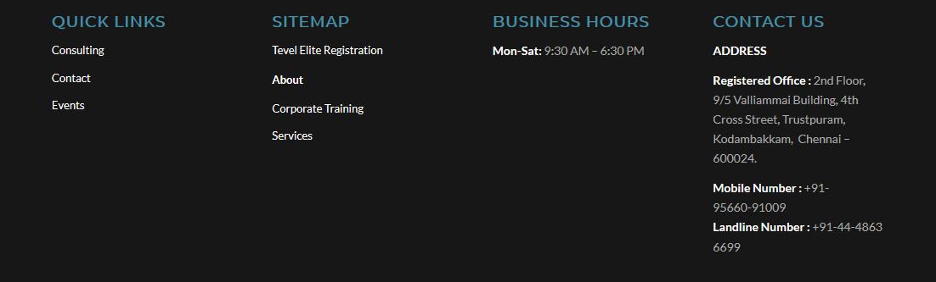

A2:Google Hacking Database
filetype:pdf site:tevelcyber.com (Search for PDF's related to the website)
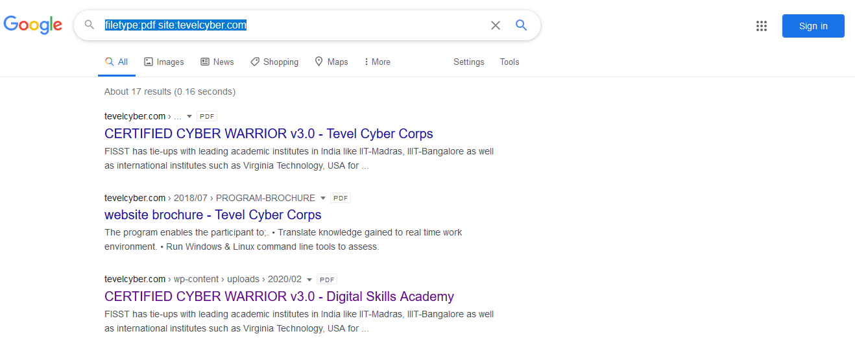

A3:site:tevelcyber.com intitle:login (Search for login page on the website)

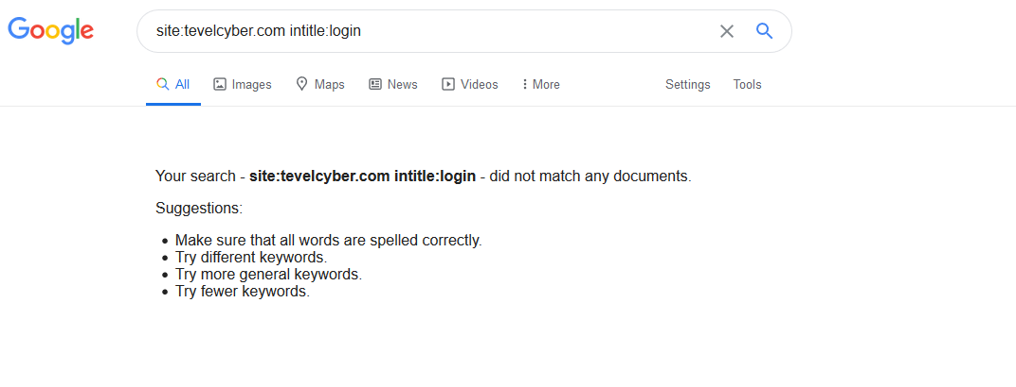

A4:site:pastebin.com tevelcyber.com (Search for password)
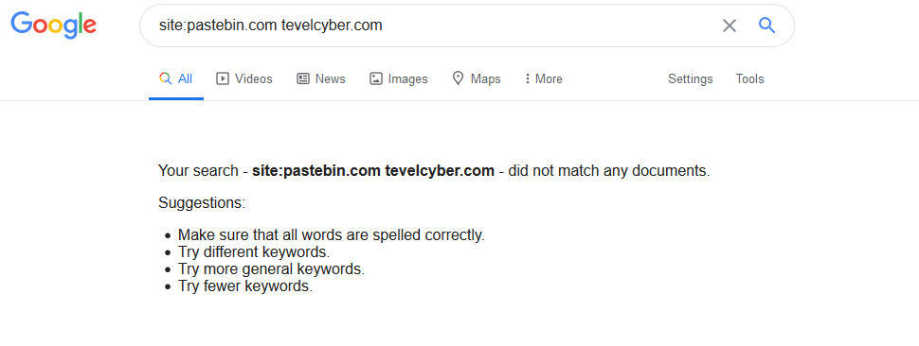

A5:WHOIS
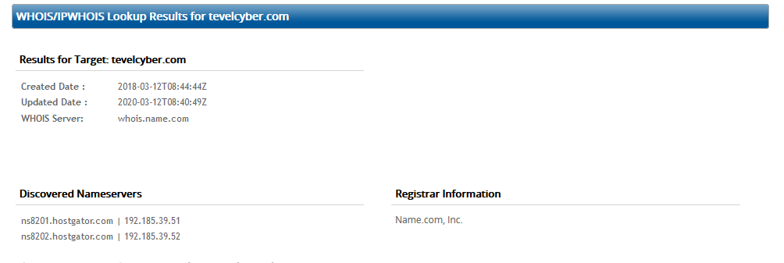



Domain Name: TEVELCYBER.COM
Registry Domain ID: 2238131330_DOMAIN_COM-VRSN
Registrar WHOIS Server: whois.name.com
Registrar URL: http://www.name.com
Updated Date: 2020-03-12T08:40:49Z
Creation Date: 2018-03-12T08:44:44Z
Registrar Registration Expiration Date: 2021-03-12T08:44:44Z
Registrar: Name.com, Inc.
Registrar IANA ID: 625
Reseller:
Domain Status: clientTransferProhibited https://www.icann.org/epp#clientTransferProhibited
Registry Registrant ID: Not Available From Registry
Registrant Name: Whois Agent
Registrant Organization: Domain Protection Services, Inc.
Registrant Street: PO Box 1769
Registrant City: Denver
Registrant State/Province: CO
Registrant Postal Code: 80201
Registrant Country: US
Registrant Phone: +1.7208009072
Registrant Fax: +1.7209758725
Registrant Email: https://www.name.com/contact-domain-whois/tevelcyber.com
Registry Admin ID: Not Available From Registry
Admin Name: Whois Agent
Admin Organization: Domain Protection Services, Inc.
Admin Street: PO Box 1769
Admin City: Denver
Admin State/Province: CO
Admin Postal Code: 80201
Admin Country: US
Admin Phone: +1.7208009072
Admin Fax: +1.7209758725
Admin Email: https://www.name.com/contact-domain-whois/tevelcyber.com
Registry Tech ID: Not Available From Registry
Tech Name: Whois Agent
Tech Organization: Domain Protection Services, Inc.
Tech Street: PO Box 1769
Tech City: Denver
Tech State/Province: CO
Tech Postal Code: 80201
Tech Country: US
Tech Phone: +1.7208009072
Tech Fax: +1.7209758725
Tech Email: https://www.name.com/contact-domain-whois/tevelcyber.com
Name Server: ns8201.hostgator.com
Name Server: ns8202.hostgator.com
DNSSEC: unSigned
Registrar Abuse Contact Email: abuse@name.com
Registrar Abuse Contact Phone: +1.7203101849 URL of the ICANN WHOIS Data Problem Reporting System: http://wdprs.internic.net/>>> Last update of WHOIS database: 2020-04-27T12:33:14Z <<<

A6:Metagoofil -d tevelcyber.com -t doc -o temp -f tevelcyber.html (File was empty, no info)
Search for document Metadata i.e.
Owner – Application owner used to create the document
Date& Time of Creation/Modification – Time and date the document was created and last modified
Network location – Location on a computer network
Geolocation – Identify where the image was created (Graphical)

A7:The Harvester
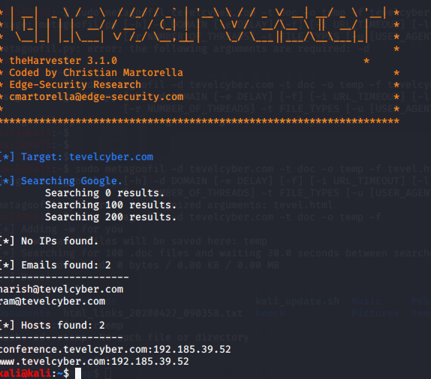

A8:Maltego

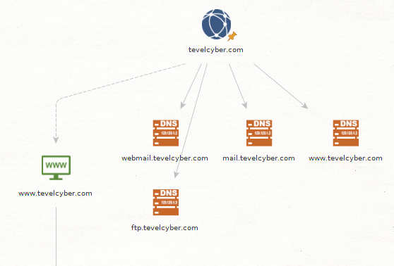
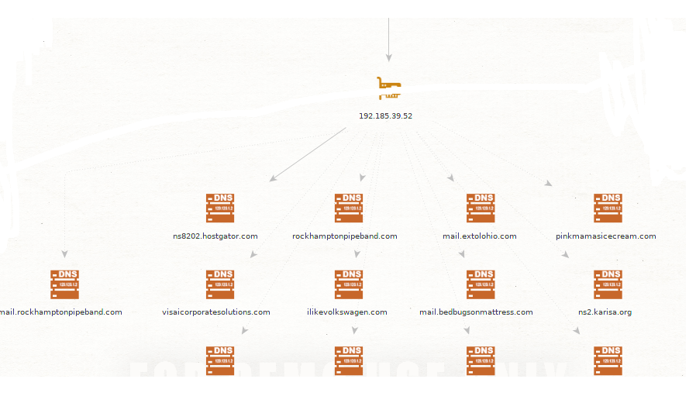

A9:Fierce
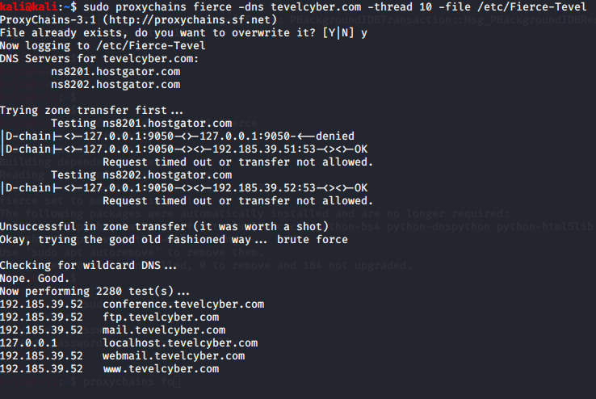

A10:NMAP
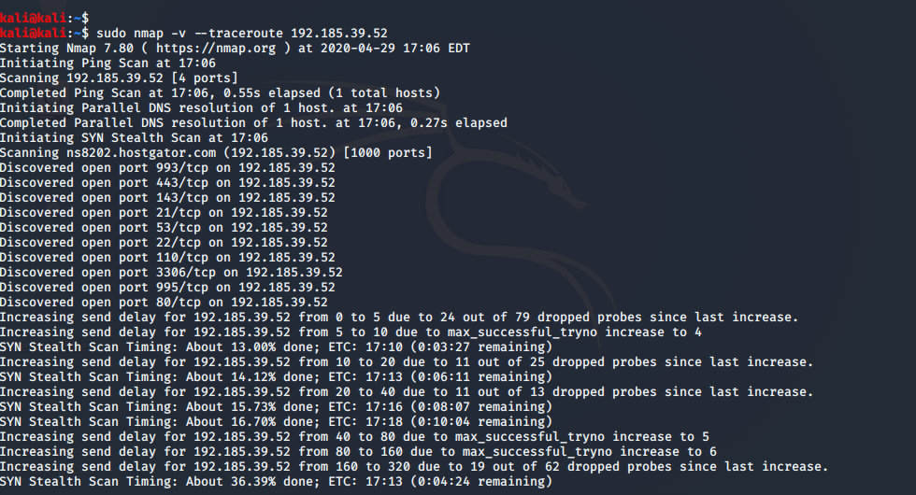

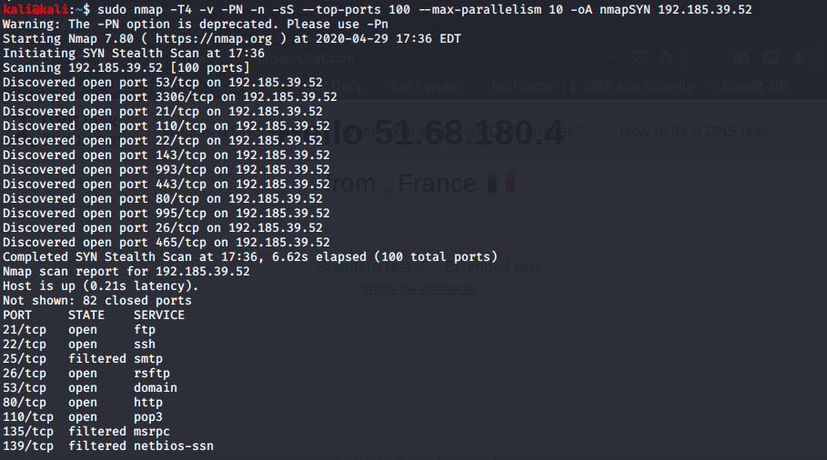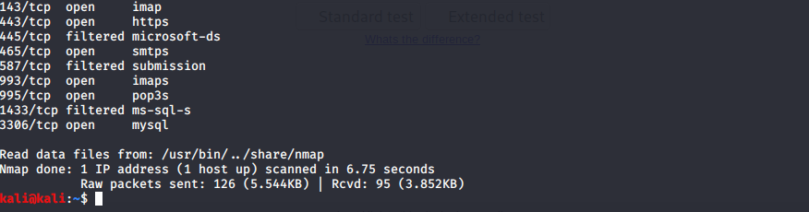
A11:Burpsuite Scan
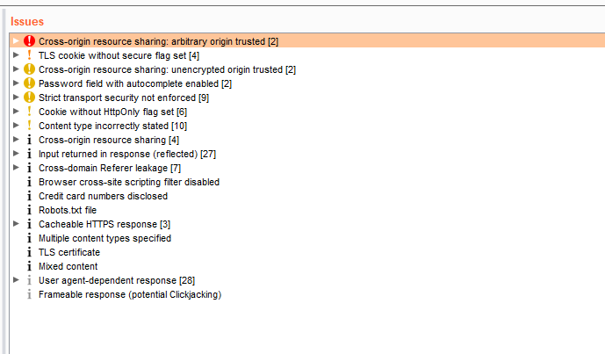

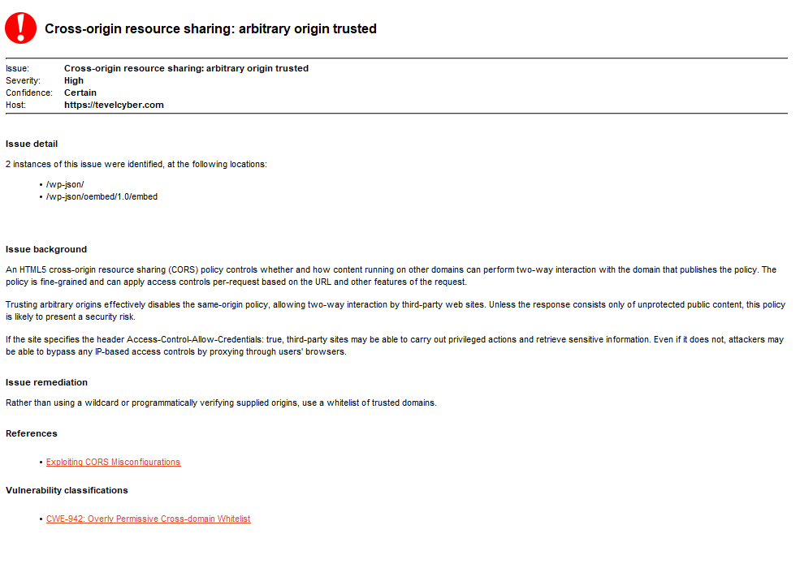
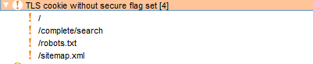
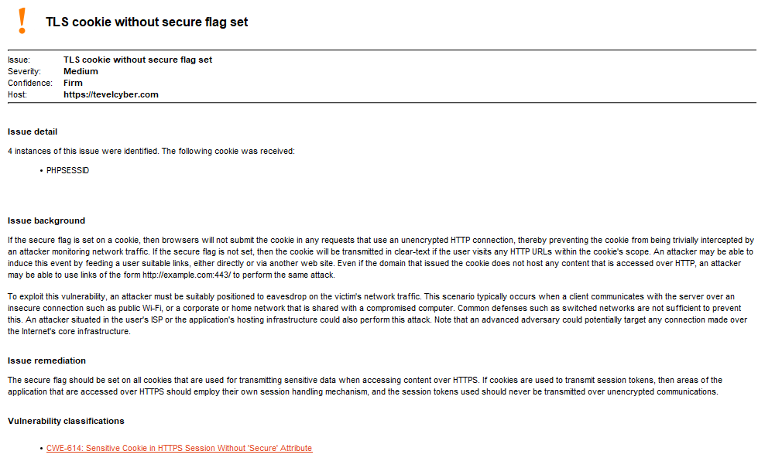
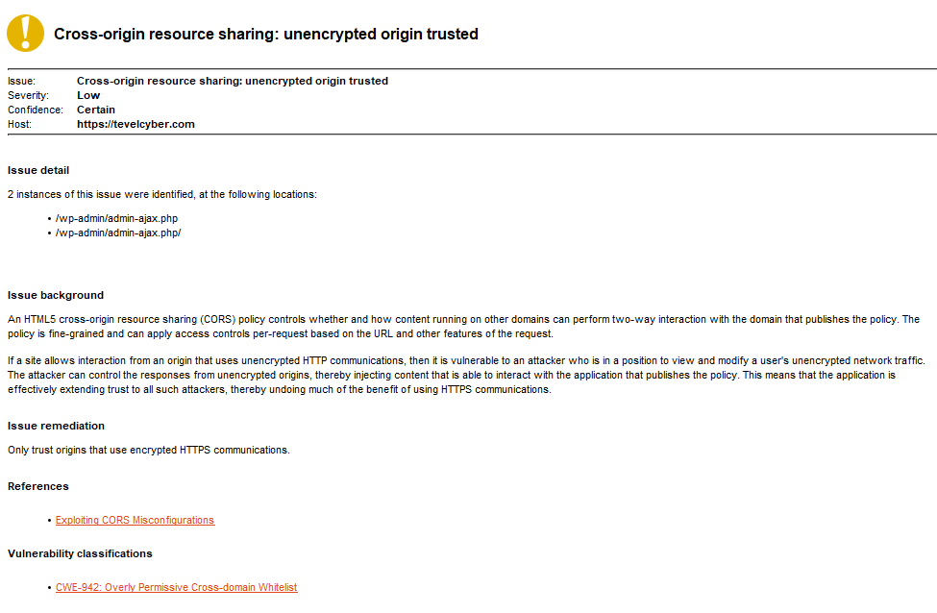
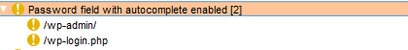
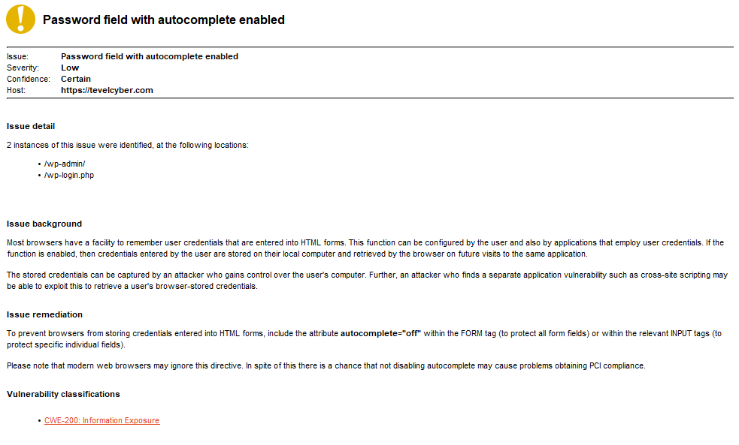

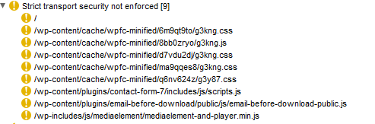
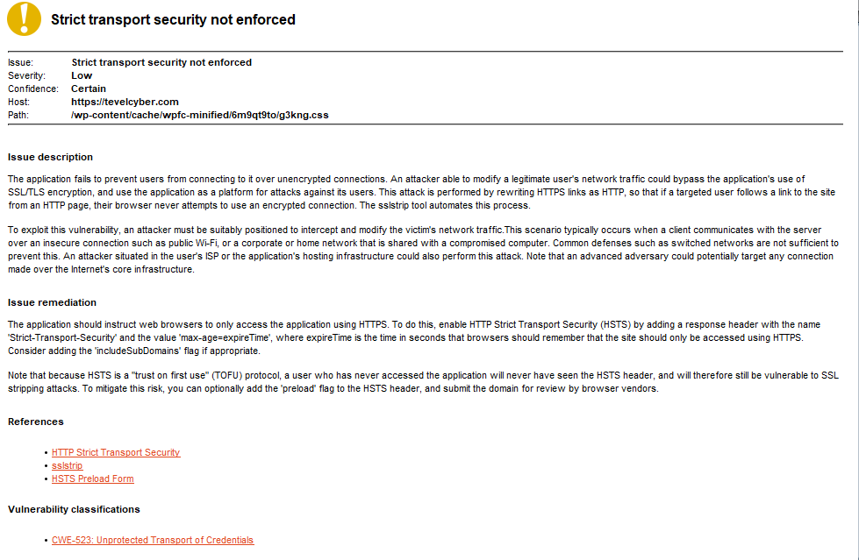

Appendix B: Attack/Hack Methodology - Search for file upload Vulnerabilities
Try and upload php shell or backdoor using Weevly and Netcat:
Local or Remote file execution would be possible if any of the other website hosted by the same provider with the same IP address has any vulnerabilities. Maltego list of websites from the reconnaissance Appendix A, shows the following Websites with the same IP address.
- rockhamptonpipeband.com
- pinkmamasicecream.com
- extolohio.com
- visacorporatesolutions.com
- ilikevolkswagen.com

Local or Remote file Attack Process
Try and access log files because they are generally editable, and content is written to them regarding server system processes, e.g.,/Proc/self/environ, /Var/log/auth.log, Var/Log/apache2/access.log.
Use the DVWA Website and Burpsuite to capture the output from the client and alter the user agent. Then replace it with code (PHP) in the user name or send an email to try and gain reverse shell access (full control).
OWASP Checklist [68] 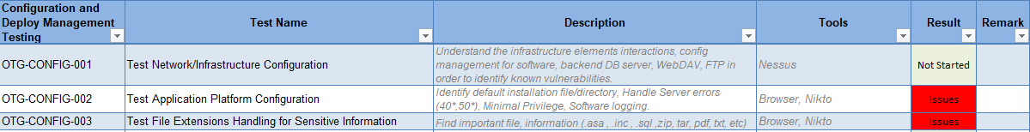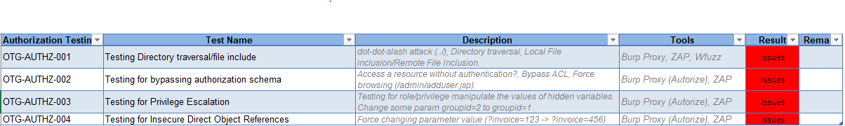

File upload Vulnerabilities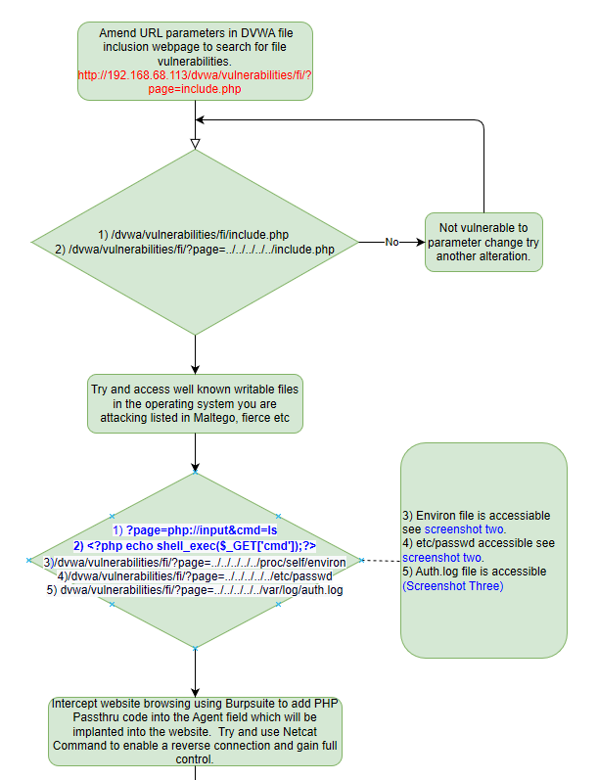
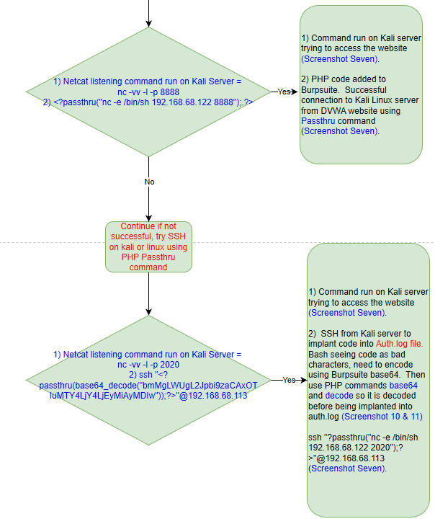

Screenshot One – able to view include.php file location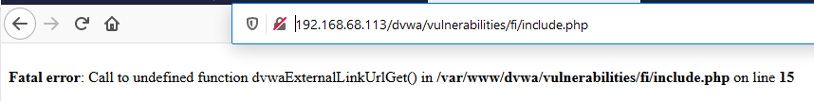
Screenshot two – use path from screenshot one to identify vulnerabilities. Try and access well known writeable files in the operating system.
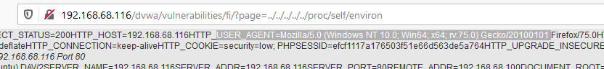
Screenshot three – Able to view contents of auth.log file
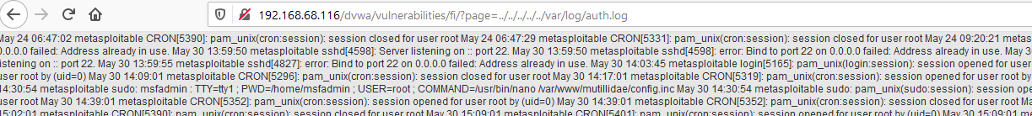
Screenshot four - Exploitable User Agent field in File
Secreenshot Five – auth.log access
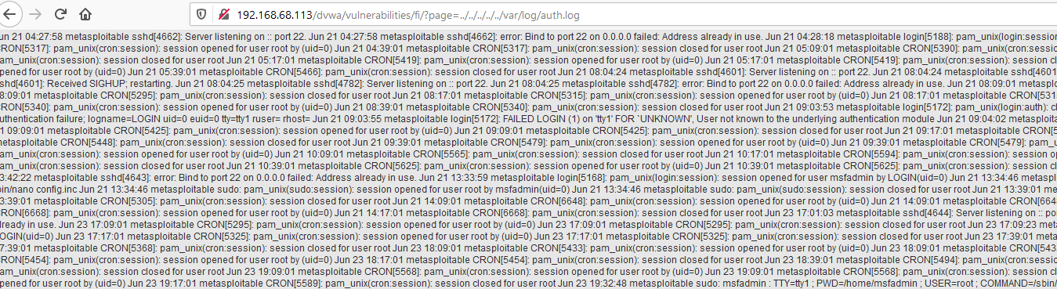
Screenshot Six – use Burpsuite to intercept code and implant PHP to exploit website (Before)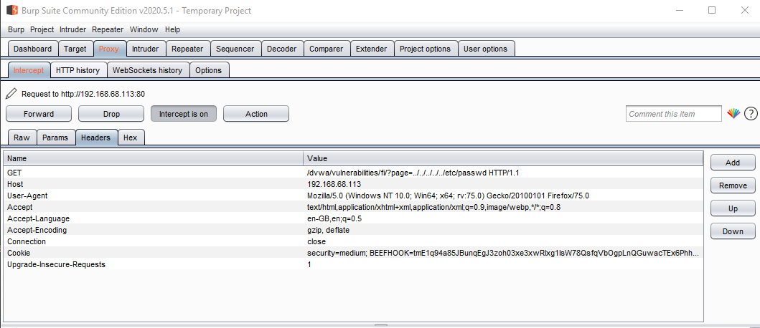
Screenshot Seven (a) – Listening using Netcat 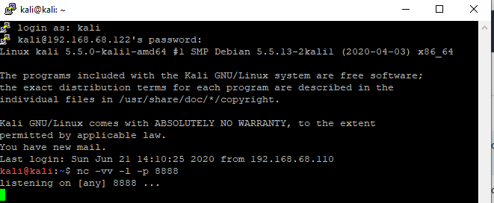
Screenshot Seven (b) - Php code implanted into user Agent field
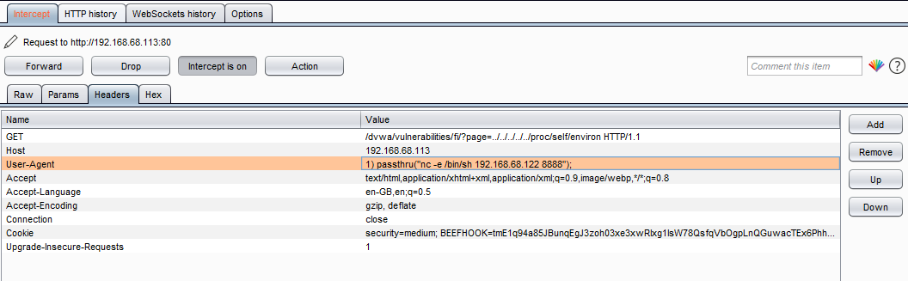
Screenshot Seven (.c) – Php Passthru Command connected to Kali linux remote server 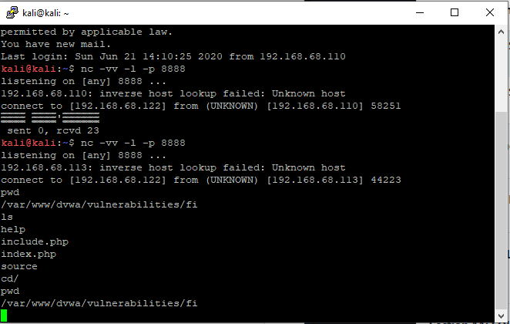

Sreenshot Eight – Test to see if Auth.log enters login attempts into the log file
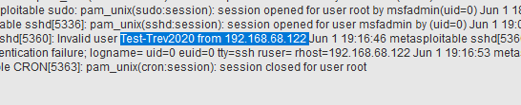

Screenshot Nine – rejects characters as bad, need to encode characters to bypass checks
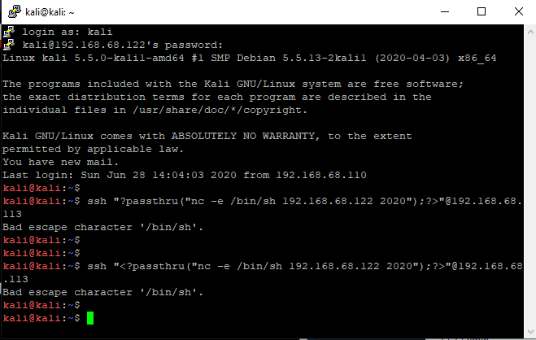

Screenshot Ten – encode characters listed as bad to bypass checks
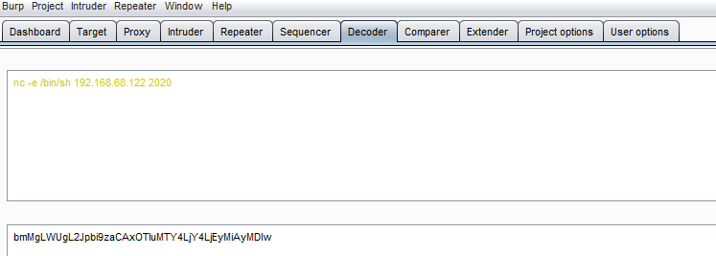

Screenshot Eleven - PHP code encode and when run decode and placed in Auth.log
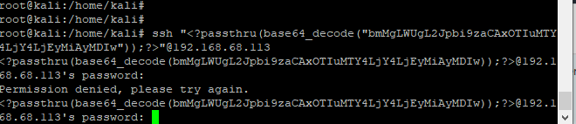

Screenshot twelve – connection established because code accepted and processed
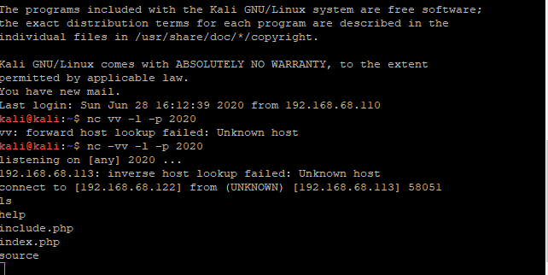

Appendix C: Attack/Hack Methodology (Discover SQL – POST)
Discover SQL Injection Vulnerabilities using POST method. CWE-89: Improper Neutralization of Special Elements used in an SQL Command [50]
Owasp_Checklist [68]
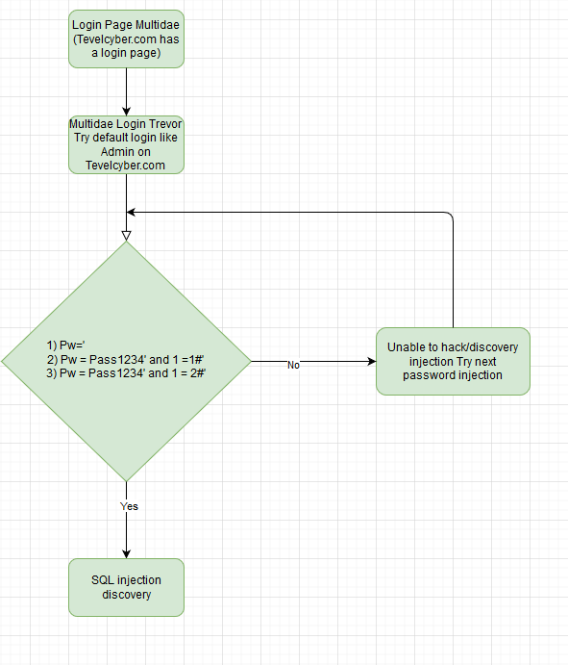
Output using Single Quotation (') as a password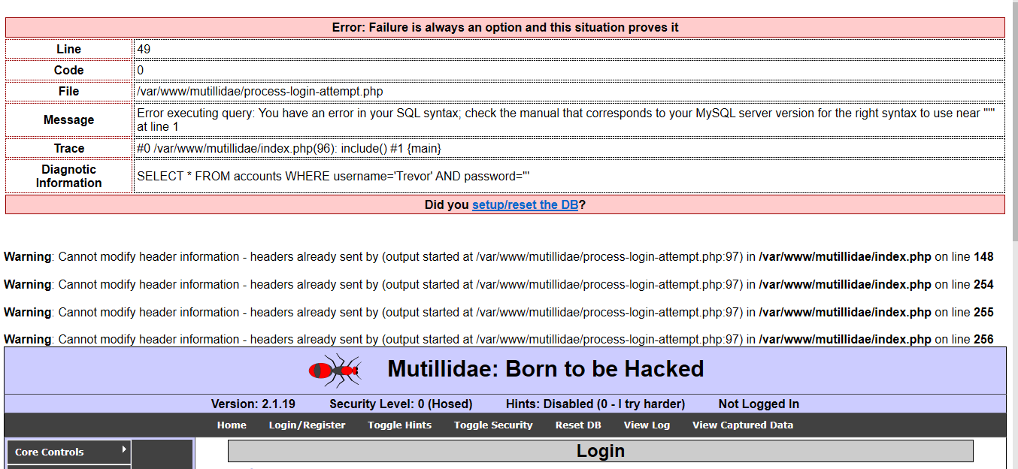

Using the username field to gain access, the Hash comments out the password and allows access.
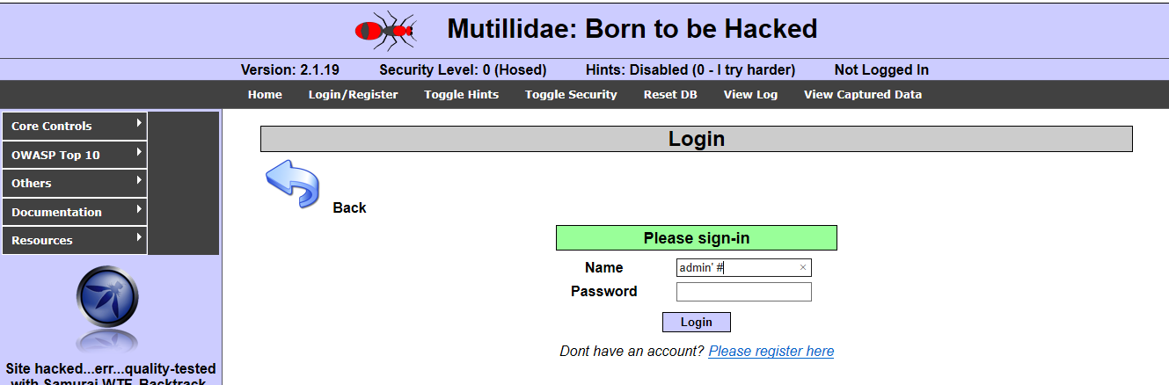

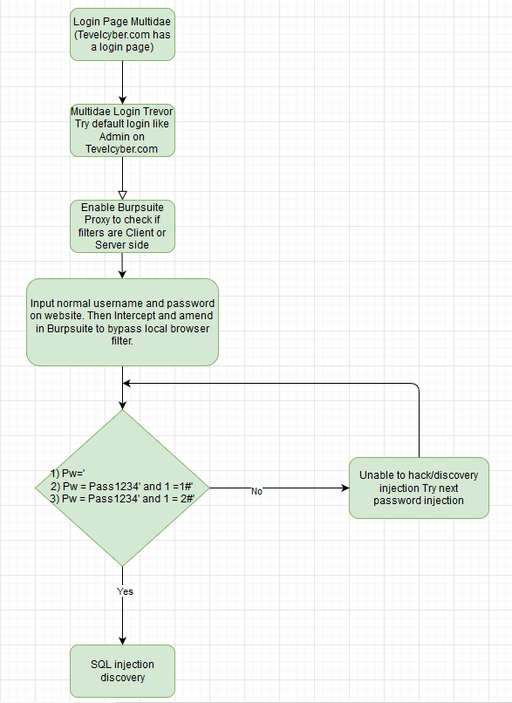
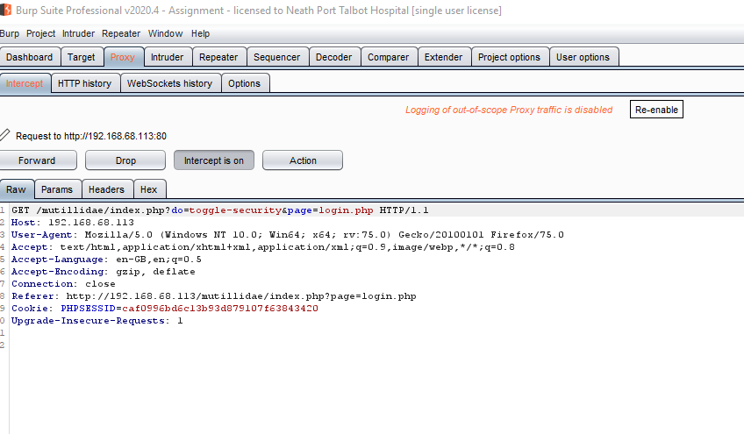

Injection filtered out, no traffic in Burpsuite, which means client/browser side filtering.
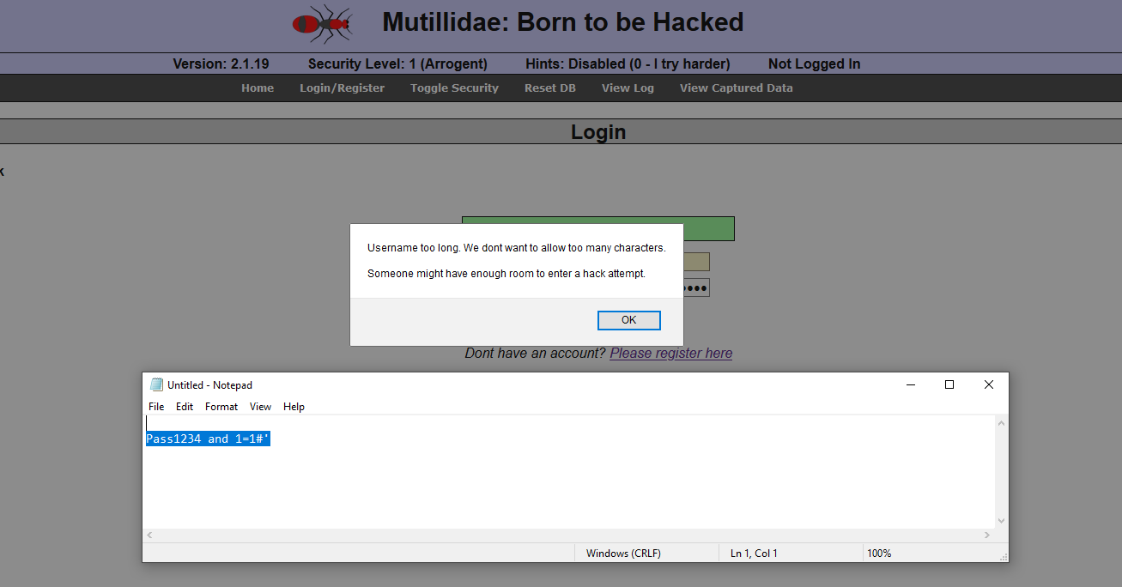

Burpsuite proxy Intercept traffic to Mutillidae Website
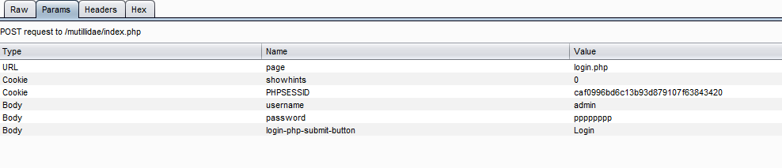

Use Burpsuite to change the password with SQL injection before forwarding onto the website.
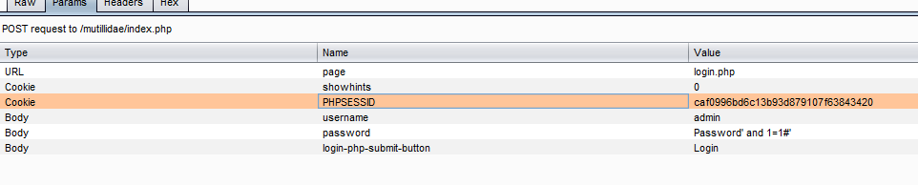
Login successful with SQL discovery Injection
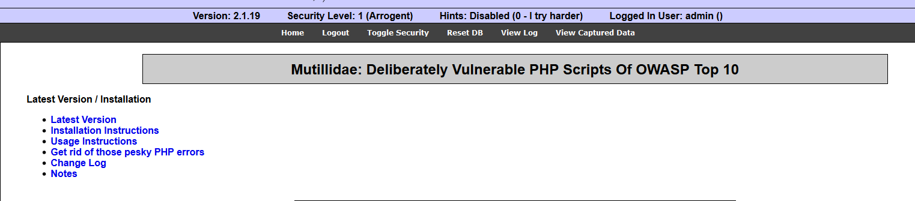

Appendix D: Attack/Hack Methodology – Discover SQL Injections
Discover SQL Injection Vulnerabilities using GET method
Try and inject code in Tevelcyber URL PHP? action=lost ( https://tevelcyber.com/wp-login.php?action=lostpassword)
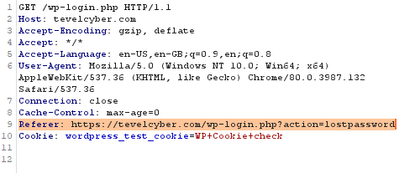

There may be other URLs on the website that could be used to check if SQL injection vulnerabilities exist. However, the company has retracted permission to carry out the Pentest. Mutillidae will be used to go through the GET injection discovery process.

Menu: Owasp Top 10\A1 Injections\SQLi – Extract Data\User Info
http://192.168.68.113/mutillidae/index.php?page=user-info.php&username=admin&password=password&user-info-php-submit-button=View+Account+Details

Select * from username = ‘$USERNAME’ and password=’$PASSWORD’
Inject code directly in the URL.

SQL Injection Methodolgy using GET
Owasp_Checklist [68]

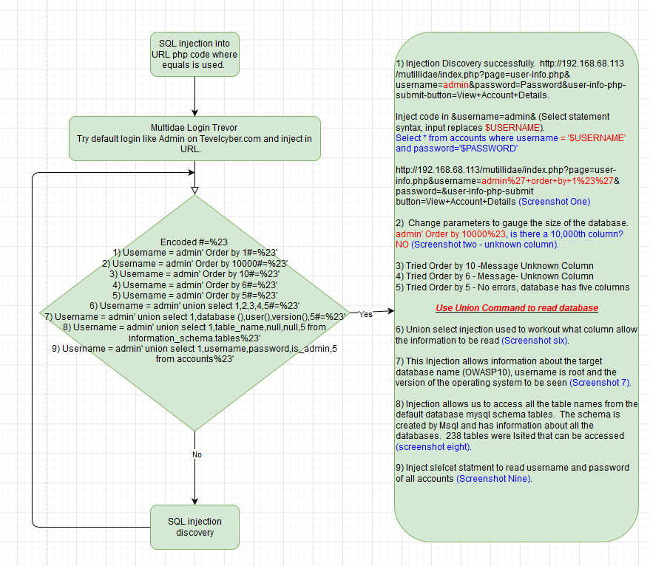

Screenshot One – Order By
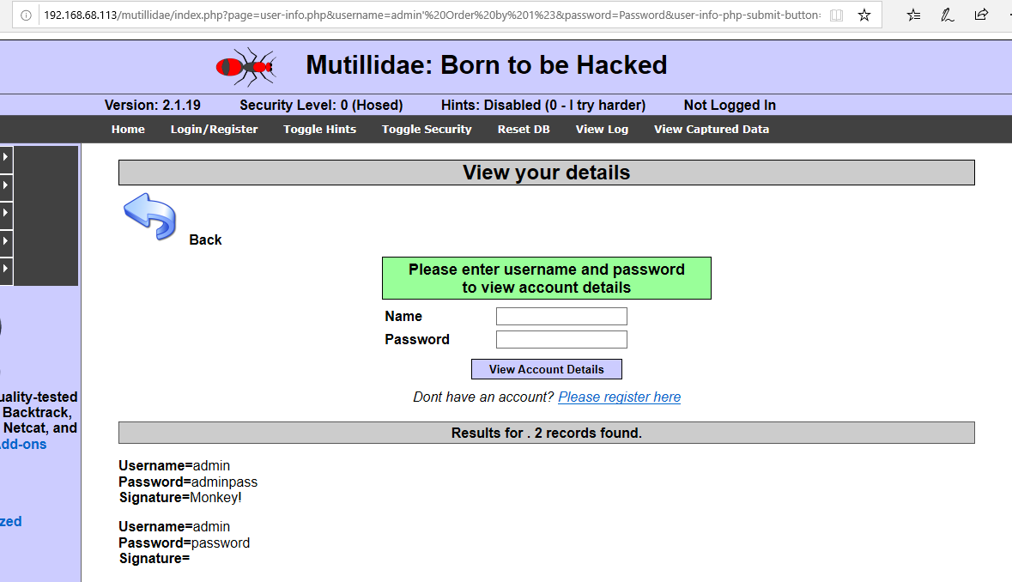

Screenshot Two – Order by
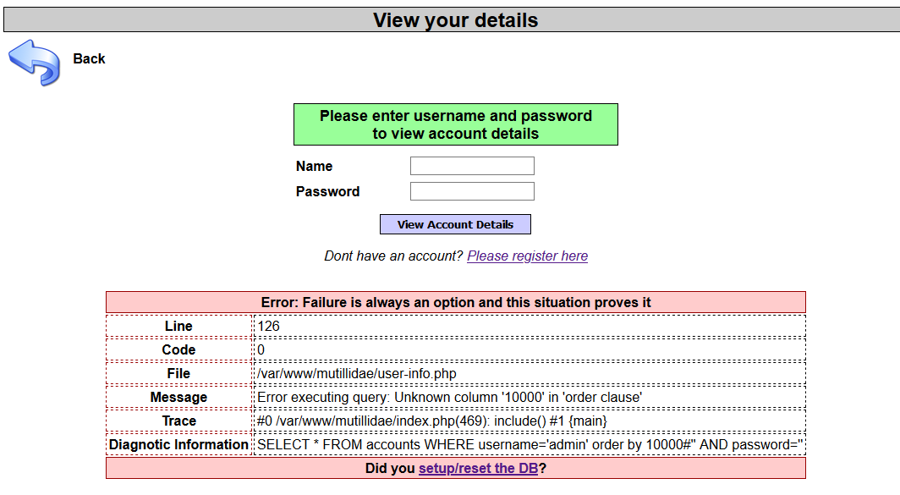

Screenshot Three – Order by
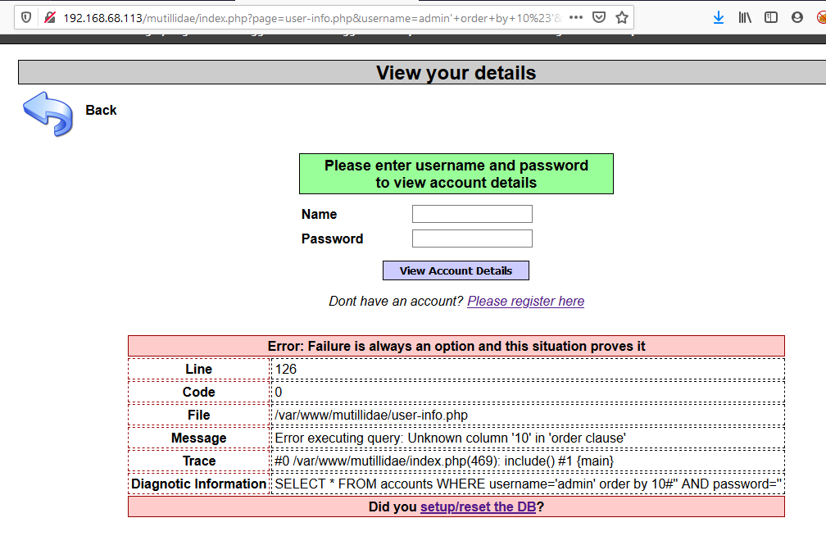

Screenshot four – Order by
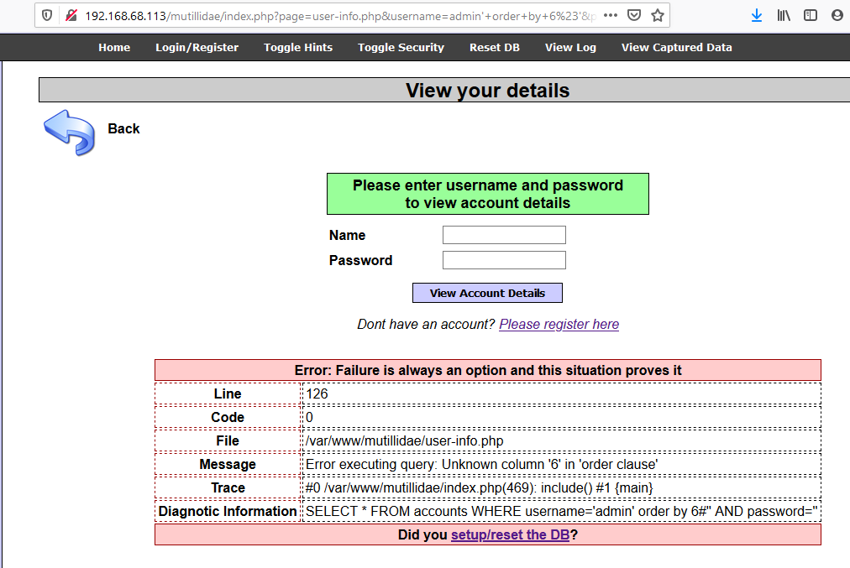

Screenshot Five – Order by
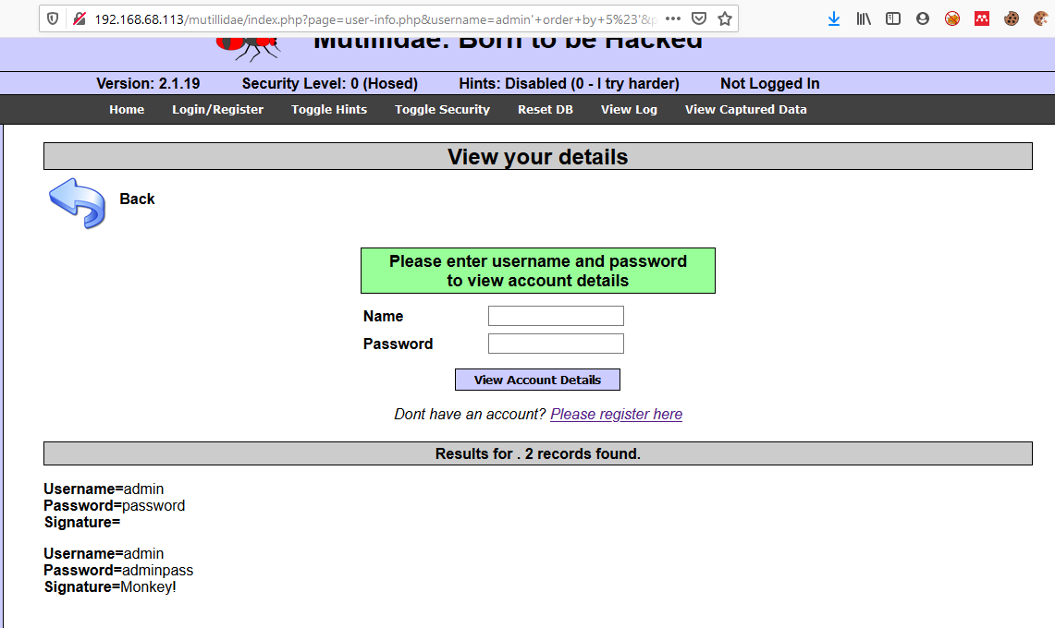
Screenshot Six – Union select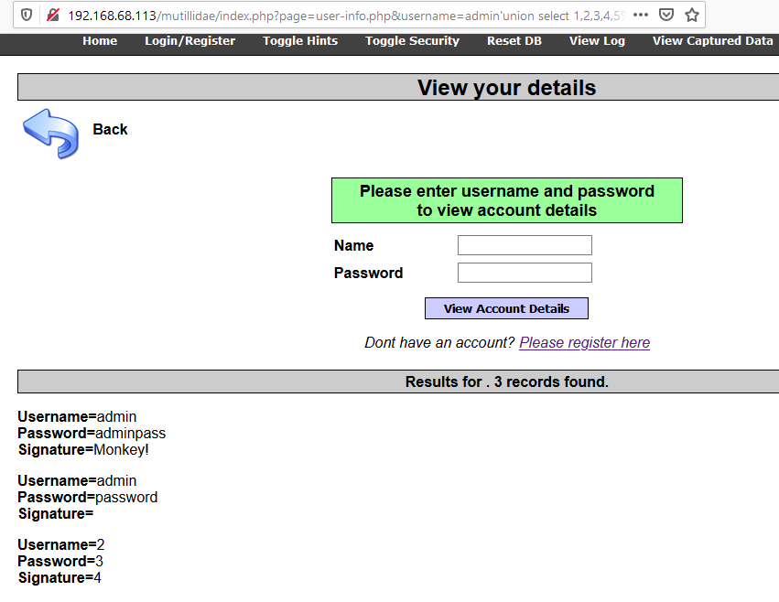

Screenshot Seven – Union Select
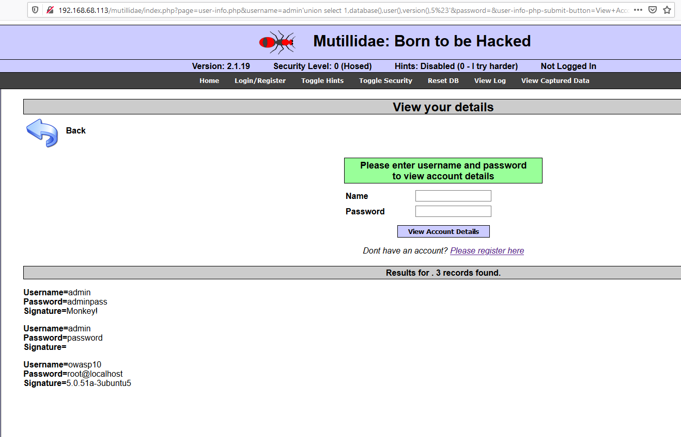
Screenshot Eight – Union Select – Default Mysql schema to read all table information.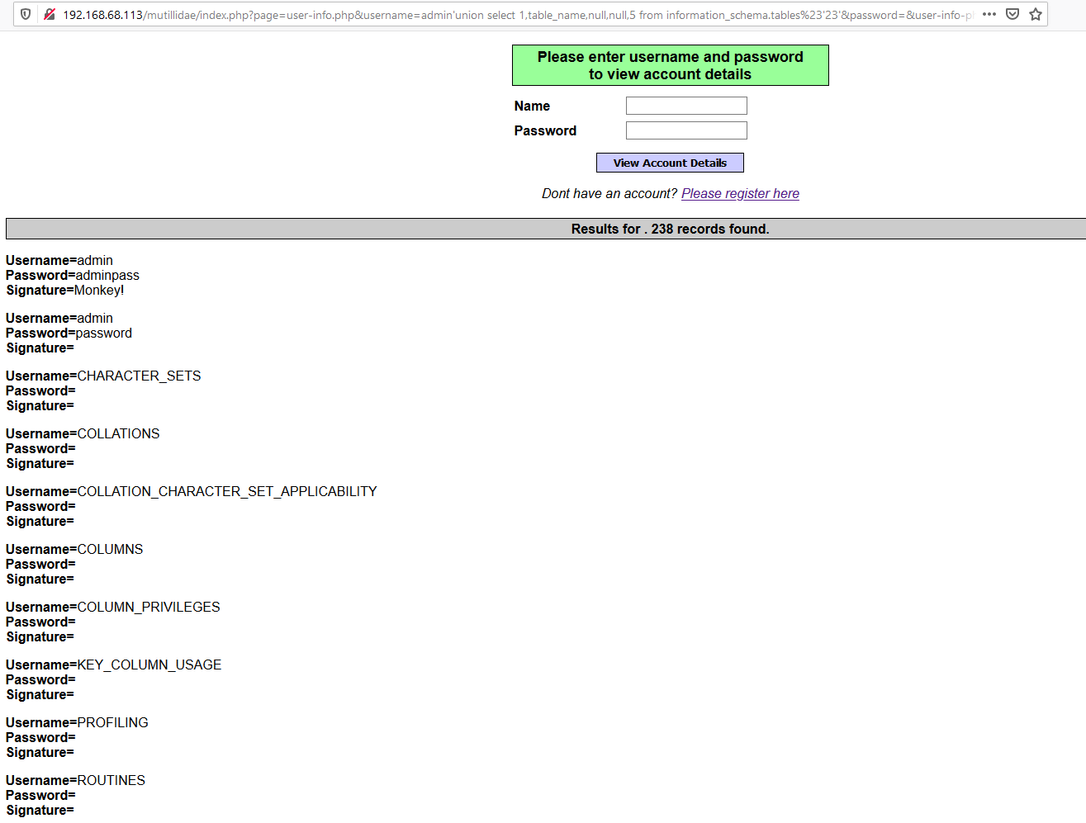
Screenshot Nine – Union Select – User credentials from Account table
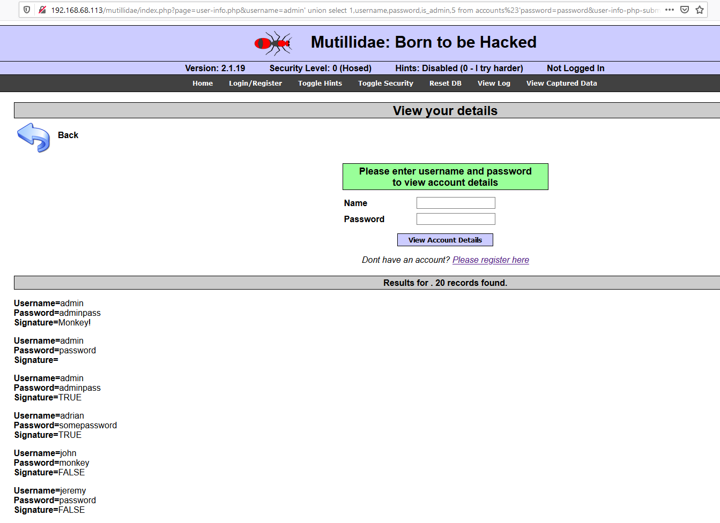

Appendix E: Attack/Hack Methodology – SQL Injection Blind
SQL Injection discover method without any database or system errors displayed (Blind)
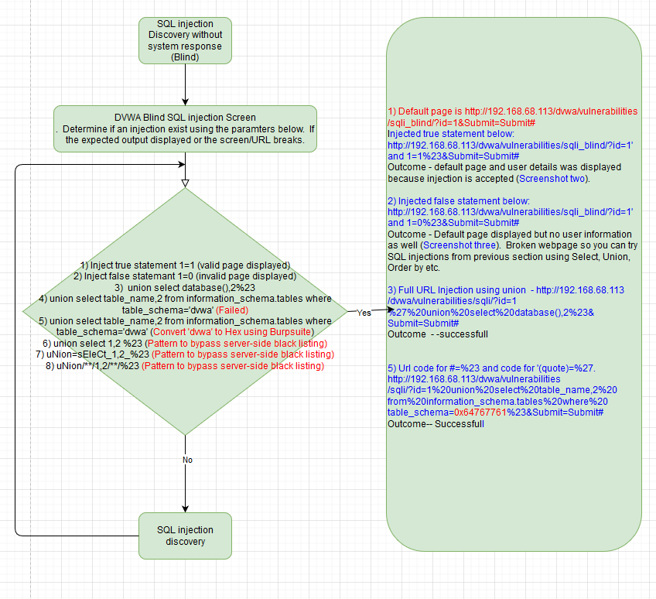

Screenshot One – 1 accepted as input
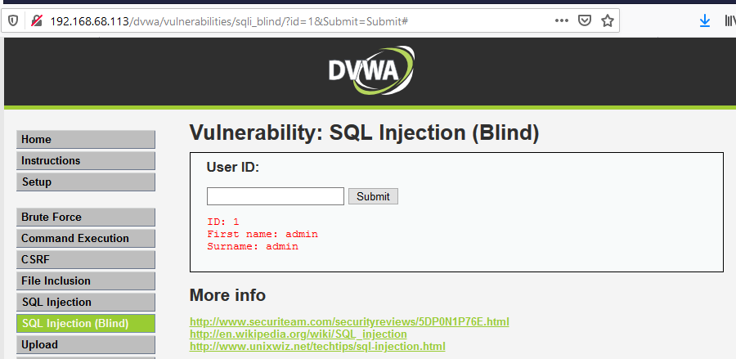

Screenshot two – Accepted true statement (1=1)
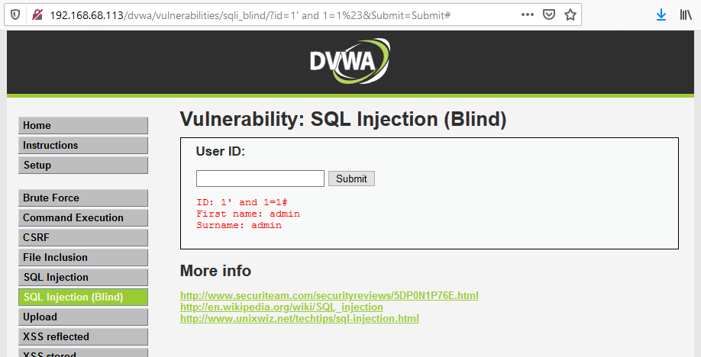

Screenshot three – unaccepted false statement (1=0), i.e., no user output displayed
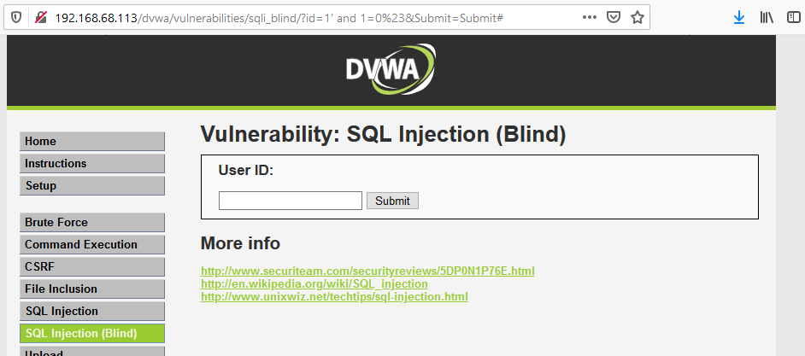

Screenshot three – Union Select injection
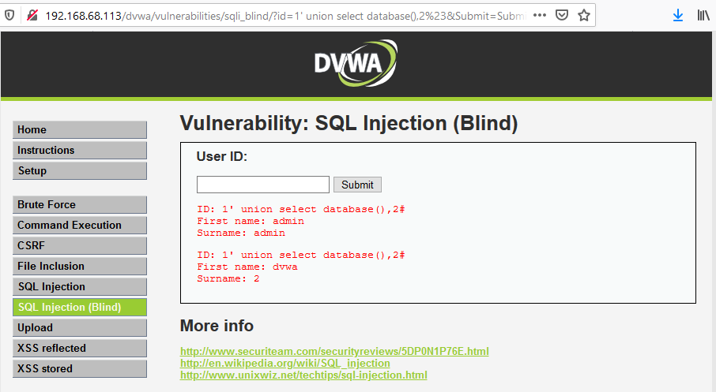

Screenshot four – Server-side security blocks quotation mark usage
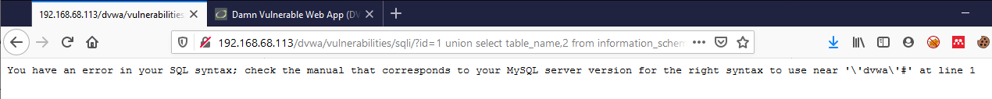
Screenshot five (a) – Burpsuite decoder convert DVWA to Hexidecimal
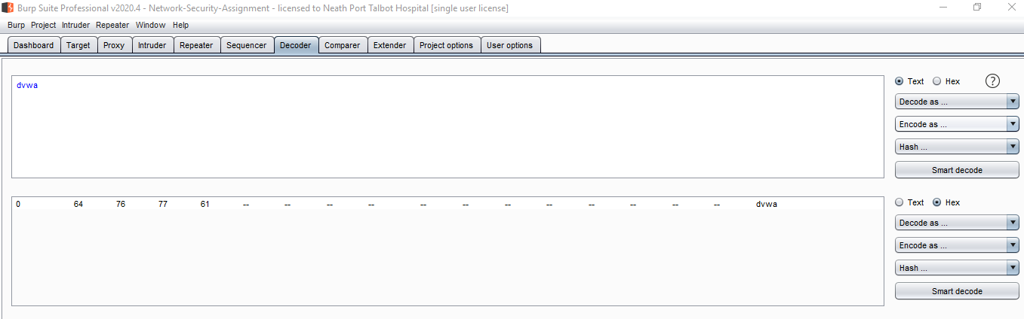

Screenshot five (b) – Burpsuite decoder, convert DVWA to Hexidecimal
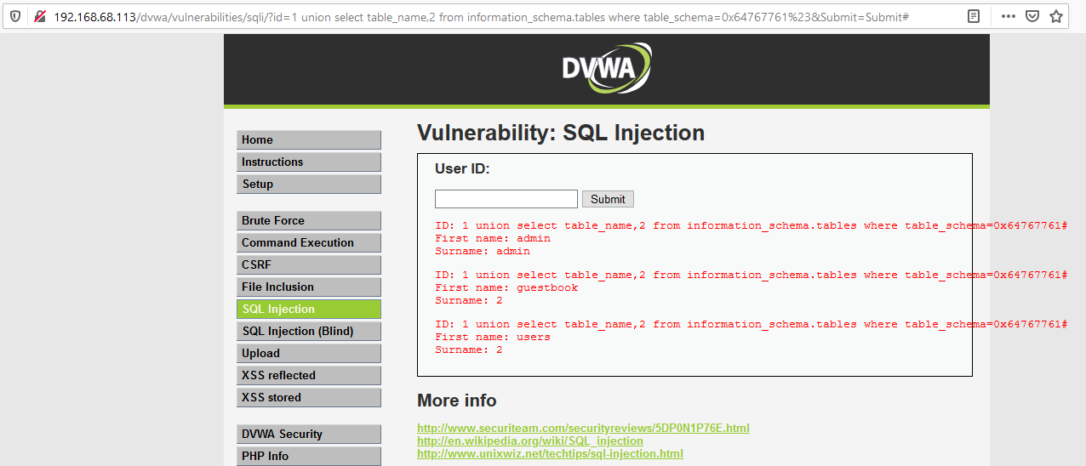

Appendix F: Attack/Hack Methodology – XSS (Beef)
Cross Site Scripting (XSS) Injection and exploitation (Beef)
Owasp_Checklist [68] (Appendix F to H)
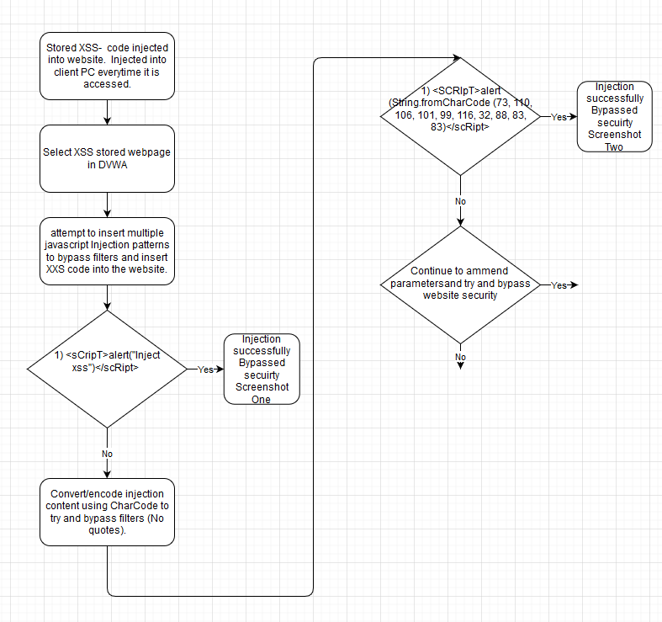
Screenshot One – Successful injection using JavaScript
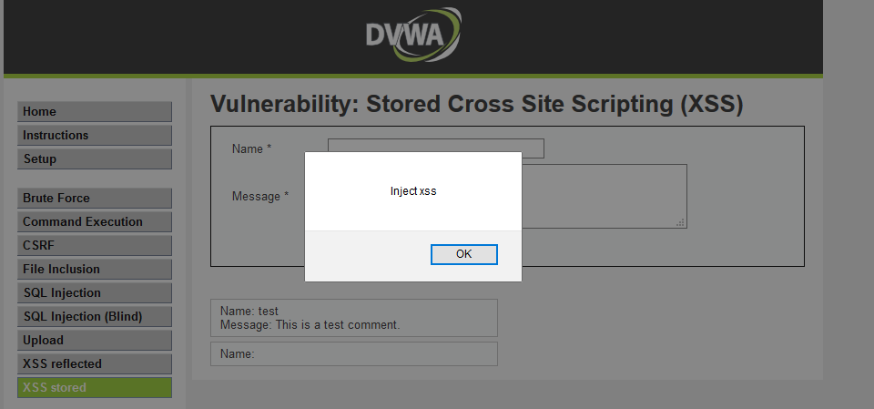

Screenshot Two (a) – Convert/encode using Char Code
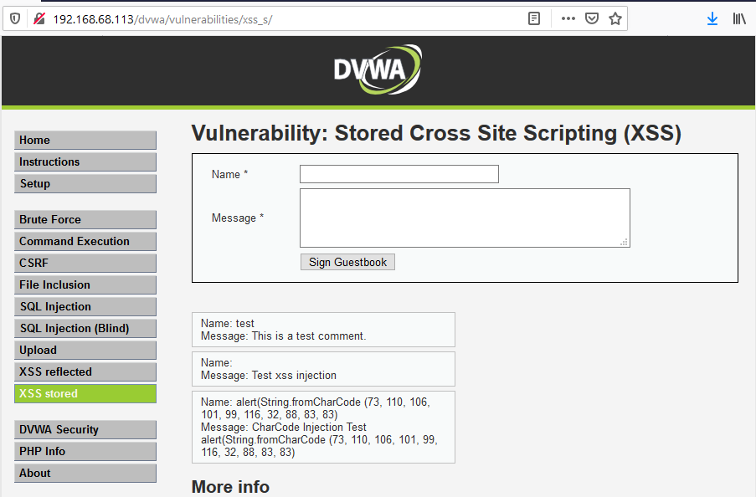

Screenshot Two (b) – Convert/encode using CharCode [69]

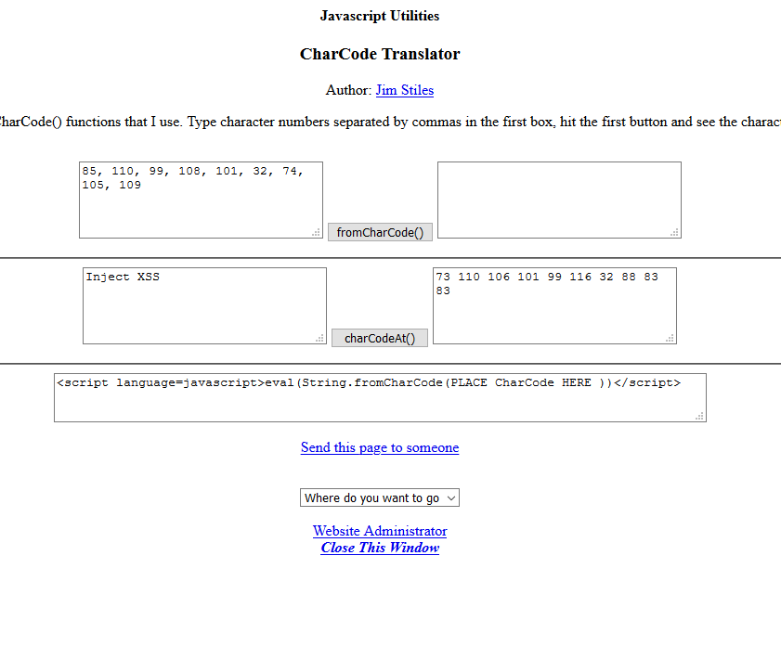

Appendix G: Attack/Hack Methodology – Cross Site Scripting
Exploit XSS using Beef Framework

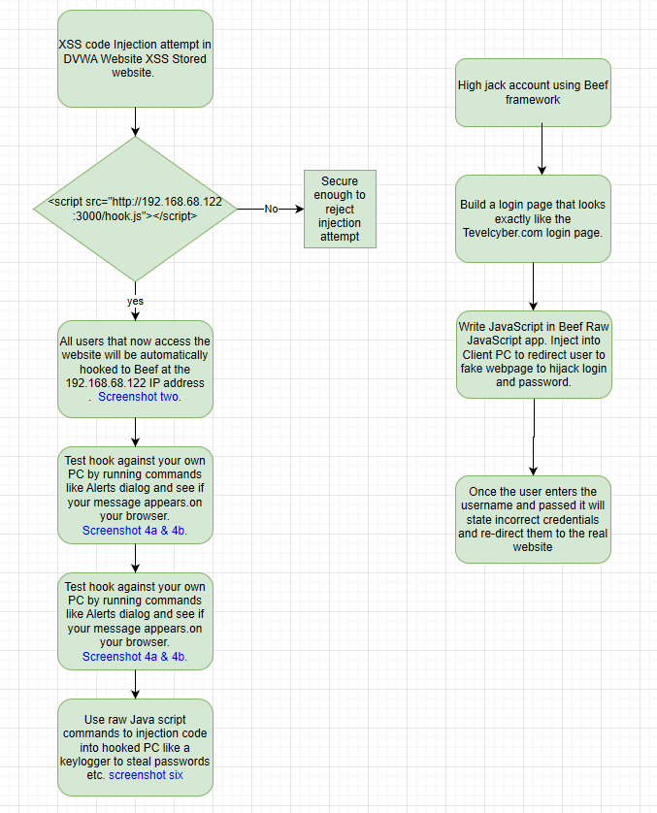

Beef application started with a URL list to inject to hook client PC's
Screenshot One – use URL below to hook users
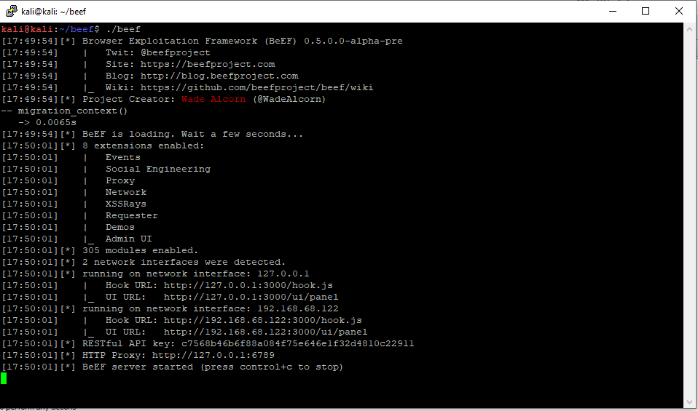

Screenshot two – Injection script accepted
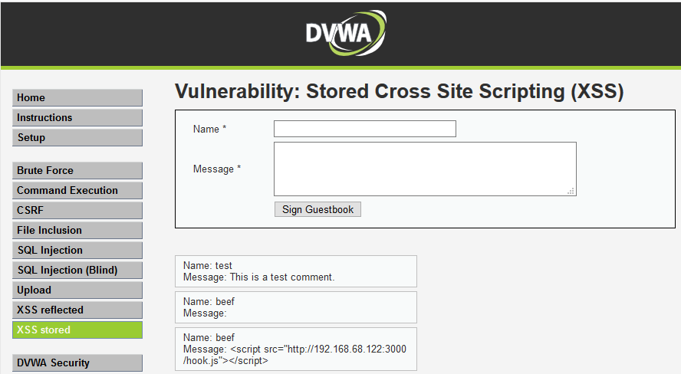

Screenshot Three – Browsed to vulnerable XSS Website from Windows PC
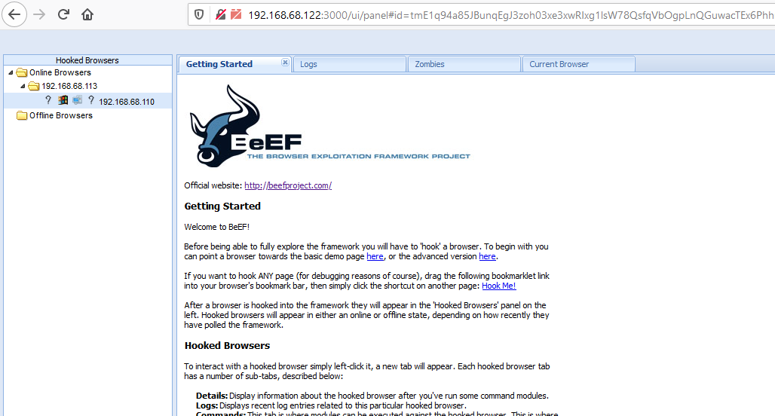

Screenshot four (a) – force message to appear in browser to prove connection/hook to that visted the DVWA website.
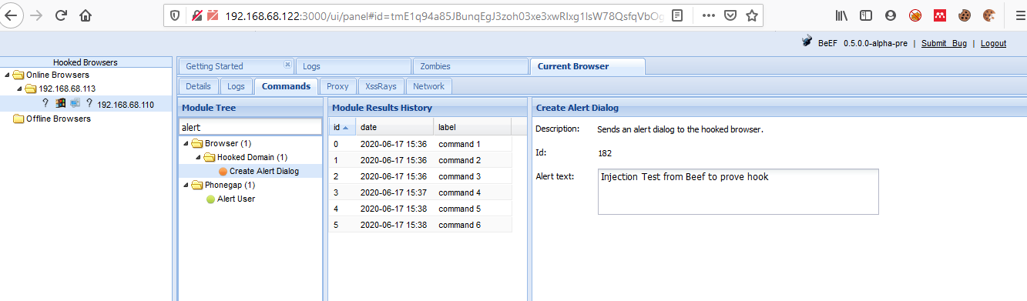

Screenshot four (b) – force message to appear in browser to prove connection/hook to user that visted the DVWA website.
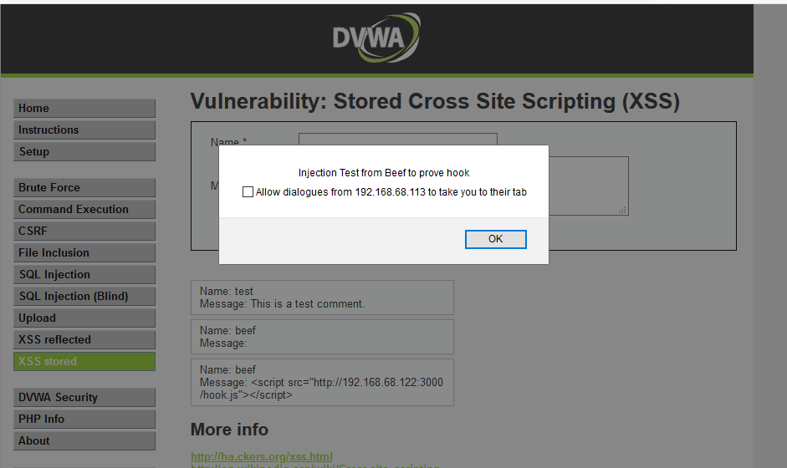

Screenshot Five
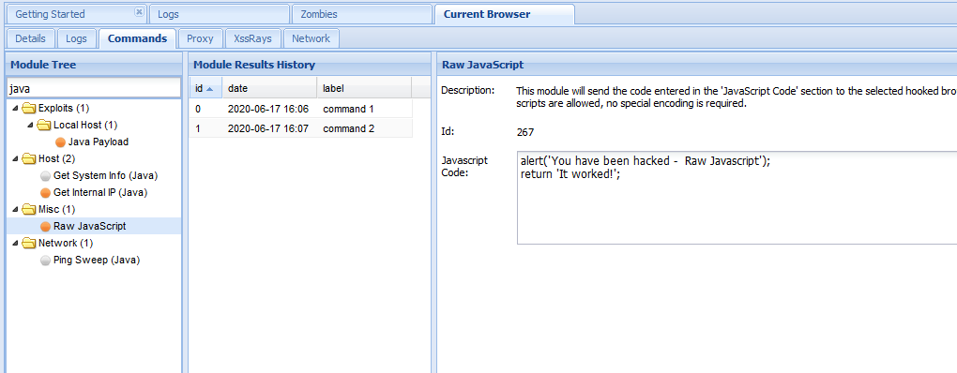

Screenshot Six
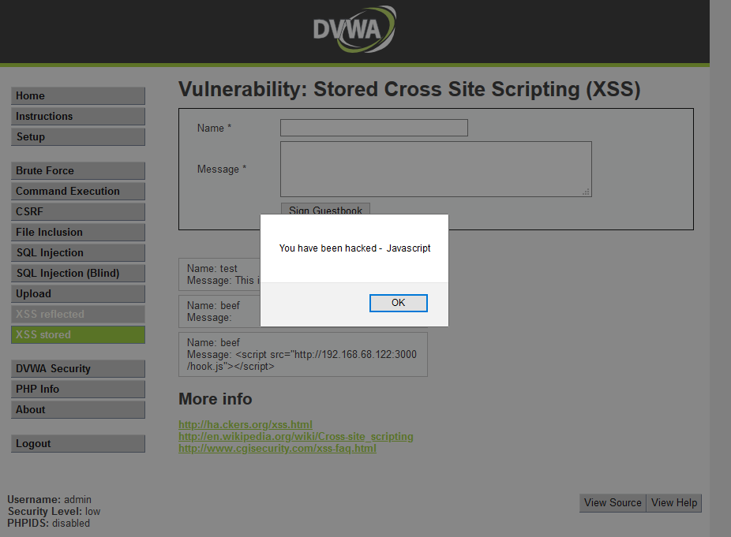

Appendix H: Attack/Hack Methodology - Cross Site Request Recovery
Cross Site Request Forgery [51] Common Weakness Enumeration (CWE): WE-352 Application/Server does not check if a request is valid i.e. send user an email with a code to authorise/allow change.
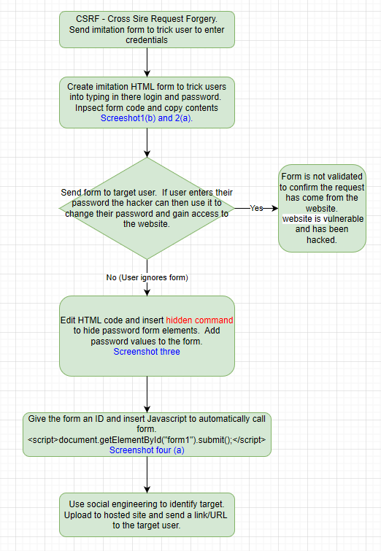
Screenshot One (a)
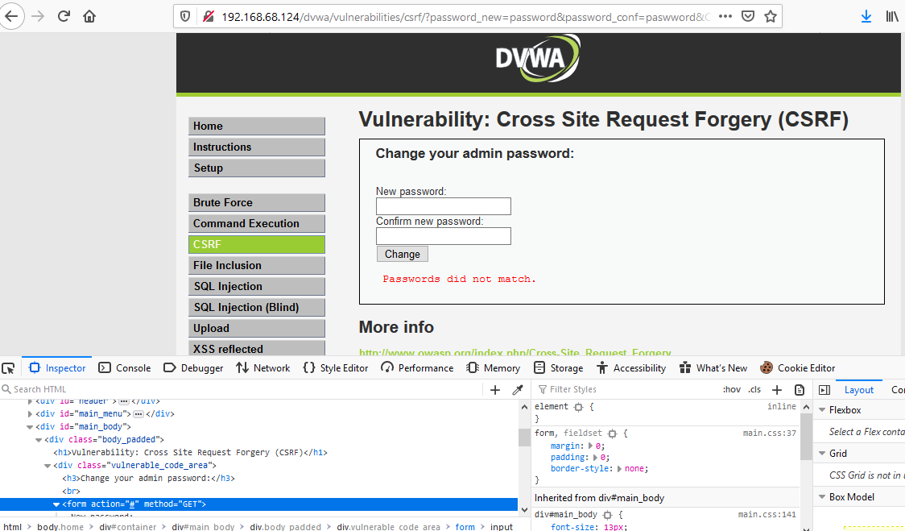

Screenshot One (b)
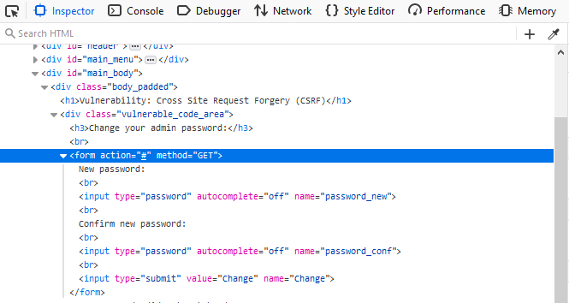

Screenshot Two (a) – Vulnerable/imitation password change form
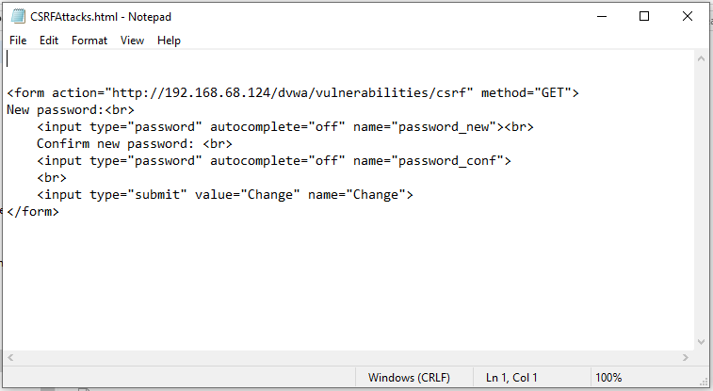

Screenshot Two (b) – Vulnerable/imitation password change form run as HTML code.
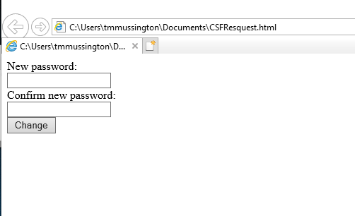

Screenshot two (.C) – Website accepts password change (Vulnerable)
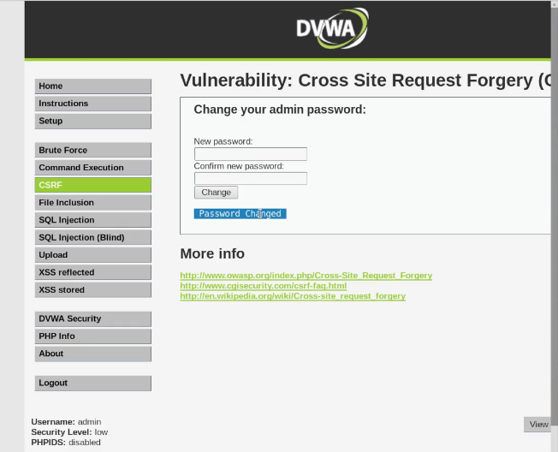

Screenshot three – blank page, source code invisible to user. Page source proves code exists.
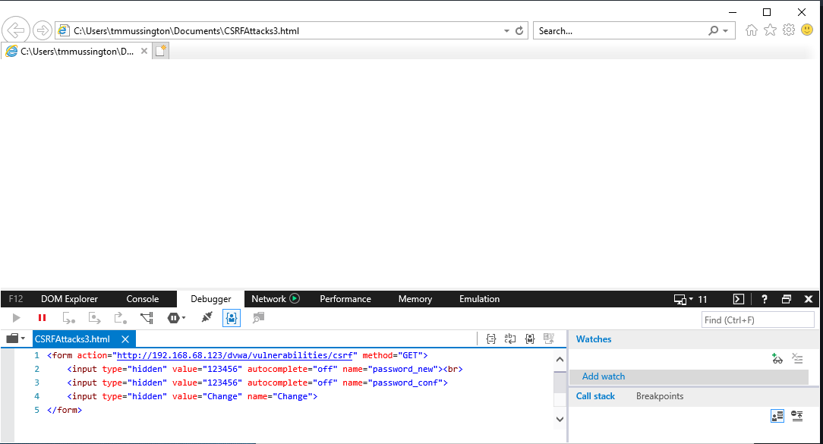

Screenshot Four (a) – Add Javascript and run HTML file created from code.
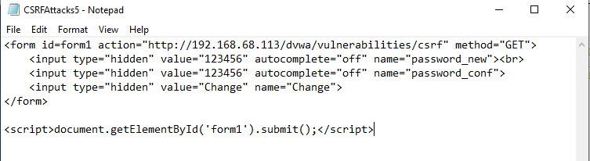

Screenshot Four (b) – ran HTML file and password changed automatically
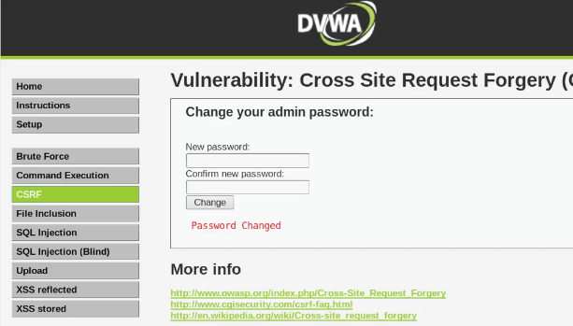

Appendix I: Attack/Hack Methodology – Brute Force
Last resort, brute force attack is the least stealthy and has a high probability of being flagged/alerted to admins and the Security Team.
Owasp_Checklist [68]
Flowchart - Brute force Attack
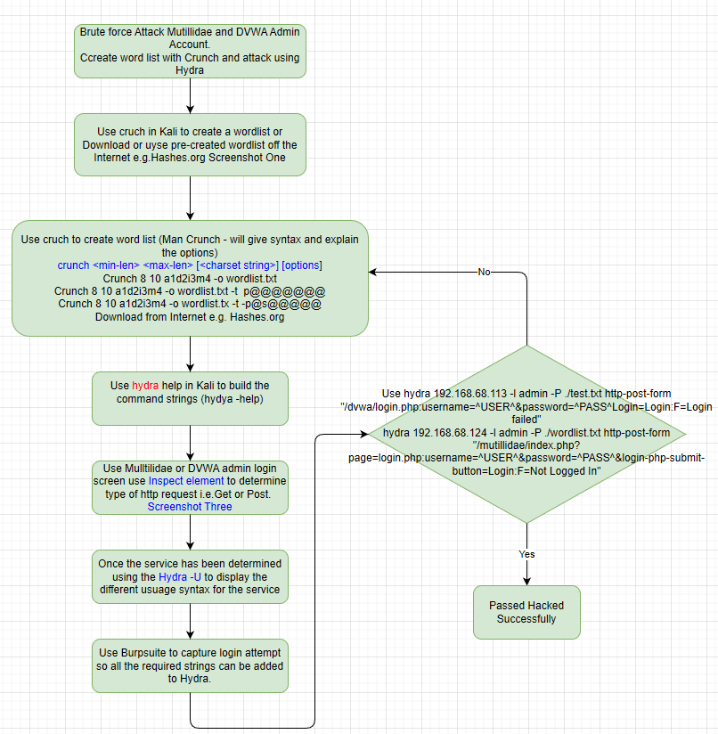
Screenshot One
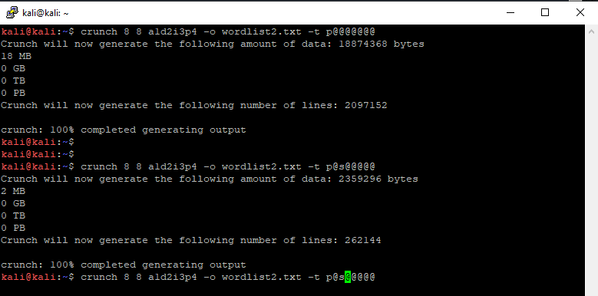

Screenshot Two – Hydra Help

Screenshot Three
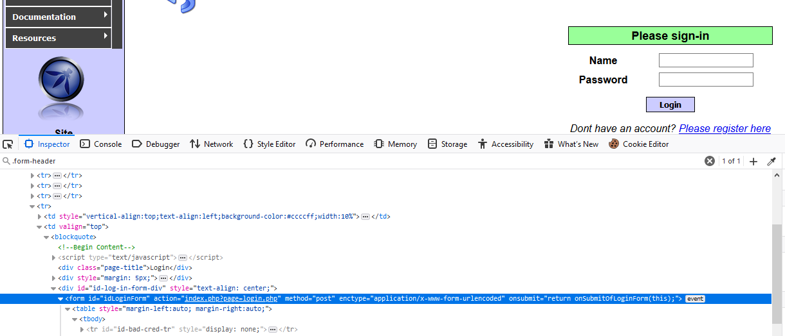

Screenshot Four
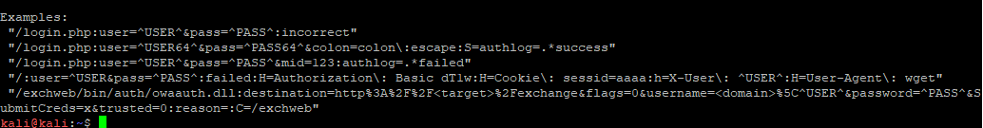

Screenshot Five
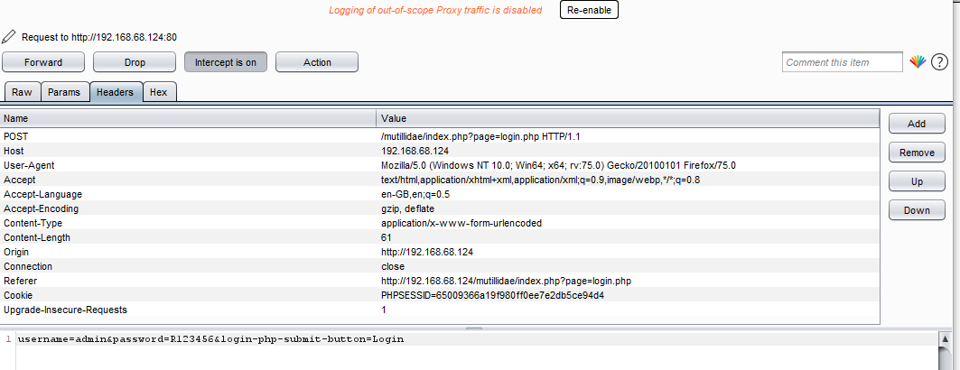
Screenshot Six
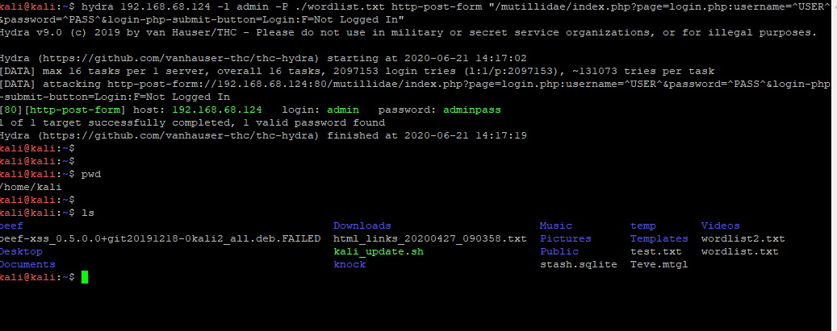

Word List already created
hydra 192.168.68.113 -l admin -P ./wordlist.txt http-post-form "/dvwa/login.php:username=^USER^&password=^PASS^Login=Login:F=Not Logged In"

References

[1] ‘UK experiencing four “nationally significant” cyber... - NCSC.GOV.UK’. Accessed: Jan. 15, 2026. [Online]. Available: https://www.ncsc.gov.uk/news/uk-experiencing-four-nationally-significant-cyber-attacks-weekly
[2] ‘Introduction: Incident Response overview - NCSC.GOV.UK’. Accessed: Jan. 05, 2026. [Online]. Available: https://www.ncsc.gov.uk/collection/incident-management/incident-response
[3] S. Alder, ‘New York Blood Center Enterprises Notifies Individuals Affected by January Ransomware Attack’, The HIPAA Journal. Accessed: Jan. 15, 2026. [Online]. Available: https://www.hipaajournal.com/new-york-blood-center-enterprises-ransomware/
[4] ‘New York Blood Center Enterprises hit by ransomware attack’. Accessed: Jan. 15, 2026. [Online]. Available: https://www.digitalhealth.net/2025/02/new-york-blood-center-enterprises-hit-by-ransomware-attack/
[5] ‘Introduction - What’s currently available - Guides at The British Library’. Accessed: Jan. 15, 2026. [Online]. Available: https://bl.libguides.com/currently-available
[6] B. Library, ‘British Library cyber incident review’, [Online]. Available: https://www.bl.uk/home/british-library-cyber-incident-review-8-march-2024.pdf/
[7] ‘NYU Website Hack Leads to the Exposure of 3 Million Applicants’ Data’. Accessed: Jan. 15, 2026. [Online]. Available: https://cyberinsider.com/nyu-website-hack-leads-to-the-exposure-of-3-million-applicants-data/?utm_source=chatgpt.com
[8] ‘NYU hit with 10 class action lawsuits following data breach - Washington Square News’. Accessed: Jan. 15, 2026. [Online]. Available: https://nyunews.com/news/2025/04/01/nyu-data-breach-lawsuits/?utm_source=chatgpt.com
[9] ‘New York Blood Center notifies 194,000 people of data breach - Comparitech’. Accessed: Jan. 15, 2026. [Online]. Available: https://www.comparitech.com/news/new-york-blood-center-notifies-194000-people-of-data-breach/
[10] H. J. Hadi, N. Ahmad, K. Aziz, Y. Cao, and M. A. Alshara, ‘Cost-Effective Resilience: A Comprehensive Survey and Tutorial on Assessing Open-Source Cybersecurity Tools for Multi-Tiered Defense’, IEEE Access, vol. 12, pp. 194053–194076, 2024, doi: 10.1109/ACCESS.2024.3510533.
[11] ‘Blog - Intrinsec’. Accessed: Jan. 15, 2026. [Online]. Available: https://intrinsecsecurity.com/blog/
[12] D. Shobana, ‘The Edge2025 finalBook (1)’, 2025, pp. 35–40.
[13] ‘1.4 Analyse vulnerabilities against inherent ML threats - NCSC.GOV.UK’. Accessed: Jan. 03, 2026. [Online]. Available: https://www.ncsc.gov.uk/collection/machine-learning-principles/secure-design/analyse-vulnerabilities
[14] ‘OWASP Top Ten 2017 | Table of Contents | OWASP Foundation’. Accessed: Jan. 03, 2026. [Online]. Available: https://owasp.org/www-project-top-ten/2017/
[15] ‘MITRE ATT&CK®’. Accessed: Jan. 05, 2026. [Online]. Available: https://attack.mitre.org/
[16] ‘How AI Caught APT41 Exploiting Vulnerabilities’. Accessed: Jan. 05, 2026. [Online]. Available: https://www.darktrace.com/blog/catching-apt41-exploiting-a-zero-day-vulnerability
[17] ‘APT Groups and Operations - Google Sheets’. Accessed: Jan. 03, 2026. [Online]. Available: https://docs.google.com/spreadsheets/d/1H9_xaxQHpWaa4O_Son4Gx0YOIzlcBWMsdvePFX68EKU/edit?gid=1864660085#gid=1864660085
[18] ‘OWASP Top 10:2021’. Accessed: Jan. 03, 2026. [Online]. Available: https://owasp.org/Top10/2021/
[19] H. Rashid, H. B. Liaqat, M. U. Sana, T. Kiren, H. Karamti, and I. Ashraf, ‘Framework for detecting phishing crimes on Twitter using selective features and machine learning’, Comput. Electr. Eng., vol. 124, p. 110363, May 2025, doi: 10.1016/j.compeleceng.2025.110363.
[20] ‘Understanding Social Engineering Victimisation on Social Networking Sites: A Comprehensive Review of Factors Influencing User Susceptibility to Cyber-Attacks - ProQuest’. Accessed: Jan. 03, 2026. [Online]. Available: https://www.proquest.com/openview/91da11222b008297442b62e1dfff492f/1?pq-origsite=gscholar&cbl=2032384
[21] ‘Testing Checklist | OWASP Testing Guide’. Accessed: Jan. 04, 2026. [Online]. Available: https://owasp.boireau.io/checklist
[22] ‘Cervantes - OWASP Checklist & Report Generation - YouTube’. Accessed: Jan. 04, 2026. [Online]. Available: https://www.youtube.com/watch?v=b6Y0Cs6HH_w
[23] ‘WSTG - v4.2 | OWASP Foundation’. Accessed: Jan. 03, 2026. [Online]. Available: https://owasp.org/www-project-web-security-testing-guide/v42/
[24] ‘Vulnerabilities in the Cloud | CSA’. Accessed: Apr. 24, 2025. [Online]. Available: https://cloudsecurityalliance.org/research/topics/vulnerabilities
[25] National Institute of Standards and Technology, ‘The NIST Cybersecurity Framework (CSF) 2.0’, National Institute of Standards and Technology, Gaithersburg, MD, NIST CSWP 29, Feb. 2024. doi: 10.6028/NIST.CSWP.29.
[26] ‘Zero trust in cybersecurity: managing critical challenges for effective implementation - ScienceDirect’. Accessed: Jan. 15, 2026. [Online]. Available: https://www-sciencedirect-com.uwtsd.idm.oclc.org/org/science/article/abs/pii/S1328726525000102
[27] Y. Guo et al., ‘A Security Protection Technology Based on Multi-factor Authentication’, in 2022 IEEE 2nd International Conference on Mobile Networks and Wireless Communications (ICMNWC), Tumkur, Karnataka, India: IEEE, Dec. 2022, pp. 1–5. doi: 10.1109/ICMNWC56175.2022.10032006.
[28] ‘Mapping the Forensic Standard ISO/IEC 27037 to Cloud Computing’, CSA. Accessed: Dec. 06, 2024. [Online]. Available: https://cloudsecurityalliance.org/artifacts/mapping-the-forensic-standard-isoiec-27037-to-cloud-computing
[29] Joint Task Force Interagency Working Group, ‘Security and Privacy Controls for Information Systems and Organizations’, National Institute of Standards and Technology, Sep. 2020. doi: 10.6028/NIST.SP.800-53r5.
[30] ‘CWE - CWE-284: Improper Access Control (4.19)’. Accessed: Jan. 05, 2026. [Online]. Available: https://cwe.mitre.org/data/definitions/284.html
[31] ‘CWE - CWE-285: Improper Authorization (4.19)’. Accessed: Jan. 05, 2026. [Online]. Available: https://cwe.mitre.org/data/definitions/285.html
[32] ‘CWE - CWE-862: Missing Authorization (4.19)’. Accessed: Jan. 05, 2026. [Online]. Available: https://cwe.mitre.org/data/definitions/862.html
[33] ‘CWE - CWE-319: Cleartext Transmission of Sensitive Information (4.19)’. Accessed: Jan. 05, 2026. [Online]. Available: https://cwe.mitre.org/data/definitions/319.html
[34] ‘CWE - CWE-326: Inadequate Encryption Strength (4.19)’. Accessed: Jan. 05, 2026. [Online]. Available: https://cwe.mitre.org/data/definitions/326.html
[35] ‘CWE - CWE-311: Missing Encryption of Sensitive Data (4.19)’. Accessed: Jan. 05, 2026. [Online]. Available: https://cwe.mitre.org/data/definitions/311.html
[36] ‘CWE - CWE-1348: CWE CATEGORY: OWASP Top Ten 2021 Category A04:2021 - Insecure Design (4.19)’. Accessed: Jan. 05, 2026. [Online]. Available: https://cwe.mitre.org/data/definitions/1348.html
[37] ‘A01 Broken Access Control - OWASP Top 10:2021’. Accessed: Jan. 15, 2026. [Online]. Available: https://owasp.org/Top10/2021/A01_2021-Broken_Access_Control/
[38] ‘A03 Injection - OWASP Top 10:2021’. Accessed: Jan. 15, 2026. [Online]. Available: https://owasp.org/Top10/2021/A03_2021-Injection/
[39] ‘Implementing Machine Learning in the Context of Web Application Firewalls | IEEE Conference Publication | IEEE Xplore’. Accessed: Jan. 04, 2026. [Online]. Available: https://ieeexplore.ieee.org/document/10584028
[40] ‘ASystematic Literature Review on Penetration Testing in Networks - Future Research Directions’.
[41] ‘A02 Cryptographic Failures - OWASP Top 10:2021’. Accessed: Jan. 15, 2026. [Online]. Available: https://owasp.org/Top10/2021/A02_2021-Cryptographic_Failures/
[42] ‘Using Transport Layer Security to protect data - NCSC.GOV.UK’. Accessed: Jan. 04, 2026. [Online]. Available: https://www.ncsc.gov.uk/guidance/using-tls-to-protect-data
[43] ‘A05 Security Misconfiguration - OWASP Top 10:2021’. Accessed: Jan. 15, 2026. [Online]. Available: https://owasp.org/Top10/2021/A05_2021-Security_Misconfiguration/
[44] S. Patil, M. Rao, L. Misal, D. Phaldesai, and K. Shivsharan, ‘A Review of the OW ASP Top 10 Web Application Security Risks and Best Practices for Mitigating These Risks’, in 2023 7th International Conference On Computing, Communication, Control And Automation (ICCUBEA), Pune, India: IEEE, Aug. 2023, pp. 1–8. doi: 10.1109/ICCUBEA58933.2023.10392030.
[45] R. Singh, M. Kumar Gupta, D. R. Patil, and S. Maruti Patil, ‘Analysis of Web Application Vulnerabilities using Dynamic Application Security Testing’, in 2024 IEEE 9th International Conference for Convergence in Technology (I2CT), Pune, India: IEEE, Apr. 2024, pp. 1–6. doi: 10.1109/I2CT61223.2024.10543484.
[46] ‘A09 Security Logging and Monitoring Failures - OWASP Top 10:2021’. Accessed: Jan. 15, 2026. [Online]. Available: https://owasp.org/Top10/2021/A09_2021-Security_Logging_and_Monitoring_Failures/
[47] ‘Effectiveness of Using OWASP TOP 10 as AppSec Standard | IEEE Conference Publication | IEEE Xplore’. Accessed: Jan. 04, 2026. [Online]. Available: https://ieeexplore.ieee.org/document/10078626
[48] ‘A09 Security Logging and Monitoring Failures - OWASP Top 10:2021’. Accessed: Jan. 15, 2026. [Online]. Available: https://owasp.org/Top10/2021/A09_2021-Security_Logging_and_Monitoring_Failures/
[49] ‘A04 Insecure Design - OWASP Top 10:2021’. Accessed: Jan. 15, 2026. [Online]. Available: https://owasp.org/Top10/2021/A04_2021-Insecure_Design/
[50] ‘CWE - CWE-89: Improper Neutralization of Special Elements used in an SQL Command ('SQL Injection’) (4.19)’. Accessed: Jan. 04, 2026. [Online]. Available: https://cwe.mitre.org/data/definitions/89.html
[51] ‘CWE - CWE-352: Cross-Site Request Forgery (CSRF) (4.19)’. Accessed: Jan. 04, 2026. [Online]. Available: https://cwe.mitre.org/data/definitions/352.html

