Apply The Greener Practice Initiative on the Radisson Blu Edwardian Hotel
Report
SUBMITTED TO: Giulia Chifari
SUBMITTED BY: Kamrul Khan
MODULE TITLE: Sustainable Hospitality & Tourism Management
STUDENT NUMBER: 2022307511
MODULE CODE: BMIH5006

Acknowledgment
For this report, I have not generated anything from AI. And I acknowledge that I also Used Grammarly to check my work.

Executive Summary:
This report investigates the implementation of Greener Practice deployed at the Radisson Blu Edwardian Hotel with a focus on long-term practices to enhance environmental responsibility. Greener Practices are defined as environmentally sound techniques to decrease a hotel’s carbon footprint and leverage sustainability. A specific Greener Practice is identified in the report and its implementation, benefits, and challenges are described. Successes at other hotels that have followed the same measures are pointed to, and such practices do hold promise in reducing costs and producing a better guest experience. Furthermore, the report analyses the environmental benefits, such as having less waste and lower energy use. The analysis leads to a conclusion with actionable recommendations based on their analysis highlighting the need to integrate sustainability into hotel operations to make them more viable for business, while still preserving a Greener future. This report in general seeks to unravel opportunities for strategically designing Greener Practices to make the Radisson Blu Edwardian Hotel more sustainable.

Contents
Acknowledgment 1
Executive Summary 2
Introduction 4
Greener Practice Initiative Selected for the Radisson Blu Edwardian Hotel: 4
Water-Saving Technologies and Low-Flow Fixtures: 5
Greywater Recycling Systems 6
Training of Employees and Guest Awareness Schemes 6
Water Usage Monitoring and Measurement 6
Other Hotels implemented this initiative 7
Hilton Worldwide: 7
Marriott International: 8
InterContinental Hotels Group 9
Water Conservation Advantages for Sustainability Hotels 9
Challenges 11
Cost-Effectiveness of Sustainability Initiatives: 12
Realistic of Water Conservation Initiatives in Hotels: 12
Environmental Benefits of Water Conservation Initiatives in Hotels: 13
Conclusion 14
References 16

Introduction:
In the recent past, two decades to be precise, there has been heightened adoption of greener practices in the running of hotels mainly because of the social-cultural responsibility that industry players and sustainable business returns associated with the practice. Greener practice refers to actions and policies advocated to conserve natural resources, reduce waste and pollution, and increase overall efficiency in a hotel’s daily operations. These steps work their way from energy-efficient lighting to reducing single-use plastics, parallel to the greater efforts to be more sustainable in a hospitality setting (International Tourism Partnership, 2021). Today, many hotels are becoming eco-certified, such as the Green Key, which recognises hotels and facilities for meeting rigorous environmental criteria and demonstrating a reduction in their environmental effect (World Travel and Tourism Council, 2020).
In this report, the Radisson Blu Edwardian Hotel in Manchester is selected and known for its luxury accommodation and modern amenities. It is situated in the centre of the city centre of Manchester which attracts several different customers, business travellers, and tourists. With some environmental effects, i.e. using energy-efficient lighting and preventing wastage the hotel Radisson Blu Edwardian has taken some steps but they should go further. If the hotel expands its options for additional green practices it can improve the hotel’s eco image and possibly appeal to the guests, while trying for a better eco-certification status.

Greener Practice Initiative Selected for the Radisson Blu Edwardian Hotel:
The greener practice initiative selected for the Radisson Blu Edwardian Hotel is water conservation and wastewater management. To address the problem of water shortage and high use of water for this industry, an appropriate strategy of the report will entail water conservation and proper management of wastewater. For hotels, water conservation initiatives are particularly important with the industry being one of the highest water consuming by guests per night. Through this, It is also possible to significantly improve the ecological efficiency of the hotel and at the same time receive increased amounts of revenue through the application of effective measures for water management.

Water-Saving Technologies and Low-Flow Fixtures:
One aspect of the water conservation drive entails the provision of low-flow fixtures in guest rooms; Shower, faucets, and toilets. Low-flow technology decreases the flow rate of water per minute without making guests uncomfortable, therefore, making recommendations for hospitality a necessity. Water-conserving technologies cut down the rate per minute of water use without detrimentally affecting the comfort of the guests, which is significant in maintaining the highest standard of hospitality (Smith et al, 2019). For example, low-flow showerheads can cut the flow of water by half from 2.5 gallons to 1.5 gallons, which initiates huge savings on water usage (Plumbing, 2019). Also adopting dual-flush toilets offers guests a choice on which water amount to use each time by saving the excess water in another approach that is effective but very simple. In addition, installing the dual flush toilet amenities for the guests enables them to use different water volumes according to their requirements in the most effective way ever known for water-saving techniques (UK Green Building Council, 2021). Cohen, (2020) stated that low-flow technology is a realistic and sustainable solution for hospitality environments, helping to minimise operational expenses and environmental effects.

Greywater Recycling Systems:
The greywater recycling system is also a significant component of this determination. Greywater is wastewater from sinks, showers, and laundry that is relatively clean and can be recycled for uses other than potable water, such as toilet flushing or landscape irrigation (Environmental Protection Agency, 2020). This way, the company using the greywater resulting from the Radisson Blu Edwardian may cut back on the use of fresh water and greywater needs not to be treated. Greywater recycling requires storage and a means through which the water is treated and purified for intended secondary use. Although the establishment of greywater systems may require an investment the replacement cost of the water utility and the minimal impact on the environment provides financial and environmental gains (Gössling et al, 2021). Friedler and Alfiya, (2021) studies demonstrate that recycling grey water can be a big water-saving accomplish in high-demand environments, such as hotels.

Training of Employees and Guest Awareness Schemes:
In terms of the water conservation programme, awareness among the employees and the guests is inestimable. It is expected that employees should learn ways of detecting and promptly reporting leaks, controlling the use of water in most intensive areas, including kitchens and laundry areas, and adopting efficient means of cleaning with little use of water (Miller and Ward, 2021). Eco-friendly practices can also be encouraged by guest awareness programs which share information on water conservation efforts, and remind guests to use less water. Chan and Wong, (2021) emphasise that staff and guests can be educated on conservation which will increase the effectiveness of water-saving initiatives.

Water Usage Monitoring and Measurement:
A water usage monitoring system can be implemented to give hotel management real-time data on water consumption so that high usage areas can be spotted and practices adjusted accordingly. For example, smart water meters can give accurate information about water use patterns, as well as help the hotel set reduction targets, see their progress, and pinpoint leaks or inefficiencies quickly (Cartair, 2020). The Radisson Blu Edwardian must adopt this data-driven approach so that the effectiveness of the water conservation initiatives can be measured, and adjusted, and that it can also show measurable Greener practice progress to guests, and stakeholders (WTTC, 2020). Pirani and Arafat, (2021) stated that the presence of data-driven water management provides organizational evidence that it can be used to optimize usage, calculate impact, and support sustainability goals.
Other Hotels implemented this initiative:
There are following hotels that implemented this initiatives:

Hilton Worldwide:
Hilton Worldwide has achieved considerable water reduction efforts throughout its managed operations. To reach its ambitious target to cut water use intensity by 50% (litters per square metre) from a 2008 baseline, the company has established eight objectives. Hilton has met its 26.5% reduction in water intensity for its managed hotels as of the end of 2023 and is continuing in sustainable water management practices (Hilton, 2023).
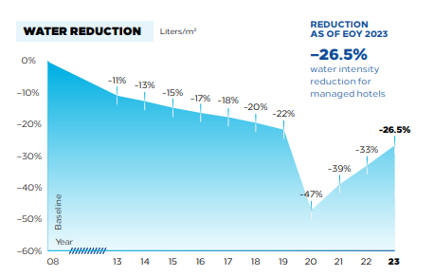
Source: (Hilton, 2023).
Hilton has also completed 12 community water projects since 2019, including three in 2023 to improve access to clean water and protect water resources to improve resilience and well-being in the communities it serves (Hilton, 2023).

Marriott International:
Marriott International has pledged to decrease the water consumed per affected room by 15% from a 2016 baseline by the end of 2025 as part of its Serve 360 Goals.
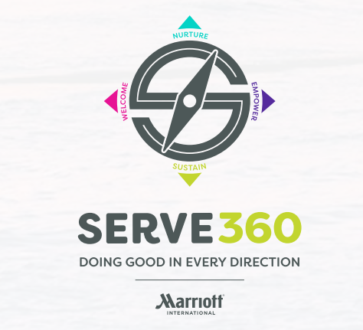
Source: Green Lodging News, (2023).
The company reported a 6.3 percent drop in water usage per occupied room as of December 2022, progressing toward its steep sustainability targets (Hasek, 2023). In 2022, Marriott substantially enhanced its water monitoring capabilities by implementing new data compliance standards through the Marriott Environmental Sustainability Hub.
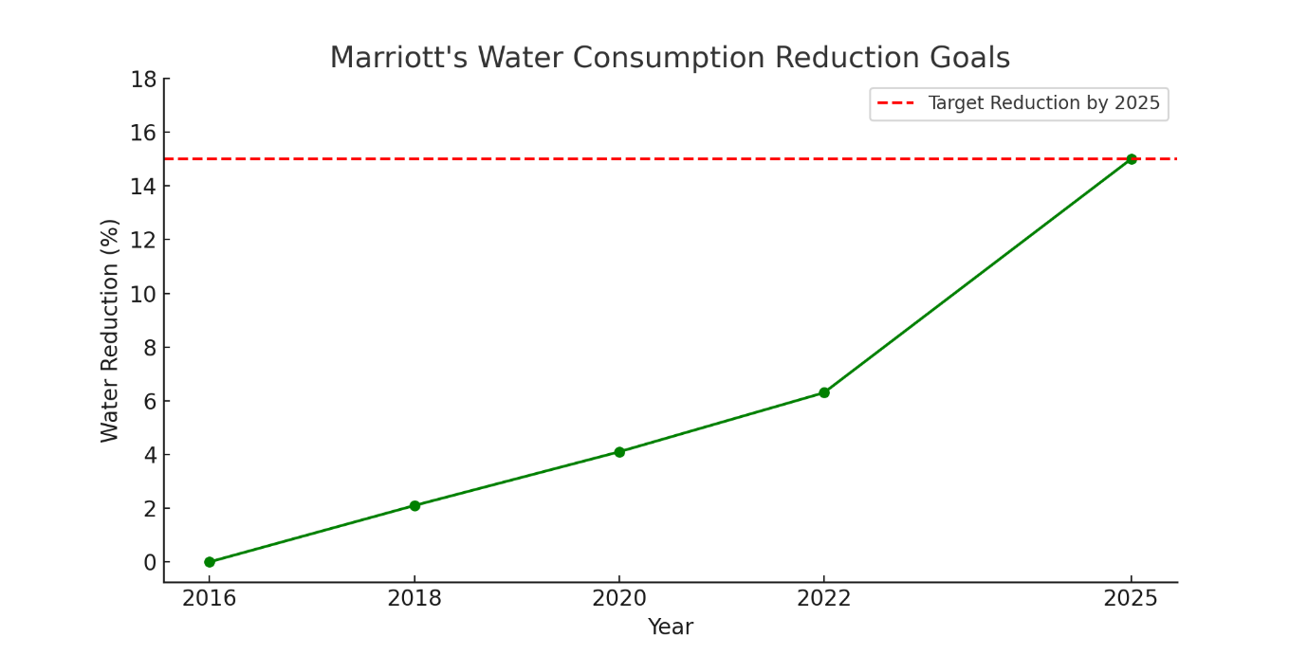
Source: Green Lodging News, (2023).
Marriott is looking for ways to improve water consumption tracking across the company's properties so it can spot and optimize its operations (Hasek, 2023).
InterContinental Hotels Group:
In 2022, InterContinental Hotels Group launched a few initiatives to help their properties conserve water. In this initiative, increased employee awareness of the value of water conservation was a key component achieved principally through the Sustainability Improvement Group (SIG). As part of this educational programme, has helped staff to practice responsible water usage and to create a culture of sustainability within the organization (Crowne, 2023). The guest rooms now used 8 litres instead of 11 litres because of IHG modernising fixtures; in the showers and aerators water consumption was lowered from 12 to 6 litres and 8 to 6 litres respectively.
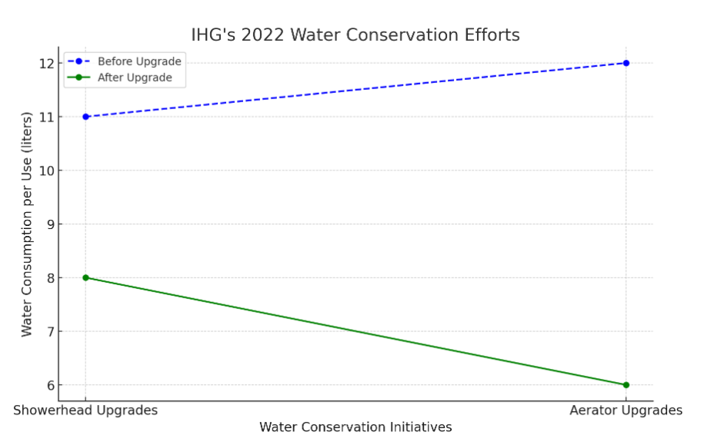
Source: (Crowne, 2023).
These improvements lead to very substantial additional water savings and help IHG achieve its sustainability goal of lowering environmental impact (Crowne, 2023).
Water Conservation Advantages for Sustainability Hotels:
There are many benefits that hotels can reap when implementing water conservation initiatives, for example: switching to that strategy as the InterContinental Hotels Group (IHG) is adopted. These benefits can be categorized into environmental, economic, and social aspects:

Environmental Benefits:
Water conservation helps in environmental sustainability since it preserves the use of water through immediate conservation of water, which is scarce. Hotels use a significant amount of water for guest services, landscaping, and operations, and then have a big impact on water use as such, reducing the amount of water consumed by implementing more efficient fixtures and practices can help reduce waste. For example, by changing showerheads and aerators, InterContinental Hotels Group significantly reduced water consumption, so conserving local water supplies and relieving municipal systems (Duran et al, 2020).
Economic Benefits:
Energy is also conserved by using less water thus reducing the utility bills, which formulate a major concern in hotel operations. Bohdanowicz, (2018) revealed that research on water conservation measures provides substantial proof that it offers a chance of extremely significant cost reductions for hotels, which could in turn be reinvested in sustainable measures. In addition, decreased water consumption commonly leads to corresponding savings on energy for water heating and the general costs of operation.
Improved Brand Reputation:
Environmental friendly practices i.e. water conserving methods make a hotel favourite for people with a sensitive conscience. Ribeiro et al, (2021) state that when more people seek environmentally friendly accommodations, hotels that openly advocate their sustainable practices such as InterContinental Hotels Group water conservation, guests will better be able to distinguish such hotels in the market. Such reputation may lead to more faithful clients, or simply more occupied places and mansions.
Compliance with Regulations:
Water use and waste management laws are becoming strict in many localities. Hotels that take proactive initiatives to reduce the use of water can be assured of compliance with local rules and avoid any fines, or penalties. Lee et al, (2019) discovered that not only does this build goodwill with regulatory organisations, but it also goes a long way to ready the hotels for future Greener practice certifications.
Challenges:

Cost-Effectiveness of Sustainability Initiatives:
- Initial Investment vs. Long-Term Savings:
Incorporating water-saving technologies like low-flow fixtures may have big initial costs. Unfortunately, though, these changes rarely lead to landmarked savings, since water and energy costs are usually reduced (Bohdanowicz, 2018).
- Improved client loyalty:
By using sustainable methods, hotels hold the potential to attract environmentally conscious customers furthering occupancy and revenue. Herath et al, (2018) indicate that Sixty seven percent of consumers like environmentally conscious hotels, the result shows.
In short, the initial costs of installing water conservation measures may be very high, but in the long-term, it is cost-effective, due to decreased operating costs, enhanced customer loyalty, and future revenue growth, on the other hand, usually far outweigh these initial costs.
Realistic of Water Conservation Initiatives in Hotels:
Water conservation in hotels is further enabled by global water scarcity, rising costs, and a consumer demand for sustainability making water conservation in hotels both realistic and required. There is the following factor that contributes to the realistic adoption of these initiatives:
- Technological Feasibility:
Today's water-saving technologies, such as low-flow fixtures, smart irrigation, and greywater recycling are feasible and affordable for hotels. Younis et al, (2020) explain that the hotels that have reduced water use by over 30% using low-flow showerheads and faucet aerators had no impact on guest comfort.
- Supportive Regulatory Environment:
The hotels adopt conservation measures as government policies promoting sustainability. Incentives for businesses to implement water-saving practices are offered by many local and national authorities, for example, the tax credits are offered. Compliance is even more important to hotels in regions with more oppressive regulations playing into the realism of widespread adoption.
- Economic Consideration:
Since initial investment is usually high, water conservation initiatives invariably show a return on investment within a few years because of the resultant saving of water. These financial values make it easy to appreciate the effectiveness of water conservation as an efficient business model (Green Hotelier, 2019).
In short, implementing water conservation strategies in hotels is realistic given technical improvements, supportive regulatory settings, changing consumer tastes, and long-term economic sustainability.
Environmental Benefits of Water Conservation Initiatives in Hotels:
1. Reduction in Water Scarcity:
Reducing water use by the hotels will greatly help stabilise the regional water supply. In water-stressed locations, Jones et al, (2019) found that a 20% reduction in hotel water use would relieve pressure on local resources.
2. Decreased Energy Consumption:
Water saving means less energy will be required for heating, pumping, or treating water. WRI (2020) states that methodologies to conserve water can also save energy, and lower carbon footprint and expenses to operate.
3. Prevention of Pollution and Eutrophication:
Hotels reduce wastewater volume, which frequently contains dangerous pollutants, by using less water. In the study by Fuchs et al, (2021), studying methods for saving water leads to a decrease in nutrient loads in water systems, and contributes to the improvement of water state for aquatic organisms.
4. Enhanced Biodiversity:
The result of the water conservation initiative is the enhancement of local habitats for wildlife. Ray et al, (2018) discovered that hotel practices with conservation measures experienced improved Biodiversity efficacy.
5. Long-term Resilience and Sustainability:
The International Tourism Partnership (2022) emphasises that sustainable practices improve hotel reputation and community resilience to climate change.

Conclusion:
This report explains the importance of the Greener practice that was evaluated through its water conservation and wastewater management strategies in hotels. Key findings explain that, however, it appears that the initial cost to invest in such technologies as low-flow showerheads is certainly a financial challenge, the reduced operational costs and the increased customer loyalty that comes with it are often worth it to businesses in the long run. The policy is evidenced by the success of large companies like Hilton, Marriott, and InterContinental Hotels that operate sufficient clear environmental policies, which also have a positive impact on the business results.
To increase the efficiency of these efforts, the hotels pursuing the rational use of water must emphasize monitoring the effectiveness of water-saving accurately. Further, constant staff training and proper guest engagement about the advantages to be harvested from greener practices may avoid any disruption of operations and perhaps improve guest satisfaction. The most effective way to achieve impact is for hotels to embed water conservation activities within the larger context of corporate sustainability objectives such as energy reduction and waste reduction. Through tracking progress meticulously and supporting these initiatives, the hotels can not only reduce costs but also attract eco-friendly customers by reinforcing the brands which will hopefully create loyalty to the hotels and improve their position in the market. In general, it should be understood that the application of the given measures is quite possible to implement in terms of water conservation, which is an essential step toward the future of the Hospitality Industry and which has both environmental and economic benefits.
Action Plan:
Install Low-Flow Water Fixtures
Many hotels and motels should purchase water-efficient devices like low-flow showerheads and faucet aerators to save water for guests ‘rooms and public areas. This initial investment can bring lifelong benefits in terms of water and energy costs linked to water heating.
Provide Staff Training for Sustainable Development:
Education for the staff should be conducted to enable them to understand the proper use and management of sustainable technologies. First and foremost, proper conservation requires staff knowledge and participation so that interruptions throughout installation are kept to a minimum while guaranteeing that conservation efforts are optimal.
Connect with Other Sustainability Imperatives:
Relate water saving to other aims that include energy and waste rationalization. Such an approach not only improves the orientation to the sustainable development goals set both at the global and company levels but also contributes to the positioning of the hotel offering in the increasingly important segment of ‘green’ or environmentally sensitive tourists.
Fascinate Eco-Conscious Guests to Promote:
The hotel markets the sustainability initiatives of the hotel as part of its brand identity. These efforts can be emphasized to attract eco-conscious travelers, retain customers, and overall reach financial and environmental goals.

References:
- Bohdanowicz, P. (2018). ‘European Hotels' Association's Initiative on Sustainable Development’. International Journal of Hospitality Management, 70, pp. 115-123.
- Berezman, O., Miller, M. (2022). Sustainable Hotel Practices and Guest Satisfaction Levels. International Journal of Hospitality & Tourism Administration 15(1), pp. 1-18
- Cohen, S. (2020). Water conservation technologies for hospitality settings: A sustainable approach. Environmental Management Journal, 15(4), pp.245-258.
- Chan, E., S., W., Wong, S., C., K. (2021). Enhancing sustainability in the hospitality industry through employee engagement and guest awareness programs. International Journal of Hospitality Management, 94, pp.102-109.
- Duran, J. M., Freire, F. and Pacheco, C. (2020) ‘The Importance of Water Management in the Hotel Sector: Strategies for Sustainable Development’, Journal of Sustainable Tourism, 28(2), pp. 264-283.
- Friedler, E. Alfiya, Y. (2021). Greywater reuse: An efficient solution for water conservation in urban areas. Journal of Environmental Engineering, 26(2), pp.180-192.
- Hilton, (2023). Travel with Purpose Report 2023. Available at: https://esg.hilton.com/wp-content/uploads/sites/4/2024/05/2023-Travel-with-Purpose-Report-ADA-final.pdf. Accessed: (29 Oct 2024).
- Hasek, G. (2023). Some Highlights from Marriott International’s 2023 Serve 360. Report. Available at: https://www.greenlodgingnews.com/some-highlights-from-marriotts-2023-serve-360-report/. Accessed: (29 Oct 2024).
- Herath, R., Tham, J., Kahatibi, A. (2018). Implementation of Green and Sustainable Practices by Hotel Managers in the Western Province of Sri Lanka. Journal of Law and Sustainable Development, 11(11), pp. 17-53.
- Koehler, D. A., Henn, S. A. Lang, C. J. (2021). ‘The Impact of Regulatory Frameworks on Hotel Sustainability Practices’, Journal of Sustainable Tourism, 29(10), pp. 1516-1532.
- Kang, J., Cho, M., Park, C. (2018) 'Cost-effectiveness of water-saving technologies in the hotel industry'. International Journal of Hospitality Management, 73, pp. 27-35.
- Khatter, A. (2023). Challenges and solution for environmental Sustainability in the Hospitality Sector’, Sustainability, 15(15), pp. 91-114.
- Lee, J., Jan, M. and Kim, S. (2019). ‘Sustainability Practices in the Hotel Industry: Implications for Management’, Journal of Hospitality and Tourism Management, pp. 45-52.
- Miller, G. and Twining-Ward, L. (2021). Sustainable tourism and eco-friendly practices. Oxford: Oxford University Press.
- Moghadam, A.A., Rahmani, K., Arjmand, H., Saadat, S. (2019) ‘Investigating the relationship between corporate social responsibility and financial performance: evidence from Iran’. Sustainability, 8(8), pp. 1-15.
- Pirani, S.I. Arafat, H.A. (2021). Smart water management systems: Implications for water conservation in hospitality. Water Resources Management, 35(3), pp.837-850.
- Patel, R., Kumar, R. (2021) 'Challenges in implementing water conservation measures in hotels: An industry perspective'. Journal of Hospitality and Tourism Research, 45(4), pp. 575-589.
- Plumbing, L. (2015). The benefits of having low flow fixtures. Available at: https://www.olearyplumbingandheating.com/blog/2019/july/the-benefits-of-having-low-flow-fixtures/. Accessed: (29 Oct 2024).
- Ribeiro, L., Pinto, M. C. Melo, M. M. (2021) ‘The Role of Eco-Certification in Enhancing Hotel Sustainability: A Focus on Consumer Preferences’. Tourism Management Perspectives, 38, pp. 74-81.
- Smith, J., Johnson, P., Robertson, K. (2019) ‘Water conservation technologies in hospitality’. Journal of Sustainable Tourism, 27(5), pp. 750-766.
- Stewardship, W. (2021). Maximising the environmental and economic benefits of water efficiency. Available at: https://sustainablehospitalityalliance.org/maximising-the-environmental-and-economic-benefits-of-water-efficiency/. Accessed: (29 Oct 2024).
- Singh, A.,Khandewal, C. (2023). Achieving Sustainable Development in the Hospitality Industry: An Evidence-Based Empirical Study. Journal of Novel Carbon Resource Sciences & Green Asia Strategy, pp1186-1198.
- Singh, R., Periera, A. (2019) 'Operational challenges in hotel sustainability initiatives', Tourism and Hospitality Management, 25(3), pp. 23-36.
- UK Green Building Council (2022). Water conservation guidelines for the built environment. Available at: https://ukgbc.org/wp-content/uploads/2022/12/Government-Policy-Scorecard-Decarbonising-the-Built-Environment-December-22.pdf. Accessed: (29 Oct 2024).
- World Travel and Tourism Council (2020) Sustainable tourism strategies for the future. Available at: https://wttc.org/. Accessed: (29 Oct 2024).
- Younis, A. A., El-Masri, M. Hossain, M. S. (2020) ‘Evaluating the Effectiveness of Water Saving Technologies in Hotels’, Journal of Cleaner Production, 261, p. 121-150.

