

Research on collision avoidance system of unmanned ship based on GIS and deep learning

by
Xin Yue

Supervisor: Beverley Holland

Project submitted as part of the requirements for the award of MSc Software Engineering

November 2021

DECLARATION

I, Xin Yue declare that I am the sole author of this Project; that all references cited have been consulted; that I have conducted all work of which this is a record, and that the finished work lies within the prescribed word limits.

This work has not previously been accepted as part of any other degree submission.

Signed : .............. 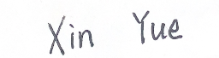...............................

Date : ............2021.11.10...................................

FORM OF CONSENT

I ...........................................Xin Yue………………………………… hereby consent that my Project, submitted in candidature for the M.Sc. Software Engineering degree, if successful, may be made available for inter-library loan or photocopying (subject to the law of copyright), and that the title and abstract may be made available to outside organisations.

Signed : ............ .................................

Date : ............... 2021.11.10................................

Abstract
Deep learning provides a new research means for the development of automatic driving field. Deep reinforcement learning is a branch of deep learning. Deep Deterministic Policy Gradient (DDPG), a representative algorithm in deep reinforcement learning, often performs well in algorithm training. But there are still large fluctuations in the training process and slow convergence speed, while most algorithms in imitation learning perform well in training fluctuations, However, such learning algorithms often rely on human experience to a large extent, and there are great limitations in data sampling.
This paper analyzes the application and characteristics of deep reinforcement learning and imitation learning in the field of automatic driving in detail. Taking the deep deterministic strategy gradient algorithm as the research object, this paper focuses on the relevant algorithms integrating imitation experience data and double experience pool, determines the strategy parameter update rules of the fusion algorithm, and introduces the Unity simulation platform in detail. Analyze its feasibility and practicability as a training scene. The main research work of this paper is as follows:
(1) Deep Deterministic Policy Gradient with Imitation and Double Experience Pool (DDPG-IDEP) algorithm is proposed, which integrates double experience pool and simulated experience data.
(2) Obtain geographic environment information, ship information and obstacle information through GIS system. And reproduce it in the simulation scene.
(3) Unity engine provides a high degree of freedom simulation scene, which can build a virtual ship simulation platform. Based on the highly free virtual ship navigation environment provided by unity, ship navigation control is carried out by using the API provided by Airsim on unity and DDPG-IDEP control strategy algorithm. The strategy parameters are continuously optimized through training, and the effectiveness of DDPG-IDEP control strategy algorithm is verified from the cumulative reward value, training time and reward value fluctuation.
Key words: Deep reinforcement learning; Imitation learning; GIS; Unity.

Content
Abstract 4
Chapter 1 Introduction 1
1.1 Aim 3
1.2 Objectives 3
1.3 Structure of the report 3
Chapter 2 Literature review 5
2.1 Challenges faced by ship navigation 5
2.2 Research on ship automatic collision avoidance 5
2.3 Research on deep reinforcement learning 17
2.4 Research on virtual platform and automatic driving 19
2.5 Geographic information system (GIS) 22
Chapter 3 Research methodology 24
3.1 Research overview 24
3.2 Research strategy 24
Chapter 4: Design and implementation 27
4.1 Construction to simulation platform 27
4.1.1 Introduction to Unity engine 27
4.1.2 Introduction to Airsim on Unity 28
4.1.3 Establishment of Ship Simulation Platform on Unity 29
4.1.4 Establishment of Ship Simulation Platform on Unity 31
4.2 Construction of algorithm platform 33
4.2.1 Visual state input 34
4.2.2 Design of round training reward value function 36
4.2.3 Playback experience pool design 39
4.2.4 Algorithm training process design 40
Chapter 5 Results and discussion 43
5.1 Simulation experiment result 43
5.1.1 Round cumulative reward 43
5.1.2 Round training time 47
5.1.3 Training fluctuation of round reward 49
5.1.4 Generalization performance of fusion strategy 53
5.2 Results 57
Chapter 6 Conclusion 57
Chapter 7 Reflection 60
References 62

Chapter 1 Introduction
The history of ship development is the history of the continuous improvement of ship safety performance and transportation efficiency. The safety of ship navigation has always been a hot issue in the field of marine transportation engineering. The research of ship collision avoidance system is also one of the most difficult issues in the field of ship research. The International Maritime Organization (IMO) has regulated the international maritime collision avoidance rules, which is used to constrain and coordinate the navigation modes of various ships to avoid collision between ships. In technical aspect, ship instruments such as radar automatic plotting system, Automatic Identification System (AIS), Electronic Chart Display and Information System (ECDIS) have brought great progress to the information acquisition in ship navigation. However, the progress of information acquisition and the formulation of rules do not reduce the collision probability to the ideal level. For ships working in inland waters, they may encounter the closed or not installed AIS vessels, or there is no AIS signal coverage in the navigation area. Geographic Information System (GIS), as the main navigation equipment, can monitor the navigation geographical environment and motion status information of ships. By combining GIS system and unmanned driving technology, the probability of collision accidents caused by human factors can be greatly reduced by replacing human drivers for ship handling and cargo transportation.
With the rapid development of artificial intelligence and autonomous driving technology, unmanned ships have become an important research topic related to intelligent transportation. The GIS system can monitor the navigation geographic environment and motion information of ships in real time. This research intends to combine GIS system and artificial intelligence to train unmanned ship to avoid collision in virtual environment.
Geographic Information System is a comprehensive subject which combines cartography with remote sensing, geography and computer science. It originated in the 1960s. The concept of GIS was first proposed by R. Tomlinson in 1963. In order to manage and plan natural resources, he established the first GIS system. With the improvement of computer technology, GIS system has been applied to more complex scenes, so it has been rapidly promoted. GIS system is widely used in transportation, commercial finance, agriculture, industry and other fields. It can realize the input, storage, query, analysis and display of geographic data. Google Earth is a map search service software developed by Google company. It integrates GIS, GPS, remote sensing and Internet to provide users with the latest three-dimensional earth display.
Deep learning (DL) is an algorithm evolved from artificial neural network, which uses multi-layer nonlinear network structure to process data. It is usually used to learn data or image. DL mainly includes Deep Neural Networks (DNN), Recurrent Neural Networks (RNN), Deep Belief Networks (DBN) and Convolution Neural Networks (CNN). In the field of driverless, CNN is widely used in the perception layer of driverless vehicles. The input of CNN network can include image, sound and video data. It is used in unmanned driving to obtain the surrounding environment and extract environmental features. Reinforcement learning is to learn how to choose the best behavior among many behaviors by interacting with the environment. Reinforcement learning can effectively solve the problem of adaptive learning in uncertain environment, and it is easier to solve the behavior decision in unmanned driving. In this paper, Deep Reinforcement Learning is used to solve the problem of local path planning and behavior decision-making of unmanned ship in uncertain environment.
It is a new goal of shipping industry to research and realize highly autonomous control of unmanned ships. In order to complete the autonomous navigation of unmanned ship, the realization of its autonomous collision avoidance navigation is the core of navigation safety. Aiming at this core problem, this paper proposes an unmanned ship collision avoidance method based on deep learning and GIS system. A ship training environment simulating real geographic information is built.
The aim of research is to establish a simulation system of unmanned ship collision avoidance based on GIS system and deep learning. The system can establish the channel model simulating the real environment and simulate the autonomous collision avoidance of the unmanned ship in the channel. According to the environment, course, control and navigation surface conditions, the unmanned ship can quickly adapt to the environment changes in the virtual environment, and has long-term stability and robustness. Firstly, GIS system is used to obtain the geographic environment information and the coordinate information of the ship. Then, combined with deep learning, the unmanned ship is trained to avoid collision in the reconstructed river. Improved Deep Reinforcement Learning algorithm DDPG-IDEP is used in the algorithm.

1.1 Aim
The aim of research is to establish a simulation system of unmanned ship collision avoidance, and verify the effectiveness of the DDPG-IDEP algorithm.

1.2 Objectives
After the implementation of the system, the following objectives are expected to be achieved：
(1) GIS system used to obtain the geographic environment information and the coordinate information of the ship.
(2) Combined with deep learning, the unmanned ship is trained to avoid collision in the reconstructed river.
(3) Verify the new algorithm DDPG-IDEP, compare it with other algorithms.

1.3 Structure of the report
The project has three main components. Firstly, the advantages and disadvantages of the existing systems and theories are analyzed by literature review and practice. The second part introduces the experimental design and how to improve the algorithm in detail. The third part verifies and compares the advantages and disadvantages of the new algorithm and the other three algorithms, and puts forward some suggestions for improvement according to the current situation.
The first chapter gives an overview of the project and describes the aim, objectives and structure of the project.
The second chapter is literature review. This project mainly studies the current situation of ship collision avoidance through literature, and compares the advantages and disadvantages of existing collision avoidance research. The research direction of the system is put forward, and the technical route of system design is determined.
The third chapter introduces the research methods, research strategies and research plans in detail.
The fourth chapter makes a detailed design and implementation of the system. Including the construction of simulation platform and algorithm platform.
The fifth chapter is the results and discussion of the system. The simulation results of the four algorithms are compared. The simulation results of the new algorithm in three different environments are compared.
The sixth chapter is the conclusion. The improvement of the algorithm and the innovation of the research work are summarized.
The seventh chapter is reflection. Reflect on the shortcomings of the project. The direction of improvement of the project is summarized. It can be improved in algorithm and virtual environment simulation.

Chapter 2 Literature review

2.1 Challenges faced by ship navigation
The environment of ship navigation is very changeable. The main obstacles include dynamic obstacles and static obstacles. Dynamic obstacles include other ships and unknown obstacles. Static obstacles include islands, reefs, sunken ships, coastlines, navigation signs, etc. Uncertain wind waves and ocean currents will also interfere with the channel. Therefore, the study of ship collision avoidance is very important for the safe navigation of ships. With the development of the world economy and the more frequent trade of various countries, there are more and more ships on the water. The navigation channel is becoming more and more crowded, which increases the risk of ship collision [1][2]. Ship collision will not only bring economic losses, but also the leakage of ship fuel will cause irreversible damage to the environment [3][4]. In 2020, a Japanese cargo ship transporting diesel and marine fuel hit a reef while passing through Mauritius, resulting in a large amount of fuel oil leakage. Mauritius declared an environmental emergency [5].
The core of ship obstacle avoidance system is collision avoidance and handling [6]. Due to the uncertainty, large inertia and nonlinearity of ship motion, the research of ship automatic collision avoidance and motion control is a great challenge. Many researchers have made certain engineering application and theoretical achievements in this regard [7-9].

2.2 Research on ship automatic collision avoidance
In order to ensure the autonomous and safe navigation of unmanned ships, it is urgent to solve the autonomous intelligent collision avoidance technology of unmanned ships under complex navigation conditions. Aiming at the problem of automatic obstacle avoidance of ships with only static objects in complex environment. Ships usually navigate automatically according to the planned route by using trajectory in known waters. Static obstacles can be avoided through global path planning or artificial route. Therefore, in the automatic collision avoidance algorithm, the dynamic obstacles encountered are generally considered first, and the static obstacles that need to be avoided are considered only after they deviate from the route.
For example, Petres [10] and others proposed a real-time reactive path planning method that can avoid static obstacles under the influence of time-varying wind. This method converts the restricted area into a virtual obstacle, then uses the artificial potential field method to construct a virtual repulsion to avoid static obstacles, and constructs a virtual traction to guide the ship to the target waypoint. The artificial potential field method has the advantages of simple algorithm and efficient calculation. However, it is necessary to set the force field parameters reasonably, which has the deficiency of local minimum [11]. In order to avoid the local minimum problem, song et al. Conducted obstacle avoidance research on unmanned ships based on the fast March method [12] with global minimum [13]. By adding the bow guidance area to the fast March algorithm, proposed a collision avoidance navigation method considering the ship motion characteristics, and successfully completed the real ship test on the lake; A multi-layer fast stepping collision avoidance navigation algorithm considering current interference is proposed by adding current to the solution space by using 4-region hazard strategy. It has the advantage of planning the path according to different optimization criteria, and the effectiveness of the algorithm is verified by simulation. Zhang Rubo's team has made outstanding research achievements on high-speed unmanned craft avoiding static obstacles in complex environments. They adopted fuzzy theory and near domain graph method, combined with the characteristics of high-speed motion of unmanned craft, and added dynamic parameters related to the distance between surrounding obstacles to speed control, so as to realize the unmanned craft accurately and quickly avoiding obstacles in complex environments, safely reach the target waypoint [14]. By analyzing the maneuvering characteristics of the surface unmanned boat, calculating its current dynamic window, and using the arc method to deal with the obstacles in the surrounding environment, they transformed the multi-objective optimization problem of selecting avoidance behavior into a single objective optimization problem, so as to quickly search these dynamic windows and obtain a set of optimal solutions, Realize rapid reactive obstacle avoidance of unmanned craft in complex navigation environment [15]; They also developed a local obstacle avoidance method based on behavior, that is, a local reactive risk avoidance method based on regional analysis, which successfully guided a surface unmanned ship to safely avoid obstacles in a real marine environment [16]. Obviously, there are not only static obstacles in the marine environment, but also dynamic obstacles that are more difficult to avoid (such as other ships in navigation). The above method has not considered the problem of dynamic obstacles, so it is necessary to further study and expand the application scope of collision avoidance algorithm.
Phanthong et al. proposed a heuristic A * algorithm and forward-looking multi wave velocity sonar to solve the problem that ships can avoid dynamic obstacles and static obstacles at the same time. The algorithm can avoid dynamic obstacles and static obstacles at the same time [17]. Praczyk uses evolutionary neural network to learn the sample data of collision avoidance and maneuvering, and realizes a multi ship automatic collision avoidance algorithm that can deal with dynamic and static rapidly changing obstacles [18]. However, the disadvantages of this method are also obvious. Its effectiveness depends on the learning data of training evolutionary neural networks. For different navigation areas, the corresponding neural network model needs to be trained. Based on the fast stepping method, sun et al. Proposed an automatic collision avoidance navigation method which can change the ship's heading and speed at the same time by taking the bow static guidance area as the dynamic domain model. He simulated the local waters in the port in the simulation navigation area and conducted collision avoidance tests under three scenarios. The simulation results show that this method has good obstacle avoidance ability [19]. Tian et al. Proposed to simulate and realize multi ship automatic collision avoidance algorithm which can avoid dynamic obstacles and static obstacles at the same time on ECDIS. This algorithm is based on speed obstacle method [20]. The above collision avoidance rules have a common deficiency. They do not consider the international rules for collision avoidance at sea [21]. According to statistics, more than 56% of ship collision accidents are caused by failing to abide by the collision avoidance rules. Therefore, the methods used for maritime navigation must comply with the international rules for preventing collisions at sea [22]. Therefore, in order to improve the practicability of the algorithm, the requirements of international maritime collision avoidance rules must be considered in the research of ship automatic collision avoidance algorithm.
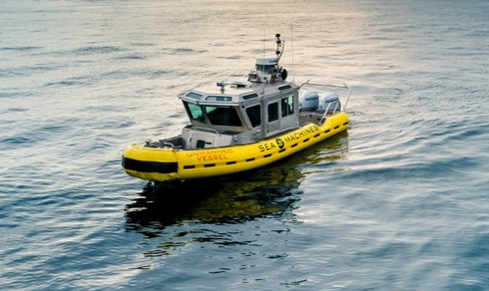
Fig.2.1 Ship with autopilot function
At present, on the premise of meeting the requirements of international maritime collision avoidance rules in open waters, there are many research results on automatic collision avoidance of two ships [23]. Because the meeting situation of two ships in open water is relatively simple, it is easier to establish an effective expert experience set according to collision avoidance rules and seafarers' common practices, so there are relatively many collision avoidance results using fuzzy logic. Damen Shtay et al. Used the fuzzy logic method to realize the automatic collision avoidance of two ships in open waters in accordance with the international maritime collision avoidance rules [24]. Lee et al. Also based on the improved artificial potential field method, by reasonably designing the fuzzy expert rule set, this ship can avoid other ships according to the requirements of the rules [25]. It is worth noting that Perera's research results on collision avoidance based on fuzzy logic method are relatively remarkable [26]. By introducing experienced helmsman actions, a relatively complete fuzzy logic rule considering collision avoidance rules is established, and a collision avoidance experiment is carried out by using a self-propelled ship model combined with a virtual ship, and a good collision avoidance effect is achieved. However, because the method based on fuzzy logic rules requires artificial expert experience, it is difficult to establish good fuzzy rules for complex multi ship encounter situations. In addition, other researchers have also achieved some results by using other methods. For example, according to the reactive collision avoidance method, combined with LOS (line of sight) path tracking method and considering the influence of ocean current, MOE and others use the Set-based theory to switch the two navigation modes of collision avoidance and path tracking, so as to realize the safe navigation of the two ships according to the collision avoidance rules [27]. Abdelaal et al. Transformed the collision avoidance problem of the two ships into a nonlinear optimization problem, and took the collision avoidance rules as constraints, so the model predictive control was used to solve the optimization problem. Finally, the effectiveness of the collision avoidance algorithm was verified by the simulation examples of the encounter, overtaking and cross encounter of the two ships [28]. Benjamin and others also transformed the collision avoidance problem of the two ships into a multi-objective optimization problem, using the Interval-programming [29] method and controlling behavior to realize the constraints of navigation rules. Not only the simulation shows that the method complies with the collision avoidance rules, but also the experimental verification is completed with two experimental ships, Compared with most current collision avoidance algorithms that only pass the simulation verification, the successful verification of the proposed collision avoidance algorithm with two experimental ships is a significant progress [30], which promotes the progress of the application of collision avoidance algorithm to real ships. As we all know, the maritime traffic flow is becoming increasingly dense, and there are fewer and fewer cases where only two ships meet. If the collision avoidance algorithm can only deal with the situation of two ships meeting, it is obviously unable to be applied to the autonomous navigation of unmanned ships in the normal navigation environment at sea.
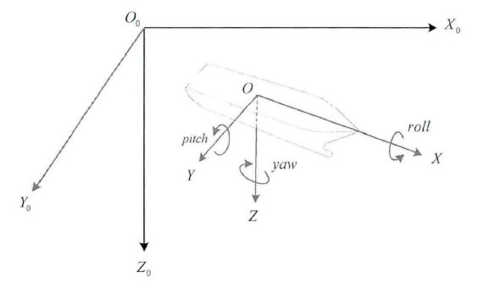
Fig.2.2 The inertial and ship-fixed coordinate system for ship
In order to achieve the goal of autonomous navigation of unmanned ships on the open sea, the collision avoidance algorithm needs to solve the automatic collision avoidance problem of multiple ships (more than two ships) in the open water. Therefore, many researchers further study the automatic collision avoidance problem of multiple ships complying with the collision avoidance rules in the open water [31]. Perera continues to expand its automatic collision avoidance algorithm for two ships in open waters based on fuzzy logic method, combined with expert experience, Bayesian network, parallel decision-making and other methods, and puts forward a variety of automatic collision avoidance methods for multiple ships to comply with collision avoidance rules in open waters. Simulation shows that these methods have good collision avoidance effects [32]. Zhang et al. Also proposed a real-time path planning algorithm based on collision avoidance rules for multi ship encounter in open water by using distributed collision avoidance decision-making scheme and linear expansion algorithm [33]. Li Lina and Chen Guoquan proposed a ship anthropomorphic intelligent collision avoidance decision-making method, which fully considers the collision avoidance rules and good ship art. Through real-time processing of various collision avoidance models required (including various collision avoidance parameter calculation models, target intersection feature models, etc.), multiple dangerous target ships can be avoided at the same time [34]. In addition, the speed obstacle method is also widely used in the study of multi ship automatic collision avoidance considering collision avoidance rules in open waters [35]. For example, Zhao et al used the evidential reasoning method to evaluate the degree of ship collision risk, so as to trigger the collision risk warning, and then used the speed obstacle method for avoidance maneuvering to realize a multi ship autonomous collision avoidance method suitable for open waters and in line with the collision avoidance rules [36]. However, among many collision avoidance studies based on speed obstacle method and other methods, Kuwata et al. Achieved particularly remarkable results [37]. By defining the hull coordinate system, they naturally integrate the collision avoidance rules into the speed obstacle method; By using the minimum encounter point for collision pre detection, setting up a safety buffer to deal with the inaccuracy of obstacle movement, and taking the measures of action lag, the algorithm can avoid the behavior of ship shaking from left to right due to frequent adjustment of feasible decision space; Thus, a multi ship automatic collision avoidance algorithm suitable for open water is proposed. Finally, the collision avoidance experiment is successfully completed with four surface ships in open water. The experimental results show that the decision-making action of the algorithm complies with the requirements of collision avoidance rules. It can be seen that the above research on collision avoidance further improves the possibility of applying collision avoidance algorithm to real ships. However, it should be pointed out that ships need to comply with international maritime collision avoidance rules not only in open waters, but also in restricted congested waters. However, the above collision avoidance methods are only applicable to multi ship automatic collision avoidance in open waters, it is still difficult to be applied to multi ship automatic collision avoidance in restricted waters. 
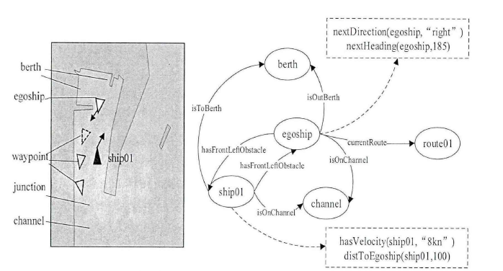
Fig 2.3 Schematic diagram of the conceptual model
In the current research results of automatic collision avoidance, there are still few automatic collision avoidance methods and auxiliary decision-making for collision avoidance that can be competent in both open and restricted waters under the requirements of collision avoidance rules. Because the automatic collision avoidance algorithm applied to unmanned ships also needs to consider the amount of calculation of the algorithm, there are fewer research results that can give collision avoidance decisions in real time. Campbell et al. Combined with the international maritime collision avoidance rules, proposed a real-time path planning method based on heuristic modified A* algorithm [38]. This method can solve the problem of automatic collision avoidance between two ships in the navigation environment with static obstacles, and can be easily extended to the encounter situation involving multiple ships in restricted waters. However, because this method still uses grid map to search the path, if the grid is too small, it will greatly increase the computational burden. If the grid is large, it cannot reflect the specific shape characteristics of small obstacles. It can be seen that the spacing and number of map grids will directly affect the calculation speed of the algorithm and even the effectiveness of collision avoidance decision-making. In addition, due to the limited navigable area of each ship in the restricted complex waters, it is very important to accurately grasp the size of the navigable area of the ship for making correct avoidance decisions. It can be seen that the collision avoidance algorithm based entirely on the grid is difficult to deal with the situation of multiple ships in the complex restricted waters. Similarly, other grid-based algorithms that study multi ship automatic collision avoidance in restricted waters have this problem [39]. Xue et al. Proposed to avoid static obstacles by using the artificial potential field laws that do not rely on the grid, and use the velocity vector strategy to avoid dynamic ships when considering the collision avoidance rules, and then avoid dangerous objects one by one according to the risk level like most other collision avoidance algorithms, so as to obtain a multi ship automatic collision avoidance algorithm suitable for open and restricted waters [40]. However, for static obstacles such as coastline, this method needs to manually set obstacles in advance to avoid the local minimum problem of artificial potential field method, which makes this method difficult to deal with the problem of automatic collision avoidance in unknown restricted navigation environment. It is worth mentioning that all ships in the test of this algorithm are controlled by this algorithm, while other ships used in the test of most algorithms are not intelligent ships, and it is assumed that other ships will abide by the collision avoidance rules. Obviously, all intelligent ships can better test the collision avoidance algorithm. In addition, assuming that other ships will abide by the collision avoidance rules, there is still a problem, that is, it is impossible to test the collision avoidance ability of the collision avoidance algorithm when other ships violate the rules. However, at present, only a few automatic collision avoidance algorithms have considered this problem [41]. Naeem et al. Also proposed a multi ship automatic collision avoidance algorithm suitable for both restricted and open waters by using the artificial potential field method, which is different from the way in which the rules are considered in the literature [42]. This method sets virtual obstacles in the potential field according to the collision avoidance rules to realize the collision avoidance decision, which meets the requirements of the collision avoidance rules, However, there are also problems that can only be applied to known waters and it is difficult to adjust the potential field gain parameters. Johansen et al. Based on the idea of model predictive control, using the ship motion mathematical model considering wind flow interference, selected different actions to preview the ship's motion trajectory in a period of time from the designed course and speed change concentration, and selected the optimal collision avoidance and manipulation strategy. The simulation results show that the algorithm can deal with complex encounter situations in restricted waters [43]. However, this method highly relies on the ship motion mathematical model for scene simulation. It can be seen that the accuracy of the ship model directly affects the effectiveness of its collision avoidance decision. Moreover, the method based on scene simulation still has the disadvantage of being unable to predict the abnormal handling of other ships. In addition, intelligent optimization algorithms such as genetic evolutionary algorithm, particle swarm optimization algorithm and ant colony algorithm are also widely used to search the path of ships in complex navigation environment. However, due to the large amount of calculation, such methods are usually used for offline global path planning or collision avoidance auxiliary decision-making [44]. Only by simplifying the obstacles in the navigation chart and reducing the amount of calculation can it be used for real-time automatic collision avoidance [45], which will also lead to the loss of navigation chart accuracy. Among the many researches on ship path planning using intelligent optimization algorithms, Szlapczynski's research results on ship path planning are systematic and significant [46]. At present, most researches on automatic collision avoidance still use safety warning circle to evaluate the collision risk of ships. Due to the maneuverability characteristics of ships, it is obvious that the safety distance required by ships in different directions is different; In other studies, the minimum encounter time, minimum encounter distance and their weight - sum are used to judge the ship collision risk. This method is simple but not comprehensive. In his research, Szlapczynski first used the ship domain to evaluate the collision risk of ships, so as to avoid the above shortcomings; Then, based on the evolutionary algorithm, the path planning in open water and limited water is studied respectively, and the collision avoidance rules are integrated. Then, the raster chart is adopted and the search strategy in the algorithm is optimized, so as to gradually improve the calculation speed of the algorithm, and a multi ship collision avoidance method suitable for both open water and limited water is obtained. However, because this method is still based on evolutionary optimization algorithm, for the navigation environment with complex coastlines and islands, or when there are too many ships, this method still has the problem of large amount of calculation and difficult to ensure the real-time performance of the algorithm. 
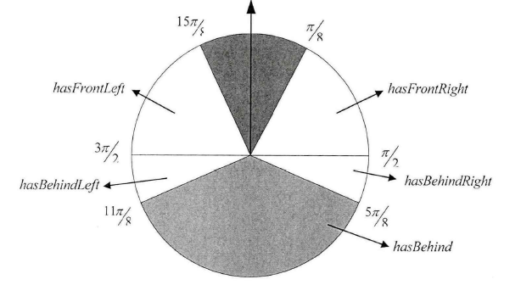
Fig.2.4 The quantitative map of the scene division based on COLREGS
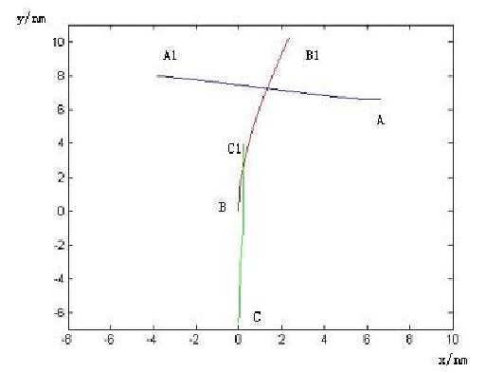
Fig.2.5 Ship collision avoidance path in multi-ship encounter situation
To sum up, the current research results of ship automatic collision avoidance are still not systematic. Generally speaking, the existing collision avoidance algorithms mainly have the following important problems that need to be systematically studied and solved:
(1) Failure to consider the international rules for collision avoidance at sea and the customary experience of navigational avoidance at sea;
(2) When verifying the algorithm, it is assumed that the speed and direction of other ships remain unchanged and comply with the navigation collision avoidance rules, and the violation of collision avoidance rules by other ships is not considered;
(3) It is only applicable to open waters and cannot be applied to restricted waters;
(4) In the study of multi ship collision avoidance, other ships or obstacles are avoided one by one according to the level of collision risk from high to low. Other objects are not taken into account when avoiding the current object, which may cause the ship to avoid the current object safely, but form an urgent situation with another object, so it is unable to solve the problem of automatic collision avoidance under multi ship complex situations;
(5) The algorithm has a large amount of calculation and cannot give collision avoidance decision in real time. It is only suitable for general auxiliary decision-making, but cannot be applied to autonomous avoidance navigation of unmanned ships;
(6) If the maneuvering characteristics of the ship are not considered, the collision avoidance navigation path cannot be applied to the real ship; Or directly using the mathematical model of ship motion to design the algorithm will also lead to the algorithm cannot be applied to the actual sea navigation. 
(7) Most algorithms only use numerical simulation to verify the effectiveness of the algorithm, and lack experimental verification using self-propelled ship model (or real ship).

2.3 Research on deep reinforcement learning
Deep reinforcement learning comes from reinforcement learning, which is the product of the combination of deep learning and reinforcement learning [47].
Deep reinforcement learning absorbs the perception ability of deep learning and the decision-making ability of reinforcement learning, so as to realize end-to-end learning from perception to control [48]. Since the proposal of deep reinforcement learning, it has made substantial progress from low latitude data to high latitude data and from single simple control to multi decision control [49]. Its application field has developed from single control to many continuous application fields of automatic control. Through reinforcement learning and deep learning, qualitative changes have taken place in the control strategy.
The concept of deep learning was first proposed by G. E. Hinton of the University of Toronto in 2006. It refers to a machine learning process that obtains a multi-level deep network structure through certain training methods based on sample data [50]. As a research hotspot in recent years, deep learning has made important achievements in many fields. Its basic idea is to use its multi-layer network structure and nonlinear transformation to combine low-level features for abstract and easily distinguishable high-level representation to discover the distributed feature representation of data [51]. Reinforcement learning is the learning between the environment and action, and constantly let the agent interact with the environment for trial and error training, so as to obtain the maximum cumulative reward. They are DRL based on value function, DRL based on policy gradient and DRL based on search and supervision. DRL based on value function is combined with Q learning algorithm in traditional RL through convolutional neural network. It is a pioneering research in the field of DRL. At the same time, it has been verified by practice that DRL based on value function has strong adaptability and universality. Because the DRL based on value function has some disadvantages, such as over estimation, evaluation error and large correlation between transferred samples, on this basis, deep double Q networks, deep Q networks based on advantage learning and deep Q networks based on priority sampling are developed respectively. Similarly, the model improvement of DRL based on value function is often realized by adding modules with new functions. There are two most common improved models, DNQ based on competitive architecture (dueling DQN) and deep circular Q network (DRQN).
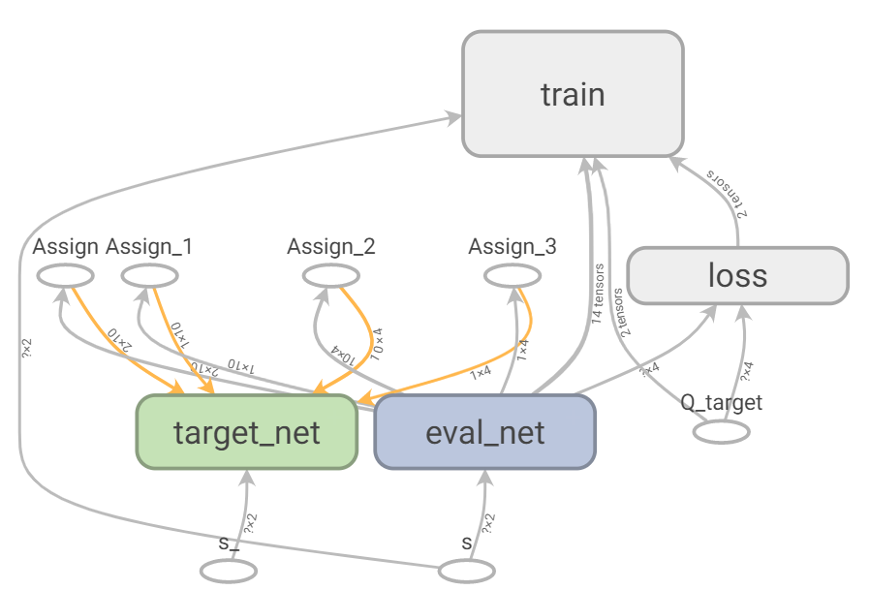
Fig.2.6 DNQ algorithm calculation diagram
In the current research process in the field of automatic driving, a considerable number of reinforcement learning algorithms have developed well, among which the most typical algorithms are policy gradient based deep reinforcement learning (PG), search and supervision based deep reinforcement learning, hierarchical deep reinforcement learning, multi task migration deep reinforcement learning Multi agent deep reinforcement learning and deep reinforcement learning based on memory and reasoning. Compared with simple DQN, deep reinforcement learning based on policy gradient can directly optimize the expected total reward value of the strategy through continuous spatial search until the optimal strategy is found. This method has better effect and scope of application than DQN [52]. In particular, the emergence of DDPQ summarizes the advantages of deep learning and strategy gradient learning algorithms. The proposal of this algorithm has greatly promoted the development of reinforcement learning, which makes the development of continuous and high-dimensional action space possible. Again, on the basis of DDPG algorithm, deep reinforcement learning algorithms based on DDPG algorithm scramble to appear and develop. It greatly promotes the application of deep reinforcement learning in the field of automatic driving. Deep reinforcement learning based on search and supervision is a process of promoting strategy search by adding additional manual supervision. In general strategy search, Monte Carlo tree search (MCTS) is basically used for search. Hierarchical deep reinforcement learning is to use multiple subtasks to learn and combine subtask strategies into global strategies. Among them, representative hierarchical DRL algorithms include hierarchical deep reinforcement learning based on internal option and deep follow-up reinforcement learning [53]. Multi task migration deep reinforcement learning is to use agent to process multiple tasks at the same time. At present, the methods including multi task migration include multi task migration of behavior simulation, multi task migration based on strategy distillation and migration method based on progressive neural network [54]. Multi agent deep reinforcement learning is a DRL model trained through mutual cooperation and competition among multiple agents. It is necessary to ensure that the action information of the previous time is added to each agent at any time, and the network parameters can be shared [55]. Memory intensive learning is the first mock exam to solve the cognitive heuristic task. This model is mainly used to endow the existing DRL model with the ability of active memory and reasoning [56].

2.4 Research on virtual platform and automatic driving
In recent years, the software of major autopilot platforms has been developing continuously. The more famous ones are Apollo autopilot open source platform, Carla open source autopilot simulation simulator, Microsoft Airsim UAV and other autonomous mobile device simulators, Udacity self-driving-car-sim open source autopilot simulator, etc. Apollo is an open-source autonomous driving research platform independently developed by Baidu company in recent years. Researchers can conduct independent research and development according to the high-performance and flexible framework of its real-time function. This research project provides a software platform for the automotive industry and the field of autonomous driving. Developers can use Apollo to quickly reconstruct the 3D world in the system. It can quickly build autopilot system for developers to study. Carla open source automatic driving simulator is jointly released by Intel laboratories and TOYOTA Research Institute and Barcelona computer vision center. It is mainly used for open source simulator of city automatic driving system development, training and verification. Carla simulator is based on Unity simulation software, which can simulate the driving environment freely and freely. Through the simulation platform, different degrees of algorithm training are carried out, and several attempts are made to train in more dangerous environments, so as to evaluate various automatic driving algorithms. At the same time, Carla provides a resource library, which can be placed in scenes under different weather and lighting conditions. The simulation system is of great practical value. Airsim is a cross platform simulation of UAVs and other autonomous mobile devices based on Unreal engine and Unity, which is open source by Microsoft. As an AI research platform, the simulator can be used to test the reinforcement learning algorithms of deep learning, computer vision and autonomous vehicles, and provides researchers with open APIs and platform independent ways to retrieve relevant data. Udacity self-driving car SIM open source autopilot simulator is built for Udacity's Nano degree of driverless car, mainly to teach how to use deep learning to train cars to drive automatically on the road [57]. The model is mainly applicable to imitation learning. The knowledge learned from deep neural network and convolutional neural network is used to imitate driving behavior. Keras is used to train, verify and test the automatic driving model. The output is the steering angle of automatic driving tools. The data collection is the data of human driving cars. The system automatically samples and collects the data according to human actions. It effectively verifies the effectiveness of imitation learning.
Automatic driving technology has made a breakthrough in recent years. In particular, the emergence of machine deep learning has subverted the field of traditional computer pattern recognition and opened a new chapter for automatic driving technology. Before the proposal of deep convolutional neural network (CNN), The recognition task of automatic driving is judged by artificial feature extraction and classifier. Because deep learning has great advantages over image processing, it can directly control the automatic driving tool end-to-end by using visual analysis, so it reduces the dependence on 3D Panoramic Map [58]. At present, many advanced driverless technologies are directly based on the method of deep learning to build the relationship between environment and vehicle control, so as to realize "end-to-end" driving control. In 2016, the automatic driving development platform released by NVIDIA was built by training a deep convolution neural network, which can directly control the driving of vehicles or UAVs through the information input by vision. However, the challenge and difficulty of this method is that it needs to contain a large number of label training data, which is usually difficult to obtain. At the same time, this method only converts "perception ability" into decision control ability. This method lacks serious dependence and rational analysis. At the same time, in the face of many complex environments, the agent must actively interact with the environment and carry out corresponding adjustment strategies and control according to the feedback results. Therefore, this topic selects the design scheme based on the combination of deep learning and reinforcement learning.
At present, autopilot decision control is mainly divided into three schools: classical robot direction based on rules, end-to-end unmanned driving technology based on deep learning and causal reasoning. The classic rule-based robot is relatively single and covers all States encountered by automatic driving by using manual logic. The disadvantage of this method is that it is difficult to create a comprehensive scene rule base. Therefore, it is likely that there will be man-made undefined States, resulting in accidents and complex and changeable road conditions of automatic driving, If the rule base does not appear in the actual scene, it will cause the agent logic confusion and finally make the wrong decision control. Therefore, this direction has poor robustness and is very fragile. The end-to-end decision control based on deep learning is carried out through the mapping relationship between state and action. This method is essentially the same as the direction of classical rule-based robot, but this method is a decision-making method based on visual information, which has the problem of "black box" [59]. If there is a wrong judgment in the whole system operation process, the problem cannot be found, and the next possible problems cannot be predicted at the same time. Moreover, deep learning completely depends on probabilistic reasoning, that is, the so-called correlation reasoning, which cannot well transform visual perception into decision control ability. Therefore, on this basis, Bayesian network is used to classify the probability of event occurrence and the reliability of event, that is, causal reasoning. This method is the integration of AI algorithms with the advantages of modularity and transparency.
Based on the above three ideas, a decision-making framework based on deep reinforcement learning is proposed, which specifically refers to that the agent obtains experience through continuous interaction with the environment, and uses the obtained data experience to adjust the limited parameters of its own algorithm, so as to achieve the integration process of deep learning and reinforcement learning. This algorithm can be infinitely close to processing all scenes, and then strengthen training in the virtual simulation environment, so as to continuously promote the maturity of the algorithm. The combination of deep learning and reinforcement learning belongs to orthogonal problem to a great extent. Deep learning gives the operation mechanism and reinforcement learning defines the optimization goal.

2.5 Geographic information system (GIS)
Geographic Information System (GIS) is a technical system that can collect, describe, display, analyze, calculate, manage and store geospatial data. It originated in the early 1960s. It is a comprehensive discipline combining computer science, cartography, remote sensing and geography. R. F Tomlinson, a Canadian surveyor, put forward the concept of GIS in 1963. In order to facilitate the management and planning of natural resources, he also established the world's first GIS system. GIS system has been rapidly promoted, and the computing level of computer is also improving. Countries such as Canada, Sweden, Germany, Japan and the United States have developed their own GIS system one after another, which has entered the formation of geographic information industry. GIS system is also applied in more complex situations. There is some representative GIS software in the market. Among them, there are more than 1000 kinds of GIS software with quotation.
According to its research and application, GIS software can be divided into two categories: one is the development function library based on GIS, and the second is the development of GIS software for users; Another kind of software is the software that uses GIS system to process user's data. At present, GIS has been widely used in many fields, such as meteorological prediction, water conservancy and hydropower, transportation, urban planning, resource investigation and environmental assessment. Select several typical GIS software systems and compare their functional characteristics and applications, as shown in table 2.2:
Table 2.2 Several common GIS software systems
number | name | type | introduction
1 | ArcGIS | Professional GIS software | It has powerful data volume management function and good scalability, but the architecture is slightly bloated
2 | MapInfo | GIS platform based on vector data structure | Focusing on desktop visualization, the graphics processing ability is slightly poor
3 | MapGIS | Desktop GIS software | Powerful drawing function, fast speed and high efficiency
4 | SuperMap | Desktop GIS software | The interface is simple and friendly, which is convenient for data editing
5 | Google Earth | Desktop map search service software | It is easy to use multiple languages for secondary development
6 | GeoStar | GIS software for shared spatial database | Integrated interface and unified dispatching data

Chapter 3 Research methodology

3.1 Research overview
The research overview of this project is shown in Figure 3.1.
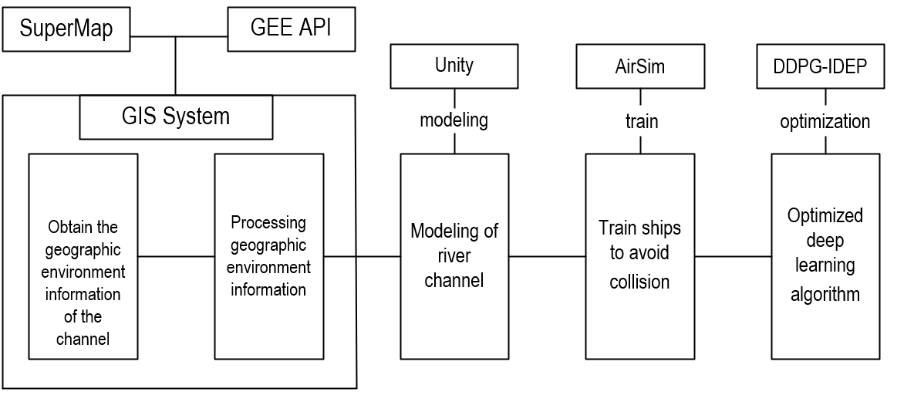
Fig 3.1 Research overview

3.2 Research strategy
This project is based on experiment. Firstly, the geographic environment information is obtained by GIS software system. Build a virtual river and set obstacles in Unity3D. An improved algorithm is proposed to train unmanned ship to avoid obstacles. The deep deterministic policy gradient with image learning and double experience pools algorithm (DDPG-IDEP) is proposed. By updating the supervision loss error of the critic network and actor network of the original DDPG algorithm, the algorithm is improved, and the network structure and training process of DDPG-IDEP algorithm are determined. With the help of the Airsim on Unity platform provided by Microsoft and referring to the relevant Python APIs (picture API, vehicle API and collision API) in the platform, a navigation control platform that can directly control virtual ships is built. On this platform, the research on ship navigation control based on DDPG-IDEP control strategy algorithm is realized.
3.3 Resources & Planning
3.3.1 Resource Requirement
(1) The data of channel and obstacles are obtained by GIS system.
(2) A computer with powerful GPU.
(3) Deep learning and reinforcement learning algorithms.
3.3.2 Gantt Chart
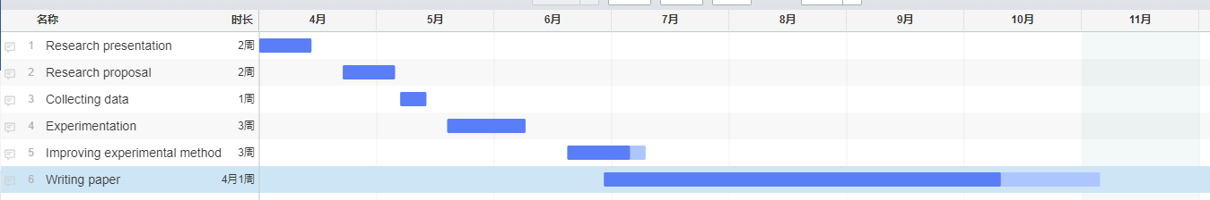
Fig 3.2 Gantt Chart of Research
As shown in the Gantt Chart, the study is divided into six stages. The first stage lasted for 14 days and has been completed. In the first stage, we finished the video and PPT of research. The second stage is to write research proposal, which lasts for 14 days and has been completed. The third stage is Collecting data, which lasts for 7 days and has completed. The fourth stage is the experimentation, which is expected to take 14 days. The fifth stage is to improve the experimental method, which is expected to take 21 days. The last stage is to write a thesis, which is expected to take about 4 months. The whole process will be completed by November 12th.

Chapter 4: Design and implementation

4.1 Construction to simulation platform
This paper studies the simulation of Microsoft Airsim UAV and other autonomous mobile device simulators. At present, the official virtual simulation platform is based on unreal engine and unity. Unity is used for simulation design in this design. Airsim officially provides the corresponding unity sample project and the wrapper around Airlib, which can be run and tested as the native plug-in of Unity3D.

4.1.1 Introduction to Unity engine
Unity, as a game engine, is mainly used in the development of game software. It is a software that can take the interactive graphical development environment as the primary way [60]. Unity has good environment rendering support, fast running speed and calculation speed, high-quality particle system, good physical motion calculation ability and multi-dimensional graphics calculation ability, and can realize architectural visualization and real-time three-dimensional animation, which can well simulate the real scene.
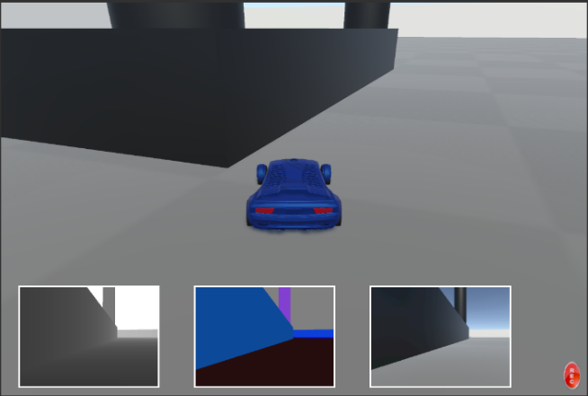
Fig 4.1 Autopilot car on Unity
With the continuous development and progress of artificial intelligence, especially in the academic research field of automatic driving, there is an urgent need for a good virtual environment as a training scene. Unity provides a good platform for such a training environment. At present, many autopilot simulation platforms, including Airsim and Carla, are tested and run based on unity. In recent two years, Unity and Microsoft have cooperated to perfectly connect Airsim autopilot simulator Arisim on Unity, so that Airsim on Unity can be used for experiments on AI, machine learning, reinforcement learning, computer vision and so on. It helps researchers promote the research of autopilot AI and deep learning. At the same time, Unity's machine learning agent tool ML-Agents can also be integrated into the function of Airsim, which is more conducive to the development of Unity based machine learning. Therefore, based on Airsim open source autopilot simulator, this design carries out simulation training and testing with the help of unity. Figure 4.1 shows the training plan of Airsim on Unity autopilot.

4.1.2 Introduction to Airsim on Unity
Airsim combines with Unity's high-performance engine to provide a wider range of development scenarios in machine learning, deep learning and computer vision. At present, Airsim is mainly composed of simulation environment and vehicle dynamics module functions. Using Airsim on unity will enable developers to develop projects on a new ecosystem and platform. At the same time, Unity's machine learning agent tool ML-Agents is now gradually integrated into the functions of Airsim, so that Airsim community and ML-Agents community have a common platform for experiment, development and development.
The reason why Airsim can be applied to unity is mainly due to the original Airsim API interface, which has also been disclosed. Developers can directly interact with Unity's scene objects through programming, including retrieving images in Unity's scene, obtaining the state of objects in the scene, and controlling objects in the scene. Therefore, Python is often required to call Airsim API in many in-depth learning, reinforcement learning and computer vision research. Using Python to call Airsim API can directly install msgpack-rpc-python installation package. The whole software installation package is directly connected with Python Programming and Arisim API. This allows developers to control the motion of objects in the scene directly by programming Python files. Therefore, Arisim on Unity completes the research on deep reinforcement learning and computer vision by using the original Airsim API and the scenes provided by Unity.

4.1.3 Establishment of Ship Simulation Platform on Unity
To build Unity ship simulation platform, first get the ship model through 3d-max, then import it into Unity, and then directly apply it in the scene. For the scene design of ship navigation, the geographical environment data obtained by GIS system can be used and build the real scene. It is necessary to draw the terrain in the real scene. Firstly, select the real scene map to be simulated in the geospatial data cloud and download its high-range data. Secondly, the elevation data is processed by SuperMap to obtain the height map corresponding to the elevation map. The height map is a black-and-white bitmap, which only contains the height information of each pixel. Finally, the height map in raw format is imported into Unity. At this time, the outline of Unity scene will be similar to that of real scene, which lays a foundation for simulating some navigation in real scene. After editing the terrain, you need to add necessary models to the terrain. By importing the models required for 3D Max production, including ships and bridges, into unity for mixed scene modeling, you can build the simulation scene.
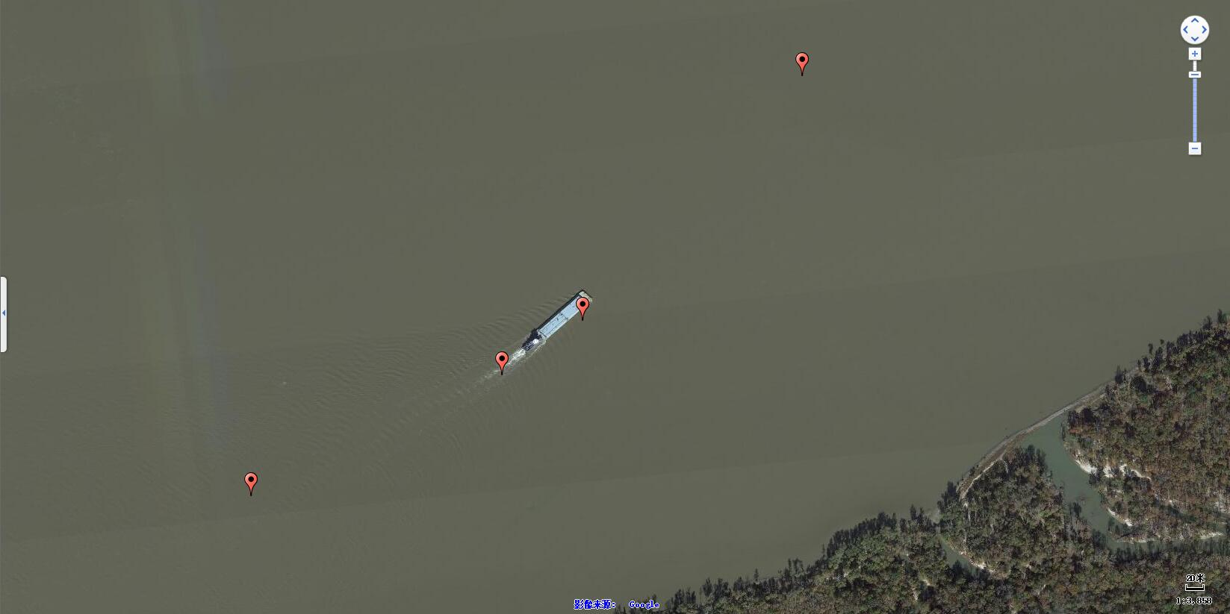
Fig 4.2 Geographical environment information of ship and obstacles
The main research content of this paper is to verify the effectiveness and robustness of DDPG-IDEP algorithm control strategy in ship navigation. Therefore, this virtual ship navigation platform omits the influence of natural factors such as ambient temperature, gravity and weather, and focuses on the ship navigation control strategy. The scene mainly simulates the simple ship control function based on real ship navigation. Therefore, the construction of ship simulation platform is shown in Figure 4.3.

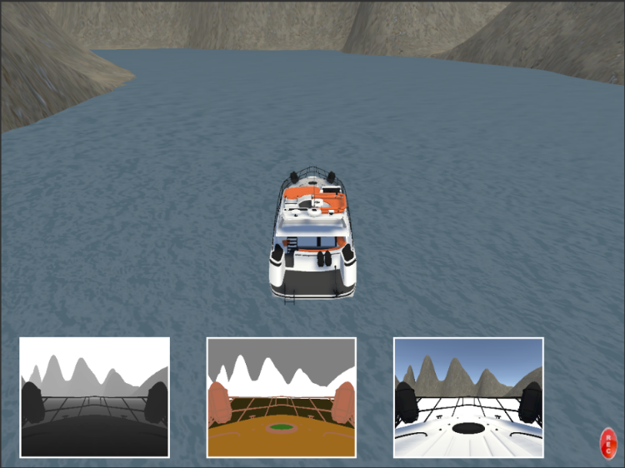
Fig 4.3 Construction of Ship Simulation Platform

4.1.4 Establishment of Ship Simulation Platform on Unity
This design mainly takes the Unity simulation environment as the experimental platform and studies the ship control in the unity simulation environment through the DDPD-IDEP algorithm strategy designed in this paper. Therefore, the training and effect of the algorithm are evaluated through the navigation performance of the ship agent in Unity.
The input states of the algorithmic network mainly include visual state input and the current state of the ship. The visual state input is mainly provided by the image API of the virtual ship navigation system. The visual picture does not reflect the current state of the ship or the position information of any object in the field of vision. Its main function is to record what actions the current ship takes according to the control strategy under the visual state according to the visual picture feature tensor. The current status of the ship is mainly provided by the on-board API of the virtual ship navigation system. Its main function is to provide the navigation position, speed and direction of the current ship, and then the system will calculate the reward value obtained by the ship according to the navigation information of the current ship. Finally, the visual input state tensor (s), the action performed (a), the reward obtained (r) and the new visual input state tensor (s ') obtained by the image API after taking the action are recorded in the experience pool as playback experience.
Computer vision API provides a comprehensive image API, which can retrieve synchronous images and ground reality from multiple cameras, including depth, parallax, surface normal and vision. The collision API obtains the collision information and returns a structure. The structure not only has the information of whether the collision occurs, but also has the information of collision position, surface normal and penetration depth. On board API can be used to set throttle, steering, etc., and retrieve status information, including speed, current gear and six kinematic quantities: position, direction, linear velocity and angular velocity, linear velocity and angular acceleration. This paper uses this API to design on-board API. The input state quantity of the algorithm training controller is mainly composed of the depth image gray set, and the selected input state quantity is shown in table 4.1. The output state quantity of the algorithm training controller is mainly composed of throttle, braking and steering, as shown in table 4.2.
Table 4.1 Network input
State quantity | Quantity | Range
current state | 1
Behavior value | 1
Reward value | 1 | —
Next state | 1
Imitation experience state | 1
Imitative experiential behavior | 1
Collision volume | 2 | [-1, +1]
Table 4.2 Network output control quantity
Control quantity | Quantity | Range
start-up | 1 | [0, +1]
braking | 1 | [0, +1]
turn | 4 | [-0.5, +0.5]
In table 4.1, the current state, behavior value, reward value and the next state are the four input quantities sampled from the playback experience pool, which provide corresponding inputs for the four networks in the algorithm. The current state and the next state are gray images of size respectively, and the behavior values correspond to the network output control quantity, with a total of six action dimensions. The reward value is provided by the reward value function. Imitation experience state and imitation experience behavior mainly provide network input for the current critic network. Their main function is to guide the action evaluation of the current critic network. The physical meaning of state and behavior is exactly the same as that of current state and behavior value. The collision quantity is mainly provided by the collision trigger of the virtual ship simulation system. When the ship collides in the process of interactive trial and error with the environment, this value is taken, indicating that there is a collision, and the collision information is fed back to the server. If there is no collision, this value is taken, and the feedback information is sent to the server for reward value design. The network output control quantity is reflected in Table 3.2. When the number of throttle is 1 and the throttle output value is "+ 1", it means that the ship is currently running. When the output value is "0", the ship navigation is not started. The braking output value "+ 1" indicates that the ship is braking during navigation, and the output value "0" indicates no braking. Here, throttle and brake are two action dimensions. The steering output is mainly divided into two left turn outputs and two right turn outputs. The left turn is composed of "- 0.5" and "- 0.25", and the right turn is composed of "+ 0.5" and "+ 0.25", of which the unit of 1 represents 90 degrees, and these four steering unit quantities constitute four action dimensions. As shown in table 4.3, the control quantity of ship navigation behavior is shown.
Table 4.3 Virtual ship behavior control quantity
Action index | Action quantity | Angle
0 | braking | null
1 | start-up | bull
2 | 0.5 | Turn right 45 degrees
3 | -0.5 | Turn left 45 degrees
4 | 0.25 | Turn right 22.5 degrees
5 | -0.25 | Turn left 22.5 degrees

4.2 Construction of algorithm platform
After analyzing the target network, network supervision error and network parameter update of DDPG-IDEP, according to the specific algorithm process of DDPG-IDEP, the network structure design and reward value function of DDPG-IDEP are analyzed in detail, and the algorithm platform is built.

4.2.1 Visual state input
The status image of the current ship can be flexibly obtained by the picture API in Airsim on Unity. The picture API can be divided into simGetimage API and simGetimages API. The former mainly obtains a single image from the camera numbered "0" and returns the image bytes in PNG format. The latter can call the cameras numbered "1", "2" and "3" to obtain the left camera view, the right camera view and the depth image respectively. The image format is uncompressed image and floating-point single channel image. This paper mainly studies the simGetimages API. The image acquisition functions are as follows:
import airsim
client = airsim.MultirotorClient()
responses = client.simGetImages([
airsim.ImageRequest(0, airsim.ImageType.Scene), //PNG format
airsim.ImageRequest(1, airsim.ImageType.Scene, False, False),// Uncompressed RGBA array bytes
airsim.ImageRequest(1, airsim.ImageType.DepthPlanner, True)])// Floating point uncompressed image
airsim.ImageRequest("0", airsim.ImageType.DepthPerspective, True, False)]// Depth perspective image
This paper mainly analyzes the input state quantity through the depth perspective image. After the imagerequest image is returned, the input image with the size of 144 * 256 will be obtained, and then the image will be compressed and converted into 84 * 84 gray image as the input tensor of the current state.
After obtaining the output state tensor, the output state tensor will be selected through three convolution layer transformations and two full connection layers in combination with the action dimension. The specific network structure is shown in Figure 4.3. Each execution unit turn will retrieve the current visual state input and obtain the tensor transformation result of the visual state after the action is executed.
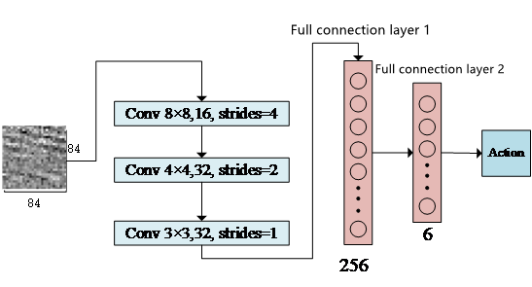
Fig 4.4 Action selection network based on visual input

In the network shown in Fig 4.4, firstly, three convolution layers are used to extract the local features of gray-scale images, and their convolution cores are respectively 8×8, 4×4 and 3×3. The number of channels is 16, 32 and 32 respectively. The three convolution layers are activated by ReLU function. The first layer of the full connection layer has 256 neurons, which adopts the ReLU activation function, and the number of neurons in the second layer of the full connection layer is the number of action dimensions. The output of the ship navigation control strategy studied in this paper is the six determined actions, which defines the ship navigation stop, ship navigation start, the action index values of left turn 0.5 unit quantity, right turn 0.5 unit quantity, left turn 0.25 unit quantity and right turn 0.25 unit quantity (1 unit quantity represents 90 degrees) are 0, 1, 2, 3, 4 and 5 respectively. There are 6 action dimensions in total, so there are 6 neurons in this layer, and there is no activation function in this layer. The parameters of the whole connection layer of the two layers are initialized by uniform distribution between [- 0.01,0.01]. Therefore, the function of action selection from visual state input to output is completed through the network.

4.2.2 Design of round training reward value function
For the design of reward value function, this design is mainly calculated by the current ship state value. Firstly, the specified upper speed limit is set to 50km/h and the lower speed limit is set to 10km/h. Here, the reward value is mainly determined by position reward and speed reward. Firstly, the input of the whole network calculation is the kinematic state of the current ship. The current kinematic state of the ship is mainly divided into six kinematic state quantities: position, direction, linear velocity and angular velocity, linear velocity and angular velocity acceleration. The required information can be obtained directly from the input value.
(1) Speed reward value calculation
The speed reward value is mainly calculated by obtaining the running speed of the current ship. The speed reward value defined here is calculated as
(4-1)
is the current sailing speed of the ship, is the lower speed limit value of 10km/h, is the upper speed limit value of 50km/h, The current ship's navigation speed is limited by the upper speed limit value and the lower speed limit value, so that the speed reward value will not be too large or too small, and the speed reward value will be stabilized between [- 0.5,0.5], so as to avoid the waste of data resources caused by too large round reward value.
(2) Location reward value calculation
The calculation of position reward value and speed reward value is relatively complex. The position reward value mainly depends on the distance between the new state and the starting point relative to the original state. The distance traveled by the ship is provided by Airsim on unity, as shown in Figure 4.5.
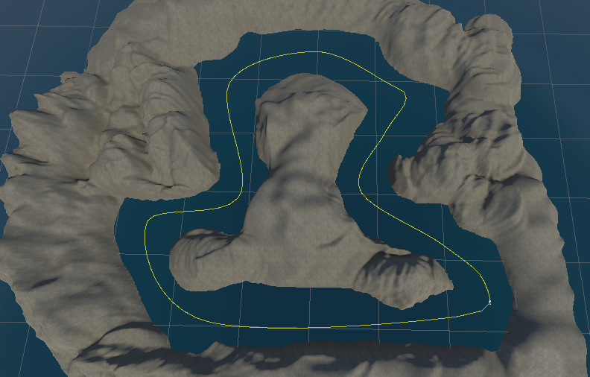
Fig 4.5 Center curve of virtual ship navigation channel
The distance of the ship is mainly determined by the actual position of the ship and the channel center curve, as shown in Fig 4.5, which shows the calculation process of the relative distance of the ship.
Fig 4.6 Curve distance calculation diagram of ship relative channel
In Fig 4.6, represents the relative distance from the ship to the starting point before taking the action, represents the relative distance from the ship to the starting point after taking the action, and is the distance difference after the current ship takes the action in the current state. If it is positive, it means that the ship is moving to the end, otherwise it means that the ship is moving to the starting point. Secondly, the navigation position of the current ship is obtained. Here, the position norm and the reward base are introduced. The position norm mainly represents the offset rate of the current ship's relative position. The reward base is the base value for calculating the reward value function. The initial value of the reward base is set to 3. Define the lower limit value of the position norm. When the position norm is less than the lower limit value , The position reward value can be directly set to - 3 to avoid the non-convergence of reward value caused by too large data, which will reduce the convergence speed of training and cause unnecessary waste of resources. The calculation of position norm is mainly based on the current ship navigation position and position norm weight. The position norm weight is determined by the initial position, and the position norm weight is:
(4-2)
According to the navigation position and position norm weight of the ship, the position norm corresponding to the current ship position can be calculated as follows:
(4-3)
Where min is the operation of taking the minimum value, norm is the operation of taking the norm, and ${Pts}^{'}$ is the next group of vectors relative to $Pts$. After the position norm is calculated by equation 4-3, the position reward value function can be calculated directly as long as the position norm is less than the upper limit of the position norm:
(4-4)
After obtaining the speed reward value and position reward value, you can directly calculate the whole behavior reward value as follows:
(4-5)
In addition to the calculation of speed reward value and position reward value, when the ship collides during navigation or the navigation direction is the opposite direction of the predetermined direction, this training round will end directly and start the next round of training.

4.2.3 Playback experience pool design
The playback experience pool is mainly composed of two parts: the priority value experience pool and the supplementary value experience pool. The input to the experience pool is the current interactive experience data $(s,a,r,s^{'}$). The difference between the playback experience pool of this design and the playback experience pool of the original DDPG mainly lies in the different storage and sampling methods. Therefore, next, the algorithm design will be carried out for the storage and sampling of experience data.
(1) Storage of empirical data
The most important storage of empirical data is to judge the value and similarity of the current input empirical data. According to the structural design of the double experience pool, the data with high value and low similarity with the previous sample are stored in the priority value experience pool, on the contrary, they are stored in the supplementary value experience pool. The evaluation standard TD-error of the sample data is calculated as follows:
(4-6)
All parameters have been defined during DDPG-IDEP design. Therefore, when the time division error of this data experience is greater, it is considered that the current data experience has higher value. When , this data experience is stored in the priority value experience pool , on the contrary, it is stored in the supplementary value experience pool .
In addition, experience playback design is also required for the measurement and storage of imitation experience data. For the experience gained after some experts' teaching, a simulation experience data pool is designed to store this series of experience. The experience pool data has been obtained through manual teaching since the beginning of training, Generally, a small part of experience trajectory data can be obtained to guide learning.
(2) Sampling of empirical data
Firstly, the two types of differentiated sampling are the imitation experience data stored in the imitation experience data pool and the experience obtained by the interaction between the agent and the environment. These two parts of experience are mainly sampled at fixed proportional intervals in the proportion of 1:1. If the total sampling quantity is set to 64, the sampling quantity of the imitation experience data and the experience obtained by the interaction between the agent and the environment is 32.
The sampling of the experience data of the interaction between the agent and the environment is mainly in the priority value experience pool and the supplementary value experience pool . The main purpose is to improve the value of the sampling data and reduce the correlation between samples. Therefore, the sampling samples in the priority value experience pool should be higher than those in the supplementary value experience pool, Therefore, the ratio of the two is set to 1.25 in this design. Because the total number of samples in this part is 32, the number of samples from the priority value experience pool is 18 and the number of samples from the supplementary value experience pool is 14.

4.2.4 Algorithm training process design
This paper mainly studies the new ship navigation control strategy algorithm based on the combination of experience pool improvement and imitation experience data based on the original DDPG algorithm. The DDPG algorithm given in reference [57] is the basis of this research and design. Therefore, this paper embeds the DDPD-IDEP algorithm into the virtual ship navigation simulation platform. The specific steps are as follows:
(1) Obtain the current visual state image of the ship by calling the image API provided by Airsim on Unity, normalize the image with the original size of 144 * 256 and compress the image into an 84 * 84 feature image, take this as the input of the action selection network, extract the image feature through three convolution layers, and select the corresponding action through two full connection layers, The action is transmitted according to Table 4.3.
(2) After the selected action is obtained, the onboard API link server provided by Airsim on unity is used to control the interaction between the ship and the virtual environment and obtain the next visual image state , then the next state is selected through the target action selection network, and the current reward value is calculated through the reward value function to obtain the interaction experience .
(3) Take the obtained interactive experience as the Q value calculation input of the current critic network and the target critic network respectively, and calculate the current Q value and the target Q value respectively. These two values will be used as the parameters of the TD-error function (equation 4-6) to evaluate the current experience, and store the experience into the priority value experience pool or supplementary value experience pool according to TD-error.
(4) Judge whether the playback experience pool capacity is full. If the capacity is not full, continue to interact with the environment. If the capacity is full, the subsequent new experience will cover the original experience and start the training and updating of the strategy network. The update process is to conduct equal proportion 1:1 random sampling from the interactive experience data pool (priority value experience pool and supplementary value experience pool) and imitation experience data pool respectively. The sampling proportion of priority value experience and supplementary value experience in the interactive experience data is 1.25 to ensure that the number of priority value experience is higher than that of supplementary value experience.
(5) The sampling experience obtained is taken as the training data of the current actor network and the current critic network. The update standard is the current value. The number of network parameter updates reaches 700 or an integral multiple of 700. If the target network parameter update standard is reached, the target actor network and target critic network parameters will be soft updated from the current actor network and the current critic network.
(6) Repeat the above five steps for network training, and at each action step, judge whether the ship collides by calling the collision API provided by Airsim on Unity. If the ship collides, the round of training ends, reset the ship's position, speed and other relevant information, and carry out a new round of training until the maximum number of rounds of training is reached.

Chapter 5 Results and discussion

5.1 Simulation experiment result
The quality of ship navigation control strategy mainly depends on the total reward value obtained by the ship in each round and the fluctuation degree of reward value. The greater the reward value obtained in each round, it indicates that the more correct actions and behaviors the ship takes under the guidance of the control strategy, the more positive returns it obtains. On the contrary, the more wrong behaviors it takes, the more negative returns it obtains. The fluctuation curve of reward value mainly reflects the change of reward value in each round. The smaller the fluctuation degree, the more stable the control strategy is, the better the algorithm performance is, and the greater the fluctuation degree, the worse the control strategy and the worse the algorithm performance is. The following will analyze the effectiveness and practicability of the control strategy in this paper from the reward value and fluctuation degree obtained in the process of ship navigation.

5.1.1 Round cumulative reward
This paper mainly adds the algorithm structure of double experience pool and imitation teaching learning on the basis of the original DDPG framework. In literature [61] and [62], in order to verify the multi unmanned vehicle intelligent decision-making of reinforcement learning and the unmanned driving research of deep deterministic strategy gradient, the round cumulative rewards of different algorithms are selected for verification, Therefore, this paper analyzes the original DDPG round cumulative reward, DDPG round cumulative reward with dual experience pool, DDPG round cumulative reward with separate imitation data, and DDPG round cumulative reward with dual experience pool and imitation experience data. Figure 5.1 shows the change trend of cumulative round rewards in the scenarios of the three algorithms.
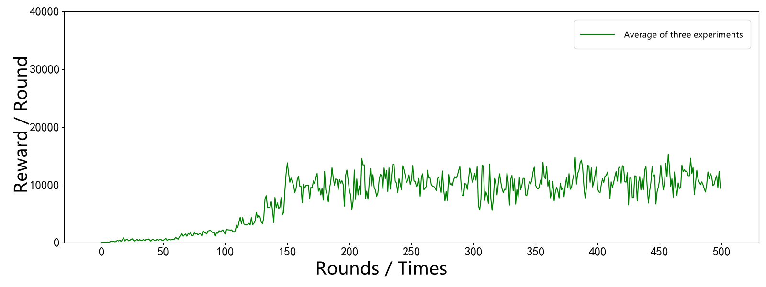
(a) DDPG algorithm 500 round reward curve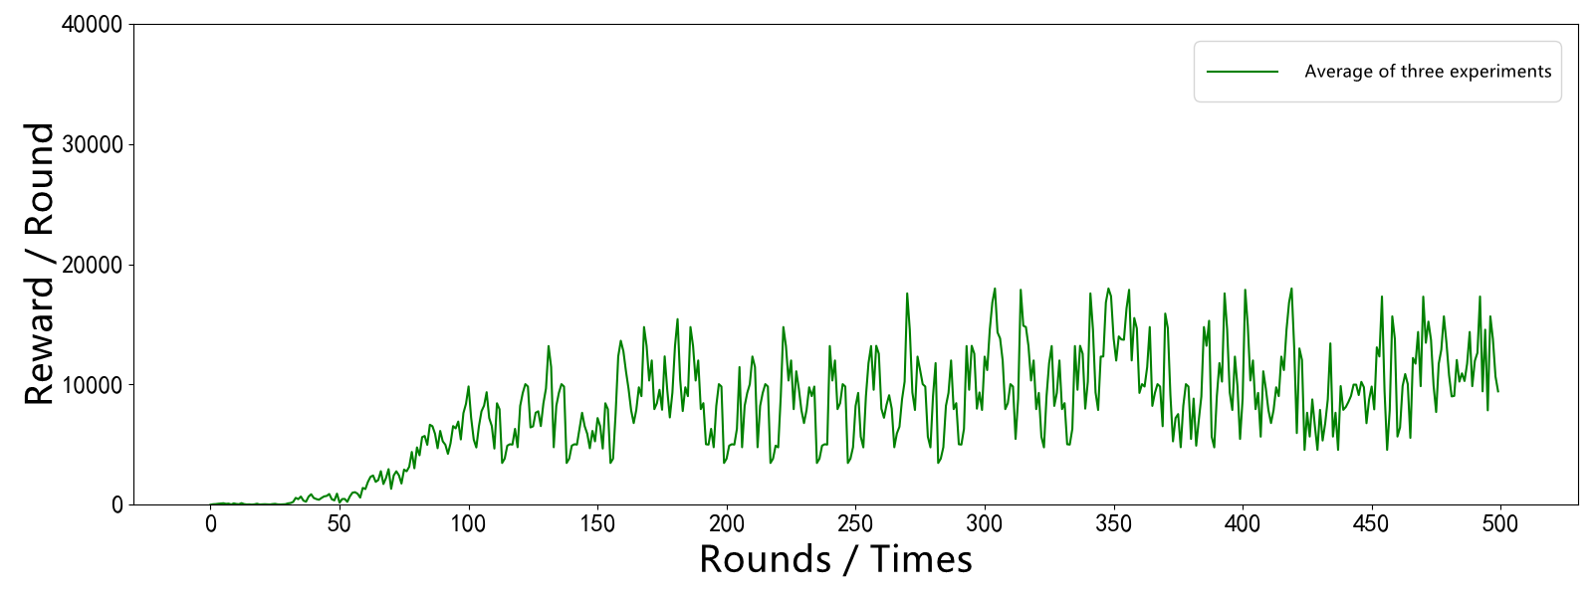
(b) Double experience pool DDPG algorithm 500 round reward curve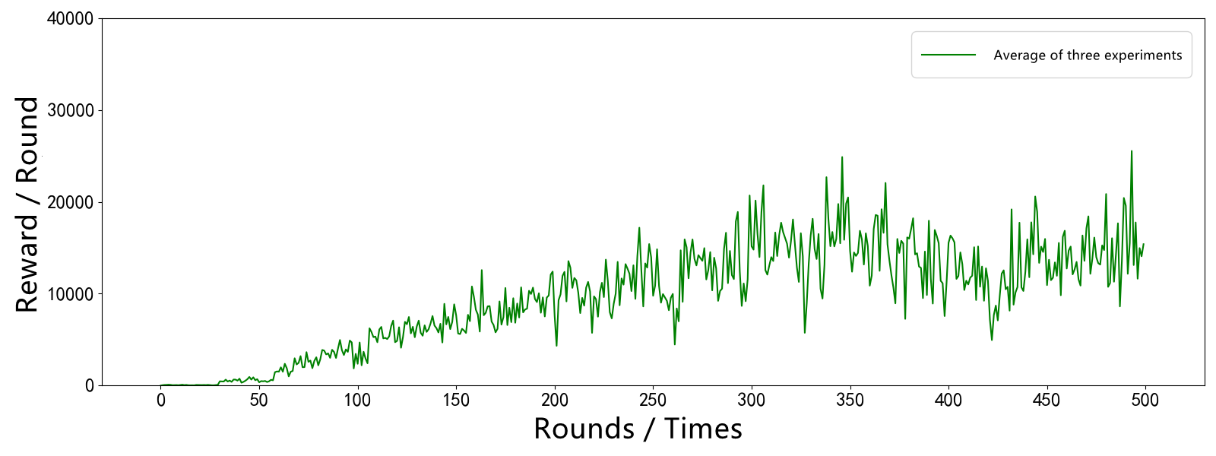
(c) 500 round reward curve of DDPG algorithm based on imitation learning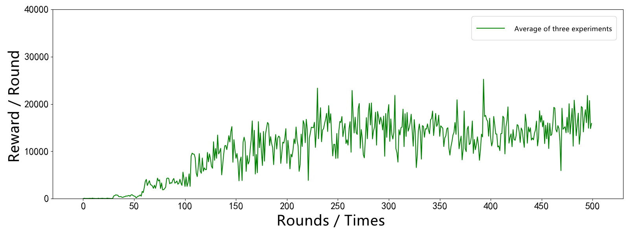
(d) DDPG-IDEP algorithm 500 round reward curve
Fig 5.1 Cumulative reward value of 500 scene rounds of four algorithms
At present, there are many studies based on DDPG algorithm based on deep reinforcement learning. In many studies, the round reward change curve of DDPG algorithm is mentioned. In references [62] and [63], the multi-agent research under the guidance of experience and the integrated multi-depth deterministic strategy gradient research are carried out respectively on the basis of DDPG algorithm. This paper mainly considers the learning algorithm efficiency under the guidance of experience pool improvement and imitation learning by comparison, it is found that the round reward results of DDPG algorithm cannot converge quickly and the training fluctuation is large. From the cumulative rewards of 500 scenario rounds of the above four algorithms, it can be seen that in (a), only the reward values of DDPG algorithm in the previous rounds are relatively small, and it starts to rise slowly after reaching a considerable number of rounds. However, in (b) and (c), there are round reward line charts after adding double experience pools and imitating experience data respectively, In these two figures, it can be clearly seen that after the start of a few rounds, the cumulative reward value has begun to rise, and it can be clearly seen that in (c), the reward value in the later rounds is significantly higher than the cumulative reward value of the previous two algorithms, indicating that in the previous few rounds, the DDPG algorithm with double experience pool can obtain high reward faster, DDPG added with imitation experience data is in a steady rising state, and more high reward values are obtained in the later stage. In (d), it is the algorithm training round of DDPG-IDEP, which combines double experience pool and imitation experience data, so that the advantages of both can be brought into play in DDPG-IDEP, indicating that DDPG-IDEP combines double experience pool and imitation experience data. It can not only converge quickly in the early stage like DDPG with double experience pool, but also obtain high rewards in the later training rounds. Therefore, the average reward of each round of DDPG-IDEP in the first 500 rounds can converge quickly and obtain high rewards.
In addition, several algorithms are analyzed from the data. The specific parameters of the four algorithms in 500 rounds are described in table 5.4, table 5.5, table 5.6 and table 5.7.
Table 5.4 Parameters and indexes of 500 rounds of DDPG training
$${Step}_{E200}$$ | $${Tran}_{E200}$$ | $${Step}_{E500}$$ | $${Ep}_{Tran10000}$$
11428 | 3039 | 49877 | 313
10233 | 2533 | 55356 | 342
10869 | 2311 | 42364 | 376
9810 | 1899 | 39608 | 409
11034 | 2793 | 33569 | 435
Table 5.5 parameters and indexes of DDPG training 500 rounds in double experience pool
$${Step}_{E200}$$ | $${Tran}_{E200}$$ | $${Step}_{E500}$$ | $${Ep}_{Tran10000}$$
10798 | 2036 | 53649 | 273
11235 | 2791 | 60231 | 326
10869 | 2403 | 49241 | 351
12034 | 3425 | 51035 | 329
11455 | 2833 | 57279 | 364
Table 5.6 parameters and indexes of 500 rounds of DDPG training imitating data
$${Step}_{E200}$$ | $${Tran}_{E200}$$ | $${Step}_{E500}$$ | $${Ep}_{Tran10000}$$
11234 | 2236 | 54613 | 283
12653 | 3564 | 56751 | 312
10984 | 2645 | 56112 | 294
12779 | 3964 | 53125 | 254
10536 | 2312 | 57327 | 325
Table 5.7 parameters and indexes of 500 rounds of DDPG-IDEP training
$${Step}_{E200}$$ | $${Tran}_{E200}$$ | $${Step}_{E500}$$ | $${Ep}_{Tran10000}$$
12313 | 2654 | 56983 | 265
12987 | 3367 | 58641 | 276
13564 | 4561 | 57451 | 254
13201 | 3978 | 54998 | 289
12478 | 4035 | 53649 | 305
Table 5.4, table 5.5, table 5.6 and table 5.7 show the five training of the four algorithms in 500 training rounds, in which the shaded font represents the best data in each data. ${Step}_{E200}$ and ${Step}_{E500}$ represent the number of steps performed during 200 rounds of training and 500 rounds of training, ${Tran}_{E200}$ represents the number of transfer processes in which the reward value of 200 rounds of training is greater than 100. ${Ep}_{Tran10000}$ represents the number of rounds in which the number of transfer processes is 10000 when the reward value of the transfer process is greater than 100.
According to the data of the above three tables, the following conclusions can be drawn:
(1) When training 200 rounds, the difference in the number of round steps completed by each algorithm is not large, but it generally performs better than the two separate algorithms in DDPG-IDEP.
(2) When training 500 rounds, it can be seen that the execution steps of the double experience pool fluctuate relatively greatly, and the execution steps of the DDPG algorithm based on imitation data fluctuate little, but its effect is still relatively poor compared with the DDPG-IDEP algorithm.
(3) In the variable ${Ep}_{Tran10000}$, it is obvious that DDPG-IDEP algorithm can use fewer rounds to achieve 10000 transfer processes with reward value greater than 100, and can quickly carry out round training in the later stage.

5.1.2 Round training time
The DDPG-IDEP algorithm designed in this paper mainly analyzes the algorithm structure of DDPG-IDEP control strategy under the condition of unstable training and slow training speed of the current DDPG algorithm, and explains to improve the experience playback pool structure, reduce the correlation between samples and improve the sample value, And the improvement of the supervision loss error under the guidance of simulated data makes the algorithm training stable and can converge quickly. In reference [66], the training time of integrated depth deterministic strategy gradient and depth deterministic strategy gradient is studied. Therefore, this paper also studies the training time with the same number of rounds as in reference [50]. Here, 6000 rounds of training are conducted for DDPG, DDPG algorithm with double experience pool, DDPG algorithm based on imitation data and DDPG-IDEP algorithm involved in this paper. As shown in Figure 5.2, the training time of four algorithms in 6000 rounds is shown. Different curves represent the time spent in a single round of training under each algorithm. The smaller the value recorded in the time curve. It shows that under this algorithm, the faster the training speed of the algorithm is, the faster the convergence of each training round can be.
It can be clearly seen in the figure that in the first few rounds, the round training times of the four algorithms are basically similar. When the number of rounds gradually increases, the DDPG-IDEP training time rises the slowest, followed by the curve rising speed of DDPG based on imitation data and DDPG with double experience pool. The time training curve displayed by DDPG rises the fastest. It can be seen from the figure that at the beginning, the training time of DDPG with double experience pool in the first round is significantly higher than that of DDPG based on imitation data. The main reason is that in the first round, DDPG algorithm based on imitation data mainly updates parameters by adding supervision error of imitation experience data, so its learning rate is relatively fast. After a certain round of training, when the sampling range of simulated experience data reaches the specified threshold, the supervision error of the original DDPG will still be used for training, and the improved playback experience pool technology mainly obtains data experience by distinguishing to select priority value and supplementary value experience in proportion. This sampling selection process has always existed. The training time increases slowly in the next round, and finally achieves the effect shown in Figure 5.2.
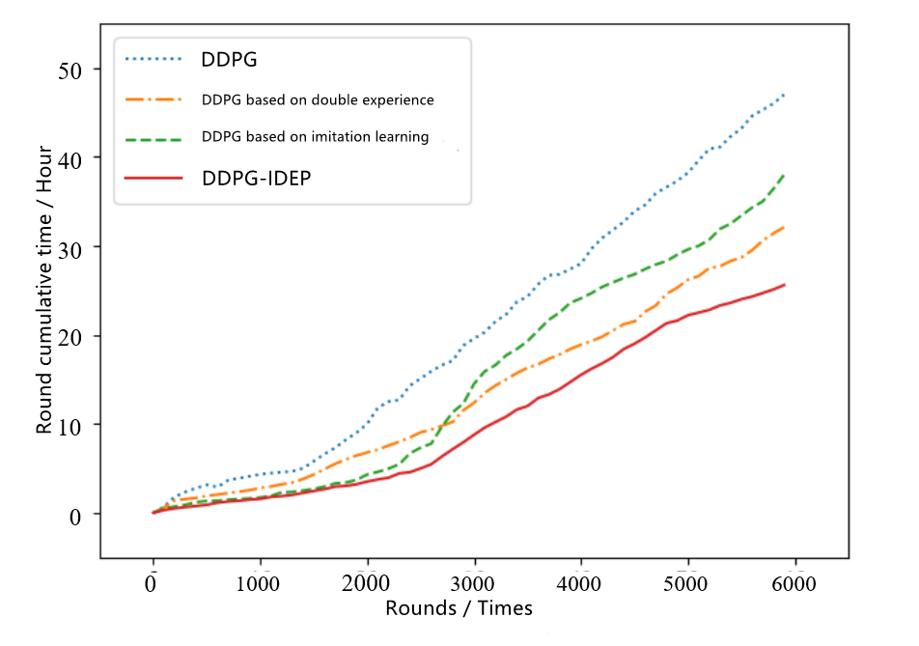
Figure 5.2 Unit training time of four algorithms in 6000 rounds

5.1.3 Training fluctuation of round reward
Training fluctuation is an important standard to verify the stability of the algorithm. Statistics are also made for 2000 rounds of DDPG, DDPG with double experience pool, DDPG based on imitation data playback and DDPG-IDEP algorithms according to the round cumulative reward. The experimental data are shown in the statistical chart of 2000 round average cumulative reward of the four algorithms shown in Figure 5.3. Figure 5.4 shows the training variance diagram of the four algorithms within 500 rounds.
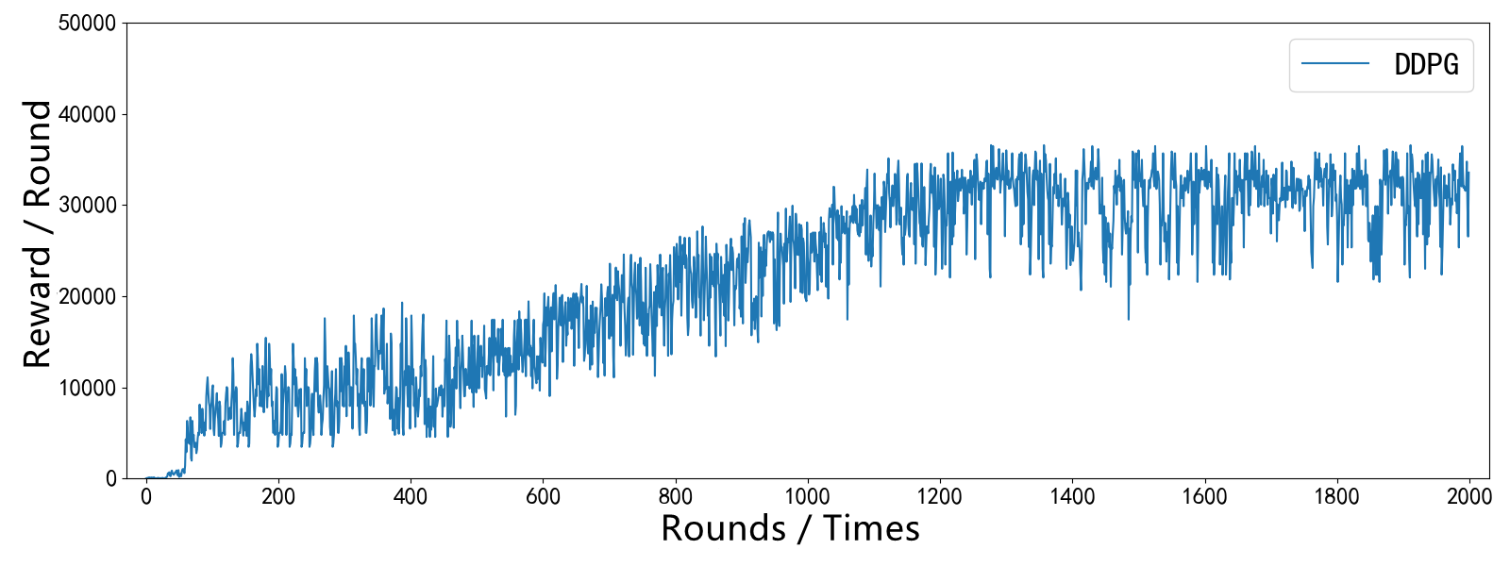
（a）DDPG Algorithm 2000 rounds reward curve

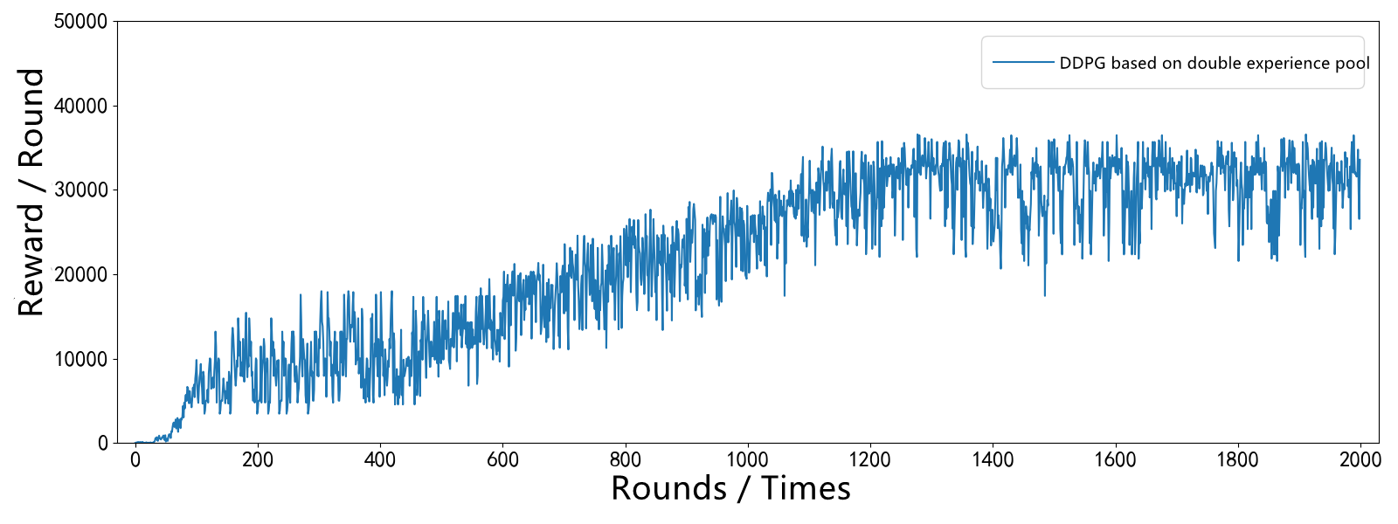
(b) Double experience pool DDPG algorithm 2000 rounds reward curve
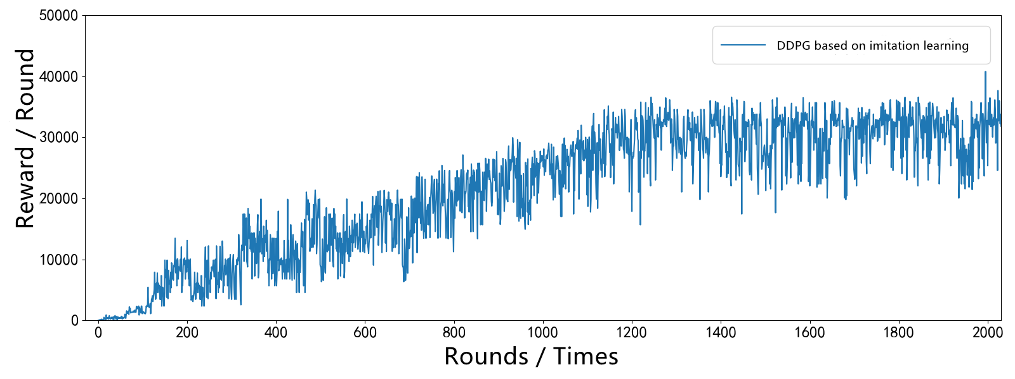
(c) DDPG algorithm 2000 rounds reward curve of imitation learning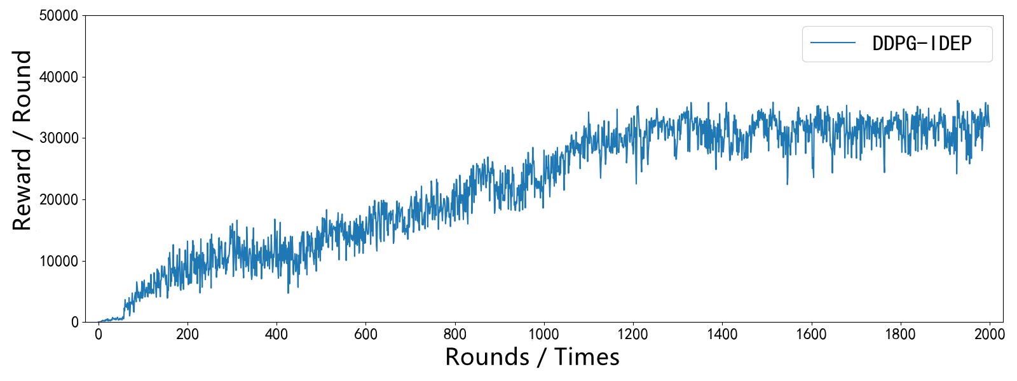
(d) DDPG-IDEP algorithm 2000 rounds reward curve
Fig 5.3 Statistics of average cumulative rewards of four algorithms in 2000 rounds
Fig 5.3 statistics of average cumulative rewards of four algorithms in 2000 rounds
By comparing the average cumulative rewards of the four 2000 rounds, it can be found that (a) in Figure 5.3 clearly shows that the original DDPG algorithm curve fluctuates greatly in the whole rising process, and the DDPG training variance fluctuates greatly compared with the other three algorithms in Figure 5.4. Therefore, only under the condition of the original DDPG algorithm, the convergence of its training effect is not very good. Figure 5.3 (b) and (c) respectively show the variation of DDPG training reward under double experience pool and simulated experience data. Obviously, the average reward variation of the two algorithms fluctuates less than that of the original DDPG. Combined with the training variance variation diagram shown in Figure 5.4, the performance of the two algorithms is improved compared with that of the original DDPG and the training effect is better. Figure 5.3 (d) shows the average reward change curve of the designed DDPG-IDEP algorithm in 2000 rounds, and combined with the training variance effect diagram in Figure 5.4, it shows that the training effect of DDPG-IDEP is significantly improved after combining double experience pool and imitating experience data. The designed DDPG-IDEP algorithm has better training performance compared with the original DDPG. The convergence of the algorithm is also greatly enhanced.
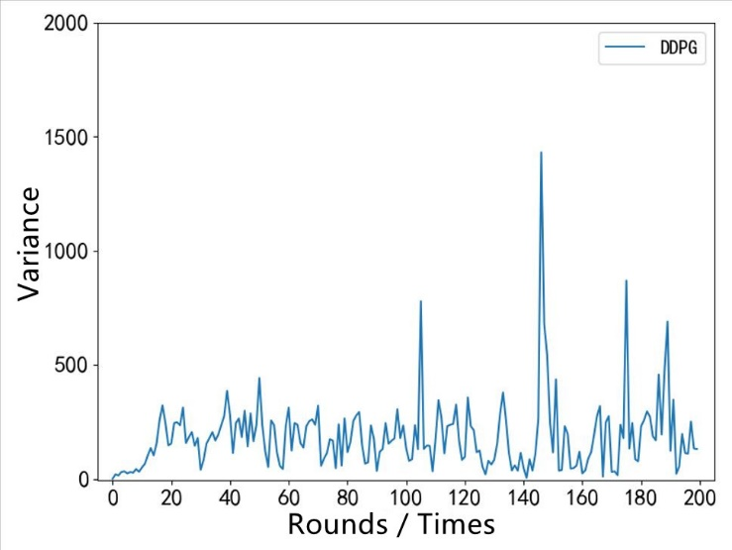
(a) Variance curve of 200 rounds reward of DDPG algorithm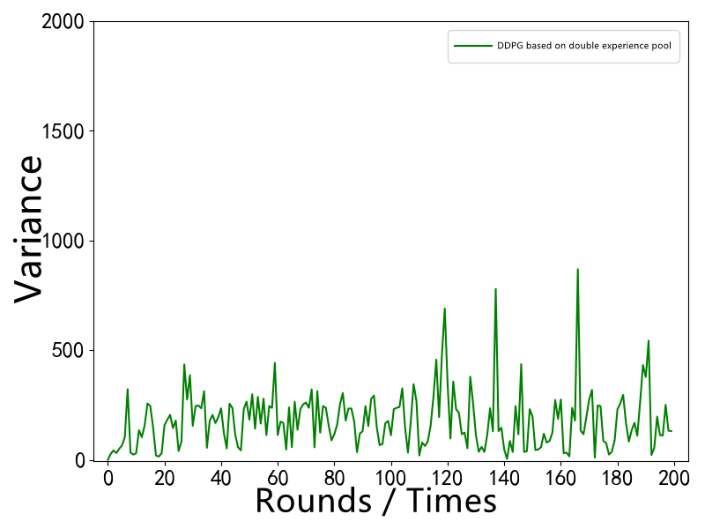
(b) Double experience pool DDPG algorithm 200 round reward variance curve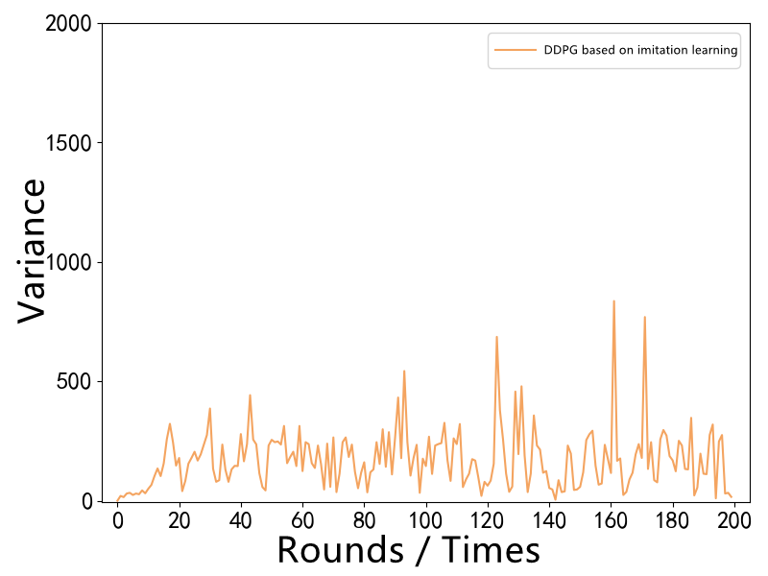
(c) 200 round reward variance curve of DDPG algorithm based on imitation learning
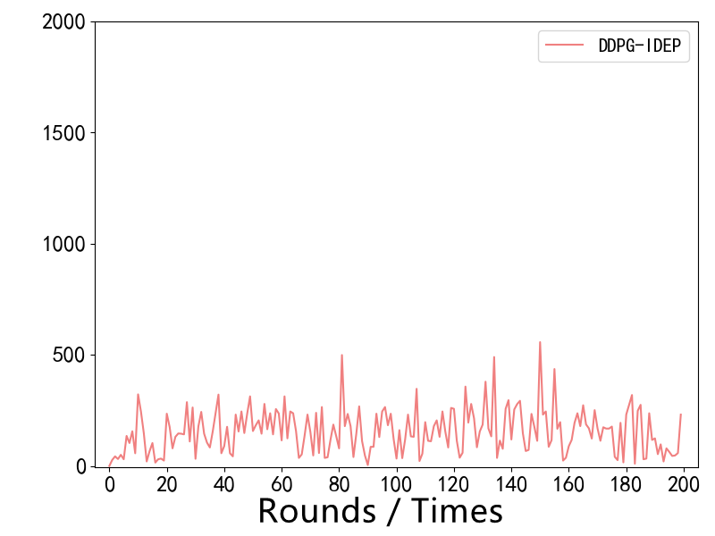
(d) 200 round reward variance curve of DDPG-IDEP algorithm
Fig 5.4 training variance diagram of four algorithms in 200 rounds

5.1.4 Generalization performance of fusion strategy
The generalization performance of the strategy is an important criterion to judge whether an algorithm is good or bad, because an algorithm often performs very well in determining the known training set. For the DDPG-IDEP algorithm strategy, the virtual ship navigation channel is equivalent to the training set, and the test on a training set often fails to explain the generalization performance of the fusion strategy. When applied to other training sets, the performance effect may be relatively poor. Therefore, for this reason, three different test maps are prepared in Unity engine. The different test maps are directly related to the different test sets, so as to verify the applicability of DDPG-IDEP algorithm strategy in different visual input states. The test map studied in this paper has similar geomorphic features and sea surface features to the training map, which ensures that it is similar to the visual state information collected by the training map. If the environmental geomorphic features differ greatly, it will affect the final generalization performance test. The training and test map model are shown in Figure 5.5 (a), (b) and (c). The DDPG-IDEP algorithm designed this time is applied to the virtual ship to train and test in (c) channel, test in (a) channel and (b) channel and obtain reward value information.
Figure 5.5 schematic diagram of three map models
The performance results of DDPG-IDEP algorithm in three map models are shown in table 5.8:
Table 5.8 performance results of DDPG-IDEP algorithm in three map models
Map model number | Total reward value | Is completed
A | 25264 | Yes
B | 36687 | Yes
C | 30793 | Yes

Table 5.8 shows that the virtual ship is mainly trained in (c) channel in Figure 5.13 under the DDPG-IDEP algorithm. The ship can successfully complete the training of (c) channel under the DDPG-IDEP control algorithm and obtain a relatively ideal reward value. After the training is completed, the trained strategy model of (c) channel is applied to (a) channel and (b) channel respectively Channel and record the total reward values on the two channels respectively, as shown in table 5.8. The virtual ship has completed the test training in channel (a) and channel (b) respectively, and also obtained a higher return value. The reason why the total reward value shown in table 5.8 is different is that the channel lengths of the three map models are inconsistent, resulting in the difference of the final total reward value. On the longer channel, the ship navigates for a longer time, so the final cumulative return is large. In the map model with shorter channel, the ship navigates for a shorter time, and the cumulative return is small. In Figure 5.5, the length of the three channels (b) is the longest and (a) the length of the channel is the shortest. Therefore, the total reward value in table 5.8 changes accordingly with the length of the three channels. Therefore, it can be concluded that DDPG-IDEP algorithm has relatively good generalization ability. After training a better model in a scene, the model can also be applicable in other environments similar to this environmental factor.
In addition, in order to study whether the trained model can have the same generalization ability for the obstacles in the channel, the obstacle channel section shown in Figure 5.6 is added under channel (c).
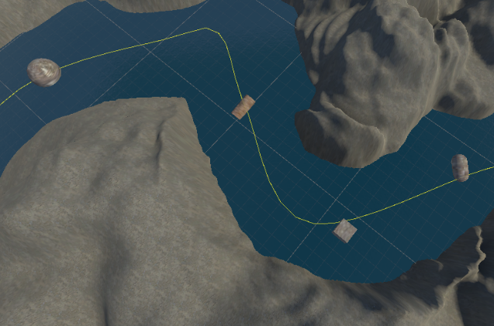
Figure 5.6 schematic diagram of obstacle segment

Four obstacles from right to left are added to the segment as shown in Figure 5.6, and the channel is tested by using the model trained in channel (c), as shown in Figure 5.7.
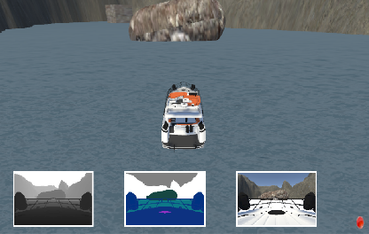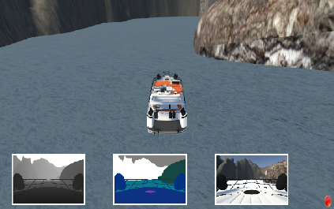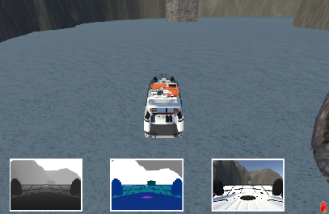
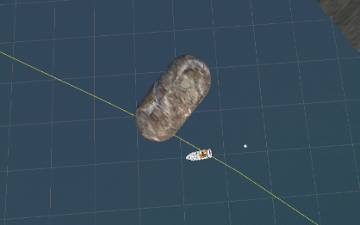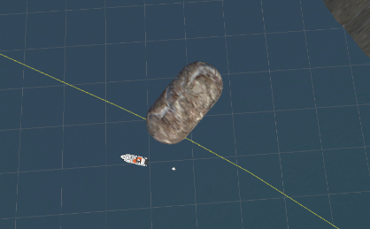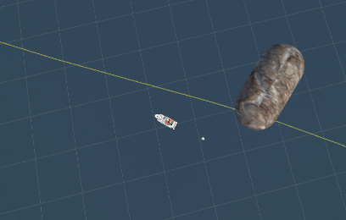
(a) Process diagram of avoiding the first obstacle
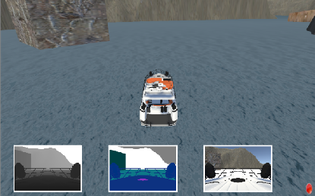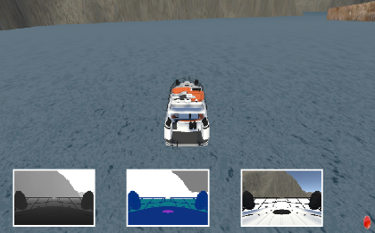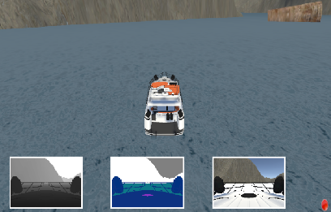
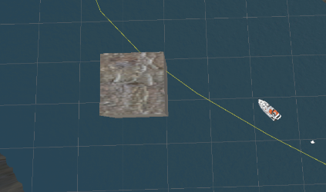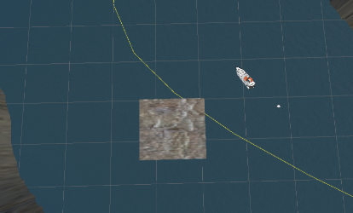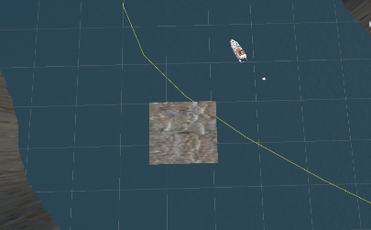
(b) Process diagram of avoiding the second obstacle
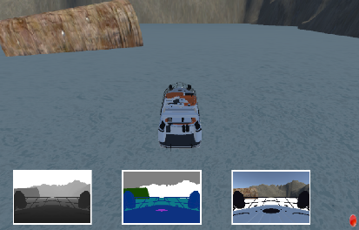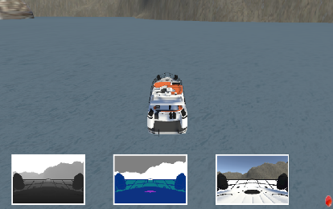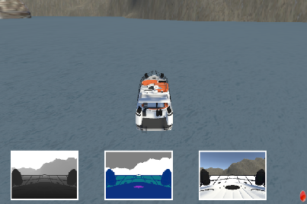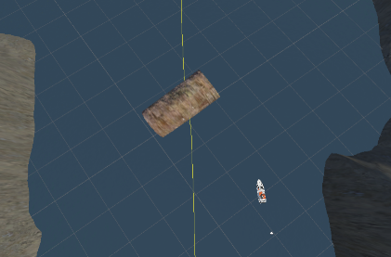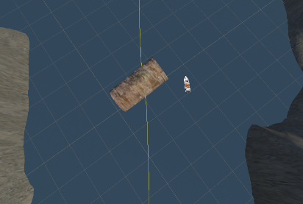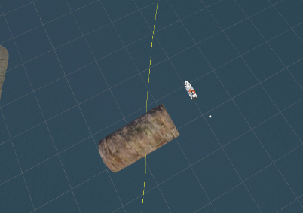
(c) Process diagram of avoiding the third obstacle
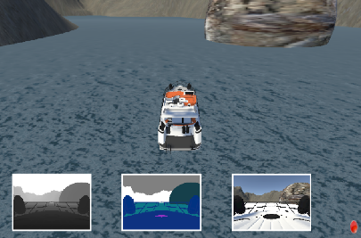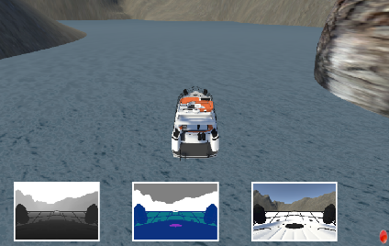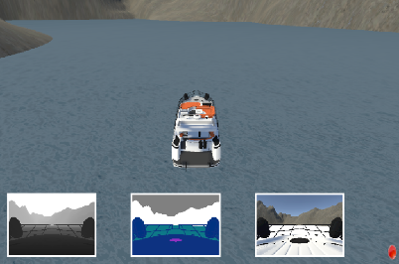
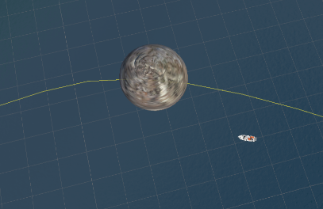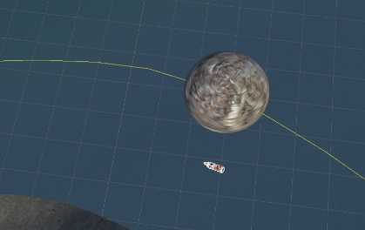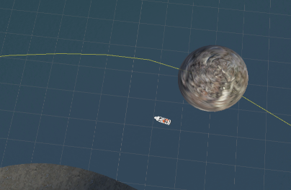
(d) Process diagram of avoiding the fourth obstacle
Figure 5.7 operation diagram of ship obstacle segment

Figure 5.7 shows the three driving diagrams and top views of the ship in front of, in and after the obstacle is detected. According to (a), (b), (c) and (d) in Figure 5.7, the ship bypasses the fixed obstacle and sails normally. It shows that the test model can be well applied to an obstacle avoidance process of some simple static obstacles, which shows that the generalization performance of the test model is good.

5.2 Results
This paper mainly analyzes the construction of simulation platform, algorithm platform and the final simulation experimental effect. The simulation platform is mainly based on Airsim on unity platform. Using the API provided by the platform, combined with the simulation environment designed by unity, Python is used for algorithm training. By analyzing the algorithm network structure, round training reward value function and playback experience pool of DDPG-IDEP, the different structures involved in DDPG-IDEP from the original DDPG are analyzed in detail. Finally, by comparing the original DDPG algorithm, the separate experience playback double experience pool DDPG algorithm, the separate DDPG algorithm imitating experience data, the round cumulative reward of DDPG-IDEP and the scene round training time, this paper explains the advantages of the DDPG-IDEP algorithm designed this time, analyzes its generalization performance and convergence, and finally explains the feasibility of this algorithm in practical application.

Chapter 6 Conclusion
With the rapid development of autopilot research at this stage, especially in-depth learning and deep reinforcement learning, many good practical results have been achieved in the field of autopilot. Whether in terms of vision or behavior control, it has developed quite rapidly in recent years. Aiming at the improvement of experience pool and imitation teaching of DDPG, a widely used deep reinforcement learning algorithm, this paper proposes a DDPG-IDEP algorithm control strategy with good convergence, fast training speed and good generalization performance, designs a virtual ship navigation system combined with unity engine and Airsim on unity interface API provided by Airsim, and uses the virtual navigation system for algorithm training, The effectiveness of the ship navigation control strategy is verified by experiments. The specific research innovations of this paper are as follows:
(1) The algorithm of combining double experience pool and DDPG is studied. A double experience pool playback experience algorithm system is proposed. The double experience pool is mainly composed of priority value experience and supplementary value experience. The experience obtained by the interaction between the agent and the environment is evaluated through time difference error (TD-error) to judge whether the currently obtained experience is priority value experience or supplementary value experience. Finally, the algorithm is extracted from the double experience pool in proportion to ensure that the priority value experience is higher than the supplementary value experience. Through the analysis of cumulative reward value, fluctuation characteristics of cumulative reward value and training time, it shows that the control algorithm is easier to converge than DDPG control algorithm.
(2) The algorithm of combining simulated empirical data with DDPG is studied. This part of the experience directly affects the error function of the algorithm at the beginning of the training round. The imitation experience data is mainly obtained by human teaching, and the state behavior experience of the current ship navigation state and behavior is continuously saved in the teaching process, so as to ensure that the imitation experience data extracted in the algorithm training process is the correct navigation experience data. Then, the current selected action is evaluated by the action error function $E(π_{E}\left(s_{E}\right),π\left(s_{E}\right))$, which also increases the convergence and stability of the algorithm.
(3) A depth deterministic gradient control strategy algorithm based on double experience pool and imitation learning is proposed. Firstly, the original network loss function of DDPG-IDEP algorithm is updated according to the DQFD algorithm design process, and then the Synthetic Supervision error loss function of DDPG-IDEP is derived according to the TD-error loss and the supervision error loss added with imitation empirical data, Finally, combined with critic network and actor network, the network parameter update rules and process of DDPG-IDEP control strategy algorithm are determined.
(4) The establishment of Unity virtual ship navigation simulation platform is studied. The virtual environment is built by Unity engine. The Airsim on unity platform provided by Microsoft Airsim realizes the call of image API, ship borne API and collision API, and realizes the direct control of ship navigation by DDPG-IDEP control strategy algorithm. The original DDPG algorithm, the DDPG algorithm with double experience pool, the DDPG algorithm with simulated experience data and the DDPG-IDEP algorithm proposed in this paper are applied to the system for simulation training. Compared with several case studies such as in-depth reinforcement learning driverless vehicle at the present stage, it is concluded that under the control of DDPG-IDEP strategy parameters, Ship navigation control has high convergence and stability.

Chapter 7 Reflection
The research content of this paper is mainly aimed at the research of ship navigation control strategy. In the face of the current driving control of vehicles, UAVs and ships, it is largely restricted by the real environment, resulting in many algorithm platforms cannot be well used in practice, so that the autopilot control algorithm cannot be evaluated for its availability and practicability, In this paper, Unity is used to build a virtual ship navigation environment, which solves the constraints of the environment on the research content to a certain extent, and can preliminarily apply the algorithm to the virtual environment that can be designed independently. The follow-up work can start from these aspects, mainly reflected in the following points:
(1) In terms of algorithm, the DDPG-IDEP algorithm studied in this paper has been improved to a great extent compared with the original DDPG algorithm, especially in terms of supervision loss. The biggest improvement of this design algorithm is the introduction of imitation data supervision in the critic network. In the follow-up work, we can consider improving the update process of the actor network and introducing imitation data supervision like the critic network. The action error is introduced as a penalty term, so that the idea of imitation data supervision can also be reflected in the actor network.
(2) in the virtual environment simulation module, although compared with many autopilot vehicle research, it has great freedom in the open-source TORCS vehicle simulator, and can independently design the scenarios that need it. However, Airsim on Unity is still more functional at this stage. On this basis, a more practical interface platform of algorithm and virtual engine can be designed.
(3) In terms of navigation control, the virtual ship driving platform designed this time is not very appropriate to the real ship, but simulates the simple dynamic model of ship navigation, which still has a certain gap with the real ship navigation environment. In the future, the dynamic model of virtual ship navigation in unity engine can be improved. By adding environmental factors similar to the real environment, the virtual simulation environment has better practical value.

References
[1] Tam C, Bucknall R, Greig A. Review of Collision Avoidance and Path Planning Methods for Ships in Close Range Encounters. Journal of Navigation, 2009, 62(3):455
[2] Tam C, Bucknall R. Path-planning algorithm for ships in close-range encounters. Journal of Marine Science and Technology, 2010, 15(4):395-407.
[3] Pedersen P T. Review and application of ship collision and grounding analysis procedures. Marine Structures, 2010, 25(3):241-262.
[4] Goerlandt F, Kujala P. Traffic simulation-based ship collision probability modeling. Reliability Engineering & System Safety, 2011, 96(1):91-107.
[5]https://www.ofweek.com/smartocean/2020-08/ART-190529-8440-30452727.html
[6] Moe S. Pettersen K Y. Set-Based Line-of-Sight (Los) Path Following with Collision Avoidance for Underactuated Unmanned Surface Vessel. Mediterranean Conference on Control and Automation. Atuhens, Greece, 2016:402-409
[7] Guo Chen, Wang Yang, Sun Fuchun, et al. Overview of motion control of underactuated surface ships. Control and decision making, 2009, 24(3): 321-329
[8] Li Ronghui, Li Tieshan, Bu Renxiang. Active disturbance rejection control for track tracking of underactuated surface ships. Journal of Dalian Maritime University, 2013, 39(2): 5-8
[10] Petres C, Romero-Ramirez M, Plumet F. Reactive path planning for autonomous sailboat. Tallinn, Estonia, 2011:112-117.
[11] Liu Z, Zhang Y, Yu X, et al. Unmanned surface vehicles: An overview of developments and challenges. Annual Reviews in Control, 2016, 41:71-93
[12] Tam C, Bucknall R, Greig A. Review of Collision Avoidance and Path Planning Methods for Ships in Close Range Encounters. Journal of Navigation, 2009, 62(3):455
[13] Pedersen P T. Review and application of ship collision and grounding analysis procedures. Marine Structures, 2010, 23(3): 241-262.
[14] Zhang Rubo. Research on obstacle avoidance method of fuzzy near field map for surface unmanned craft. Computer engineering, 2012,38 (21): 164-167.
[15] Paden B, Cap M, Yong S Z, et al. A Survey of Motion Planning and Control Techniques for Self-driving Urban Vehicles[J]. IEEE Transactions on Intelligent Vehicles, 2016, 1(1):33-55.
[16] Lecun Y, Bengio Y, Hinton G. Deep Learning [J]. Nature, 2015, 521(7553):436.
[17] Phanthong T et al. Application of A* algorithm for real-time path re-planning of an unmanned surface vehicle avoiding underwater obstacles. Journal of Marine Science and Application, 2014, 13(1):105-116.
[18] Praczyk T. Neurakl anti-collision system for Autonomous Surface Vehicle. Neuro-computing, 2015, 149:559-572.
[19] Graves A, Mohamed A R, Hinton G. Speech Recognition with Deep Recurrent Neural Networks[J]. Acoustics, Speech, and Signal Processing, 1988. ICASSP-88. 1988 International Conference on, 2013.
[20] Tian Y et al. On the velocity obstacle based automatic collision avoidance with multiple target ships at sea. International Conference on Transportation Information and Safety. Wuhan, China, 2015:468-472.
[21] Ben N, Wang Y, et al. A two-layered multi-agent reinforcement learning model and algorithm[J]. Journal of Network and Computer Applications,2006,30(4).
[22] Parisotto E, Ba J L, Salakhutdinov R. Actor-mimic: deep multitask and transfer reinforcement learning//Proceedings of the International Conference on Learning Representations, San Juan, Puerto Rico, 2016:156-171.
[23] Wender S, Watson I. Combining Case-Based Reasoning and Reinforcement Learning for Tactical Unit Selection in Real-Time Strategy Game AI[C]// International Conference on Case-Based Reasoning. Springer International Publishing, 2016.
[24] Damen Shtay A. An Intelligent Control System for Ship Collision Avoidance. International Journal of Engineering & Technology, 2012, 9(10):26-31.
[25] Lee S M. A fuzzy logic for autonomous navigation of marine vehicles satisfying COLREG guidelines. INTENATIONAL JOURNAL OF CONTROL AUTOMATION AND SYSTEMS, 2004, 2(2):171-181.
[26] Perera L P, Carvalho J P. Decision making system for the collision avoidance of marine vessel navigation based on COLREGs rules and regulations. Congress of Intl.Maritime Assoc. of Mediterranean. Istanbul, Turkey, 2009:1121-1128.
[27] Wang C, Zhang X, Cong L, et al. Research on intelligent collision avoidance decision-making of unmanned ship in unknown environments[J]. Evolving Systems, 2018.
[28] Abdelaal M. NMPC-based trajectory tracking and collision avoidance of unmanned surface vessels with rule-based colregs confinement. IEEE Conference on Systems, Process and Control. Melaka, Malaysia, 2017:23-28.
[29] Benjamin M R. The Interval Programming Model for Multi-objective Decision Making. Cambridge: Computer Science and Artificial Intelligence Laboratory, 2004.
[30] Pei K, Cao Y, Yang J, et al. DeepXplore: Automated Whitebox Testing of Deep Learning Systems[J]. 2017.
[31] Ishii S, Yoshida W. Part 4: Reinforcement Learning: Machine Learning and Natural Learning[J]. New Generation Computing, 2006, 24(3): p.325-350.
[32] Perera L P. Intelligent Ocean Navigation and Fuzzy-Bayesian Decision/Action Formulation. IEEE JOURNAL OF OCEANIC ENGINEERING, 2012,37(2):204-219.
[33] Zhang J, Zhang D, et al. A distributed anti-collision decision support formulation in multi-ship encounter situations under COLREGs. Ocean Engineering, 2015,105:336-348.
[34] Li Lina, Chen Guoquan, Shao zhe Ping. Construction of ship anthropomorphic intelligent collision avoidance decision method and its evaluation standard. Journal of Dalian Maritime University, 2011,37(4):1-5.
[35] Jeffrey D Johnson, Jinghong Li, Zengshi Chen. Reinforcement Learning: An Introduction[J]. Neurocomputing,2000,35(1).
[36] Zhao Y, Li W. A real-time collision avoidance learning system for Unmanned Surface Vessels. Neurocomputing, 2016, 182:255-266.
[37] Kuwata Y et al. Safe Maritime Autonomous Navigation With COLREGS, Using Velocity Obstacles. IEEE JOURNAL OF OCEANIC ENGINEERING, 2014, 39(1):110-119.
[38] Campbell S, Naeem W. A Rule-based Heuristic Method for COLREGS-compliant Collision Avoidance for an Unmanned Surface Vehicle. IFAC Proceedings Volumes, 2012, 45(27):386-391.
[39] Watkins CJ C H, Dayan P.Q-learning[C]//Machine Learning.1992:279--292.
[40] Xue Y, Clelland D et al. Automatic simulation of ship navigation. Ocean Engineering, 2011, 38:2290-2305.
[41] Sutton R S, Mcallester D, Singh S, et al. Policy Gradient Methods for Reinforcement Learning with Function Approximation[J]. Advances in Neural Information Processing Systems,2000,12:1057-1063.
[42] Shiau Hong Lim, Huan Xu, Shie Mannor. Reinforcement Learning in Robust Markov Decision Processes[J]. Mathematics of Operations Research,2016,41(4).
[43] Johansen T A. Ship Collision Avoidance and COLREGS Compliance Using Simulation-Based Control Behavior Selection with Predictive Hazard Assessment. IEEE TRANSACTIONS ON INTELLIGENT TRANSPORTATION SYSTEMS, 2016, 17(12):3407-3422.
[44] Cho W S, Wang M. Deep Primal-Dual Reinforcement Learning: Accelerating Actor-Critic using Bellman Duality[J]. 2017.
[45] Bouzy B, Chaslot G. Monte-Carlo Go Reinforcement Learning Experiments[C]// Computational Intelligence and Games, 2006 IEEE Symposium on. IEEE, 2006.
[46] Szlapczynski R, Szlapczynska J. Review of ship safety domains: Models and applications. Ocean Engineering, 2017, 145:277-289.
[47] Szepesvári, Csaba. Least-Squares SARSA(Lambda) Algorithms for Reinforcement Learning[C]// Fourth International Conference on Natural Computation. IEEE Computer Society, 2008.
[48] Abtahi F, Fasel I. Deep Belief Nets as Function Approximators for Reinforcement Learning[C]// IEEE ICDL-Epirob 2011. IEEE, 2011.
[49] Van Hasselt H, Guez A, Silver D. Deep Reinforcement Learning with Double Q-learning[J]. Computer Science, 2015.
[50] Zhai J, Liu Q, Zhang Z, et al. Deep Q-Learning with Prioritized Sampling[M]// Neural Information Processing. Springer International Publishing, 2016.
[51] Lillicrap T P, Hunt J J, Pritzel A, et al. Continuous Control with Deep Reinforcement Learning[J]. Computer Science, 2015, 8(6): A187.
[52] Mnih V, Badia A P, Mirza M, et al. Asynchronous methods for deep reinforcement learning//Proceedings of the Interna-tional Conference on Machine Learning. New York, USA,2016:1928-1937.
[53] Schulman J, Levine S, Moritz P, et al. Trust region policy optimization//Proceedings of the International Conference on Machine Learning. Lugano, Switzerland,2015:1889-1897.
[54] Lopes M, Melo F, Montesano L, et al. Abstraction Levels for Robotic Imitation: Overview and Computational Approaches[M]// From Motor Learning to Interaction Learning in Robots. 2009.
[55] Hussein A, Gaber M, Elyan E, et al. Imitation Learning: A Survey of Learning Methods[J]. 2017.
[56] S. Ross and J. A. Bagnell. Efficient reductions for imitation learning. In Proceedings of the 13th International Conference on Artificial Intelligence and Statistics (AIS-TATS), 2010.
[57] Silver D, Lever G, Heess N, et al. Deterministic policy gradient Algorithms[C]//International Conference on International Conference on Machine Learning. JMLR.org, 2014:387-395.
[58] Hester T, Vecerik M, Pietquin O, et al. Learning from Demonstrations for Real World Reinforcement Learning[J]. arXiv:1704.03732[cs.AI].2017.
[59] Sharma A, Noel M M. Active disturbance rejection control for cargo ship steering. American Control Conference. Chicago, USA, 2015:3956-3961.
[60] Li R, Li Q. Application of Active Disturbance Rejection Control in ship course and track control. Proceedings of the 30th Chinese Control Conference. Yantai, China, 2011:6310-6314.
[61] Guo Zongyi. Research on intelligent decision-making method of multiple unmanned vehicles based on Reinforcement Learning [D]. Dalian University of technology, 2019.
[62] Wu junta. Research on unmanned driving strategy based on integrated multi depth deterministic strategy gradient [D]. University of Chinese Academy of Sciences, 2019.
[63] Chen H, Liu Q, Yan Y, et al. Deep deterministic multi actor critic algorithm based on experience [J]. Computer research and development, 2019,56 (08): 1708-1720.

