
APPENDIX GA36a

LEVEL 4 ASSESSMENT SPECIFICATION

Student name: |  | Student ID number:
Programme: | BEng Motorcycle/Motorsport/Automotive Engineering
Module: | Engineering Design and Materials
Module code: | ACHA4001 | Contribution to Overall Module Assessment (%): | 50%
Lecturer: | Andrew Harrison | Internal Verifier: | Owen Williams
Assignment Title: | The production of 3D Modelled Components and Assemblies | Word count (or equivalent):
Submission deadline: | 30/04/21 | Return date of provisional marks & written feedback: | Within 20 working term time days of submission date
Submission method: | All written assessments, where practical and possible, must be submitted via Turnitin unless otherwise instructed by the Lecturer. (Please DO NOT put this assessment specification into Turnitin or it will match many similarities with other students’ submissions.)  Alternative submission method (if applicable):  Late submission of the assessment will result in a late penalty mark. Penalties for late submission: Up to one week late, maximum mark of 40%. Over one week late, 0%. Only the Extenuating Circumstances Panel may approve a change to submission dates.
Academic honesty / referencing: | Academic honesty is required. In the main body of your submission you must give credit to authors on whose research and ideas your work is based. Append to your submission a reference list that indicates the books, articles, etc. that you have used, cited or quoted in order to complete this assessment.

Module Learning Outcomes
(from module syllabus)
Upon the successful completion of this module, the student should be able to:

•Show knowledge and understanding of design methodologies and processes (problem definition/decision making/communication etc.)

•Demonstrate skills in communicating the design, material and manufacturing of products through the preparation and interpretation of Engineering Drawings to BS8888 through the medium of 2D and 3D CAD tools. Including cognitive skills to allow choice of material and manufacturing processes to meet specific design criteria.

TASK DESCRIPTION

Computer Aided Design (CAD) is used extensively throughout many industries. Although two-dimensional CAD software is still appropriate for some applications, the use of three-dimensional solid modelling and assembly applications are widespread across a number of engineering sectors. In this assignment you will gain experience in using a Computer Aided Engineering Solid Modelling package in the production of three-dimensional solid models of components and assemblies.

Task 1

Using the SolidWorks Computer Aided Engineering software, create a solid model of the ‘Sliding Jaw’ based on the geometry and dimensions outlined in the technical drawing provided on Moodle (Sliding Jaw .pdf)

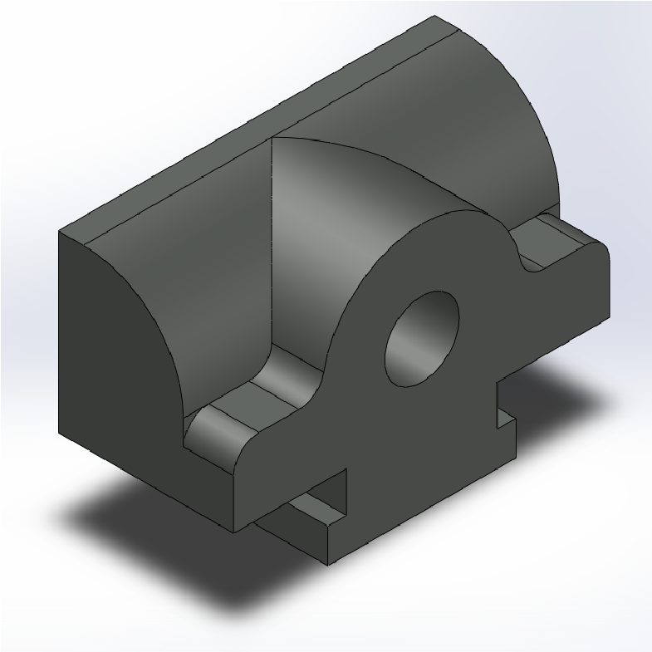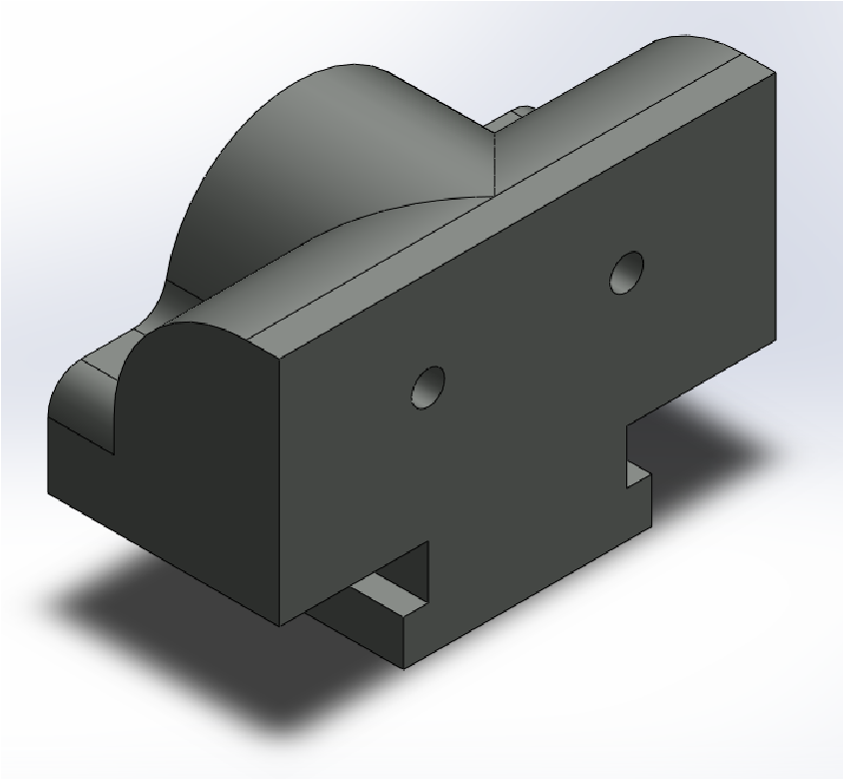

3D Images of the ‘Sliding Jaw’ (technical drawing available on Moodle)

(35 Marks)

Task 2

Using the SolidWorks Computer Aided Engineering software, you are required to construct an assembly of the following parts:

- Base
- Bush
- Handle Lever
- Jaw Plate
- Screw Shaft
- Sliding Jaw

The Base, Bush, Handle Lever, Jaw Plate and Screw Shaft geometry have already been modelled and should be downloaded from Moodle as separate part (.SLDPRT) files.

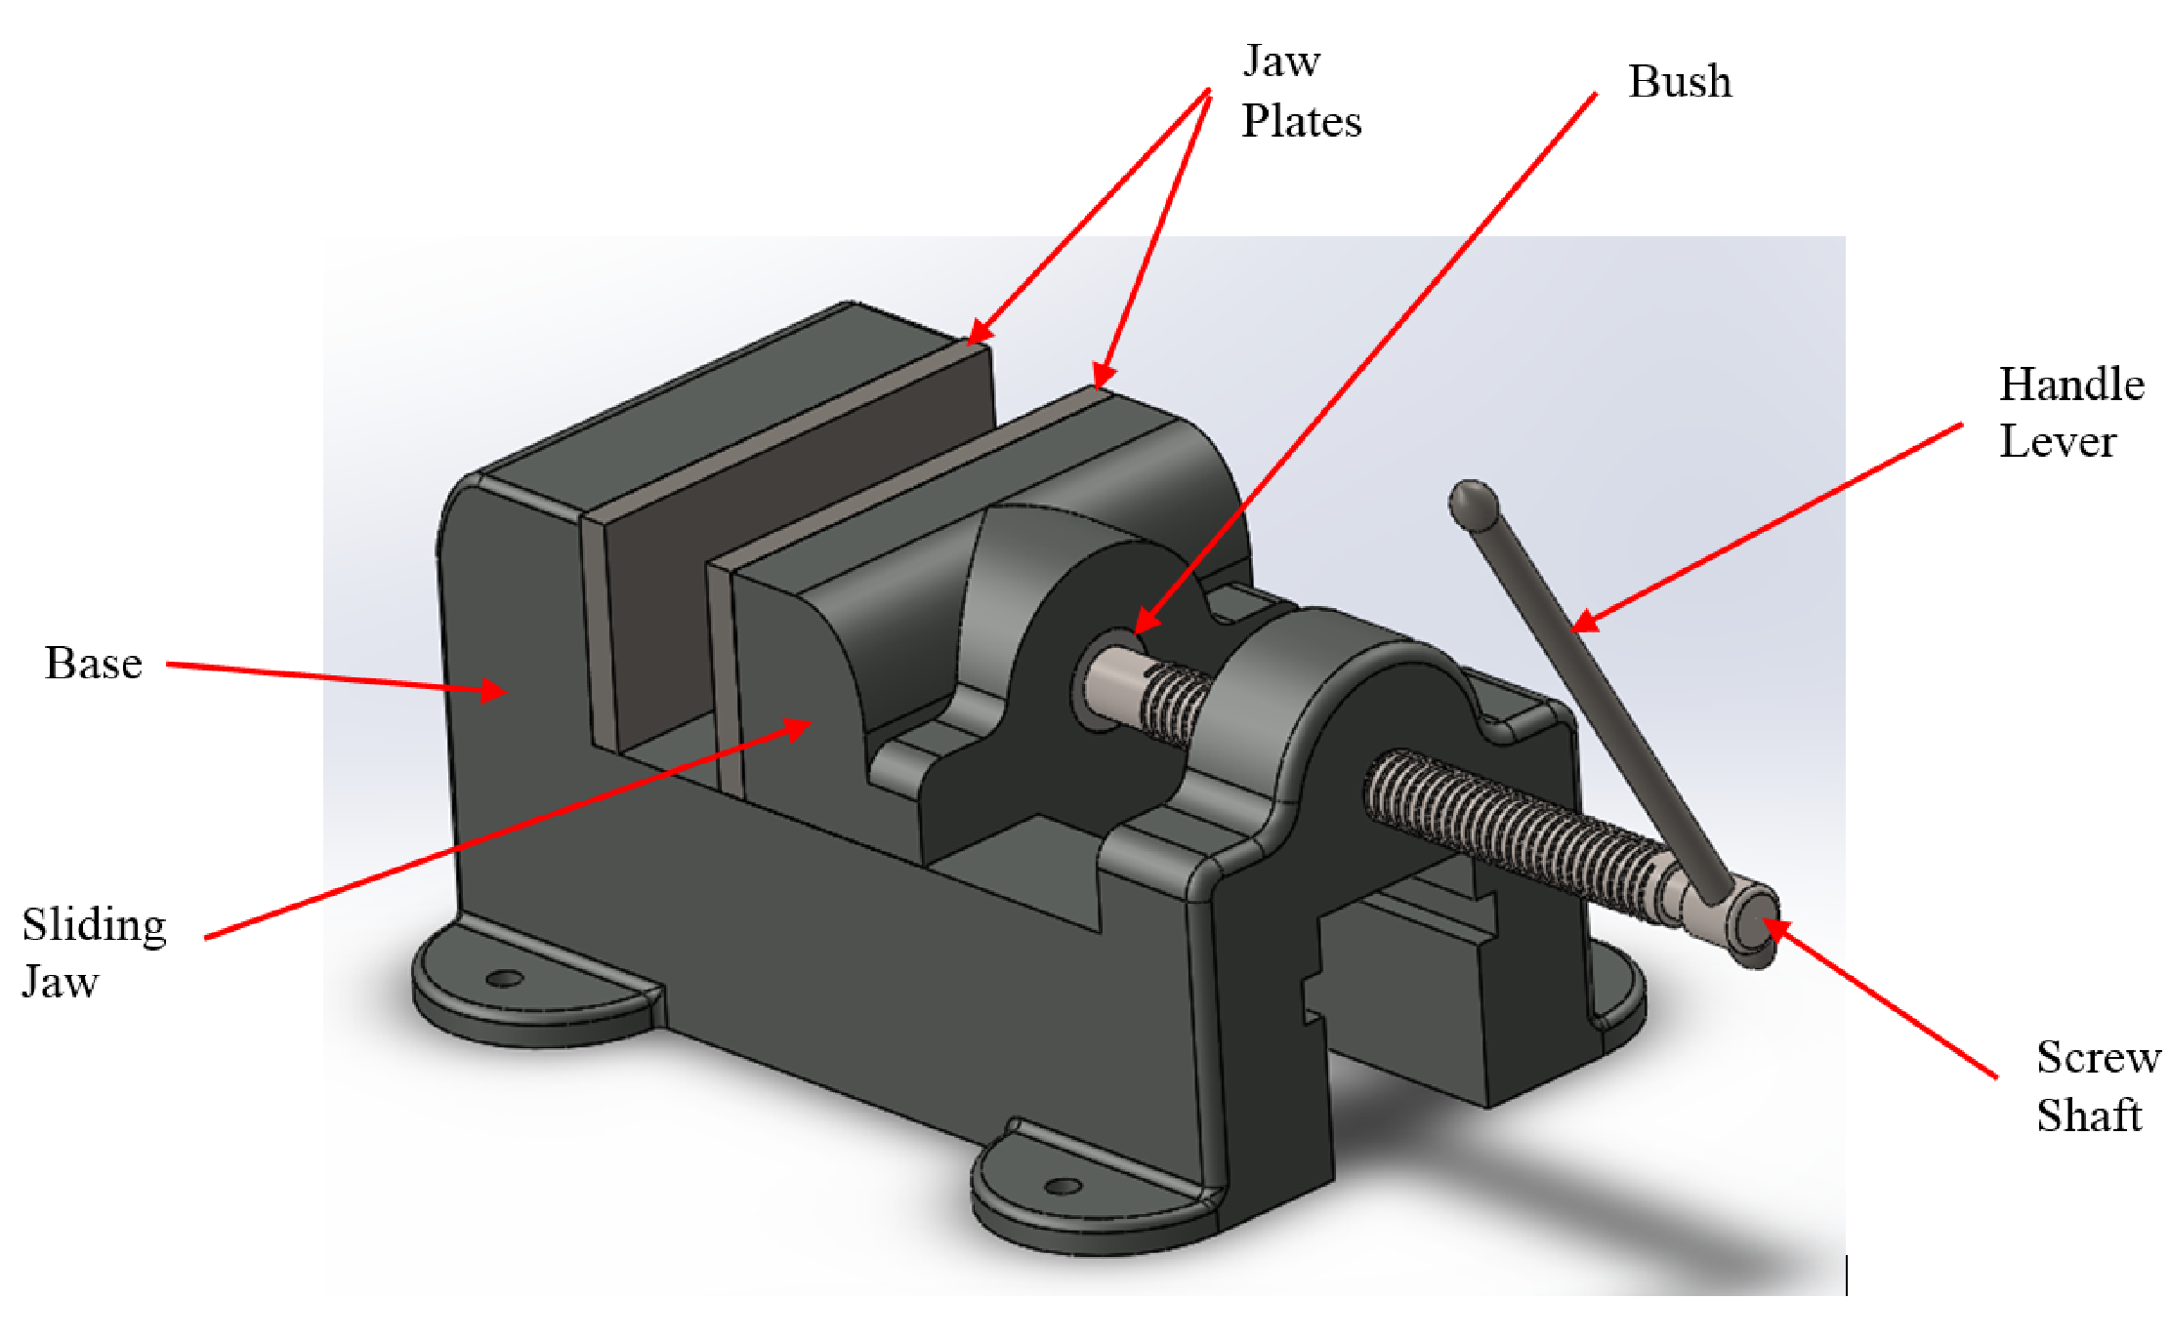

Using the Sliding Jaw model which you developed in Task 1, you are required to position and constrain each of the components within the assembly in order that the inter-part assembly geometry represents that of a vice. A motion simulation clip is available on Moodle to clarify the desired inter-part geometry (Vice Motion .avi).
(35 Marks)

Task 3

Model a component (of your choosing) to sit in the vice. This may be similar to one of the components you’ve modelled previously or could be a new geometry. Aim to demonstrate:

- The use of a wide range of modelling tools and strategies
- The ability to develop complex features / part geometry
- The ability to apply efficiency in the modelling process

(30 Marks)

GUIDANCE FOR STUDENTS IN THE COMPLETION OF TASKS

- You are to begin and finish your modelling activity in a single, session lasting no longer than two hours. However, you may practice and prepare for your assessment activity beforehand. Completed models/assemblies should be uploaded to the ‘CAD Submission’ Turnitin link at the end of the assignment lab session in a ‘zipped’ folder.

- Please keep a copy of your work in your ‘My Documents folder’. Please don’t amend or re-save any of your assignment part-files once you have finished the lab session as the electronic date-stamp will invalidate files as a verifiable backup of the work completed for the assignment.

You will be marked on your ability to:

- Create correct Part Geometry
- Use a range of appropriate tools when modelling (sketch and feature functions)
- Manage and organise the part structure
- Create a suitable assembly structure with appropriate mating conditions and degrees of freedom.

It is advised that regular saves are carried out during the lab session in case of IT/software crashes or interruptions.

Saving Your Work
Remember that the assembly file along with the files of any parts instanced within the assembly should uploaded to the Turnitin link. Therefore, the files saved onto the CD should look like the list below (not necessarily in order).
- Base
- Bush
- Handle Lever
- Jaw Plate
- Screw Shaft
- P****** Sliding Jaw
- P****** Task 3 Part

It’s advised that regular saves are carried out during the lab session in case of IT/software crashes or
interruptions. It is best to work of the ‘C’ drive of the machine during the assignment session (create a file in ‘My Documents’) and then upload a copy the entire ‘zipped’ file to the Turnitin link once you have finished your work.

MARKING CRITERIA AND STUDENT FEEDBACK

This section details the assessment criteria. The extent to which these are demonstrated by you determines your mark. The marks available for each criterion are shown. Lecturers will use the space provided to comment on the achievement of the task(s), including those areas in which you have performed well and areas that would benefit from development/improvement.

Assessment Criteria Applied | Marks available | Marks  awarded
1. Part Modelling from a Technical Drawing
This task will be assessed by evaluating the your ability to interpret the engineering drawing provided to develop an accurate solid model of the ‘Sliding Jaw’ | 35
2. Assembly Development
This task will be assessed by evaluating your ability to use assembly definition tools to build a digital representation of the vice assembly. You should aim to develop an assembly which represents the static and dynamic relationships which exist between the vice components. You should aim to develop a digital (SolidWorks) assembly which reflects the inter-part relationships which would exist in its real-world equivalent. | 35
3. Free Part Modelling
Develop part geometry of a component to be sited in the vice. You should aim to:  - Use of a wide range of modelling tools and strategies  - Demonstrate the ability to develop complex features / part geometry  - Apply efficiency in the modelling process (efficient use of sketches and features). | 30

Late Submission Penalties (tick if appropriate)
Assignment Mark (Assessment marks are subject to ratification at the Exam

Student FEEDBACK FORM

This section details the extent to which the assessment criteria are demonstrated by you, which in turn determines your mark. The marks available for each category of skill are shown. Lecturers will use the space provided to comment on the achievement of the task(s), including those areas in which you have performed well and areas that would benefit from development/improvement.

Generic Assessment Criteria | Marks available | Marks  awarded
1. Engagement with Literature Skills
.
 | 10
2. Knowledge and Understanding Skills

 | 30
3. Cognitive and Intellectual Skills

 | 30
4. Practical Application Skills

 | 20
5. Transferable Skills for Life and Professional Practice

 | 10

Assessment Mark (Assessment marks are subject to ratification at the Exam Board. These comments and marks are to give feedback on module work and are for guidance only until they are confirmed. ) | Late Submission Penalties (tick if appropriate) |  | %
 | Up to 1 week late (40% Max) |  | %
 | Over 1 week late (0%) |  | %

GENERIC ASSESSMENT CRITERIA

Level 4
In accordance with the Framework for Higher Education Qualifications, at the end of Level 4 students will be expected to have demonstrated knowledge of the basic underlying concepts and principles of a subject, and an ability to evaluate and interpret these within the context of that area of study. They should be able to present, evaluate and interpret qualitative and quantitative data in order to develop lines of argument and make sound judgements in accordance with basic theories and concepts of their subject(s) of study. They will have learned how to evaluate different approaches to solving problems, and will be able to communicate the results of their study/work accurately and reliably, and with structured and coherent arguments. They will be able to undertake further training and develop new skills within a structured and managed environment and will have the qualities and transferable skills necessary for employment requiring the exercise of some personal responsibility.

Level 4 | FAIL | MARGINAL FAIL | SATISFACTORY  (3rd / Pass) | GOOD  (2.2 / Pass) | VERY GOOD  (2.1 / Merit) | EXCELLENT  (1st / Distinction) | EXCEPTIONAL  (1st / Distinction)
Category | 0-29% | 30-39% | 40-49% | 50-59% | 60-69% | 70-84% | 85-100%
Engagement with literature (including reading, referencing,  academic conventions and  academic honesty) | Little or no evidence of reading and/or reliance on inappropriate sources.  Views and findings mostly unsupported and non-authoritative.  Referencing conventions used incoherently or largely absent. | Poor engagement with essential reading. No evidence of wider reading. Reliance on inappropriate sources, and/or indiscriminate use of sources. Heavily reliant on information gained through class contact. Inconsistent and weak use of referencing. | Engagement with a limited range of mostly relevant and credible sources but with some reliance on information gained through class contact. Some omissions and minor errors.  Referencing conventions evident though not always applied accurately or consistently. | Engagement with an appropriate range of literature, including sources retrieved independently. Some over-reliance on texts rather than other sources. Referencing may show minor inaccuracies or inconsistencies. | Engagement with a wide range of literature, including sources retrieved independently.  Selection of relevant and credible sources. Generally sound referencing, with no/very few inaccuracies or inconsistencies. | Engagement with an extensive range of relevant and credible literature. Consistently accurate application of referencing. | Exceptional engagement with an extensive range of relevant and credible literature. High-level referencing skills consistently applied.
Knowledge and understanding (Knowledge of the basic underlying concepts and principles of a subject.) | Major gaps in knowledge and understanding of the basic underlying concepts and principles of the subject matter. Inclusion of irrelevant material. Substantial inaccuracies. | Gaps in knowledge of the basic underlying concepts and principles, with flawed or superficial understanding. Some significant inaccuracies and/or irrelevant material. | Limited knowledge and understanding of the basic underlying concepts and principles within the subject area. Some elements may be missing. | Knowledge of the basic underlying concepts and principles is accurate with a good understanding of the field of study but lacks depth and/or breadth. | Competent knowledge of the basic underlying concepts and principles. Exhibits very good understanding. | Excellent knowledge and understanding of the basic underlying concepts and principles of the subject. | Exceptional, detailed knowledge and understanding of the basic underlying concepts and principles
Cognitive and intellectual skills  (Evaluate underlying concepts and principles of a subject and interpret qualitative and quantitative data in order to develop lines of argument and make sound judgements.) | Wholly or almost wholly descriptive work. Little or no evaluation of the underlying concepts and principles.  Failure to develop arguments, leading to illogical or invalid judgements. Minimal or no use of  evidence to back up views. | Largely descriptive work, with superficial evaluation of the underlying concepts and principles. Weak interpretation of data, flawed development of arguments and judgements. Information accepted uncritically, uses generalised statements made with scant evidence and unsubstantiated opinions. Ideas sometimes illogical and contradictory. | Limited attempt at evaluation of the underlying concepts and principles, tending towards description.  Can interpret qualitative and quantitative data but with some errors. Some evidence to support emerging arguments and judgements but these may be underdeveloped or with a little inconsistency / mis-interpretation. | Good evaluation of the underlying concepts and principles. Can interpret qualitative and quantitative data, with minor errors.  An emerging ability to use evidence to support the argument.  Mostly valid arguments and logical judgements. | Sound evaluation of the underlying concepts and principles. Can interpret qualitative and quantitative data accurately. Ability to devise arguments using evidence to make mostly appropriate and valid judgements. | Excellent evaluation of the underlying concepts and principles. Can interpret qualitative and quantitative data accurately and with some insight. Excellent ability to devise arguments using evidence and make appropriate and valid judgements. | Exceptional evaluation of the underlying concepts and principles based evidence. Outstanding interpretation of qualitative and quantitative data.  Exceptional ability to devise arguments using evidence and make wholly appropriate and valid judgements.
Practical skills  (Different approaches to solving problems in particular contexts.) | Limited or no use of taught, basic methods, materials, tools and/or techniques.  Little or no appreciation of the context of the application.  Very weak evidence of different approaches to problem-solving in particular contexts. | Rudimentary application of taught, basic methods, materials, tools and/or techniques but without consideration and competence. Flawed appreciation of the context of the application.  Weak evidence of different approaches to problem-solving in particular contexts. | An adequate awareness and mostly appropriate application of basic methods, materials, tools and/or techniques.  Basic appreciation of the context of the application.  Can identify problems in particular contexts and propose basic alternative approaches or solutions though there may be errors. | A good and appropriate application of basic methods, materials, tools and/or techniques.  Clear appreciation of the context of the application.  Good evidence of different approaches to problem-solving in particular contexts and proposes mostly appropriate solutions. | A very good application of a range of basic methods, materials, tools and/or techniques.  Very good consideration of the context of the application. Very good evidence of different approaches to problem-solving in particular contexts and proposes appropriate solutions. | An advanced application of a range of taught, basic methods, materials, tools and/or techniques.  The context of the application is well considered, and insightful.  Excellent evidence of different approaches to problem-solving in particular contexts and proposes appropriate solutions. | Exceptional levels of application and deployment skills in particular practical contexts. Outstanding identification of problems in particular contexts and formulation of wholly appropriate, thoughtful solutions / different approaches.
Transferable skills for life and professional practice  (Communicate the results of their study/work accurately and reliably, and with structured and coherent arguments; the qualities needed for employment requiring the exercise of some personal responsibility within a structured and managed environment.) | Work is poorly structured, disorganised, inaccurate and/or confusingly expressed. Very weak use of language and/or very inappropriate style. Failure to work effectively individual or as part of a group. Little or no evidence of the skills for employment requiring the exercise of some personal responsibility. | Work is poorly presented in a disjointed manner. It is loosely, and at times incoherently, structured, with information and ideas often poorly expressed. Weak use of language and/or inappropriate style. Flawed approach to individual or group work, meeting only partial obligations to others. Limited evidence of the skills for employment requiring the exercise of some personal responsibility. | Mostly ordered presentation and structure in which relevant ideas / concepts are reasonably expressed. Work may lack coherence and/or accuracy in places. Can work as part of a group, meeting most obligations to others but perhaps with limited involvement in group activities.  Demonstrates the basic skills for employment requiring the exercise of some personal responsibility, with some areas of minor weakness. | Mostly coherent, organised and accurate work, in a suitable structure and is for the most part clearly expressed. Can work effectively independently and/or as part of a team, with clear contribution to group activities.  Demonstrates the skills for employment requiring the exercise of some personal responsibility, with some areas of strength and some of minor weakness. | Work is accurate, coherent, fluent, well-structured and organised.  Can work effectively independently and/or as part of a team, with very good contribution to group activities. Demonstrates very good skills for employment requiring the exercise of some personal responsibility, with just occasional minor weakness. | Work is coherent, very fluent and is presented professionally. Can work effectively independently and/or as part of a team, with an excellent contribution to group activities. Demonstrates excellent skills for employment requiring the exercise of some personal responsibility with an appetite for further development. | Work is accurate, exceptionally coherent, very fluent and presented well. Can work effectively independently and/or as part of a team, with an exceptional contribution to group activities. Demonstrates exceptional skills for employment requiring the exercise of some personal responsibility with an appetite for further development.

