

Implementation of Cloud Based Real Time Data Warehouse

by
Xun Guo

Supervisor: Dr Michael Dacey

Project submitted as part of the requirements for the award of
MSc Software Engineering (Web Development)

November 2021

Appendix 1: Declaration and Form of Consent

DECLARATION

I, Xun Guo declare that I am the sole author of this Project; that all references cited have been consulted; that I have conducted all work of which this is a record, and that the finished work lies within the prescribed word limits.

This work has not previously been accepted as part of any other degree submission.

Signed : Xun Guo

Date : 2020.11.8

FORM OF CONSENT

I __________Xun Guo__________ hereby consent that my Project, submitted in candidature for the M.Sc. Software Engineering (Web Development), if successful, may be made available for inter-library loan or photocopying (subject to the law of copyright), and that the title and abstract may be made available to outside organisations.

Signed Xun Guo

Date _______2020.11.8

Abstract: As the fast growing of Internet and data economy, role of data becomes more and more important in people’s lives and the timeliness of data has push the development of real time processing technologies. As a product of various data processing technologies, a real time data warehouse usually consists of three main tasks: collect, process and store. In addition, cloud computing technology promotes the revolution of data processing as well. In this project, the architecture of a cloud based real time data warehouse was designed firstly. Second, the demands from a e-commence were analyzed and the relative hierarchy of the real time data warehouse was implemented. Third, several functional tests were used to verify the successful operation of the platform. Last but not least, the effect of the cloud Kubernetes service was discussed through cluster monitoring data.

Key words: Real time data warehouse; Flink; Cloud service; Kubernetes

Table of Contents
1 Introduction 1
1.1 Backgrounds 1
1.2 Current Situation 2
2 Literature Review 6
2.1 Development of Real-time Processing Technology 6
2.2 Development of Container Technology 7
2.3 Real-time Data Warehouse 9
3 Research Methodology 13
4 Development Methodology 14
4.1 Waterfall Model 14
4.2 Requirement Definition 16
4 Implementation 19
4.1 Design of RTDW 19
4.2 Technical Architecture 23
5 Result 48
5.1 System environment construction 48
5.2 System Test and Verification 50
5.3 System Evaluation 53
6 Conclusion and Recommendation 55
6.1 Conclusion 55
6.2 Recommendation 56
7 Reflection 57
Reference 59

1 Introduction

1.1 Backgrounds
With the growing development of the digital era, the intellectualizing of terminal equipment and the refinement of business services, data operation plays a more and more important role in enabling business intelligent operation. There are more and more real-time demands for data processing, such as search recommendation, real-time analysis, advertising and system monitoring. The traditional batch-based data processing mode cannot meet the business requirements. A real-time data processing platform is needed to support the scenario of streaming data processing mode, effectively make full use of the technical advantages of big data and fast data and enable the fine operation of business production.

In recent years, with the rise of streaming data processing framework, the concept of real-time data warehouse has been adopted by more and more Internet companies. Real time data warehouse is a new evolution of traditional database. It is a data storage, processing and application service platform characterized by real-time data processing and real-time application. In terms of the data access process, after real-time data collection, it is quickly cleaned and stored into a data structure of a certain format and can immediately provide data services to the outside. The delay of the whole data link can be controlled at the millisecond level, realizing the "acquisition, storage and use" of data.

1.2 Current Situation
At present, major Internet companies in the industry have built real-time data warehouses based on Flink. For example, Alibaba is one of the first companies to build real-time computing platforms in China. It aims at and deeply cultivates Flink, the most cutting-edge real-time computing framework. On this open-source framework, it has developed Blink big data real-time platform and formed a Blink real-time production cluster with thousands of units, supporting core production business scenarios such as advertising, recommendation, search and large screen [1]. As a biggest life service platform in China, Meituan is also at the forefront of the industry in the construction of real-time data warehouse. It uses the Flink framework to iterate the original Storm framework to support the real-time scenarios of multiple roles such as operation and maintenance, security and users [2].

In view of the continuous improvement of intelligence and efficiency, the application scenarios of real-time data warehouse are constantly enriched. The rapid handling and real-time calculation of data provide operators with automatic strategic tools, provide users with personalized products and services, improve business conversion rate and increase revenue for enterprises, improve intelligent operation capacity, save costs and improve efficiency at the same time. In general, real-time data warehouse is mainly used to serve the following scenarios [3]:
- Member marketing: Real time analysis of user attribute, characteristics and behaviour data to accurately recommend member products for users. Combined with the content popularity, product price and marketing conversion rate, build a member business value model, calculate the recommend strategy in real time, and maximize the traffic value of each user.
- Recommended search: Collect user behaviour data in real time, predict user preferences and intentions in combination with user search content input, and recommend personalized products and services for users in search content and search results.
- Advertising: In the commercialization scene of digital business, calculate the advertising delivery transformation data in real time, combined with the dynamic bid of advertisers, comprehensively and quickly determining the delivery strategy and content, improving the platform efficiency of realization.
- Decision support: User behaviour characteristics, business transaction indicators and other data are updated in real time to provide the latest market changes for operation; Real time large screen, forming dynamic situation map, providing real-time full view for leaders.
- Real time monitoring: Real time monitoring and alarm reminding of system performance, interface interaction and other data, so as to improve the timeliness of fault discovery and recovery of the system.
- Real time risk control: Abnormal behaviour detection and identification, the fastest and most accurate detection of abnormal and illegal transactions he prevention of merchants' bill swiping, creating a safe and reliable transaction ecological environment and minimizing business losses.

However, many real time platforms are still implemented based on physical machines in which Yarn plays the core role to schedule and manage cluster resources. While these platforms have some common issues [4]:
- Lack of Resilience: Many real time systems’ urgent demands of resources are periodic. For real-time computations, many of them work in the daytime. Additionally, their processing clusters have be capable to code with some accidents which require a lot of computation resources. While, many big data clusters are not resilient and do not own the ability to auto-scale in a short time easily. To handle the demands of various services, the systems need to reserve fixed and enough resources for tasks normal and accident operation.
- Low Resource Utilization: For storage intensive services such as preserving log, the percentage of utilization of CPU resources is normally less than 30. While in terms of those services with high CPU utilization, their utilization of storage resources, such as disk resources, always keep a low level. In addition, while services are running at a low peak without much load, system resources cannot be made full use of as well. In result, lots of resources cannot be fully utilized.

With the boom of the development of computer science, virtualization technologies [5] have been developed and applied to a lot of fields of Internet applications. In early period,virtualization [6] was able to simplify and improve the sharing and management of computer resources by dividing physical machines into many relatively smaller virtual machines with isolated computation resources and independent operating systems. While, traditional virtualization technologies met several issues gradually, such as low resources utilization, high maintenance and operation cost and complex control process. Thus, to handle these common problems, developers and scholars developed Docker, a lightweight virtualization technology. Each docker container provides an independent and complete operating environment for applications [10]. Container technology uses system level space isolation technology and limits how many resources each container can use. The docker containers share the same system kernel, which can effectively improve memory utilization. Besides, the value of container management systems became important as well. Kubernetes is an open-source container management system released by Google, designed to deploy manage and scale containerized applications automatically [7].

With the emergence of cloud computing technologies, the problems mentioned above were eased to some extends. Many companies transformed data processing platforms from traditional data centers into cloud. One of the characteristics of traditional virtualization is the virtualization of operating system. With this, multiple logical computers are able to run on a physical computer at the same time. For those logical computers, their operating systems can be the same or various, and the application programs are able to operate in independent spaces without interrupting [8]. While, this model faces several issues and challenges as well [9]:
- Complex Implementation and Configuration: The work of the generation, management, operation, maintenance and destruction of virtual machines is massive, and it is difficult to configure as well.
- Difficulty of Updating and Upgrading: Virtual clusters of traditional cloud platforms usually include multiple operating systems, and communication among components is complex. Therefore, updating and upgrading of these platforms is not an easy task.

The Computing Platform is designed to build a Real-time Data Warehouse (RTDW). For Data Intelligence, Data Warehouse (DW) is essential and necessary. Meanwhile, DW is also a basic service provided by the companies whose data volume has grown up to a specific level. From the perspective of Business Intelligence, data is the result of users’ feedbacks, and it is important to get the feedback as soon as possible, which is helpful for companies to make decisions and improve products in time. Traditional offline DWs mainly process data in the way of “T+1”, which means the data cannot be handled immediately. The drawback of the traditional way is that the time value of data cannot be maximized. As the fast development of Internet industry, more and more business indicators need to be viewed in real time to facilitate better business analysis. Specifically, the increasing value of timeliness of data has been paid attention when developing a company, and it can be reelected in many applications, such as real-time recommendation, precise marketing, real-time logistics, etc. This is the reason why RTDW matters. In addition, to deal with the above issues existing in real time platforms, this article would make full use of Kubernetes’ characteristics and apply the advantages to big data platforms through a server-less Kubernetes cloud service. Specifically, a dedicated Kubernetes cluster supplied by Alibaba Cloud for computing engine which is sensitive to computing resource like CPU and memory would be an important part of the platform.

2 Literature Review

2.1 Development of Real-time Processing Technology
Processing of real-time stream data plays a significant role in applications of big data and performs very well in Internet services of real-time computing and analyzing compared to batch processing system. The early technologies of big data were intended to handle the issue of calculating large batched offline data, such as the most famous MapReduce (MR), Pig and Spark. Although MR has been developed for a long time and achieved success, its high latency is always a problem that cannot be overlooked. Essentially, this is due to Hadoop’s way of storing intermediate states which stores intermediate data of every Map and Reduce task in HDFS which is based on a disk. That means large numbers of extra disk IO and network IO are unavoidable, that would slow down the calculation to a large degree.

Later, to handle the disadvantage of Hadoop, UC Berkley’s laboratory made great progress and developed a new framework Apache Spark which can also work with Hadoop storing data in HDFS and improve the efficiency greatly meanwhile [11]. Spark creatively uses resilient distributed dataset (RDD) to provide richer functions than MR and simplify calculation logic of complex function [12]. Due to significant improvements, Spark has been widely applied in many companies.

However, when the traffic of a company keeps growing up to a really prominent level, the low latency framework based on offline calculation would also be in the trouble of blocking. Until the emergency of true real-time stream calculation framework, this problem relieved to some extent.

Apache Storm is the earliest leading distributed stream calculation engine developed by Twitter [13], which can process massive volume data efficiently. Storm dominates the non-stateful stream work by storing intermediate data during the process in memory temporarily. While in the scenario of complex work, it also requires developers to customize much code to handle potential problems.

After Strom, more platforms such as Spark Streaming, and Flink have been developed gradually. They are almost realized based on two main ways: stream and micro batch. Micro batch like Spark Streaming, is a compromise of stream calculation, but it is more stable than stream because there is no need to maintain the data state in stream computation.

In comparison, Apache Flink is a new but excellent stream framework, which achieves a balance between performance and stability by providing stream processing engine Flink and batch processing engine FlinkSQL [14]. Through treating batch date as bounded stream data, a special stream, Flink combined the two models into one. Therefore, its advancement and potential has gotten the approval of industry. Many scholars and developers have verified its advantages from some distinct aspects. S.Chintapalli (2016) concluded that Flink and Storm work like true real-time processing engines with low latencies, while Spark can deal with higher throughput but with higher latencies [15]. J. Karimov (2018) supposed that Flink should be the first choice in terms of latency, and when it comes to cases with large windows, fink performs well in throughput as well [16]. For both aggregation and join queries, J. Karimov observed that Flink also shows a good overall throughput. In addition, when experience periodic peak of data, Flink degrades least in performance [17].

2.2 Development of Container Technology
After about a decade of improvement, cloud engineering has come out with several successful products. Initially, the virtual machine worked as a basic unit for scheduling. While, because it contains whole independent physical and software resources, it is difficult to efficiently utilize resources, fastly schedule and maintain. So, since the release of Docker, a new generation of container technology, much attention was attracted and many IT companies like Google, Tencent, and Amazon gradually claimed to support it. Container technology is lighter, and container-based virtualization technology shares host OS. Felter W et al. [18] tested the load of traditional virtual machine and container technology on CPU, memory, storage IO and network. The test results demonstrate that the performance of container technology is equal to or better than traditional virtual machine in many aspects. Chung M T, et al [19] applied docker container technology to high performance computing. Experimental results show that they have many advantages in application portability, convenience and scalability.

As the prosperity of Docker, requirement of management and scheduling system for container cluster became urgent. Container choreography includes resource management, container scheduling and service management from bottom to top. Resource management mainly manages CPU, memory, port, IP and other resources. Scheduling needs to solve the problems of container placement, expansion, and upgrade, while service management needs to solve the problems of application dependence, grouping, and load balancing of service access [20]. As the open-source version of Borg [21], which is developed, used and maintained in Google for many years, Kubernetes combined its origin features and community’s contributions, becoming the most popular and leading container management system [22]. As the key concept of Kubernetes, Pod consists of several Docker containers and is the management unit in Kubernetes. Its existence helps Kubernetes realize a series of functions, such as automatic deployment, scalability, and load balance. Kubernetes can be used to build a container cluster system. There are two kinds of nodes in the cluster: master and node. Master is the control node of the cluster, and node is the working node.

Nowadays, many large IT companies treat cloud computing platforms and relative services as one of their core business. For instance, Google developed GCE (Google Computing Engine); Microsoft built Azure; Alibaba designed Alibaba Cloud Computing; Tencent developed Tencent Cloud.

The building of big data platforms based on container technologies has not been very mature, but most big data components have developed corresponding versions that can run on modern containers. R Zhang et al. (2015) implemented a Hadoop cluster in Docker containers, improving cluster’s performance in configuration, isolation a utilization by taking advantage of Docker’s features [23,24]. In terms of Spark, Kubernetes scheduler improves the efficiency of using resources through avoiding additional Spark drivers, leading to less time cost as well [25]. A. Raju (2019) also concluded that Kubernetes was the best choice for Spark while handling big sized jobs compared to Spark’s other schedulers: Standalong scheduler, Mesos and Yarn [25].

2.3 Real-time Data Warehouse

2.3.1 Concept
Normally, real-time computing can process the stream data which is continuously generated without collecting all the data and processing it at one time. In comparison with offline computing, this can reduce the computing time to a large extent of one time as the smaller volume of data. Therefore, real-time computing emphasizes the short computation time and the current results. The real-time monitoring of current data from an application is a common scenario. Generally, in this scenario, the business logic is simpler than offline requirements, and there are fewer statistical indicators, but more attention is paid to the timeliness of data and user interaction. Ordinary real-time operation gives priority to timeliness, so the results can be obtained directly from the data source through real-time operation, as is shown in Fig. 1. Although the timeliness is better in the way, the disadvantage is that the intermediate results in the computation process are not saved. Therefore, when facing many real-time requirements, the re-usability of the calculation is poor, and the development cost increases fast along with the increase of demands. Besides, if some of the results lose, the whole operations need to be conducted again, which would also cost a lot of time.
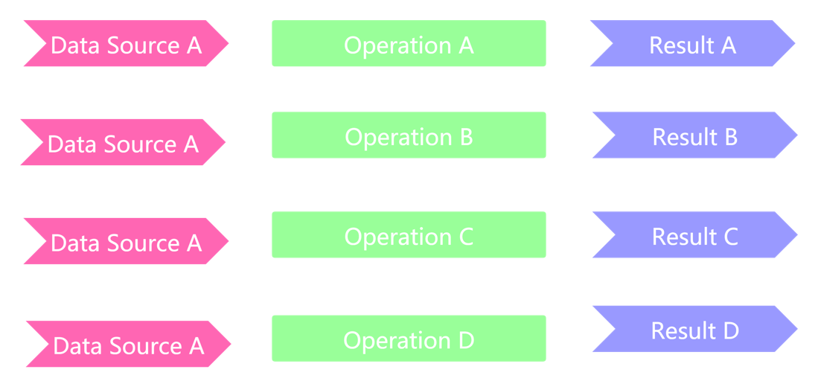
Fig. 1. Flow chart of ordinary real-time operation

Based on the concept of data warehouse, real-time data warehouse dedicates to plan and layer the data processing process in order to improve the re-usability of data. Unlike the above real-time task, one data source is transformed to one result by one operation, RTDW makes several improvements: 1) the collection of the same data will be limited to very few times; 2) the single complex operation is divided into several relatively simple operations, including extract, transform, load etc.; 3) the intermediate results of the above operations can be saved, which means the output of previous operation can be the input of the next operation, reducing the cost of loss recovery. Fig. 2 demonstrates the flow chart of RTDW.
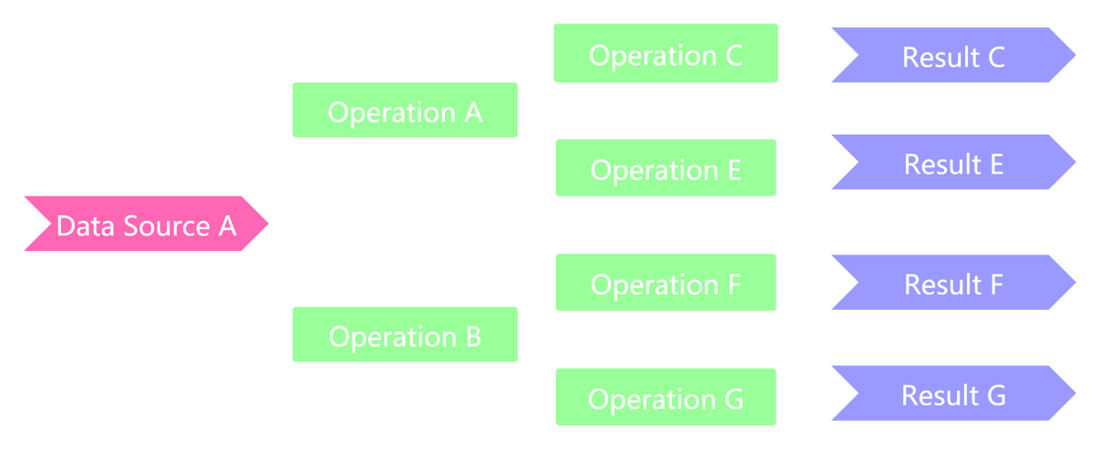
Fig. 2. Flow chart of RTDW

2.3.2 Development
The real-time processing capability of data has become a major factor for enterprises to enhance their competitiveness. At the initial stage, to realize a specific requirement, enterprises mainly write a specific real-time computing task to process real-time data. With the increase of demand, computing tasks increase accordingly, and the developers of different tasks are different, resulting in the differentiation of development styles. The real-time data processing in this stage lacks unified planning, and the code style is seriously differentiated, which has great obstacles in maintenance cost and development efficiency [18]. In order to avoid the above problems, developers refer to the concept and model of DW to re-plan and redesign real-time data processing and RTDW was developed on the base of DW. The difference between traditional Offline DW and RTDW are shown in Table 1 [19].

Table 1. The difference between traditional DW and RTDW
 | Offline DW | RTDW
Architecture | Offline Big Data Architecture | Kappa
Timeliness | Historical data | Real-time data
Computing Framework | MapReduce/Hive/Spark | Storm/Flink
Throughput | Batch processing with high throughput | Stream process with lower throughput
Data Model | Snowflake/Star | Wide table

To fasten query processing in the Data Warehouse Systems, Cuzzocrea et al [20] introduced a novel method on the base of Lambda architecture to ensure the DW can satisfy the requirement of near real-time OLAP. In order to implement real-time data warehouse, Mehmood et al [26] applied MongoDB at the phase of ETL to process unstructured (NoSQL) and structured (SQL) data from various sources efficiently. In near-real-time data warehousing, Naeem et al [27] designed a memory optimization algorithm (Memory Optimal Index-based Join) aimed at joining real data with persistent data with low latency.

2.3.2 Hierarchy
Generally, according to successful applications and experiences of many IT companies, the real-time data warehouse is guided by the requirements of production application scenarios, with Flink flow computing framework as the core, and divided according to functions. It is divided into four layers: access layer, computing layer, aggregation layer and service layer to meet the real-time requirements of business.
- Access layer: Use various data access tools to collect data sources, including ‘binlog’ from database, buried point logs from website and back-end service logs. The data is collected and synchronized to Kafka. These data not only participate in real-time calculation, but also participate in off-line calculation, to ensure that the real-time and off-line original data are unified [28]. In the access layer, the real-time ETL tool is integrated to filter, clean and convert the original data, including table joining and dimension completion. Based on the data information of fact table and dimension table, the intermediate data or intermediate wide table of the middle layer can be accessible.
- Computing layer: The core of real-time data warehouse, which serves the logical operation and processing of aggregated data. At present, Flink, Sparkstreaming and OLAP databases' own computing engines are mainly applied. Flink computing engine is mainly used for real-time data synchronization, streaming ETL and second level real-time indicator calculation. Sparkstreaming is mainly applied for quasi real-time indicator calculation demand scenarios of complex multi-dimensional analysis. Hive and Clickhouse are mainly suitable for multi-dimensional analysis scenarios that do not require high query response time. In the computing layer, the basic data is classified and summarized into different data subsets for different objects, such as orders, users, products, etc. For these data subsets, combined with the requirements of different business scenarios, structured, standardized and applicable result data can be obtained through different computing frameworks [29].
- Aggregation layer: Summarize the output results of the computing layer, precipitate and collect user labels, analysis indicators, recommendation results, transformation effects, etc., update them in real time or regularly, directly retrieve or call them to the service layer, and provide unified query services, metadata and indicator management, data quality and blood relationship [31]. The aggregation layer mainly uses ES, Redis, HBase and Kafka to realize the data sink of the computing layer.
- Service layer: Encapsulate the data of the aggregation layer in a variety of ways, such as API and SDK, to form the ability of real-time external output. The real-time data warehouse is applied to search recommendation, big data risk control, real-time BI, advertising, operation and maintenance monitoring and other scenarios to directly support the real-time data needs of the business.

2.3.3 Topic Oriented
The topic of RTDW is an abstract concept corresponding to the application-oriented concept of traditional database. It integrates, classifies and analyzes the data in enterprise information system at a higher level. Each topic corresponds to a macro analysis theme. Logically, it is the analysis object related to the macro analysis field in the corresponding enterprise. Topic oriented data set is a complete and consistent description of higher-level object data. The so-called higher level is relative to application-oriented data set, which means that there is a higher level of data abstraction in the way data is organized according to topics. The data in data warehouse is topic oriented, which corresponds to the characteristics of application-oriented data set in traditional database. The topic is determined according to the requirements of the analysis. This is different from organizing data according to data processing or application requirements.

3 Research Methodology
The purpose of the research is to realize a computing platform which plays a role of real-time data warehouse. The research will investigate how to build the RTDW and how to make full use of the advantages of Kubernetes in the application. Specifically, the parts of the platform and the architecture of the data warehouse will be explained why they would be applied. Additionally, the assessment of benefits of Kubernetes will be conducted as well. In this section, the research approach, research design data collection would be talked about.

According to the philosophy, post positivism will be applied to the research. Post-positivism as a correction to the assumptions made under positivism allows for the inclusion of variables that cannot be measured in analyzing given scenarios or problems [32]. Besides, the adoption of post positivism as the leading philosophical stance in addressing the research problem would result in preference for a mixed design that allows for incorporation of different data collection mechanism. Based on post positivism, a mix of quantitative method and qualitative method will be used to analyze and assess the project.

Since the aim of the project is to build a RTDW taking advantage of Kubernetes. The first step is to decide the components of the data warehouse and explain the advantages and functionalities of them as a part of the platform according to their characteristics. The next step is to analyze the way to make full use of benefits of Kubernetes and how to combine it and RTDW effectively. When the platform is completed, several functional tests of it will be conducted to evaluate whether the platform can successfully work. Lastly, a specific performance monitoring tool designed for Kubernetes cluster Prometheus would be used to collect some running data that can be used to evaluate whether the method can improve source utilization to some extent.

When it comes to the limitations of the project, two main aspects are as follows. First, the project is an application to deal with real-time data, but we do not have a real scenario, such as a website or a mobile application to produce real-time information and transfer it to the platform. To code with the issue, a simple program which can generate some e-commence records in specific format would be used to simulate the real condition. Second, since the limitation of local physical machine, a non-cloud based identical computing platform cannot be created. Therefore, precise evaluation of the benefits of Kubernetes bringing about cannot be conducted. Thus, some running data of cluster conditions provided by monitoring tool would be used to assess the effect of the cloud Kubernetes cluster.

4 Development Methodology

4.1 Waterfall Model
In terms of the development methodology of the project, waterfall model which works well for smaller projects where requirements are very well understood, is chosen to help to complete the whole process of the platform. Waterfall model divides the software life cycle into three phases: planning, development and operation. Each phase is divided into several stages shown in Fig. 3, including requirement definition, feasibility analysis, design, programming, software testing, operation and maintenance. In this model, the work procedures are expended like a waterfall, from top to bottom. The characteristics of the model are as follows [33]:
1) Each stage is sequential, and the beginning of a stage is based on the work of the previous stage. A schedule can be set with deadlines for each stage of development, and a product would proceed through the development process model phases one by one. Due to the rigidity of the workflow model, it is not difficult to manage since each phase in the model has specific review and deliverable processes.
2) The perspective of delaying realization is throughout the whole model and reinforces good habits: define-before-design. The waterfall model arranges the analysis of and design stages before coding. These stages only consider the logical type of the target system and do not involve the realization of the software. The advantage is that the way can find a more conductive method to solve the problem without the limitations of specific implementations.
3) Waterfall model does work well for smaller projects whose requirements are uncomplicated, due to easily understandable and explainable phases, clearly defined stages and well understood milestones.
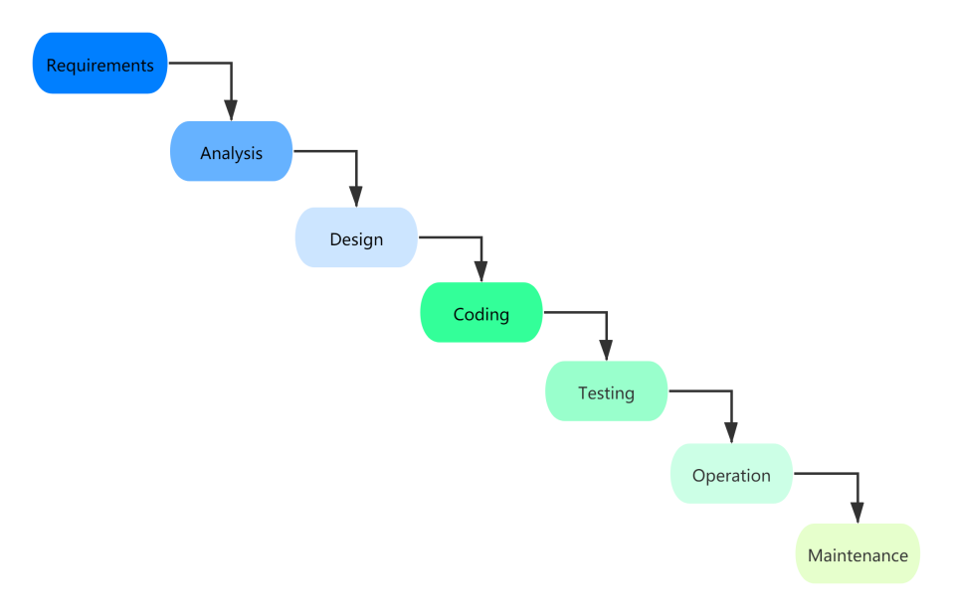
Fig. 3. Phases of Waterfall Model

4.2 Requirement Definition
The real-time computing platform is designed to make full use of modern Internet technologies to improve the operational efficiency and resource utilization of a e-commence company. Nowadays, the project plans to realize the requirements by processing the user behavior data and business data with some real-time relative components and cloud services.

4.2.1 System Construction Goal
Based on the above demands, the construction goal of the project are as follows:
(1) The collection of user behavior data and business data. The two kinds of data come from different sources: log server and business database. Therefore, the collection needs to be conducted relatively.
(2) The modelling of user data. The original data of e-commerce reports are collected in log server and business database. Considering the possible business expansion and business demands of the business subject in the future, the user behavior data and business data should be operated into a fine-grained way. Plan and design more fine-grained data layering to better solve the problems of insufficient scalability and maintainability.
(3) The construction of real-time computing system with high efficiency. To build and improve the platform, several key components are introduced, such as Kafka——message queue with high throughput and low latency, Hbase——distributed NoSQL database supporting real-time reading and writing, Flink——real-time processing engine. In addition, cloud services of Kubernetes cluster will also be used to deploy Flink, which may be helpful to improve the utilization of computing resources.

4.2.2 System Functional Requirements Analysis
Unlike system construction, functional requirements mainly consist of basic platform architecture requirements and data analysis requirements. Next, the overall demand analysis of the system platform will be first introduced, focusing on the demand analysis of the basic components. Then, discuss the data analysis of the RTDW system, which refers to user behavior analysis, order analysis and detailed topic analysis.

(1) Basic Architecture Requirements Analysis

In order to provide strong support for data analysis requirements, basic architecture requirements can be divided into ETL system requirements, Kafka cache system requirement, Flink computing system requirements, Hbase storage system requirements and Kubernetes cloud service system requirements.

1) ETL System Requirements Analysis

ETL System is mainly used to connect external data sources, load external data into e-commerce RTDW. Transform data from various data sources into various topics of data warehouse to complete different tasks later.

2) Kafka Cache System Requirements Analysis

Combined with ETL System, Kafka completes the decoupling work with downstream data analysis system. In this way, it can prevent records loss under massive data when consuming speed is not fast enough and ensure the security of message sequence when access traffic surges. In consideration of the characteristics, this project uses Kafka cache system to complete the decoupling of data acquisition system and data processing system, which optimizes the system and makes the system have the characteristics of data redundancy, elastic data consumption, recover-ability, data sequence guarantee and asynchronous communication [34].

3) Flink Computing System Requirements Analysis

Flink is the key part of the platform, it burdens the tasks of processing the e-commence data in certain logic in real time and it is the engine of the whole system. The tasks can be divided into two main kinds: aggregation tasks and join tasks. Aggregation tasks mainly refers to the counting of certain indicators, such as unique visitors. Join tasks mainly happen between the join action of two or more tables to obtain target report forms.

4) Hbase Storage System Requirements Analysis

In the platform, Hbase provides the service of high performance reading and writing [35]. During the data operation process, some common dimension data can be stored in extra database, and these data can be load and reused in later operations which are designed to realize different functions.

5) Kubernetes Cloud Service System Requirements Analysis

In this platform, Flink will be deployed directly on the Kubernetes cluster, which is a cloud service provided by Alibaba Cloud, and the cluster can realize auto-scaling. Through this way, the platform will be able to easily realize the dynamic expansion of computing resources. When there is no task, the cluster would become a minimum state and keep the engine alive. When the workload increases, more Flink nodes would be added to handle the tasks.

(2) Business Requirements Analysis

When the basic platform is completed, the multi-layers real-time data warehouse is going to be built and some relative data analysis would be conducted as well. User behavior analysis and business analysis are the two main parts.

1) User Behavior Analysis

For user behavior data, it is the event data generated during the user's interaction with the client product in the process of using the product, such as page browsing, clicking, staying, comments, likes, collections, etc. User behavior analysis is the analysis and calculation of user data based on the behavior dimension. The user behavior module aggregates and stores the data of different time dimensions in different levels of RTDW and provides decision support for the operation of each department of the whole enterprise. For example, active user analysis is aimed to calculate the unique visitors during a period. The judgement of new user is designed to take different strategies to different users by judging their behavior records.

2) Business records Analysis

For user business interaction data, including login, order, user, commodity, payment and other related data generated in business processes, this kind of business data is coarse-grained data obtained from high aggregation of event data, which is usually stored in relational databases such as MySQL etc. User business analysis mainly refers to the login, order, user, commodity, payment and other related data generated in the business process and uses these data to complete user consumption and other business analysis. In this project, some business data is stored in MySQL and generated intermediate dimension tables are saved in Hbase, so these kinds of operations also include some join operations which can combine different tables into one wide table according to a certain topic. The wide table contains many details and can be used to visualization display.

4 Implementation

4.1 Design of RTDW
The design of the real-time data warehouse is aimed to provide data services. Data services are mainly the external service capabilities of the data warehouse, including not only the ability to provide back-end data for data applications such as query system, report system and external data interface, but also the ability to provide basic data for data mining and data analysis. While providing data services, it also carries out strict data management. The main purpose of the data management is to realize the supervision of the whole process data of the enterprise, sort out the existing huge data assets of the enterprise, ensure the data quality of the data warehouse and provide better and stable data services.

4.1.1 Hierarchical Design
Different Internet companies have their own layering strategies. Generally, they are only divided into three layers. The RTDW level involved in this paper divides the data warehouse in more detail. It will adopt a five-layer structure and be divided into ODS layer, DWD layer, DIM layer, DWS layer and ADS layer. The functions of each layer are shown in Table 2.

Table 2. Hierarchical design of data warehouse
Name | Function
ODS | Store the original data synchronized directly from the business system
DWD | Unify the format and clean the data from ODS layer
DIM | Extract common dimension data from DWD layer
DWM | Further processing of some data from DWD and DIM layers
DWS | Slightly summarize the data from DWD, DIM, and DWM layers
ADS | Store the result data directly for various data application services

(1) Operational Data Store (ODS)

The operational data store (ODS) is the first level of data warehouse. It is a topic oriented, integrated data set. It is the access layer between heterogeneous systems and RTDW. The data sources of RTDW are various and these data may be stored in different application systems, databases with different functions, different geographical locations [36]. Besides, the diversity of data formats makes the configuration of data conversion very complicated. If data cleaning is carried out directly in heterogeneous systems, it will not only increase the burden of heterogeneous systems, but also inevitably affect the data logic of the original heterogeneous systems. The persistent data in ODS is completely consistent with the heterogeneous system in terms of data style, data granularity and mapping relationship between data. Therefore, it only needs to use extraction components to simply copy the original data to the data warehouse without data conversion, which has reached the minimum change to the heterogeneous system. The most fine-grained data is persisted in the ODS layer, while the data persisted in other data layers of the data warehouse are generally aggregated or calculated coarse-grained data without storing additional detail data and only the ODS layer can complete the query of detailed data. The levels outside the ODS layer realize the enterprise's decision-making scheme requirements from a macro perspective, while the ODS layer reflects the details of data conversion or fine-grained data retrieval requirements from a micro perspective, which means the ODS layer stores the most original data of the entire data warehouse, and directly loads the original logs and data from outer data sources without extra operation.

(2) Data Warehouse Detail (DWD)

Data Warehouse Detail (DWD) is used to clean and standardize the data from ODS layer, including removing null values, dirty data and data exceeding the limit range. The DWD layer precipitates the data of ODS layer, reducing the complexity of later extraction. At the same time, the DWD information model mainly follows the form of enterprise business transaction processing, centralizes various professional data, and the granularity of the detail layer is consistent with that of the ODS layer, which belongs to the public resource of analysis.

(3) Dimension (DIM)

The purpose of DIM is relatively simple, storing dimension tables. Taking the dimension as the modeling driver, based on the business meaning of each dimension, define the dimension and dimension primary key, add dimension attributes and associated dimensions, define the calculation logic and snowflake model, complete the process of attribute definition and establish a consistent data analysis dimension table [37]. At the same time, you can define the primary and child relationship of the dimension, and the attributes of the child dimension will be merged into the primary dimension to further ensure the consistency and convenient use of the dimension.

(4) Data Warehouse Middle (DWM)

Based on the data of DWD layer, this layer performs some slight aggregation operations on the data, generates some columns of intermediate result tables, improves the reusability of public indicators and reduces repeated processing. In short, aggregate the common core dimensions to calculate the corresponding statistical indicators

(5) Data Warehouse Service (DWS)

Based on the DWD, DWS conducts a mild aggregation and summary of data. In the actual production process, it is usually used in two business scenarios. One business scenario is that for user behavior data, the event table in the DWD layer is usually introduced into the time dimension for aggregation [38]. For example, the daily active equipment list also has different time granularity and data dimensions in different companies. In another business scenario, multiple tables in DWD layer will be associated according to different business analysis topics, and finally a wide table with rich dimension analysis fields and a large amount of redundant data related to the analysis topic will be formed to aggregate the single day behavior of each user, so as to conduct statistical analysis from different angles after associating user dimension information. This can improve the corresponding query ability and the convenience of data analysis. DWS layer is the direct data interface layer of data warehouse for each department. It ensures the consistency and data unity of data warehouse data. Data analysts and operators can directly obtain and process data from DWS layer and finally obtain report summary.

(6) Application Data Store (ADS)

ADS is usually generated from the user behavior data and user business wide table in the DWS layer. ADS layer will provide data for various statistical reports. The ADS layer stores the data with the highest granularity in the whole data warehouse. As the last layer of the data warehouse, the data has completed the highest degree of granularity conversion. Because it is directly application-oriented, there are usually more tables in ADS layer than in DWS layer. Applications oriented include user activity analysis, total transaction analysis, etc.

4.2 Technical Architecture
The whole technical architecture of the platform consists of several main parts, such as data collection, RTDW and computing engine, shown in Fig. 4. The detailed description and implementation are as follows.
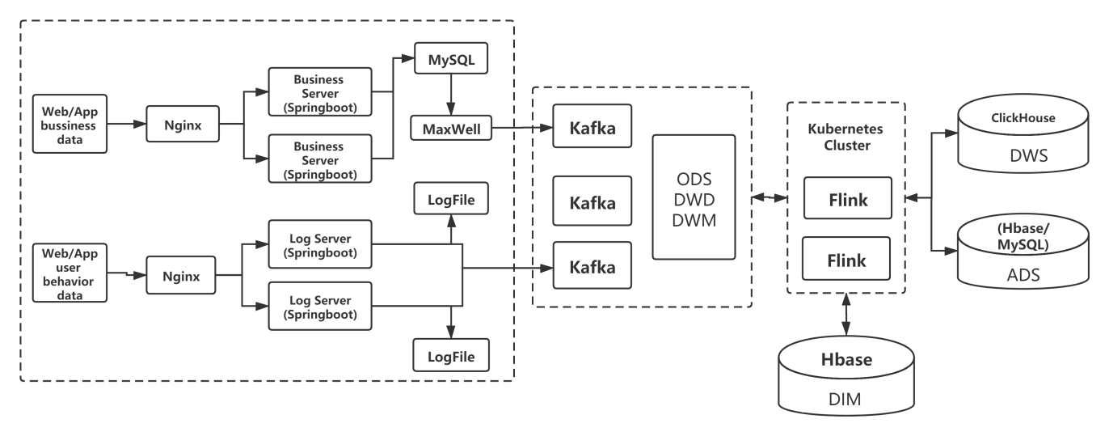
Fig. 4. Technical architecture of the platform

4.2.1 Implementation of Data Collection System
The data respectively comes from the business server and the log server. The data of the business server usually comes from the back-end embedded point data. The data format is structured data storage and calculation, while the log server will collect the user's behavior data which is non-structured. Therefore, the two data sources need two different procedures to deal with respectively.

(1) User Behavior Data Collection

In a production environment of e-commence, the user behavior data, such as choosing various products, visiting different pages, is normally generated when users visit corresponding websites or using corresponding applications. However, the project does not focus on the building of a website and only concentrates on the platform which is capable of handling the data generated from those websites. Thus, in order to simulate the real time data stream, the project build a simple application which can keep generating daily user behavior data and sending it to target server.

After the records are gathered, they will be directly sent to the server with Nginx to realize load balance in the way of Reverse Proxy. Reverse proxy means that the proxy server accepts the requests, then forwards the request to the servers on the internal network, and returns the results obtained from the servers to the client [39]. In this condition, the proxy server appears as a server externally. Reverse proxy load balancing technology is to dynamically forward requests from the Internet to multiple servers on the internal network in the form of reverse proxy for processing, to achieve the purpose of load balancing. The following Code-1 is the configuration of Nginx.
Code-1
location /applog{
proxy_pass http://www.logserver.com;
}
upstream www.logserver.com{
server hadoop102:8081 weight=1;
server hadoop103:8081 weight=2;
server hadoop104:8081 weight=3;
}
On each node of the cluster, an application called ‘mall2021-logger-0.0.1-SNAPSHOT.jar’ would be started ahead responding for receiving the data from Nginx and forwarding it to Kafka. Since the two processes always work together, a shell script named ‘logger.sh’ can be created to combine the log collecting process. The following script Code-2 includes both the start action and stop action.
Code-2
#!/bin/bash
APPNAME=mall2021-logger-0.0.1-SNAPSHOT.jar
case $1 in
"start")
{
for i in hadoop102 hadoop103 hadoop104
do
echo "========: $i==============="
ssh $i "$JAVA_BIN -Xms32m -Xmx64m -jar /opt/module/rt_mall/$APPNAME >/dev/null
2>&1 &"
done
echo "========NGINX==============="
/opt/module/nginx/sbin/nginx
};;
"stop")
{
echo "======== NGINX==============="
/opt/module/nginx/sbin/nginx -s stop
for i in hadoop102 hadoop103 hadoop104
do
echo "========: $i==============="
ssh $i "ps -ef|grep $APPNAME |grep -v grep|awk '{print \$2}'|xargs kill" >/dev/null
2>&1
done
};;
esac
When the log servers receive the data forwarded by Nginx, the application responded to handle the logs would store them to the disk and send them to Kafka as a producer at the same time. The records sent to Kafka brokers are collected in topic “ods_base_log”, which belongs to ODS layer as the original data.

(2) Business Data Collection

In terms of the business data generated during consumers’ activities, when it comes from websites/Apps to businesses servers through Nginx, it would be saved in MySQL in the next step. In order to obtain the changes happened to the tables in MySQL, this project use Maxwell to get the changes and send them to Kafka brokers.

Maxwell is a software which can capture the changes in real time of MySQL. MySQL adopts master-slave replication mechanism. The binary log of MySQL is the most important log of MySQL. It records all DDL and DML statements in the form of events, as well as the time consumed by the execution of statements. After the master database writes the changed records to the binary log, slave database sends the dump protocol from the database to the MySQL master database and copies the binary log events of the master's main database to its relay log. The slave reads and redoes the events through relay log and synchronizes the changed data to its own database. Maxwell disguises himself as a slave database, pretends to copy data from the master, reads the MySQL binary log in real time, generates a message in JSON format, and sends it to Kafka as a producer. The topic of the data is “ods_base_db_m”, belonging to ODS layer as well.

4.2.2 Implementation of various layers of RTDW
After the process of data collection and transfer in last section, the original records have gathered in Kafka which is able to cache and persist them. This section aims at specifically constructing the layers of real-time data warehouse. The purpose of building real-time data warehouse is mainly to increase the re-usability of data calculation. Each time a new statistical demand is added, it is not calculated from the original data, but from semi-finished products which refer to the result tables stored in different layers of RTDW. Since different layers are characterized by various functions, the RTDW will introduce various technical tools to fit various requirements. The Fig.5 demonstrates the details of the RTDW architecture, not only the flow direction of data but also the relationships between different layers and components. In addition, the change of amount of data when flowing is shown as well.
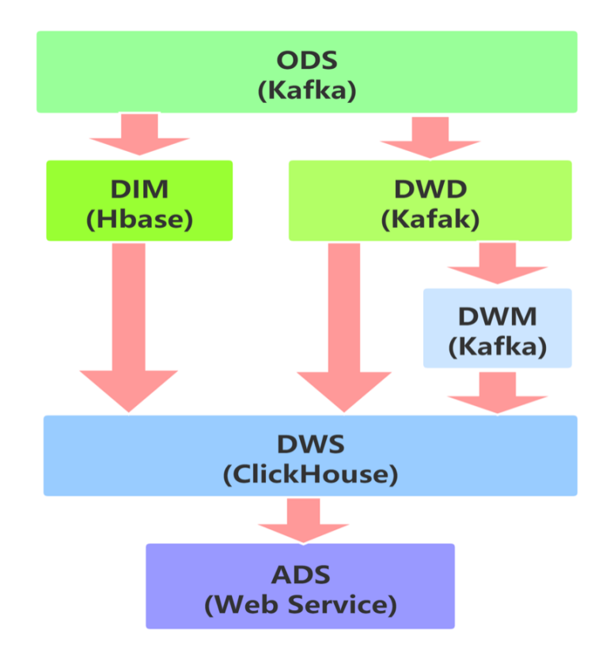
Fig. 5. Details of RTDW architecture
As the ODS layer stores the most original data from multiple data sources, maintains the most original state of data, its data volume is the largest. Besides, ODS layer does not execute any clear logic, but pull the data from the back-end server to the big data cluster, as a backup of back-end data. During the process of ETL, undergoes preliminary clearing, dividing and transfer, the original data of ODS will be extracted and sent to it downstream, DWD and DIM. Next, the detailed data will be slightly aggregated according to some common topics or indicators, forming the content of DWM. Because the refined report is composed of various data with coarse-grained data characteristics, it is necessary to aggregate the specific data of DIM, DWD and DWM into a wide table. This is the process of generating DWS layer, and DWS table is obtained by joining multiple specific event tables. Finally, this wide tables are aggregated into the coarse-grained table of the final business subject, which means tables of ADS layer can be generated. At this layer, the fields in the tables are usually the result of large aggregation operators, and the most original fine-grained characteristics of the data are lost.

The following table shows the contents belonging to different layers involved in the project. It includes the names of the topics in Kafka, tables in Hbase and ClickHouse, the comments to describe which indicators they aimed at, and their layers and storage locations.
Table 3. Contents in various layers
Name | Comment | Layers | Storage location | Source
ods_base_log | Logs from website or mobile app | ODS | Kafka | Log server
ods_base_db_m | Records from database | ODS | Kafka | MySQL
dwd_start_log | Start logs | DWD | Kafka | Kafka
dwd_page_log | Page view logs | DWD | Kafka | Kafka
dwd_display_log | Products display logs | DWD | Kafka | Kafka
dwd_order_info | Records of order information | DWD | Kafka | Kafka
dwd_order_detail | Records of order details | DWD | Kafka | Kafka
dim_user_info | Records of user information | DIM | Hbase | Kafka
dim_base_province | Records of province information | DIM | Hbase | Kafka
dim_sku_info | Records of standard product unit information | DIM | Hbase | Kafka
dim_spu_info | Records of stock keeping unit information | DIM | Hbase | Kafka
dim_base_trademark | Records of trademark information | DIM | Hbase | Kafka
dim_base_category3 | Records of product category | DIM | Hbase | Kafka
dwm_unique_visit | Unique visit records | DWM | Kafka | Kafka
dwm_user_jump_detail | User jump detail records | DWM | Kafka | Kafka
dws_visitor_stats | Records of user oriented | DWS | ClickHouse | Kafka,Hbase

(1) Implementation of DWD and DIM

In the layer of DWD, several topics in Kafka are created to store the results, refer to the log record, they are “dwd_start_log”, “dwd_page_log”, “dwd_display_log” respectively, the format of them are ‘Json’, shown in Code-3. The first three topics originates from the topic stored in ODS “ods_base_log”.

Code-3
{"common":{"ar":"420000”"ba":"Oneplus","ch":"oppo","is_new":"1","md":"Oneplus7","mid":"mid_15","os":"Android11.0”，"uid":"21","vc":"v2.1.111"},
"page":{"during_time":6284,"item":"5”"item_type":"sku_ids","last_page_id":"trade","page_id":"payment"},
"ts":1631908719000}
{"common":{"ar":"370000”"uid":"13","os":"Android11.0”"ch":"xiaomi","is_new":"1","md":"Xiaomi 9","mid":"mid_18","vc":"v2.1.132”，"ba":"Xiaomi"},
"start":{"entry":"icon","open_ad_skip_ms":0,"open_ad_ms":8833,"loading_time":12922,"open_ad_id":16},
"ts":1625884882000}
{"common":{"ar":"230000","uid":"36","os":"iOS13.3.1","ch":"Appstore","is_new":"0","md":"iPhone 8","mid":"mid_19","vc":"v2.1.132","ba":"iPhone"},
"page":{"page_id":"home","during_time":17009},
"displays":[{"display_type":"activity","item":"2","item_type":"activity_id","pos_id":1,"order":1}…]
"ts":1625884834000}
In terms of the user behavior data, the previously collected log data has been saved to Kafka as the ODS layer. The log data obtained from Kafka's ODS layer consists of three categories: page log, start log and display log. Although these three types of data all belong to user behavior data, they have completely different data structures. Thus, it is necessary to split them and write them to different topics of Kafka as DWD layer.

To realize the logic mentioned above shown in Fig. 6, this project applies stream processing engine Flink to complete the target. Flink can deal with the data sent to it one by one in real time in the form of flow with low latency. It provides rich operators, such as map, filter, reduce and etc., to complete rich functions. If these operators are not enough to realize certain complex demands, Flink also supplies many costumed functions to satisfy various requirements. For the three divided topic, the page logs are output to the mainstream, the start logs are output to the start side output stream, and the display logs are output to the display side output stream.
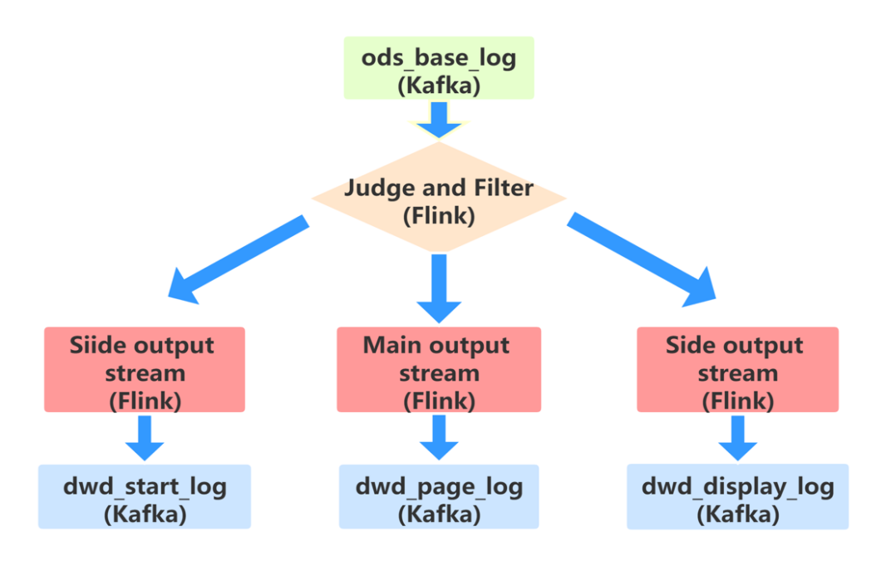
Fig. 6. Logic flow of BaseLogApp
For the records Flink pulled from Kafka, the user-defined function transforms the format of ‘String’ into ‘Json’. Then, use method to judge the keys characterizing each record. The records belong to page logs would be output to the mainstream of Flink and be sent to “dwd_page_log” in the next step. Other records would be output to the side stream and then be sent to Kafka topics of “dwd_start_log” and “dwd_display_log” respectively.

In terms of the business data, changes in business data can be collected by Maxwell, but Maxwell writes all data into one single topic. However, because each table has different characteristics, some tables are dimension tables, some tables are fact tables, and some tables are both fact tables and dimension tables in some cases. Obviously, this is not convenient for data processing in the future, so it is necessary to disassemble and divide these tables. In real-time calculation, dimension data is generally written into the storage container, which is generally a database convenient for query through the primary key, such as HBase, Redis, MySQL, etc. Additionally, the fact data is normally written into the stream for further processing, like forming a wide table.

For Flink real time task, in order to make judgement of which table the records belong to, the way of reading configuration is a useful method. Such a configuration is not suitable for writing in the configuration file, since every time the business needs to modify the configuration, the computing program needs to restart to obtain the modification. Therefore, a dynamic configuration scheme is needed to get this configuration dynamically. Once the configuration changes, real-time computing can automatically perceive it. In this project, MySQL is applied to initialize and maintain the configuration in a dynamic way. Since the change of configuration is not frequent, the way of using SQL to get configuration is a suitable method. The following figure demonstrate the principle. Table 4. demonstrate how to divide the data flow by reading the configuration. In the configuration table, “source_table” points out where the record comes from, “sink_type” demonstrates which container should the record sink to, “sink_table” shows the target table or topic of the record and “sink_column” means that different columns of a single table may have various destination. Fig. 8 shows several records in configuration table. Fig. 7 demonstrate the procedures mentioned above.
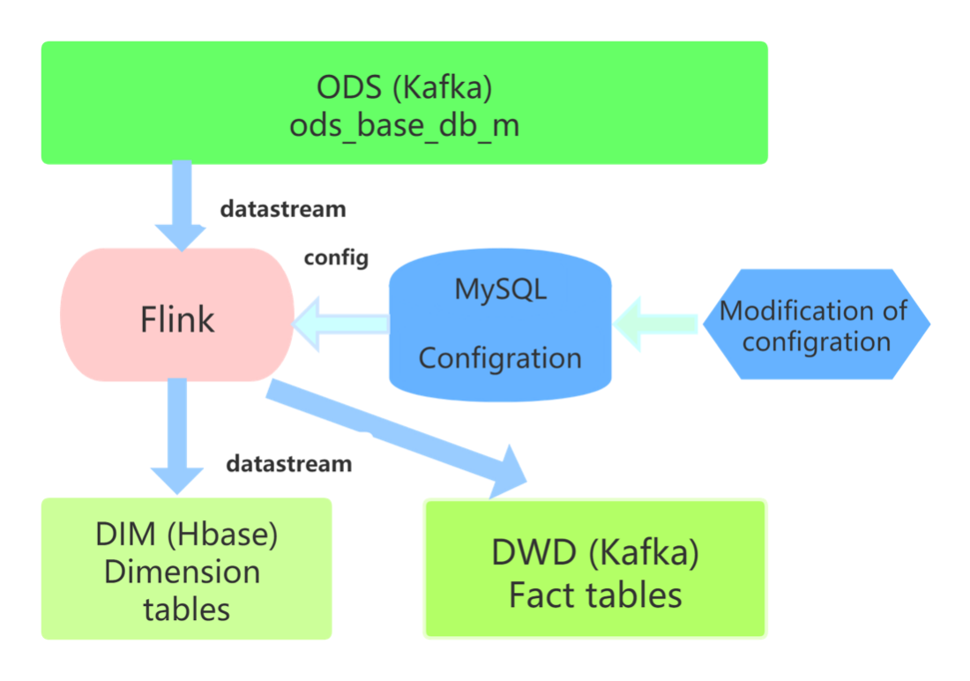
Fig. 7. Procedures of dynamically obtain configuration
Table 4. Configuration table: “table_process”
Name | Type | Comment
source_table | String | Source of table
operate_type | String | Type of operation:insert, update, delete
sink_type | String | Kafka or Hbase
sink_table | String | Output table (topic)
sink_columns | String | Output columns
sink_pk | String | Primary key
sink_extend | String | Extension of table

Fig. 8. Records in configuration table
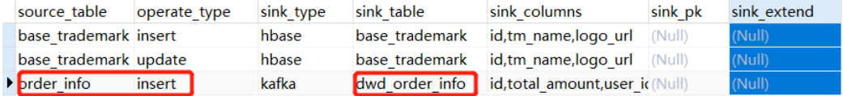

To realize the whole process mentioned above, the project uses a user defined class called “TableProcessFunction” which includes several mehtods to respond to various tasks. When the Flink job starts, the method ‘open ()’ will finish the initialization firstly, and then define and timer to execute ‘initTableProcessMap()’ to obtain the configuration from ‘table_process’ periodically and store them in ‘tableProcessMap’. Next, the method ‘processElement()’ accepts the records, tags them and filer redundant columns according to ‘tableProcessMap’. In the end, the tagged records will be sent to mainstream, and side stream whose destinations are DWD (Kafka) and DIM (Hbase) respectively. Fig. 9 show the logic flow mentioned above.

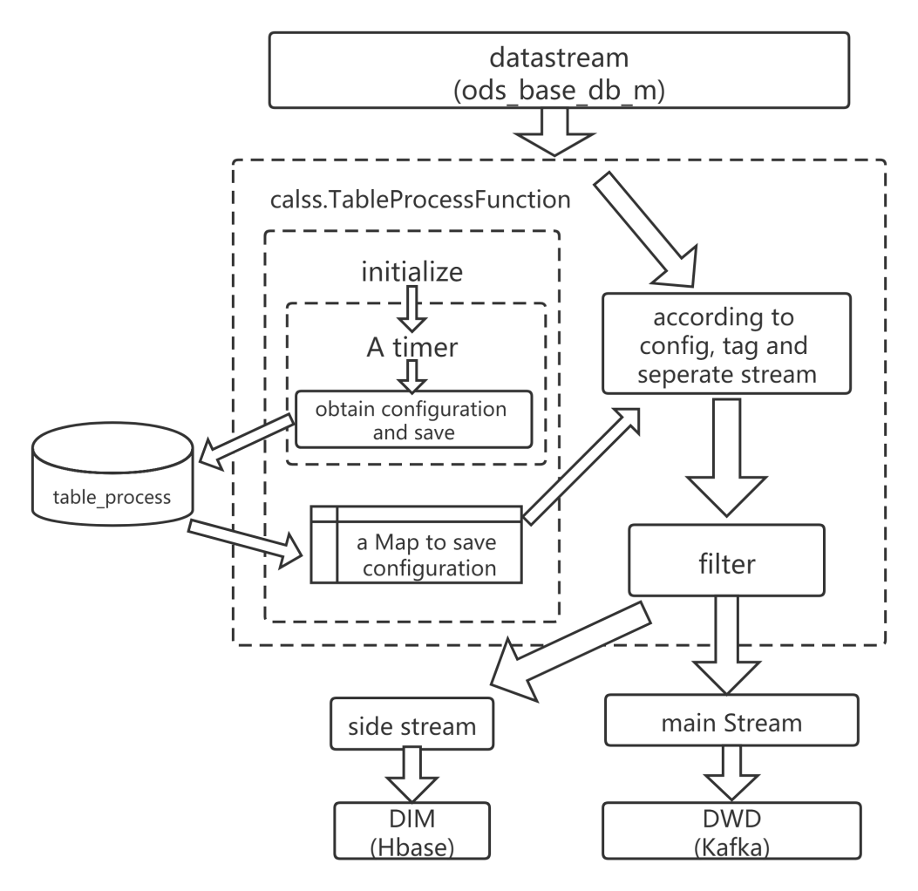
Fig. 9. Logic flow of BaseDBApp

(2) Implementation of DWM

The DWM (Data Warehouse Middle) is mainly responsible to serves DWS. Since, in order to complete the requirements, if the processes directly operate the data from DWD layer to DWS layer, there will be a large amount of calculation, and some intermediate results of calculation are likely to be reused by various DWS topics. Therefore, some DWD layers will form a DWM layer. At layer of DWD, the tasks of calculating unique visitor, calculating user jump detail, forming order wide table and payment wide table will be introduced.

1) Unique Visitor

In real time tasks, unique visitor means daily active user. There are mainly two aspects needed to check to recognize the unique visitor. First, find the first page the visitor visited which means the visitor started to use application. Second, remove the repeated data since a visitor would visit the same page in many times.
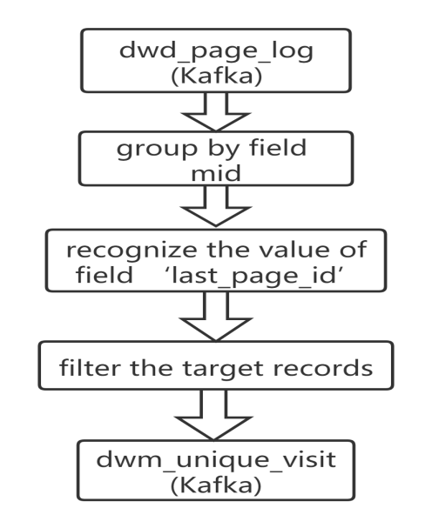
Fig. 10. Logic flow of UniqueVisitApp
Fig. 10 demonstrates the logic to realize this part. For the records from ‘dwd_page_log’, they would be grouped by ‘mid’ by using method ‘keyBy()’ at first and use ‘lastVisitDateState’ a variable of ‘ValueState to record user visit time. Then, realize class ‘RichFilterFunction’ to complete the action of filtering. The class first overwrite ‘open ()’ to complete the initialization behavior, then overwrite ‘filter ()’ to realize the core logic. In this process, for every record, if the filed ‘last_page_id’ is not null, it would be filtered, which means that the user is not the first time to visit the page. Because ‘lastVisitDateState’ is used to record the visit time of user, if it does not belong to today’s records, it means the user has not visited the page, and the record should be kept. After the filter process, the results which is the unique visit of the user would sink to the topic ‘dwm_unique_visit’ of Kafka.

2) User Jump Detail

Jump behavior of visitor means the user only visit one page of the website and does not visit other pages. By focusing on the jump out rate, we can see whether the visitors can be attracted quickly. The quality comparison between the users drained from various channels, and the comparison of the jump out rate before and after application optimization can also see the results of optimization and improvement. The jump rate is the number of jumps divided by number of visits.

To recognize the jump behavior indicator data collection, the following characteristics should be pay attention, as shown in Fig. 11. First, make a judgement about whether the page is first page the user visited recently. This can be obtained by judge whether the record has value of the field ‘last_page_id’ whose existence indicates this is the first visited page. Second, after a period (a custom time) of first visit, the user did not visit other pages. In comparison with the first feature, the second recognition is more complicated. The indicator cannot be figured out by only one record, it needs a combination of judgement: a current record and a next record. The result of the current record relies on the judgement of the next record within a custom period. In terms of this kind of problems, the CEP (Complex Event Processing) technology of Flink plays a vital role. CEP is very suitable for identifying an event through multiple data combinations, and the user jump out event is essentially a combination of a condition event and a timeout event.
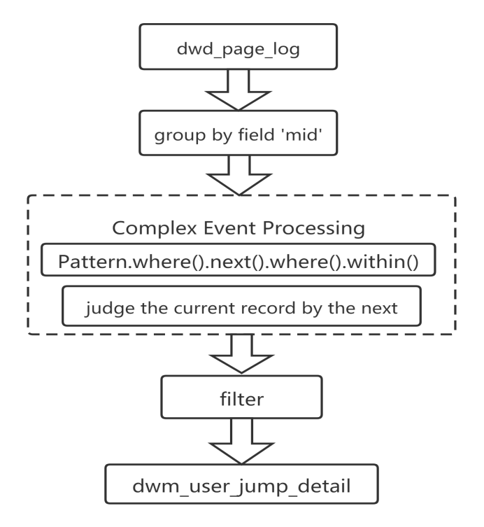
Fig. 11. Logic flow of UserJumpDetailApp
Since the process involve the time judgment, the time characteristic of Flink stream processing environment should be set, and the field ‘ts’ in record will be pointed as the ‘EventTime’ of data stream. The records from ‘dwd_page_log’ will be grouped by ‘mid’ firstly. Then, apply CEP expression to match the first page record whose next record will be another page appearing within 10 second. In the end, use method ‘flatSelect’ to extract the filtered records and output to topic ‘dwm_user_jump_detail’ of DWM in Kafka.

3) Order Wide Table

Orders are important objects of statistical analysis. There are many dimensions of statistical needs around orders, such as users, regions, categories, brands, etc. In order to make the statistical calculation more convenient and reduce the join actions between large tables, the relevant data around orders will be integrated into a wide table of orders in the process of real-time calculation. In the previous operation, the data has been divided into fact data and dimension data. The fact data is sent into Kafka data stream (DWD layer), and the dimension data is sent to HBase for medium and long-term storage. Then we should integrate and associate real-time and dimensional data in DWM layer to form a wide table. There are two kinds of associations need to deal with here: fact data and fact data association, fact data and dimension data association. Fact data and fact data association are actually the join between streams. Fact data and dimension data association are actually querying external data sources in stream calculation. The following Fig.12 demonstrates how to realize.
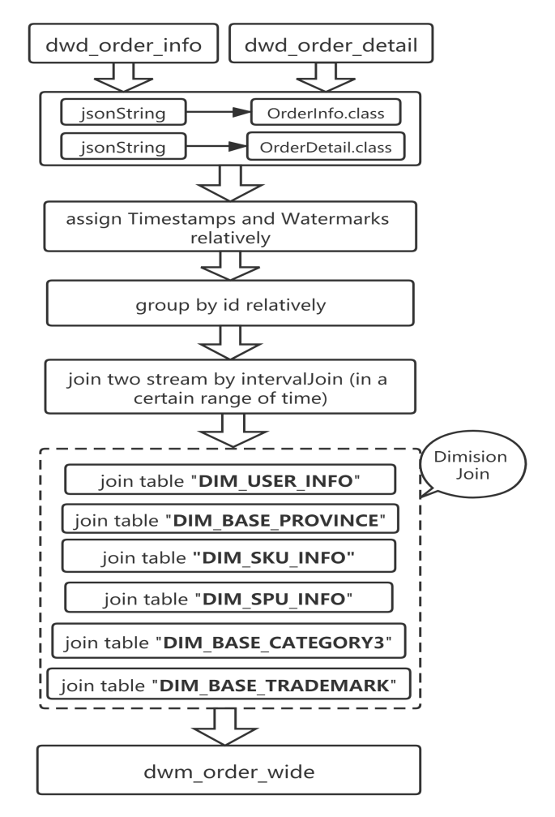
Fig. 12. Logic flow of OrderWideApp
To begin with, the job will pull the data stream from topics of ‘dwd_order_info’ and ‘dwd_order_detail’ in Kafka, transforming the type of Joson into entity classes: ‘OrderInfo’, ‘OrderDetail’. There are two kinds of stream join in Flink. One is Time Windowed Join, such as ‘join’ and ‘cogroup’, and the other is Temporary Table Join based on state cache, such as ‘intervaljoin’. ‘Intervaljoin’ is selected in the project because it is simpler to use than window join and avoids the problem that the data needed to be matched is in different windows. Since the join action involves time characteristic, the Event Time of the data streams should be identified, and in this section, the ‘create_ts’ is chosen. Then, group the records of two stream by keys ‘id’ and ‘order_id’ respqctively for the join of two streams. Next, apply ‘intervalJoin’ to complete the join action, calling the merge methods ‘mergeOrderInfo’ and ‘mergeOrderDetail’ identified in class ‘OrderWide. Code-3 presents the member variables and methods of class OrderWide.
Code-3
@Data
@AllArgsConstructor
public class OrderWide {
//from OrderInfo
Long order_id ;
String order_status;
Long user_id;
String create_time;
String create_date;
BigDecimal activity_reduce_amount;
BigDecimal total_amount;
BigDecimal coupon_reduce_amount;
BigDecimal original_total_amount;
BigDecimal feight_fee;
Long province_id;

//from OrderDetail
Long detail_id;
Long sku_id;
BigDecimal order_price ;
Long sku_num ;
String sku_name;
BigDecimal split_activity_amount;
BigDecimal split_coupon_amount;
BigDecimal split_total_amount;
BigDecimal split_feight_fee;

//from DIM_USER_INFO
Integer user_age ;
String user_gender;

//from DIM_BASE_PROVINCE
String province_name;
String province_area_code;
String province_iso_code;
String province_3166_2_code

//FROM DIM_SKU_INFO
Long spu_id;
String category3_name;
Long tm_id;
String sku_name;

//from DIM_SPU_INFO
String spu_name;
Long spu_id;

//from DIM_BASE_CATEGORY3
Long category3_id;
String category3_name;

//from DIM_BASE_TRADEMARK
Long tm_id;
String tm_name;

String expire_time;
String operate_time;
String create_hour;

In the process of Flink stream operating, it is often to interact with external database systems and complete the fields in the fact table with a dimension table. For example, in the e-commerce scenario, the ‘sku_id’ of a commodity needs to be associated with some attributes of the commodity, such as the industry, and manufacturer. By default, in Flink’s MapFunction, only a single parallel can be used to interact with external systems in synchronous mode: send the request to external storage, IO block, wait for the request to return, and then continue to send the next request. This way of synchronous interaction often consumes a lot of time waiting on the network. In order to improve processing efficiency, you can increase the parallelism of MapFunction, but increasing the parallelism means more resources, which is not a good solution. Flink introduces Async I/O in 1.2 version. In the asynchronous mode, IO operations are asynchronized. A single parallel can send multiple requests continuously and processes the request first return. Therefore, there is no need for blocking and waiting between consecutive requests, which greatly improves the flow processing efficiency. Asynchronous query actually entrusts the query operation of dimension table to a separate thread pool, so that it will not be blocked by a query. A single parallel can send multiple requests continuously to improve the concurrency efficiency. Therefore, the project builds a class DimAsyncFunction which extends RichAsyncFunction to query dimension tables asynchronously. As one of the parameters of method ‘AsyncDataStream.unorderedWait’, the query results of DimAsyncFunction’s methods will join with existed data stream. In total of six dimension tables will join the main data stream in this part. When the join actions complete, the wide table will sink to topic ‘dwm_order_wide’ in Kafka.

4) Payment Wide Table

The main reason for the wide payment table is that the payment table does not contain order details, the payment amount is not subdivided into commodities, and there is no way to count the payment status of commodity level. Therefore, the core of this wide table is to associate the information of the payment table with the order details. The implementation is similar to that of order wide table.

(3) Implementation of DWS

Currently, the original records have been split into independent Kafka topics and dimension Hbase tables by mean of diversion. In the next step, how to deal with the data would depend on what indicators are needed to calculate in real time according to requirements. Because real-time computing is different from offline computing, the development, operation and maintenance costs of real-time computing are very high. It is essential to consider whether it is necessary to build a large and comprehensive middle layer like offline data warehouse according to actual demands. If it is not necessary to be large and comprehensive, the specific indicators are required to be figured out as the outcomes of Flink job. These indicators output in the form of topic wide table is the DWS layer. DWS is a slight aggregation of the data, it combines more real-time data in the form of topics which is convenient for management and can also reduce the number of dimension queries.

Topic of Visitor State

In terms of the topic of visitor state, the wide table of DWS layer involves fact data including page view (PV), unique visitor (UV), jump out rate, session count and continues visit duration shown in Table 4, and the dimension data including channel, area, etc.

Table 5. The indicator details of visitor
Topic | Indicator | Source | Source Layer
Visitor | Page view | from dwd_page_log | DWD
Visitor | Unique visit | From dwm_unique_visit | DWM
Visitor | Jump out rate | From dwm_user_jump_detail | DWM
Visitor | Section count | From dwd_page_log | DWD
Visitor | Visit time | From dwd_page_log | DWD

Code-4
@Data
@AllArgsConstructor
public class VisitorStats {
// Statistics start time
private String stt;
// Statistics end time
private String edt;
// Dimensions: version
private String vc;
// Dimensions: channel
private String ch;
// Dimensions: area
private String ar;
// Dimension: new or old user
private String is_new;
// Metrics: number of unique visitors
private Long uv_ct=0L;
// Metrics: page views
private Long pv_ct=0L;
// Metrics: number of entries
private Long sv_ct=0L;
// Metrics: number of jumps
private Long uj_ct=0L;
// Metrics: duration time
private Long dur_sum=0L;
//statistic time
private Long ts;
}
To begin with, turn the data from source topics into data streams, transfer them to the same entity class ‘VisitorStats’ to unify the type. The member variables of the entity class are shown in Code-4. Then, union all the streams into one, assign timestamps and watermarks, group the records by four keys: ‘ch’, ‘ar’, ‘vc’ and ‘is_new’. Next, conduct aggregation of fields ‘pv_ct’, ‘uv_ct’, ‘uj_ct’, ‘sv_ct’ and ‘dur_sum’ and complete the assignment empty fields ‘stt’ and ‘edt’ based on tumbling windows of a period of 10 seconds. In the end, write the result records into ClickHouse. As a database dedicated to the statistical analysis of a large number of data, Clickhouse not only ensures the ability of massive data storage, but also considers the response speed. It also supports standard SQL, which is flexible and easy to use. The logic mentioned above is shown in Fig. 13.
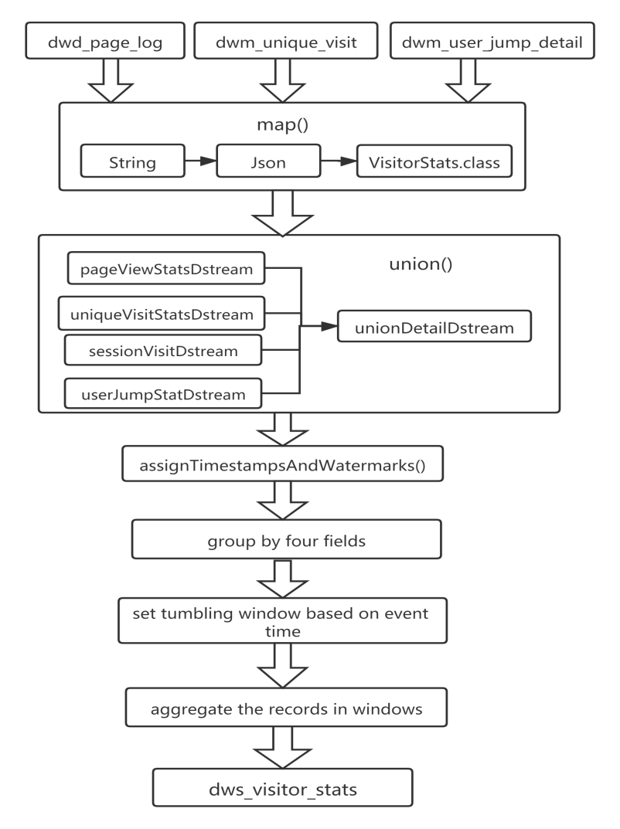
Fig. 13. Logic flow of VisitorStatsApp

4.2.3 Implementation of Flink Native Kubernetes
Kubernetes is a popular container-orchestration system for automating the deployment, expansion and management of computer applications. Flink’s native Kubernetes integration make it possible to directly deploy Flink on a running Kubernetes cluster, its principle is shown in Fig. 14. In additional, Flink is capable to dynamically allocate and de-allocate TaskManagers based on the demanded resources since it can directly communicate with Kubernetes. Flink provides an entry script kubernetes-session.sh of Kubernetes mode. After the user executes the script, the Flink client will generate Kubernetes resource description files, including Flink Master service, Flink Master Deployment, Configmap. After receiving the resource description request from Flink, Kubernetes starts to create FlinkMaster Service, Flink Master Deployment and Configmap resources. As can be seen from the principal figure, with the creation of Flink Master, Dispatcher and K8sResMngr components are created at the same time. K8sResMngr is the core component of native mode. It is this component that communicates with Kubernetes API server and applies for TaskManager resources. Currently, users can submit task requests to Flink cluster.
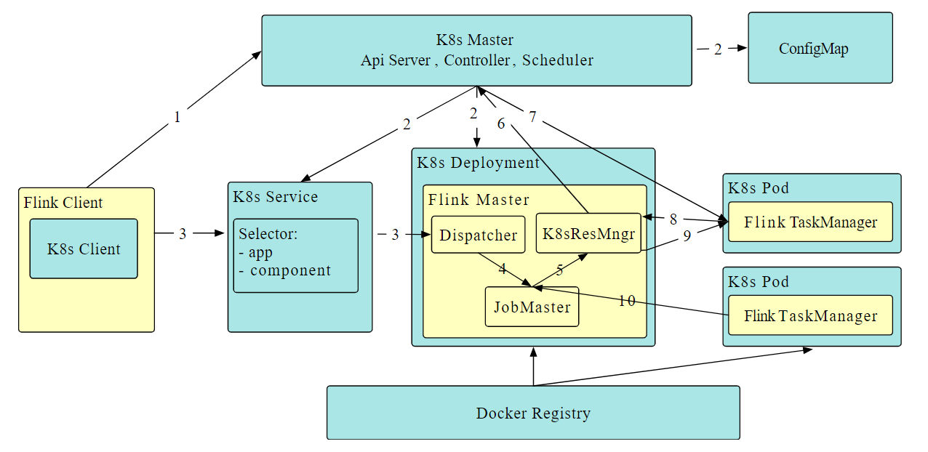
Fig. 14. Operating principle of Flink Native Kubernetes[40]

This project use Alibaba Cloud Serverless Kubernetes (ASK) cluster to deploy Flink application. ASK cluster is a server-less Kubernetes container service launched by Alibaba cloud. It is convenient to directly deploy container applications without purchasing nodes, without node maintenance and capacity planning for the cluster. The cost user needs to pay is calculated according to the amount of CPU and memory resources configured by the application. ASK cluster provides complete Kubernetes compatibility, and reduces the threshold for using Kubernetes, allowing you to focus more on applications rather than managing the underlying infrastructure. In addition, the pod in ASK cluster is based on Aliyun elastic container instance (ECI) and runs in a safe and isolated container running environment. The advantages of ASK are as follows [41]:

- Operation and maintenance free: Quickly create a server-less cluster with low threshold and deploy container applications at the second level. Focus on business applications without managing Kubernetes nodes and servers.
- Second level elasticity: There is no need to worry about the capacity planning of cluster nodes. According to the application load, it can easily and flexibly expand the resources required by the application.
- Native compatibility: Support native Kubernetes applications and ecology, including Service, Ingress, Helm, etc., and seamlessly migrate Kubernetes applications.
- Security isolation: Pods are created based on ECI. Pods are isolated from each other to prevent mutual interference.
- Cost reduction: Applications are created on demand, billed according to the volume, without cost when there is no application. At the same time, server-less brings lower operation and maintenance costs.
- Service integration: Support seamless integration of container applications and Alibaba cloud basic services; Support direct interaction with existing applications and databases in VPC; Support the interconnection between container and virtual machine application.

When the cloud Kubernetes cluster has been created, the jobs can be submitted to it by Flink client directly on local machine. There is no need to prepare a high-performance computing environment, just need one node to run as the client. In terms of the details of submission, the Application Mode is applied in this scenario. Application Mode would create an independent cluster, a dedicated JobManager is started for submitting the job and the ‘main ()’ program runs on it. When the job is completed, the JobManager exits. Comparing with other modes, like Session Mode and Per-Job Mode in Fig. 15, the processes of downloading dependencies and generate JobGraph from application included in ‘main ()’ method would not conduct on client which would cost a lot of resources and network bandwidth. Therefore, this mode can save CPU cycle and spread the network load for downloading dependencies in the dedicated cluster. Furthermore, Application Mode allows the submission of applications consisting of multiple jobs, which is very suitable for the project, since the RTDW consists of many modules and each module can be considered as a job.
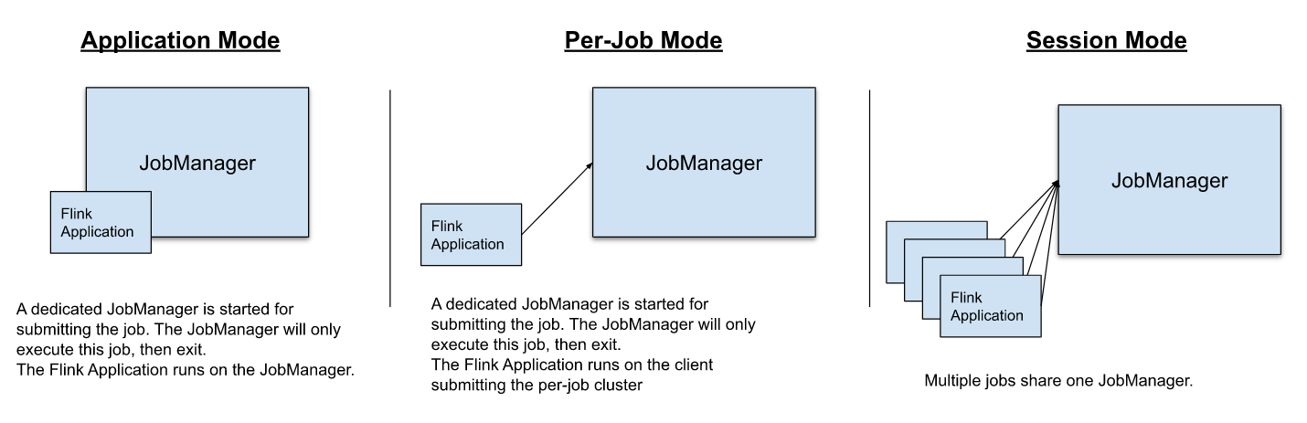
Fig. 15. Deployment modes of Flink[14]
When a job is submitted to the cloud cluster successfully, a yaml file would be automatically generated which contains the details of the deployment. From the yaml file, some main aspect can be understood. In terms of the labels, the ‘component’ is jobmanager and the ‘type’ is flink-native-kubernetes. The deployment apply RollingUpdate Strategy of which Max Surge is 25% and Max Unavailable is 25%. For the volume, the relative files would be stored in HDFS accoding to configuration file. In addition, the ‘imagePullPolicy’ is ifNotPresent and ‘restartPolicy’ is Always.

Code-5
apiVersion: apps/v1
kind: Deployment
metadata:
annotations:
deployment.kubernetes.io/revision: '1'
creationTimestamp: '2021-10-19T07:01:54Z'
generation: 1
labels:
app: flink-k8s
component: jobmanager
type: flink-native-kubernetes
…...
name: flink-k8s
namespace: default
resourceVersion: '21207817'
uid: 512d18a7-570b-478b-946d-fe7100973c9d
spec:
progressDeadlineSeconds: 600
replicas: 1
revisionHistoryLimit: 10
selector:
matchLabels:
app: flink-k8s
component: jobmanager
type: flink-native-kubernetes
strategy:
rollingUpdate:
maxSurge: 25%
maxUnavailable: 25%
type: RollingUpdate
template:
metadata:
labels:
app: flink-k8s
component: jobmanager
type: flink-native-kubernetes
spec:
containers:
- args:
- bash
- '-c'
- kubernetes-jobmanager.sh kubernetes-session
command:
- /docker-entrypoint.sh
......
image: 'apache/flink:1.13.2-scala_2.11'
imagePullPolicy: IfNotPresent
name: flink-main-container
ports:
- containerPort: 8081
name: rest
protocol: TCP
- containerPort: 6123
name: jobmanager-rpc
protocol: TCP
- containerPort: 6124
name: blobserver
protocol: TCP
resources:
limits:
cpu: '1'
memory: 1600Mi
requests:
cpu: '1'
memory: 1600Mi
terminationMessagePath: /dev/termination-log
terminationMessagePolicy: File
volumeMounts:
- mountPath: /opt/hadoop/conf
name: hadoop-config-volume
- mountPath: /opt/flink/conf
name: flink-config-volume
dnsPolicy: ClusterFirst
restartPolicy: Always
schedulerName: default-scheduler
securityContext: {}
serviceAccount: default
serviceAccountName: default
terminationGracePeriodSeconds: 30
volumes:
- configMap:
defaultMode: 420
items:
- key: core-site.xml
path: core-site.xml
- key: hdfs-site.xml
path: hdfs-site.xml
name: hadoop-config-flink-k8s
name: hadoop-config-volume
- configMap:
defaultMode: 420
items:
- key: logback-console.xml
path: logback-console.xml
- key: log4j-console.properties
path: log4j-console.properties
- key: flink-conf.yaml
path: flink-conf.yaml
name: flink-config-flink-k8s
name: flink-config-volume
status:
conditions:
- lastTransitionTime: '2021-10-19T07:01:54Z'
lastUpdateTime: '2021-10-19T07:02:59Z'
message: ReplicaSet "flink-k8s-7cc6cc4469" has successfully progressed.
reason: NewReplicaSetAvailable
status: 'True'
type: Progressing
- lastTransitionTime: '2021-10-19T07:47:51Z'
lastUpdateTime: '2021-10-19T07:47:51Z'
message: Deployment does not have minimum availability.
reason: MinimumReplicasUnavailable
status: 'False'
type: Available
observedGeneration: 1
replicas: 1
unavailableReplicas: 1
updatedReplicas: 1

5 Result
The last chapter has talked about the design and implementation of the architecture and specific parts of the real-time computing platform. In this chapter, various tests and relevant results will be discussed.

5.1 System environment construction

5.1.1 Hardware Environment
The system test uses one server to build a 3-node cluster environment. The hardware configuration of a single server is shown in Table 6.
Table 6. System test Hardware Environment
Hardware Environment
Operating system | CentOS-7
CPU | Intel(R)Core(TM)i5-4200H@2.8GHz
Memory | 4G(DDR3)
Hard disk | 300G
Core / Thread | 2 Core / 4 Thread

5.1.2 Software Environment
Because the big data environment often causes unknown system functions and errors due to software version conflicts, there are certain requirements for the matching of versions of various components. The software versions used in cluster system testing are given in detail, as shown in Table 7.
Table 7. System Test Software Environment
Software Environment
JDK | jdk-8u212-linux-x64
Kafka | Kafka_2.12
Hadoop | Hadoop-3.1.3
Mysql | Mysql-5.7.28
Maxwell | Maxwell-1.25.0
Nginx | Nginx-1.12.2
Zookeeper | Zookeeper-3.5.7
Flink | Flink-1.13.2

5.1.3 Cluster Deployment

The distribution of cluster services and services roles are show in Table 8.
Table 8. Distribution of Cluster Services
Service | Node1 | Node2 | Node3
Kafka | √ | √ | √
Hadoop | √ | √ | √
Mysql |  | √
Maxwell |  | √
Nginx | √
Zookeeper | √ | √ | √
Flink | √
Hbase | √ | √ | √

5.2 System Test and Verification
Functional testing is based on functional requirements analysis to verify the functions of the system gradually. Its general contents are as follows: determine the verification function, put forward the test purpose and expected results, define the test process, and verify whether the actual results meet the expectations. Functional testing is mainly black box testing, without considering the internal details of the program.

The first case aimed at testing the application of BaseDBApp. This application was designed to dynamically obtain the configuration from MySQL and split the original data stream from ODS layer and sink the result records into different destinations. The two points of the test are the process of reading configuration and the process of filtering and dividing. Table 9 shows the whole test process.
Table 9. Test Case of Splitting Log Stream Dynamically
Test No. | T-01
Function | Dynamically dividing of business logs
Level | Functional Test
Purpose | Verify the function of splitting the log stream according to configurations dynamically.
Input | The data from ‘ods_base_db_m’
Process | (1) start HDFS, Zookeeper, Kafka, Maxwell, Mysql, Hbase  (2) insert test data to ‘table_process’  (3) run BaseDBApp.jar to  (4) start businesslogger.jar to generate logs  (4) check results in Hbase and Kafka
Expectation | The outputs of Hbase tables and Kafka topic are consistent with configuration table ‘table_process’.
Result | The business logs are collected, divided and sent to Hbase and Kafka according to configuration table.

The second case focused on the function of collecting the records of an indicator. An application named UniqueVisitApp is responsible for it. In order to complete the requirement, the process includes the action of pulling records from ODS layer, filtering records and sinking results to DWM layer. Table 10 shows the details of the process.
Table 10. Test Case of Unique Visitor
Test No. | T-02
Function | Unique Visitor
Level | Functional Test
Purpose | Verify the function of collecting records relative to .
Input | The data stored in topic ‘dwd_page_log’
Process | (1) start Zookeeper, Kafka  (2) run logger.sh, BaseLogApp.jar to split stream  (3) run UniqueVisitApp.jar to read data and process  (4) start behaviorlogger.jar to generate logs  (5) check console output and relevant topic content
Expectation | The console outputs collect records, and these records are stored in Kafka topic
Result | The records in topic ‘dwm_unique_visitor’ are consistent with console output

The third case was designed to test the function of forming a wide table by OrderWideApp. This application collected the data from different resources, such as topics in DWD layer and dimension table in DIM. In order to satisfy the demands, the application had to build a class containing all the targeted fields and relative methods to complete the join action firstly. Next, associate two data streams of various topics stored in Kafka. In the end, load and combine the records from various tables in Hbase. Therefore, the successful operation of the application require that all the three procedures works. It success also relies on the successes of previous applications, and the details are shown in table 11.
Table 11. Test Case of Forming Wide Table
Test No. | T-03
Function | Form wide table
Level | Functional Test
Purpose | Verify the function of forming a wide table
Input | The data from ‘dwd_order_info’, ‘dwd_order_detail’ and DIM layer
Process | (1) start HDFS, Zookeeper, Kafka, Maxwell, Mysql, Hbase  (2) run BaseDBApp.jar  (3) load and initialize relevant dimension tables into Hbase  (4) run OrderWideApp.jar  (5) start businesslogger.jar to generate logs  (6) check output in console and Kafka topic ‘dwm_order_wide’
Expectation | The records in topic ‘dwm_order_wide’ is the combination of various data streams and dimension tables.
Result | The results records in ‘dwm_order_wide’ are consistent with expectation, they are the output of specific join actions.

The fourth case is used to verify a function of forming a topic oriented wide table realized by application VisitorStatsApp. This application concentrates on calculating and summarizing several common or intermediate results of the data warehouse. Therefore, it can be generally divided into two main process. One is unifying the format of records stored in different resources and the other is completing the reduce action of certain aimed indicators based on the custom Flink window. The details of the test are presented in Table 12.
Table 12. Test Cast of Visitor Oriented Wide Table
Test No. | T-04
Function | Visitor oriented wide table
Level | Functional Test
Purpose | Verify the function of unifying outcomes of different layers and forming a visitor oriented wide table
Input | The intermediate results from DWD and DWM layers
Process | (1) start HDFS, Zookeeper, Kafka,  (2) run logger.sh, BaseLogApp.jar  (3)UniqueVisitApp.jar, UserJumpDetailApp.jar, VisitorStatsApp.jar  (4) start behaviorlogger.jar to generate logs  (5) check output in console and table ‘visitor_stats’ in ClickHouse
Expectation | The records in topic ‘visitor_stats’ is the combination of various intermediate results.
Result | The results records in ‘visitor_stats’ are consistent with expectation.

5.3 System Evaluation
In order to evaluate the value and performance of cloud Kubernetes cluster used to complete Flink jobs, this part would use the results and monitoring data supplied by Aliyun Serverless Kubernetes service to present the advantages of cloud based architecture. The following figures demonstrate the situation of job BashLogApp.jar during its running period. The parallelism of the job was set as four to handle the pressure from upstream data and improve the timeliness of the platform. From Fig. 15 and Fig. 16, it is obvious that the usage of the memory and CPU by the whole Flink cluster when no application was submitted, the cluster just applied very few resources to keep it alive and the session with Flink client. When the specific job was submitted, the original cluster would be dynamically scaled by applying for more resources according to the configuration identified in the application or the configuration file. The figure of CPU using situation demonstrates that the original requested CPU cores was 1.45 and it became 5.45 after the program was loaded and analyzed, due to the concurrency had been set 4 previously. When the job was stopped, the auto-scaling cluster would release the extra resources it did not need at that time, just as the memory usage situation in Fig. 14.
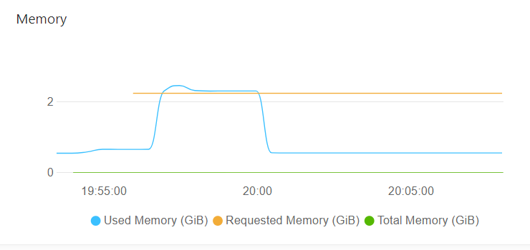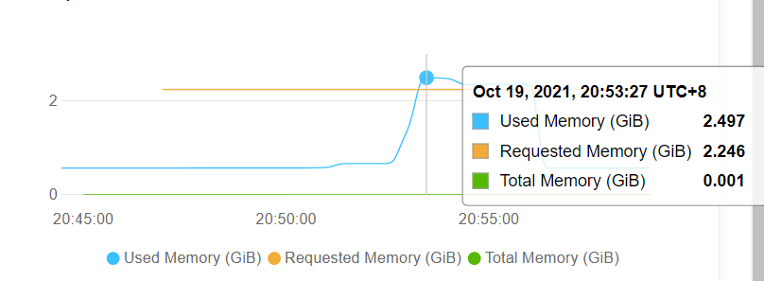
Fig. 15. Memory situation
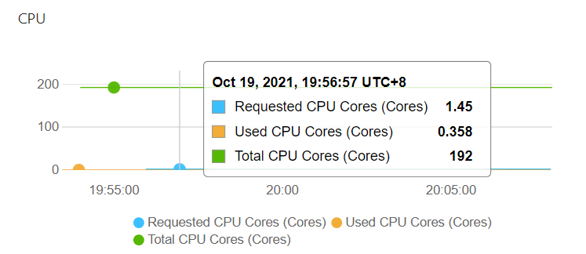
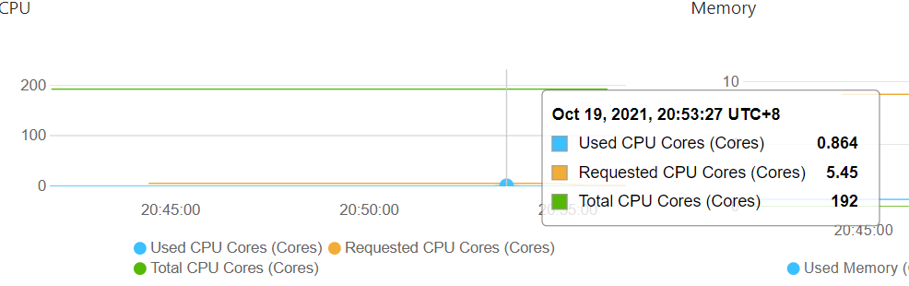
Fig. 16. CPU situation

In terms of the pods situation of the Kubernetes cluster, shown in Fig. 17, four extra pods were extended to satisfy the demands of target job which was consistent with CPU and memory extension. Besides, when the job was stopped, the pods dedicated for it would be released too. As the cost of the cluster is based on the actual resources you have used, thus, the dynamical extension and release of cluster resources would reduce the total cost to a large extent.
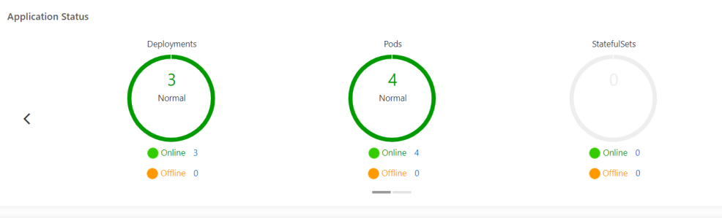
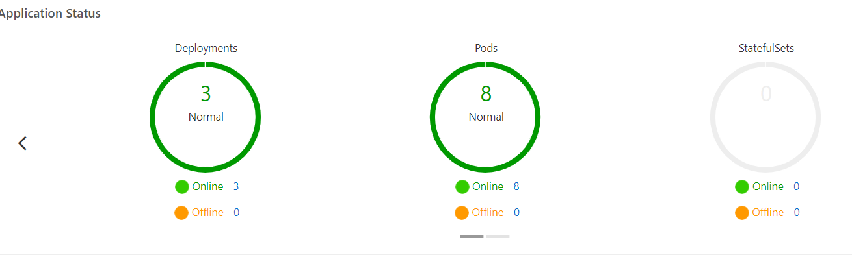
Fig. 17. Pods situation

6 Conclusion and Recommendation

6.1 Conclusion
With the rapid development of real-time computing technology, Flink has gradually become the popular operating engine. The continuous evolution and iteration of Flink ecology result in the continuous optimization of streaming data processing performance, and the continuous improvement of its stability, low delay, reliability and ease of use. In addition, the real-time data warehouse integrating stream and batch processing can not only meets the demands of traditional offline computing, but also adjusts to the development of real time data processing, achieving the effect of integrated data development and application and providing a powerful data technology tool for intelligent operation. Besides, the fast-changing container technology and cloud service make the building of cluster environment more convenient and provide high performance service on demands dynamically.

The content of the project can be summarized as follows:
- Discussed the shortcomings of traditional data warehouse and rapid development of real time data warehouse. Based on advanced container technology and cloud computing service, put forward the design and implementation of a cloud based real time data warehouse.
- Applied post positivism according to the characteristics of the project as research methodology to instruct the implementation. Used waterfall mode as development methodology to work out the plan and steps to finish the project.
- Based on the e-commence data, analyzed the requirements of the RTDW, including system basic architecture requirements and some business requirements, and put forward the construction objectives and principles of the system.
- According to the construction objectives and component characteristics, completed the design of the RTDW architecture. Combining the traits of data sources and features of various business requirements, constructed various layers of RTDW, and met the basic architecture requirements at the same time.
- Made full use of Alibaba Cloud Serverless Kubernetes cloud service to build a auto-scale cluster dedicated for Flink jobs, making up for the lack of performance of local machines and reducing the operating cost by applying for resources on demand. Confirmed the effects and benefits of cloud service brought to the project through analyzing the actual running situation of the cloud cluster.

6.2 Recommendation
In general, the project focused on the design and implementation of a simple real time data warehouse whose computing engine was deployed on a Kubernetes cluster supplied by cloud service. Currently, the development of RTDW in big data ecosystem is an important approach to combine data governance and intelligent operation, and there are still several aspects of the project can be improved in future.
- In data processing filed, data visualization is a very important approach to express the change or volume of data and make the value outcome of data operation more understandable for normal users who are not very familiar with IT technology. The combination of data warehouse system and data visualization platform is a useful and efficient way to meet the target. In this project, the work of extracting outcomes of various layers in RTDW and presenting them in custom way or through a mature commercial visualization tool still need effort to complete in future work.
- In production environment, due to the large volume of data, there are demands for servers to deploy different components. In this project, the three nodes of the operation environment were virtualized from a local machine. Although, the architecture based on cloud service is not highly sensitive to the performance of local machines. While, to ensure the normal operation of application, the disk space, memory and CPU should also be maintained at a certain reasonable level. In addition, when the configuration parameters of running environment has changed, various applications should also need modifications to fit new environment.
- In this project, the topics created to store classified records or intermediate results of each layer of RTDW are not rich enough. In real e-commence scenario, the changing and complex business requirements may result in more classifying, joining, reducing actions to make the structure of the data warehouse more complete and clear. Therefore, after the initial structure of the RTDW, some extra details still need to be supplemented in the next step.

7 Reflection
With the continuous improvement of data processing technology and network transmission speed, this project built a real time data warehouse based on some successful application case in this filed and put forward a innovative architecture of RTDW by combining local resources and cloud service. During this period, from only an idea to a complete project, I have learned a lot and improved my capability from the experience.

At the beginning of the project, the task that I had figured out was just a idea. Without enough preparation and plan, I just went ahead. Since the work on learning previous researches and the similar projects others have done was absent, there was not clear structure of the report and plan to guide the steps. I wasted a lot of time on some valueless work and could become clueless when encountered problems. Later, under the guidance of supervisor, I started to spend more time on the literature review, research methodology and development methodology at first stage, making a relatively detailed plan of the project. Due to the similarity of this kind of project from previous research and preparation, I could figure out solutions to some common problems in a relatively short time by previous experiences. In addition, I planned to build a whole big data processing cluster on Kubernetes cluster at initial stage. While I underestimated the difficulty and complexity of these task, and my local machine was not capable enough to run so many components and some of which were very sensitive to the performance of machine. Therefore, I started to adjust my initial plan, deploying the components that were not very sensitive to resources on local machine and applying cloud service of Kubernetes cluster to operating Flink jobs. It was the change that made the project easier to implement and resolve the shortage of resources.

High-quality planning ahead of action is the prerequisite for success. Set a clear direction for later work can fully make people understand the purpose of each stage. Additionally, making yourself know what is the most important thing helps to arrange your time reasonably. It enables people to clearly evaluate the progress of each stage and positively review the efficiency of each stage. So that people can shift the focus from the work itself to the results generating continuous confidence, enthusiasm and motivation for people. Being flexible and making adjustment are very important to the complete of a project in reality. If we can't be flexible, we will often be in a passive state, with a lot of trouble and trouble. When the environmental conditions change and deviate from our previous conceived track, we need to make timely adjustments in order to solve the problems and do things well. In general, awareness of the importance of good plan and the adjustment ability can be the most significant outcome that I obtained from the project. In the future, I will be more flexible and make enough preparations before the actions.

Reference
[1] Blink. [Online]. Available: https://github.com/apache/flink/tree/blink
[2] Real time warehouse construction practice of meituan based on Flink. [Online]. Available: https://tech.meituan.com/2018/10/18/meishi-data-flink.html
[3] CAI Kun,YAN Yu,ZHANG Yun,PENG Tao,YE Xiuyong. Based on the Real-time Data Warehouse Technology, Enabling the Commercial Intelligent Operation of Ecological Cooperation Platform. China Science & Technology Overview.2021, 7, 23-24.
[4] TencentCloudNative. Should big data platforms be more containerized? [Online]. Available: https://blog.csdn.net/yunxiao6/article/details/107090476
[5] Mell P M, Grance T. The NIST Definition of Cloud Computing. National Institute of Standards & Technology, SP 800-145. 2011.
[6] N. Jain and S. Choudhary, "Overview of virtualization in cloud computing," in - 2016 Symposium on Colossal Data Analysis and Networking (CDAN), 2016.
[7] Kubernetes. [Online]. Available: https://kubernetes.io/docs/
[8] Smith J E, Nair R. The Architecture of Virtual Machines. Computer, 2005, 38(5):32-38.
[9] Weike Du. Design and Implementation of Spark Platform for Big Data Streaming Computing Based on Kubernetes. University of Posts and Telecommunications. 2017.
[10]Docker Architecture. [Online]. Available: https://docs.docker.com/get-started/overview/#docker-architecture
[11]Matei Zaharia, Reynold S. Xin, Patrick Wendell, et al. Apache Spark: a unified engine for big data processing. <i>Commun. ACM</i> 59, 11 (November 2016), 56–65.
[12]Zaharia M, Chowdhury M, Das T, et al. Resilient distributed datasets: A fault-tolerant abstraction for in-memory cluster computing. Proceedings of the 9th USENIX conference on Network Systems Design and Implementation. USENIX Association, 2012: 2-2.
[13]Apache Storm.[Online]. Available: https://storm.apache.org/
[14]Apache Flink. [Online]. Available: https://flink.apache.org/
[15]S. Chintapalli et al, "Benchmarking streaming computation engines: Storm, flink and spark streaming," in - 2016 IEEE International Parallel and Distributed Processing Symposium Workshops (IPDPSW), 2016.
[16]J. Karimov et al, "Benchmarking distributed stream data processing systems," in - 2018 IEEE 34th International Conference on Data Engineering (ICDE), 2018.
[17]G. van Dongen and D. Van den Poel, "Evaluation of Stream Processing Frameworks," IEEE Transactions on Parallel and Distributed Systems, vol. 31, (8), pp. 1845-1858, 2020..
[18]The building of Real-time Data Warehouse. [Online]. Available: https://blog.csdn.net/qq_22473611/article/details/107514897
[19]Bouaziz S., Nabli A., Gargouri F. (2017) From Traditional Data Warehouse To Real Time Data Warehouse. In: Madureira A., Abraham A., Gamboa D., Novais P. (eds) Intelligent Systems Design and Applications. ISDA 2016. Advances in Intelligent Systems and Computing, vol 557. Springer, Cham. https://doi.org/10.1007/978-3-319-53480-0_46
[20]Cuzzocrea A., Moussa R., Vercelli G. (2018) An Innovative Lambda-Architecture-Based Data Warehouse Maintenance Framework for Effective and Efficient Near-Real-Time OLAP over Big Data. In: Chin F., Chen C., Khan L., Lee K., Zhang LJ. (eds) Big Data – BigData 2018. BIGDATA 2018. Lecture Notes in Computer Science, vol 10968. Springer, Cham. https://doi.org/10.1007/978-3-319-94301-5_12
[21]Verma A, Pedrosa L, Korupolu M, et al. Large-scale cluster management at Google with Borg. Tenth European Conference on Computer Systems. ACM, 20155:1-17.
[22]D. Bernstein, "Containers and Cloud: From LXC to Docker to Kubernetes," IEEE Cloud Computing, vol. 1, (3), pp. 81-84, 2014.
[23]R. Zhang, M. Li and D. Hildebrand, "Finding the big data sweet spot: Towards automatically recommending configurations for hadoop clusters on docker containers," in - 2015 IEEE International Conference on Cloud Engineering, 2015. DOI: 10.1109/IC2E.2015.101.
[24]J. Rey et al, "Efficient prototyping of fault tolerant map-reduce applications with docker-hadoop," in - 2015 IEEE International Conference on Cloud Engineering, 2015. DOI: 10.1109/IC2E.2015.73.
[25]A. Raju, R. Ramanathan and R. Hemavathy, "A comparative study of spark schedulers' performance," in - 2019 4th International Conference on Computational Systems and Information Technology for Sustainable Solution (CSITSS), 2019. DOI: 10.1109/CSITSS47250.2019.9031028.
[26]E. Mehmood and T. Anees, "Performance Analysis of Not Only SQL Semi-Stream Join Using MongoDB for Real-Time Data Warehousing," in IEEE Access, vol. 7, pp. 134215-134225, 2019, doi: 10.1109/ACCESS.2019.2941925.
[27]M. A. Naeem, F. Mirza, H. U. Khan, D. Sundaram, N. Jamil and G. Weber, "Big Data Velocity Management–From Stream to Warehouse via High Performance Memory Optimized Index Join," in IEEE Access, vol. 8, pp. 195370-195384, 2020, doi: 10.1109/ACCESS.2020.3033464.
[28]Zhi Qi. Apache Flink + TiDB: A Scale-Out Real-Time Data Warehouse for Analytics Within Seconds. 2020-11-11. [Online]. Available: https://en.pingcap.com/blog/apache-flink-+-tidb-a-scale-out-real-time-data-warehouse-for-analytics-within-seconds
[29]Justin Hayes. An Overview of Real Time Data Warehousing on Cloudera. 2020.2. [Online]. Available: https://blog.cloudera.com/an-overview-of-real-time-data-warehousing-on-cloudera/
[30]David Taylor. What is Data Warehouse? Types, Definition & Example. 7, 2021. [Online]. Available: https://www.guru99.com/data-warehousing.html
[31]Data warehouse architecture (offline and real-time). 2020.10. [Online]. Available: https://blog.csdn.net/xiaohu21/article/details/109061280
[32]Engle Eric. Post Positivism.Duncker & Humblot:2014-02-18.
[33]Priya Pedamkar. Waterfall Model. [Online]. Available: https://www.educba.com/waterfall-model/
[34]Noussair Fikri,Mohamed Rida,Noureddine Abghour,Khalid Moussaid,Amina El Omri. An adaptive and real-time based architecture for financial data integration. Journal of Big Data,2019,6(1):
[35]Abdeltawab Hendawi,Jayant Gupta,Jiayi Liu,Ankur Teredesai,Naveen Ramakrishnan,Mohak Shah,Shaker El-Sappagh,Kyung-Sup Kwak,Mohamed Ali. Benchmarking large-scale data management for Internet of Things[J]. The Journal of Supercomputing,2019,75(12):
[36]W.Jianmin, Z. Wenbin, F. Tongrang. Y.Shilong. and L. Hongwei, "An improved join-free snowflake
schema for ETL and OLAP of data warehouse," Concurrency and computation, vol. 32,no.23,2020, doi:10.1002/cpe.5519.
[37]Alibaba Cloud: Intelligent data building and management Dataphin - Dimension layer (DIM). [Online]. Available: https://help.aliyun.com/document_detail/137615.html
[38]Yi Jia. Design and inplementation of e-commerce multidimensional analysis system based on Hive. Zhejiang University of Technology. 2020. (in Chinese)
[39]Nginx Doc: Nginx Reverse Proxy. [Online]. Available: https://docs.nginx.com/nginx/admin-guide/web-server/reverse-proxy/
[40]Native Kubernetes Setup Beta. [Online]. Available: https://ci.apache.org/projects/flink/flink-docs-release-1.10/ops/deployment/native_kubernetes.html
[41]Serverless Container Service ASK. [Online]. Available: https://www.aliyun.com/product/cs/ask?spm=5176.21040285.J_8058803260.52.5be76908Xmrfo1

