Name: Madalina Ghiorghi
Student number: 2215490
PERSONAL DEVELOPMENT PLAN
Learning in the Digital Era – BMPL4007/BMPS4009

Table of Contents
Task 1 - Reflection 2
Task 2 – Personal Development Plan 5
Reference list 10

Task 1 - Reflection
Gibbs Reflective Cycle
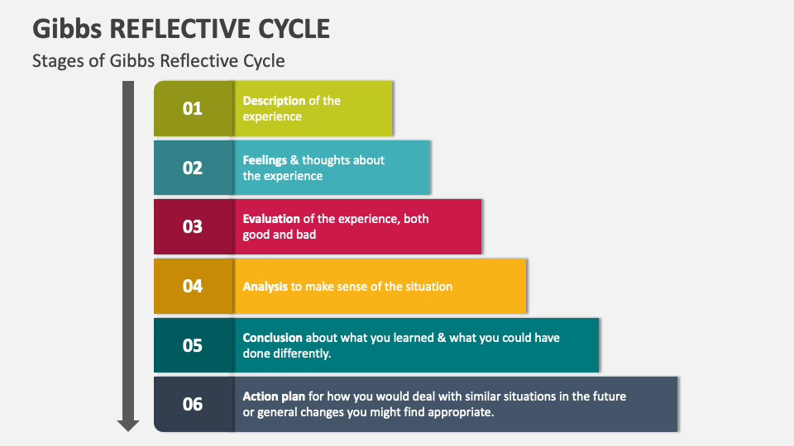
Figure 1: Gibbs Reflective Cycle
(Source: Collidu.com, 2023)
Description- The foremost step of Gibb's reflective model is Description, it describes the overall situation in a reflective format (Adeani et al., 2020, p.140). As a student of the University of Wales, I took part in this module which has helped me to learn about various important transferable skills. All those skills would certainly benefit me in my future aspirants. At that time, I realised that I have to work on some important skills which can create issues for me in future. Some of those skills are time management skills, research ability and communication skills. After the completion of the module, I realised that I managed to develop those skills along with some other skills such as literature skills, practical skills, psychological skills and more. The maximum part of the module was done through online media as the modern world is shifting rapidly. From the situation I got to know that transferable skills are mandatory to achieve the academic and professional goals of an individual.
Feelings- I feel that by doing the module, I could develop and improve my knowledge of policing courses which could help me in my career progression in the future and assist in accomplishing my goals. In the beginning, I was super excited as I thought that I could easily finish the module without any hindrances. However, as time went on, I felt that I did not possess all the necessary transferable skills to me and it led me to demotivation during the course. Now I think it was good for me as I got an opportunity to evaluate my competencies and figure out areas where I should work. This is one of the most important steps in the Gibbs reflective cycle (Markkanen et al., 2020, p.45).
Evaluation- The third stage of the reflective cycle is the Evaluation stage where an individual understands the good part and the bad part of the overall situation (Ed.ac.uk, 2023). While completing the policing course I realised that investigation skill is the most important ability that should be developed by the student to prosper in a professional career. Communication skill is important to enhance investigation ability as more interactions are required to know the scenario and modus operandi of the crime. It created an issue for me as I did not have enough communication skills to me. On the other hand, the good part was psychological skills, and practical skills were to me which got more developed after the module.
Analysis- Before starting the module I went through various videos and offline sources which aided me in getting knowledge of how an individual should behave during the module or some required skills that should be possessed by the individual. It was the reason for the things that went well throughout the module (Livecareer.com, 2023). Along with this, the stage analyses both the bad and good feelings of an individual with suitable justification. As I did not have some important skills such as time management, and research ability it created several issues for me.
Conclusion- I have learnt from the overall module that I should be more careful in future during my policing course. I got to know about transferable skills, various aspects of my course and how I can cover all the aspects properly. Moreover, I also got to know that time management skill is very important so that I can act properly with time, research ability is also required to reach the core of the criminal’s mind. In future, if I face the same situation again, I would certainly develop all the required skills before taking part in the module.
Action Plan
Objectives | Specific | Measurable | Achievable | Realistic | Time-bound
Enhancing my communication | Communication skills are directly linked with investigation ability which is an integral part of the policing course (Skillsyouneed.com, 2023). | I would be able to interact with a lot of people without feeling hesitation. | I have to consult with my tutors, and other experts to grow this skill to me. | It would benefit me to get promotions in my professional care as I would be able to solve critical cases easily. | 5 months
Improving time management skills | Time management skill helps to understand the sequencing and time limit for a particular task (Skillsyouneed.com, 2023). | I can see the benefits as I can arrange all the tasks as per their importance. | At first, I would divide tasks and fix a proper time schedule for each task. | It would create a good image of me for my seniors. | 8 months

Task 2 – Personal Development Plan
Student Name |  | Student Number |  | Module |  | Code
 |  |  |  | Learning in the Digital Era |  | BMPL4007  BMPS4009
What goals do I want to achieve? | How will I measure my progress? |  | What resources or support will I need? |  | How is the objective relevant to my personal aspirations? | What is the timeframe for the achievement of my goals?
Specific | Measurable |  | Achievable |  | Relevant | Timebound
Enhancing time management skills while studying policing course. | I would be able to accomplish all my assignments, projects and tasks before the submission date. Along with this, time management skill stops an individual from not taking extra work pressure during a professional career (Griffin, 2021). |  | There are several ways to enhance the time management skills of an individual. This is one of the most vital skills that should be present to every person to prosper in life (Daft, 2021). I have decided that I would create a proper time schedule to enhance the skill, I would also divide all the tasks at first before starting a particular one. It would benefit me to cover all the sections as per their importance. Along with this, I have also thought that I would keep an alarm clock with me which would keep me remembering about my tasks. |  | I collected information about the skill during this module. In my future professional career, I will be assigned a pile of files and I need to sort those files properly. Time management skills would be beneficial at that time as it can help me to know about the time limit which I should invest in a particular task. Due to this ability, I would also be able to close cases by finding out the main culprit. It would portray a good image of me to my higher authority and they would promote me in upper positions. | 8 months
Increasing communication skills | Communication skills are required to improve the investigation ability of an individual (Khan et al., 2017, p.20). I would notice that I can progress in any case by finding proper information from victims and eyewitnesses. I would also give justifications for my deeds to my seniors if I had this ability to me. Increased communication skills would assist me in making my juniors understand my planning during a certain case. |  | Communication skills can be achieved by following several online videos, taking part in teamwork, more real-life practices and more. I have decided to consult with tutors and experts who have a lot of field knowledge about various cases. I have to understand how I can ask tricky questions which would leave culprits with no other option than confessing their guilt. |  | Investigation skill is totally dependent upon the efficiency of communication skills and this is the most important skill which should be developed during policing courses. Improved communication skills would lead me to investigate and create the case file properly. This can also influence my career growth in future. | 5 months
Improving research skills during the course | Research skills refer to the abilities that help an individual collect in-depth knowledge about a certain topic or matter (Hendriarto et al., 2021, p.55). I would find that I can easily reach the core of any case which makes the solving process easier. Additionally, I would also notice that I can understand how I should proceed further in any case. The ability would also be beneficial in my academic career to include effective information in my assignments, projects and more. |  | Research skill is a kind of ability that can be improved by watching previous ways and taking advice from seniors. Moreover, I would take help from offline and online books to know how the authors guide to development of the skills to individual. I have also decided that I would maintain continuous communication with my peers so they can suggest to me some proper videos and journals regarding my research skills. At first, I need to analyse the case and then create proper ways about how I should start to reach the end and get all my answers during that time. Further, I have fixed to invest a certain time every day to improve my ability to. |  | The skill is very relevant to the policing course. Research means going into the deep of the case. The main thing that is taught to us during the course is to find out the modus operandi of the crime. Improved research ability would certainly help me to do this. I have to research the background of the victim, supposed criminals and more. It would make the case clear to me why the person or persons have committed such a crime intentionally. Thus, the criminals would get proper punishments and innocent people would be free from custody. | 7 months

Reference list
Websites
Collidu.com, 2023. Available at: https://www.collidu.com/presentation-gibbs-reflective-cycle [Accessed on- 29th August 2023]
Ed.ac.uk, 2023. Available at: https://www.ed.ac.uk/reflection/reflectors-toolkit/reflecting-on-experience/gibbs-reflective-cycle [Accessed on- 29th August 2023]
Livecareer.com, 2023. Available at: https://www.livecareer.com/resources/resumes/basics/transferable-skills-set [Accessed on- 29th August 2023]
Skillsyouneed.com, 2023. Available at: https://www.skillsyouneed.com/ips/communication-skills.html [Accessed on- 29th August 2023]
Skillsyouneed.com, 2023. Available at: https://www.skillsyouneed.com/ps/time-management.html [Accessed on- 29th August 2023]
Journals and Books
Adeani, I.S., Febriani, R.B. and Syafryadin, S., 2020. Using GIBBS’reflective cycle in making reflections of literary analysis. Indonesian EFL Journal, 6(2), pp.139-148. https://doi.org/10.25134/ieflj.v6i2.3382
Daft, R.L., 2021. Management. Cengage Learning. https://books.google.co.in/books?hl=en&lr=&id=HBQcEAAAQBAJ&oi=fnd&pg=PP1&dq=time+management+skills&ots=4-vzLwKM3r&sig=pfNWI0PzLWK8
Griffin, R.W., 2021. Management. Cengage Learning. https://books.google.co.in/books?hl=en&lr=&id=8uUXEAAAQBAJ&oi=fnd&pg=PP1&dq=time+management+skills&ots=kZyo0o63wR&sig=jHx1grDVGdDMMMitiNYeYkB
Hendriarto, P., Mursidi, A., Kalbuana, N., Aini, N. and Aslan, A., 2021. Understanding the Implications of Research Skills Development Framework for Indonesian Academic Outcomes Improvement. Jurnal Iqra'Kajian Ilmu Pendidikan, 6(2), pp.51-60. http://idr.uin-antasari.ac.id/id/eprint/23114
Khan, A., Khan, S., Zia-Ul-Islam, S. and Khan, M., 2017. Communication Skills of a Teacher and Its Role in the Development of the Students' Academic Success. Journal of Education and Practice, 8(1), pp.18-21. http://iiste.org/Journals/index.php/JEP
Markkanen, P., Välimäki, M., Anttila, M. and Kuuskorpi, M., 2020. A reflective cycle: Understanding challenging situations in a school setting. Educational Research, 62(1), pp.46-62. https://doi.org/10.1080/00131881.2020.1711790

