
Developing Emotional Intelligence Skills
BA (Hons) Leadership & Management Skills for the Workplace Assignment Title: Component 2 – Individual report Module Code: lclm5006 Lecturer Nam
Sylene Angela Cedeno Pincay (2330431) | 3/22/26 | Total words: 2910

Contents
Introduction: Emotional Intelligence (EI) 2
Theoretical Foundations of Emotional Intelligence 3
Mayer-Salovey Ability Model 3
Goleman’s Mixed Model: 4
Bar-on Trait Model 5
Application of Emotional Intelligence Components in the Workplace 5
Self-Awareness and Self-Regulation 5
Table: Self-awareness and Self-Regulation in the Workplace 6
Empathy and Social Awareness 7
Table: Empathy and Social Awareness in the Workplace 8
Motivation and Workplace Performance 8
Table: Motivation and Workplace Performance 9
Social Skills and Relationship Management 9
Table: Social Skills and Relationship Management 9
Generational Differences and Emotional Intelligence 10
Key Differences Between Generations 11
Managerial Challenges 11
Implications for Workplace Practice 12
Mindfulness and Its Relationship with Emotional Intelligence 12
Real-World Application of Emotional Intelligence 13
Google: Emotional Intelligence and Psychological Safety 13
NHS: Emotional Intelligence in Healthcare 13
Synthesis: Emotional Intelligence, Mindfulness, and General Dynamics 14
Recommendations for Workplace Practice 15
Implement Structured Emotional Intelligence Training 15
Integrate Mindfulness into Organisational Practices 15
Develop Generationally Inclusive Communication Strategies 15
Conclusion 16
References 17

Introduction: Emotional Intelligence (EI)
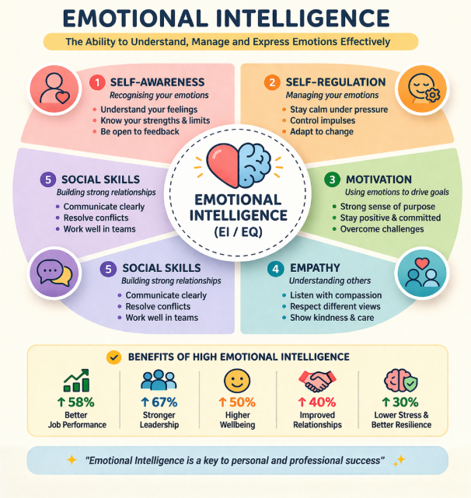
Emotional intelligence (EI) has emerged as a crucial concept in understanding human behaviour, particularly within professional environments where interpersonal interactions shape performance and organisational success. Popularised by Daniel Goleman, emotional intelligence refers to the ability to recognise, understand, manage, and influence one’s own emotions as well as those of others. Goleman’s well-known assertion, “If you are turned out of your own emotions, you will be poor at reading them in other people,” highlights the foundational premise of Emotional Intelligence: self-awareness is the gateway to social awareness and effective relationships.

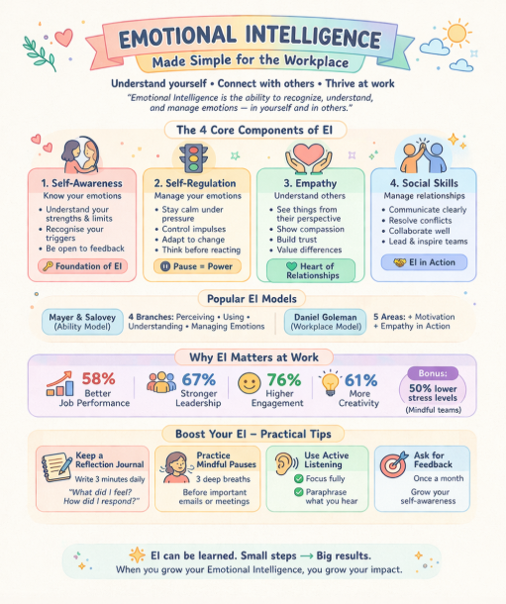
In the workplace, emotional intelligence is increasingly recognised as a critical determinant of performance and leadership effectiveness. Employees who demonstrate high self-awareness can better understand their emotional responses, while self-regulation allows them to manage stress and maintain professionalism under pressure. Similarly, empathy and social skills facilitate collaboration, conflict resolution, and affective communication across diverse teams. The visual representation highlights how these competencies translate into measurable outcomes, including improved job performance, stronger leadership, enhanced well-being, and reduced stress. However, while EI contributes significantly to workplace success, it must be applied alongside organisational support systems. Therefore, emotional intelligence should be viewed not as a standalone capability but as an integrated skill set that enhances both individual effectiveness and organisational performance.

Theoretical Foundations of Emotional Intelligence

Mayer-Salovey Ability Model
The Mayer-Salovey model conceptualises EI as a set of cognitive abilities structured into four branches: emotional perception, emotional facilitation of thinking, emotional understanding, and emotional regulation (Mayer, Salovey and Caruso, 2026). This model positions EI as comparable to traditional intelligence, suggesting it can be objectively measured.
In a workplace context, employees utilise this model through interpreting emotional cues (e.g., tone, body, language) and regulating emotional responses in high-pressure environments. For example, in customer-facing roles, emotional perception enables employees to detect dissatisfaction and respond appropriately.
While the model provides a robust theoretical foundation, its practical application is limited by measurement challenges. Tests such as the MSCEIT assume universal emotional interpretations, which may oversimplify the complexity of emotional experience in diverse workplaces.
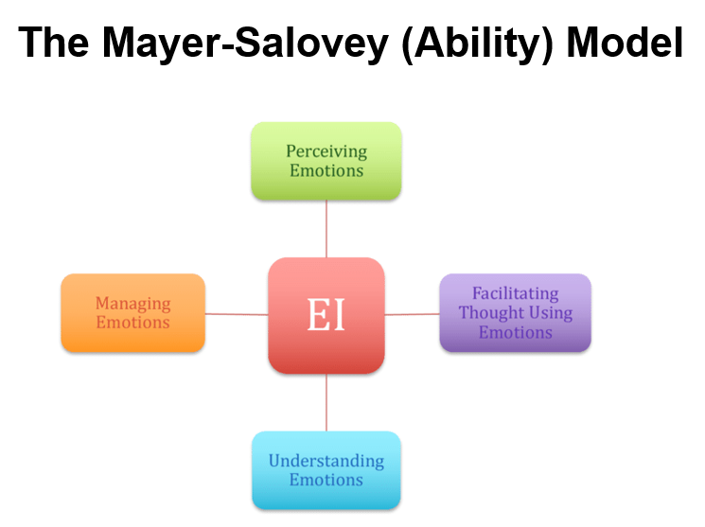

Goleman’s Mixed Model:
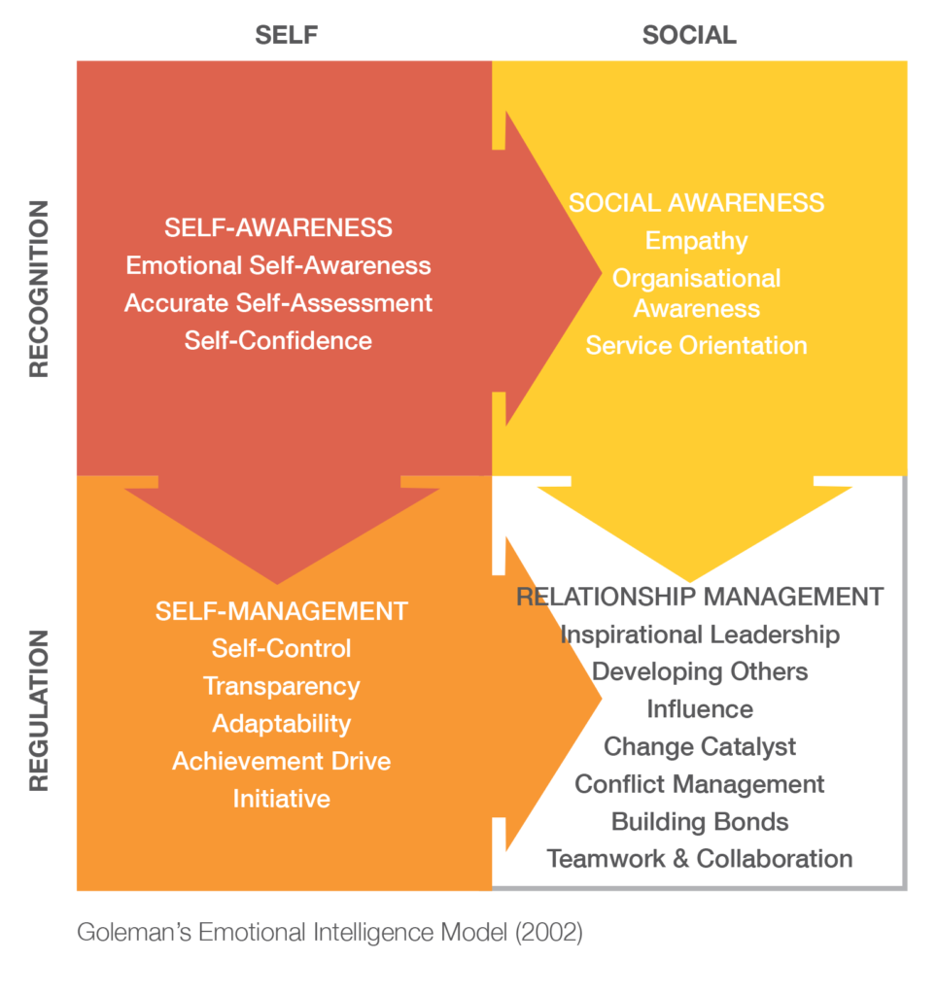
Goleman’s framework expands EI into five competencies: Self-awareness, self-regulation, motivation, empathy, and social skills (Goleman, 2998). This model is widely used in organisational settings due to it direct relevance to workplace behaviours and leadership.
Employees apply these competencies in various ways:
- Self-awareness supports reflective decision-making.
- Self-regulation help manage stress and conflict.
- Empathy enhances teamwork and inclusion.
- Social skills facilitate collaboration and leadership influence.
Despite its popularity, Goleman’s model has been criticised for conceptual ambiguity and overlap with personality traits such as emotional stability and extraversion (Joseph and Newman, 2010). This raises questions about whether EI is a distinct capability or a repackaged combination of existing constructs.
Nevertheless, its practical utility in organisational development cannot be dismissed.
This model is particularly relevant in an organisational context because it connects emotional competencies with workplace performance and leadership effectiveness.

Bar-on Trait Model
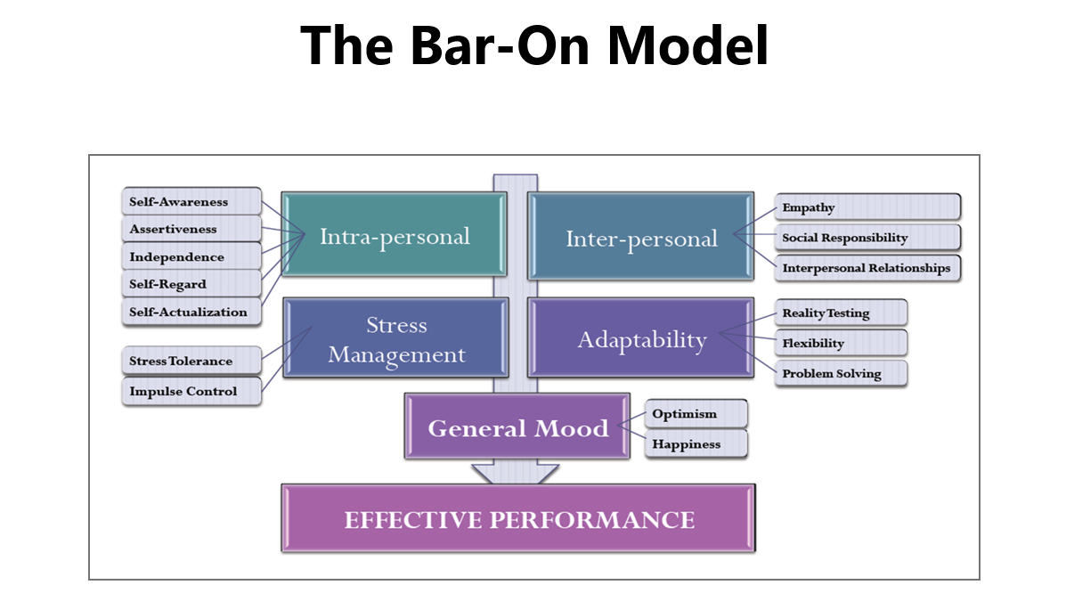
The Bar-On model conceptualises EI as a range of emotional and social competencies, including stress tolerance, adaptability, and interpersonal skills (Bar-On, 2006). It emphasises self-perceptions rather than objective ability.
In the workplace, this model explains how employees' emotional traits influence resilience, adaptability to change, and interpersonal effectiveness.
A key limitation lies in its reliance on self-report measures, which are susceptible to bias and social desirability effects. Furthermore, the model blurs the boundary between personality and intelligence, weakening its theoretical distinctiveness.

Application of Emotional Intelligence Components in the Workplace

Self-Awareness and Self-Regulation
Self-awareness is foundational to EI, enabling employees to recognise emotional triggers and their impact on behaviour. In practice, employees who are self-aware can adjust their responses in stressful situations, leading to improved decision-making and reduced workplace conflict.
Workplace Application:
- Understand how their emotions affect their performance
- Recognise stress responses and manage them proactively
- Are more receptive to feedback
For example, during high-pressure tasks, a self-aware employee may recognise rising anxiety and take steps to manage it, such as prioritising tasks or seeking clarification.
While self-awareness improves decision-making and accountability, it requires continuous reflection and feedback. In fast-paced environments, employees may struggle to maintain self-awareness due to time constraints or cognitive overload.
Self-regulation complements this by allowing individuals to manage emotional reactions. For instance, employees who regulate frustration during organisational change are more likely to maintain productivity and support team stability.
Workplace Application:
Employees demonstrating self-regulation:
- Remain calm under pressure
- Avoid implosive reactions in conflicts
- Maintain professionalism in challenging situations
For instance, in customer service roles, self-regulation is essential when dealing with dissatisfied clients.
Although self-regulation enhances workplace harmony, excessive suppression of emotions may lead to emotional exhaustion or burnout. Therefore, organisations must balance emotional control with healthy emotional expression.
However, excessive emotional regulation may result in emotional suppression, which has been linked to burnout and reduced psychological well-being (Grandey and Melloy 2017). This highlights a tension between organisational expectations of emotional control and employee authenticity.

Table: Self-awareness and Self-Regulation in the Workplace
EI Component | Workplace Application | Evidence & Statistics | Critical Insight
Self-Awareness | Recognising emotional triggers, improving decision-making and performance | Only 10-15% of individuals are highly self-aware, yet self-awareness increases productivity by 14% and job satisfaction by 20% (ZipDo, 2025) | Indicates a major skills gap in organisations; training is necessary, but not widely embedded
Self-Regulation | Managing stress, avoiding impulsive behaviour, and improving professionalism | El contributes to 58% of job performance, particularly through emotional control (Jobera,2024) | Over-regulation may lead to emotional suppression and burnout

Empathy and Social Awareness
Empathy is essential for effective teamwork, leadership, and diversity management. Employees who demonstrate empathy are better able to understand colleagues’ perspectives, fostering trust and collaboration.
Workplace Application:
Empathetic employee:
- Build strong interpersonal relationships
- Support colleagues during challenges
- Enhance customer relations
In leadership, empathy enables managers to understand employee concerns and foster inclusive environments.
While empathy strengthens relationships, excessive empathy may lead to emotional bias in decision-making. Leaders must balance empathy with objectivity to maintain fairness and organisational efficiency.
From a generational perspective, empathy may manifest differently. For example:
- Millennials and Generation Z tend to value emotional openness and inclusivity.
- Generation X and Baby boomers may prioritise professionalism and emotional restraint.
These differences can create misunderstandings in the workplace, where emotional expression is interpreted differently across age groups (Twenge, 2020).
While empathy enhances collaboration, it is not universally beneficial. Over-identification with others’ emotions can impair objectivity and decision-making, particularly in leadership roles.

Table: Empathy and Social Awareness in the Workplace
EI Component | Workplace Application | Evidence & Statistics | Critical Insight
Empathy | Understanding colleagues, improving teamwork and leadership | Employees with empathetic leaders show 76% higher engagement and 61% higher creativity (ElecrolQ, 2025) | Empathy enhances performance but may reduce objectivity in decision-making
Social Awareness | Interpreting workplace dynamics and communication styles | 71% of employers value emotional intelligence over IQ in hiring decisions (CareerBuilder survey) | Demonstrates a shift from technical to interpersonal competencies

Motivation and Workplace Performance
Intrinsic motivation, a core EI component, drives employees to achieve goals beyond external rewards. Emotionally intelligent employees are often more resilient, adaptable, and committed.
Research indicates that EI is positively correlated with job performance and leadership effectiveness (Miao et al., 2017). However, motivation is also influenced by organisational culture, leadership style, and external incentives.
Workplace Application:
Highly motivated employees:
- Exhibit persistence in achieving objectives
- Demonstrate initiative
- Maintain optimism despite setbacks
Such individuals contribute to productivity and innovation.
Intrinsic motivation is strongly linked to job satisfaction. However, external factors such as organisational culture, leadership style, and reward systems significantly influence motivation levels. A lack of alignment between personal and organisational goals may reduce employee engagement.

This suggests that EI alone is insufficient to explain performance outcomes. Overemphasis on EI may overlook structural and organisational factors that shape employee behaviours.

Table: Motivation and Workplace Performance
EI Component | Work Application | Evidence & Statistics | Critical Insight
Motivation | Driving performance, resilience, and goal achievement | 90% of top performers have high emotional intelligence (Wifitalents, 2026) | EI strongly correlates with success, but may overlook organisational barriers
Motivation (Leadership) | Inspiring team and improving productivity | EI leaders perform up to 40% better in leadership effectiveness (School of EQ, 2024) | Leadership success is multi-factorial; EI alone is insufficient

Social Skills and Relationship Management
Social skills enable employees to communicate effectively, manage conflict, and build professional networks.
These skills are particularly valuable in leadership and team-based environments.
For example, leaders with strong social skills can:
- Influence team behaviour
- Resolve disputes constructively
- Foster positive organisational culture
However, social skills linked to EI can be used manipulatively. Employees may exploit emotional awareness to influence others for personal gain, raising ethical concerns about the application of EI in organisations.

Table: Social Skills and Relationship Management
EI Component | Workplace Application | Evidence & Statistics | Critical Insight
Social Skills | Communication, conflict resolution, teamwork | Teams with high EI outperform others by 20% (Jobera, 2024) | Risk of manipulation through advanced interpersonal influence
Relationship Management | Leadership, employee retention, engagement | High EI managers retain 70% of employees for 5+ years (Forbes/Korn Ferry) | Highlights the EI’s strategic importance, but dependent on organisational culture

Generational Differences and Emotional Intelligence
Generational diversity introduces complexity into the application of EI in the workplace. Different generations have distinct values, communication styles, and emotional norms, which influence how EI is expressed and interpreted.
- Baby Boomers may emphasise hierarchy and emotional restraint.
- Generation X often values independence and pragmatic communication.
- Millennials and Gen Z prioritise emotional expression, inclusivity, and psychological safety.
These differences can be both beneficial and problematic:
Positive impacts
- Diverse perspectives enhance creativity and problem-solving.
- Younger generations may promote emotional openness and well-being.
- Older generations contribute experience and emotional stability.
Negative impacts
- Misinterpretation of emotional cues across generations
- Conflicts arising from differing communication styles
- Resistance to change or new emotional norms
While EI frameworks assume universal emotional competencies, generational differences challenge this assumption. Emotional intelligence is therefore context-dependent, shared by social, cultural, and generational factors.

Key Differences Between Generations
Aspect | Generation X | Millennials | Generation Z
Work style | Independent | Collaborative | Hybrid
Communication | Direct | Feedback-oriented | Digital-first
Motivation | Stability | Purpose | Growth & flexibility
Technology | Adapted | Highly proficient | Native

Managerial Challenges
Managing a multigenerational workplace presents several challenges:
- Communication gaps due to different preferences
- Conflicting expectations regarding work-life balance
- Varying attitudes toward authority and hierarchy
- Differences in learning and development styles
Without proper management, these differences may lead to conflict, reduced cohesion, and inefficiencies.
Strategies for Managing Generational Diversity
- Adopt Flexible Leadership Style
- Adjust management approaches based on individual needs.
- Avoid a one-size-fit-all leadership
- Promote Inclusive Communication
- Use multiple communication channels (digital and face-to-face)
- Encourage open dialogue and feedback
- Encourage Collaboration
- Create cross-generational teams
- Foster Knowledge sharing and mentorship
- Provider Development Opportunities
- Offer training tailored to different learning preferences
- Support career progression across all generations
- Leverage Emotional Intelligence
- Use empathy to understand generational perspectives
- Apply social skills to mediate differences
- Build trust through transparent communication

Implications for Workplace Practice
The application of EI in organisations offers several benefits, including improved communication, leadership effectiveness, and employee wellbeing. However, organisations must adopt a critical and balanced approach.
Practical recommendations:
- Integrate EI training with cultural and generational awareness
- Encourage authentic emotional expression rather than suppression
- Use EI ethically, avoiding manipulation
- Combine EI development with structural organisational improvements

Mindfulness and Its Relationship with Emotional Intelligence
Mindfulness has gained increasing attention within organisational psychology as a complementary construct to emotional intelligence. Defined as the ability to maintain present-moment awareness with a non-judgmental attitude (Kabat-Zinn, 2015, mindfulness enhances individuals’ capacity to recognise and regulate emotional responses.
From a theoretical perspective, mindfulness strengthens core components of EI, particularly self-awareness and self-reflection. For instance, employees who practice mindfulness are more likely to recognise emotional triggers before reacting impulsively, thereby improving decision-making and interpersonal interactions. This aligns with the EI framework proposed by Daniel Goleman, where self-awareness is considered foundational to emotional competence.
While mindfulness is often presented as universally beneficial, its effectiveness is context-dependent. Some scholars argue that mindfulness interventions may place responsibility on individuals to manage stress, rather than addressing systemic organisational issues such as workload or poor leadership (Purser, 2019).
This raises concerns about the “commodification” of mindfulness practices. Younger employees (e.g., Generation Z) are generally more receptive to mindfulness initiatives, often viewing them as essential to mental health. In contrast, older generations may perceive mindfulness as less relevant or overly abstract, potentially limiting its organisation's impact.
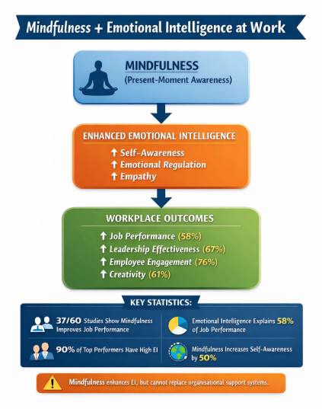

Real-World Application of Emotional Intelligence

Google: Emotional Intelligence and Psychological Safety
One of the most cited examples of EI in practice is Google through its “Project Aristotle” research. The study found that the most effective team is not necessarily those with the highest technical ability, but those characterised by psychological safety-a concept closely linked to emotional intelligence.
Employees who demonstrated empathy, active listening, and emotional awareness contributed to environments where team members felt safe to express ideas without fear of judgment.
While this supports the importance of EI, it also highlights that emotional intelligence must be embedded within organisational culture. Individual EI alone is insufficient without supportive structures and leadership behaviours.

NHS: Emotional Intelligence in Healthcare
While in the National Health Service, emotional intelligence is increasingly recognised as essential for patient care and team coordination. Health professionals rely on empathy and emotional regulation to manage high-stress situations and deliver compassionate care.
However, the NHS also illustrates the limitations of EI. High emotional demands, combined with resource constraints, can lead to emotional exhaustion despite high EI levels among staff.
This demonstrates that while EI can enhance performance, it cannot compensate for systemic organisational challenges, reinforcing the need for structural support.
Leadership and Corporate Performance
Research across industries shows that leaders with high EI are more effective in managing change, resolving conflict, and motivating employees. For example, emotionally intelligent leadership has been linked to increased employee engagement and reduced turnover (Miao et al., 2017).
Despite these benefits, there is a risk of over-attributing organisational success to EI, ignoring other critical factors such as strategy, resources, and external environment.

Synthesis: Emotional Intelligence, Mindfulness, and General Dynamics
A deeper analysis of how emotional intelligence, mindfulness, and generational diversity are interconnected rather than isolated constructs.
- Mindfulness enhances EI by improving emotional awareness and regulation.
- Generational differences shape EI expression, influencing communication styles and workplace expectations.
- Organisational context determines effectiveness, moderating how EI is applied in practice.
This interconnected perspective moves beyond traditional EI models, suggesting that emotional intelligence should be understood as a dynamic, context-dependent capability rather than a fixed trait or ability.
Advanced critical insight:
A key limitation across all EI models is their tendency to assume universality. In reality, emotional intelligence is shaped by social, cultural, and generational influences. This challenges the notion of Ei as a standardised competency and calls for more flexible, context-sensitive approaches.

Recommendations for Workplace Practice
Based on the critical evaluation of EI, mindfulness, and generational differences, the following recommendations are proposed to enhance organisational effectiveness and employee well-being.

Implement Structured Emotional Intelligence Training
Organisations should introduce formal EI development programmes aligned with models proposed by Daniel Goleman and John D. Mayer. These programmes should focus on developing self-awareness, emotional regulation, empathy, and social skills. Research demonstrates that emotional intelligence contributes significantly to job performance and leadership effectiveness (Miao, Humphrey and Qian, 2017). Training must be continuous rather than a one-off initiative to ensure long-term behavioural change.

Integrate Mindfulness into Organisational Practices
Organisations should embed mindfulness practices into daily routines, such as brief guided sessions, reflective exercises, or wellbeing programmes.
Mindfulness enhances emotional regulation and self-awareness, strengthening core EI competencies (Kabat-Zinn, 2015). Companies like Google have successfully implemented mindfulness programmes, improving employee focus and collaboration.

Develop Generationally Inclusive Communication Strategies
Organisations must recognise generational differences in emotional expression and communication styles and adapt accordingly. Different generations interpret emotional cues differently, which can lead to misunderstandings.
Embed Emotional Intelligence in Leadership Development
Leadership training programmes should prioritise EI competencies, particularly empathy, relationship management, and emotional regulation. Emotionally intelligent leadership has been linked to improved employee engagement and organisational performance (Miao et al., 2017). Leadership effectiveness depends on multiple factors; EI should be integrated alongside strategic and technical competencies.
Promote Ethical Use of Emotional Intelligence
Organisations should establish guidelines to ensure EI is applied ethically and not used manipulatively. While EI can enhance influence and communication, it may also be exploited to manipulate others for personal gain. Ethical awareness is essential to maintain trust and psychological safety in the workplace.
Strengthen Organisational Support Systems
Organisations should not rely solely on individual EI but must address structural issues such as workload, culture, and leadership practices. Evidence from organisations such as the National Health Service shows that high emotional demands can lead to burnout despite strong EI. This ensures a balanced approach where responsibility is shared between individuals and the organisation.

Conclusion
This report has critically evaluated how employees utilise emotional intelligence components within the workplace, drawing upon established models and contemporary research. While EI provides valuable insights into interpersonal effectiveness, leadership, and workplace dynamics, its conceptual ambiguity and measurement challenges limit its theoretical precision.
The integration of mindfulness further enhances emotional intelligence by strengthening self-awareness and emotional regulation. However, both construct must be applied critically, recognising their limitations and broader organisational context.
Generational differences add another layer of complexity, influencing how emotional intelligence is expressed and interpreted. While diversity can enhance creativity and innovation, it may also create communication barriers and misunderstandings.
Ultimately, this report argues that emotional intelligence should not be viewed as a standalone solution to workplace challenges. Instead, it should be integrated with organisational strategies, leadership practices, and cultural awareness to create sustainable and effective work environments. A nuanced, critical approach to EI enables organisations to harness its benefits while avoiding oversimplification and misuse.

References
Bar-On, R. (2006) ‘The Bar-On model of emotional-social intelligence (ESI)’, Psicothema, 18, pp. 13–25.
CareerBuilder (2019) Emotional intelligence in the workplace survey. Available at: https://www.careerbuilder.com (Accessed: 17 March 2026).
ElectroIQ (2025) Emotional intelligence statistics. Available at: https://electroiq.com (Accessed: 17 March 2026).
Goleman, D. (1995) Emotional Intelligence: Why It Can Matter More Than IQ. New York: Bantam Books.
Goleman, D. (1998) Working with Emotional Intelligence. New York: Bantam Books.
Google (2016) Project Aristotle: Understanding team effectiveness. Available at: https://rework.withgoogle.com (Accessed: 17 March 2026).
Grandey, A.A. and Melloy, R.C. (2017) ‘The state of the heart: Emotional labour as emotion regulation reviewed and revised’, Journal of Occupational Health Psychology, 22(3), pp. 407–422.
Jobera (2024) Emotional intelligence statistics. Available at: https://jobera.com (Accessed: 17 March 2026).
Joseph, D.L. and Newman, D.A. (2010) ‘Emotional intelligence: An integrative meta-analysis and cascading model’, Journal of Applied Psychology, 95(1), pp. 54–78.
Kabat-Zinn, J. (2015) Mindfulness. London: Piatkus.
Mayer, J.D. and Salovey, P. (1997) ‘What is emotional intelligence?’, in Salovey, P. and Sluyter, D. (eds.) Emotional Development and Emotional Intelligence: Educational Implications. New York: Basic Books, pp. 3–31.
Mayer, J.D., Salovey, P. and Caruso, D.R. (2016) The ability model of emotional intelligence: Principles and updates. Available through academic sources.
Miao, C., Humphrey, R.H. and Qian, S. (2017) ‘A meta-analysis of emotional intelligence and work outcomes’, Journal of Occupational and Organizational Psychology, 90(2), pp. 177–202.
Mindful Workplace Community (2021) Mindfulness in the workplace research findings. Available at: https://mindfulworkplace.community (Accessed: 17 March 2026).
National Health Service (NHS) (2022) Emotional intelligence framework in healthcare. Available at: https://www.nhs.uk (Accessed: 17 March 2026).
Purser, R. (2019) McMindfulness: How Mindfulness Became the New Capitalist Spirituality. London: Repeater Books.
Six Seconds (2024) State of the heart: Emotional intelligence trends report. Available at: https://www.6seconds.org (Accessed: 17 March 2026).
Twenge, J.M. (2020) Generational Differences in Work Values. Cambridge: Cambridge University Press.
Verywell Mind (2024) Emotional intelligence in the workplace. Available at: https://www.verywellmind.com (Accessed: 17 March 2026).
Wifitalents (2026) Emotional intelligence statistics. Available at: https://wifitalents.com (Accessed: 17 March 2026).
ZipDo (2025) Self-awareness statistics. Available at: https://zipdo.co (Accessed: 17 March 2026).
Zeidner, M., Matthews, G. and Roberts, R.D. (2020) What We Know About Emotional Intelligence. Cambridge, MA: MIT Press.

