project initiation document
project management (acda5004)
November 16, 2018
Matthew Lewington
BSc Software engineering
UWTSD School of Applied Computing
Contents
1. Introduction 1
2. Background 1
3. Project Definition 1
3.1 Project Objectives 1
3.2 Scope 2
3.2.1 Included 2
3.2.2 Excluded 2
3.3 Deliverables 2
3.4 Constraints 3
3.5 Assumptions 3
4. Business Case and Benefits 3
4.1 Benefits 3
4.2 Options 3
4.3 Cost and Timescale 3
4.4 Cost/Benefit Analysis 3
5. Risk Analysis 3
5.1 Risk Identification 3
5.2 Risk Prevention 3
5.3 Risk Management 4
6. Roles and Responsibilities 4
6.1 Project Organisation Chart 4
6.2 Project Sponsor 4
6.3 Project Authority 4
6.4 Project Manager 4
6.5 Project Team 5
7. Initial Project Plan 5
7.1 Assignments, Schedule and Resources 5
7.2 Project Control 6
7.3 Quality Control 6
8. References and Further Reading 7

1. Introduction
Provided within this report will be the initiation document with relevant information for the project.

2. Background
The BeSafe application is aimed at providing information to those travelling to or living in areas that may be affected by some form of disaster. Whether it be man-made (terrorism, act of war, etc...), a natural disaster, or some form of bacterial or viral outbreak.
This application will be used to advise people of what to do during one of these events, how to provide basic CPR, and will provide an emergency alert on their device(s) if the risk is imminent.
There has been a steady decline in natural disaster events and casualties since the year 2000 [1], and hopefully with use of an application we can help end users minimise risk, maximise survivability and reduce the number of casualties. This may also reflect in the reduction of stress on the emergency services.

3. Project Definition
The purpose of this application is to provide safety information for people(s) in or travelling to a certain area.
There are some applications (AccuWeather [2], Red Cross [3]) that provide some information separately, but the BeSafe application will combine the features of these applications and make them available world-wide, providing health, first aid and disaster information to anyone within, or travelling to those areas.

3.1 Project Objectives
- Develop an application that will assist the user with disaster relief and how to prepare or administer first aid.
- Application updated via information from relevant authorities. Updates will be pushed to a central database, application will utilise this data.
- Application will be able to get local information via GPS and display local information, or user will be able to select an area (city, country, etc…) and they will be shown the data for that area.

3.2 Scope

3.2.1 Included
- Requirements document to define what information we will need to know about areas, primarily prone to natural disaster, then additional features.
- Contacting authorities and health organisations to see if they would be able to provide information on daily/weekly, either direct to a database or to a support team.
- Marketing towards travellers and general population. Adverts to be developed and marketed on travel websites.
- Application to be developed in-house. View to bring in external support teams for updating information if required.
- Need to identify how best to store collected data from end users and authorities so it is readily accessible for end users.

3.2.2 Excluded
Application will not:
- Alert emergency services for assistance.
- Plan evacuation routes.
- Allow the end user to make calls.
- Be used to plan a trip.
- Provide real-time information.
- Be substituted for a doctor’s advice.

3.3 Deliverables
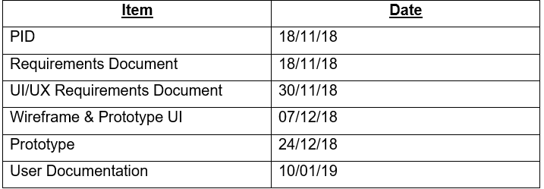
Table 1 - Deliverables

3.4 Constraints
- Time – Only 2 months to produce a prototype.
- Technical ability – Some members of the team may not be able to complete the application if it is a coding language they are unfamiliar with.

3.5 Assumptions
- Enough staff are available to create the application and manage the information in the database.
- There is support for the product from sponsor(s).

4. Business Case and Benefits
This project is being carried out to provide safety and/or travel advice to users, to help lower the number of casualties in time of natural disaster or any other event that may end in injury or loss of life.

4.1 Benefits
- Assist travellers.
- Provide safety advice.
- Provide first aid advice.

4.2 Options
- Heatmap of problem areas
- Emergency Alerts

4.3 Cost and Timescale
Application is being developed in-house by students, so will not cost anything.

4.4 Cost/Benefit Analysis
- No cost.
- Benefits to end users.

5. Risk Analysis

5.1 Risk Identification
- Staff Sickness.

5.2 Risk Prevention
- Unable to control staff sickness.

5.3 Risk Management
- Should be able to work from home. Else, another person will be able to pick up their work load.

6. Roles and Responsibilities

6.1 Project Organisation Chart

6.2 Project Sponsor
- Sue Maw

6.3 Project Authority
- Sue Maw
- Ian Wells

6.4 Project Manager
- Jon Davies
  - Oversee work progress,
  - Head progress meetings with team,
  - Update stakeholders/sponsors,
  - Assign work load

6.5 Project Team
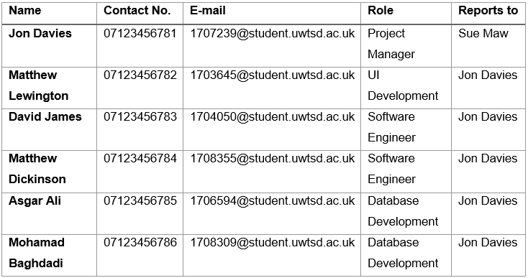
Table 2 - Project Team

7. Initial Project Plan

7.1 Assignments, Schedule and Resources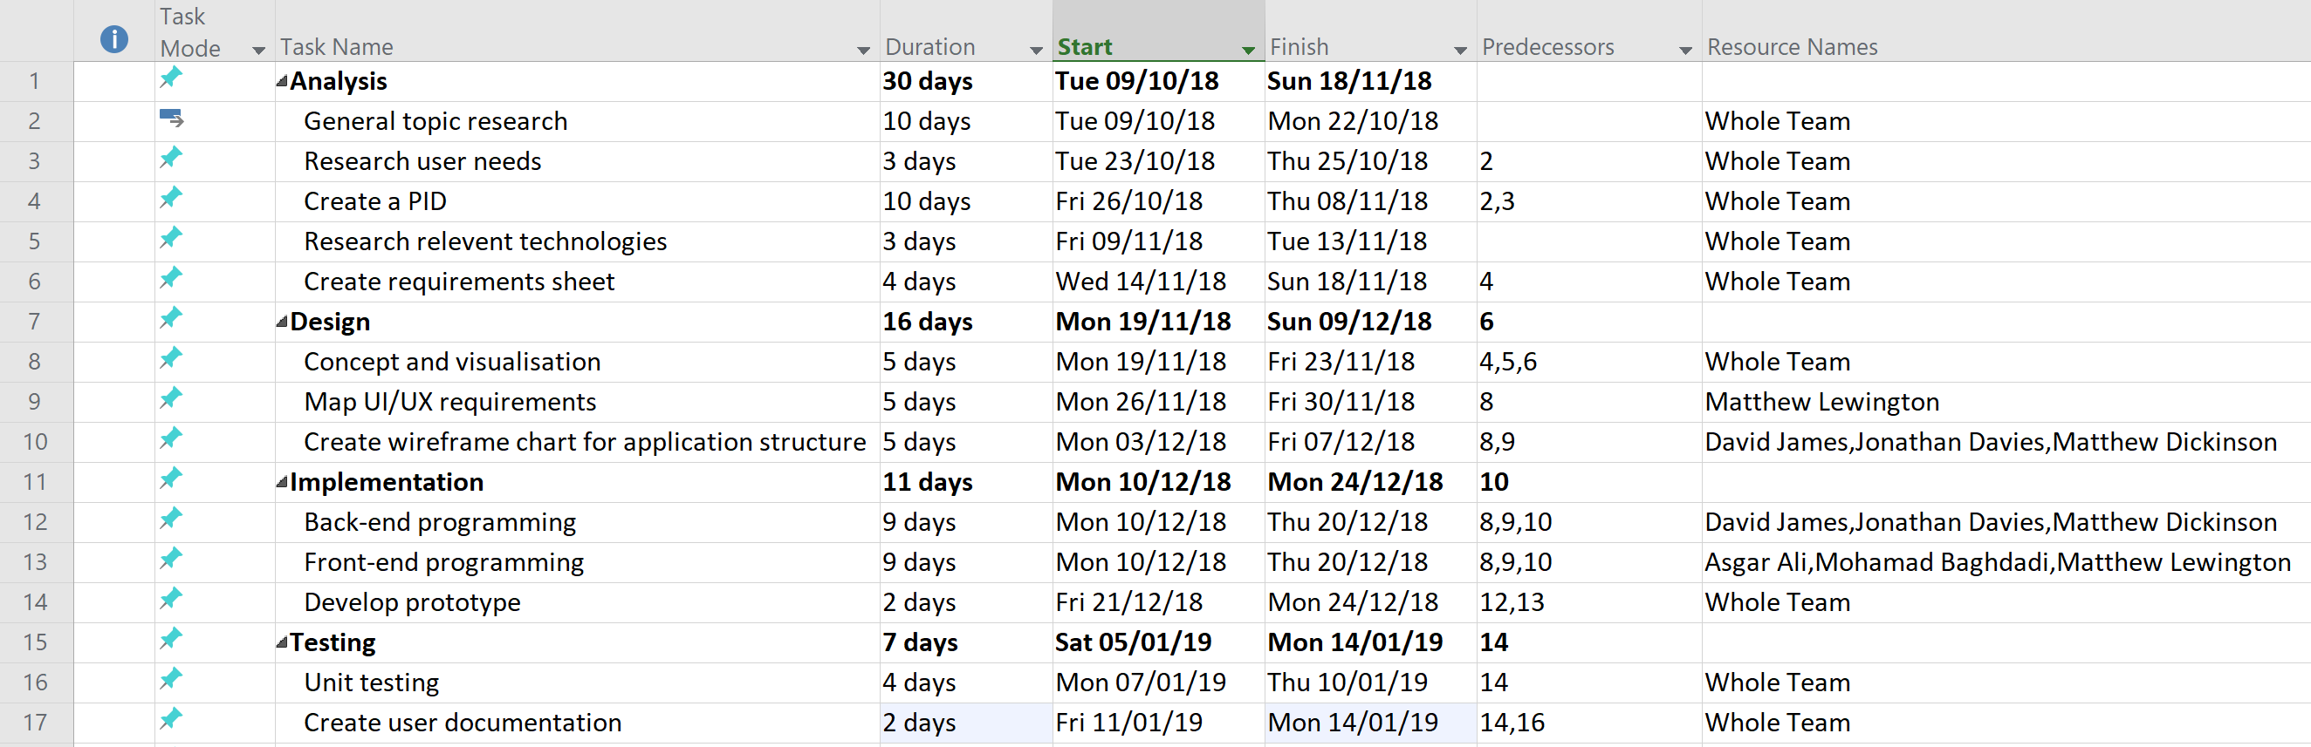
Fig 1 - Screenshot of Schedule [4]
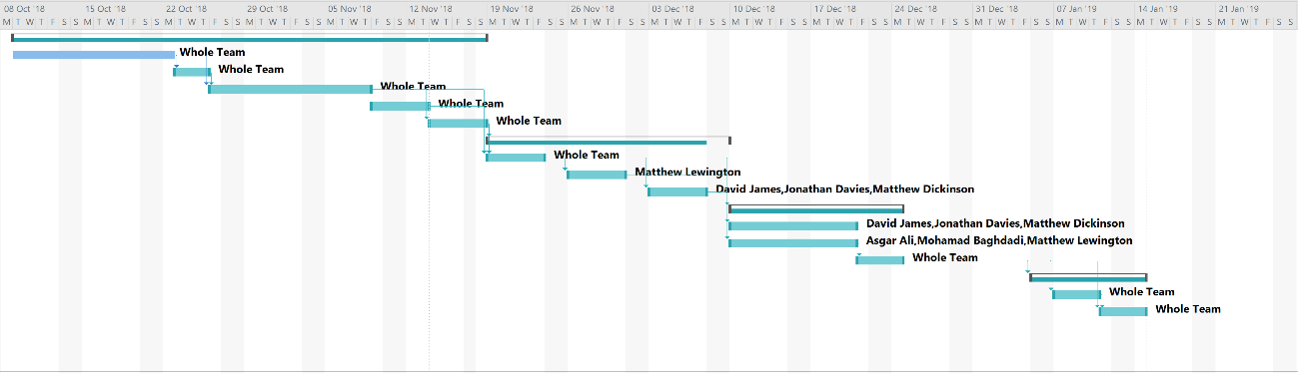
Fig 2 - High level Gantt Chart [4]

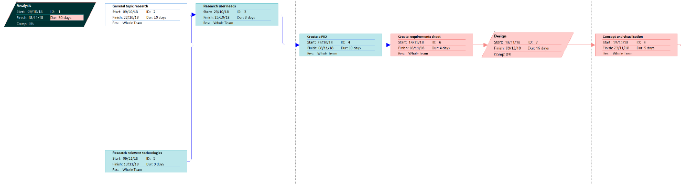
Fig 3 – PERT a [4]

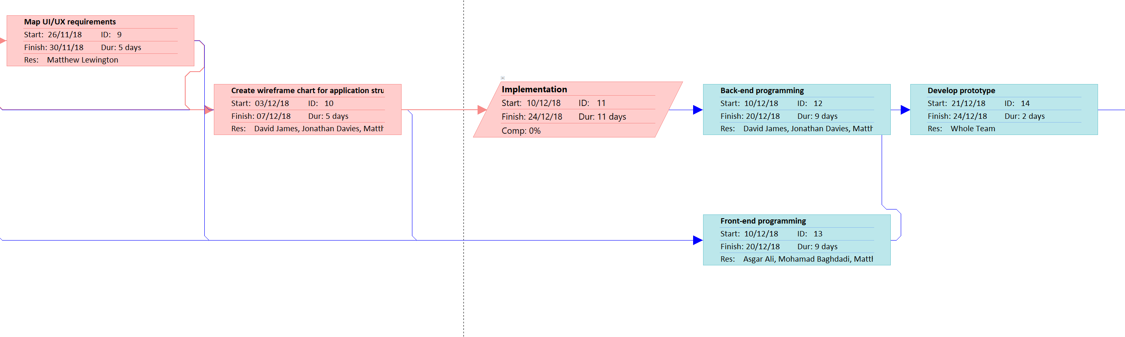
Fig 4 – PERT b [4]

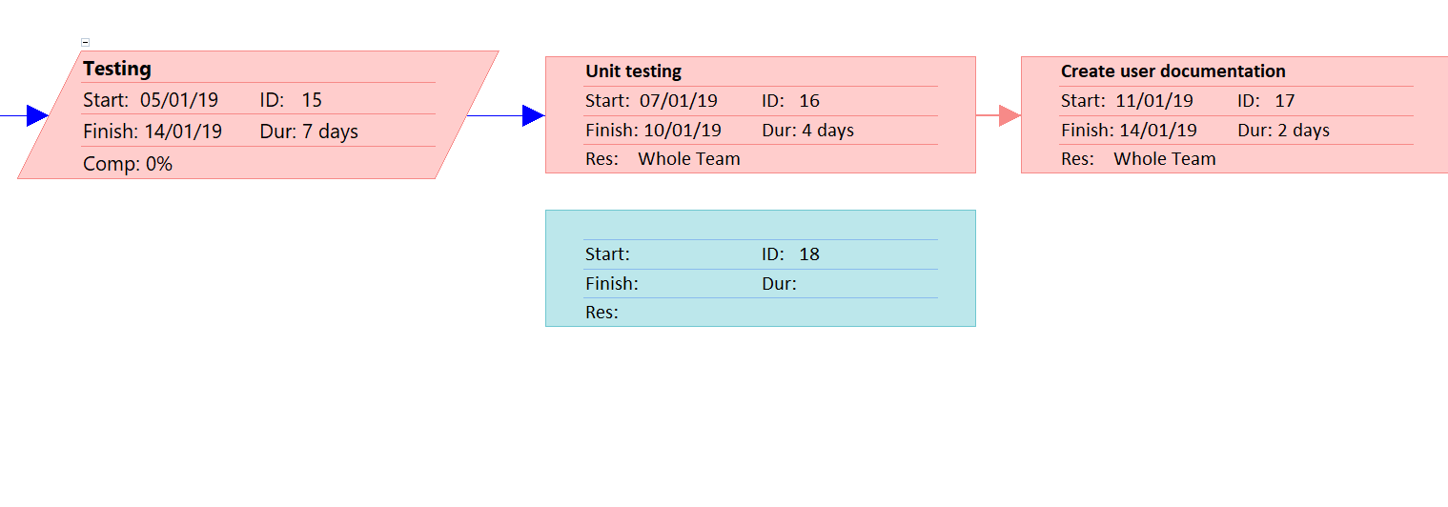
Fig 5 – PERT c [4]

7.2 Project Control
- Weekly team meetings to be held and any updates provided.
- Bi-weekly sponsor updates.

7.3 Quality Control
- In house testing
- User beta testing

[5][6]

8. References and Further Reading
[1] “Natural Catastrophes.” [Online]. Available: https://ourworldindata.org/natural-catastrophes.
[2] “AccuWeather Downloads.” [Online]. Available: https://downloads.accuweather.com/. [Accessed: 25-Oct-2018].
[3] “First aid apps.” [Online]. Available: https://www.redcross.org.uk/first-aid/first-aid-apps. [Accessed: 25-Oct-2018].
[4] J. Davies, “Gant & PERT.” .
[5] H. Maylor, Project Management, Fourth. Pearson, 2010.
[6] rbkc, “Joint Strategic Needs Assessment Draft Project Initiation Document Project Initiation Document History Revision History.”

