

Programme: BA Business Management

Module: International Business Communication
Coursework: Essay

Module code: LCBB6001

Name: Tatiana Prutean

Student ID: 2121754

Table of content:
Introduction ………………………………………………………………….3
British business communication ……………………………………………3
J Sainsbury plc ………………………………………………………………4
German business culture………………………………………………….. 5
Hofstede cultural Dimensions: UK and Germany ……………………….6
Switzerland business culture ………………………………………………8
Hofstede cultural Dimensions: UK and Switzerland ……………….......10
Conclusion ………………………………………………………………….11
References …………………………………………………………………..13

Introduction
Business communication plays a pivotal role in the operational efficiency, growth and success of modern enterprises. It encompasses the sharing of information between people within and outside an organization in a professional manner. Effective communication is crucial for the smooth operation of any business entity, as it facilitates the exchange of ideas, decision-making processes, and problem-solving mechanisms. This essay explores the significance, types, barriers and effective strategies of business communication in a business context between UK, Germany and Switzerland.
Business communication refers to the process by which information is exchanged among employees, managers and other stakeholders of an organization. It is a fundamental component of the organizational structure, enabling the flow of information necessary for the execution of tasks and the achievement of business objectives. The primary goal of business communication is to improve organizational practices, eliminate silos, foster a collaborative work environment, and promote a culture of transparency.
British business communication
British business communication is characterized by its formality, politeness and emphasis on professionalism. Understanding the nuances of business communication in the UK can be crucial for successful interactions in a professional setting. Here are some key points to consider:
1. Formality and Politeness: British business culture values formality and politeness. Initial communications are typically formal, and it's common to use titles and surnames until invited to use first names. Polite language, such as "please" and "thank you," is expected.
2. Understatement and Humour: The British often use understatement and a dry sense of humour in their communication. It's important to listen carefully and read between the lines, as direct language is not always used to convey negative feedback or criticism.
3. Indirect Communication: In line with the preference for understatement, British business professionals may communicate in an indirect manner. This means that they may hint at or suggest something rather than stating it outright.
4. Email Etiquette: Email communication in the UK business context is generally formal, especially in initial exchanges. It's common to start emails with a formal greeting and end with a polite closing.
5. Meeting Etiquette: Meetings typically start with some light conversation before moving on to the main agenda. Punctuality is important, as is coming prepared and dressing appropriately, which often means business attire in traditional industries.
6. Consensus and Apologies: Apologizing, even if you haven't made a mistake, is seen as a way to smooth over any potential conflict and is a common feature in British communication.
J Sainsbury plc
J Sainsbury plc, commonly known as Sainsbury's, is one of the leading supermarket chains in the United Kingdom. Founded in 1869 by John James Sainsbury and his wife Mary Ann in London, it has grown to become one of the UK's largest retailers, focusing on groceries but also offering a wide range of other products, including clothing, homewares, and financial services.
Market Position and Strategy
- Second-Largest Supermarket Chain - Sainsbury's is considered the second-largest chain of supermarkets in the UK, based on market share. It operates a wide range of store formats, including superstores, convenience stores, and an online retail platform.
- Diverse Product Range - it offers a broad spectrum of products, including groceries, clothing (under the Tu clothing brand), and general merchandise. Sainsbury's has also expanded into financial services through Sainsbury's Bank.
- Focus on Quality and Sustainability - Sainsbury's markets itself on quality and sustainability, targeting middle to upper-income shoppers. It has made commitments to improve the environmental impact of its operations and product sourcing.
J Sainsbury plc has established a strong presence in its home market. With its success and expertise in the retail industry, the company is now considering expanding its operations globally. This essay explores the potential benefits and challenges of Sainsbury opening a management office in Germany and Switzerland focusing on the cultural, legal and economic aspects that need to be considered.
German business culture
German business culture is characterized by its efficiency, structure, formality and emphasis on planning. This culture reflects the country's values of punctuality, reliability, and quality. Understanding these key characteristics is essential for anyone looking to engage in business activities within Germany or with German companies.
Germany stands as one of the world's leading economies, with a robust industrial base and a reputation for engineering excellence. The success of the German economy is deeply intertwined with its business culture, which is distinct and has evolved over centuries.
In German business culture, punctuality is not just a virtue but a fundamental expectation. Meetings, appointments, and deadlines are taken very seriously, and being late is considered disrespectful and unprofessional. This adherence to time reflects the broader German value of reliability and is seen as indicative of one's overall approach to business.
German business culture is deeply committed to quality and innovation. The "Made in Germany" label is globally recognized as a symbol of quality, reflecting the country's dedication to excellence in manufacturing and engineering.
Opening a new office in a foreign country presents a myriad of challenges for any multinational company, and British firms venturing into Germany are no exception. The process is fraught with both opportunities and obstacles, stemming from differences in legal systems, cultural nuances, labour laws, and economic environments. This essay delves into the specific challenges that British multinational companies may face when establishing a new office in Germany, covering legal and regulatory hurdles, cultural and linguistic barriers, labour market dynamics, and economic and financial considerations.
Legal and Regulatory Hurdles - One of the primary challenges British companies encounter when opening an office in Germany relates to navigating the complex legal and regulatory environment. Germany's legal system, characterized by its meticulousness and stringent regulations, can be a formidable barrier for foreign companies unfamiliar with the landscape. For instance, the process of company registration, obtaining necessary permits, and compliance with local laws such as the Datenschutz-Grundverordnung (GDPR) for data protection requires thorough understanding and careful navigation. Post-Brexit, British companies no longer benefit from the single market freedoms within the EU, making the establishment process potentially more cumbersome and subject to customs regulations, tariffs, and additional scrutiny.
Cultural and Linguistic Barriers - English is widely spoken in the business world, the German business culture places a high value on formality, precision, and direct communication. Misinterpretations or misunderstandings stemming from cultural nuances can hinder effective communication and business negotiations. Furthermore, operational documents, legal contracts, and marketing materials may need translation and localization to align with the German context, necessitating additional resources and time.
Labour Market Dynamics - The German labour market is known for its robust worker protection laws, strong labour unions, and a highly skilled workforce. While these factors contribute to a stable and productive work environment, they can also pose challenges for British companies.
Economic and Financial Considerations - The cost of doing business in Germany, including taxes, labour costs, and real estate prices, can be higher compared to other locations. British companies must conduct thorough market research and financial planning to ensure profitability in the German market. Additionally, fluctuations in currency exchange rates between the pound sterling and the euro can impact financial planning and operations.
Hofstede cultural Dimensions: UK and Germany
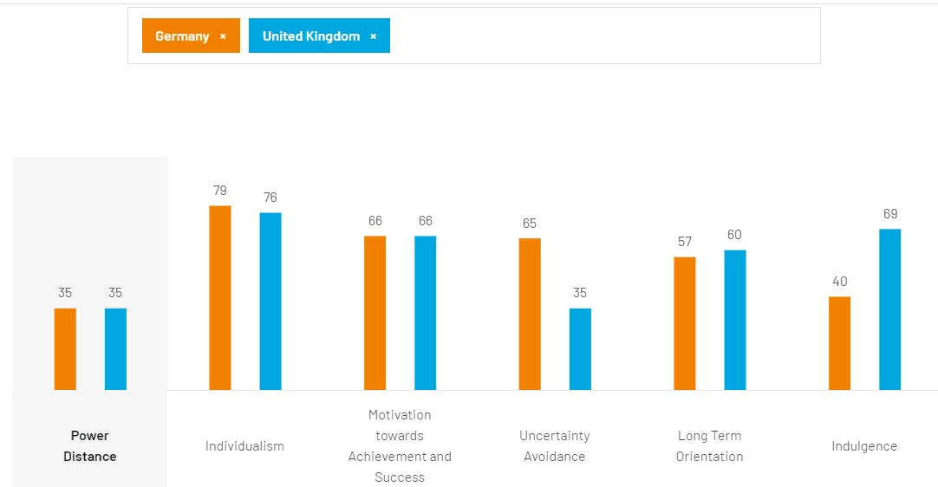
Source: https://www.hofstede-insights.com/country-comparison-tool?countries=germany%2Cunited+kingdom
The study of cultural dimensions, particularly through the lens created by Geert Hofstede, offers a fascinating lens through which to explore and compare national cultures. Hofstede's cultural dimensions theory is a framework for understanding how the values in the workplace are influenced by culture. It highlights six dimensions of culture that affect people’s work attitudes and behaviours.
- Power Distance means the extent to which less powerful members of organizations and institutions accept and expect that power is distributed unequally. The UK generally exhibits a lower power distance compared to many other countries, indicating a preference for equality and decentralized decision-making processes. In contrast, Germany has a slightly higher power distance, though still moderate, reflecting a structured hierarchy and respect for authority within organizations.
- Individualism vs. Collectivism -This dimension looks at the degree to which individuals are integrated into groups. The UK and Germany are both considered individualistic societies, though the UK scores slightly higher on this dimension. This indicates that in both countries, individual achievement and freedom are highly valued, with people looking after themselves and their immediate families.
- Masculinity vs. Femininity addresses the distribution of emotional roles between the genders and the value placed on competitiveness vs. care. Both the UK and Germany score towards the masculine end of the spectrum, though Germany does so more pronouncedly. This suggests that both societies value competition, achievement, and success, with Germany placing a slightly higher emphasis on these aspects.
- Uncertainty Avoidance deals with a society's tolerance for ambiguity and uncertainty. Germany scores significantly higher on this dimension than the UK, indicating that German culture has a low tolerance for uncertainty and ambiguity. This is reflected in a well-structured society with clear rules, laws, and regulations. In contrast, the UK's lower score suggests a more pragmatic culture that is comfortable with ambiguity and unstructured situations.
- Long Term Orientation vs. Short Term Normative Orientation - reflects a society's time horizon and the extent to which it values long-term commitments and respect for tradition. Germany has a higher score on Long Term Orientation than the UK, indicating a more pragmatic approach where thrift and perseverance are valued. In contrast, the UK, with its lower score, tends to uphold traditional values and norms while exhibiting a shorter-term outlook on planning and success.
- Indulgence - The UK scores higher on indulgence than Germany, suggesting that British society places a greater emphasis on leisure time, acting as they please, and enjoying life. In contrast, Germany, with a lower score, tends to be more restrained, with stricter social norms and a lesser focus on leisure.
In conclusion, while the UK and Germany share some cultural similarities, particularly in their individualistic tendencies and a preference for masculinity, significant differences exist in their approaches to power distance, uncertainty avoidance, long-term orientation, and indulgence.
Switzerland business culture
Switzerland, nestled in the heart of Europe, is known for its precision, efficiency and unique blend of cultures. These characteristics not only define the Swiss way of life but also deeply influence its business communication. Understanding the main characteristics of Switzerland's business communication is essential for anyone looking to engage successfully with the Swiss business environment.
Switzerland's business communication is marked by a high degree of formality. This formality is reflected in the use of titles and surnames in all professional interactions, unless explicitly invited to do otherwise. The Swiss value respect and politeness, which are considered vital in maintaining professional relationships. This level of formality extends beyond verbal communication to business attire, with a preference for conservative and high-quality clothing.
Switzerland's multilingualism significantly influences its business communication. With four official languages (German, French, Italian, and Romansh), the linguistic landscape of Switzerland is diverse. The Swiss are generally proficient in at least one other national language in addition to their mother tongue, and many are also fluent in English, which is widely used in business contexts.
Punctuality is a deeply ingrained value in Swiss society and, by extension, in its business culture. Meetings, phone calls, and deadlines are expected to be strictly adhered to. Time is viewed as a valuable resource, and being late is seen as a sign of disrespect and unreliability. This punctuality underlines the Swiss emphasis on efficiency and respect for others' time, making it a critical aspect of business communication.
A British multinational company opening a new office in Switzerland may encounter several challenges. These challenges are often due to differences in legal, cultural, and economic environments between the UK and Switzerland. Here are some of the key challenges to consider:
1. Regulatory and Legal Differences: Switzerland is not a member of the European Union (EU), which means it has distinct legal and regulatory frameworks compared to the UK, especially post-Brexit. Companies must navigate Swiss laws on company formation, employment, taxation, and data protection, which may differ significantly from those in the UK.
2. Cultural Differences: While both countries value professionalism, Swiss business culture places a high emphasis on punctuality, precision, and formality. Understanding and adapting to these cultural norms in business communications and negotiations is crucial for British companies to succeed in Switzerland.
3. Language Barrier: Switzerland has four official languages (German, French, Italian and Romansh), with German being the most widely spoken. The linguistic diversity may pose a challenge for British companies, especially in terms of recruitment, marketing, and local communication. Ensuring materials and communications are available in the appropriate language(s) is essential.
4. Labour Market and Employment Laws: Switzerland is known for its high labour costs and stringent regulations regarding work permits, especially for non-EU nationals. Companies need to be prepared for these factors in their planning and budgeting.
5. Banking and Finance Regulations: Switzerland has a unique banking system and financial regulations. British companies must understand these differences, especially regarding taxation, capital requirements, and reporting obligations. The Swiss banking system is renowned for its stability, privacy, and complexity.

.
Hofstede cultural Dimensions: UK and Switzerland
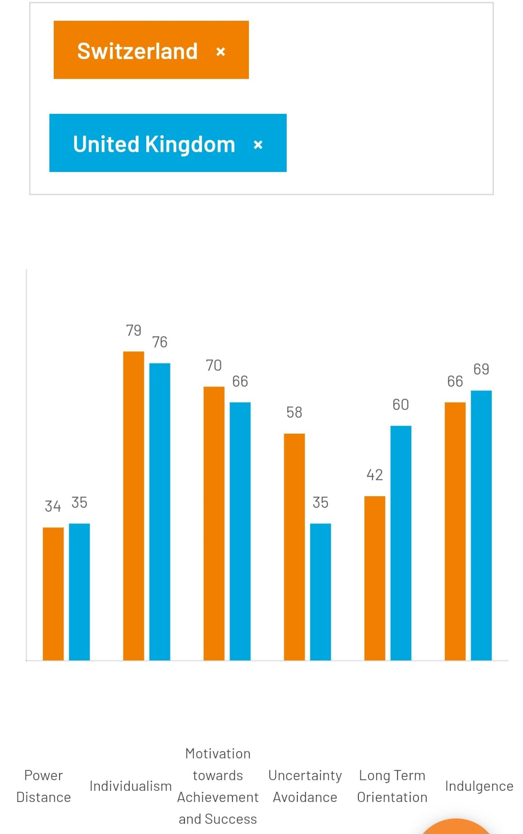
Source: https://www.hofstede-insights.com/country-comparison-tool?countries=switzerland%2Cunited+kingdom
Geert Hofstede's model of cultural dimensions provides a systematic framework to analyze and compare cultures on several key dimensions. These dimensions provide insights into the behaviour, attitudes, and values of societies, which are essential for effective cross-cultural communication and international business.
- Power Distance Index (PDI) - The UK exhibits a relatively low Power Distance, indicating a society that values equality and challenges authority. In contrast, Switzerland also shows a low Power Distance, although it may vary slightly across different cantons due to its federal structure.
- Individualism vs. Collectivism - The UK is characterized by high Individualism, reflecting a society with a loose-knit social framework in which individuals are expected to take care of themselves and their immediate families. Similarly, Switzerland also scores high on Individualism, emphasizing personal freedom and achievement.
- Masculinity vs. Femininity - The UK and Switzerland are both considered relatively masculine societies, where success, competition, and achievement are highly valued. However, both countries also exhibit a strong concern for quality of life and well-being, suggesting a balance between masculine and feminine values.
- Uncertainty Avoidance Index - The UK has a moderate score on this dimension, indicating a society that is relatively tolerant of uncertainty, with a flexible approach to change and innovation. Switzerland has a slightly higher score, reflecting a greater need for rules and planning, but still remains relatively flexible compared to high UAI countries.
- Long-Term Orientation vs. Short-Term Normative Orientation - The UK tends to have a shorter-term orientation, focusing on traditions and achieving quick results. Switzerland, on the other hand, scores higher on Long-Term Orientation, indicating a more pragmatic approach, valuing savings, and showing perseverance towards achieving long-term goals.
- Indulgence vs. - Both the UK and Switzerland are considered restrained societies, where there is a tendency towards cynicism and a lower emphasis on leisure time.
Conclusion
In conclusion, while opening a new office in Germany offers British multinational companies access to one of Europe's largest and most dynamic markets, it requires navigating a complex array of challenges. Legal and regulatory hurdles, cultural and linguistic barriers, labour market dynamics, and economic and financial considerations all play a critical role in the establishment process. Success in this endeavour demands thorough preparation, adaptability and a deep understanding of the German business landscape. By addressing these challenges head-on, British companies can position themselves to thrive in the German market, leveraging opportunities for growth and expansion in the heart of Europe.
Switzerland's business communication is characterized by its formality, clarity and precision, multilingualism, punctuality, and consensus-building. These characteristics are deeply rooted in the Swiss cultural values of respect, efficiency, and inclusivity. For individuals and businesses looking to engage with the Swiss market, understanding and adapting to these communication traits are essential for building successful and lasting professional relationships.
When setting up an office in Germany or Switzerland, it is crucial to conduct a thorough analysis of multiple factors in order to choose the right business structure. Key considerations include legal requirements, liability and risk management, tax implications, capital requirements and ownership flexibility. By carefully evaluating these factors, multinational companies can ensure compliance with German and Switzerland laws, maximize tax efficiency, effectively manage liability and establish a strong foundation for their operations in the mention countries.

References:
1. Work Culture In Germany: Characteristics, Ethics & Differences Available at: https://www.vantagelens.com/blog/work-culture-in-germany/
2. Hofstede Available at (https://www.hofstede-insights.com/)
3. Germany Culture: Facts, Customs, and Traditions. Available at (https://daadscholarship.com/germany-culture-facts-customs-and-traditions/)
4. Dutta, M.J. (2007) “Communicating About Culture and Health: Theorizing Culture-Centered and Cultural Sensitivity Approaches,” Communication theory, 17(3), pp. 304–328. Available at: https://doi.org/10.1111/j.1468-2885.2007.00297.x.
5. Gallego-Álvarez, I. and Pucheta-Martínez, M.C. (2021) “Hofstede’s cultural dimensions and R&D intensity as an innovation strategy: a view from different institutional contexts,” Eurasian business review, 11(2), pp. 191–220. Available at: https://doi.org/10.1007/s40821-020-00168-4.
6. Guffey, M. E., & Loewy, D. (2018). Business Communication: Process & Product. 9th ed. Cengage Learning. pp. 20-47
7. Locker, K. O., & Kienzler, D. S. (2014). Business and Administrative Communication. 11th ed. McGraw-Hill Education.
8. Tunc, A.O. (2020) Business management and communication perspectives in industry 4.0. Edited by A.O. Tunc and P. Aslan. Hershey, Pennsylvania: IGI Global. Available at: https://doi.org/10.4018/978-1-5225-9416-1.
9. Blundel, Richard. (2004) Effective business communication. Harlow: Financial Times Prentice Hall.
10. Linder, W. and Mueller, Sean. (2021) Swiss democracy : possible solutions to conflict in multicultural societies. 4th ed. 2021. Cham: Springer Nature. Available at: https://doi.org/10.1007/978-3-030-63266-3. pp. 9-47
11. OECD Economic Surveys: Switzerland. Available at: https://www.oecd-ilibrary.org/economics/oecd-economic-surveys-switzerland-2024_070d119b-en
12. World Bank's "Doing Business" Report on Switzerland. Available at: https://www.doingbusiness.org/content/dam/doingBusiness/country/s/switzerland/CHE.pdf
13. Deresky, H. (2017). International management. Harlow, Essex: Pearson.
- Dignen, B., McMaster, I. (2013). Collins Effective International Business Communication. London: Collins

