HRM Assignment 1
Michael Gale – 1705934

Raspberry Pi Foundation – A focus on employee experience…

Executive Summary:
The following report has been created to outline a new direction for Raspberry Pi focusing holistically on the employee experience, leading to improved employee engagement and involvement.
To create a positive employee experience, which will lead to increased employee engagement, HR will need to focus on a variety of issues including meaningful work, employee talent development, growth, rewards, wellness, the work environment, management and leadership (Deloitte, 2017. PP 55).
The report outlines 7 key recommendations for Pi Senior Management to consider:
1. Analyse HR Capabilities
2. Focus on employee experience
3. Invest in technology
4. Utilise big data and people analytics
5. Incorporate design thinking
6. Regular employee surveys
7. Build an organisation for the future

Contents Page:
Executive Summary……………………………………………………………………. 1
Introduction …………………………………………………………………………….. 4
Employee Engagement and involvement …………………………………………... 4
Employee experience …………………………………………………………………. 6
Maslow’s Hierarchy of Needs ………………………………………………………….7
Benefits to a positive employee experience ………………………………………… 8
Potential issues to a positive employee experience …………………………………9
Recommendations ……………………………………………………………………... 10
Appendices………………………………………………………………………………. 15
Bibliography……………………………………………………………………………… 18

Introduction:
Established in 2008, the Raspberry Pi foundation (Pi) is a UK-based educational charity to increase awareness, knowledge and understanding of the power of computers (Raspberry Pi, 2018).
Our mission:
“To put the power of computing and digital making into the hand of people all over the world.” (Raspberry Pi Foundation, 2018-2020).
This report has been requested by the Managing Director of the Raspberry Pi foundation and will outline key information related to the definitions of employee engagement and involvement, why they are important, what challenges the organisation could face and make recommendations for the organisation to continue its success.
The case will be made for a holistic focus on the employee experience as opposed to just focusing on employee engagement as experience encompasses the journey from recruitment to retirement and if you get the experience right, engagement will follow (Deloitte, 2017. PP11).
Employee Engagement and involvement:
According to Kruse (2012) employee engagement is the commitment employees have to their organisation and its goals. Kruse (2012) goes on to say that an emotional commitment is key as it means employees actually care for their work and not just for money.
Employee engagement has become an increasing concern for organisations today due to claims it predicts all manner of positive outcomes (Kumar and Sia, 2012). Most companies have low employee engagement, only 13 percent of the global workforce is “highly engaged”, according to the Gallup polling firm. The research also found out that upwards of half the workforce would not recommend their employer to their peers (Deloitte, 2015).
Employee engagement is important for Pi to get right, and Pi needs to have a clear focus and strategy as engagement is seen as a key driver for organisational performance (Deloitte, 2015). According to Towers Perrin research companies with engaged workers have up to six percent higher profits. Kenexa research shows that shareholders are likely to receive five times higher returns over five years if employees are engaged (Kruse, 2012). Organisations that create deep employee engagement outperform their peers and more often than not will attract the top talent (Deloitte, 2015). This is why it is so imperative Pi focus on their employees to ensure the organisation continues to be a success.
Stewart (2012) believes that although engagement is important, employee involvement is actually more important. Stewart (2012) defines engagement as employees coming to work and caring about work but involvement is when employees share in the responsibility for the success of the organisation. Employee involvement has also been linked to the high commitment paradigm. Open communication with a focus on performance, strategy, finances and operational matters conveys an important message that employees are to be trusted and treated in an open and positive manner (Marchington and Wilkinson, 2005). Stewart (2012) says that the leadership of organisations needs to engage employees in the mission of the organisation. For any employee engagement or involvement initiatives to be successful, the drive and direction needs to start with the leadership team of Pi or from a dedicated team (Deloitte, 2017), this will be discussed in more detail later in the report.
The above section shows the importance of increased employee engagement or employee involvement, the next section of the report will discuss how Pi should focus on the employee experience.
Employee Experience:
For Pi to become even more successful and outperform its peers the focus needs to be on a productive, positive employee experience, this has emerged as the new contract between employers and employees (Deloitte, 2017). Employee experience requires a holistic approach looking at areas such as worker satisfaction, engagement, wellness and alignment (Deloitte, 2017). Employee experience means companies need to provide employees with a workplace experience that meets their expectations and needs (Lyons, 2017). To create strong employee engagement Pi needs to focus on the employee experience from recruitment through to retirement (Deloitte, 2017). This includes all staff from full time and part time to volunteers, which Pi had 10,000 from CoderDojo alone in 2017 (Rasperry Pi, 2017).
Factors that Pi could focus on to create a positive employee experience include:
- Meaningful work
- Supportive management
- Positive work environment
- Growth opportunity
- Trust in leadership (Deloitte, 2017).
Employee experience was ranked as very important or important by nearly 80 percent of executives but only 22 percent felt that their organisation was excellent at building a positive employee experience (Deloitte, 2017). As mentioned earlier a strong employee experience or engagement means that Pi can attract the best talent, have the lowest voluntary turnover rates and are more profitable (Deloitte, 2015).
Maslow’s Hierarchy of Needs:
A starting point for Pi to approach creating a positive employee experience is to consider Maslow’s hierarchy of needs:

(McLeod, 2017. Simply Psychology).
Maslow’s Hierarchy of needs is a classification of five basic needs into five categories with the lower needs more basic and the more these basic needs were satisfied, the better the psychological health of the individual (Lester, 2013.) It is also described as a motivational theory with individuals moving up to the next level once the previous level is fulfilled (McLeod, 2017).
Pi should utilise the learning from Maslow and consider if employee’s needs, based on the above diagram, are being met in the workplace. This will help Pi when designing a positive employee experience.
Benefits to a positive employee experience
The benefits to a positive employee experience, leading to increased employee engagement are many:
- Increased organisational performance – research shows that if staff are trusted and feel they contribute to the organisation then the organisation will perform better (Marchington and Wilkinson, 2005)
- Attracting the best talent – organisations that have a strong culture defined by strong leadership, employee engagement, meaningful work and job/organisational fit are more likely to attract the best talent (Deloitte, 2015)
- Improve employee engagement – by focussing on the employee experience HR teams can improve employee engagement (Deloitte, 2017)
- Increased staff retention – By focussing on the right areas (employee experience) and driving engagement, Pi can improve retention (Deloitte, 2015)
- Outperform peers – If employee engagement is driven through a positive experience Pi can outperform its peers

Potential issues to a positive employee experience:
Creating a positive employee experience could potentially have some organisational challenges, and the following section will outline these.
The initial challenges are around the capabilities of HR, according to Deloitte (2015), HR is stagnating and isn’t performing significantly better than in past years. Pi will need to focus on the capabilities of HR staff to deliver a positive experience, just 11 percent of respondents to a Deloitte survey felt their organisations provide excellent development (Deloitte, 2015). According to the same research there is a huge gap between what business leaders want and the capabilities of HR to deliver (Deloitte, 2015).
Pi will need to review and potentially restructure the HR department in order to be able to focus on a positive employee experience. HR, traditionally, has addressed issues such as engagement, culture, rewards, and learning as separate programmes (Deloitte, 2017). To focus on a positive employee experience HR will need to rethink the roles, structures, strategy, and tools in order for all of the areas mentioned previously to come under one roof (Deloitte, 2017).
Engaging employees by creating a positive employee experience could hinder the effectiveness of group decisions and team decisions due to them being more time consuming (Gennard and Judge, 2002).
As you can see the potential challenges or issues with a positive employee experience are not that substantial so this is definitely an area Pi needs to focus on. The next section will focus on recommendations Pi should consider in order to achieve a positive employee experience.

Recommendations:
1. Analyse HR Capabilities
As stated earlier in this report there is a huge gap between what business leaders want and the capabilities of HR to deliver it (Deloitte, 2015).
Pi should undertake a training needs analysis (TNA) of the current HR department to understand where the gaps are in order for the organisation to achieve a positive employee experience. A TNA reviews learning and development needs for staff and considers what knowledge and behaviours they need and how to develop them, the end product of a TNA will be a robust learning and development plan (The Educators, 2018).
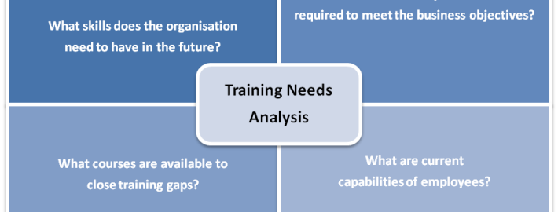
(The Educators, 2018).
2. Focus on employee experience
Pi needs to ensure that the focus on employee experience comes from the top down, a senior manager will need to be designated to own the employee experience (Deloitte, 2017).
Employee experience needs to become a priority of the organisation with Pi recognising that the experience is as valuable and can have as much value or impact as a customer experience strategy (Deloitte, 2017).
HR at Pi needs to be restructured to allow it to own, and lead on the entire employee experience. This includes: engagement; career development; learning; organisational design; analytics; performance management; rewards; and culture (Deloitte, 2017).
3. Invest in technology
Pi needs to ensure that technology is at the forefront of the employee experience, in today’s world employees have come to expect a range of technology or tools to help them manage their working life as easy as they manage their personal lives (Lyons, 2017). Between 2010 and 2015 the HR technology investments market grew by 50 percent into a $10 billion industry (Deloitte, 2015). There are now third-generation HR systems that are designed to be used by 99% of an organisation (Lyons, 2017).
4. Utilise big data and people analytics
Pi needs to start focusing on using data and people analytics. Data can be used to adapt products and services to better meet customer needs, but can also optimise operations and infrastructure. Using data correctly has also been known to find new sources of revenue (IBM, 2018).
Pi should look at other organisations who have or are successfully using data such as Microsoft and Google who mine their own data to predict hires, whereas IBM creates project teams more effectively by using its employee database (Capelli, 2015).
To utilise big data Pi first needs to look at what data it holds internally and ensure that it can be analysed and understood, work would need to be undertaken to check the data is compatible and all held in one place by HR (Capelli, 2017). After this Pi can start to look externally as there is a new world of employee data linked to social networks, recruiting networks and talent networks (Deloitte, 2015). Learning how to view, manage and utilise this data could lead to better recruiting, hiring, retention and leadership development (Deloitte, 2015).
After ensuring data is accurate, understood and utilising external data, Pi needs to then focus on people analytics. The focus of people analytics is utilising digital tools and data to measure and understand employee performance (Deloitte, 2017). Back in 2015, Deloitte research discussed that people analytics has the potential to change the way HR will work but also that organisations have been slow to develop their capabilities to take advantage of it. In 2017, Deloitte discussed that 71 percent of companies see it as a high priority but adoption of people analytics hadn’t changed much since 2016. This is an area Pi needs to understand and focus on to help develop the organisation and its employees. Discussions need to be had by Pi Senior Management as to where people analytics sits, as organisations leading in this area are utilising it for the whole business as opposed to just a HR focus and have formed multidisciplinary teams (Deloitte, 2017).
“Companies that take the time and make the investment to build people analytics will likely outperform their competitors significantly in the coming years.”
(Deloitte, 2015. PP 10).

5. Incorporate design thinking
When utilising technology or creating new tools for employees, Pi needs to ensure it incorporates design thinking. Design thinking has the power to effect change by influencing human behaviour (Naiman, 2018) and is around focusing on human centred design, which will enhance the user experience at every touch point (Naiman, 2018).
Josh Bersin at Deloitte predicted that HR teams in 2017 will focus on designing integrated, high-value experiences that engage, inspire and excite employees and stop just designing programmes (Naiman, 2018).
Some key question for Pi to consider in regards to thinking like a designer are:
- What do employees experience on their journey from getting hired to leaving the company?
- What does a great employee experience look like end to end?
- How can HR help build human centred design principles throughout the organisation? (Naiman, 2018).
6. Regular employee surveys
In order to understand and monitor the impact of this report and the focus on employee experience Pi will need to ensure it regularly surveys its staff team to gain real time feedback (Deloitte, 2017). Traditionally, organisations rely on annual engagement surveys that take months to deploy and this once a year survey is now obsolete (Deloitte, 2015).
Creating a positive employee experience will require constant feedback, action and monitoring and regular surveys of employees will achieve this (Deloitte, 2017).
7. Build an organisation for the future
In order for Pi to continue its success, Raspberry Pi has sold 17 million computers since 2012 (Raspberry Pi Foundation, 2018-2020), Pi needs to build an organisation for the future, (Morgan, 2014), now. According to Deloitte (2017), and a survey they carried out 88 percent of respondents believe building an organisation of the future is important or very important.
Morgan, 2014 believes the future of work is all about freedom, due to technological advances and the internet employees will be able to collaborate in new ways. The future employee will have a flexible work environment (Morgan 2014), with successful organisations designed for speed, agility and adaptability enabling them to compete and win in today’s market (Deloitte, 2017).
Pi will need to consider the following in order to build an organisation for the future (Deloitte 2017):
- Examine new communication tools – technologies such as Slack or Workplace could be impactful
- Ensure talent mobility is a core value – employees should move between teams
- Provide regular employee feedback – regular feedback empowers people to reset goals continuously and feel rewarded. The days of the annual performance review are coming to an end.
The seven principles of a future employee, the fourteen principles of a future organisation, and the ten principles of a future manager have been attached as appendices to this report. End.
Appendix 1
Principles of a future employee (Morgan, 2014):
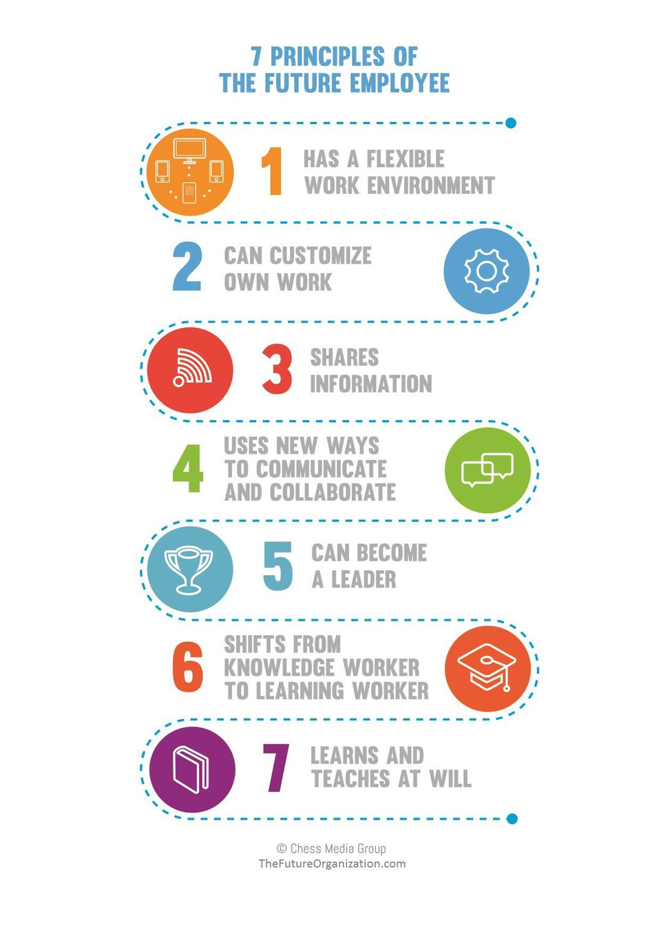
Appendix 2
Principles of a future organisation (Morgan, 2014):
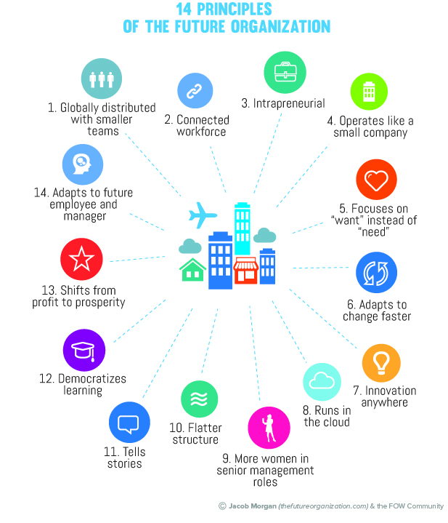

Appendix 3
Future principles of the future manager (Morgan, 2014):
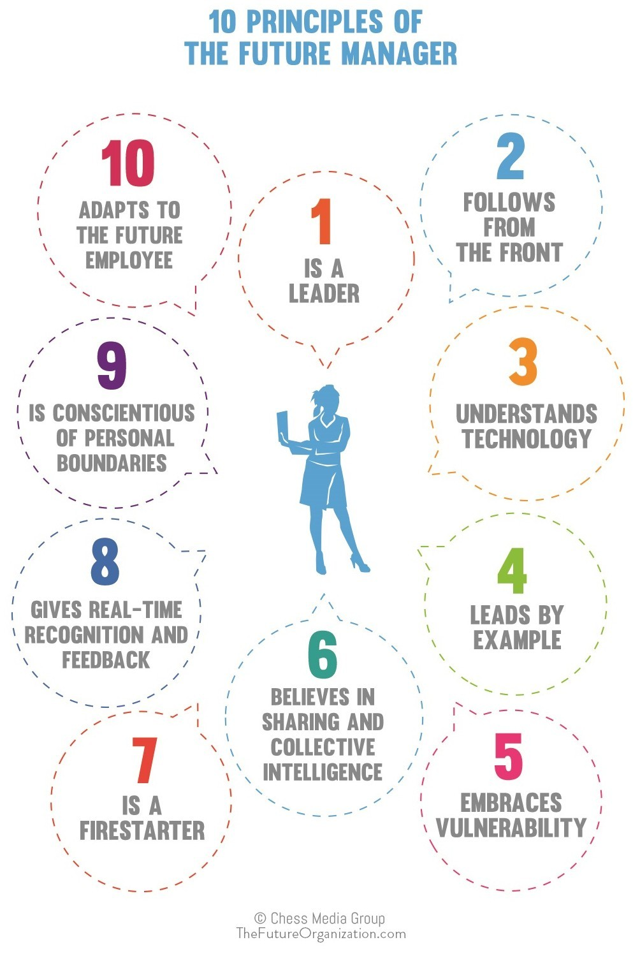
Bibliography
Capelli, P. 2015. ‘Why we love to Hate HR… and what HR can do about it.’ https://hbr.org/2015/07/why-we-love-to-hate-hr-and-what-hr-can-do-about-it [Accessed 5th March 2018]

Capelli, P. 2017. ‘There’s no such thing as Big Data in HR.’ https://hbr.org/2017/06/theres-no-such-thing-as-big-data-in-hr [Accessed 15th April 2018]

Deloitte University Press, 2015. ‘Leading in the new world of work.’ https://www2.deloitte.com/insights/us/en/focus/human-capital-trends/2015.html [Accessed 15th February 2018]
Deloitte University Press, 2017. ‘Rewriting the rules for the digital age.’ https://www2.deloitte.com/content/dam/Deloitte/global/Documents/About-Deloitte/central-europe/ce-global-human-capital-trends.pdf [Accessed 20th March 2018]
Gennard, J. and Judge, G. 2002. ‘Employee Relations’

IBM, 2018. The Four V’s of Big Data.’ http://www.ibmbigdatahub.com/infographic/four-vs-big-data [Accessed 10th April 2018]

Kruse, K. 2012. ‘What is Employee Engagement’ https://www.forbes.com/sites/kevinkruse/2012/06/22/employee-engagement-what-and-why/#41c582907f37 [Accessed 12th April 2018]
Kumar, R. Sia, S.K. 2012 ‘Employee Engagement Explicating the Contribution of Work Environment’ http://journals.sagepub.com.ezproxy.uwtsd.ac.uk/doi/pdf/10.1177/0258042X1103700104 [Accessed 13th April, 2018]
Lester, D. 2013. ‘Measuring Maslow’s Hierarchy of Needs.’ http://journals.sagepub.com.ezproxy.uwtsd.ac.uk/doi/pdf/10.2466/02.20.PR0.113x16z1 [Accessed 14th April 2018]

Lyons, L. 2017.‘The Role Technology Can Play In Employee Experience: What you select is critical’ https://search-proquest-com.ezproxy.uwtsd.ac.uk/docview/1952652391?accountid=130472&rfr_id=info%3Axri%2Fsid%3Aprimo [Accessed 14th April 2018]

Marchington, M and Wilkinson A. 2005. ‘High Commitment HRM and Performance’ Chapter 3, Published by the CIPD

McLeod, S. 2017. ‘Maslow’s Hierarchy of Needs.’ https://www.simplypsychology.org/maslow.html [Accessed 14th April 2018]

Morgan, J. 2014. ‘The Future of Work.’ http://otgo.tehran.ir/Portals/0/pdf/The%20Future%20of%20Work.pdf [Accessed 15th April 2018]
Naima, L. 2018. ‘Why Your HR Department Should Embrace Design Thinking.’ https://www.inc.com/linda-naiman/6-ways-hr-applies-design-thinking-to-deliver-engaging-employee-experiences.html [Accessed 15th April 2018]

Raspberry Pi Foundation, 2017. ‘Annual Review 2017.’ https://static.raspberrypi.org/files/about/RaspberryPiFoundationReview2017.pdf [Accessed 14th April 2018]

Raspberry Pi Foundation, 2018-2020. ‘Strategy 2018-2010.’ https://static.raspberrypi.org/files/about/RaspberryPiFoundationStrategy2018%E2%80%932020.pdf [Accessed 12th April 2018]
Raspberry Pi, 2018. ‘About Raspberry Pi Foundation.’ https://raspberrypi.workable.com/ [Accessed 12th April 2018]
Stewart, L. 2012. ‘Leaders and Employee Involvement – IA’ https://www.youtube.com/watch?v=UQWzz9VdiU4 [Accessed 15th March 2018]
The Educators, 2018. ‘Training Needs Analysis.’ http://www.theeducators.co/design-solutions/needs-analysis/ [Accessed 14th April 2018]

