Functionality and Design in a Household Object

Cameron Lane- OME Apprentice


Table of Contents
Introduction 2
The Power Cable 2
Requirements 3
QFD 1 5
Concept Generation 7
Concept Evaluation 9
QFD 2 12
Conclusion 14
Annex A 17

Introduction
Systems engineering emerged in the 20th century as an application of the systems approach to problem solving. It served to reduce the complexity of problems, by looking at the whole system, and breaking it down into numerous sub-systems all working together [1]. In order to develop a solution to a problem, it is therefore necessary to look at the subsystems, and if required altering, adding or removing them, in order to develop a whole system that meets the requirements [1]. This is particularly important in the development of military systems, often with strict budget, timeline and performance requirements, where unexpected performance of the system can lead to delays, budget overruns or poor performance.
There are numerous examples in military development and procurement of issues with experimental and in-service equipment that could have been identified in the design stages of the programmes, that could have saved time and cost later on in the programme. The Type 45 destroyer programme has seen the entire class of ships going through additional upgrades during maintenance, due to the intercooler system for propulsion cutting out in high ocean temperatures, potentially leaving them without power in areas such as the Middle East [2]. The Littoral Combat Ship is another example from the US. Designed to be small, agile, operating in shallower waters in lower risk areas, growth of requirements has led to a class of ships underequipped to serve in areas they were designed for, as a result of an unreliable powerplant oversized for the size of the ship in order to reach an unrealistic 40+ knot speed requirement [3] [4]. And finally, Ajax, a vehicle with vibration issues severe enough that dozens of its crews are being injured from its use, with some rendered unfit for military service as a result of severe vibrations [5] [6].
Through system engineering, looking at the system as a whole and breaking it down into sub-systems, these flaws in development can be caught at an earlier stage. Is there another method of propulsion that the LCS could have used for this speed, was there another approach all together to fulfil the requirements than a 3,000-ton ship going 40+ knots, could the insufficient numbers of crew have been identified earlier [4]. Similarly for the Type 45, was there a different system for cooling to prevent losing power in warm waters [2]. And for Ajax, could the issues of the significantly increase weight have been predicted [6]. This paper will seek to explore systems engineering, through a case study of something found in every household, power cables. It will seek to follow the full methodology, looking firstly at what the problem is, the requirements of the user, the functions that need to be completed for the problem to be solved, concepts to meet these functions, and finally concept evaluation.

The Power Cable
Almost every appliance in the modern household will incorporate a power cable and plug into the design, for one simple reason, everything relies on power. Even battery powered devices often use chargers requiring cables. While it would often be included in an appliance as a sub-system, the power cable and plug can be looked at as a system on its own, with flaws and components that need to be considered during design. Power cables date back to the start of the electrification of houses [7]. Initially used to connect lights, it wasn’t long until it was adapted for other appliances in the house. Since then, materials have changed, from exposed metal, to paper, to rubber coated cables, and the design of plugs has changed, but it is ultimately still a plug and cable like it originated [8] [9] [7]. However, power cables offer limitations. They can be a hazard to users if damaged, such as water spilt around them, or exposed wiring. If there are multiple appliances it can also be a maze of crosses cables and sockets, especially for uses such as chargers. And there are limits to the mobility of appliances when plugged in. Given how long-ago power cables originated, is there a better method that could be developed now?
From looking at where power cabled are used, it is possible to define the problem they are used to solve. The purpose of a power cable is to provide energy to an appliance. From this, we get our operation requirement:
The System Must Provide Energy to the Appliance

Requirements
To start with, it is important to look at the requirements for a power cable, to break it down into simple statements of what the problem is, and the key requirements that need to be hit to solve it. Consulting current users, common themes that came up for requirements were durability, flexibility, strong connection to plug, sufficient cable length, and resistance to damage.
From the feedback of users, a set of 5 requirements to solve the problem have been decided upon. Much of this feedback is based on a solution to providing power that is based on a cable, which makes sense as it is what is familiar. Therefore, it was important when using the feedback to ensure that the requirements had no potential to bias later stages of concept generation. Therefore, these key themes were looked at to understand the underlying cause. Strong connection to the plug, resistance to damage, and sufficient cable length can come down to safety, mobility and easy to operate. From these underlying causes, 5 key requirements were written.
- The system must provide sufficient energy for the operation of the device
- The system must provide energy in a safe and controlled manner
- The system should provide energy where it is needed
- The system should be easy to operate for all ages and abilities
- The system should not damage the appliance during operation

After establishing these system requirements, it is then important to order the importance of these requirements. To do this, a pairwise comparison is conducted. This method ranks all the requirements against themselves, to give a final score for the importance of each. While the comparison for the power cable is relatively simple, with only 5 requirements, this can be used for significantly larger numbers of requirements, as it narrows it down to simple comparisons between 2 individual requirements. For this method, it is decided where the ranking of each requirement sits between a strong preference and no preference, with numbers assigned based on this. The results of this exercise can be seen below in Table 1.

Table 1- Pairwise Comparison of Requirements

Graph 1- The Importance Rankings of Requirements
From Graph 1, above, it is clear to see that there are two stand out results in the ranking of these requirements. The most important factor in the design of the system is that it provides sufficient energy for the operation of the appliance. This is closely followed by the system providing energy in a safe and controlled manner. The final three requirements are still important for the system to meet but are less importance in relation to the other two. Ranked in order, we have the 5 requirements below:

- The system must provide sufficient energy for the operation of the device
- The system must provide energy in a safe and controlled manner
- The system should be easy to operate for all ages and abilities
- The system should provide energy where it is needed
- The system should not damage the appliance during operation

QFD 1
Following the establishing of the requirements for the system, it is next important to look at how the system will function. In order to not bias the concepts that are generated later, it is again important to generate functions that do not require certain features or subsystems. As such, 5 key functions have been identified for the successful implementation of the system:
Connect Energy Source
Enable Energy Source
Provide Energy
Disable Energy Source
Disconnect Energy Source

These are not necessarily the only functions that the system will perform, nor are they the only ones that the system needs in order to fulfil the operational requirement. Depending on the concept that is chosen, additional system specific functions may be added in order for subsystems and components to operate successfully.
From this, we go through Quality Function Deployment 1, to look at the interaction between the requirements and the functions of the system. This is used to understand what it is the customer is looking for, to see what functions are most important to meet the customers’ expectations. The identified functions are compared against the requirements, to decide if the function has no, low, medium or high impact on each of the requirements, seen below in Table 2.
Table 2- Quality Function Deployment 1

Graph 2- Quality Function Deployment 1
From QFD 1, we end up with Graph 2, above. It is clear that providing energy has the single most important impact on meeting the requirements for the system. This is important for understanding which functions should be focused upon. All 5 of the functions need to be fulfilled for a successful system, however a system that focuses on the other four functions at the expense of providing energy is likely to be received worse by the user.

Concept Generation
Requirements | Means
Connect Energy Source | Plug | Pipe | Wireless | Self-Contained- always connected | Laser | Attach Flywheel | Attach Drive Belt | Connect Axle
Enable Energy Source | Switch | Plug In | Valve | Always On | Manually insert power source
Provide Energy | Wireless Electricity | Cabled Electricity | Battery Electricity | Nuclear- Thermal | Spin up Flywheel | Laser- thermal | Solar- Thermal | Geothermal | Driving Belt | Axle
Disable Energy Source | Switch | Remove plug | Close valve | Always On | Manually remove power source
Disconnect Energy Source | Unplug | Disconnect pipe | Wireless | Self-contained, don’t disconnect | Disconnect laser | Remove flywheel | Disconnect Drive Belt | Disconnect Axle
Table 3- Concept Generation

Table 3, above, shows some of the many options available to meet the 5 functions of the system. This is the concept generation stage of systems engineering. Ultimately, buried in the table above is the final concept for the system, found through systems engineering to best meet the operational requirement. This stage is the reason that it was important to exclude any bias in the earlier setting of the functional requirements and functions of the system. Had the requirements been along the lines of ‘Plug in the cable’ and ‘Turn on the switch for the plug’, the available concepts are limited to a solution involving a cable, a switch and a plug, which leads to this problem being solved by reinventing the power cable. There is meant to be little rigidity in this stage, suggesting any means possible to meet the requirements. Many of the ideas posed above could be considered unrealistic, or impossible to implement. A laser-based means of powering household appliances has numerous issues, both in terms of power transfer, and in safety, however it is technically possible. It is at this stage that innovation can occur. The idea of a laser would have been science fiction when power cables were first used yet are now seeing deployment on the battlefield. Through concept generation, new technologies can be considered that previously were not available or mature enough for practical use. New mixes of options can be investigated. Could power cables that are always live be better or is it best to remain using switches to turn them on and off.
The table above is however an indication of the possibilities for solving the problem. Some of the means could be used in multiple concept designs, some may only work with a very specific set of options, with many combinations wildly impractical or impossible. An example of this would be the system in red, incorporating wireless connections, enabled through valves, for energy provided by a flywheel. Additionally, as mentioned above in QFD 1, there are functions that may need to be included in some of these systems for them to operate depending on the means used, that are not included on this table as they are relevant to single systems only.

Concept Evaluation
Requirements | Means
Connect Energy Source | Plug | Pipe | Wireless | Self-Contained- always connected | Laser | Attach Flywheel | Attach Drive Belt | Connect Axle
Enable Energy Source | Switch | Plug In | Valve | Always On | Manually insert power source
Provide Energy | Wireless Electricity | Cabled Electricity | Battery Electricity | Nuclear- Thermal | Spin up Flywheel | Laser- thermal | Solar- Thermal | Geothermal | Driving Belt | Axle
Disable Energy Source | Switch | Remove plug | Close valve | Always On | Manually remove power source
Disconnect Energy Source | Unplug | Disconnect pipe | Wireless | Self-contained, don’t disconnect | Disconnect laser | Remove flywheel | Disconnect Drive Belt | Disconnect Axle
Table 4- Concept Evaluation
Provides Sufficient Energy-
Provides Energy Safely-
Easy to operate for all-

Concept Evaluation follows concept generation. The first stage of this is utilising the function means table to de-select options. To do this, some of the requirements are chosen to compare the options against, to pick out any that do not fit in well with them. This does mean that these requirements may be favoured stronger in the final system, hence it is important to select them carefully. Using the pairwise comparison table from earlier, the natural choices are the two standout requirements in terms of importance, providing sufficient energy, and doing so in a safe and controlled manner. Additionally, the third requirement, being easy to operate for all ages and abilities is also being included, as this requirement will have a significant impact on the operation of the system by the user. Using these three requirements, we end up with Table 4, above. As can be seen; by applying these three requirements, numerous options are removed from contention, with the reasoning for their removal listed in Annex A.
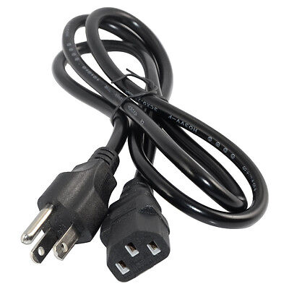
Now that the options have been down-selected, possible system concepts need to be selected from the remaining options. To do this, options are selected to meet each function to see if they form a completed system. Some of the options will still be incompatible with each other, which is expected, but it should be possible to form whole systems still. Three system concepts have been developed based on the remaining options, shown below:
Image 1- Power Cables
Highlighted in orange is the current solution in use across the world, a power cable, as show above in Image 1. Power is supplied through a cable, with power enabled through plugging in the cable and switching it on.
Solution two is highlighted in green, an example of which is show in Image 2, below. This solution used the wireless transmission of electricity to power a device, using a switch to turn the supply on and off. This solution currently sees use mainly for phone chargers, however is also seeing use in electric vehicle charging.
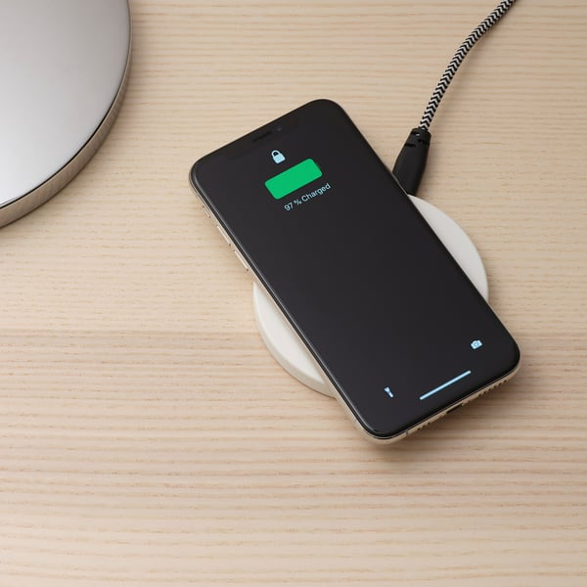
Image 2- Wireless Chargers
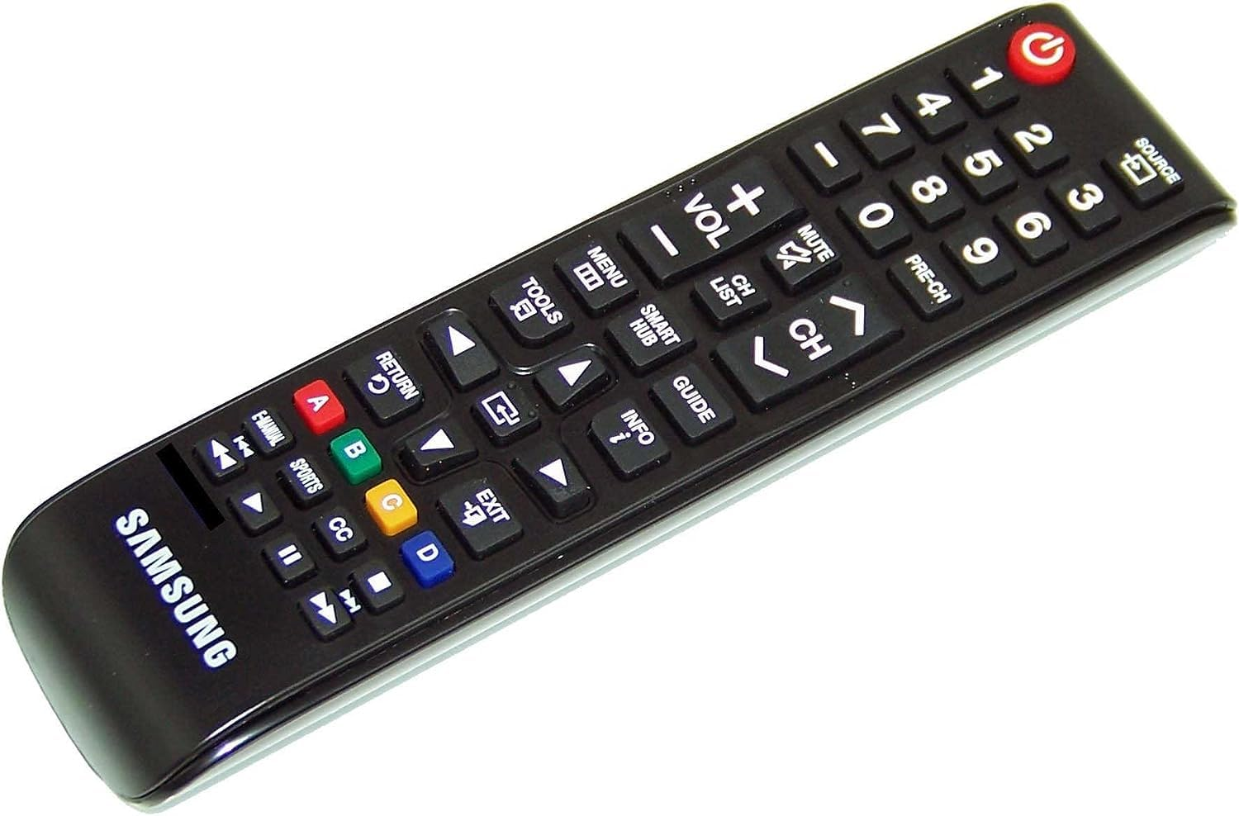
Finally, Solution 3 is shown in blue. This solution used batteries for power, contained within the device, and is always turned on providing power. An example of this is shown in Image 3, below.
Image 3- Battery Powered Appliances

Now there are three solutions developed to solve the problem, all of which achieve the 5 identified functions required by a system, and all of which meet at least 3 of the 5 functional requirements. It is now time to decide which of the solutions is the best of the three. To do this, a Pugh matrix is used. This method compares all three solutions at the same time, scoring them against a number of criteria. The current solution, the power cable, is chosen as the standard to score against, gaining a score of three for all criteria, on a scale of 1 to 5. The criteria that are being used for the comparison need to be decided on. The 5 requirements for the system are being included, as these are the key requirements identified that the system should meet. Additionally, the complexity of integration is being included. Implementing a solution that brings with it a significant amount more time and work may not have strong enough benefits in other aspects than a weaker, but easier to implement solution. Additionally, cost is being included. Similarly to implementation, a solution marginally better but significantly more costly to design and manufacture may not necessarily be a better solution overall.
Criteria | Solution 1- The Power Cable | Solution 2- Wireless Power | Solution 3- Self Contained Batteries
Provide Energy Safely | 3 | 3 | 2
Provide sufficient energy | 3 | 3 | 2
Be easy to operate for all ages and abilities | 3 | 5 | 3
Provide energy where it is needed | 3 | 2 | 5
Not damage the appliance in operation | 3 | 3 | 2
The complexity of implementation | 3 | 1 | 2
Cost | 3 | 1 | 2
Total Score | 21 | 18 | 18
Table 5- Pugh Matrix of System Solutions
The total scores for each of the three solutions can be seen at the bottom of the table. Solution 2, wireless power, scores 18, scoring well on the ease of operation due to the ability to place the appliance and have it powered, however losing points on both the complexity of implementation and the cost, requiring complete redesigned of both appliances and the areas the are being used. Solution 3, self-contained batteries, also scores 18, scoring well on providing energy where required, due to its self-contained nature, however losing points due to the potential dangers of batteries to users and the appliance, the difficulty in supplying enough power, and the cost and implementation complexity. As a result, Solution 1, the current solution, the power cable, scores the highest, with a score of 21 overall, with standard marks in all categories.
At this stage, using the Pugh Matrix, one option is to see if there are any composite solutions that can be formed from the solutions that were scored. This is done through looking at areas that scored high in the Pugh matrix, and seeing if they can be combined into another solution. In the case of the problem being looked at in this paper, this would involve combining the ease of operation of the wireless power system, with the ability for batteries to provide power where it is needed, and the ease of implementation and low cost of a power cable. While this method can potentially successfully find new solutions that had not been identified from the function means table, in this case a solution combining those options is not possible. As a result, Solution 1 remains the winning solution.

QFD 2
The final step before detailed design of the solution can begin is to conduct Quality Function Deployment 2. At this stage, we are verifying that the selected concept meets the requirements laid out earlier, and that all functions are being met. To do this the functions required for the system to operate are compared against the design solution chosen. At this stage, had the Pugh Matrix not revealed a clear winner amongst solutions, a QFD 2 should be completed for all potential solutions, to check that all functions are being met. Additionally, at this stage any design features specific to the individual solution should be included, to ensure that all supporting solutions to the design are being examined for their importance. The results of QFD 2 can be seen below.

Table 6- Quality Function Deployment 2
From conducting QFD 2 on the power cable solution, it can be seen that there is an extremely strong correlation between the functions and the design solutions, indicated by the red boxes. These red boxes indicate where there is a strong relationship between that function and a design feature. Connecting the power cable to the socket on the wall has a strong relationship with the function of connecting the energy source. Orange boxes indicate medium relationships. It is possible to have weak relationships; however, none are shown here. Finally, the blank boxes indicate there is no relationship between the function and the design feature.
The data gathered during QFD 2 is a highly positive sign to see, showing that there is a strong relationship. This is expected for a QFD 2 of a system that has been produced through Function Means Analysis. What is also an encouraging sign going into the design stage of system engineering is that there are not random relationships away from this line. Had there been relationships in the top left or bottom right corner of the table, there could be unexpected properties and interactions within the system, potentially leading to issues with the use of the product if not corrected before design and manufacture. Additionally, as shown in Table 7, below, there are not blank columns or rows in the table. While the individual rows and columns are sparsely filled, this is largely due to both the limited functions and design features present in this solution, and the relative simplicity of it. A more complex system, or an untried solution to a problem, could see lines sparsely filled, or blank. Blank rows indicate that that function is not being met by the design solution, while a blank column indicates that there is a feature of the design that has to impact on any of the system functions. In both cases, this indicates a failure in the Functional Means Analysis.
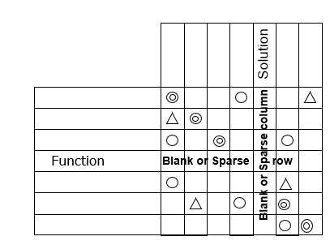
Table 7- Example of a Failure in QFD 2

Conclusion
In conclusion, it is clear that there can be significant benefits to designing a system through the systems engineering approach. While the case studying being looked at in this paper reveals that the ideal solution is that which is already being used, and that the benefits of other possible solutions do not outweigh the drawbacks of them, going through the design process highlights why it is that a solution chosen almost 150 years ago. From the initial stages, we see the difficulties in establishing a set of unbiased requirements from a problem, based on feedback on a preexisting solution. However, through following the methodology, we see the importance of this being done, to ensure unbiased requirements, that truly understand what it is that the customer is after. From this, we get the functions required by the system in order to meet the requirements. Going through the methodology on a power cable highlighted the importance of breaking down a problem into the base functions required. Settling for a function that states ‘plug in the cable’ inherently forces a design with a cable, not allowing for innovation in design. As shown in the concept generation stage, there is a huge range of possible options a system could incorporate. A world of appliances plumbed into central steam power sounds like a safety nightmare, but interesting to see nevertheless, as does a world of wireless power, where devices receive electricity wherever they are.
The endless possibilities of concept generation are bought down to reality in the concept evaluation phase, revealing the inherent safety issues of nuclear and steam powered appliances, or the power supply issues of thermal power from the sun. This down selection is critical for showing the realistic possibilities, narrowing the possible choices to power cables, wireless power, and battery packs for all. The Pugh Matrix revealed that feasible does not mean practical, and that a wireless world for now is still just a possibility, with strong reasons for power cables being the default choice for appliances across the world. Finally, we get to QFD 2, the sanity checks on the system concept, making sure that all of the functions are being met, an early chance to identify any unexpected interactions or behaviours, and a chance to streamline system features to only those that actually have an impact on the operation of it. This is the final chance to identify issues prior to physically designing the system, before significantly more time and money is spent on it. This is the purpose of systems engineering, a chance to check on the design as it is progressing, check it does actually fulfil the requirements, check that all required functions are being met, check that all features of the system have a purpose, and potentially most importantly, check that there are no unintended interactions within the system. As shown at the start, not identifying these interactions during the design stage, can cost hundreds of millions of pounds following manufacture, entirely preventable through system engineering.

References

[1] | D. K. Hitchins, Systems Engineering: A 21st Century Systems Methodology, Chichester: John Wiley & Sons, 2007.
[2] | G. Allison, “HMS Daring, the Royal Navy’s first Type 45 destroyer, has reached a significant, albeit unfortunate, milestone.,” UK Defence Journal, 2024.
[3] | U. N. (. Lieutenant Commander Steven T. Wills, “Confessions of a Former LCS Champion,” Proceedings, vol. 149, no. 12, 2023.
[4] | R. O'Rourke, “Navy Littoral Combat Ship (LCS) Program: Background and Issues for Congress,” Congressional Research Service, 2019.
[5] | J. D. R. Laydon, “Ajax: Soldiers medically discharged after noise exposure,” Forces News, 2021.
[6] | K. Whannel, “Minister 'disgusted' after soldiers injured in Ajax exercise,” BBC News, 2025.
[7] | “History of the Power Cord,” Jameco Electronics, [Online]. Available: https://www.jameco.com/Jameco/workshop/resources/history-of-the-power-cord.html?srsltid=AfmBOopmhNNUMRDA_wpupjEKD5vbIuOohoZS3zTCkqMKrxNPkmZ0T07I. [Accessed 1 2026].
[8] | “What is the history of electrical cables?,” Eland Cables, [Online]. Available: https://www.elandcables.com/the-cable-lab/faqs/faq-what-is-the-history-of-electrical-cables. [Accessed 1 2026].
[9] | “Summary of Electric Power Cable History,” ELEK, [Online]. Available: https://elek.com/articles/summary-of-electric-power-cable-history/?srsltid=AfmBOorSKxCf2a1AfEH0Rbi-y3B0eExwSGTPusfahs7T1dy3DUWMzoQU. [Accessed 1 2026].

Annex A
Option | Reason for Removal
Pipes | Plumping fit for water or steam is highly dangerous for those inexperienced, failing the requirement for ease of use by all
Nuclear | All sources of power using nuclear material have significant hazards to their operation
Lasers | Utilising lasers for power would require high powers, which pose significant dangers to people, as well as requiring significant work to get working every time, reducing the ease of use
Flywheels | Flywheels are often heavy, and to provide the power required for many appliances would require extreme speed, posing a significant danger to all involved, as well as potentially insufficient power supply to the device
Drivebelts | A drivebelt in operation is moving at high speeds, posing significant safety hazards to users
Axels | Same as drive belts, there are significant safety hazards to their use
Solar Power | Utilising solar power would have significant issues with the sufficient supply of power to the device, as well as the issues with plumping pipes
Geothermal | Ignoring the significant cost of geothermal as a power source, this would require high pressure piping, a significant danger

