Investigating Internal Resistance and Resonant Frequency Using Simulation and Mathematical Theory
Fundamentals of Electrical and Electronic systems
Jess Eardley (2217994)
2023
Table of Contents
Abstract 2
Introduction 2
Programs Used and Layout Diagrams 2
Task 1 2
Equipment: 2
Task 2 3
Equipment: 3
Method 4
Task 1 4
Task 2 4
Results 5
Simulation results of Task 1 5
Table of results 6
Theory Calculations for Task 1 8
Simulation results of Task 2 9
Table of results 11
Theory Calculations for Task 2 12
Analysis of results 13
Task 1 Analysis 13
Task 2 Analysis 13
Conclusion 13
References 14

Abstract

This report investigates comparatively, the electronic mathematical theory and computational simulation. The two tasks involve a simple DC resistance load circuit and a RCL circuit. To which simulation measurement tools are used to display results and are supported by the theory calculations. Furthermore, the advantages and disadvantage of using computational simulation software are analysed.

Introduction

This report will investigate the following:

Task 1, an unknown resistance load in a DC circuit using Thevins Theorem and the relationship between resistance and power. Task 2, the resonant frequency of a RCL circuit and the relationship between frequency and voltage capacitance. Both using a simulation software and mathematical theory.

The purpose of this report is to compare the result form theoretical calculation with the results from a simulation and see any discrepancies and understand what could cause this.

Thevenin’s Theorem is used to calculate the load resistor, RL, as it is best used when the RL is subject to change [1]. To use this theorem the circuit must be liner, must contain only passive components e.g. resistors, inductors, and capacitors [1]. In Thevenin’s Theorem the RL is removed temporarily and calculating the original circuit. After the calculations the RL is then added back into the circuit and calculations are made of the circuit as if it was a simple series circuit [1]. This can be done using simulations and imputing meter readers into the circuit and in theoretical calculations.

The resonant frequency, Fr, of the RCL circuit is also the natural frequency at which the circuit, if not driven by a voltage, will oscillate [2]. At Fr, the effects of the inductor and the capacitor cancel each other so that impedance (Z) equals reactance(R) and the I_{rms} is a maximum [2].

Programs Used and Layout Diagrams

Task 1

For this task an electrical simulation software called Proteus [3] was used to simulate a DC circuit with 3 resistors and 1 unknown resistance load. The components and measuring equipment can be selected from a list an added to the design sheet.

Equipment:

3 X Generic resistors (1KΩ, 10KΩ ,12Ω)
1 X Variable generic resistor (1KΩ to 20KΩ)
1 X DC voltage source (20V)
1 X Voltmeter
1 X Ohmmeter (KΩ)
1 X Ammeter (mA)
Connecting wires

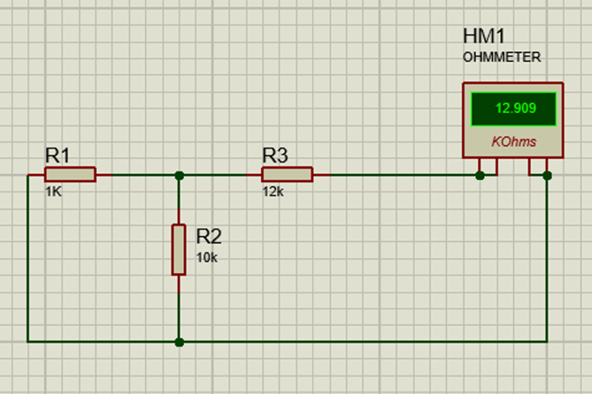
Figure 1-Task 1 Set-up Unknown RL Circuit

Task 2

For this task a RCL circuit with a resistor, inductor and capacitor was simulated. With the virtual instruments, signal wave generator and oscilloscope [3].

Equipment:

1 X Generic resistor (100Ω)
1 X Generic Inductor (5mH)
1 X Generic Capacitor (0.1μF)
1 X Oscilloscope
1 X Signal Generator
Ground
Connecting wires

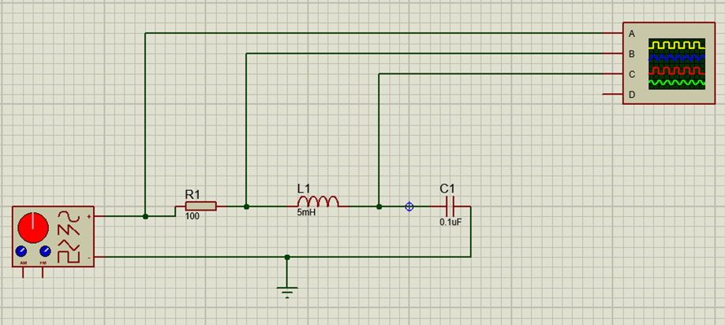
Figure 2-Task 2 Set-up RCL Circuit

Method

Task 1

A circuit was first created using the known resistors and an Ohmmeter. The RTH or Req could then be read from the Ohmmeter and used for the 3rd circuit. The VTH value then needed to be calculated so the known resistors and the DC voltage source were then added to find the voltage of the circuit with a voltmeter [1]. The Voltage source and the known resistor are then replaced with the values of VTH and RTH and an Ammeter is placed into the circuit to measure the current of the circuit. Once all the values are measured the variable load resistor was then changed from values 1KΩ to 20KΩ and the current, resistance and voltage was imputed into the table to compare the results. A graph displaying the relationship between the power and the resistance was made using the results from the simulation circuit.

The theory calculations used was Thevenin’s Theorem for finding the theoretical value of RTH, VTH and current. Explained in the results section in this report.

Task 2

A RCL circuit was created using the simulation software using a resistor, inductor, capacitor, a signal wave generator with a voltage of 10 V and the frequency input varied from 1KHz to 20KHz and an oscilloscope to view the results. The oscilloscope had to be set to view the wave form. The voltage difference was calculated from reading out the value from the peak and trough of the sinusoidal wave form. The data was inputted into a table from the recorded the voltage difference values of the resistance, inductance, and the capacitance for each frequency value. A graph was then used to compare the frequency and voltage difference in capacitance. From this graph the resonant frequency is shown as the highest value.

For the theory the resonant frequency an equation was used. This is shown in the results section of this report.

Results

Simulation results of Task 1

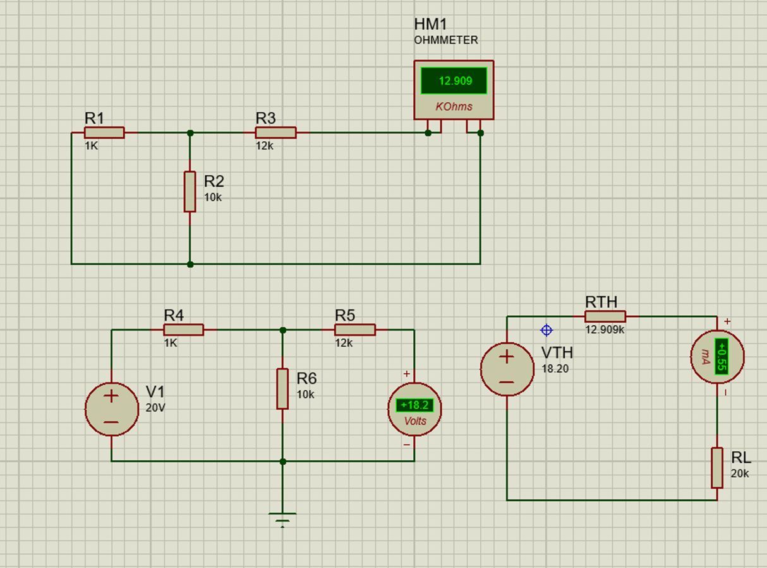
Figure 3-Simulation of Thevins Theorem to find RL

Table of results
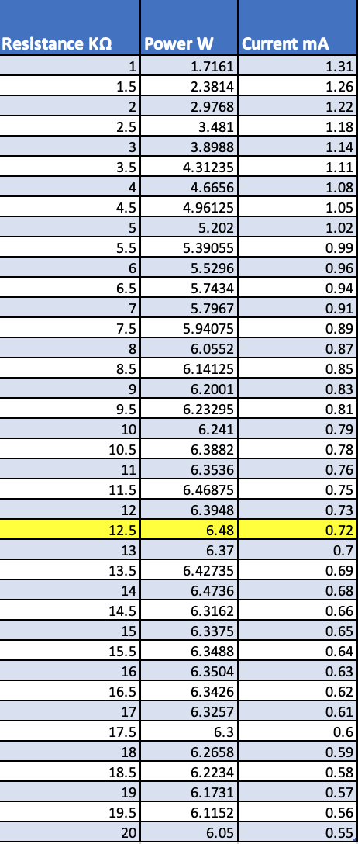
Figure 4-Task 1 Table of results
Displayed in Yellow, highlighted is the simulated Resistance Load (RL) which is equal to the internal resistance (RS), with a value of 12.5 KΩ. This is displayed as the largest value on the graph.

The graph highlights the relationship between Power and Resistance. As the resistance increase from 1 KΩ to 12.5 KΩ the Power in Watts also increases. After 12.5 KΩ the Power fluctuates until 16 KΩ to when the Power slowly decrease by approximately 0.1 W until 20KΩ.

Figure 5-Graph displaying the relationship between Power in Watts and Resistance in K Ohms.

Theory Calculations for Task 1
R1=1kΩ
R3=12kΩd°
R2=10kΩd°
V1=20V
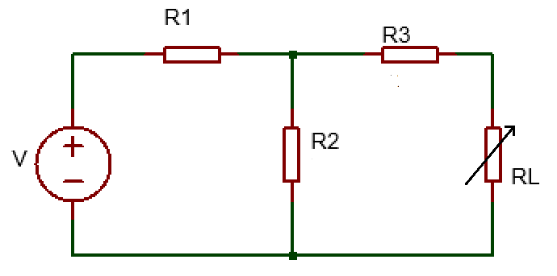

$$RTH={\left(\frac{1}{1}+\frac{1}{10}\right)}^{-1}+12000=12909 =12.909K$$

$$I=\frac{V}{R1+R2}=\frac{20}{11000}=0.0018 Amps$$

$I=\frac{V}{R}$ $V_{R2}=VTH=R2 X I=\frac{R2 X V1}{R1+R2}=\frac{\left(11000\right)\left(20\right)}{11000}=18.18 Volts$

$$RL=\frac{VTH}{I}=\frac{18.18}{0.0018}=10100 =10.1 K$$

A
B

Simulation results of Task 2

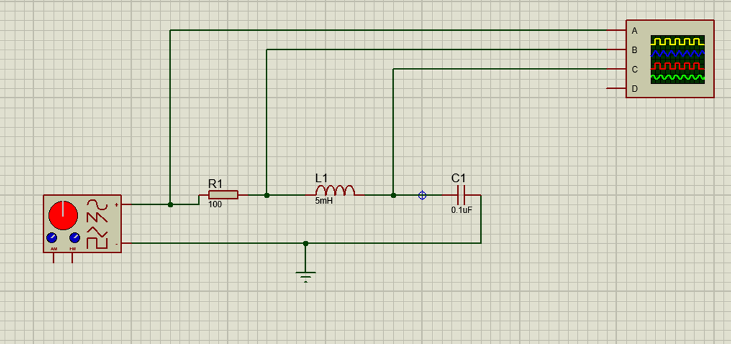
Figure 6- RCL circuit simulation
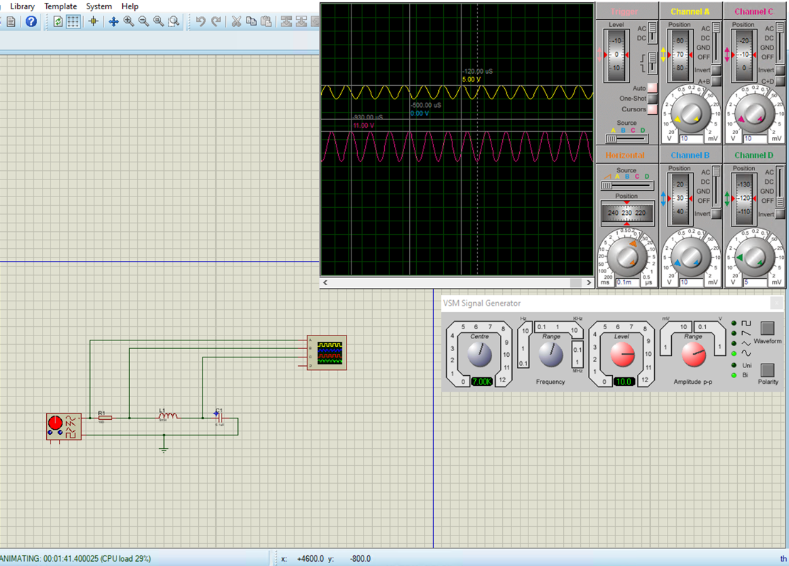
Figure 7-VR, VL and VC at resonant frequency, 7KHz displayed on oscilloscope with cursor values.

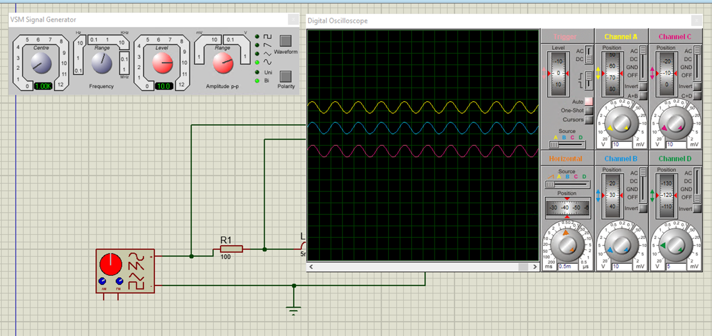
Figure 8-VR, VL and VC shown in-phase on oscilloscope.

Table of results

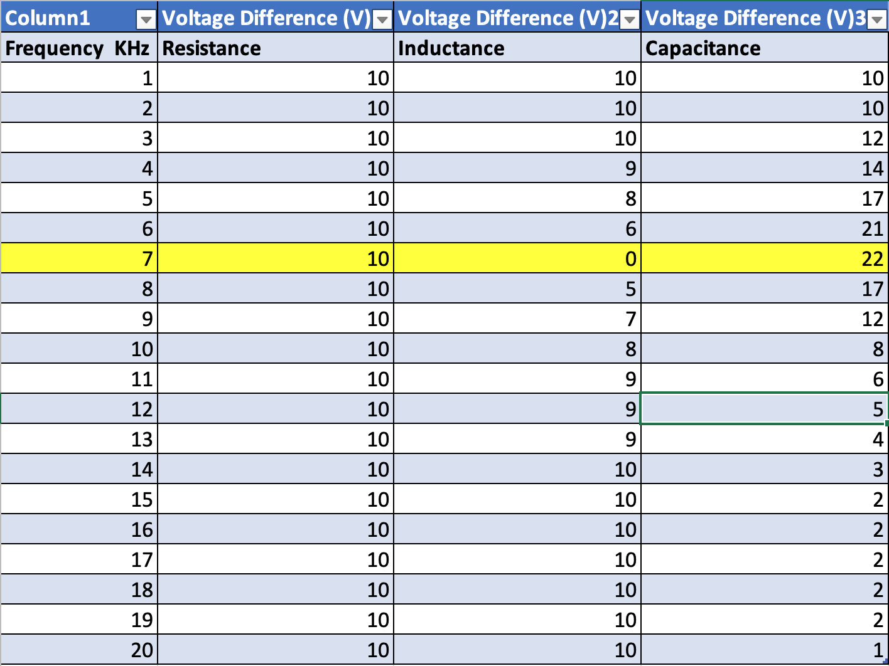
Figure 9-Task 2 Table of results

Displayed in yellow is the Resonant Frequency, Fr, 7 KHz this is the highest point on the graph displayed below at 22V, Vc, voltage Capacitance. After this peak the Frequency increases however the Voltage capacitance decrease steeply until 15 KHz to 19KHz then decreases again the 1 Vc at 20KHz.

Figure 10-Graph displaying the relationship between Voltage Capacitance V and Frequency KHz

Theory Calculations for Task 2

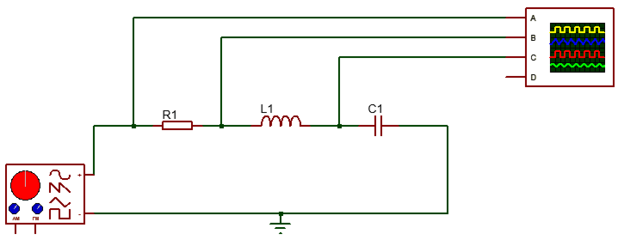
100Ω
5mH
0.1μF

$$Fr=\frac{1}{2π√LC} CITATION lum23 \backslash l 2057 [2]=\frac{1}{2π√(5×{10}^{-3})(0.1×{10}^{-6})}=7117.63 Hz=7.12 KHz$$

Analysis of results

Task 1 Analysis

The simulation and theoretical values for the resistance load, current, Thevenin’s voltage and Thevenin’s resistance are displayed in the table below. This shows the direct comparison of the results and immediately the values are not too dissimilar.

The values of the RTH and VTH for the simulation and the theory show the best comparable results as to 1 d.p they are equivalent values at 18.2 V and 12.9 KΩ.

The theory and simulation results are very similar showing accurate reading of the simulation data and accurate calculations of the theory values.

Values | Simulation | Theory
RL (KΩ) | 12.5 | 10.1
I (mA) | 0.72 | 1.8
VTH (V) | 18.2 | 18.18
RTH (KΩ) | 12.909 | 12.909

Task 2 Analysis

The simulation and the theoretical values for the resonant frequency are displayed in the table below. The comparison of the two results shows a 0.12 KHz difference. This shows an accurate result due to the simulation circuit being constructed and read correctly as well as accurate theory calculations.

Values | Simulation | Theory
Fr (KHz) | 7 | 7.12

The simulation results of both circuits provide validity to the basic electronic theory.

However, with more complex circuitry there may be more error and simulation will have to be more heavily relied upon. Though the simulation doesn’t consider real-world environments such as circuit leakage through noise, heat and sound.

Conclusion

To conclude the simulation and theoretical results showed similarities as both data sets used the same electronic component theory, Thevenin’s Theorem and RCL circuit theory to calculate the desired values. However, a strong understanding of computational simulation systems is required to use the simulation software and for simple circuits the theory would suffice to be able to build the circuit or prove a theorem.

References

[1] | A. A. Circuits, “How to Use Thevenin’s Theorem,” [Online]. Available: https://www.allaboutcircuits.com/textbook/direct-current/chpt-10/thevenins-theorem/. [Accessed 07 July 2023].
[2] | lumenlearning, “RLC Series AC Circuits,” [Online]. Available: https://courses.lumenlearning.com/suny-physics/chapter/23-12-rlc-series-ac-circuits/. [Accessed 09 July 2023].
[3] | Proteus, “VSM Simulation,” Proteus, [Online]. Available: https://www.labcenter.com/simulation/. [Accessed 07 July 2023].
[4] | L. Prasad, “What is Circuit Simulation? Its Advantages and Types,” ElectronicsHub, 19 January 2023. [Online]. Available: https://www.electronicshub.org/circuit-simulation/. [Accessed 7 July 2023].
[5] | Circuit Diagram, “Circuit Diagram,” Circuit Diagram, [Online]. Available: https://www.circuit-diagram.org/editor/. [Accessed 07 July 2023].

