University of Wales Trinity Saint David
BA Business Management
Module: Entrepreneurship
Module code: LCBB5001
Student: Raluca Manda
Lecturer: Vasilios Tavlaridis
Assignment title: Assessment Component 2- REPORT

Table of contents
- Introduction
- Main body
  - J.K. Rowling achievement
  - Motives and entrepreneurial traits
  - Future
  - Why J.K. Rowling as entrepreneur?
- Conclusion
- Reference list

- Introduction
"An entrepreneur is an individual who creates a new business, bearing most of the risks and enjoying most of the rewards," according to Investopedia (2023). Entrepreneurship is the process of starting a business.
In any economy, entrepreneurs are essential because they have the knowledge, drive, and ability to foresee requirements and launch novel initiatives. Successful entrepreneurship that accepts the risks associated with founding a startup is rewarded with financial gain and expansion prospects.
This examination will cover a number of topics, including my favourite entrepreneur, a brief overview of my past, how I became successful, and the qualities and goals I should pursue going forward.
This report will have a word count of 1500.

- Main Body
According to, Female Entrepreneur Association (2011), Joanne Kathleen Rowling was born in Chipping Sodbury, England in 1965. She began writing at the age of 6 with a story called ‘Rabbit’, which she never finished.
In the summer of 1990, on a delayed train from Manchester to London, she came up with the idea of a boy who discovers he is a wizard. But it would be 7 years before the idea became a book.
In that same year her mother died of Multiple Sclerosis, and she left for Portugal to teach English, hoping to find a way to deal with her grief.
In October 1992 she married a Portuguese television journalist, Jorge Arantes. But the marriage lasted just eleven months.
In 1993 she left her husband and returned to England, with the one legacy of her failed marriage – a daughter named Jessica.

All of a sudden, she found herself fighting poverty and depression. She lived in a tiny flat in Edinburgh and struggled to raise her daughter on a welfare cheque of £70 a week.

Unable to heat her flat, she sat in cafés and took bus rides and wrote ‘Harry Potter and the Philosopher’s Stone’ while her daughter slept in a pram.
The manuscript is said to have been rejected by three British publishers – Penguin, Transworld and HarperCollins.
But Bloomsbury Children’s Books did sign her up, reportedly paying £10,000 for the rights to ‘Harry Potter and The Philosopher’s Stone’.
The Philosopher’s Stone was published on 30 June 1997 and was an instant success.
The book was published under her initials because her publisher feared that boys would be less likely to read the book if they knew it was written by a woman.
At a book fair in Italy later that year, Scholastic Books bought the American rights for $105,000, an unheard-of figure for a children’s writer with only one book to her name.
It was published in the States in 1998 with the title ‘Harry Potter and the Sorcerer’s Stone’.
The sequel, ‘Harry Potter and the Chamber of Secrets’ was published in June of 1999 and later that year, the third book in the series was released, ‘Harry Potter and the Prisoner of Azkaban’.
By the time her fourth book appeared in 2000 – ‘Harry Potter and The Goblet of Fire’ – the series had become an international phenomenon: the initial print run for her 4th book was 1.5 million copies in the UK and 3.8 million in the US.
By 2000, JK Rowland had become the highest-earning woman in Britain, with an income of more than £20.5 million.
In 2001 her annual earnings were estimated at over £24m, placing her between Madonna and Paul McCartney in the ranks of high-earning celebrities.
In October 1998 Warner Brothers bought the rights to ‘Harry Potter and the Sorcerer’s Stone’ and its sequel (‘Harry Potter and the Chamber of Secrets’), for $700,000.
With the release of the first Harry Potter film, J.K. Rowling’s total earnings are estimated to have exceeded $100 million.
In March 2001 she was awarded an OBE by the Queen, for services to children’s literature.
She is one of the most successful women in the world because she made the choice to keep going even when times were tough and she never gave up. She is clearly very talented too, but if she hadn’t have chosen to keep going her talent would be completely unknown today.’

  - J.K. Rowling achievements
During research it was found that, J.K Rowling achievements is, ‘they have made Rowling the seventh richest entrepreneur in the UK with an estimated net worth $1 billion’ (Julie Tucker,2018), also the author of Harry Potter, she is involved in philanthropic work, and she even build a global community “Pottermore”.
According to Forbes (2024), ‘J.K. Rowling went from being an unemployed single mother, living on welfare, to become one of the bestselling authors of all time. She was plagued by self-doubt and rejected countless times along the way but kept pushing on because she believed in herself. Not all of us will become famous authors but we can become the greatest version of ourselves by having a vision, accepting setbacks, being persistent and making a little magic along the way.’

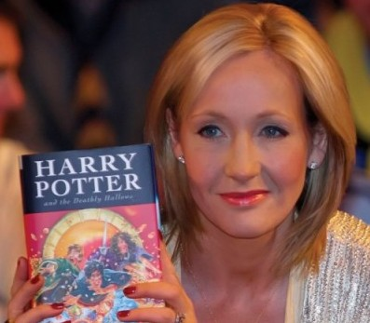
(J.K Rowling, 2001)

2.2 Motives and entrepreneurial traits

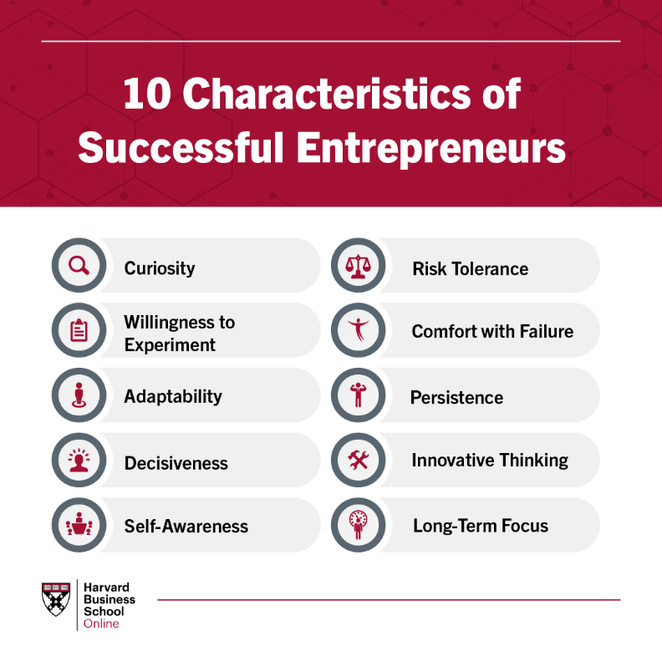(Kelsey Miller,2020)

2.3. Future
I could say, that in the future I would like to become and entrepreneur and to be successful like my favourite author, J.K. Rowling and of course to be creative in writing just like her.
This author, in my opinion, is still an inspiration today since, despite facing rejection from several publishers, she persisted in pursuing her goals and did what brought her joy.
I think that in order to become an entrepreneur, I will need to put more effort into developing my resilience and time management skills, which are crucial for personal growth.

2.4. Why J.K Rowling as an entrepreneur?
As it was mentioned before, J.K Rowling is my favourite author, her books (Harry Potter), made me to develop myself in my childhood , to be more creative and to use my imagination and now as a grow up , reading about her past and what she is been through , even after she became well known she did not stop to achieve her dreams and she starts helping the others.
She became well known in United Kingdom, and she did influence the others by her contributions in the literature, culture, business and society.
‘When you think that life is meaningless and you encounter failure after failure, read this success story of JK Rowling. JK Rowling decided to become an author when she was six years old. Yet, by the time the first Harry Potter book was published, she was 32 years old. In the 26 years it took for her dream to become a reality, she had worked various jobs she didn't like, got a bachelor’s degree in a subject her parents chose, her mother died, her father abandoned her, had a failed marriage, suffered from poverty, and fell deep into depression twice. But not once did she think of giving up on her dream.
Her perseverance made her what she is today. After she became wealthy, she decided to give back a lot of her money to the world. She spent a lot of money on charities to help those in need. So, read this success story of JK Rowling when you want to give up. More importantly, never give up on your dreams and help others when you become successful.’ (Maddy,2020)

- Conclusion
In summary, J.K. Rowling's entrepreneurial path is an incredible tale of inventiveness, tenacity, and achievement. Rowling's business energy has been evident throughout her career, as she rose from modest beginnings to become one of the most renowned writers of our time.
Her remarkable imagination and vision allowed her to construct a complete universe that captivated the interest of millions of readers. Rowling's tenacity in the face of setbacks and rejection is a testament to her fortitude and will to triumph.
She demonstrated solid business sense in the process of turning her love of storytelling into a global business empire.

- Reference list
- https://wisuru.com/biography/the-success-story-of-jk-rowling/
- https://www.investopedia.com/terms/e/entrepreneur.asp#What%20Is%20An%20Entrepreneur?
- https://femaleentrepreneurassociation.com/2011/12/the-story-of-jk-rowling/
- https://www.forbes.com/sites/tomward/2016/08/17/how-j-k-rowling-rose-to-success-and-how-you-can-too/?sh=7452e4f23d83
- https://www.bing.com/images/search?q=j+k+rowling+pictures&form=HDRSC4&first=1
- https://online.hbs.edu/blog/post/characteristics-of-successful-entrepreneurs

