
Consultancy Report Premier Inn
Student name:Liviu Zaharia-2122725

[Date]
[Company name]
[Company address]

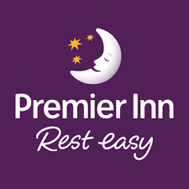

Executive Summary
This consulting report covers a strategic analysis of Premier Inn, a leading hotel chain in Munich known for its location advantage and quality service delivery. Established in 1995, Premier Inn is one of the most famous chain hotels in the UK. However, the following challenges have emerged recently: low customer satisfaction, low occupancy rates, and emerging competition from new hotels with better facilities and amenities than other hotels. For these reasons, the hotel must proactively protect its brand image and market standing.
Several important issue areas are highlighted in the analysis. First, it is crucial to mention that many of the facilities provided at Premier Inn have become outdated and do not meet the current industry standards, which affects guests’ perceptions and satisfaction. Some concerns include inefficiencies in the service delivery process, including delays and inadequate responsiveness to the guests’ needs. In addition, there has been a rise in new hotels in Munich that incorporate modern technology and unique designs effective at poaching some of Premier Inn’s customers.
To address these challenges, this report provides a comprehensive strategy that includes extensive infrastructural improvements, technology, and staff development. The renovation plan entails redesigning the guest rooms, dining areas, and public spaces to meet the current needs of guests as required by modern-generation travelers. Technological recommendations include integrating mobile check-in/out options, innovative room options, and an improved online customer service interface.
One of the essential elements of the proposed strategy is establishing a comprehensive training program for all hotel employees. This program would aim to enhance customer relations, service delivery, and effectiveness in using technology. Thus, by equipping its employees with the right tools and information, Premier Inn can guarantee that the infrastructure and technology improvements will positively impact the guests.
It is suggested that the recommendations be phased and implemented over three years so that there is little disturbance to the work routine and any changes can be made dynamically based on the feedback received and the changing circumstances. This phased approach also enables the organization to gradually incorporate new systems and practices without overworking the staff or causing discomfort to the guests.
Therefore, the organization must embrace the best practices in change management as it undergoes this transformation. The present study reveals that employees’ participation, communication, ongoing feedback, and sufficient training and support are essential factors to consider in managing this inter-organizational transition. Such practices will assist in managing resistance, enhance the cultures of improvement, and ensure that the whole team agrees with the same objectives.
The proposed improvements' cost implication is $5 million, which is a big investment that is expected to generate a big return through increased revenues from high occupancy rates and a more loyal clientele. Hence, it is crucial to make a detailed cost analysis and develop an effective financial plan to manage this investment in the best way possible and achieve the desired results without risking Premier Inn's financial position.
The following are the potential benefits of adopting these strategic recommendations. They are enhanced guest satisfaction, optimized operational outcomes, renewed brand positioning, and boosted market position in the highly competitive Munich hotel industry. This way, Premier Inn is likely not only to meet but also go beyond the expectations of the contemporary traveler and strengthen its position as one of the key players in the industry about the current challenges.
Overall, this consultancy report gives Premier Inn a clear plan to regain and strengthen its position in the market by improving facilities and services and adopting technology. Thus, developing these strategic areas will pave the way for Premier Inn’s growth and profitability and further strengthen its position in the market. Applying these strategies and proper change management practices will help enhance Premier Inn’s position as the most suitable accommodation for tourists in Munich, thus giving them the best experience.

Table of Contents
1 Executive Summary 2
2 Introduction 5
2.1 Background of Premier Inn 5
2.2 Background of the Consultancy Firm 5
2.3 Overview of the Issue 6
2.4 Theoretical Frameworks 6
3 Analysis 7
3.1 Detailed Description of the Issue 7
3.1.1 Specifics of the Problem 7
3.1.2 Departments Affected 7
3.2 Impact on Premier Inn 8
3.2.1 Short-term and Long-term Effects 8
3.2.2 Financial Implications 8
3.3 Causes of the Issue 8
3.3.1 Internal Factors 8
3.3.2 External Factors 9
3.4 PESTEL Analysis 9
3.4.1 Political Factors 9
3.4.2 Economic Factors 10
3.4.3 Social Factors 10
3.4.4 Technological Factors 10
3.4.5 Environmental Factors 10
3.4.6 Legal Factors 11
3.5 SWOT Analysis 11
3.5.1 Strengths 11
3.5.2 Weaknesses 11
3.5.3 Opportunities 12
3.5.4 Threats 12
3.6 TOWS Analysis 12
3.6.1 Strategies Based on Strengths 12
3.6.2 Addressing Weaknesses 13
3.6.3 Capitalizing on Opportunities 13
3.6.4 Mitigating Threats 13
4 Recommendations and Change Management 13
4.1 Detailed Recommendations 13
4.2 Implementation Strategies 13
4.3 Change Management Practices 14
4.4 Potential Benefits 14
4.5 Cost Analysis 14
4.6 Success Measurement 14
5 Action Plan 14
5.1 Breakdown of the Problem 14
5.2 Proposed Solutions 14
5.3 Desired Outcomes 14
5.4 Time Scale 14
5.5 Budget 14
6 Conclusion 14
7 Reference 15

Introduction

Background of Premier Inn
It is specialized hotel that resides in one of the busiest cities in the world – Munich, Germany. Situated in centralized areas that are close to sightseeing spots and commercial areas, it caters for both tourists and clients with business to attend. Premier Inn is stationed in Munich, a city which is famous for its historical and cultural tourisms as well as economically prosperous business tourisms (Wickham and Wilcock, 2020). This hotel was founded in the year 1995 and has incredibly grown to become one of the best hotel companies in Kenya as far as services offered to hospitality industry is concerned.
Overall, Premier Inn has basic standard rooms, deluxe and superior rooms as well as thirteen executive suites and one presidential suite to meet the variety of guests’ needs. The facilities range from a well-equipped gym and rejuvenating spa and massage room, an exotic indoor pool, mouth-watering restaurants offering local and global dishes, and versatile conference facilities with appropriate technology. Moreover, what makes this hotel more attractive for tourists is an opportunity to get a Wi-Fi connection, room service, and even a concierge 24/7 (Thomas, 2023). For this reason, with its strategic location, history, and all-round endowment, Premier Inn is entailing as the most preferred accommodation in Munich.

Figure 1 Premier Inn hotel view (Sourced: tripadvisor)

Background of the Consultancy Firm
Premier Inn Consultancy Firm is a limited company that has specialized in consultancy services especially to the hospitality industry. I have assembled a highly professional team to perform the work, which will include deep knowledge of these spheres, hotel management experience, understanding of the strategic planning, and implementing change. Given the diverse market systems that we have previously worked on, it is well-placed to handle the scenarios that are typical for the clients. Our firm is focused not only on providing the relevant and practical analysis of the existing conditions, strengths, and weaknesses as well as the development of appropriate and effective strategies that will enable our clients to improve the overall performance (Swogger and Williams, 2021). Consultancy professionality is another core competence of the organization to guarantee the firm receives the best consultancy advice to tackle its existing problems as Premier Inn.

Overview of the Issue
Over this last year, the organization identified that customer satisfaction, and the occupancy rates at the hotel also called Premier Inn had dropped drastically. This course is majorly due to worn out facilities, poor service delivery, and the stiff competition from other hotels in the surrounding areas. This decline in customer satisfaction is evidenced by worst complaints on social media, thus complicating the hotel’s image and revenue streams.
The necessity of solution implementation cannot be accentuated enough as these problems touch the Hotel’s performance and its market position. Status indicators such as occupancy and customer satisfaction benchmarks can decline, leading to many critical consequences such as financial implications, reduced market share, and so on (Reisz, 2020). Thus, it is necessary to perform objective and significant alterations within the organization’s flow to bring more vitality and reconstruct the competitive advantage of the Premier Inn.

Theoretical Frameworks
Thus, to explain the dilemma as well as to identify the weaknesses that Premier Inn faced and later overcame, it is essential to use certain theoretical concepts.
PESTEL Analysis: It will also enable us evaluate the macro-environmental factors that affects the hotel’s environment. The analysis of PEST segments individual Political, Economic, Social, Technological, Environmental, and Legal factors to discover possible opportunities and threats in the external environment (Reichwein, 2023).
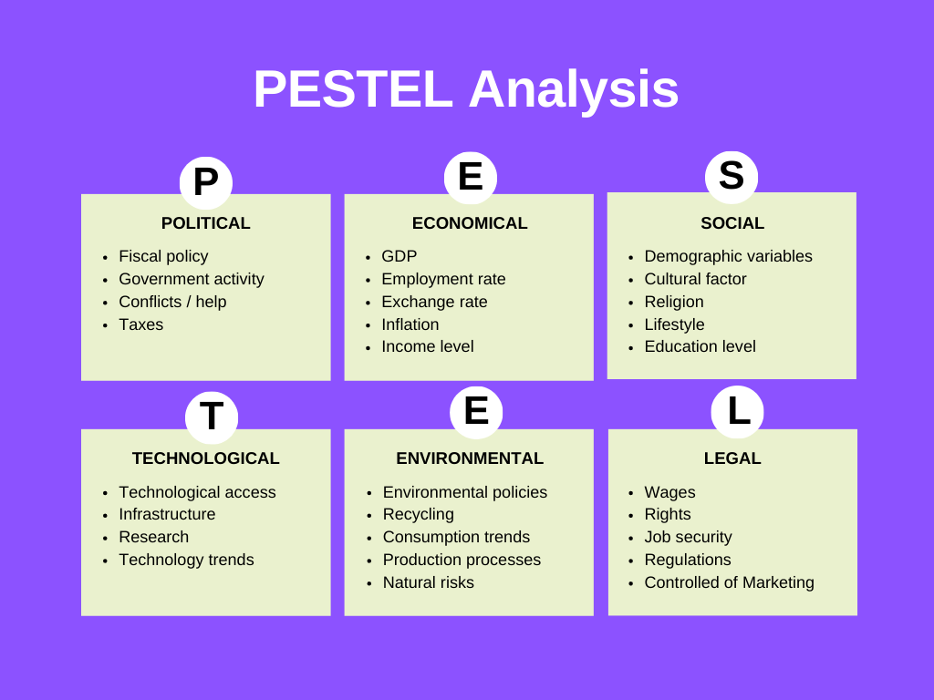
Figure 2 PESTLE analysis of Premier inn (Sourced: MBA skool)
SWOT Analysis: In this particular case, internal analysis tool will help us in identifying the SWOT needs of Premier Inn. SWOT analysis will then enable the firm to both explore the strength, weakness, opportunities and threats facing the hotel and in the market.
TOWS Analysis: Based on the information gathered from the analysis of the hotel’s environment using the SWOT analysis, the next procedure to follow is the TOWS analysis, which will assist in identifying the best strategy to apply by matching the opportunities with the strengths and weaknesses with threats (Pipes, Chief of Staff and Communications, 2024). This will help in case of coming up with measures and strategies to counter such problems while at the same time grasping the opportunities that may be present in the various problems.
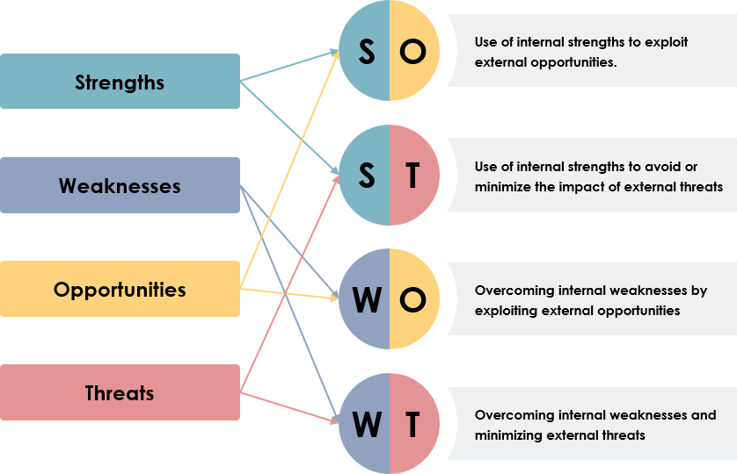
Figure 3 TOWS Analysis (Sourced: MBA skool)\
Using all these frameworks, we shall be able to offer deep and constructive critique as well as come up with recommendations that shall help Premier Inn overcome its problems in the natural course of holding its ground.

Analysis

Detailed Description of the Issue

Specifics of the Problem
This testimonial in the current budget and forecasts shows that the observed satisfaction rates of clients, as well occupancy of Premier Inn hotel, have been lowering their levels during the last year. The emerging hard core problems include facility infrastructure, customer service delivery this being largely due to increased competition from other newer hotels which have sprouted around the region (Piecyk et al., 2021). The issue can be referred to as a general in its nature, which means that the firm suffers from both operational and strategic issues.

Departments Affected
Issues such as fair dealing, data protection, and human rights laws directly affect several departments at Premier Inn. The management acknowledges that the Housekeeping Department is experiencing an issue of providing and ensuring high quality and cleanliness of room, which causes some dissatisfaction among guests. With regard to the Front Desk Department, it is currently struggling to provide fast check-in and check-out services to guests and customers, often being too slow to meet customers’ expectations. , Food and Beverage department has also been accused of poor performance which consists of slow service and low quality food services (Osman Ahmed El-Said et al., 2024). In the same way, the Maintenance Department experiences a weeding, owing to the increased demand for repair and enhancements, a necessity that is paramount to maintaining the hotels facilities in good shape.

Impact on Premier Inn

Short-term and Long-term Effects
However, the current negative traffic on the social media platforms is due to the decline of the customer satisfaction level as the company recorded a high demand and popularity in Premier Inn during its early years. This has seen many visitors refuse to book with them due to poor reviews left by tourists, who have had a bad experience. Nevertheless, occupancy rates have reduced significantly, and the hotel fails to realize the projected revenues.
Lack of attention to these issues in the long run may affect Premier Inn in terms of market competitiveness within the sphere of hospitality. If the guests remain dissatisfied for a prolonged period, their entire clique might switch to other brands or players which will cause an immense loss of market share (Neelands et al., 2022). The hotel’s perceived image that has taken years of good service to create may prove hard to regain further.

Financial Implications
These issues of ASAs and derives carry overwhelming financial implications. This means that the available rooms are empty for a considerable time thus affecting the cash inflow derived from the hotel business. The revenue from room rents, food and beverage sales, and other related services also reduces due to reduced guest arrivals. Also, the constant requirement in maintaining and enhancing the Infrastructure to address with the aged facilities makes the operation expensive. Availing revenue through expense increases the pressure on the hotel, and if the revenue fails to offset the expenses, it compromises the hotel’s financial stability and may result in other areas like marketing budgets and staff training being cut back further (Nalley and Gregory, 2021).

Causes of the Issue

Internal Factors
The internal environment has also some factors that have led to the problems facing Premier Inn. Firstly, there are shortcomings including the failure to undertake capital investments to improve the hotel’s utilities and structures. Moving on, management has not paid much attention to updates, which is evident in old fashioned rooms and outdated equipment. Secondly, one is able to see a lot of chaos in terms of training and development of the personnel. The human resource seems to lack the necessary skills in fulfilling the company’s promise of service delivery to guests in the facility. The final organizational communication deficiency that was observed in the hotel is that the internal communication systems are ineffective, therefore causing confusion and slow service delivery.

External Factors
External environment also have a big contribution to the issues that experienced by Premier Inn. The new entrants have established new hotels in this region with modern fashionable facilities and relatively cheap prices that increase competition (Martí-Parreño, Gómez-Calvet and Prat, 2020). These newer establishments will take a considerable market share from Premier Inn and contribute toward the proposed improvement plan for the establishment. It also has not wise effectively able to respond and adapt to other market factors, specifically the new trends that more and more customers seem to be leaning towards – the use of technological infrastructure and solutions for accommodation as well as focus on being environmentally responsible. References. The movement of supply and demand in the market and occasional occurrences like the COVID-19 outbreak have shrunk their business besides putting pressure on the efficient functioning of the hotel.

PESTEL Analysis

Political Factors
The effect of the political viabilities on the hospitality industry has been generally favorable in Germany (Kaliappen and Hassan, 2022). However, the following operational factors could influence Premier Inn: Though shown to enhance the image of a country and attract tourists, any changes in the laws governing tourism could affect Premier Inn’s operations.
It is examples such as the following that show that any changes in legal requirements for the offering could impact Premier Inn: Of equal importance for predicting the possibility of disruption is the comprehension of these political factors.

Economic Factors
There are several factors that business people ought to consider and they all come under the economic environment in the hospitality industry. Another macro environmental factor is a recession, whereby people can have less disposable income to spend in hospitality because they travel less. On the other hand, economic development may help increase the flow of tourists and fill hotel rooms (Johnson et al., 2020). About the case of Premier Inn, the organization has the need to keep track of the available economic indicators to ensure they alter their various strategies.

Social Factors
Key demand factors in the hotel industry include: Changes in Social Factors The global society is dynamic and constantly evolves with every social change affecting the demand in the hotel industry. Trends have shifted towards so-called experience economy, with consumers seeking customization and real life experiences. Next, it is critical to have a look at how proposed change might impact the overall health and safety of the industry post-pandemic. The mentioned above social changes are areas that need to be addressed to enable Premier Inn to satisfy its customers.

Technological Factors
Every other day, new innovations sweep through the hospitality industry through innovations. It also redefines guest experience with new digital key technologies, mobile check-ins and room automation (George, 2021). Non- adoption of these technologies has therefore placed Premier Inn in a negative competition with hotels that engage in use of such advances. One of the most important business strategies with regard to technology is effective investments in technology to future proof any kind of operation.

Environmental Factors
Tourism is progressively acknowledging the impacts of the environment and has turned into a reason for travelers. Sustainability measures, also known as considerations of environmental impacts of operations and sustainable use of resources and energy, in other words application of successful innovations in the management of energy efficiency and waste are becoming normative. Some concerns that could be raised by having no green programs include The organization has fail to have green initiatives this might be a problem for those guests that are environmentally inclined and wish to book at Premier Inn (Fei, Kim and Kim, 2024). Sustainability is an aspect that can be adopted by the hotel hence enhancing its attractiveness while at the same time cutting down on the various costs involved.

Legal Factors
It is lawful to insist in compliance to the health and safety regulation, employment practices and consumer protection policies among others. Any infringements of the law will lead to severe penalties as well as significant escalation of the hotel’s reputation. Of importance to the success of the proposal is the legal implication that must surround Premier Inn and this must regard to all legal restrictions that should not be violated by the company in order to avoid legal ramifications (Eyres, Deakin and Mackie, 2020).

SWOT Analysis

Strengths
- Reputation: It is clear that the Premier Inn has over the years developed a very good reputation and this carries its brand across in its service delivery.
- Location: The hotel is quite popular because it is located in Munich, having both conference opportunities and leisure amenities for tourists.
- Amenities: Various guests’ needs are met with a recreational facility, private swimming pool, and a well-equipped health club along with other features such as conference facilities (Dias and King, 2022).

Weaknesses
- Outdated Facilities: There is evidence that the facility is not well-equipped as the competition as its physical structures and some of their services date from the earlier years.
- Service Efficiency: This is because some of the main departments that are responsible for delivering services to the guests end up performing their duties in a substandard way.
- Internal Communication: This is true, especially because most organizations have departments, and lack of proper communication between departments causes inefficiency of the organisation as a whole.

Opportunities
- Technological Upgrades: It is, therefore, crucial to encourage technology investment so as to create a great guest experience while at the same time improving efficiency (Burns, 2022).
- Market Trends: Managing to be relevant to the trend of the preservation of the environment and the call for personalization may help attract more guests.
- Partnerships: Some of the ways in which the hotel can enhance the identification of its picture with the local populations and tourism agencies are Cooperation with local businesses.

Threats
- Competition: The level of technology implemented in newer hotels is even more superior to that of Premier Inn and hence, is a major threat to the hotel’s market share.
- Economic Uncertainty: The financial crisis might affect the number of travelers who prefer to visit tourist attractions that leads to low hotel occupancy (Amiri, 2022).
- Regulatory Changes: In certain cases, it is possible to confront new barriers like elevated taxes or more rigid labor regulations resulting in additional expenses.

TOWS Analysis

Strategies Based on Strengths
- Leveraging Reputation: Leverage on the well-established hotel brand to advertise its services, products, and aim to attract clients who have not booked the hotel as well as those who have.
- Maximizing Location: Leisure and other customers increase their awareness on the unique positions of the hotel to provide them with the best services by partnering with local areas and businesses.

Addressing Weaknesses
- Facility Upgrades: In order to achieve the goal to improve hotel’s competitive position and increase its occupancy rate, it is critical to focus on measures aimed at improving hotel facilities and making them as close to competitors’ standards as possible.
- Improving Service Efficiency: Develop and enact thorough staff training practices to improve the quality and speed of services available to the public.

Capitalizing on Opportunities
- Technological Integration: Use advanced technology or various applications for check-ins through mobile phones, control of rooms and others to make it convenient to the guests and enhance efficiency (Ahmad, 2021).
- Sustainability Initiatives: It is wise to incorporate environmental policies in the facility through energy efficient mechanisms and waste management approaches appealing to environmentally sensitive users.

Mitigating Threats
- Competitive Analysis: Another relevant factor is to perform periodic market audits in order to have more insights concerning competitors’ product range and modify the course of action respectively.
- Economic Preparedness: Come up with basic strategies to help manage the hotel during economic challenges with a view of minimizing their effect on the revenue.
- Regulatory Compliance: It’s also crucial to keep track of new rules and preferences to prevent various legal problems and, in particular, fines.
- Through these measures, a clear picture is obtained of the current status of the firm, Premier Inn, as well as a set of strategic recommendations that are to be applied when solving the problems and improving conditions for it’s functioning (Martí-Parreño, Gómez-Calvet and Prat, 2020).

Recommendations and Change Management

Detailed Recommendations
To solve Premier Inn's problems, the following recommendations are presented. They are aimed at both the current state and the company's future development to achieve lasting success. The following recommendations are some concrete measures that can be taken to improve the facility's infrastructure and service delivery.
There is an urgent need to carry out a complete overhaul of the facilities of the Premier Inn. This entails changing the room's look to a contemporary design and enhancing the use of technologies in the room, such as climate, lighting, and entertainment controls. Other spaces like lobbies, food outlets, and meeting halls also need upgrades to enhance the general outlook and utility (Zhang, Tavitiyaman and Tsang, 2022). Service delivery needs to be enhanced and improved through the integration of technology. Allowing guests to complete check-in and check-out procedures using a mobile application will significantly shorten the time required to complete these steps. An online customer service system should be set up to enable guests to convey their needs, experience, and feedback to the hotel through the Internet, with options for various responses to regular inquiries and complaints (Kaliappen and Hassan, 2022). Design an ongoing training regimen for employees that involves the enhancement of customer relations skills as well as operational knowledge of new technologies being adopted in the hotel business. They should have training in one-on-one contact with guests to ensure their satisfaction, how to handle complaints and manage crises to meet the demands of the guests, and training on how to use new technologies and tools in their daily work (Wickham and Wilcock, 2020).
Begin with the areas that received the most negative feedback, especially the lobby and most commonly booked rooms. To improve service delivery quickly, implement a short-term and very intensive training program for the front-of-the-house staff (Johnson et al., 2020). Conduct post-checkout surveys to measure and address guests' satisfaction through a digital survey.
Identify a general renovation strategy for upgrading all guest rooms and public areas in three years using green products and energy conservation technologies. Develop a comprehensive technology roadmap that will entail frequent technological changes in the IT systems, the use of artificial intelligence in guest engagement, and regular staff training on these new technologies (Thomas, 2023). Create a standing organizational change management committee that will be permanently tasked to review the current operations and the application of technology so that Premier Inn can always be a leader in the hospitality industry.

Implementation Strategies
To fully implement these recommendations, a systematic approach should be taken to guarantee that resources are utilized appropriately and that the existing operations are not disturbed as much as possible.
The following should be put in place to ensure the smooth implementation of the project:
Establish a project management office (PMO). This PMO should include all the stakeholders from the organization, including top management, middle management, and front-line employees. Create and outline a resource management plan that ranks the projects according to the goal of increasing the guests' satisfaction and the hotel's productivity. This involves determining financial resources, time frames, and personnel to be used in each project phase (George, 2021). Begin with the most critical assignments, likely to yield the most pronounced effects on the quality of service delivery and internal processes. All large projects must be rolled out in stages to reduce the impact on the hotel's running and to enable the lessons learned in one phase to be taken into the next phase of the project.
This means that funding should be directed towards necessary repairs and technological upgrades that can yield the most significant results regarding guest satisfaction and reduced costs due to increased efficiency (Swogger and Williams, 2021). Establish cross-functional teams for each of the project phases and ensure that all team members clearly understand the roles that are expected of them and the level of authority they have to exercise during the implementation process. It is, therefore, advisable to arrange for systematically structured training and development of the team to build up capacity and prepare the team to meet new operations challenges.

Change Management Practices
It is equally important to focus on the people side of change to ensure the success of new processes and technologies (Fei, Kim and Kim, 2024). Organizational change management best practices can also reduce resistance to change and create an improvement environment. Involve the employees in the planning process and involve them in the decision-making and idea-sharing sessions during the different stages of change. This makes employees feel that they are part of the organization, embracing the implemented changes. Offer extensive training courses for employees that equip them with the necessary knowledge to operate new technologies and procedures and make them aware of the positive impact these changes will have on their work and the hotel's performance (Sharpe, 2022). Ensure that you establish a clear and systematic communication strategy that will be used to convey the information on the progress of the changes. One should ensure that all employees are reached through different means, such as email, notice boards, and group meetings. Ensure the organization's leaders at all levels discuss the changes and address the concerns that the changes may have brought, along with identifying the achievements made. Managers should ensure that they adopt these changes and show how they have brought positive changes to the operations of the hotel and guests (Eyres, Deakin and Mackie, 2020).

Potential Benefits
If Premier Inn implements the recommendations presented in this report, the company will experience numerous advantages and improvements in the hotel's guest experience and operations. Therefore, upgrading facilities and incorporating technology is expected to increase Guest Satisfaction Scores at Premier Inn significantly. Customers will also benefit from the enhanced facilities and improved service delivery, which results in increased positive feedback and customer loyalty. Also, new technologies and well-trained staff will help in better management, reducing costs and increasing the ability to respond to guests’ needs and demands (Sayeed, 2020). This operational efficiency reduces costs and improves guest satisfaction because their needs are met accordingly and promptly.
With increased guest satisfaction, occupancy rates are also expected to rise. Happy guests will return and refer their friends and family to the hotel; this results in higher occupancy rates and, thus, more income (Dias and King, 2022). In addition, by updating the strategies that meet the changing needs of the guests and keeping the innovation strategy, Premier Inn will enhance its competitiveness in the hospitality industry. The hotel will be more capable of capturing and maintaining guests' patronage, standing out among other accommodations thanks to its enhanced service and focus on quality. In the long run, these strategic adjustments will guarantee that Premier Inn will continue being preferred by travelers in search of excellent services and quality accommodation (Reisz, 2020).

Cost Analysis
The financial impacts of the proposed measures need to be carefully presented so that the future sustainability of these measures is assured and suitable funds are allocated to them. The capital outlay required for the identified significant changes in the physical plant and technology is expected to be $5 million. This amount is for upgrading infrastructure, incorporating new technologies, and providing basic training for the course faculty (Burns, 2022). Furthermore, the project shall incur annual recurring costs of around $500,000 for staff training and technological support. These are the costs incurred during the year and are necessary to ensure that the existing enhanced infrastructure is maintained and that the workforce is familiar with new systems and technologies.

Table 1: Capital Improvement Costs Breakdown
Item | Amount ($)
Building Renovations | 1,500,000
Equipment Purchases | 700,000
Exterior Improvements | 300,000
Safety Upgrades | 500,000
Total | 3,000,000

Table 2: Technology Improvements Costs
Item | Amount ($)
Software Licenses | 300,000
Hardware Purchases | 400,000
Networking Infrastructure | 200,000
Training and Implementation | 100,000
Total | 1,000,000

Table 3: Training and Development Costs
Item | Amount ($)
Initial Staff Training | 300,000
Ongoing Professional Development | 400,000
Training Materials | 200,000
External Consultants | 100,000
Total | 1,000,000

Contingency Plan
Description | Allocation (%) | Amount ($)
Contingency for Unforeseen Costs | 10% of Total Project Cost | 500,000

Summary Table: Overall Budget Allocation
Budget Item | Amount ($)
Capital Improvements | 3,000,000
Technology Improvements | 1,000,000
Training and Development | 1,000,000
Contingency | 500,000
Total Project Cost | 5,500,000

Some of these financial requirements may include the need to source capital that can be repayable without straining the hotel’s funds (Reichwein, 2023). This could entail ensuring you have the best possible financing arrangements, or perhaps you can use other assets. In addition, there is the need to set aside an emergency fund to cater for unforeseen expenses that may be incurred during the implementation process. The author of the text rightly opines that expenditures should be tracked regularly to control costs and make them consistent with the project phase. It is recommended that the financial plan be revised to accommodate actual expenses and any modifications to the project (Ara and Kishore Kumar Das, 2021). This detailed cost analysis helps Premier Inn to plan for the improvements it wants to make without putting the company in a financial risk.

Success Measurement
It is, therefore, essential to set measurable targets and fulfill checkpoints to monitor the achievement of the recommendations. To this end, key performance indicators (KPIs) must be defined to track aspects such as customer satisfaction, operational effectiveness, and overall hotel financial returns. The following are the KPIs that will help measure performance and determine the areas that need attention. Since people are critical consumers of hotel services, guest satisfaction is an essential factor influencing the hotel's overall performance (Piecyk et al., 2021). Other metrics include the guest satisfaction index, which captures and analyses the feedback from surveys and reviews to assess the guests’ experience. This will help the hotel address any negative comments in the index and take necessary measures to address them. Another critical area that has to be evaluated is operational efficiency. Performance indicators like overall room utilization rates, which estimate the extent to which the hotel rooms are occupied at any one time, will inform how effectively the hotel can capture and retain guests (Ang, 2022).
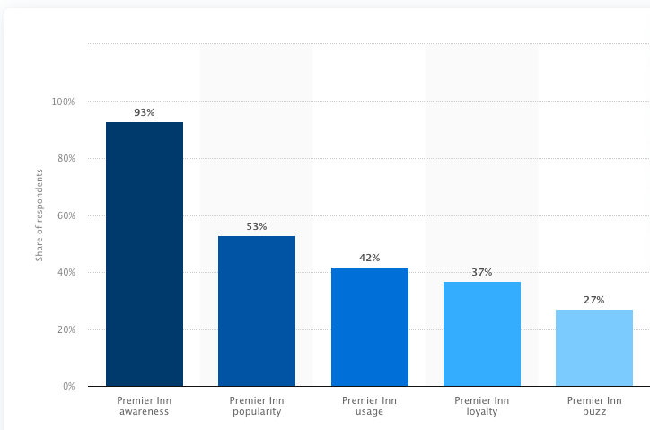
Figure 4 Premier Inn brand profile (Sourecd: Statista)
Revenue per available room (RevPAR) is another significant measurement used to calculate occupancy, and ADR is used to measure the hotel's total revenue. Economies realized through operational changes are also another important KPI. By recording the expenses and the savings gained from enhancing efficiency, the hotel can evaluate the strategies' cost-effectiveness. This will assist in verifying that the funds spent on infrastructure and technological enhancements yield the expected results. These KPIs should be tracked periodically to evaluate the performance against the established targets; this could be done monthly or quarterly (Osman Ahmed El-Said et al., 2024). With this, it is possible to determine any discrepancies or deviations from the intended plan to allow for appropriate alteration. An adaptive approach means the hotel can adjust its operations and service delivery to fit changes prevailing in the market and among the guests. The periodic assessments will involve checking and comparing the data obtained with the set interval (Amiri, 2022). This analysis will help determine what has been going well and needs more attention. In this way, based on the periodic evaluations of these indicators, Premier Inn can regularly update its strategies and, thus, enhance the continuous performance improvement and solid competitive position within the hotel industry (Neelands et al., 2022).

Action Plan

Breakdown of the Problem
First, the major problem is Premier Inn's degraded customer satisfaction, which is due to poor infrastructure, standardless services, and increased competition from recently constructed hotels that offer the latest amenities.

Proposed Solutions
As a way forward, we suggest the following: Enhancing facilities, including buildings and equipment; applying new technologies in service management; and training all employees and other stakeholders (Nalley and Gregory, 2021). These actions will help upgrade the infrastructure and improve operational efficiency and the guests' experience.

Desired Outcomes
It should be noted that the main goals are enhancing the guest satisfaction level, increasing occupancy rates, and improving the hotel’s position in the market. These outcomes are expected to help revitalize and strengthen the position of Premier Inn as a leading brand preferred by travelers (Ahmad, 2021).

Time Scale
The action plan will be implemented in stages within three years. For instance, staff training and high-priority renovation projects will be implemented as soon as the plan is developed in the first three months. The following year will entail in-depth remodeling and technological enhancements in the following year; the last year will be smoothing out all the adjustments and incorporating state-of-the-art training and procedures (Miller, 2024).

Budget
The total cost of implementing the action plan is $5 million. This entails $3 million for capital improvements, $1 million for technology improvements, and $1 million for training and development of the workforce. Contingency is also factored into the costs by providing 10% for unforeseen occurrences.

Conclusion
This consultancy report for Premier Inn has revealed significant areas of concern that, if tackled, can bring Premier Inn back to life and help it regain its lost position in the competitive market of the hospitality industry. The main findings, derived from the research, suggest a need for enhancing the physical facilities and changing the approaches used in rendering services to clients in the 21st century. Some factors attributed to the decline in guest satisfaction and occupancy rates include outdated facilities and ineffective service delivery systems.
The solutions suggested in the recommendations section include the complete renovation of the school, the use of the most modern technological equipment, and an extensive training program for teachers and all other staff. These are some of the strategies that have been put in place to not only solve some of the current problems but also to ensure that Premier Inn is well set to meet future challenges. We have devised actions that include redesigning room furnishings, adopting mobile check-in/out procedures, and rolling out staff training on customer service standards and overall work performance.
The implementation plan approach we recommend is a step-by-step approach that will enable us not to interrupt the normal running of the hotel business and allocate our resources to the most important projects. The change management process has been suggested to be implemented to prevent complications, especially emphasizing the need to involve the employees and communicate effectively to gain their support and avoid reluctance.
These recommendations may lead to enhanced guest satisfaction, more effective operations, and an enhanced competitive strategy. They would help improve Premier Inn's financial position and strengthen its brand in the market.
The suggestions in this report are intended to greatly improve Premier Inn's functionality and guests' experiences. Thus, if Premier Inn manages to address all the issues discussed in this paper, the company should expect to witness a significant enhancement in guest satisfaction levels and operational performance. We are confident that these changes will place Premier Inn on a path to a bright future and reestablish its position as the preferred choice in the Accommodation sector of the hospitality industry.
Therefore, we would like to thank Premier Inn for allowing us to undertake this work and present a detailed assessment and suggestions for the future. It has been a pleasure to collaborate with the Premier Inn team, whose advice and assistance have greatly contributed to the development of this consultancy report. All in all, we would like to thank all the participants for their willingness to change and are interested in observing the successful application of the mentioned strategies.

Reference

Ahmad, J. (2021). Investment and Development for Tourism and Hospitality Revenue Collection in Bangladesh. Tourism in Bangladesh: Investment and Development Perspectives, pp.325–336. doi:https://doi.org/10.1007/978-981-16-1858-1_20.
Amiri, M. (2022). The influence of business intelligence and analytics on performance of tourism and hospitality companies. [online] sapientia.ualg.pt. Available at: https://sapientia.ualg.pt/handle/10400.1/19132.
Ang, D.J. (2022). The Emergence of Serviced Apartments/Apart-Hotels and Opportunities Post COVID-19. UNLV Theses, Dissertations, Professional Papers, and Capstones. [online] Available at: https://digitalscholarship.unlv.edu/thesesdissertations/4551/.
Ara, A. and Kishore Kumar Das (2021). Knowledge Management Innovation Model for Higher Education. Springer eBooks, pp.139–164. doi:https://doi.org/10.1007/978-981-16-2055-3_6.
Burns, L.R. (2022). Group Purchasing Organizations (GPOs): An Overview. Springer eBooks, pp.45–110. doi:https://doi.org/10.1007/978-3-031-10739-9_3.
Dias, C. and King, M. (2022). A Meta-Analysis of NPL’s Impact Case Studies: Charting NPL’s Economic and Societal Benefit Mechanisms | NPL Publications. Npl.co.uk. [online] doi:http://eprintspublications.npl.co.uk/9353/1/IEA8.pdf.
Eyres, L., Deakin, V. and Mackie, P. (2020). Local Economic Change and Regeneration in Felixstowe Following the 2012 Coastal Resilience Project – A Case Study. doi:https://doi.org/10.1680/cm.65147.487.
Fei, A., Kim, J. and Kim, S. in (2024). Effects of environmental sustainability practice in the economy hotel to Gen Zer’s purchase decision: Behavior economy approach using choice based conjoint analysis. International Journal of Hospitality Management, [online] 118, p.103678. doi:https://doi.org/10.1016/j.ijhm.2023.103678.
George, R. (2021). Tourism and Hospitality Products, Branding, and Pricing. Marketing Tourism and Hospitality, pp.249–283. doi:https://doi.org/10.1007/978-3-030-64111-5_8.
Johnson, J., Whittington, R., Regnér, P., Angwin, D., Johnson, G. and Scholes, K. (2020). Exploring Strategy. [online] Google Books. Pearson UK. Available at: https://books.google.com/books?hl=en&lr=&id=ieksEAAAQBAJ&oi=fnd&pg=PT25&dq=Consultancy+Report+Premier+Inn&ots=XEBaUfJgea&sig=VoEYD_lXoFKnfWdmvnGudkwbZaQ [Accessed 28 May 2024].
Kaliappen, N. and Hassan, A. (2022). Digital Trends in Asian Hotel Industry. Technology Application in Tourism in Asia, pp.147–163. doi:https://doi.org/10.1007/978-981-16-5461-9_9.
Martí-Parreño, D.J., Gómez-Calvet, D.R. and Prat, D.J.M. de (2020). ICTR 2020 3rd International Conference on Tourism Research. [online] Google Books. Academic Conferences and publishing limited. Available at: https://books.google.com/books?hl=en&lr=&id=gR_dDwAAQBAJ&oi=fnd&pg=PA293&dq=Consultancy+Report+Premier+Inn&ots=1g0KjJhQNz&sig=5iCoL6EKxC6Nxb7WMaQsBR79caI [Accessed 28 May 2024].
Miller, A. (2024). Big Money in Franchising: Scaling Your Enterprise in the Era of Private Equity. [online] Google Books. Figure 1 Publishing. Available at: https://books.google.com/books?hl=en&lr=&id=WrvuEAAAQBAJ&oi=fnd&pg=PP15&dq=CONSULTANCY+REPORT+PREMIER+INN&ots=SzJUze3zcY&sig=9xgE-Q-tnPPAIUXsNuU2cfr5A4Y [Accessed 30 May 2024].
Nalley, M. and Gregory, A. (2021). A Case for Change, Market Segmentation and Brand Management. Journal of Hospitality & Tourism Cases, 9(2), pp.60–65. doi:https://doi.org/10.1177/216499872100900214.
Neelands, J., Henry, N., De Souza, V., Beer, H., Bharatan, I., Scott, M., Hammerton, T., Tomlins, R., Healey, T. and Lam, S.C. (2022). Coventry UK City of Culture 2021 : performance measurement & evaluation – Supplementary report. [online] wrap.warwick.ac.uk. Available at: https://wrap.warwick.ac.uk/169625/ [Accessed 23 Nov. 2023].
Osman Ahmed El-Said, Sayed Elhoushy, Smith, M. and Marwa Youssif (2024). Crisis-driven innovation in hospitality: How do international hotel chains innovate to recover from a global crisis? International journal of hospitality management, 120, pp.103758–103758. doi:https://doi.org/10.1016/j.ijhm.2024.103758.
Piecyk, M., Allen, J., Woodburn, A. and Cao, M. (2021). Template Technical Report front page: Title Online Shopping and Last Mile Deliveries. [online] Available at: https://www.repository.cam.ac.uk/bitstreams/29ff7472-7289-4104-a033-6802aa98be02/download.
Pipes, Chief of Staff and Communications, D. (2024). 2006-V38 (3)-February BOT Minutes. Board of Trustees Minutes. [online] Available at: https://commons.stmarytx.edu/board_minutes/11/ [Accessed 28 May 2024].
Reichwein, P. (2023). The origins of the Canadian Birkebeiner Ski Festival: invented traditions, winter sportscapes, and heritage sport tourism in sustainability and the UNESCO Beaver Hills Biosphere. Journal of heritage tourism, 19(1), pp.129–147. doi:https://doi.org/10.1080/1743873x.2023.2256898.
Reichwein, P. (2023). The origins of the Canadian Birkebeiner Ski Festival: invented traditions, winter sportscapes, and heritage sport tourism in sustainability and the UNESCO Beaver Hills Biosphere. Journal of heritage tourism, 19(1), pp.129–147. doi:https://doi.org/10.1080/1743873x.2023.2256898.
Reisz, T. (2020). Showpiece City: How Architecture Made Dubai. [online] Google Books. Stanford University Press. Available at: https://books.google.com/books?hl=en&lr=&id=QyIAEAAAQBAJ&oi=fnd&pg=PT7&dq=Consultancy+Report+Premier+Inn&ots=25bLsRR9ec&sig=4yIQJZr3d3-XHKkczC3roTFuMAk [Accessed 28 May 2024].
Reisz, T. (2020). Showpiece City: How Architecture Made Dubai. [online] Google Books. Stanford University Press. Available at: https://books.google.com/books?hl=en&lr=&id=QyIAEAAAQBAJ&oi=fnd&pg=PT7&dq=CONSULTANCY+REPORT+PREMIER+INN&ots=25bLtXY3cd&sig=3ZXPb2GvROyQCz8jrHf1sDzL4r0 [Accessed 30 May 2024].
Sayeed, Y. (2020). Network Woodrow Characters Passes European Priority Charles Ticket Stevens Separate Warren Perched Running School Decline. [online] IEEE EXPLORATION IN MACHINE LEARNING, p.1. Available at: https://alogicalmind.com/publications/paper-2bbf83b2fb40f99473257a460ed008.pdf.
Sharpe, D. (2022). The Lived Experience of Hotel Isolation: Evaluation of the Newham Council Hotel Isolation Pilot: Learning from a Rapid Evaluation 2021–2022. [online] repository.uel.ac.uk. Available at: https://repository.uel.ac.uk/item/8q66q.
Swogger, J. and Williams, H. (2021). Drawing the Line: What’s Wat’s Dyke? Practice and Process. Offa’s Dyke Journal, 3, p.211. doi:https://doi.org/10.23914/odj.v3i0.326.
Thomas, A. (2023). The City in the City: Architecture and Change in London’s Financial District. [online] Google Books. MIT Press. Available at: https://books.google.com/books?hl=en&lr=&id=UG2qEAAAQBAJ&oi=fnd&pg=PA3&dq=Consultancy+Report+Premier+Inn&ots=T9SDwQd03F&sig=83RmjD6ajTzYHVTz1p2DBC1TTx4 [Accessed 28 May 2024].
Wickham, L. and Wilcock, J. (2020). Business and Management Consulting. [online] Google Books. Pearson UK. Available at: https://books.google.com/books?hl=en&lr=&id=4ecsEAAAQBAJ&oi=fnd&pg=PT17&dq=Consultancy+Report+Premier+Inn&ots=NCTQCTyGop&sig=bD_O-lhXbUYA9rxOxTRRKLiDy5E [Accessed 28 May 2024].
Zhang, X., Tavitiyaman, P. and Tsang, W.Y. (2022). Preferences of Technology Amenities, Satisfaction and Behavioral Intention: The Perspective of Hotel Guests in Hong Kong. Journal of Quality Assurance in Hospitality & Tourism, pp.1–31. doi:https://doi.org/10.1080/1528008x.2022.2070817.

