
COMPONENT 1: DESIGN AND IMPLEMENTATION OF A RELATIONAL DATABASE SYSTEM
Introduction to Web and Database Concepts - ACCA4023
Student ID: 2512918
Bernard unuigboje ileogben


July 9, 2026
UNIVERSITY OF WALES TRINITY SAINT DAVID

Contents
Scenario Analysis 3
Entity Relationship Diagram (ERD) 4
1. Entity Descriptions 4
1.1 ParkingSite 4
1.2 ParkingSlot 4
1.3 Customer 4
1.4 Vehicle 5
1.5 Booking 5
1.6 Payment 5
2. Relationships 5
3. Entity Relationship Diagram 7
Normalization 8
1. Unnormalised Form (UNF) 8
2. First Normal Form (1NF) 8
3. Second Normal Form (2NF) 8
4. Third Normal Form (3NF) 8
Sample Data Population 10
Query Development 12
Testing and Validation 17
Design Decisions and Future Work 20
Design Decisions 20
Future work 20
References: 21

List of Figures
Figure 1: Entity Relationship Diagram 7
Figure 2: Booking Data Populated 10
Figure 3: Customer Data Populated 10
Figure 4: ParkingSite Data Populated 11
Figure 5: ParkingSlot Data Populated 11
Figure 6: Payment Data Populated 11
Figure 7: Vehicle Data Populated 11
Figure 8: Query 1 SQL Statement 12
Figure 9: Query 1 Results 12
Figure 10: Query 2 SQL Statement and Results 13
Figure 11: Query 3 SQL Statement and Results 14
Figure 12: Query 4 SQL Statement 14
Figure 13: Query 4 Results 15
Figure 14: Query 5 SQL Statement 15
Figure 15: Query 5 Results 15
Figure 16: Query 6 SQL Statement 16
Figure 17: Query 6 Results 16
Figure 18: Query 7 SQL Statement 16
Figure 19: Query 7 Results 17
Figure 20: Query 8 SQL Statement 17
Figure 21: Query 8 Results 17
Figure 22: Microsoft Access Relationships Window 19

Scenario Analysis
The designed relational database is the AutoPark Management System, which was created to solve the problem of managing several parking sites operated by one of the parking service providers in the city. The company currently uses manual registration to keep the data of its clients, vehicles, allocation of parking lots, bookings and payments. Manual recording results in problems such as duplication of data, loss of information, delays in the processing of parking operations and errors in data input [1]. This reduces the efficiency of the operation and complicates the control of the parking lots, customer activities and revenues. The designed database overcomes these problems by automating the parking operations through a single centralised database created with Microsoft Access. It stores the data about customers, vehicles, allocation of parking lots, bookings and payments, and generates reports for management. As a result, it offers better data integrity, shorter processing time and improved decision-making based on reliable and timely updated data.

Entity Relationship Diagram (ERD)
The Entity Relationship Diagram (ERD) offers the general view of the AutoPark Management System database [2]. It shows the main participants of the parking management process, their properties and relations with each other. In addition to ensuring the fact that the database corresponds to the needs of the company, ERD keeps the data consistency and integrity. The database includes the following six entities: ParkingSite, ParkingSlot, Customer, Vehicle, Booking and Payment. Each entity has its own primary key that allows identification of the particular entity and foreign keys that establish relations between associated tables.

1. Entity Descriptions

1.1 ParkingSite
The ParkingSite class holds details of all the parking areas under management of the company. There are several parking areas in the organization and therefore, there must be ways to differentiate between them to keep track of the parking slots and their capacities.
Attribute | Description
SiteID (PK) | Unique identifier for each parking site
SiteName | Name of the parking location
Address | Physical address of the parking site
Capacity | Total number of parking spaces available

1.2 ParkingSlot
The ParkingSlot class holds details of individual parking slots within the parking areas. Each parking slot belongs to a certain parking site and has some status.
Attribute | Description
SlotID (PK) | Unique identifier for each parking slot
SiteID (FK) | References ParkingSite.SiteID
SlotNumber | Unique parking slot number
SlotType | Type of parking slot (Standard, EV, Disabled, Compact)
Status | Availability status of the slot

1.3 Customer
Details of personal particulars of the car owners are stored in the Customer class.
Attribute | Description
CustomerID (PK) | Unique customer identifier
FirstName | Customer's first name
LastName | Customer's last name
Phone | Contact number
Email | Email address

1.4 Vehicle
Details held in the vehicle class are those of cars belonging to the customers. Each car has its own customer.
Attribute | Description
VehicleID (PK) | Unique vehicle identifier
CustomerID (FK) | References Customer.CustomerID
RegistrationNumber | Vehicle registration number
VehicleType | Type of vehicle
Colour | Vehicle colour

1.5 Booking
The Booking class holds details of parking bookings made by customers.
Attribute | Description
BookingID (PK) | Unique booking identifier
VehicleID (FK) | References Vehicle.VehicleID
SlotID (FK) | References ParkingSlot.SlotID
EntryTime | Vehicle entry date and time
ExitTime | Vehicle exit date and time

1.6 Payment
Details of payment for booking made by the customers are stored in the Payment class.
Attribute | Description
PaymentID (PK) | Unique payment identifier
BookingID (FK) | References Booking.BookingID
Amount | Parking fee
PaymentMethod | Payment method used
PaymentDate | Date of payment

2. Relationships
Relationship between objects in the AutoPark Management System can be established by using one-to-one and one-to-many relationship to ensure consistency of data.
Relationship | Cardinality | Participation | Business Meaning
ParkingSite → ParkingSlot | 1 : Many | Mandatory | A parking site has many parking slots, and each parking slot belongs to one parking site only.
Customer → Vehicle | 1 : Many | Mandatory | One customer has many cars, and one car belongs to one customer only.
Vehicle → Booking | 1 : Many | Mandatory | One car has been booked many times at different periods of time, whereas one booking is done for one specific car.
ParkingSlot → Booking | 1 : Many | Mandatory | One parking spot can have many bookings at different times, and one booking is done for one specific parking spot.
Booking → Payment | 1 : 1 | Mandatory | One booking results in making one specific payment for one booking.
One-to-many relationship ensures effective storage of related data and avoids unnecessary repetition of data [3]. There is one-to-one relationship between the Booking and the Payment. This means that each booking has a corresponding payment record.

3. Entity Relationship Diagram
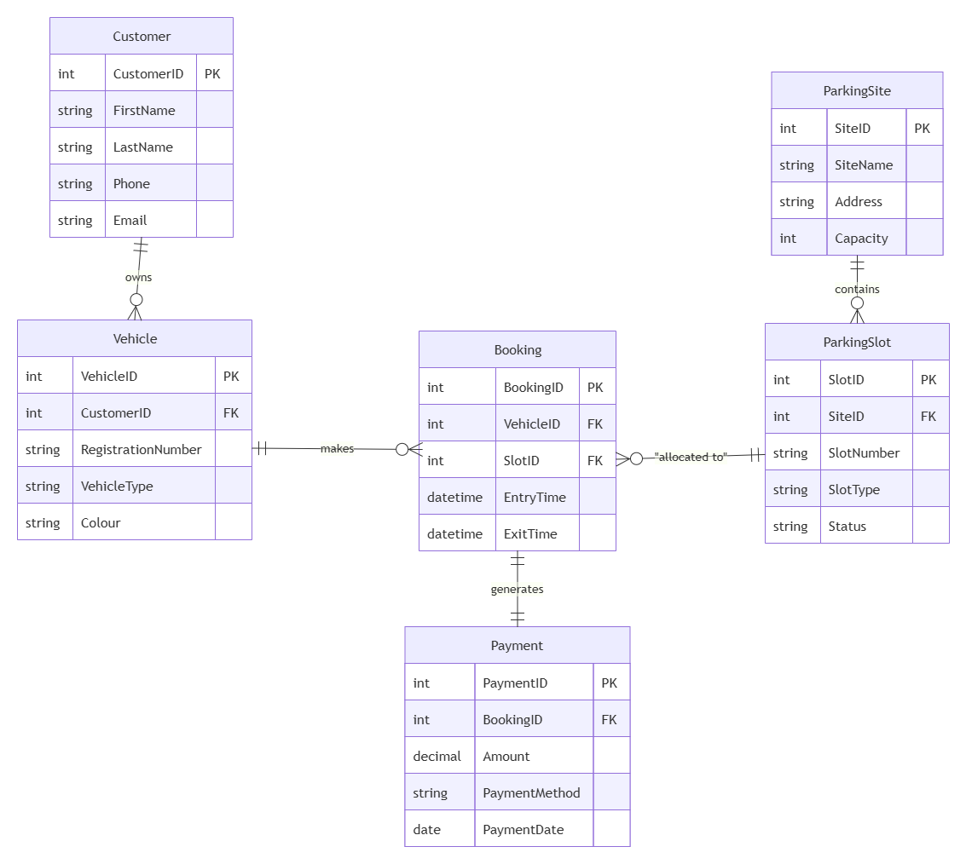
Figure 1: Entity Relationship Diagram
A Primary Key (PK) is created for every entity to uniquely distinguish the records within each table, while relationships are established using Foreign Keys (FK), which enforce referential integrity among the related tables [4]. SiteID links each parking slot to the parking site it belongs to, and CustomerID links each vehicle to its owner. VehicleID and SlotID connect bookings with vehicles and parking slots respectively, and BookingID connects each payment to its booking. These relationships reflect the real business processes of parking operations and ensure stable and reliable data management.

Normalization
The process of the normalisation is the process of the data arrangement in a relational database to remove redundancy and to improve the integrity of data [5]. Normalisation of the AutoPark Management System database was done up to the Third Normal Form (3NF) to store the piece of information once and in one place and to ensure good relationships between the entities.

1. Unnormalised Form (UNF)
All the information can be stored in one table that contains all the information about the customers, cars, parking sites location, and the information on booking and payments. There will be duplications and repetitions of groups and values.
Customer | Vehicle | Parking Slot | Booking | Payment
Olivia Carter | CF24 OLC | A01 | 01/07/2026 | £12.50

2. First Normal Form (1NF)
No repeating groups had occurred, and all attributes had been turned into atomic ones to achieve the First Normal Form. Customer, vehicle, parking slot, booking and payment records had been divided separately.
Customer | Vehicle | Booking
Olivia Carter | CF24 OLC | Booking 001

3. Second Normal Form (2NF)
The Second Normal Form is used to avoid partial dependencies so that non-key attributes depend only on the primary key [6]. The payment information was placed into another table because it does not depend on the information about the customer and vehicle, but it depends on the booking.
Booking | Payment
BookingID | PaymentID
VehicleID | Amount
SlotID | PaymentMethod

4. Third Normal Form (3NF)
Third Normal Form is concerned with transitive dependencies and ensures that non-key attributes depend only on the primary key [7]. The database that will be obtained will have six tables: ParkingSite, ParkingSlot, Customer, Vehicle, Booking and Payment. Information contained in two tables is related information and foreign keys help establish connections between entities. The design helps reduce redundancy, improve consistency of the information and facilitate querying of the information.
Table 3.1 Normalisation Process
Stage | Description | Result
UNF | Single table containing all parking information | High redundancy and duplicate data
1NF | Atomic values and removal of repeating groups | Separate records created
2NF | Removal of partial dependencies | Booking and Payment separated
3NF | Removal of transitive dependencies | Six fully normalised relational tables
The final database meets the requirements of the Third Normal Form.

Sample Data Population
Once the database relationships were created, sample data was entered for each entity to confirm that the AutoPark Management System functions correctly. Each of the six tables (ParkingSite, ParkingSlot, Customer, Vehicle, Booking and Payment) contains five records representing realistic operations: customer registration, vehicle ownership, parking slot allocation, booking transactions and payments. The records were created so that referential integrity is maintained through the foreign keys relating to the primary keys. This sample data also allowed the developer to verify the relationships between tables, data integrity and the accuracy of the SQL queries [8], and to build reports and queries confirming that the database meets the requirements of the AutoPark Management System.
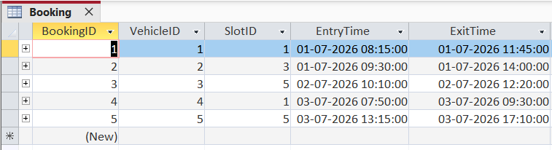
Figure 2: Booking Data Populated
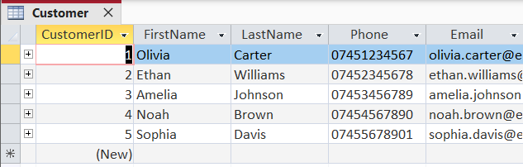
Figure 3: Customer Data Populated
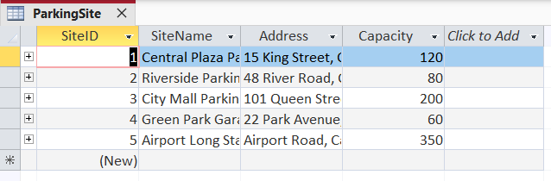
Figure 4: ParkingSite Data Populated
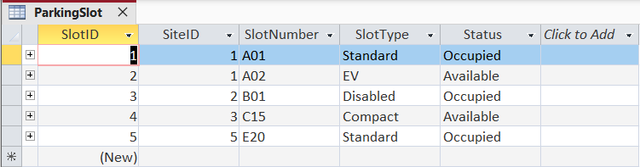
Figure 5: ParkingSlot Data Populated
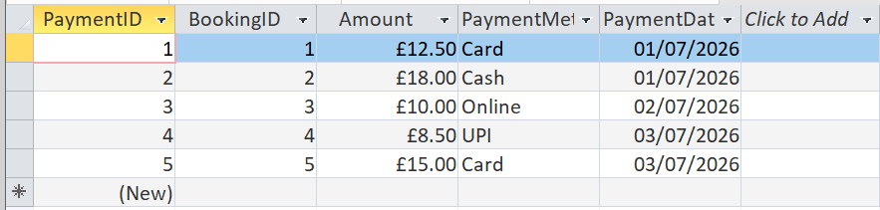
Figure 6: Payment Data Populated
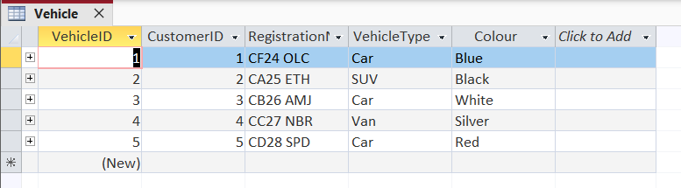
Figure 7: Vehicle Data Populated

Query Development
The following queries are performed by the AutoPark Management System to access and analyse the information stored in the database. They demonstrate the efficiency of the relational design in practice, allowing users to control slot reservations, obtain customer and vehicle information, calculate income and generate management reports. All queries were created and tested in Microsoft Access using the sample data, confirming that the relationships are correctly established and the system meets the operational demands of the parking management services.
Query 1: Parking Slots Occupied at the Time
Purpose: The purpose of this query is to obtain all the parking slots that are currently occupied. This will help the personnel of the parking lot to see which parking slots are not occupied and to understand the number of occupied parking slots at any time.
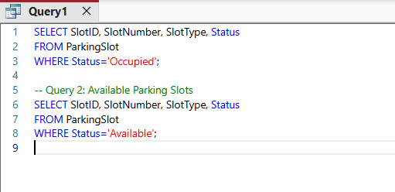
Figure 8: Query 1 SQL Statement
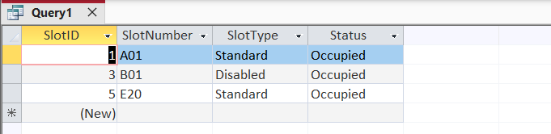
Figure 9: Query 1 Results
Explanation
This is a search query that will help the management to search for the occupied parking slots within the ParkingSlot table in the database.
Query 2: Available Parking Slots
Purpose: It will provide the list of all the parking slots that are currently available to make new bookings.
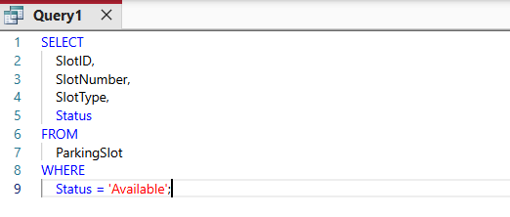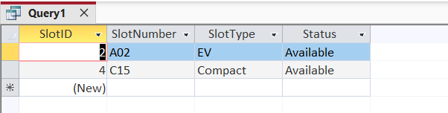
Figure 10: Query 2 SQL Statement and Results
Explanation
The records will be filtered in the ParkingSlot table according to the availability of parking slots.
Query 3: Car in Parking Slot A01
Purpose: The purpose of this query is to extract data from the car which is booked in parking slot A01 based on vehicle registration number, type of vehicle and booking information.
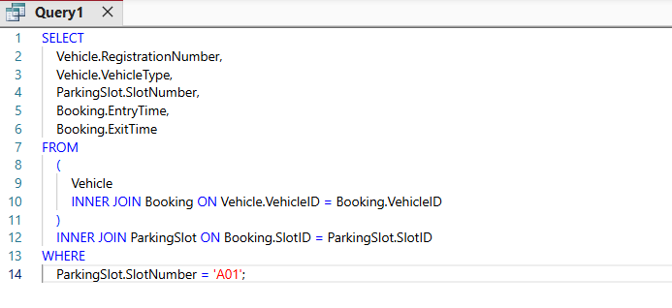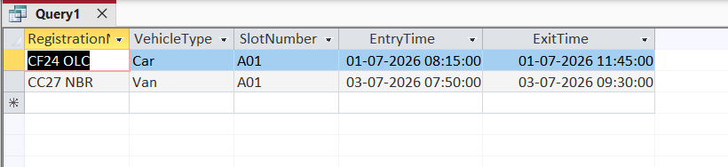
Figure 11: Query 3 SQL Statement and Results
Explanation
This query will consist of the combination of tables i.e. Vehicle, Booking and ParkingSlot based on foreign key relationship. It will extract the details of vehicle booked with the help of slot A01.
Query 4: Customers' Payments
Purpose: The purpose of this query is to extract data regarding the payments made by the customers including payment value, payment mode and payment date.
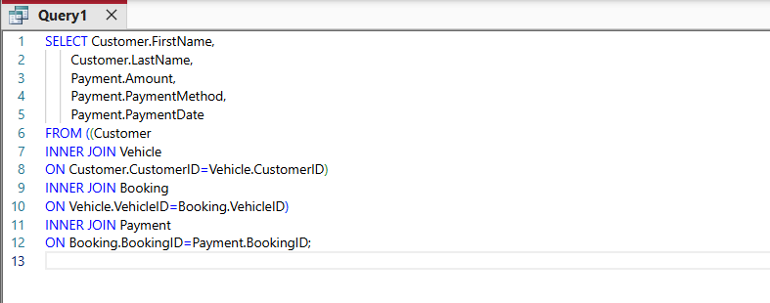
Figure 12: Query 4 SQL Statement
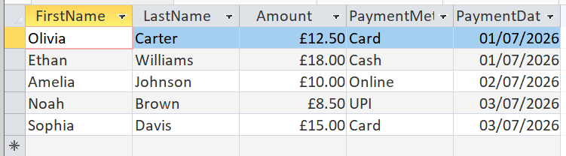
Figure 13: Query 4 Results
Explanation
In this query the concept of INNER JOIN function among customer, vehicle, booking and payment table will be used. A complete record of all payments of customers will be extracted.
Query 5: Total Revenue
Purpose: The purpose of this query is to calculate the total revenue earned through parking payments.
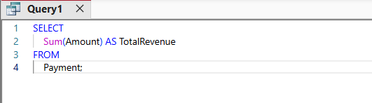
Figure 14: Query 5 SQL Statement
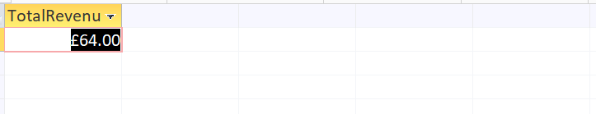
Figure 15: Query 5 Results
Explanation
In this query, the SUM() aggregate function of the Amount column of the Payment table will be used.
Query 6: Cars at Parking Site
Purpose: This query will retrieve all cars registered with parking sites.
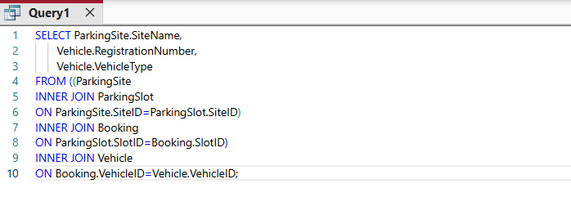
Figure 16: Query 6 SQL Statement
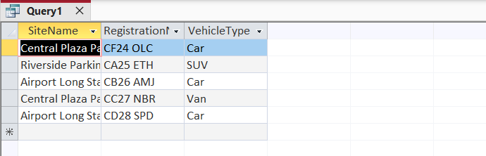
Figure 17: Query 6 Results
Explanation
This is a joint query which involves the table ParkingSite, ParkingSlot, Booking and Vehicle. This will retrieve registration numbers and types of vehicles for each parking site. This will help the management in knowing where the cars are located.
Query 7: Parking Site with Many Bookings
Purpose: This query will retrieve the most utilized parking site in terms of the number of bookings.
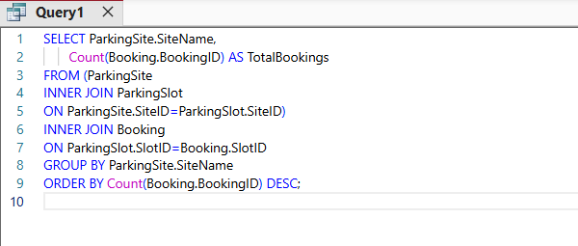
Figure 18: Query 7 SQL Statement
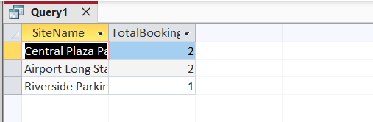
Figure 19: Query 7 Results
Explanation
This query will retrieve booking records from the ParkingSite and use COUNT() function to retrieve the number of bookings. The sorting will be made in descending order to help the management identify the most used parking sites.
Query 8: Bookings on 01/07/2026
Purpose: This query will retrieve booking records of 01/07/2026.
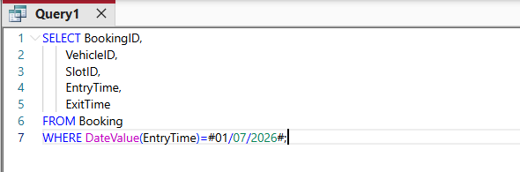
Figure 20: Query 8 SQL Statement
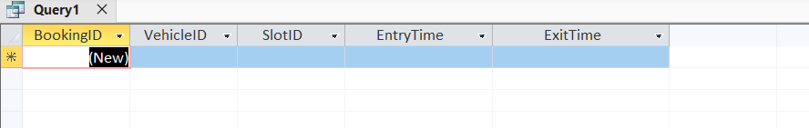
Figure 21: Query 8 Results
Explanation
This query will involve EntryTime field to help retrieve the booking records. It will help the employees to keep the activities of the parking sites on daily basis.

Testing and Validation
The AutoPark Management System was validated and tested after implementation in Microsoft Access to confirm that all functional requirements are fulfilled. Testing covered table creation, data entry, relationships, SQL queries and report generation, with every functionality checked against the sample data to ensure that records are stored and retrieved correctly. Validation rules prevent invalid data from entering the database, and referential integrity keeps all related tables consistent.
Several validation rules ensure the quality of the data: parking capacity and payment amounts cannot be negative, customer names and booking times are mandatory fields, and the exit time must be after the entry time. Foreign key constraints prevent orphan records, so nothing can be entered without a corresponding customer, booking or payment. The Enforce Referential Integrity option was enabled in Microsoft Access, and all test cases produced the correct results.
Table 6.1 Testing Results
Test ID | Test Performed | Expected Result | Actual Result | Status
T1 | Add a new customer | Customer record saved successfully | Customer record saved successfully | Pass
T2 | Add a new vehicle | Vehicle linked to the correct customer | Vehicle linked successfully | Pass
T3 | Add a parking site | Parking site created | Parking site added successfully | Pass
T4 | Add a parking slot | Slot assigned to the selected parking site | Slot assigned correctly | Pass
T5 | Create a booking | Booking stored with valid vehicle and slot | Booking recorded successfully | Pass
T6 | Record a payment | Payment linked to booking | Payment stored successfully | Pass
T7 | Execute occupied slot query | Occupied slots displayed correctly | Correct records returned | Pass
T8 | Execute available slot query | Available slots displayed correctly | Correct records returned | Pass
T9 | Calculate total revenue | Total payment amount displayed | Revenue calculated correctly (£64.00) | Pass
T10 | Display customer payment history | Customer and payment information displayed correctly | Correct customer payment history shown | Pass

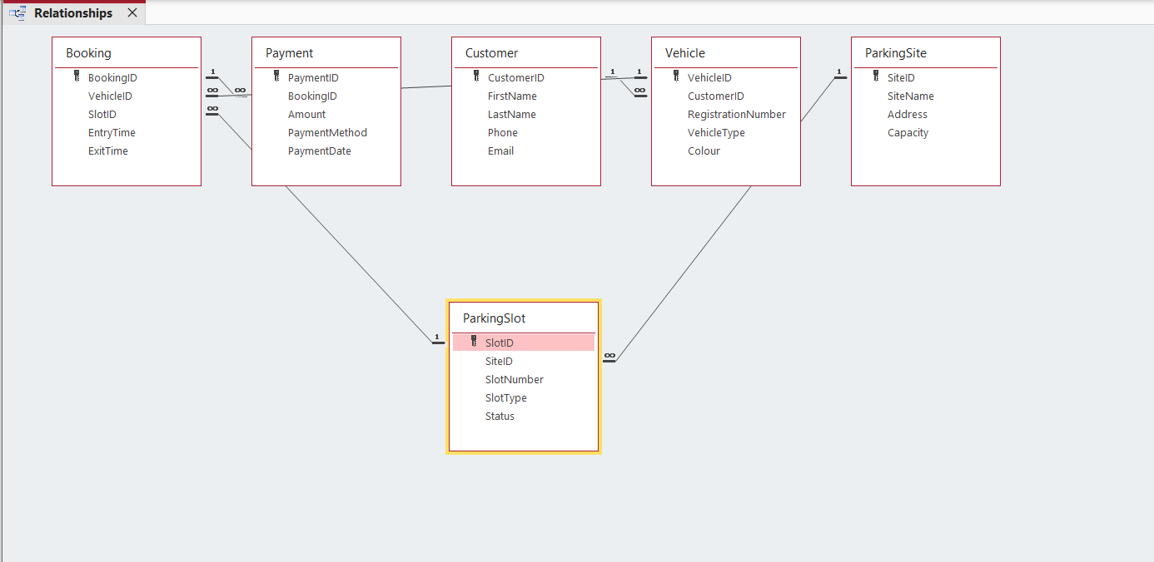
Figure 22: Microsoft Access Relationships Window
Validation Rules Implemented
Field | Validation Rule | Purpose
Capacity | >0 | Prevents negative parking capacity
Amount | >=0 | Prevents negative payment values
EntryTime | Required | Every booking must have an entry time
ExitTime | >= EntryTime | Ensures exit time is after entry time
Phone | Input Mask | Ensures correct phone number format
Email | Validation Rule | Ensures a valid email format
CustomerID | Foreign Key | Prevents vehicles without customers
BookingID | Foreign Key | Prevents payments without bookings

Design Decisions and Future Work

Design Decisions
The Relational Database Model was used for the AutoPark Management System because it stores and manages interrelated data effectively with minimal redundancy, offering data integrity, easy retrieval through SQL queries and straightforward handling of relationships between entities. The entities ParkingSite, ParkingSlot, Customer, Vehicle, Booking and Payment were chosen because they represent the essential modules of any parking management system. The AutoNumber data type was used for primary keys to guarantee unique identifiers and avoid duplicate records, while foreign keys create the relationships between tables and maintain referential integrity, preventing orphan or invalid records. The database was normalised to Third Normal Form to avoid duplication of data and to support consistency and maintainability. Challenges faced during implementation included incorrect relationship settings, foreign key constraint violations and inserting sample data in the wrong order; these were resolved by creating and populating parent tables before child tables.

Future work
Although the existing AutoPark Management System has proved effective, several improvements could make it more efficient and user-friendly. Online booking functionality would reduce waiting times and optimise the use of parking space, while QR-code or barcode entry would automate the entry process and eliminate manual checks. A mobile app would let customers book parking spaces and receive real-time availability information, and an AI module could forecast demand and allocate spaces optimally at the busiest times. Further enhancements include automated email/SMS notifications for booking confirmations and payment receipts, a management dashboard with occupancy and financial charts, a cloud database for greater scalability, and secure digital payment gateways.

References:
- C. Claudisnei, "Parking System: A Comprehensive Management Solution for Small Parking Facilities," in Journal Dekstop Application (JDA), vol. 4, no. 1, pp. 34–41, 2025.
- K. Acharya, "Automobile Management System project report," in Authorea Preprints, 2024.
- M. Witzko, "Avoiding data duplication and enhancing data quality in SIMULTAN through rule-based taxonomy mapping," Ph.D. dissertation, Technische Universität Wien, Vienna, Austria, 2025.
- M. Kvet, and J. Papan., "The complexity of the data retrieval process using the proposed index extension," in IEEE Access, vol. 10, pp. 46187–46213, 2022.
- M. Hardini et al., "Application of database normalization in increasing data storage efficiency," Int. Trans. Artif. Intel., vol. 3, no. 2, pp. 201–211, 2025.
- N. Amato, "Mastering database normalization: A comprehensive exploration of normal forms," in ResearchGate, 2023.
- Z. Zhang, S. Link, "Synthesizing third normal form schemata that minimize integrity maintenance and update overheads: parameterizing 3nf by the numbers of minimal keys and functional dependencies," in Proc. ACM on Manag. Data, vol. 3, no. 3, pp. 1–25, 2025.
- A. Uzzaman et al., "Optimizing SQL databases for big data workloads: Techniques and best practices," Acad. J. Bus. Admin. Innov. Sustain., vol. 4, no. 3, pp. 15–29, 2024.

