University of Wales Trinity Saint David
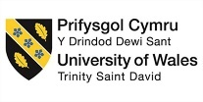
THE GLOBAL BUSINESS ENVIRONMENT
Topic – IMPACT OF COVID-19- BUSINESS ENVIRONMENT- PEUGEOUT
Submission date: 08.01.2022
Word count: 1972
Module code: LCBB4005
Student name: Elena Diana Bengulescu
Student id: 2023255
Table of content
- Introduction ………………………………………………………… 1
- Business Environment’s Analysis ……………………………... 2.3.4
- PSA Peugeot Citroen Group’s SWOT Analysis ……………… 4.5.6.7
- PSA Peugeot Citroen Group’s PESTLE Analysis …………… 7
- The impact of COVID – 19 on the company ………………….. 8
- Conclusion …………………………………………………………. 8
- References …………………………………………………………. 9.10
- Appendix ……………………………………………………………. 10

- Introduction
Business environment is the combination of all external and internal elements that can impact a business. External elements and internal elements can impact on each other, and both operate to impact an organization. There are five components of Business Environment: Economical Environment, Social Environment, Political Environment, Legal Environment, Technological Environment.
Business Environment helps in identifying opportunities and making the first move is an advantage and helps identifying threats and can be an early warning signal. It can help with rapid changes and improving performance.
Microenvironments are external small elements within the organization that can impact the capacity to serve its consumers. Macroenvironments are external bigger societal elements that affect the microenvironment. Internal environment is an environment that can be managed, and it cannot impact an external environment.
However, for a better understanding of a Business Environment, many analyses can be done as SWOT analysis, PESTLE, Porter’s Five Forces and Value chain.
These analyses help the managers of the organizations to understand better the Business Environment and to be up to date. They are using these strategies to reach an objective and it is the direction of a company for a long time. Being a competitive business environment, the organizations need to plan their objectives, development, and to apply a strategy and to make adjustment if it needs to.
- Business Environment’s Analysis
The SWOT Analysis is a practical instrument for analysing and understanding all type of business and organization’s terms and situations, The SWOT analysis means Strengths, Weaknesses, Opportunities and Threats. The SWOT analysis is useful for the strategy applied within the company, to plan the business, marketing, to assess the competitors, for the company and product expansion and research reports. The elements Strength and Weaknesses are internal elements, and the other two elements, Opportunities and Threats are external elements and can be identified by the PESTEL analysis. (Weihrich, H., 1982)
PESTEL Analysis is a structure of macro-environmental elements used in the environmental examining the component of strategic management. P-political, E-economic, S-socio-cultural, T-technological, E-environmental, L-legal are the factors that help to make this analysis. It is beneficial to understand if the market is growing or decreasing, position of the company, prospective and direction for future actions. (Michael E. Porter 1980)
Figure 1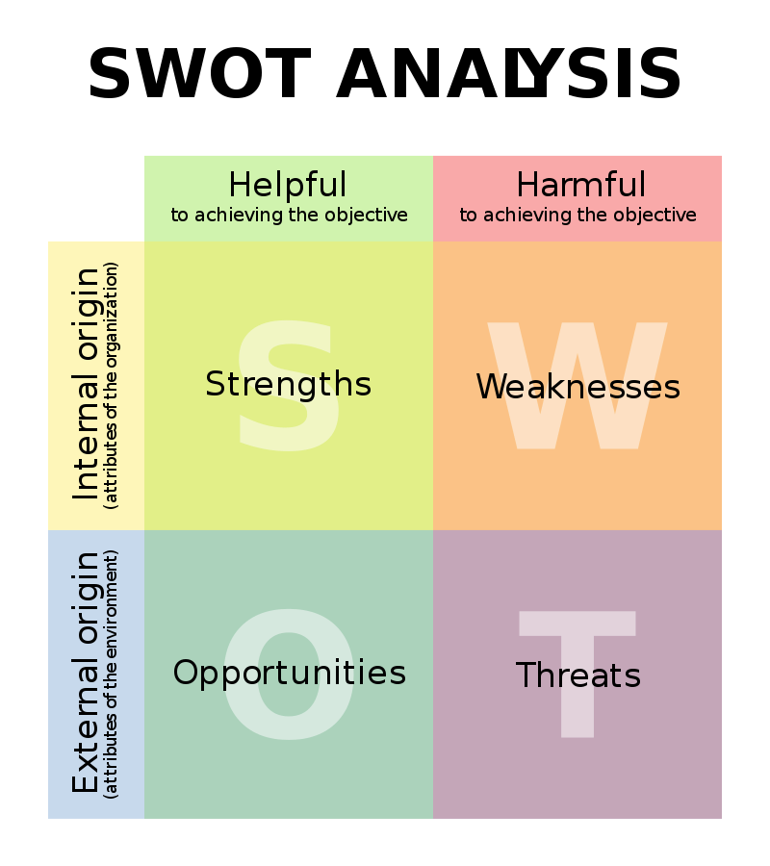
Source: Weihrich, H. (1982) “For convenience, the matrix that will be introduced is called TOWS, or situational analysis”. p. 46.

Figure 2
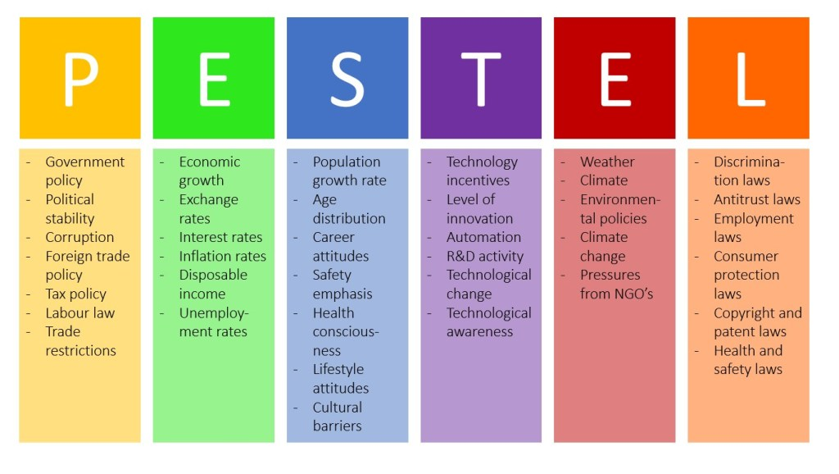
Source: Aguilar, F. (1960) “Scanning the Business Environment”.

Groupe PSA (Peugeot Societe Anonyme) is one of the oldest automobiles manufactures which was founded in 1810 as a metal organization and because the industrial revolution became bigger, they launched into cars. PSA made the first car in 1890 and the first union was with Citroen in 1976 to become the PSA Peugeot Citroen Group.
The Group’s mission statement is “Our vision: to become a leading car manufacturer and a provider of mobility solutions to enhance our customers’ freedom of movement on a day-to-day basis and around the world”.
- PSA Peugeot Citroen Group’s SWOT Analysis
Strengths:
- Consumers’ satisfaction is a big centre of attention for the company.
- Big expansion in used car service segment.
- Big product mix offers.
- Evolution of a powerful technology platform through FREE2MOVE.
- Big financial production and point of view.
PSA has few of the most recognized marques in the domestic trading where it works. Brand recognition helps very much to attract new customers.
Higher-level product and higher quality of the services can make PSA to have a bigger market share in the future as the present customers are loyal to the brand.
The domestic trading where PSA is working is an origin of strength and barrier to the extension and transformation of the business. For its growth, the company can easily do it with no big transformation but will need further funding into research and transformation to join international market.
PSA has a big victorious track record for having new products in the domestic trading but also serve to the diverse market based on the insights from local buyers. PSA has tried out many ideas in distinct markets and launched the successful Global Business solutions.
Powerful Balance Sheet and Financial Statement of PSA can assist the company to put money into new and different ideas that can diversify in the future the revenue stream and grow Return on Sales.
PSA has the advantage of the first mover in number of divisions. The company tried in various areas Mergers and acquisitions. The Global Business solutions and strategies has assisted PSA in approaching with individual solution to tap the new markets.
Powerful relationship with the regular distributors – PSA has powerful connection with the company’s distributors and many collaborators of the supply chain. The company can enlarge products and services by inspiring from the skills of its distributors and supply chain collaborators.
Weaknesses:
- Powerless to keep market share in the Chinese market.
PSA has lack of critical abilities, more in the technology’s area and digital transformation. The organization is trying to reorganize processes by expanding in Artificial Intelligence and machine learning.
The demand of the products did not go down but there is a customer dissatisfaction among the PSA’s consumers. The company need to focus on the sectors where it can upgrade customer purchase and post purchase experience.
PSA’s business model can be simply duplicated even with the number of patents and copyrights the organization own so that makes it a weakness for the company.
PSA’s track record on environmental problems is not so good and this can conduct to consumer backlash as people is now taking into consideration environmental protections as essential part of making business.
PSA has consolidated technology in the backend procedures, but it has not been capable yet to tackle the power of technology in the front-end procedures.
Project Management is very concentrated on internal delivery when it should take into consideration all the interests of external stakeholders. This point of view can conduct to poor public relation and customer backlash.
Opportunities:
- Develop in electrified mobility.
- Having a vertical integration in the electric vehicles area.
- Growing market share by expanding into countries across the globe.
- LCV market growing in the Europe area.
- Collaborations to be reached by the PSA-FCA merger.
- Having digital stores to sell cars online.

PSA can use expansion in artificial intelligence to better anticipate customer needs, serve to niche areas, and make greater advice engines.
Machine learning and Artificial Intelligence innovation is changing the technology landscape that PSA works in. The company can use these expansions in improving efficiencies, lowering costs, and changing procedures.
PSA is experiencing now restricted access to big level talent market caused by the limited budget. If PSA is expanding into international market, can lead to tap into international talent market. It can also assist to bring the talent into domestic market and expanding into new segments Merges and acquisitions.
The ingress of new consumers has conduct to development of customers preferences and tastes. Because of this, PSA has faced two big challenges: how to keep loyal consumers and how to reach the new consumers. The company has attempted to expand first using many brands and then by attach numerous characteristics based on consumer tastes.
E-commerce business version can assist the organization to make connections with local suppliers and logistics provider in international market. It can assist to decrease the cost of entering a new market and get to consumers at a smaller marketing budget.
Threats:
- Because of Brexit, many businesses and jobs can be lost.
- Covid – 19 crises.
- Dropping in revenue because of the exchange rate fluctuations.
- Downturn in the world auto market.
Growing costs component for operating in expanded market because of environmental regulations – PSA must deal with these costs as governments are trying to impose bigger environmental taxes to encourage cleaner options. PSA can pay more for logistics and packaging.
The company has concentrated on China for its next level of expansion but there is expansion pressure between US China trade connections, and it can conduct to protectionism, more grating into international trade, bigger costs in terms of labour cost and making business cost.
Expansions like Brexit, Russian sanctions, foreign exchange disaster, smaller oil prices, etc. are affecting international business environment. PSA needs to concentrate on these circumstances and make them part of strategy making.
During the time, the bargaining power of consumers of PSA has become bigger and is having influence on prices. PSA can follow horizontal integration to integrate and bring efficiencies and it needs elemental transformations to business model rather than cosmetic changes. (SWOT & PESTLE.com, 2022)
- PSA Peugeot Citroen Group’s PESTLE Analysis
PESTEL Analysis is very important to recognize the external threats and opportunities appearing caused by the macro environment expansion. Transformations in macro environment elements can affect the Porter Five Forces and industry attractiveness.
Political:
- Several taxation metrics in Eurozone now intersecting to CO2 taxation.
- United States forced sanctions over Iran and will cause big dropping in business.
Economical:
- COVID – 19 effects on automobile industry.
- Argentina’s currency disaster has an impact on sales.
- Brexit effect on the automotive industry.
Social:
- Big amount of job losses in Opel factory because of cost-cutting.
- Transforming customers tastes regarding transportation.
Technological:
- Moving to dedicated EV construction by 2025.
- Slowdown in expansion of fully autonomous vehicles.
Environmental:
- Group PSA in CDP’s “Climate Change A-list”.
- Concentrated on innovations to minimise the environmental effect of materials.
Legal:
- Anti-trust worries by EU regarding PSA-FCA union.

- The impact of COVID – 19 on the company
The business-related impacts of Coronavirus in automotive industry have attracted the interests of researchers and marketers. Overcoming the disadvantages of this crisis becomes the priority of many organizations like PSA Peugeot Citroen (PSA Group). The success in the marketing communication of different PSA Group brands including Peugeot (e.g., Citroen, DS, Opel, Free2Move) is related on understanding of customers perceptions. The necessity of social distancing after COVID – 19 resulted in bigger positive brand perceptions, possible bigger request for personal automobiles in the future, but moving from public transport to personal cars may cause an ethical dilemma for the responsible area of customers who have environmental sustainability worries. This conflict has an impact on Peugeot and its present and possible customers. However, launching and increasing awareness toward electric cars can be a solution for safety and sustainability considerations of customers. The closing of production and the small auto demand because of the pandemic will possibly have a negative impact over PSA’s revenue and cash flow in 2020. At the end of fiscal year 2019, Peugeot’s net cash was 10.6 billion euros. It seems the pandemic did not impact Peugeot’s planner merger with Fiat Chrysler in 2021. The union with Fiat Chrysler can be important for Peugeot to grab recovery opportunities in markets like the United States and Brazil. Peugeot holds 17% of the market in Europe and for a better outlook it needs the production patterns to return to normal.
- Conclusion
The COVID – 19 pandemic had a rapid and big effect on the globally integrated automobile industry. Signs cover a disturbance in Chinese parts exports, big scale manufacturing interruptions across Europe, and the closure of assembly parts in the U.S. This is having big pressure on an industry already managing with a downshift in global request, and likely guiding to increased merger and acquisition activity. The effects of the automobile industry started in China, where sales jumped 71 percent in February 2020; by April, sales had dropped 47 percent in the U.S. and dived 80 percent in Europe.
Because of the pandemic, many dealers shut their sales floors to the public and involved with consumers over the phone, via videoconference, or by special appointment only, resulting a decrease on sales. Stated by the data assembled by Statista, the world automobile industry will increase by around 9 trillion dollars by 2030, of which 38% will be produced by new vehicles. (Statista 2022)

- References
Irina Surdu, Kamel Mellahi (2018), “PSA Peugeot Citroen: Re – Entering the United States Harvard Business Review Case Study”. Published by HBR Publications.
Weihrich, H. (1982), p. 54 “For convenience, the matrix that will be introduced is called TOWS, or situational analysis”.
Weihrich, H. (April 1982), “The TOWS matrix – a tool for situational analysis”. Long Range Planning.
Nandone, Felix Adam (9 April 2019), “A PESTLE analysis of international retailing in the East African Community”. Global Business and Organizational Excellence.
Michael E. Porter (1980), “Competitive Strategy: Techniques for Analyzing Industries and Competitors (Abstract)”.
Dalirazar, Sadaf; Sabzi, Zahara (2020-12-12). “Strategic analysis of barriers and solutions to development of sustainable buildings using PESTLE technique”. International Journal of Construction Management: 1-30.
Schmieder-Ramirez, J. and Mallette, L., “Using the SPELIT Analysis Technique for Organizational Transitions”, Chapter 28 of “Education Applications and Developments” edited by Mafalda Carmo, Science Press, 2015. Retrieved 2015-08-21.
Statista Data (2022). Available at: http://statista.com/statistics/574151/global-automotive-industry-revenue/
“History of the Peugeot family, pioneers of the French industry”. www.peugeot.com Archived from the original on 5 June 2017. Retrieved 1 May 2018.
Bradford and Duncan, (2000), Simplified Strategic Planning. p.1. Chandler House.
Importance of Strategy in Business Environment. Available at: http://mbaknol.com/strategic-management/importance-of-strategy-in-business-enviornment/
SWOT & PESTLE.com (2022). Groupe PSA SWOT & PESTLE Analysis – SWOT & PESTLE.com. [online] Available at: http://www.swotandpestle.com/groupe-psa/ Accessed 08.01.2022
PSA automotive group. Available at: http://www.groupe-psa.com/en/automotive-group/quality/

Amanda Jean Dalugdug (10 April 2020) “S & P changes outlook on Peugeot to negative over COVID – 19 risks”. Available at: http://spglobal.com/marketintelligence/en/news-insights/latest-news-headlines/s-p-changes-outlook-on-peugeot-to-negative-over-covid-19-risks-57989982
Whittington, Richard, (2020) Exploring strategy: text and cases. 12th ed. Harlow: Pearson
Worthington, Ian, (2006). The business environment. 5th ed. Harlow, England: Prentice Hall Financial Times an imprint of Pearson Education
- Appendix
Figure 1 Weihrich, H. (1982) “For convenience, the matrix that will be introduced is called TOWS, or situational analysis”. p. 46.
Figure 2 Aguilar, F. (1960) “Scanning the Business Environment”.

