Installing Python and PyCharm IDE (Windows)

1. Go to http://www.python.org and click on "Downloads"

2. Probably easiest is to get the standalone installer for "Python 3.XX.X" button as shown. At the time of writing Python is on version 3.14.2 – don't worry if there is a later version shown - just download and install the latest one. The download is approximately 28.5Mb.

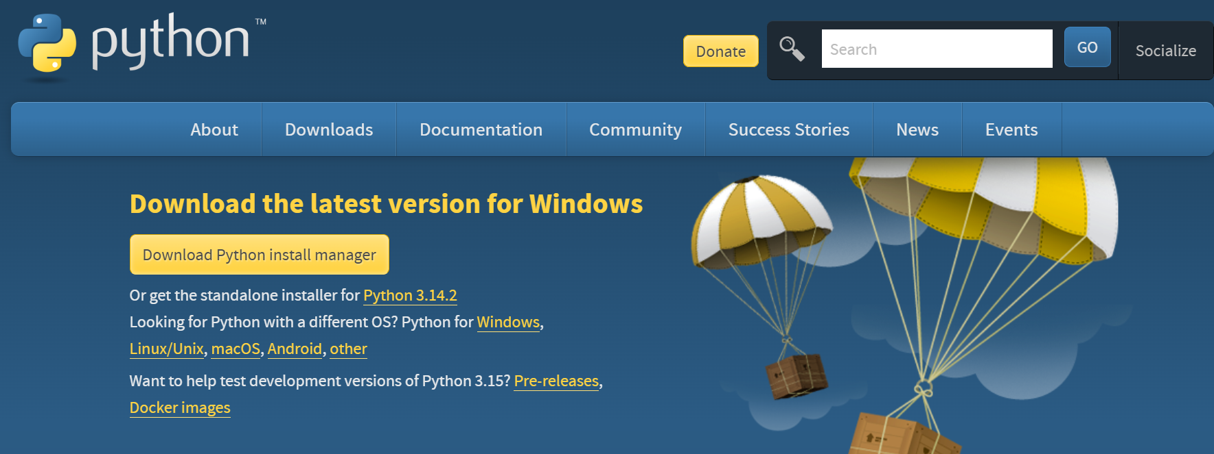

3. Install Python by clicking on the downloaded file.

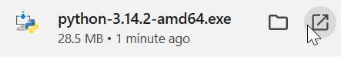

(You may have to look in your Windows Downloads folder(or similar) to find the file)

Various screens will appear, make your way through them:

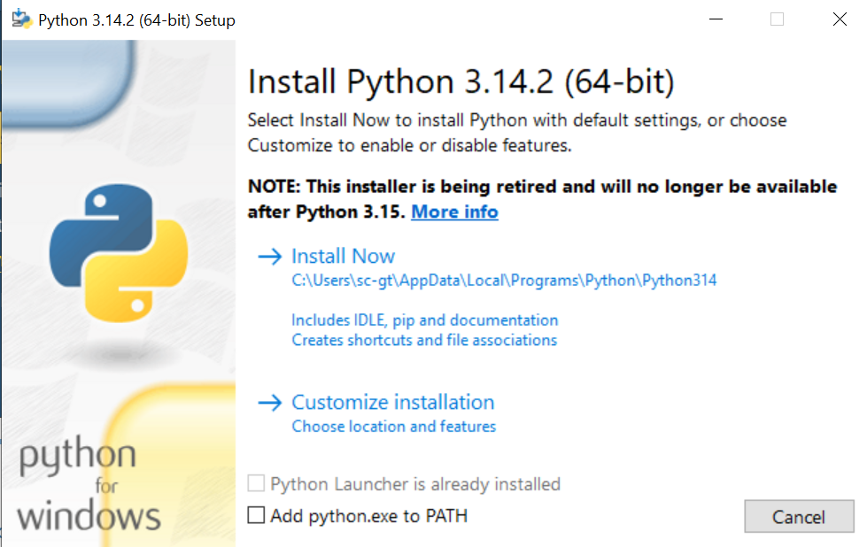
Tick “Use admin privileges when installing py.exe”

At the end, you’ll see something like this:

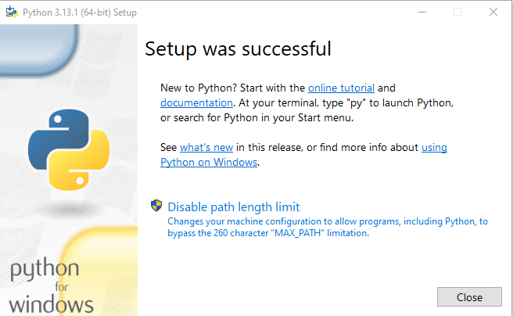
4. When Python is installed, we need to install a separate Python editor

Go to https://www.jetbrains.com/pycharm/download/?section=windows and download and install the PyCharm IDE (Integrated Development Environment)

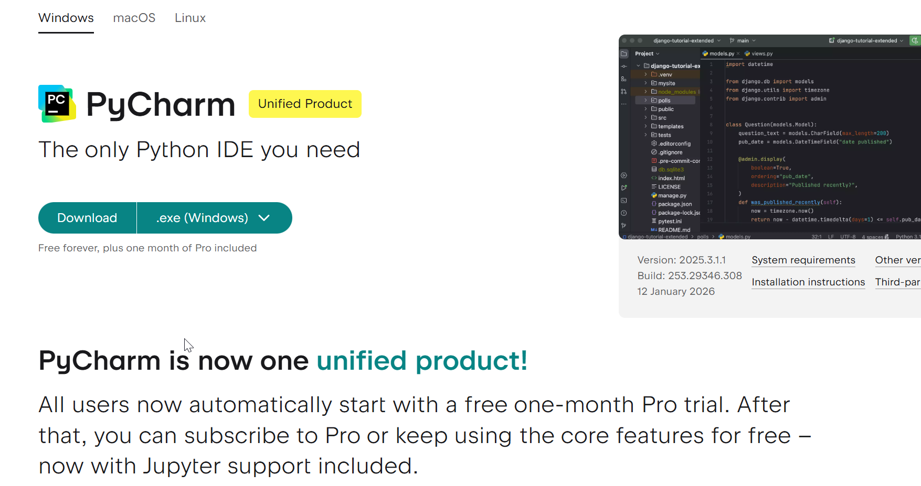

Note: Previously, PyCharm was split into two products, Professional and Community. It is only one product now – there is no need to subscribe to Pro, the core features will be enough for our purposes.

5. Once the file is downloaded, install it



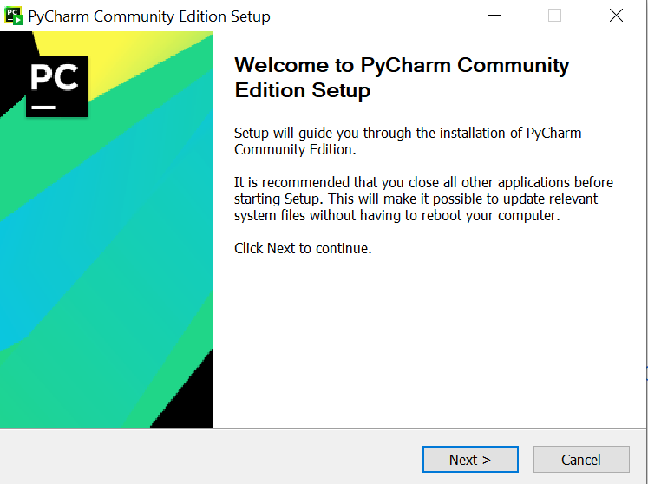

Default settings are fine (if asked): (Press “Next”)
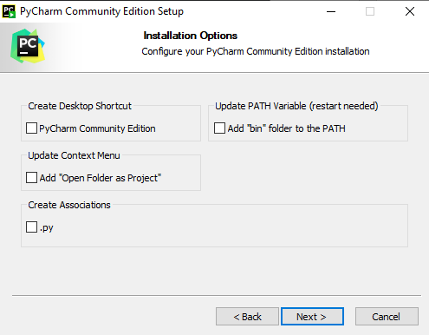

6. Once installed, you should see it in your Windows programs menu :


Python for Mac OS

Python is also available for Mac OS.

On http://www.python.org/downloads , click on "macOS"

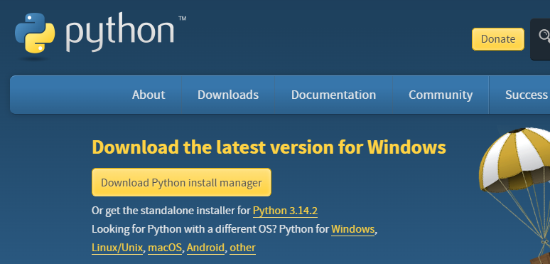

Download and install the latest Python 3 release:

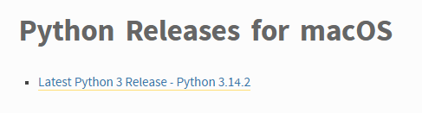

PyCharm is also available for macOS: https://www.jetbrains.com/pycharm/download/?section=windows



