STRATEGIC MANAGEMENT AND SUSTAINABILITY
MODULE CODE: LCBB6015
COMPONENT 1: COURSEWORK: WRITTEN REPORT

STUDENT NAME: IONUT HRISCA
STUDENT ID: 2243953

Executive Summary
In this report, the strategic position of Aston Martin Lagonda Global Holdings plc in the changing luxury automobile industry is analysed. It analyses the external issues applying the PESTLE analysis as well as Porter's Five Forces, and these issues are regulatory pressures, uncertainty in the economy and intense competition. Value Chain, RBV, and SWOT are internal analysis tools that determine the key strengths of the company (such as high costs, financial constraints, strong brand heritage, and craftsmanship) and weaknesses (such as high costs and financial constraints). On the basis of these findings, strategic options such as electrification, brand expansion, cost optimisation and market growth are offered to improve competitiveness, profitability improvement and long-term sustainable development.

Table of Contents
Executive Summary 2
1. Introduction 4
2. Company Overview 4
3. External Environment Analysis (PESTLE) 5
4. Industry Analysis 7
5. Internal Environment Analysis 8
6. Strategy Formulation 12
7. Conclusion & Recommendations 12
References 14

1. Introduction
Strategic management is very important in facilitating organisations to operate in complex and dynamic business environments and gain long-term competitive advantage (Kale et al., 2024). Strategic decision-making is now more crucial than ever in the automotive industry due to the fast-changing technology, the growing levels of environmental regulations, and the changing consumer preferences. The total car sales in the whole world in the year 2024 were 74.6 million, which is 2.5 per cent more than the car sales in 2023 (ACEA, 2025). The case of this report is Aston Martin Lagonda Global Holdings plc, a famous UK car manufacturer that produces luxury cars and has a long history, performance and exclusivity. This report aims to critically examine the internal and external environment that affects the strategic position of Aston Martin.

Figure 1: Aston Martin
Source: (Aston Martin, 2024)

2. Company Overview
The Aston Martin Lagonda Global Holdings plc is a luxury car manufacturer based in the United Kingdom with its headquarters situated in 1913, and they specialise in making high-performance sports cars that are seen to possess prestige, heritage and craftsmanship (Aston Martin, 2024). The brand is also internationally connected with exclusivity and has a great cultural awareness due to its long-term relationship with the James Bond franchise. The vision of the company is to be the most desirable ultra-luxury British performance brand in the world, which is backed by the mission statement, which is to provide vehicles that would be de luxurious, technologically advanced and of unmatched design. Its essence of working is associated with the realisation of sustainability profitability by innovation, electrification and brand premiumisation as it competes with the most successful luxury automotive companies like Ferrari, Lamborghini, and Bentley.

3. External Environment Analysis (PESTLE)
Political
In the case of Aston Martin Lagonda Global Holdings plc, political forces are influential in the determination of operational and strategic choices. The trade agreements, tariffs, and cross-border supply chains have brought complications in the UK's industrial policies, especially after Brexit. Such changes have added administrative overheads and even a delay in getting components when sourcing them from the suppliers in Europe. Moreover, the UK automotive sector is among the country's assets and one of the most diverse in the world (Smmt, 2026). The political stability in major export markets would also be important since Aston Martin highly depends on international sales as a source of revenue.
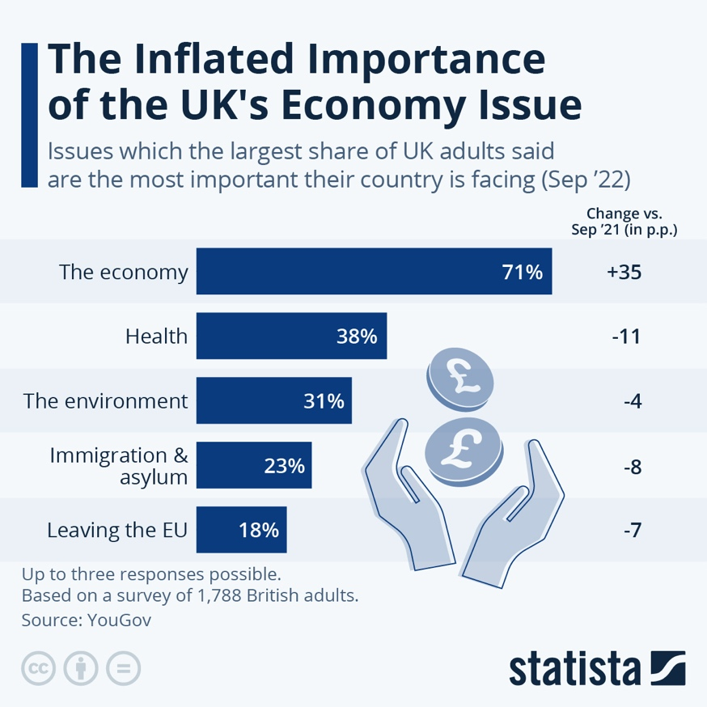
Figure 2: Economy UK
Source: (Armstrong, 2022)
Economic
The demand for luxury automobiles depends greatly on the economic conditions. The target customers of Aston Martin consist of high-net-worth people, which means that the demand is directly linked to wealth distribution and economic growth worldwide and financial market performance. Luxury vehicles sell more during economic booms, but the economic recession, inflation and increasing interest rates have the potential to decrease discretionary products, even among wealthy consumers (Fortune Business Insights, 2025). Moreover, continuous supply chain discontinuity and high cost of raw materials in the world have added to the cost of production, thus impacting profitability. The company is also affected by currency fluctuations since it deals with several other countries across the world and exports a significant percentage of its vehicles.
Social
The luxury car industry is being transformed by social trends as it relates to consumer preferences. Sustainability is an emerging trend, and consumers are increasingly attached to environmentally friendly brands (Kumar, Prakash and Kumar, 2021). This is also shifting towards the need for hybrid and electric luxury cars. There is also a significant shift in the classic ownership models to the experiential luxury, where consumers are more interested in the brand identity, exclusivity, and personal experiences. Aston Martin has a solid heritage founded on the association with the luxury lifestyle positioning, which gives the company an edge in this regard. Nonetheless, the shifting demographics and younger and more affluent consumers demand that the brand change its image to stay current.
Technological
The automotive industry is changing at a fast rate through technological changes. Electric powertrains, battery technology, and autonomous driving systems changes define the new rules (Yeung, 2024). In the case of Aston Martin, it is important to stay abreast with these changes in order to be competitive with other technologically advanced competitors. This has been overcome by the company by entering into strategic alliances, most prominent among them being the case of the Mercedes-Benz Group AG, which enables the company to access advanced engineering, powertrain technology, and a digital platform. Through such collaborations, Aston Martin is in a position to offer clarity on how much it can save in terms of research and development despite quickening the innovation.
Legal
The motorcycle market is greatly regulated, and Aston Martin should fit into strict legal frameworks, especially when it comes to emission and safety benchmarks. The UK and European Union have also developed highly stringent environmental policies, such as net-zero carbon emissions, and the prohibition of internal combustion engine vehicles in the next several decades (Shahzad et al., 2024). Due to the elevated costs of adherence to these laws, a large amount of money needs to be invested in cleaner technologies, which may raise operating expenses. Lack of adherence to legal norms might lead to both financial and reputational losses, which is why legal compliance is a highly strategic issue.
Environmental
In the automotive business, environmental factors are taking more and more control of the business strategy. Governments, stakeholders, and consumers have mounting pressure on companies to lower their carbon footprint and get down to sustainable practices (Yunus, Elijido-Ten and Abhayawansa, 2020). In the case of Aston Martin, this would be to move away from traditional internal combustion engines to hybrid and fully electric vehicles. Sustainability is also needed by the company to be followed throughout its value chain, which entails the procurement of materials in an environmentally friendly manner and the reduction of emissions during manufacturing. As much as such a transition can be complicated in the areas of cost and technological capacity, it can also be used to improve brand reputation and keep up with the international sustainability trends.

4. Industry Analysis
Force | Level | Analysis
Competitive Rivalry | High | The competition surrounding the luxury sports automotive market is quite fierce, and the rivals of the industry, such as Ferrari, Porsche, and Bentley Motors, vie against one another on the aspects of performance, innovative design and the value of the brand (Data Insights Market, 2025). The main aspect of differentiation for Aston Martin Lagonda Global Holdings plc is exclusivity, heritage, and design. Nevertheless, competitors that are more financially and technologically endowed mount pressure on the market share and profitability.
Threat of New Entrants | Low | The entry barriers are very high since entry entails a lot of capital investment, high technological demands, and stringent regulatory costs. Moreover, the lack of credibility in new firms because of strong brand loyalty and heritage in the luxury segment makes it challenging (Chen and Lee, 2021). Consequently, the threat of entry by new entrants and threats to the niche of Aston Martin are low.
Bargaining Power of Suppliers | Moderate | Aston Martin is also a car maker that uses specialised suppliers of quality parts, which include engines, electronics and luxury materials. This dependence heightens the supplier's power. Nonetheless, the presence of strategic partnerships, including those with Mercedes-Benz Group AG, can reduce the risks and offer exposure to modern technology and balance in the supplying associations.
Bargaining Power of Buyers | Moderate | The luxury customers are wealthy people and require high personalisation, quality and performance (Yeoman and McMahon-Beattie, 2018). They are also able to access numerous top brands and can switch to them quite easily. This intensifies the buyer power, and Aston Martin has to keep innovating and ensure its brand attractiveness to stay in business.
Threat of Substitutes | Moderate | The threats to demand are complemented by substitutes (other luxury items are produced, e.g., yachts, private jets) and a new brand of electric vehicles (e.g., Tesla Inc.), which offers an experience of luxury, and makes a direct threat to the demand.
Table 1: Porter’s Five Forces Analysis
Source: (Developed by Author)

5. Internal Environment Analysis
Value Chain Analysis
Inbound Logistics
In the Aston Martin Lagonda Global Holdings plc case, inbound logistics is concerned with the acquisition of high-quality materials like top-grade leather, aluminium and hi-tech components. Its suppliers worldwide are highly specialised to guarantee high quality, thus supporting the luxury image but making it costly and dependent (Aston Martin, 2025).
Operations
The work of Aston Martin is based on hand-cut manufacturing processes, uniting the ancient crafts with modern technologies (Warwickshire, 2025). This strategy guarantees high-quality products and exclusivity, but at a cost of production being more expensive and economies of scale being lower than those of the competitors in mass markets.
Outbound Logistics
The company has a small-scale production model with distribution of the vehicles through a few dealerships and exclusive distributors. This has a restricted allocation that maximises brand exclusivity and high perceived value by customers.
Marketing & Sales
Aston Martin does not possess the strongest brand narratives, as it builds on its British heritage and James Bond iconicity to make its brand popular around the world and as a symbol of luxury.
Service
The company provides a luxurious consumer experience in the form of personalised services, customised solutions, and high-quality after-sales services that have led to high customer loyalty and enduring relationships with customers.
Resource-Based View (RBV)
Strong luxury brand heritage: The brand Aston Martin Lagonda Global Holdings plc owns a worldwide renowned brand with prestige, exclusivity, and a British heritage. Their emotional appeal and differentiation which has been achieved through its long-established relationship with the James Bond brand has been used as an invaluable intangible asset, something which would be hard to duplicate on the part of competitors.
Engineering partnerships (Mercedes-Benz): The advanced powertrain technology, electronics, and innovation capability offered by a strategic partnership with Mercedes-Benz Group AG can enable Aston Martin to be more competitive and lessen the research and development expenses.
Skilled craftsmanship: The employees of the company show the best hand-built production and provide high-quality and customised cars (Gibian, 2017). This allows product differentiation and strengthens the ultra-luxury status of this brand in the international car market.
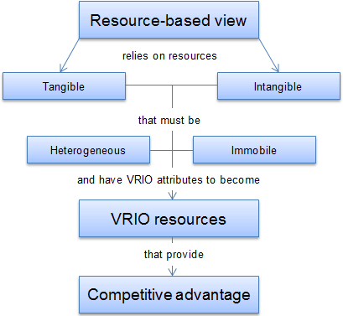
Figure 3: VRIO
Source: (Jurevicius, 2023)
VRIO Analysis
Resource | Valuable | Rare | Inimitable | Organised | Outcome
Brand prestige | ✔ | ✔ | ✔ | ✔ | Sustained competitive advantage
Engineering partnerships | ✔ | ✖ | ✖ | ✔ | Competitive parity
Craftsmanship | ✔ | ✔ | ✔ | ✔ | Competitive advantage
Table 2: VRIO Analysis
Source: (Developed by Author)
SWOT Analysis
Category | Analysis
Strengths | Aston Martin Lagonda Global Holdings plc has the advantage of having a robust internationally recognised brand image of luxury, heritage, and exclusivity. Its strong engineering profiles make it produce high-performance sports cars, and because of its high-volume, low-volume production strategy, it has created brand desirability and customer attraction.
Weaknesses | The company has been facing a history of financial instability, which affects its long-term expansion and investment abilities. The cost of production, due to the handcrafted production and high-quality materials, decreases the profit margins. Also, the small economies of scale limit cost effectiveness relative to the large competitors.
Opportunities | The luxury electric vehicle (EV) market is experiencing a high growth potential, and this can enable Aston Martin to strategise itself with sustainability trends. The addition of SUVs and especially the DBX crosses its product range. New opportunities include new revenue markets in China and the Middle East.
Threats | The pressure on market share will be high due to the existence of well-established luxury brands in the market. Financial crises might decrease the sales of luxury cars (Wen et al., 2021). In addition, strict regulations and environmental policies on emissions impose challenges to compliance and raise the costs of operations.
Table 3: SWOT Analysis
Source: (Developed by Author)

6. Strategy Formulation
Strategic Option 1: Electrification Strategy
Launching electric and hybrid cars must be an immediate priority for Aston Martin Lagonda Global Holdings plc in order to keep up with the fast-paced industry. This is in line with the trends of sustainability across the globe and the stringent regulations of emissions, besides increasing brand relevance to the environmentally sensitive consumers. The collaborative approach through cooperation with Mercedes-Benz Group AG, in particular, may access the high-tech EV and spend less on its development (Achillas and Iosifidou, 2024).
Strategic Option 2: Brand Expansion
The other portfolio can be diversified by the company through expanding into SUVs and the luxury lifestyle. With the success of such models as the DBX, Aston Martin can add additional sources of revenue other than conventional sports cars and appeal to the segment of the high-net-worth population with a wide range of interests.
Strategic Option 3: Cost Optimisation
High manufacturing costs can be minimised by enhancing operational efficiency by simplifying production processes and improving the supply chain management (Juhara, 2024). It will raise profitability without compromising the quality and exclusiveness of the products.
Strategic Option 4: Market Expansion
Aston Martin needs to concentrate on the advancement of its markets in the high-growth luxury markets like Asia and the Middle East, where the emerging wealth and demand for high-quality vehicles pose huge growth prospects.

7. Conclusion & Recommendations
It can be concluded that Aston Martin is a highly competitive and fast changing automotive business environment where brand-prestige could not be compromised with financial viability and technology progress. Although the firm enjoys a good heritage and exclusivity, they still experience future problems with the profitability and the adoption of new technologies. To overcome these problems, there are a number of strategic measures that can be suggested. First, the company needs to pick up its transition to electric cars to satisfy the regulation and evolving consumer tastes. Second, the company can access capabilities by strengthening strategic partnerships, especially in technology and innovation to lower the cost of development. Third, it may increase its revenue streams and competitiveness in the market by increasing its presence in the high-margin SUV segment. Lastly, to increase the overall profitability and the long-term survival of operations in a volatile market environment, the cost efficiency of operations should be increased.

References
ACEA (2025). Economic and Market Report: Global and EU auto industry – full year 2024. [online] ACEA - European Automobile Manufacturers’ Association. Available at: <https://www.acea.auto/publication/economic-and-market-report-global-and-eu-auto-industry-full-year-2024/> [Accessed 18 March 2026].
Achillas, C. and Iosifidou, P. (2024). Shifting towards electric vehicles: a case study of Mercedes-Benz from the perspective of cross-functional teams and workforce transformation. World electric vehicle journal, 15(7), p.325.
Armstrong, M., (2022). Infographic: The Inflated Importance of the UK’s Economy Issue. [online] Statista Daily Data. Available at: <https://www.statista.com/chart/28231/most-important-issues-uk/?srsltid=AfmBOoorN1nOovuI5jSZYC2k1ooJd3_iT_m9STYrxLV4U_5aimicW1XL> [Accessed 18 March 2026].
Aston Martin (2024). About us. [online] Aston Martin. Available at: <https://media.astonmartin.com/about-us/?lang=eng#:~:text=Aston%20Martin%20Lagonda%20is%20the,manufactured%20in%20St%20Athan%2C%20Wales.> [Accessed 18 March 2026].
Aston Martin (2025). Interim results for the six months ended 30 June 2025. [online] Aston Martin Lagonda Global Holdings Plc. Available at: <https://www.astonmartin.com/-/media/corporate/documents/h1-results-2025/aston-martin-lagonda-h1-2025-results.pdf> [Accessed 18 March 2026].
Aston Martin, (2024). Home. [online] www.astonmartin.com. Available at: <https://www.astonmartin.com/en> [Accessed 18 March 2026].
Chen, X. and Lee, G. (2021). How does brand legitimacy shape brand authenticity and tourism destination loyalty: Focus on cultural heritage tourism. Global Business & Finance Review (GBFR), 26(1), pp.53-67.
Data Insights Market (2025). Understanding growth challenges in the luxury sports car market 2026-2034. [online] Data Insights Market. Available at: <https://www.datainsightsmarket.com/reports/luxury-sports-car-136023> [Accessed 18 March 2026].
Fortune Business Insights (2025). Luxury Car Market Size, Share, Trends | Growth Report [2032]. [online] Fortune Business Insights. Available at: <https://www.fortunebusinessinsights.com/luxury-car-market-104453#:~:text=Luxury%20vehicles%20are%20high%2Dpriced,will%20further%20fuel%20market%20growth.> [Accessed 18 March 2026].
Gibian, R. (2017). At the Aston Martin Factory, artisans and technology combine to create luxury cars. InsideHook. [online] 4 Nov. Available at: <https://www.insidehook.com/autos/check-aston-martin-factory-luxury-cars-made-hand#:~:text=However%2C%20the%20more%20than%20100,a%20human%20can%20do%20that.%E2%80%9D> [Accessed 18 March 2026].
Juhara, S., (2024). Optimising supply chain management: Strategies for enhancing efficiency and reducing costs in manufacturing industries. The Journal of Academic Science, 1(1), pp.37-44.
Jurevicius, O., (2023). Resource-Based View. [online] Strategic Management Insight. Available at: <https://strategicmanagementinsight.com/tools/resource-based-view/> [Accessed 18 March 2026].
Kale, A.A., Sharma, S., Kumar, R. and Ranjan, A. (2024). Navigating the dynamics of strategic management: A comprehensive analysis. Available at SSRN 4821465.
Kumar, A., Prakash, G. and Kumar, G. (2021). Does environmentally responsible purchase intention matter for consumers? A predictive sustainable model developed through an empirical study. Journal of Retailing and Consumer Services, 58, p.102270.
Shahzad, S., Faheem, M., Muqeet, H.A. and Waseem, M. (2024). Charting the UK's path to net zero emissions by 2050: Challenges, strategies, and future directions. IET Smart Grid, 7(6), pp.716-736.
Smmt, (2026). Automotive Business Intelligence | Automotive Market Insights | SMMT. [online] SMMT. Available at: <https://www.smmt.co.uk/automotive-intelligence/> [Accessed 18 March 2026].
Warwickshire, (2025). Aston Martin honoured with King’s Award for Enterprise in Innovation – Warwickshire County Council. [online] Warwickshire County Council. Available at: <https://www.warwickshire.gov.uk/news/article/5458/aston-martin-honoured-with-king-s-award-for-enterprise-in-innovation> [Accessed 18 March 2026].
Wen, W., Yang, S., Zhou, P. and Gao, S.Z., (2021). Impacts of COVID-19 on the electric vehicle industry: Evidence from China. Renewable and Sustainable Energy Reviews, 144, p.111024.
Yeoman, I. and McMahon-Beattie, U. (2018). The future of luxury: mega drivers, new faces and scenarios. Journal of Revenue and Pricing Management, 17(4), pp.204-217.
Yeung, G. (2024). Competitive dynamics of lead firms and their systems suppliers in the automotive industry. Environment and Planning A: Economy and Space, 56(2), pp.454-475.
Yunus, S., Elijido-Ten, E.O. and Abhayawansa, S. (2020). Impact of stakeholder pressure on the adoption of carbon management strategies: Evidence from Australia. Sustainability Accounting, Management and Policy Journal, 11(7), pp.1189-1212.

