What is Child Development? (Blog 1)
Definition of Child Development
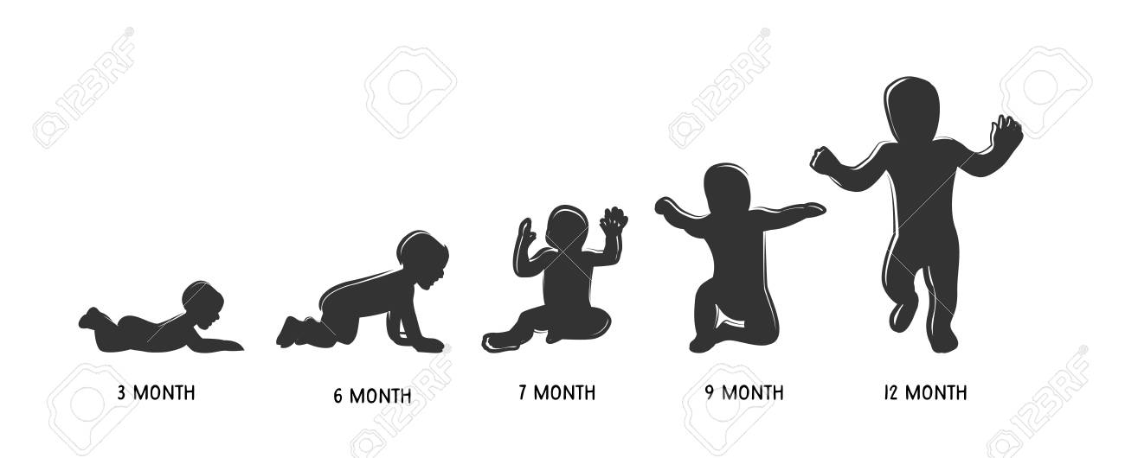
Child development is the way in how a child will grow and modify over the time of their childhood, this can be through biological development, cognitive development and environmental means (Keenan, T., Evans, S. and Crowley, K. 2016).
(Image by Lipets. J, 2020)
Factors of Child Development
Biological development can include physical maturity and advancement with motor skills, cognitive development refers to a change in mental ability, such as memory skills, problem solving, creativity and emotional development, and environmental is everything social that can change the way in how we perceive ourselves and others (Keenan, T. Et al, 2016).
Children need to incorporate these factors to achieve a stable adulthood. The beginning of life is an expedition for children, from being fully dependent upon people to care and protect them, to becoming fully independent and they have to incorporate all the skills they have developed over their childhood to be functioning adults (The University of Nottingham, No Date).
As children develop, they become explorers, they want to examine their environment, as they mature, they are able to explore more of their surroundings, they are able to respond and interact with others while following the social norms (Oswalt, A. 2020).
There are so many factors affecting a child’s development, when parents try and help their children progress in life, for example learning to walk, this does not mean that they will start sooner than anyone else, it is mainly up to a complex process which is dependent on their personality, physical wellness, mental ability, and emotional motivation (Oswalt, A. 2020).
Role of the Caregiver within Child Development
For care givers, it is up to them to help their child develop in a safe and healthy manner, children need a safe and healthy environment to explore and require a balance between boundaries and freedom of exploring their new developing skills (Oswalt, A. 2020).
Children need to have the freedom to trial and error certain situations, which is necessary for their cognitive, social and physical development (Oswalt, A. 2020). However, some parents are overprotective which can decrease developmental progress (Oswalt, A. 2020).
It is up to care givers to help expose their children to new ideas, abilities and new activities (Oswalt, A. 2020). Interacting with the children should be enjoyable and relaxed if not, the anxiety or stress from the care giver may affect the child’s development and can transferr their own feelings upon their children causing more challenges (Oswalt, A. 2020).
Nature or Nurture
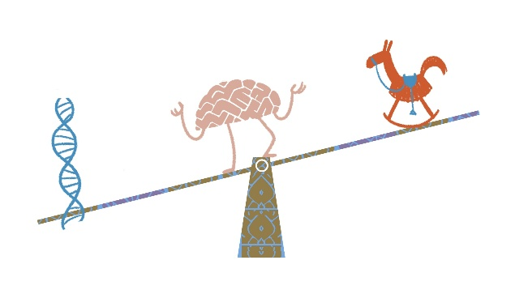
Everyone comes into the world with innate abilities, such as innate motor, hearing, smelling, touch, taste, sensory abilities and these abilities advance rapidly through their environment (Infancy and Childhood, 2020). Many researchers thought that these innate abilities could be developed by Maturation, which means having a genetic formula that has preregistered development (Infancy and Childhood, 2020). Furthermore, even though maturation is a large factor in development, children also develop skills by moving around in their environment and being affected by their environment (Infancy and Childhood, 2020).
Child psychological development has a vast array of approaches, the biological approach focuses more on genetics, while the behaviourist approach favours the environment (McLeod. S, 2018). However, both genetics and the environment contribute to physical and mental development (McLeod. S, 2018).

(Image by Moleman. P, 2018)
Child Development Theories
Within child development there are multiple theories that explore various aspects of child development, which include environmental, emotional and psychological growth (Cherry. K, 2020).
Child development occurs from birth to adulthood; however, this was largely ignored before the 20th century, children were mostly viewed as smaller adults, while little attention was paid to their advances in mental ability and physical growth (Cherry. K, 2020).
Child development became more of an interest within the 20th century, however it tended to concentrate on abnormal behaviour, in more recent years, researchers have become more interested in common child development and the influences that can affect it (Cherry. K, 2020).
It is important for adults to understand and appreciate child development, it is essential as it allows them to help children develop in the best way possible. There are many theories that have been described as grand theories, these theories attempt to define every aspect of development and often use a stage approach (Cherry. K, 2020). Other theories can be known as mini-theories, they mostly focus on a specific aspect of child development, such as physical, biological or social growth (Cherry. K, 2020).
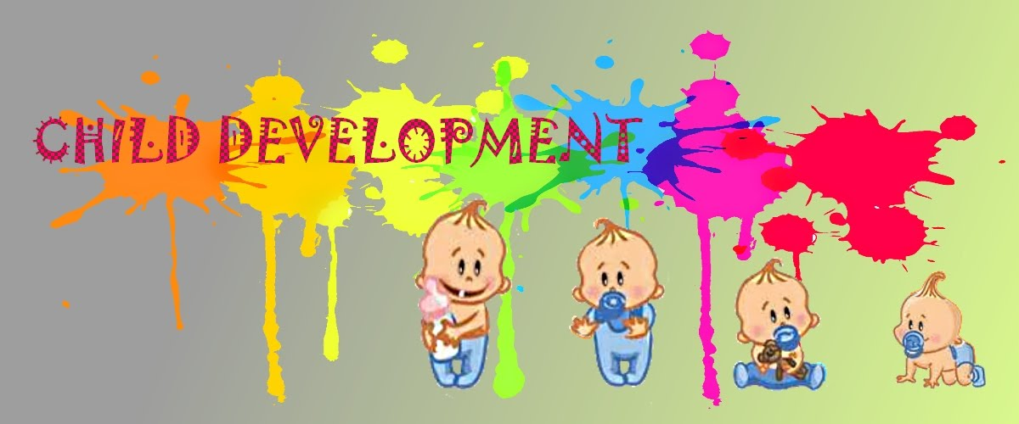
In the upcoming blogs, I will be discussing how the aspects of biology, cognitive and social factors can have an impact upon child development and include theories to support these aspects of development.

(Image by Child’s Development Milestones and Theories, No Date)

Biological Impact on Child Development (Blog 2)
Biology in Child Development
Human behaviour can be influenced by their innate characteristics, which they inherit from their parents (Nature vs. Nurture, No Date). Child development can be influenced by their biology, some biological factors can include genes, nutrition, gender, hormone levels, health, ethnicity, and disability (Haddad. D, 2019). These factors can be a positive and a negative aspect of a child’s biology, they can impact a child throughout their life and can affect them at key periods in their development (Haddad. D, 2019).
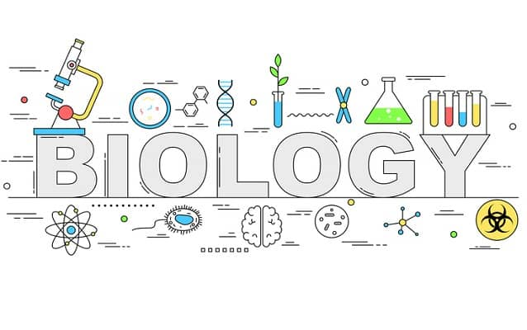
Research which was conducted at Rutgers University examined how prenatal factors affected the linguistic development of a child and how postnatal factors have a key component in a child’s cognitive capacity (Haddad. D, 2019).
A child’s biology can impact them throughout life, they may receive prejudice or discrimination for something they were born with, it may be something as little as their hair colour or more importantly which gender they may choose to appoint to themselves.
(Image by Biology, 2020)
Ethology and Child Development
There are many theories that examine how biology can affect a child’s development, Ethology theory depicts children being biologically programmed which are the products of evolution and these contribute to a survival instinct (Crowley. K, 2016). Within the Ethological theory is determines that in childhood there is a notion of a critical period, which is referred to as the sensitive period, where a child is notably ready to receive new skills (Crowley. K, 2016).

Developing various mental attributes can be seen as a way to promote a survival instinct, these are promoted in our evolutionary past (Crowley. K, 2016). Evolution can be used to explain the various aspects of child development, such as mental states and the difference of play styles between genders (Crowley. K, 2016). Moreover, evolution is seen to be helping to adapt the length of time it takes for a child to develop physically and mentally (Crowley. K, 2016).
(Image by The Theory Test, 2018)
Gender in Child Development
At birth, a child is assigned a sex based on their physical characteristics, however when they develop a question of gender identity may emerge, they may question their gender identity, which refers to an internal sense a child may have that comes from an interaction of biological traits, environmental influences and environmental conditions (Rafferty. J, 2018).
Child develop a recognition of gender as young as 4 months, they are able to differentiate between male and female faces, at 6 months they can discriminate between faces and voices by gender, they may become accustom to faces of the genders and make associations between those faces and voices (Psychol. A.R, 2010).
Children at age 2 become more conscious of their physical traits and differences between genders, at 3 most children can label themselves as either gender and by 4 they may have a stable sense of their gender identity (Rafferty. J, 2018). However, gender roles are not stereotypical, child have cross-gender preferences, playing with one another is a normal part of gender development and exploration within their own notion of their gender (Rafferty. J, 2018).
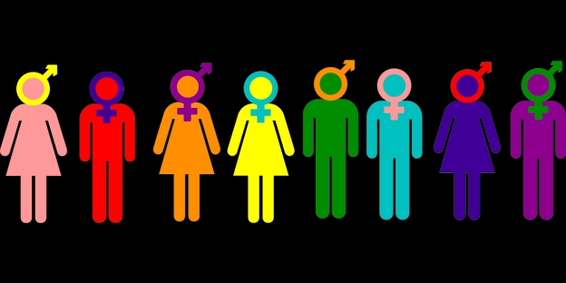
When a male is a foetus, they can produce testosterone as early as 7 weeks of gestation, which helps with growth and survival of the neurons in the many parts of their brain (Are there any differences in the development of boys’ and girls’ brains, 2020). However, male brains tend to operate their two hemispheres more individually during specific tasks, while females may use both their hemispheres to a more equal standard (Are there any differences in the development of boys’ and girls’ brains, 2020).
(Image by Turner. L, 2018)
Female infants tend to advance quicker than males when it comes to sensory and cognitive development, the females are more likely to be advanced in vision, hearing, memory, smell, and touch than their male counterparts (Are there any differences in the development of boys’ and girls’ brains, 2020). Furthermore, female infants can be more socially in tuned, they may also respond readily to a human’s voice or face and females also lead males in the development of motor and language skills (Are there any differences in the development of boys’ and girls’ brains, 2020).
Gender is a big influence in cognitive maturation, males tend to develop and learn differently from females, and research also suggests that males have a lower level of school achievement than females (Haddad. D, 2019).
However, the view of gender differs from cultures and social backgrounds, and it is important to acknowledge that biological factors do not act on their own (Haddad. D, 2019). Moreover, the environment and cognitive capacity of a child can also influence their development as well as their biology.
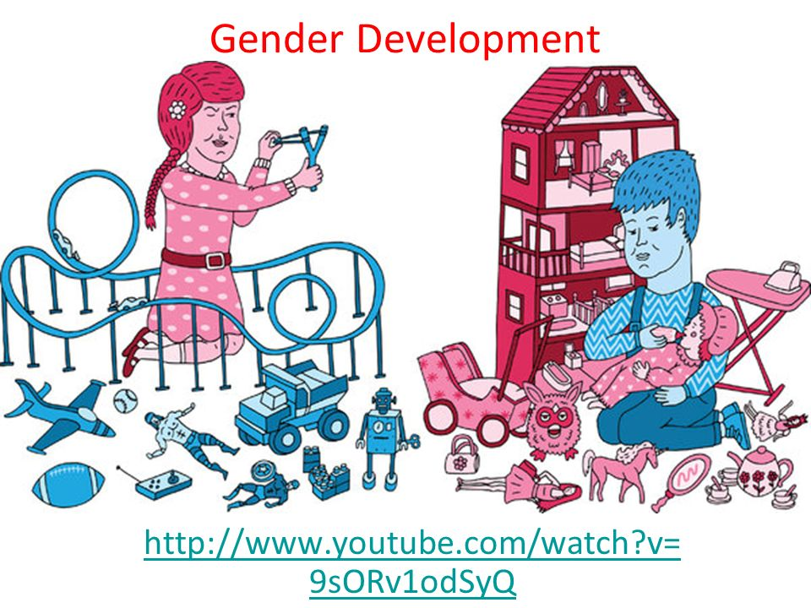
(Image by Underwood. C, 2020)

Cognitive Impact within Child Development (blog 3)
Cognitive Development
Cognitive development is extremely important in the development of a child, this is when a child’s brain develops certain skills such as thinking, learning, adventure and problem-solving skills (Cognitive Milestones, No Date). Cognitive development can also affect other areas of child development including language and social skills (Cognitive Milestones, No Date). Children advance their cognitive skills through experiencing and interacting with the environment around them, this can also help them make progress in how they may process, store and use the information that they learn (Oswalt. A, 2020).
(Image by Guye. S, 2017)
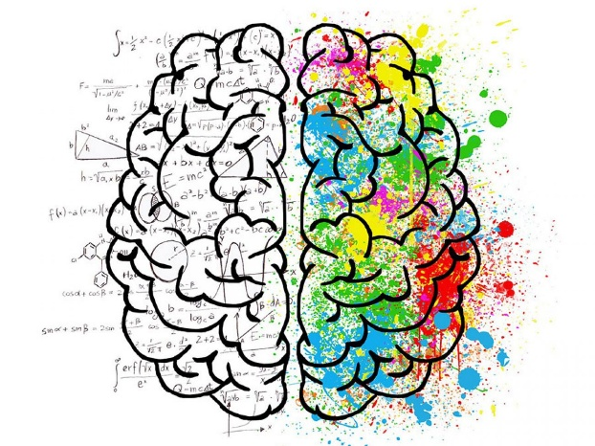
Cognitive Milestones
There are many ways to how a person can try and measure a child’s cognitive development, and this can be done through Piaget’s stages of cognitive development (Oswalt. A, 2020). Piaget was influenced by the biological notion of adaption, due to a child’s body adapting to fit into their environment, their minds adapt to help them function in that environment (Crowley. K, (2016).
Piaget assumes that children are active learners and act much like scientists performing various experiments around their environment (Cherry. K, 2020). He states that as children explore the environment, they add new knowledge, build existing knowledge and change previously held knowledge to welcome in new information (Cherry. K, 2020).
Piaget states that children go through 4 developmental stages, the sensorimotor stage: 0 to 2-year olds, the preoperational stage: 2 to 7, the concrete operational stage 7 to 11, and formal operational stage: 12 plus (Cherry. K, 2020).
During the first sensorimotor stage, cognitive development occurs in a relative short period of time but involves a considerable growth (Cherry. K, 2020). Piaget states that they learn that items still exist, even though they cannot see them, this is called object permanence (Cherry. K, 2020). He also states that children learn their actions can cause things to happen within their environment (Cherry. K, 2020).
Furthermore, the second preoperational stage, children at this stage are egocentric and are constantly getting better with language and thinking skills, however they still tend to think about things in a concrete manner (Cherry. K, 2020). The children also use basic mental portrayals such as pictures and language to represent the environment (Crowley. K, (2016).
Moreover, the third concrete operational stage, the children start to think more logically and organised about concrete events, they also begin to understand the concept of conversation, and the children can use their logic from information they have gained to use in a general principle (Cherry. K, 2020). Children at this stage become less egocentric, they understand that their thoughts are unique to them, also not everyone shares their feelings, opinions or beliefs, and they can start to think about how other people may think and feel about certain events (Cherry. K, 2020).
Additionally, the fourth formal operational stage, the children start to think abstractly, to reason about hypothetical issues and begin to use deductive logic (Cherry. K, 2020). The children may also begin to have deeper thoughts into moral, philosophical, ethical, social and political affairs (Cherry. K, 2020). Children begin to mature at this stage, they are able to think more scientifically and begin to see multiple outcomes from many potential solutions (Cherry. K, 2020).
Piaget’s cognitive development theory strongly influences child development, and has been applied within an educational environment (Crowley. K, 2016).
Parental Separation and Its Effect on Child Development
In 2007 half of divorces had at least one child under 16, 20% of these children were under 5 years old and many more go through parental separation every year that are not married (Divorce or separation of parents, 2020).
When separation of parents occurs, it is typical for the child to be unhappy, have low self-esteem, behavioural problems and a sense of loss (Divorce or separation of parents, 2020). This may be a short-term affect, however there are long term affects that can result from separation, the children tend to perform lower in education, suffer from depression and may have ongoing problems with their behaviour (Divorce or separation of parents, 2020).
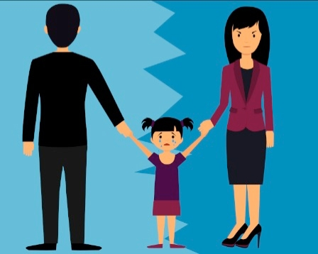
Moreover, children may suffer the trauma of relocation, where their parents move to separate locations, it can cause additional stress, the sudden shock can affect their emotional stability and can create an adjustment period for the children which may benefit them in the long term (Nickson. C, 2019). Through this adjustment period it is important that the children don’t feel abandoned as it can affect their cognitive development, it may create insecurities which may cause children to act immature to their actual age (Divorce or separation of parents, 2020).

(Image by Miles. D, 2020)
Environments Impact on Child Development (blog 4)
Environmental Development
The environment can affect children in multiple ways, it exposes them to a variety of conditions, these can include the physical environment, social environment, economic environment, and educational environment (Factors Affecting Child Development, No Date).
Some theorist for example empiricists, and behaviourists believe that at birth, children are born with a blank slate, also known as tabula rasa, this is then filled by experiencing or learning through their environment (McLeod. S, 2018). The environmental theorists believe that children develop psychological and behavioural characteristics from their surrounding environment and observing others (McLeod. S, 2018). For example, Banduar’s famous Bobo doll experiment findings saw that aggression is learnt from the environment through observation and imitation (McLeod. S, 2018).
Social Development
From birth, children will learn how to be social, and develop better social skills throughout their childhood (Social Development, No Date). When the child is 6 weeks, they begin to socially smile and become attached to main carers, then by age 2 they are able to be social with other children, playing together, and taking turns. (Social Development, No Date).
Additionally, by the time a child is 3 they start to imitate and start to develop routines (Social Development, No Date). The children start to form relationships via their close social network, they will try to play with other children and begin to show empathy towards others (Social Development, No Date). When they reach 5, children should be able to get dressed and use the toilet by themselves, this is done through repetition within their home environment (Social Development, No Date).
However, as puberty starts their environment may change, and they will have to be able to adapt to the many changes that will happen to them physically and mentally (Social Development, No Date).

Family Environment
Consequently, a child’s family is the most important part of their development, the bonding between family members helps nurture and protect the child from physical and emotional harm (Arora. M, 2018). The family of a child can affect their environment immensely, their education, health, finance, and attention towards the child can all have an impact upon their development (Arora. M, 2018). The parents have to make the best possible choices for their children which will affect their indoor and outdoor exposure to any environment (Influences on Children’s Health, 2004).
(Image by Arnold-Korzeniowskil. K, 2018)
Moreover, the effect of a child’s household environment impacts their development dramatically, this can include their physical surroundings, including the noise, aggressive family members, and the amount of people who live there (Arora. M, 2018). The child may imitate the behaviour which they have seen at home, while they are at school and be punished for it not being socially acceptable in that environment (Arora. M, 2018). Having a negative house hold can cause some children to become more emotional distant and introverted which can affect them in later life ((Arora. M, 2018).
While in education it is up to the parents, and the school itself to make sure that the child has the best possible environment to help develop their skills (Arora. M, 2018). Children are constantly monitored within their education setting to see if they are hitting their developmental milestones, if they are not, it is up to their teachers to make sure their parents know and then try to help their children progress further (Factors Affecting Child Development, No Date).
Moreover, as children get older, they will spend more time in different physical locations outside the household, such as school, friends’ houses and even a workplace (Influences on Children’s Health, 2004). Carers of children should constantly encourage their developments, when learning new skills in the physical environment, or psychological environment, all developments should be valued and supported (Factors Affecting Child Development, No Date).

Reference List:
Are there any differences in the development of boys’ and girls’ brains? 2020. Available at: https://www.zerotothree.org/resources/1380-are-there-any-differences-in-the-development-of-boys-and-girls-brains (Date Accessed: 15/04/20)
Arnold-Korzeniowski. K, 16/11/2018. Dear Caregivers, We See You and We Thank You. Available at: https://www.oncolink.org/blogs/2018/11/dear-caregivers-we-see-you-and-we-thank-you/ (Date Accessed: 28/04/20)
Arora. M, 16/08/2018. 5 Important Factors That Influence Early Childhood Development. Available at: https://parenting.firstcry.com/articles/5-environmental-factors-influencing-early-childhood-development/ (Date Accessed: 27/04/20)
Biology. 2020. Available at: https://english-online.org.ua/materials/13468 (Date Accessed: 28/04/20)
Cherry. K, 04/01/2020. Child Development Theories and Examples. Available at: https://www.verywellmind.com/child-development-theories-2795068#the-background-of-child-development-theories (Date Accessed: 27/04/20)
Cherry. K, 31/03/2020. The 4 Stages of Cognitive Development. Available at: https://www.verywellmind.com/piagets-stages-of-cognitive-development-2795457 (Date Accessed: 27/04/20)
Child’s Development Milestones and Theories. No Date. Available at: https://sites.google.com/site/1122703096v1/development-stages-1 (Date Accessed: 28/04/20)
Children’s Health, The Nation’s Wealth: Assessing and Improving Child Health. 2004. Available at: https://www.ncbi.nlm.nih.gov/books/NBK92200/ (Date Accessed: 27/04/20)
Cognitive Milestones. No Date. Available at: http://helpmegrowmn.org/HMG/DevelopMilestone/CognitiveMilestones/index.html (Date Accessed: 19/04/20)
Divorce or separation of parents - the impact on children and adolescents: for parents and carers. 2020. Available at: https://www.rcpsych.ac.uk/mental-health/parents-and-young-people/information-for-parents-and-carers/divorce-or-separation-of-parents---the-impact-on-children-and-adolescents-for-parents-and-carers (Date Accessed: 27/04/20)
Early Childhood Assessment. 2014. Available at: http://resourcesforearlylearning.org/fm/early-childhood-assessment/ (Date Accessed: 15/04/20)
Evans, S. and Crowley, K. (2016) An Introduction to Child Development. 3rd edition. London: Sage. Available at: https://books.google.co.uk/books?id=yl8CDgAAQBAJ&pg=PT165&dq=Keenan,+T.,+Evans,+S.+and+Crowley,+K.+(2016)+An+Introduction+to+Child+Development.+3rd+edition.+London:+Sage.&hl=en&sa=X&ved=0ahUKEwiR2bHGoe_oAhXinFwKHWTWAScQ6AEIMjAB#v=onepage&q=Keenan%2C%20T.%2C%20Evans%2C%20S.%20and%20Crowley%2C%20K.%20(2016)%20An%20Introduction%20to%20Child%20Development.%203rd%20edition.%20London%3A%20Sage.&f=false (Date Accessed: 27/04/20)
Factors Affecting Child Development. No Date. Available at: https://www.beststart.org/OnTrack_English/2-factors.html (Date Accessed: 27/04/20)
Guye. S, 03/07/2017. Can cognitive training really make us smarter. Available at: https://bold.expert/can-cognitive-training-really-make-us-smarter/ (Date Accessed: 28/04/20)
Haddad. D, 14/09/2019. Biological Factors That Influence Child Development. Available at: https://www.verywellfamily.com/biological-factors-affecting-child-development-2162219#citation-3 (Date Accessed: 15/04/20)
Important Milestones: Your Baby By Two Months. 24/10/2019. Available at: https://www.cdc.gov/ncbddd/actearly/milestones/milestones-2mo.html (Date Accessed: 15/04/20)
Infancy and Childhood. 2020. Available at: https://www.sparknotes.com/psychology/psych101/development/section3/ (Date Accessed: 15/04/20)
Introduction. No Date. Available at: https://www.nottingham.ac.uk/helmopen/rlos/child/foundation/page_one.html (Date Accessed: 27/04/20)
Lipets. J, 28/04/2020. Vector – Baby development icon, child growth stages, toddler milestones of first year. Available at: https://www.123rf.com/photo_95895805_stock-vector-baby-development-icon-child-growth-stages-toddler-milestones-of-first-year-.html (Date Accessed: 28/04/20)
Martin. L. C, and Ruble. N. D, 20/08/2013. Patterns of Gender Development. Available at: https://www.ncbi.nlm.nih.gov/pmc/articles/PMC3747736/ (Date Accessed: 15/04/20)
McLeod. S, 2018. Nature vs. Nurture in Psychology. Available at: https://www.simplypsychology.org/naturevsnurture.html (Date Accessed: 27/04/20)
Miles. D, 2020. There Are No Winners In The Game Of Parental Alienation. Available at: https://www.ourfamilywizard.co.uk/blog/there-are-no-winners-game-parental-alienation (Date Accessed: 27/04/20)
Moleman. P, 18/01/2018. Nature and nurture: congenital and acquired. Available at: https://breininactie.com/nature-and-nurture-congenital-and-acquired/ (Date Accessed: 28/04/20)
Nature vs nurture debate. No Date. Available at: https://www.nottingham.ac.uk/helmopen/rlos/child/foundation/page_three.html (Date Accessed: 27/04/20)
Nature vs. Nuture. No Date. Available at: https://courses.lumenlearning.com/atd-hostos-childdevelopment/chapter/nature-vs-nurture/ (Date Accessed: 27/04/20)
Nelson. C. A, and Michalowski. J, 22/06/2018. How Does Parental Separation Affect a Child’s Brain? Available at: https://www.brainfacts.org/thinking-sensing-and-behaving/childhood-and-adolescence/2018/how-does-parental-separation-affect-a-childs-brain-062218 (Date Accessed: 19/04/20)
Nickson. C, 18/11/2019. The Psychological Effect of Separation on Children. Available at: http://www.separateddads.co.uk/psychological-effect-separation-children.html (Date Accessed: 19/04/20)
Oswalt. A, 2020. Different Types of Development. Available at: https://www.gracepointwellness.org/461-child-development-parenting-infants-0-2/article/11377-different-types-of-development (Date Accessed: 15/04/20)
Oswalt. A, 2020. Early Childhood Cognitive Development: Introduction. Available at: https://www.gracepointwellness.org/462-child-development-parenting-early-3-7/article/12757-early-childhood-cognitive-development-introduction (Date Accessed: 27/04/20)
Rafferty. J, 18/09/2018. Gender Identity Development in Children. Available at: https://www.healthychildren.org/English/ages-stages/gradeschool/Pages/Gender-Identity-and-Gender-Confusion-In-Children.aspx (Date Accessed: 15/04/20)
Social and Emotional Milestones. No Date. Available at: http://helpmegrowmn.org/HMG/DevelopMilestone/SocialEmotionalMilestones/index.html (Date Accessed: 27/04/20)
Social Development, No Date. Available at: https://www.nottingham.ac.uk/helmopen/rlos/child/foundation/page_seven.html (Date Accessed: 27/04/20)
THE THEORY TEST. 2018. Available at: https://www.ian-markwick.co.uk/get-an-lgv-licence/theory-test/ (Date Accessed: 28/04/20)
Turner. L, 19/04/2018. The Gender War: Why The 2 Gender Model Is Dumb. Available at: https://medium.com/@lucylit/the-gender-war-why-the-2-gender-model-is-dumb-1c0f04548bae (Date Accessed: 28/04/20)
Underwood. C, 2020. Gender Development. Available at: https://slideplayer.com/slide/9020792/ (Date Accessed: 28/04/20)

