Postgraduate Certificate in Teaching
in Higher Education (Advanced HE accredited)

UNHE7009/7010

Advanced Teaching and Assessment in Higher Education

Patronella Ganza
2321767

I confirm that I have not presented any AI-generated materials as my own work in this portfolio. However, I acknowledge that I have used Grammarly to proofread and improve the readability of my portfolio.

Table of Contents
Reflective Report of a Teaching Intervention Cycle 3
Description of the experience 4
Feelings 7
Evaluation 8
Analysis 10
Conclusion 13
Action Plan 13
References 16
Poster : Student Engagement 18
Observations 20
PGCert tHE Observation Form (1) 20
Reflective report 20
Reference 24
PGCert tHE Observation Form (2) 24
Reflective report 24
Reference 29
PGCert tHE Observation Form (3) 29
Reference 33
Non-academic Misconduct and Conflict Management 33
References 36
Disability Awareness Session: Hidden Disabilities 36
References 38
Academic Misconduct workshop 39
References 41
Reflective Statement 42
References 43
Appendix A 44
PG Cert tHE -TEACHING LOG FOR PATRONELLA GANZA 44

Reflective Report of a Teaching Intervention Cycle
Introduction
My teaching intervention is grounded in the Professional Standards Framework (PSF) 2023, as it recognises the diverse contexts in higher education and the various practices that contribute to high-quality learning. All my experiences and evidence in my teaching reflection are outlined in the D2 descriptor, one of the framework's dimensions. Within the higher education institution where I work, I wear two hats: a lecturer and an academic programme manager (PM). These two roles significantly promote effective practice, demonstrate leadership within the professional team while valuing students, offer support, and enhance effective learning (V5).
To guide this report, I utilise the Gibbs Reflective Cycle (1988) as a framework for structured reflection. I chose this reflective cycle because it offers a systematic approach to learning from experience, utilising its six stages (see Fig. 1 below). Its cyclic nature is beneficial for analysing repeated experiences to facilitate learning and planning for what worked or did not work (Trimasse, 2024). In contrast, other reflective models, such as Driscoll's (1994) model of reflection, are more systematic in their approach to asking what, while Kolb's (1984) reflective model also emphasises learning through action and reflection.
Reflective skills play a vital role in any profession, enhancing practices to provide adequate service to students and other professional departments. According to Barton and Ryan (2013), reflection is a transformative process that enables the acquisition of deep and substantive knowledge. In academic settings, Ryan (2011) suggests that reflection is associated with transforming practice, whether regarding learning or professional practices. On the other hand, Rogers (2001) contends that reflection is a cognitive and emotive process that necessitates active participation. This implies that reflective practices demand more than simply narrating events; they should involve understanding, critical thinking, and the capacity to transcend various stages of a particular event. The analysis and evaluation of interpretations must include one’s beliefs and action plans.
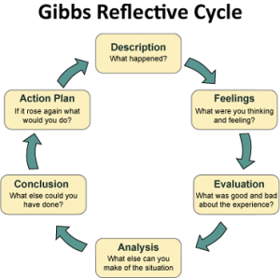Fig. 1 Gibbs Reflective Cycle (1988)

Description of the experience
The teaching intervention is based at a higher education institution with a diverse student population in the United Kingdom, whom I respect as I impart knowledge to learners with different personal characteristics and multiple marginalised factors (V1). The demographic statistics of the cohort are as follows: 558 students in the 2024/2025 academic year. Most students (68%) are 30 years and older, with 95% having no declared disability. Ethnic groups include: White 60%, Asian 6%, Black 18%, Mixed 2%, and Other 14%. Evidence suggests a growing increase in student populations in higher education as institutions create responsive learning environments (Awang-Hashim et al., 2019). This, in turn, enables educators to address diverse related issues, achieve equity, and enhance participation.
As a lecturer in a class of 30 students, my role includes implementing pedagogical activities such as teaching, designing and preparing learning materials, and developing and applying new teaching methods to reflect changes in research (A1). To achieve this, I used online tools, role plays (practical examples in class), and written assessments to enable effective and inclusive learning. Due to the diverse nature of the students, my responsibility also lies in identifying those who need support through referring to the appropriate services (A4). Since I was teaching the group for the first time, my initial approach fluctuated between a facilitative and authoritarian style (V3). By week three, I could identify students who were engaged in the learning process, participating actively, and motivated to succeed (V2). This observation was made through interactions with students in class, including those who contributed to tasks, maintained regular attendance, and responded to additional support outside of learning time. In contrast, this observation also revealed that students who arrived late to class or left early, some of whom might have slept during lessons, and others missed sessions were disengaging with the module.
These disengaged students were frequently in and out of class, disrupting the lecture flow. To avoid these disruptions and ensure inclusivity, I encouraged the students to participate in class and group activities and share their experiences (A2). Thomas (2012) asserts that educators should prioritise creating an inclusive and supportive learning environment that caters to each student's needs and fosters a sense of belonging. The other approach that I used was asking questions about the lecture content, the students reacted aggressively, raising their voices or shouting in class. This behaviour often led to students storming off or causing disagreements with others who were keen to learn. This caused distressed among student, considering the unconducive learning environment, especially those with mental health conditions and learning disabilities. Finn and Zimmer (2012) argue that student engagement involves adhering to classroom rules, punctuality, and respectful interactions with teachers and peers. I had to organise separate meetings with each of the disengaged students inorder to understand what was triggering some classroom behaviours and to emphasise the University's non-academic misconduct policy (A4).
The outcome of the meetings indicated that, although students are enthusiastic about learning and wish to change their lives, external factors hinder their engagement. From my interaction with them (A2), I identified that; two students lived far from the campus, which strained their finances and made it challenging to afford food and shelter. According to Kahu and Nelson (2018), the well-being of students serves as a mediating mechanism between contextual variables, such as living far from campus, and student engagement. An audit report of 140 universities in the UK indicates that 27% operate food banks, and 11% provide vouchers to their students in acknowledgement of rising poverty levels (Hanna, 2023). Another student reported being evicted from her home and facing homelessness with her child; therefore, focusing on education was one of her least concerns. According to Digby and Fu (2017), individuals experiencing homelessness are more likely to lack fundamental educational abilities and/or credentials, which has a substantial impact on schooling. Disrupted education and a lack of interest in additional education and training are frequently considered contributing factors, leading to entrapment in low-wage, hazardous employment with few prospects for progression (Quilgars et al., 2008). Additionally, a common theme reported in the meeting was domestic violence (DV). Three women stated that their partners were assaulting them, but due to financial constraints and responsibilities for their children, they felt compelled to stay with their husbands. Due to the university safeguarding policy, I raised a cause for concern and referred them for counselling as it is my responsibility to maintain safety for learners (A4. K5). In a cross-sectional study of 368 university students, 28. 7% reported experiencing DV at some point in their lives, while 19% encountered DV later in adulthood (Attalla and Rome, 2020). The study found that experiencing DV negatively impacts academic achievements. These issues affect both learning (for students) and teaching in higher education (for lecturers), as they influence overall performance beyond the individual student. Monitoring student retention, withdrawal, and progression rates as a PM is crucial to the program's success. Therefore, meeting with the students to understand their disengagement was essential for establishing a foundation and building evidence of positive impact (V4). This shows that there are broader contexts in which higher education operates, which have implications for lecturers' practice.

Feelings
After teaching several groups over the past years, I initially believed I would continue using the same approach to deliver my sessions, which always involved being firm. I had previously encountered students who deliberately disengaged because they were only interested in student finance loans or leaving without a proper plan for attending university. Upon meeting these students, I concluded that their behaviour was related to past/present experiences and other external factors. More importantly, it seemed that many students in the group were equally disengaged. I initially felt disrespected as some students would yell when confronted. The first few weeks of the term were emotionally and psychologically draining. However, after consulting with some lecturers facing similar challenges in their classrooms (V5), I was determined not to give up on these students. Having the students talk to me individually and open up about hidden challenges led to a breakthrough. Sundani and Mamokhere (2021) note that the relationship between students and lecturers is essential, as it enhances decision-making processes and identifies overarching barriers to promoting quality education, ultimately impacting academic performance. Reflecting on this case, I am overwhelmed by how it unfolded. I progressed from teaching a class with students who were not engaging with the learning materials, did not submit mid-term assessments in week five, and missed classes, to showing compassion and employing a holistic approach in my conversations, resulting in positive and improved classroom outcomes and participation (K1). I created a conducive learning environment which fosters student engagement (A2); through having an open-door policy, students can have a safe space to raise concerns. The group also connected through buddy systems, where students support each other on tasks. However, this outcome came with perceived difficulties, such as inadequate time for individual meetings, resources, and information. This was frustrating because, as a lecturer, I am motivated by seeing my students succeed as I impart knowledge. Yet, when I direct students to some services (A4), they often lack the resources to support them fully. Additionally, information regarding domestic violence and homelessness is not available on the information platforms, despite many students experiencing these hardships.

Evaluation
Having disengaged students with behavioural challenges can be very difficult for a lecturer. Moreso, disruptions has negative impact on other students’ mental well-being. Taking immediate action could have alleviated my emotions, as I dreaded teaching the class during those first few weeks. However, I am pleased that I did not ignore the situation, as I recognised that something needed to be done. The observations helped build evidence, which I used when meeting the students. My actions and behaviour were tested; even though I felt disrespected, the intervention of communicating and understanding my students better overshadowed my initial perceptions of them. I learnt to see students as individuals who, like anyone else, can face challenges in life. More importantly, the students' behaviour served as a defence mechanism since they had no one to listen to or support them. Therefore, my actions towards them in class influenced when those mechanisms arose. With interventions such as helping students to interrupt studies, signposting for counselling, and referring to the local authority for temporary accommodation, I felt fulfilled, fostering a sense of belonging among the students (V2). I had to share my experience with colleagues who had encountered similar challenges in their classes. The positive learning atmosphere is reflected in the eagerness of students to participate, submit assignments, improve their grades, and provide feedback through surveys, including module evaluations and the National Student Survey (NSS) or UKES (K3). Using the PV11a annual programme monitoring report, statistics showed improvements in programme retention levels (89% to 92%) and module evaluation feedback (61% to 67%). In addition to the reports, I collected student feedback to evaluate the overall satisfaction with the programme (K3). Out of 470 students on the programme, I received 81% responses, and overall, the students were satisfied with the programme and the support they received from the lecturers and other departments to learn and submit their assessments effectively. Below are some of the feedback comments collected from students anonymously :
“Pat is an excellent and brilliant teacher. I appreciate her method, which makes me want to engage more. She brings out the best in her students”.

“It is wonderful to have a good lecturer. Having a skilled and engaging teacher can make a significant difference in your learning experience. Pat, you are wonderful to everyone. Thank you for the support this term, particularly after our meeting on my personal circumstances.”

“Thank you to all my lecturers in the term. I am now completing term 3. It was not easy. I am a domestic abuse victim. I received most of my support from Bianca and PM Pat. The only issues the university needs to improve are food choices, online classes when there are strikes, and support with housing/ finances for DA victims”.

Analysis
Student engagement is universally acknowledged as a critical factor affecting academic success and learning in higher education. Fostering active engagement is not a one-size-fits-all concept, as students are diverse and have different learning needs. Although institutions may assert success in enrolling 'non-traditional' students (widening participation), numerous students encounter considerable obstacles in pursuing higher education (Harding, 2011; Rose-Adams, 2013). Therefore, as a lecturer, when organising a lesson for students, I consider their varying learning styles to minimise the need for additional assistance (A1). For instance, I offer educational resources ahead of time, utilise lecture recordings with captions, and provide audio and video transcripts (V2). According to Singh (2011), BAME students have half the likelihood of graduating with a "good degree" compared to white students, and are more likely to report unhappiness with their university experience or drop out. Black and ethnic minority graduates typically earn less than their white colleagues and have a much lower employment rate six months after graduation (Zwysen and Longhi, 2016).
Thus, this intervention was selected due to the diverse students enrolling who face various barriers to learning, which negatively impact their engagement in class (V2). Two theories support this intervention. Firstly, the sociocultural theory (Vygotsky, 1978) offers a broader social context for understanding students' perspectives by emphasising the importance of social interaction and collaboration in learning processes. It considers the individual (interests, motivation, cognitive capacity), environment (relationships, external forces), culture (language, behaviour), and historical context (attitude, perception, past experiences). Applying this theoretical principle helped me improve student learning, retention, and progression through interactions with them in the 1:1 meetings, and providing an open door to assist and refer according to needs (K1). However, it is argued that sociocultural theory alone is insufficient as an explanatory framework for student engagement (Kahu, 2013). Secondly, the educational engagement theory (Rachmad, 2022) is also analysed, underscoring the significance of active participation in the educational process to achieve optimal learning outcomes (see Fig. 2 below). This theory emphasises the involvement of various stakeholders, including students, lecturers, and departments, in well-being, disabilities, and finances, to create meaningful and compelling learning experiences. In practice, I have directed my students to various services to enhance their learning and help them reach their full potential, such as the disability, wellbeing and finance departments (V5). Although physical presence is essential, engagement should encompass emotional, cognitive, and behavioural involvement (Kahu, 2013).
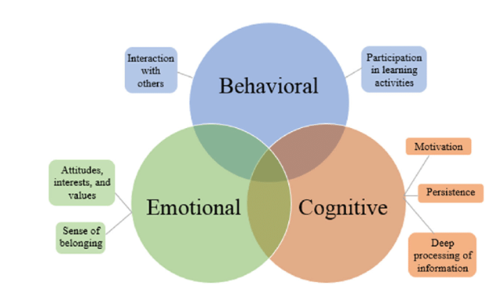
Fig 2. Educational Engagement Theory
Combining the social, cultural, and educational engagement theory into this reflection could assist in solving some of the challenges that did not go well, such as applying the same context when dealing with students from diverse backgrounds. Whereas, when you understand each student by taking a holistic approach to their learning, for example, my interactions with each one promote clarity for both the lecturer and the students, as an understanding is built upon (K2). Biggs and Tang (2011) contend that a lack of student proficiency is not always the cause of teaching failure, which occurs when students fail to learn. Thus, it is believed that the teacher's actions have a greater influence on learning than the kinds of pupils one teaches. Hence, I became aware of the various approaches that encourage students to engage with their learning in class (V1, V2). Considering the number of students in higher education, having the time to interact on a one-to-one basis could be a significant concern. Moreover, given the volume of administrative tasks in academia, other lecturers may perceive these interactions as unnecessary. In addition, due to the staff shortages in different departments, there is a delay in assisting students when they are vulnerable and need help. As a result, such students will likely self-withdraw or be forced to withdraw due to a lack of engagement. After reviewing this intervention, submission rates increased from 62% to 68%. This is connected to having the ability to identify students who were disengaged in class, understand their challenges, then signpost, provide appropriate resources for learning and supporting them to complete their assignments during class times (A4). Some of my students did not have laptops to complete their assessment, therefore, they had the ability to borrow from the library and completed their tasks in class (K4). This gave them the opportunity to get clarify on assessments and gained summative feedback (A3). Besides the submission increase, positive feedback was received from the programme's external examiner:
Comment from External Examiner:
“Overall the assessment strategy is strong and clear. The module learning outcomes have always been reflected in the assessment and this is consistent and strong. The assessment documents have always been well laid out, containing relevant information and guidance on how to approach the assessment as well as marking criteria. The marking criteria used has been appropriate and the assessments have been appropriate for the modules and level of study. There is a very robust internal moderation process in place and this is to be commended. The marking has been consistent and fair. The standards are consistent and favourably with other UK institutions. Increased submissions are noted, which summarises the programme's success”.

Conclusion
I learnt that every student is different, regardless of their physical presence at the University. Their sociocultural, cognitive, behavioural and environmental factors can impede their success in higher education. As a lecturer, it is essential to address any behavioural concerns immediately as prolonging this can impact other learners, particularly those with mental health or learning difficulties. Moreover, I will continue to diligently identify students who need support and apply the education engagement theory to explore any barriers (A4). Lastly, I learnt that sometimes we must challenge our ability as lecturers by coming out of our comfort zones and dealing with classroom behaviours or challenges without fear or feeling disrespected. Ideally, a more positive experience would have involved scenarios where students only disengaged without the behavioural aspects (non-academic misconduct). However, the combination of these aspects cannot be easily wiped away unless addressed. In the future, I will consider the students' diversity, strive to understand them from the first week, and promote an open-door policy where students can interact with me on either module-related or other aspects that may affect their learning (V1). I will also consider gaining training in managing behavioural issues in class, so that I can handle these types of situations more effectively.

Action Plan
There are various ways that I can adopt to deal with similar situations. However, these future strategies can be classified into three categories: micro, meso, and macro levels. Firstly, at the micro-level, strategies I will adopt include considering Maslow’s hierarchy of needs, which consists of the five stages, namely physiological needs, safety needs, love/belongingness needs, esteem needs and self-actualisation as seen on Fig. 3 below (Maslow, 1943). The fundamental needs are physiological and safety needs, which comprise necessities like food, housing, a comfortable temperature, safety, and security (Abbas, 2020). As psychological demands, love/belongingness and esteem encompass interpersonal relationships, social networking, self-assurance, and respect for and from others. According to Abbas (2020), self-actualization encompasses creativity, achievement, skills, and problem-solving abilities.
I will develop approaches that encourage students to engage positively with student services early in their learning (including library services, learner support and career services, for example (A4). This could be either developing a questionnaire that students can complete during the induction period, so that structures are put in place before the term starts. I will also consider integrating diverse perspectives (e.g. minority or indigenous values) into programmes, pedagogies, and/or approaches to student support services (A4). I still think it's critical to include a variety of cultures and societies in my lessons and to acknowledge the value of preparing students for a world that is becoming more diverse and interconnected by having a solid grasp of the problems that people who are different from themselves face (V4). However, to successfully achieve this, based on my understanding of the students' pedagogical value and limitations, I would need to implement teaching that makes use of a variety of technologies and resources. For example, utilising digital technologies to improve live interactions with students, such as through live polls, or interacting with them via webinars, videoconferencing, or asynchronous learning through discussion forums, blogs, etc (K4).
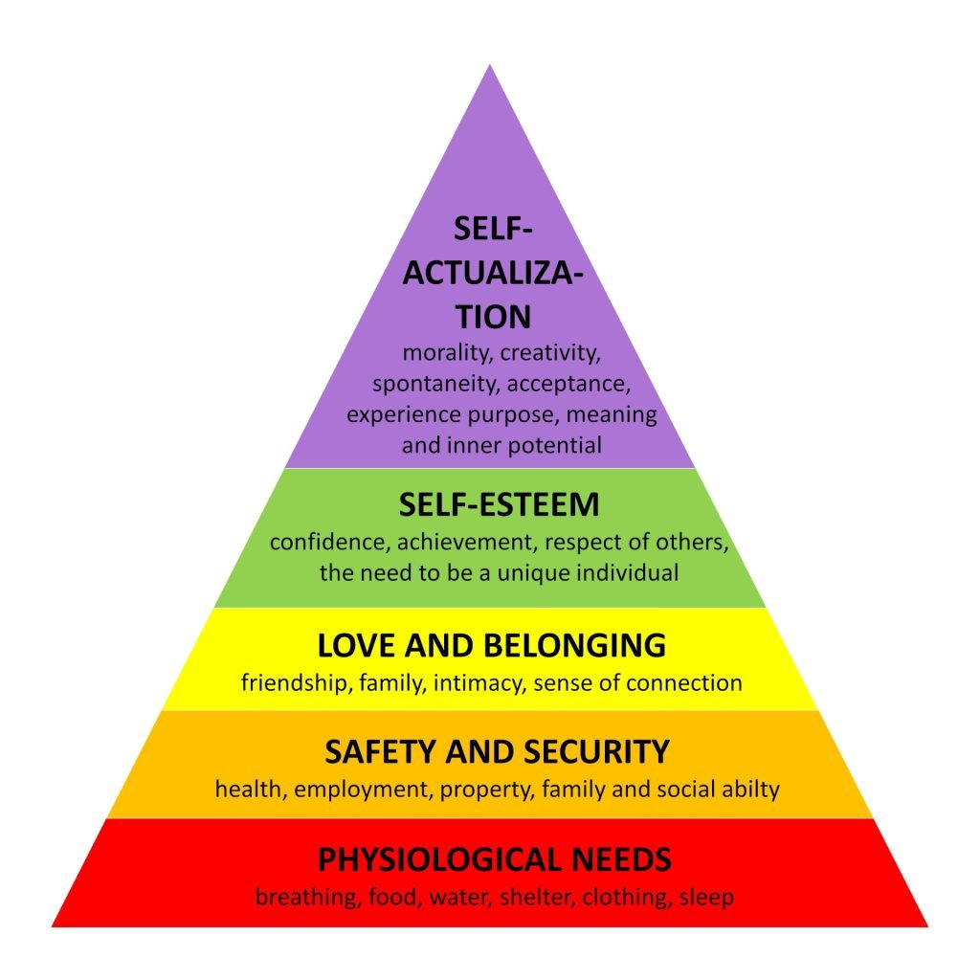Fig 3. Maslow Hierarchy of Needs

Secondly, as a programme PM, at the meso level, I will analyse the teaching issues at the campus, supporting and encouraging my colleagues through engaging in university trainings that can assist in achieving better student engagement (V5, A5). In addition, I can leverage the trans-disciplinary approach through cross-campus collaborations, in order to integrate sustainability into teaching programmes. This way, I will gain insight into various challenges encountered and decisions that are made to overcome them, which I will disseminate with my colleagues on my campus. In addition, it is important for me to plan learning activities that are flexible, inclusive, offer learners some choice, promote engagement and active learning (V2). For example, during curriculum reviews, having portfolios as assessments can promote incorporating either practical or written tasks to be achieved rather than having a non-flexible curriculum, eg writing an essay, which can increase the use of artificial intelligence (AI) and increase academic misconduct. Hence, in the forthcoming curriculum, I will think about rethinking practical assessment with a simulation method created for a class project or creating an industry-related unit or module employing gaming concepts (gamification) (K2). However, higher education institutions face several challenges such as lack of adequate resources to enhance effective teaching and learning outcomes (Chang and Lui, 2025). It is important for me to advance my knowledge through learning from research seminars, conference presentations, scholarly networks and collaborations (V3)
Lastly, at the macro level, I plan to engage with external experts (e.g. industry, community) to help provide a positive impact on the programme (V5). For example, I can collaborate with local health and social care organisations, NHS, Social services, and local authorities to provide workshops at the university or offer volunteering services that the students can utilise. Integrating authentic workplace resources and activities in teaching, showing an understanding of how learners learn in practical settings (K1), can motivate students, increase engagement as they apply learning to practice. More importantly, I can suggest to the university management the importance of work placement in health programmes.

References
Abbas, J., (2020). Service quality in higher education institutions: qualitative evidence from the students’ perspectives using Maslow hierarchy of needs. International Journal of Quality and Service Sciences, 12(3), pp.371-384.
Attalla, S.M. and Bt Rome, A.A., (2020). Effects of Domestic Violence on Academic Achievement among University Students in Selangor, Malaysia. Malaysian Journal of Medicine & Health Sciences, 16.
Awang-Hashim, R., Kaur, A. and Valdez, N.P., (2019). Strategizing inclusivity in teaching diverse learners in higher education. Malaysian Journal of Learning and Instruction, 16(1), pp.105-128.
Barton, G., & Ryan, M. E. (2013). Multimodal approaches to reflective teaching and assessment in higher education. Higher Education Research & Development, 33(3), 409–424. https://doi.org/10.1080/07294360.2013.841650.
Biggs, J. and Tang, C. (2011) Teaching for quality learning at university. Open University Press, McGraw Hill.
Chang, J. and Liu, D., (2025). Optimising learning outcomes: A comprehensive approach to virtual simulation experiment teaching in higher education. International Journal of Human–Computer Interaction, 41(4), pp.2114-2134.
Digby, A. and Fu, E. (2017) ‘Impacts of homelessness on children – research with teachers, Shelter’. [Online] Available at https://england.shelter.org.uk/__data/assets/pdf_file/0011/1474.
Driscoll, J. (1994). Practicing clinical supervision: A reflective approach. Ballière Tindall.
Gibbs, G. (1988). Learning by doing: A guide to teaching and learning methods. Further education unit. Oxford.
Hanna, L. (2023). Are On-Campus Food Banks the New Staple? [online]. Available at: https://www.hepi.ac.uk/2023/09/14/are-on-campus-food-banks-thenew-staple/#:~:text=HEPI’s%20latest%20report%20on%20how,%25)%20of%20 universities%20in%20Wales [Accessed 12 February 2025].
Harding J (2011) Financial circumstances, financial difficulties and academic achievement among first-year undergraduates. Journal of Further and Higher Education 35(4): 483–499.
Kolb, D. A. (1984). Experiential learning: Experience as the source of learning and development. Prentice-Hall.
Maslow, A.H. (1943). A theory of human motivation". Psychological Review, 50(4), 370–396.
Quiglars, D., Johnsen, S. and Pleace, N. (2008) ‘Youth homelessness in the UK’. [Online]. Available at https://www.jrf.org.uk/report/youth-homelessness-uk (Accessed 20 February 2020).
Rachmad, Y. E. (2022). Educational Engagement Theory. Lüneburger Heide Buch Internationaler Verlag, Spezialausgabe 2022.[online] https://doi.org/10.17605/osf.io/kgtcx [Accessed 20th February 2025].
Rogers, R. R. (2001). Reflection in higher education: A concept analysis. Innovative Higher Education, 26(1), 37–57. https://doi.org/10.1023/A:1010986404527.
Rose-Adams J (2013) Leaving university early: Exploring relationships between institution type and student withdrawal and implications for social mobility. Widening Participation and Lifelong Learning 15(2): 96–112.
Ryan, M. (2011). Improving reflective writing in higher education: A social semiotic perspective. Teaching in Higher Education, 16(1), 99–111. https://doi.org/10.1080/13562517.2010.507311
Singh G (2011). Black and minority ethnic (BME) students’ participation in higher education: improving retention and success. York: Higher Education Academy.
Sundani, N.D. and Mamokhere, J., (2021). The impact of student-lecturer relationship on good decision making and quality promotion in the institutions of higher education and training. African Perspectives of Research in Teaching and Learning, 5(2), pp.136-147.
Thomas, L., (2012). Building student engagement and belonging in Higher Education at a time of change. Paul Hamlyn Foundation, 100(1-99), pp.1-102.
Trimasse, N., (2024). The use of reflective reports in higher education. Reflective Practice, pp.1-18.
Vygotsky, L. S. (1978). Mind in Society: The Development of Higher Psychological Processes. Cambridge, MA: Harvard University Press.
Zwysen. W, and Longhi. S., (2016). Labour market disadvantage of ethnic minority British graduates: university choice, parental background or neighbourhood? London: Institute for Social and Economic Research.

Poster : Student Engagement

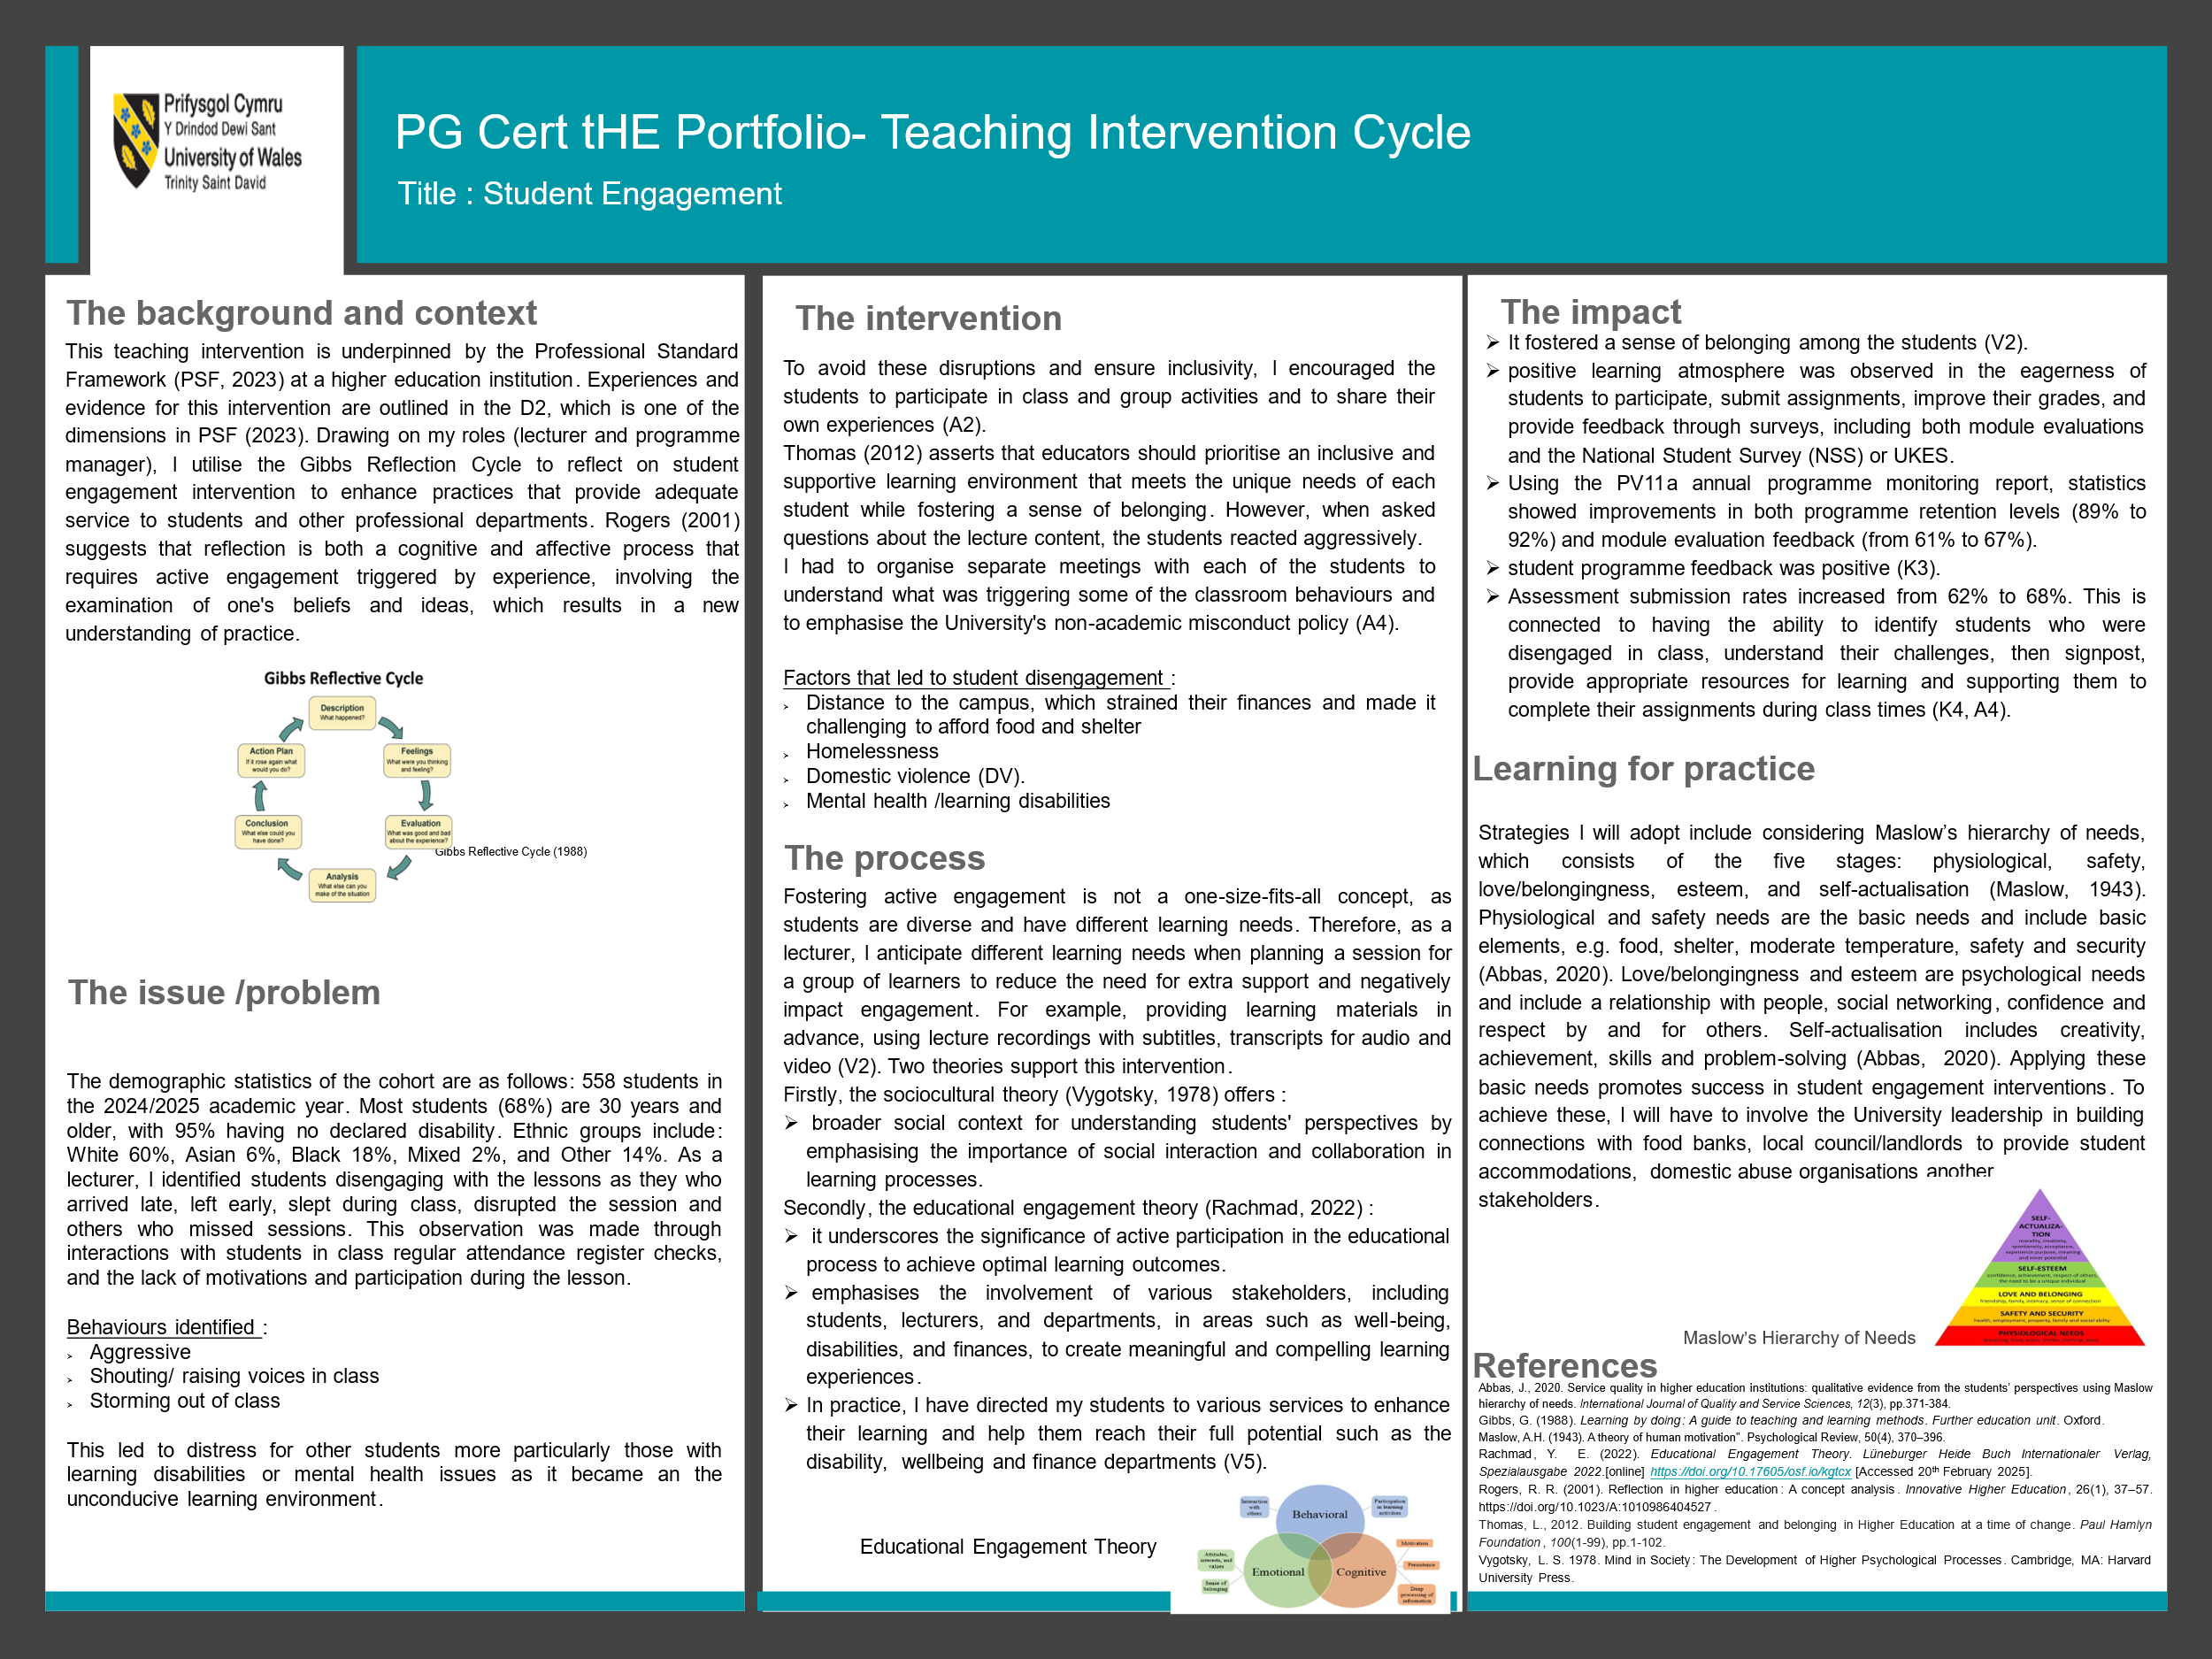

Observations

PGCert tHE Observation Form (1)

Reflective report
Details of the Observation
Observee | Dr Patronella Ganza
Practice Advisor / Expert peer observer | Dr Lizeta Demetriou
Date of the Observation | 6th of March 2025
Campus / Location | London
Date, Time, Duration | 6th March 2025, 09:30 – 10:30
Subject Speciality | Introduction to Health and Social Care
Type of activity | Lecture
Teaching/Support preparation [A1: Design and plan learning activities]

Comments
Patronella designed an effective lesson plan that fostered an interactive learning environment. By incorporating various elements such as group discussions, question-and-answer sessions, and formative feedback, Patronella ensured that students were actively engaged throughout the lesson. These interactive components not only facilitated deeper understanding but also encouraged students to participate and collaborate with their peers. Her approach to teaching was dynamic and responsive, adapting to the needs of the students and promoting a more inclusive and participatory classroom experience.
Moreover, Patronella demonstrated thorough preparation and a strong grasp of governance and quality frameworks. This expertise was evident in the design of the lesson and the materials used, which were tailored to the appropriate level for Level 4 students. The well-structured lesson plan and relevant materials contributed to a cohesive and enriching lecture.
The methods used throughout the lesson, ensured that all the students in the class were engaged and participating in the lesson.

Teaching [A2: Teach and/or support learning.]
Comments
The aims of the presentation were to discuss quality and governance in health and social care, while the part observed focused on CQC Fundamental Standards. The key teaching aid for this lesson was the whiteboard. From the first couple of minutes of this observation, it was evident that Patronella had established an excellent rapport with the students. This allowed for a conducive learning environment to be created in addition to enhancing student engagement and motivation. The good rapport between Patronella and students was crucial in creating an atmosphere where students felt comfortable participating and contributing to the discussion.
Despite the classroom being relatively quiet with a few dominant students, Patronella’s practices, such as asking and answering questions, significantly enhanced student engagement and contributions. Patronella clearly explained the topic of the lesson and provided relevant examples to reinforce understanding. Her ability to connect with students and encourage their participation ensured that even the quieter students felt included and valued. This approach aligns with educational research that emphasizes the importance of interactive teaching methods in promoting active learning and student involvement. Importantly, Patronella effectively summarized the topic at the end of the lesson, which allowed students to consolidate their understanding.
In future lessons, it will be beneficial to use additional teaching aids, such as flipcharts. For instance, when students were assigned to a group and asked to complete a discussion activity, flip charts could have been given to them so that they can take notes and present their discussion back to the whole class.

Effective Learning Environments [A4:Develop effective learning environments and approaches to student support and guidance.]

Comments
Patronella demonstrated a keen understanding of her students' needs and levels, ensuring that the examples she provided were accessible to everyone in the class. This inclusive approach encouraged students to share their own examples from personal experiences, enriching the learning environment with diverse perspectives. Despite the presence of dominant students, Patronella made a concerted effort to engage all members of the class. When she assigned group work activities, she actively circulated around the classroom to ensure that every group member was involved in the discussion. This hands-on approach not only fostered collaboration but also ensured that quieter students had the opportunity to contribute, thereby enhancing the overall engagement and learning experience.
Assessment [A3: Assess and give learners feedback]

Comments
Patronella exhibited excellent class management skills and consistently provided formative feedback to the students throughout the lesson. Her positive feedback approach helped reinforce students' understanding and confidence. The question-and-answer techniques she employed were particularly effective in gauging whether the students had a solid understanding of the lesson content. To further enhance engagement in future lessons, it could be beneficial to nominate quieter students to speak. Additionally, during group work activities, asking questions specifically to quieter members can help involve them without putting them on the spot, fostering a more inclusive and supportive learning environment.

Core Knowledge

Comments
Patronella demonstrated excellent knowledge of the lesson topic, which was evident in her clear and confident delivery. The quality of the materials she used was very good, enhancing the overall learning experience. Her well-prepared slides, relevant examples, and structured content ensured that all learners were engaged and could easily follow along. This thorough preparation and understanding of the subject matter helped students to understand the topic more effectively.

Professional values

Comments

Patronella's ability to connect the lesson content with real-world applications reinforced students' understanding. Patronella established excellent rapport with her students, creating a welcoming and supportive classroom environment. Her approachable demeanor and genuine interest in student contributions encouraged active participation throughout the lesson. By fostering a sense of trust and respect, she made students feel comfortable sharing their thoughts and asking questions. Patronella's interactive teaching methods, including group discussions and formative feedback, further promoted student engagement.

Examples of good practice:
- Patronella established rapport with her students and created a supportive learning environment.
- Patronella’s teaching methods, including the question and answers technique as well as the group discussion ensured that students were actively engaged.
- The use of real life examples further enhanced students’ understanding of the lesson.
- Excellent manner of providing formative feedback.

Action points:
- Patronella could utilize a range of other teaching methods, such as flipcharts to enhance students experience.
- Quiter students can be nominated to provide examples in class or during group work.
Observer ...Dr Lizeta Demetriou Date 07/03/2025

Observee .......P.Ganza.. Date 10/03/25


My teaching session on the importance of governance and quality in health and social care is covered in this reflective report. The framework Gibbs's (1998) reflective cycle will be used to analyse how Dr. Lizeta's observations have affected my instruction.
My teaching methods, capacity to hold students' attention, presenting style, and the tools utilised during the session were the main areas of Dr. Lizeta's observation. The pedagogical approach included the use of digital technologies and resources for learning such as Moodle, quizzes on Kahoot, interactive whiteboard, videos and incorporated group discussions (K2, K4). Interactive sessions promoted student engagement, ensuring all students were learning (A2). Some parts of the lesson were question-and-answer sessions, and I provided formative feedback (A3). According to Pepple (2022), student involvement reflects their educational experiences and is a key factor in their performance in higher education. It concerns learning, tenacity, contentment, and academic achievement (Kahu and Nelson, 2018). My teaching approach effectively created a positive learning environment as I was confident in delivering the session, as the topic was one of my areas of expertise (A5). This was achieved through lesson preparations, reading and making use of published literature (V3). However, there are always areas for improvement, such as identifying quiet students early and including them in discussions and group tasks. This approach aligns with educational research that emphasises the importance of interactive teaching methods in promoting active learning and student involvement (V2). Given this knowledge, I am able to identify my areas of strength and growth. Although my method of instruction fosters a supportive learning atmosphere, there is room for improvement in the following areas:
- I could utilise a range of other teaching methods, such as flipcharts to enhance students experience.
- Quiter students can be nominated to provide examples in class or during group work.

Reference
Gibbs, G. (1998). Learning by doing: A guide to teaching and learning methods. London: Further Education Unit. Oxford Polytechnic: Oxford.
Kahu, E.R. and Nelson, K., (2018). Student engagement in the educational interface: Understanding the mechanisms of student success. Higher education research & development, 37(1), pp.58-71.
Pepple, D.G., (2022). An ecological perspective of student engagement through digital technology: Practical application and implications. British Educational Research Journal, 48(6), pp.1216-1231.

PGCert tHE Observation Form (2)

Reflective report

Details of the Observation
Observee | Dr. PATRONELLA GANZA
Practice Advisor / Expert peer observer | Dr. Hoang Nguyen
Date of the Observation | 20th March 2025
Campus / Location | London
Date, Time, Duration | 09:30-10:30. One hour.
Subject Speciality | Effective Communication in Health and Social Care
Type of activity | Lecture
Teaching/Support preparation [A1: Design and plan learning activities]

Comments
- The lecturer presented a well-structured lesson plan, effectively allocating time and content to support both teaching and learning objectives for the session.
- The teaching and learning methods selected were highly suitable, fostering an active learning environment through a combination of lecturing, interactive questions and answers, and a participatory activity.
- The lecturer demonstrated thorough preparation for the session and displayed excellent knowledge of the subject matter.

Teaching [A2: Teach and/or support learning.]

Comments
- The majority of the observed session focused on lecturing, with the presentation being clear and delivered at an appropriate pace.
- The lecturer provided verbal reinforcement and encouragement effectively.
- Slides projected onto a screen were the primary teaching medium, with no handouts or additional digital resources used.
- Communication between the lecturer and students was effective, fostering a positive learning environment.
- A strong rapport between the students and the lecturer was evident.
- The teaching methods employed were appropriate, but the session could have been enhanced with additional resources, such as using a whiteboard to record student responses during group activities or summarizing the previous session’s learning points.

Effective Learning Environments [A4:Develop effective learning environments and approaches to student support and guidance.]

Comments
- The class atmosphere was excellent, with students displaying a relaxed, quiet demeanor and a positive attitude. No disruptions occurred during the session.
- Students demonstrated strong attention retention and were highly engaged throughout the class.
- The lecturer actively encouraged quieter students to participate by seeking their opinions on the topic, ensuring inclusivity in the discussion.
- When students struggled to understand a question or failed to respond, the lecturer skillfully rephrased it to facilitate comprehension.
- Most students grasped the information effectively and performed well in the assigned task.
- The lecturer maintained a positive attitude towards the students and exhibited enthusiasm for the subject matter.
Assessment [A3: Assess and give learners feedback]

Comments
- The lecturer employed formative assessment through a group activity focused on the week's topic.
- The question-and-answer technique was used multiple times and executed effectively.
- Classroom management was handled well, with no disruptions and strong attention retention from students.
- The lecturer demonstrated an appropriate attitude towards the students, effectively managing the class by establishing rules for participation (e.g., guidelines for speaking).
- Positive reinforcement was provided to students who answered correctly, with encouraging remarks such as "well done."
- The instructions for the group activity were clear and easy to follow.

Core Knowledge

Comments
- The lecturer displayed strong subject knowledge and active listening skills.
- The teaching methods were suitable and effective but could have been enhanced by incorporating a wider range of resources and learning technologies.
- The lecturer demonstrated proficiency in evaluating student responses, both during the recap and the group task.
- The observed teaching session was effective in supporting student learning.
- Clear guidance was provided by the lecturer regarding the tasks discussed, as well as the group activity.
- The formative assessment methods, teaching techniques, and classroom conduct aligned appropriately with the University's Academic Quality Handbook.

Professional values

Comments
- The lecturer showed respect for learners and their perspectives, offering support to those who struggled to understand the questions or recall previous discussions.
- Students were addressed by names.
- Participation was actively encouraged, with efforts to ensure all students engaged in the discussion or activity.
- Evidence-informed approaches were employed, and the Lesson Plan was both thorough and appropriate for the session.
- An attitude of inclusivity and appreciation for diversity was evident in the lecturer's interactions with students.

Examples of good practice:
- Actively promoted an engaging, participatory learning environment throughout the class.
- Demonstrated excellent teaching and learning practices, showcasing strong skills as an educator.
- Maintained high levels of student engagement during the session.
- Actively encouraged students to participate and contribute to the class activities.
- Provided clear explanations and guidance to support students who needed additional assistance with their learning.
Action points:
- to use more bullet points, not full sentences, in the slides to encourage students to take notes.
- to use the smart screen to take note and emphasize the slide's contents
- To also walk down the tables to interact with students who are sitting in the back
- To give students a minute or two to internalise the learning experience.
- To use more resources for teaching and learning (e.g. whiteboard, online resources, etc.)

Observer ....Hoang Nguyen......... Date 20th March, 2025
Observee ........P. Ganza Date 25th March 2025

My teaching experience on effective communication in health and social care is covered in this reflective report. I will discuss how my teaching has been impacted by Dr. Hoang's observations.
I started the session with a recap of what had been taught in the previous session (A3). Evidence suggests the importance of brief recap tests or questions that cover the important concepts from the prior class (Dunlosky and Rawson, 2015). Recapping sessions can be used as an assessment tool to promote effectiveness in enhancing the learning of diverse individuals and groups. As the session progressed, I included questioning, group tasks, a video session on the topic which prompted me to provide verbal reinforcement and engage student learning (A2). Teachers and preceptors have long used questions as teaching tools to assess students’ knowledge, promote comprehension, and stimulate critical thinking (Tofade et al., 2013). This increased the student’s confidence and understanding of the topic, and helped build a rapport. However, I was able to identify some students who were not participating and were a bit quieter (V2). This was one area I needed to develop in my teaching, according to Dr Lizeta’s observation. Identifying disengaged students is vital in any class setting, hence I reached out by seeking their opinions on the topic, which ensured inclusivity in the discussion. More importantly, when students struggled to understand a question or failed to respond, I skilfully rephrased it to facilitate comprehension. The effectiveness of a question is significantly influenced by the word choice and phrasing. Rephrasing the question or offering clarifying remarks can assist students understand the purpose of the question when a desirable response is not available after the first prompt (Tofade et al., 2013). My teaching approach demonstrated an appropriate attitude towards the students, and I effectively managed the class by establishing rules for participation. By setting these expectations, I was able to foster a more respectful and productive learning environment.
From this observation, I can provide an insight into my strengths and areas I can improve. While my teaching style contributes to a positive learning environment, areas to improve will include:
- To use more bullet points, not full sentences, in the slides to encourage students to take notes.
- To use the smart screen to take note and emphasize the slide's contents
- To also walk down the tables to interact with students who are sitting in the back
- To give students a minute or two to internalise the learning experience.
- To use more resources for teaching and learning (e.g. whiteboard, online resources, etc.)

Reference
Dunlosky, J. and Rawson, K.A., (2015). Practice tests, spaced practice, and successive relearning: Tips for classroom use and for guiding students’ learning. Scholarship of Teaching and Learning in Psychology, 1(1), p.72.
Tofade, T., Elsner, J. and Haines, S.T., (2013). Best practice strategies for effective use of questions as a teaching tool. American journal of pharmaceutical education, 77(7), p.155.

PGCert tHE Observation Form (3)
Reflective report

Details of the Observation
Observee | Dr. Patronella Ganza
Practice Advisor / Expert peer observer | Dr. Renuga Jayakumar
Date of the Observation | 3/4/2025
Campus / Location | London
Date, Time, Duration | 3rd April 2025, 9:30am-10:30am, 1 hour
Subject Speciality | Health
Type of activity | Lesson
Teaching/Support preparation [A1: Design and plan learning activities]

Comments

The lecturer has organised the lecture delivery neatly. Delivery of the session was designed with appropriate tasks.

Teaching [A2: Teach and/or support learning.]

Comments

Started the class with checking the learning with previous lesson and after reinforcing the learning moved to introduce the new topic.
Relevant live examples were used. Steady pace has been maintained throughout. Good use of question session, used different types of questions to reinforce the learning. Very good rapport has been evidenced between student and teacher.

Effective Learning Environments [A4:Develop effective learning environments and approaches to student support and guidance.]

Comments

Very active and friendly environment for learning. The students actively engaged in the learning activities. Students brought recent examples and relate it with the topic discussed. The lecturer has tried to accommodate the individual learners need wherever possible.

Assessment [A3: Assess and give learners feedback]

Comments

Used lot of questions to assess the learners. Also, used relevant case studies to enhance the students analytical skills.
Core Knowledge

Comments
The lecturer demonstrated excellent in-depth knowledge in the subject, and showcased very good classroom management. Students enjoyed the learning, engaged very well with the learning process.

Professional values

Comments

At different times during the class, the lecturer made an effort to ensure everyone is participating. Very good research has been evidenced in the slides. The students were identified with their names.

Examples of good practice:
Warm and congenial learning environment. Activities like case studies and questions were well crafted to encourage the students to engage with the learning activities. Very active and energetic packed lesson.

Action points:
The questions sessions could have been crafted with quiz sessions such as Vevox or Mentimeter to create a competitive learning environment.

Observer ......Renuga Jayakumar......... Date : 3/4/2025

Observee .............P. Ganza................. Date : 9/4/2025

This reflective report covers the observation experience of my teaching session on equality and discrimination in health and social care. I will examine how Dr. Renuga’s observations have influenced my teaching. This session covered one of the important topics in health and social care, which is how to promote equality and understand the nine characteristics of discrimination according to the Equality Act 2010. Adequate preparation was made prior to the session using my expertise in the health sector which aided understanding of the topic (K3). In this class, a few of the students are already working in the health and social care sector. Therefore, they brought recent examples and challenges in their workplaces. To enhance learning, I provided case studies and relevant examples (K2). A study that compared the learning outcomes of 348 students who were given instructor-provided examples versus student-generated examples during a lesson found that students who created their own examples performed worse on a recall and application test than students who were exposed to instructor-provided examples (Bolkan and Goodboy, 2019).
Due to the length of the session (four hours), I tried to accommodate learners wherever possible by providing breaks, time to interact, and adopting various techniques that promote learning styles (V1). A comprehensive understanding of the various learning styles of students and effective classroom management techniques can also contribute to improved academic performance. It is also well accepted that students' lack of motivation, discipline issues, and dropout rates may be caused by a mismatch in their learning styles (Yotta, 2023). Accommodating learners in the classroom can implement various strategies, including differentiated instruction, scaffolding, providing choices, and creating a positive learning environment. These approaches aim to cater to diverse learning styles, needs, and abilities, ensuring all students have opportunities to succeed. My in-depth knowledge of the subject aided this, which helped me facilitate good classroom management skills. The role of classroom management in creating effective learning is shown by the pivotal role of lecturers in their knowledge in subject matter, designing curriculum, and teaching methods (Gultom and Saun, 2016). Another study established the importance for lecturers to foster relationships with their students to create a positive learning atmosphere (Chandra, 2015). Hence, I call students by their name in class and try to meet those I think need support and refer them to appropriate services (A4). In the session, I included the use of the whiteboard for elaboration, and students engaged on Moodle as they participated in online activities as proposed by Dr Hoang in my previous observation (K4). While my teaching style contributes to a positive learning environment, areas to improve recommended by Dr Renuga include:
- Using technological devices for interaction sessions in class
- Adopting other ways to promote interactions and engagement with the lesson such as using Vevox or Mentimeter on quizzes.

Reference
Bolkan, S. and Goodboy, A.K. (2019). Examples and the facilitation of student learning: Should instructors provide examples or should students generate their own?. Communication Education, 68(3), pp.287-307.
Chandra, R. (2015). Classroom Management for Effective Teaching. International Journal of Education and Psychological Research (IJEPR), 4(4).
Gultom, E., & Saun, S. (2016). The role of classroom management in creating an effective English learning. Journal of English Language Teaching, 5(1), 18–24.
Yotta, E.G. (2023). Accommodating students' learning styles differences in English language classroom. Heliyon, 9(6).

Non-academic Misconduct and Conflict Management

CPD event: Non-academic misconduct and conflict management
Organiser: UWTSD
Time &. Date: 4th February 2025 at 10am – 11am
Location: Microsoft Teams

Reflective report
I attended a CPD event titled “ Non-academic misconduct and conflict management” by David Sherwood on Microsoft Teams on February 4, 2025. This session was important for me to attend as it guided lecturers on managing conflicts and non-academic misconduct in the classroom, particularly when students are from various backgrounds. Some of the topics that were covered were the student code of conduct, expectations as a professional, recording disruptive behaviour, good practice and how to report.
During the session, the student code of conduct was emphasised as it includes what is expected of the students and the lecturers, such as conducting ourselves as professionals at all times as we represent the University. Section 11.1 of the Non-academic Misconduct policy states that in circumstances where poor attendance, health and safety, danger to self or others, or verbally and physically abusive behaviour, lecturers should exercise their professional judgement to exclude the student from the class session. This helps in promoting a conducive learning environment for the other learners (A2). It is important that students are aware of and understand this policy so that they can access it when needed and ensure their conduct is in alignment with institutional and legal expectations (Andrews-Brown, 2022). As a lecturer, I set ground rules that are agreed by everyone in the class, promote effective communication, deal appropriately with student complaints, and promote engagement through class contributions, group tasks, or comfort breaks (A2). As a program manager, I have been involved in several incidents as a mediator, where the lecturer is unable to resolve a dispute with a student or is unable to solve students' disputes. In such scenarios, I remain calm and professional at all times and avoid confronting the student(s) in front of the class. This is because disruptive behaviour has implications for the learner's experience, particularly those with hidden disabilities or mental health conditions (V4). Therefore, it's critical that I take proactive, supportive action when I see difficulties emerging and deal boldly and effectively with issues that arise during teaching or support sessions, either for or between individuals or groups, especially those who are marginalised.
During the CPD workshop, I gained new insights which enriched my teaching practice, such as understanding the reporting process. For example, if there is a cause for concern and a non-academic misconduct incident needs reporting, a Proforma – Part A form is completed, which should detail the event and add any evidence. This is assessed by the academic team, who can either call the student for suspension or go through an investigation and a panel to make an informed decision on the academic plan of the student. This process aligns with K5 of the PSF2023, which involves taking deliberate steps to adhere to regulations or standards to ensure the quality of the learner experience is appropriate for other learners. As a PM, I have learnt to support my lecturing team when they may encounter disruptive behaviours in class (V5). For example, in meetings, I emphasise maintaining safety for learners, set ground rules, respect professional boundaries and know my learners, such as what can trigger them and what to do in such cases. The UWTSD policies and procedures on non-academic misconduct align with V4 of the PSF, demonstrating my capacity to learn the wider context of higher education. This is because non-academic misconduct is associated with factors such as economic, psychological, economic and social factors (Biggs and Tang, 2011).
To conclude, the CPD session was very insightful. It provided knowledge and encouraged lecturers to understand the policies and procedures to follow when faced with difficult classroom situations. I can now confidently visit my classes knowing what to do and how I can support other lecturers. I believe attending this event has contributed significantly to my professional development relevant to the PSF 2023, as I need to set clear expectations for behaviour in the learning environments on your programmes (A5).

References
Andrews-Brown, A. (2022). Communicating non-academic policies to students: Exploring effective practices in higher education institutions. [online] https://ucalgary.scholaris.ca/server/api/core/bitstreams/f48f0999-699f-4dff-94dd-fe2d1632936c/content [Accessed on: 9th April 2025].
Biggs, J. and Tang, C. (2011). Teaching for quality learning at university. Open University Press, McGraw Hill

Disability Awareness Session: Hidden Disabilities

CPD event: Disability Awareness Session : Hidden Disabilities
Organiser: UWTSD
Time &. Date: 27th March 2025 at 10am – 11am
Location: Microsoft Teams

Reflective report
I attended the CPD workshop titled: Disability Awareness: Hidden Disabilities led by the Disability team across the campuses of UWTSD. The CPD was essential for my learning as I teach students from diverse backgrounds, and inclusive practice is an important aspect of higher education learning and teaching practice (V1). A disability is not immediately apparent, for example, autism, ADHD, mental health (Couzens et al., 2015). An individual can have both visible and invisible disabilities. Globally, 1 in 7 individuals have a disability, and of those, 80% are invisible (Homecare, 2025). These illnesses can have a fluctuating effect, which can lead to the student not attending classes, feeling fatigue, brain fog and problems with memory and concentration (Kendall and Tarman, 2016). Hence, Couzens et al. (2016) argue that “self-disclosure of a disability is a very personal decision”. For this reason, some students are discrete about their condition and do not get reasonable adjustments in place until the assessment period, when they encounter challenges completing assessments. The CPD workshop also provided insights on autistic students find it challenging to communicate or interact with others, take long to understand information as they have stressors around sensory extremes like bright light, loud noises, and find it hard to understand how other people think. 3.5% of students in HE are identified as having an Autism Spectrum Condition (Hubble and Bolton, 2021). Autistic students had just a 40% chance of reaching their desired academic achievement, which is 12% lower than the average student population (Bharat et al., 2021).
Due to the invisible nature of disabilities, I promote appropriate teaching environments (A2) by including regular breaks and allowing students to leave the class at any point during the class to rest. I also directly engage with those who have disclosed their disability by offering additional learning workshops as a means to achieve equity (V2) and help overcome barriers students are likely to encounter. Nevertheless, it is my practice to continue identifying students who are likely to have hidden disabilities (V4). Recognition of the significance of the external issues has an effect on learning and teaching in higher education and influence the learning experience. For example, students get overwhelmed during assessment periods and are unsure who can assist them. In such cases, I signpost to the disability team (A4) to assess after completing a dyslexic checklist. Signposting provides additional breaks and opens up the conversation to get support, 1:1 mental health or study skills tutoring. The spoon theory provides strategies to manage the condition or illness in the units of energy (Lange, 2022). This means planning, pacing and managing strategies are crucial. Without the application of the spoon theory, students disengage, are disruptive or have a destressed behaviour as they cannot conserve their energy for the more useful things in the day. Hence, when I identify these students, I apply clear and explicit instructions at individual levels (K1). This act can be challenging, particularly when you have module content to cover and at the same time trying to balance the teaching approach that meets all the learners in the classroom. Therefore, at the end of the class, I request for the students to stay behind and check for clarity or summarise the main points and offer the student the opportunity to ask questions.
The CPD equipped my teaching and provided knowledge on how to cater for students with hidden disabilities. Students with hidden disabilities in higher education may experience anxiety and challenges in reading, comprehending complicated texts, taking notes during lectures, writing essays, synthesising course material, and managing their time. Therefore, as educators, we need to understand that many students live with multiple marginalising factors (V1), and we can apply various teaching approaches to support students learning (K2).

References
Bharat, R., Uzaina, Niranjan, S., Yadav, T., Newman, S., Marriott, J., Smith, G. and Sawlani, G., (2021). Autism Spectrum Disorder in the COVID 19 Era: New Challenges—New Solutions. Indian pediatrics, 58(9), pp.890-891.
Couzens, D., Poed, S., Kataoka, M., Brandon, A., Hartley, J., & Keen, D. (2015). Support for students with hidden disabilities in universities: A case study. International Journal of Disability, Development and Education, 62, 24–41.10.1080/1034912X.2014.984592.
Homecare. (2025). Non-visible disabilities: Living with a hidden disability. [online] Non-visible disabilities | Living with a hidden disability [Accessed on 9th April 2025].
Hubble, S. and Bolton, P., (2021). House of Commons Briefing Paper: Support for Disabled Students in Higher Education in England [online]
Kendall, L., (2016). Higher education and disability: Exploring student experiences. Cogent Education, 3(1), p.1256142.
Lange, S., (2022). Different not less: Neurodiversity as a lens for understanding our students better. Scope: Contemporary Research Topics (Learning and Teaching), 11, pp.112-119.

Academic Misconduct workshop

CPD event: Academic Misconduct Workshop
Organiser: UWTSD
Time &. Date: 8th April 2025 at 11am – 12noon
Location: Microsoft Teams

Reflective report
I attended the Academic Misconduct workshop led by Jason Harcourt, one of the Academic Investigators at the institute. The workshop was essential for my CPD as a lecturer because it directs my professional conduct when marking and understanding the procedure when referring students who have either plagiarised, collusion or there are aspects of false authorship. Several factors have been identified as contributors to academic misconduct. Awasthi (2019) suggested that the assessment task and individual attitude are major factors in academic misconduct. Although Sozon et al. (2025) identified cultural, psychological, social, institutional and individual factors that contribute to academic misconduct. Examples of individual factors include lack of time management to complete the assessment, stress, anxiety or being overwhelmed and lack of motivation. In addition to the above, Lancaster (2020) adds that essay mills and the integration of artificial intelligence (AI) such as ChatGPT, have increased academic misconduct and has diminished academic integrity across higher education. While maintaining academic integrity is crucial for all fields of study, the health field is more vulnerable to issues than many others when it comes to claiming that students are qualified for practice. There are serious risks in the health field if a student graduates and enters the workforce without having acquired the necessary skills.
Hence, the workshop provided insights into identifying academic misconduct and ways to report or, more importantly, reduce incidences of bad practice. As a program manager, I initiate the discussion on academic misconduct in classes and introduce the academic misconduct policy to the learners (K5). To enhance good practice, I support the lecturers on the program to provide adequate time for learners to write parts of their assessments during class time (K2). Other elements discussed in the workshop were the increased number of students that lack paraphrasing skills or understanding the importance of referencing. In my role as PM, my termly planning for the program includes collaborating with other services to enhance practice, such as library services, academic support and digital skills officers to visit the student groups (V5, A1). This application informs the students to be aware of resources that are available to them. Even though the visits are once a term, the lecturers need to continue supporting the students in the correct use of AI, paraphrasing and referencing correctly (A4). It is argued that lecturers lack adequate time to teach other aspects of academia due to the heaviness of the module content that maximises the teaching time (Sutoro, 2021). To conclude the workshop, Jason emphasised the importance of designing assessments that mitigate academic misconduct. Each term, I have been involved in setting assessments for all six modules on the programme as per the existing curriculum (A1). The assessments include relevant professional and digital skills and/or encourage students to express ideas in digital media or using subject-specific technologies in authentic contexts. Therefore, the assessments include exams, portfolio tasks and reports to help reduce academic misconduct.
Through the CPD event, I gained new strategies to better support students and the lecturing team in understanding the institute's academic misconduct policy. For the students, it helps them recognise the consequences faced, and for the lecturing team, it guides them in grasping how to identify and report, using the SC05 form and attaching evidence (A5). In conclusion, the CPD event was an excellent opportunity for me to develop knowledge and skills related to the University procedures and how my Pm and lecturing role are linked to it. As a result, l believe the event has contributed significantly to my professional development relevant to the PSF.

References

Awasthi, S., (2019). Plagiarism and academic misconduct: A systematic review. DESIDOC Journal of Library & Information Technology, 39(2).
Lancaster, T., (2020). Academic discipline integration by contract cheating services and essay mills. Journal of Academic Ethics, 18(2), pp.115-127.
Sozon, M., Alkharabsheh, O.H.M., Pok, W.F., Sia, B.C. and Chowdhury, M.A., (2025). Exploring three decades of key themes and trends in academic misconduct in higher education institutions: a literature review. Journal of Applied Research in Higher Education.
Sutoro, M., (2021). November. Reality of Lecturers’ Performance, What’s Next?. In The 1st International Conference on Research in Social Sciences and Humanities (ICoRSH 2020) (pp. 320-324). Atlantis Press.

Reflective Statement

This reflective statement focuses on the development throughout the program and analyses the future development while applying PSF 2023. As a lecturer in higher education, effective teaching which meets the learning needs of diverse students is paramount. It was important for me to do my PGCert qualification as an academic staff in order to deliver effective teaching practice. Effective teaching is characterised by the depth of subject knowledge, student engagement and also the different teaching methods that the lecturer can apply. To accommodate a range of demands, different educational approaches, interactive platforms, group support, and assessment are required (Davidoff and Jayusi, 2025). At the start of the PGCert, I was anxious as I did not know how to complete the qualification, considering my personal circumstances, such as completing a PhD, work and family life. However, I was determined to go through the learning process to the end, as I received enormous support from my supervisor. My main challenge was having time to reflect on practice considering the overwhelming workload, managing students, on the programme, supporting lecturers, attending exam boards, inductions and more. Phenwan (2024) asserts that any practice that enhances the capacity to reflect relates to better learning outcomes and long-term professional performance. Hence, I began to apply various teaching tools and mechanisms that are tailored to the modules (A2), and adopted a practice where I would record what worked or did not work well each week and my feelings, which hardly ever happened in the past.
The program has taught me that the implementation of the teaching tools should also consider collaborating with employers to ensure the currency of programmes of study, responsive to industry skills demand, which goes beyond student assessments (A1). This enhances the programme relations with key stakeholders (e.g. discipline leads, professional network, learning designers) (V5). I have also developed my teaching techniques as I am now able to use a variety of activities such as group tasks, questioning, case studies and using technology-enhanced learning, eg, the use of whiteboards (K2). However, the need for higher education institutions to change and adapt is more than ever in a time when digitalisation is drastically altering the educational landscape (Lang, 2023). Digital technology integration in higher education is becoming more and more crucial to giving students the abilities and information they need to succeed in the contemporary world (K4). This means I need to adopt the use of technology in my teaching by applying other teaching techniques that students can effectively learn, such as using Vevox or Mentimeter. According to Castro et al. (2019), digital technology also enables teachers to provide students with more dynamic and captivating learning experiences, which can help them comprehend complex concepts.
To conclude, I have gained immense knowledge of professional standards and teaching in higher education, which has helped me apply inclusivity, effectiveness, context, and impact in my professional practice.

References
Castro, R. (2019). Blended learning in higher education: Trends and capabilities. Education and Information Technologies, 24(4), 2523–2546.
Davidoff, Y. and Jayusi, W. (2025). Effective online teaching and learning strategies: interdisciplinary research of student perceptions in higher education. Education and Information Technologies, 30(3), pp.3717-3742.
Lang, J. (2023). Workforce upskilling: Can universities meet the challenges of lifelong learning? The International Journal of Information and Learning Technology. 10(11).
Phenwan T. (2024). Teaching of reflection in higher education: a narrative review. MedEdPublish (2016), 14, 53.

Appendix A

PG Cert tHE -TEACHING LOG FOR PATRONELLA GANZA

UWTSD London Campus

Date | Session Details | No. of hours | Advisor Signature
27/11/24 | Digital Skills and Literacy | 4 | Lizeta Demetriou
4/12/24 | Digital technology in Health and Social Care | 4 | Lizeta Demetriou
11/12/24 | Data Collection Tools | 4 | Lizeta Demetriou
18/12/24 | Research in Health and Social Care | 4 | Lizeta Demetriou
19/12/24 | Public health and Governing bodies | 4 | Lizeta Demetriou
14/02/25 | Introduction to Health and Social care – origins of the NHS | 4 | Lizeta Demetriou
14/02/25 | Epidemiology | 4 | Lizeta Demetriou
20/02/25 | Health and Social care models | 4 | Lizeta Demetriou
21/02/25 | Infectious diseases | 4 | Lizeta Demetriou
27/02/25 | Person centred care | 4 | Lizeta Demetriou
28/02/25 | Governing bosies and collaborative partnership | 4 | Lizeta Demetriou
6/03/25 | Non-infectious diseases | 4 | Lizeta Demetriou
7/03/25 | Governing bosies and collaborative partnership | 4 | Lizeta Demetriou
13/03/25 | Measuring, monitoring and control of diseases | 4 | Lizeta Demetriou
14/03/25 | Presentation Assessments | 4 | Lizeta Demetriou
20/03/25 | Determinants of Health | 4 | Lizeta Demetriou
21/03/25 | Effective communications in H&SC | 4 | Lizeta Demetriou
27/03/25 | Presentation assessment | 4 | Lizeta Demetriou
28/03/25 | Administrative skills and Recording keeping in H&SC | 4 | Lizeta Demetriou
3/04/25 | Public health priorities and challenges : Obesity | 4 | Lizeta Demetriou
4/04/25 | The concept of Empowerment | 4 | Lizeta Demetriou
10/04/25 | Needs Assessment and Care Act 2014 | 4 | Lizeta Demetriou
11/04/25 | Revision for assessment 2 | 4 | Lizeta Demetriou
17/04/25 | Feedback sessions | 4 | Lizeta Demetriou
18/04/25 | Revision and Assessment support | 4 | Lizeta Demetriou
Total Hours |  | 100

Participant's signature …………….. …………..
Practice Advisor's signature ……………

