

ENTREPRENEURSHIP LCBB5001
~ Assessment 2 ~

Entrepreneurship:
Start-up business model in renewable energy UK market:
WIND POWER AXXE

Lecturer: Dr Ejiro Esohwode
Student: Vladimir Mihai BARA – 2110942

Table of Contents:
- Introduction……………………………………………………..3
- First report core points…………………………………………..4
- Detailed Business Plan for a UK-Based Wind Energy Harvesting Company: WIND POWER AXXE…….……………...………………..6
- Company WIND POWER AXXE LOGO and mission:……….11
- Conclusion …………………………………………………... .10
- References …………………………………………………….11

“Man’s mind, once stretched by a new idea, never regains its original dimensions.”
Oliver Wendell Holmes, Jr.

- Introduction:

This report follows the first entrepreneurship report about the start-up business model in the renewable energy UK market. We will call the new company WIND POWER AXXE.
This report emphasizes the importance of a business idea converted into a reliable business plan. In the first report, we observed the reasons for becoming entrepreneurs by doing a strong SWOT analysis emphasizing entrepreneurial skills and knowledge. At this stage, we will go deeper into the analysis of the business plan proposed.
Our future company, WIND POWER AXXE aims to capitalize on the UK's leadership in offshore wind energy, and small individual rooftop options. With the UK government's commitment to expanding wind capacity significantly by 2030 and 2050, the company is poised to leverage these developments. The key focus will be on innovative offshore wind technologies and small individual rooftop options. Also, integration into the UK's electrical systems, aligns with the insights from Anaya-Lara et al. in "Offshore Wind Energy Generation".
We will focus on the products that offer the possibility of harvesting small wind energy systems, known as grind-connected systems. After analysing the business concepts, the report will evaluate the wind turbine for housing and business in the UK market.
Nevertheless, this report represents the starting point for the beginning of our entrepreneurial pathway in the renewable energy sector. This report is the starting point for a journey where human capabilities are strengthened by our mind innovation reflecting the leadership guidance from government projections about environmental care. The UK’s commitment to achieving net-zero emissions by 2050, represents the acceleration of the renewable energy sources, with wind energy playing a pivotal role.

- First report core points:
We emphasize in the first report, that in the UK market, there is a need for cheaper and cleaner energy. This energy could be achieved in the UK, especially by harvesting wind power. A dynamic start-up business will focus on this need and take advantage of the UK Government's guidelines and forecasts.
In order to successfully conquer the growing market-share the new company will have to base on strong leadership analysed in the SWOT matrix. This is paramount as John C Maxwell underlined as “everything rises and falls on leadership”. We will list below our SWOT analysis table, as we identified in the first assessment as well.
Leadership SWOT Analysis from entrepreneurship point of view:
Strengths | Weaknesses
Personal leadership advantages:  - Creativity, and adaptability = Open to new, and creative ways of solving issues.  - Strong work ethic and determination.  - Vision, strong leadership, and massive action.  - Keeping family values and have in mind a multi-generational succession planning = this preventing of taking wrong actions in short term.  - Being aware that networking has the power to propels the business OR to massively hold it back. That’s why a professional is more valuable than an acquaintance.  - Interpersonal skills developed in negotiations.  - Flexible and adaptive.  - Analyzing and following the business numbers in decision making, rather than moment personal impression. However, after analyzing the numbers put the maximum enthusiasm in action.  - Teachable = always seek ways of learning AND improving, especially when the success strike (as success doesn’t teach, only failure preach).  - Mental straightness = The fails aren’t finals, only necessary steps towards the success (fail forward). Also, the current success could break a greater success.  - Seek personal, professional and leadership development.  - Always improving time management. As time is the real and ultimate resource nonrenewable. | Areas for improvement:  - Being aware of limited entrepreneurship skills, that are usually develop in time and during networking.  - Self-limitation = being aware that it’s extremely hard to be the best engineer and the best businessperson at the same time. Accept that other people could do a better job and well reward them for that better job (H. Ford example).  - All the people have the procrastination issue = always remember that the right time is NOW and the massive action supposed to be in place since yesterday! Cure this issue with the conscient time management applied daily. Social media is for PR department, and the best networking is happened in face-to-face interactions.
Opportunities | Threats
Situations to apply my advantages:  - Doing entrepreneurship networking and being part of clubs.  - Seek opportunities for growing and SWOT analyzed them. Also, there will be start-up credits and loan, there will governments aids but accessing them at the wrong time could stop the evolution of the business.  - Seek organic and organizational growing by attiring the best talent. Focused on enthusiast young people that want to be part of positive climate impact.  - Always prioritized the business evolution and keep the family equipoise = there will be necessary overseas business trips, always involve the family in them in order to offer to the family a new cultural holiday time while business meeting is taking part. Have the mindset of multigenerational succession planning. | Where I am at risk:  - Accrue competitional environment in the energy field = find the niche in order to partnership with the best stakeholders; avoid unnecessary competitional conflict, bring innovative sollutions.  - Economic instability and uncertainty. Do not engage into unnecessary loan and financial agreements.  - Being aware of the four economic seasons / act in accordance with the business cycles.  - Government regulations.

- Detailed Business Plan for a UK-Based Wind Energy Harvesting Company - WIND POWER AXXE:
Our start-up business name is ‘WIND POWER AXXE’ and this entrepreneurship idea will emphasize the critical role of wind energy as a sustainable and renewable resource in the UK's energy strategy. The UK's commitment to achieving net-zero carbon emissions by 2050 necessitates a significant shift towards renewable energy sources, with wind energy playing a pivotal role.
On purpose of succeeding in the UK market, and not following the majority path of failing as a new business we have established the leadership pathway and also, we will strongly follow the business plan for our new company, WIND POWER AXXE. In the United Kingdom, the failure rate for new businesses is notably high in the initial years of their existence. According to research by Fundsquire, about 20% of small businesses fail within their first year. This number increases significantly within three years, with approximately 60% of small businesses failing in this timeframe. Furthermore, only about 33% of small businesses are able to reach the 10-year mark.
These statistics highlight the challenges faced by new businesses in the UK, particularly in their early years. Factors such as running out of cash, lack of market demand, and being outcompeted are some of the common reasons behind these failures. The COVID-19 pandemic also had a significant impact on businesses, with many having to reduce operations or temporarily shut down. The failure rates vary across different industries and regions, with certain sectors like transport and storage experiencing higher failure rates than others, as we could analyse the article of Phil Greenway, UK Money, September 2023.

  - Market Analysis:
The UK's wind energy sector, particularly offshore wind, is a global leader. The target is to increase capacity to 50 GW by 2030, including 5 GW of floating offshore wind, as outlined in the report by ORE Catapult. The market presents opportunities and challenges such as supply chain bottlenecks and regulatory complexities, demanding a strategic approach informed by current market insights.
Bórawski et al., (2020) provide a detailed analysis of the growth of wind energy in the EU, with specific emphasis on the UK. For instance, the UK had a cumulative installed wind capacity of 7,894 MW as of 2020, illustrating significant growth potential.
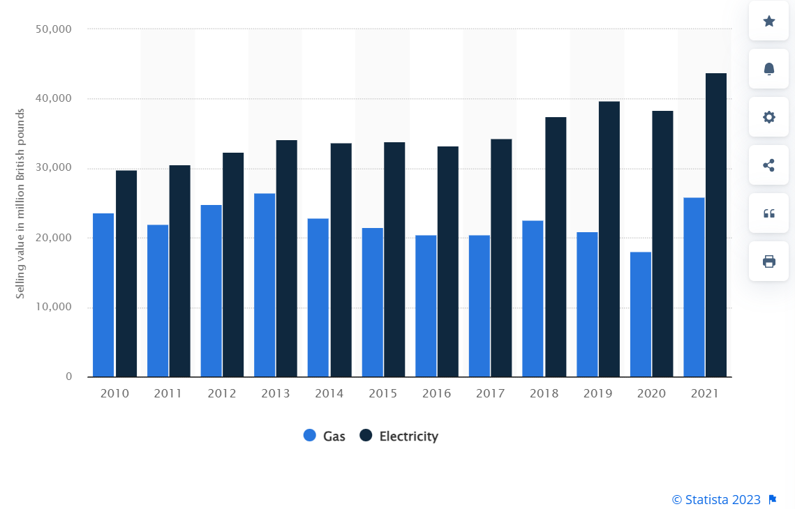
Also, in our first report, we emphasize the fact that in the UK market, wind harvesting power could take the market share of gas and electricity. This means that the potential of this market could be calculated in billions of pounds, as Statista Research Department showed after analyzing UK Government data.

Figure 1: The selling value of Electricity and Gas for all sectors in the UK from 2010 – 2021: Gas vs. Electricity. Source: https://www.statista.com/statistics/545396/value-electricity-gas-all-consumers-united-kingdom-uk/

  - Product and Services:
The company, WIND POWER AXXE will focus on offshore wind technologies suitable for the UK market. It will draw on examples like the Dogger Bank and Seagreen projects, incorporating lessons from their development, underlined in https://ore.catapult.org.uk/blog/uk-offshore-wind-2023-round-up-and-2024-outlook. The service offerings will include installation, maintenance, and grid integration, with an emphasis on adapting to the UK's offshore environment.
Also, WIND POWER AXXE, will develop its financial strategy in order to be able to offer its products and services in monthly installments for customers. This will help the company to offer an affordable plan for a bigger range of customers.
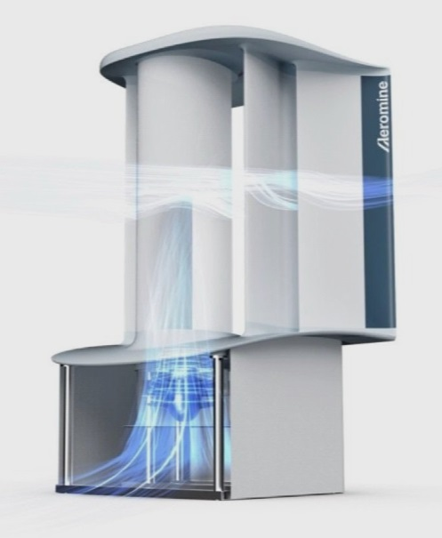
WIND POWER AXXE will have a range of products, however, WIND POWER AXXE will do a partnership with Aeromine Technologies company, https://www.aerominetechnologies.com/, in order to offer its products and services in the UK market. The wind turbine will be a motionless one and will look like this:

Figure 2: Aeromine Technologies motionless wind turbine. Source: https://www.aerominetechnologies.com/
This is one example of the product that will be launched on the UK Market. WIND POWER AXXE will develop its own Research and Development department and partner with universities in order to improve its products. Also, WIND POWER AXXE will focus on producing its units in the UK and European countries like Romania.
Canbulat et al., 2021, discuss the critical challenge of energy storage in the context of the UK's wind energy sector. Explore how integrating energy storage solutions can mitigate issues like wind energy curtailment, thereby increasing efficiency and reducing financial losses.

  - Marketing and Sales Strategy:
Marketing strategies will align with the UK's net-zero emissions goals, highlighting contributions to national objectives. A sales strategy could involve partnerships with established players such as Ørsted or Siemens Gamesa Renewable Energy. The approach will be informed by the market positioning and strategies of these key players, as discussed in Mordor Intelligence’s report, (https://www.mordorintelligence.com/industry-reports/united-kingdom-offshore-wind-energy-market).
However, a dynamic marketing and sales team will establish partnerships with construction companies, like Tylor Wimpey, and building management companies, like the UK giant Savills in order to place its products on their buildings.

  - Operational Plan:
Geographic advantages for offshore wind farms in the UK will be a focal point on top of the previously discussed strategy to place the motionless wind turbine. The company will navigate challenges in supply chain and project financing, with insights from the UK government's investment initiatives in offshore wind, as reported by Mordor Intelligence. Also, WIND POWER AXXE company will make it possible to get the virgin market share from the motionless wind turbine on the existing buildings.

  - Management and Organization:
The team will comprise experts in the UK's regulatory environment and offshore technology, reflecting the organizational needs for operations in a market where offshore wind is predominant. The structure will support operations and align with UK business practices.
WIND POWER AXXE leadership will develop each division of the company, in order to have organic economic growth based on partnerships established.

  - Financial Plan:
The plan will acknowledge increased costs due to material prices and interest rates, as detailed in ORE Catapult’s round-up. The financial strategy will be robust to handle market realities, reflecting the UK government's commitment to investing in the sector.
In 2020, Jansen et al, analyzed how the cost reductions in offshore wind technologies have enabled projects to be commercially competitive without reliance on subsidies. For instance, between 2015 and 2019, the price paid for power from offshore wind farms fell by approximately 11.9% per year.
In the same year 2020, Loukatou et al, Examine the financial implications of combining wind farms with battery storage. Highlight how this can lead to different revenue streams, affecting the overall profitability and financial viability of wind energy projects.

  - Sustainability and Environmental Impact:
WIND POWER AXXE operations will align with the UK's environmental standards and contribute to the country's carbon reduction targets. This approach will be informed by the advancements in reducing the UK's carbon footprint through offshore wind farms like Dogger Bank.
However, once the WIND POWER AXXE company has its first motionless wind turbine installed on a building, this model will be quickly multiplied to other places in the UK by the company.
Abrell & Kosch, in 2021 done a deep dive into the impact of carbon pricing on renewable energy support. They explore how changes in carbon prices necessitate adjustments in renewable energy subsidies and the implications for wind energy investment decisions.

- Company WIND POWER AXXE LOGO and mission:
WIND POWER AXXE company has the mission to offer clean energy harvested mainly from wind power in the UK market. In order to achieve this mission, WIND POWER AXXE has two axes of action: selling or leasing and installing to particular household entities and business entities wind motionless turbines to harvest wind power. This mission will offer the end consumers cheaper and cleaner energy. This is an important aspect of the energy market worldwide, especially in the UK market after the COVID-19 pandemic.
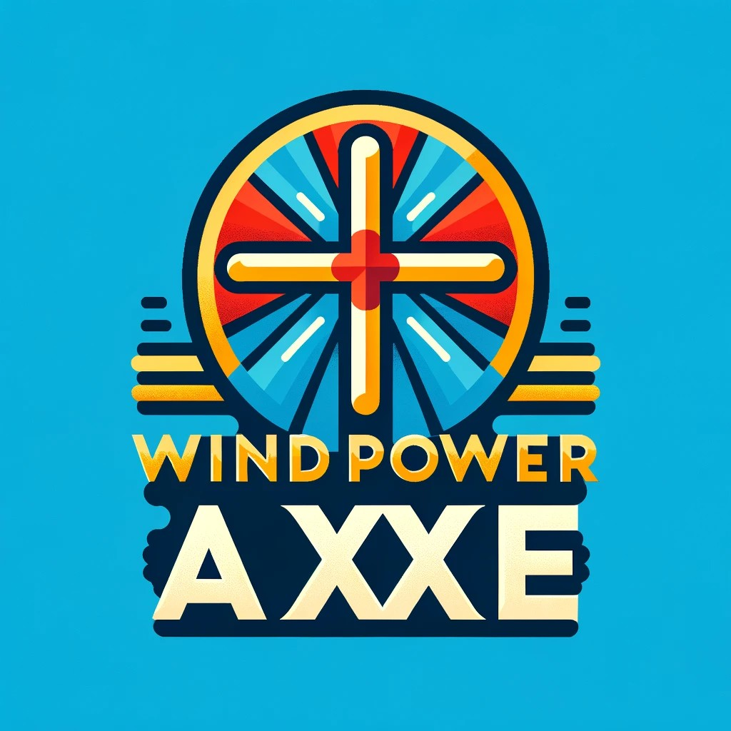
WIND POWER AXXE company logo is the following:
- Conclusion:
The UK energy market has a constant need of power energy. Post Covid-19 pandemic era is manifesting in a big financial pressure on the household and business entities. For those reasons any company that could provide accessible solutions to harvest free resources as wind is welcome on the market. Our start-up business, WIND POWER AXXE company will bring innovative solutions to consumers and aim to revolutionize the UK energy market.
In conclusion, the business plan for wind-harvested energy in the UK market underscores the critical role of wind energy in the nation's transition towards a sustainable and renewable energy future. The market analysis reveals a robust growth trajectory for wind energy, particularly in offshore sectors, driven by technological advancements and supportive government policies. On top of that, our start-up business, WIND POWER AXXE company will open and explore also a virgin market, that one of the end consumers that could become prod-consumers and will develop it into a multi-billion profit market. Financial analysis indicates that, despite challenges, the sector presents a viable investment opportunity, especially with the decreasing cost of wind energy technologies and the potential for high returns on investment.
The technological innovation in wind energy, including advancements in turbine efficiency and energy storage solutions, plays a pivotal role in enhancing the sector's competitiveness and addressing intermittency issues. The regulatory environment in the UK, characterized by favourable policies and incentives, further bolsters the growth of wind energy. However, it is crucial for stakeholders to stay abreast of policy changes and participate in advocacy efforts to maintain a conducive regulatory landscape.
Sustainability and environmental impact considerations are integral to the sector's success. Wind energy significantly contributes to reducing carbon emissions and has a relatively low environmental footprint compared to traditional energy sources. Effective strategies for end-of-life management of wind turbines and minimizing ecological impacts are essential for maintaining the sector's sustainability credentials.
Case studies and practical implementations of wind energy projects in the UK demonstrate the feasibility and effectiveness of wind power in diverse settings, from large-scale farms to localized, community-based initiatives. These examples serve as valuable blueprints for future projects and underscore the adaptability of wind energy solutions. On top of those, our start-up business, WIND POWER AXXE company will bring revolutionary products and also will offer adequate financial solutions with the aim of improving the energy efficiency of the end-consumers.
In summary, the wind energy sector in the UK presents a promising avenue for achieving environmental goals while providing substantial economic opportunities. Continued innovation, supportive policies, and a commitment to sustainability are key to harnessing the full potential of wind energy, positioning the UK as a leader in renewable energy, and contributing to global efforts against climate change. Nevertheless, offers consumers excellent service and cheap and clean energy.

This report represents for me the opportunity to start my entrepreneurship pathway in an industry that requires effort, passion, and especially creativity: wind power harvesting service. In a short time, this report vision will be put in place. The first step will be to record WIND POWER AXXE company to the UK Company House and gather a specialist team in order to start the partnerships with existing players in the world energy market.

- References:

- Offshore Wind Energy Generation: Control, Protection, and Integration to Electrical Systems by Olimpo Anaya-Lara et al., https://www.wiley.com/en-gb/Offshore+Wind+Energy+Generation%3A+Control%2C+Protection%2C+and+Integration+to+Electrical+Systems-p-9781119969154, accessed on 15 December 2023.
- Wind Energy Explained: Theory, Design and Application" by J.F. Manwell, J.G. McGowan, and A.L. Rogers, https://www.wiley.com/en-gb/Wind+Energy+Explained%3A+Theory%2C+Design+and+Application%2C+2nd+Edition-p-9780470015001, accessed on 15 December 2023.
- The Economics and Policy of Solar Photovoltaic Generation" by Pere Mir-Artigues, Pablo del Río, https://link.springer.com/book/10.1007/978-3-319-29659-3, accessed on 15 December 2023.
- UK offshore wind 2023 round-up and 2024 outlook – ORE, https://ore.catapult.org.uk/ , accessed on 15 December 2023.
- New Plan to Lay Out Path for UK Offshore Wind Growth Expected in Early 2024" | Offshore Wind, https://www.offshorewind.biz/, accessed on 15 December 2023.
- UK Offshore Wind Energy Market - Forecast & Statistics, https://www.mordorintelligence.com/, accessed on 15 December 2023.
- 25 Latest Wind Energy Statistics & Facts (2024 UK) - DIY Garden, https://diygarden.co.uk/, accessed on 15 December 2023.
- John C. Maxwell, ‘The 360 Degree Leader: Developing Your Influence from Anywhere in the Organization, https://www.academia.edu/40839353/John_Maxwell_The_360_Degree_Leader_Developing_Your_Influence_from_Anywhere_in_the_Organization, accessed on 15 December 2023.
- The selling value of Electricity and Gas for all sectors in the UK from 2010 – 2021: Gas vs. Electricity, https://www.statista.com/statistics/545396/value-electricity-gas-all-consumers-united-kingdom-uk/, accessed on 5 December 2023.
- https://www.nerdwallet.com/uk/business/start-up-failure-statistics/ accessed on 16 December 2023
- Phil Greenway, UK Money, September 2023, https://www.ukmoney.net/how-many-new-businesses-fail/, accessed on 16 December 2023
- Bórawski et al., 2020, https://www.sciencedirect.com/science/article/abs/pii/S0960148120311575, accessed on 16 December 2023
- Canbulat et al., 2021, https://www.mdpi.com/1996-1073/14/6/1691 accessed on 15 December 2023
- https://doggerbank.com/press-releases/dogger-bank-wind-farm-announces-net-zero-carbon-operations-and-maintenance-base/, accessed on 15 December 2023
- Jansen et al, 2020, https://orbit.dtu.dk/en/publications/offshore-wind-competitiveness-in-mature-markets-without-subsidy, accessed on 15 December 2023.
- Loukatou et al, 2020, Optimal valuation of wind energy projects co-located with battery storage, https://www.sciencedirect.com/science/article/pii/S0306261920316391, accessed on 15 December 2023.

