Student Name: Wioleta Teresa Knysz
Student ID: 1919631

Module: LCMB7001
Assignment: Marketing Management ( part 2 )
Lecturer: Tashara Balendran

Date: 1st September 2023

THE TANNING SHOP

THE ROLE OF MARKETING IN THE TANNING SHOP CHAIN BASED ON INTERNAL ENVIRONMENT ANALYSIS AND KEY EXTERNAL INFLUENCING DRIVERS

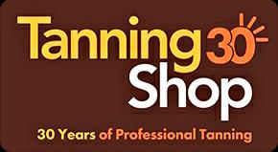
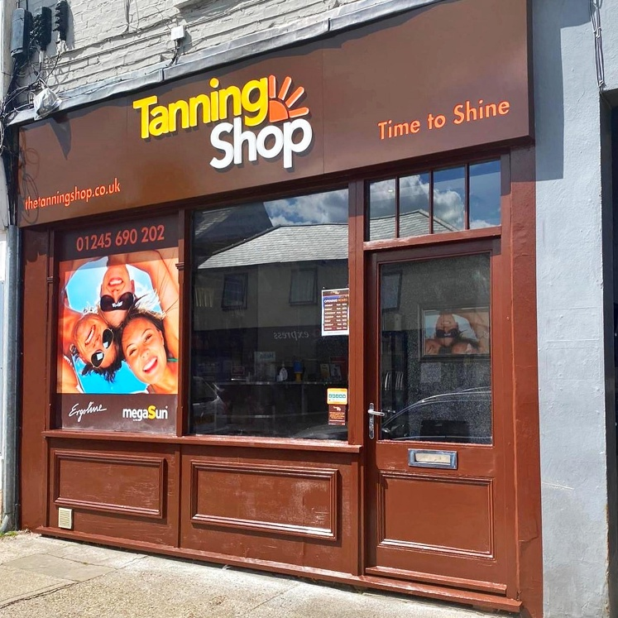
pic. The Tanning Shop (2023)

Table of content

- Abstract.

- Introduction.

- The Tanning Shop – the unbeatable leader in the tanning industry.

- Macro Environment as fundamentals of organisation.

Porter’s 5 Forces – what may affect profitability?
SWOT

- Marketing – what went well? what went wrong?

Internal Marketing – advantage of sponsorship.

STP process - Segmentation. Targeting. Positioning.

Seven P’s Marketing Mix

Lifetime Customer Value and Touch Points.

- Brand Image – Critical Judgement.

- Recommendation – Generic Strategies.
- Conclusion
- References.

- Abstract.

Purpose of the report:
Clarifying brand marketing strategies to eliminate potential errors and strengthening the company's image.

Design and Approach:
Based on the methodology, the investigation has been performed to spot the strengths and weaknesses of the enterprise and support the strategic decision-making process via marketing approaches.

Findings:
Despite its strong market position, the author provides evidence of poor marketing movements and suggests ways of improvement.

Value of the report:
Marketing awareness.
- Introduction.

The Tanning Shop, a private limited company headquartered over thirty years ago in Darlington (Companies London, 2016-2023), is the UK's and Ireland's largest tanning shop chain, offering the highest quality tanning beds with innovative, safe tanning systems (Maguire, 2022) and spray tans as an alternative instant tan.
The goal:
Ensuring a beautiful deep tan with unique equipment, supportive products and a trained staff providing detailed information and advice which is an inseparable part of the brand’s service offer (Maguire, 2022).
As mentioned by the Director in 2022, the expansion of the chain in Great Britain to over a hundred branded stores (Maguire, 2022).

The Tanning Shop Limited is an innovator of franchise strategy in the British and Irish tanning market, offering tried/tested business models, an established brand image and an attractive pack of other benefits for budding entrepreneurs for as little as a sixty-thousand-pound investment (ARTICHOKE MEDIA LTD, 2023).

It seems obvious that The Tanning Shop is a well-established enterprise in Great Britain, and at the moment, the competition is not able to adversely affect the business. Nevertheless, on the basis of the external environment, incentives that have already been able to undermine the prosperity of the enterprise, such as epidemics or social/ethical factors, should be identified. This report aims to shed light on marketing strategies used by The Tanning Shop chain and to point out some rather sensitive issues that too boldly have been overlooked.
Therefore, the author goes through Macro-Environmental Factors, Internal Marketing, Value Proposition and Lifetime Customer Value in conjunction with existing touch points. The concept of STP and brand image as well as the aforementioned findings supported by SWOT, Porter's Five Forces and 7 P's Marketing Mix models, will also be discussed.

The report focuses on conscious marketing awareness; thus recommendations as a ‘fresh blood input’ are also provided.

- The Tanning Shop – the unbeatable leader in the tanning industry.

Competitive Intelligence (CI) – Franchise

Quoting Fuld (1995), companies have access to the same type of information, but only those that are able to transfer the knowledge into conscious action triumph in the market (Cavallo et al., 2020). This is the system of being smart in an aggressive world of rivals. Competitive Intelligence is a process that enables an organization to explore the threats posed by the external environment, and see in its opportunities that are competitively unbeatable (Cavallo et al., 2020). The franchise initiative was a good move on the part of The Tanning Shop as their CI for competitive positioning and strength of their channels of distribution.

Advantages of introducing franchise tanning stores:

- large chain of tanning shops
- transforming a potential rival into a franchisee
- control on British tanning market
- barriers of entry created - leader in franchise tanning business
- reduction of potential risk at a newly opened location
- the power of the right to take a branch and connect it to an individual network for greater profits
- competitive positioning strategy - a recognizable brand, associated with the only one representing tanning salons in the UK, giving the customer the opportunity to use one package in all locations of the country

Disadvantage (however, this is not in any proportion to all the possible benefits):

- limited right to manage franchise outlets
- SUNBURN AT FRANCHISE STORE (+/- COURT) = BRAND IMAGE AFFECTED

- Macro Environment as fundamentals of organisation

The macro environment refers to external factors that may impact an organization's operations, strategy, and overall business environment. These factors include economic, social, political, technological and environmental influences that can influence organizational performance and decision-making.

Porter’s 5 Forces – what may affect a profitably?

LOW – ANYONE CAN ENTER THE UK’S TANNING MARKET EVEN WITH SIXTY THOUSEND POUNDS INVESTMENT (ARTICHOKE MEDIA LTD, 2023) AND THREATEN TTS’ LOCAL BRANCH BY STANDARD OF SERVICE PROVIDED, EQUIPMENT AND PRICES
HIGH – THE TANNING SHOP HAS ESTABLISHED ENTERPRISE WITH OVER 100 STORES SO CREATED HIGH BARRIES OF ENTRY AT THE SAME TIME, PREVENTING RIVALS TO WEAKNESS THE BRAND

THREAT OF NEW ENTRANTS
LOW/HIGH

SELFTANNING PRODUCTS GIVING QUICK , PATCH FREE AND INSTANT TAN – COCO&EVE, ST TROPEZ
COMPETITORS OFFERING MOBILE SPRAY TANNING SESSIONS – LOCAL BEAUTICIANS/ SPRAY TAN EXPERTS
LOCAL SUNBEDS SHOPS
= SAVING TIME AND MONEY ALTERNATIVES ENSURING CUSTOMERS’ SAFETY AND CONVENIENCE
THREAT OF SUBSTITUTES
HIGH

PURCHASE DECISION AFFECTED BY ECONOMY – MAJOR FOCUS ONLY ON THE NECESSARY SPENDINGS (Kotler et al., 2020) AND SOCIAL STATUS
AGE RESTRICTIONS AND AWARENESS OF THE NEGATIVE EFFECTS OF UV ON HEALTH AFFECTS CUSTOMER DECISION-MAKING PROCESS AS WELL AS THE PERCEIVED TYPE OF BUSINESS AS CONTRIBUTING TO LIFE RISK:
- BAN ON ARTIFICIAL UV TANNING IN AUSTRALIA (BBC, 2022)
- CANCER RESEARCH UK STATISTICS PUBLISHED STATISTIC OF OVER TWO THOUSEND SKIN CANCER DEATHS YEARLY IN BRITAIN (BBC, 2022)
- THREE QUARTER UK’S DERMATOLOGIST AGAINST UV SESSIONS AND MOSTLY ALL AGREE TO PROHIBIT THE SERVICE UNDER 21 (The British Skin Foundation, 2019)

BARGAINING POWER OF CUSTOMERS
HIGH

ALTHOUGH THERE ARE SEVERAL BRANDS THAT MAKE UV TANNING BEDS, THERE IS LIMITED NUMBER OF SUPPLIERS AT THE MARKET PROVIDING INNOVATIVE AND UNIQUE UV TANNING MACHINES LIKE ERGOLINE (Tan Empire, 2020)
= HIGH PRICE OF EQUIPMENT, REPLACEMENTS AND IMPORT

BARGAINING POWER OF SUPPLIERS
MEDIUM

THERE ARE NO REPORTS OR EVIDENS ABOUT THE OTHER SUNBED NETWORK IN THE UK MARKET.
THE ONLY COMPETITION CAN BE THE ALTERNATIVE WAY OF TANNING AND SAFE TANNING OPTION E.G. SPRAY TANS - EVERY HUMAN HAS DIFFERENT BELIEFS AND PREFERENCES ACCORDING EFFECTIVE OR SAFE TANNING PROCEDURES
POTENTIAL RIVALS = THE DEVELOPING NETWORK OF MOBILE FAKE TAN EXPERTS WORKING ON VARIUS PRODUCTS (FAKE BAKE, ST TROPEZ) AVAILABLE TO FIND ON GOOGLE SEARCH ENGINE OR SOCIAL MEDIA
RIVALRY
LOW

Paying attention to the strengths and weaknesses of The Tanning Shop Ltd, the author of the report also uses the SWOT model for detailed analysis. Although, the mentioned above Porter's 5 Forces tool is an excellent model for in-depth up do day analysis of the company's environmental situation, its marketing strategies in relation to market needs and threats.

SWOT

STRENGTHS

Strong Brand – since 1991 on the market (Maguire, 2022)

Channels of Distributions – direct and indirect (franchising) cover most of Britain.

Most Advanced Technology – high quality sunbeds (The Tanning Shop, 2023)

Diversity – over one hundred branches, various tanning equipment and alternative tanning systems, including spray tans and tanning shots (The Tanning Shop, 2023).

WEAKNESSES

Specific Industry - the risk of burns could lead the company to court; thus, costs and policy type are subject to change.

OPPORTUNITIES

Brand Extension:

Vertical Backwards Integration to protect the established brand and increase its value and attractiveness (Berger et al., 2023) - branded self-tanners, tanning supplements and mobile spray tanning promoting a safe approach of getting the tan as an alternative stable source of income.

Brand Expansion:

Diversity in the form of entering other countries with high UV tanning demands and low competitiveness.

THREATS

Social Threats:

Market influences the wants – the ‘healthy era’ may affect the performance of artificial sunbathing.

In agreement with Cancer Research UK (2023), which gathered the information, UV tanning leads to skin cancer and DNA damage due to sunburns or excessive exposure. Therefore, the number of fanatics of sunbed shops can decrease rapidly at any time.

Legal Threats:

Legal defence (age restrictions) and guidance of The Department of Health and Social Care in Britain (Chartered Trading Standards Institute, 2023) may change.

Risk of introducing bans for tanning businesses in the UK and Ireland as a consequence of a procedure already introduced in another country.

- Marketing – what went well? what went wrong?

INTERNAL MARKETING – ADVANTAGE OF SPONSORSHIP

It is enough to visit a randomly chosen branch of one of The Tanning Shop to be greeted by a beautifully tanned young woman or ... sometimes a man. That is an excellent showcase of the brand, which at the same time inspires confidence in the effectiveness of the service offered. Who wouldn't want a beautiful skin colour that imitates youth, gives a sense of uniqueness and exclusivity, and distracts attention from imperfection?

Julie Bain (2018) published the sincere confession of the employees of the tanning salon, uncovering the truth about sponsorship strategies. The employer provided free-of-charge tanning sessions for the crew as a benefit of the position in exchange for using their attractive image, which supports the process of selling tanning packages by visual persuasion to obtain such an appearance (Bain, 2018). That is an indirect but efficient form of marketing, an excellent move adapted also by The Tanning Shop, the best possible form of influencing customer behaviour in the beauty industry.

STP PROCESS - Segmentation. Targeting. Positioning

Segmentation

- geographic segmentation: wide range of units across the country, enabling persona to easily access the branches
- demographic segmentation: persona over eighteen years old, regardless of status, gender, skin colour
- benefit segmentation: persona with the need to prepare the skin for the holiday to prevent sunburn and maintain a tan afterwards; to get an instant tan for weddings, festivals and any other occasions; to improve the condition of acne skin; to take care of their attractiveness

Targeting

- reaching each target group for whom tanning is associated with a benefit – mostly women, students, young adults, and office workers who lack time for tanning; therefore, branches located on high streets near mass gatherings of people

Positioning

- value proposition – an attractive mix of benefits (Kotler et al., 2020, p. 218) = desired shade of tan in affordable price, convenient place and preferable way (sunbed or spray tan)
- ‘time to shine’

SEVEN P’S MARKETING MIX

- PRODUCT VARIETY - INNOVATIVE FAST TANNING EQUIPMENT; WIDE RANGE OF TANNING ACCELERATORS; TANNING SHOTS CONTAINING VITAMIN D AND BETA CAROTENE

- PRICE - AFFORDABLE PRICES FOR MINUTES, SESSIONS AND PACKAGES

- PLACE - WIDE RANGE OF UNITS IN EASILY ACCESSIBLE LOCATIONS

ADVANTAGE - AVAILABILITY TO OPEN ONE ACCOUNT AND USE SERVICES ACROSS ALL BRANCHES

DISADVANTAGE - NOT APPLICABLE TO FRANCHISE STORES

- PROMOTION

THE TANNING SHOP CREATES THE BRAND AWARNESS AND BUILD ENGAGEMENT THROUGH INTEGRATED MARKETING COMMUNICATION (IMC):

SOCIAL MEDIA ADVERTISING - UV AND SPRAY TAN OFFERS POSTS WITH EXCLUSIVE LOOKING TANNED PEOPLE USING VARIOUS OCCASIONS BACKGROUNDS SUCH AS WEDDING, FESTIVAL, HOLIDAY TO ATTRACT THE DESIRE TO BE TANNED; FACEBOOK COMPETITION

SPONSORSHIP – TAKING PART OF LOVE ISLAND SHOW (The Tanning Shop, 2023) TO CREATE BRAND AWARENESS, SPONSORING CREW’ SUNBATHING AS A BRAD IMAGE

PUBLICITY - ‘REFER A FRIEND’; THREE FOR TWO SPRAY TAN (The Tanning Shop, 2023) LEADING TO SPREAD THE WORD OF MOUTH

RELATIONSHIP MARKETING - PROVIDING ALL YEAR AROUND STUDENTS AND NHS WORKERS’ DISCOUNTS (The Tanning Shop, 2023)

- PEOPLE - TRAINED STAFF WITH PERSONAL EXPERIENCE IN UV AND SPRAY TANNING

- PROCESS

AN INSTANT DEEP FAKE TAN IN MINUTES; UV TANNING RELAXING SESSIONS ALLOWING TO BUILD THE DESIRED SHADE OF TAN; ADVICE ON INDIVIDUALLY SELECTED TANNING PROGRAM FROM TRAINED STAFF; PREBOOKING TANNING SESSION VIA PHONE OR WEBSITE; ACCESS TO PERSONALISED ACCOUNT AND STORE LOCATOR

- PHYSICAL EVIDENCE - PRICE LISTS/ FLYERS; INFORMATIVE WEBSITE THAT ALLOWS TO BOOK A SESSION IN A CONVENIENT TIME AND LOCATION

LIFETIME CUSTOMER VALUE AND TOUCHPOINTS

In agreement with Kennedy (2021), people tend to do things that build their self-esteem, and every enterprise should take advantage of manipulation within the marketing strategy.
Engaging its target market in an endless adventure with the company, The Tanning Shop builds a massive base of loyal customers, constantly drawing their attention to all kinds of touch points by manipulative communication:

- using a sense of belonging, appreciation and a sense of doing a good deal = online and offline advertising of tanning packages and special deals (discounted memberships) e.g., students, NHS and military workers (The Tanning Shop, 2023)

- influencing customers’ decision-making process = persuasion of the desire for tanned skin using social media and posters presenting healthy-looking glow skin and deep dark holiday tan

- sensory adaptation = consciously creating a client's addiction to a tanning session by their tanning experience in achieving desired results or building the intensity of tan

- offering private space in the form of a personal account on the website, The Tanning Shop smuggles the blog contents that engage the target market and influence their decision (e.g., tanning frequency; must have tan for specific occasion)
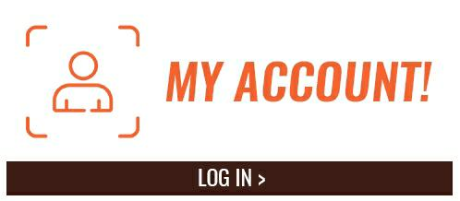
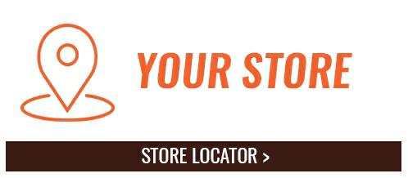


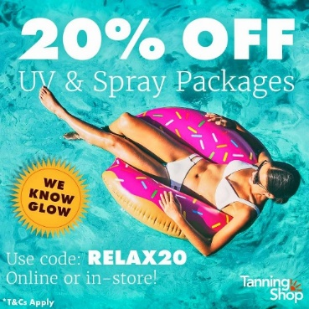
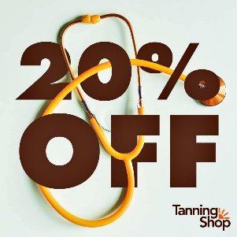
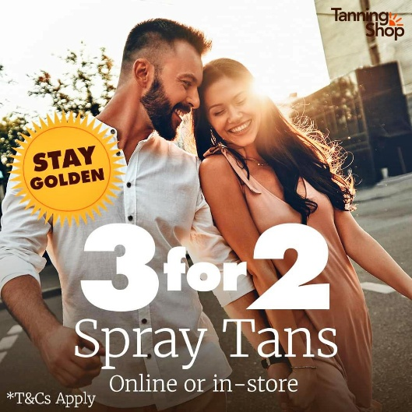
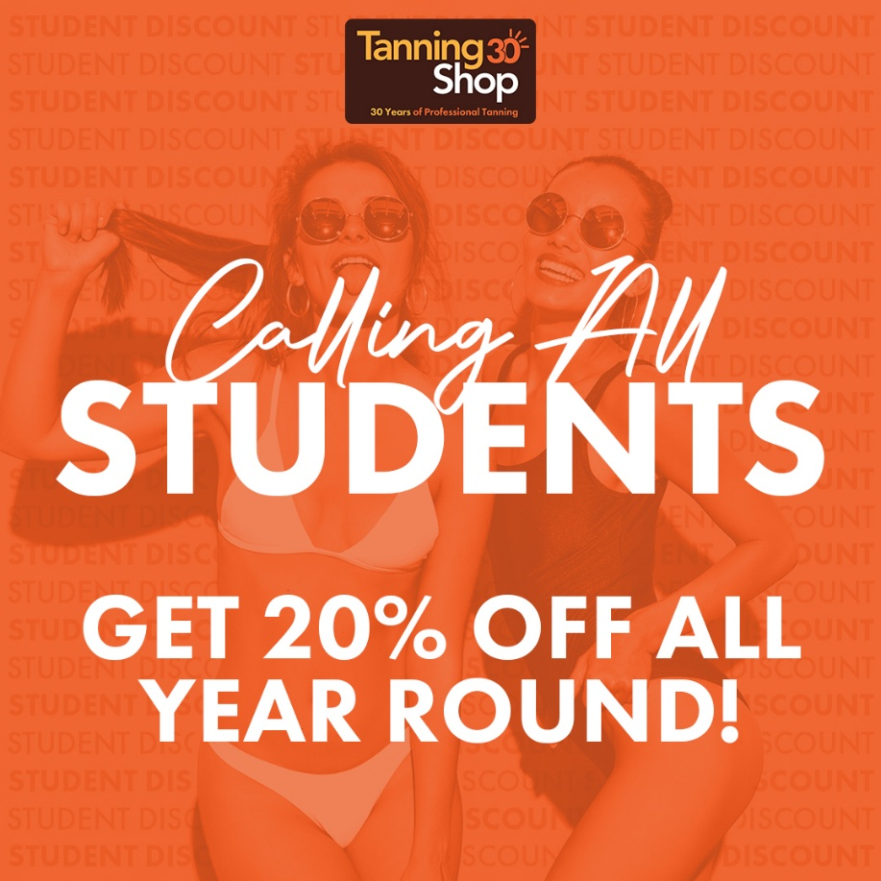
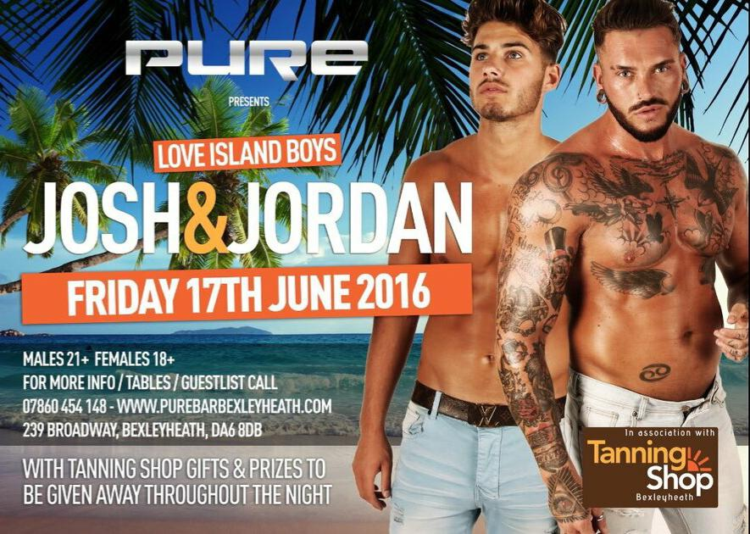
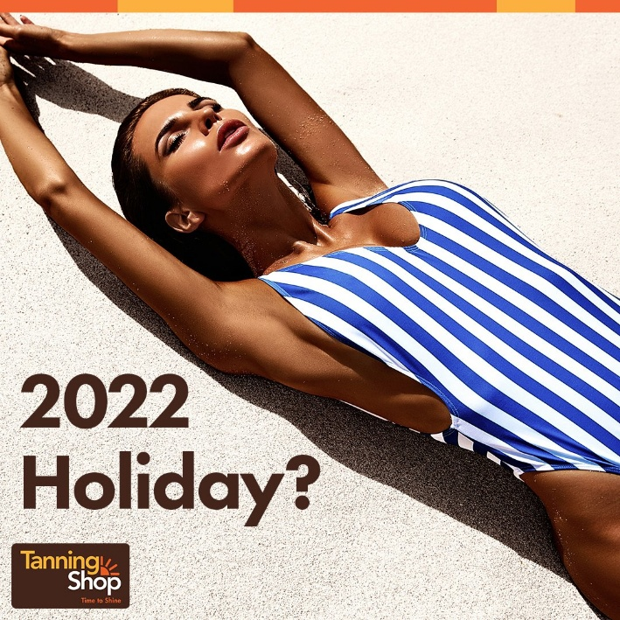
pic. The Tanning Shop (2023)

- Brand Image – Critical Judgement

In agreement with Kennedy (2021), all marketing decisions created with care for the brand standard should follow the path of three essential points- principle, strategies and tactics.
Although The Tanning Shop promotes the brand with an excellent logo Time to Shine (The Tanning Shop, 2023) that speaks for itself, and well-played marketing tricks that engage and acquire customers into the tanning journey, unfortunately, the company's inappropriate tactic affected the good name of the brand.

‘Day by Day, Hour by Hour, Choice by Choice... We Weave Strands of Fabric That Become the Cape of a Superhero Or the Shroud of a Disgraced Pariah’ (Kennedy, 2021, p. 116).

The Tanning Shop risked greatly established brand image damage by focusing on the wrong factor when introducing a new tanning strategy. ‘BOOST YOUR VITAMIN D’ promotion (The Tanning Shop, 2023) sparked controversy by putting the company in an unfavourable light. According to the Advertising Standards Authority and The Committee of Advertising Practice (2017), suggesting by TTS that UV tanning is the best method to increase the level of vitamin D builds people's misconceptions, at the same time endangers them to increased exposure to artificial tanning.

Every business needs to fascinate and motivate its target group (Kennedy, 2021), and although direct-response marketing in the form of exposure to media fire can attract so much needed attention for business (Kennedy, 2023, p. 128), the tactical marketing strategy should always be weighed against the potential risks.

When the British council demanded the withdrawal of the campaign and the promotion of tanning beds as a source of boosting vitamin D level (ASA and CAP, 2017), branded vitamin shots supporting tanning turned out to be a rescue strategy focusing on micronutrient D.

- Recommendation – Generic Strategies.

EXCLUSIVE MEMBERSHIPS PROGRAMS
FREE TANNING SESSIONS FOR SPECIFIC TARGET GROUP

FURTHER EXPANSION
THREAT OF NEW ENTRANTS

THREAT OF SUBSTITUTES

EXCLUSIVE SPRAYTANS PACKAGES

MOBILE SELF TANNING IN BRANDED VAN

PROMOTING SPRAY TANS

SAFE TAN CUSTOMERS EDUCATION AND AWARNESS THAT SUNBURN CAUSE CANCER NOT SUSTAINABLE UV TANNING

FREE TANNING EDCATION AS AN EXTRA BENEFIT FOR REGULAR CLIENTS

BARGAINING POWER OF CUSTOMERS

TANNING EDUCATION

FOCUS

INDUSTRY FORCE

DIFFERENTATION

COST LEADERSHIP

- Conclusion.

Tanning Shop is an unrivalled business, thanks to its strengths, including modern equipment, master plan of marketing approaches and an innovative strategy in the beauty industry - franchising on a huge scale. However, being a market leader does not mean that the business will survive every crisis. UV tanning is still a very risky issue, and not carefully thought-out marketing strategies in terms of reasoned credibility and ethics in manipulation can provoke opposition to the incorrectness of this market.

- References.

ARTICHOKE MEDIA LTD (2023), ’The Tanning Shop’, ARTICHOKE MEDIA LTD, accessed 26July 2023, [ https://www.what-franchise.com/franchise-opportunities/health-beauty-franchises/the-tanning-shop ]

ASA and CAP (July 17, 2017), ‘ASA Ruling on The Feel Good Group Ltd t/a The Tanning Shop’, ASA and Cap, accessed 25 July 203, [ https://www.asa.org.uk/rulings/the-feel-good-group-ltd-a17-382434.html ]

Bain J., (May 31, 2018), ‘Confessions of a Former Tanning Salon Employee’, The Skin Cancer Foundation, accessed 25 July 2023, [ https://www.skincancer.org/blog/confessions-former-tanning-salon-employee/ ]

Berger S., et al., (July 18. 2021), ‘Creating a resilient supply chain: a framework for assessing the viability of backward vertical integration’, Kearney, accessed 25 July 2023, [ https://www.kearney.com/service/mergers-acquisitions/article/-/insights/creating-a-resilient-supply-chain-a-framework-for-assessing-the-viability-of-backward-vertical-integration ]

Cancer Research UK (n. d), ‘How does the sun and UV cause cancer?’, Cancer Research UK, accessed 25 July 2023, [ https://www.cancerresearchuk.org/about-cancer/causes-of-cancer/sun-uv-and-cancer/how-does-the-sun-and-uv-cause-cancer#Keyreferences0 ]

Cavallo A., et al., (2020), ‘Competitive intelligence and strategy formulation: connecting the dots’, An International Business Journal, Vol. 31 No. 2, pp. 250-275, DOI: 10.1108/CR-01-2020-0009, p.251

Chartered Trading Standards Institute (March, 2023), ‘Sunbeds’, Business Companion. Trading Standards Law Explained, downloaded 25 July 2023, [ https://www.businesscompanion.info/en/quick-guides/underage-sales/sunbeds-s ], p. 2

Companies London (2016-23), ‘THE TANNING SHOP (U.K) LIMITED’, Companies London, accessed 25 July 2023, [ https://www.companieslondon.com/uk/02786961/the-tanning-shop-uk-limited ]
https://www.cancerresearchuk.org/about-cancer/causes-of-cancer/sun-uv-and-cancer/how-does-the-sun-and-uv-cause-cancer#Keyreferences0
Gill G., (May 20, 2022), ‘Scientists: A ban on sunbeds could save lives from skin cancer’, BBC, accessed 25 July 2023, [ https://www.bbc.co.uk/news/newsbeat-61508470 ]

Kennedy D. S., (2021), ‘THE BEST OF NO B.S. THE ULTIMATE NO-HOLDS-BARRED ANTHOLOGY’, Entrepreneur Books, Irvine, p. 113, p. 116, p. 119, p.128, pp. 323-324

Kotler P., et. al., (2020), ‘PRINCIPLES OF MARKETING. EIGHTH EUROPEAN EDITION’, Pearson Education Limited, Harlow, pp. 85-86, p. 218

Maguire B., (January 22, 2022), ‘The Tanning Shop Sheffield: UK’s largest tanning chain opens first city store at Crystal Peaks shopping centre’, National World Publishing Ltd, accessed 25 July 2023, [ https://www.thestar.co.uk/business/consumer/uks-largest-tanning-chain-to-open-store-at-popular-shopping-centre-3538110 ]

The British Skin Foundation (July, 2019), ‘77% of dermatologists agree sunbeds should be banned in the UK’, The British Skin Foundation, accessed 25 July 2023, [ https://www.britishskinfoundation.org.uk/news/77-of-dermatologists-agree-sunbeds-should-be-banned-in-the-uk ]

Tan Empire (January 15, 2020), ‘WHICH TANNING BEDS GENERATE THE MOST PROFIT FOR TANNING SALONS?’, Tan Empire, accessed 25 July 2023, [ https://tanempire.co.uk/blog/which-tanning-beds-generate-the-most-profit-for-tanning-salons/ ]

The Tanning Shop (n. d), ‘BOOST YOUR VITAMIN D – THE TANNING SHOP’, The Tanning Shop, accessed 25 July 2023, [ https://thetanningshop.co.uk/vitamin-d/ ]

The Tanning Shop (n. d), The Tanning Shop, accessed 25 July 20023, [ https://thetanningshop.co.uk/ ]

