BA Business Management

Introducing the Modern Workplace, LCBB4003
Lecturer: Gregory Cowan

Assessment 1:
Organizational Structure and Culture

Anastasia Ursu,
ID:2024744

2021

Content
- Introduction………………………………………...................................................3
- The concept and types of organizational structure and
organizational culture …..........................................................................................4
- Analyse how organizational structures can influence
organizational performance......................................................................................6
- Analyse how organizational culture can influences
organizational performance......................................................................................7
- The nature and the role of leadership........................................................................8
- Analyse the effect of development and leadership....................................................9
- Conclusions…………….......….……………………..............................................15
- Reference list…........................................................................................................16

- Introduction

The original logo of Adidas was designed in 1990.

Adidas' original logo from 1997.

The organization history can also give a sense of corporate culture. It is good to remember to include a company history in the business plan and employee handbook on an online website.
the Adidas company. Each popular company has a beginning. Adolf, Adi ‘’ Dassler founded the company in 1920. He started in the laundry room, in a small town in Germany. Adi Dassler and his older brother Rudolf joined a successful business with a reputation for the best shoes to the world’s athletes and their trainers, they sell around 200,000 pairs of shoes every year, ahead of World War II. In 1947 the relationship between the brothers broke up. The company has been part of important sporting moments. In 1952 after the Summer Olympics, Adi Dassler purchased the three-stripe logo, from the shoe brand Karhu Sports.
About the products, Adidas sells a range of clothing, for men and women, sweatshirts, jackets, leggings and pants, and T-shirts. To have innovative marketing success, Adidas was divided into three main groups: Style Essentials, Adidas Original, and Yamamoto-3. In the current report I will analyze the corporate structure and culture, and the relationship between work performance and job satisfaction.

- Concept and the types of Organizational structure
Organizational structure can be defined as a system in which certain activities are directed to achieve the objectives and goals of an organization. These activities may include responsibilities, roles, and rules. Also, the organizational structure can determine how this information flows between company levels.
Organizational structure can be considered as a viewing perspective for everyone to see their organization and its environment. I will describe each one of the types of organizational structures and reasons why I consider each of them.
1.Flat structure able companies with several levels between senior management and staff level employees. Many start-up companies use this organizational structure ahead they grow up and build out distinctive departments. Google is a company known for its start-up flat organizational structure, which means that it has adopted middle management. One more example is Facebook, also known as a flat organizational structure, fewer managers, and supervisors in relation to lower- level employees.
2. Hierarchy structure. This type of structure is the most popular organizational chart type. From this type of organization derived some models and is grouping based on a few factors. The first factor is function, this group responded by functionality, for example finance and technical. The second one is geography; this group is based in the region.

This type of organizational structure is always used by sizable organizations. An example can be the Corporations, the Governments, and hierarchical organizations with structured level of management, power, and authority. An example of this type of structure can be Amazon.

3. Span of Control. This type of structure can represent the number of subordinates under a manager direct control. Spain control can be for example a manager with five direct reports, this can be considered a span of control of five. This type can be a narrow and wide span of control.
Here I can give an example of a company- KFC. A wide span of control is a single supervisor oversees a substantial number of subordinates and the example of a company can be Google.
4.Chain of command This type of organizational structure describes how each member of a company reports to one another. When an employee reports to a manager, and then he reports to a senior manager and who will report to the vice president and who will report to the president of the company.
Examples of this type could be a Marketing Agency.

- Organizational culture.
Many different meanings and opinions to define or to explain the organizational culture. Organizational culture can be defined as a system of shared values and assumptions. In another definition, organizational culture can contain an organization experiences and expectations, philosophy, and values that govern how people behave in organizations and future intentions.
Organizational culture can affect organization performance, productivity and provide instructions on customer service, participation and exactitude, and product quality.
Organizational culture is exclusive in everyone organization and the tough things are to change. The key to a prosperous company is to form a culture based on a firmly held and distributed by structure and strategy.
Culture can be characterized by the following types: culture can be diverse, dynamic, change, cumulative, shared by the group of people, and culture can be learned.
- Types of organizational culture. Harrison classifies diverse types of organizational cultures. But developing his ideas Charles Handy describes four types of organizational culture: power organizational culture, task organizational culture, person organizational culture and role organizational culture.
1. Power organizational culture, built upon a central power source and it is influenced by a central figure of the organization. This type of culture we can find in small entrepreneurial organizations and depends on trust, personal communications, and empathy.
2. Task culture, this type of organizational culture is based on expert power and on position or personal power. In terms of culture, meaning which one is stronger than others. Task cultures bring the right people and resources, unifying power in the group.
3. Person Culture, central focus is on individuality. If a group of people worked together, they decided to share office space, the equipment, then the organizational results would have a person culture. In each organization there is a unique culture, and the largest business tries to be a mix of cultures.
4. Role culture, determinate by bureaucracy and coherence. This type of organizational culture we can find in a strong company. The functions of specialists are for example: finance, product, and purchasing. This type is more important than a source of power, position or individuality.
- Analyse how organizational structure can influence organizational performance.
Organizational Structure means how people are organized or how the job is coordinated and divided. Organizational Performance this concept is difficult to describe because it has a different significance. The term of performance was always confusing with productivity. The difference between performance and productivity is that productivity indicates the volume of tasks performed. But performance is a boarder pointer including productivity as well as factors and quality. An organizational structure has a strong impact on organizational performance. This may mean that a relationship between the process and labor productivity with the organizational structure can affect the behavior of employees in the organization.
, Imposible is nothing’’, this is the slogan of the company Adidas. They apply the 4 P’s, meaning the people, product, planet and the partnership. The adidas company used functional, divisional, matrix, and hybrid structures. The adidas Group organizational structure are organized by an Executive Board, by a Supervisory Board, and by a General meeting.
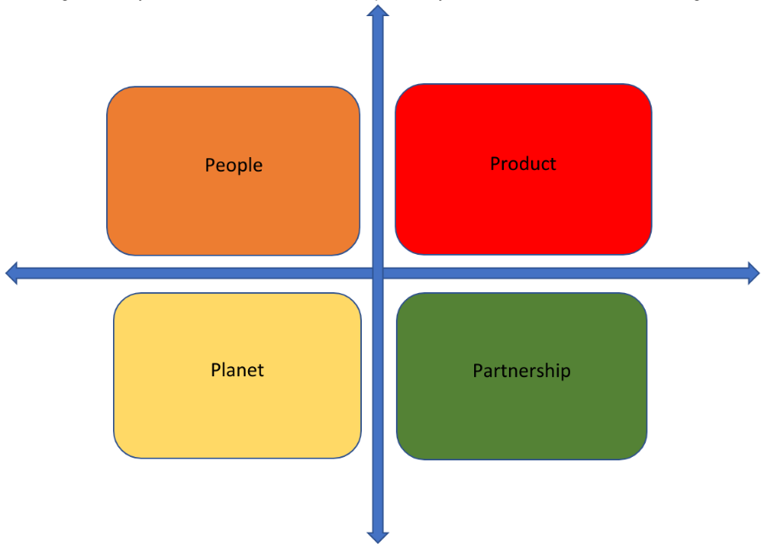
Figure 1: 4 P’ s of Adidas Group

- Analyse how organizational culture can influence organizational performance.
The Adidas Group said, ‘the people are the key to the company’s success.’ They have talents people in the company who work with passion. It’s very important to understand the role of organizational culture being in our time culture plays a significant role. The Adidas Group make sure that employees share the common goal, and their achievement in the right direction, given their excellent performance. The organizational culture of the Adidas Group can also be evaluated by Hosfeld's cultural model. Anyway, this model has limitations and must be considerate when applying this model to understand the culture of any organization. The Adidas Group has four components of strong cultures: values culture, heroes' culture, rites and rituals culture, and cultural networks.
Culture can increase job satisfaction by understanding problem solving and organizational performance.
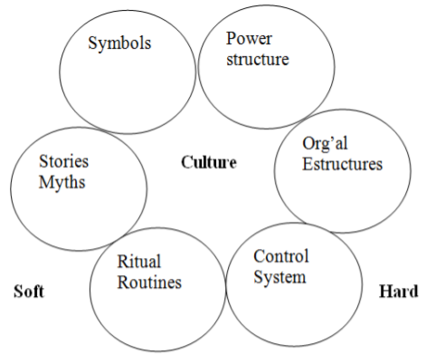
Figure2: Organizational culture,
Source: The Importance of Organizational Culture, 2000

  - Nature and the role of leadership
Leadership is personal ability, which creates an unclouded vision. It is the ability to share same important vision with others and motivate them to follow it, it is the ability to provide the organizational structure, tools and information that allow others to be successful in pursuing the vision and to address the risks and conflicts that arise during the pursuit of that vision. Leadership is playing an increasingly significant role in corporate structures.
John Kotter believes that leadership refers to the process of guiding a group or groups of people through non-coercive means. In another think, John Harvey say that leadership refers to achieving extraordinary results through ordinary people. Most specialists define leadership as a process of social influence in which the leader requires the voluntary participation of subordinates to achieve organizational goals.
In leadership, the role of leader involves a few specific behaviors others can expect from you, such as those to give a vision to the group led, to lead the direction of a team, to assume responsibilities, and others. Instead, leadership status, which is gained naturally, implies a position recognized by others, consisting in the behavior of others to give up "Led" by that person and to give him trust and respect. The important roles of leaders could be:

It offers a vision. The leaders need to create and communicate a motivating vision about the future, and it engages others in pursuing it. People when work with more devotion they are guided by a vision and they believe that their efforts matter. Withal, the pressure of daily work usually distracts people, limiting their perspective on what is possible. By sharing visions and values, leaders take mission first plan as a guiding beacon that guides people to greater achievements. It creates harmony. People notice what leaders say or do by taking suggestions from their behavior. Leaders model behaviors that create an environment conducive to participation and teamwork. They encourage diversity opinions and value individual perspectives while helping team members stay focused. By facilitating understanding and harmony, leaders prove the power of teamwork to make clear and quality decisions. Good planning increases the predisposition for successful implementation.

    - Analyse and explain the critical factors for effective management and leadership.
Regarding the management-leadership and leader-manager relationship, respectively, the opinions of the specialists are divided. Management has a wider scope than leadership. The relationships through which managerial leadership materializes are at the same time managerial relationships. As a result, leadership is exercised within the managerial responsibilities and competencies involved. It can therefore be concluded that there is no abstract leadership, but only concrete leadership that manifests itself within a certain structure of human relations.
The management-leadership relationship can be represented graphically as follows:
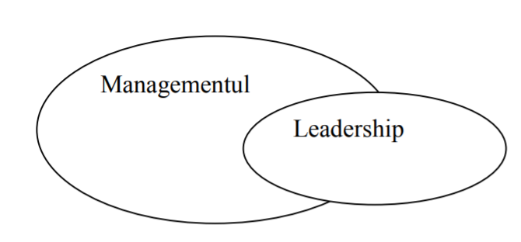
Figure 3: relationship between management and leadership
The content and effectiveness of leadership depend on the characteristics of the organizational culture involved and the leader's ability to understand and take them into account.
Difference between management and leadership: Managers are the ones who establish the structure and delegate the authority of the person and the responsibility of each one, the leaders promote directions developing the organizational vision and communicating it to the employees and inspiring them to realize it.
Management includes planning, organizing, staffing, directing, and controlling; management is a part of the management's management function. Leaders focus only on listening to workers, building relationships, teamwork, inspiring, motivating workers and convincing them. But both are especially important in a company strategy, it is essential for organizational success.

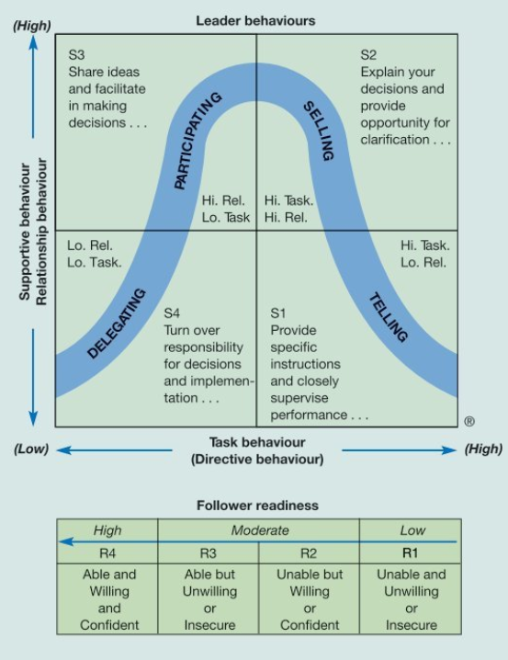
Figure 4: Leader model
Source: Organizational Behavior and
Management, Laurie J. Mullins, Gill Christy (2010), pp 390

  - Conclusion
This assessment analyzes the concussion of organizational structure and culture on organizational performance. Based on methodology, organizational performance can depend on the structure of the organization. If the structure is clearly viewing people can perform better, and productivity will be increased, and tasks will be divided. Results of this study show positive join between performance improvement and a strong culture. I want to deduce that organizational culture has a positive effect on the employees’ work performance. In conclusion, leadership means the ability of a leader, of a leadership to determine a group of people, to work with it in achieving a goal based on their forceful emotional and operational involvement.
This study is based on literature, further online information.

- References:
Alvesson, M. 1987 Organizations, culture, and ideology. International Studies of Management and Organization, 13(3):4-18.
D. Nelson and C.J. Quick, Understanding organizational behavior. Mason OH: South Western Cengage Learning.

Hofstede Geert (2001), Culture's Consequences: comparing values, behaviors, institutions, and organizations across nations (2nd ed.).

Kotter 2012, Corporate culture, and performance. New York.

Lawrence G. Hrebiniak.

Laurie J. Mullins, Management and Organizational Behavior, 11th , 17th ed.
Schein, E.H.1983, The role of the founder in creating organizational culture.
Schein, E.H.1985, Organizational culture and leadership. San Francisco: Jossey- Bass.
http://www.adidas-group.com/en/local/search
http://www.adidas-group.com/en/sustainability/Overview/progress/management

Handy’s (1976) Model of Organizational Culture
https://www.adidas-group.com/en/group/culture/

