
THE CONTINENTAL HOTEL
Financial Management for the Hotel Industry

DALE CLARKE
SOFA BEGUM
2021259

Table of Contents
EXECUTIVE SUMMARY: 2
Task 1 3
Task 2 4
Reference List 10

EXECUTIVE SUMMARY:

This report is the budget planning for the continental hotel for 4 months. This report is prepared for the regional account’s director. This report will have budget presentation in excel sheet screenshot attached and will detail the zero-based budgeting what is it and how we can implement it in the hotel sector specially in The continental hotel. A 15-room hotel called The Continental is located in London. Each room at the hotel costs $250 per night. The hotel features a top-notch restaurant as well.
This report aim was to create a month-by-month only 4 month cash budget estimate for January 2022 to December 2023 using the information that applies to the Hotel. The rules of zero-base budgeting, its objectives, philosophy, policies, financial policy plan for the hotel, are all included in the executive summary. Zero-based budgeting (ZBB) is a way of planning a budget wherein every subsequent period's spending must be supported. Beginning with a "zero foundation," every operation inside a company is examined for its demands and expenditures as part of the zero-based budgeting process. Zero-based budgets are the targeted processes, which have cheaper expenses, and more methodical implementation are the main benefits of it. The drawbacks have included potential for resource-intensiveness, vulnerability to manipulation by smart management, and predisposition toward relatively brief strategy.
In the budget plan report the summary and calculations are highlighted, how to implement the zero-base budgeting are presented. Highlights of the key components of how to adopted his type budget for “The continental hotel” are also given.

Task 1
THE CONTINENTAL HOTEL BUDGET PLAN

Task 2

Zero-base budgeting technique with a view to implementing this type of budgeting approach in the future (The Continental Hotel)

Zero-based budgeting requires an organization to justify each expenditure line and begins each budget at "zero." The conventional budgeting method, that is based on past budgets and only permits revisions to existing budgets, is in contrast to this method of financing. In Peter Pyrrh's book "Zero Based Budgeting: A Realistic Admin Tool for Analyzing Expenditure," published in the 1970s, the term "zero-based budgeting" was used (Finance Strategists, n.d.). Once more, establishing marketing giants that will bridge the gap between corporate objectives and financial limits as well as profit from zero-based budgeting's usual efficiency. Marketers will develop new synergies and economic edge that will line with the strategic objectives stay ahead of the competition in the international market place through The Continental Hotel's excellent fiscal reporting and stronger business connections. (Martin, undated)
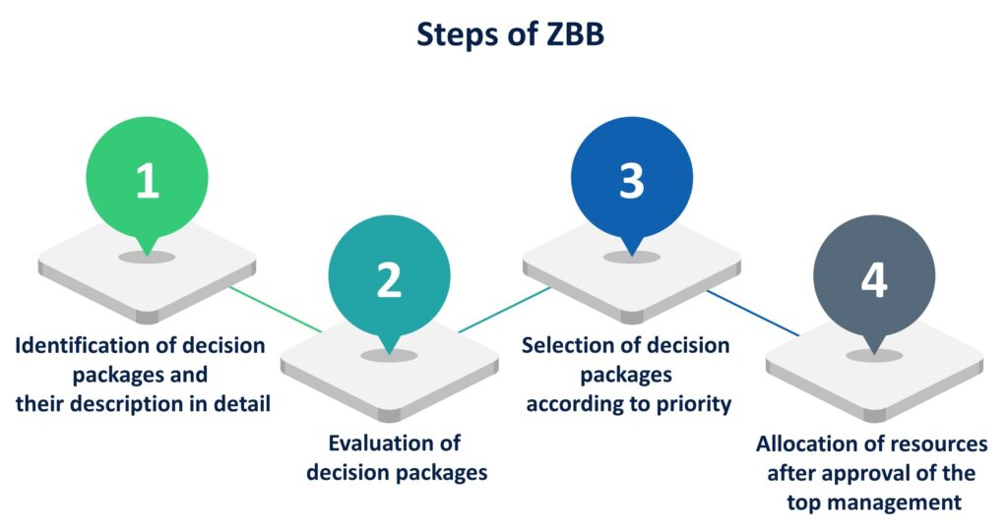
(Wikipedia Contributors, 2019)

Zero-based budgeting, or ZBB, is a budgeting technique that requires justification for every new phase costs. The Continent Hotel will keep certain values to promote ZBB to the hotel and the staff and will eliminate frivolous expenditure by re-examining possibilities. The zero-based budgeting approach begins with a "zero basis" and analyzes the requirements and costs of each function contained therein.
Below are 5 points that are mentioned:
1. Get going: Begin with an overview.
2. Assess: Inspect each expense component.
3. Justify: Compile a list of every item in the budget.
4. Simplify: Establish what procedures should be followed and how they should be carried out.
5. Carry out: Put careful planning and carrying out processes into practice. (Contributors to Wikipedia, 2019)
In contrast, The Continental Hotel employs a range of budgeting strategies, including conventional budgeting. When the budget from the prior year is utilized to create the budget for the current year and to make modifications to the budget from the prior year at the time under consideration. Zero-based budgeting, in contrast to traditional budgeting, starts with nothing and justifies each individual expense over the course of a reporting period. Zero-based budgeting will start from the beginning and look at each specific organizational need rather than the incremental budgeting increases seen in traditional planning. Fundamentally, this enables purposeful, top-down analysis of project performance. Zero-based budgeting is routinely used by organizations, and The Continental Hotel is no exception. (Martin, undated)
-Budgets will be made to account for the costs associated with every new period of the Continent Hotel, such as a month.
Both conventional budget and zero-based budgeting will be used by the Continental Hotel to keep track of its expenditures.
-Managers will use zero-based budgeting to help cut expenditures.
-Zero-based budgeting as an accounting method has several advantages, include streamlined activities, reduced costs, budgetary adaptability, and process of a business. If management examine how each dollar is spend at the aforementioned Continent hotel, the top operating income processes will be more clear. Zero-based budgeting, on the other hand, can lead to reduced costs as it avoids resource misallocation, which can happen over time when a budget is built up gradually. Again, the ZBB process will function in stark contrast to traditional yearly budgeting techniques. The actuals from the previous year are occasionally used to generate traditional yearly budgets, and a few percentage points are added to compensate for depreciation and wage increases. A simple and progressive budget will lead to inefficiencies and missed opportunities to increase savings. Once more, ZBB will insist that The Continental Hotel develop their yearly budget from scratch each year (thus its name) in order to ensure that all of the budget's components are reasonable, important, and designed to boost savings. 2019 (Anaplan)

Here are the approximate budget calculations for The Continental Hotel's new 2023 budget based on the previous two years. Using it only as an example to demonstrate how figures are displayed (not actual figures).
Month Predicted Revenue  £ ( 2021) | Month Predicted Revenue  £ ( 2022) | Month Predicted Revenue  £ ( 2023, Approx.)
January 80,000  February 45,000  March 75,000  April 40,000  May 35,000  June 40,000  July 45,500  August 50,900  September 55,000  October 40,000  November 45,900  December 35,800 | January  82000  February 40,000  March 85,000  April 45,000  May 30,000  June 42,000  July 35,500  August 55,900  September 58,000  October 42,000  November 41,900  December 39,800 | January  85000  February 49,000  March 86,000  April 43,000  May 35,000  June 40,000  July 32,500  August 65,900  September 70,000  October 46,000  November 45,900  December 40,800

The covid epidemic has compelled businesses and the government to revise their business plans, change their work processes, and take a more resilient tack. The Continental hotel had to restart operations in June after the pandemic's onset, which coincided with the declaration of an emergency, effectively brought the business to a standstill. The hotel is working to regain the trust of its customers by using the emergency hygiene measures put in place. When it became apparent that the pandemic would not stop soon, drastic action was taken. In order to "take advantage" of the sharp decline in market demand, authorities decided not to reopen the 4 hotels that were still under Accor administration at the time and instead to begin a larger renovation effort. As it will include:
Because of zero-based budgeting, management of The Continental Hotel will evaluate every penny spent during each budgetary period. Management must defend all operational costs. As part of this process, they must also identify which parts of the company generate money and justify all operational expenses.
Reduces legacy costs as much as possible
Legacy expenditures may not be taken into account in regular planning for years, unless the Continental Hotel is forced to make drastic decisions as a result of an economic crisis. Over time, costs tend to increase, and each department fights to defend its budget against reductions. This approach is unsophisticated and, over time, will result in a huge misallocation of resources. Zero-based budgeting will avoid this if implemented properly.
While zero-based budget will be a very difficult approach based on projected data that can only be applied to profit centres of it, traditional budgeting is a fairly simple way based on statistics which will applicable to all sections of The Continental Hotel. The main distinction between this hotel's conventional budgeting and zero-based budgeting is that traditional budgeting takes into account expenditures from the previous year, thus expenses are not minimal. However, expenditures will be kept to a minimum since zero-based budgeting will begin at zero.
To be ready for any future events, the Continental Hotel should budget expenditures and expenses. Establishing a budget guarantees that businesses are properly allocating their resources and controlling expenditures. The Continent hotel will generate a significant profit using this technique, despite the fact that zero-based budgeting, a typical budget technique, will earn no predictions and rather than based its expectations on financial planning as zero.
In the framework of this hotel budgeting, Zero-based budgeting will try to represent the actual costs that a department of The Continental Hotel will experience. This method of budgeting will be more effective, while being stricter.
The goal of zero-based budgeting is to make management accountable for spending and maximize the profitability of the Continental Hotel by reducing costs rather than increasing revenue. Therefore, just at end of each day, the Continental Hotel will have to make the choice between using the more simple budget preparation approach or devoting time and resources to the budgeting process in order to offer more accurate statistics.
Finally, The ZBB plan will allow funds to be channelled and more closely connected to growth efforts and goals of the Continental Hotel. It will eliminate non-working money that inefficiently supports the strategy. A budget will be created by merging the numerous results and expenditure packages, and it should produce a set of precise outcomes for the entire school or district. The ZBB method will involve identifying the decision unit (a single activity or cluster of activities), making the decision, and assisting the leader in avoiding conventional expenditures that are no longer necessary. Again, some more facilities will be there like-
- It will help to be established what will happen and how to measure effectiveness empirically;
- It will offer a "returns" approach to choosing budget priorities;
- It will offer the data required to make decisions about whether to keep running programs, create new ones, stop running programs, or introduce new ones.
- In the end, it will result in a more deliberate simplicity of effort while boosting student and program success; and It will compel those responsible for budget development to assess if such initiatives will indeed boosting employees accomplishment. (Nnoli, Adeyemi and Onuora, n.d.)

Reference List

Sertifi. (n.d.). 5 Factors to Consider During Hotel Budget Season. [online] Available at: https://corp.sertifi.com/blog/posts/5-factors-to-consider-during-hotel-budget-season/ [Accessed 22 Mar. 2022].
RoomKeyPMS. (n.d.). How to Plan Your Hotel Budget: A Step-by-Step Guide. [online] Available at: https://roomkeypms.com/resources/how-to-plan-your-hotel-budget-step-by-step-guide/ [Accessed 22 Mar. 2022].
Kagan, J. (2019). Zero-Based Budgeting (ZBB). [online] Investopedia. Available at: https://www.investopedia.com/terms/z/zbb.asp.
Investopedia. (2019). Zero-Based Budgeting: Benefits and Drawbacks. [online] Available at: https://www.investopedia.com/ask/answers/051515/what-are-advantages-and-disadvantages-zerobased-budgeting-accounting.asp.
WallStreetMojo. (2017). Traditional Budgeting vs Zero Based Budgeting | Top 10 Differences. [online] Available at: https://www.wallstreetmojo.com/traditional-budgeting-vs-zero-based-budgeting/.
Net, H. (n.d.). Zero Based Expenses – How to Plan and Manage | By David Lund. [online] Hospitality Net. Available at: https://www.hospitalitynet.org/opinion/4093947.html.
www.google.com. (n.d.). introduce Zero-based Budgeting - Google Search. [online] Available at: https://www.google.com/search?q=introduce+Zero-based+Budgeting&oq=introduce+Zero-based+Budgeting&aqs=chrome..69i57j0i22i30l4j0i390.1603j0j7&sourceid=chrome&ie=UTF-8 [Accessed 23 Mar. 2022].
www.google.com. (n.d.). conclusion of zero based budget - Google Search. [online] Available at: https://www.google.com/search?q=conclusion+of+zeo+based+budget&oq=conclusion+of+zeo+based+budget&aqs=chrome..69i57j0i13.20437j0j9&sourceid=chrome&ie=UTF-8 [Accessed 23 Mar. 2022].
eFinanceManagement.com. (2019). Sanjay Bulaki Borad. [online] Available at: https://efinancemanagement.com/budgeting/zero-based.
ClearTax (n.d.). Zero Based Budgeting ( ZBB ) - Overview & Advantages. [online] cleartax.in. Available at: https://cleartax.in/s/zero-based-budgeting#:~:text=How%20does%20zero%2Dbased%20budgeting [Accessed 23 Mar. 2022].
Dean, B.V. and Cowen, S.S. (1979). The Use of Zero-Base Budgeting in Industry: Some Observations. Interfaces, [online] 9(4), pp.55–60. Available at: https://www.jstor.org/stable/25059771 [Accessed 23 Mar. 2022].
Finance Strategists. (n.d.). Zero-Based Budgeting (ZBB) | Definition | Steps | Example. [online] Available at: https://learn.financestrategists.com/finance-terms/zbb/?gclid=Cj0KCQjwtvqVBhCVARIsAFUxcRsbmoN4Go2qxmG0OExrn67tiNKERHkF29ycAeHkr3aVgnmsTOoV6HEaAscnEALw_wcB [Accessed 1 Jul. 2022].
Martin, C. (n.d.). Council Post: Improve Your Marketing Performance With Zero-Based Budgeting. [online] Forbes. Available at: https://www.forbes.com/sites/forbesagencycouncil/2021/10/08/improve-your-marketing-performance-with-zero-based-budgeting/?sh=596097f55d98 [Accessed 1 Jul. 2022].
Martin, C. (n.d.). Council Post: Improve Your Marketing Performance With Zero-Based Budgeting. [online] Forbes. Available at: https://www.forbes.com/sites/forbesagencycouncil/2021/10/08/improve-your-marketing-performance-with-zero-based-budgeting/?sh=596097f55d98.
anaplan (2019). What is Zero Based Budgeting? (Advantages, Steps & Examples). [online] Anaplan. Available at: https://www.anaplan.com/blog/zbb-zero-based-budgeting-guide/.
Nnoli, U., Adeyemi, S. and Onuora, O. (n.d.). ZERO-BASED BUDGETING: PATHWAY TO SUSTAINABLE BUDGET IMPLEMENTATION IN NIGERIA. [online] Available at: https://dspace5.zcu.cz/bitstream/11025/22503/1/Udeh.pdf [Accessed 3 Jul. 2022].
Wikipedia Contributors (2019). Zero-based budgeting. [online] Wikipedia. Available at: https://en.wikipedia.org/wiki/Zero-based_budgeting.

