Student number: 2516956
Word count – 2785

The first 1000 days.
Please Choose one of the following statements [DELETE AS APPROPRIATE]

a. I confirm that I have not used any AI tools in the research and creation of this assignment. I confirm that I have not presented any AI generated materials as my own work. I confirm I have copies of my drafts, notes, and other resources I used, which I may be asked to provide in evidence.
The first 1,000 days of a child’s life span from the point of conception up until the age of two. This period is extremely important as it covers some of the most significant stages of a child’s physical, emotional, and mental development. During the first 1,000 days, good nutrition is very important for a child’s growth and brain development. Bowlby’s attachment theory suggests that when a child’s basic needs, such as food, are met, they are more likely to feel safe and secure. Proper nutrients help children grow, stay healthy, and have the energy to interact with their carers. This supports strong attachment and helps build a good foundation for future development and wellbeing.

During the first 1,000 days of life, the foundations for a child’s future health, learning, and behaviour are formed. A child’s brain begins developing in utero, and although brain development continues throughout life, it grows most rapidly during this initial period. Bowlby believed that early relationships are extremely important for healthy brain development. His attachment theory explains that when a child’s needs are met through consistent feeding, comfort, and care, they feel safe and secure. This sense of security supports healthy brain growth and emotional development. Positive, loving interactions with carers help strengthen brain connections that support learning and emotional control. These early experiences create strong foundations that influence a child’s wellbeing, behaviour, and ability to form relationships later in life.

(Source: word stock images)

Because of this, the experiences a child has in these early years can have long-lasting effects throughout their life.According to the House of Commons, children who experience a positive and supportive upbringing during the first 1,000 days are more likely to enter society on a more equal footing and have better life chances overall. A nurturing environment can support healthy brain development, emotional security, and physical growth, all of which are essential for a child’s future wellbeing. Nutrients are also a key factor according to the American institute of health as establishing healthy dietary habits within the first 1000 days can help a child continue healthy habits throughout their lifetime which reduces the chance of things like obesity later on in life.
The House of Commons also highlights how important it is for parents and carers to have access to the right support, services, and resources to provide a stable and safe upbringing during this time. However, despite the recognised importance of the first 1,000 days, not all parents and carers have the tools, knowledge, or support needed to provide a healthy and nurturing environment. Factors such as poverty, lack of education, limited access to healthcare, and social inequalities can make it more difficult for families to meet their child’s needs. This can result in disadvantages that may affect a child’s development long-term. Because of this, the issue is increasingly being addressed by policymakers and health services. Improving support during the first 1,000 days is seen as essential in reducing child mortality and ensuring that every child is given an equal opportunity from the very beginning of life.

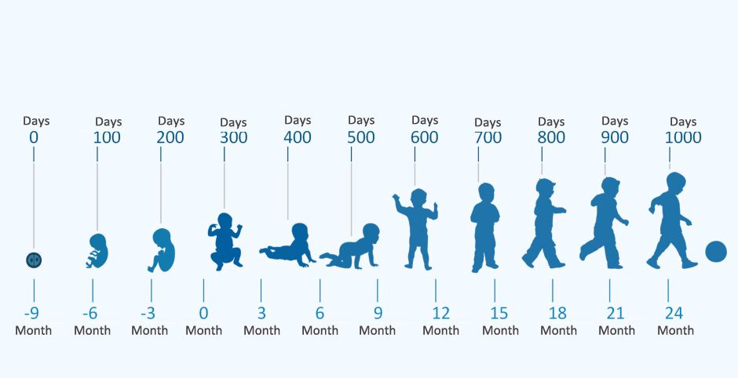
Learning opportunities.
The first 1,000 days of life, from pregnancy to around two years old, are a vital time for a child’s learning and development. During this period, a child’s brain develops rapidly and is strongly influenced by the experiences and interactions they have with caregivers. Positive learning opportunities in the early years help to build strong foundations for future development. Babies learn through observing body language, facial expressions and gestures. They often copy what they see, such as smiling, waving or clapping. This supports early communication skills and helps babies understand emotions and social interaction. Practitioners play an important role by using positive body language, eye contact and responsive interactions. Talking to children supports language development and early thinking skills. Responding to a baby’s sounds and words encourages communication and helps them learn new vocabulary. Research shows that regular conversation between adults and young children supports brain development. Reading books from an early age helps children develop listening skills, language and a love of stories. Play is also essential, as it supports physical development, problem-solving and social skills.

Safety.
Safety is very important in the first 1,000 days because it helps a baby grow strong, healthy, and confident. According to Maslow, a child needs to feel safe before they can learn, play, and form relationships. A safe home and careful daily checks for risks, like sharp objects or unsafe sleeping areas, protect babies from accidents and harm. Feeling secure and protected lowers stress and helps the brain develop properly. When babies grow up in a safe and loving environment, they are more likely to become independent, healthy adults who can explore the world, make decisions, and build strong relationships. Safety lays the foundation for their future growth and wellbeing.

Good health.
Maslow’s hierarchy of needs shows that basic needs like food, health, and safety must be met first. When these needs are met, children can grow, learn, and develop properly. Good health is very important during the first 1,000 days of a child’s life because this is when their body and brain grow the fastest. If a child is often unwell or does not get the right care, it can affect their development later on. Access to medication and health services helps treat illnesses early and keeps children healthy.
According to unicef (2021) Community health workers are important because they monitor growth, give nutrition advice, and treat childhood illnesses quickly. Strong local healthcare services help make sure all children receive care, no matter where they live or how much money their family has. Emotional health is also important. When children feel safe, loved, and comforted, they develop better emotionally.

(IDSMed, 2024)

Adequate nutrition during the first 1,000 days of a child’s life is very important because this is when the foundations for healthy growth and development are formed. A mother’s health and diet directly affect her baby during pregnancy, so eating a balanced diet is essential. Factors such as diet, genetics, and hormones all play a role in how a child grows and develops. Research by the national library of medicine shows that a mother’s diet, weight, and lifestyle choices can influence a baby’s immune system, organ development, and overall health. Breastfeeding is especially important in the early months, as breast milk provides the ideal nutrition for the first six months of life. It contains all the nutrients a baby needs in the right amounts, helping to support healthy growth and future wellbeing.
Nutrition.

Being responsive.
Being responsive in the first 1,000 days of life is essential for healthy emotional, social and physical development. Responsiveness means recognising a baby’s needs and responding to them in a warm, consistent and caring way. During this early period, babies depend entirely on adults to meet their needs and help them feel safe. According to John Bowlby’s attachment theory, babies form strong emotional bonds with caregivers who respond consistently to their needs. When a baby is comforted when they cry or smiled at when they seek interaction, they begin to build trust. This secure attachment helps children feel safe to explore their environment and supports future relationships and emotional wellbeing. Emma Pikler also highlighted the importance of respectful and responsive care. She believed that babies should be treated as capable individuals whose cues and signals should be carefully observed. By recognising when a baby is hungry, tired or overstimulated, caregivers can respond appropriately, helping the child feel understood and valued. Responsive feeding is an important part of this. When adults respond to hunger cues rather than following rigid routines, babies learn to trust that their needs will be met. Offering comfort, love and reassurance through cuddling, gentle touch and soothing voices supports emotional security and brain development.

CAREGIVING

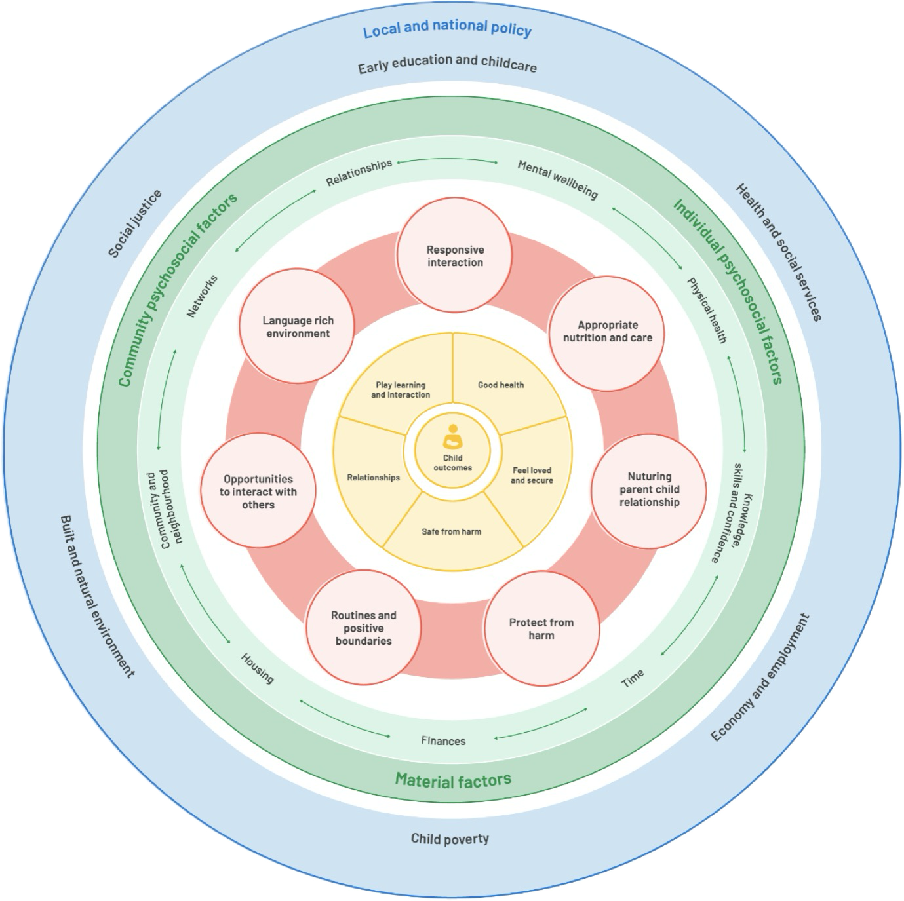
F
Source : Public health Wales

The first 1,000 days of life, from pregnancy to around two years old, are a crucial time for a child’s development. Public Health Wales explains that experiences during this period can have a long-lasting impact on a child’s physical health, emotional wellbeing and ability to learn later in life. Because parents and carers have the biggest influence during these early years, supporting families at this stage is very important.Professional practitioners play a key role in supporting families during the first 1,000 days. Public Health Wales highlights that parents need more than just information; they also need emotional support, reassurance and access to services. Practitioners can help by building positive and trusting relationships with parents, listening to their concerns and offering non-judgemental support. This helps parents feel more confident and able to meet their child’s needs.Practitioners can support responsive care by helping parents understand their baby’s cues, such as crying, facial expressions and body movements. When parents respond quickly and warmly, babies learn that they are safe and cared for, which helps build trust. Public Health Wales stresses that feeling safe and secure in early life supports healthy brain development.

Strong professional partnerships are essential during the first 1,000 days of a child's life because no single service can address all the complex needs of families in this time. Collaboration among midwives, health visitors, early years practitioners, GPs, and mental health services creates a coordinated and comprehensive approach to support. When professionals share important information and communicate well, families are less likely to face gaps in care. This ensures that any concerns regarding development, wellbeing, or safety are recognized and dealt with promptly. This teamwork aligns with Bronfenbrenner’s ecological systems theory, which shows that a child’s growth is shaped by various interconnected systems around them, such as family, community, and professional networks (Bronfenbrenner, 1979).
Maternal factors significantly influence how well these professional partnerships work. A mother's mental health issues, like anxiety or depression after giving birth, can affect her ability to connect with services and trust professionals. If mothers feel judged or overwhelmed, they might step back from seeking help, making early intervention less effective. On the other hand, when professionals use a positive and understanding approach that respects different cultures, mothers are more likely to engage and ask for help. Bowlby’s attachment theory points out that a caregiver's emotional support is vital for forming secure attachments; therefore, taking care of maternal wellbeing is key for positive outcomes for infants (Bowlby, 1988).

As mentioned previously responsive feeding is also important. Practitioners can encourage parents to recognise signs of hunger and fullness rather than relying on strict routines. This helps babies feel understood and supports healthy growth.Providing comfort, love and affection is essential in the first 1,000 days. Practitioners can model gentle handling, soothing voices and positive interactions, and signpost families to additional support, such as health visitors or mental health services, when needed. By supporting parents in these ways, practitioners help give children the best possible start in life.

Social economic factors like poverty, unstable housing, and lack of social support can also affect how well partnerships function. Families dealing with many stresses may focus on urgent needs instead of connecting with services. Strong professional partnerships can help ease these challenges by providing appropriate referrals, practical assistance, and clear communication across services. In the end, effective partnership working not only supports mothers but also enhances the caregiving environment—fostering secure attachments, resilience, and healthy growth during the crucial first 1,000 days.

Enabling adults/ environments.

Enabling adults and enabling environments are very important in supporting children during the first 1,000 days of life. Enabling adults are people, such as parents and early years practitioners, who are able to support babies by being caring, responsive and understanding. When adults have good knowledge of child development and feel supported in their role, they are more confident in meeting a baby’s needs. This helps babies feel safe, secure and valued, which is essential for healthy development.

An enabling environment is a safe, calm and welcoming space that supports a baby’s learning and wellbeing. During the first 1,000 days, babies need environments that offer comfort, routine and positive interactions. Simple things such as gentle voices, familiar routines and safe spaces to explore help babies feel secure. When babies feel safe, they are more likely to develop trust and confidence. Bowlby’s attachment theory explains that babies form strong emotional bonds when adults respond to their needs in a sensitive and consistent way (Bowlby, 1988).

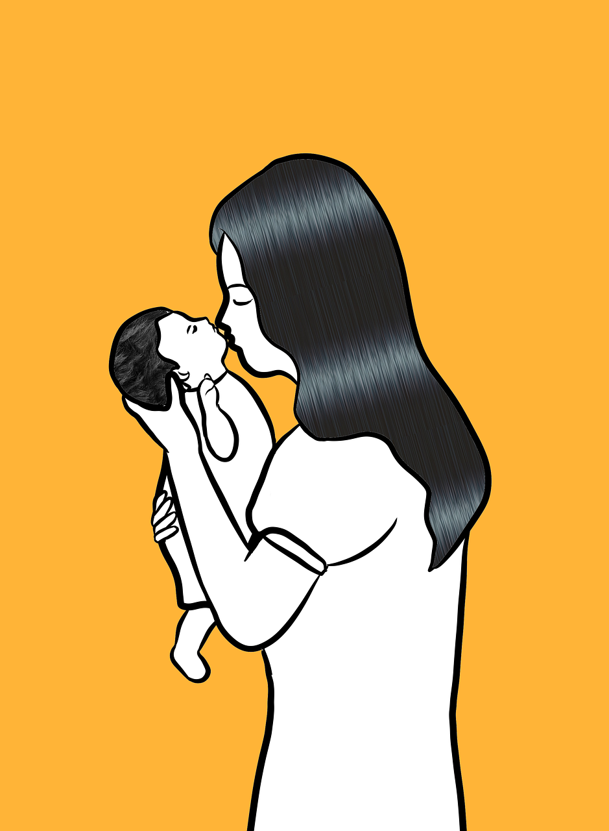
Bronfenbrenner’s ecological systems theory highlights that a child’s development is influenced by different environments, including the home, early years settings and the wider community (Bronfenbrenner, 1979). When these environments work together, children receive consistent care and support. Overall, enabling adults within enabling environments help to give children the best possible start in life by supporting emotional wellbeing, learning and healthy development during the crucial first 1,000 days.
Source:pixabay
Challenges
In the first 1,000 days of a child's life, families can encounter various challenges that impact their child's growth and wellbeing. One common issue is parental mental health. Some parents may struggle with stress, anxiety, or postnatal depression, making it difficult for them to meet their baby's needs. Early years practitioners and health visitors might see parents who seem withdrawn or overwhelmed. To help, they can provide reassurance, listen without judgment, and guide parents to support services.
Another challenge is financial strain or unstable living situations. Families dealing with poverty, housing issues, or unemployment may find it hard to maintain regular routines or access resources for their child. This can lead to children arriving at care settings tired, hungry, or unsettled. Practitioners can assist families by offering practical support such as food assistance information, flexible schedules, and referrals to local services. Collaborating with other professionals ensures that families get the right help when they need it.
Some families also face difficulties accessing services. Language barriers, lack of transportation, or fear of judgment might stop parents from engaging with these services. Practitioners can help by communicating clearly, building trusting relationships, and providing information in an easy-to-understand manner. Consistent and positive interactions boost parents' confidence and sense of support.
Social isolation presents another challenge for both parents and babies. Without strong support networks, parents may feel lonely and uncertain about how to care for their child. Encouraging parent groups, stay-and-play sessions, and informal chats can foster connections among parents. By acknowledging these challenges and responding thoughtfully, practitioners can help reduce barriers, support families effectively, and promote positive outcomes during those crucial first 1,000 days.

 | Activity | Benefit | Approach
Exploring outdoors | Exploring the outdoors can involve spending time in the garden, lying on the grass, going for buggy rides, or taking short walks in nature. While an adult helps them, babies can see trees, feel the weather, watch animals, and listen to the sounds of nature. | Playing outside helps kids grow physically by promoting movement, strength, and coordination. It also boosts mental health and lowers stress for both babies and adults. Nature offers valuable learning opportunities without overwhelming the senses. | The Forest School method emphasizes learning outdoors and believes that spending time in nature helps kids build confidence, resilience, and wellbeing right from a young age.
Responsive interaction | Responsive interaction involves engaging with babies through talking, singing, reading, smiling, and making eye contact. Adults react warmly and consistently to the sounds, gestures, and facial expressions of babies. | This helps babies develop language skills, communication abilities, and strong emotional bonds. When adults respond with care, babies feel safe, appreciated, and understood, which aids in their emotional growth. | The Reggio Emilia approach highlights the importance of listening to children and recognizing them as effective communicators right from birth.
Sensory play | Sensory play involves letting babies explore natural items like leaves, stones, pinecones, water, sand, and various textured materials. Under supervision, babies can touch, observe, listen to, and safely investigate these different objects. You can set up these activities either indoors or outdoors, making sure they are calm and suitable for their age. | Sensory play helps with brain development by allowing babies to understand the world through their senses. It sparks curiosity, enhances focus, and boosts early problem-solving abilities. Additionally, sensory experiences aid in emotional regulation, helping babies feel relaxed and secure while they play. | This method is connected to the Forest School approach that promotes exploration using natural resources and the Reggio Emilia approach that emphasizes learning through hands-on activities led by children.

- References.

- Bowlby, J. (1969) Attachment and Loss: Volume 1 – Attachment. London: Penguin Books.

- Bowlby, J. (1988) A Secure Base: Parent-Child Attachment and Healthy Human Development. London: Routledge.

- Bronfenbrenner, U. (1979) The Ecology of Human Development. Cambridge, MA: Harvard University Press.

- CARE Laos (2022) The First 1000 Days. Phongsaly & Sekong Provinces: CARE Laos. Unpublished project profile. Available at: https://www.care.org/wp-content/uploads/2022/01/Project-Profile-MoFAII-LUX-2019-Aug-09.pdf
- Edwards, C., Gandini, L. and Forman, G. (2012) The Hundred Languages of Children. Santa Barbara: Praeger.

- House of Commons Health and Social Care Committee (2019) First 1000 Days of Life: Thirteenth Report of Session 2017–19. London: House of Commons. Available at: https://publications.parliament.uk/pa/cm201719/cmselect/cmhealth/1496/1496.pdf (Accessed: 8January 2026).

- Knight, S. (2013) Forest School and Outdoor Learning in the Early Years. London: Sage.

- Marmot, M. et al. (2010) Fair Society, Healthy Lives. London: The Marmot Review.

- Maslow, A.H. (n.d.) Maslow’s Hierarchy of Needs. Simply Psychology. Available at: https://www.simplypsychology.org/maslow.html (Accessed: 10 January 2026).

- National Institutes of Health (2015) Safety Needs Mediate Stressful Events Induced Mental Disorders. European Psychiatry, PMC5050353. Available at: https://pmc.ncbi.nlm.nih.gov/articles/PMC5050353 / (Accessed: 10 January 2026).

- National Institutes of Health (2022) Importance of Maternal Nutrition in the First 1,000 Days of Life and Its Effects on Child Development: A Narrative Review. Nutrients. Available at: https://pmc.ncbi.nlm.nih.gov/articles/PMC964036 / (Accessed: 11January 2026).

- UNICEF (2017) Early Moments Matter for Every Child. New York: UNICEF.

- UNICEF Lao PDR (n.d.) Ensuring a Healthy Start: The First 1,000 Days. Available at: https://www.unicef.org/laos/ensuring-healthy-start-first-1000-days-0 (Accessed: 24 January 2026)

- UNICEF (2025) “Lao PDR puts early childhood at the heart of national progress” (press release). UNICEF, 22 October. Available at: https://www.unicef.org/laos/press-releases/lao-pdr-puts-early-childhood-heart-national-progress-partners-call-investment-first (Accessed: 24 January 2026).

- Public Health Wales (2021) A Public Health Approach to Supporting Parents: Summary Report.

- Pikler, E. (2002) Peaceful Babies, Contented Mothers. London: Hawthorn Press.

