Name；Ziqian Huang

Student Number；2304510

Link：
https://uowtsd-my.sharepoint.com/personal/2304510_student_uwtsd_ac_uk/_layouts/15/stream.aspx?id=%2Fpersonal%2F2304510%5Fstudent%5Fuwtsd%5Fac%5Fuk%2FDocuments%2FHRM%20presentation%2Emp4&referrer=StreamWebApp%2EWeb&referrerScenario=AddressBarCopied%2Eview

Slides：
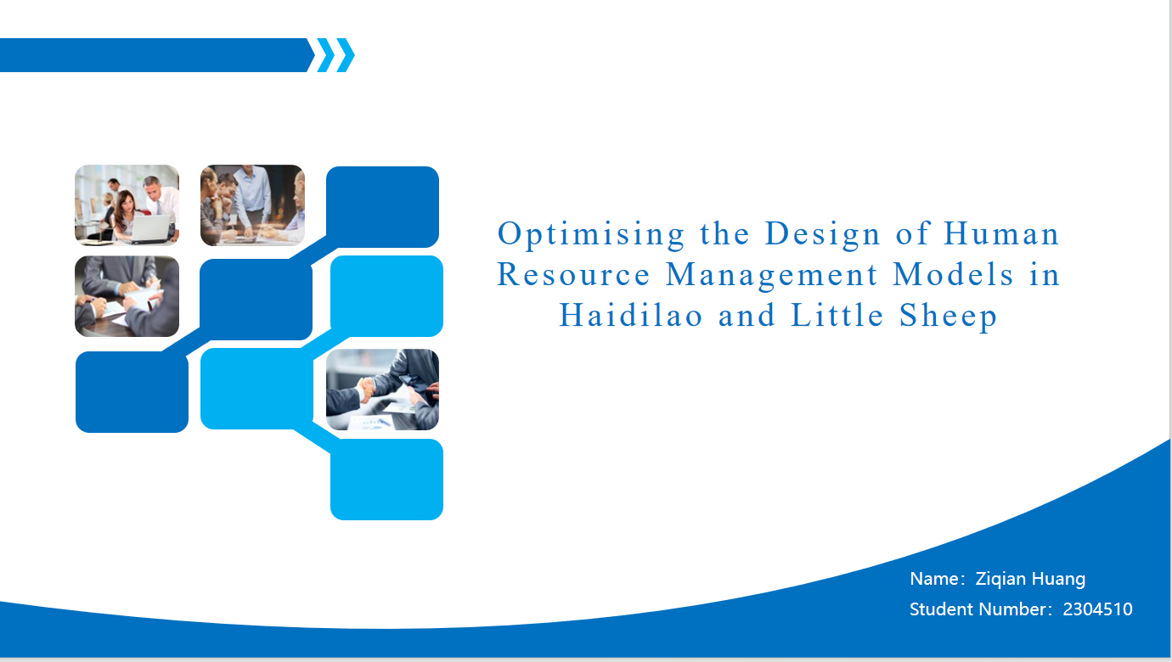
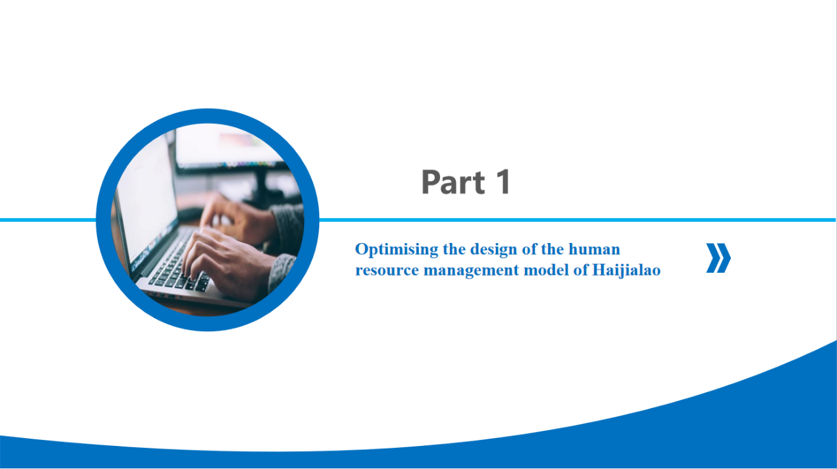
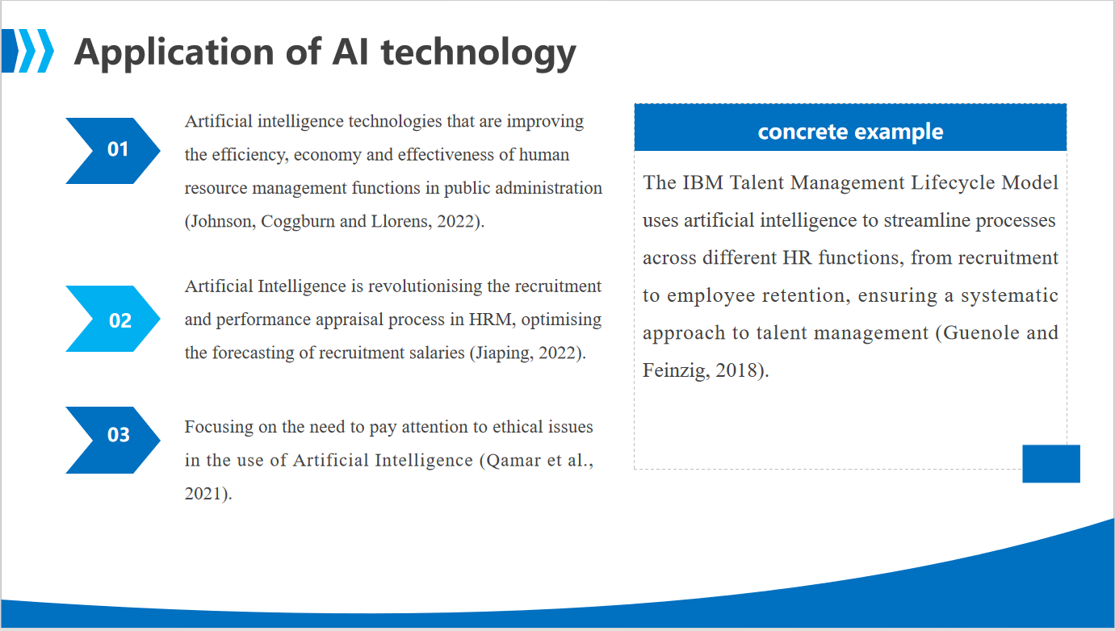
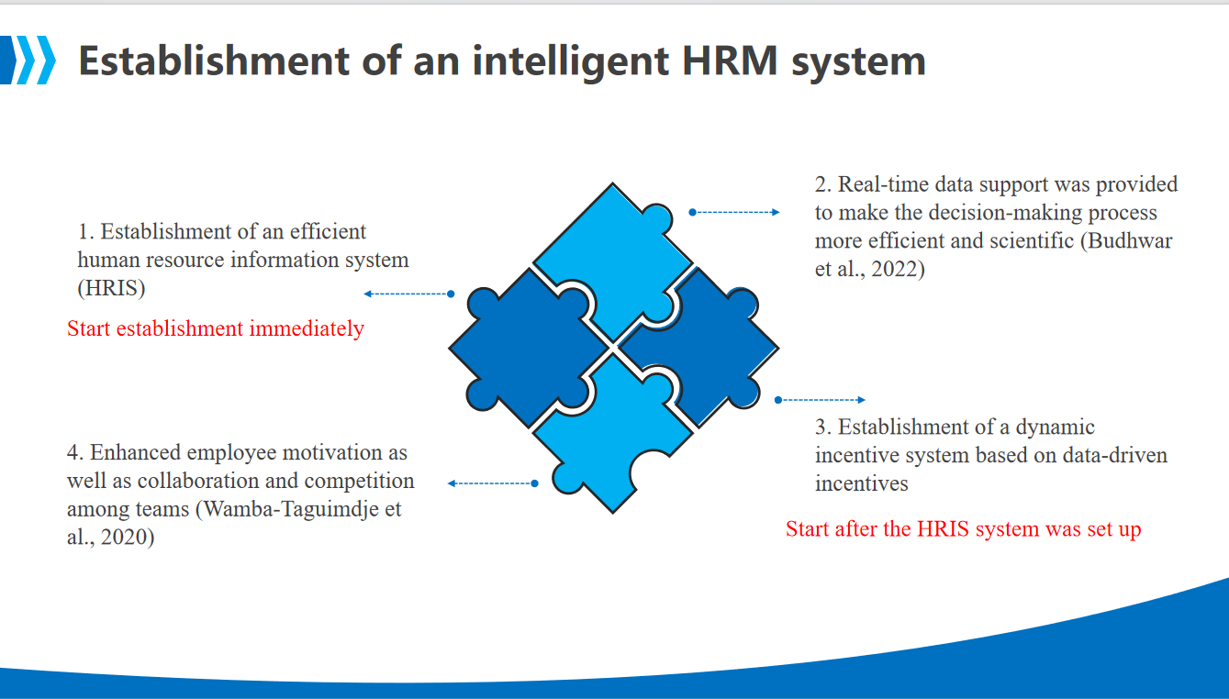
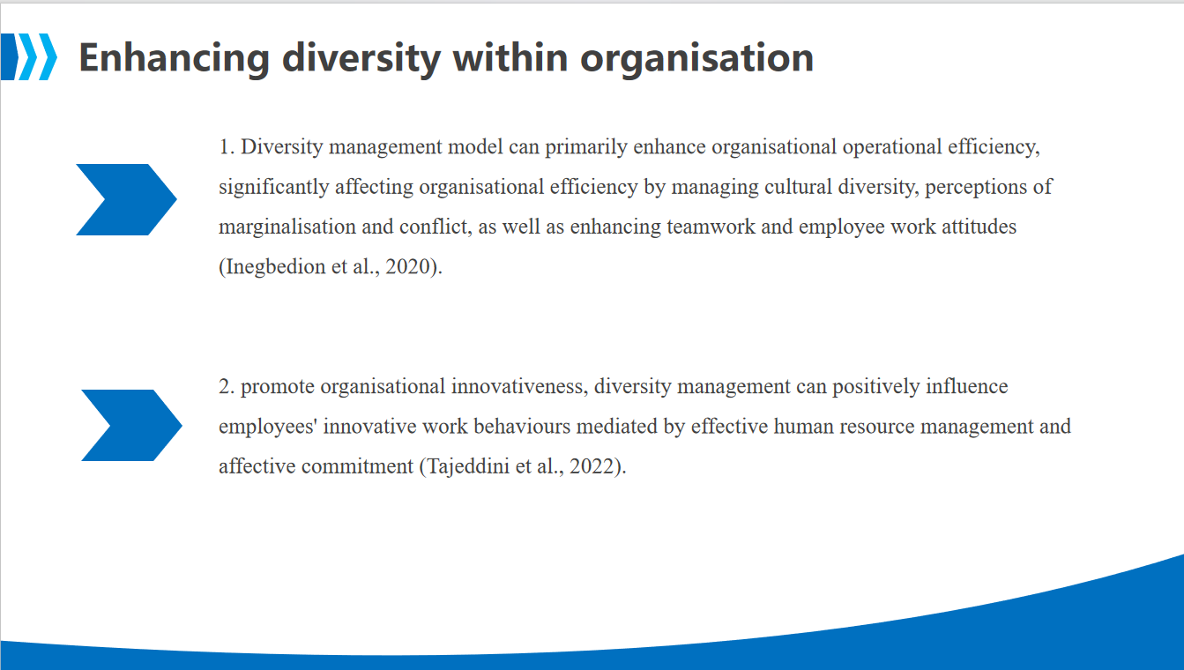
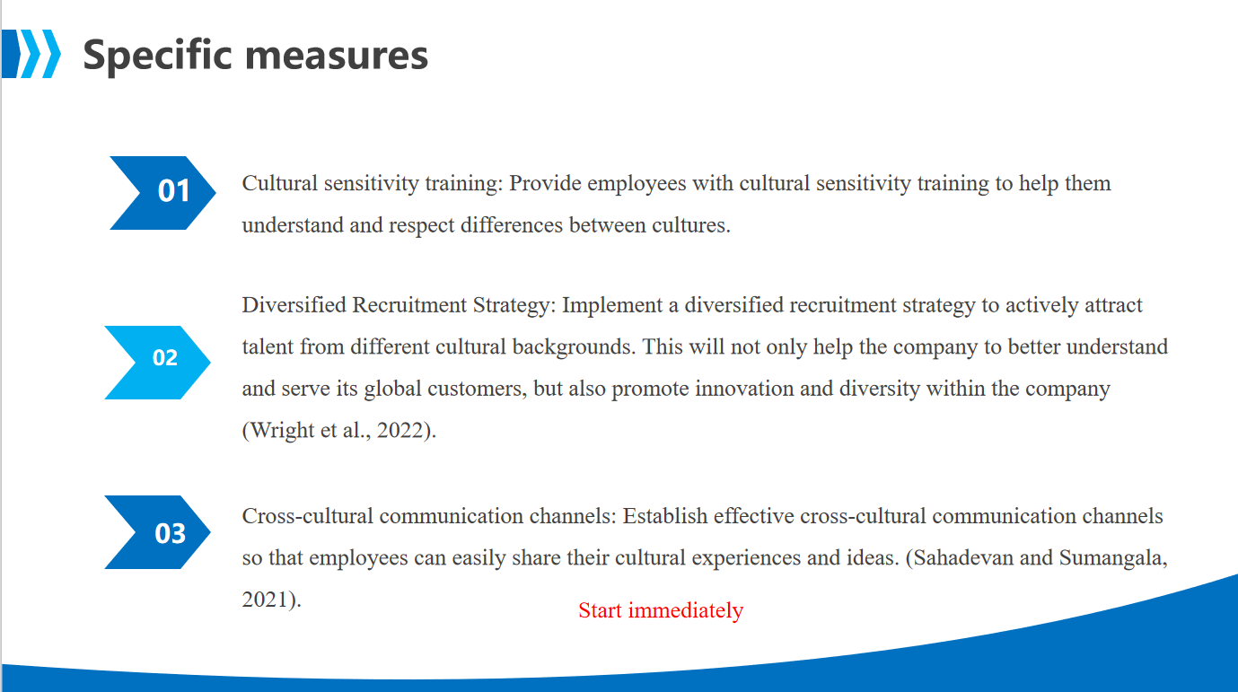
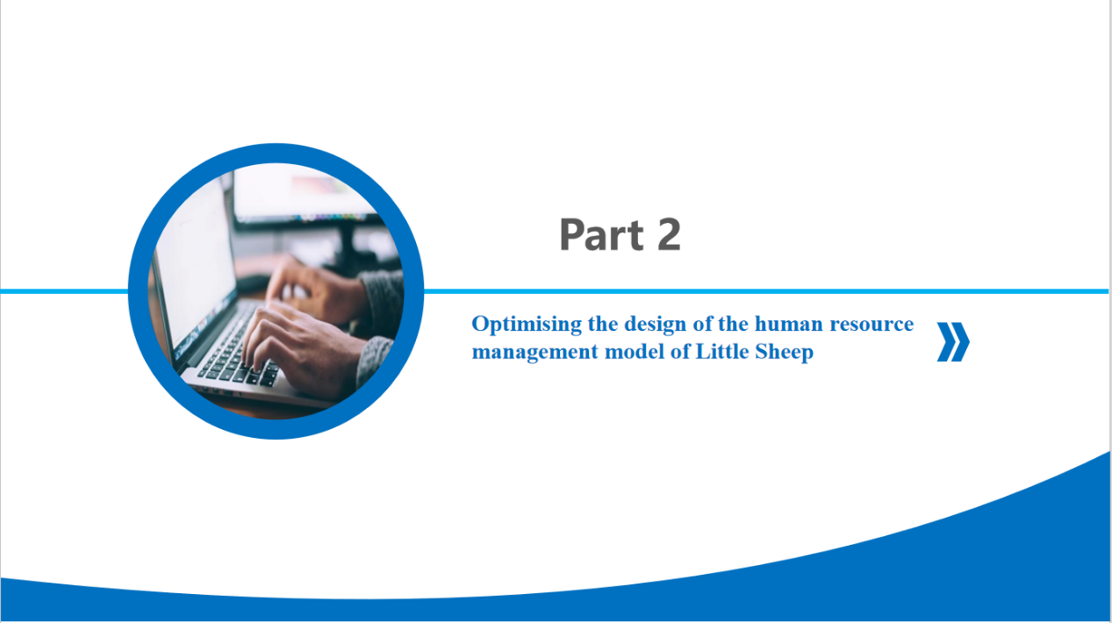
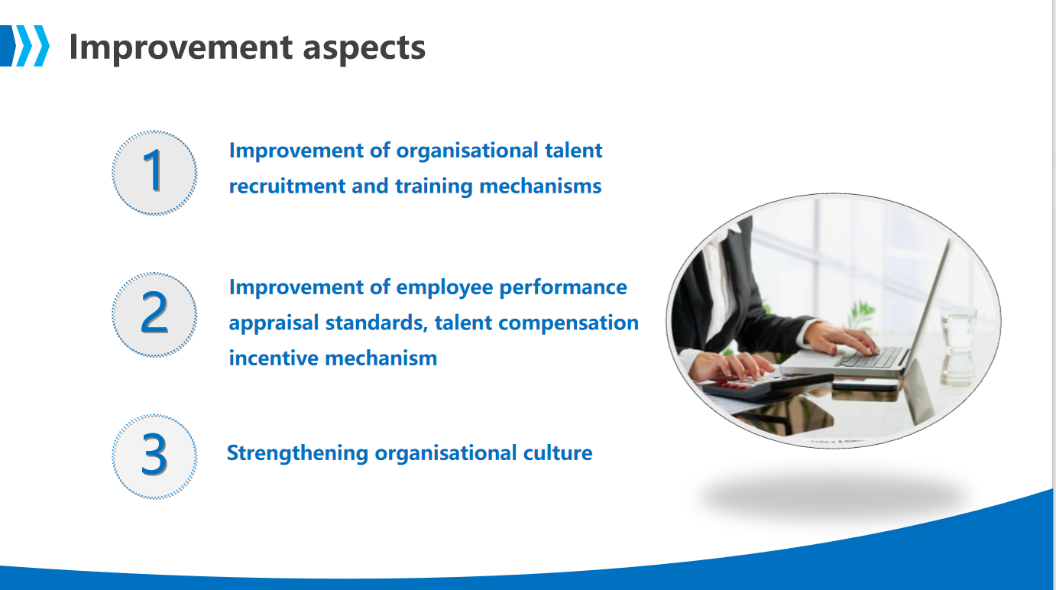
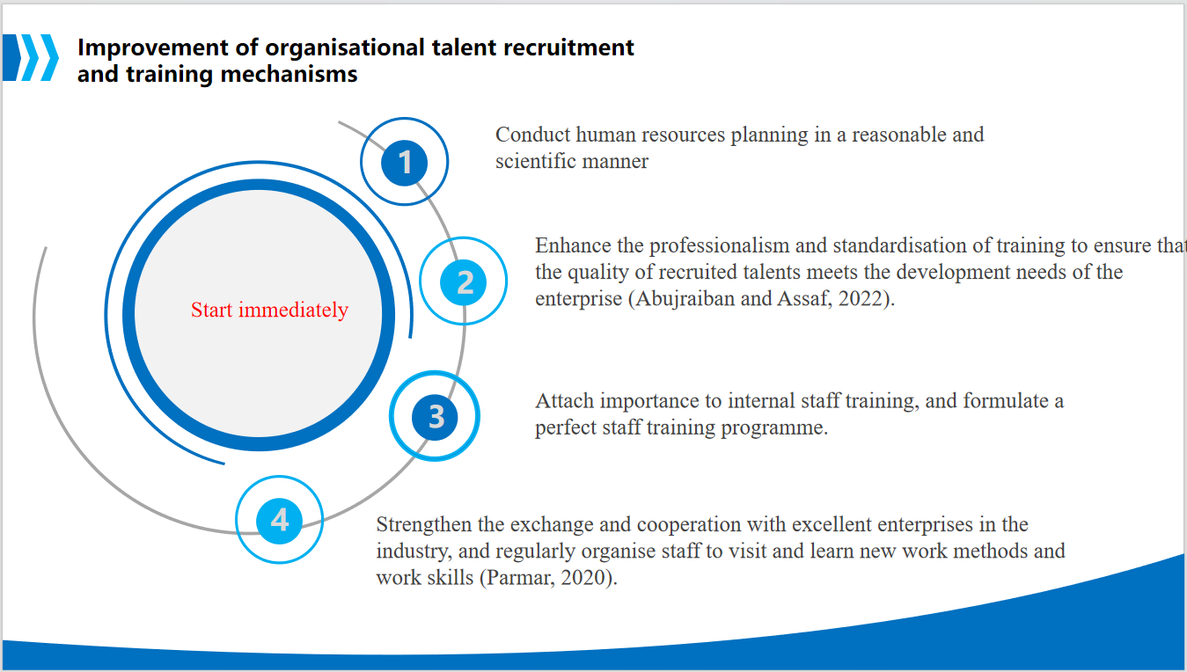
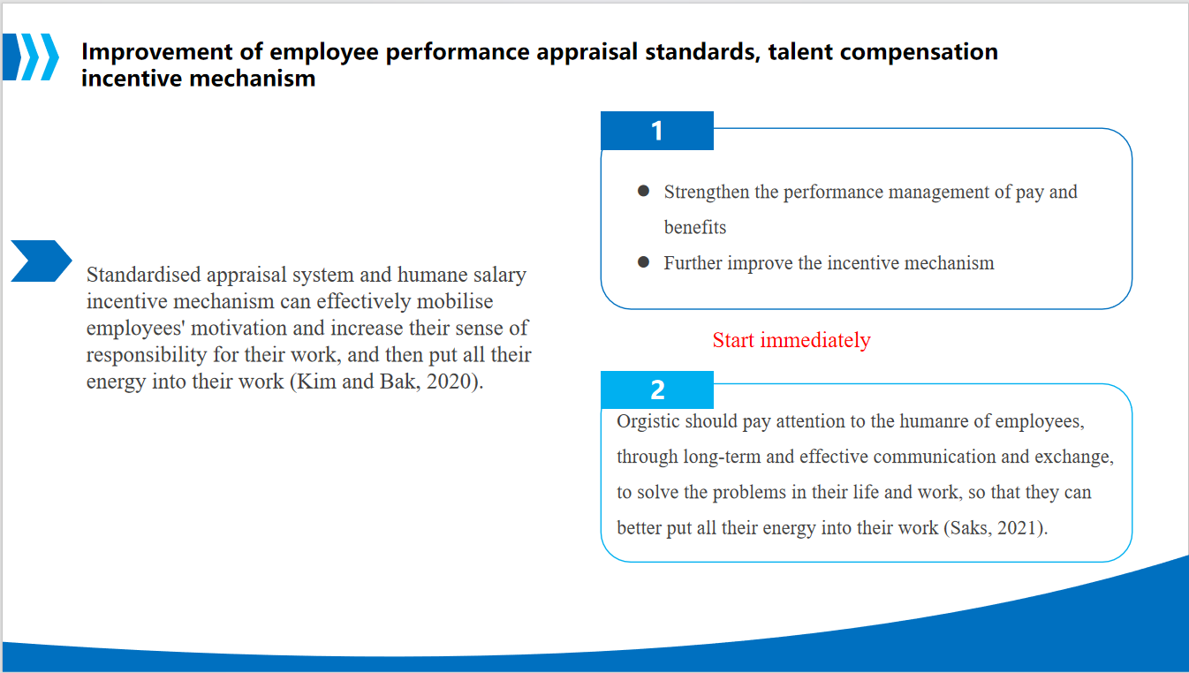
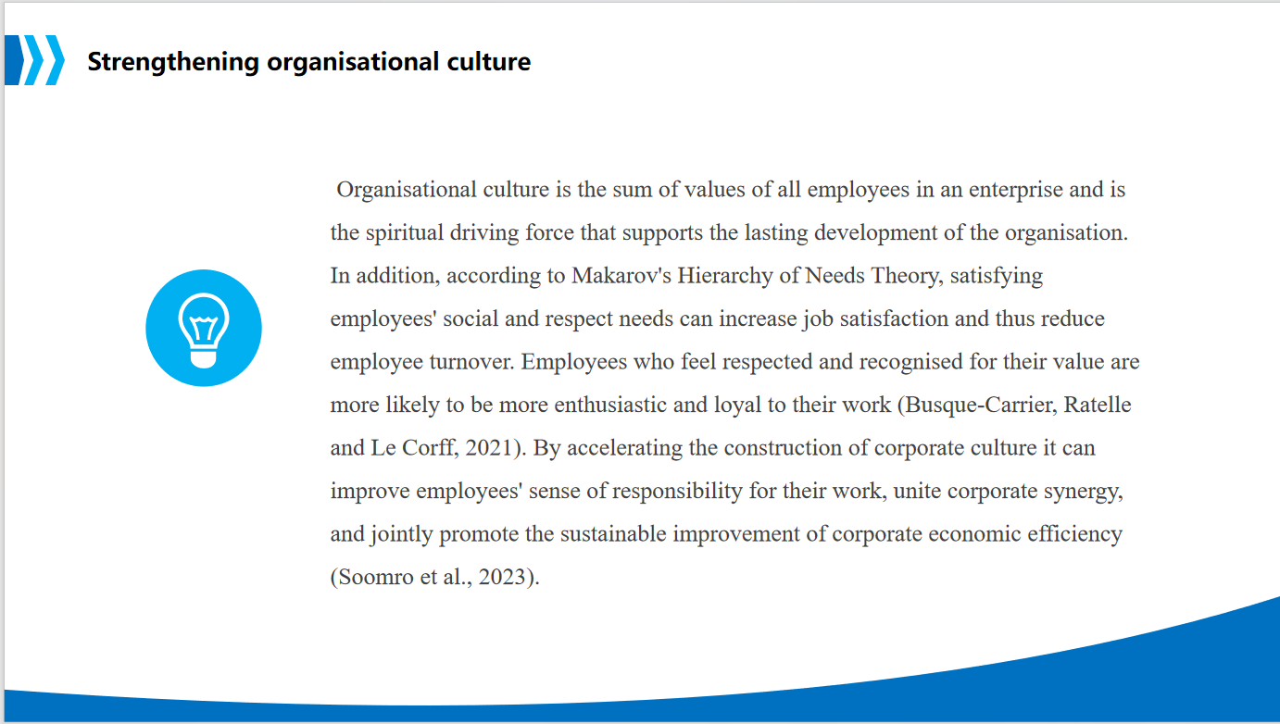
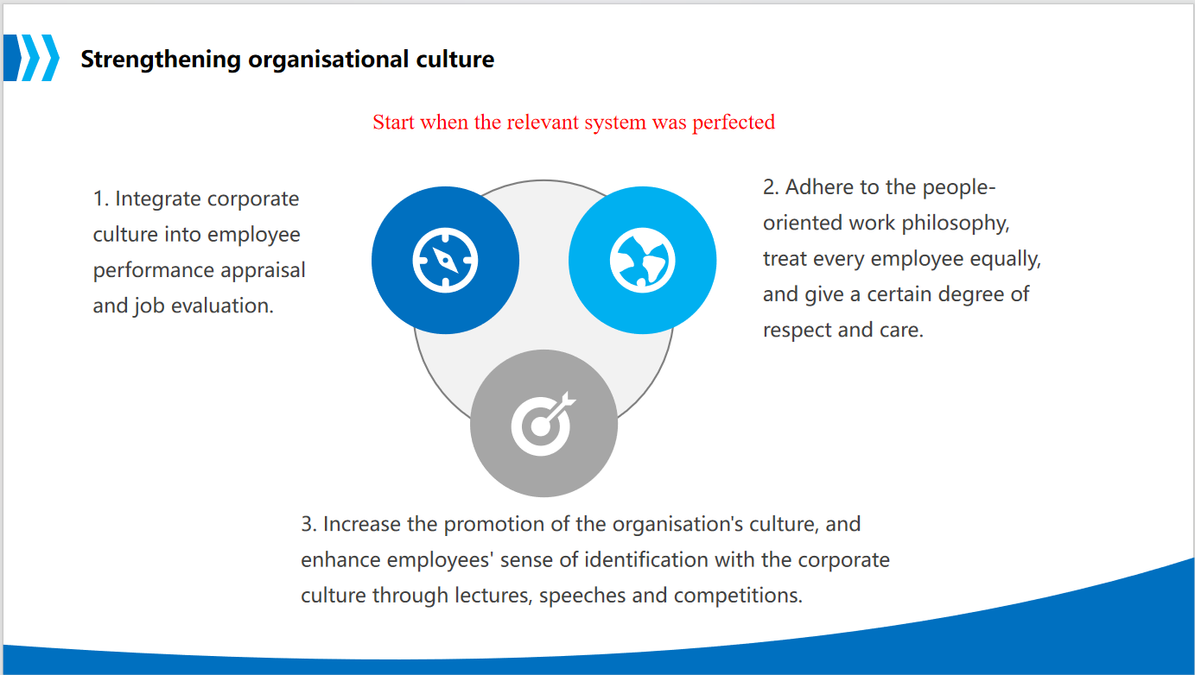


References
Abujraiban, A. and Assaf, G.J. (2022). Effect of Strategic Planning of Human Resources in Management Performance. Civil Engineering Journal, 8(8), pp.1725–1738. doi:https://doi.org/10.28991/cej-2022-08-08-014.
Budhwar, P., Malik, A., De Silva, M.T.T. and Thevisuthan, P. (2022). Artificial intelligence – challenges and opportunities for international HRM: a review and research agenda. The International Journal of Human Resource Management, [online] 33(6), pp.1065–1097. doi:https://doi.org/10.1080/09585192.2022.2035161.
Busque-Carrier, M., Ratelle, C.F. and Le Corff, Y. (2021). Work values and job satisfaction: The mediating role of basic psychological needs at work. Journal of Career Development, 49(6), p.089484532110438. doi:https://doi.org/10.1177/08948453211043878.
Guenole, N. and Feinzig, S. (2018). The Business Case for AI in HR With Insights and Tips on Getting Started. [online] Available at: https://forms.workday.com/content/dam/web/en-us/documents/case-studies/ibm-business-case-ai-in-hr.pdf [Accessed 23 Apr. 2024].
Inegbedion, H., Sunday, E., Asaleye, A., Lawal, A. and Adebanji, A. (2020). Managing diversity for organizational efficiency. SAGE Open, [online] 10(1), pp.1–10. doi:https://doi.org/10.1177/2158244019900173.
Jiaping, Y. (2022). Enterprise Human Resource Management Model by Artificial Intelligence Digital Technology. Computational Intelligence and Neuroscience, 2022, pp.1–9. doi:https://doi.org/10.1155/2022/6186811.
Johnson, B.A.M., Coggburn, J.D. and Llorens, J.J. (2022). Artificial Intelligence and Public Human Resource Management: Questions for Research and Practice. Public Personnel Management, 51(4), p.009102602211264. doi:https://doi.org/10.1177/00910260221126498.
Kim, D.H. and Bak, H.-J. (2020). Reconciliation Between Monetary Incentives and Motivation Crowding-Out: The Influence of Perceptions of Incentives on Research Performance. Public Performance & Management Review, pp.1–26. doi:https://doi.org/10.1080/15309576.2020.1771387.
Parmar, A. (2020). Internal Recruiting Strategy as an Instrument for Managing Knowledge Workforce During Critical Times. Shanlax International Journal of Management, 8(1), pp.35–41. doi:https://doi.org/10.34293/management.v8i1.3204.
Qamar, Y., Agrawal, R.K., Samad, T.A. and Chiappetta Jabbour, C.J. (2021). When Technology Meets people: The Interplay of Artificial Intelligence and Human Resource Management. Journal of Enterprise Information Management, 34(5). doi:https://doi.org/10.1108/jeim-11-2020-0436.
Sahadevan, P. and Sumangala, M. (2021). Effective Cross-Cultural Communication for International Business. Shanlax International Journal of Management, [online] 8(4), pp.24–33. doi:https://doi.org/10.34293/management.v8i4.3813.
Saks, A.M. (2021). Caring human resources management and employee engagement. Human Resource Management Review, [online] 32(3), p.100835. doi:https://doi.org/10.1016/j.hrmr.2021.100835.
Soomro, B.A., Zehri, A.W., Anwar, S., Abdelwahed, N.A.A. and Shah, N. (2023). Developing the relationship between corporate cultural factors and employees’ organizational commitment via self-efficacy. South Asian Journal of Business Studies. doi:https://doi.org/10.1108/sajbs-12-2021-0459.
Tajeddini, K., Budur, T., Gamage, T.C., Demir, A., Zaim, H. and Topal, R. (2022). Impact of diversity management on innovative work behavior: mediating role of human resource management and affective commitment. Journal of Management Development, 42(1). doi:https://doi.org/10.1108/jmd-06-2022-0154.
Wamba-Taguimdje, S.-L., Fosso Wamba, S., Kala Kamdjoug, J.R. and Tchatchouang Wanko, C.E. (2020). Influence of artificial intelligence (AI) on firm performance: the business value of AI-based transformation projects. Business Process Management Journal, [online] 26(7), pp.1893–1924. doi:https://doi.org/10.1108/bpmj-10-2019-0411.
Wright, F., Malone, S.K., Wong, A., D’Eramo Melkus, G. and Dickson, V.V. (2022). Addressing Challenges in Recruiting Diverse Populations for Research. Nursing Research, 71(3), pp.218–226. doi:https://doi.org/10.1097/nnr.0000000000000577.

