Portfolio of Evidence

Session 1

It was my first time to work as a teaching assistant in the Confucius institute. I worked in the level 4 classroom with Miss Zhou, the Chinese teacher. This lesson aim was to teach children to know the pinyin of temperature. Cold, hot, very cold, not very cold, very hot, not very hot, cool. Instead of sitting in their proper seats, the children sat in a straight in front of the classroom. To begin with the lesson, Miss Zhou taught children to learn the pinyin of these words, leading the children to know the figures of the words and pinyin displayed on the screen. Miss Zhou asked them to read these words time by time to get familiar with them. After they became familiar with the words, they played a game called Words Catching. Each person held a temperature word card standing in a circle and was asked to remember the words. The child standing in the centre had to catch the child holding the specified word. If the child holding specific shouted out another word before the captor caught the word, the captor had to find the child holding the changed word quickly and caught him. Words can be always changed until the captor caught one child and changed the position of captor and holder. This game allowed children to quickly memorize the words in their hands and others' hands in a tense and exciting atmosphere. Although it is very simple, it has a good auxiliary teaching effect. After the game, Miss Zou instructed the children to write the words they learned and gave them homework.

Session 2

It was the same teaching content as the session 1, but with another group of students. The teacher firstly led the children to know pinyin, but one of the little boy left great impression on me. He seemed to be a Chinese & UK hybrid with good-looking appearance, but react slowly on what was taught in class. As a result, Miss Zhou took special care of him by asking him to read aloud, which helped him memorize them. After understanding pinyin, the teacher divided the students into two groups for PK. The teacher read chosen word several times, sometimes asking the student to read twice more than her, sometimes asking the student to read one time less than her. According to the number of student who read right, team can get its points. There was a conflict between two children in the competition. One child pointed at the other using finger, which was very impolite in British etiquette. After a reminder, the child pointed to others again. Teacher punished him to go back to his seat and reflect on it before he joined their game. I think it is right, because education is not only to teach students knowledge, but also to teach students some correct habits.

Session 3
Session 3 and Session 4, I came to the Confucius institute to assistant with the course of calligraphy and ink painting. Confucius institute invited teachers from Beijing union university to teach the children.

In the calligraphy class, the teacher introduced to us the origin of Chinese characters and the history of Chinese characters. The first Chinese characters were hieroglyphs, which were carved into tortoise shells or animal bones based on the shape of objects. As Chinese history changed and developed, these characters eventually took on the simplified Chinese language, which is now easy to write. After introducing the history of Chinese characters, the teacher began to teach us to write calligraphy. In ancient China, calligrapher used writing brushes to write Chinese characters. Therefore, the teacher prepared the writing brush and Chinese art paper for us to write Chinese characters in advance. The first is to teach us how to hold the brush with its own unique gesture. Only in the correct gesture can they write a good looking brush. In addition, the teacher took the character "Fu" in Han dynasty as an example to guide us to observe the character. "Fu" in Han dynasty is different from "Fu" in simplified Chinese characters. Finally, the teacher also specially prepared the Chinese New Year red couplet paper to give the children a chance to write “Fu” couplets. This is an interesting Chinese character class.

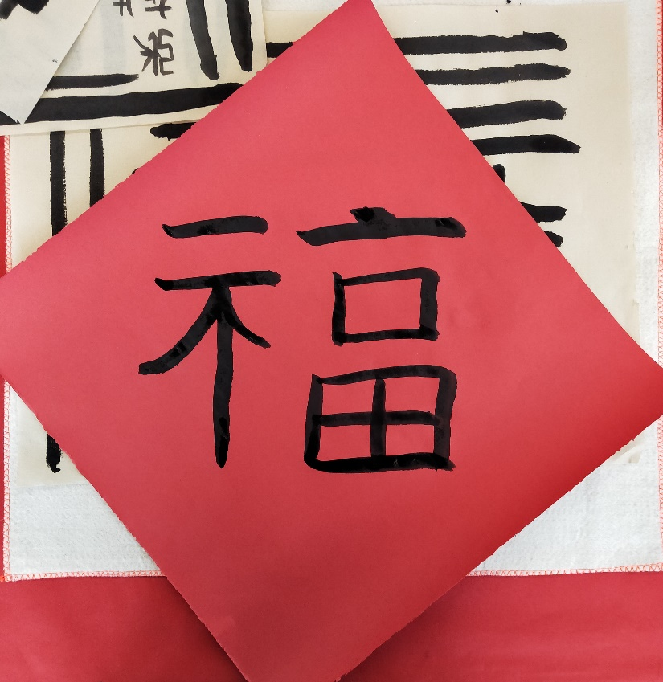
Picture 1 “Fu” in red couplet

Session 4

In Session 4, another teacher taught students Chinese ink painting. Chinese ink painting is Chinese traditional painting. Painters mainly use the Chinese calligraphy brush pen, ink, pigment, Chinese art paper as the main tools to draw. First of all, the teacher introduced Chinese ink painting by showing some of his works and some of the artists' works. While appreciating the beauty of Chinese ink painting, the teacher stimulated the children's interest in Chinese ink painting. In addition, the teacher taught students to draw ink paintings of pandas. Considering that the children may have no painting foundation, the teacher printed out the pandas to be drawn in advance and distributed them to the children. When drawing, the children put the picture under the art paper. Through the drawing paper, they can see the outline of the panda. It is easier for the children to draw the panda in this way. The panda is black and white, so it is simple for students to just draw the black part, and with a few bamboo aside. When students completed the painting, the teacher told them that she brought Chinese seals. Painter often put a red seal aside with the name and the date of painting to make it a symbol of painter. I found that the ink painting also attracted the participation of local British children. I asked the little girl how this course was for her, she said it was great and she learn a lot.
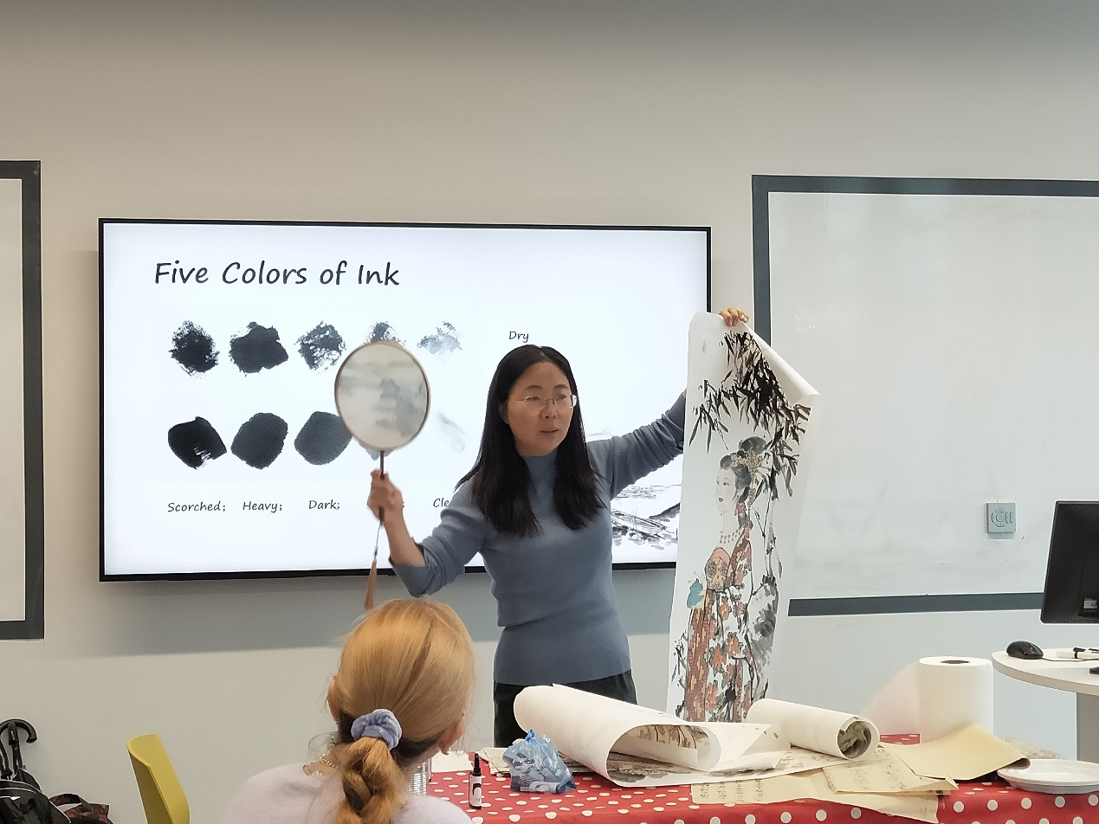
Picture 2 Teacher’s introduction for works
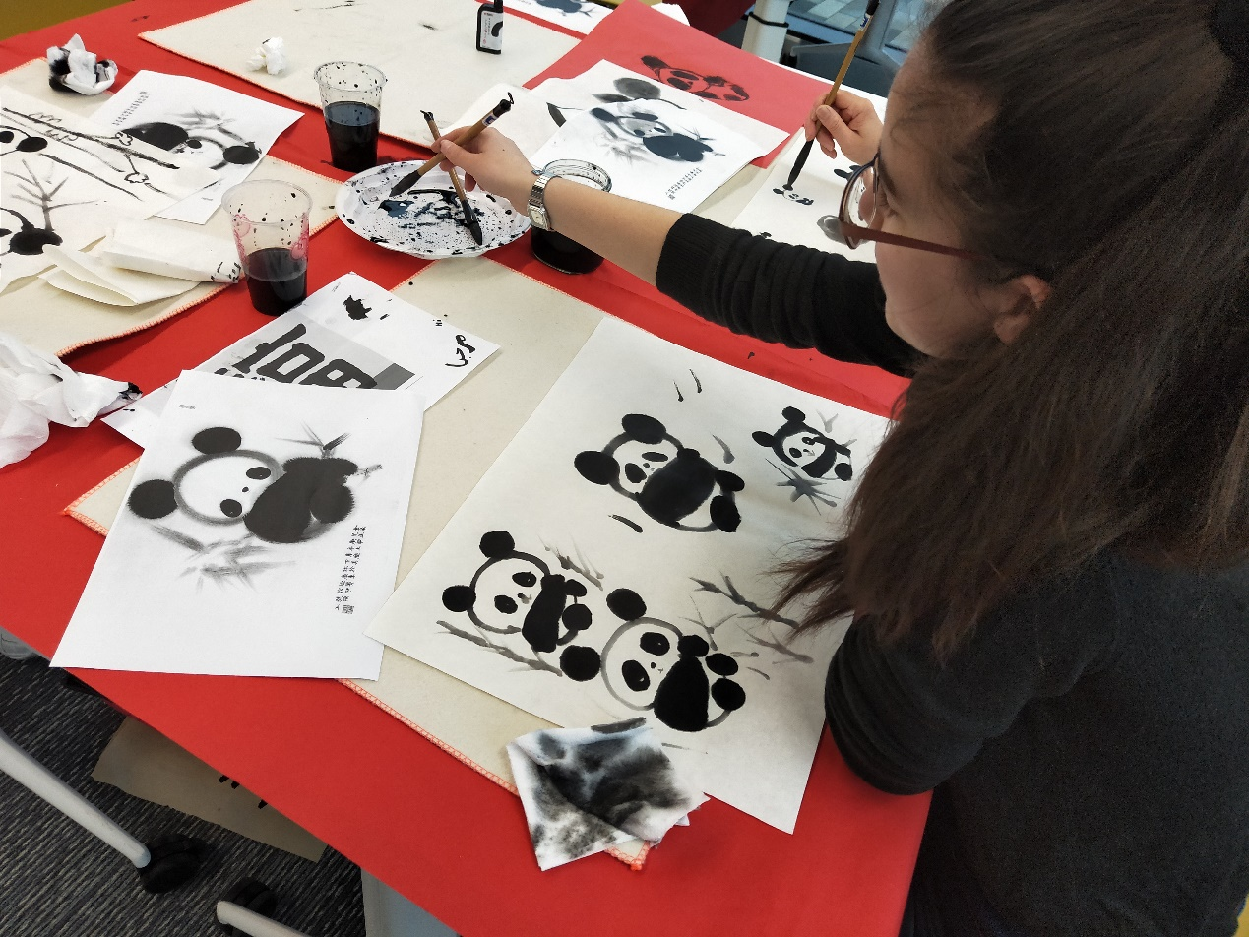
Picture 3 UK girl’s work

Session 5

I came to the classroom instructed by Miss Xu as a teaching assistant today. I found that the students in this class were relatively young, so the teaching content was mainly in pinyin. This lesson is about the pronunciation of "an, ang, en, eng, in, ing". Miss Xu's class is different from Miss Zou's, with everyone sitting in their own seats, not asking the children to sit together in front of the classroom. Although the classroom is very big, there are two rows of desks and chairs, but the children take the initiative to sit near the teacher's desk and chair. At first, Miss Xu brought everyone to read pinyin, through the constant reading of pinyin, to help the children form a memory. After the children master the basic pinyin, the teacher points to pinyin randomly on the screen and call the children to answer the corresponding pronunciation. I found that if there are children wandering in mind and don’t listen carefully, Miss Xu will call his name and ask him to read the pinyin, and the children will focus on the pinyin. In this way, teacher can indirectly remind the child to concentrate on learning instead of telling him not to be distracted. After learning pinyin, Miss Xu took the children to play the word catching game to help the children know pinyin and corresponding Chinese characters. After observation of the whole, I found that the children are lovely and no children affected the class order. Miss Xu is also very good master of the classroom because the children would like following her pace to learn knowledge.

Session 6

In this session, I went to Miss Luan's class as a teaching assistant. There seemed to be more students in this class. Some sit in the front row, some in the back row. There were many children in the front row, so I chose a seat in the back and sat next to a little boy. There was also a very young girl and a little black girl at the same table. When Miss Luan was teaching pinyin and asked everyone to read along, the children at the table I sat hardly read along, except the little black girl in a low voice. Maybe the back row was far from the lectern, so I found that Miss Luan seemed unable to take care of the students behind, so I told the children that you had better read with the teacher. The little boy still didn’t want to read. The little girl smiled at me without reading, so I guessed that she might be too young to know what I was talking about. The little black girl smiled sheepishly and continued to read after teacher in a low voice. At recess, I said to the little black girl if she didn't understand anything, you can ask me. The little girl smiled shyly and said OK. I think that's why we need students of the same age to attend classes together, so that the children can keep up with the pace of the teacher, and the teacher can manage the class more easily.

Session 7

Today I came to Miss Luan's senior class, the class of students have mastered the basic pinyin, can start to use words to make sentences. In this session, Miss Luan talked about the use of because. When she asked if anyone would like to be volunteer to make a sentence, students looked at each other and no one took the initiative to try. So Miss Luan asked one of students to make a sentence. The student thought for a while and then said, "It's cold today because it's windy." Later, the teacher asked several students to make a sentence, and some of them misunderstood the cause and result, so they made a sentence in Chinese such as "today I received a gift, because I am very happy". I found these British Born Chinese lived in the UK since their childhood, so they would like to give results before causes in the sentence. While in China, Children will talk causes before results. For example, "it is very windy today, so it is very cold". This is actually related to the mind pattern, which is caused by the environment. The British tended to state results directly and supported with evidence. The Chinese, on the other hand, liked to lay out the reasons and then talk about the results. In my opinion, this is interesting difference in multi-culture.

Session 8

In this session, I worked as a teaching assistant in Miss Luan's junior pinyin class, the same class as session 7. There are more naughty boys in this class. What impressed me most was that there was a boy who did not seem to have the consciousness of obeying the rules in the class. He always followed his temperament and went to the computer on the desk to listen to the class, and then went to the window of the classroom and looked out of the window. There is also a little boy from UK, who is also very naughty. He took other children's stationery and chased around the room, which made the class order a mess. However, Miss Luan realized that the children were naughty, so she played games to attract their focuses. The teacher invited three children every time to stand in front of three projection screens in the classroom. Children competed to point out the pinyin with their fingers fast and correctly after teacher read them randomly. Such games can not only keep their attention on what they are learning, but also help them remember pinyin. In addition, Miss Luan also asked us several teaching assistants to take charge of several children, holding pinyin cards for the children to read. So I usually showed the children the side of the picture. If they read it wrong, I corrected them and showed them the pinyin on the opposite side. If they're right, I would move on to the next one. This kind of distributed teaching cost more teaching assistants, but it is also have better effect for children.

Session 9
Chinese school postponed its original teaching plans due to the coronavirus, so I cannot continue my assistance and observation on it. However, I do extra math tutor for kid of Chinese in Swansea. After getting the permission of Caroline, I will record my math teaching experience.

The child I taught is Sunny, a girl of Year 6. Her mother hopes that I can teach her the content of Chinese math in sixth grade and help her master the thinking of solving math problems. Different from traditional Chinese teachers, I don't like to think of myself as an interpreter of knowledge. I prefer to make friends with students and be a knowledge guide to guide children to solve problems by themselves. In this session, I asked her to choose one of several topics to study, and she chose proportion. I told her that since this is your choice, you need study it carefully. First of all, I asked her to observe the proportions carefully and get a conclusion about its form, and she concluded that the proportion is the ratio on both sides, with an equal sign in the middle. In addition, I led Sunny to judge if a few expressions are proportional. At first she always calculated the ratio of each ratio to see if she could write an equal sign in the middle. In the process, I put forward there is an easier way to judge proportion and asked her if she wanted to learn, which improve her motivation to learn it. I told her that a ratio can be divided into the internal item and the external item according to the distance from the equals sign. If two ratios can form a proportion, the product of the internal items will equal the product of the external items. When she found out, she tried to use this method to judge the proportion, which is much faster than before. She was very happy and proud. In this process, I also kept asking her what proportion was. By asking again and again, I helped her to remember the basic form and definition of proportion, which is also the basis for learning more knowledge about proportion in the future. After that, I also guide her to learn a lot of knowledge about proportion. Once her motivation was stimulated, she can study happily.

Session 10

This lesson is about the knowledge of circles. Sunny has mastered the method of calculating the area and circumference of a circle. Now I will exercise her ability to solve problems in a given situation. In my opinion, there is a skill in solving mathematical problems. In many cases, Chinese mathematical problems do not directly give you the conditions and values you need. Therefore, students need to understand every sentence and get the conditions and values given in this sentence. So, I told Sunny to underline what you think is important for each sentence you read, and write down the conditions you get from it, so that when you've read all the sentences, you can get all the conditions hidden in the questions. Sunny did it this way and got all the conditions. Sunny hope to be able to solve the problem in mind, but it usually cost a lot of time or get a wrong answer. Thus, I advised Sunny to draw the graph when she did geometry type problem. For example, one problem tells you the perimeter of a circular flowerbed. Now plant more flowers at a width of 1m around the flowerbed. What is the area of the whole flowerbed? So if you just draw a circle labelled with number, and then draw a circle labelled it 1 meter in width around it, it would be much easy to solve the area of the whole circle. I always guided Sunny to find the solution to the math problem and asked her to write down the steps so that it would be easier to solve the problem if she encountered similar questions next time. Reading the questions carefully, drawing the pictures to understand and actively summarizing is the secret of mathematics learning.

Reflection

Confucius institute assistant experiences help me know that different teachers use their different ways to stimulate students’ motivation. As Chinese children's math teacher, I try to make friends with children. It would be much effective to stimulate students' motivation, give necessary guidance for themselves to find the methods for problems, and actively summarize and record these steps, than with the teacher as the centre for knowledge. It is not an easy thing to teach students to learn, but if we can inspire students' learning motivation through some methods and organize teaching effectively, the whole learning process will become more interesting and students can also study happily.

