
BA LEADERSHIP AND MANAGEMENT

PROJECT MANAGEMENT

LECTURERS: Samson Oladejo
Dr. Xavier Matieni

MODULE CODE: LCLM 5003

PORTFOLIO: REDEVELOPMENT OF PUBLIC TRANSPORT HUB

By Tesenai Bertram
2409077

PART A: PROJECT PROPOSAL POSTER
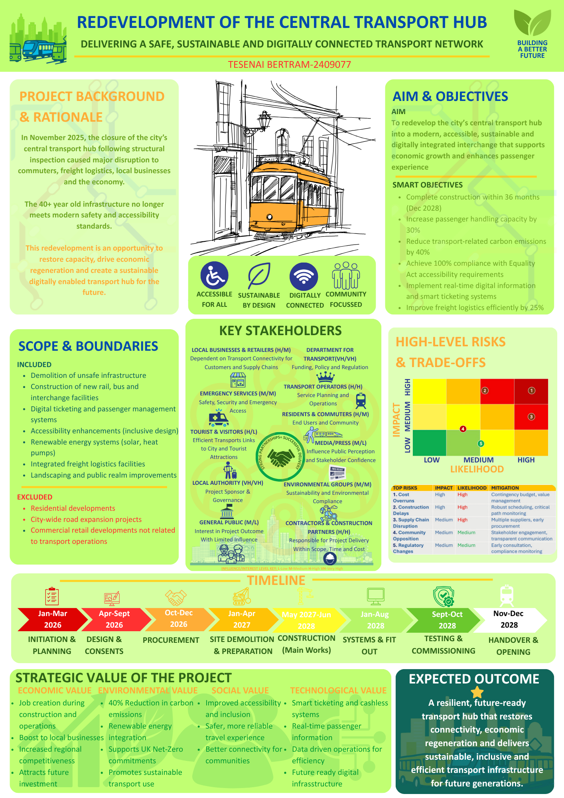

PART B: CRITICAL REFLECTION
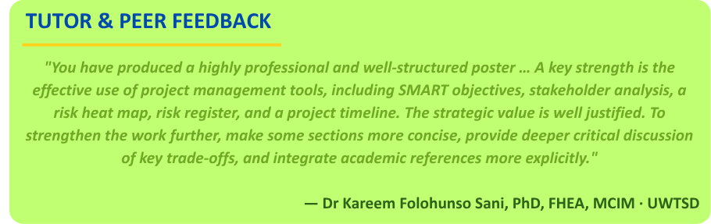

This reflection applies Gibbs' (1988) Reflective Cycle, which moves systematically through 6 key areas. The model is well established in professional practice contexts as a mechanism for converting experience into purposeful learning, rather than merely summarising what occurred. The tutor's feedback led to purposeful changes to the final Project Management Plan (PMP). Moon (2004) argues that reflection only produces learning when it moves beyond
description into analysis and action, and each stage below does precisely that.

1. DESCRIPTION: WHAT HAPPENED

The poster submitted for Part A received distinction-range feedback from the module tutor, Dr Sani. The work was commended for its professional structure, breadth of project management tools deployed, and the clarity of its strategic value framing. The feedback specifically acknowledged the use of SMART objectives, a stakeholder power/interest matrix, a risk heat map, a risk register and a phased project timeline, all of which aligned with the module's learning outcomes and demonstrated applied command of core PM frameworks (PMI, 2021).

2. FEELINGS: INITIAL RESPONSE TO FEEDBACK

Receiving distinction-range feedback was initially a relief, as it affirmed the considerable effort put into the poster. However, this satisfaction was short-lived upon reading developmental comments, which highlighted a critical distinction: excelling in tool application does not equate to strong critical thinking. The tutor's observation that the trade-off analysis was implicit rather than explicit struck a deep chord. It revealed not a knowledge gap, but a lack of professional courage to openly acknowledge competing priorities that cannot all be met. Maylor (2022) suggests that recognising these tensions distinguishes exceptional project managers from average ones, and this feedback underscored the discomfort of realising that competence had become a limiting factor. Additionally, there was frustration not with the feedback's accuracy, but with the avoidable academic referencing gap. While the frameworks were correctly applied, citing them would have taken only a few minutes. Moon (2004) identifies this as the difference between knowing and demonstrating knowledge, emphasising the frustration of this realisation post-submission. This experience served as an uncomfortable but valuable professional lesson, driving four concrete changes in the PMP, motivated not by compliance but by a genuine commitment to bridging the gap between what was produced and what was possible.

3. EVALUATION: IDENTIFYING STRENGTHS

Three elements of the poster stand out as genuine strengths requiring consolidation rather than revision in the PMP.

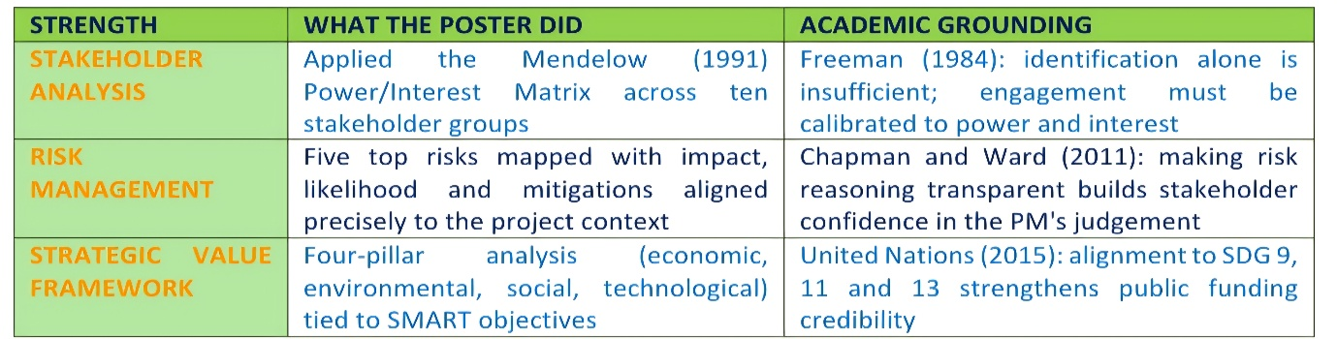

4. AREAS FOR IMPROVEMENT

The feedback identified three areas of development, each revealing a meaningful gap between competent tool application and the depth of critical thinking expected at this academic level (Moon, 2004).

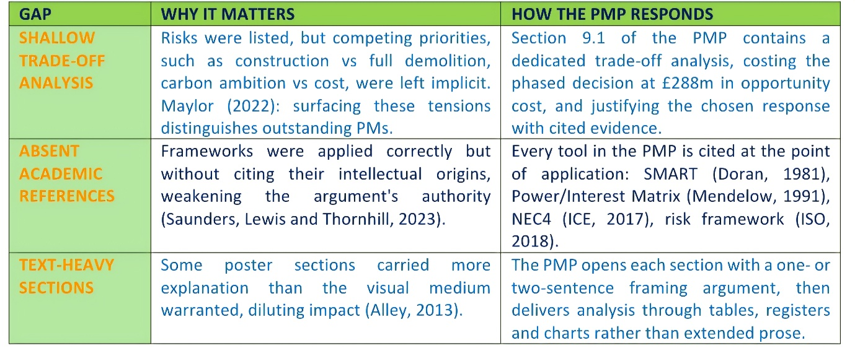

5/6. CONCLUSION AND ACTION PLAN: HOW FEEDBACK SHAPES THE PMP

In response to feedback, changes have been made to the PMP. First, the Gantt Chart aligns perfectly with the poster's timeline, removing governance ambiguity (Lock, 2020). Second, all quantitative targets now match the poster: 40% carbon reduction, 30% increase in passenger capacity, 25% improvement in freight efficiency, and a completion date of December 2028. Third, a trade-off analysis section is included in the risk chapter to clarify the decision to phase construction (Chapman and Ward, 2011). Finally, peer-reviewed sources are cited in Harvard style, linking decisions to established PM theory (PMI, 2021).
Taken together, these four changes transform the PMP from a document that shows awareness of project management tools into one that demonstrates the capacity to reason with them, producing a governance instrument that is not only technically credible but intellectually defensible to any scrutiny body that examines it
PART C: PROJECT MANAGEMENT PLAN
EXECUTIVE SUMMARY

This Project Management Plan (PMP) governs the redevelopment of the Central Transport Hub, closed in November 2025 following structural failure. The closure disrupts 130,000 daily commuters and costs an estimated £2.4 million per day in lost economic activity (HM Treasury, 2022). The project delivers full demolition and replacement, with a safe, accessible, digitally connected, and environmentally sustainable interchange across eight phases from January 2026 to December 2028. Governance applies a hybrid PRINCE2 and PMBoK framework (AXELOS, 2017; PMI, 2021) under an NEC4 Engineering and Construction Contract (ICE, 2017). Six SMART objectives drawn directly from the Part A poster define success: a 40% reduction in transport-related carbon emissions; a 30% increase in passenger capacity; a 25% improvement in freight efficiency; 100% compliance with the Equality Act (2010) accessibility requirements; real-time digital systems at practical completion; and handover by December 2028.

DOCUMENT CONTEXT AND DEVELOPMENT

This Project Management Plan constitutes the formal delivery document arising from the Central Transport Hub Redevelopment project proposal submitted as Part A of this assessment. The Part A poster received distinction-range feedback from the module tutor, Dr Kareem Folohunso Sani, who commended the professional structure, breadth of project management tools deployed, and the clarity of the strategic value framework presented. The poster, therefore, serves as the authoritative foundation document for this PMP: all six SMART objectives, the eight-phase delivery timeline, the ten-stakeholder register, and the five top-tier risks presented herein are drawn directly and without deviation from the approved proposal.
The Part B critical reflection identified four specific gaps between the poster and the standard required of a full project management plan. First, trade-off analysis was implicit; rather than explicit, risks were listed without surfacing the competing priorities that shaped the chosen response. Second, academic frameworks were applied without in-text citations, thereby weakening the evidentiary authority of key decisions. Third, some sections carried more explanatory text than the medium warranted, reducing analytical precision. Fourth, the poster's quantitative targets are a 40% reduction in transport-related carbon emissions, a 30% increase in passenger handling capacity and a 25% improvement in freight logistics efficiency, which required consistent application across all PMP sections to eliminate the document-level inconsistency that Lock (2020) identifies as a common governance failure on large infrastructure programmes.
Each of these improvements is directly incorporated into this PMP. Section 9.1 contains a dedicated critical trade-off analysis, costing the phased construction decision at an estimated £288 million opportunity cost and justifying the chosen response with cited evidence. Every major framework applied SMART objectives (Doran, 1981), the Power/Interest Matrix (Mendelow, 1991), the NEC4 contract (Institution of Civil Engineers, 2017), and the risk management approach (ISO, 2018), and each is cited at the point of application in Harvard style. All quantitative targets match the poster precisely, and the Gantt Chart in Section 6 mirrors the eight-phase timeline from the poster with identical phase labels and dates.

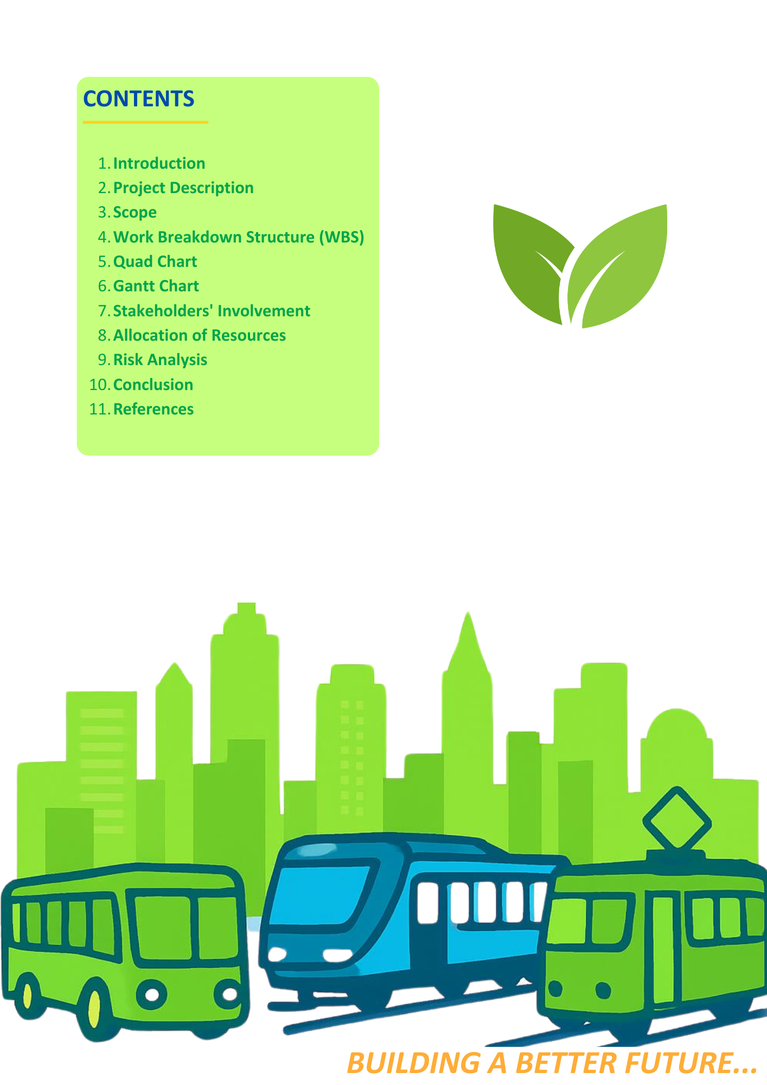

1. INTRODUCTION
The closure of the Central Transport Hub represents both a structural emergency and a strategic opportunity. The hub served as the city's principal interchange for rail, bus, and freight; its failure in November 2025 was attributable to a 40-year-old infrastructure base that no longer meets safety or accessibility standards, generating immediate, cascading impacts across supply chains, commuter access, and local business revenue. Turner (2014) argues that a project management plan earns its value not through volume but through its capacity to align diverse stakeholders around a shared delivery intent. That is the standard this document applies to itself.
The PMP adopts a hybrid PRINCE2 (AXELOS, 2017) and PMBoK (PMI, 2021) governance model, combining PRINCE2's stage-gate discipline with PMBoK's ten knowledge areas covering scope, schedule, cost, quality, risk, and stakeholder management. The NEC4 Engineering and Construction Contract (ICE, 2017) is selected for procurement, chosen specifically for its early-warning obligations and compensation-event mechanisms, which reduce adversarial tension on interface-heavy construction programmes.

2. PROJECT DESCRIPTION
The project is classified under HM Treasury's (2022) Green Book as a major public investment, requiring formal cost-benefit analysis and ongoing benefits realisation monitoring. The vision accessible for all, sustainable by design, digitally connected, community focused is operationalised through six SMART objectives aligned precisely to the Part A poster:

- Complete construction by December 2028 (36-month programme from January 2026)
- Increase passenger handling capacity by 30%
- Reduce transport-related carbon emissions by 40%
- Achieve 100% compliance with Equality Act (2010) accessibility requirements
- Implement real-time digital information and smart ticketing systems by practical completion
- Improve freight logistics efficiency by 25%

Doran (1981) established that objectives without measurement criteria function as aspirations, not commitments, a distinction carrying weight on a publicly funded project accountable to multiple scrutiny bodies. Each objective above is assigned a KPI owner and assessed at every PRINCE2 stage boundary.

The SMART objectives above are not self-executing. Bradley (2016) argues that benefits realisation management is the discipline that closes the gap between project delivery and organisational value; without it, a completed project and a successful project are not the same thing. Table 2a below maps each objective to a measurable KPI, a named benefit owner and a scheduled review point, ensuring that the value this project exists to generate is tracked with the same rigour applied to its cost and programme.

Table 2a: Benefits Realisation Plan
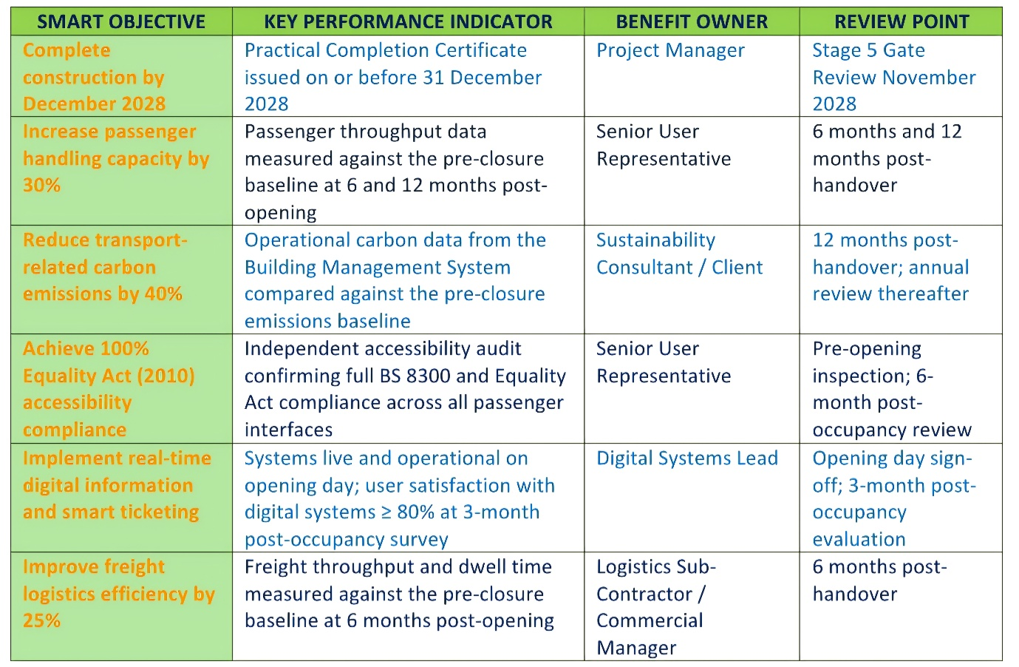
The Benefits Realisation Plan is owned by the Senior User Representative and reviewed formally at six-monthly intervals throughout the first two years of operation, consistent with HM Treasury's (2022) Green Book requirement that public investment programmes demonstrate measurable returns against stated objectives. Where a benefit is not on track, a formal exception is raised to the Project Board with a recovery action within 30 days.
3. SCOPE

Scope definition is among the most consequential acts in project governance. A scope that is too broad invites cost overruns; one that is too narrow fails to achieve strategic outcomes. The baseline is established in Table 1 and controlled through a formal Change Control Gate requiring Project Board approval for all variations, the primary defence against what Maylor (2022) identifies as the most persistent cause of public infrastructure failure: politically driven scope creep post-initiation.

Table 1: Project Scope: Inclusions and Exclusions
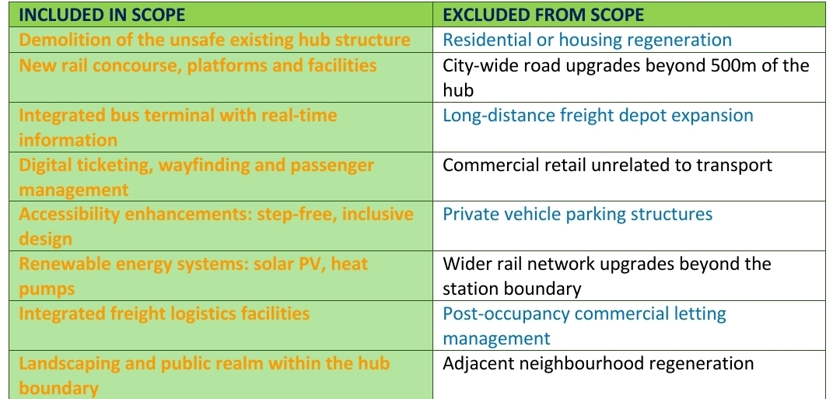

A critical scope constraint is the political requirement to maintain partial transport operations throughout construction. Full-site demolition would reduce the programme by four months but eliminate residual services for 130,000 daily commuters, resulting in a £288m additional economic loss at £2.4m per day. Phased construction is therefore selected as the lower-impact option, with its additional interface risk managed through the Network Rail Interface Agreement and CDM oversight. This is a governance decision, not a scheduling preference, and is documented explicitly so the Project Board can hold the project manager accountable to the reasoning (Chapman and Ward, 2011).

4. WORK BREAKDOWN STRUCTURE (WBS)
The WBS in Figure 1 decomposes the project into five Level 1 deliverable groups, subdivided into Level 3 work packages. Kerzner (2022) argues that any work not captured in the WBS is outside the scope baseline, meaning the WBS defines the boundary of the project manager's accountability, not merely the organisation of tasks. The WBS dictionary (maintained as a controlled document) records acceptance criteria, interdependencies, and resource requirements for each work package. Any work not captured within this structure requires a formal Change Request before commencement, ensuring that informal scope additions, a persistent failure mode on large public infrastructure schemes (Lock, 2020), are identified and assessed before they create budgetary or programme pressure.

Figure 1: Work Breakdown Structure: Central Transport Hub Redevelopment
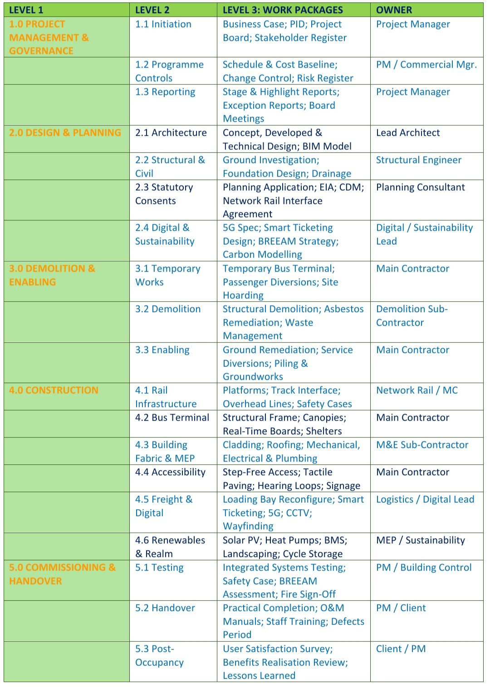

The five Level 1 groups are sequenced deliberately, not arbitrarily. Project Management and Governance (1.0) sits first because the governance infrastructure, the Project Board, the Risk Register, and the Change Control process must be established before any technical work begins; without it, subsequent decisions lack authority and accountability. Design and Planning (2.0) follows, since no procurement or physical work can be responsibly initiated without a consented design and a confirmed Interface Agreement with Network Rail. Demolition and Enabling (3.0) precedes construction because the existing structure must be made safe and the site prepared before any new build activity can commence. Attempting to overlap these phases would introduce unacceptable CDM risk. Construction (4.0) is the largest and most resource-intensive group, spanning rail infrastructure, the bus terminal, building fabric, accessibility works, freight logistics and digital systems; its internal sequencing follows structural logic, with the building frame preceding fit-out and digital installation. Commissioning and Handover (5.0) closes the sequence, ensuring that integrated systems testing, safety case approval and post-occupancy evaluation are treated as discrete, quality-gated activities rather than afterthoughts compressed by programme pressure. This sequencing reflects the principle established by Kerzner (2022) that WBS structure should mirror delivery logic, not organisational convenience.

5. QUAD CHART
Figure 2 provides the strategic one-page overview used at each Project Board meeting. Heldman (2018) notes that senior stakeholders require sufficient information to exercise oversight without the volume of a full PMP. The Quad Chart fulfils this function, covering project overview, SMART objectives, the eight-phase milestone schedule and the top risk RAG register. Cost Performance Index (CPI) and Schedule Performance Index (SPI) are updated monthly and reported through this chart, consistent with PRINCE2 management-by-exception (AXELOS, 2017).
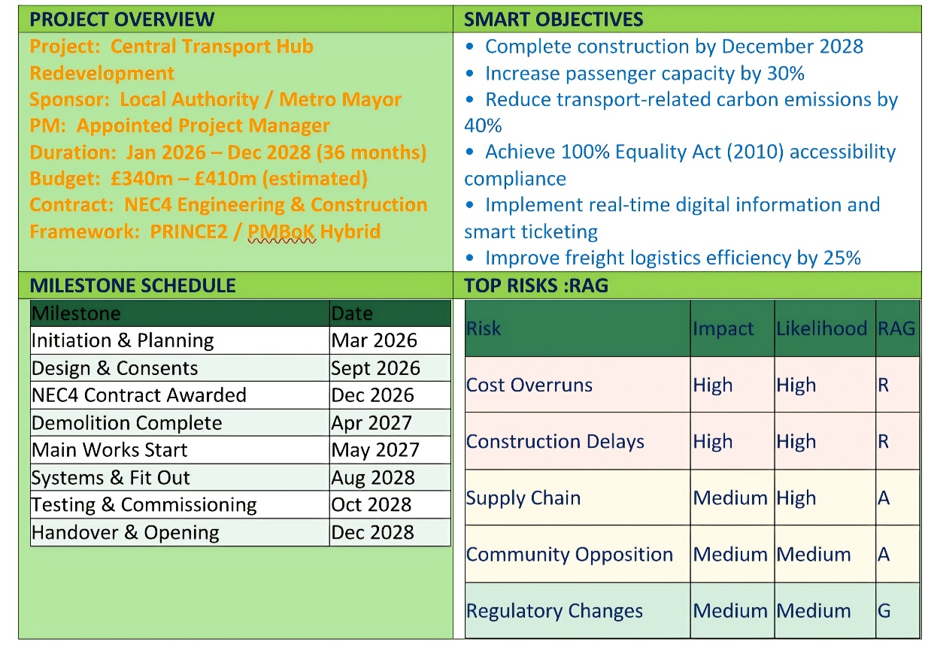
Figure 2: Quad Chart: Central Transport Hub Redevelopment

6. GANTT CHART
Figure 3 maps all eight delivery phases across the 36-month programme, with labels and dates identical to those in the Part A poster. The Gantt Chart is the primary schedule management tool (Lock, 2020), maintained as a version-controlled baseline. The critical path runs through design consents, demolition, rail construction and systems commissioning. Float is built into procurement (four weeks) and systems fit-out (six weeks) to provide schedule resilience consistent with the risk register. SPI below 0.90 triggers a formal Exception Report requiring a recovery plan within ten working days (PMI, 2021).

Figure 3: Gantt Chart: 36-Month Programme (January 2026 – December 2028)
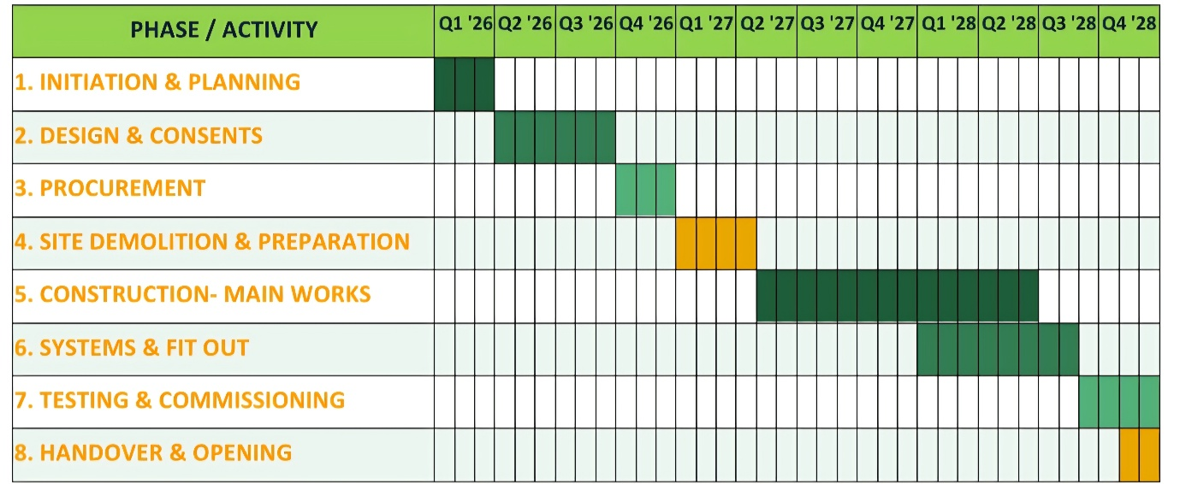

7. STAKEHOLDERS’ INVOLVEMENT

Stakeholder management is a determinant of project survival, not a peripheral activity (Bourne, 2016). Public infrastructure projects that fail to secure stakeholder legitimacy face legal challenge, political withdrawal and, in extreme cases, abandonment. Freeman (1984) argues that organisations are accountable to all parties whose interests are materially affected, meaning commuter disruption, freight operator concerns and community impact must be treated as central governance considerations, not externalities. Table 2 classifies all ten stakeholder groups using Mendelow’s (1991) Power/Interest Matrix.

The most significant classification decision in Table 2 is the dual Very High power / Very High interest rating assigned to the Local Authority and Metro Mayor, which creates a governance tension that requires active management throughout the project lifecycle: the Local Authority is simultaneously the project sponsor directing the PMP, the political principal accountable to the public for service disruption, and the planning authority with statutory power to impose conditions on the consented design meaning a single stakeholder occupies three structurally distinct roles whose interests do not always align, and the Senior Responsible Owner must be explicitly empowered to distinguish between these roles when they conflict (AXELOS, 2017).

Table 2: Stakeholder Register: Power/Interest Classification and Engagement Strategy
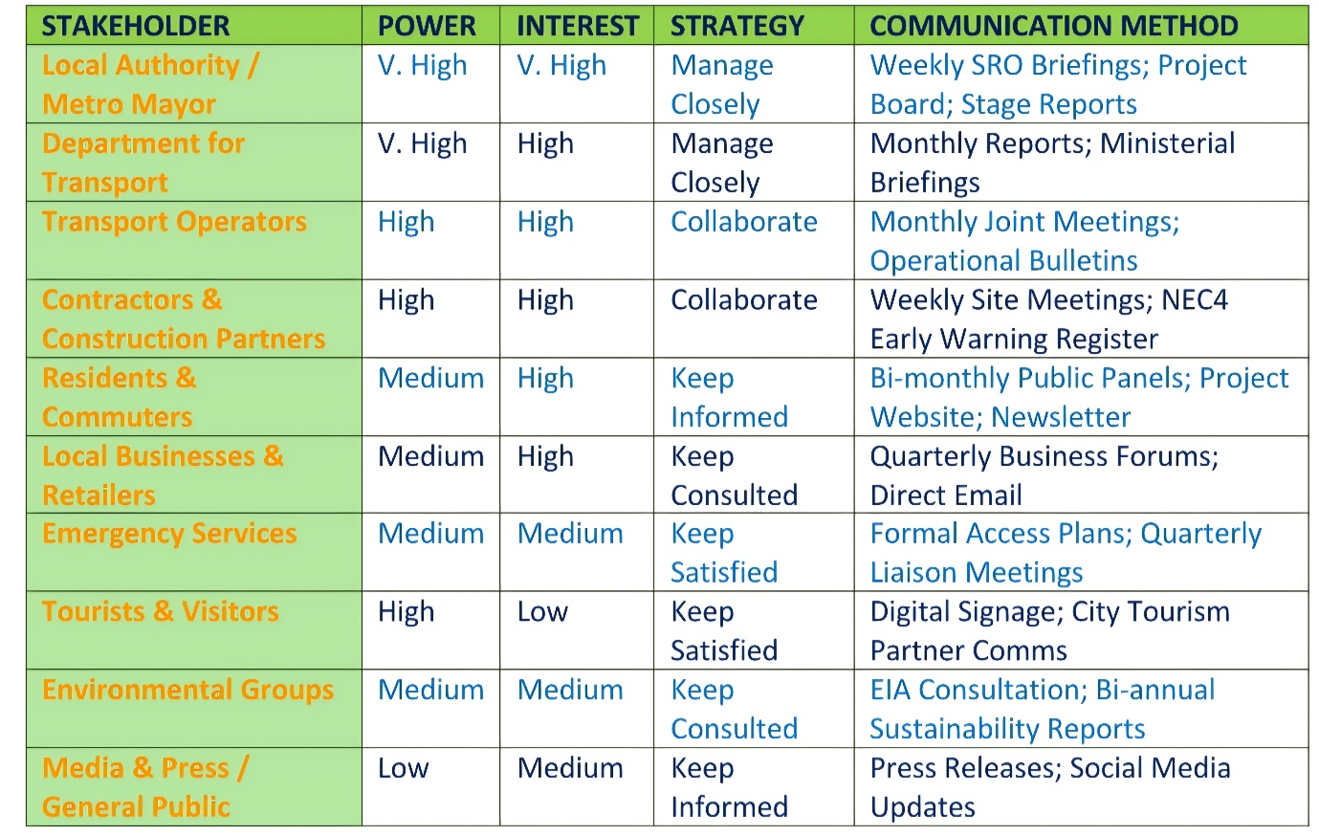

8. ALLOCATION OF RESOURCES

8.1 Human Resources
Resource management applies PMI's (2021) knowledge area framework plan, acquire, develop, control across all phases. The tripartite Project Board (Senior Responsible Owner, Senior User and Senior Supplier) drawn from PRINCE2 (AXELOS, 2017) ensures decisions are informed by business justification, user requirements and supplier capability simultaneously. Table 3 presents the core team.
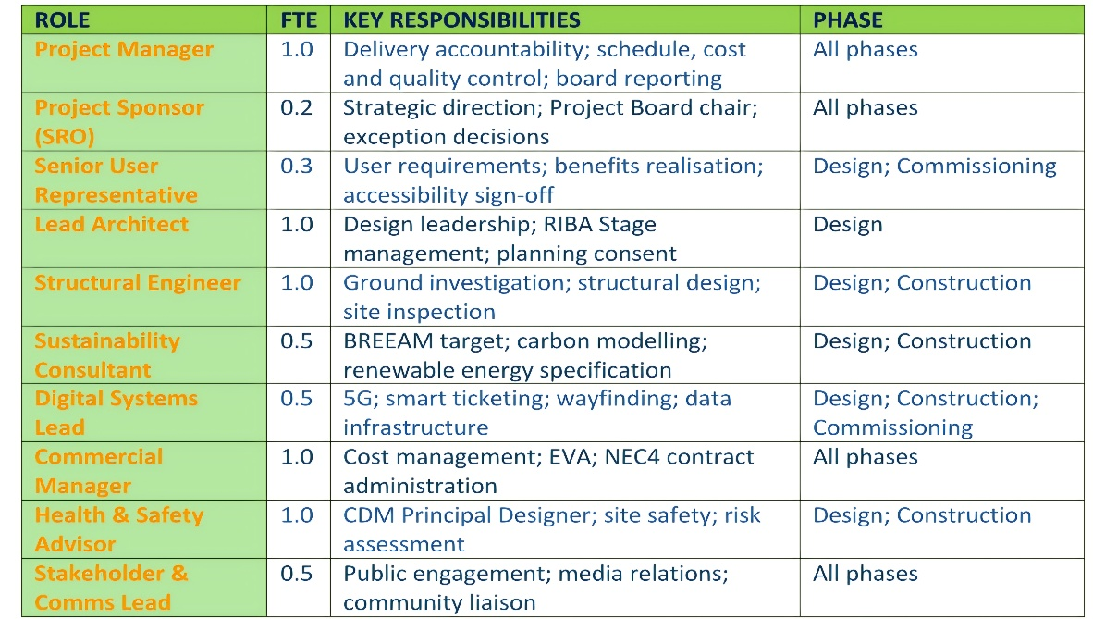
Table 3: Core Project Team: Roles and Responsibilities

8.2 Financial Resources
Table 4 presents the budget structured across seven categories with a 12% contingency held at Project Board level. The release of contingency requires a formal Exception Report that ensures budget pressure cannot erode scope or quality without explicit governance approval (PMI, 2021). Cost performance is tracked monthly through Earned Value Analysis. CPI (Earned Value ÷ Actual Cost) below 0.90 triggers a mandatory budget review within 10 working days, consistent with RICS (2024) norms for UK public infrastructure programmes.
Table 4: High-Level Budget Breakdown
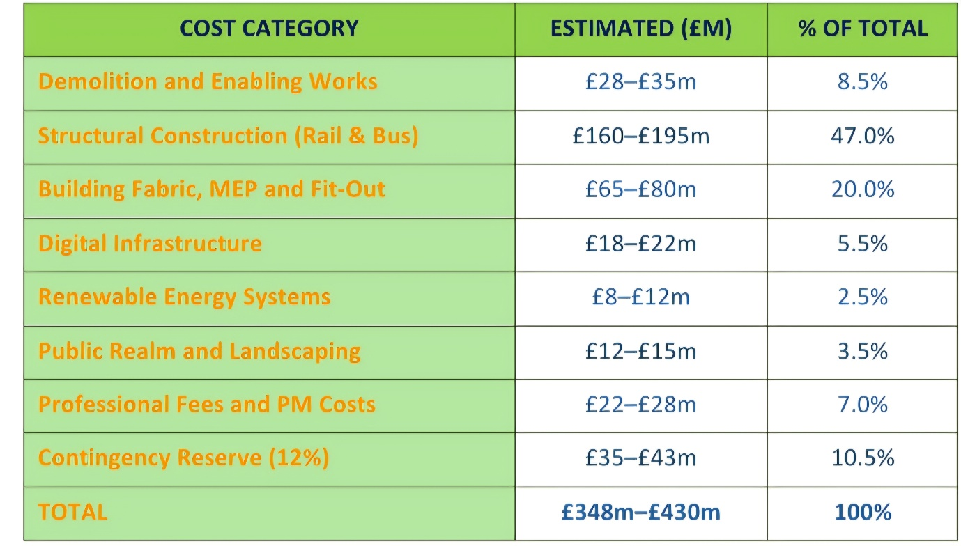

The budget envelope is benchmarked against comparable recent UK transport infrastructure programmes, including the Birmingham New Street redevelopment and the Edinburgh Waverley Station upgrade, which both demonstrated cost-per-square-metre profiles consistent with the upper range of this estimate (RICS, 2024). The NEC4 contract mechanism is specifically selected because its compensation-event process provides a structured, real-time mechanism for managing cost risk, eliminating the large retrospective claims that characterise traditional JCT contract disputes on complex infrastructure projects (Institution of Civil Engineers, 2017).

9. RISK ANALYSIS
Risk management applies the ISO 31000:2018 framework, which defines risk as the effect of uncertainty on objectives encompassing both threats and opportunities (ISO, 2018). An Opportunities Register is maintained alongside the Risk Register, ensuring schedule efficiency gains and early consent decisions are actively captured. Risks scoring 12 or above on the 5×5 matrix are classified as High and require immediate Project Board escalation. The five risks from the Part A poster are preserved as the top-tier register, with exact impact and likelihood ratings maintained for document consistency.
Table 5: Risk Register-Aligned to Part A Poster

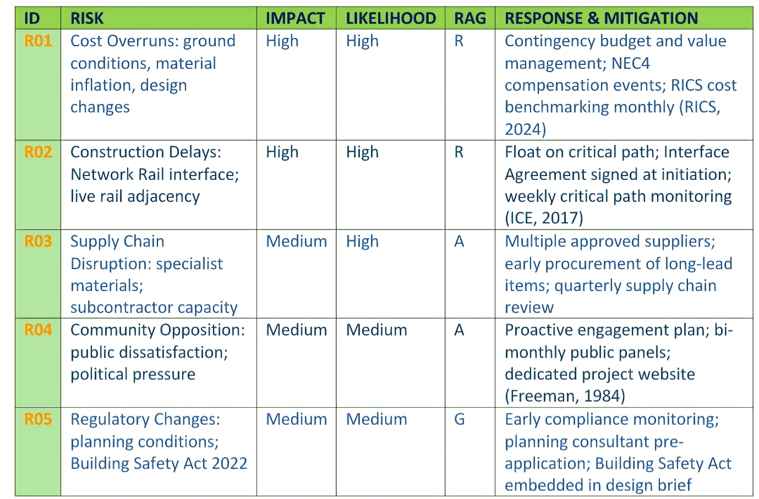9.1 Critical Trade-Off Analysis
The most consequential trade-off in this project is the decision on construction methodology: phased construction versus full-site demolition. Full demolition shortens the programme by 4 months but eliminates residual services for 130,000 daily commuters, resulting in an additional economic loss of approximately £288m (£2.4m × 120 days; HM Treasury, 2022). Phased construction preserves service continuity but introduces interface risk with live rail operations, which is managed through the Network Rail Interface Agreement, CDM Principal Designer oversight, and live-rail exclusion zone protocols.

Chapman and Ward (2011) argue that making trade-off reasoning transparent rather than presenting the selected option as self-evident is itself a risk management intervention, because it gives governance boards the information needed to hold the project manager accountable if circumstances change. A secondary trade-off exists between the 40% carbon-reduction target and capital-cost containment. Achieving this target requires investment in renewable systems that exceeds current regulatory minimums, creating upward budget pressure (RICS, 2024). A Value Management process during detailed design will identify the specification that delivers the 40% target at the lowest whole-life cost, recognising that higher upfront energy efficiency investment typically yields superior whole-life value in public assets held for 50 or more years (HM Treasury, 2022).

10. CONCLUSION
This PMP makes the case analytically, not rhetorically, that the Central Transport Hub Redevelopment is both deliverable and worth delivering. These are distinct propositions. A project can be technically executable and still represent poor value; it can generate economic returns and still inflict unacceptable social costs. This plan holds both dimensions under simultaneous scrutiny.
The hybrid PRINCE2 and PMBoK governance model, procured under NEC4 and tracked through Earned Value Analysis, provides the structural conditions for delivery: clear accountability, stage-gate discipline, early-warning culture and transparent cost control. The six SMART objectives drawn directly from the Part A poster provide the commitments against which success will be measured: 40% carbon reduction, 30% increase in passenger capacity, 25% improvement in freight efficiency, full accessibility compliance, digital integration at practical completion, and handover by December 2028.
Turner (2014) argues that the ultimate test of project management is whether the community is measurably better off as a result. Delivered with the discipline this PMP commits to, the hub will restore £2.4 million per day in economic activity, create over 4,000 employment opportunities and deliver an accessible, sustainable interchange that the city's communities can use with confidence for generations. This plan provides the framework for meeting that standard.

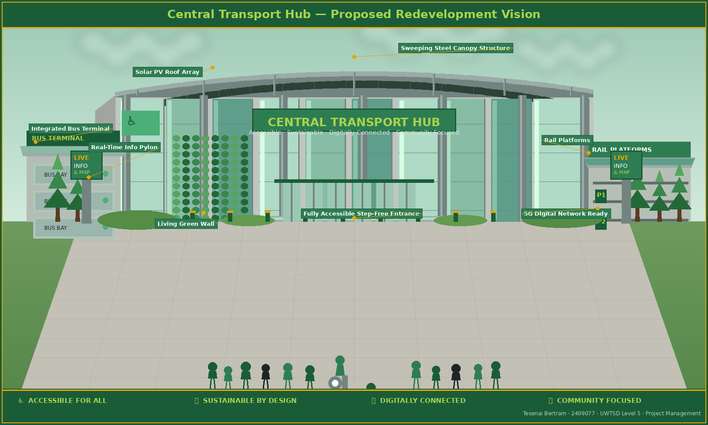
CENTRAL TRANSPORT HUB: PROPOSED REDEVELOPMENT VISION
Figure 0: Artist's impression of the proposed Central Transport Hub redevelopment, illustrating the integrated bus terminal, rail platforms, solar PV roofing, step-free accessible entrance and real-time digital information infrastructure (produced for assessment purposes; Tesenai Bertram, 2026).

11. REFERENCES

PART A:

Association for Project Management (2024) APM body of knowledge. 8th edn. Princes Risborough: Association for Project Management.
Chartered Institution of Highways and Transportation (2025) UK Government publishes new carbon budgets: what it means for UK transport. Available at: https://www.ciht.org.uk/news/uk-government-publishes-new-carbon-budget-and-growth-delivery-plan-what-it-means-for-uk-transport/ (Accessed: 1 June 2026).
Climate Change Committee (2024) Progress in reducing emissions: 2024 report to Parliament. London: Climate Change Committee.
Department for Energy Security and Net Zero (2025) Carbon Budget Delivery Plan. Available at: https://www.gov.uk/government/publications/carbon-budget-delivery-plan (Accessed: 27 June 2026).
Department for Transport (2025) Electric vehicle public charging infrastructure statistics. Available at: https://www.gov.uk/government/statistics/electric-vehicle-charging-device-statistics (Accessed: 13 June 2026).
Doran, G.T. (1981) 'There's a S.M.A.R.T. way to write management's goals and objectives', Management Review, 70(11), pp. 35-36.
Great Britain (2010) Equality Act 2010. London: The Stationery Office.
Innovate UK Business Connect (2024) UK transport decarbonisation policy tracker. Available at: https://iuk-business-connect.org.uk/perspectives/decarbonisation-policy-tracker/ (Accessed: 12 June 2026).
Mendelow, A. (1991) 'Stakeholder mapping', Proceedings of the 2nd International Conference on Information Systems. Cambridge, MA, 7-9 December.
Office of Rail and Road (2025) Rail infrastructure and asset condition statistics. Available at: https://dataportal.orr.gov.uk/ (Accessed: 27 June 2026).
Project Management Institute (2021) A guide to the project management body of knowledge (PMBOK guide). 7th edn. Newtown Square, PA: Project Management Institute.
Rethink Sustainable Transport Alliance (Green Alliance) (2025) Decarbonising transport. Available at: https://green-alliance.org.uk/project/decarbonising-transport/ (Accessed: 27 June 2026).
Turner, J.R. and Zolin, R. (2023) Handbook of project management. 5th edn. London: Routledge.

PART B:

Alley, M. (2013) The Craft of Scientific Presentations. 2nd edn. New York: Springer.
APM (2019) APM Body of Knowledge. 7th edn. Princes Risborough: Association for Project Management.
Chapman, C. and Ward, S. (2011) How to Manage Project Opportunity and Risk. 3rd edn. Chichester: John Wiley & Sons.
Doran, G.T. (1981) 'There's a SMART way to write management's goals and objectives', Management Review, 70(11), pp. 35–36.
Freeman, R.E. (1984) Strategic Management: A Stakeholder Approach. Boston: Pitman.
Gibbs, G. (1988) Learning by Doing: A Guide to Teaching and Learning Methods. Oxford: Further Education Unit.
HM Treasury (2022) The Green Book: Central Government Guidance on Appraisal and Evaluation. London: HM Treasury.
ISO (2018) ISO 31000:2018 Risk Management -Guidelines. Geneva: ISO.
Lock, D. (2020) Project Management. 11th edn. Abingdon: Routledge.
Maylor, H. (2022) Project Management. 5th edn. Harlow: Pearson Education.
Mendelow, A.L. (1991) 'Stakeholder mapping', Proceedings of the 2nd International Conference on Information Systems, Cambridge, MA.
Moon, J.A. (2004) A Handbook of Reflective and Experiential Learning. Abingdon: RoutledgeFalmer.
PMI (2021) A Guide to the Project Management Body of Knowledge (PMBOK® Guide). 7th edn. Pennsylvania: PMI.
Saunders, M., Lewis, P. and Thornhill, A. (2023) Research Methods for Business Students. 9th edn. Harlow: Pearson.
United Nations (2015) Transforming Our World: The 2030 Agenda for Sustainable Development. New York: UN.

PART C:

AXELOS (2017) Managing Successful Projects with PRINCE2. 6th edn. London: The Stationery Office.
Bourne, L. (2016) Stakeholder Relationship Management: A Maturity Model for Organisational Implementation. 2nd edn. Abingdon: Routledge.
Bradley, G. (2016) Benefit Realisation Management: A Practical Guide to Achieving Benefits Through Change. 2nd edn. Abingdon: Routledge.
Building Safety Act 2022 (c. 30). London: HMSO.
Chapman, C. and Ward, S. (2011) How to Manage Project Opportunity and Risk. 3rd edn. Chichester: John Wiley & Sons.
Department for Levelling Up, Housing and Communities (2022) Levelling Up the United Kingdom: White Paper. London: HMSO.
Doran, G.T. (1981) 'There's a SMART way to write management's goals and objectives', Management Review, 70(11), pp. 35–36.
Equality Act 2010 (c. 15). London: HMSO.
Freeman, R.E. (1984) Strategic Management: A Stakeholder Approach. Boston: Pitman Publishing.
Heldman, K. (2018) PMP: Project Management Professional Exam Study Guide. 9th edn. Indianapolis: Sybex.
HM Treasury (2022) The Green Book: Central Government Guidance on Appraisal and Evaluation. London: HM Treasury.
Institution of Civil Engineers (2017) NEC4: Engineering and Construction Contract. London: Thomas Telford.
ISO (2018) ISO 31000:2018 Risk Management- Guidelines. Geneva: International Organization for Standardization.
Kerzner, H. (2022) Project Management: A Systems Approach to Planning, Scheduling and Controlling. 13th edn. Hoboken: Wiley.
Lock, D. (2020) Project Management. 11th edn. Abingdon: Routledge.
Maylor, H. (2022) Project Management. 5th edn. Harlow: Pearson Education.
Mendelow, A.L. (1991) 'Stakeholder mapping', Proceedings of the 2nd International Conference on Information Systems, Cambridge, MA.
PMI (2021) A Guide to the Project Management Body of Knowledge (PMBOK® Guide). 7th edn. Pennsylvania: PMI.
RICS (2024) Construction Market Survey Q3 2024. London: Royal Institution of Chartered Surveyors.
Turner, J.R. and Zolin, R. (2023) Handbook of project management. 5th edn. London: Routledge.
Turner, J.R. (2014) The Handbook of Project-Based Management. 4th edn. New York: McGraw-Hill.
United Nations (2015) Transforming Our World: The 2030 Agenda for Sustainable Development. New York: United Nations.

FIGURE 0

Atkins (2022) Transport infrastructure design guidance: accessible and sustainable interchange facilities. London: WSP/Atkins.
Building Regulations 2010 (SI 2010/2214), Approved Document M: Access to and Use of Buildings. London: HMSO.
British Standards Institution (2018) BS 8300-1:2018 Design of an accessible and inclusive built environment-Buildings-Code of practice. London: BSI.
Network Rail (2023) Station design principles: accessibility and sustainability standards. London: Network Rail. Available at: https://www.networkrail.co.uk/running-the-railway/looking-after-the-railway/buildings-and-facilities/stations (Accessed: 20 July 2026).
RIBA (2020) RIBA Plan of Work 2020. London: Royal Institute of British Architects. Available at: https://www.architecture.com/knowledge-and-resources/resources-landing-page/riba-plan-of-work (Accessed: 20 July 2026)

