Food and Beverage Operations
BMIH4002

Student name: Shahidul Alam
Student ID number: 2235209
Table of Contents
Introduction 1
Part-1: Restaurant Concept 1
Restaurant concept 1
Target Audience of Hotel Trinity 1
Reasoning behind menu choices 2
Part 2: Menu Design 2
Conclusion 5
References 6

Introduction
The report aims to develop a menu based on the new concept to meet current health well-being trends and customers' preferences. The report focuses on Hotel Trinity where builds a new concept for foods for target customers based on the new trends within the market. Identified target audiences, and provides reasoning for selecting the menu. The menu of the Hotel Trinity focuses on food and beverage selection based on the theme, pricing strategy, nutrition and special dietary requirements, menu layouts, and design, sustainability, and seasonality.

Part-1: Restaurant concept

Restaurant concept
Hotel Trinity is a part of the Trinity Hotel Chain. Hotel Trinity is an India-based hotel chain that has a presence in the market of London, UK along with India (Tripadvisor.com, 2023). So, the new concept for the Hotel Trinity needs to be like that could reflect the culture of the hotel. So, the new restaurant concept of the Hotel Trinity is “Eat healthy with taste”. “Eat healthy with taste” is the restaurant concept because it reflects the new healthy food trends within the market along with inspiring those people who want to diet to taste the foods of Hotel Trinity. That will not only help to manage the diet of customers but will also provide an experience of good taste.

Target Audience of Hotel Trinity
The Target Audience of Hotel Trinity has aged 18 to 50 years old in the UK and Indian people who are from high-income levels and want to eat a healthy and balanced diet food that is free from gluten and lactose (Oyster.com, 2023). Also, customers who are vegetarians along with those who want to taste beef and fish but in a healthy way. Also, the high-income level of customers is mostly family groups, business executives, and individuals. Since the target audiences are from two countries UK and India so the new concept of Hotel Trinity is made based on the preferences of both kinds of customers (Cardiff, 2020). So that could meet current health and wellness trends.

Reasoning behind menu choices
The choices of the menu are the starters, main course, desserts, and beverages. The reason behind selecting this menu is to enable a full course of meals to customers which could provide them contentment to have such as greater lunch or dinner (Cousins, 2020). Also, the target customers of Hotel Trinity are family groups who visit the hotel with family, individuals who visit with their friends, and business executives who visit the hotel with team members for meetings (Davis et al., 2018). So, the preferences of target customers of Hotel Trinity are mostly remaining full courses which included both savoury and desserts so the menu consists of dishes for the full course. Starters are those that the restaurant will enable as the first course of the meal, then will provide the main course, then desserts, and then beverages to customers that will ensure a full course of the menu for target customers (Johnston, 2012).

Part 2: Menu Design
Food and beverage selection: The new concept of the food of Hotel Trinity “Eat healthy with taste” includes dishes for starters, main dishes, desserts, and beverages. The food choices for starters are the Air Fryer Cabbage Pakora, Vegetable Samosas with Cilantro Mint Chutney, Lentil Fritters with Mango Chutney, Papdi Chaat, and Khaman Dhokla. All the starters are good for health with low fat, low sugar, and balanced diet because all these starters are made by using vegetables which have low calories and fibre (Motarjemi and Lelieveld, 2014). The menu choice for Main dishes is Malai Prawns with Polaw, Dhak India Cake, Parwal Stuffed with Biryani, served with fried potatoes, Vegan Squash and Mushroom Pie, Low-fat Beef and Potato Pies, Healthy Chicken Pie, Slow Cooker Vegetarian Hotpot, and Healthy Fish Pie (Fogel, 2019). All these main courses are reflecting the theme of the restaurant which is “To meet the taste requirements of all”. Also, reflects the culture of both India and the UK. So, target customers who want a healthy balanced diet food with good taste could prefer these food items. These food items have lower fat, no sugar, and balanced calories and fibre which is the reason behind selecting these dishes (Gorin, 2022). Palak Cake and Peanut Caramel, Gulabi Gulab, Frozen Fruit Bars, Yogurt Parfait, Oat Apple Crisp. All these deserts are made without sugar only using the sweetness of fruits. Beverages such as coconut water, banana smoothies, Low-fat and fat-free milk, Pomegranate Juice, Lemon Juice, Fruit tea, Sugarcane juice, and Guava ginger juice are made from fresh fruits and dairy products which are good for health (Hawkes, 2020). That is meeting the preferences of the target audience along with new health wellness trends within the market.
Pricing strategy: The new food menu of Hotel Trinity is based on a premium pricing strategy where the price for each of the starters, main courses, desserts, and beverages are higher than its competitors. Because the target customers of Hotel Trinity are those who have high-income levels, business executives, and others.
Nutrition and special dietary requirements: The food menu of Hotel Trinity focuses on the nutrition and dietary requirements of target customers where including foods based on seasonal vegetables, beef, fish, and dairy products which have lower fat, lower sugar elements, lower calories, and fiber (Oyster.com, 2023). All the beverages are special dietary items along with air fryer cabbage pakora, khaman dhokla, palak cake, yogurt parfait, and healthy fish pie, which are the special dietary items on the menu (Tripadvisor.com, 2023).
Menu layouts and Design
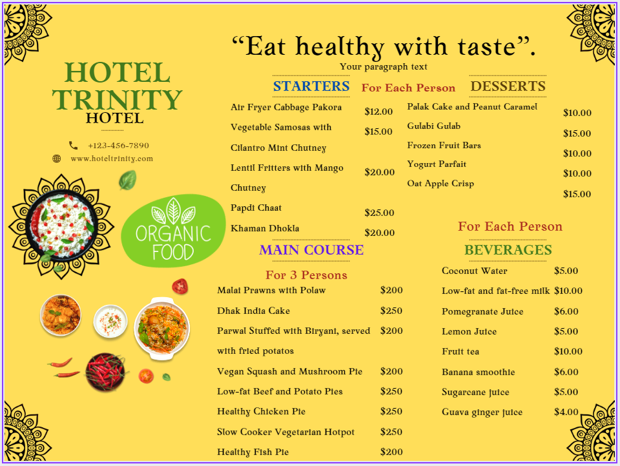
Sustainability and Seasonality: The dishes on the new menu mostly consist of those dishes and beverages which are made from fresh vegetables and fruits which are seasonal fruits and vegetables. That makes the menu of Hotel Trinity most attractive to target customers who are vegetarians along with those who are non-vegetarians because the menu also consists of dishes made of beef and fish which are along with seasonal vegetables (Cardiff, 2020). Hotel Trinity’s operations are aligning with environmental trends. Because Hotel Trinity provides leftover foods to poor social people along with avoiding to use of vegetables, beef, fish, and fruits which consist of harmful chemicals, and collect these items directly collaborated from farmers, dairyman, and fisherman (Fogel, 2019). That is helping to reduce the negative impact on the environment along with helping to ensure the health and well-being of customers.

Conclusion
The target customers of Hotel Trinity are the high-income level of customers aged 18 to 50 who are conscious about their health and from the UK and India. So, the food selection within the new menu consists of foods that are made of fresh vegetables, fruits, and dairy products that could meet the health preferences of target customers. The price of food items is set by following a premium pricing strategy and setting a high price than competitors. Also, ensures sustainability factors by providing leftover foods to the poor and collaborating with farmers, dairymen, and fishermen directly to collect chemical-free fruits, vegetables, dairy products, fish, and beef.

References
Cardiff (2020). Making Healthy Food Choices. Center for Nutrition Policy & Promotion.
Cousins, J. (2020). Food and beverage service. 9th ed. London: Hodder Education Group.
Davis, B et al. (2018). Food and Beverage Management. 6 ed London: Routledge.
Fogel, Robert W. (2019). Health, Nutrition, and Economic Growth. Economic Development and Cultural Change, 52(3), pp.643–658.
Gorin, A. (2022). 10 Healthy Food Trends to Expect in 2020 | Everyday Health. [online] EverydayHealth.com. Available at: https://www.everydayhealth.com/pictures/top-healthy-food-trends/.
Hawkes, C. (2020). A food policy package for healthy diets and the prevention of obesity and diet-related non-communicable diseases: the NOURISHING framework. Obesity Reviews, 14(S2), pp.159–168.
Johnston, R. (2012). Service operations management: improving service delivery. 4th ed. Harlow, England: Pearson.
Motarjemi, Y and Lelieveld, H (2014). Food safety management: a practical guide for the food industry. Illustrated edition. Amsterdam: Academic Press.
Oyster.com (2023). Trinity City Hotel Review: What To REALLY Expect If You Stay. [online] Oyster.com. Available at: https://www.oyster.com/dublin/hotels/trinity-city-hotel/.
Tripadvisor.com (2023). HOTEL TRINITY ISLE - Prices & Reviews (Bengaluru, India). [online] Tripadvisor. Available at: https://www.tripadvisor.com/Hotel_Review-g297628-d1730285-Reviews-Hotel_Trinity_Isle-Bengaluru_Bangalore_District_Karnataka.html.
Zutshi, A. (2019). How to develop well-informed and assured teams to embed food safety compliance in the UK catering and hospitality industry, Perspectives in Public Health, 139(6), pp. 294–295.

