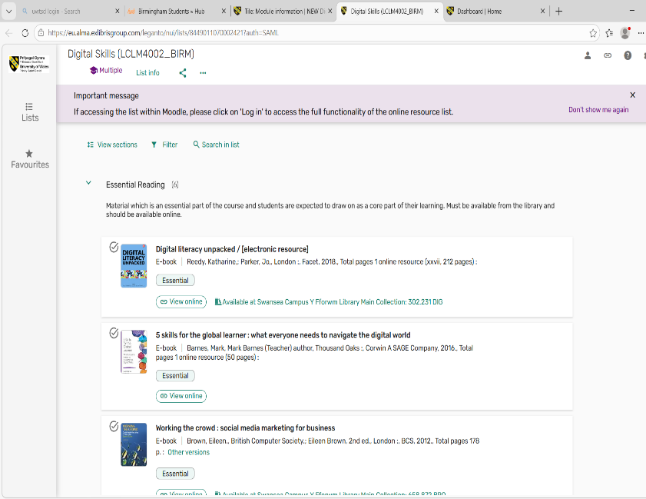
Screenshot One:
In this image, I used digital skills to create a screenshot of a reading list to help me with my studies.
I feel confident when I can easily locate the images that I have saved, as it helps me find information quickly and navigate to the content that I need for a specific purpose. Especially to stay organised when completing tasks that require important sources to back up my work.
I often use these tools to help me with my understanding of my module and link in sources for information that I can refer back too.
We use these in everyday life for information and Education especially in the modern world.

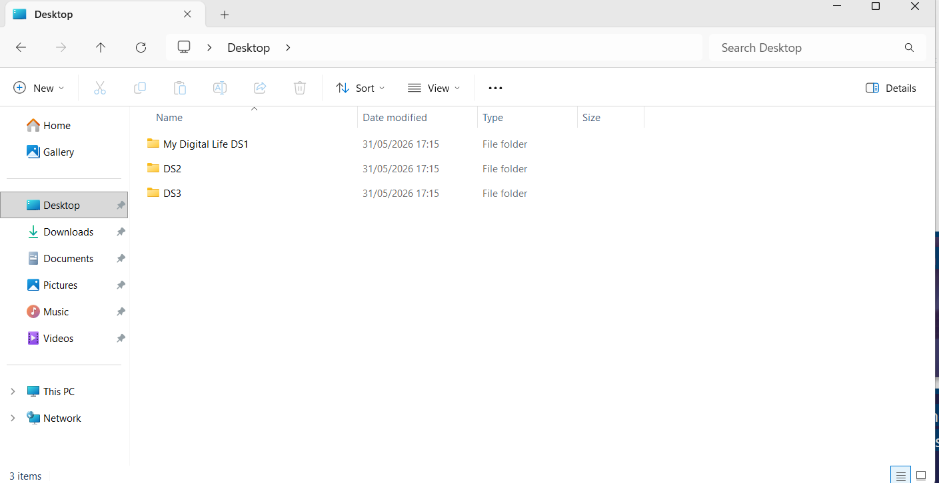

Screenshot Two:
In this image, I used digital skills to create a screenshot of my files of my DS1, 2 And 3 Assignments for this module.
In a business setting this would be used to keep files in order to create a calm, balanced and organised workplace.
Digital skills are important in any business, to help companies improve productivity, communication and operate efficiently.
In everyday life, businesses would use organised files to complete tasks faster with more accuracy.
Organised Files, Reduces errors, saves time, improves security and ensures employees/employers can easily access the information they need.

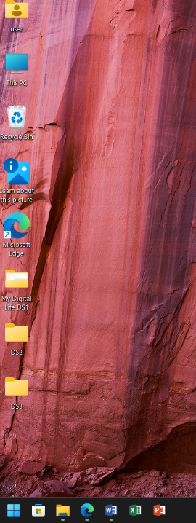
Screenshot Three:
In this image, I used digital skills to create a screenshot of my files of my DS1, 2 And 3 Assignments for this module located on my laptop home screen.
I often use these tools for quick access without having to navigate through multiple folders, which saves time. Especially when working on important documents, PowerPoints or spreadsheets.
Which in a business setting is a very important tool to increase productivity and save time when working on things with deadlines like the modules for the assessment.
I hope this module will help me not only understand day to day digital skills but also skills that will help me in a workplace environment. Helping me better with organisation, prioritising tasks and keeping important work visibly organised.

Screenshot Four:
In this image, I used digital skills to create a screenshot of my University Dashboard Hub.
I use these tools often in my everyday life especially when trying to navigate my module information on apps like Moodle.
With full access on hub to apps we use in everyday life Like Facebook, Spotify and Instagram. There’s also apps to engage in the professional workplace for example; Microsoft Teams and LinkedIn. Which also offer the opportunity for networking.
These Digital skills are important to me because they analyse not just day to day online skills, they offer skills that are workplace related too.
Like Timetables, Calendars, Attendance and deadlines. Everything you would need in a workplace or a business setting.
Creating a centralised access point for everything means not only improving efficiency but also bringing important tools together in one place helping employees/students to work more effectively, stay informed and build valuable professional connections.

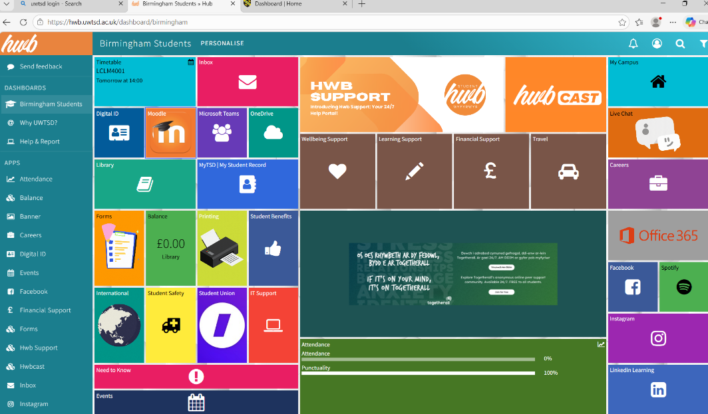

Screenshot Five:
In this image, I used digital skills to create a screenshot of my Organised Folder of screenshots.
I often use Screenshotting to save important bits of information to use at a later time.
When doing presentations over video calling conferences, it’s an important tool for saving information when on an important time schedule or deadline.
We could also use this tool for giving feedback, to highlight specific areas of someone’s work or sharing information.
Organising these files into a folder specifically designed for screenshots as shown in this image; meaning it’s easily accessible to find.
I want my digital skills to improve from this module, I would improve this by labelling certain screenshots within the folder, not only to increase flexibility as a student but also increase efficacy and productivity in a workplace environment or professional setting.

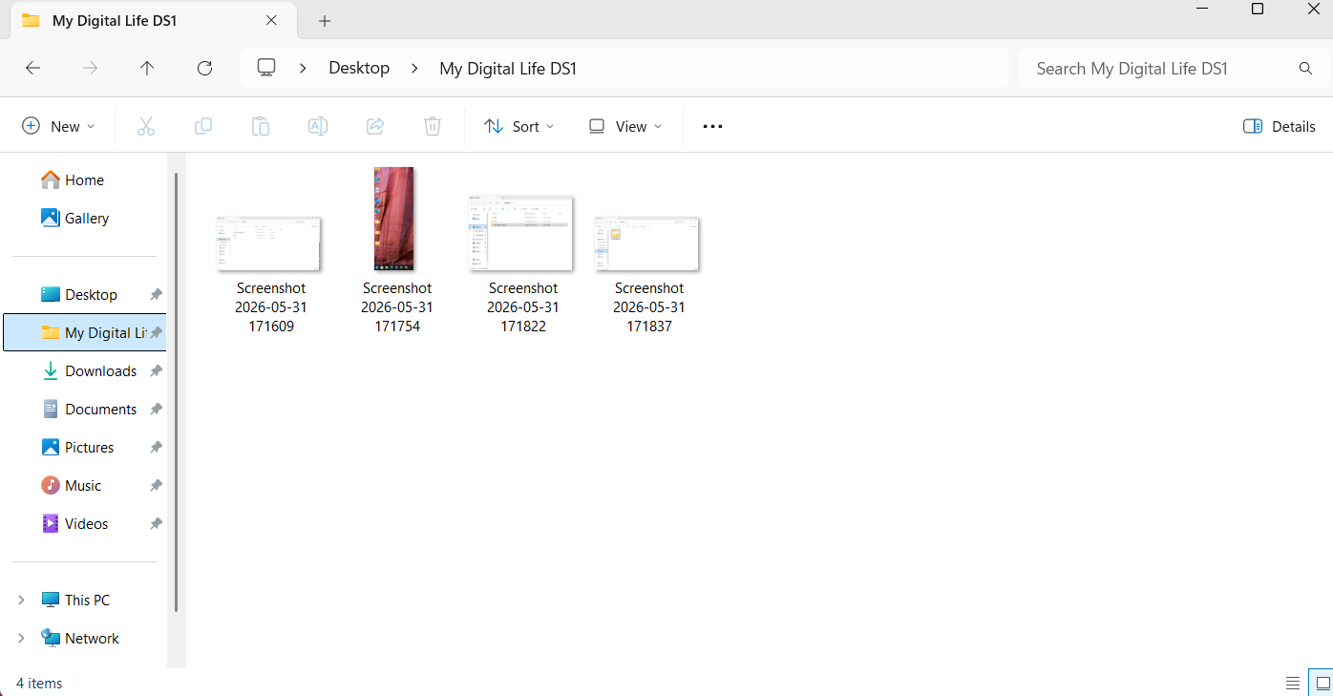

Screenshot Six:
In this image I used digital skills to create a screenshot of my LinkedIn profile.
In the digital world, LinkedIn is important in both a work setting and as a student because it helps create professional connections, showcase their skills and discover new opportunities.
In a workplace environment for instance, networking allows businesses and other professionals to connect to potential new customers, industry professionals and possibly new employers.
As a student, LinkedIn provides a platform to create a professional profile, highlight achievements, and gain insights into different career paths. More examples include Internships, future work placements and apprenticeships.
It is a valuable tool for developing a professional online presence and exploring new and different career prospects.

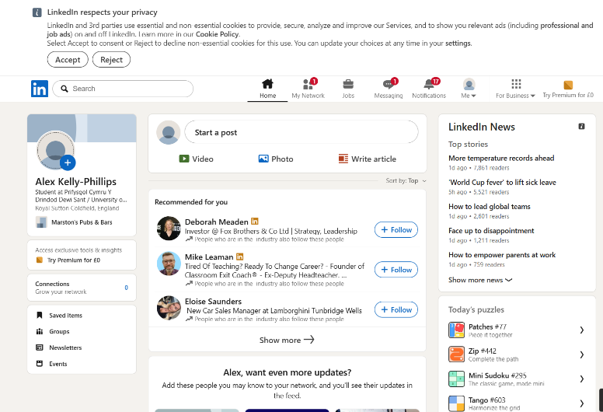

Reflection:
Through completing my digital life assignment, I have developed a greater understanding of how digital skills are used in both everyday life and the workplace.
I have learned the importance of keeping files organised, using digital tools efficiently and managing information in a way that improves productivity.
Creating this assignment also helped me improve my confidence when using platforms such as LinkedIn, Moodle, Hub and Cloud based storage systems for example; files.
I now understand how digital technology and skills can support communication, networking, and collaboration in professional environments.
Reflecting on this assignment has shown me that strong digital understanding and skills are essential for success as both a student and a future employee/employer.
I will continue to develop these skills to improve my effectiveness and adaptability in the Digital World.

