Site Investigation Report

By Dylan J Pugh
Contents
2 Design Brief 3
3 Location 4
4 Historical Data 5
4.1 WW Bombings;- 5
4.2 Tram Lines; - 6
4.3 Industrial Era;- 7
4.4 Risks 7
5 Ground Investigation 10
5.1 Soil and Rock Formation 10
5.2 Borehole Data 11
5.3 Risks 11
6 Coastal 12
6.1 Risks 12
7 Codes of Practise 14
8 Foundations 15
9 References 17
10 Appendix 18

Design Brief

City and County of Swansea have chosen to enter into a joint agreement with Marriot Hotels to create a new restaurant and ice-cream parlour (with manager’s apartment) on Swansea foreshore, in the position indicated. The site is located between County Hall and the Marriot Hotel and is illustrated on the attached images. The building, which is to share parts of the car park of both of the existing adjacent facilities, is to have a GIA (Gross Internal Area) at ground floor level of approximately 300 square metres.
The building is to contain the restaurant, café bar, ice-cream parlour, kitchen, food-stores etc. At second floor level, there is to be a self-contained manager’s apartment and staff welfare facilities. This project is procured via a Design and Build contract.

You are to assume that you work as a junior construction professional, requested to initiate a preliminary study for a full site investigation as part of the feasibility stage of the project.

Location

Historical Data

WW Bombings;-
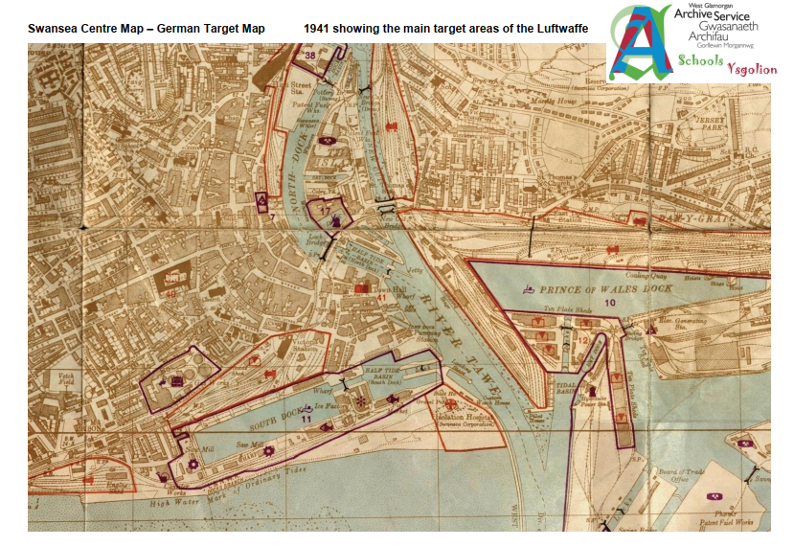
Purposed Area
(Three Night Blitz, 2020)
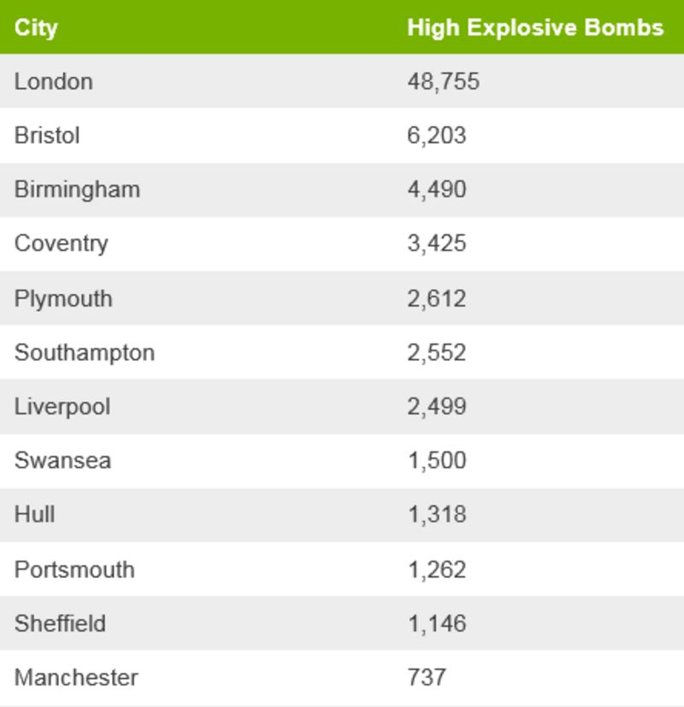
During WW, Swansea was a main asset for its Docks and factories. So, the German Air Force bombed along Mumbles to what is now SA1, destroying everything from homes, docks, and buildings. Which is known as the “Three Night Blitz” (See Appendix 1 for other maps).
There have been 1,500 bombs recorded by the MOD that have been found in the Swansea area says a report by the BBC (BBC, 2018).

(BBC, 2018)

Tram Lines; -

In 1867, the Swansea Victoria Station was opened. The railway had a tramline running on the roadside on Oystermouth Road (Figure 3) and on the other side was the train tracks along the beach front (Figure 2).
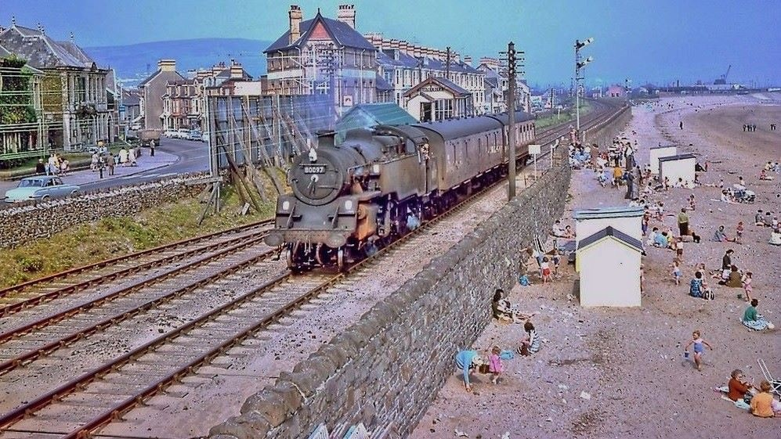
Mumbles Railway Line from Simon L. Jones Swansea Council.
The Swansea Victoria line ran from Swansea Docks to Mumbles as Mumbles area. The line was used for public transport and moving goods between the 2 places.
The line would start at Swansea Victoria then go through and by the docks and then towards mumbles. The line finishes in Pontarddulais.
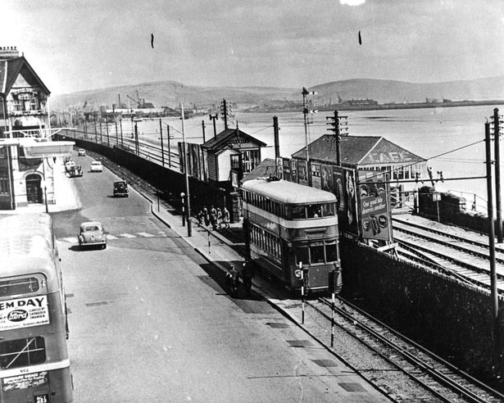
Tram Line from Simon L. Jones Swansea Council.

Industrial Era;-
Swansea was renowned for its production of copper given it the nickname “Copperopolis” for its large production of copper supply to the world. It was one of the world’s leading areas for copper production. As during World War II, it was a main target as the docks, factories and seafront were bombed during the war as it known as the “Three Night Blitz”.
As Swansea did have a lot of coal mines as it was a main part of their industry. As there have been cases that house developers have found abandoned miner shafts. Below is a map of the coal mining areas by the Local Coal Authority (Local Coal Authority).
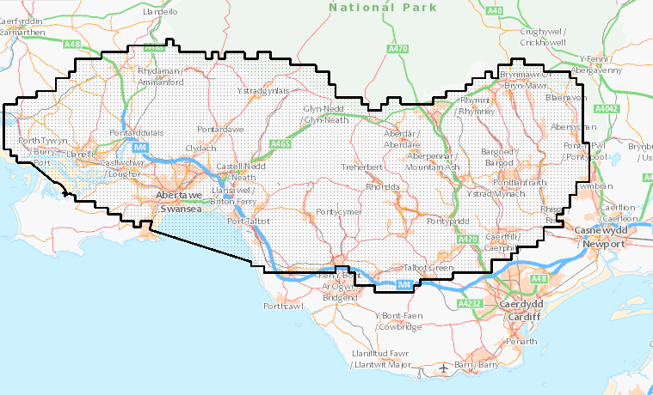

Risks
The risks that could arise from historical records are that during WWII bombings, some bombs could have landed around the area, but they might have not exploded. As its very common to find unexploded bombs as a report from the BBC says, “Since 2010, the Ministry of Defence (MoD) says it has been involved with making safe 450 German WW2 bombs - about 60 per year.” (BBC, 2018). The ground around the area could be unstable due to the WWII bombings so subsidence could occur so the parlour could sink or collapse due to the unstable ground.
Furthermore, other risks that could arise are abandoned coal mines or pockets of coal. As if there is abandoned mine shafts they can cause problems as there could be voids underneath the ground and make the ground unstable as if you use pile foundations they could be hammered into rock but beneath that rock could be a shaft which the pile could fall through as the weight of the parlour could but pressure on the rock above the void. Also, if there is any coal found in the area and it’s within the Coal Boards mining land they can have first priority on it to mine the coal and that can cause the project to be delayed due to coal mining.
Since the site had the old rail and dock line running through the area there is a possibility of the old tracks being there still as they could’ve of been buried over and forgotten about so when using the Vibro-hammer to knock the piles in could cause the pile to break or have the pile bounce off it and kicking up which could cause serious injury or fatality. Also, if you do a Sumo scan which is a sonar surveying to find underground services the old lines could repel the sonar and throw off the correct positions of the services which can cause severe problems. With the railway is used to transport the likes of oil, chemicals and resources so the trains could’ve leaked out hazardous substances which could contaminate the site and make the site harder to work on as you would have to remove that material and have it properly disposed of and that adds extra cost to the project.
The area has been listed as a flood risk area as this can cause problems as the site could flood or if the building is built and not high enough the building could flood and cause damages and it can delay the construction of the project (See Appendix 2).
With being between the Civic Centre and Marriott Hotel, there is a likely chance of services being around the area which can cause problems as they will affect the foundations as they’ll be in the way and if you use an auger you could hit one and have a service strike.
The area has a lot of history but there is a lot of factors which are known of that could cause problems like unexploded bombs or rail tracks. However, there is a lot of unknown factors that could cause problems such as undocumented services or voids due to mining. So, the site is very dangerous as you don’t know fully what’s underneath the site.
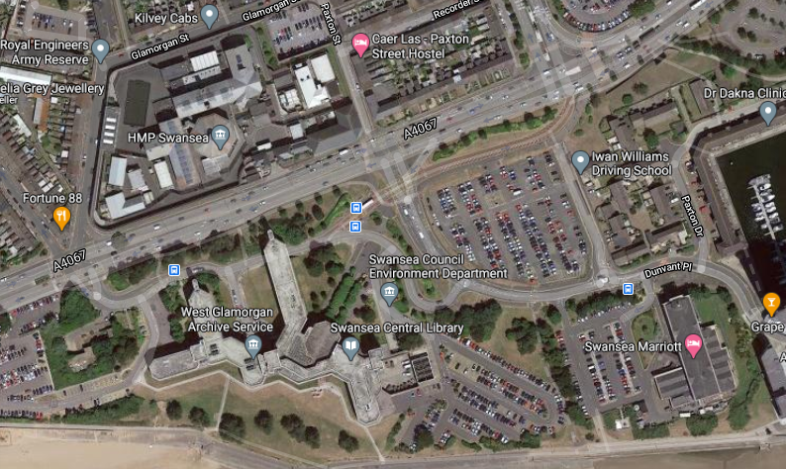
The site is by the Civic Centre and Marriott Hotel. The site is on the seafront and accessed by going on Oystermouth road then turning into the junction for the Civic Centre and then you turn to go towards the Marriott and the site is on the vegetation that’s on the edge of the car park.
Marriott Hotel
Oystermouth Road
Site Area
Civic Centre

Ground Investigation

Soil and Rock Formation
(British Geological Survey, n.d.)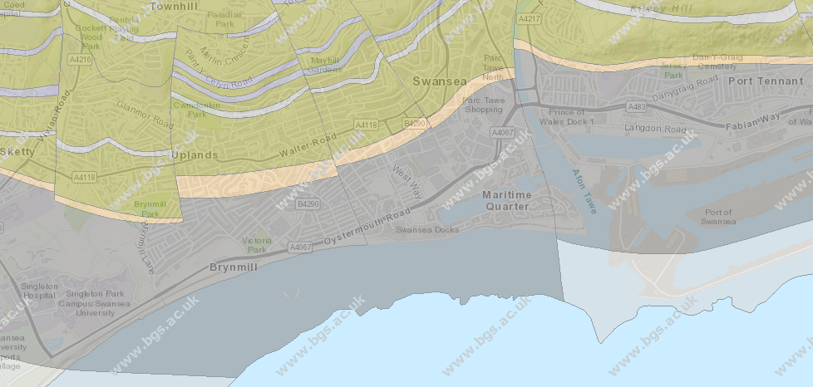
According to British Geological Survey that our purposed area on the Swansea Seafronts Bedrock is made up of Mudstone, Siltstone and Sandstone. The bedrock ranges to the South Wales Middle Coal Measures which dates back the Upper Carboniferous era.
Carboniferous took place 360 million years ago when Carboniferous limestone formed in the United Kingdom (CGP, 2010).
The superficial layer is the layer of rock that has formed there in the most recent millennium. The makeup of the superficial layer is Blown Sand which is transported by wind (See Appendix 3).

Bedrock

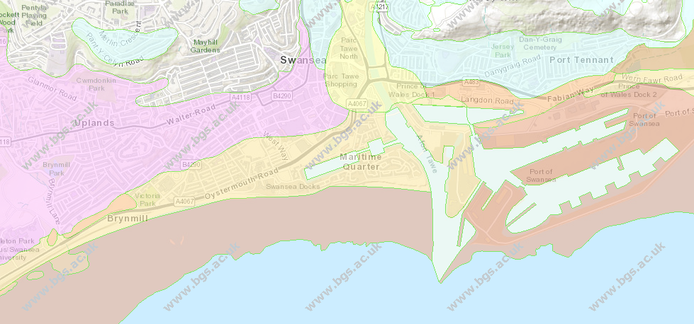 (British Geological Survey, n.d.)
Superficial

Borehole Data
See Appendix 4 to see Borehole Sheets for the site. The Borehole data was taken in 1975. The data sheets show us that the investigation went 22m down. From Ground level to approximately 2.55m the ground is made up of sand then from 2.55m down clay appears more frequently. At 7.95m the layers of clay become larger in thickness compared to other layers further up which are made up of sands, clays, and shale.
The further down you go the more hard and durable material is. As at 11m to 18.6m you have “very stiff grey gravelly boulder clay” referenced to the data sheets. Between 18.6m to 22m is Mudstone.

Risks
The grounds makeup has an impact on the foundations you use as using the wrong one could cause the building to collapse or sink. As the top layers of sandy material is loose and soft and would give way is a massive amount of weight has been put onto it. As things like Step Cracking will happen and sinkage. The whole area is the same so working around this area could cause distributions as the ground around the area could move and make the area unsafe to work in as vehicles driving over the top of it could sink and get stuck.
Also, the harder material is further down around 7 plus metres so you would have to have foundations going down that far as that would be the safest and most ideal area to put them as its strong and hard material but in some places it might be deeper and not as thick so the foundations in some areas could give way and cause subsidence due to areas having different thickness.
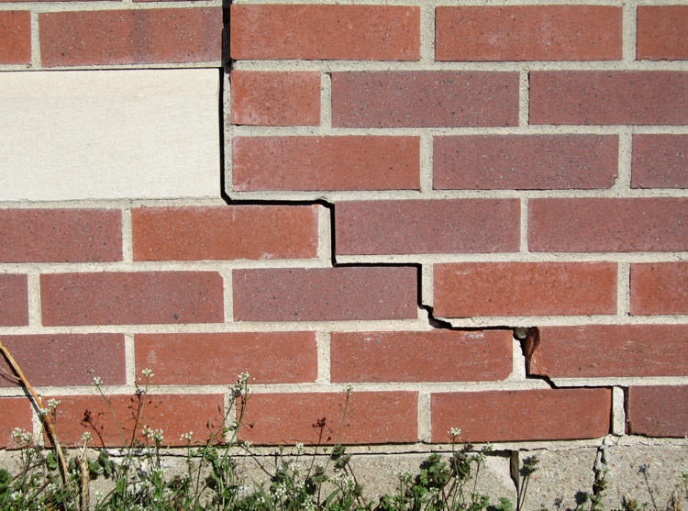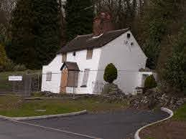
(Stablwall, n.d.) (a3, n.d.)

Coastal
The site is located on the seafront of Swansea. The superficial ground makeup of the site is Blown Sand which is caused by the wind moving sand over time. However, since it’s by the coast, the tide would also help make the grounds makeup.
This is due to Swash and backwash. Swash is when the tide comes in and pushes the sand up while the backwash pulls the sand back so over time the tide has moved sand around the area and since there is a sea wall and defences along the seafront they can cause the sand to build up.

Risks
When designing and building the Parlour you have to look at the sea level as the location of the site is on the seafront and it is close to the promenade so the waves could splash and hit the building. As the Welsh coast line is one of the highest in the world so it can cause problems as due to global warming sea level is rising so if the parlour is designed to what it is now and if the sea level does rise it then the parlour could flood.
Furthermore, coastal erosion can occur as the rise in sea level can cause the tides and waves to become high and go over the sea wall easier and damage the ground around the area or building. So, it could cause the ground beneath the area to collapse or sink (See Appendix 5 for reports of coastal erosion around the area).

Codes of Practise
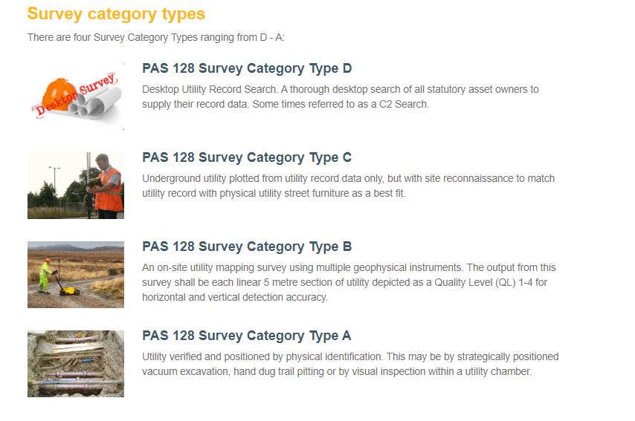 (Hughes, n.d.).
PAS128 is the new standard for GI (Ground Investigation). The above screenshot was taken from Malcom Hughes website. There are 4 categories for GI. D is the cheapest and least accurate way as your using information from other sources which you presume are right and done proper. C is a one up from D. It uses D but goes one step further as you do Site Reconnaissance and see if the records you have been given tally up to the site itself. B is doing a GPR survey which stands for Ground Penetration Radar, this sends pulses below ground which will bounce off and give you locations and depths of services or any foreign objects.
Type A is the best method but most costly as you carry out Trail holes and lift up chambers and everything to get accurate locations of services.
PAS128 is the new standard that’s being pushed to be used. As BS5930:2015 is the latest and most current standard for Site Investigation as it goes through the main objectives and reasons behind a Site Investigation.

Foundations
For this project I would use pile foundations as it’s the best suited for this task.
Referring back to my assessment on the borehole data, the top layers of the ground are made up of sandy material which wouldn’t support the weight of the building as using shallow foundations would be very vulnerable to subsidence and sinkage. The harder stronger material is further down so using deep foundations like piling would be most effective are they would be able to rest on the clay and support the Parlour.
Bored piles would be the most suitable choice. As the grounds top layers are soft material so any forms of piling that uses a vibro-hammer which use vibrations to knock the piles in can make the ground become unstable, as the vibrations could distribute the ground surrounding the area.
With bored piles you can use an auger to drill the holes down to the depth which you want and are suitable for the foundations to sit on. Then you would place the reinforced steel frames into the holes and pour concrete down them, to make reinforced concrete as a way to make it more sustainable and durable. Then form a ring beam around the piles which then will make a suspended floor which you can make higher to the reduce the risk of flooding due to the rise in sea level. Also, using bored piles you can avoid hitting services as you can space them out equally and have the services running in between them.
Below is a zoomed in view of a cross section of a pile and beam foundation for full drawing look at Appendix 7.
Also, using BS8004:2015 which is the British Standard for doing foundations in the UK.
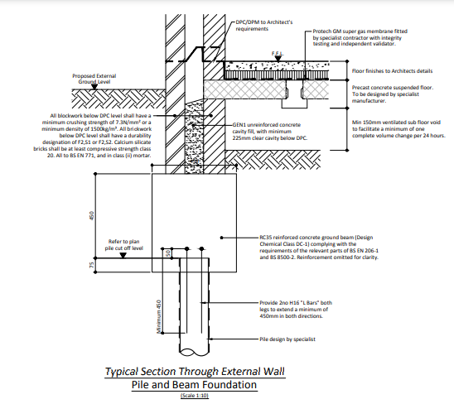 (DT, 2014)

References
a3. (n.d.). Spotting The Signs Of Subsidence. Retrieved from a3: https://a3-online.co.uk/blog/spotting-the-signs-of-subsidence/
Archives, W. G. (2020, April 29). Three Night Blitz. Retrieved from swansea.go.uk: https://www.swansea.gov.uk/article/57405/The-Three-Nights-Blitz#:~:text=The%20Three%20Nights'%20Blitz%20was,killed%20and%20397%20were%20injured.
Authority, L. C. (n.d.). Local Coal Authority. Retrieved from BGS: https://mapapps2.bgs.ac.uk/coalauthority/home.html
BBC. (2018). Unexploded bombs: How common are they? https://www.bbc.co.uk/news/uk-43061244.
CGP. (2010). The Rock Cycle. In CGP, GCSE Geography Complete Revision & Practise (p. 21). CGP.
Council, W. G. (1975). Retrieved from British Geological Survey: https://www.bgs.ac.uk/
Cymru, C. N. (2017). Cyfoeth Naturiol Cymru. Retrieved from cyfoethnaturiolcymru.gov.uk: https://maps.cyfoethnaturiolcymru.gov.uk/Html5Viewer/Index.html?configBase=https://maps.cyfoethnaturiolcymru.gov.uk/Geocortex/Essentials/REST/sites/Flood_Risk/viewers/Flood_Risk/virtualdirectory/Resources/Config/Default&layerTheme=3
DT. (2014, November). Retrieved from http://planpub.eppingforestdc.gov.uk/NorthgatePublicDocs/00456382.pdf
Facility, N. T. (n.d.). National Tide and Sea Level Facility. Retrieved from National Tide and Sea Level Facility: https://www.ntslf.org/tides/datum
Hughes, M. (n.d.). What is PAS128. Retrieved from Malcom Hughes: https://www.pas128.co.uk/what-is-pas.html
Stablwall. (n.d.). Step Cracks In Your Foundation – Should You be Concerned? Retrieved from Stablwall: https://stablwall.com/step-cracks-foundation-concerned/
Survey, B. G. (n.d.). British Geological Survey. Retrieved from British Geological Survey: https://www.bgs.ac.uk/
Survey, B. G. (n.d.). British Geological Survey. Retrieved from British Geological Survey: https://www.bgs.ac.uk/
https://geotechnicaldesign.info/bs5930-2015.html
https://geotechnicaldesign.info/bs8004-2015.html

Appendix
Appendix 1- Three Night Blitz (Three Night Blitz, 2020).
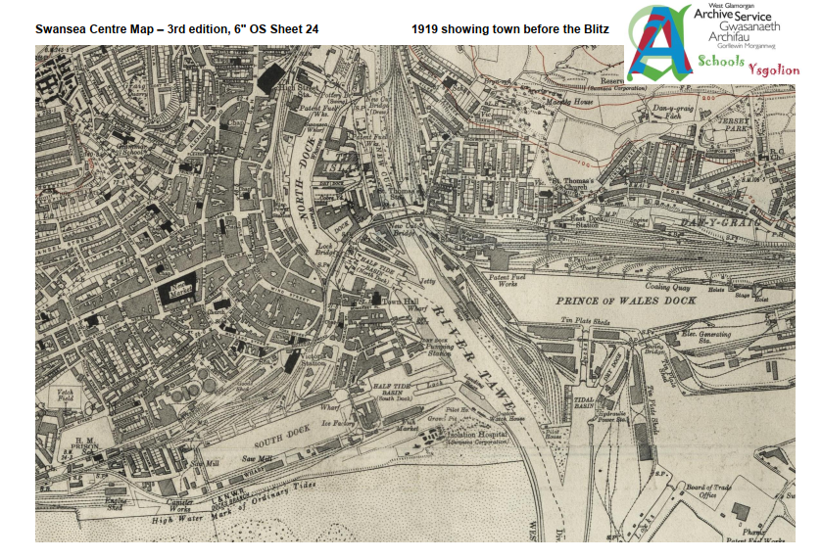
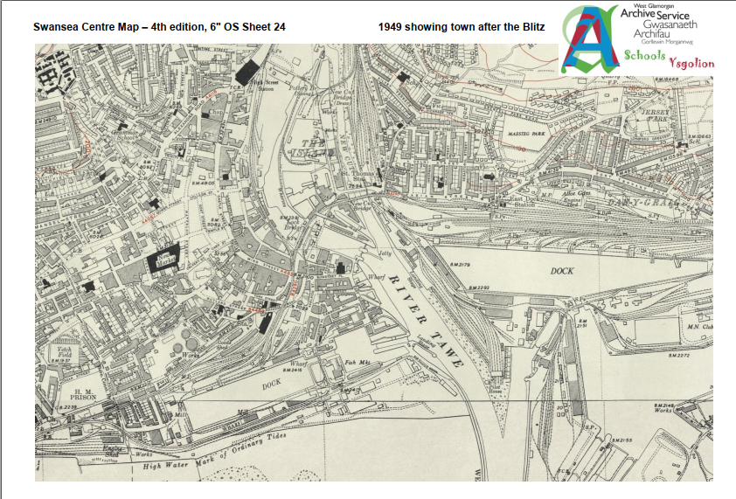

Appendix 2- Flood Risk Area. (Cymru, 2017)
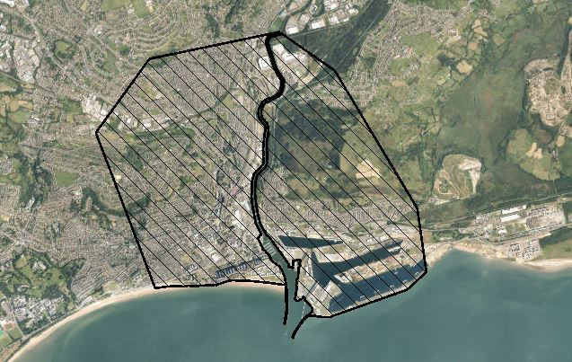
Appendix 3 - Geology key (British Geological Survey, n.d.)
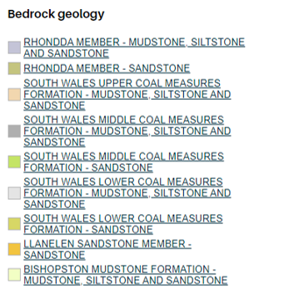
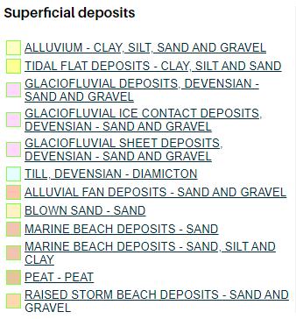
Appendix 4 - Bore Hole records from BGS (British Geological Survey, n.d.)
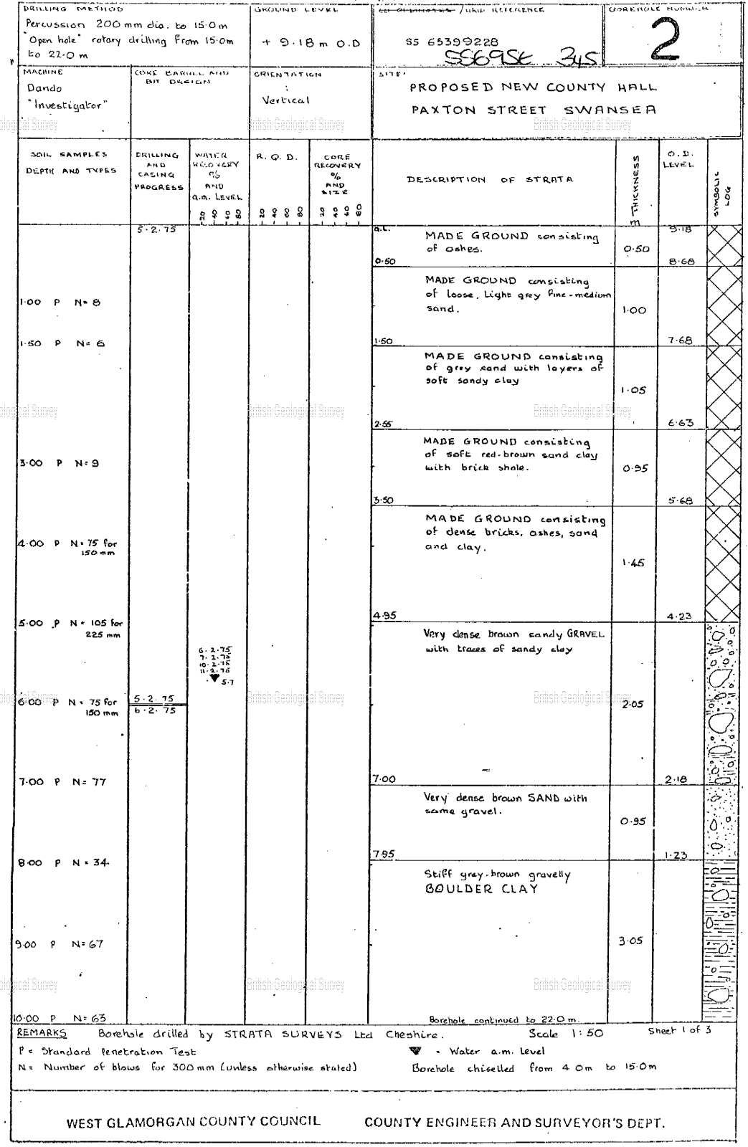
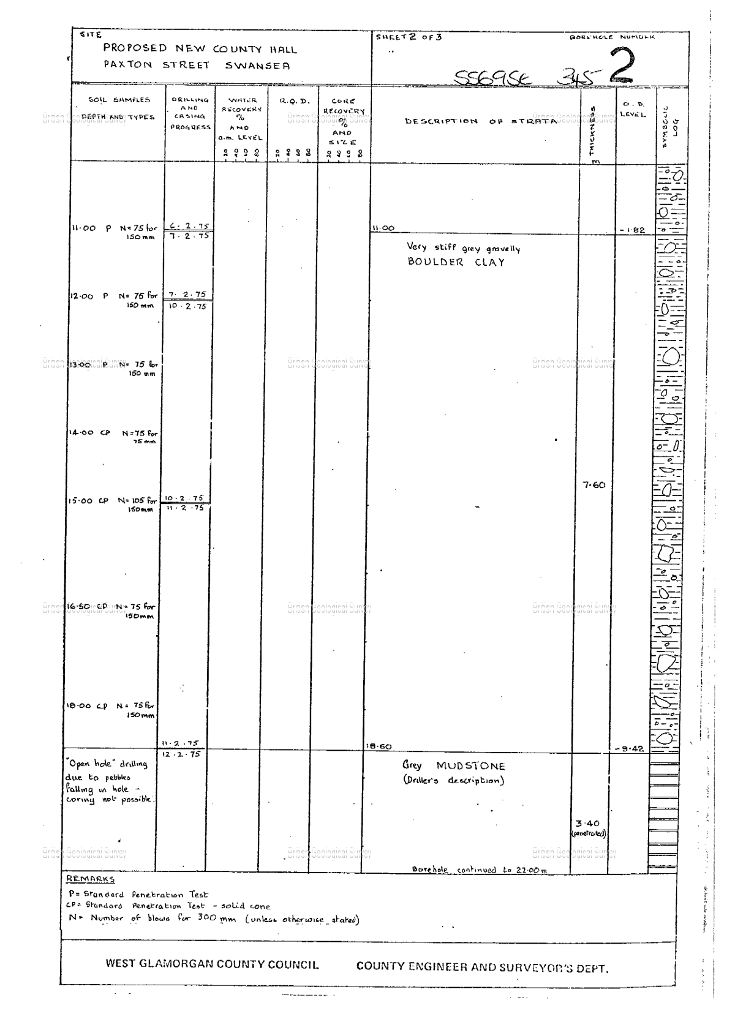
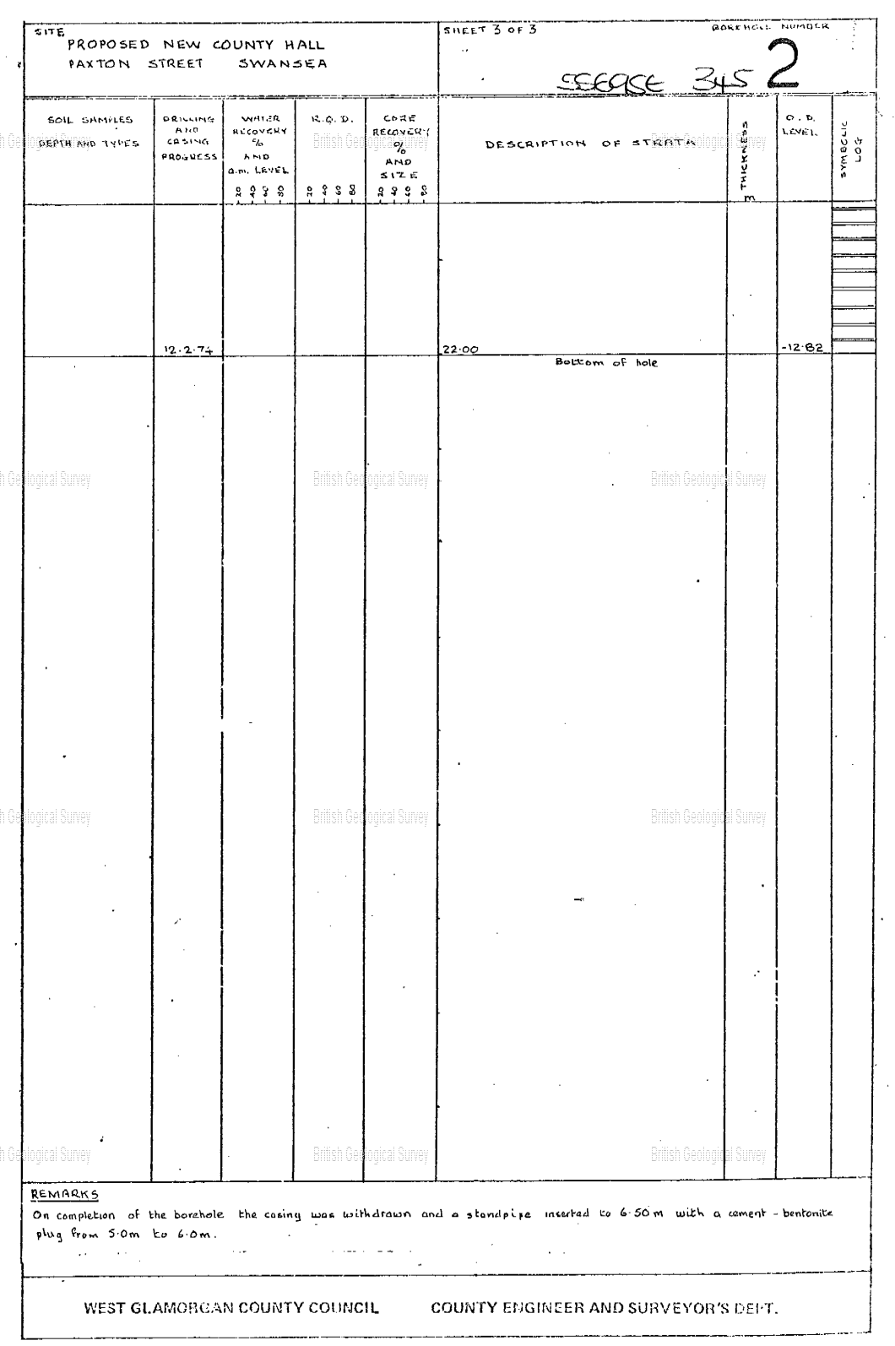

Appendix 5 - Photographs of coastal erosion around the site area.
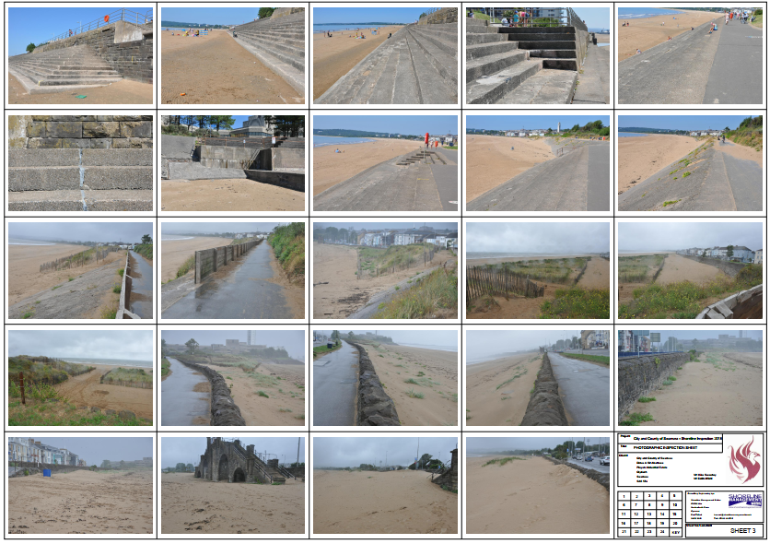
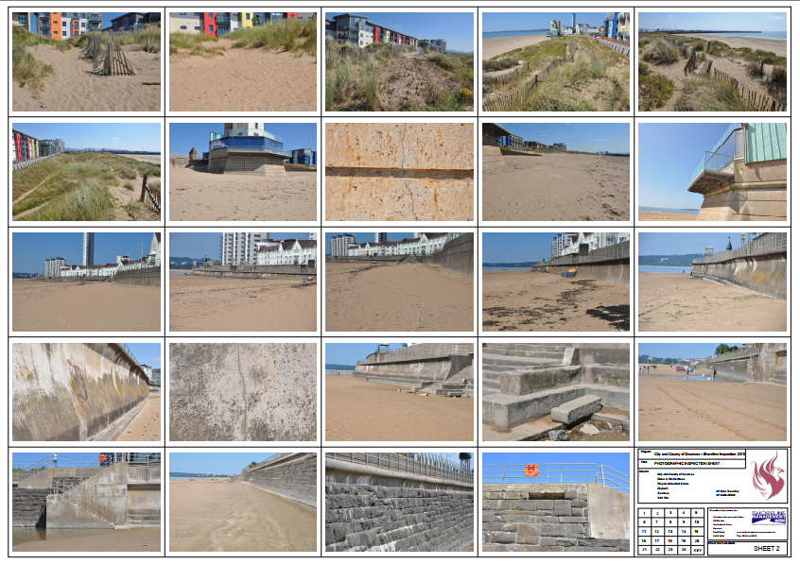

Appendix 7 - Drawing of a typical Pile and Beam cross section. (DT, 2014)


