Ontological Positions and Philosophical Underpinnings

Weicheng Lai
UWTSD Art and Design PhD Student
Student ID: 2318943

Introduction

Content and Purpose of the Study
This study explores the influence of metal music on the traditional painting process by having artists with painting experience listen to metal music during the creative painting process.
Therefore, this study aims to assist traditional painting artists in addressing the challenges of marginalisation that traditional painting techniques may encounter in the context of rapid technological development and increasingly diverse creative environments. By reinvigorating artists' attention to perception and self-emotional expression during the painting process, this study not only provides a new approach to art creation but also expands this approach to the field of adult art education, opening up new perspectives and teaching strategies for artists and art educators.

Ontological and epistemological perspectives of this paper
From the perspective of technological determinism, where matter determines consciousness, advances in science and technology have changed the means of creation and the thinking of artists in their explorations. However, artworks are not merely direct reflections of external stimuli, but are constructed by each artist within his or her own unique cognitive framework and experience. Therefore, the ontology of this paper is constructivism. The core view is that art creation is a constructive process of personal experience, and artists construct artworks through their personal cognitive and emotional responses. And this process can still be stimulated and transformed in new environmental contexts.
Epistemology focuses on the sources and ways of acquiring ‘knowledge’, especially on how to gain an understanding of the world. In this study, art creation is a process of cognitive construction based on personal consciousness and multiple aspects because the artist is not only the receiver of the external world but also the interpreter of his/her perceptual experience, thinking, memory, and creative expression. Based on the ontological perspective of constructivism, the epistemology is centred on how to interpret the impact of the artist's perception, emotional response, and expression of materials during the process of creating a painting and forming knowledge and understanding of the study.

Chapter structure of the paper
The text is divided into four chapters. The first chapter aims to introduce the context of the study, drawing out the core issues through an in-depth discussion of the current situation of painting artists, adult art education, and metal music. It analyses the correlation between them, laying the foundation for subsequent in-depth research on ontology-related issues. Chapter 2 delves into reflections on personal experience and practice, detailing the process of forming ontological and epistemological perspectives on artistic creation during past creative practices of growing up and studying art, and how these beliefs have influenced my thinking about the creative process and outcome. Chapter 3 will explore the theories and concepts that have had a profound impact on my worldview, including the core theories that have shaped my ontology, the artist's perspective, and epistemology. Ultimately, Chapter 4 will develop in-depth my final view of a constructivist ontology and critically examine other possible ontologies. Also, this chapter will critically explore the limitations of constructivism.

1 Research Background

In this study, the ontological inquiry focuses on the impact of metal music on the creative process of artists' painting. The research object covers three main areas: the creative challenges faced by traditional painting artists, the problems in adult art education, and the cultural context in which metal music has developed. Through a broad exploration of these research contexts, the aim is to enhance the connection and explanatory power between the research object and ontology and epistemology.
1.1 The state of the traditional painting artist
In recent years, emerging art forms such as new media and artificial intelligence have emerged in society. For example, digital artist Beeple's solo exhibition in China in November 2024 shows how his work breaks people's imagination of emerging technologies and blurs the boundaries between digital and physical existence. (Deji Art Museum, 2024) It is undeniable that new technologies bring new experiences and feelings to viewers, but the change in people's way of production and life in the age of digital intelligence also poses changes and challenges to the artistry of traditional painting, and traditional painting techniques seem to be gradually marginalised. In the 2024 China Art Market Trend Report, it is mentioned that a series of innovative algorithms and models have emerged in the field of digital art, and that AI technology's ability to process images has fundamentally changed all aspects of the art ecosystem, and in particular, has caused a huge impact on the way of art production and the establishment of artists' identities. (TIAMSA CHINA, 2024) In the process of creation, technological art represented by AI relies more on the processing of information and the adjustment of parameters by machines. Artists' creations usually originate from the construction and interpretation of perceptions, including observations, sensory experiences, memories and emotions, and are expressed through “conscious” or “unconscious” reactions. Although new technologies can help to realize ideal artistic effects, in contemporary art creation, painting often neglects the emotions and expressions of perception in the creative process due to the demands of concept or technique. Under the influence of the market, audience and creative habits, artists who rely on perception are facing the pressure of creative transformation and limited self-expression.

1.2 The state of the metal music community
Metal, as a unique and niche music genre whose origins can be traced back to the 1970s, was born and is independent of rock music. In China, the spread of metal music is the result of the influence of multiple social factors. China's policy of reform and opening up has facilitated the absorption of foreign cultures. Social change has inspired the pursuit of individuality and rebellion, while technology, the internet, and globalisation have accelerated the process of cultural exchange and diversity. Against this backdrop, social pressure and the need for emotional expression have led to metal music becoming an important channel of self-expression and emotional catharsis for young people. The categorisation of music creation groups can be modelled on that of rock music, and studies have been conducted to classify these groups. For example, the first category is institutional marginalisers, who include practitioners of professional art groups and their children, who were exposed to Western music at an earlier age. The second category is urban vagabonds, mainly freelance musicians, including young people in the local rock scene and those who are strangers with dreams. The third category is crossover artists, who were originally successful in other fields and then turned to the field of rock music, including High School Students. (Zhang.H, 2017) Despite the continued growth of China's music industry in recent years, metal music has been controversial due to its unique form and visual representation, which has kept it on the periphery of mainstream culture. In certain cities, performance activities of metal music and its extreme forms are still somewhat restricted. In addition, many large-scale music festivals have begun to reduce the participation of traditional metal bands due to the public's low preference for this style of music. Under the multiple pressures of cultural identity, market demand, and audience preference, the challenges faced by the metal community have many similarities to the dilemmas encountered by today's painting artist community. Band members are pondering whether they should adjust their style to fit the market, and at the same time exploring how to maintain a true expression of their emotions in the process.

1.3 The state of adult art education in China
On the other hand, adult art education in China's first-tier cities is booming. Distinct from art education that is mainly for teenagers and college students, these courses are mainly provided by training institutions in the market, which target groups of adults who have no professional foundation or simply harbor a strong interest. These courses are initially designed to meet the aesthetic, spiritual, life, learning, and social needs of adults. However, due to the differences that exist between individuals, limited learning time, market factors, and the ease of access brought about by technology, these courses often tend to teach techniques on how to reproduce photographs and create quick paintings. This tendency leads to the problem that students' interest in art learning gradually wanes. The learning of art theories is often neglected in the course content, and there is a lack of cultivation of students' creativity, imagination, and perception, which makes it difficult for students to engage in self-expression and to express their ideas and emotions effectively. At the same time, this type of teaching does not adequately meet their need to reduce the pressure of work and life.

1,4 The nature of the research object and its way of existence
With the development of new technology, the creation of traditional painting faces great pressure from the external environment, and artists gradually deviate from spontaneous perception and emotional expression in their creations. At the same time, metal music, as a form of music full of energy and emotional tension, can stimulate strong emotional responses and perceptual experiences, which brings new possibilities for artistic creation. Due to the diversity and richness of artistic creation techniques, as well as the evolution of the artist's personal creative state, the artist's emotional experience and self-expression during creation are not constant, but continue to evolve with the passage of time, emotional ups and downs, and changes in physical conditions.
In this study, we are concerned with the influence of metal music on artistic creation. Metal, as a form of music with strong emotional and expressive qualities, not only has an auditory impact but also has the ability to inspire artists to create visually. This begs the question: how does metal music exist as a form of music? Do the responses and expressions it provokes in artistic creation depend solely on perceptual stimuli, or on the artist's understanding and interpretation of its nature? This study argues that the cognitive and emotional responses in artistic creation are not mere sensory stimuli but are closely related to the artist's understanding of the intrinsic qualities of metal music, and thus reflect the creator's personal cognitive framework.
As a researcher, I believe that the process of artistic creation is not merely a response to sensory stimuli but is closely related to the creator's inner understanding and emotional experience of external things. Therefore, in this study, I will focus on examining how metal music influences an artist's visual creation through multiple layers of emotional resonance, rhythm, and melody. I argue that metal music not only exists as a sound that triggers an emotional response in artists through its complex legato segments, strong rhythms, and extreme voices but also stimulates the way they perceive the world. The cultural significance and emotional value of metal music lie in the interplay between the creators' individual experience, emotional resonance, and their own cultural background, which in turn shapes the emotional frame of mind in their creative process.
2 Reflections on personal experience and practice

As an art creator and educator, I have been exposed to drawing, painting, piano, and other art forms since childhood. These early interests and experiences have had a profound impact on my choice of college major and direction of research. This essay will take both painting and music to illustrate their ontological and epistemological influence on each of my major stages.

2.1 Painting
During my primary school years, I was first introduced to Chinese painting and experienced the fascination of ink doodling. The teacher provided us with facsimiles and themes and showed us how to use the strokes and colours of traditional Chinese painting. Although I was not yet able to use the brush as skilfully as an adult, I could feel the gap between myself and the teacher's demonstration work. At the same time, I recognised the many contingencies inherent in the creation of ink paintings. Painting is a subjective and accidental form of expression for the creator.
Over time, I began to study systematic sketching in depth, starting with simple apples and geometries and gradually transitioning to more complex and richer images. I mastered a more rational and scientific way of observing and expressing objects. This process helped me successfully enter the Academy of Fine Arts. During my undergraduate studies, I specialised in printmaking. My work was mainly focused on lithographs, but the rich language and fine craftsmanship of woodblock, copper, stone, and silk screen prints gave me a deeper understanding of the relationship between pictorial language and creative conception. I realise that behind every amazing creation lies countless thoughts, experiments, and revisions by the artist.
The Chinese art teaching system places great emphasis on the development of a foundation in modelling, and as a result, our curricula during that period were filled with a great deal of sketching and colouring exercises. The Chinese method of teaching drawing stems from several key sources. Firstly, Xu Beihong introduced the nineteenth-century French academic system of Western drawing art to China, and the concept of drawing he developed during his stay in France had a profound impact on China. Secondly, due to the specific historical and political background, China's cultural and artistic education was more inclined to borrow the model of the Soviet period, which was mainly reflected in the concept of sketching represented by artists such as Cheschakov and Leben. Finally, the linear modelling method of Romanian artist Boba also contributed a unique part to the Chinese teaching model. In the subsequent historical development, the models of Cheschakov and Boba dominated in China due to the social demand for realistic painting subjects. The French Academic system, which followed classical aesthetics, also faded in the world due to the development of modern and contemporary art in the twentieth century. This made me wonder why the painting I studied always differed in so many ways from the masters of the Renaissance to Neoclassicism. The Soviet approach with its creative-expressive tendencies also made it difficult for me to connect with the rigorous procedures of printmaking. At this point, my view of knowledge was a social or environmental construct.
So, in order to trace the roots of a more traditional art, after I graduated with a Bachelor's degree, I travelled to Italy, the Vatican, Switzerland, and France to visit European culture and art. Later, I was fortunate enough to study with a teacher who graduated from Italy and was well-versed in the techniques of realist painting from the European Renaissance to the 19th-century French Academy. I learned from him a modelling knowledge that was very different from the current Chinese modelling system - the Bargue system of drawing inherited from the Western classical tradition. The Chinese modelling system, on the other hand, is derived from the styles of Cheschakov and Leben during the Soviet period, and there is a great difference between the two in terms of method and pictorial outcome. Bargue's focus is on the coherence of light and shadow, order and volume, and has a classical beauty of subtlety, rationality, and harmony. ( Figure1) Whereas, Leben's model focuses more on hard structural contrasts, space, and the expression of realistic scenes.( Figure2) Later on, I also studied the traditional European oil painting materials and techniques, and tried to apply the oil painting techniques of Jan van Eyck, Titian, Rubens, and others to the expression of portraits and still life paintings. By applying these approach, I was able to quickly determine all the procedures of a painting from start to finish. It was then that I realised that creativity is essentially a process of comprehensively pre-determining the final pictorial outcome. This got me thinking: is the embodiment of the artist still important in the creative process?

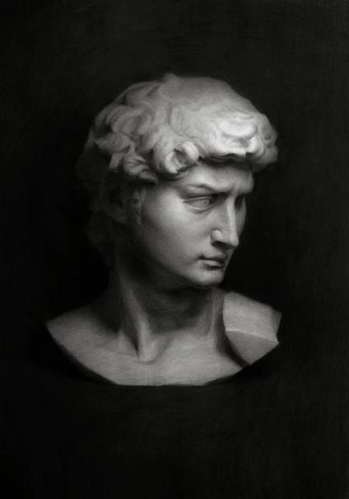
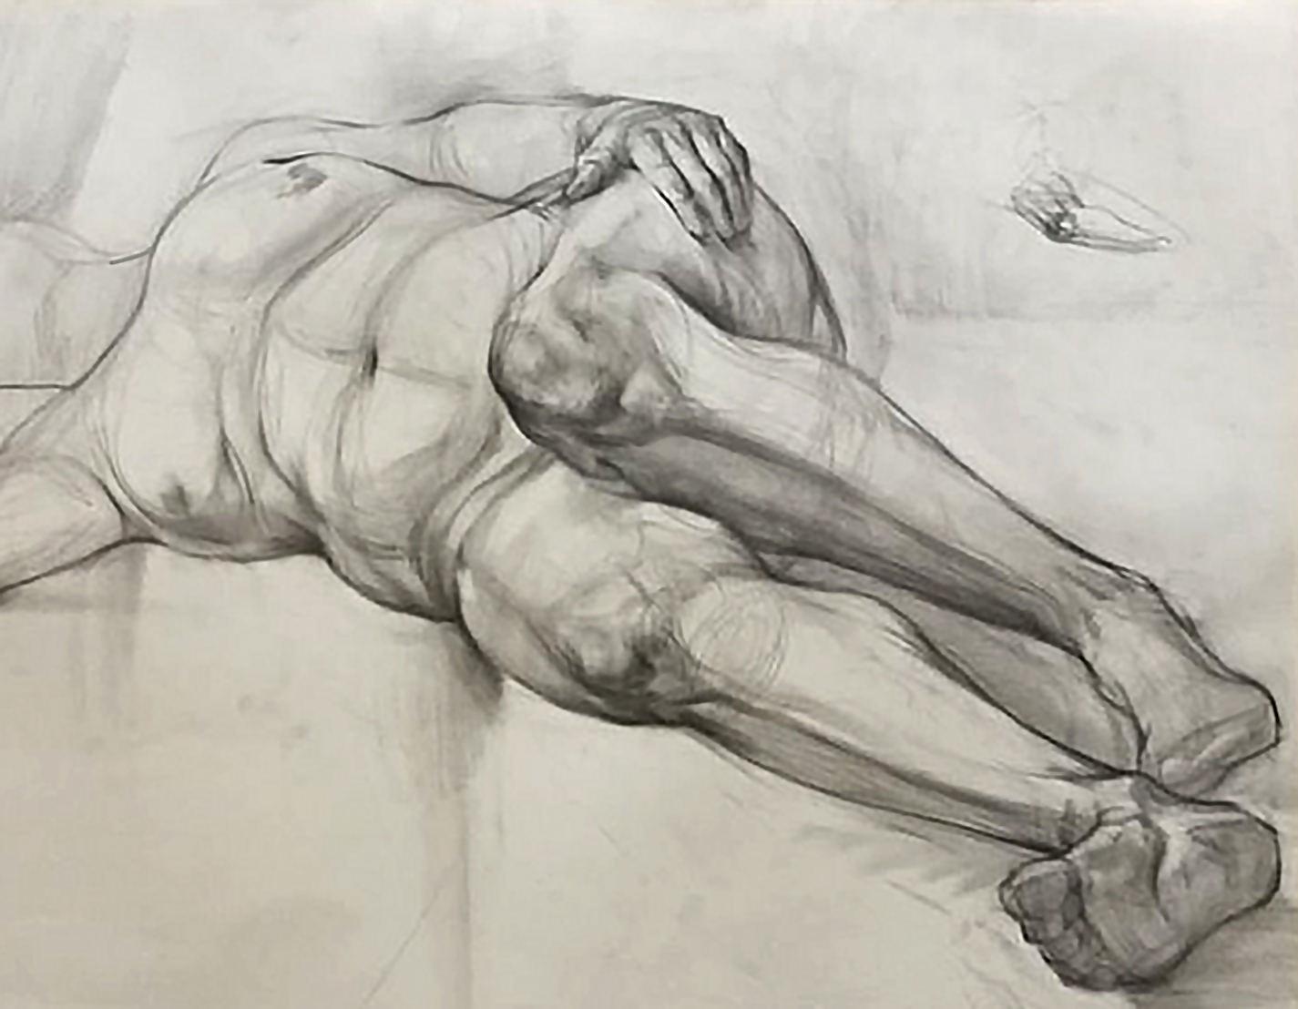
Figure 1 My work in the Balger method (Lai. W, 2022) Figure 2 My work in the Chischakov method.(Lai. W, 2018)

During my postgraduate studies, I specialised in oil painting, exploring the thinking process in art creation. My mentor's guidance stimulated my interest in cultural theory and artistic interdisciplinarity. In 2021, I was recommended by my mentor to participate in China's first National Academic Nomination Exhibition of Young Oil Painting Art. At that time, China was in a period of recovery from the New Crown Epidemic, and people interacted mainly through the Internet and social platforms. When thinking about creating traditional realism or surrealism works, I faced the difficulty of finding materials. Due to home isolation, people had little contact with the outside world and relied on social software for daily communication. During an online course, my classmates made funny ‘misunderstandings’ because they were not familiar with the operation of the software. I took a screenshot of these conversations and decided to use them to express the funny moments of the Internet era. This raised the question: if a screenshot can directly convey an effect, is drawing still necessary? At the suggestion of my teacher, I used the technique of silkscreen printmaking to present these moments of dialogue, similar to Joseph Kosuth's work exploring linguistics and semiotics. In the exhibition, my works were contrasted with realistic or abstract works, unexpectedly attracting the interest of the audience. ( Figure3) This way of setting the end result has been with me for a long time.

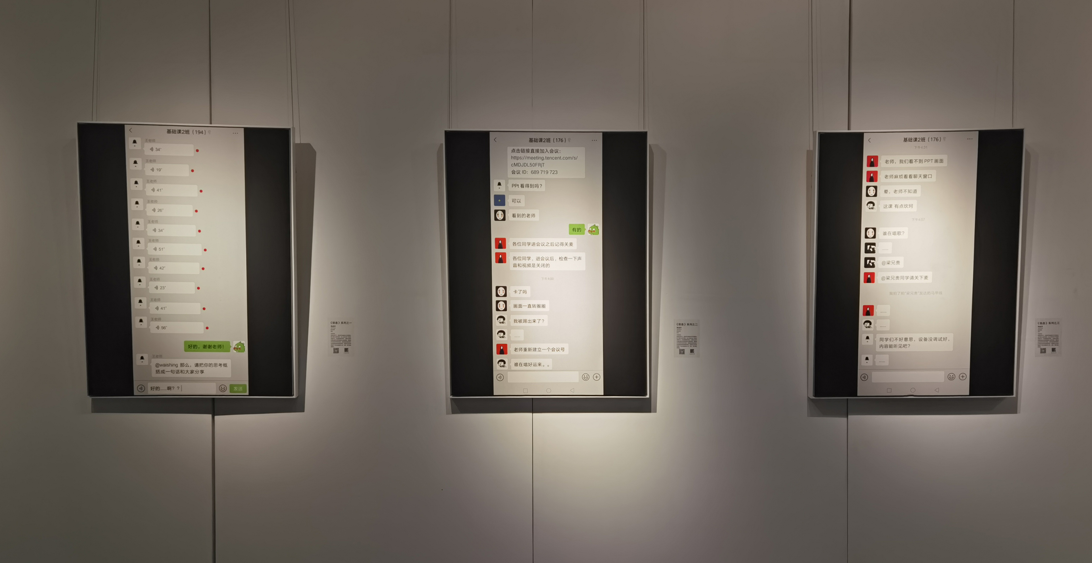
Figure 3 Works: Information Series (Lai. W, 2021)
But I quickly reflected shortly thereafter. After I received my master's degree, I plunged into the field of art education for high school students and adults. At the beginning of my teaching career, I followed the traditional Cheschakov method. This is because the idea of this teaching is that students must go through rigorous basic training to be able to use their imagination and creativity more freely when creating art. However, by observing my teaching style as well as that of other adult teaching institutions in the community, I have found that students are usually full of excitement when they are first introduced to painting. However, as they learned more, they gradually found it boring and tedious, as well as difficult to relieve the pressure from their daily work and life. Generally speaking, students believe that although systematic professional learning can bring a certain sense of achievement, many instincts are suppressed in the process of learning to paint. As a result, I reduced the copying sessions and began to rethink the importance of a sense of engagement and experience in the creative process.
Looking back on my initial thinking, it seems that artists who set goals as a result-oriented approach are not significantly involved in self-expression during the creative process, especially in terms of perception. Recalling my graduation work during my undergraduate studies, the lithograph production cycle was long and technically demanding, and prolonged concentration would easily diminish my passion. Therefore, I used to listen to metal music to stimulate my passion for painting. The convenience of technology allows us to create near-perfect images quickly, giving the viewer an ideal experience. However, this convenience may cause the artist to lose the understanding and emotional investment in the work, weakening the connection between the artist and the work, and making it difficult for the viewer to understand the artist's emotions through the surface of the work.
In re-examining the works of the masters from the Renaissance to the Modernist period, we notice that even though they made numerous sketches for retouching before creating large-scale oil paintings or fine woodblock prints and lithographs, they would only begin the formal process of creation once they were certain of the final effect of the idea or sketch in their brains. However, they approached painting with different understandings and constructions of schema, which enabled them to incorporate their personal emotions and reflections into their works. Even if they had an expected judgment on the outcome of the work, the subjectivity of the artist is always essential. This shift has led artists to pay more attention to the involvement of feelings when painting; otherwise, we would not have witnessed the evolution of brushstrokes, colours, and textures in the history of painting in the works of painters ranging from Jan van Eyck, Titian and Rembrandt, to Van Gogh, Bacon, and Freud.

2.2 Music:
Having been exposed to the arts since childhood, I often felt the monotony of a traditional academic life. As a result, I developed a strong interest in the field of music, games, and entertainment. During my middle school years, it was the wave of revival of metal music in the United States at the beginning of the 21st century. With my simple piano skills, I was intrigued by the elements of metal music that populated television entertainment and video games at the time. It was also during that time that I began to try to form my own band and relieve myself of the stresses of school and life in this way.
As a metal enthusiast and creator of visual art, I have long experienced the stimulation of music on my state of being in the creation of paintings. However, as I have explored the culture of metal music in depth, I have come to realise that the influence of metal music as an art form is not only aural stimulation, but also involves the construction of complex emotions, cognition and cultural identity. When certain song styles and lyrics come up, I strongly identify and resonate with them. However, for some of my friends around me, they see it as an ear-splitting racket. This made me think deeply about metal as perceived ‘presence’. It serves as an external form of reality, but there is no absolute answer to what it means to each individual.
In the course of my instrumental practice, I have noticed that even when musicians of equal calibre play the same piece of music, each one will end up presenting a different style of playing according to his or her own interpretation. Under more liberal conditions, each person would also choose different arrangement styles and instrumental timbres according to their personal preferences. Compared to painting, the subjectivity of the musician is much more obvious. This also made me realise that even if the desired result is set for a painting, the work can also convey a personal understanding as long as the artist's subjective expression is reflected.
Through in-depth reflection on my personal experience and creative practice, I have gradually constructed a comprehensive ontological and epistemological perspective. From time to time, I adjust my state of mind while painting by changing the music, which not only enriches my creative experience but also leads me to think deeply about ontological and epistemological issues: how do I, as an artist, integrate my understanding of metal music into the experience of the painting process? These reflections gradually shaped my new understanding of artistic creation: the outcome of artistic creation is a complex process of intertwining the artist's perception, understanding, emotion, and culture, which includes the personal experience of artistic creation, the art form, and a deep understanding of the cultural context. Thus, my ontological position suggests that the existence of artistic creation is not singular, but that it touches upon the emotional, cultural, and socially meaningful dimensions of each individual, while the epistemological position emphasizes the construction of the artist's subjectivity in the creative process.

3 Ideas that have influenced my worldview

3.1 Theory
Gombrich's schema and Corrective theory provide a powerful framework for my understanding of the personal construction of an artist's worldview. This theoretical system focuses on the evolution of an artist's style and the development of technique, and explores how artistic expression seeks a balance between tradition and innovation. He introduced the concept of ‘schema’, although he did not originate it. However, his use and expansion of the concept in linguistic studies inspired the art historian Gombrich to introduce the concept into the field of art. His most fundamental explanation of schema can be found in his book Art and Illusion. He mentions it in his book: ”The schema is not the product of a process of “abstraction,” of a tendency to “simplify”; it represents the ﬁrst approximate, loose category which is gradually tightened to ﬁt the form it is to reproduce. (E. H. Gombrich, 2023) In an artist's creative process, schemas make them dependent on specific visual frameworks and learned techniques. These schemas not only map visual experiences but are also heavily influenced by artistic traditions. By continually adapting these schemas, artists bring their images closer to the visual effects they seek. Gombrich suggests that artistic creation is not simply a ‘copy’ of reality but a creative reconstruction based on established schemas and norms. Corrective theory, on the other hand, emphasizes that artists not only rely on tradition and experience when creating art but also ‘correct’ these schemas - that is, reflect on, adjust, and innovate their visual experience.
With the help of Gombrich's theoretical framework, we can observe how artists from the Renaissance to the Impressionist period ‘corrected’ traditional artistic patterns through their personal worldview, cultural background, interests, and perceptions under the social and cultural background of their respective eras, thus promoting the development of art. Taking the artworks from the Renaissance to the Impressionist period as an example, Jan van Eyck's innovation of the Tempera technique, Titian's improvement of Jan van Eyck's oil painting technique, Rubens' optimization of the oil base, and Michelangelo's inheritance of stylistic patterns are all indicative of this process. The Impressionists, on the other hand, revolutionized the visual schema of traditional painting by abandoning the finer techniques of realism and pursuing instantaneous impressions of the natural world through the capture of instantaneous changes in light and color. The theories of schema and rectification provide us with an understanding of how artists built upon traditional schemas.

3.2 The Artist
The Post-Impressionist master Paul Cézanne has had a profound influence on my worldview and philosophical foundations. Cézanne's work not only subverted the norms of traditional art, but also introduced a unique perspective that the world is made up of three basic geometric shapes: the sphere, the cube, and the cone. This prompted Cézanne's artistic style to emphasise the complementary nature of colour, the sense of volume and structure at the edges of objects, and his paintings intricately intertwine these elements, demonstrating his deep insight into the nature of perception and subjectivity. This concept had a profound impact on modernist art, changing the way artists viewed and deconstructed painting. Cézanne's paintings reveal an attitude that values the ‘thinking man's self’ and suggests a conscious attempt to question and challenge the absolute authority of external reality. His work is not only a graphic contribution, but also a profound reflection on the perception of the world and the meaning of existence.
In the history of Chinese art, there are painters with similar ideas, and Ni Zan is one of the best. His artistic thinking is highly consistent with his artistic style, and his main theoretical point of view is reflected in his active advocacy of the doctrine of ‘escape’. He emphasised that the core of painting does not lie in the detailed portrayal of objects, but rather in the expression of one's inner ‘free spirit’.
Whether it is the theory of rectification, as proposed by Gombrich, or the epistemology of Cézanne and Ni Zan, their ideas coincide with the philosophical ideas of the German philosopher Immanuel Kant, particularly regarding the centrality of subjectivity in understanding reality. It is this constant construction and unravelling of the absence of inherent properties, order, and structure in itself that allows me to recognize the influence of ontology and epistemology on artistic creation.

4 Ontological and Epistemological Stance

In this chapter, I will describe how my research perspective shifted from critical realism to constructivism. I will then outline the constructivist ontological stance of this research. Ultimately, I will critically examine other relevant ontological perspectives. After all, these different perspectives have been represented in my personal experience. Finally, the limitations of constructivism are critically considered.

4.1 Criticism
Among the foundations of my philosophical thought, Marxist philosophical thought comes to mind first, which stems from the fact that it was part of the Chinese basic education system I received. The position of criticism has influenced me for a long time during my extended period of learning to paint.
As a theoretical perspective of criticism, Marxist philosophy emphasizes core ideas such as dialectics, historical materialism, and scientific socialism. These ideas not only help develop our critical thinking and logical reasoning skills but also deepen our understanding of the laws of social development. At the same time, it has empowered me to think about and understand the historical processes I study from different sociological and cultural perspectives. For example, the Frankfurt School in Germany criticized the control of the culture industry over individuals and society and emphasized the revelation of social structures through theoretical critique. The Birmingham School of Cultural Studies in the UK, on the other hand, emphasizes cultural diversity and a focus on how culture shapes social structures. Mark Post, in his theory of the second media age, proposes a new social structure brought about by the Internet and digital technology, emphasizing changes in the way information is disseminated and decentralized social interaction. (Chu.X, 2015) These perspectives have helped me to see and understand the development of the world.
Technological determinism argues that material conditions and technological advances have largely shaped human ideologies and ways of thinking. Historically, technology has driven diversity in artistic creation. For example, Renaissance painters used mathematical principles and perspective to enhance the realism of their paintings; the emergence of photography in the 19th century facilitated the exploration of color and light by Impressionist painters; and the rise of Pop Art represented a shift in the visual arts from handmade to mechanical reproduction.
In the digital age, the development of technology has dramatically changed the means and methods of artists' creativity. Artists are now able to use advanced software and hardware tools to create works of art like never before.

4.2 Constructivism
However, despite the importance of the reality of technological development in society, it is the subjectivity of the artist in the creative process that is crucial, regardless of the time period. The expression of the artist's perception of metal music is also not the result of oppression and control within the social structure, but rather the subjectivity of the individual creator's emotions, thoughts, and creativity.
Artists incorporate their own emotions, thoughts, values, and personal experiences into their work, thereby constructing artworks that are personal in their unique cognitive frameworks and experiences. This process embodies the philosophy of constructivism. 'Constructivists believe that the social world is a product of human thought - that reality is constructed through people's perceptions and reinforced through interaction with others. Social reality is seen as something that is constantly being produced and reproduced; it only exists if people persist in creating it through their everyday actions, words, and beliefs. The constructivist view of social reality recognises that the nature of the social world may vary from culture to culture and from group to group and, unlike the realists, believes that the social world consists of a multiplicity of realities rather than a single objective social reality. (Denscombe. M, 2010) This is in line with traditional painting, which emphasizes sensory experience and intuitive expression, reflecting artistic creation as a dynamic, interpretive being.
Therefore, this study adopts a constructivist ontological perspective. Artists are involved in creation through their personal perceptions, emotions, and cultural backgrounds. This constructive process determines how the artist interprets and transforms external stimuli, thus influencing his or her creative practice. Epistemology, on the other hand, emphasizes here how the artist's sensory experience of listening to metal music stimulates his or her emotional and intuitive response to the creation of a painting, which in turn leads to a unique understanding of the creative process. Therefore, an in-depth understanding and reflection on the artist's perception and personal worldview is of key significance in grasping his creative thinking, emotional expression, and artistic style.

4.3 Empiricism
There have been a number of studies in the past on perception, creativity, emotions, and other areas that have favoured empirical evidence. Among the more similar ones are Process Modification and Uncontrollability in an Expert Contemporary Artist's Creative Processes (Okada et al, 2024) and A Successful Creative Process: the Role of Passion and Emotions (Ariane C. St, 2015), among others. They have investigated the impact of emotions on people's creative process through a large number of quantifiable data methods. However, in this study, the cognitive process of artistic creation is not rational or logical reasoning, but rather the acquisition of knowledge through direct experience of perception and emotion. Metallic music, as a unique external stimulus, has an impact on the creative process of traditional painting that goes far beyond the technical aspects and is not accessible in terms of objective data or material measurements.

4.4 Subjectivism
Whilst this study recognises that the subject's perceptions and experiences play an important role in the creation of art, it is argued that the nature of a work of art is not entirely dependent on the consciousness of a single individual, but rather is closely related to wider cultural, historical and social contexts that reflect different individual understandings of metal music culture. These universals and commonalities are closely related to a certain cultural or social context. Therefore, the research framework of this paper does not lend itself to a subjectivist ontology, but requires a more integrated and pluralistic perspective.

4.5 Critical Analysis of Constructivism
The constructivist research paradigm has three main flaws of its own. Firstly, it is vulnerable to relativism. Secondly, it carries uncertainty. Finally, it lacks rigour (Denscombe, M., 2010). In this study, although constructivism emphasises the role of social and cultural context in the construction of knowledge, individual emotional responses and understanding of the art form often play a decisive role in the creator's practice. The emphasis on individual experience may challenge the collective perspective of constructivism and raise questions about the dominant role of society and culture in artistic creation.
Furthermore, the creation of metal music is not only imbued with subjectivity and cultural constructs, but it also possesses physical properties, emotional depth, and resonance for a particular audience. Although constructivism provides us with a perspective for understanding culture, society, and cognition, certain expressions and art forms may not be easy to fully interpret using a constructivist framework in the process of artistic creation. For example, the communication of certain emotions in metal music can be realised directly through the strength, rhythm, and melody of the sound, and this ‘sound ontology’ of expression may not be fully interpreted in terms of the theory of cultural constructs.
Therefore, in order to ensure that the research is carried out successfully, we will strengthen our focus on theory and consider adopting a mixed research methodology as an aid.

Conclusion

In summary, through an in-depth exploration of the background and ways of being of the object of study, reflections on personal experiences and practices, and analyses of art theories and concepts that influence ontology, as well as a critical examination of multiple ontologies, this paper finally identifies the ontology as constructivism.
Under the constructivist paradigm, artistic creation is a process by which the artist constructs a work through cognition and emotion, and this process can be stimulated and transformed in new environments. Epistemology is concerned with where knowledge comes from and how it is acquired. In this study, artistic creation is a process of construction based on personal awareness and cognition, and the artist is the receiver and interpreter of the external world. Based on constructivism, epistemology centres on how the artist perceives, emotionally reacts to, and expresses metal music, and develops knowledge and understanding for the study.
At the same time, critical realism and other relevant ontological positions are explored in depth and the applicability of each theory is critically analysed. While critical realism provides us with a powerful tool for revealing social structures and historical processes, it appears to be more limited in explaining the emotional and cognitive roles of the individual creative process. Constructivism, on the other hand, focuses more on the individual's perception and experience in the cultural and social context, proposing that artistic creation is realised through interaction with the outside world and the construction of a cultural framework. However, constructivism also has its limitations, especially when dealing with individual emotional depth and non-cultural factors in artistic creation, and it may not be able to fully explain all creative phenomena. Therefore, it may also be possible in the future to explore the multiple dimensions in artistic creation more comprehensively through a mixed research approach.

Bibliography

Angeler D, Sundstrom S, Allen C. (2016)‘Deathcore, creativity, and scientific thinking’, Research Ideas and Outcome. DOI: 10.3897/rio.2.e8867

Clarke, K and Yellow Bird, M. (2021) Decolonizing Pathways towards Integrative Healing in Social Work. Oxon: Routledge Press.

Clough, E.（2021)‘Devil Is Fine, Devil Is Kind: Slave Spirituals, Satanic Black Metal, and Cultural Appropriation in the Music of Zeal & Ardor’, Comparative American studies. DOI: 10.1080/14775700.2021.1981077

Deleuze, G. (2001) Difference and Repetition. London: Continuum Press .
Merleau-Ponty, M. (2012) Phenomenology of Perception. Oxon: Routledge Press.
Zhang. D. (2022) ‘Research on Adult Zero-Basic Art Education’, Fine Arts, (10), PP. 71-73. DOI：10.16129/j.cnki.mysdz.2022.11.047

Reference

Deji art museum. (2024) Beeple: tales from a synthetic future. Available at: https://www.dejiart.com/en/exhibition/beeple-laizirenzaoweilaidegushi/ (Accessed: 29 Decemeber 2024).

TIAMSA CHINA. (2024) Art market trends report. Available at: https://mp.weixin.qq.com/s/_8QPixds8v25aUngj2QBKA (29 Decemeber 2024).

Zhang. H. (2017)‘Sociological reexamination of Chinese rock music in times of change’, China Literature and Art Criticism, (10), PP. 73-80. DOI: 10.19324/j.cnki.zgwypl.2017.10.014

E. H. Gombrich. (2023) Art and Illusion. 11th edn. princeton university press.

Hadi Bashiri Dezfooli and Marjan Sheykh Zadeh (2019) ‘The Place of Subjectivity in Representation of Nature in Cézanne’s Paintings Based on Its implication in Kant’s Thought’, Piykarah (Shūshtar. Online), 8(16), pp. 29–37. Available at: https://doi.org/10.22055/pyk.2019.14967.

Immanuel Kant. (2001) Critique of the Power of Judgment. 1st edn. Cambridge: Cambridge University Press

Chu. X. (2018) ‘On The Relationship between the Development of Technology and the Transmutation of Artistic Morphology’, DOI: 10.27014/d.cnki.gdnau.2018.000243

Denscombe. M. (2009) Ground rules for social research: guidelines for good practice. 2nd ed. Maidenhead: Open University Press

Okada, T. and Yokochi, S. (2024) ‘Process Modification and Uncontrollability in an Expert Contemporary Artist’s Creative Processes’, The Journal of creative behavior [Preprint]. Available at: https://doi.org/10.1002/jocb.635.

St-Louis, A.C. and Vallerand, R.J. (2015) ‘A Successful Creative Process: The Role of Passion and Emotions’, Creativity research journal, 27(2), pp. 175–187. Available at: https://doi.org/10.1080/10400419.2015.1030314.

